Activity 2 Word Count: 1,098.
Activity 4 Word Count: 920.
I can confirm that all of the work and evidence included in the portfolio below is my own work. Any information from other sources has been evidenced and referenced correctly to the best of my ability.
Portfolio
Tracy Hughes - 1904853

Contents
1. Activity 1 - Identify and collect information relating to your HR development programme 1
2. Activity 2 – CIPD HRPM Professional Areas Report 2
3. Activity 3 – Work-Based Evidence 6
4. Activity 4 – Group Dynamics and Political Behaviour in Organisations Report 7
5. Activity 5 – Self-Assessment and Development Plan 10

Activity 1 - Identify and collect information relating to your HR development programme
Within this activity, evidence has been collected from the relevant sources of information surrounding my HR development programme. These pieces of evidence have been accessed through the programme handbook, CIPD websites, induction questionnaire (issued by my tutor) and other information available via Moodle and Library resources.
  - CIPD Websites and Resources
The CIPD Student Hub provides a range of resources that can help and support students in their studies and developing their career in the future. An example of some of the key resources available to students can be found in the figure below.
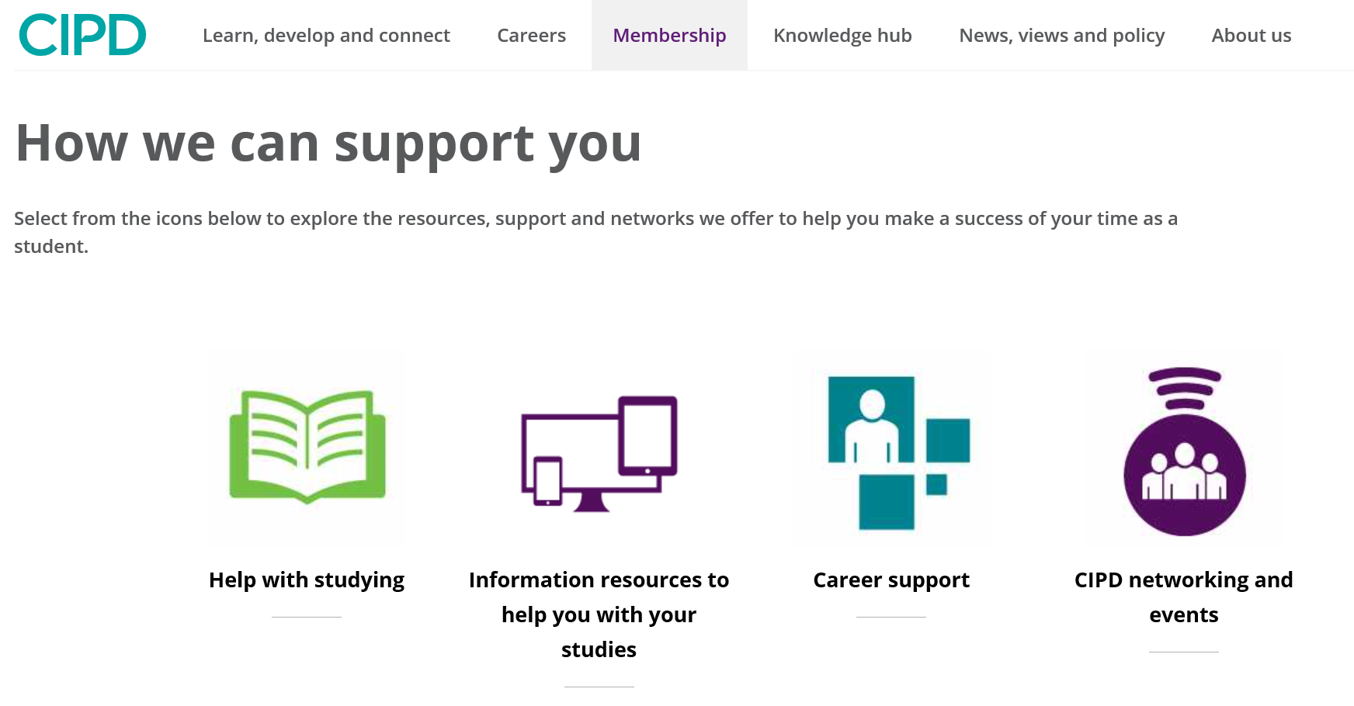
Figure 1: ‘How we can support you’ (CIPD, 2019)
When accessing each of the links above, a wide variety of resources can be found. These can help students to find credible sources when compiling reference lists and bibliographies and can point students towards the best sources of information relating to their individual and wider studies.
  - Induction Questionnaire

  - Moodle and Library Resources
Moodle and the wider library resources available to students can offer support in writing and finalising written assignments and other forms of assessment. For example, numerous books and journal articles have been accessed through the library search to help support the reports that are included within this portfolio.

Activity 2 – CIPD HRPM Professional Areas Report
The following activity consists of a 1000 word report describing and outlining the CIPD HR profession map. This includes an executive summary, introduction, main body, conclusion and recommendations. A reference list is also included to demonstrate and evidence the wider sources that were used throughout the report’s contents.
  - Executive Summary
This report focuses on the HR Profession Map created by Chartered Institute of Personnel and Development (CIPD) in 2013, as well as looking at the latest edition from 2019. Essential areas and behaviours are considered with attention paid to why these are important for effective HR professionals. The definition of ‘being professional’ and ‘being a professional’ is also considered in relation to the Profession Map. The key findings of the report are summarised and recommendations suggest that the map has both current and future credibility.
  - Introduction
This report will examine the CIPD HR Professional Map, including the essential areas and progressive bands. In order to achieve this, both the 2013 and newly developed 2019 versions of the Professional Map will be discussed. Within this, the behaviours will also be outlined with three key areas being focused on in greater detail. What it mean to be a professional will also be considered through the use of seminal texts and core sources within the literature. Throughout the report numerous credible sources, including books and peer-reviewed journal articles, will be evidenced. An overarching focus on how the professional map defines the HR profession and why the behaviours are essential to being an effective HR professional will be maintained during each section of the report.
  - Main Body
    - CIPD HR Professional Map Outline
In 2013, the first version of the CIPD HR Professional Map (below) was released with the aim of demonstrating the key behaviours that HR professionals need to be effective within the field.
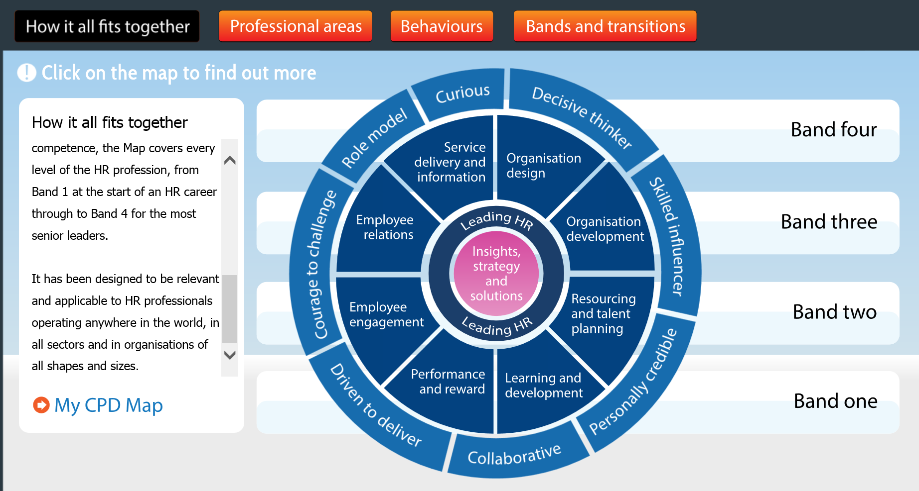
Figure 2: ‘HR Professional Map’ (CIPD, 2013)
Within the map, four bands are provided where individuals should be making progress further into their HR career. Professionals in Band 1 will be new to the profession and seeking attainment of new skills. However, Band 4 suggests that an individual should be a leader within their organisation.
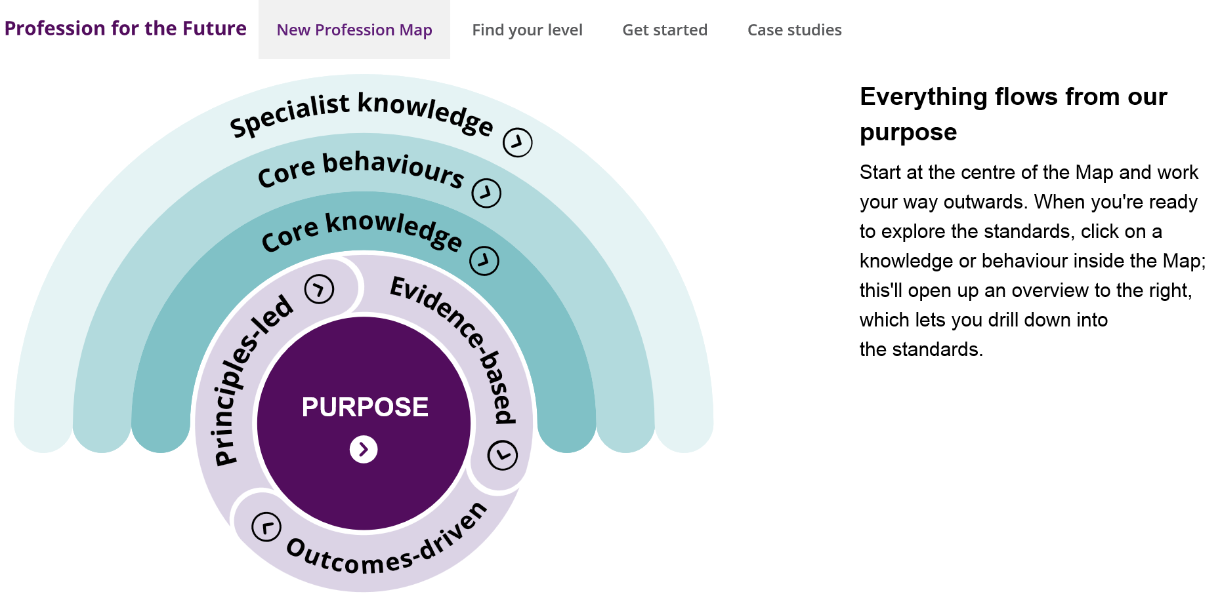
Figure 3: ‘HR Professional Map’ (CIPD, 2019)
The 2019 version of the professional map (above) provides a wider range of essential areas for HR professionals. This includes overarching sections ‘Core Knowledge’ and ‘Core Behaviours’ that remain almost the same as the 2013 map. However, a new area labelled ‘Specialist Knowledge’ has been added to the map’s diagram. This area suggests that HR professionals will develop different knowledge during their career. The new map has been described as detailed and includes scope for consistent updating as the profession evolves (Adams, 2018). This provides a stronger reliability and longevity to the maps’ contents.
    - Essential Behaviours and Areas
One of the key elements of the professional map is the key areas and behaviours that HR professionals should demonstrate within their roles and responsibilities. The key areas of the map consist of: organisation design, organisation development, resourcing and talent planning, learning and development, performance and reward, employee engagement, employee relations, service delivery and information. ‘Learning and Development’ is defined as an individual’s ability to build knowledge within the organisation in order meet current and future requirements. ‘Employee Engagement’ focuses on the work that put into ensuring that all employees are driven and motivated to be successful. This is usually developed through an increased feeling of connection and engagement in relation to their work. Initially, the format of the profession map was questioned by some sources, suggesting that it would rapidly become dated (Logan, 2009). However, with the profession map being fit for purpose until its’ 2019 update, it clearly remained up-to-date with the HR profession.
The essential behaviours of the professional map include: decisive thinker, skilled influencer, personally credible, collaborative, driven to deliver, courage to challenge, role model and curious. ‘Collaborative’ explains that an individual should work effectively with a wide range of peers and colleagues both within and outside of the organisation. ‘Driven to Deliver’ has a simple focus of whether the individual is capable of achieving the best outcomes for their company and the determination and resourcefulness that they demonstrate whilst trying to get this success. These elements of the profession map were described as comprehensive and detailed when they were initially announced (Berry, 2009).
    - What does it mean to be a professional?
When considering the essential behaviours in any profession, it is important to consider what it means to be a professional and the key components of this within each field of specialist knowledge. In the case of being an effective HR professional, this is relatively transferable. A professional is commonly referred to as someone who has specialist knowledge and has the autonomy to make their own judgements on specific situations (Lester, 2010). However, when working alongside other people it is crucial that a professional has the ability to ‘be professional’ through a commitment to a core set of principles and having a strong sense of ethics (CIPD, 2017).
  - Conclusion
Overall, the professional map provides a comprehensive guide to the essential behaviours and areas of expertise that HR professionals require in order to be effective. The map takes into account what an individual needs to ‘be professional’ as well as ‘be a professional’ within the field. This is achieved through the focus on ethics, values and collaboration as well as specialist knowledge. The latest edition of the CIPD professional map (2019) offers a better summary of the role that specialist knowledge plays in the profession. It suggests that specialist knowledge is not essential in all roles of HR and will only be developed through extensive experience. Furthermore, the essential behaviours that are provided create a holistic set of skills that are given evidenced approval in the sources that have been utilised throughout the report (Berry, 2009).
  - Recommendations
Based on the content of the professional map and how it has developed since 2013, few recommendations can be made that go against the information that the CIPD is providing. As discussed above, the CIPD has moved towards more general behaviours and more specific knowledge. This seems like a sensible alteration to the professional map as it demonstrates that although the behaviours are essential to make progress, not all knowledge will be seen as essential to every HR professional. Therefore, if any recommendation were to be made to a HR professional accessing the map, it would be to focus on the essential behaviours as this is where the key foundations for success, such as ethics and attitudes, are formed.
  - Reference List
Adams, K. (2018) ‘CIPD launches new Profession Map’, People Management, Dec 2018/Jan 2019, p. 54.
Berry, M. (2009) ‘CIPD revamps standards with HR profession map’, Personnel Today, p. 14.
CIPD (2017) HR professionalism: what do we stand for? Research Report. United Kingdom: Chartered Institute of Personnel and Development, pp. 1-43.
CIPD (2019) New Profession Map. Available at: https://peopleprofession.cipd.org/profession-map (Accessed: 11 January 2020)
CIPD (2013) The 2013 Profession Map. Available at: https://www.cipd.co.uk/learn/profession-map/2013-profession-map (Accessed: 12 January 2020)
Lester, S. (2010) On professions and being professional. Available at: http://scholar.google.co.uk/scholar_url?url=https%3A%2F%2Fpdfs.semanticscholar.org%2F0c01%2Fc931220b7d598a071f0e88ce17e24f5e7fdf.pdf&hl=en&sa=T&ei=VyYbXoCLHfrSsQLHl5UQ&scisig=AAGBfm1z7me2rcMl1PJPC8CQatS73JxwZg&nossl=1&ws=1280x706&at= (Accessed: 12 January 2020)
Logan, G. (2009) ‘Lukewarm welcome for CIPD HR profession map’, Personnel Today, p. 2.

Activity 3 – Work-Based Evidence
The following activity is a collection of evidence that has been selected in order to demonstrate my ability to participate in work projects. Furthermore, the evidence is also aimed at presenting the skills I have attained and developed during these work projects, such as problem-solving and analytical skills.
3.1. Emails (Collaboration and Communication)
One of the key elements of my responsibility within my professional organisation comes in the form of professional emails with colleagues and peers. It is important to maintain a professional tone and manner within the format of an email, even though it can feel like an informal method of communication. Due to the advancement of technologies and mobile technologies, emailing is one of the most effective and efficient forms of communication within the workplace due to the speed and ease of access of emails.
However, it is crucial that professionalism is maintained when using emails in this context. Therefore, that is an issue that I consistently ensure is correct and proper within my own emails and communication with colleagues. I have demonstrated this ability to communicate effectively in digital formats within numerous and vast emails with my peers.
3.2. Work Projects (Problem-Solving and Leadership)
One of the best examples of being involved in a work project within my own organisation is the opening of our new store during October 2019. Due to my role as manager within the store it was important that I played a leading role in the opening and duties of the store. My colleagues and team were all relatively new to the job role as we needed to hire a whole new group of staff for the store opening. Therefore, I had to demonstrate clear and effective leadership skills that could allow my team to become efficient within their individual and group roles for the opening of the store.

- Activity 4 – Group Dynamics and Political Behaviour in Organisations Report

The following section of the portfolio consist of a report looking at group dynamics. This includes definitions and theories surrounding the concept as well as examples from real-life experiences. Political behaviour in organisations is also outlined with attention paid to power in the company hierarchy.
  - Group Dynamics
Within this section of the report, group/team dynamics will be defined and conceptualised through the use of academic sources. Theoretical definitions and models that demonstrate the dynamics of a group or team will also be presented.
    - Definitions
Group dynamics is defined as the inner-workings of a group or team, social interactions and group development are some of the key elements of the dynamics of a group (Cartwright and Zander, 1968). Further definitions focus on the aims of an effective group dynamic, including collaboration, problem-solving and positive interactions. Bion (1961) outlines how the target of a group should be able to keep it on-task and focused on reaching their end goal. Freud (1921) seems to agree with this, stating that a ‘mass’ comes together for a moment to achieve a common goal. Therefore, group dynamics can be defined as the ways that a group collaborates and co-operates, with a clear focus on the common task that they are trying to achieve together.
    - Theory and Models
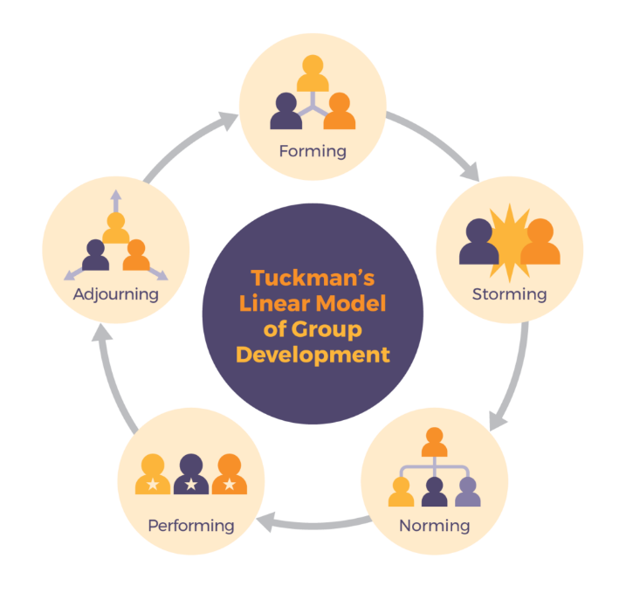
There has been significant attention paid to the theory of group dynamics and as a result, numerous theories have been developed focusing on the phenomena. One of these is the theory on group development created by Bruce Tuckman in 1965.

Figure 4: The stages of the Tuckman Model. (eCampus Ontario, 2018)
The theory (above) explains how a group goes through different phases of development: forming, storming, norming and performing. The concept is that a team must come together and ‘form’ with the common goal that was previously outlined by Bion (1961) and Freud (1921). This should be followed by a period of ‘storming’ where ideas and potential solutions to the task will be created, developed and discarded. Ideally, during this time, ‘norming’ will be taking place. This is where a group or team will begin to normalise with each other and should learn how to have good collaboration skills and social interactions. Finally, the cycle will be completed through a stage of ‘performing’. This is where the task or end goal will be achieved due to the development that the group has underdone during the 3 earlier phases. Within Tuckman’s theory, it is important to note that a group may not remain at the performing stage once they reach it. This has happened during my own time in work, where a new task may cause myself and my colleagues to thrash out new ideas within a stage of ‘storming’. Furthermore, I have also seen this development take place in my work context when new members of the team have joined my workforce. For example, in my role as a Manager at a large retail company we opened a new store. This led to a significant amount of new staff being introduced to the group and required the whole cycle of Tuckman’s model to be conducted. Due to this, the team is now performing successfully and has managed to remain at the ‘performing’ stage for long periods of time.
  - Political Behaviour in Organisations
When working within any team or organisation, conflict and other issues are always a distinct possibility. No matter how successful the group is these can arise from a number of scenarios, such as a disagreement between two members of the team, individuals attempting to further their own personal interests or ‘cliques’ beginning to emerge from the wider group dynamic (Bhatnagar, 1992). I have experienced disagreements within my own work organisation on numerous occasions. Usually, in my own experience, they come to a form of resolution where the team is able to return to a successful and smooth passage. This has been in the form of resolution between the two individuals or removal of an individual from the team in order to return the group to a successful state.
Power is viewed as one of the key aspects of political behaviour within an organisation. Usually, this is enacted with the aim of consolidating, increasing or taking power within the organisation in question (Parrel and Peterson, 1982). Examples of this consist of doing favours for colleagues, having access to key resources and position within the organisation’s hierarchy (Astley and Sachdeva, 1984). Personally, I have experienced numerous real-life examples of colleagues attempting to gain or maintain power within my organisation. Usually, this takes the form of doing favours for colleagues but in the form of strategically supporting those in higher positions than the individual. By carrying out this political behaviour, the individual aims to increase their role within the organisation and eventually move into a higher position in the company hierarchy. This will then result in the acquisition of increased power, which is usually the goal of political behaviour in an organisation.
There are some factors that can impact the political behaviour of the individual in this particular scenario. Hickson, et al. (1971) outlines how the degree of uncertainty and the importance of the task can alter the decisions of the individual. For example, they are more likely to take on the task if it is crucial to the organisation and will lead to significant recognition. Therefore, it is important to consider these elements when considering the political behaviours that people can undertake within an organisation, particularly when the possibility of uncertainty and failure is present.
  - Reference List
Astley, C. W. and Sachdcva, P. S. (1984) ‘Structural Sources of Intraorganizational Power: A Theoretical Synthesis’, The Academy of Management Review, 9 (1), pp. 104-113.
Bhatnagar, D. (1992) ‘Understanding Political Behaviour in Organizations: A Framework’, Vikalpa: The Journal for Decision Makers, 17 (2), pp. 15-22.
Bion, W. R. (1961) Experiences in groups. London: Tavistock.
eCampus Ontario. (2018) ‘Tuckman’s Linear Model of group development’, in Communication for Business Professionals - Canadian Edition [Online] Available: https://ecampusontario.pressbooks.pub/commbusprofcdn/. (Accessed: 13 January 2020)
Freud, S. (1921) ‘Group psychology and the analysis of the ego’ In: J. Strachy (Ed.), The standard edition of the complete psychological works of Sigmund Freud (Vol. XVIII, pp. 69–142). London: The Hogarth Press.
Hickson, D., Hinings, C., Lee, R., Schcneck, R. and Pennings, J. (1971) ‘A Strategic Contingency Theory of Intra-Organizational Power’, Administrative Science Quarterly, 16, pp. 216-229.
Parrel, D. and Peterson, S. (1982) ‘Patterns of Political Behaviour in Organizations’, Academy of Management Review, 7 (3), pp. 403-412.
Tuckman, B. (1965) ‘Developmental sequence in small groups’, Psychological Bulletin, 63 (6), pp. 384-399.

Activity 5 – Self-Assessment and Development Plan
To finish off the portfolio of evidence, a self-assessment will be conducted through the use of the CIPD self-assessment tool. Once the results of this have been identified and collected then a development plan will be produced. Two professional areas and two behaviours will be included within the plan. This will focus on my personal development objectives, including areas that have been identified through the self-assessment process, and a justification of why these areas of development have been selected.
  - Self-Assessment
During the self-assessment, I decided to focus on some of the core and essential areas that were covered within the report in Activity 2 of the portfolio. Therefore a key focus was placed on ‘Learning and Development’, ‘Employee Engagement’, ‘Collaborative’ and ‘Driven to Deliver’. These areas represent a wide range of skills and behaviours that I view as essential and also possible areas of improvement for myself within my present and future career development plans.
Overall, I was found to be emerging or developing in all of these areas. Therefore, most of the developments proposed by the self-assessment tool by CIPD were to consult key resources and information and maintain a focus on my development. For example, in order to improve my Employee Engagement area, maintaining and developing a belief and understanding in the organisation’s ethos and values is essential.
  - Personal Development Objectives
The key objectives and elements of my personal development that were provided as a result of my self-assessment process can be found below:
•Conduct an employee segmentation / grouping exercise with senior managers. Draw distinctions between different groups of employees and identify the strategies that will drive greater connection and engagement for specific segments.
•Partner with senior managers from the outset to secure their ownership and involvement in reviewing engagement results for their area of responsibility, and deciding on appropriate interventions or actions to improve employee engagement.
•Design and deliver employee engagement solutions for your organisation.
•Compare and benchmark your organisation’s approach to employee engagement with other organisations in your sector as well as with wider organisations who have been recognised as leaders in this area (e.g. award winners). Identify and share best practice which will be of benefit to your organisation.
•Identify an area of concern or declining trend from employee engagement results and advise senior managers on a range of interventions to tackle this, highlighting the relative costs and benefits of each.
•Define key measures and performance metrics (such as retention, attendance, productivity) to evaluate the impact of engagement interventions and track these regularly to assess impact. Refer to existing case studies and evaluation research on the CIPD and ‘Engage for Success’ websites.
•Become the most networked member of your HR team. Develop your organisational radar and keep your ‘finger on the pulse’ to bring insights and feedback to your HR colleagues.
•Develop your external network to include a number of well-recognised employee engagement experts and consultancies, and share the latest research and models on employee motivation and engagement and innovative practice that can be applied in your organisation. Share your insights with HR colleagues.
  - Development Plan
My development plan can be found below using the template provided on Moodle. This consists of four key areas of development that were identified during the CIPD self-assessment tool.

Development plan

NAME: | Tracy Hughes | MEMBERSHIP NUMBER: | 55478642
COVERING THE PERIOD FROM: | January 2020 | TO: | September 2020

This record sheet is for your guidance only – you may present your development plan in any other format.

Planned outcome

Where do I want to be by the end of this period? What do I want to be doing? (This may be evolutionary or “more of the same”.)

What do I want/need to learn? | What will I do to achieve this? | What resources or support will I need? | What will my success criteria be? | Target dates for review and completion
‘Employee Engagement’ – Increase fulfilment levels in employees in order to increase their contribution. | Access theory and research on how best to increase levels of fulfilment in employees. I will then test and use theories to see which works best for me and my team. | I will need access to theories and research which can be found on Moodle and the library search. CIPD also provides me with access to credible sources to find this information. | An increase in fulfilment and contribution of employees will be measured in both general and specific means. Team morale will be measured through observation and commitment to work and contribution will be measured through statistical data. | September 2020.
‘Learning and Development’ – Comparison and Best Practice | Look at other organisations and how they conduct themselves. Also consider best practice and the work that we complete in my team. | Access to other company and organisation’s practices. I will also access resources on best practice via Moodle and Library search. | Success criteria will be based on areas of improvement for my team and if other forms of practice appear to suit these needs any greater than we currently do. | September 2020.
‘Collaboration’ - Mentoring | Aim to mentor colleagues who are new or inexperienced with HR practices. | Access to theory for myself and my colleague. Access to theory on mentoring and how best to support an individual in learning new or unfamiliar concepts. | Success will be dependent on whether my colleagues begin to learn and understand the HR practices of our organisation. | September 2020
‘Driven to Deliver’ – Team-Based Projects | Aim to take part in more and large team projects within my organisation. | Access to team projects and theory surrounding effective team practice, such as group dynamics theory that has been outlined in the portfolio. | Success criteria will consist of engagement with and contribution to team based projects within my organisation. | September 2020.

