Business Research
BMMB7028

Name of the Student: MARSOOK KOTTADAN
Student ID: 2220272

Subject: THE IMPACT OF REMOTE WORK ON EMPLOYEE PRODUCTIVITY AND WELL-BEING : A COMPARATIVE AALYSIS
Abstract
The study has discussed close analysis of the advantages and issues related to remote work and allows devising organizational policies and tactics to maximize efficiency of remote work. This will consist of the deployment of supportive technologies, building virtual collaboration, and providing employees with resources for their wellness. In summary, broad comparative analysis will finally pave the way for sound decisions that will feed into the growth of techniques to boost both productivity and welfare in remote work environments. A study of the best practices and strategies that help in maximizing the productivity of work and promoting wellbeing in the remote work environment will help to develop evidence-based policies and practices which are targeted to strengthen employee success as well as organizational effectiveness in the transforming remote work environment. Secondary Methodology has used for collecting more information about remote working.

Table of Contents
Introduction 5
Background 5
Research Aim and Objectives, Questions 6
Rationale 7
Significance of the study 8
Research Summary 8
Literature Review 10
Introduction 10
Differences in productivity levels between remote work and traditional office settings 10
Evaluation the effects of remote work on various aspects of employee well-being, including mental health, job satisfaction, and work-life balance 12
Identification factors that contribute to differences in productivity and well-being outcomes between remote and office-based work arrangements 14
Best practices and strategies for optimizing productivity and promoting well-being in remote work environments 16
Theoretical Framework 18
Conceptual Framework 19
Literature gap 20
Research Summary 21
Research Methodology 22
Introduction 22
Research Philosophy 23
Research Approach 23
Research Design 23
Data Collection Method 24
Data Analysis Method 24
Sampling Strategy 25
Ethical considerations 25
Advantages and disadvantages of Method 25
Resource implications and needs (costs/time) 26
Timeline 27
References 29

Introduction

Background
The shift to remote work has channeled its way all across the globe as technology started to rapidly grow and the emergence of global COVID-19 pandemic further pushed its growth. With the evolution of remote work, the impact on the organization's workforce productivity and well-being is the central question in modernity (Daraojimba et al. 2023). Online work provides employees with the flexibility of location and autonomy that permits them to find a better balance between work matters and personal life issues. While it gives some worries that it determines low productivity and psychophysical well-being, the traditional office-based work spaces are compared to remote work.
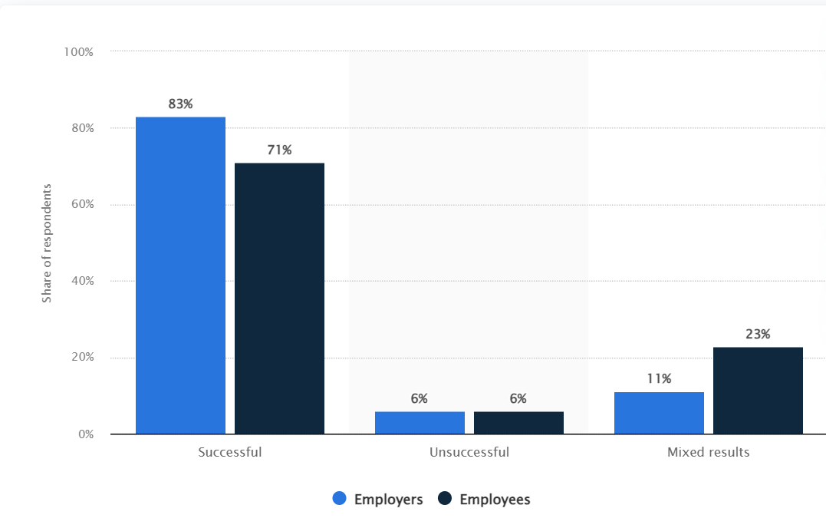
Figure 1.1: Views of employees and employers and their success
(Source: Statista, 2024)
According to the study in which both employers were asked and workers themselves were asked, 83 percent of employers agreed remote work was good, but only 73 percent of employees agreed (Statista, 2024). Whereas almost all of the respondents have agreed with the fact that remote work was worth the effort already. Remote work can be described as using modern technology of various types of remote connections mainly to keep substantial communication between employees and their colleagues outside the office. The comparative study of remote work and office-based work settings is an inevitable step in construction of this position. This research, in turn, would focus on the issues of productivity gap, job satisfaction, work-life balance and mental health conditions difference among remote and office-based workers (Oltean and Taylor, 2023). By analyzing different components including communication efficiency, task involvement and social interaction researchers might reveal the intricate influence remote work has on employee’s effectiveness and worker health.

Research Aim and Objectives, Questions
Aim
The aim of the study is to the impact of remote work on employee productivity and well-being: A Comparative analysis
Objectives
- To assess the differences in productivity levels between remote work and traditional office settings.
- To evaluate the effects of remote work on various aspects of employee well-being, including mental health, job satisfaction, and work-life balance.
- To identify the factors that contribute to differences in productivity and well-being outcomes between remote and office-based work arrangements.
- To explore best practices and strategies for optimizing productivity and promoting well-being in remote work environments, based on comparative analysis with traditional office settings.
Research Questions
- How do these qualitative changes in productivity translate into differences in productivity levels of remote workers as compared to workers in traditional office settings?
- What mental health issues, satisfaction with work, and balance between work and life derive from the work remotely?
- Which factors lead to the disparities in the productivity and welfare indicators among the remote workers and the ones based at industries?
- What is the most effective and efficient way to manage different tasks and to preserve workers' well-being in remote work if compared with the absolute office?

Rationale
The rationale behind a comparative study on remote work and its effect on employee productivity and well-being lies in the fact that there is an increasing trend of working remotely due to a pandemic which has enabled this shift (Kasinathan et al. 2022). In light of the fact that businesses are about to face the consequences of working remotely in terms of the efficiency of work and the well-being of the employee, the comparison of the impact of remote work as an alternative to traditional office work is becoming an essential thing.
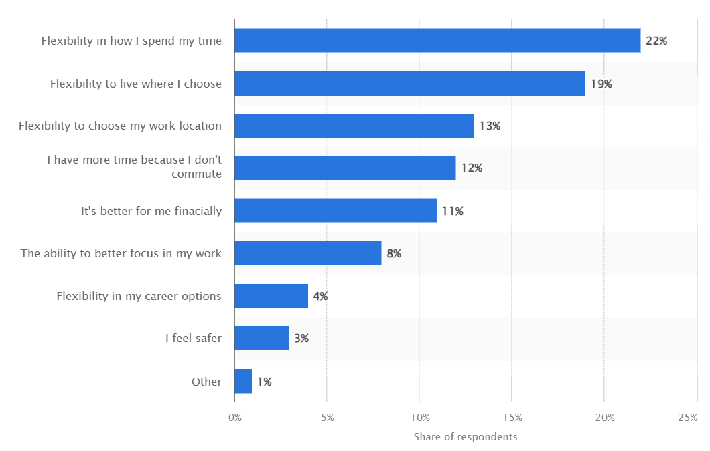
Figure 2: Benefits of remote working
(Source: Statista, 2024)
The graph reflects that at the beginning of 2022, the main advantage of work from home around the globe was the possibilities for flexible scheduling as 22% of the respondents as the biggest privilege (Statista, 2024). There is a diversity of respondents’ living place concerned and this flexibility took the second place. It has now become possible to draw a distinction between productivity levels resulting from remote work versus traditional office settings. On the other hand, evaluating the effects of remote work on employees' health, mentally, job satisfaction and work life balance from different perspectives would give us extended information about employee welfare (Tubaro and Casilli, 2022). Acknowledgement of the causes behind distinct effectiveness levels and welfare outcomes in terms of remote and office-based work arrangements plays a pivotal role in organizations in terms of the development of necessary interventions to take care of potential risks and utilize the inherent opportunities.

Significance of the study
The value of the comparative analysis of telecommuting on effectiveness and wellness of workers is multilayered and goes to various parties that consist of organizations, employees, policy makers, and researchers (Raghavan et al. 2021). The management of the organizations should feel the positive or negative consequences of remote work on productivity and well-being, which in turn is crucial for the next strategies. Through investigating the parameters that lead or hamper employee performance and wellbeing while in remote or office-based work settings, organizations can then develop their policy formulations, operations, and work infrastructure to facilitate optimal remote work arrangements. This can result in higher production per unit of time, a better job performance and a positive attitude of the employees, which eventually could improve organizational performance and competitiveness.
For the employees, this delivers an insight into the positive and negative consequences of teleworking, self-empowerment with regard to devising their work routine, well-being and their career enhancement. As for policymakers, the study helps to build legislative basis with regards to remote work, for instance, personnel efficacy and the safety at the workplace, as well as telecommuting rules and regulations (Petcu et al. 2023). Through reviewing the results of the compare analyses that rely on evidence findings, policymakers can work side by side to build frameworks that address the integration of remote work into the larger labor market, while at the same time the protection of the employee rights and well-being are tightly guaranteed.

Research Summary
This study intends to assess the divergence in employee productivity and student-wellbeing in remote setup when compared to the traditional office-setup. An assessment of productivity levels through a comparative analysis is made having in view variances in effects on satisfaction of work, mental health and work–life balance. The study's greatness is in decision making by the organizations, increased working morale, policymaking and insight into the evolving world of remote work.

Literature Review

Introduction
The reason for the rapid rise of remote work has two major causes: technology progress and the impact of the COVID-19 pandemic. Through this introduction, the study provides a fundamental framework to focus on how remote work differs from traditional office settings in terms of employee productivity and well-being. The exploration of productivity variations and the assessment of their effects on mental health, job satisfaction, and work-life balance are among the objectives of this research, which strives to share insights and contributing factors in outcomes differences. Moreover, it sets out to pinpoint best practices and techniques contributing to productivity and work-well balance in remote working conditions by far the still scarcely addressed field of study.

Differences in productivity levels between remote work and traditional office settings
According to Oancea-Negescu and Tutui, (2023), Comparison of productivity levels between remote work and traditional office workplaces is one of the hottest topics and the focal point of many sociologists, experts and leaders in these times of the rising popularity of remote work models due to the outbreak of the COVID-19 pandemic. As the organization's ability to achieve its goals rests heavily on understanding the work flexibility equation, recognizing the differences in employees is crucial. Some elements that can lead to discrepancies in the levels of productivity between remote work and office-based settings include how communication flows, task structure, tech availability, and environmental factors.
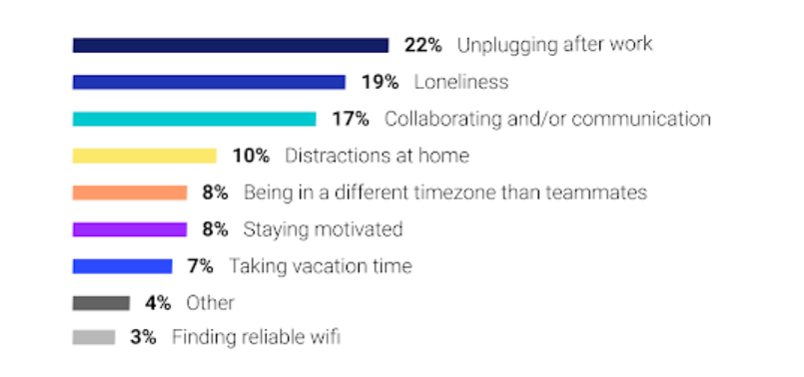
Figure 2.1: Biggest Challenges during work remotely
(Source: Inspired by Awada et al. 2021)
While the origin of the difference in the level of productivity can be traced to the distinctive type of communication in remote work and traditional office set up, we cannot ignore other factors contributing to productivity. On the other hand, Choudhury et al. (2021) suggested that Workers in standard offices enjoy what we can define as live, brief conversations on a variety of issues, therefore, collaborations, problem-solving, and decision-making occur in real-time. On the other hand, remote work tools are predominantly digital-based communication platform examples are email, instant message, and video conference systems which give the opposite of instant response, likely lose translation, and difficulties in communication. There is no replacement for the instantaneous conversations and interactions between each other that usually take place in the office setting. It is very likely that the remote employees will encounter some problems such as the delay in obtaining or giving feedback, the inability to resolve issues, and loss of team cohesion, which in turn will influence productivity.
Besides that, how work is structured and flows of tasks can have an impact on how efficient workers can be when these work setups are made from home compared to office. Similarly, Awada et al. (2021) argued that in a typical office setting employees usually follow the already established patterns of workflow, repetition and routines which are directed at the implementation and completion of all needed tasks and make performing tasks easier and more effective. The physical arrangement of fellow workers and supervisors because of direct contact, expands efficient guidance, coordination and support, speeding up project workflow and problem-solving. However, compared to working on-site, remote work might provide autonomy and the flexibility in work time allowing employees to select their work pace and schedule. A self-directed work routine can bring some motivation and accomplishment, but it can be hard to organize tasks, make explicit time schedules, and not to lose focus without the expected firm direction.
Apart from that, technology and resources availability are additionally crucial features that influence productivity of remote jobs. In a traditional office environment workers get centralized resources, essential equipment, and infrastructure that they need with their work tasks and as a result, operation is smooth and unbroken. In comparison, Diab-Bahman and Al-Enzi, (2020), Although a remote work environment requires a lot from individual technology setup, home internet connection and home office, the quality and reliability of which is not controlled by the organization, may be different from each other. Instantaneous technical problems such as website outages, hardware failure, or software incompatibility can delay the flow of work and productivity loss if IT help is not accessible on-site.

Evaluation the effects of remote work on various aspects of employee well-being, including mental health, job satisfaction, and work-life balance
The assessment of the consequences of remote work for various parts of how workers feel, including mental health and job satisfaction among others, is extremely important for determining the overall effect that remote-work arrangements have on employees’ quality of life and work performance. The study written by Sokolic, (2022), Remote work comes with many potential advantages for employee's welfare like flexibility, less traffic stress, and better control on working hours. On the other hand, it is accompanied by specialized problems that affect a person's mental health and work-life balance.
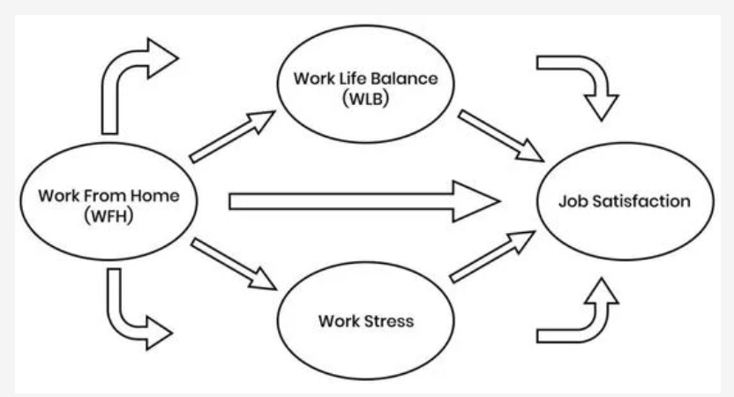
Figure 2.2: Work-life balance
(Source: Mdpi, 2024)
Another notable point is a mental health effect on remote work. Despite the fact that remote work helps to get rid of some stressful aspects of traditional offices such as commuting and office politics, it, however, can create a feeling of loneliness or a sense of burn out. Social engagement could be reduced as a result of remote workers having fewer informal relationships with colleagues, less collaboration, and also increased feelings of disconnection from the organization and the organization itself (Neidlinger et al. 2022). Besides, lack of separation between life and work in a remote environment can suffer an increased level of stress for work, difficulty of switching off work and anxiety. As a result, examining the mental health of remote workers is certainly important and necessary. Therefore, employers need to focus on social connectivity, provision of mental health resources, and work-life balance practices to offer support to the mental health of remote workers.
On the other side, Nurhasanah et al. (2022) suggested that remote work is able to impact job satisfaction given different facets of the workplace. Despite the fact that some personnel may enjoy the benefit of the opportunity to work remotely, others may miss the human interaction, team spirit, and the sense of belonging that they would have with a face-to-face office environment. Factors like efficiency of communication, career development prospects, and organizational culture can also play a significant role in employee satisfaction, which might be different between the two types of jobs-remote and office based. Therefore, it makes sense to conduct employee surveys to find out the reasons behind job satisfaction in a remote working environment and subsequently come with proper interventions such as timely feedback meetings, career development initiatives, and recognition programs.
On the one hand, Erro-Garcés et al. (2022), argued that remote work can cause the work-life balance to shift as personal and work boundaries are distorted. Working from home perhaps gives employees the opportunity to manage their work schedule at a pace which suits them best and to incorporate their personal commitments more easily, on the other hand, it can be difficult to maintain a balance between work and life, set boundaries and differentiate between working hours and leisure time. The detachedness of the remote employees may result in guilt or pressure to be available 24/7 and it may disrupt the balance of their routines and boundaries that in general are essential for their well-being.

Identification factors that contribute to differences in productivity and well-being outcomes between remote and office-based work arrangements
The knowledge of the above-mentioned factors must come first for the companies looking to perfect work environments and favor employee excellence irrespective of working remotely or in the traditional office atmosphere. This can be either a great advantage or disadvantage, being the one that determines the success of both co-workers and the company as a whole. As stated by Beckel and Fisher, (2022), An employee in a traditional office has much higher chances of collaborating with teams and brainstorming issues in person whenever the need arises. It leads to a glue that strengthens the teamwork, collaboration and accountability among colleagues, and eventually increases the production while they develop job satisfaction.
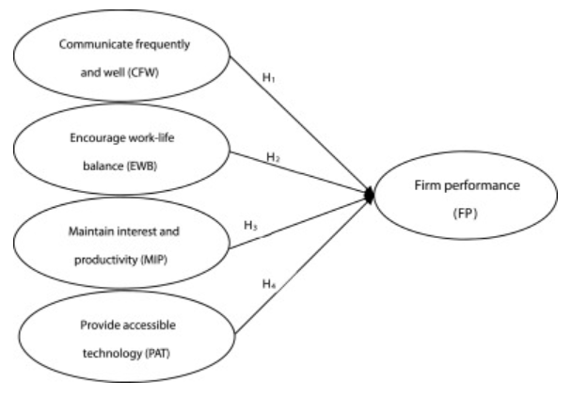
Figure 2.3: Remote working performance
(Source: Inspired by Lehtonen and Ramström, 2021)
Remote work mainly depends on digital communication tools such as emails, instant messaging, and video conferencing which furthered communication barriers since they suggest delays and misunderstanding. Distance working involves restrictions with fast feedback provision or problem resolution. On the contrary, Charalampous et al. (2022) suggested that their employees miss informal exchanges, team cohesion and collaboration which impact productivity and overall wellbeing when only working online. Workers in conventional offices take the lead from solid conducted procedures, procedures and workflows often leading to progress in performance of operative tasks and effectiveness of work.
Alternatively, distant employment accelerates freedom and flexibility of the workers in the process of performance of duties which may be done according to the schedule of an employee and his or her own speed. While autonomy might drive more motivation and satisfaction, it can be posited that the challenges of concentration on a task, management of time, and focus without having a steady working environment can also occur (Lehtonen and Ramström, 2021). Nevertheless, the reliance on the establishment of the private technical resources, internet connectivity, as well as the home office environments emanating different quality and reliability levels can be a problem for this system. Sometimes workers have to deal with problems like slow internet, hardware faults, software incompatibility or the lack of instant access to IT support, which may disturb their work, since remote workers do not have access to immediate onsite support.

Best practices and strategies for optimizing productivity and promoting well-being in remote work environments
The achievement of the goal of a productive and fair working process in the remote environment is realized through the inclusion of best practices and strategies developed in the context of the differences between remote and traditional office workspaces. According to Beckel, J.L. and Fisher, (2022), The new engagement can be achieved by introducing active approaches and supportive resources that make this atmosphere as conducive as possible to employee prosperity, satisfaction and well-being. The best attitude to set the productivity rising in remote work environments is to outline clear goals and objectives. Employees get to work within an overall framework known as clear guidelines, deadlines, and metrics for performance where their primary role is made and they get to work productively. Determining such things as the starting and ending of working hours, the amount and type of time away, also communication protocols, helps with accountability and also allows for compliance between individual and organizational goals.
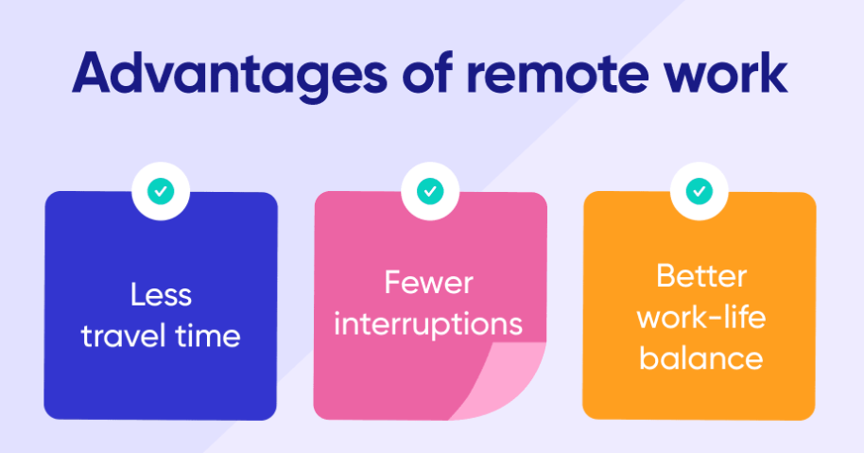
Figure 2.4: Advantages of remote working
(Source: Inspired by Bonaventura et al. 2021)
On the other hand, Haque, (2023), The role of communication as another critical strategy to ensure productivity is also highlighted in the remote work environment. A widespread content of communicative vehicles including email, instant messaging, video conferencing, and project management instruments for a successful performance of remote groups. Happenings like daily team meetings, weekly or bi-weekly check-ins, and virtual social events foster a feeling of connection, enable teamwork, and liven up the environment, hence countering feelings of loneliness and boosting everyone's productivity. The implementation of technology solutions and infrastructure backing is probably important for the achievement of remote work success.
The study written by Bonaventura et al. (2021), Having employees with working hardware, software, and IT support at their disposal makes work-related tools and resources like web browsers, spreadsheets, word processors, email inboxes, and many others available to them as needed. Work-life balance and employee wellness require support when people are teleworking, to ensure productivity and morale are kept up. Accordingly, creating flexibility in work schedules, teaching time management strategies and breaks regularly can reduce the possibility of having a remote employee burning out or feeling fatigued. By bringing about wellness programs, mental health resources and using employee assistance programs which are already in place, a remote kind of work environment will undoubtedly foster the well-being and improved resilience of workers.
Similarly, updating the culture of peer trust, autonomous working environment, and keeping in mind the perceived recognition would not only keep the employees engaged and happy but also help them to perform their tasks in remote working (Leuhery et al. 2024). To bring in more performance from the staff, it is recommended to give them the authority to take the decision, have a sense of control over their work, and hence be more motivated and engaged.

Theoretical Framework
The theoretical approach which offers an insight into how remote work alters the productivity and wellbeing of employees could be founded on some theories such as Job Demands-Resources (JD-R) Model and Self-Determination Theory (SDT).
Job Demands-Resources
The JD-R Model posits that job characteristics can be categorized into two broad categories: job characteristics and workplace support. Job Stressors refer to those activities that are either physically, mentally, or emotionally exerting and are along with the strain. While the job resources indicate elements at the workplace that are beneficial to achieving the goals of the job, decrease job demands, and stimulate growth and development, job demands, on the contrary, are the factors that cause job demands (Jansen in de Wal et al. 2020). Applying this division model to remote work indicates that the remote working features including autonomy, flexibility, and technology support could function as job resources which encourage employees to accomplish their tasks well and have an improved work-lives balance.
Self-Determination Theory
According to Self-Determination Theory (SDT), psychological needs that intrinsically drive these processes are the autonomy, competence and relatedness needed for an individual to be privately motivated (they want to do activities), the sense of well-being and the requirement for proper functioning (Giebe and Rigotti, 2022).
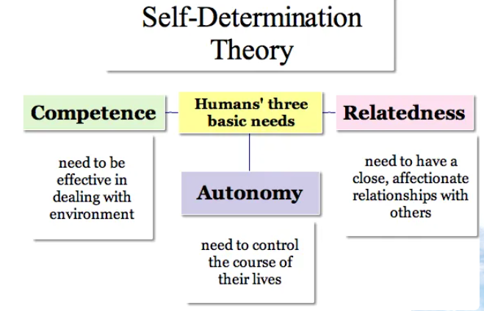
Figure 2.5: Self-Determination Theory
(Source: Inspired by Giebe and Rigotti, 2022)
According to SDT in the remote work setting, autonomy refers to the opportunity to work flexibly with the options to work from a different location. Employees who work in remote settings are likely to demonstrate high motivation, better job satisfaction and they tend to be happy due to these attributes. Nevertheless, on the one hand, such remote work plans that do not offer enough autonomy or create the circumstances for learning new skills or simply do not provide social connections, may develop a state of laziness and resentment instead.

Conceptual Framework

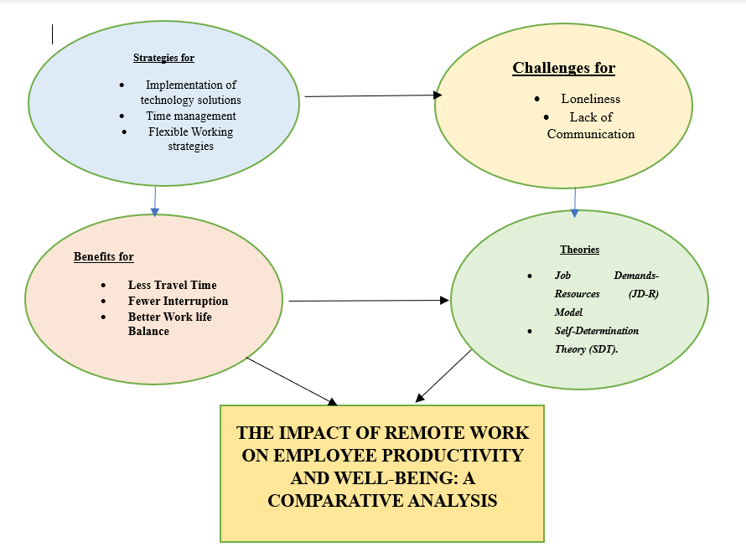
Figure 2.6: Conceptual framework
(Source: Self-Created)

Literature gap
While an extensive amount of research has been conducted in that regard to analyze how the productivity and well-being of the employees are affected by remote work, there is no information about the surveying of different demographic groups, such as gender, age, and occupation, on various types of remote work arrangements. The study of existing literature in this context tends to be just general and it looks at average data across all groups of employees, leaving out what may be variations. Consequently, the missing literature should be filled by more specific research which will investigate how the concern of gender, age, work function and family tasks interact with the remote work processes and how they can be different from performance, occupation satisfaction and wellbeing points of view.

Research Summary
The study probes into remote work productiveness and wellbeing effects, exploring the isolated system as compared to the workplace office among employers. It is through this that the role of communication dynamics is highlighted, task structure, technology access, as well as the influence of the environment. Through the utilization of theoretic frameworks ranging from JD-R model to SDT theory, it gives insights about mediation of nature of remote work on outcomes. The purpose is to come up with strategies that can be used for high productivity and for the staff to have the best working environment. Such efforts also contribute in bringing out the new future of remote work research.

Research Methodology

Introduction
Saunders' Research Onion models the four layers approach for grasping complex research beginnings from global philosophies to the next level of research design and methodology (Saunders, 2007). When considering the remote work effect on employee productivity and well-being, the Research Onion will elucidate those parts such as the assumptions used due to the philosophy, research tools and methods used, data collection methods, and analysis techniques.
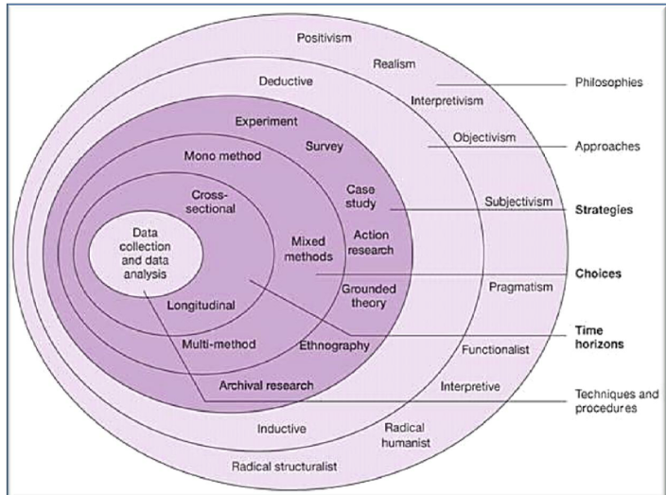
Figure 3.1: Research Onion
(Source: Saunders, 2007)
Through a step-by-step process involving the peeling off each onion peel, researchers thereby can gradually discover how many different aspects of remote work impacts the employee, thus offering precious science to the field of organizational psychology and management.

Research Philosophy
Interpretation philosophy is a research philosophy emanating from the field of social sciences. It acknowledges subjectivity of human feelings and shares the platform to other scholars on the basis of individual perceptions, meanings, and interpretation for the understanding of social phenomena. When discussing the effect of remote work on the employees' productivity and well-being through an interpretivist approach, the researchers are enabled to examine the employees' experiences, perceptions and the way they strive to interpret remote work dynamics (Bhat et al. 2023). Researchers that use qualitative methods including interviews, focus groups, or ethnographic observations to study the effects of remote work on an individual level are to collect in-depth and carefully crafted perceptions, judgment and feelings that describes how remote work influences the sense of productivity, satisfaction, and well-being.

Research Approach
An investigation indulges in induction when deductions are the inferred from the selected valid empirical evidence based on specific studies. In order to find out the influence of remote employment on worker’s life and work studies, the inductive strategy is an approach based on the test information and real-life experience of people who are working remotely (Halkias and Neubert, 2020). Data accruing and analysis process will be iteratively done and the occasions, ideas, and patterns will then keep coming out. Such relationship will help the researchers to understand the role of the remote work settings on the workers’ outcomes thus, a basis for theories and explanations will be established. The inductive approach which involves the collection of data from individuals who have been working remotely irrespective of the indistinct districts and persistent dimensions is a method that assists researchers to grow understanding from personal experiences and advice back.

Research Design
Exploratory design of scientific research will apply flexible and curious approach to the problem examination of remote work as a performance and well-being factor. Researchers will use several qualitative techniques like self-reporting, interviews, and focus discussions, survey for getting the information and assessing different areas of remote work (Casula et al. 2021). It will focus on calculating the numbers, identifying the key factors, and analyzing the principles that govern the processes of production and happiness, as they are when work is done remotely. Remote workers, organizational stakeholders, and researchers can share their points of view on the barriers to, benefits of, and perception of remote work by exchanging ideas, which will liberate more information for researchers to draw a clearer picture. This experience-oriented design lays the basis for further exploration and hypothesis testing, helping determine the type of studies and interventions in the future that will be more precise and targeted.

Data Collection Method
Secondary data collection may include information that has been collected and analyzed by others for different purposes. This information is to be used in the present inquiry. By working with these sources including academic journals, government reports, industry publications, and online databases will be where the numbers can be obtained (Oakman et al. 2020). Investigators employ the secondary data as a sourcing platform that allows them to back up the experimental results, confirm the speculations, or establish additional context to the study. Through use of data repositories and already published research papers from google scholar, scientists can eliminate all the time and resource wastage. To a certain extent, they can also locate the hidden connections behind apparently disconnected occurrences that later can help them ultimately determine the underlying facts and patterns relevant to their research.

Data Analysis Method
According to Braun & Clarke, (2022), Thematic analysis is one of the indispensable qualitative methods that help reveal the abiding effect of remote work on employee productivity and wellness. It includes steps like data entry, initial coding theme identification, coding memo, review, definition, and writing up findings. This way, researchers can discover the commonalities between the different remote work undergoes, learn patterns, give more profound insights, and contribute to the evolved knowledge about this relatively new phenomenon. In contrast to traditional forms of qualitative data analysis, which tend to focus more on individual data points, thematic analysis uses a systematic approach for extracting complex trends from large volumes of data.

Sampling Strategy
In the study dealing with the effect of telecommuting on the efficiency and the well-being of the workers, this could be achieved through purposive sampling that does involve choosing the participants on the grounds of the particular things which matter to the research goals (Obilor, 2023). As such, researchers may strategically target remote workers from different career paths, job categories or different social backgrounds in order to acquire a vast range of experiences and observations about remote work. The precise and focused sampling method guarantees that the sample resembles the population on whom the research is focused and that detailed analysis around the specific themes that are of interest is therefore possible.

Ethical considerations
Ethics is the one of the most important considerations when researching the influence of remote work on employees' productivity and wellbeing. Researchers must guarantee fully-informed consent, complete confidentiality, and voluntariness of the participants (Beckel and Fisher, 2022). Furthermore, they have to reduce inevitable harm and anguish to participants and keep the accuracy of the research. Ethical standards include openness in data collection, analysis, and reporting in a manner that protects human rights as well as dignity. Besides this, the researchers should also consider revealing their conflicts of interest and sign off on the institutional or professional code of conduct so as to maintain ethical standards throughout the research process.

Advantages and disadvantages of Method
Secondary data collection offers different benefits such as the fact that it is cost-effective, time-saving, as well as it opens up a whole variety of already existing datasets which may use (Subrahmanya et al. 2022). It provides researchers with a chance to assess the trajectory, and they can also compare their findings with studies of other issues and context. Furthermore, the secondary data can outline the primary research outcomes and bring additional facts or data, if needed.
Nonetheless, secondary information may not be sufficiently up-to-date, or lacking in power, and researchers may have less possibility to control its accuracy and reliability (Park et al. 2023). Besides this, there might exist contradictions or prejudices in the processes of data collection or in the degree of reporting of the original sources. To conclude, the usefulness of secondary data could be questioned because it might not always fit the precision of the research objective/question.

Resource implications and needs (costs/time)
Resource | Cost | Time
Personnel | $50,000 for researchers and assistants | 6 months for research activities
Technology | $10,000 for software and equipment | 2 weeks for setup and maintenance
Participant Incentives | $5,000 for compensating participants | 1 month for organizing incentives
Travel and Logistics | $20,000 for travel and accommodation | 2 months for planning and coordination
Professional Services | $15,000 for hiring consultants | 3 months for liaising and utilizing services
Data Collection | $8,000 for data collection methods | 4 months for conducting data collection
Data Analysis | $6,000 for data analysis software | 3 months for data analysis and interpretation
Literature Review | N/A | 1 month for reviewing literature
Writing and Publication | N/A | 2 months for writing, revising, and submitting
Project Management | N/A | 1 month for coordination and compliance
Table 1: Resource Implications
(Source: Self-Created)

Timeline

Activity | Duration
Research planning | 1 month
Literature review | 2 months
Proposal development | 1 month
Ethics approval | 1 month
Participant recruitment | 1 month
Data collection | 2 months
Data analysis | 2 months
Interpretation of findings | 1 month
Report writing | 1 month
Review and revisions | 1 month
Finalization and submission | 1 month
Table 2: Timeline
(Source: Self-Created)

References
Awada, M., Lucas, G., Becerik-Gerber, B. and Roll, S., 2021. Working from home during the COVID-19 pandemic: Impact on office worker productivity and work experience. Work, 69(4), pp.1171-1189.
Beckel, J.L. and Fisher, G.G., 2022. Telework and worker health and well-being: A review and recommendations for research and practice. International Journal of Environmental Research and Public Health, 19(7), p.3879.
Beckel, J.L. and Fisher, G.G., 2022. Telework and worker health and well-being: A review and recommendations for research and practice. International Journal of Environmental Research and Public Health, 19(7), p.3879.
Beckel, J.L. and Fisher, G.G., 2022. Telework and worker health and well-being: A review and recommendations for research and practice. International Journal of Environmental Research and Public Health, 19(7), p.3879.
Bhat, R.M., Silllalee, A. and Kandasamy, L.S., 2023. Concepts and Contexts: The Interplay of Philosophy and History in Understanding Human Society. East Asian Journal of Multidisciplinary Research, 2(6), pp.2581-2590.
Braun, V. and Clarke, V., 2022. Conceptual and design thinking for thematic analysis. Qualitative psychology, 9(1), p.3.
Casula, M., Rangarajan, N. and Shields, P., 2021. The potential of working hypotheses for deductive exploratory research. Quality & Quantity, 55(5), pp.1703-1725.
Charalampous, M., Grant, C.A. and Tramontano, C., 2022. “It needs to be the right blend”: A qualitative exploration of remote e-workers’ experience and well-being at work. Employee Relations: The International Journal, 44(2), pp.335-355.
Choudhury, P., Foroughi, C. and Larson, B., 2021. Work‐from‐anywhere: The productivity effects of geographic flexibility. Strategic Management Journal, 42(4), pp.655-683.
Daraojimba, C., Bakare, A.D., Olurin, J.O., Abioye, K.M., Obinyeluaku, M.I. and Daraojimba, D.O., 2023. A review of post-covid telecommunication investment trends: Impacts on infrastructure development. Computer Science & IT Research Journal, 4(1), pp.1-19.
Diab-Bahman, R. and Al-Enzi, A., 2020. The impact of COVID-19 pandemic on conventional work settings. International Journal of Sociology and Social Policy, 40(9/10), pp.909-927.
Erro-Garcés, A., Urien, B., Čyras, G. and Janušauskienė, V.M., 2022. Telework in Baltic countries during the pandemic: effects on wellbeing, job satisfaction, and work-life balance. Sustainability, 14(10), p.5778.
Giebe, C. and Rigotti, T., 2022. Tenets of self-determination theory as a mechanism behind challenge demands: A within-person study. Journal of Managerial Psychology, 37(5), pp.480-497.
Halkias, D. and Neubert, M., 2020. Extension of theory in leadership and management studies using the multiple case study design. Available at SSRN 3586256.
Haque, S.M.S., 2023. The impact of remote work on hr practices: navigating challenges, embracing opportunities. European Journal of Human Resource Management Studies, 7(1).
Jansen in de Wal, J., van den Beemt, A., Martens, R.L. and den Brok, P.J., 2020. The relationship between job demands, job resources and teachers’ professional learning: Is it explained by self-determination theory?. Studies in Continuing Education, 42(1), pp.17-39.
Johnson, S.S., Grossman, R., Miller, J.P., Christfort, K., Traylor, A.M., Schweissing, E., Bonaventura, C.D., Salas, E., Kreamer, L., Stock, G. and Rogelberg, S., 2021. Knowing well, being well: Well-being born of understanding: The science of teamwork. American Journal of Health Promotion, 35(5), pp.730-749.
Kasinathan, P., Pugazhendhi, R., Elavarasan, R.M., Ramachandaramurthy, V.K., Ramanathan, V., Subramanian, S., Kumar, S., Nandhagopal, K., Raghavan, R.R.V., Rangasamy, S. and Devendiran, R., 2022. Realization of sustainable development goals with disruptive technologies by integrating industry 5.0, society 5.0, smart cities and villages. Sustainability, 14(22), p.15258.
Lehtonen, J. and Ramström, J., 2021. An in-depth comparison between remote and workplace bound workers productivity and well-being.
Leuhery, F., Hasan, S.Z., Mustari, V.H., Widaningsih, R.R.A. and Lubis, F.M., 2024. The Evolution of Work-Life Balance: Redefining Priorities in Human Resource Management. Dinasti International Journal of Economics, Finance & Accounting, 5(1), pp.23-34.
Mdpi, (2024), Work life balance, Available at: https://www.mdpi.com/2227-7099/9/3/96/[Accessed on: 19th March, 2024]
Neidlinger, S.M., Felfe, J. and Schübbe, K., 2022. Should I Stay or Should I Go (to the Office)?—Effects of Working from Home, Autonomy, and Core Self–Evaluations on Leader Health and Work–Life Balance. International Journal of Environmental Research and Public Health, 20(1), p.6.
Nurhasanah, N., Pratama, Y.A.S. and Nurmaisyah, I., 2022. The Effect of Job Satisfaction, Work-Life Balance and Psychological Well-Being on Employee Performance at PT. JAS. Applied Quantitative Analysis, 2(2), pp.1-13.
Oakman, J., Kinsman, N., Stuckey, R., Graham, M. and Weale, V., 2020. A rapid review of mental and physical health effects of working at home: how do we optimise health?. BMC public health, 20, pp.1-13.
Obilor, E.I., 2023. Convenience and purposive sampling techniques: Are they the same. International Journal of Innovative Social & Science Education Research, 11(1), pp.1-7.
Oltean, O. and Taylor, A., 2023. Back to the Future: How the Convergence of Globalization and Technology is Changing Labour and Mobility. Social Change Review, 20(1), pp.19-44.
Park, M., Somborn, A., Schlehuber, D., Keuter, V. and Deerberg, G., 2023. Raman spectroscopy in crop quality assessment: focusing on sensing secondary metabolites: a review. Horticulture Research, 10(5), p.uhad074.
Petcu, M.A., Sobolevschi-David, M.I., Crețu, R.F., Curea, S.C., Hristea, A.M., Oancea-Negescu, M.D. and Tutui, D., 2023. Telework: A Social and Emotional Perspective of the Impact on Employees’ Wellbeing in the COVID-19 Pandemic. International Journal of Environmental Research and Public Health, 20(3), p.1811.
Raghavan, A., Demircioglu, M.A. and Orazgaliyev, S., 2021. COVID-19 and the new normal of organizations and employees: an overview. Sustainability, 13(21), p.11942.
Saunders, M., Lewis, P.H.I.L.I.P. and Thornhill, A.D.R.I.A.N., 2007. Research methods. Business Students 4th edition Pearson Education Limited, England, 6(3), pp.1-268.
Sokolic, D., 2022. Remote work and hybrid work organizations. Economic and social development: Book of proceedings, pp.202-213.
Statista, (2024), Biggest Benefits to working remotely, Available at: https://www.statista.com/statistics/1111309/biggest-benefits-to-working-remotely-worldwide/[Accessed on: 19th March, 2024]
Statista, (2024), Work success, Available at: https://www.statista.com/statistics/1211650/employer-employee-view-remote-work-success/[Accessed on: 19th March, 2024]
Subrahmanya, S.V.G., Shetty, D.K., Patil, V., Hameed, B.Z., Paul, R., Smriti, K., Naik, N. and Somani, B.K., 2022. The role of data science in healthcare advancements: applications, benefits, and future prospects. Irish Journal of Medical Science (1971-), 191(4), pp.1473-1483.
Tubaro, P. and Casilli, A.A., 2022. Who bears the burden of a pandemic? COVID-19 and the transfer of risk to digital platform workers. American Behavioral Scientist, p.00027642211066027.

