-

ACHA4011 Workshop and practice
Finlay Kingscott (2410844)
Motorsport Engineering
December 1st, 2024

Finlay Kingscott (2410844)




Engineering Technical Report

Contents

Chapter 1 – Introduction 3

Chapter 2 – Health & Safety with Risk Assessment 4

2.1 – Risk Assessment Matrix 4

Chapter 3 – Engineers Role in Society 5

3.1 – Responsibilities of Different Companies 5

Chapter 4 – Problem Solving 6

Chapter 5 – Team Structure 7

5.1 – Pros & Cons of a Functional Team Structure 8

Chapter 6 – Personal Development Plan 9

Chapter 7 – Conclusion 10

Bibliography 11

Chapter 1 – Introduction

This report will offer a brief overview of some of the topics covered during the first semester of the Workshop & Practice lectures such as the role in society engineers have and how they could deal with issues in the industry to name a few with an overarching theme of responsibility. Given that engineering is such a broad topic, this report has been tailored towards the course being studied so will feature predominantly references and ideas specific to the automotive and motorsport industries.

I have used Aria AI to help with obtaining accurate references

Chapter 2 – Health & Safety with Risk Assessments

The university has recently acquired a BMW 1 series track car, owned by an external party that wants it turned into a tarmac rally car. One of the major modifications required is the designing and mounting of a skid plate to the underside. There is already a universal front skid plate made from 2mm sheet steel which weighs around 15.5kg. For a race application, steel is far too heavy so a part aluminium, part carbon-kevlar skid is being constructed. A template needs to be made to ensure the new plate will be the correct size and sit securely. Card is a fairly common material to mock up quick templates due to its light weight and ease to work with. Card can either be cut with scissors or a box cutter. Whilst a box cutter may take longer on larger tasks such as this, it will likely be more accurate but does come with more safety concerns due to the exposed blade. It is important that gloves are worn, and any cuts are made facing away from the body to minimise risk of cuts or nicks. (Washington.edu, 2023) GCSE and A-Level exam boards for relevant subject such as Design & Technology or Product Design (e.g.: AQA & WJEC) will mention the requirement for a cutting board as t not damage the surface underneath the material being cut. However, in a workshop environment with large, metal work surfaces, this isn’t particularly necessary.

A workshop environment can have lots of hazards, so it is essential that the correct personal protective equipment (PPE) is worn. Foot protection in the form of steel-toe cap shoes/boots is essential to for minimising injuries. Safety gloves and eye protection are also recommended to be worn but can be essential depending on the task being performed. (Tower, n.d.) Whilst not specifically mentioned in any health and safety guidelines for workshops, having headphones in with music playing can be dangerous as it prevents or limits the person from being able to hear any potential dangers. If the person wants to listen to music whilst they work, a radio or speaker would be the safest option but only having a singular ear bud in is an acceptable alternative.

2.1 Risk Assessment Matrix
 | Negligible | Minor | Moderate | Significant | Severe
Very Likely | Cutting a finger with box cutter/scissors
Likely |  |  | Trap fingers when securing plate to car | Skid plate falls whilst working under the car
Possible |  | Cut hands on unfinished metal edges |  | Hearing damage if power tools are used
Unlikely |  |  | Dropping skid plate whilst carrying it |  | Jack stands fail
Very Unlikely | Bolt falls from underside of the car
Chapter 3 – Engineers Role in Society

The term ‘engineer’ covers an incredibly broad range of professions, with six major branches and hundreds of subcategories, (Types of Engineering Degrees, 2016) it is important that there is a code of conduct to ensure every action is performed safely and with consideration for things like sustainability, environmental impact and well as how it will impact how a person or company is perceived. Due to the wide range of sectors, there are multiple different codes of conduct that will all have very similar main bodies of text, but will each have extensive sections with more specific regulations. As the transport sector makes up such a significant portion of global emissions – around 14% (Harrison,2001) with the majority of this coming from tailpipe emissions – the automotive sector for engineering has a large responsibility to uphold sustainable practices.

3.1 Responsibilities of Different Companies
 | PIRELLI Group | FORD Performance
Sustainability responsibilities | Pirelli make both race tyres and road tyres which both have vastly different applications and purposes, as well as different regulations they must meet, particularly for their sustainability. | As we move to the future, there is a big push on manufacturers for more sustainable methods of powering their vehicles. Whether that be electric, hydrogen or another fuel alternative, it is important that these companies switch as the world is running out of fossil fuels. It is also important that any manufacturing facilities are powered and operated in a sustainable way with resources coming from reputable locations and companies.
Environmental responsibilities | Rubber is a material that can be both sustainable and not depending on how it is sourced and used. It is important that tyre manufacturers like Pirelli use sustainably sourced rubber to limit their carbon footprint as rubber for tyres make up 75% of all-natural rubber produced. (www.zsl.org, n.d.) Pirelli currently supply tyres for Formula 1: they offer five slick compounds as well as two wet compounds (Pirelli,2024) where there is less concern about longevity of the tyre – the softest lick compound, the C5, may only last 15 laps. | As FORD’s performance division, it is important that the company abide by any emissions laws or any manufacturing stipulations regarding environmental impact. The USA division of FORD Performance mainly comprises of vehicles with high curb weights and high displacement engines such as the Bronco® and F-150® Raptor® and the latest gen of Mustang® (Ford Motor Company,2022) so there is a responsibility to make sure the vehicles meet the regulations to all countries the vehicles will be sold in.

Chapter 4 – Problem Solving

“Failure is central to engineering.” (Petroski, 1992) In this modern day, it is rare that a product or idea will come to market having never seen any issues in the development, production or distribution phases of its life cycle. In the automotive sector, this is especially prevalent. Within the first 8 months of 2024, 1.1 million of the 41.1 million cars on the road were recalled by the DVSA. Comparably, in 1997, only 27 of the 22.8 million (www.nimblefins.co.uk, 2019) cars were recalled. (Bodyshop Magazine – The leading accident repair industry website, 2024) This data could be used to show that as manufacturing moves towards higher output production, more issues will arise.

Depending on when an issue is found, how easy it will be to rectify the problem will differ dramatically. If the issue is found quickly whilst the product is still in the development phase, the amount of time and expense to fix the issue will be low. However, if tan issue is not found until the product is already commercially available, it can have significant impacts on the business, both financially as well as the brands image.
If an issue is found with the product already on market, the most common ways a manufacturer can deal with them is to either have a recall of the product or send out updated replacement parts or products. A recall on a large scale can be very expensive and time consuming for a company.

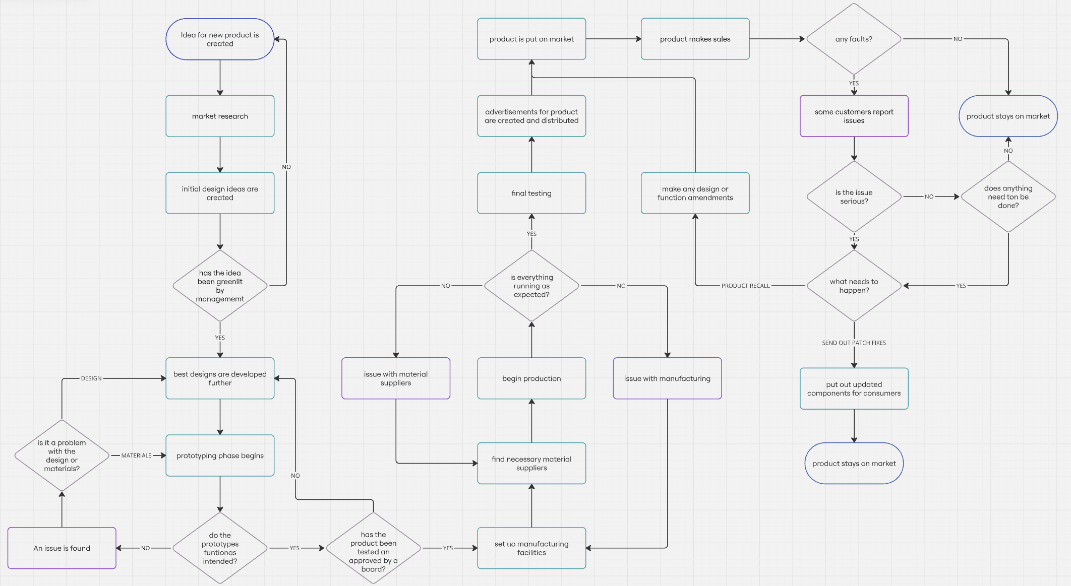
Figure 1: Flow diagram created using miro.com – based on product development cycle taught at A level Design & Technology (WJEC.co.uk, 2024)

Chapter 5 - Team Structure

As part of the Duke of Edinburgh Gold award, a 4-day expedition must be completed. (The Duke of Edinburgh’s Award, n.d.) To make it considerably easier, I did it as part of a group of seven comprised of friends from sixth form. The expedition was done in the Eryri (formerly Snowdonia) National Park with the group having full freedom over the route and where we would be staying.
It made the most sense to use a functional team structure as each person had a role that they were well versed in. A “functional organisational structure groups people into different sectors based on areas of expertise” (Vaughan, 2022) by using this way of structuring the group we were able to use our time very efficiently. This was particularly important for the navigation aspect as we had a minimum of 15km worth of walking each day with rucksacks weighing around 18kg. As there was only seven of us, we were not split into teams but instead had individual roles based on our skill sets. For example, a couple members had proficient map reading skill as they had done orienteering in the past. And another used their time in the scouts to take charge on the campsites and set up the cooking apparatus. Having this structure with everybody having their own roles led to very little disagreements meaning we were able to work very efficiently and finish each day ahead of our planned schedule. We finished the expedition with an accomplished feeling knowing we had worked as effectively as a group as we could with only a couple minor navigational mistakes.

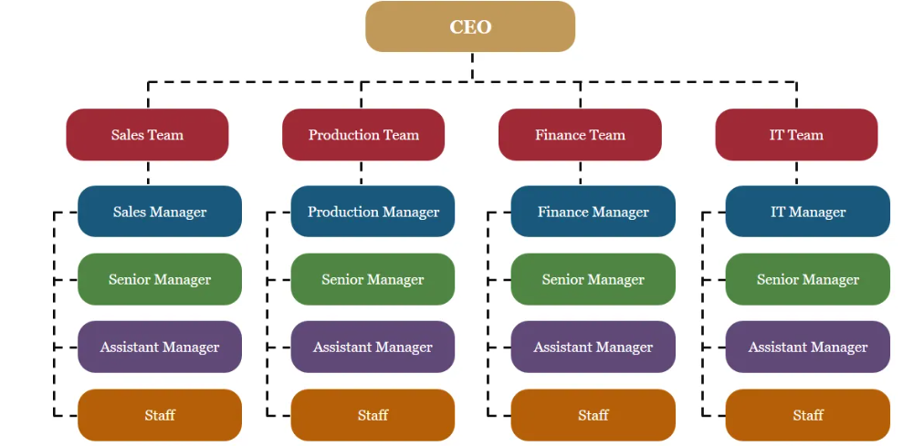

Figure 2: A diagram to show the layout of a functional team structure (slideegg, n.d.)

5.1 Pros & Cons of a Functional Team Structure
Positives of a functional team structure | Negatives of a functional team structure
Allows tasks to be performed more efficiently as the team will all have greater knowledge in that field.  People within the team can further their knowledge and experience in the field as they roles and tasks they will be performing will be similar.  Reduced operating costs from less time and resources spend on R&D (less relevant to my example) | As everyone in each sector can be considered a specialist, there can be conflicts of interest with each person having a slightly different solution to a problem. This can slow down any decisions.  As the team is comprised of people with expertise in the same field, it can limit the viewpoint of the group, and they may not consider the overarching picture for the whole organisation.  There may be a lack of communication between different groups in an organisation, which can limit progress and, in some cases, have a negative impact on it.
(Gleeson, 2019) (Slingo, n.d.)

Chapter 6 – Personal Development Plan

Name – Finlay Kingscott
Degree – Motorsport Engineering
Previous Qualifications – Physics, Design & Technology and Geography A-Levels
Previous Experience – researched and built a custom shopping trolley go-kart as part of an Extended Project Qualification during Sixth Form
Long Term Goals (5 – 10 years)
I’m not somebody who believes that long term goals are beneficial; it can give you tunnel vision and prevent you from seeing opportunities outside of your initial aspirations. Because of this mindset, I tend to keep any long-term goals vague.
Have a well-paying job in the motorsport field that I enjoy. Ideally on location but a factory position is fine
Short Term Goals (next 5 years)
I came to this course thinking I had a solid understanding of most things’ motorsport. I appear to have slightly overestimated my practical knowledge. Therefore, during my time on this course, I want to get involved with the rally team and broaden my experiences.
I am on a course that heavily centres around vehicles and racing but don’t have a driver’s licence. Not having a pink bit of plastic isn’t my main concern, it’s about not having knowledge of how a car should feel to drive and how it shouldn’t.
Decide what industry I would like to go into after university.
Goal | Objective | Resources Required | Measurement | Target Date
Get involved with and work with the rally team | Work on the car and maybe get involved with sponsorships |  | Attending meeting age getting assigned roles and tasks to complete | June ‘25
Acquire a full driving licence  Maybe get motorcycle licence too | Pass my practical driving test  Take a CBT test and all other necessary exams | A car  A motorbike and all necessary gear | Passing practical test for driving  Passing all required tests for motorbikes | Winter ‘25
Graduate with good results | Pass each section of my course |  | Results after final year | June ’27
Work in the motorsport sector | Get a job working for a race team |  | Getting accepted into a position at a reputable team | Summer ‘28
Chapter 7 – Conclusion

The responsibility of an engineer particularly to maintaining a safe working environment for themselves and those around them is incredibly important. There are multiple ways to ensure this with risk matrixes and flow charts offering a good visual representation of the sort of issues that may face an engineer in the workplace, whether that be in a manufacturing facility, workshop, research & development department or anywhere else you would find an engineer.
Efficiency is key to a company or brands success. A high level of efficiency can be created through the use of an appropriate team structure and good problem-solving skills. These both tie in with each other as a good team structure can increase the team’s ability to solve problems more complex or faster than a poorly organised team. This creates a positive feedback loop but does narrow the scope of the team in certain cases so it may be more beneficial in some cases to have a wide range of skill sets in a group, depending on the task at hand.
This report is finished with a personal development plan, a brief look into what I have achieved in the past and what I want to achieve in the future. It offers a clear and concise interpretation of my aspirations both during the remaining length of the course and beyond. While personally, I do not like the idea of planning out your future, I can however see that it could prove valuable to a lot of people as it gives them goals to strive for.

Word count (excluding Chapter 6): 1,910
Bibliography

Bodyshop Magazine – The leading accident repair industry website. (2024). UK vehicle recalls up tenfold in 30 years. [online] Available at: https://www.bodyshopmag.com/2024/news/uk-vehicle-recalls-up-tenfold-in-30-years/#:~:text=UK%20vehicle%20recalls%20are%2010,also%20lead%20to%20voluntary%20recalls. [Accessed 24/11]

The Duke of Edinburgh’s Award. (n.d.). Timescales. [online] Available at: https://www.dofe.org/do/timmescales/

Ford Motor Company. (2022). Performance Ford® Style | Find the Best New Ford® Performance Sports Cars & Trucks for You | Ford.com. [online] Available at: https://www.ford.com/new-performance-vehicles/.
Gleeson, P. (2019). Benefits & Disadvantages of a Functional Organisational Structure. [online] Chron. Available at: https://smallbusiness.chron.com/benefits-disadvantages-functional-organizational-structure-11944.html

Harrison, R.M. (2001). Pollution: causes, effects and control. Cambridge, England: Royal Society of Chemistry

www.nimblefins.co.uk. (2019). Number of Cars in the UK 2022. [online] Available at: https://www.nimblefins.co.uk/cheap-car-insurance/number-cars-great-britain#nogo

Petroski, H. (1992). To engineer is human: the role of failure is successful design. New York: Vintage Books

Pirelli (2024). Pirelli Motorsport: best products for motor competitions. [online] Pirelli.com. Available at: https://www.pirelli.com/tyres/en-ww/motorsport/car/formula-1

Slideegg. (n.d.) Functional Organisational Structure PPT and Google Slides. [online] Available at: https://www.slideegg.com/functional-organizational-structure-57049 (image)

Slingo, L. (n.d.). Functional organisational structures – pros and cons. [online] TopCV. Available at: https://topcv.co.uk/career-advice/functional-organisational-structure-pros-and-cons

Tower. (n.d.). What are the most effective forms of PPE for the automotive industry? [online] Available at: https://wearetower.com/industry/automotive/most-effective-forms-of-ppe-for-the-automotive-industry

Vaughan, T. (2022). Functional Organisational Structure: Pros and Cons Ⅰ Poppulo. [online] poppulo.com. Available at: https://wwww.poppulo.com/blog/functional-organizationa-structure-pros-and-cons

Washigton.edu. (2023). New box cutter safety guidance Ⅰ EHS. [online]. Available at: https://www.ehs.washington.edu/about/latest-news/new-box-cutter-safety-guidance [Accessed 23/11]

Wjec.co.uk. (2024). AS/A Level Design and Technology. [online] Available at: https://www.wjec.co.uk/qualifications/design-and-technology-asa-level/?sub_nav_level=digital-resources#tab_resources [Accessed 24/11]

Wwwzsl.org. (n.d.). Unsustainable natural rubber poses major threat to wildlife and people Ⅰ ZSL. [online] Available at: https://www.zsl.org/news-and-events/news/natural-rubber-transparancy-issues-sustainability

