

An investigation into Double crewing in policing in the United Kingdom – Should officers always be double crewed when on duty?

Christopher George (2222767)
BSc Professional Policing
Date of submission:27/06/2025

Acknowledgements

This research project was made possible through the unwavering support and guidance of various individuals and organisations, and I am truly grateful for their contributions and support.

This body of research reflects the boundless love and unwavering support I have received from my friends and family during the course of its completion. I owe a great deal of gratitude to my parents, who have supported and nurtured my drive and desire to achieve my lifelong goals of becoming a police officer and completing a university degree. Your support and encouragement have been instrumental throughout my whole life, and I am eternally grateful to you both.

To my loving partner, Lauren. Your encouragement, support, and understanding throughout all aspects of this research project cannot be understated. Without your sacrifices, I would not have succeeded.

Finally, to my wonderful colleagues and supervisor. The guidance, discussions, assistance, and knowledge have been invaluable and have provided the enrichment and instrumental insights that have been pivotal in completing this research project.

Declaration and Statements

This work has not previously been accepted in substance for any degree and is not being concurrently submitted in candidature for any degree.
Signed: C. George
Date: 07/03/2025

STATEMENT 1
This dissertation is being submitted in partial fulfilment of the requirements for the degree of BA.
Signed: C. George
Date: 07/03/2025

STATEMENT 2
This dissertation is the result of my independent work/investigation, except where otherwise stated.
Other sources are acknowledged through footnotes that provide explicit references. A bibliography is appended.
Signed: C. George
Date: 07/03/2025

STATEMENT 3
I hereby give consent for my dissertation, if accepted, to be available for photocopying and for interlibrary loan, and for the title and summary to be made available to outside organisations.
Signed: C. George
Date: 07/03/2025

STATEMENT 4
I hereby give consent for my dissertation, if accepted, to be available on the university’s IT system to those who have consent to use the system.
Signed: C. George
Date: 07/03/2025

Table of contents:

Chapter 1- Introduction
Chapter 2 – Literature review
Chapter 3 – Research Methodology
Chapter 4 – Findings and Recommendations
Chapter 5 – Bibliography
Chapter 6 - Annex

Chapter 1 – Introduction

This chapter of the dissertation aims to provide a background and rationale for the research study. Within this chapter will be an explanation of the aims and objectives of the dissertation, as well as its structure.

Background and rationale
This research project is inspired by my own experiences working as a police constable and those of my colleagues and peers who have first-hand experience of the pressures modern-day constables face in completing their day-to-day duties, the risks posed by dangerous offenders, and the ever-changing expectations and needs of the public. It is also inspired by the story of my friend and colleague Nathan Attwell, who on Friday, 20th December 2024, was working a normal shift on a single crewed basis and responded to a call to locate a male involved in a violent incident. Attwell located the male in an alleyway and was subjected to a violent assault resulting in serious injuries, including a fractured cheekbone, eye socket, and broken nose. Vladev, L. (2025)
Policing is an inherently dangerous occupation, and the ever-changing landscape of policing in the United Kingdom requires constant evaluation to ensure the safety of officers, as well as the requirement of meeting the needs of the public. A recent report found that a staggering 50,259 assaults on emergency workers were recorded in the year March 2023-2024, (Police Federation, 2024). The need for adequate and robust measures to protect officers cannot be understated, and this research aims to analyse the key themes in deciding if a single or double crewed unit is more appropriate for everyday policing in the modern age. The importance of research into the benefits and drawbacks of double crewing cannot be understated, as this research will provide decision-makers with insight to take steps to ensure the safety and welfare of officers on duty, as well as meeting the needs of the organisation.

Aims, Objectives, and Structure.

Aim - This dissertation aims to investigate and critically evaluate the role of double crewing in a policing context. To evaluate the effectiveness of both single and double crewed units and provide insights to inform future policy considerations to keep officers and the public safe.

There are four objectives outlined in this dissertation as outlined below.
- To investigate and analyse literature currently available using appropriate and evaluated sources to understand key themes surrounding the topic of double crewing.

- To identify and select an appropriate and considered approach to the research and fully understand the subject of double crewing.

- To obtain further information through the use of first hand research and analyse the collected data to gain an insight into the opinions and experiences of currently serving and ex-serving officers with invaluable experience to better understand the topic of double crewing.

- To provide recommendations to support further areas of study and research to further improve understanding on the research topic.
Chapter one has introduced the research topic. It has introduced the research rationale, the aim of the research, and its objectives. The next chapter will present a literature review, which will present the Secondary research obtained and outline gaps in the available knowledge.

Chapter 2 – Literature review

Introduction
Double crewing in a policing context is the practice of deploying two officers in a single vehicle, or in the absence of a vehicle, having two officers deployed to a single request for service from a member of the public or organisation requesting police attendance. The subject of double crewing has been the subject of heated debate within the field of policing for some time. This literature review aims to explore the implications and role of double crewing. It will achieve this by exploring existing research available to the public, identifying key themes, and highlighting gaps in the currently available body of knowledge. I will utilise search engines such as Google, forums, existing libraries containing academic studies, and the scholarly search engine Google Scholar to locate and extract information from existing items of literature to form the foundation of the literature review.

Evolution of policing methods and technological advancement

There have been several changes in policing operational strategies, resource allocation policies, and reviews of community engagement and methods over the years, which have contributed to the evolution of normal crewing practices within police forces across the United Kingdom. Community-oriented policing, which is most often associated with a focus on crime prevention through effective engagement with local communities, community leaders, collaboration between the police and other agencies such as local authorities, social services departments, youth clubs and other working relationships rather than just enforcement (Skogan, 1990). This change was somewhat influenced by public demands for more effective policing strategies as a result of rising crime rates in the United Kingdom. (Maguire, 2007.)
The shift to more proactive policing methods outlined above, rather than focusing solely on responding to incidents when they are called in by service users, can have a notable effect on the requirement for officers to be double crewed. Through targeted action by analysing crime data, utilising intelligence-led action, community engagement, and an emphasis on anticipatory measures to reduce and prevent crime before it occurs by providing a high-visibility proactive presence, can assist in the reallocation of resources and re-evaluation of traditional patrolling methods, ie, double crewing, by reducing crime in “hot-spots” and reducing the need for officer backup from another unit. (Taylor et al., 2010)

The introduction of technological advancements and the use of technology have had a notable impact on the policies implemented concerning single crewed units, which have become more prevalent as a result. Technological advancements have profoundly transformed how officers are dispatched and respond to incidents. The implementation of technological advancements has had an effect on operational efficiency, enabling police forces to adapt to the ever-changing needs of communities and to changing crime patterns. The introduction of body-worn video cameras (BWV), which was first introduced and trialled by the Metropolitan Police Service in 2005 and has been instrumental in transforming how officers document interactions with the public and provide an unfiltered account of what has happened at the scene of an incident, this in turn enhances accountability and promotes ethical practices. (Miranda, 2021; Ghaffari, 2023) There are, however, notable limitations when considering body-worn cameras, most notably the officer using the equipment must activate it and is therefore not an accurate means of capturing all incidents, only those that are chosen by the attending officer(s). It does, however, indicate that when using BWV, there can be a notable change in behaviour by both the police officer and the subject owing to the knowledge that the incident is being recorded and can be used as evidence.
Research suggests that when BWVs are used in public interactions, the rates of assaults on officers are 15% higher than when they are not activated. (University of Cambridge, 2016) This research indicates that there is a notable difference between the timing of the officer using the BWV during an incident, indicating that if the attending officer activates the BWV and both persons are aware of the camera being utilised then this is more likely to alter the behaviour of the subject to become more compliant, however if the camera is activated mid-interaction this is more likely to provoke a reaction that results in use of force, and likely assault. (University of Cambridge, 2016)

Economic and financial considerations
A key consideration when asking the question of whether or not single or double crewing should be the normal working practice for UK police forces is the Economic and financial considerations. The average police constable, working in 2025, earns a salary of £36,000 per year. (Glassdoor.co.uk, 2025) With police forces facing budget constraints, cost effectiveness is a key factor when choosing the crewing statuses of officers, as forces face tough decisions amid the constraints of ever-tightening budgets. This means forces are looking for ways to reduce spending, and with officers costing over £36,000 per year, utilising employees to be as efficient as possible must be a key factor in the financial burden on forces. An instrumental government policy which has played a transformational role in the ability of forces to properly fund workforces and, in turn, adjust the crewing status of officers on patrol is the introduction of Austerity measures following the 2008 financial crisis. The UK coalition government at the time, formed by the Conservative and Liberal Democrats, imposed a period of Austerity which lasted until it was declared ended in 2019, and was aimed at reducing public expenditure substantially to address the massive budget deficits facing the UK treasury. These measures, which significantly reduced public spending, had impacts on policing that are still felt to this day. (Topping, J. 2021) Following the introduction of Austerity, a report called The Comprehensive Spending Review 2010 highlighted that the budget cuts for UK policing amounted to around 20% of the overall policing budget by 2014/2015, which imposed constraints on the essential resources required for effective policing, such as staffing, training, and resource availability. (Allsop, 2013) This reduction in funding effectively resulted in a large decline in the number of employed police officers on duty and thus had a detrimental effect on the frontline operational capabilities of forces across the country. As a result, in March 2018, it was recorded that the UK had the lowest number of police officers since 1980. The police officer headcount fell steadily during the 2010’s following the introduction of Austerity, from 146,030 in March 2010 to 125,094 in March 2018, a decline of 20,936 officers despite the population of the UK increasing significantly from 63 million (2010) to 66.4 million (2018) This decline in officers and increase in population has undoubtedly affected force policies and financial constraints, leading to policy changes and extra workloads for the remaining workforce, thus resulting in a reduction in the ability of the police to respond effectively and promptly to incidents and reduce crime in communities. (Leahey et al., 2020)
As a result of Austerity overall, Police forces are often dealing with issues of social welfare concerns such as mental health crises, homelessness, and other social issues where other services have been affected, and the police are being called upon as the only available service to be able to respond to the call for service. The growing demand for police involvement in these matters, when paired with the reductions in staffing levels and policy changes, has led to officers being stretched thinner than ever before and, in turn, further diminishing the ability to focus on core objectives and policing responsibilities.
Experience, decision-making and groupthink theory
Another crucial consideration when discussing single and double crewing status in policing in the United Kingdom is the level of competence of the officers on shifts. Following the austerity measures discussed above, and following a large proportion of long-term serving officers with an abundance of experience working as constables and higher ranks left the police service, taking up the Voluntary Redundancy Scheme, which further increased the deficit of officers. The home office, seeing that crime rates were rising at the time, introduced in 2019 the uplift program as part of the Boris Johnson government with an aim to recruit 20,000 new police officers to ease pressure on policing, reduce crime, and improve outcomes for victims. (NPCC, 2025) As a result of this, the reduction of experienced officers and the introduction of constables fresh out of training leads to significantly affected policing outcomes as a result of poorer decision-making confidence, levels of situational awareness, and overall effectiveness and efficiency of responses in various policing situations. Research indicates that confidence and experience have a vital role to play in how police officers handle uncertain, challenging, and confrontational encounters with the public, which is a core element of the role of a Police Constable. Novices exhibit less confidence than experienced officers, resulting in hesitance during critical incidents (Shortland et al., 2020) For example, officers with less experience may find it more difficult to effectively apply the National Decision Model (NDM) in high-pressure situations, leading them to rely more on their colleagues, mentors, Sergeants and their intuition and immediate thoughts rather than utilising a well-structured decision making process learned through on-the-job experience.
Integration of mentoring by an experienced officer in a double-crewed status is vitally important when officers are inexperienced, so that the effects of collaborative working can lead to a sense of confidence and foster a sense of competence and readiness, which is key in decision-making in the context of policing. There is evidence outlined in research that guided experience can enhance learning outcomes and increase officer safety by reducing the chances of poor decisions being made at crucial elements of an officer's attendance at a call, which may lead to an increased opportunity for violence and escalation. (Ponomarenko et al., 2022; Phillips, 2016)
Conversely, regardless of the level of experience between crewed officers, crewed composition, whether single or double, can shape the overall effectiveness of decision-making. With officers being more stressed than ever, with increased demand and more demanding workloads and investigations, this additional cognitive load can have an effect in dynamic situations (Houdmont et al., 2008)
While there is clear evidence that there are vast benefits to crewing an experienced officer or officers with inexperienced officers, particularly when discussing confidence and decision-making at incidents, conversely, there is a need to consider the possible effects of groupthink theory. Groupthink theory, introduced by Irving Janis, is explained as a psychological phenomenon that happens in cohesive groups, which is often the case in policing. Officers work together in shifts and spend long shifts with each other every working day. It is explained that where there is the desire for a leader, or consensus when making decisions, this can also over-ride the decision-making process of individual officers.
Where new police officers are trained to achieve “gold-standard” policing from the initial training received, often their input can be overlooked or silenced by those of their more experienced counterparts. The urgent nature of policing situations can lead to officers prioritising swift actions following the instructions of their peers over taking time to discuss best practice and deliberate prior to taking action, thus leading to poorly informed decisions (Priyanto & Wening, 2024)

Officer Safety Training (OST) and equipment
Proper training and effective equipment are essential elements when assessing the need for consideration for police officers to operate in double-crewed units. With effective training methodologies, personal protective equipment, and confidence to use the equipment in the correct situations enhances an officer's capability which plays a role in determining policing strategies, risk assessments when deploying to policing incidents and operations. Officers are required to complete mandatory Officer Safety Training as part of the onboarding process and the initial 28-week training course every officer undertakes before going out into the public on patrol. This is followed by an annual refresher, which teaches self-defence techniques, practical application of equipment uses such as handcuffing, baton wielding, unarmed tactics, use of PAVA – an incapacitant spray, taser, first-aid, and conflict resolution and management training. The application of this training in real-world scenarios has an effect on operational safety and efficiency, which in turn when used correctly and proper risk assessments are completed, can decrease the necessity for double crewing.
The above, combined with the use of technology, is instrumental in streamlining operational effectiveness, allowing officers to respond to incidents independently. (Airel et al., 2018) Conversely, however, advancements in specialist training for police officers, sufficient appointments and technological advancements, when put together, aren’t always sufficient when dealing with certain situations and do not completely negate the need for tactical evaluations when determining the need for backup from additional officers and the deployment of double-crewed units. In high-risk situations, it is important to recognise the need for a balanced approach in practical scenarios when deciding on how best to crew officers when responding to these incidents.
Conclusion:
In conclusion, the literature review has identified that whilst there are several previous publications and research papers on the topic of officer safety and double crewing, the question of whether or not officers should be routinely double crewed remains unanswered due to gaps in the available literature. Whilst there are arguments both for and against, and several considerations raised, there is not enough concrete evidence to support or refute the benefits of single versus double crewing in policing in the United Kingdom. The literature review has raised points that support single crewing, such as financial constraints following years of budget cuts and deficits to police budgets as well as technological advancements and availability of technology to assist officers and increase efficiency, there are still identifiable dangers posed by single crewed officers when compared to double crewed teams and these must be risk assessed. Officers who are double crewed are also subject to factors that can increase or decrease their effectiveness whilst performing their duties. Being paired with more experienced officers can lead to groupthink, and the reduction in discussion and opportunity for deeper considered decision making, which can lead to confrontations, poor decision-making, and a reduction in learning opportunities. It is clear, however, that the workforce is under a lot of stress and stretched thin, as well as far less experienced than it used to be, following Austerity measures as well as officers taking up voluntary redundancies being offered in the past. There are identifiable gaps in the literature, mainly due to the lack of available literature in the United Kingdom. Much of the available literature cited in the literature review above was sourced from reports that were created and based on policing in other countries, such as the United States of America. The problem with this is that the style of policing in America can differ from state to state, and is generally considered a policing by force narrative, whereas policing in the United Kingdom is by consent of the public. There are also notable differences in the standards of training and equipment carried by officers. Officers in the United Kingdom are not routinely armed with firearms for protection, whereas most officers in America do carry firearms. It is also noted that officers in the United Kingdom do not always carry tasers either, and a lack of lethal and non-lethal at-range subject subdual methods can mean a big difference in the ability of constables to be single crewed in America.

Chapter 3 - Research methodology

Introduction
The previous chapter of this research project set out to analyse the existing key literature available on the topic of double crewing in a policing context in the UK. This chapter aims to identify the best method of selecting the most appropriate research methods to conduct the research project. This document will outline the methods used in collecting primary and secondary research, both of which have been employed in this research project.
There are many reasons research is used to achieve the goals of the researcher. The advancement of knowledge – Research contributes to the increase of knowledge in a particular field, helping to expand on understanding, validate theories, and explain concepts. Research helps to address real-world problems and can be instrumental in improving processes, practices, policies, and outcomes. It assists in informing decision-making, innovation, development, and the evaluation of current guidelines and practices. (Hassan, M. 2023)
As explained by Layla Taylor, there are typically two main types of research. These are Primary and Secondary research. Primary research is used when new information is collected through the use of interviews, surveys, and experiments, and is original data. Secondary research is typically existing information that has already been collected by someone else, for example, data collected from previous studies, books, articles, and government reports. Both have benefits when used to complete research studies and can work synergistically to produce a new theory or study. (Taylor, L. 2024)
Research Design
When considering techniques and theories around the collection of primary research data for use in this study, a common method for research collection is the use of The Research Onion (Phair, D, and Warren,K. 2021). This was considered and applied in the collection of both qualitative data and quantitative data. Quantitative data is the collection of numerical data and its analysis through statistical methods. Whereas Qualitative research gathers non-numerical data, for example, an exploration of the experiences and attitudes to gain insights about the studied topic. (McLeod, 2025)
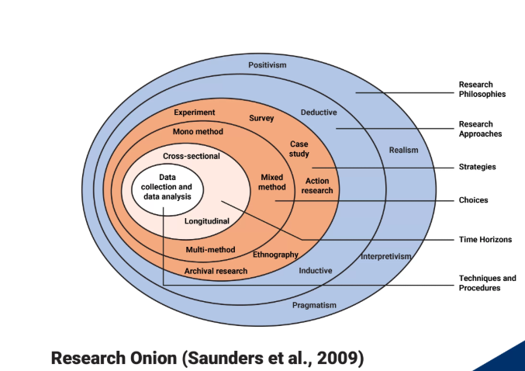
The Research Onion contains six layers to outline how the research data is collected. These are.
Philosophies: The selected philosophy for use in this research is interpretive.
Approaches: The selected Approach is Inductive.
Strategies: The selected strategy is a survey.
Choices: Mixed methods approach utilising both qualitative and Quantitative research.
Time Horizons: Cross-sectional time horizon
Techniques and procedures: I will outline in this Methodology chapter the techniques and procedures used in the collection of data.

Another method used in the collection of data will be used as part of my primary research collection: the use of the Likert scale. The Likert scale is typically used as a tool to collect data as part of a survey to measure opinions, beliefs, perceptions, and attitudes about a particular topic. (Williams, T. 2023)
Participants and sample size
To achieve the desired Qualitative and Quantitative research outcomes, I have carefully selected a considered approach to selecting participants to take part in the research study. To be able to provide a worthwhile response to the questions raised in the survey, I have only opened up the survey to currently serving or previously serving front-line police constables and higher ranks with at least some front-line service in their careers. This was chosen because the participants must have at some point worked both independently and whilst being crewed as part of a double-crewed unit, so they have an understanding of the topic and can provide a real insight into their experiences and give their opinions accordingly. The sample size of this study was aimed at achieving 50 participants. The reason at least 50 participants were requested is to ensure there was enough variety of participants, diversity of participants, as well as the difference in experience levels and ranks. This amount has been exceeded, with a total of 55 participants providing their answers and feedback.
Data collection methods
A survey was created through the use of Microsoft Forms, an openly accessible software available online, and a link was created and published on ‘the Beat’, which is the Gwent Police intranet system where access is freely gained by police officers and staff. This survey was completely optional and anonymous. This was used for the Qualitative portion of the research. To collect the Quantitative portion of the research, the majority of existing studies were sourced via the internet using search engines such as Google and Google Scholar, to ensure the validity and reliability of sources quoted. I also sent messages via Teams messenger to groups of employees directly to request their participation.
Data analysis
The data obtained has been collated and examined through the existing software of Microsoft Forms, which provides circular graphs to give a clear indication of the results obtained for easy manual analysis.
Ethical considerations
To ensure the data was collected ethically, I had obtained Ethical approval before the commencement of the research activity by outlining the methods to be used, the target audience, compliance with data protection regulations and legislation, the control measures used to ensure safety of data and I ensured that I obtained informed consent from all participants before completion of the survey. This was achieved by an opening statement both before clicking the link and accessing the survey itself, and by a confirmation message at the very start of the survey detailing an anonymity clause, that participation was voluntary, and withdrawal can be achieved at any time by closing the survey before completion.
Validity and reliability
To ensure the reliability and validity of data obtained, I have retained copies of screenshots of the original questionnaire, the posting location, and associated messages. The only people who can access the survey and complete it are employees of Gwent Police; therefore, any intrusion would not be possible, ensuring the target audience is achieved and therefore the reliability of those involved is not refuted.
Limitations
There are some limitations to the collection of data achieved through the use of the survey method outlined above. The intranet service is openly accessible, and there is a message box on the right-hand side that is viewed upon accessing the site. This is, however, a busy area, and the request for survey completion would not have been at the top of the screen for very long, thus reducing the visibility and reducing the number of viewers and potentially reducing the sample size and reducing the opportunity for a more broadened participant study.

Chapter 4 – Analysis of results

Introduction
The previous chapter of this research project set out the methodology for the collection of primary data as part of the primary research data collection for this dissertation. The chosen method was the use of a survey, which was posted on the Gwent Police intranet and Teams chats over the course of two weeks between 4th June 2025 and 18th June 2025. In total, 55 responses were received, and the collection of data will be analysed in this chapter. The data will be presented in the form of multiple-choice questions, including Likert scale (Williams, T. 2023) questions and free-text comments. The data collected (George, C. 2025) aims to achieve a better understanding of the topic of double crewing and the opinions of colleagues and peers in the Gwent Police Service to answer the question ‘Should officers be double crewed at all times? The nature of the data collection is Qualitative data. The respondents were asked to consent to taking part in the survey and complete a short demographic questionnaire before continuing onto the main data collection points for analysis. The results are as follows:

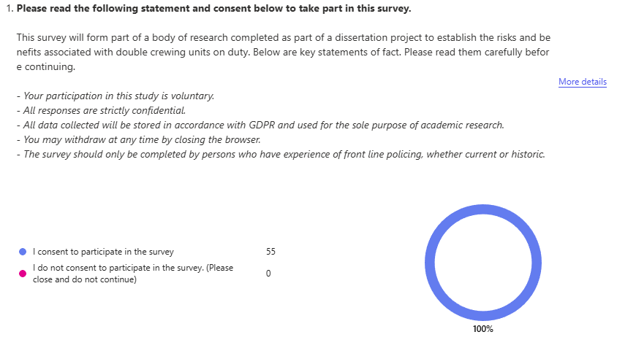
The first figure provided a statement of fact relating to the survey and ensured the sample participants fully understood the anonymity clause and ethical considerations of the survey. All participants were therefore aware that they could withdraw at any time and not choose to proceed. 100% of participants gave their consent to proceed with the survey.

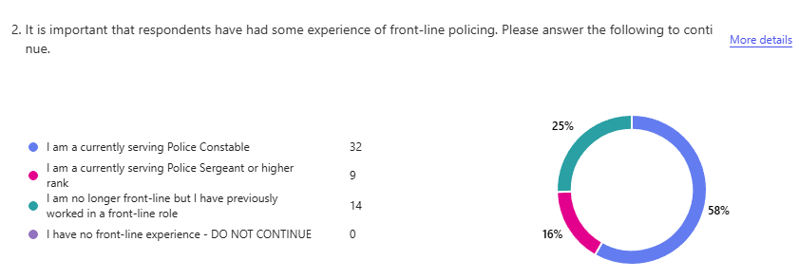
Participants were asked about their current rank and experience within the police. This was to confirm that every participant had some form of front-line policing experience to ensure the accuracy of data collected and value. The vast majority of respondents were currently serving as constables.

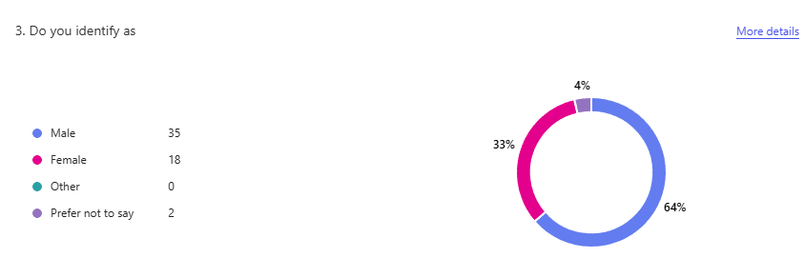
The next section asked respondents to provide their gender and age to gather further demographic information.

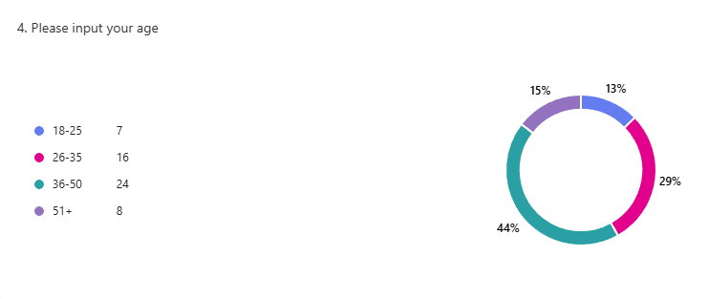

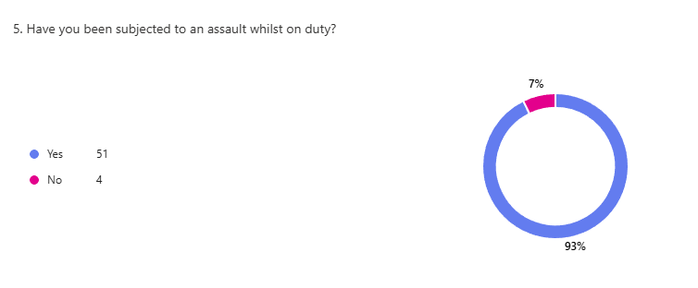
Somewhat unsurprisingly, the next question produced an expected result when asking the question “Have you been assaulted whilst on duty?” A staggering 93% of respondents returned a yes, stating they had been assaulted on duty during their careers.
The next question, “What was your crewing status at the time?” aimed to evidence whether or not officers were more likely to be assaulted when they were single crewed or double crewed. Initially, the expected outcome was that more officers would be assaulted as a single crewed unit, however the results returned that more of the respondents were actually assaulted when they were in a double crewed setting with 51% of respondents stating they were double crewed when they were assaulted on duty compared to 49% who were single crewed at the time.
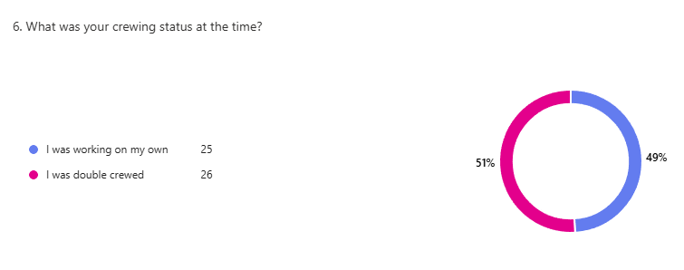
Despite the above statistic received with the majority of respondents being assaulted whilst being double crewed when they were assaulted on duty, the next question related to the attitude of officers and their feelings of safety when double crewed. The findings were surprising in that 86% of respondents strongly agreed with the statement “I feel safer on duty when double crewed.”, despite being assaulted when in this paired crewing status. This may be evidence that even though the likelihood of being assaulted may not be affected by the crewing status, the feeling of safety working with another officer to have your back at calls is more important than the likelihood of actually being assaulted.

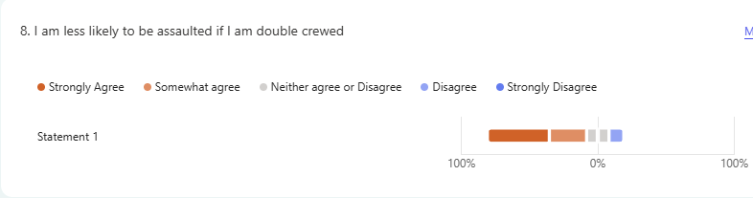
To further support this argument, the next question asked was another Likert scale statement: ‘I am less likely to be assaulted if I am double crewed.’ Again, the result of this is somewhat surprising when compared to the respondents' assault responses, with 45.5% of respondents strongly agreeing that they are less likely to be assaulted if they were double crewed.

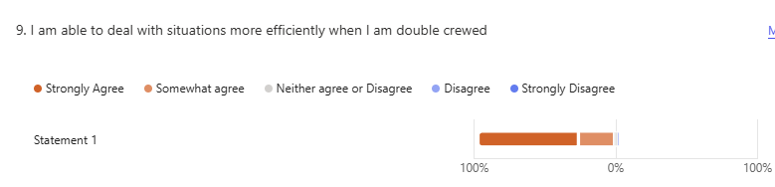
Another key question when considering whether it is best to be single or double crewed is that of efficiency at calls. When asked, 70.9% of respondents strongly agreed, and 25.5% of respondents somewhat agreed that being double crewed meant they were more efficient at calls.

As part of this dissertation study, it was also important to consider how officers felt about double crewing when considering utilising the National Decision Model (NDM) and whether they felt it was important to have another officer with them when decision-making at calls. 53.7% of respondents strongly agreed that they preferred to have a second officer at a call to better utilise the NDM, 29.6% agreed, 9.3% neither agreed nor disagreed, and the remaining 7.4% disagreed.
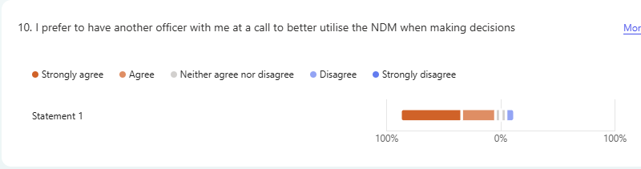
Respondents were also asked if, in contrast to the above, they preferred making decisions on their own and felt that others’ input might hinder the decision-making process. The results of this question were more mixed, with 11.1% strongly agreeing, 14.8% agreeing, 25.9% neither agreeing nor disagreeing, 35.2% disagreeing, and the remaining 13% strongly disagreeing.
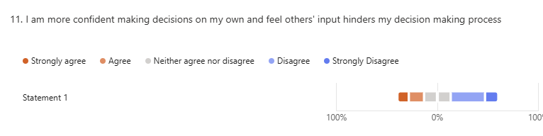
Finally, respondents were encouraged to use the final part of the survey to leave any additional comments they felt would assist in the research study. 13 respondents chose to write a short statement as follows.
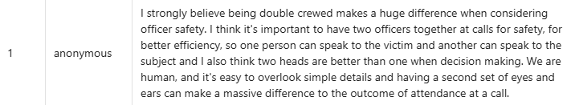
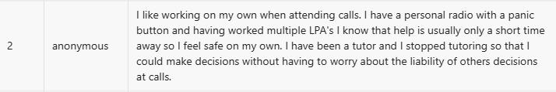
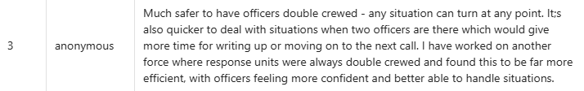




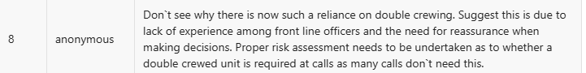
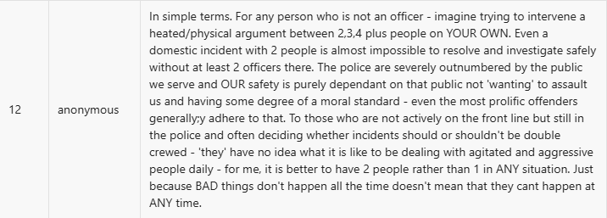


Result of findings:
By reviewing the Qualitative responses outlined above it is clear that officers have strong opinions about whether or not officers should be double crewed at all times when on duty in the UK, with the majority of respondents indicating that they are less likely to be assaulted, more efficient, able to better use the NDM to make decisions at incidents and calls as well as providing invaluable insights into their views and experiences which are all varied and considered. It is however clear, that despite feeling safer and better equipped to deal with situations from a safety and efficiency perspective, the overarching finding, question 6 where respondents indicated that more of them were assault while being double crewed does not support that the opinions and other statements of the benefits of being double crewed translate into a reduction in the likelihood of assault whilst on duty.

Conclusion:
This chapter of the research project set out to obtain insights into the opinions of serving and ex-serving police constables and higher ranks in relation to questions surrounding the research topic. The results were mixed and somewhat contradictory. This indicates that the answer to the question of double crewing is not as simple as it may seem and requires further in-depth analysis and research. The next chapter of the dissertation will seek to provide recommendations and answer the question: Should police officers be double crewed at all times?

Chapter 4 – Findings and Recommendations

This research project aimed to identify key themes surrounding the topic of double-crewing in the context of policing in the UK to answer the question, “Should officers be double-crewed at all times?” Based on the Qualitative and Quantitative analysis outlined in the research project above, it can be concluded that while there are benefits to operational efficiency and, in certain situations, benefits to officer safety, the results indicate that officers are not always more likely to be subjected to assault on duty when single crewed. The research examined critical aspects of modern-day policing in the United Kingdom by focusing on the practice of double-crewing and its effects on officer safety, decision-making, and public accountability. The research project has highlighted that, though traditionally the practice of double-crewing was used as a safety measure, to keep officers safe and enhance confidence when dealing with high-risk, complex, and challenging situations during their duties. The research conducted as part of this dissertation has highlighted, however, the necessity for the practice of double-crewing is undermined in light of advancing technology, community engagement strategies and policy implementations, and shifts in policing philosophies and attitudes that facilitate better single-crewing models.

One of the key findings relates to decision-making and the role that confidence plays. Research indicates that officers of all abilities and experience levels have a tendency to prefer to be double crewed for the benefits of having a second person to share the decision-making process with and to apply the NDM better. Officers with less experience often lack the experience needed to be able to make effective and timely decisions in high-pressure situations, which officers commonly encounter daily, thus being a requirement for effective policing and potentially at a detriment to both their safety and the effectiveness of their response.

Having less experience means newer officers frequently rely on more experienced officers for guidance, which increases the necessity for double crewing; conversely, however, this can lead to situations where decisions are made on peer influence rather than on established best practices as learnt through the training given as part of the onboarding process as a new constable. More experienced officers may not have received updated training or guidance on how to better deal with situations and by crewing more experienced officers with new officers this can lead to the dilution of training given, in favour of more tried and tested methods of dealing with incidents that may not be as functional as they used to be.

This issue raised by the research completed as part of this dissertation topic concludes that while the presence of an experienced officer in a double-crewed setting may provide a sense of security, reassurance and safety for the newer officer, it can often lead to the inhabitation of decision-making development and thus reducing the opportunity for autonomy going forward, and increasing the necessity for the officer to be more frequently double-crewed.

The significance of the financial and cost implications of double-crewing cannot be understated either, and the findings have emphasised that the effects of Austerity measures introduced years ago are still having an impact on policing, the need for forces to implement policies that support single-crewing to improve efficiency and reduce reliance on double-crewing. The budget restraints have impacted essential services, leading to officers being more stressed, with higher workloads and dealing with more mental health and socio-economic incidents, where other agencies would be better suited to dealing with them. These fiscal constraints have led to a rise in the use of technology to support intelligence-led proactive policing, which is supplementary to and sometimes replaces the traditional method of response policing and responding to incidents as they happen, as the evidence shows that targeted action based on crime data can assist forces in optimizing the use of and allocation of resources, lowering the need for double-crewing.

Even though double crewing has traditionally been linked to increased officer safety, the circumstances of contemporary police demand that its applicability be re-examined. A move towards more adaptable, intelligence-led policing tactics may produce better results given the implications of financial limitations, technological breakthroughs, and the demand for decisive and independent policing as a result of Austerity measures and the introduction of a much newer, less experienced workforce.

The research also produced invaluable opinions from officers as part of the Qualitative research obtained as part of the research conducted to fill the gaps in the literature and knowledge, as well as raise additional topics to further inform decision-making around double crewing practices and policies.

As a result of these findings, my initial recommendation raises the question: Are Police forces and organisational leaders able to effectively risk-assess incidents to ensure officer safety and manage the needs and expectations of the public efficiently by allocating the correct resources to ensure optimal results? And the need for future research into this topic. The research outlined in this dissertation has explored the correlations between single and double crewed resourcing in the contexts of officer safety, efficiency, and decision-making.

The second recommendation I make following concluding my research would be consideration for further research into ranking officers and individual responsible for the implementation of resourcing and allocation of officers whether single or double crewed, and whether or not they are too detached from front-line policing having progressed onto higher ranking roles and whether or not they are out of touch with modern policing to be able to make accurate evaluations of policing contexts, crime analytics and changes since they stopped working on the front line. This would bolster research into the ability of forces to make determinations to better safeguard officers and improve efficiency.

Another recommendation would be the exploration of how double-crewing affects the likelihood of and outcomes of complaints against officers. According to a report by the IOPCC in the year 2023-2024, there were 85,458 complaints made against officers. (IOPCC, 2025) A comparison of the crewing status of these complaints would highlight areas of further research to provide context and further information to support whether single or double crewing is a better option going forward.

Finally, a further topic for further research would be the impact of morale and mental health considerations for officers on the front line dealing with traumatic incidents and ever-increasing demand and workload stresses. This body of research identified that there are arguments for and against double crewing in the context of efficiency. By focusing future research on the impact of morale and mental health, this will add further weight to the argument.

Chapter 5 – Bibliography

Allsop, C. (2013). Motivations, money and modern policing: accounting for cold case reviews in an age of austerity. Policing & Society, 23(3), 362-375. https://doi.org/10.1080/10439463.2013.782211

Ariel, B., Lawes, D., Weinborn, C., Henry, R., Chen, K., & Sabo, H. (2018). The “less-than-lethal weapons effect”—introducing tasers to routine police operations in england and wales: a randomized controlled trial. Criminal Justice and Behavior, 46(2), 280-300. https://doi.org/10.1177/0093854818812918

Ghaffari, N. (2023). Surveillance and resistance: police use of technology and activist mobilization in the san francisco bay area. Berkeley Undergraduate Journal, 37(1). https://doi.org/10.5070/b337162076

Hassan, M. (2023). Purpose of Research - Objectives and Applications. [online] Research Method. Available at: https://researchmethod.net/purpose-of-research/#google_vignette.

Houdmont, J., Elliott-Davies, M., & Donnelly, J. (2018). Single crewing in english and welsh policing: frequency and associations with violence towards and injuries in officers. Policing & Society, 29(7), 820-833. https://doi.org/10.1080/10439463.2017.1417990

IOPC (2023). Police complaints Statistics for England and Wales (plain text format) - 2023/24 | Independent Office for Police Conduct (IOPC). [online] Policeconduct.gov.uk. Available at: https://www.policeconduct.gov.uk/publications/police-complaints-statistics-england-and-wales-202324-plain-text.

Leahy, D., Pepper, I., & Light, P. (2020). Recruiting police support volunteers for their professional knowledge and skills: a pilot study. The Police Journal Theory Practice and Principles, 94(3), 282-297. https://doi.org/10.1177/0032258x20914676

Miranda, D. (2021). Body-worn cameras ‘on the move’: exploring the contextual, technical and ethical challenges in policing practice. Policing & Society, 32(1), 18-34. https://doi.org/10.1080/10439463.2021.1879074

NPCC (2025). Police Uplift Programme. [online] Police.uk. Available at: https://www.npcc.police.uk/our-work/police-uplift-programme/.

Phair, D. and Warren, K. (2021). Saunders’ Research Onion: Explained Simply. [online] Grad Coach. Available at: https://gradcoach.com/saunders-research-onion/.

Phillips, S. (2016). Police discretion and boredom. Journal of Contemporary Ethnography, 45(5), 580-601. https://doi.org/10.1177/0891241615587385

Police Federation (2024). ‘Appalling’ Number Of Assaults On Police Officers. [online] www.polfed.org. Available at: https://www.polfed.org/dorset/news/2024/appalling-number-of-assaults-on-police-officers/.

Police Federation (2024). ‘Appalling’ Number Of Assaults On Police Officers. [online] www.polfed.org. Available at: https://www.polfed.org/dorset/news/2024/appalling-number-of-assaults-on-police-officers/.

Police Officer Salaries (2025) Glassdoor.co.uk. Available at: https://www.glassdoor.co.uk/Salaries/police-officer-salary-SRCH_KO0,14.htm.

Priyanto, E. and Wening, N. (2024). The influence of dominant leadership and group cohesiveness on groupthink phenomenon in the decision-making process: a systematic literature review. Eduvest - Journal of Universal Studies, 4(6), 4766-4784. https://doi.org/10.59188/eduvest.v4i6.1201

Shortland, N., Thompson, L., & Alison, L. (2020). Police perfection: examining the effect of trait maximization on police decision-making. Frontiers in Psychology, 11. https://doi.org/10.3389/fpsyg.2020.01817

Simpson, R. and Grossman, L. (2025). An examination of calls for service handled by single- versus double-crewed patrol units in oakland, california. APB, 1(1), 52-54. https://doi.org/10.22215/apb.v1i1.5235

Taylor, B., Koper, C., & Woods, D. (2010). A randomized controlled trial of different policing strategies at hot spots of violent crime. Journal of Experimental Criminology, 7(2), 149-181. https://doi.org/10.1007/s11292-010-9120-6

Taylor, L. (2024). Primary vs Secondary Research – What’s The Difference? [online] Journal Publisher Blog. Available at: https://www.journalpublisher.co.uk/blog/primary-vs-secondary-research/.

Topping, J. (2021). Austerity, path dependency and the (re)configuration of policing. Policing & Society, 32(6), 715-730. https://doi.org/10.1080/10439463.2021.1965142

Vladev, L. (2025). Cwmbran: Man jailed for violent attack on police officer. BBC News. [online] 1 Apr. Available at: https://www.bbc.co.uk/news/articles/ckg5vy7jxwwo.

Williams, T. (2023). Likert Scale 101: Everything You Need to Know (With Examples). [online] dovetail.com. Available at: https://dovetail.com/surveys/likert-scale/.

Chapter 6 - Appendix



UNDERGRADUATE DISSERTATION
RESEARCH PROPOSAL FORM

Please complete the following research proposal and submit it to Turnitin.

Which project option are you taking? Please tick:

8,000-word project

NAME: Christopher George | STUDENT ID No.: 2222767

DRAFT RESEARCH TITLE QUESTION: An investigation into Double crewing in policing in the United Kingdom – Should officers always be double crewed when on duty?

INTRODUCTION:

The role of a Police Constable in the UK is one that carries the need for critical thinking in stressful, fast-paced moments where an officer’s decision making can mean the difference between life and death for not only the public they serve, but also for themselves and their colleagues. As a standard in my Police force, Police officers routinely patrol and answer emergency calls as a single unit. In this dissertation, I will conduct research and consider whether police constables in the UK should be routinely double crewed. I will consider officer safety, critical thinking, training and efficiency when researching this topic.

There has been some research into the effectiveness of double crewed units in comparison to single crewed officers which I have discovered in my initial research of the topic, however the vast majority of the research I have found tends to focus on the ability of the officer(s) to manage conflict and focuses on violence and injuries, rather than the effectiveness of double crewing, comparing considerations around decision making processes and the value of having two persons working together to utilise the national decision making process and how effective or how detrimental having two conflicting, or supporting opinions can be to the service provided by police services in the UK.

By completing this research, I hope to identify areas to support or contradict the argument for double crewing within the police to support police forces' decision-making process when deciding how best to allocate units to incidents going forward. I believe this research will contribute a great deal to considerations for force policies going forward, while filling in the gap of research currently present in this topic of discussion.

SUMMARY OF RESEARCH OBJECTIVES:

- To identify key advantages or drawbacks of officers being double or single crewed
- To establish the perception of the public when being dealt with by either one or two officers during their interactions.
- To gain insight into the decision-making processes and how it may be affected by the addition of a second officer if double crewed rather than single crewed, and the confidence of the officer(s) to make decisions when attending incidents

LITERATURE REVIEW:

There are some bodies of research I have been able to locate that explore the benefits of double-crewed officers whilst conducting their roles, however, there isn’t enough research available in comparison with other research topics. I aim to increase the research available to be able to produce a body of work that may help to gain a better insight into the benefits of double crewing at all times.

SUMMARY OF RESEARCH –SURVEY METHOD:

I am going to utilise several research methods when completing my dissertation, including online research. The internet provides easy access to published articles, previous research by other academic students, professional reports, and insights as part of my quantitative and qualitative research methods.

Library – previous publications and books can also provide excellent materials to bolster my understanding of the topic to better understand what research has been done previously, what gaps are present in the current research available, and where best to concentrate my efforts.

Questionnaires – Asking serving and retired police constables, sergeants, and other ranks questions to better understand how front-line and back office to draw on their experiences during their careers. I will also use this primary source of research to identify further areas of study to bolster my research.

Internet research – I will utilise search engines such as Google to find existing studies, bodies of research, articles, and forums where topics exploring double crewing have already been published, explore the existing research, and locate gaps in the literature to identify worthwhile topics for further exploration to bolster my research.

UWTSD MOODLE library – I will explore the available literature offered on the University of Wales Trinity Saint David’s page to explore existing publications.

SUMMARY OF SAMPLING FRAMEWORK:

I will be mainly looking to speak to serving officers in relation to their experiences attending calls while being double crewed as well as single crewed. Many officers who are employed at Gwent Police are transferees from other police forces who have experienced other forces’ policies where double crewing is concerned and have come from areas where the demographic of the population, crime rates, and experiences will be different.

ETHICAL ISSUES:
When considering ethical issues in conducting this research, I do not believe that there will be any ethical issues that may come to light. All participants will either be serving or ex-police officers and staff. I do, however, understand that the topics explored may be challenging and triggering to some, including officers who have been victims of violent attacks during the course of their duties. I will take this into consideration when approaching these topics and take into account whether the participant has been subjected to a particularly violent assault whilst on duty.

TIME SCALE:

I anticipate this research project will last for around six months.
REFERENCE LIST:
Reference List
Blake, L. (2001) “The impact of single and two-officer patrols on catching burglars in the act: A critique of the audit commission’s reports on youth justice,” The British journal of criminology, 41(2), pp. 381–396. Available at: https://doi.org/10.1093/bjc/41.2.381.

Houdmont, J., Elliott-Davies, M. and Donnelly, J. (2019) “Single crewing in English and Welsh policing: frequency and associations with violence towards and injuries in officers,” Policing & society, 29(7), pp. 820–833. Available at: https://doi.org/10.1080/10439463.2017.1417990.

Officers should be double crewed when attending violent incidents (2022) Sypfcopperconnection.co.uk. Available at: https://sypfcopperconnection.co.uk/?p=312810 (Accessed: November 3, 2024).

Simpson, R. and Grossman, L. (2024) “Patrol officer activity by single- versus double-crewed status: The call-related output of one-officer and two-officer patrol units,” Journal of criminal justice, 94(102248), p. 102248. Available at: https://doi.org/10.1016/j.jcrimjus.2024.102248.

Wiggett, I. (2021) The evidence on double crewing in response policing: It’s more productive and it’s safer, Policing Insight. Available at: https://policinginsight.com/feature/analysis/the-evidence-on-double-crewing-in-response-policing-its-more-productive-and-its-safer/ (Accessed: November 3, 2024).

APPLICATION FOR ETHICAL APPROVAL

RESEARCH STUDENTS
This form is to be completed by the student within SIX months for full-time students and TWELVE months for part time students, after the commencement of the research degree or following progression to Part Two of your course.

Once complete, submit this form via the MyTSD Doctoral College Portal at (https://mytsd.uwtsd.ac.uk).

This document is also available in Welsh.

RESEARCH STAFF ONLY
All communications relating to this application during its processing must be in writing and emailed to pgresearch@uwtsd.ac.uk , with the title ‘Ethical Approval’ followed by your name.

STUDENTS ON UNDERGRADUATE OR TAUGHT MASTERS PROGRAMMES should submit this form (and receive the outcome) via systems explained to you by the supervisor/module leader.

In order for research to result in benefit and minimise risk of harm, it must be conducted ethically. A researcher may not be covered by the University’s insurance if ethical approval has not been obtained prior to commencement.

The University follows the OECD Frascati manual definition of research activity: “creative work undertaken on a systematic basis in order to increase the stock of knowledge, including knowledge of man, culture and society, and the use of this stock of knowledge to devise new applications”. As such this covers activities undertaken by members of staff, postgraduate research students, and both taught postgraduate and undergraduate students working on dissertations/projects.

The individual undertaking the research activity is known as the “principal researcher”.

Ethical approval is not required for routine audits, performance reviews, quality assurance studies, testing within normal educational requirements, and literary or artistic criticism.

Please read the notes for guidance before completing ALL sections of the form.

This form must be completed and approved prior to undertaking any research activity. Please see Checklist for details of process for different categories of application.

SECTION A: About You (Principal Researcher)
1 | Full Name: |  | Christopher George
2 | Tick all boxes that apply: |  | Member of staff: | ☐ | Honorary research fellow: | ☐
 | Undergraduate Student | ☒ | Taught Postgraduate Student | ☐ | Postgraduate Research Student | ☐

3 | Institute/Academic Discipline/Centre: | University of South Wales Trinity Saint David
4 | Campus: | Swansea
5 | E-mail address: | 2222767@student.uwtsd.ac.uk
6 | Contact Telephone Number: | 07534160424
 | For students:
7 | Student Number: | 2222767
8 | Programme of Study: | Bachelor of science Professional Policing Practice
9 | Director of Studies/Supervisor: | Jane Davies

SECTION B: Approval for Research Activity
1 | Has the research activity received approval in principle?  (please check the Guidance Notes as to the appropriate approval process for different levels of research by different categories of individual) |  | YES | ☐ | NO | ☐
 |  |  |  |  | Date
2 | If Yes, please indicate source of approval (and date where known): Approval in principle must be obtained from the relevant source prior to seeking ethical approval | Research Degrees Committee |  | ☐
2 |  | Institute Research Committee |  | ☐
2 |  | Other (write in) |  | ☐

SECTION C: Internal and External Ethical Guidance Materials
 | Please list the core ethical guidance documents that have been referred to during the completion of this form (including any discipline-specific codes of research ethics, location-specific codes of research ethics, and also any specific ethical guidance relating to the proposed methodology). Please tick to confirm that your research proposal adheres to these codes and guidelines. You may add rows to this table if needed.
1 | UWTSD Research Ethics & Integrity Code of Practice | ☒
2 | UWTSD Research Data Management Policy | ☒
3 | [List any other relevant documents here] | ☐

SECTION D: External Collaborative Research Activity
If there are external collaborators then you should gain consent from the contact persons to share their personal data with the university. If there are no external collaborators then leave this section blank and continue to section E.
1 | Institution
2 | Contact person name
3 | Contact person e-mail address
4 | Is your research externally funded? |  | YES | ☐ | NO |  | ☐
5 | Are you in receipt of a KESS scholarship? |  | YES | ☐ | NO |  | ☐
6 | Are you specifically employed to undertake this research in either a paid or voluntary capacity? | Voluntary | YES | ☐ | NO | ☐
7 |  | Employed | YES | ☐ | NO | ☐
8 | Is the research being undertaken within an existing UWTSD Athrofa Professional Learning Partnership (APLP)? | If YES then the permission question below does not need to be answered. | YES | ☐ | NO |  | ☐
9 | Has permission to undertake the research has been provided by the partner organisation? | (If YES attach copy)  If NO the application cannot continue | YES | ☐ | NO |  | ☐

Where research activity is carried out in collaboration with an external organisation
10 | Does this organisation have its own ethics approval system? | YES | ☐ | NO | ☐
 | If Yes, please attach a copy of any final approval (or interim approval) from the organisation (this may be a copy of an email if appropriate).

SECTION E: Details of Research Activity
1 | Indicative title: | Should Police officers be double-crewed at all times?
2 | Proposed start date: | TBC | Proposed end date: | TBC
Introduction to the Research (maximum 300 words per section)
Ensure that you write for a Non-Specialist Audience when outlining your response to the points below:
- Purpose of Research Activity
- Proposed Research Question
- Aims of Research Activity
- Objectives of Research Activity
Demonstrate, briefly, how Existing Research has informed the proposed activity and explain
- What the research activity will add to the body of knowledge
- How it addresses an area of importance.
3 | Purpose of Research Activity  The purpose of the Research Activity is to identify gaps in knowledge surrounding the research topic and using this create an appropriate Qualitative and Quantitative body of research to fill the gaps in knowledge, and identify recommendations for future research.  (this box should expand as you type)
4 | Research Question  Should police officers be double crewed at all times whilst on duty?  (this box should expand as you type)
5 | Aims of Research Activity  The aim of the research activity is to establish and explore the existing literature publicly available on the topic of double crewing, its benefits and drawbacks when considering several factors such as officer safety, efficiency, utilisation of the National Decision Model as well as any other topics that come to light during the course of the research. I will also aim to explore the opinions and experiences of serving and retired constables and higher rank employees, as well as those of staff and community support officers. The aim of this is to better understand the risks and challenges faced by frontline staff, and to better understand how to provide a more effective, efficient, and safe service to the public we serve.  (this box should expand as you type)
6 | Objectives of Research Activity  - To investigate and analyse literature currently available using appropriate and evaluated sources to understand key themes surrounding the topic of double crewing.  - To identify and select an appropriate and considered approach to the research and fully understand the subject of double crewing.  - To obtain further information through the use of first hand research and analyse the collected data to gain an insight into the opinions and experiences of currently serving and ex-serving officers with invaluable experience to better understand the topic of double crewing.  - To provide recommendations to support further areas of study and research to further improve understanding on the research topic.  (this box should expand as you type)
Proposed methods (maximum 600 words)
Provide a brief summary of all the methods that may be used in the research activity, making it clear what specific techniques may be used. If methods other than those listed in this section are deemed appropriate later, additional ethical approval for those methods will be needed. You do not need to justify the methods here but should instead describe how you intend to collect the data necessary for you to complete your project.
7 | The proposed method used in the research activity is the use of Microsoft Forms to create a survey to collect quantitative and qualitative information used to gain insights into the research topic question and form the basis and fill gaps in the research. I will be following the research onion method in gathering this information and its analysis.  (this box should expand as you type)
Location of research activity
Identify all locations where research activity will take place.
8 | I will conduct this research activity predominantly by using questionaries which are accessible to all staff with access to the Gwent Police intranet page, the beat. This will give users a clear option whether to take part or whether to decline to take part in the research activity.  At police stations in the Gwent Police force area – Gwent Police has over 10 police stations for frontline staff. I will look to visit a number of these and ask officers directly to take part.  Via the telephone – I will contact serving, and ex police staff and constables who I have known personally for some time to request they take part in the research activity.  (this box should expand as you type)
Research activity outside of the UK
If research activity will take place overseas, you are responsible for ensuring that local ethical considerations are complied with and that the relevant permissions are sought. Specify any local guidelines (e.g. from local professional associations/learned societies/universities) that exist and whether these involve any ethical stipulations beyond those usual in the UK (provide details of any licenses or permissions required). Also specify whether there are any specific ethical issues raised by the local context in which the research activity is taking place, for example, particular cultural and/or legal sensitivities or vulnerabilities of participants. If you live in the country where you will do the research then please state this.
9 | None  (this box should expand as you type)

10 | Use of documentation not in the public domain: Are any documents NOT publicly available? | NO | ☒
10 |  | YES | ☐
11 | If Yes, please provide details here of how you will gain access to specific documentation that is not in the public domain and that this is in accordance with the current data protection law of the country in question and that of England and Wales.  (this box should expand as you type)

 | Does your research relate to one or more of the seven aims of the Well-being of Future Generations (Wales) Act 2015? | YES | NO
12 | A prosperous Wales | ☐ | ☒
13 | A resilient Wales | ☐ | ☒
14 | A healthier Wales | ☐ | ☒
15 | A more equal Wales | ☐ | ☒
16 | A Wales of cohesive communities | ☐ | ☒
17 | A Wales of vibrant culture and thriving Welsh language | ☐ | ☒
18 | A globally responsible Wales | ☐ | ☒
19 | If YES to any of the above, please give details:
 | (this box should expand as you type)

SECTION F: Scope of Research Activity
 | Will the research activity include: | YES | NO
1 | Use of a questionnaire or similar research instrument? | ☒ | ☐
2 | Use of interviews? | ☒ | ☐
3 | Use of focus groups? | ☐ | ☒
4 | Use of participant diaries? | ☐ | ☒
5 | Use of video or audio recording? | ☐ | ☒
6 | Use of computer-generated log files? | ☐ | ☒
7 | Participant observation with their knowledge? | ☐ | ☒
8 | Participant observation without their knowledge? | ☐ | ☒
9 | Access to personal or confidential information without the participants’ specific consent? | ☐ | ☒
10 | Administration of any questions, test stimuli, presentation that may be experienced as physically, mentally or emotionally harmful / offensive? | ☒ | ☐
11 | Performance of any acts which may cause embarrassment or affect self-esteem? | ☐ | ☒
12 | Investigation of participants involved in illegal activities? | ☐ | ☒
13 | Use of procedures that involve deception? | ☐ | ☒
14 | Administration of any substance, agent or placebo? | ☐ | ☒
15 | Working with live vertebrate animals? | ☐ | ☒
16 | Procedures that may have a negative impact on the environment? | ☐ | ☒
17 | Other primary data collection methods. Please indicate the type of data collection method(s) below. | ☐ | ☒
 | Details of any other primary data collection method:  (this box should expand as you type) | ☐ | ☒
If NO to every question, then the research activity is (ethically) low risk and may be exempt from some of the following sections (please refer to Guidance Notes).

If YES to any question, then no research activity should be undertaken until full ethical approval has been obtained.

SECTION G: Intended Participants
If there are no participants then do not complete this section, but go directly to section H.

 | Who are the intended participants: | YES | NO
1 | Students or staff at the University? | ☐ | ☒
2 | Adults (over the age of 18 and competent to give consent)? | ☒ | ☐
3 | Vulnerable adults? | ☐ | ☒
4 | Children and Young People under the age of 18? (Consent from Parent, Carer or Guardian will be required) | ☐ | ☒
5 | Prisoners? | ☐ | ☒
6 | Young offenders? | ☐ | ☒
7 | Those who could be considered to have a particularly dependent relationship with the investigator or a gatekeeper? | ☐ | ☒
8 | People engaged in illegal activities? | ☐ | ☒
9 | Others. Please indicate the participants below, and specifically any group who may be unable to give consent. | ☐ | ☒
 | Details of any other participant groups:  (this box should expand as you type) | ☐ | ☒

Participant numbers and source
Provide an estimate of the expected number of participants. How will you identify participants and how will they be recruited?
10 | How many participants are expected? | 10-20  (this box should expand as you type)
11 | Who will the participants be? | Police Officers  Police staff  Community support officers  (this box should expand as you type)
12 | How will you identify the participants? | Voluntary participants who access the police intranet page and select to take part in the study  Serving police staff at police stations  Serving police officers at police stations  Serving police community support officers at police stations  Retired and ex-serving staff, community support and police officeres  (this box should expand as you type)

 | Information for participants: | YES | NO | N/A
13 | Will you describe the main research procedures to participants in advance, so that they are informed about what to expect? | ☒ | ☐ | ☐
14 | Will you tell participants that their participation is voluntary? | ☒ | ☐ | ☐
15 | Will you obtain written consent for participation? | ☐ | ☒ | ☐
16 | Will you explain to participants that refusal to participate in the research will not affect their treatment or education (if relevant)? | ☐ | ☐ | ☒
17 | If the research is observational, will you ask participants for their consent to being observed? | ☐ | ☐ | ☒
18 | Will you tell participants that they may withdraw from the research at any time and for any reason? | ☒ | ☐ | ☐
19 | With questionnaires, will you give participants the option of omitting questions they do not want to answer? | ☒ | ☐ | ☐
20 | Will you tell participants that their data will be treated with full confidentiality and that, if published, it will not be identifiable as theirs? | ☒ | ☐ | ☐
21 | Will you debrief participants at the end of their participation, in a way appropriate to the type of research undertaken? | ☒ | ☐ | ☐
22 | If NO to any of above questions, please give an explanation
I will include a declaration at the start of the questionnaire with words to the effect of “By completing this questionnaire you are providing your consent to participate in this research. This is voluntary, you are not required to complete any questions you are not comfortable completing and you may exit without submitting at any time. Only fully completed questionnaires will be added to the research findings.”

(this box should expand as you type)

 | Information for participants: | YES | NO | N/A
24 | Will participants be paid? | ☐ | ☒ | ☐
25 | Is specialist electrical or other equipment to be used with participants? | ☐ | ☒ | ☐
26 | Are there any financial or other interests to the investigator or University arising from this study? | ☐ | ☒ | ☐
27 | Will the research activity involve deliberately misleading participants in any way, or the partial or full concealment of the specific study aims? | ☐ | ☒ | ☐
28 | If YES to any question, please provide full details
 | (this box should expand as you type)

SECTION H: Anticipated Risks

Outline any anticipated risks that may adversely affect any of the participants, the researchers and/or the University, and the steps that will be taken to address them.

If you have completed a full risk assessment (for example as required by a laboratory, or external research collaborator) you may append that to this form.
1 | Full risk assessment completed and appended? |  | Yes | ☐
1 |  |  | No | ☒
2 | Risks to participants  For example: sector-specific health & safety, emotional distress, financial disclosure, physical harm, transfer of personal data, sensitive organisational information
 | Risk to participants:  Transfer of personal data,  Sensitive organisational information  (this box should expand as you type) | How you will mitigate the risk to participants:  Outlining to all participants that completion of the questionnaire is voluntary and not all questions are mandatory. Consider the proportionality and necessity of all questions considered and the level of detail required and consider whether or not this may lead to sensitive information being accessed/given.  (this box should expand as you type)
3 | If research activity may include sensitive, embarrassing or upsetting topics (e.g. sexual activity, drug use) or issues likely to disclose information requiring further action (e.g. criminal activity), give details of the procedures to deal with these issues, including any support/advice (e.g. helpline numbers) to be offered to participants. Note that where applicable, consent procedures should make it clear that if something potentially or actually illegal is discovered in the course of a project, it may need to be disclosed to the proper authorities
I anticipate this research study will include some sensitive subjects where the exploration of experiences of officers who may have been assaulted, both physically and sexually whilst on duty may be triggering and upsetting to some. I do not anticipate any information obtained during the course of this research study will contain any information that may be illegal, or lead to the requirement to disclose information to the relevant departments such as professional standards or line managers as per force policy, however participants will be given the option to input free text and offer their opinions which may lead to potential information which may require passing on to the relevant person(s). I will explain fully to all participants that their participation is voluntary, all information will be handled in accordance with GDPR as well as force policies, and that any information can be scrutinised at a later date should the content require investigation.

(this box should expand as you type)
4 | Risks to the investigator  For example: personal health & safety, physical harm, emotional distress, risk of accusation of harm/impropriety, conflict of interest
 | Risk to the investigator:  I do not believe there will be any risks to myself as the investigator.  (this box should expand as you type) | How you will mitigate the risk to the investigator:  PPE to be worn and radio set on person.  (this box should expand as you type)
5 | University/institutional risks  For example: adverse publicity, financial loss, data protection
 | Risk to the University:  None identified  (this box should expand as you type) | How you will mitigate the risk to the University:  (this box should expand as you type)
6 | Environmental risks  For example: accidental spillage of pollutants, damage to local ecosystems
 | Risk to the environment:  None identified  (this box should expand as you type) | How you will mitigate the risk to environment:  N/A  (this box should expand as you type)

 | Disclosure and Barring Service
 | If the research activity involves children or vulnerable adults, a Disclosure and Barring Service (DBS) certificate must be obtained before any contact with such participants. | YES | NO | N/A
7 | Does your research require you to hold a current DBS Certificate? | ☐ | ☒ | ☐
8 | If YES, please give the certificate number. If the certificate number is not available please write “Pending”; in this case any ethical approval will be subject to providing the appropriate certificate number.

SECTION I: Feedback, Consent and Confidentiality

1 | Feedback  What de-briefing and feedback will be provided to participants, how will this be done and when?
Participants will be thanked for their contribution to the research study. Depending on the outcome of the research it may be published online for participants to review and obtain information on any outcomes achieved as a result of the research.

(this box should expand as you type)
2 | Informed consent  Describe the arrangements to inform potential participants, before providing consent, of what is involved in participating. Describe the arrangements for participants to provide full consent before data collection begins. If gaining consent in this way is inappropriate, explain how consent will be obtained and recorded in accordance with prevailing data protection legislation.
Prior to commencement I will include a disclaimer regarding consent where all participants will be fully aware that by taking part in the study, they are giving their consent for their participation and for their data to be collected. Only data that is absolutely necessary will be collected, and any persons wishing to withdraw from the study after commencing it may do so and their participation and data will be deleted.

(this box should expand as you type)
3 | Confidentiality / Anonymity  Set out how anonymity of participants and confidentiality will be ensured in any outputs. If anonymity is not being offered, explain why this is the case.
Participants will be offered the opportunity for their anonymity to be kept when taking part in this research, this is to allow in particular serving officers to provide a true reflection of their feelings without the risk of persecution or negative response/feedback from supervising officers.

(this box should expand as you type)

SECTION J: Data Protection and Storage

 | Does the research activity involve personal data (as defined by the General Data Protection Regulation 2016 “GDPR” and the Data Protection Act 2018 “DPA”)? | YES | NO
1 | “Personal data” means any information relating to an identified or identifiable natural person (‘data subject’). An identifiable natural person is one who can be identified, directly or indirectly, in particular by reference to an identifier such as a name, an identification number, location data, an online identifier or to one or more factors specific to the physical, physiological, genetic, mental, economic, cultural or social identity of that natural person. Any video or audio recordings of participants is considered to be personal data. | ☐ | ☐
 | If YES, provide a description of the data and explain why this data needs to be collected:
2 | YES – Names, age range, collar number, six figure number, sex. I will only collect a minimal amount of information on the participants to ensure that I adhere to GDPR guidelines.  (this box should expand as you type)
 | Does it involve special category data (as defined by the GDPR)? | YES | NO
3 | “Special category data” means sensitive personal data consisting of information as to the data subjects’ –  (a) racial or ethnic origin,  (b) political opinions,  (c ) religious beliefs or other beliefs of a similar nature,  (d) membership of a trade union (within the meaning of the Trade Union and Labour Relations (Consolidation) Act 1992),  (e) physical or mental health or condition,  (f) sexual life,  (g) genetics,  (h) biometric data (as used for ID purposes), | ☐ | ☐
 | If YES, provide a description of the special category data and explain why this data needs to be collected:
4 | YES – I will be collecting data on the protected characteristics listed above to ensure a fair cross-section of participants this will ensure there is no bias and to show that a wide audience has been considered when conducting this research.  (this box should expand as you type)

 | Will data from the research activity (collected data, drafts of the thesis, or materials for publication) be stored in any of the following ways? | YES | NO
5 | Manual files (i.e. in paper form)? | ☒ | ☐
6 | University computers? | ☐ | ☒
7 | Private company computers? | ☒ | ☐
8 | Home or other personal computers? | ☐ | ☒
9 | Laptop computers/ CDs/ Portable disk-drives/ memory sticks? | ☒ | ☐
10 | “Cloud” storage or websites? | ☐ | ☒
11 | Other – specify: | ☐ | ☒
12 | For all stored data, explain the measures in place to ensure the security of the data collected, data confidentiality, including details of backup procedures, password protection, encryption, anonymisation and pseudonymisation:
Force-issued computer systems are protected by security measures put in place by the organisation. Their laptops and storage systems will be used in this research.

All paper documents will be stored securely, and once scanned/collated will be destroyed by utilising the secure document disposal system in the organisation.

(this box should expand as you type)

 | Data Protection
 | Will the research activity involve any of the following activities: | YES | NO
13 | Electronic transfer of data in any form? | ☒ | ☐
14 | Sharing of data with others at the University outside of the immediate research team? | ☐ | ☐
15 | Sharing of data with other organisations? | ☐ | ☒
16 | Export of data outside the UK or importing of data from outside the UK? | ☐ | ☒
17 | Use of personal addresses, postcodes, faxes, emails or telephone numbers? | ☒ | ☐
18 | Publication of data that might allow identification of individuals? | ☒ | ☐
19 | Use of data management system? | ☒ | ☐
20 | Data archiving? | ☐ | ☒
21 | If YES to any question, please provide full details, explaining how this will be conducted in accordance with the GDPR and Data Protection Act (2018) (and any international equivalents, where appropriate):
 | (this box should expand as you type)
22 | List all who will have access to the data generated by the research activity:
Only myself

(this box should expand as you type)
23 | List who will have control of, and act as custodian(s) for, data generated by the research activity:
Only myself

(this box should expand as you type)
24 | Give details of data storage arrangements, including security measures in place to protect the data, where data will be stored, how long for, and in what form. Will data be archived – if so how and if not why not.
All data stored on paper will be retained for the duration of the research project and will be destroyed upon its completion. All electronically gathered information will be retained for the duration of the project and deleted upon its completion.

(this box should expand as you type)
25 | Please indicate if your data will be stored in the UWTSD Research Data Repository (see https://researchdata.uwtsd.ac.uk/ ). If so please explain. (Most relevant to academic staff)
No

(this box should expand as you type)
26 | Confirm that you have read the UWTSD guidance on data management (see https://www.uwtsd.ac.uk/library/research-data-management/) | YES | ☒
27 | Confirm that you are aware that you need to keep all data until after your research has completed or the end of your funding | YES | ☒

SECTION K: Declaration
The information which I have provided is correct and complete to the best of my knowledge. I have attempted to identify any risks and issues related to the research activity and acknowledge my obligations and the rights of the participants.

In submitting this application I hereby confirm that I undertake to ensure that the above named research activity will meet the University’s Research Ethics and Integrity Code of Practice which is published on the website: https://www.uwtsd.ac.uk/research/research-ethics/
1 | Signature of applicant: | C. George | Date:  11/11/2024

For STUDENT Submissions:
2 | Director of Studies/Supervisor: |  | Date:
3 | Signature: |  | Date:

For STAFF Submissions:
4 | Academic Director/ Assistant Dean: |  | Date:
5 | Signature: |  | Date:

Checklist: Please complete the checklist below to ensure that you have completed the form according to the guidelines and attached any required documentation:
☒ | I have read the guidance notes supplied before completing the form.
☒ | I have completed ALL RELEVANT sections of the form in full.
☒ | I confirm that the research activity has received approval in principle
☒ | I have attached a copy of final/interim approval from external organisation (where appropriate)
☐ | I have attached a full risk assessment (where appropriate) ONLY TICK IF YOU HAVE ATTACHED A FULL RISK ASSESSMENT
☒ | I understand that it is my responsibility to ensure that the above named research activity will meet the University’s Research Ethics and Integrity Code of Practice.
☒ | I understand that before commencing data collection all documents aimed at respondents (including information sheets, consent forms, questionnaires, interview schedules etc.) must be confirmed by the DoS/Supervisor, module tutor or Academic Director.

RESEARCH STUDENTS ONLY
Once complete, submit this form via the MyTSD Doctoral College Portal at (https://mytsd.uwtsd.ac.uk).

RESEARCH STAFF ONLY
All communications relating to this application during its processing must be in writing and emailed to pgresearch@uwtsd.ac.uk , with the title ‘Ethical Approval’ followed by your name.

STUDENTS ON UNDERGRADUATE OR TAUGHT MASTERS PROGRAMMES should submit this form (and receive the outcome) via systems explained to you by the supervisor/module leader.

