An Early Years Practitioner’s Handbook:
A guide to transitions


(I stock by Getty images, 2008)

Partnerships
Content
Page 3
Introduction

Pages 4-5

Pages 6-7

Page 8

Pages 9-10

Pages 11-12

Page 13
Proposed Outcomes
Intervention
Environment
Partnerships
The needs of the child
An Adults Role

Introduction

The aim of this handbook
This handbook has been made to help support early years practitioners through the transitions of children in the early years, those being children between the ages of 0 and 7. The handbook will examine what the term "transition" means, the adult's role, children's needs, the learning environment, the value of partnership working, some of the practical interventions that practitioners can use to assist seamless transitions and desired results for children. The theories related to transitions in the early years setting will also be discussed.

What is Transition and Transitioning
Transitions are moves made by children from their homes to early learning and childcare facilities, from there to primary school, from one level to the next, from secondary school, between schools, and from secondary to higher education and beyond. (Parentzone Scotland, 2017).
(Birth to 5 Matters, 2022) Moving to a more structured time of the day, such as lunchtime, or moving from home to a childminder, to nursery, and back again all within the same day are examples of transitions. Transitions also include moving "horizontally" from one room to another within the same setting. (Birth to 5 Matters, 2022) Early transitions should be handled delicately because they establish the foundation for favourable attitudes toward the numerous future transitions children will encounter throughout their lives. (Birth to 5 Matters, 2022) Children can be especially vulnerable during times of change. Moving a child from a setting or environment where they feel "known" to one where they feel "unknown" might cause insecurities about getting their needs and entitlements fulfilled. While some children are resilient enough to handle change, others are more susceptible to unpredictability.
(Birth to 5 Matters, 2022) Transitions enable opportunities for professional communication with the home as well as within and between settings. All early childhood educators have a duty to make sure that children feel at home, develop a sense of belonging, and have the support they need to settle down comfortably. (Birth to 5 Matters, 2022) It is appropriate to obtain the opinions of everyone who has dealt with the child during transitional times, including other practitioners, speech therapists, health visitors, bilingual teaching assistants, and educational psychologists. All parties involved in the child's life are better able to plan for their specific requirements thanks to these viewpoints.

An adults role

(Rhondda Cynon Taf County Borough Council, 2022) As part of supporting children's learning and transitions, good practise emphasises the significance of thoroughly managing and planning transitions while considering the needs of the child. (Rhondda Cynon Taf County Borough Council, 2022) The demand for efficient communication networks and information-sharing protocols by all individuals involved in the process is essential for successful transitions.
Parents involvement
(Birth to 5 Matters, 2022) By first visiting children in their familiar, secure, and comfortable environment, practitioners can ease transitions for them. (Birth to 5 Matters, 2022) Practitioners can go to the location where children are already enrolled, allowing them to meet new people in a comfortable atmosphere. In order to completely understand and respond to each children's needs and concerns, practitioners can gain information about the child from the parents at these times as well as receive it.

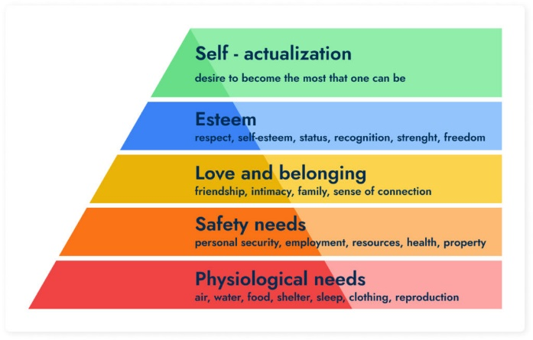
(MA Education, 2016) We can better understand how to support children's transitions into new environments by using Maslow's hierarchy of needs. The first level of the pyramid states that in order to attain homeostasis (the body's normal functions), A child's physiological demands must come first. (MA Education, 2016) a child must feel comfortable and secure in their surroundings after their physical requirements have been met. We then reach the level of "needs for belonging and affection." Although a child may have progressed beyond this level at home, they will need to find a new caregiver to bond with when they reach a new environment and their primary caregiver leaves. (MA Education, 2016) Early childhood educators must try to help the child feel emotionally comfortable first. It is unlikely that the child will feel secure enough in such environment to learn and grow immediately (MA Education, 2016). The confidence and self-esteem of the child are addressed at the next level of the pyramid (esteem needs). Before a child may anticipate advancing in their development, Maslow contends that all four stages must be fully attained.

Creating a strong bond
(Professional association for childcare and early years, 2016) A positive start depends on developing a strong bond between the adult and the child or making the most of one that already exists. According to John Bowlby's book "Attachment and Loss," children with stable attachments are more likely to “Approach the world with confidence and, when faced with potentially alarming situations, is likely to tackle them effectively, or to seek help.” Bowlby’s concepts are known as attachment theory.
Secure Attachments
(Professional association for childcare and early years, 2016) A successful transition depends on developing a strong bond between the adult and the child or making the most of one that already exists. (Professional association for childcare and early years, 2016) Children that have a secure connection are more likely to “Approach the world with confidence and, when faced with potentially alarming situations, is likely to tackle them effectively, or to seek help” according to John Bowlby's theory in his book "Attachment and Loss,"
Key Person
(Professional association for childcare and early years, 2016) Children can learn through seeing others and interacting with them. The important person acts as the child's confidant and role model. The key person will watch a child to ascertain how they learn through play, their next developmental stage, their areas of interest, and whether there is any cause for concern or a need for more help. (Professional association for childcare and early years, 2016) They will communicate this information to the relevant people and collaborate with multi agencies to create a support strategy.
(Essex County Council, 2022) state that the provision must reflect and support all children, and practitioners must respond to each child's growing needs and interests while guiding their development through warm, supportive interaction. A crucial principle of appreciating all children is inclusion.

The needs of the child

Moving to Reception from Nursery
(Early Years Alliance, 2017) A child's life undergoes a lot of changes when they start school, including being separated from familiar children and adults. Children have a firmer understanding of "people permanence" by the time they are ready to begin school and may therefore approach new situations with some self-assurance. However, if they want to be ready to approach the transfer to school with confidence, they will need to prepare.
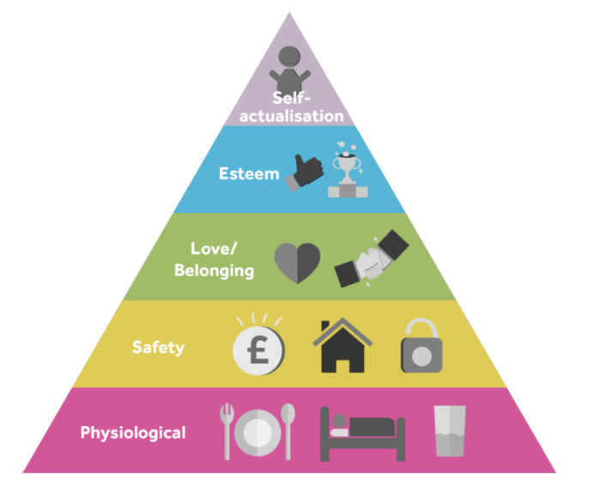
A child must be cared for properly, get enough sleep, feel comfortable at home, and have self-confidence in order to succeed in school (University of Reading, 2022). Popular theory Maslow's Hierarchy of Needs emphasises several requirements for success (University of Reading, 2022).

(University of Reading, 2022)

Maslow structured these needs so that one must be met before the next can be satisfied. Starting with the physiological and safety elements of a person's basic requirements, the pyramid eventually rises to self-actualisation, which is the term for a person realising their full potential as a human being (University of Reading, 2022). (University of Reading, 2022From a child development perspective, Maslow's theory addresses all developmental requirements for children, including those for physical, emotional, social, cognitive, language, and aesthetic growth.
The key lesson to learn from studying Maslow's theory is that physical and mental health are the foundation of a positive human situation. Before expecting a child to realise their full potential, you must cater to their basic requirements (University of Reading, 2022).
(University of Reading, 2022) When adults establish predictable routines and establish clear expectations, children handle transitions the best. Children require assistance in learning how to control and express their emotions, as well as develop coping mechanisms for stress and how to control their actions and behaviour. (Ring and O'sullivan, 2021) For children and parents to be fully informed, know what to expect, and have confidence that there is continuity between preschool and primary settings, communication has been identified as a vital component of effective transitions (Dockett, Perry, and Kearney, 2010; UNICEF, 2012). The researchers developed a research approach to make sure that children's perspectives were meaningfully included in the study because they were aware that children's voices were rarely incorporated in research on this transitional stage (Ring and O'sullivan, 2021).
(Nursery World, 2019) It is essential that practitioners take the time to learn precisely what the children's concerns are if they are to address the children's fears about transition. Peer talks can be initiated through activities like circle time sessions. However, some fears will be unique to each child, so caregivers should take every opportunity to talk to and listen to each child as their worries surface. (Nursery World, 2019) Given that they are likely to have developed a close and trustworthy relationship with their key children, key workers have a particularly significant role to play in helping their key children emotionally. It's important to visit the new location to soothe any anxieties about the unfamiliar. Children are typically invited to their new setting along with their parents, caregivers, or essential workers. (Nursery World, 2019) Children can meet new staff members and possibly other children in their group during such visits. They also help the children get used to some new routines that at first can be confusing to young children and the way the space is laid out.

Partnerships

A partnership with parents or guardians
(GOV.UK, 2021) The early years foundation stage (EYFS) places a strong emphasis on collaborating with parents and caregivers. The relationship between parents and staff will initially begin when they first visit the school or setting (GOV.UK, 2021). (GOV.UK, 2021) It is crucial to provide parents and caregivers with a variety of opportunities to participate in their children's education. (Birth to 5 Matters, 2021) Only when parents and professionals collaborate to help the children make meaningful connections to the world around them and to develop a love of learning can partnerships with parents be genuinely effective. (Birth to 5 Matters, 2021) No family or parent should be excluded from this process. When it comes to their personal job of promoting their child's wellness, growth, and learning, parents must feel valued, listened to, and trusted.
Partnerships with multi-agencies
(WJEC,2019) Since each child is unique, they will all have various needs. Some of these demands may only be met by skilled experts, while others can be met by anybody with adequate knowledge and commitment. (WJEC,2019) It is essential to consider what business organisations and experts can provide. For the benefit of children and their families/caregivers, settings must successfully collaborate with them. (Devon County Council, 2022) The parents and any other agencies, if they are engaged, should be aware of the unique requirements of the children. (Devon County Council, 2022) Through a multiagency meeting, this should be achieved. For children with considerable and ongoing requirements, practitioners should try to provide an enhanced transition as soon as possible. This is often offered on an individual basis and is unique to the individual.
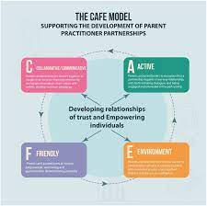
Froebel’s Principles of Partnership
(Kambouri et al., 2021) A contemporary Froebelian approach is unique in that it strives for "unity" in it’s understanding of how practitioners may collaborate with families in the best interests of children, while also acknowledging the value of families. (Kambouri et al., 2021) The foundation of Froebel's pedagogical beliefs is the notion that a child's understandings and relationships come from their parents and family (Froebel c1826 trans., 1912). To participate in the relationship, both parents and practitioners must feel empowered. (Kambouri et al., 2021)

Environment

The environment to which the child will be learning will play a big part in the transition process from nursery to reception.

(Daniels, 2001) Any meaningful examination of how children learn is central with Vygotsky's views. According to Vygotsky, learning occurs when children engage with their social surroundings rather than when they develop in isolation. (Saul McLeod, 2014) Vygotsky and Jean Piaget are frequently compared, especially regarding his cognitive-developmental theory. They disagreed on the reasons for delaying the introduction of developmental concepts to children until they are at the appropriate developmental stage. Vygotsky's zone of proximal development was not accepted by Piaget, who believed that children themselves are the most important source of cognition. (Saul McLeod, 2014) However, Vygotsky claimed that a child's social environment can support cognitive development. When it is required, a child's social environment can help them adapt culturally to novel situations. (Saul McLeod, 2014) The aim of Piaget and Vygotsky was to discover how children acquire concepts and subsequently transform them into speech.
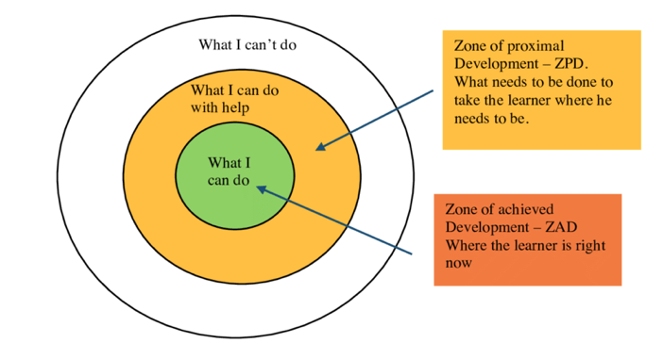(Main, 2020)

(Main, 2020) The ZPD was first conceived by Lev Vygotsky. Every person has "2" phases of skill development, according to Vygotsky: a level that may be attained independently and a level that may be attained with the aid of a mentor or instructor with expertise. The level a person can get with assistance is known as the ZPD in Vygotsky's theory. According to Vygotsky, providing the right advice to a student who is in the ZPD for a particular task will give them enough of a "boost" to complete the activity. (Main, 2020) The child is guided through this process until they achieve the maximum level of competency.

(Good Therapy, 2015) By building on the first five phases of development proposed by Sigmund Freud, Erikson influenced psychological ideas. Erikson, a pioneer in the study of the life cycle, thought that every individual went through eight phases of development. Erikson emphasised that the environment has a significant impact on identity, self-awareness, adjustment, and human development. (Good Therapy, 2015) Erikson's phases of psychological development each place a strong emphasis on a core conflict. (Good Therapy, 2015) According to Erikson's theory of development, kids don't necessarily go through each stage on cue. The student is guided through this procedure until they achieve the maximum degree of competency.
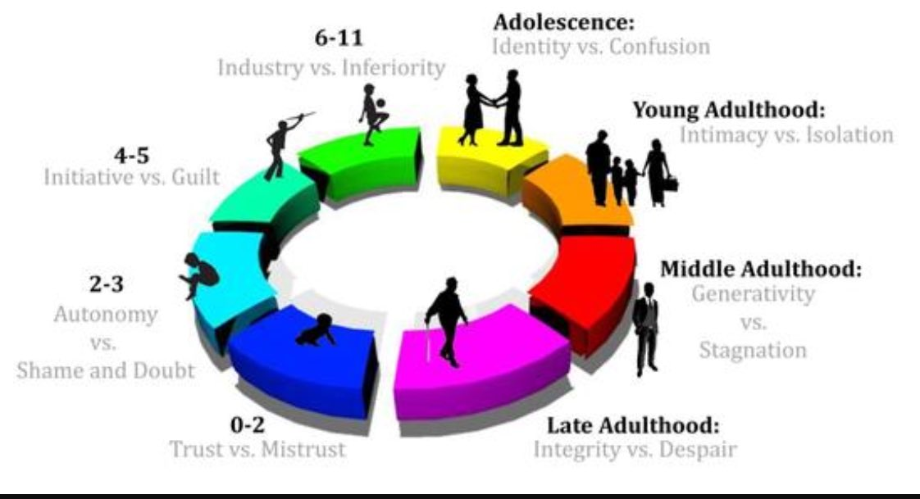

(Early Years Matters, 2022) Children's environments play a significant role in supporting and enhancing their growth and learning. Because they feel at ease, at home, and at comfort in certain circumstances, young children are encouraged to play there. (Early Years Matters, 2022) Children may explore and learn about the environment they are in and the objects they can see, touch, move, or control when they feel emotionally safe and secure. The emotional environment, the outdoor environment, and the interior environment are the three categories used in the EYFS to characterise the environment. (Early Years Matters, 2022) The environment for play and learning in the EYFS is made up of these three elements.

Intervention

To enable the best support for children during the transitioning period from nursery to reception many interventions will need to be implemented. In doing this it ensures that a close bond between families and bond building between families happens during this transition period.
(Early Intervention Foundation, 2020) Since these are the four developmental domains where intervention has the most potential to change a child's course and benefit them for the rest of their life, early intervention programmes usually centre on nurturing children's physical, cognitive, behavioural, social, and emotional growth.

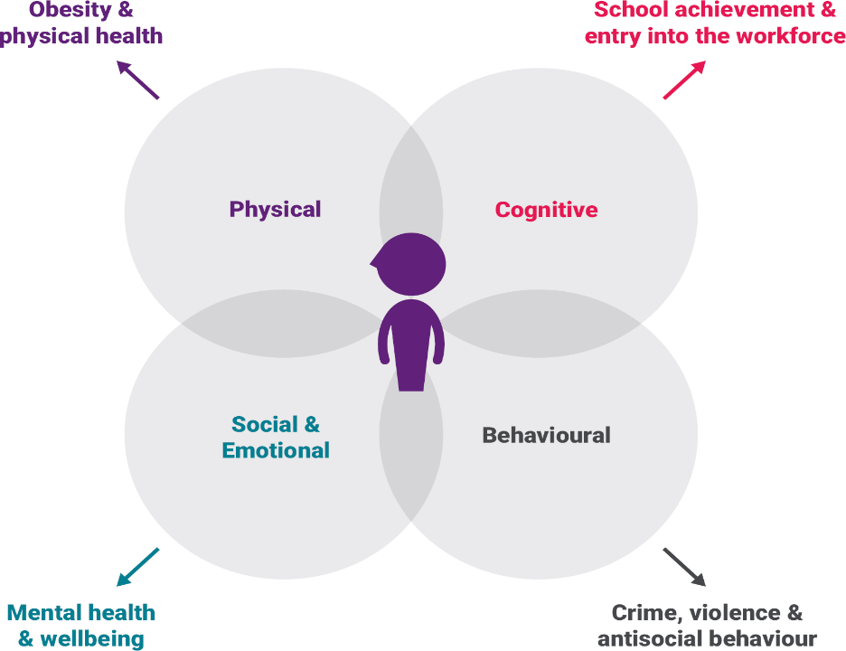
(Early Intervention Foundation, 2020)

(Waltham Forest Council, 2019) All staff working in the setting are helped and guided by policies and procedures. They guarantee and support the safety of all families, children, employees, volunteers, and everyone else involved in the setting. When rules and procedures are carefully thought out and, more significantly, put into practise, they help everyone in the setting understand and agree on how things should be done. Procedures include detailed instructions and recommendations on what should or must be done in a certain situation or with reference to a specific problem. (Waltham Forest Council, 2019) To suit the requirements of everyone working in the setting and to account for any changes that may have occurred there and in the larger community, policies should be "living" documents that need to be evaluated on a regular basis.

Here below are some of the policies that are used within every childcare setting:
- Child Protection
- Safeguarding
- ALN Policy
- Health and Safety
- GDPR
- Attendance policy
- Risk Assessment
Learning through play
(Ni Direct, 2018) Children and young people who play have better cognitive, physical, social, and emotional health. (Ni Direct, 2018) Children learn about the world and about themselves through play. They also pick up qualities like confidence, self-esteem, resilience, problem solving and so on, that they need for relationships, work, and school further on in their lives.

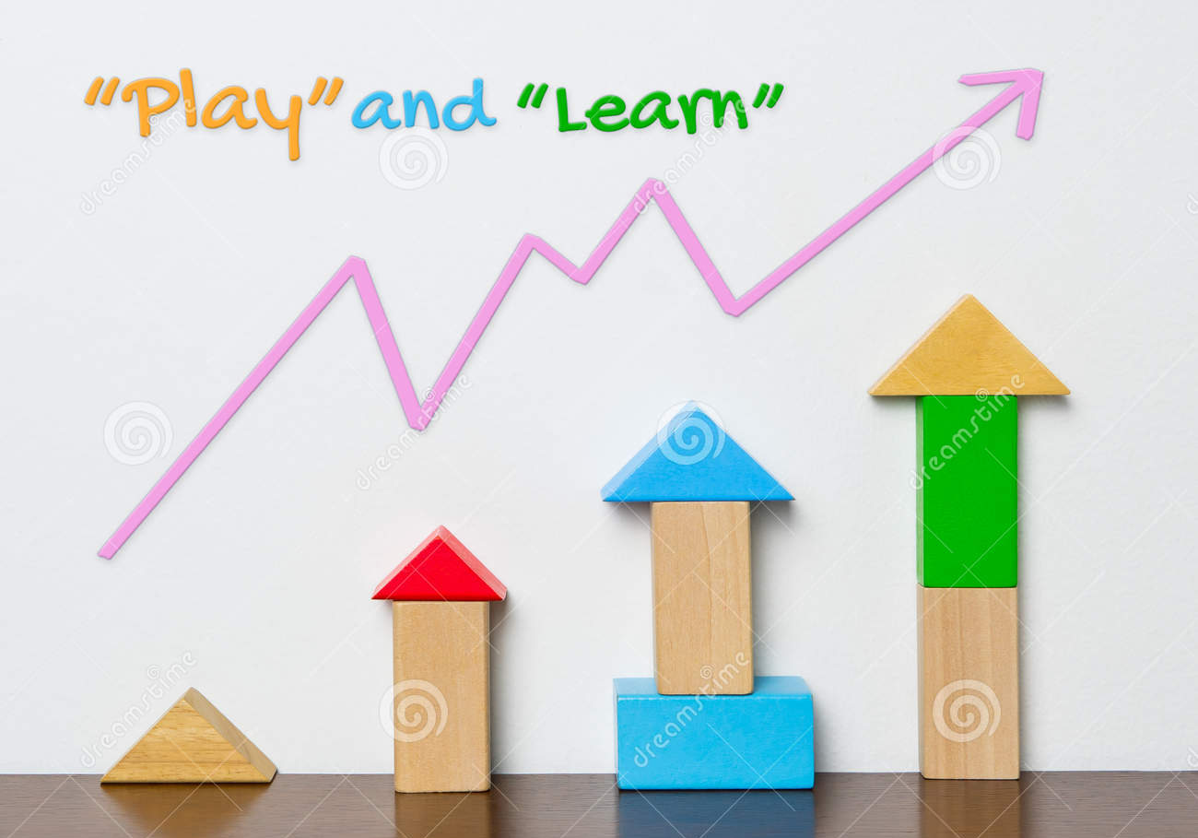
(Source: dreamstime.com)

Proposed Outcomes

(Early Years Matters, 2022) Children view transitions as important life milestones that significantly affect their development. These are unquestionably exciting times of change for any child, with new opportunities for growth. (Early Years Matters, 2022) They can also be unsettling periods where things are different than usual, expectations and protocols are different, and faces are still unknown. Every child needs a smooth transition, which is not a singular occurrence that just "happens."
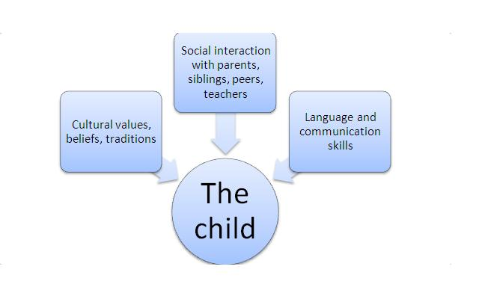
(Learning and adolescence development, 2020)

(Mcleod, 2022) Vygotsky's theories emphasise the fundamental significance of social interaction in the creation of cognition since he was certain that community plays a significant part in the process of "making meaning" (Vygotsky, 1978). Piaget believed that children's growing must always come before their learning, however Vygotsky claimed that learning is an important and universal aspect of the process of creating culturally organised, distinctively human psychological function (1978, p. 90).
The goal is for the child to transition successfully, with the help of their parents, caregivers, and all the setting's professionals. Early Years Practitioners must develop connections and an environment that are uplifting and encouraging so that the child may flourish and develop in their own manner.

Reference list
Birth to 5 Matters (2021). Parents as partners – Birth To 5 Matters. [online] Birth to 5 Matters. Available at: https://birthto5matters.org.uk/parents-as-partners/ [Accessed 30 Nov. 2022].
Birth to 5 Matters (2022). Transitions – Birth To 5 Matters. [online] Birth to 5 Matters. Available at: https://birthto5matters.org.uk/transitions/.
Croner-i (2019). Managing Transitions in Early Years Provisions | Croner-i. [online] Croneri.co.uk. Available at: https://app.croneri.co.uk/feature-articles/managing-transitions-early-years-provisions [Accessed 25 Nov. 2022].
daniels, H. (2001). Vygotsky and Pedagogy. [online] Taylor and Francis Group. Available at: https://doi.org/10.4324/9780203469576 [Accessed 3 Dec. 2022].
Devon County Council (2022). Transition in the early years: Guidance for schools and settings - Support for schools and settings. [online] Transition in the early years: Guidance for schools and settings. Available at: https://www.devon.gov.uk/support-schools-settings/inclusion/transition/transition-in-the-early-years/ [Accessed 3 Dec. 2022].
Early Intervention Foundation (2020). Developing a good theory of change. [online] Early Intervention Foundation. Available at: https://www.eif.org.uk/resource/developing-a-good-theory-of-change [Accessed 3 Dec. 2022].
Early Years Alliance (2017). Hello, ‘big school’ - managing transitions. [online] early years alliance. Available at: https://www.eyalliance.org.uk/hello-big-school-managing-transitions [Accessed 25 Nov. 2022].
Early Years Careers (2022). 8 ways to create strong parent partnerships. [online] www.earlyyearscareers.com. Available at: https://www.earlyyearscareers.com/eyc/learning-and-development/8-ways-create-good-parent-partnerships/ [Accessed 30 Nov. 2022].
Early Years Matters (2022). Enabling Environments. [online] Early Years Matters. Available at: https://www.earlyyearsmatters.co.uk/our-services/school-and-nursery-improvement-partner/enabling-environments/#:~:text=Enabling%20environments%20encourage%20babies%20and [Accessed 3 Dec. 2022].
Essex County Council (2022). Role of the adult. [online] eycp.essex.gov.uk. Available at: https://eycp.essex.gov.uk/the-early-years-foundation-stage/how-do-i-become-an-outstanding-practitioner/role-of-the-adult/ [Accessed 25 Nov. 2022].
Good Therapy (2015). Erik Erikson Biography. [online] www.goodtherapy.org. Available at: https://www.goodtherapy.org/famous-psychologists/erik-erikson.html#:~:text=Erikson%20emphasized%20that%20the%20environment [Accessed 3 Dec. 2022].
GOV.UK (2021). Working in partnership with parents and carers - Help for early years providers - GOV.UK. [online] help-for-early-years-providers.education.gov.uk. Available at: https://help-for-early-years-providers.education.gov.uk/get-help-to-improve-your-practice/working-in-partnership-with-parents-and-carers [Accessed 30 Nov. 2022].
I stock by Getty images (2008). Muddy Hand Prints. [online] iStock. Available at: https://www.istockphoto.com/vector/muddy-hand-prints-gm165588181-6162788 [Accessed 20 Nov. 2022].
Kambouri, M., Wilson, T., Pieridou, M., Quinn, S.F. and Liu, J. (2021). Making Partnerships Work: Proposing a Model to Support Parent-Practitioner Partnerships in the Early Years. Early Childhood Education Journal, 50. doi:10.1007/s10643-021-01181-6.
MA Education (2016). Support transitions using an effective key person system. [online] Early Years Educator. Available at: https://www.earlyyearseducator.co.uk/features/article/support-transitions-using-an-effective-key-person-system [Accessed 25 Nov. 2022].
Main, P. (2020). The Zone of Proximal Development: A teacher’s guide. [online] www.structural-learning.com. Available at: https://www.structural-learning.com/post/the-zone-of-proximal-development-a-teachers-guide [Accessed 3 Dec. 2022].
Mcleod, S. (2022). Vygotsky’s sociocultural theory of cognitive development. [online] Simply Psychology. Available at: https://www.simplypsychology.org/vygotsky.html [Accessed 3 Dec. 2022].
Ni Direct (2018). How play helps children’s development. [online] nidirect. Available at: https://www.nidirect.gov.uk/articles/how-play-helps-childrens-development#:~:text=Play%20improves%20the%20cognitive%2C%20physical [Accessed 3 Dec. 2022].
Nursery World (2019). Transition between settings. [online] Nursery World. Available at: https://www.nurseryworld.co.uk/News/article/transition-between-settings [Accessed 25 Nov. 2022].
Parentzone Scotland (2017). What are transitions? | Transitions | My child | Parent Zone. [online] Gov.scot. Available at: https://education.gov.scot/parentzone/my-child/transitions/what-are-transitions/#:~:text=%E2%80%8BTransitions%20are%20the%20moves [Accessed 25 Nov. 2022].
Professional association for childcare and early years (2016). Transitions and settling in. [online] Available at: https://www.pacey.org.uk/Pacey/media/Website-files/PACEY%20member%20practice%20guides%20(PDFs)/PG10-transitions-and-settling-in.pdf [Accessed 25 Nov. 2022].
Rhondda Cynon Taf County Borough Council (2022). Transition information for Early Years | Rhondda Cynon Taf County Borough Council. [online] www.rctcbc.gov.uk. Available at: https://www.rctcbc.gov.uk/EN/Resident/SchoolsandLearning/AccessandInclusiontoEducation/WorkinginPartnershipwithParents/SchoolTransitionAdvice/TransitioninformationforEarlyYears.aspx.
Ring, E. and O'sullivan, L. (2021). Adapted from: https://childrensresearchnetwork.org/knowledge/resources/the-importance-of-including-the- childs-voice-in-the-transition-process The importance of including the child’s voice in the transition process: Signposts from a national evaluation of concepts of school readiness in Ireland. [online] Available at: https://dspace.mic.ul.ie/bitstream/handle/10395/2386/Ring%2c%20E.%20%282016%29%20The%20importance%20of%20including%20the...%28Pre-published%29.pdf?sequence=2&isAllowed=y.
Saul McLeod (2014). Lev Semyonovich Vygotsky - PLT Learning Content. [online] Google.com. Available at: https://sites.google.com/site/pltlearningcontent/overview-theorists/lev-semyonovich-vygotsky [Accessed 3 Dec. 2022].
University of Reading (2022). Maslow’s hierarchy of needs. [online] FutureLearn. Available at: https://www.futurelearn.com/info/courses/supporting-learning-primary/0/steps/58666 [Accessed 25 Nov. 2022].
Waltham Forest Council (2019). Early Years Policies and Procedures | The Hub - Waltham Forest Education Hub. [online] thehub-beta.walthamforest.gov.uk. Available at: https://thehub-beta.walthamforest.gov.uk/earlyyearpoliciesandprocedures [Accessed 3 Dec. 2022].

