Project Report

Name: Morgan Jones
Student number: 1706863
Module: (ACDA5005)
Course: Electronic Engineering

Contents
Project Report 1
Name: Morgan Jones 1
Introduction 3
Setup 3
Data transfer 4
Connect to database 7
Data filter 7
Interpret data 9
Graph 10
Data Protection (login, logout) 11
References 15
Appendix 16

Introduction
This report will explain how to setup a WAMPServer, what the code does and explain the decisions of why the code was used in this way for the website and database

Setup
Before you start on the programming you are required to create a database using a wamp server
“
- Go to http://www.wampserver.com/en/
- Download WAMPServer
- Install at C:/wamp64
- Your PHP files should be placed in C:/wamp64/www
- Access your files at: http://localhost/login.php or something along those lines as the php file name changes for each file
- Access database at http://localhost/phpmyadmin
- To access database in php files use coninfo.php file and include reference in the required files
- You must also change the settings from long to short tags by clicking on WAMPServer in the taskbar of your computer. Select "PHP settings" - in the list of settings, make sure that short_open_tags is ticked.” [1]
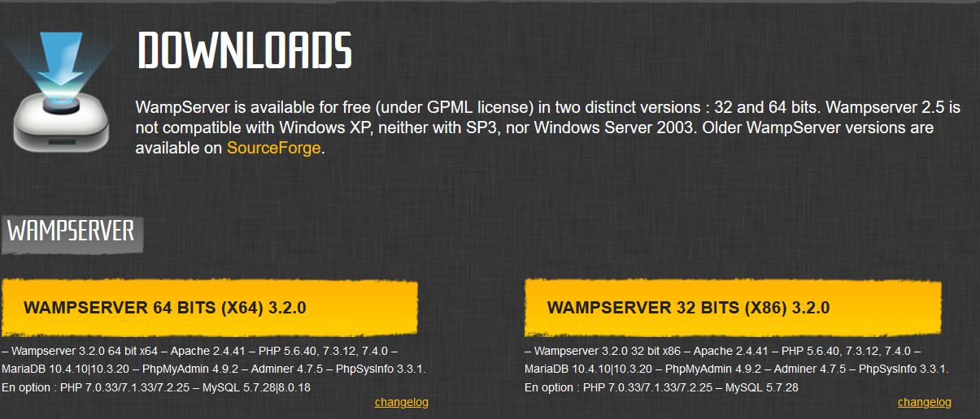

Figure 1 download section of http://www.wampserver.com/en/ [2]

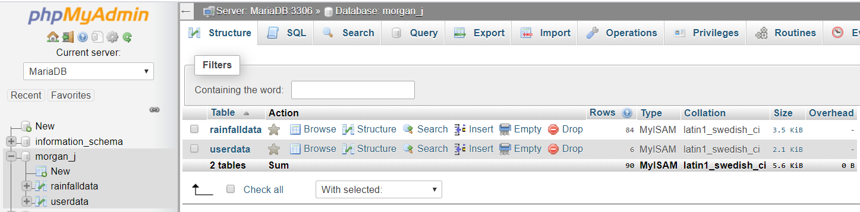
Figure 2 databases inside morgan_j folder in phpMyAdmin

Data transfer
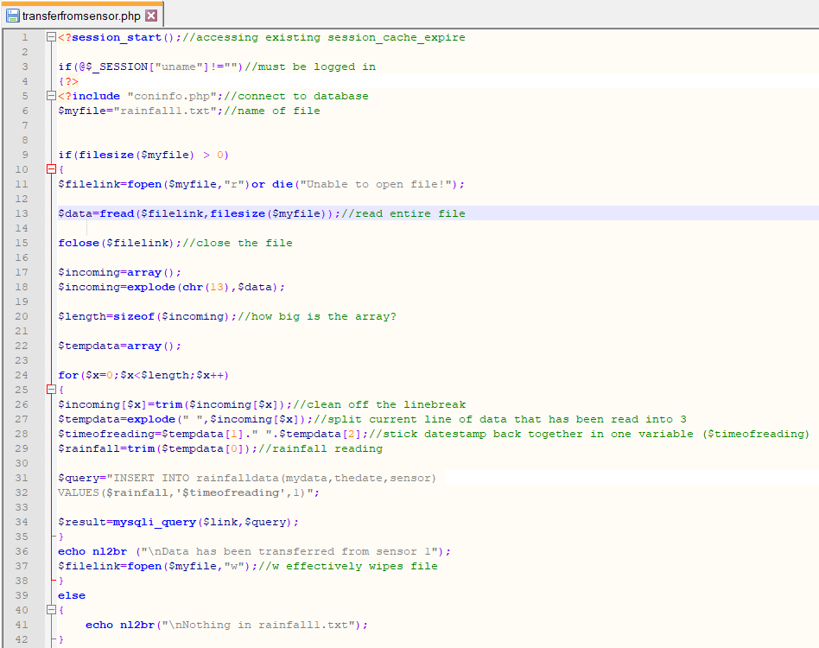
Figure 3 transfer data from sensor code with security
The above code in figure 3 is used to transfer the data from the text files to the database and is then deleted from the files to prevent the chance of duplicates as shown in figure 10. The code is repeated three times one for each file/sensor the only things changed are the parameters for each specific file for example rainfall1.txt as the file name and sensor ‘1’ in the values section lines 6 and 32 in figure 3 There is also code which will display if the file is empty or data has been transferred as shown in figure 7 and figure 8.
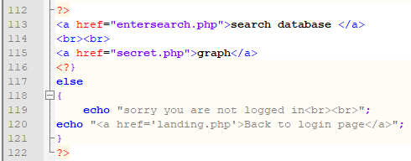
Figure 4 security and page links
As you can see on lines 1 to 4 on figure 3 and lines 117 to 121 on figure 4 this the security measure I have set up to stop people accessing the website just by typing in the URL they must go through the login page but if anyone try's just the URL the user will get blocked and figure 5 comes up you also have the ability to move through the website by using the URL links on the page.
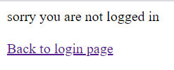
Figure 5 URL security

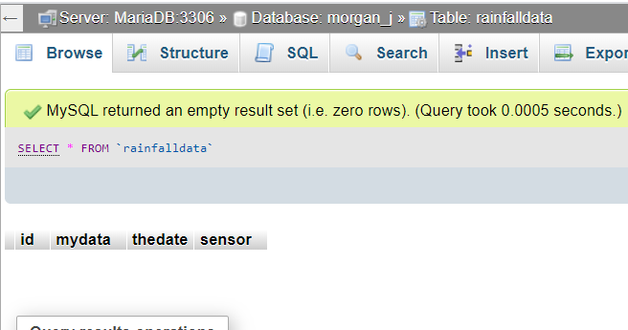
Figure 6 empty database before transfer
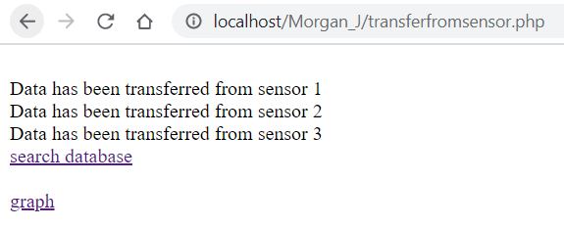
Figure 7 weblink to show transfer of data
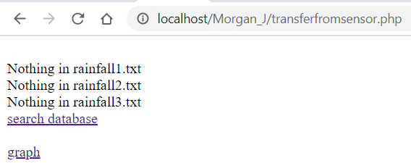
Figure 8 show that the txt files are empty to prevent duplicate results

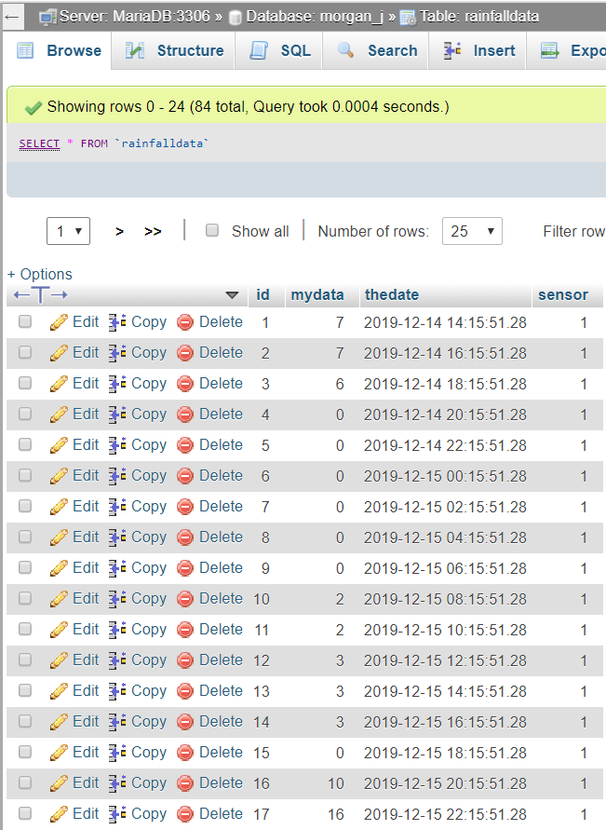
Figure 9 the data been transferred to the rainfalldata database
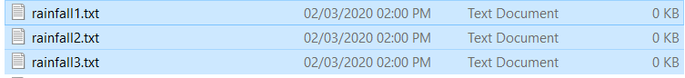
Figure 10 data has been deleted from files

Connect to database

Data filter
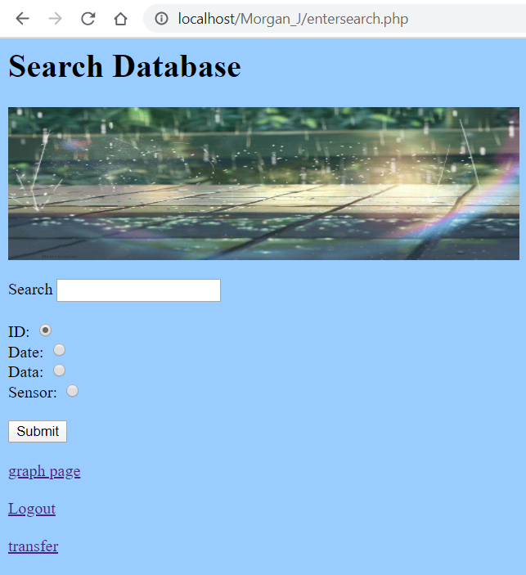
Figure 11 search database page
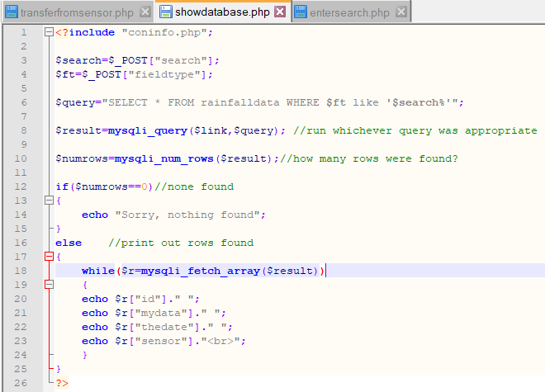
Figure 12 how the database connects to the search page
The above figure 12 is used to connect the search page to the database more specifically the rainfalldata database meaning without this page you would not be able to access the database and any searches would not works. A wild card was also added to the query on line 6 so that any radial button clicked will work as without it only some of the searches will work.
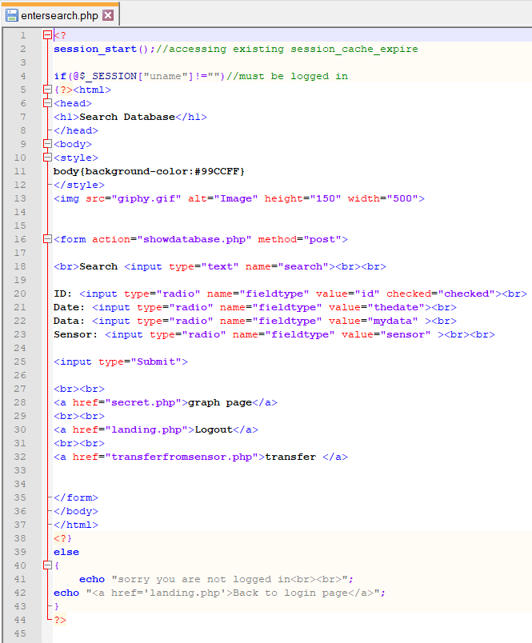
Figure 13 the code connecting entersearch.php to showdatabase.php and the radial buttons to filter the data
The code shown in figure 13 works with the code in figure 12 as the user enters what they want to see using the input bar and radial buttons in figure 11 this is done by the showdatabase.php code takes the user inputs and scans the database looking for anything that matches and then put it on the screen but if there is nothing to be found then the message sorry, nothing found will be shown.

Interpret data
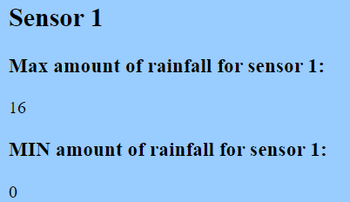
Figure 14 interpreted data from sensor
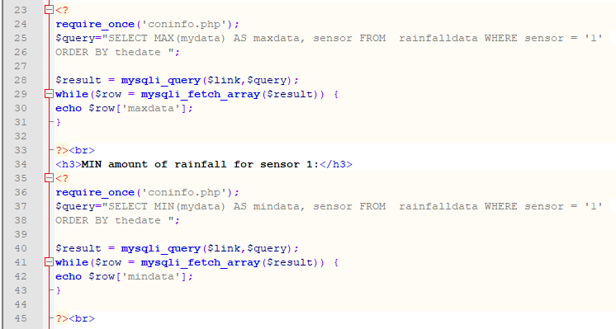
Figure 15 code for max and min rainfall
The code in figure 15 is used to help the user interpret the data by show the user the max and min rainfall for each of the sensors as shown in figure 14. You repeat the code three times you just change where you find the information in the database more specifically which sensor to use as shown on lines 25 and 37 shown in figure 15.

Graph
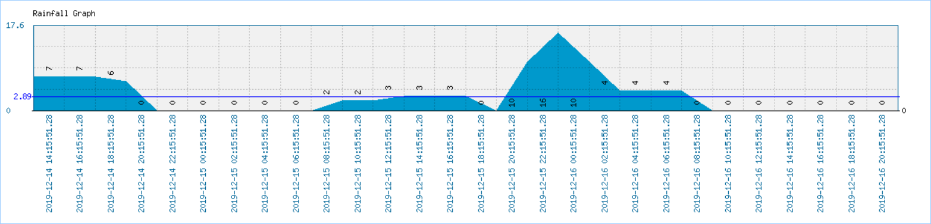
Figure 16 sensor data shown in graph by date
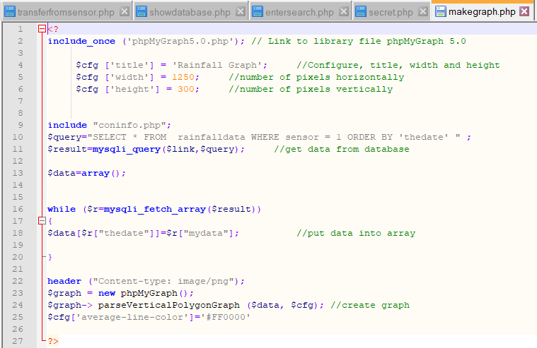
Figure 17 code to get the data and create graph
The above figure 17 shows the code used to create the graph there are three files containing this code one for each sensor the code on line 2 connects to the file phpMyGraph5.0php which is a library that controls what the graph will look like. The graph has also been set up so that the graph data is shown and labelled by data as shown by figure 16
Mention phpmygraph5.0php

Figure 18 file to help create graph

Data Protection (login, logout)
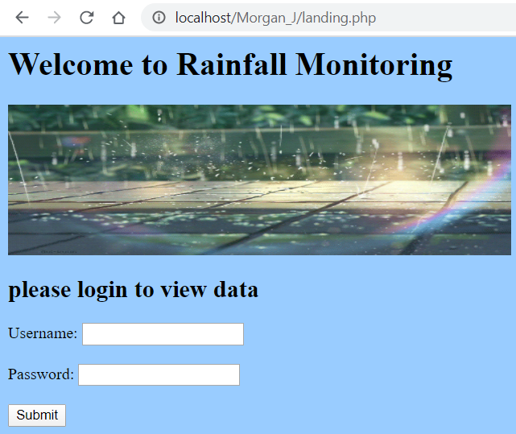
Figure 19 login page
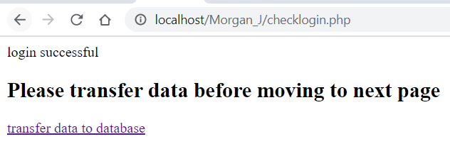
Figure 20 check login page to confirm login and link to transfer data
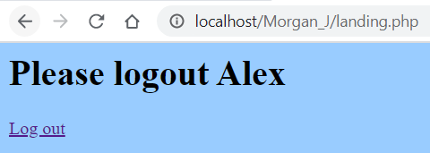
Figure 21 logout page
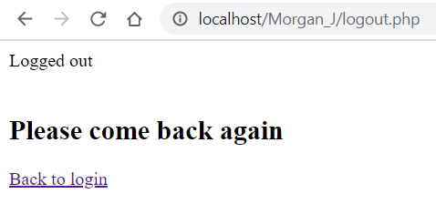
Figure 22 to confirm logout and go back to login page button
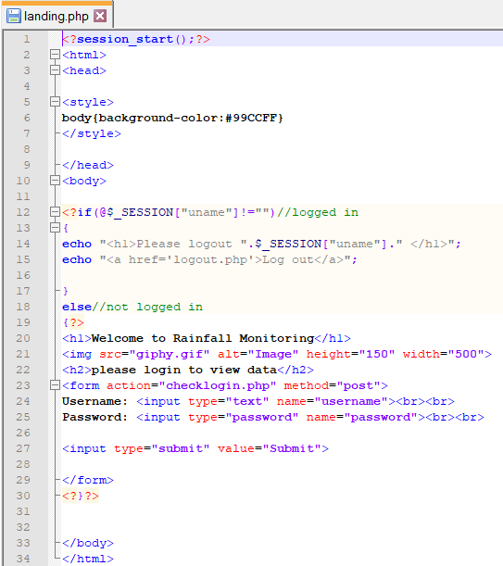
Figure 23 code for login and logout pages
The above figure 23 contains the code for the login show in figure 19 and logout in figure 21 The lines 20 to 29 contains the code for the login page there two in put slots one for a username which is a text field and one for a password which is encrypted meaning that no one can see the password. One the username and password have been filled in and the submit button has been pressed it automatically moves you to the check login page which checks the entered details with those stored on the user database. And lines 12 to 17 are for the logout page as the code asks the user to logout and give them a link which takes them to a page which confirms that the user logged out of the website as show in figure 22.
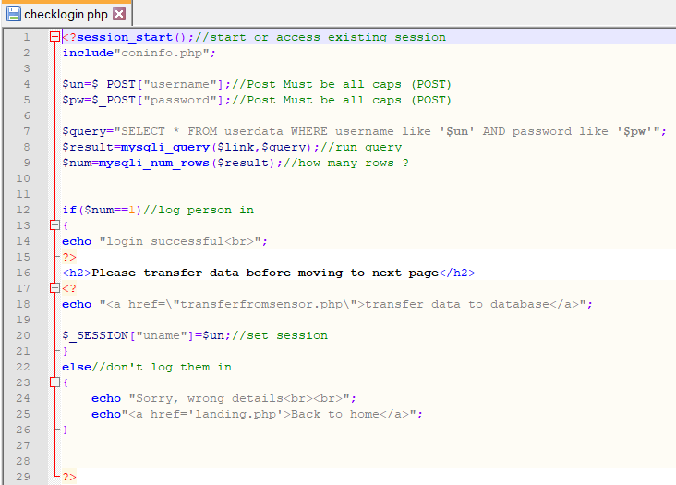
Figure 24 code to check login and move to transfer page
The code shown in figure 24 is used to work with the code found in figure 23 specifically the login section as it checks the details entered for the username and password with those in the userdata database and if they are correct it will allow you to access the website if the details are wrong it tells you Sorry, wrong details and gives you link for the login page to try again
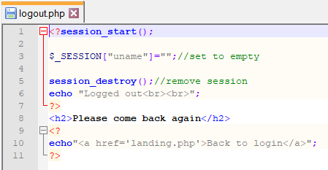
Figure 25 to check logout

The code in figure 25 is used to remove the user from the website meaning that they will have to log back in via the login in page if the user wants to look at the data again

References

[1] | “L5 - Smart and Connected Devices I,” [Online]. Available: https://moodle.uwtsd.ac.uk/course/view.php?id=5746. [Accessed 06 January 2020].
[2] | “wampserver,” [Online]. Available: http://www.wampserver.com/en/. [Accessed 01 November 2019].

Appendix
Figure 1 download section of http://www.wampserver.com/en/ [2] 3
Figure 2 databases inside morgan_j folder in phpMyAdmin 4
Figure 3 transfer data from sensor code with security 4
Figure 4 security and page links 5
Figure 5 URL security 5
Figure 6 empty database before transfer 6
Figure 7 weblink to show transfer of data 6
Figure 8 show that the txt files are empty to prevent duplicate results 6
Figure 9 the data been transferred to the rainfalldata database 7
Figure 10 data has been deleted from files 7
Figure 11 search database page 8
Figure 12 how the database connects to the search page 9
Figure 13 the code connecting entersearch.php to showdatabase.php and the radial buttons to filter the data 10
Figure 14 interpreted data from sensor 11
Figure 15 code for max and min rainfall 11
Figure 16 sensor data shown in graph by date 11
Figure 17 code to get the data and create graph 12
Figure 18 file to help create graph 12
Figure 19 login page 12
Figure 20 check login page to confirm login and link to transfer data 13
Figure 21 logout page 13
Figure 22 to confirm logout and go back to login page button 13
Figure 23 code for login and logout pages 14
Figure 24 code to check login 15
Figure 25 to check logout 15

