Managing Enterprise in the 21st century
Lisa Dower -1902875


Phoenix play business plan

Our business proposal is to open a soft play area in Townhill called Phoenix Play. I am going to be working in partnership with Nicola Brain and Laura Morgan. We will be opening the soft play area for local families in the Phoenix Centre. The phoenix centre is a not for profit organisation situated in the heart of the community.
The service that we are planning to provide will be to offer an indoor soft play area that will create opportunities for children to interact with other children through play. In addition to this we will be organising children’s parties at competitive rates. The area provided will be a safe environment for children to gain social skills through play. Parents will be able to make friends in a relaxed atmosphere with refreshments provided by the onsite café. With the knowledge that the service will be provided in an area of high deprivation our prices will be affordable for residents. We have consulted with parents and have decided that play sessions will be provided to attracted children up to the age of 7. After research in the area we have discovered that there are no activities available for children of this age range.
We will look to open our play provision between 10am-1pm for preschool children and 4pm-6pm for children up to 7 years old. At weekends we will organise birthday parties, taking away the stress from parents. Within a set price parents can choose from various buffet menus, 1-hour soft play and a visit from a Disney princess or a super hero character. Throughout school holidays we will offer extra play sessions for families.
We know there is need for this in our community through community research that we carried out. We spoke to residents and completed questionnaires to find out if having a soft play area in Townhill would be of benefit. Many parents felt that having somewhere to take their young children would help them socialise and make friends, particularly lone parents and new comers to the area.

The owners of this business have many years’ experience of working in community settings. We are all parents ourselves and have attended play settings with our own children. We have looked at the skills set and experience of all owners and have decided on individual responsibilities.

Owner 1-Laura Morgan
Laura has 2 young children of her own and has in depth knowledge of accounts, book keeping and pay roll. She is currently working in the finance department at the Phoenix Centre. Given her experience and skill set, she will be responsible for the financial side of the business.
Owner 2- Nicola Brain
Nicola is currently employed at a very busy community café and has excellent customer service experience. Within her role she has carried out in depth allergy training. Nicola works very closely with a local marketing company and has very good IT skills. She will be responsible for Marketing and Customer Service.

Owner 3- Lisa Dower
Within my role as office manager I am responsible for recruiting staff, managing a team of employees and working very closely with other organisations. My skills set will allow me to take responsibility for human resources. I will create job descriptions and personal specifications to ensure that we have qualified staff who are DBS checked. I will arrange all relevant training for all staff.
By bringing our play provision to the area we will be creating employment opportunities for local people. We would need to employ qualified staff to ensure we can provide a professional service.
We will be employing two part time staff that will be paid minimum wage. Employees will also be DBS checked and would be paediatric first aid trained. Experience with children is essential along with excellent customer service skills.
By employing three part time members of staff including a cleaner we will have the flexibility to cover staff holidays and sickness. As business owners we will also have the certificates required so that we can also work when needed. Everyday cleaning would be done by staff at the end of every shift. We would employ the same cleaner as the phoenix centre who would give the play area a deep clean once a week. We will employ a local solicitor for any legal requirements.

Human Resources
Recruiting staff will be a process that we would all be part of, and we will work closely with the local nursery manager who has 20 years’ experience to assist us with panel interviews. Any training needed for us and staff would be provided.
We would look for candidates who:
- Has the necessary qualifications and experience with working with children.
- Able to supervise young children in a safe secure environment.
- Stop behaviour which could be dangerous.
- Respond quickly in emergency situations.
- Deliver excellent customer service and resolve complaints should they arise.
- Process bookings and payments through cash and credit card transactions.
- Conduct general routine maintenance and cleaning duties around the play area, to ensure it meets the required standard.
- Promote product and services to customers and visitors

Recruitment process
The recruitment process for employment is very important particularly for a new business. We are going to be looking at the job description and all that is involved in recruiting employees.
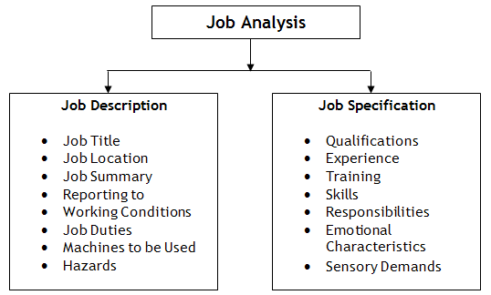
(managementstudyguide.com) assessed on 28th November 2019
The job description and personal specification need to be clear for potential employees, as managers we need to ensure that we have all tasks involved in the role listed. We will be working closely with our local communities for a work team to ensure that we have the suitable candidates apply. Communities for work will advertise the post along with our local job centre.
The job specification would highlight the need for candidates to be able to carry out the tasks on a day to day basis. This will include that the area that they are working in is kept clean and tidy and in accordance with health and safety requirements. Be able to work as a team and deliver excellent customer services will also be needed.
The person specification will include knowledge and experience in working with children and candidates would require a minimum NVQ level 1 qualification in childcare. Can work within a team be outgoing friendly and enthusiastic. Knowledge of health and safety would be beneficial. A good understanding of the English language in both verbal and written would be essential and welsh speaking would be an advantage. Candidates will need to be pleasant and professional when dealing with children, parents and other staff. Have well developed communication skills both orally and written and can manage multiple tasks and priorities.
Our interview process will be in 2 parts where all candidates will be invited to take part in activities that would help us to determine whether they have adequate communication skills. We will be looking for candidates that can work as a team, be hands on and carry out day to day tasks easily. From this, candidates who score the highest in this activity will be invited to take part in a panel interview. Using our individual skills set and with the knowledge and experience of the nursery manager on our interview panel we will score each candidate after answering a sequence of 5 questions. The overall score from both parts of interview will help us choose the most suitable candidate. Successful candidates will be offered employment on a trial basis of three months where we will monitor their work to ensure that they are competent in their role before offering them a permanent position. All permanent staff will take part in annual appraisals where their progress and ongoing development will be discussed. This will be carried out by one of the three owners of the business.
Panel interviews reduce the risk of making a bad hire. The panel’s goal is to make the best hiring decision possible given the information available about the position and the finalists.
Since each panel member brings a different set of experiences, thoughts, beliefs, and biases to the interview process, the members' strengths tend to compensate for each other’s' weaknesses. In the most effective panels, members work well with one another while being unafraid to respectfully challenge each other’s judgments and assertions about the potential hire.
(WHY employers like panel interviews online 29th december 2019)

Gantt Chart
A Gantt chart, commonly used in project management, is one of the most popular and useful ways of showing activities (tasks or events) displayed against time. On the left of the chart is a list of the activities and along the top is a suitable time scale. Each activity is represented by a bar; the position and length of the bar reflects the start date, duration and end date of the activity. This allows you to see at a glance:
What the various activities are When each activity begins and ends
How long each activity is scheduled to last
Where activities overlap with other activities, and by how much
The start and end date of the whole project
(Gantt.com online 28th November 2019)
We also used a Gantt chart which is a project management tool that illustrates how the project will run. Our Gantt chart shows our progress of our business and shows who have carried out what tasks.
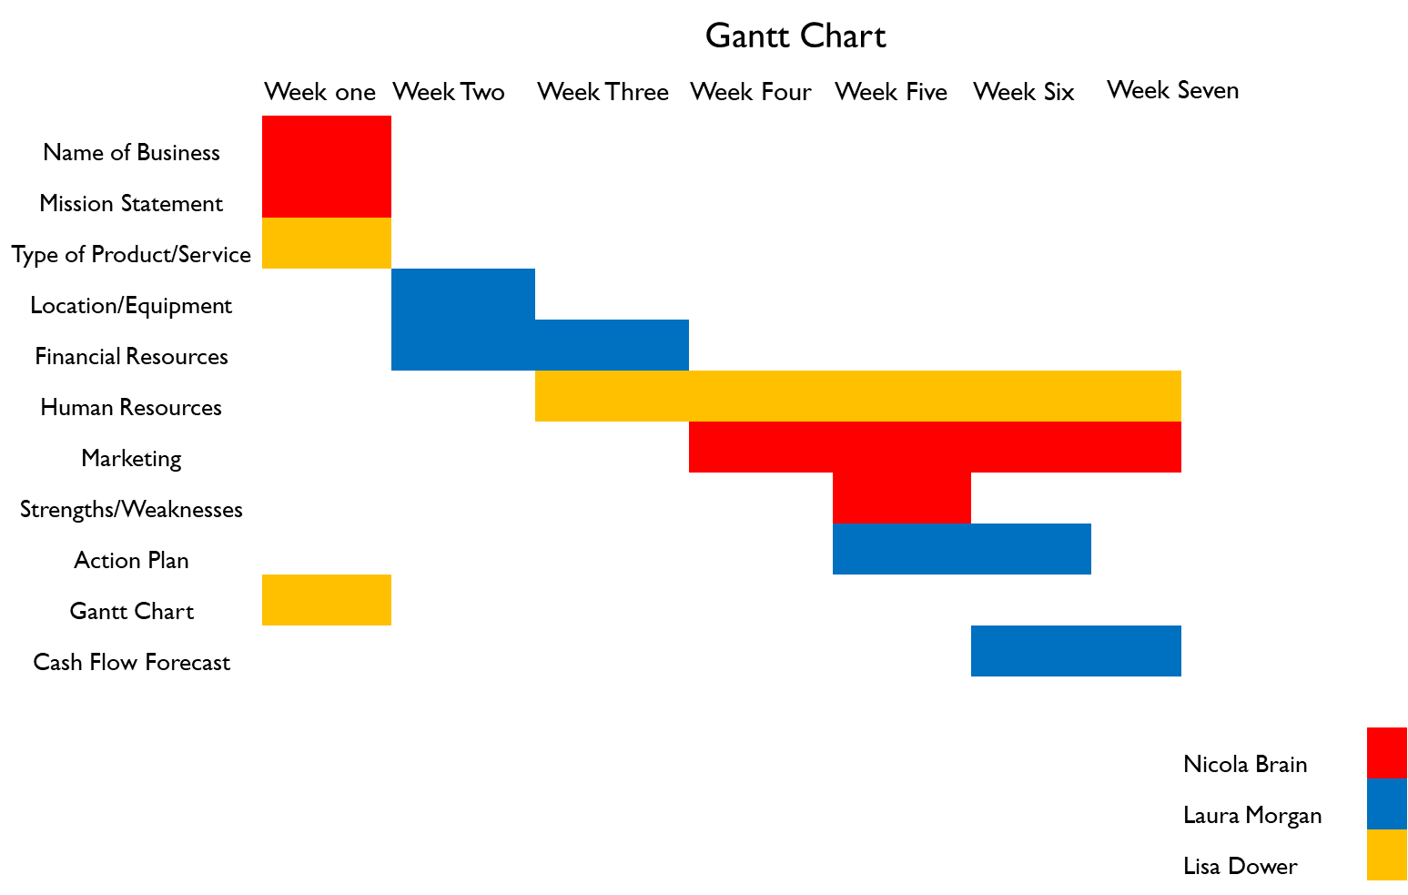
The gantt chart above shows the tasks required and the timelines as to when necessary tasks need to be completed.
Down the left-hand side is a list of the tasks that are needed to be completed and across the top of the chart shows the weeks in which tasks will need to be done. We colour coded our names to see what each of us were doing along with the time set for each task.
From the gantt chart above Nicola Brain is colour coded red and is responsible for working on naming the business, the business mission statement and marketing. Laura Morgan is colour coded blue and responsible for sourcing equipment, financial resources, looking at action plans and completing a cashflow forecast. I am colour coded yellow and was responsible products and services, human resources and preparing the gantt chart. The chart clearly states that all tasks would be complete in seven weeks.
In conclusion to this report completing a business plan in detail ensures that all aspects of the business are considered. Working in partnership means that skills and experience can be shared. We are all parents with varied skills and qualifications, and this enabled us to share responsibilities accordingly.
Market research is an important factor to consider when starting a business and we looked at other play provisions in the area as well consulting with parents in the area to find out whether they would use our service. From this consultation we were able to decide on opening hours and set prices. If we hadn’t carried out this consultation we wouldn’t have known if the play provision was something that was needed in the area.
Employing competent staff with the relevant qualifications and skills is a vital part of starting a business. We approached this task together with the assistance of a local nursery manager. We needed to make sure that job descriptions and personal specifications were detailed, and we had included everything that was required of candidates. The communities for work team assisted with this process.
Using the gantt chart when sharing tasks ensured that business owners were aware of when tasks would need to be complete. The gantt chart can be used as an ongoing tool to share responsibilities and ensure they are timely as the business continues to develop.

Google.com. (2019). [online] Available at: https://www.google.com/search?q=job+spec+and+job+description&safe=strict&source=lnms&tbm=isch&sa=X&ved=2ahUKEwjnzfH2i43mAhVRr3EKHdM_D48Q_AUoAXoECA8QAw& [Accessed 28 Nov. 2019].
Gantt.com. (2019). What is a Gantt Chart? Gantt Chart Software, Information, and History. [online] Available at: https://www.gantt.com/ [Accessed 28 Nov. 2019].
The Balance Careers. (2019). What Job Applicants Should Know About How Panel Interviews Work. [online] Available at: https://www.thebalancecareers.com/panel-interview-1669475 [Accessed 30 Nov. 2019].

