

Module Name: Project Management
Module Code: LCLM 5003
Student Name: Roselyn Bunda
Student ID: 2414761
Lecturer Name: Xavier Matieni.

Part B- Reflection from the feedback Summary
The tutor’s peer’s comments on the project proposal poster offered insightful information about the original project plan’s advantages and shortcomings. The project idea’s clarity, especially its emphasis on reconstructing a major transport corridor in the wake of the West Midlands flooding, was one of its main strengths. The poster made it simple for the audience to comprehend the goal of the project by clearly communicating the issue, goals and expected results.

Additionally, positive feedback was received regarding the porter’s visual presentation. The layout, headings, and structured information all contributed to a concise and engaging presentation of the project’s key elements. This demonstrates an understanding of how to effectively communicate project ideas to stakeholders, which is a critical project management competency.
However, several areas of improvement were identified. One of the key recommendations was for more details in the planning elements, particularly in terms of timelines, risk analysis, and resource allocation. While the poster provided an overview, it fell short in explaining how the project would be implemented in practice. This emphasized the importance of transitioning from conceptual ideas to more detailed planning in the overall project management plan.
Stronger justification for decisions made within the project was another important area of feedback. For instance, additional proof and logic, backed by pertinent scholarly sources, were needed for the transport corridor project selection and the suggested timeline. This is consistent with the need to apply project management theories and exhibit critical thinking.
Furthermore, feedback suggested improving stakeholder analysis by identifying specific stakeholder roles, as well as their level of influence and interest. This is critical for maintaining effective communication and engagement throughout the project’s lifecycle.
The final project management plan will be improved in several ways in response to this input. First, to give a clear schedule and task distribution, a comprehensive Work Breakdown Structure (WBS) and Gantt chart will be included. Second, a thorough risk analysis that identifies possible hazard and suitable mitigation techniques will be created. Thirdly, more specific information about human, financial, and material resources will be included in resource allocation.
Additionally, to support decision-making and bolster the project’s theoretical foundation, scholarly literature and project management frameworks like PRINCE2 and PMBOK will be incorporated. Clearly defining the roles, interests, and communication tactics of stakeholders will also improve stakeholder analysis.
Overall, the feedback has helped to refine the project approach and ensure that the final project management plan is more detailed, structure, and consistent with academic Expectations. This process has also fostered collaboration among team members, leading to a stronger sense of ownership and commitment to the project success. As a result, we are now better equipment to tackle potential challenges and achieve our objectives effectively. This collaborative effort not only enhances our project outcomes but also strengthens our skills in teamwork and communication. Moving forward, we will continue to seek feedback and adapt our strategies to maintain this momentum and drive further improvements.

Contents
Introduction 9
Project Description 9
Work Breakdown Structure (WBS) 10
Quad Chard 11
Ganttchart 11
Stake holder analysis 12
Allocation of resources 12
RISK ANALYSIS 13
RACI Matrix 14
CONCLUSION 14
Reference 15

Introduction
In July 2025, several towns in the West Midlands, including Worcester, Shrewsbury, and Kidderminster, experienced catastrophic flooding because of weeks of heavy rain caused by an unusual Atlantic weather system. The River Severn exceeded critical levels and breached flood defences in several locations, causing significant damage to infrastructure, homes, and businesses. Major highways were submerged or damaged causing disruption in the movement of people, emergency services, and goods. As a result, local authorities, and emergency management teams prioritized the restoration of critical road infrastructure. This project proposes reconstructing and reopening a flood-damaged highway corridor in Worcester. The project’s goals is to restore safe and efficient transportation, support economic recovery, and strengthen resilience to future flooding events.

Project Description
The project’s main goal is to rebuild and reopen a significant highway corridor in Worcester that sustained significant damage during the River Severn’s flooding.
Assessment of road damage, clean up debris and flooding water, repairing roads surfaces and foundations, repairing damaged drainage systems, and implementing enhanced flood-resistant infrastructure.
In cooperation with the Environment Agency, emergency services, contractors, and infrastructure engineers, the local council will oversee the project. Depending on the weather and resource availability, the project is anticipated to take six months to complete.
The project’s scope outlines the parameters, deliverables, and main goals for rebuilding the main transportation route in the West Midlands that was impacted by flooding.
In Scope:
The following tasks will be part of the projects: Repairing and resurfacing damaged roads, bridge and road structure repair and reinforcement, Drainage system installation and enhancement, build infrastructure that is resistant to flooding, managing traffic while building, and quality control and safety inspections.

Out of Scope:
The following activities are excluded from this project. Rebuilding residential properties, repair private businesses, Long-term urban redevelopment projects, and non-transport infrastructure, including schools and hospitals.

Project Goals
The project’s main goals are:
Within six months, restore complete transportation functionally.
Boost resistance to flooding in the future.
Verify adherence to environmental and safety laws
Reduce disturbance to nearby communities.

Project Outcomes
The main deliverable of the project is:
The transport corridors are fully operational and safe.
Improved drainage and flood-prevention systems.
Completed infrastructure repairs.
Final inspection and approval reports

Work Breakdown Structure (WBS)

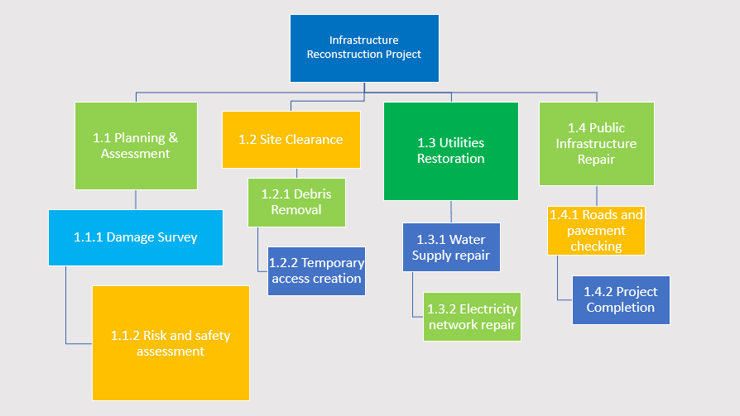
Figure 2: Work Breakdown Structure (WBS) of the project, outlining the major phases including planning, assessment, design, construction, and testing.

Quad Chard
Project | stakeholders
Reconstruction of a principal transport corridor in the West Midlands following flood damage. | - Local Council  - Project Manager  - Engineers  - Contractors  - Environment Agency  - Local Community
Measure of Success | Measure of Success
- Restored road access  - Improved flood resilience  - Safe transport infrastructure  - Minimal disruption to community | - Project completed within 6 months  - Within budget  - Reduced future flood damage  - High stakeholder satisfaction
Figure 3: The Quad chart summarizes the project’s key aspects, such as the project overview, stakeholders, desired outcomes, and success metrics. It provides a succinct visual representation that facilitates effective communication among stakeholders. The chart highlights the project’s main objectives and defines how success will be measured, ensuring that project goals are aligned with expected outcomes.

Ganttchart

Figure 1: The project schedule and important stages over a six-month period are depicted in the Gantt chart. Planning and site assessment precede the design phase of the project. Given the difficulty of reconstructing the transportation infrastructure, the construction phase is the longest. Testing and handover are part of the last stage to make sure the project satisfies safety and quality requirements. The Gantt chart facilitate efficient time management and aids in project monitoring.

Stake holder analysis
KEEP SATISFIED | MONITOR
- Service of emergencies  - Regional transportation authorities | - Environmental organization  - General public
KEEP INFORMED | MANAGE CLOSELY
- Local companies  - Local resident | - Department of transportation  - Worcester City Council

Stakeholders were analysed based on their level of power and interest to ensure effective communication and project success.

Allocation of resources
Resources were allocated to ensure efficient project completion focus on using time, budget, and workforce effectively. Proper allocation helps avoid delays and overspending.
Human resources:
Project manager-oversees planning and execution
Engineers, designers- develop and design the project
Construction workers- carry out implementation
Health & safety officer- ensures safe working conditions
Material resources
Construction materials (e.g. concrete, steel, equipment)
Tools and machinery required for implementation
Technology and software for planning and design
Financial
Budget allocated for each phase of the project
Cost control measures in place
Regular monitoring to prevent overspending
Time
Project timeline managed using Grantt chart
Deadlines set for each stage
Progress tracked to ensure timely completion

RISK ANALYSIS
Risk | Likelihood | Impact | Risk Level | Mitigation Strategy
Severe weather delays | High | High | High | Adaptable timeline and backup time
Budget overrun | Medium | High | High | Overrun of the budget
Material supply delays | High | Medium | High | Frequent budgetary control monitoring
Health & safety incidents | Low | High | Medium | Delays in the supply of materials
Environmental damage | Medium | High | High | Observe environment laws and regulations
Stakeholder conflicts | Medium | Medium | Medium | Frequent stakeholder meetings and communication
Design errors | Low | High | Medium | Expert evaluation and quality assurance
Figure 5: Risk management is a critical part of the project management process. Risk assessment identifies potential risks to the project’s successful delivery.

RACI Matrix
Task |  | Project Manager | Engineers | Contractors | Local Council | Environment Agency | Community
Project Planning |  | A | C | I | C | C | I
Site Assessment | R |  | A | C | I | C | I
Design |  | A | R | C | C | C | I
Constructors |  | C | R | A | I | I | I
Risk Management |  | A | R | C | C | C | I
Monitoring & Control |  | A | R | C | I | I | I
Project Completion |  | A | R | C | C | I | I
Figure 4: RACI matrix
The roles and responsibilities of important project stakeholder’s accountability, communication, and task ownership clarity. While engineers and contractors are mainly compliance and environmental considerations, stakeholders like the Environmental Agency and local authorities are consulted.
been assessed according to its likelihood and potential impact. High-level risks like weather delays, budget overruns, and supply chain issues necessitate proactive risk management strategies. By implementing appropriate control measures, the project team can reduce disruptions and keep the project on track and within budget.

CONCLUSION
The flooding in the West Midlands caused significant damaged to infrastructure, disrupting transportation and economic activities. Restoring the damaged highway corridor is essential for supporting community recovery and improving regional connectivity.
This project management plan outlines a structure approach to reopening and reconstructor the flood-damaged highway. By applying project management principles such as scope definition, work breakdown structures, stakeholders’ engagement, and risk management, the project can be completed efficiently and safety.
Successful implementation will restore transportation access, support economic recovery, and improve resilience against future flooding events.

Reference
Project Management Institute (2021) PMBOK Guide.
UK Government (2022) National Flood and Coastal Erosion Risk Management Strategy.
Hillson, D. (2016) Managing risk in projects.3rd ed. London: Routledge.
Kerzner, H. (2017) Project management: A system approach to planning, scheduling and controlling.12th ed. Hoboken: Wiley.
Lock, D. (2020) Project management. 11th ed. London Routledge.
Project Management Institute (PMI) (2921) A guide to the project body of knowledge (PMBOK Guide). 7th ed. Pennsylvania.
UK Government (2025) Flood Recovery and Infrastructure Report.
Project Management Institute (PMI) (2021) A Guide to the Project Management Body of Knowledge at: https://www.pmi.org(Accessed)21 April 2026).
Association for Project management (APM) (2022) What is project management? Available at: https://www.apm.org.uk (Accessed:21 April 2026).
Environmental Agency (2023) Flod risk management strategy.
Project Management Institute (2021) PMBOK Guide.
UK Government (2022) National Flood and Coastal Erosion Risk Management Strategy.
Environmental Agency (2023) Flod and coastal risk management report. London: Environment Agency.

