The use of technology in a healthcare sector

Name: Mary Joseph-mang
Student number: 2030737
Lecturer: Terry Walcott
Submission date:10/01/2022

Contents

- Introduction
- Benefits of technology in the healthcare sector
- The use of technology during the global pandemic
- How much has technology improved healthcare

Introduction
Overtime, the incorporation of technology in the healthcare sector has resulted in the improved patient diagnosis and treatments . The healthcare sector is undoubtedly the most significant of all the areas that have benefited from it . As a result, the quality of life has improved throughout time, many lives have been spared .Technology has rapidly become something that we use in our day to day lives from browsing to communicating with love ones and colleagues to researching and learning new things. Technology is the new normal and it plays a vital role in the healthcare sector today. Mobile technology has changed the environment we live in over the last decade, affecting everything from how we watch television to how we hail cabs. Now, a new revolution fueled by mobile technology, artificial intelligence (AI), and other emerging technologies is poised to transform healthcare forever.

The benefits of technology in the healthcare sector
There are several advantages of using information technology in healthcare, sometimes they are known as health information technology. To begin, information technology allows health care providers to store and access data from a patient's medical records. It also improves patient communication by providing a readable format that anybody may utilise. As a consequence, the likelihood of drug mistakes is reduced. Finally, it facilitates the retrieval of patient information from a database without the need for fresh health tests. All of the technologies mentioned above in healthcare have one thing in common: they increase patient health and safety. The usage of medical technological instruments ensures the safety of patients. First, there are medication warnings, flags and reminders, consultation and diagnosis reports, and improved patient data accessibility. Alerts, in particular, might assist someone in sticking to specified medications and treatment regimens. Additionally, computerised data recording can contribute to uniformity of practise across all health professionals. Finally, based on previous data, utilising an electronic health record can enhance the care delivered for common illnesses.

Many revolutionary technological developments in healthcare have occurred in recent years:

- 3D printing – 3-D-printing Has been used in a variety of sectors for several years. When it comes to the healthcare sector, it develops implants and even surgical joints. It can also be used in the creation of perfectly matched limbs which will allow the increase of movement and comfort.
- Artificial organs- Similar to 3D printing but this is for functioning organs which will mean the immune system of the patient will not reject them. This could also be called bio printing which is emerging technology with health care which has a potential to save millions of lives.
- Robotic surgery- This gives surgeons more control and flexibility so that they can operate less and he also makes surgeries a lot more easier.
- Health wearables- Health wearables began as a fitness tracker to track heart rate and pace but now it is included in healthcare applications it will-make it a lot easier to detect cardiovascular irregularities and will be easier to avert serious problems.
- Virtual reality (VR)- Virtual reality is very common in this day and age it is mostly used for entertainment purposes. This can help medical Students gain real life experiences with a visual of the human autonomy.
- Telehealth- This is a fast growing market which will allow patients to access their medical can on digital devices. This will also enable patients to contact their doctor efficiently and also this will allow doctors to give diagnosis as well as medical advice .

In the healthcare industry, the revolutionary effect of technology is unmistakable. Despite the fact that it is a field that requires highly competent employees with many years of education, it is also one that requires a lot of infrastructure and instruments. The rise in global life expectancy and the ageing of populations have created a high need for healthcare innovation and technology.

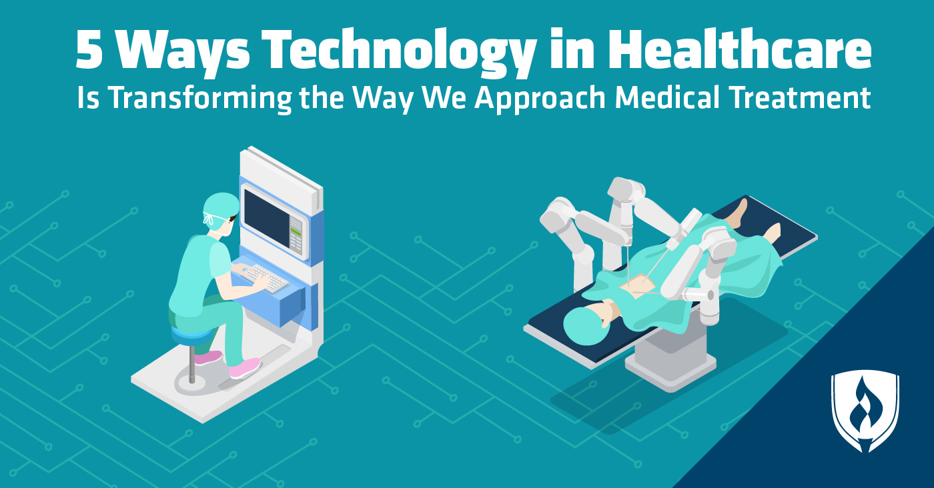

The use of technology during the global pandemic in the healthcare sector
The worldwide epidemic of COVID-19 is hastening the need for digital reinvention and adoption of healthcare technology solutions. Allow IBM's experience to guide you through an increasingly linked and data-rich environment. Rethink your transformation strategy with a smarter design, modernised core systems, open standards, and increased data value. We work with you to provide safe platform experiences that meet your data and AI demands across the company.

Various applications were used during the pandemic by Healthcare are professionals for example applications like zoom, WhatsApp, Zoho, Google workspace, google hangout , Microsoft teams, telegram etc

These were the various applications that were used by healthcare professionals and patients to communicate during the pandemic, it was a safe and efficient way to communicate at the time. This was also a safe way for people who were vulnerable to covid 19 to communicate it gave them a peace of mind knowing that they could communicate with doctors , nurses etc in the comfort of their homes were they were safe and not having contacts with other people.

How much has technology improved healthcare
The replacement of outmoded paper records with electronic health records (EHRs) has been a game-changer for everyone in the medical field. This industry-wide deployment has touched a variety of positions, from medical assistants to medical coding experts to registered nurses.
Nurses and technicians are in charge of entering patient information into a centralised, computerised system. Medical billers and coders update patient records with diagnostic codes (such as test findings) and submit medical claims to insurance companies at their scheduled visits.
Patients may now access their information at the touch of a button, which ensures that mistakes are identified sooner.
This has saved a lot of time in the health care sector.

References

https://ied.eu/blog/importance-of-technology-in-healthcare/

https://www.ibm.com/industries/healthcare?utm_content=SRCWW&p1=Search&p4=43700067988230949&p5=e&gclid=CjwKCAiArOqOBhBmEiwAsgeLmQ-lNkYChGt-7Rne926OWgXg53-YuVqWVA2OtjWAbd_uL71WQrtMzhoCnO8QAvD_BwE&gclsrc=aw.ds

https://www.rasmussen.edu/degrees/health-sciences/blog/technology-in-healthcare-transformation/

