

Component 1- Coursework: Portfolio
Software Solutions for Business
ACCA4026

Student name: Syed Ahmed
Student ID: 2545458
Date:10.08.26
Lecturer’s name: Kwame Assa-Agei, Fahed Ahmed

Table of content
Introduction 2
Task 1 2
1.1 Shopify 2
1.2 Wix 3
1.3 Comparison of Shopify and Wix 3
Task 2 3
2.1 What is Mind Mapping? 4
2.2 My Mind Map 4
Task 3 5
3.1 Microsoft Word 5
3.2 Microsoft Excel 6
3.3 Microsoft PowerPoint 8
3.4 Microsoft Access 9
Feature One 11
Feature Two 13
Task 4 15
4.1 Microsoft Teams 15
4.2 Google Docs 17
Conclusion 18
References (IEEE Style) 19

Introduction
The use of digital technologies is vital in enhancing business efficiency, communication, and decision making in modern organisations. The portfolio is an investigation of various modern software packages which assist in everyday business activities such as e-commerce website builders, mind-mapping software, Microsoft Office applications, communication and collaboration software. Academic research and demonstrations are combined in the portfolio to assess the productivity improvements, data management, teamwork, and information sharing benefits of these technologies. A series of practical activities using screenshots illustrate the use of important software features in realistic business scenarios. In general, this portfolio provides a good overview of the relevance of digital software solutions for effective and efficient performance in the workplace.

Task 1

1.1 Shopify
Shopify is a cloud-based ecommerce platform that allows companies to build, manage, and expand online stores without needing to have advanced coding expertise. It offers a comprehensive solution to sell products on your website, social media and online marketplaces, and handle payments, inventory and customer orders from a single place. It offers customisable website templates, secure payment processing, inventory management, order tracking, marketing tools, analytics, and access to thousands of third-party applications from the Shopify App Store.
Shopify's great thing is that it's easy to use, and companies can create a professional online store easily. It can be easily scaled, so it is ideal for small start-ups and big companies, and provides security, mobile friendliness, and 24/7 customer support. Shopify has some drawbacks, such as the monthly subscription fee, extra transaction charges in case you use external payment gateways, and the fact that it's less customisable than a completely built website. Shopify is ideal for entrepreneurs, small and medium-sized businesses (SMEs), and established online retailers looking for a secure, scalable, and easy-to-use platform to manage their online business.

1.2 Wix
Wix is a cloud-based website builder that allows anyone or any business to build a professional website and online store with a drag-and-drop system without coding. It comes with a variety of customisable templates and built-in features for website design, eCommerce, blogging, booking systems, and digital marketing. The intuitive website editor, secure hosting, mobile optimisation, search engine optimisation (SEO) tools, online payment options and app marketplace to enhance the functionality of a website are key features.
Wix's most notable feature is its intuitive interface, which is perfect for those looking to build a website without extensive technical knowledge. It also offers customization options, cost-effective pricing models, and inbuilt marketing tools to help businesses quickly get an online presence. Wix also has some drawbacks, such as less flexibility in modifying templates after the content is published, less advanced e-commerce capabilities than other dedicated platforms like Shopify, and limited scalability for large online businesses. In summary, Wix is ideal for freelancers, small businesses, start-ups and organizations looking for an attractive and user-friendly website that offers simple to moderate e-commerce capabilities.

1.3 Comparison of Shopify and Wix
Shopify and Wix are both options that can help businesses get online and start selling products via ecommerce sites. Shopify, on the other hand, is specifically created for online retail and has more sophisticated attributes for inventory management, payment processing, and business scalability, which makes it appropriate for medium and big e-commerce businesses. Wix, on the other hand, emphasizes simplicity, affordability, and flexible website design, making it a suitable option for small businesses, freelancers, and individuals looking for an easy-to-use platform with basic to moderate e-commerce features.

Task 2

2.1 What is Mind Mapping?
Mind mapping is a visual organising, linking, and communicating process around a central theme. A mind map starts with the main topic in the center with related ideas, concepts and tasks radiating outwards in a structured manner. This helps the user to grasp relationships between parts of information and easy the complex topics. Mind Mapping is mainly used for brainstorming, planning, problem solving and knowledge organisation. It allows people and groups to arrange information and make connections more effectively than linear notes, providing a visual display of information.
There are a number of advantages to mind mapping for business. It stimulates creativity by enabling free flow of ideas, aids memory and understanding by visual organisation and aids better decision making by clarity in the presentation of information. It also boosts productivity by enabling employees to prioritize tasks, plan projects, and manage workflows effectively. In the business world, mind maps are commonly used for project planning, strategic planning, meeting preparation, process improvement, and team collaboration. Mind maps can be used by managers to plan business goals, delegate tasks and uncover possible issues; by employees to brainstorm, resolve problems, and convey information. This makes mind mapping a useful means of enhancing the planning and collaboration of organisations.

2.2 My Mind Map
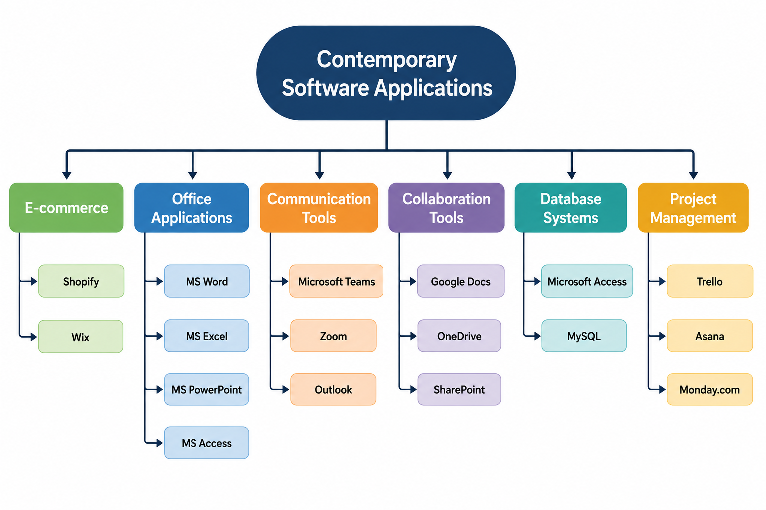

Task 3

3.1 Microsoft Word
Microsoft Word is a popular word processing program that allows users to produce, edit, format and publish business documents. It is generally employed in business activities to create reports, letters, meeting agendas, contracts, manuals, and other business documents. It is very user-friendly and has a lot of formatting options, making it a must-have tool for everyday office work and business correspondence. Microsoft Word provides various features to enhance document creation and management. They include templates for professional documents, spelling and grammar checking, word formatting, tables, charts, images, SmartArt, page layout options, headers and footers, auto table of contents and mail merge to create personalised letters or emails. It also enables cloud storage with Microsoft OneDrive, so users can get their documents from various devices and work together in real-time. For example, a human resources department can use Microsoft Word to create employment contracts and personalised offer letters using the Mail Merge feature. In a similar way, a project manager can create a project report using tables, charts, and pictures to clearly inform the stakeholders about the project's progress.
Microsoft Word offers a few benefits to business processes. It helps to boost productivity by making document creation easier, adds an extra level of professionalism with its advanced formatting features, minimizes the chances of document errors with its proofreading capabilities, and facilitates collaboration by allowing for document sharing and real-time editing. It can also be used with different file types, allowing for easy sharing of documents with clients and colleagues. While the advantages of Microsoft Word are numerous, there are some disadvantages. Documents with complex formatting might not format the same when opened in other software, and users will need to acquire new skills to use more advanced features. In addition, organisations will need to typically buy a Microsoft 365 subscription to use the most recent capabilities and cloud-based services. However, Microsoft Word is still one of the most dependable and popular office software to use for professional business documentations.
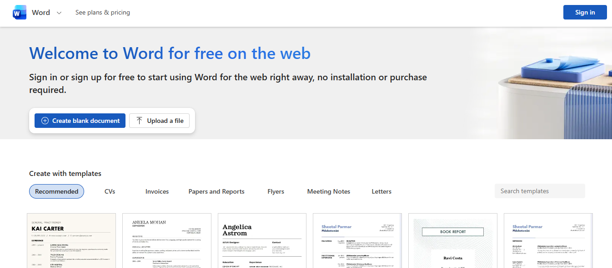

3.2 Microsoft Excel
A spreadsheet program that is commonly used in business to organize, analyse and manage data is Microsoft Excel. It helps users to analyze data correctly and make decisions based on it and generate reports. In finance, accounting, sales, human resources, project management, and other fields, Excel can handle large amounts of numerical and text information and is used often.
The primary role of Excel is to organize business data into rows and columns to store and analyze the data in a structured manner. It enables them to keep track of business data like sales, employee records, budgets, and inventory, etc., and helps them notice trends. There are many advanced charting options in Excel that can convert raw data into charts such as bar charts, line graphs, pie charts, and scatter plots. These charts assist managers and stakeholders in comprehending trends, measuring performance, and sharing business data.
The application also has a variety of pre-programmed functions that perform calculations and enhance accuracy. These functions are commonly used in finance calculations, logical testing, and retrieval from a large dataset such as SUM, AVERAGE, COUNT, IF, VLOOKUP and XLOOKUP. Tables are a useful feature that can be used in Excel to organise data clearly and automatically sort, filter and format data. Records are easier to handle, and reports are easier to prepare in tables, without having to make adjustments to ranges of cells.
Another important feature of MS Excel is Automation. Users can automate repetitive tasks using formulas, PivotTables, conditional formatting, Flash Fill, and macros. These attributes help lower manual workload, boost efficiency, and decrease the chances of human error in business operations. There are a number of benefits to using Microsoft Excel. It increases data accuracy, enables data analysis for informed decision making, saves time for calculations, and generates professional reports and charts. It also is highly compatible with other Microsoft Office applications, which makes it easier to share information.
There are a few restrictions, however, with Excel. Large amounts of data can slow down performance, complex formulas can be hard for novices to use, and formulas or data entry errors can yield inaccurate results. In addition, Excel is not as well suited as other database systems to handle large amounts of relational data. Although there are some restrictions, Microsoft Excel is one of the most useful and commonly used programs for business data management and analysis.
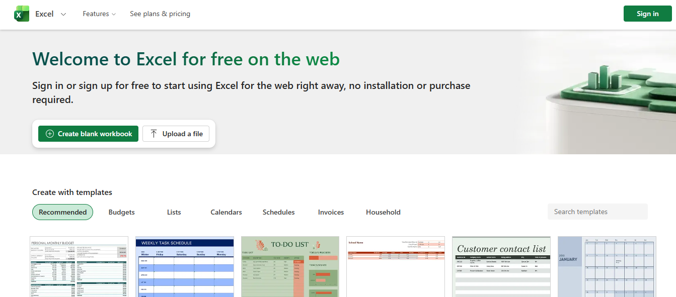

3.3 Microsoft PowerPoint
Microsoft PowerPoint is a presentation software application that was developed by Microsoft Corporation that allows a user to create, edit and deliver professional presentations. It is popular in offices, schools, and various organisations for conveying messages, sharing information, and conducting training and support sessions. PowerPoint enables information to be presented in slides, which helps to make even complex topics easier to understand due to the combination of text, pictures, and visual elements.
The main function of Microsoft PowerPoint is to present information in a clear, interesting, and organized way. It is used by businesses to make sales presentations, project updates, training sessions, marketing proposals, business reports etc. A great presentation is key to making your audience understand your material and to communicate effectively in meetings and conferences. PowerPoint has a variety of presentation tools which can help you make attractive slides. These include professionally designed templates, themes, SmartArt graphics, charts, tables, icons, diagrams, and drawing tools. Users can also use speaker notes, hyperlinks, and section dividers to enhance the structure and delivery of presentations.
Animation features enable users to specify the way text, pictures and objects enter into slides. Animations for entrance, emphasis, and exit and motion path can be used as a way to draw attention to important elements and hold the audience's attention. Moreover, slide transitions add the transition between slides, making the presentation more professional. Animations should be used sparingly, however, to not distract the audience. PowerPoint also has multimedia capabilities including drawing, audio, video, screen recording, and voice-over. All these features will enhance the interactivity and engaging nature of the presentation and enable the presenter to convey more complex concepts. Multimedia can be especially valuable for product demonstrations, staff training, and presentations to students.
Microsoft PowerPoint offers several benefits for businesses. It's easy to use and presents information in a clear, easily understood way, adds visual and multimedia elements to make it more engaging to the audience, allows team collaboration in the cloud with Microsoft 365, and can be integrated with other Microsoft Office applications like Word and Excel. It also enables presentations to be shared in various formats, such as PDF and video. While there are these advantages, there are also some disadvantages to PowerPoint. Too much text or animation can make a bad presentation. Making quality presentations can also be time consuming, and there are certain advanced features that require a Microsoft 365 subscription. However, Microsoft PowerPoint is still one of the best ways to present professionally and convey business information.
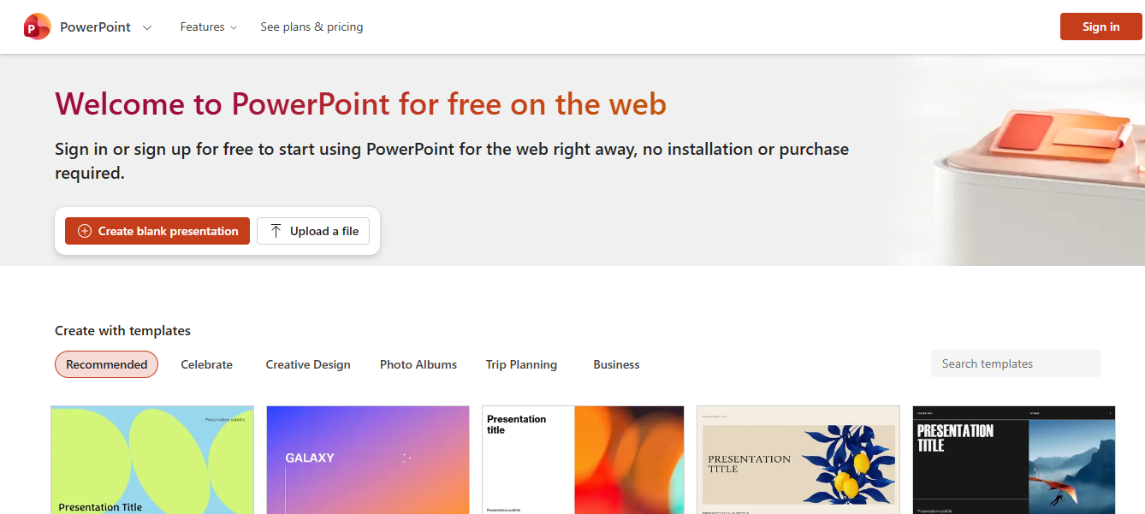

3.4 Microsoft Access
Microsoft Access is a Database Management System (DBMS) developed by Microsoft which allows users to store, organise and manage large amounts of information efficiently. It is widely adopted by organizations of all sizes for handling structured data like customer records, employee information, inventory, sales transactions, and supplier details. Access uses tables to store data, unlike spreadsheet programs, which minimizes data duplication and enhances the accuracy of the data.
The main use of Microsoft Access is to build and manage relational databases where users can easily add, retrieve, and update information. Access maintains data consistency and integrity across related tables by maintaining links between the tables in common fields, allowing users to manage business data more easily. A major component of Access is its ability to create queries to search, filter, sort and analyze data to specific criteria. Queries enable businesses to get the information they need and carry out calculations and calculations that produce valuable insights without having to manually check huge amounts of data.
Access also has forms that have a user-friendly interface for entering, editing, and viewing records. By using forms, users can interact with the database without directly changing the tables, which can simplify data entry, minimize errors, and boost efficiency. Reports are another feature that is important, as this allows information from the database to be converted to professional documents to be printed or shared. Reports can aggregate data on sales, customer information, inventory, and financial information, and can provide a summary of these figures to aid in decision making for managers. There are a number of benefits to using Microsoft Access. It helps to organize data, avoid data duplication by using relational database design, ensures the accuracy of data, and enables users to develop their own queries, forms, and reports. It also provides seamless integration with other Microsoft Office applications, like Excel and Word, for more convenient exchange and analysis of business data.
But there are some drawbacks to using Microsoft Access. It works well for small to medium scale databases and can have performance problems for very large databases or for many users to access at once. There's also technical knowledge needed for advanced database design, and only Windows offers Access. For larger organizations, a more powerful database system like Microsoft SQL Server or Oracle might be a better option. However, these are the drawbacks of Microsoft Access, and it can still be a useful and cost-effective database for many business applications.
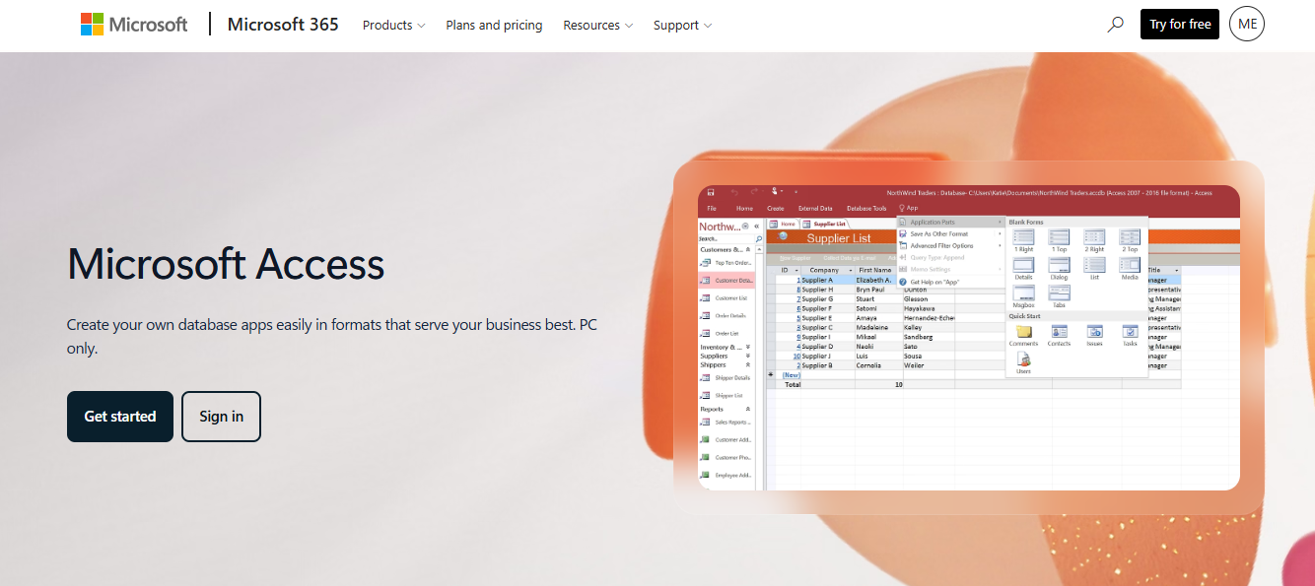

Feature One
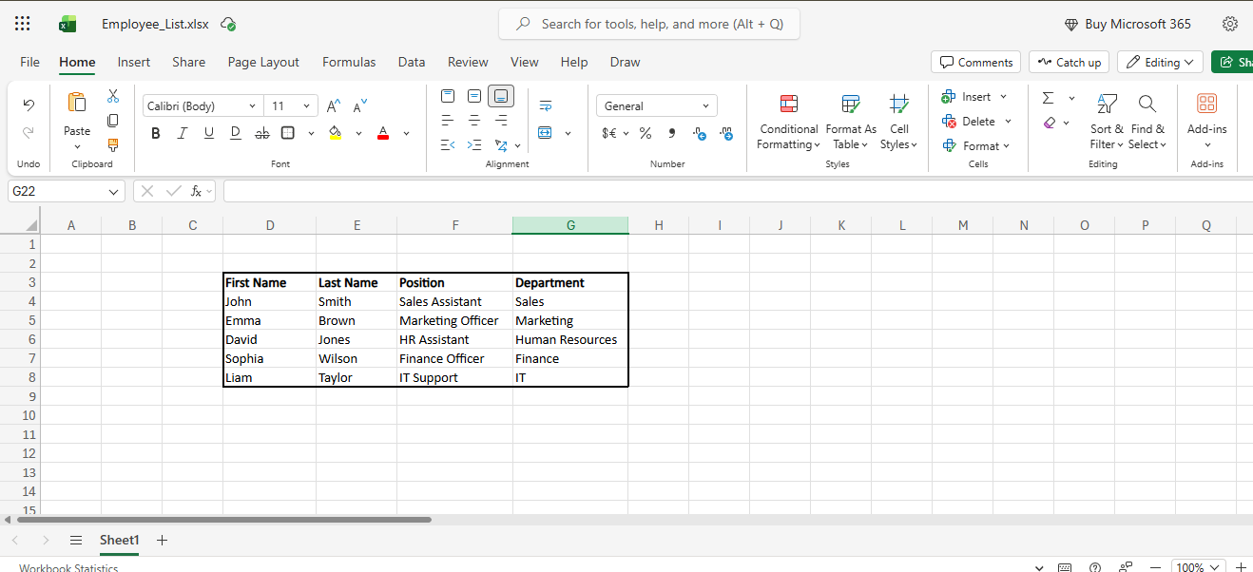
Figure 6. Employee details created in Microsoft Excel for use in Mail Merge
An Excel spreadsheet was created to store employee information, including first name, last name, job position, and department. This spreadsheet acts as the data source for the Mail Merge process, allowing personalised information to be inserted automatically into multiple documents.
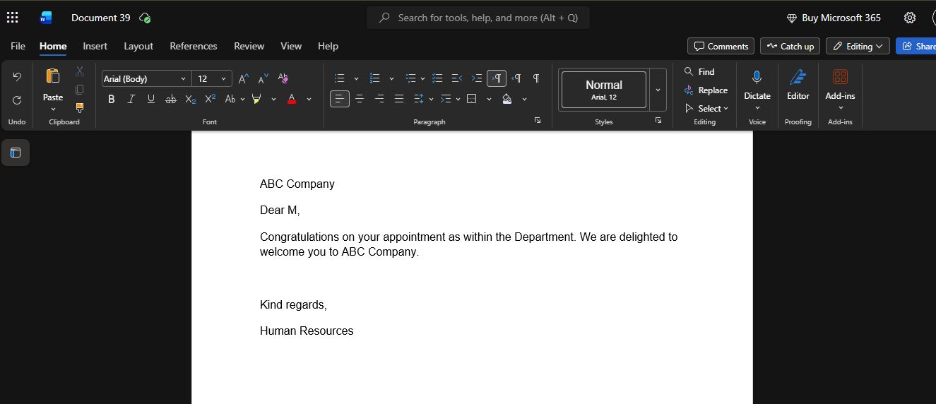
Figure 7. Standard appointment letter created in Microsoft Word before Mail Merge.
A standard business letter was prepared in Microsoft Word. At this stage, the document contains the main content of the letter but does not yet include personalised employee details.

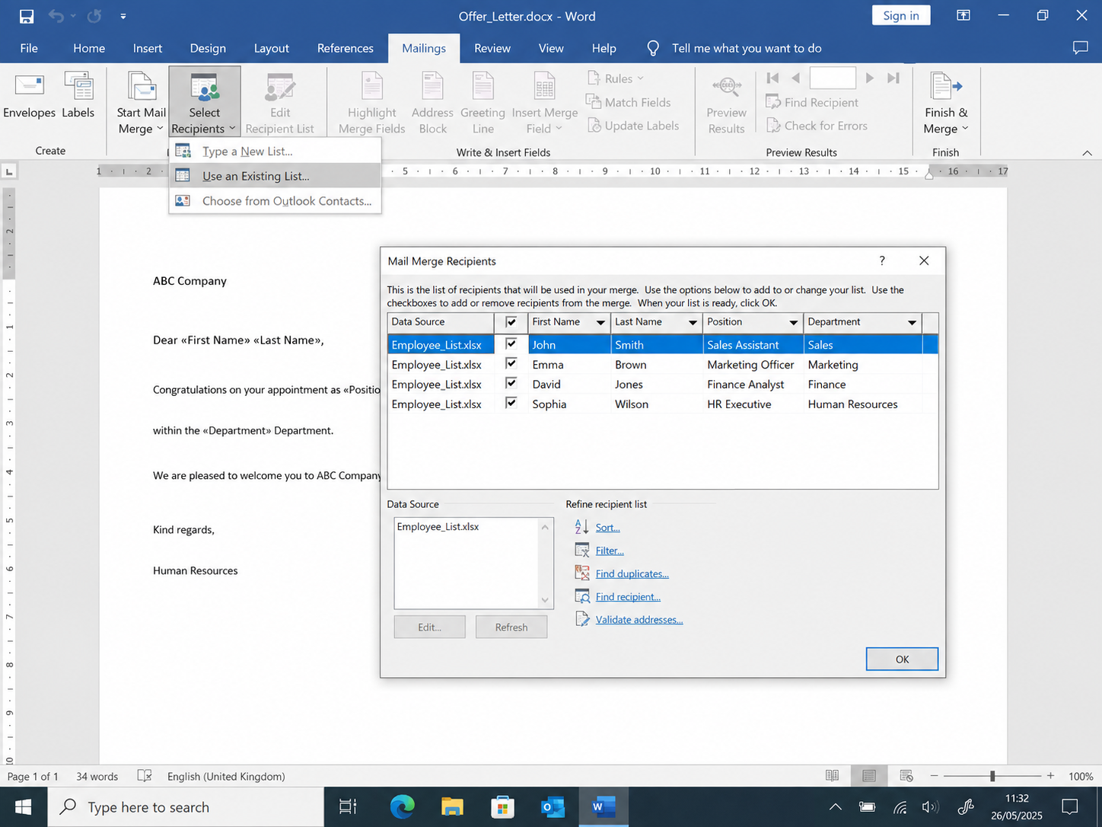
Figure 8. Selecting the Excel spreadsheet as the Mail Merge recipient list.
The Excel spreadsheet was linked to Microsoft Word by selecting Use an Existing List from the Mailings tab. This established the data source for the Mail Merge process and enabled Word to access employee information for generating personalised letters automatically.

Feature Two
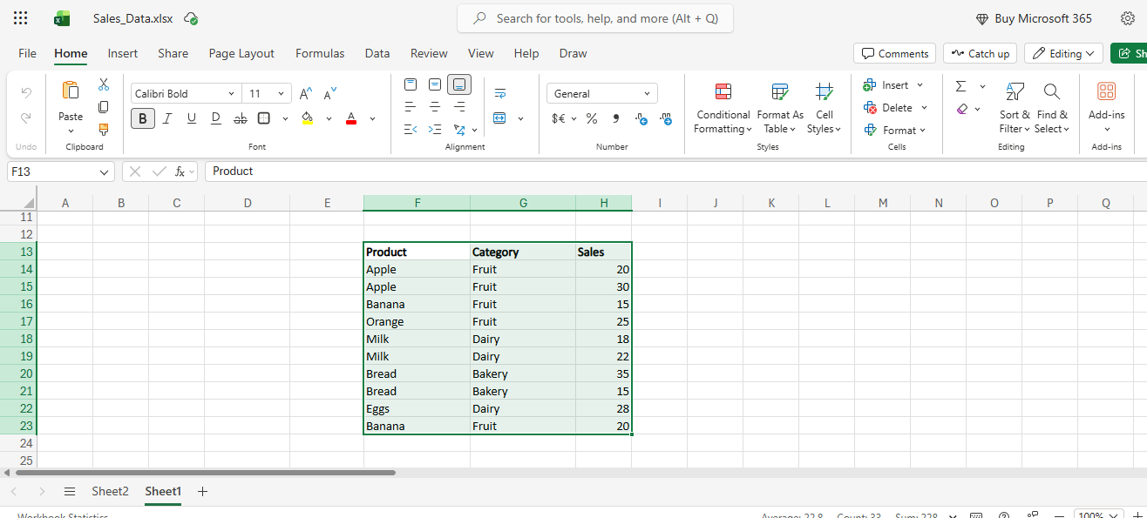
Figure 9. Sample sales data created in Microsoft Excel.

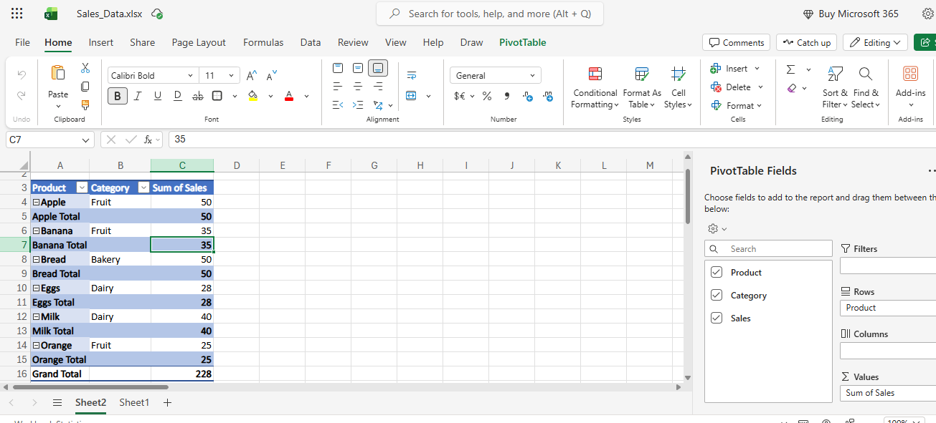
Figure 10. Creating a PivotTable from the selected dataset.
The PivotTable feature was selected from the Insert tab. A new worksheet was created automatically, providing a workspace to build a summary table without changing the original dataset.
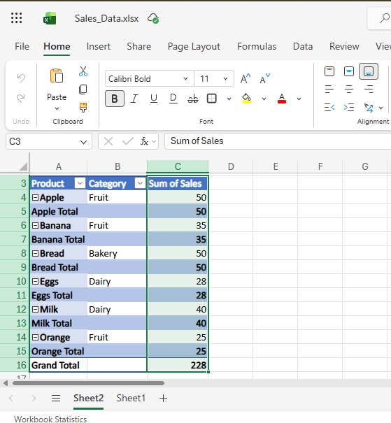
Figure 11. PivotTable summarising total sales of products.
The Product field was placed in the Rows area, while the Sales field was placed in the Values area. Excel automatically calculated the total sales for each product, providing a clear summary of the data.

Task 4

4.1 Microsoft Teams
Microsoft Teams is a cloud-based communication application designed by Microsoft which helps employees to communicate, collaborate, and share information within an organisation. It integrates IM, video conferencing, file sharing, and team collaboration into a single application, making it a must-have resource for today's business. Teams is part of Microsoft 365 and works with other Office applications, enabling people to work efficiently from anywhere. Microsoft Teams is all about enhancing communication and collaboration in the workplace. It allows staff members to connect in real-time via individual chat, group chat, and online meetings. Teams also facilitate remote and hybrid work with a hub that enables users to access files, chat with colleagues, and manage projects from anywhere.
Microsoft Teams provides several capabilities which make doing business more productive. These include IM, voice and video calls, online meetings, screen sharing, file sharing, team channels, calendars, and integration with applications like Microsoft Word, Excel, PowerPoint, OneDrive, and SharePoint. Additionally, users can record meetings, set up tasks, and work on documents together without having to switch between several applications. Microsoft Teams offers a number of benefits to businesses. It enhances communication by enabling quick information sharing among employees, promotes collaboration with shared workspaces and real-time document editing, and boosts productivity by consolidating various business tools into a single platform. It also provides flexibility as it allows users to work remotely and securely communicate with Microsoft's cloud-based security tools.
While there are advantages to using Microsoft Teams, there are also some drawbacks. Users might need to learn how to use it, and if the internet connection is not good, the quality of the meeting and communication could be impacted. Furthermore, if the platform is not properly managed, organisations with numerous channels and notifications might find themselves overwhelmed with information. In the business, Microsoft Teams are used for virtual meetings, coordination among the staff, communication with customers, training, or projects. It creates a secure and integrated communication environment that enhances team collaboration, workflow efficiency, and facilitates smooth business operations.
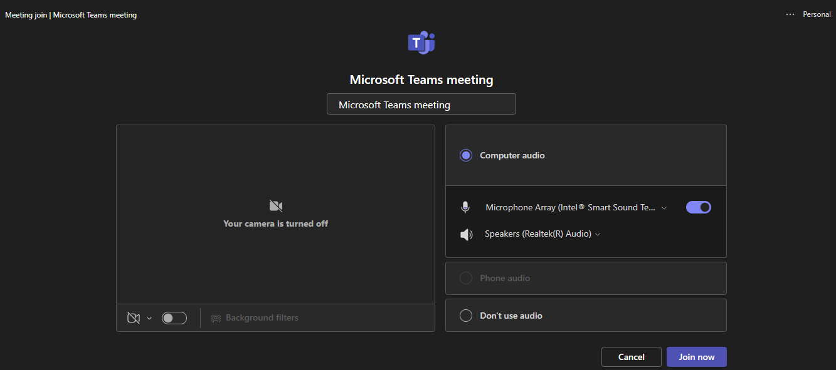
Figure 12. Starting a meeting from Microsoft Teams

4.2 Google Docs
Google Docs is a cloud-based word processor that allows users to create, edit, and share documents online. Businesses, education institutions and organisations use it widely due to the fact that it enables several people to operate on the same document from separate locations at the same time. Google Docs is part of Google Workspace, which allows for collaborative and efficient document management without the need to install software. One of the main reasons for using Google Docs is to make it easy to create documents and to get people working together. Users can create reports, meeting minutes, business proposals, policies, and other professional documents anywhere, anytime with an internet connection.
One of the key features of Google Docs is its document sharing capability. Users can send documents to co-workers via e-mail or create a shareable link. Organisations can manage who can view, comment on or edit documents through varying levels of permissions (Viewer, Commenter and Editor), enhancing security and collaboration. Google Docs also has live editing, which allows people to edit the same document at the same time. Changes are made instantly, and team members can work simultaneously, add comments, and offer suggestions while decreasing the number of versions to exchange.
Google Drive cloud storage is another great feature. Documents will be automatically saved while users are working, minimizing the chance of losing documents if they accidentally close or if the device fails. This also allows users to access their files from various devices like a computer, tablet, or smart phone. Google Docs comes with Version History, keeping track of all changes made to a document and who made each change. Document Management is more reliable as users can see the previous versions, compare changes and recover earlier versions when needed.
Google Docs has a number of advantages: it allows for real-time collaboration, automatic saving, quick sharing of files and costs less for software. But it does have its drawbacks. While some advanced formatting features are possible in Microsoft Word, Internet connection is required for optimal experience, and compatibility issues might arise in converting complex Word documents. However, with these restrictions, Google Docs is still a great tool to collaborate with others in today's business world.
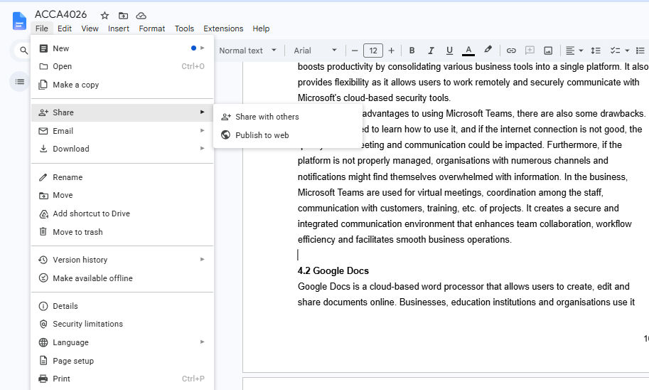
Figure 13. Sharing a file from google docs

Conclusion
This portfolio shows how a variety of modern software applications are used in business to enable efficient working and enhance productivity in the workplace. E-commerce platforms were discussed to show how businesses can set up and run their online platforms, and the use of mind mapping was demonstrated to show the importance of visual planning and idea organization. Microsoft Office applications (Word, Excel, PowerPoint, and Access) were assessed for their capacity to produce documents, analyse data, give presentations, and manage databases. Use of software features in real business context through practical activities was demonstrated in the context of Mail Merge and PivotTables. Furthermore, Microsoft Teams and Google Docs were explored to determine that they can be effective tools for communication and collaboration, enabling team working, both in the office and remotely. The overall findings of theoretical research and practical testing showed that digital software solutions have an important contribution to make towards enhancing communication, decision making, data management and organisational efficiency. These technologies are critical for the needs of today's business and for the productivity of the workplace.

References (IEEE Style)
[1] Shopify Inc., Shopify Features. [Online].
[2] Wix.com Ltd., Wix eCommerce Features. [Online].
[3] T. Buzan and B. Buzan, The Mind Map Book. London, UK: BBC Active, 2010.
[4] Microsoft Corporation, Microsoft Word. [Online].
[5] Microsoft Corporation, Microsoft Excel. [Online].
[6] Microsoft Corporation, Microsoft PowerPoint. [Online].
[7] Microsoft Corporation, Microsoft Access. [Online].
[8] Microsoft Corporation, Microsoft Teams. [Online].
[9] Google LLC, Google Docs. [Online].
[10] Google LLC, Google Workspace. [Online].
[11] Microsoft Corporation, Create a Mail Merge in Word. [Online].
[12] Microsoft Corporation, Create a PivotTable to Analyse Worksheet Data. [Online].
[13] A. Badiru and V. Agustiady, Information Technology and Management. Boca Raton, FL, USA: CRC Press, 2019.
[14] S. Stair and G. Reynolds, Principles of Information Systems, 14th ed. Boston, MA, USA: Cengage Learning, 2021.
[15] K. Laudon and J. Laudon, Management Information Systems: Managing the Digital Firm, 17th ed. Harlow, UK: Pearson, 2022.
[16] J. Walkenbach, Microsoft Excel 365 Bible. Indianapolis, IN, USA: Wiley, 2022.
[17] J. Lambert and C. Lambert, Microsoft Word Step by Step. Redmond, WA, USA: Microsoft Press, 2022.
[18] J. Lambert, Microsoft PowerPoint Step by Step. Redmond, WA, USA: Microsoft Press, 2022.
[19] M. Shelly, S. Vermaat and J. Sebok, Discovering Computers 2023: Digital Technology, Data and Devices. Boston, MA, USA: Cengage Learning, 2023.
[20] P. Turban, G. Solomon and R. Sharda, Information Technology for Management, 12th ed. Hoboken, NJ, USA: Wiley, 2021.

