Certificate of Higher Education Computing
Learning in the Digital Era
ACCA4025
Assessment 1: E-Portfolio
[Shahzad Khawaja 2128045]
https://sites.google.com/view/shahzad-khawaja

Contents
Study and employability skills 1
Automatic Referencing tool 1
References 2
'Life is a Team Sport' Activity 2

Study and employability skills
Some of the high-level qualities, skills and competences which will develop such transferable skills are as:
- creative thinking
- critical thinking
- making presentations

Creative Thinking

Creative thinking is all about developing and innovative solutions to the problems. A Creative thinkers brainstorm is not only many ideas, but it also had variety and range of them. You can manipulate the ideas in unusual ways and can make good connections to outline novel possibilities which have the potential to direct meet a given purpose. In another way Creative thinking is the ability to look at things differently and it can find new ways of solving problems and create new solutions.

Critical Thinking

In a Critical thinking it got the ability to think clearly and understand the logical connection between ideas. critical thinking does not mean looking only for the most important characteristics of a theme or just disapproving ideas. It’s also about not admitting what you read or what you going to hear at face value, but it always searching the information or ideas, and disagreements you find in your studies.

Making Presentations

Making presentation is a way of communicating your Views and ideas to an audience. When someone gives a presentation, they give a formal talk, often to sell something or get support for a proposal.

Automatic Referencing tool
Mendeley is a program for adding references lists and in-text citations to Microsoft Word documents [1]. By clicking "References" to locate a Mendeley Cite-O-Matic section, we may choose citations from our desktop Mendeley and insert them as in-text citations in your Word document. We can also choose our required reference style from the Style option box. We will select "Insert Citation" from the Mendeley Word plug-in bar and then use the search box to look up the pertinent citation [2].
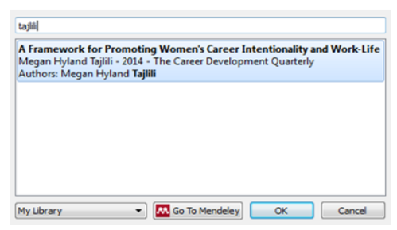
Figure 1: Mendeley Search Box [2]
Additionally, by choosing "Go to Mendeley" and selecting "Cite," we can choose a citation from our Mendeley library and add it to our work.
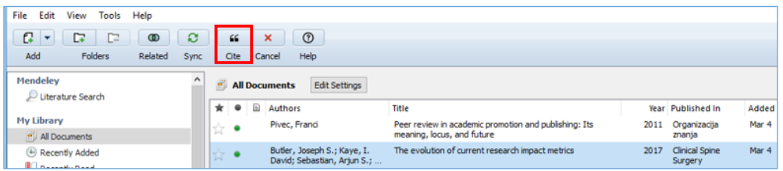
Figure 2: Mendeley library [2]
After making the necessary changes in our Mendeley library, we will amend the in-text citations in our Word document by clicking the "Refresh" button on the Mendeley Word plug-in bar [3].
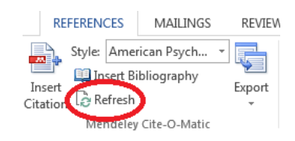
Figure 3: Editing in-text citations [2]
When we click an in-text reference in your document, the button labelled "Insert Citation" in the Mendeley Word plug-in bar changes to "Edit Citation," allowing us to delete an author or add a page number [4].
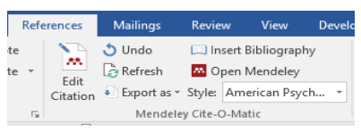
Figure 4: Edit citation [2]
We'll select "Insert Bibliography" to begin compiling our list of references. Each time we include a new in-text citation in our document, the reference will be immediately added to our reference list.
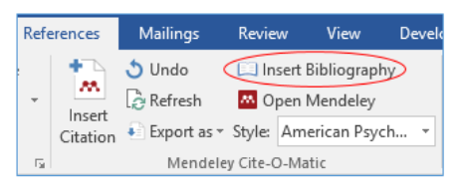
Figure 5: Insert Bibliography [2]

References

[1] | Mendeley, "Getting started with Mendeley Reference Manager," 2022. [Online]. Available: https://www.mendeley.com/guides/mendeley-reference-manager/.
[2] | A. Library, "Using Mendeley Cite," 1 April 2022. [Online]. Available: https://aut.ac.nz.libguides.com/mendeley/word.
[3] | ULS, "Introduction to Citation Management," 29 April 2021. [Online]. Available: https://pitt.libguides.com/citationmanagement/mendeley.
[4] | U. o. C. Irvine, "Mendeley Research Manager: Why Mendeley?," 15 June 2022. [Online]. Available: https://guides.lib.uci.edu/Mendeley.

'Life is a Team Sport' Activity
 | 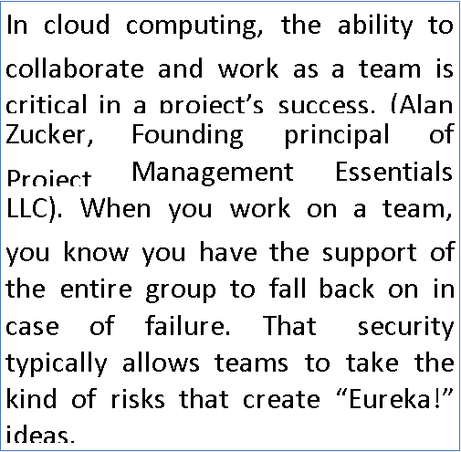
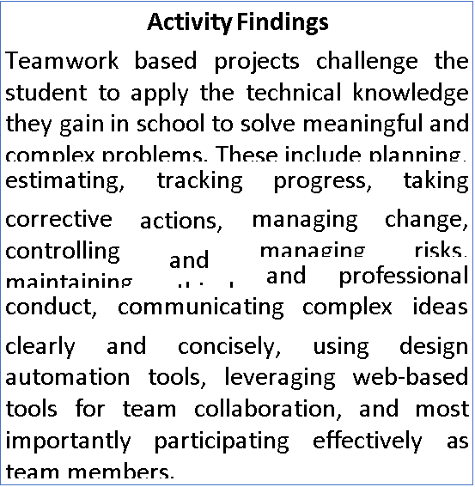 | 

