

CHROME BEYER AND NORMAN CONSULTANCY

London HEATHROW Marriott P.I.D. &
Final Consultancy Report

Erol Asan, 1814997
1814997@student.uwtsd.ac.uk
Lecturer: Efua Adams, M6X01930_LON
August 2020
Table of Contents

P.I.D (Project Initiation Document)..............................................2
Background……………………………………………………….2
Project Scope…………………………………………………….3
Deliverables……………………………………………………....3
Constraints and Assumptions………………………………...4
Confidence in the Audit Team…………………………………4
Project Control………………………………………………...…5
Project Initiation Day…………………………………………....5
Consultancy Report………………………………………………....6
Front Office/ Lobby Arrival…………………………………….7
Arrival Experience……………………………………………....7
Guest Check-In…………………………………………………..8
Bar…………………………………………….…………………...8
Room Service……………………………………………………9
Restaurant (Breakfast).........................................................9
General Bedroom……………………………………………...10
- Bedroom………………………………………………….….10
- Bathroom…………………………………………………....11
Lobby…………………………………………………………….11
- Public Restrooms………………………………………….11
- Elevators…………………………………………………….12
- Corridors…………………………………………………….12
Fitness Centre and Pool……………..……………………….13
Meeting Area……………………………………………………13
Back of House………………………………………………….14
Food Safety……………………………………………………..14
Sales and Marketing…………………………………………...15
Guest Service Delivery………………………………………...15
Financial Management…………………………………………16
Employee Engagement, Training & Development………..16
Leadership…………………………………………………....….17
Green Hotel……………………………………………………....17
Property Maintenance & Facilities Management……...…..17
Conclusion………………………………………………...……..18
Appendix………………………………………………………..…….19

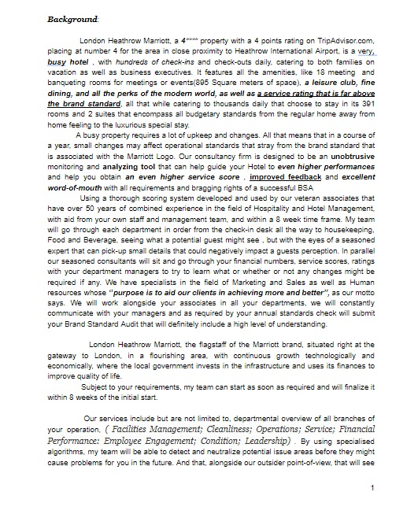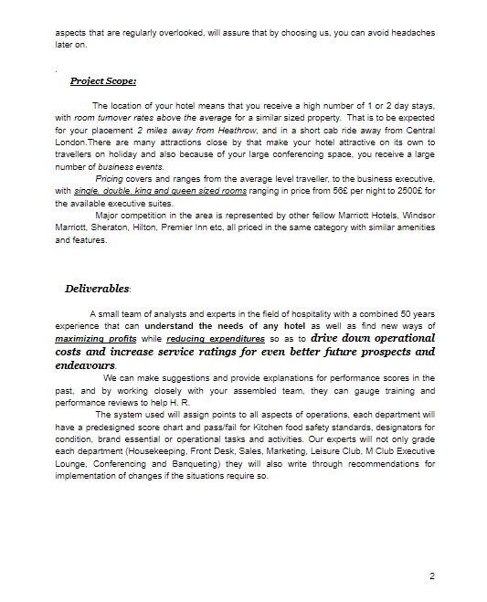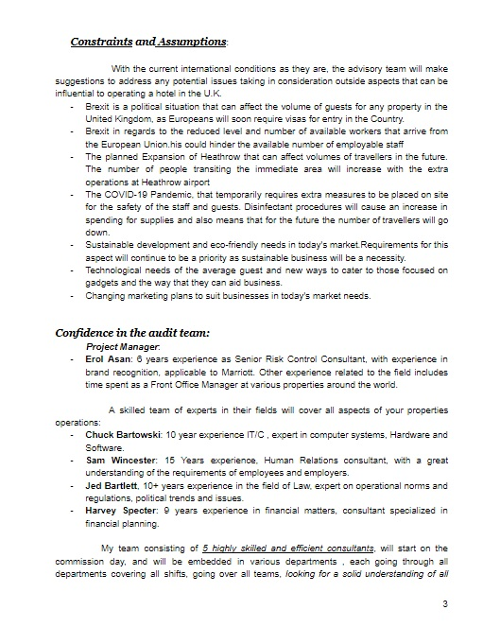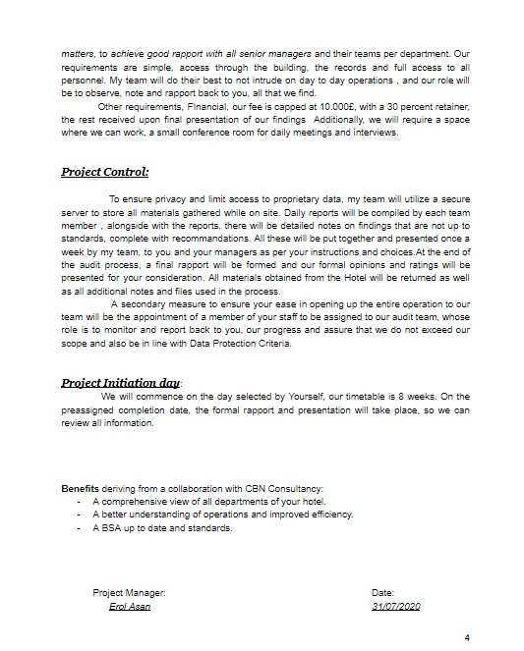

Consultancy Report

The following report is the work of Chrome Beyer & Norman, covering the activity of the London Heathrow Marriott in 2020, an evaluation as directed by the General Manager Ron Voss, that encompasses all the activity, quality, services, as observed by the audit team for the period of 8 Weeks (22 June 2020- 21 August 2020).
We thank the Marriott team for the chance we were given to work besides them, and we would like to show our appreciation for the openness shown by the organisation as a whole.
Below is a breakdown of our results, with an 88.88% score overall. All areas will be covered further from entry to exit, through all departments and areas of the hotel.
 | Points Available | Points Awarded
Lobby Arrival | 45 | 45
Arrival Experience | 15 | 15
Check-in Process | 135 | 130
Bar | 205 | 125
Room Service | 150 | 150
Restaurant- Breakfast | 265 | 195
Bedroom | 320 | 320
Bathroom | 220 | 220
Lobby | 50 | 50
Public Restrooms | 80 | 80
Elevator | 20 | 10
Corridors | 50 | 50
Fitness Centre & Pool | 100 | 100
Meeting Rooms | 80 | 50
Back of House | 110 | 100
Food Safety | 6 | 6
Department | Pass | Fail
Food Safety | 10 | 0

Front Office/ Lobby Arrival:
Score: 45/45

Upon first arrival at the hotel, any guest entering the lobby sees an immaculate, organised desk, fully staffed and ready to interact and help. Full marks were given as all the associates were at their stations, all active and engaging, seeking new people that just walked through the doors. Uniforms pressed, using the appropriate responses to cues as well as using Marriott Standard welcomes and salutations. The staff was engaging and cheerful, having information at hand and seeming genuinely ready to aid in any endeavours. The 5 stations were very busy at check-in time, but the wait was not felt.

Arrival Experience
Score:15/15

The atmosphere upon arrival on the Hotel’s grounds is crisp, the grounds are well maintained, the parking lot is clean and well marked, the facade of the building is clean and modern, no signs of wear and tear, the 2016 renovation has done a great job bringing the older building up to date. The flags were in order, clean and flying high, no signs of decay observed,

Guest Check-In

Score: 130/135

The check-in process was handled professionally, all pertinent information was given, about the hotel, services, times and available items for the guests use. The training was clear as the staff on the desk responded to cues, smiled genuinely, and had a general pleasant demeanor that reflected back an air of relaxation throughout the process. Technologically, the mobile check-in service was used and made the process streamline. The associate that I interacted with had all the required information, and inquired on all opportunities for upselling (room upgrades, BonVoy system, M Club Access, etc.) There was not wait time from entry into the lobby to being aided by the desk staff, and I was immediately called forward upon making visual contact with the employees.
An opportunity for better service towards the guests was observed to be during the passing of the room keys, room numbers must not be said out loud and the sleeve on its own is more than sufficient to inform the guest where to go and keep in line with Privacy and Data Protection Requirements.

Bar
Score: 125/205

The M Club Lounge is the in house bar offered at this property, it is a feature set aside for BonVoy members mostly but also an additional feature used in upselling. It has limited operational hours, as it is open and staffed only during Breakfast and Dinner hours, with access given throughout the day so guests can enjoy a self serve beverage, or snack. During the peak morning hours its role is as a buffet, staff being present simply to stock up the buffet line and clear the tables after use by the guests. The team here is polite and trained in being fast and efficient, as there are times where room must be cleared quickly due to large volume of use as peak hours. While many branded services are not available due to the self-serve nature of the lounge, the staff here will respond to queries and cues, will give out information or will make sure the manager can help the guest. Uniform wise, the staff wear aprons (understandably because of their primary role as table cleaners) but they are well cleaned and kept tidy.
The Dinner time presence is slightly different as there is also a level of waiter service, food and drinks can be ordered and upselling is possible and has been observed to be used.
Opportunities emerge with a recommended increase of staff and operational hours, some branded features being currently inaccessible to the team. Service would emprove with:
- The presence of a Lounge Host.
- Diversity in the menu.
- Increase of available features during the day.
- Further training for the wait staff on cues and responses.

Room Service
Score: 150/150

This service is outside the Marriott’s purview as it is run by Carluccio’s, a restaurant within the property but not owned and operated by the Marriott. It has shown some impressive qualities, from the adequate use of the name upon calling, the responses to the call, responding to cues, using opportunities for upselling, the room service itself, food quality above reproach. The standards were also upheld by the server that was prompt in delivering the order, and followed the Brand Standard Protocols when dealing with a guest.

Restaurant - Breakfast
Score: 195/265

While visiting the M Club Lounge for breakfast, the following items were observed:
- There was no personnel connection with the staff, as they seemed to be in a hurry at all times, however they were polite and responded to some cues. Branded features were seen laking as several opportunities were missed simply because of the high level of traffic.
- The food selection was impressive, covering all general requirements of guests, kids meal options also available. The quality was also beyond reproach and fresh.
- The presence of to-go cups was appreciated even though the drinks station was self-serve.
- Recommendations could be made concerning the increase of staff, rearrangement of tables to better suit the high volume of guests at peak hours and an increase in training for some of the wait staff that seem to not be informed on the contents of the menu items, recipes and allergens.
- The lower score reflects the impersonal touch as the breakfast service is self-serve, it lacks the features of a regular restaurant.

Bedroom
Score:320/320

All standards have been observed to be at top scoring level, maximum score was awarded to the room appearance as the criteria were met with ease, the Housekeeping department being at top condition for presentation, cleanliness and procedures.
The renovation process has left the rooms looking like new, modern furniture, new technology (television, phone, wi-fy Signal all beyond reproach), the condition of the carpets and floor was impressive, the cleaning team shows its attention to detail and all branded features were both present as well as in top working order.
No improvements could be seen to be needed as the assigned room was up to the high standards of the Marriott chain. Quality was present from the moment of entry into the room, to its eventual exit.
Housekeeping staff was observed to be courteous as well as expedient in the accomplishment of their duties. Uniforms were tidy and clean, up to standards. The rooms showed no sign of prior use, which for an establishment like the London Heathrow Marriott with its high room turn-over, and increased check-in/ out on a daily basis is quite an accomplishment.

Bathroom
Score: 220/220

Again the maximum score was awarded for the cleanliness and general condition found in the bathroom area. All items were present as they should have been, from towels and cups, to the toiletries that are standard, they were all in place. Top working order facilities shower, toilet and sink make the guest feel that their stay at a 4 star hotel is what they are getting. Quality wise products used and displayed were beyond reproach and points were awarded to the presentation and the manner in which they were arranged.

Lobby
Score:50/50

Cleanliness and condition of the lobby is beyond reproach as it was observed to be constantly patrolled by either the check-in desk staff , housekeeping or members of the maintenance team. This to maintain the first impression as flawless to anyone coming through the front doors. Members of staff were seen to interact with guests as well as clear trash and debris left behind by rushing patrons.

Public Restrooms
Score: 80/80

These areas were thoroughly inspected by the audit team, on several occasions, the condition and cleanliness of the facilities were beyond reproach. The role of the maintenance team being clear as all items were in clear functioning order. The cleanliness of the areas is maintained by a very diligent and meticulous team. No issues to be reported.

Elevators
Score: 10/20

The presence of 4 elevators in the lobby area was not felt during the audit process. 2 out of the 4 were shut down due to issues with the systems, and out of the remaining 2 there were several occasions in which one or the other were offline for several hours.
Because of the failure in condition of the elevators, the following plan must be put in effect immediately to avoid discomfort for guests as well as any future issues with their operation.
- The maintenance team must cordon off the 2 elevators that are not in use and mark them as NOT IN USE.
- A full and comprehensive check of the elevator systems must be done by a specialized company with experience in these types of facilities.
- All 4 must undergo an immediate safety check to ensure no problems could affect the wellbeing of the guests and staff that have been seen using them as well in the fulfillment of their duties.
- The maintenance team must make it a priority to see to the safety of operation for these facilities.

Upon fixing the issues found, opportunities for a better service score can be achieved as guests will no longer have to queue to use the elevators at busy times. Also this will alleviate the issue of too many people being forced to share the available elevators making the process more comfortable and quiet.

Corridors
Score: 50/50

The condition of the corridors is fine, no issues were found on any of the 6 operational floors. It was observed that there is a regular cleaning that is undertaken by the housekeeping staff that keeps dirt from being collected even though these areas see a lot of traffic throughout the day. Again the recent renovations have made a positive mark as the true age of the property is not observable to staying guests.

Fitness center and Pool
Score:100/100

These facilities have been observed to be in constant use by hotel guests as they are open at all hours of the day and accessible by card key. This service is also available to non guests as passes can be purchased separately by locals. The upselling opportunities have been monitored and it is a valid way of generating further revenue for the hotel without creating any discomfort to guests. The area is well staffed by competent people. The machines are new and all in working order. They are maintained and cleaned regularly by associates. The pool area is well ventilated and the water quality has been observed to be verified regularly. PH levels are verified at regular intervals and the temperature of the water is maintained constant. The Facilities are in working order and even with high usage no discomfort comes to those that choose to work out here.

Meeting area
Score: 50/80

While the general condition of these spaces is up to standards, the all around cleanliness could be improved. With a massive 895 square meters of available space in its 18 available meeting rooms, it is understandable that there is a large area to clean, to that point there are areas that have been noted as having lesser priority for the team here when it comes to overall cleaning. While it is not noticeable, the space could do with an extra deep cleaning of the carpets and walls during the times the various rooms are not used so as not to disturb the people using them.
Improvement in service score could be obtained by increasing the number of staff in this area, with the additional team members being assigned to aid in the cleaning process of such a large area. Otherwise all facilities seem to be in good working order, and new lending the space the air of new and modern.

Back of House
Score: 100/110

THe only area where points were not awarded is in regards to the straws in the cafeteria in the employee only area. No other issues minor or major have been noticed by the audit team. The general feeling in these areas is that of cohesiveness of the team, familiarity and ease. No issues were noticed, as this area as all other areas is maintained at a high level of cleanliness even though no guests have access here. Staff interviewed have responded positively to questions regarding the point system for Ambasador, Titanium and or other tiers of the BonVoy promotional program as well as all other branded features of the Marriott Hotels.

Food Safety
Score: 10/10

With a 100% pass when it comes to food safety, the kitchen area of the Hotel is up to standard. All procedures and logs are filled correspondingly, Hygiene standards are respected by all members of the staff, surfaces are kept clean, temperatures are respected for the various food types. All machines are in good condition and in good working order. The executive chef does a great job in training his staff in keeping standards high to prevent incidents. The new equipment in use also aids in accomplishing all duties without issues and avoiding problems that in the end would only be a problem for the guest. The training regiment already in effect seems to be doing its job very well and no issues have either been observed or noted in the past year.
Sales and Marketing

With a 4 / 5 rating on TripAdvisor and 314 reviews, the reputation of the London Heathrow Marriott is very good with room still for improvement. The team behind the Marketing plan is doing a great job currently, always being room for further improvement. The fact that the hotel is 5minutes away from a a major airport like Heathrow ensures that there will always be people interested in staying at an international branded hotel well known for its impressive quality and history. The social media presence of the property is quite extensive, Facebook, Instagram and Twitter being platforms from which promotions are generally announced to attract past guests and new ones as well. All unique projects are presented publicly to show the audience how active the brand is and what they are doing to stay current. Results are what prove they are doing such a great job, seeing as the property has an average booking percentage of 95% or more.

Guest Service Delivery

Opportunities for presenting a better guest service can be achieved by:
- Increase in staff numbers to make guests feel more helped by achieving more interaction with them.
- The lack of a concierge service full time could be an obstacle that could improve service score if reinstated.
- Having additional security cameras would increase the feeling of security with the guests feeling more protected.
- A more diverse menu in the M Club Lounge would encourage guests to eat there and not at Carluccio’s

Because of the general fast pace at which business is being handled at this property any additional staff and services could bring better service scores from people that have even more to applause if they will be made to feel as if they are home and differentiating this property from any other airport hotel.

Financial Management

Possibilities for increased profits can derive from creating partnerships with London tour operators, bus tours as well as creating an agreement with other businesses whose role is mainly tourism.
Other ways to decrease costs could be found by moving all dry-cleaning activities in house by investing in the machines that could wash and dry linens. This would reduce costs as well as wait times that occur when dealing with outside contractors.
Because of its low personnel retention numbers, especially in the housekeeping department, a suggestion might be moving towards and agency service for cleaning services that would ensure a continuous flow of necessary personnel without additional payroll costs and at the same time avoiding lack of available cleaners when shifts are missed.

Employee Engagement , Training & Development

Within the 8 weeks, the audit team has observed a great deal of personnel engagement, due to high levels of participation in events planned by the management. From the Wellbeing Challenge, to Cleaning up the Thames river, employees are happy to participate in charitable events sponsored by the Marriott. Engagement levels are high also because the training courses that are put up by the Marriott are very popular, employees being eager to further develop their skills and grow career wise.
Other examples of participation from associates are the pictures, paintings, volunteer sign-up sheets that can be found along the back of the house corridors, showing past, present and future projects with people at the property.

Leadership

The audit team recommends continuous training programmes to be put in place by the management team in order to maintain such a high level of quality for the future. However a major issue that we feel needs to be addressed is the problem in communication with the housekeeping floor supervisors, the current system is quite difficult for new employees to understand and having a better way to contact maids on the floor would increase the speed at which rooms are made available for guests. Team building exercises could also be used for strengthening team bonds especially between Front Office and Housekeeping and maybe also the addition of a liaison position between them to facilitate communication.

Green Hotel

LHM, is currently implementing recycling programs that are up to the Serve 360 standard. But that is not all, because of the renovation from the previous years water saving devices have been added, a more efficient air conditioning system has been put in place, as well as a training protocol for staff to help in saving the environment. The use of electric, or hybrid vehicles in its fleet is also a good step towards an even more sustainable property.

Property Maintenance & Facilities Management

In this report there have been many suggestions put up that would be beneficial to the properties future profits and would also reduce costs but we also see the need for an increased presence of the maintenance department, and IT, currently there being only two on site maintenance persons during the day, and none at night meaning that the 2 man team must handle quite a few issues in a limited timeframe. IT support is offsite and whenever there is an issue with the network, it takes time for it to be resolved, the extra cost of having an extra person on hand would reduce discomfort that might be felt by guests.

Conclusion:

We here at Chrome, Beyer and Norman hope that the audit led by our team in the past 8 weeks was as unobtrusive as possible and that our results and suggestions would be helpful for the coming years plan. Our conclusion in regards to the property known as London Heathrow Marriott is that during the past years you have diligently maintained a high level of quality, both in training and in practice and this year nothing has changed. We believe that your staff is very well trained and efficient, your practices are up to the standards of the Marriott International brand whose flag is present outside your doors and your facilities look brand new even with your high business traffic and continuous activity. We believe your organisation will fair well in the coming year and we believe that there will not be any issues that cannot be passed by the very talented management team.
In the future, please do not hesitate in contacting Chrome, Beyer and Norman Consultancy for any other guidance concerning any of the recommendations we have presented in this document.

Appendix

