A Lean Assessment of a Production Warehouse Environment: Using a case study of Cabot Carbon Ltd, FMO Division Barry Site

MSc Lean & Agile Operations Final Project Report

Shaun Richards – Student 1904543

Acknowledgements
I would not have been able to complete this project without the guidance and support of my supervisor, company colleagues and family.
I would like to extend my thanks to my project supervisor, Mr. Andrew Thorn, for the guidance given, words of encouragement, constructive criticism, and more so his patience.
I must also take the opportunity to thank my colleagues at Cabot Carbon Ltd for their full cooperation and support as without this the project would have been very difficult to complete; and would also like to make special reference to the sites Operation’s Manager Mr. Jonathan Halls for unwavering support and guidance offered when completing the project sometimes looked hopeless.
Furthermore, I would like to thank my family for their support, in particular my wife Nicola who gave me the time needed to work through the project whilst she took the brunt of completing the day-to-day homelife activities, along with delivering me a glass of wine when it was needed most, also my youngest daughter Abi for giving me special badges and hugs for ‘doing well at University’.

Please note that this document includes some business sensitive information belonging to Cabot Carbon Ltd so should remain strictly confidential and not shared with anyone outside of the project evaluation team. Any hardcopies presented should be returned to the author once the evaluation is completed.

Executive Summary
This final project is aimed at assessing how lean production, lean improvement tools and lean principles can be successfully implemented in a production warehouse environment, with a focus on the fumed metal oxide (FMO) industry. The objectives were to understand how lean principles can improve the efficiency of a business, to identify how lean principles can be successfully applied to packaging and logistical processes within the production warehouse and identify best practice for lean implementation in production warehouses. The final project also investigates how organisational culture can affect a lean implementation and identifies opportunities for lean principles to be used at the Cabot Carbon FMO business in South Wales.
The research investigated the essence of lean, its principles, tools, and techniques. The literature demonstrates that lean is a structural system with each element supporting the whole and therefore an organisation only implementing a selection of tools is unlikely to attain the full benefits. The literature review showed that a focus on people and leadership is crucial. If a lean implementation is to be successful it must be adopted in full.
To identify opportunities at the Cabot Carbon FMO plant a thorough appraisal was conducted investigating whether previous lean implementation had been attempted at the facility, with little evidence found of this. To assess the current understanding of lean within the organisation a survey questionnaire was designed and issued to a selection of employees at the FMO plant concentrating on those within the Operations group and more specifically the production warehouse environment. Observations of tasks being undertaken was also carried out with a view to understanding where wastes were apparent along with benchmarking machine cycle times.
A critical examination of the data collected from the lean appraisal, lean questionnaire, and task observation demonstrated that lean principles and methodology can be translated effectively to a production warehouse, but the results highlighted that whilst attempts had previously been made to introduce some lean tools at the Cabot Carbon FMO facility they had not been fully implemented, understood or sustained.
It was concluded that the reasons for the lean tool implementation not being sustained was due to poor Lean Leadership and lack of understanding of lean principles in key roles. Following the critical examination, a lean roadmap was compiled to take advantage of the opportunities identified and improve the packaging and logistical operations of the Cabot Carbon FMO production warehouse.

Contents
Acknowledgements 2
Executive Summary 3
Chapter 1 - Introduction 10
1.1 Research Title 10
1.2 Research Aims 10
1.3 Objectives of Research 10
1.4 Background Information 11
1.5 Synopsis 13
Chapter 2 – Research Methodology 14
2.1 Literature Review 14
2.2 Employee Questionnaire 14
2.3 Case Study 15
2.4 Observation 15
Chapter 3 - Literature Review 16
3.1 The Origin of Lean Production 16
3.1.1 Craft Production 16
3.1.2 Mass Production 17
3.2 The Toyota Way – Toyota Production System (TPS) 21
3.2.1 Ohno’s 7 Wastes – Muda 22
3.3 The Discovery and Timeline of Lean 24
3.4 The 5 Lean Principles 25
3.5 The Characteristics of Lean 26
3.6 Lean Tools 27
3.6.1 Value Stream and Process Mapping 27
3.6.2 Total Productive Maintenance (TPM) 29
3.6.3 5S 29
3.6.4 Standardised Work 31
3.6.5 Visual Management 32
3.6.6 Gemba 32
3.7 Organisational Culture 33
3.7.1 Developing a Lean Culture 34
3.7.2 The Role of Leadership 35
3.8 Change Management 36
3.8.1 Resistance to Change 37
3.9 Lean Implementation 38
3.10 Lean Assessments 39
3.11 Questionnaire - Survey 41
3.11.1 Questionnaire Design 42
3.11.2 Run a trial survey 43
3.11.3 Conducting the main survey 43
3.11.4 Survey data analysis 43
3.12 Commercial Demand Forecasting 43
3.13 Bottleneck – Theory of Constraints (TOC) 45
Chapter 4 - Cabot Carbon Production Warehouse 46
4.1 Cabot Carbon FMO Lean Manufacturing Questionnaire 49
4.1.1 Research Aim 49
4.1.2 Population and Sample Size 49
4.1.3 Issuance and Collection 50
4.1.4 Questionnaire Design 50
4.1.5 Pilot Questionnaire 57
4.1.6 Main Questionnaire 57
4.1.7 Lean Questionnaire Data Analysis 58
4.2 Lean Assessment at Cabot Carbon Barry 66
4.3 VSM Current State 67
4.3.1 VSM Current State Highlighted Wastes 69
4.3.2 Process Mapping Activities 71
4.3.2.1 H&B FIBC Packing 71
4.3.2.2 Treated Paper-Sack Packing 76
4.3.2.3 Product Shunting 80
4.3.2.4 Facility End of Line (EOL), Storage, Loading and Shipping Process 82
4.4 Current Machine Technology and Capability 86
4.4.1 Packing Machinery 86
4.5 Area Layout 96
4.6 Commercial Demand 98
Chapter 5 – Conclusions 100
5.1 How Lean Can Improve Business Efficiency 100
5.2 How Lean can be applied effectively within a Production-Based Warehouse 100
5.3 How Organisational Culture affects Lean Implementation 101
5.4 Lean Roadmap 102
6.0 References 104
7.0 Appendices 108
Appendix 1 – 14 Toyota Way Principles 108
Appendix 2 – Change at three steps (CATS) as a grand foundation 109
Appendix 3 – Kotter’s 8-Step Change Model 110
Appendix 4 – Lean Transformation Frameworks 111
Appendix 5 – The research and dissemination of lean production – a time-line 112
Appendix 6 – The 25 Principles of Lean 113
Appendix 7 – An Overview of Questionnaires 117
Appendix 8 – Goldratt’s 5 Step Theory of Constraints (TOC) Process 118
Appendix 9 – Cabot Corporation Vision, Strategy, Values 119
Appendix 10 – Cabot Corporation Values 120
Appendix 11 – Cabot Corporation Guiding Principles 121
Appendix 12 – Accompanying E-Mail sent with Lean Manufacturing Understanding Questionnaire 122
Appendix 13 – Questionnaire Scoring Table 123
Appendix 14 – Schonberger’s 16 Principles of World Class Manufacturing 124
Appendix 15 – Cabot FMO WPS Manager Job Specification 126
Appendix 16 – Production Warehouse Stacking Plan 127
Appendix 17 – Actual Production Warehouse Stacking with range of SKU’s 128
Appendix 18 – Commercial Demand - Email detailing Proposed/Potential Switch from paper-sacks to FIBC’s for large volume key customers forwarded by Cabot EMEA Commercial Director 129
Appendix 19 – Example of A3 Problem Solving in Cabot Carbon FMO Production Warehouse 130
Appendix 20 – Paper-sack and FIBC SKU’s Produced in the Barry FMO Production Warehouse 131

List of Tables
Table 1 - Craft Production versus Mass Production ……………………………………………………19
Table 2 – Manufacturing and Marketing of Model T Ford’s 1908-1916 ………………………………20
Table 3 - 5S Workplace Scan …………………………………………………………………………..30
Table 4 – Understanding Resistance ...…………………………………………………………………38
Table 5 – Research Issue versus Research Questions ………………………………………………….55
Table 6 - Questionnaire Scoring Criteria (Weighting) …………………………………………………62
Table 7 – H&B Process Map Value Activities …………………………………………………………73
Table 8 – Treated 10kg Process Map Value Activities ...………………………………………………76
Table 9 – Product Shunting Process Map Value Activities ……………………………………………80
Table 10 – Facility Storage, Loading & Shunting Process Map Value Activities ………………………………82
Table 11 – All Packaging Machine rates assumptions based on observed cycle times ……………….88
Table 12 - Commercial Demand by Product, Pack Type and Delivery Method ………………………98
Table 13 – Lean Roadmap Five Year Action Plan ……………………………………………………102

List of Figures
Figure 1 – Barry FMO facility build/expansion timeline ……………………………………………..12
Figure 2 – Research Choices (Saunders, Lewis, & Thornhill, 2019) ...……………………………….14
Figure 3 – The Toyota Production System (Kehr & Proctor, 2017) ………………………………….22
Figure 4 – The Five Lean Principles (Hines, Found, Griffiths, & Harrison, 2008) ……………………………25
Figure 5 – Granularity of work ……………………………………………………………………….28
Figure 6 – The Three Levels of Culture ………………………………………………………………34
Figure 7 – Level 5 Hierarchy ………………………………………………………………………….36
Figure 8 – Production Operations Transition-To-Lean Roadmap ..…………………………………………………..39
Figure 9 – The 20 Keys ……………………………………………………………………………………………………………………40
Figure 10 – Types of Questionnaires …………………………………………………………………41
Figure 11 – Steps of the Forecasting Process ...………………………………………………………44
Figure 12 - 5 Step TOC process ………………………………………………………………………45
Figure 13 – Aerial view of Cabot Carbon Barry FMO Facility ………………………………………46
Figure 14 – Aerial view of Cabot/Dow facilities …………………………………………………….47
Figure 15 – WPS Personnel Org. Structure …………………………………………………………………………………….48
Figure 16 – Lean Manufacturing Understanding Questionnaire …………………………………….51
Figure 17 – Questionnaire response rate by facility role …………………………………………….58
Figure 18 – Lean Manufacturing Understanding Questionnaire (Raw Data) ……………………….59
Figure 19 – Average Lean % by facility role ………………………………………………………..63
Figure 20 – Overall Average Lean % Understanding & Functional Lean Area % ………………….64
Figure 21 – Lean functional area questions weighted data ………………………………………….65
Figure 22 – Lean understanding questions weighted data …………………………………………..65
Figure 23 – Examples of 5S and Visual DMM at the Cabot Carbon Production Warehouse ………66
Figure 24 – Production Warehouse Value Stream Map …………………………………………….68
Figure 25 – H&B FIBC Packing Process Map Current State ……………………………………….72
Figure 26 – Production Warehouse Layout Depicting H&B Machine Conveyor tie in to Wrapping Machine ……………………………………………………………………………………………..74
Figure 27 – H&B FIBC Packing Process Map Future State ………………………………………..75
Figure 28 – H&B FIBC Filling Current & Future State Process Map Analysis ……………………76
Figure 29 - Treated Paper-sack Packing Process Map Current State ………………………………….77
Figure 30 – Paper-sack Filling Current & Future State Process Map Analysis ……………………….78
Figure 31 – Treated Paper-sack Packing Process Map Future State …………………………………..79
Figure 32 – Product Shunting Process Map Current State …………………………………………….81
Figure 33 – Facility Storage, Loading and Shipping Process Map Current State ……………………..83
Figure 34 – EOL, Storage, Loading & Shipping Current & Future State Process Map Analysis ……..84
Figure 35 – Facility Storage, Loading and Shipping Process Map Future State ………………………85
Figure 36 – Packing Machine Rate V’s Packing Line Rate ……………………………………………87
Figure 37 – Bottleneck Flowchart - Daily Production Baseline for FY22 taken from Table 12 in Commercial Demand …………………………………………………………………………………..90
Figure 38 – Bottleneck Flowchart - Daily Production Baseline for FY22 taken from Table 12 in Commercial Demand with reduced Treated Densed volume ………………………………………….91
Figure 39 – Bottleneck Flowchart - Daily Production Baseline for FY22 taken from Table 12 in Commercial Demand with no Dow Pipeline outlet ……………………………………………………92
Figure 40 – Bottleneck Flowchart - Daily Production Baseline for FY22 taken from Table 12 in Commercial Demand with no Dow Tanker outlet …………………………………………………….93
Figure 41 – Bottleneck Flowchart - Daily Production Baseline for FY25 taken from Table 12 in Commercial Demand ………………………………………………………………………………….94
Figure 42 – Bottleneck Flowchart - Daily Production Baseline for FY28 taken from Table 12 in Commercial Demand …………………………………………………………………………………95
Figure 43 – Barry Production Warehouse Layout ……………………………………………………96
Figure 44 – Further Layout drawing highlighting storage areas ……………………………………..97
Figure 45 - Production Demands – Storage/Delivery Method and Pack Type ………………………99

Chapter 1 - Introduction

1.1 Research Title
‘’A Lean Assessment of a Production Warehouse Environment: Using a case study of Cabot Carbon Ltd, FMO Division Barry Site.’’

1.2 Research Aims
There is limited literature on how lean production is implemented and lean principles applied to a production warehouse environment. The research hypothesis is that there are significant opportunities to improve the performance firstly in the production warehouse at the Cabot Carbon FMO facility in Barry through the adoption of lean production methods and principles, therefore the research objectives for this final project are as follows.
- Learn how Lean Principles and Methodologies can improve the efficiency of a business.
- Understand how Lean Principles and Methodologies can be successfully applied in a production-based warehouse and identify best practice for a Lean implementation in this environment.
- Develop and compile a Lean Improvement Road Map for implementation in the Cabot Carbon FMO production warehouse.
- Understand the role of organisational culture and how it can affect the implementation of Lean Principles and Methodologies.

1.3 Objectives of Research
The main objective of this research project is to consider how lean production, lean improvement tools along with the principles and philosophies which sustain it can aid the Cabot FMO business in improving the performance of its operations within the production warehouse as it has long since been proven that Lean is an established and successful manufacturing system within many businesses.
A further objective is to gain an understanding of how well Lean Manufacturing tools and techniques are understood and applied within the Barry FMO facility across a variety of levels via the use of questionnaires and informal interviews. Once the collected data is analysed this will aid in developing a Road Map that will lead to an implementation of lean production and its tools and philosophies within the Cabot Barry FMO production warehouse leading over time to significant improvements of the activities being undertaken which will be a major benefit to the personnel working in the area and the site.

1.4 Background Information
Cabot Carbon was founded in 1882 by Godfrey and Samuel Cabot, opening their first manufacturing facility in Pennsylvania USA producing Carbon Black. The company continued to expand operations throughout the 1900’s building and commissioning further Carbon Black manufacturing facilities in the USA and Canada, whilst also establishing several manufacturing facilities in Europe, South America, Asia Pacific and the Middle East.
The company moved to and established its Global Headquarters in Boston Massachusetts (USA) in 1991.
It was in the late 1950’s when the company started to diversify into specialty and performance-based chemicals when they built and commissioned their first Fumed Metal Oxide (FMO) manufacturing facility in Illinois USA (1958) with further facilities built and commissioned in Rheinfelden, Germany (1987), Barry, Wales (1992), followed by four further facilities in the USA (2), China and Inner Mongolia during the 2000’s.
The company currently has presence in 63 locations globally with 46 of these locations being manufacturing facilities employing approximately 4,500 people. The company’s product portfolio and applications are as follows;
- Activated Carbons (Air, Water, Chemical Purification)
- Advanced Carbons
- Aerogel (Thermal Insulation, Architectural Daylighting, Personal Care)
- Carbon Blacks for Elastomer Reinforcement
- Engineered Elastomer Composites
- Fumed Metal Oxides (Adhesives, Coatings, Greases, Silicone Rubbers & Sealants)
- Inkjet Colorants and Inks
- Masterbatches and Conductive Compounds
- Specialty Carbon Blacks
For the purposes of this project the author will be using the Production Warehouse at the FMO facility in Barry, Wales as the focus of the case study. The groundbreaking and facility build commenced in 1989 with manufacturing of Hydrophilic based products starting in 1992, during the 30-year history the facility has expanded the Hydrophilic capacity on 3 occasions and added Hydrophobic (Treated Silica) production to the site in 1998 which again has been further expanded on 4 occasions as can be seen in Figure 1. The Barry FMO facility holds a fence-line partnership contracted agreement with Dow (formerly Dow Corning) where feedstock and some utilities are supplied via a network of piping by Dow to the FMO facility with Fumed Metal Oxide being supplied back to Dow again via piping.
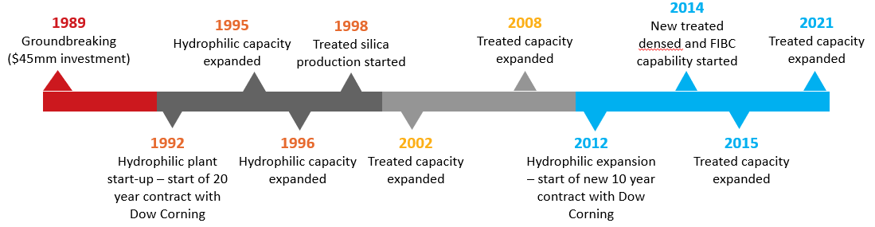
Figure 1 – Barry FMO facility build/expansion timeline.
The author of this project holds the position of Warehouse, Packaging and Shipping (WPS) Manager at the Cabot Carbon FMO Facility in Barry, South Wales having previously spent many years working in processing operational and production engineering roles at the facility. The WPS Manager is part of a middle management team made up of a Shift Manager group (5), Production Engineer and training coordinator which report into the sites Operations Manager.
The responsibilities of the WPS Manager include but are not limited to the daily management of the facilities production scheduling, product loading and shipping operations along with overseeing the packaging operations, developing, and leading process improvements within these areas (see full job specification in Appendix 15). The author also has employee management responsibilities for a team of 14 people working within these disciplines with 9 of these employees being direct reports and the remaining 5 having a matrix reporting line to the WPS Manager.
As stated, the author is constantly challenged with identifying continual improvement opportunities within the production warehouse owing to both the Hydrophilic & Hydrophobic manufacturing units gaining capacity increases over time so the packaging operations and personnel working within the area need to keep up with the additional required throughput. Whilst it can often be easy to improve efficiencies of machinery it can be more challenging to improve work practices due to the involvement of people and innate or perceived resistance to change.

1.5 Synopsis
Chapter Two aims to emphasise the approach which was taken to complete this research project. It will also aim to explain why the chosen methods were decided on as opposed to others available. The research data will be collected in both quantitative and qualitative analysis forms, initially by using a simple questionnaire survey followed by observing people as they go about their activities to aid in establishing machine and task cycle times along with unearthing wastes as defined in the ‘Lean Wastes’. It is planned that the questionnaires will be issued to a variety of employees working in a range of roles at the Barry FMO facility but will be particularly concentrated on the thirty employees that work predominantly within the production warehouse in packing, logistics and shipping roles.
In Chapter Three of this project paper, it is intended that the author will undertake a thorough review of all current and past relevant literature, including but not limited too professional journal articles and publications along with applicable published reports and textbooks pertaining to Lean Principles and tools. In undertaking this review it will give the report author a good underpinning knowledge of the subject areas which will aid in undertaking the assessment of the production warehouse in Chapter Four.
Chapter Four will look at the current state of the production warehouse in the Barry FMO facility with a view to understanding whether some of the lean principles, tools and techniques may already be being used and/or applied or where gaps exist, and improvements gained by introducing relevant lean tools and techniques. This assessment will critique machinery, equipment layout, people and technologies being applied.
Chapter Five will aim to conclude the report along with producing a comprehensive set of recommendations via the use of a roadmap to apply lean practices and therefore drive improvements in the Barry FMO production warehouse with a view to rolling this out into other discreet facility areas.

Chapter 2 – Research Methodology
This chapter will begin by defining the methods which will be used to compliment the project and aid with gaining a full understanding of the topic concerning Lean Principles and Methodologies via a literature review.
There are a variety research choices available to those undertaking research as can be seen in Figure 2. For the purposes of this project a mixed method approach will be used to aid with the collection and analysis of both qualitative and quantitative data.
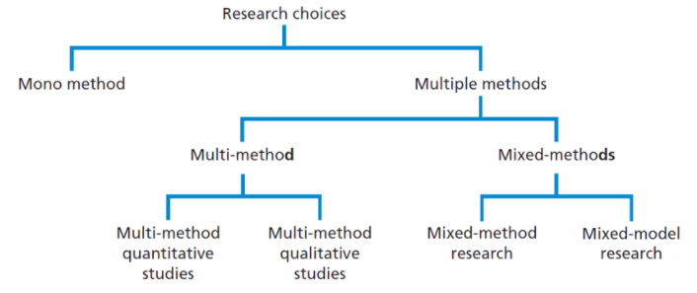
Figure 2 – Research Choices (Saunders, Lewis, & Thornhill, 2019)

2.1 Literature Review
The first step of the research will be to undertake and complete a thorough examination of the available literature regarding Lean Principles and Methodologies whilst also looking closely at demand forecasting. Consideration will also be paid to what, if any work has already been undertaken in implementing Lean Methodologies within Cabot Carbon Ltd.

2.2 Employee Questionnaire
A questionnaire will be used to assess the current understanding of Lean Principles and Methodologies at Cabot Carbon FMO Ltd, Barry. This will be achieved by developing a questionnaire designed to identify what the employees at the FMO facility perceive Lean to mean. The questionnaire will be issued to a selection of employees from the Facility General Manager to the Operators and Technicians working at shop floor level. The questionnaire will be centered on the Operations and Engineering & Technical teams along with the facility leadership team which equates to fifty-eight employees (64% of employees). The questionnaire undertaken will be anonymous for those participating.

2.3 Case Study
The production warehouse at Cabot Carbon Ltd, Barry will be used to form the basis of the study. The study will look at and consider the resources, both human and machine at its disposal to ascertain the suitability to the tasks and capacity required based on the changing environment that the facility is currently seeing and changes to be faced in the future. This type of study does have limitations based on it being viewed in isolation with it being described by Gerring as ‘’Case connotes a spatially delimited phenomenon (a unit) observed at a single point in time or over some period of time’’. (Gerring, 2007)

2.4 Observation
Primary data will be collected via the observation of operators and technicians undertaking their daily activities with collected data then being analysed to gain a clearer understanding of task cycle times along with mapping and measuring the activities against the ‘Lean Wastes’ to determine what wasteful activities, should they exist be removed to drive improvements in efficiency. Data will also be collected to determine packing machine set up to understand the impact that this may have on fill cycle times. All data collected will be collated in such a way that those being observed will remain anonymous when the data is presented within the project report.

Chapter 3 - Literature Review

3.1 The Origin of Lean Production

‘’No new idea springs full-blown from a void. Rather, new ideas emerge from a set of conditions in which old ideas no longer seem to work. This was certainly true of lean production, which arose in one country at a specific time because conventional ideas for the industrial development of the country seemed unworkable. Therefore, to understand lean production and its origins fully, it is important to go much further back in time, in fact, back to the origins of the motor industry at the end of nineteenth century.’’
(Womack, Jones, & Roos, 2007)

3.1.1 Craft Production
Automobiles were an extremely rare sight in the late nineteenth century, with the first automobile having only been patented by Carl Benz in the mid-1880’s, more than a decade later you could still not go and purchase an automobile from a dealership as you can today. If you were wealthy enough to purchase an item such as an automobile, you would have to seek an engineering company and or coachbuilder with the skill and knowledge who you could commission to build one for you with both being limited in numbers. Those who would build these automobiles at the time were known as craftsmen, being composed of exceedingly skilled tradesmen with vast knowledge of mechanical design principles and the materials they worked. This manufacturing environment is described by Womack et al (2007) as “the classic craft production system”. The system required the engineering machine shop or coachbuilder owners discussing the exact specification of the automobile with the customer. Once the specification was understood the owners of the coachbuilding company would then order the specific parts required from other machine shops which specialised in manufacturing that product or working with a specific material. This meant that much of the design for the automobile parts would have taken place in individual craft shops.
This method of sourcing parts in itself, along with machine capabilities at the time resulted in further work when the parts commissioned were to be assembled together at the coachbuilder. The Craftsman working at the coachbuilders would have to take the supplied parts and file or rework them somewhat in order to get them to fit together. This process would be continued until the entire automobile was finished, this in turn would essentially mean that the customers automobile was bespoke, and never were there two automobiles the same.
A basic assumption in the mass production environment is that cost per unit falls significantly as production volumes increase. This assumption however is incorrect in the classic craft production system. If a coachbuilder operating in this fashion determined to produce 100,000 identical cars each year, the cost per unit would not have reduced much below the cost per unit of producing 10. This is mainly because of the requirements of manual intervention to enable the components to fit together during assembly. The characteristics off the classic craft production system are summarised as follows;
- Very highly skilled workforce specialising in design, machine operations, and fitting. The workforce learned their trade by completing an apprenticeship gaining a full set of craft skills along the way and many of the craftsmen’ goal was to own and run their own machine shop.
- The parts and components used in craft production were designed and manufactured at many small, regionalised machine shops who specialised in that particular part, component, or material. The ordering of these parts was coordinated by the coachbuilder owner who maintained close contact with the customer, employees, and suppliers.
- There were no specialised machine tools for making automobiles. All the parts and components were manufactured on general purpose drilling, grinding, and milling machines.
- Very low annual production figures, generally a 1000 or fewer units per year, of which perhaps only 5% of the same design and no two automobiles identical in dimensions.
The disadvantages of craft production are therefore clear; the production costs were high due to the need of skilled labor and the bespoke manufacture and fitting of components. The cost per unit did not drop with increased volume, which meant that automobiles were reserved only for the advantaged who could afford such a high-priced product. Additionally, due to each unit being principally a prototype, constancy and reliability were changeable.

3.1.2 Mass Production

“I will build a motor car for the great multitude. It will be large enough for the family but small enough for the individual to run and take care for. It will be constructed of the best materials, by the best men to be hired, after the simplest designs that modern engineering can devise. But it will be so low in price that no man making a good salary will be unable to own one – and enjoy with his family the blessings of hours of pleasure in God’s great open spaces”
(Ford & Casey, 2010)
As discussed in the previous section the craft production method was widely used by the early onset automobile manufacturers during the mid-1890’s through to the early 1900’s when the Ford Model T was brought into production under the watchful eye of the innovative Henry Ford in 1908. In designing the Model T, Henry Ford’s objective and vision was to design an automobile that was both easily manufactured by the producer and user-friendly for the purchaser as until this point automobiles had been manufactured by the likes of coachbuilders using craft production methods leading to them being difficult to build or assemble and would often require both a chauffeur and engineer to drive and repair due to the complexities which existed. Ford was deemed to have revolutionised the automobile industry with the innovational methods used when designing the Model T for manufacture and subsequent servicing.
As demand grew for Ford’s innovatively designed Model T a new way of production on mass was required and developed by Henry Ford using ideas from other industries which required parts to be produced both quickly and accurately such as gun, watch and clock makers along with conveyors used in flour milling and foundries to move grain and large components giving birth to the integrated moving assembly line which was put into practice at Ford’s new assembly plant in Highland Park, a city just north of Detroit by 1912. Many view the term ‘’Mass Production’’ to be that of the continuously moving assembly line, however this is not the case with Womack et al determining this to be ‘’the complete and consistent interchangeability of parts and the simplicity of attaching them to each other’’ (Womack, Jones, & Roos, 2007).
The integrated production system was enabled by inter-changeability, being identified as the enabler to reduce assembly costs and therefore purchasing costs by examining the craft production system and exposing those higher costs incurred as a result of a skilled craftsperson being required to customise a component to fit. Ford would insist that the same gauging system was used for all parts fabricated for the Model T throughout the fabrication process with this leading to all constituent parts being assembled without the need of modification by the skilled craftsperson to assemble with this being key in reducing assembly costs. The required parts were manufactured on special purpose machines being checked against pattern gauges ensuring they were fit for purpose leading to them being assembled in minutes and onwardly delivered to the moving assembly line to be fitted to the Model T. This was a significant step in moving on from the so-called craft production methods used for many years with Ford linking interchangeable parts a standardised approach to work and moving production line thus creating continuously flow.
Ford gained a significant advantage of his competitors with the combination of inter-changeability, simplicity, and uncomplicated assembly along the moving production line. Ford was now able to focus on jettisoning the skilled assembly workers and reduction in cycle times. When the Model T was first launched in 1908 the average time taken to assemble was 514 minutes. Those assembling in 1908 were tasked during the cycle time in being involved in assembling large parts of the automobile before moving onto the next with this including fitting all mechanical parts to the chassis (wheels, suspension components, transmission, and engine etc.) with this taking most of the working day. To aid with reducing the cycle time Ford determined that each assembler would perform single tasks only, for example attaching wheels and once that was completed, they would move onto the next automobile on the assembly line. This first step enabled the cycle time to be reduced from 514 minutes to 2.3 minutes by 1913 with this significant reduction in cycle time increasing productivity considerably due to the assembly line workers being completely familiar with a single activity leading to the task being performed quicker. The overall improvements made in the reduction in manufacturing cycle times of key components and cars are shown in Table 1.
Table 1: Craft Production versus Mass Production (Womack, Jones, & Roos, 2007)
Minutes of Effort to Assemble: | Late Craft Production, Fall 1913 | Mass Production, Spring 1914 | Percentage Reduction in Effort
Engine | 594 | 226 | 62
Magneto | 20 | 5 | 75
Axle | 150 | 26.5 | 83
Major components into complete vehicle | 750 | 93 | 88

Ford very quickly recognised that an increase in productivity at the assembly plant translated into a reduction in cost to manufacture each unit, this cost advantage was therefore used to aid in reducing the retail price of the Model T allowing the product to become more available to a wider range of customers with this being demonstrated in Table 2.

Table 2: Manufacturing and Marketing of Model T Ford’s 1908-1916 (Hounshell, From the American System to Mass Production 1800 - 1932, 1985)
Calendar  Year | Retail Price  (Touring Car) | Total Model T Production | Total Model T  Sales
1908 | $850 | N/A | 5,986
1909 | 950 | 13,840 | 12,292
1910 | 780 | 20,727 | 19,293
1911 | 690 | 53,488 | 40,402
1912 | 600 | 82,388 | 78,611
1913 | 550 | 189,088 | 182,809
1914 | 490 | 230,788 | 260,720
1915 | 440 | 394,788 | 355,276
1916 | 360 | 585,388 | 577,036

The characteristics of Ford’s mass production system can be summarised as;
- Unskilled assembly workforce, the requirement of the mass production workforce was to perform one task as fast as possible. Many of the mass production workers had no previous experience or engineering background.
- Fully interchangeable parts, each component of the Model T could be fitted to any of the cars being assembled without any further rework.
- Components and parts are manufactured on specialised machines designed to manufacture a particular component. This resulted improved repeatability regarding dimensional tolerance.
- Very high annual output figures, by 1923 Ford had produces 2.1 million Model T chassis, all fully interchangeable. This was enabled by an increase in production flow from reducing assembly cycle times and the conveyor assembly line.
Ford’s mass production system was not disadvantaged by flow; it was however lacking in the ability to provide variety. The Model T was limited to one colour and one specification meaning that all Model T chassis were in essence identical until the end of 1926 with Henry Ford being quoted as saying; ‘’Mass production is not merely quantity production, for this may be had with none of the requisites of mass production. Nor is it merely machine production, which also may exist without resemblance to mass production. Mass production is the focusing upon a manufacturing project of the principles of power, accuracy, economy, system, continuity and speed.’’ (Hounshell & Ford, 1985) with this leading to the identification that change was required to satisfy the desire for variety within the customer base, when consumers wanted variety Ford seemed to lose his way somewhat.

3.2 The Toyota Way – Toyota Production System (TPS)

The Toyota Production System (TPS) is a unique process for managing manufacturing with early development being overseen by a Japanese Industrial Engineer - Taiichi Ohno, the designed system relied heavily on ‘Continuous Improvement’ and ‘Respect for People’. TPS is a comprehensive integrated approach which considers all the elements of a manufacturing operation. TPS was developed as a system shortly after World War 2 at a time when Japan as a manufacturing nation was struggling immensely against the backdrop of Mass Production in the United States so flexibility and creative thinking was required to enable Toyota to become competitive with a Toyota internal document stating ‘’We accept challenges with a creative spirit and the courage to realise our own dreams without losing drive or energy. We approach our work vigorously, with optimism and a sincere belief in the value of our contribution. And further: We strive to decide our own fate. We act with self-reliance, trusting in our own abilities. We accept responsibility for our conduct and for maintaining and improving the skills that enable us to produce added value’’. (Liker, 2004).
During the early 1950’s the then Toyota president, Eiji Toyoda had spent some time visiting a number of major automobile production factories in the United States with the Ford River Rouge plant being of particular interest, to gain an understanding of the development of the mass production system since a previous visit during the late 1930’s. On returning to Japan, Toyoda gave an assignment to Ohno to simply improve the Toyota production system in a such a fashion that it would equal the productivity of the Ford mass production system. With this assignment passed down, Ohno set about understanding benchmarking Ford through further visits to the U.S. and the studying of books penned by Henry Ford which led to the discovery that Toyota needed to master the art of continuous flow which Ford had achieved via the utilisation of the moving assembly line. Ohno also discovered that whilst ford had achieved continuous flow there were many inherent faults with the mass production system in place as this relied heavily on keeping the expensive machines and workforce busy leading to millions of parts being produced which built up high inventory levels of work-in-progress (WIP) which of course required movement and storage. Ohno knew that Toyota were unable to afford this luxury of what he considered ‘waste’ because they simply didn’t have the finances or space for this, however it was felt that Toyota could use continuous flow with this being developed into one-piece flow with flexibility to change based on the demands of the customer. Ohno determined that the best way to achieve the desired objective was to return to the shop floor which was a place he understood well which is where the journey really began ably supported by a group of engineers, managers and workers who were all dedicated to making their company a success where principles such as one-piece flow were perfected through learning using hands on experience. Over many years Ohno and his dedicated team developed what became known as the Toyota Production System. Ohno’s understudy Fujio Cho developed a simple representation in 1973 of TPS in the form of a house, as shown in figure 3.
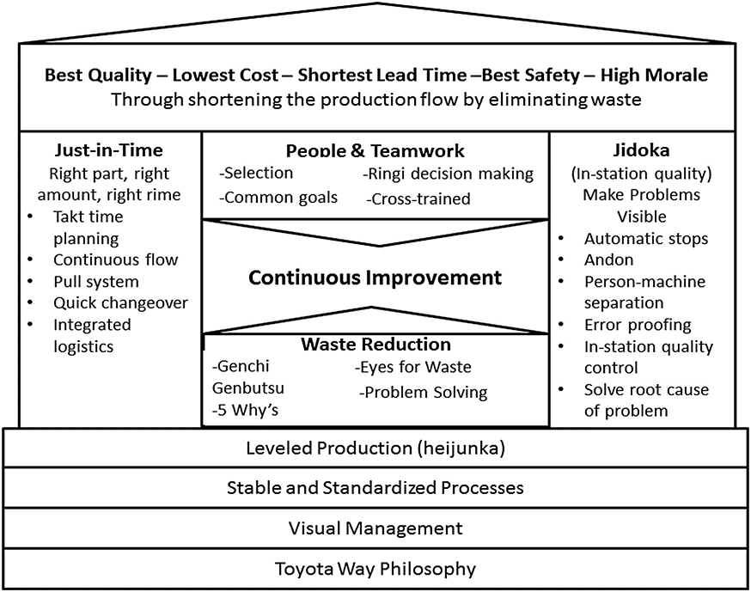
Figure 3 – The Toyota Production System (Kehr & Proctor, 2017)

3.2.1 Ohno’s 7 Wastes – Muda
Muda is the Japanese word for waste. Ohno identified the first seven types of Muda associated with manufacturing environments. A further eighth waste has since been recognised regarding underutilising employee skills which is perhaps one of the most damaging within corporations. Boutros and Cardella (Boutros & Cardella, 2016) describe the eight types of Muda as;
- Transportation: Moving a product or parts between manufacturing processes adds no value, is expensive, and can cause damage or product deterioration.
Examples include movement of paperwork, multiple handoffs of information, multiple approval steps, excessive email attachments, and unnecessary CC copies to people who don't really need the information.
- Excessive inventory: Excessive inventory wastes resources through costs of storage and maintenance.
Examples include purchasing or making things before they are needed, things waiting in an electronic or physical inbox and mass amounts of unread email.
- Unnecessary motion: Resources are wasted when workers have to bend, reach, or walk long distances to do their jobs. Workplace ergonomics or 5S (sort, straighten, shine, standardise, and sustain) assessments should be conducted to design the most optimal and efficient work environment.
Examples include walking to a copier, printer, or fax; walking between offices: and backtracking back and forth between computer screens.
- Waiting: Processes are ineffective and time is wasted when one process activity waits to begin while another finishes. The flow of operations should be smooth and continuous.
Examples include slow computer speed, workstation downtown, waiting for approvals, waiting for information from people, and waiting for clarification or correction of work received from upstream processes.
- Overprocessing: Overly elaborate and expensive equipment is wasteful if simpler machinery would work just as well.
Examples include relying on inspections, checkpoints, reviews, or approvals rather than designing processes to eliminate errors; reentering data into multiple systems or applications; making extra copies; and generating and unused reports.
- Overproduction: The manufacturing of products in advance or in excess of demand wastes money, time, and space.
Examples include printing paperwork that might change before it is needed, processing an order that might change before it is needed, and any processing that is done on a routine schedule regardless of current demand.
- Defects: Product rejects and rework within your processes.
Examples include data entry errors, other types of order entry or invoice errors, and any error that gets passed downstream only to be returned for correction or clarification.
- Underutilisation of employee skills: Employees are typically hired for a specific skill set, but they usually bring other skills and insights to the workplace that should be acknowledged and utilised, yet employees are often underutilised or pigeonholed into specific responsibilities.
Examples include putting employees in roles that do not exploit their experience, not staffing projects with the right employees, and not allowing open feedback.
Since the original categories of waste were established, others have been proposed, including; Unsafe Workplaces and Environments, Lack of Information or Sharing of Information, Equipment Breakdown, Environmental with a lot of emphasis being placed on this final one due to this commonly wasting natural resources and company funds whilst not promoting corporate social responsibility.

3.3 The Discovery and Timeline of Lean
A paper written by Matthias Holweg ‘The Genealogy of Lean Production’ (Holweg, 2007) credits the first published academic paper on the Toyota Production System (TPS) to have been written by Sugimori et al in 1977 which entitled; ‘Toyota production system and Kanban system: Materialization of just in time and respect for human system’. At the time the paper did not cause much of a stir amongst the manufacturing society despite the impact TPS would have on the automotive industry. During the nine years which followed several other studies were undertaken with articles written by indstrialists and academics alike. The ideas described in these papers would slowly become understood in the West, particulary by JamesP. Womack, Daniel T. Jones and Daniel Roos.
Lean and Lean Production are the terms created to describe TPS in the book The Machine That Changed The World by Womack et al. The book describes a detailed study of the Japanese techniques used in automotive manufacturing which were coming to light in the early 1980’s, which were later named “lean production”, and how they contrasted against western mass production practices. The study was enabled through the Massachusetts Institute of Technology. This study became known as the International Motor Vehicle Program (IMVP) which firstly commenced in 1979 and slowly gathered pace, the study included visiting automobile manufacturing facilities in many global locations to gather data . Lean production is described by the authors as being an holistic business system for organising and managing product design, manufacturing operations, raw material suppliers and customer relations. Womack et al (2007) additionally describe how lean production if applied can increase purchaser liking whilst reducing human exertion, capital spending, raw material usage, product defects, and lead-time, compared with mass production methods.
In 1996 Womack and Jones penned and published a further book called Lean Thinking: Banish waste and create wealth in your corporation. The book describes an explicit method to manufacturing identified as Lean Thinking, this approach was built on their knowledge of Toyota and the principles used. Lean thinking is described as creating value and making value flow by the reduction and/or removal of waste. Womack and Jones describe 5 lean principles in the book and conclude that they can be applied to any manufacturing environment and even whole enterprises. Lean is simply not a “cutting back” exercise where every person is required to do more, however the end result a successful lean implementation is doing more with less; less human exertion, less equipment, less time and less space.
See Appendix 5 ‘The research and dissemination of lean production’ for further details of the Lean Timeline.

3.4 The 5 Lean Principles
There are five lean principles decribed below which underpin the lean mindset within an organisation with these being designed by Womack and Jones and stating in Lean Thinking ‘’Fortunately, there is a powerful antidote to muda: lean thinking (Womack & Jones, Lean Thinking, 1996). The principles objectives are to provide a way to specify value within the manufacturing process, align value-adding activities in the process in the most efficient sequence, allow these activities to be conducted when requested without disruption, and to perform these activities more efficiently.
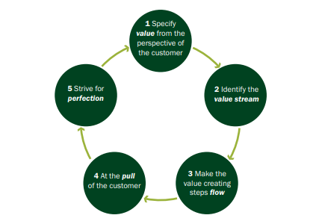
Figure 4 – The Five Lean Principles (Hines, Found, Griffiths, & Harrison, 2008)
- The first point is to specify value from the perspective of the customer and understand that only a small amount of time and effort within any organization adds value that would be recognised by the customer, once this is realised, we must then specify what does and does not create value for the customer and not from the perspective of individual firms, functions, and departments. Once non-value adding activities or ‘waste’ are exposed these can then be targeted for removal. This can be a significant challenge as it requires close customer and supplier associations along with a detailed understanding of their needs.
- Next the Value Stream needs to be identified with this requiring comprehensive analysis of the required steps which enable the design, order, and manufacture of the product or service from raw material or input to a final product or service. In order to achieve this, it necessitates looking at the whole supply chain or demand network remembering that the company is only as good as its weakest link. Focus should be paid on the product or customer and not an individual department, machine, or process step. The value stream should map and measure the entire process and not individual departments or activities.
- The third principle concentrates on making the value Flow, which means ensuring all the actions in the process that create value for the customer flow without interruption, diversions, backflows, waiting or scrap generation. Where possible avoid batching and queuing or at the very least continuously aim to reduce them, this seriously challenges companies to move away from batch processing philosophies and drives them to eliminate all Muda.
- Next comes Pull. Now that the principle of flow has been established it becomes important to only operate and produce as required which simply means that the supplier only produces what the customer requires. This conceptual approach can be difficult for many companies to grasp as traditionally production operations are scheduled based on historic or forecasted sales. Bicheno and Holweg quote ‘’A pull system is one in which work is released based on status of the system and thereby places an inherent limit on WIP’’ by contrast ‘’A pull system is one in which work is released without consideration of system status and hence does not inherently limit WIP’’ (Bicheno & Holweg, The Lean Toolbox, 2016).
- The final principle is Perfection. Now that the previous principles have been worked through and implemented achieving perfection perhaps seems possible. Perfection should lead not only to being defect free but simply delivering what the customer wants, when they want it at an acceptable and fair price with minimum waste.

3.5 The Characteristics of Lean
The topic of Lean Manufacturing along with its principles have been evaluated with many literature papers and books published, to try and help businesses understand the concept and principles of a lean organisation. Amongst the published literature, many tools and methods have been developed by lean gurus such as Goldratt, Schonberger, Imai, Womack and Jones, who built their methods from the research and trials undertaken by the ‘greats’ such as; Edward Deming, Juran, and Ohno. To distil the principles of lean can present organisations with a daunting task. To aid organisations through a lean transformation Bicheno and Holweg, have identified 25 principles which are deemed to be common themes in most research and at the core of lean and these can be viewed and evaluated in Appendix 6.

3.6 Lean Tools
This section will research some of the available techniques and methodologies that support a lean enterprise whilst at the same time contributing to improving productivity. There are several tools and practices which exist primarily to support both quality and productivity improvements with each contributing to increased productivity in some way along with fitting into or being a fundamental part of a lean approach. Consideration will firstly be paid to the analytical tools available that aid with the understanding of the value stream and mapping this, followed by some of the practical tools which originated within Toyota such as ‘’Gemba’’, Total Productive Maintenance (TPM) along with 5S.

3.6.1 Value Stream and Process Mapping
Rother & Shook describe the Value Stream as; ‘’A value stream is all the actions (both value-creating and nonvalue-creating) currently required to bring a product through the main flows essential to every product: (1) the production flow from raw material into the arms of the customer, and (2) the design flow from concept to launch.’’ (Rother & Shook, 2018)
Value Stream Mapping (VSM) along with Process Mapping are visualisation exercises which are widely considered as being fundamental tools in Lean to aid with the unearthing of wastes within the process giving understanding of what activities are considered as valuable from the perspective of the customer. This leads to revealing those activities which are as described by Bicheno and Holweg (2009) as; ‘value adding (VA)’, ‘avoidable non- value adding (NVA)’ and ‘necessary non-value adding (NNVA)’, it does however need to be understood that in some cases those activities that fall into the NNVA category are in fact essential in delivering the product or service to the customer.
Bicheno & Holweg state that – ‘’Mapping is the Meta Tool in the Lean Toolbox because the mapping tools should guide the use of many other tools. Remember that all mapping and analysis is waste unless it leads to action. Doing mapping is not the same thing as doing Lean. The real purpose of mapping is to design the future state. It is a visualization exercise – a vision of the current state and of the future state’’ (Bicheno & Holweg, The Lean Toolbox: A handbook for Lean Transformation, 2016).
Whilst VSM is a tool with many years in existence demonstrating great results it can be considered static, based on the moment and experience dependent with these limitations discussed by Stadnicka & Litwin as follows ‘’Not all of the existing problems can be easily identified with VSM because the analysis takes into consideration only a static aspect of the system modelled and the situation on a manufacturing line, affected by many different problems, is dynamic though. Therefore a method that considers system dynamics should be applied’’. (Stadnicka & Litwin, 2019).
It needs to be understood that VSM’s offer a complete view of how work flows through systems in their entirety, they differ considerably from process maps in numerous ways. VSM’s firstly provide in effect a means to set up strategic direction for creating improvements. The penchant to dive into the deep end and design micro level improvements before the entire work system being the macro picture is completely understood, is a significant contributor to flawed optimisation. Figure 4 below demonstrates that work has various degrees of granularity, highlighting VSM falls within the macro perspective providing the means for leadership to define strategic improvements to the workflow, whereas process level mapping enables the people who do the work to design tactical improvements.
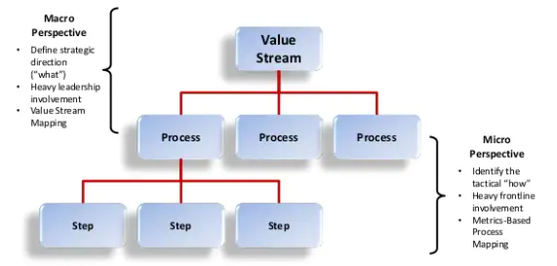
Figure 5. Granularity of work (Martin & Osterling, 2014)
As discussed above the mapping of a process aids with developing a visual representation of the task or activity being undertaken in line with the micro perspective as opposed to the entire value stream in the macro perspective, whilst building on your knowledge and understanding of the specific steps with this being highlighted by Damelio as follows, ‘’You map a process to add to your knowledge about the work the map represents so that you may apply that knowledge in order to achieve a specific goal or other intended purpose. Ideally the goal or purpose is explicit, and its intent is to measurably improve the business’’ (Damelio, 2011). A large part of the mapping process is to understand where and how improvements can be made with Hines and Rich stating that there are normally five stages as follows;
- The study of the flow of the processes;
- The identification of waste;
- A consideration of whether the process can be rearranged in a more efficient sequence;
- A consideration of a better flow pattern, involving different flow layout or transport routing; and
- A consideration of whether everything that is being done at each stage is really necessary and what happens if superfluous tasks were removed.
(Hines & Rich, 1997)
The creation of a process map generally develops a shared understanding and overview of what the process being mapped involves. One of the major benefits of the process map is that the outcome is that of a graphical representation of what can be a complex or abstract idea. Because everyone learns and absorbs information differently, some individuals perhaps relate better with a picture than they would with a written or spoken narrative. Using a process map in a meeting, presentation, or a training session can help ensure everyone is getting the message and is on the same page. Process maps once created can be used as live documents and altered when changes are either made or required ensuring they remain current.

3.6.2 Total Productive Maintenance (TPM)
A crucial and fundamental part of a lean manufacturing operation is machine and plant reliability. Without doubt no lean implementation can be successful with a high level of machine and plant breakdowns or stoppages. TPM is therefore regarded as essential to lean, encompassing more than just breakdown issues. TPM in essence covers unit availability, unit performance, unit quality, together with safety and capital investment through making best use and extending the life of an organisations material goods.
TPM uses a combined approach of preventative maintenance practices using recommendations normally provided by the original equipment manufacturer (OEM) and total quality concepts which encourage employee involvement, data driven decisions, zero defects along with strategic focus. Those operating the machines are charged with undertaking time-based inspections, preventative repair activities along with daily care and cleaning of their machines. In undertaking the inspections the machine operators are able to compile and interpret maintenance and operational data of their machines which will aid in identifying signs of deterioration prior to a breakdown so that more detailed maintenance activities can be undertaken in a planned way minimising the risk of defects, downtime, and production disruption.

3.6.3 5S
5S is possibly one of the most recognised and popular tools within Lean but does come with both positive and negative connotations. The positive is that 5S is relatively simple to implement and can quickly have a progressive impact on both quality and productivity whilst sending a powerful message that Lean has arrived within the organisation. The negative side if too barely understood is that this 5S can become a diversion from the true priorities with it also being viewed as merely tidying up.
When considering implementing 5S it needs to be clearly understood that this is not just about cleaning an area up, if this is what is needed then undertake the clean up as opposed to suggesting that you are implementing 5S as if the theory is misinterpreted the power of the concept is very quickly lost. The real objectives of a 5S program should be to reduce waste, reduce variation and improve productivity whilst also supporting a change in mindset and attitudes from perhaps accepting that you work in an area which is disorganised to one that recognises the advantages of one which is organised and where it can be seen that everything has its place and everything is in the place it should be.
The meaning of 5S is to undertake the following; Sort, Set in Order, Shine, Standardise and Sustain further descriptions of the goals and how to eliminate or correct can be seen in Table 3 below.
Table 3 - 5S Workplace Scan - (Russell & Taylor, 2009)
The first 3S’s tend to be quite easily achieved so the emphasis needs to be placed on the final 2 of standardising and sustaining as without these companies will find it very difficult to fully practice 5S with them tending to drop in and out and apply the easy to do S’s as and when the need arises. Bicheno and Holweg (Bicheno & Holweg, The Lean Toolbox, 2016) quote Hiroyuki Hirano as suggesting a host of activities to aid with the sustaining of 5S as follows;
- A 5S month, once a year (?), to re-energise efforts.
- 5S days, one to four per month including evaluations.
- 5S seminars by outside experts – with lots of photos.
- 5S visits to leading outside companies.
- 5S patrols, following a set route.
- 5S model workplaces (this has become popular in NHS hospitals).
- 5S competitions.
- 5S award ceremonies.
- 5S exhibits.
- 5 minute 5S each day.

3.6.4 Standardised Work
Standardised work is the foundation for continuous improvement and operator empowerment which aims to create processes and procedures that are repeatable, resolute and capable.
‘’To standardise a method is to choose out of many methods the best one, and use it. What is the best way to do a thing? It is the sum of all the good ways we have discovered up to the present. It therefore becomes the standard. Today's standardisation is the necessary foundation on which tomorrow's improvement will be based. If you think of standardization as the best we know today, but which is to be improved tomorrow you get somewhere. But if you think of standards as confining, then progress stops.’’
(Ford, Today and Tomorrow, 2018)
Standards can be viewed as being either ‘soft’ or ‘hard’ with those that are soft being perhaps an expected service or behavior, a desired appearance or condition whilst those which are hard, tend to be safety, engineering or process standards which have limited but allow a degree of tolerance.
It is important to understand that standards should not be set with a view of ‘catching you out’ but there to enable. Standards will also aid with the unearthing of problems within a process as the problem is normally a deviation from the standard so without a standard there can be no problems!
Standards should be developed from the aspect of the best way to undertake an activity and belong to those who actually undertake it, written at the place of work and improved upon. Using this approach aids those undertaking the activity in fully comprehending the details of the activity enabling them to consider ways to improve it.
MacInnes (MacInnes, 2009) defines that in order to achieve standardisation the following eight step approach should be followed;
- ‘’Establish improvement teams.
- Determine your takt time.
- Determine your cycle time.
- Determine the work sequence.
- Determine the standard quantity of your work in progress.
- Prepare a standard workflow diagram.
- Prepare a standard operation sheet.
- Continuously improve your standard operations.’’

3.6.5 Visual Management
Visual management, ‘visuality’ or ‘control by sight’ as (Bicheno & Holweg, The Lean Toolbox, 2016) succinctly state it is again a key premise within Lean operations, leading too if correctly implemented an improvement in quality and productivity owing to clear performance indicators or expectations being set out in a visible way meaning that the operator should be able to quickly determine if there is a deviation from the expected standard. Examples of visual management include but are not limited to, 5S boards, area photographs giving examples of how the area should be presented, standard operation work sheets, process control charts, marked walkways and machine areas, Andon systems, visual operating procedures.
Visual management like many other Lean tools sits within the 14 Principles of the Toyota Production System.

3.6.6 Gemba
‘’Gemba’’ is a Japanese word which nominally translates into English as ‘’the real place’’. Ohno of Toyota was renowned for stating that ‘’management begins in the workplace’’ with his philosophy being, going to see where the value is being added, observe first-hand and seek the facts, this approach was very different from what was traditionally practiced in the western world where the tendency was to remain in the office environment and discuss opinions. Liker quoted Tadashi Yamashina as stating ‘’It is more than going and seeing. ‘’What happened? What did you see? What are the issues? What are the problems?’’ Within the Toyota organization in North America, we're still just going and seeing. ‘’OK, I went and saw it and now I have a feeling.’’ But have you really analyzed it? Do you really understand what the issues are? At the root of all that, we try to make decisions based on factual information, not based on theory. Statistics and numbers contribute to the facts, but it is more than that. Sometimes we get accused of spending too much time doing all the analysis of that. Some will say, ‘’Common sense will tell you. I know what the problem is.’’ But collecting data and analysis will tell you if your common sense is right. (Liker, 2004)
Gemba walks were developed by Toyota as part of the ‘‘Toyota Production System’’ and are a good way ‘’to go and see’’ and must be encouraged throughout the organisation with participants from all levels of leadership taking part as this enables dialect between the leaders and operators and opportunity to look, see, learn whilst gaining mutual understanding of issues.
It is however essential to remember what a Gemba Walk is not. A Gemba Walk is a way to amass information through observation and contact with workers. It is not a time;
- To find fault and call out employees on it.
- To try to quickly implement a change on the spot.
- To disregard employee input. Getting that input is one of the main goals of a Gemba Walk.

3.7 Organisational Culture
Many organisations discuss or touch on culture in their business strategy statement and how the culture of their organisation has a great influence on how successful they are in their markets, but what is culture? Is it real? And should it be considered during a lean implementation.
Culture as a word is thought of as constituting society, seen simply as the ‘way of life’ for groups of people with this being supported by their laws, customs, traditions, social standards, values to name but a few.
Organisational academics along with managers use the word ‘culture’ as a way of describing the practices which are used to handle employees and championing the values within an organisation. Those tasked with leading or managing often speak about developing the ‘right culture’, which seems to suggest that culture is as stated above connected to the right set of values which they are striving to attain. Edgar Schein defines culture as follows;
‘’A pattern of shared basic assumptions that was learned by a group as it solved its problems of external adaptation and internal integration that has worked well enough to be considered valid, and, therefore, to be taught to new members as the correct way to perceive, think, and feel in relation to those problems.’’
(Schein & Schein, 2016)
Schein’s definition suggests that culture grows over time with it including behavioral norms, values, shared points of view, decision making along with relationships which have grown to be accepted by the group during that time.
Culture generally is viewed as having different levels (see figure 5 below), the term ‘level’ denoting the extent to which the cultural singularity is visible to the viewer. The levels themselves range from the very noticeable things that are easily seen or felt through to those being so deeply embedded that they define the culture and it’s DNA, whilst in between are a variety of espoused values, ideologies, rationalisations such that the cultural members use these as means of identifying the culture and themselves.
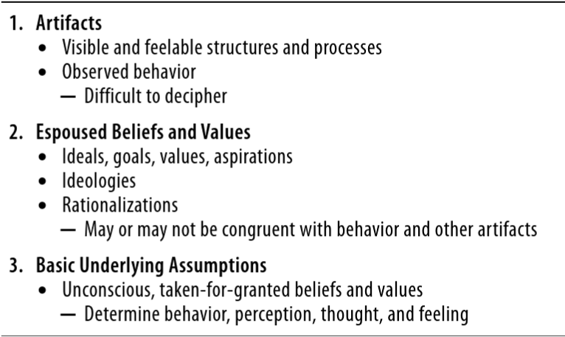
Figure 6 - The Three Levels of Culture (Schein & Schein, 2016)

3.7.1 Developing a Lean Culture
As discussed in the organisational culture section, culture is something which is learnt based on familiarity and experiences over an extended period of time with this then becoming embedded in the organisational group and understood as being the ‘norm’. When an organisation determines to undertake a Lean Transformation they are therefore choosing to move away from the ‘norm’ which will impact or change culture, it should be understood at this point that Lean requires revolutionary change but ‘culture’ tends to be evolutionary and occurs day by day.
To achieve a ‘Lean’ culture all people within the organisation from the top down to the bottom need to share two connected characteristics related to erudition – ‘humility’ and ‘respect’ which are seen as one of the twenty-five lean principles with Bicheno and Holweg stating ‘’The more one strives for Lean, the more one realises how little one knows, and how much there is yet to learn.’’ (Bicheno & Holweg, The Lean Toolbox, 2016), to learn you need humility, respect should also not be confused with being nice but should be seen as recognising the talents which people possess that perhaps you do not and these need to be drawn out for all to learn from. To aid with changing culture organisations should concentrate on their management system, visual management to communicate targets, leadership conduct, particular hopes, tools and routine practices.

3.7.2 The Role of Leadership
Organisational culture goes hand in hand with the role of leadership in any corporation. Generally people connect ‘Lean’ with being a set of tools which are implemented with a view to create a more efficient process, Mann (Mann, 2009) however states the tools represent at most only twenty percent of the effort in lean transformations with the remaining eighty percent required being exhausted on changing the ‘leaders’ practices, behaviours and ultimately their mindset’. Leadership plays a very important role within lean transformations and must be viewed differently from management. ‘’Management is doing things right; leadership is doing the right things. Management is efficiency in climbing the ladder of success; leadership determines whether the ladder is leaning against the right wall’’ (Covey, 2004).
Mann further determines that senior leaders play a central role in Lean management. Their contributions are essential in:
- Developing and implementing structures and processes that anticipate and respond to the difficulties of a lean initiative that crosses internal boundaries;
- Transforming commitments to change into actual change, supporting and sustaining new behaviors and practices;
- Increasing the odds that process improvements survive the transition from project mode to ongoing process;
- Establishing and maintaining new, process-focused measures alongside conventional measures of results;
- Creating conditions in which a sustainable Lean culture of continuous improvement can develop.
(Mann, 2009)
Jim Collins the author of such books as ‘Built to Last’ and ‘Good to Great’ (Collins, 2001) categorises that leadership comes in a hierarchy of five levels as depicted in Figure 6, identifying Level 5 as the one which leads to the most viable and effectual business stating Level 5 leaders in addition to their management team look firstly to develop the ‘Who’ and ‘Get the right people on the bus’, before considering the ‘What’, as having the right people in place can help determine the path to greatness, whereas as Level 4 leaders firstly consider the ‘What’ before determining the ‘Who’ and then look to make the vision happen.
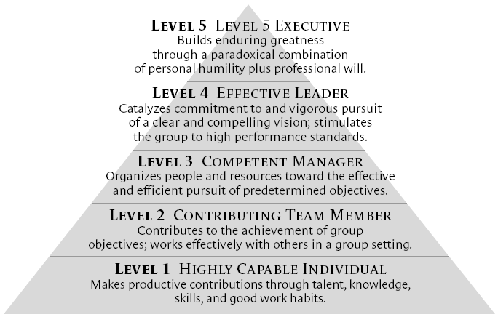
Figure 7 – Level 5 Hierarchy (Collins, 2001)

3.8 Change Management
When undertaking an assessment such as this it becomes blatantly obvious that change will be inevitable, with this being faced almost even more so when considering the changing world that we currently live in, when confronted with a global pandemic coupled with the scrutiny of climate change where businesses are having to make sweeping changes to the way they operate not just to remain competitive and satisfy the required reduction in their carbon footprint but to uphold reputation as a responsible corporation.
McCalman et al (McCalman, Paton, & Siebert, 2016) state ‘’Change may be regarded as one of the few constants of recorded history. Often society’s ‘winners’, both historically and contemporary, can be characterised by their common ability to effectively manage and exploit change situations.’’
Beer and Nohria (Beer & Nohria, 2000) states ‘’The common ground that supports a wide variety of change initiatives is based on the idea that they focus, on structure and the corporate culture systems within the organisation with the consequence of improving both organisation and employee well-being.’’
Some change is uncomplicated and therefore easy to adapt too, however some change can be very complex and less easy to adopt. Change can occur in different ways but some approaches to change have stood the test of time with Burnes (Burnes, 2004) referencing Kurt Lewin’s simple yet effective original approach of ‘’unfreezing, moving and re-freezing’’, to achieve this successfully though McCalman et al state that some rules should be applied to give the change the best chance of success as follows;
- Rule 1 Establish that there is need.
- Rule 2 Think it through thoroughly.
- Rule 3 Discuss it informally with those likely to be affected.
- Rule 4 Encourage the expression of all objections.
- Rule 5 Make sure you are willing to undertake change yourself.
- Rule 6 Monitor the changes and reinforce them at all points.
(McCalman, Paton, & Siebert, 2016)
Whilst Kotter (Kotter, 2012) explains an eight step model to aid with transitioning through major change initiatives which consist of the following; ‘Establish a sense of urgency, Create the guiding coalition, Develop a vision & strategy, Communicate the change vision, Empower broad-based action, Generate short-term wins, Consolidate gains and produce more change, Anchor new approaches in the culture’. This approach is further explained in Appendix 3.

3.8.1 Resistance to Change
It goes without saying that not all change is readily accepted and can meet with a perceived level of resistance, however it seems that the regular stance in scrutinizing the ‘resistance to change’ is decidedly one sided with it nearly always favoring that of the change agent (Dent & Goldberg, 1999).
What needs to be better understood is that what is being seen as ‘resistance to change’ is actually more related to the fear of the unknown as people tend to be comforted with what is familiar to them, another view is that what is seen as ‘resistance to change’ is being perceived or imagined by the change agent themselves based on their investment in the planned change or even lack of belief in the change itself.
Understanding the reasons for ‘resistance to change’ and therefore working to remove it is essential to adding the required cultural change in any transformation, Hines et al (2008) identified four basic forms of resistance as described in table 4.

Table 4 Forms of Resistance (Hines, Found, Griffiths, & Harrison, 2008)
Understanding Resistance
Organisational resistance | Underlying issue is lack of control. Expressed as NIH (Not Invented Here)
Political resistance | When change is seen as a loss and/or threat to the status quo
Individualised resistance | Expressed as WIIIFM (What Is In It For Me)
Technical resistance | Underlying issues are insecurity and concern that they understand how. What is not understood is often resisted. Expressed as being overwhelmed by the details

3.9 Lean Implementation
There are numerous lean transformation models which distinguish different methodologies to implement lean, and all being developed over time by hands-on lean ‘experts’. Womack and Jones (1996), and Liker (2004) are authors who strongly champion The Toyota Way of lean, and actively put into effect the use of the Toyota principles as an implementation model, while Hines (2008) a lean academic and part time advisor believes that lean transformation begins in the boardroom where strategy is set and policy deployed from, both claim to work and give examples of successful lean implementation. Bicheno and Holweg (2016) recognises that there is no right or wrong implementation model, but a case of ‘horses for courses.’ The lean transformation model should be chosen based on the needs whilst considering the current state of the organisation, if strategy is weak, then start there. Bicheno and Holweg have summarised the better-known transformation models and where they are more applicable based on their business sector, manufacturing or service, this summary can be referred to in Appendix 8.
The ‘Transition to Lean Roadmap’ model shown in Figure 8 has been referenced in a number of papers (Crabill, et al., 2022), (Tortorella & Fogliatto, 2017) relating to both lean implementation and leadership requirements for said implementation. The model provides guidance which can be used to evolve an existing manufacturing operation to one which fully implements Lean philosophies and best practices. The roadmap outlines an organised implementation process, specifying actions in order of primacy which act as markers in the drive towards Lean manufacturing. The model is organised into significant stages with interfacing points with other systems both internal to manufacturing operations and external to the corporation well-defined.
It is equally important to remember that the roadmap presented is not a recipe of actions to be strictly and blindly followed for every implementation. Rather, each implementation will be exclusive due to each corporation having its own embedded culture, policies and systems which may in some cases support or impede the Lean transformation. The various phases are to be regarded simply as stage-gates or a point to pause to confirm that the prior elements listed are either to some degree in place or at least being attended too before moving forward to the following phase.
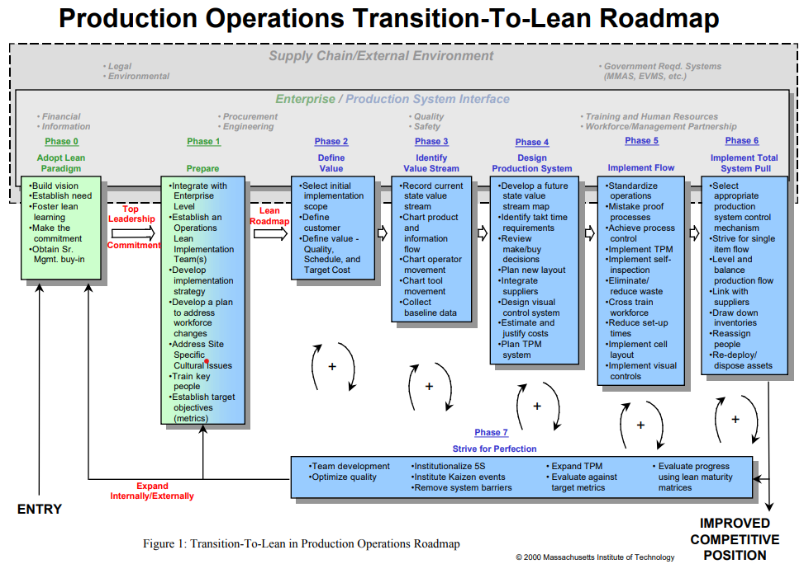
Figure 8 – Production Operations Transition-To-Lean Roadmap (Crabill, et al., 2022)

3.10 Lean Assessments
To ascertain areas of weakness or improvement opportunities within an organisation, lean assessments can be used to benchmark against lean best practices. The results from such assessments can be used to give the organisation guidance and direction to focus efforts for lean implementation. Initially it will be important to undertake the assessments cyclically as a way of assessing the condition of the lean transformation. A lean assessment is a good way of identifying areas which may be missed by the value stream mapping exercises undertaken, for example continuous improvement, motivation of employees and customers alike and supplier performance.
One such tool that can be used in lean assessments is Iwao Kobayashi’s ‘’20 keys’’ as this is viewed as being important in both guiding lean implementation and assessing effectiveness with Petrarolo (1998) describing ‘’The 20 Keys method is an important benchmarking and improvement approach that offers a way to examine and systematically improve the strength of an organization by focusing on 20 different but interrelated aspects’’. The ‘20 keys’ which can be seen in Figure 9 offers a systematic approach towards achieving flexibility and adaptability within organisations concentrating on manufacturing better quality products faster whilst reducing costs and strengthening and energizing the workplace. Keys 1 to 4 are akin to the basics of lean which may be viewed as the starting point leading on to the remaining 16 keys. Each of the keys follows a five-point grading scale which aids in evaluating the operation, ranging from beginner (level 1) through to world class (level 5). The 20 keys are very closely linked with each other so to achieve higher levels in each of the keys substantial progress is required in all keys. Parallels can also be drawn when considering Richard Schonberger’s 16 Principles of World Class Manufacturing which can be viewed in Appendix 14 along with the 25 Principles of Lean as described by Bicheno and Holweg as seen in Appendix 6.
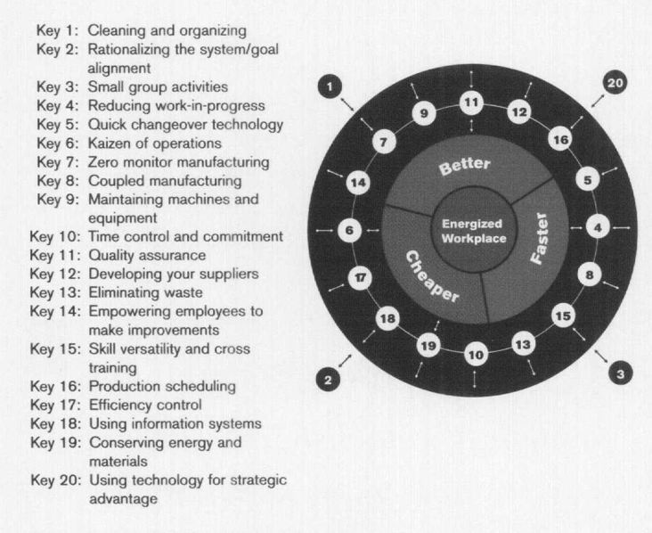
Figure 9 – The 20 Keys – Taken From (Petrarolo, 1998)

3.11 Questionnaire - Survey
Questionnaires are perhaps the most widely used method for collecting data and can be a valuable aid during a research project and are proven to be a good vehicle to efficiently collect vast amounts of information from large numbers of people in relatively short periods of time prior to quantitative analysis.
Popular methods of types of questionnaires and how they are generally undertaken can be seen in Figure 8, further information on the attributes of different methods can be found in Appendix 7.
Questionnaires are useful for gathering opinions, attitudes, understanding and preferences giving the researcher setting the survey many advantages, however depending on how they are conducted they can also have their disadvantages if self-completed, such that response levels can be low, questions can be misread or misinterpreted along with participants providing answers they believe the researcher is looking for as there tends not to be a means of checking this.
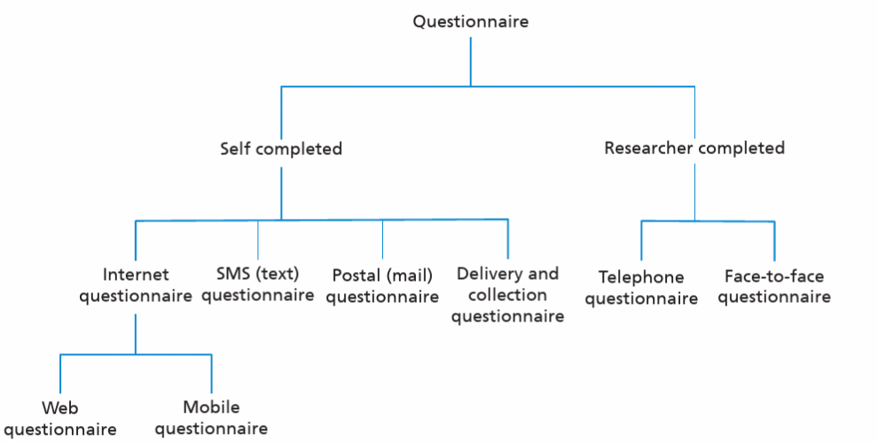
Figure 10 – Types of Questionnaires (Saunders, Lewis, & Thornhill, 2019)
Collis and Hussey state that ‘questionnaires are associated with both positivistic and phenomenological methodologies’ (Collis & Hussey, 2003), with closed questions normally being asked under the positivistic method whilst open questions tend to be used for the phenomenological method. The use of open questions provokes data which is qualitative, promote individual thoughts and enable the respondent to express views, however there can also be negatives such as they take longer to complete which may reduce responses and can be more difficult to analyse. The use of closed questions provokes data which quantitative which is makes the data easier to analyse and tend to be quicker for respondents to complete which may improve the response rate, however the negatives could be that respondents answer without thought and you do not get opinions that may change your viewpoint. There are a variety of questions which can be used to aid in getting the information which the surveyor desires as described by Dr Carrie Winstanley (2010) below;
- Closed questions with a single answer
- Closed questions with multiple choices
- Questions answered by rating or ranking
- Open-ended simple questions (short answer)
- Open-ended complex questions (long answer)
Constructing a questionnaire (Winstanley, 2010)

3.11.1 Questionnaire Design
The questionnaire must directly correlate to the research aim with Collis & Hussey (2003) along with Saunders et al (2019) stating that if the method is positivistic the surveyor is required to have substantial knowledge of the subject matter prior to designing the questions with this perhaps coming from the study literature review or existing knowledge.
The layout of the questionnaire remains an important factor in developing the respondents interest to complete it, the form should be minimalistic in design and only hold the relevant information required such as a clear title which is representative of the questionnaire aims, a layout which is consistent throughout the form along with considering the number of questions being kept as short as possible and asked succinctly, and most importantly information of how this can be returned to the surveyor.
A good way to standardise the questionnaire form is by utilising electronic tools if able as these offer the following advantages as described by (Cottrell, 2014);
- Inbuilt design features and guidance,
- Speed and ease of distribution,
- Being intuitive to use when designing your own questionnaires,
- Professional appearance of survey,
- Speed and ease in collating responses,
- Speed and ease in presenting data
It is however important that if you are using electronic tools that you give some advance warning to the respondents or compliment the questionnaire with an email explaining who you are if not known along with stating the purpose of the survey, approximate time to complete along with what the data captured will be used for. Some electronic tools such as ‘Survey Monkey’ or ‘Microsoft Forms’ enable the survey to be conducted anonymously but the surveyor needs to ensure that this doesn’t disrupt the outcome.

3.11.2 Run a trial survey
Once the questionnaire has been designed it would be a good exercise to trial the survey within a small group of approximately ten percent of the target audience and seek feedback. The aim of undertaking the trial survey is to reveal any shortcomings in the survey regarding the questions, layout, grammar, etc so that these can be corrected prior to rolling out the main survey to the entire target audience.

3.11.3 Conducting the main survey
Once any feedback from the trial survey has been actioned it is time to conduct the main survey. Depending on how the survey is being conducted (electronically, paper-based, phone etc) it will need to be determined how to keep track of the respondents identification and status whilst also considering if the survey is named or anonymous, as simple database can be used for this if verbal or paper-based whilst if undertaken electronically the tool used may already have this in place. It is also worth considering the length of time the survey will run for and factor in some timely reminders for completion to get as many responses as possible.

3.11.4 Survey data analysis
Consideration needs to be paid to analysing the data provided from the survey and whether this waits until the survey end date or if you can start it sooner. There are a variety of different ways to analyse data with some specifically designed packages for handling large data sets, some electronic tools used for surveys have data analysis built in and will collate/change the data as surveys are returned, Excel can also be used for small data sets with either manual data entry of transfer from another compatible package. Using Excel can be very useful as it enables quick conversion of data into graphs and/or pivots leading to quick analysis of the researcher to interpret particular trends should they exist.

3.12 Commercial Demand Forecasting
A forecast is considered an expectation or hope of something that may occur in the future. In business Anderson et al state that ‘a forecast refers to an estimate or prediction of what is likely to happen in the future’ (Anderson, Anderson, & Parker, 2013), attention should be paid to ‘estimate’ and ‘prediction’ as being the key words here as both can be (in)accurate, Slack et al similarly state ‘Some forecasts are accurate. We know exactly what time the sun will rise at any given place on earth tomorrow or one day next month or even next year. Forecasting in a business context, however, is much more difficult and therefore prone to error’ (Slack, Brandon-Jones, & Johnston, 2013). What we do know however is that there is a level of uncertainty with regards to how many orders may be received at any point in time yet we still need to forecast to ensure that we have the facilities and resources in place to supply the potential or theoretical demand.
As stated by Caniato et al (Caniato, Kalchschmidt, & Ronchi, 2011), there are two main approaches which are used when forecasting, ‘quantitative’ (i.e. statistical) and ‘qualitative’ (i.e. judgmental). Generally the former are considered to be more accurate provided sufficient historical data is available along with the phenomena being investigated having stability, whilst the latter tend to be used when previous data is not available or instability within the investigation being present. Both approaches have their own inherent strengths and weaknesses.
Forecasting is not as simple as just pinpointing and utilising a given method to calculate an educated guess of perhaps what demand may be seen by the supply chain in the future. A continually monitored process is required which enables adjustment which is seen as being the required steps in a forecasting process as shown in Figure 11.
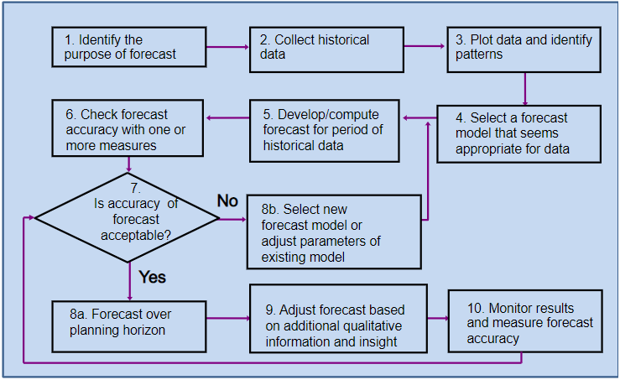
Figure 11 - Steps of the Forecasting Process (Russell & Taylor, Operations Mangement , 2014)
Forecasts in general are based on time and normally focus on short to mid-term (daily, weekly, monthly up to approximately eighteen months to two years) and then the long term which could be as far into the future as five to ten years. The long-term forecasts aid businesses in making strategic decisions with regards to expanding existing facilities or planning new facilities to serve the forecasted growth or markets.

3.13 Bottleneck – Theory of Constraints (TOC)
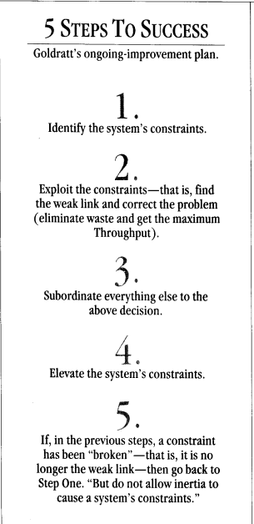
Manufacturing processes by nature may well have constraints within them which may be because of how the process was originally set up or expansion of the said process over time. These constraints are commonly known as ‘Bottlenecks’ which were described by Wolniak, et al as ’a problem that delays progress’ or ’department, facility, machine, or resource already working at its full capacity and which, therefore, cannot handle any additional demand placed on it’ (Wolniak, Skotnicka-Zasadzien, & Gebalska-Kwiecien, 2018).
Eli Goldratt developed ‘The Theory of Constraints (TOC)’ and promoted this using three measures of performance within operational environments as follows; Throughput, Inventory, Operating Expense, and these should be considered in that order of priority with the view of increasing throughput whilst reducing inventory and operating costs. The term ‘throughput’ should be contemplated in the context as being products once sold. Throughput can be hindered by constraints or bottlenecks from both an internal of the organisation perspective and external, these can be managed by applying the ‘five step TOC process’ with this approach shown in Figure 12 (Sheridan, 1991), this is further explained in Appendix 8. The five step TOC process is viewed as being a means of continuous improvement and similarities can be drawn with ‘Plan, Do, Check, Act (PDCA)’, however is a more focused approach.
Figure 12 – 5 Step TOC process
The best way to identify and unearth the bottleneck within the process is to use process mapping tools as an aid. Observing and mapping each step of the process will help with the understanding of where the constraint lays, caution should be paid to not using machine capacity specifications over observation as the specifications are typically set using optimal operating conditions, similarly when observing human resources undertaking activities that all normal activities and tasks are considered as separate processes remembering that process mapping is taken from a single point in time unless it is being carried out dynamically supplying more consistent data sets to aid with setting cycle times for individual tasks and activities.

Chapter 4 - Cabot Carbon Production Warehouse

The Cabot Barry FMO Facility build started in 1989, commencing production of Hydrophilic Fumed Metal Oxide (FMO) products in 1992. The facility has a symbiotic fence line relationship with a silicones manufacturer (Dow) with an initial 20 year contract beginning when the FMO facility went into production with the contract being further extended by 10 years in 2012, this relationship enables a partially closed-loop production system which is described by Herwig Winkler as ‘’striving for sustainability by improving economic and environmental goals simultaneously’’ (Winkler, 2011).
The two facilities share utilities services along with a two-way supplier/customer connection with Dow supplying Cabot blended liquid feedstock via pipelines which is converted through a continuous burner process into Hydrophilic FMO powder with this in turn being supplied back to Dow via further pipelines to the Dow Barry facility along with bulk loading transfer in road tankers to other European Dow facilities. Cabot returns by-products to Dow from the Cabot process which are then converted back into feedstock to return to Cabot for further conversion to FMO’s.
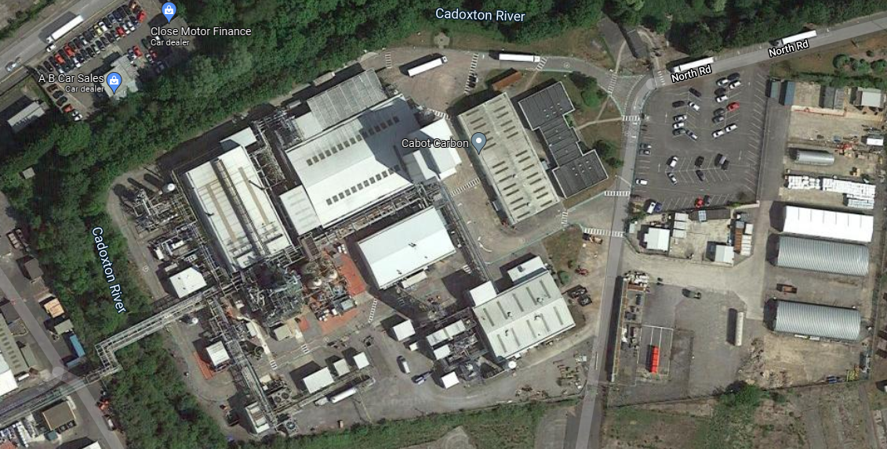
Figure 13. Aerial view of Cabot Carbon Barry FMO Facility (Google Maps, 2021)

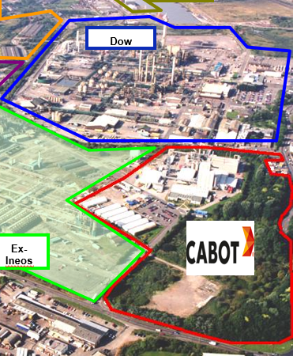
When the Cabot FMO facility first went into production in 1992 the Hydrophilic capacity was set at 8,500 metric tons (M/T’s) per year with approx. 3,500 M/T’s being supplied to Dow either direct via a pipeline or in bulk road tankers. The remainder of the product was packaged in paper-sacks in the production warehouse for supply to niche customers. Between 1992 and 2012 when the initial 20-year contract was extended the Hydrophilic capacity was expanded on three occasions with it currently in 2021 being 12,700 M/T’s per year with the Dow requirement also increasing to approx. 5,500 M/T’s with the remainder again being packaged in either 10kg paper-sacks or Flexible Intermediate Bulk Containers (FIBC’s) along with approximately 1,950 M/T’s being Silo stored as feed for the Hydrophobic treated process reactors.
Figure 14. Aerial view of Cabot/Dow facilities
During 1998 the first Hydrophobic treated silica batch reactor production unit was built and commissioned with an annual capacity of approx. 530 M/T’s with all manufactured product being packaged in 10kg paper-sacks. The Hydrophobic production unit has been expanded on four further occasions between 2002 and 2021 via the addition of two further batch reactors followed by the conversion of one of the batch reactors to a continuous process reactor in 2015 with the latest expansion in 2021 being the addition of silica feed pre-heaters on the inlet to the batch reactors. The total production capacity of the Hydrophobic reactors as of October 2021 is 2,300 M/T’s per year with this product being packaged in 10kg paper-sacks and FIBC’s within the production warehouse for supply to a variety of customers.
As fumed metal oxide has a very low bulk density, densification processes are used for both Hydrophilic and Hydrophobic grades to increase bulk density with a view to reducing filling times and increasing payloads in bulk and FIBC deliveries along with aiding product incorporation in the final customers processes.
The facility operates following a business vision, strategy, values set and guiding principles;
Vision – We will be the most innovative, respected, and responsible leader in our markets – delivering performance that makes a difference.
Strategy – Extend our leadership in performance materials by investing for the growth in our core businesses, driving application innovation with our customers, and generating strong cash flows through efficiency and optimization.
Values – As Cabot employees, we value integrity, respect, excellence and responsibility.
The above vision, strategy, values set along with the guiding principles are strategically displayed around the facility to serve as reminders to all how Cabot operates, the visual displays used can be seen in Appendices 9, 10 and 11.
The Cabot Barry Facility employs 92 people in total of which 30 work directly within the warehouse, packaging and shipping (WPS) teams (see Figure 15 for WPS organisation structure) and report into the sites Operations Manager either via the WPS Manager or Shift Manager. The facility operates on a 24/7 basis for 365 days per year, there tends to be one planned turnaround per year for approximately two to three weeks, however this doesn’t mean that the whole site is shut down as some plant sections such as the Hydrophobic reactors and packaging areas will continue to run for all or part of the turnaround.
The packaging team follow a 24/7 shift pattern whereas the shipping team, work a Monday to Friday day pattern, with the loading team following a continental pattern covering loading activities from 6am to 10pm on a Monday to Friday basis with an eight-hour loading window on a Saturday.
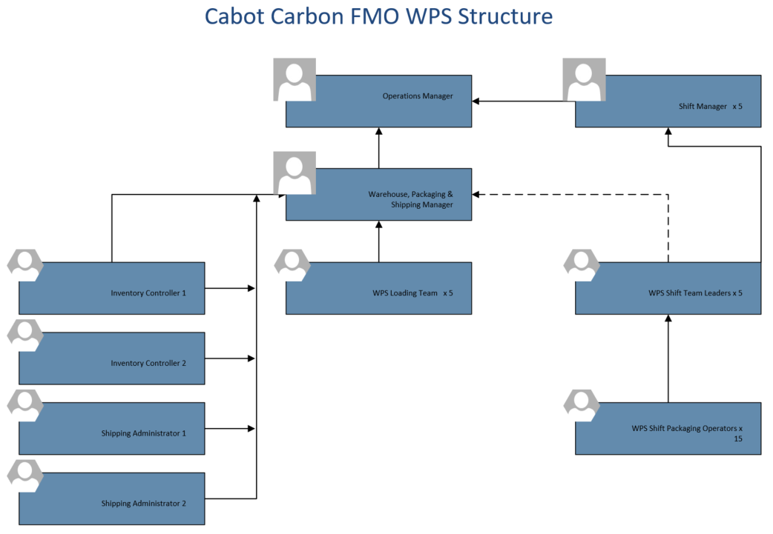
Figure 15 – WPS Personnel Org. Structure

4.1 Cabot Carbon FMO Lean Manufacturing Questionnaire
The purpose of undertaking the Lean Manufacturing questionnaire is to assess the current understanding of Lean Manufacturing and its concepts at the Cabot Carbon FMO facility in Barry. The approach used to complete this section of research was as follows;
- Define the research aim 4. Questionnaire design
- Ascertain the population and sample size 5. Completing a pilot and main survey
- Questionnaire issuance and collection process 6. Analysis of collected data

4.1.1 Research Aim
The research undertaken to date suggests that over time there have been attempts at implementing some Lean Manufacturing tools such as 5S and Visual Management to aid with driving continuous improvement within the Barry FMO facility, however there are signs that this isn’t being sustained. The literature reviewed as part of this final project succinctly highlights that for Lean Transformation to be successful the people within the organisation are crucial in the success of the transformation. The supposition therefore suggests the reasons for the failure to sustain the improvement work at Barry could be attributable to the lack of understanding of Lean Manufacturing within the organisation.
The purpose of the research questionnaire is therefore to determine the level of understanding of Lean Manufacturing at the Barry FMO facility whilst also determining how ‘Lean’ each functional area of the facility may be.

4.1.2 Population and Sample Size
To be successful Lean Manufacturing demands all functions of a business to act and carry out their daily role in a certain manner, as described in Appendix 6 (The 25 Lean Principles). The population included in this research will therefore come from a variety of functions and levels within the Barry FMO facility as follows;

- Engineering & Technical
- Shift Managers
- Inventory & Shipping
- WPS Day Technicians
- WPS Shift Technicians
- Leadership Team
- Shift Process Technicians

Burgess (Burgess, 2001) determines that to gain thorough analysis an optimal sample size of between 20% - 30% of the population is required. The Barry FMO facility employs ninety-two people in total so to gain the required 30% for analysis, twenty-seven responses would be required. It was therefore determined that the questionnaire would be shared with fifty-eight people (63% of the entire facility population).

4.1.3 Issuance and Collection
It was decided to aid with the issuance and collection of the questionnaire that this would be undertaken using an electronic format with Microsoft Forms being selected as the questionnaire vehicle and therefore self-administered by the respondent. The Form was drafted and issued with an accompanying e-mail detailing the reasoning for the questionnaire and giving some instructions for completion – copies of both can be found in Figure 16 (Form) and Appendix 12 (email). Once the questionnaire was completed it was then submitted electronically by the respondent for viewing by the administrator. To encourage a healthy response rate the survey was made anonymous after receiving feedback during the pilot survey, however to aid with the research and future training needs the respondents were requested to select their job role on site.

4.1.4 Questionnaire Design
The design of the questionnaire was relatively simple once the delivery method was chosen as the layout for Microsoft Forms is already set, however the type of questions chosen were determined to be that of Closed and Multiple Choice. The reasoning for choosing these question types are as follows;
- Take less time to answer so likely to improve response rate
- Can be more specific
- Easier to analyse
- Produce quantitative data

Figure 16 - Lean Manufacturing Understanding Questionnaire
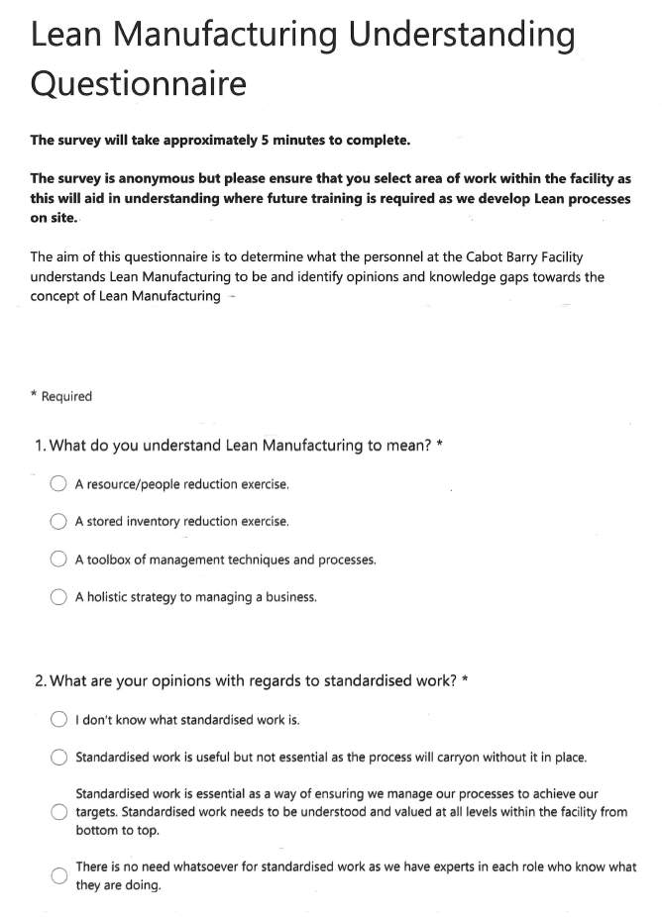
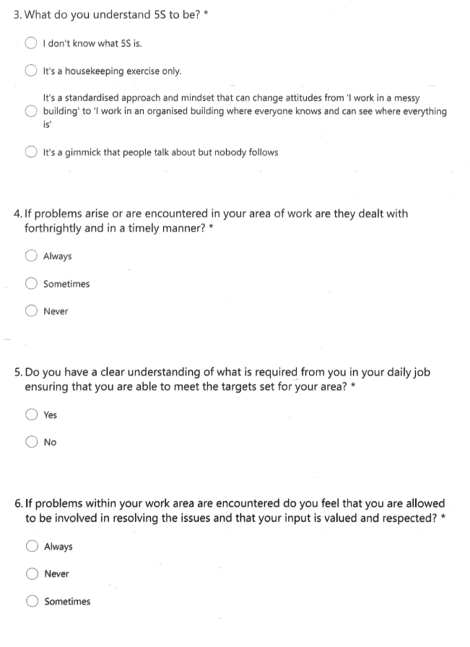
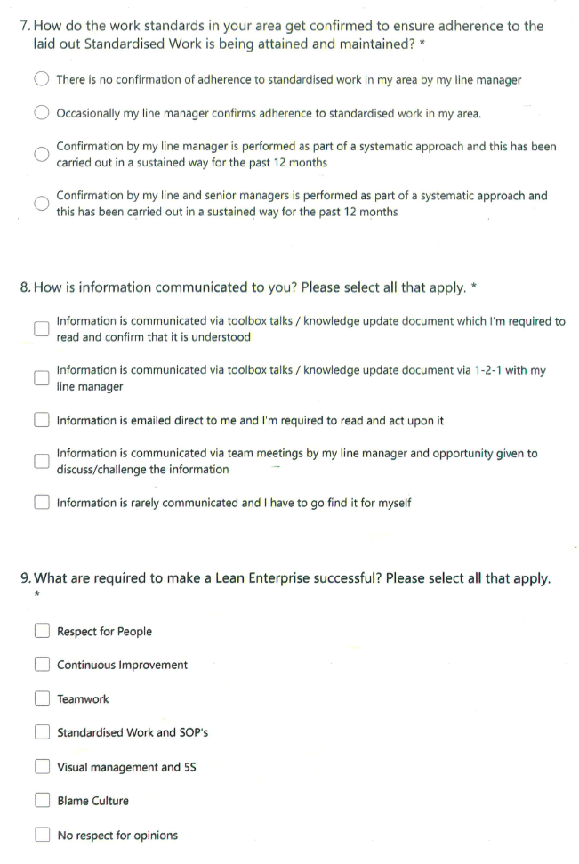
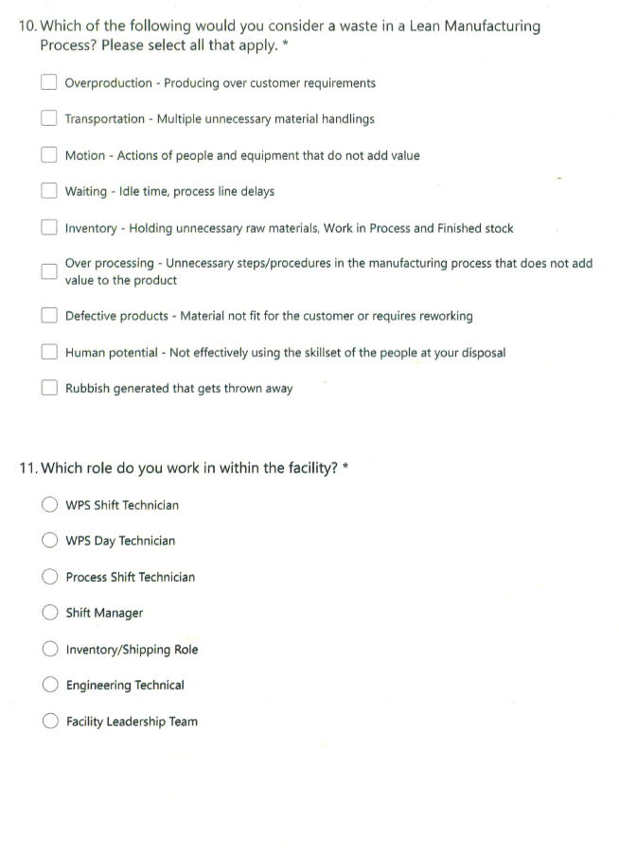
To determine tangible questions a fundamental connection must be established between the research aim and the chosen questions via the research issues. To bring this together, Table 5 has been produced detailing the research aim at the top along with the research issues and questions generated to satisfy the areas of interest.
Table 5 – Research Issue versus Research Questions
AIM: To identify the level of knowledge and understanding of Lean Manufacturing and its’ application at Cabot Carbon FMO facility Barry.
Research Issues | Research Questions
Do employees at Cabot Carbon FMO facility Barry identify what Lean Manufacturing is? | Q1. What do you understand Lean manufacturing to mean?  - A resource/people reduction exercise.  - A stored inventory reduction exercise.  - A toolbox of management techniques and processes.  - A holistic strategy to managing a business.
Do employees value standardised work? | Q2. What are your opinions with regards to Standard Work?  - I don’t know what standardised work is.  - Standardised work is useful but not essential as the process will carry on without it in pace.  - Standardised work as essential as a way of ensuring we manage our processes to achieve our targets. Standardized work needs to be understood and valued at all levels within the facility from bottom to top.  - There is no need whatsoever for standardized work as we have experts in each role who know what they are doing.
Do employees understand what the tool 5S means? | Q3. What do you understand 5S to be?  - I don't know what 5S is.  - It's a housekeeping exercise only.  - It's a standardized approach and mindset that can change attitude from ‘I work in a messy building’ to ‘I work in an organized building where everyone knows and can see where everything is.’  - It's a gimmick people talk about but nobody follows.
Does the area employee seek to identify the root cause of problems and implement countermeasures? | Q4. If problems arise or are encountered in your area of work are they dealt with forthrightly and in a timely manner?  - Always  - Sometimes  - Never
Are employees daily objectives aligned with Cabot Carbon Barry annual goals and objectives? | Q5. Do you have a clear understanding of what is required from you in your daily job ensuring that you were able to meet the targets set for your area?  - Yes  - No
Do employees feel that their input is valued and respected? | Q6. If problems within your work area are encountered do you feel that you allow it to be involved in resolving the issues and that your input is valued and respected?  - Always  - Never  - Sometimes
Does a culture for Gemba and work conformation exist? | Q7. How do the work standards in your area get confirmed to ensure adherence to the laid out Standardised Work have been attained and maintained?  - There is no confirmation of adherence to standardised work in my area by my line manager.  - Occasionally my line manager confirms adherence to standardised work in my area.  - Confirmation by my line manager is performed as part of a systematic approach and this has been carried out in a sustained way for the past 12 months.  - Confirmation by my line and senior managers is performed as part of a systematic approach and this has been carried out in a sustained way for the past 12 months.
Are employees engaged and informed? Is there a standard for communication and engagement? | Q8. How is information communicated to you? Please select all that apply.  - Information is communicated via toolbox talks / knowledge update documents which I'm required to read and confirm that it is understood.  - Information is communicated via toolbox talks / knowledge updated documents via 1-2-1 with my line manager.  - information is emailed and direct to me and I'm required to read and act upon it.  - Information is communicated via team meetings by my line manager and opportunity given to discuss / challenge the information.  - Information is rarely communicated and I have to go find it for myself.
Do employees understand some fundamental tools and processes to make a lean enterprise successful? | Q9. What are required to make a lean enterprise successful? Please select all that apply.  - A respectful people  - Continuous improvement  - Teamwork  - Standardised work and SOP's  - Visual management and 5S  - Blame culture  - No respect for opinions
Do employees understand the fundamental rule of Lean Manufacturing, the removal of waste? Can the employees identify critical wastes? | Which of the following would you consider a waste in lean manufacturing process? Please select all that apply.  - Overproduction - producing over customer requirements  - Transportation - multiple unnecessary material handlings  - Motion - actions of people and equipment that do not add value  - Waiting - idle time, process line delays  - Inventory - holding unnecessary raw materials, work in process and finished stock  - Overprocessing - unnecessary steps/procedures in the manufacturing process that does not add value to the product  - Defective products - material not fit for the customer or requires a reworking  - Human potential - not effectively using the skill set of the people at your disposal  - Rubbish generated that gets thrown away

4.1.5 Pilot Questionnaire
The questionnaire was initially issued to some selected personnel within the target groups of the facility with a view to detecting any potential issues with the questioning along with suggestions on how to improve the potential response rate. Concern was raised consistently regarding the need to clarify that in some questions more than one response needed to be selected along with in some quarters that a better response rate may be received if the questionnaire was anonymous. To address the points raised the questionnaire was altered to reflect in some questions that more one response may be required by adding ‘Please select all that apply’, additionally the respondents name being required was removed and replaced with ‘Which role do you work in within the facility’.

4.1.6 Main Questionnaire
The main questionnaire was issued to all target groups during Week 4 2022 via e-mail to all selected respondents. The respondents were given 4 Weeks to complete and submit the questionnaires for analysis. The final response rate at the end of Week 8 2022 was a total 37 respondents, which equates to 64% of the targeted group and 40% of the entire employee population at Cabot Carbon FMO Barry facility. The spread of respondents by role within the facility can be seen in Figure 17.
Figure 17 – Questionnaire response rate by facility role

4.1.7 Lean Questionnaire Data Analysis
Microsoft Forms as discussed was the software chosen to undertake the questionnaire, in part this was used based on the software’s capability to automatically produce graphical representation of the respondents answers, however the data presented was considered to be raw as shown in figure 18, and not truly representative in demonstrating the understanding of Lean within the facilities roles.

Figure 18 - Lean Manufacturing Understanding Questionnaire (Raw Data)
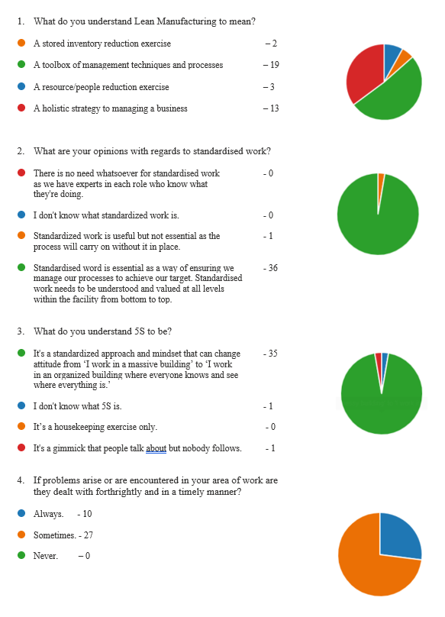
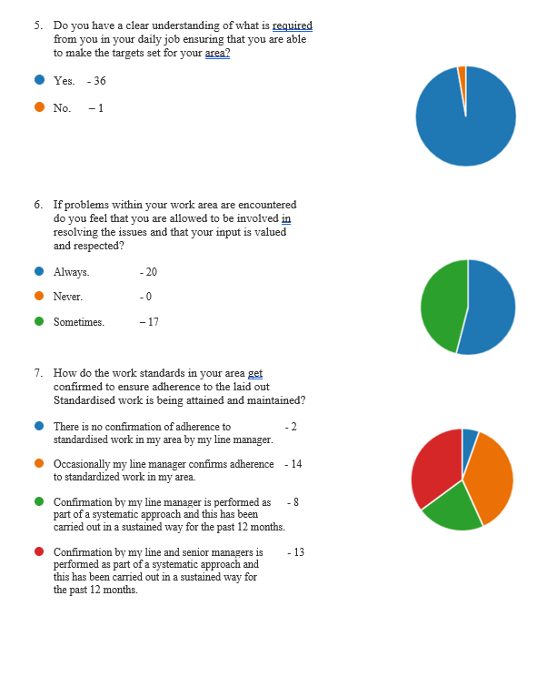
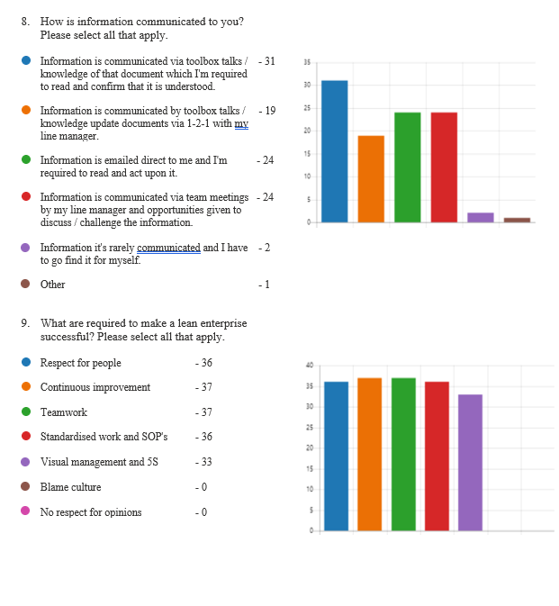
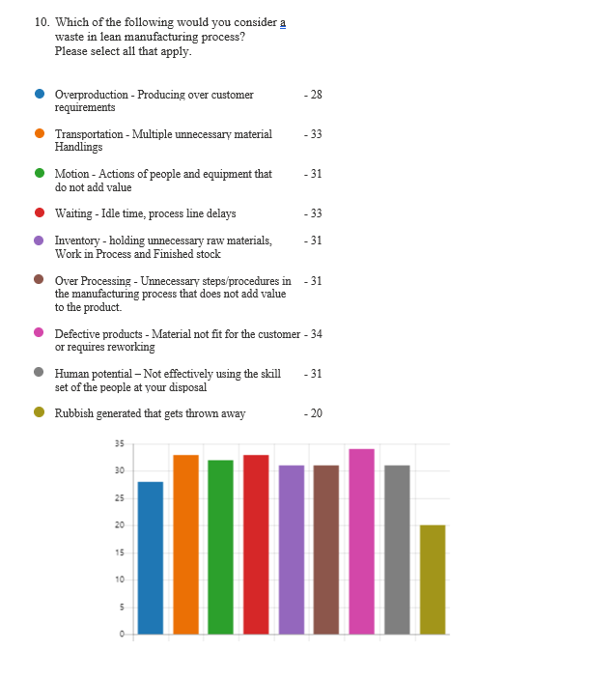
To enable a more thorough and visual analysis of the collected data it was determined to download the raw data from Microsoft Forms into a Microsoft Excel spreadsheet and use pivot table functionality to manipulate the data for more detailed analysis. To further understand the data presented a numerical weighting was added to the possible answers with the answers having a strong correlation to Lean given a higher weighting than those with a weaker or no correlation to Lean which were given a lower or zero weighting, the total scores by responder are then added to give an overall Lean percentage score by facility role. The scoring criteria/weighting for each answer is referenced in table 6, whilst the scores themselves can be found in Appendix 13. As previously stated the questionnaire aim was two-fold, to identify the level of lean manufacturing understanding by functional role along with how lean these roles operate. Table 5 shows the survey questions and the possible answers along with the areas of research they fit into, the questions shaded in blue are aimed at the responders understanding of lean manufacturing whilst those shaded in orange are aimed at the functional areas/roles the responder works within at the facility.
Table 6 - Questionnaire Scoring Criteria (Weighting)
Total number of questions | 10
Percentage per question | 10%
Question number | Weighting | Question number | Weighting
1.1 | 0 | 8.1 | 1
1.2 | 0 | 8.2 | 3
1.3 | 0 | 8.3 | 1
1.4 | 10 | 8.4 | 5
2.1 | 0 | 8.5 | 0
2.2 | 0 | 9.1 | 2
2.3 | 10 | 9.2 | 2
2.4 | 0 | 9.3 | 2
3.1 | 0 | 9.4 | 2
3.2 | 0 | 9.5 | 2
3.3 | 10 | 9.6 | 0
3.4 | 0 | 9.7 | 0
4.1 | 10 | 10.1 | 1.25
4.2 | 5 | 10.2 | 1.25
4.3 | 0 | 10.3 | 1.25
5.1 | 10 | 10.4 | 1.25
5.2 | 0 | 10.5 | 1.25
6.1 | 10 | 10.6 | 1.25
6.2 | 0 | 10.7 | 1.25
6.3 | 5 | 10.8 | 1.25
7.1 | 0 | 10.9 | 0
7.2 | 2.5
7.3 | 5
7.4 | 10

When analysing the collected data it shows the average Lean percentage at the facility to be 76.8%. This can be further broken down to highlight the average lean percentage by functional role, as shown in figure 19. As can be seen in figure 20 the lean average percentage for those working in shop floor functional roles (WPS Shift & Day, Process Technicians) sit below the average facility percentage at 70% average, whilst those in technical and management roles sit on or above the average facility percentage at 82% average, therefore a gap of 12%. This data analysis outcome is not a surprise as those people working within the technical and managerial functional roles have at some stage in their careers or educational training been exposed to Lean Manufacturing principles, techniques and tools whilst those operating in the shop floor roles have received limited training or exposure to these principles. The data outcome does identify areas for improvement across all functional areas with greater emphasis required within the shop floor roles.

To further interrogate the data, the questionnaire answers were separated to highlight the average lean understanding percentage along with the functional lean area percentage as can be seen in figure 18.
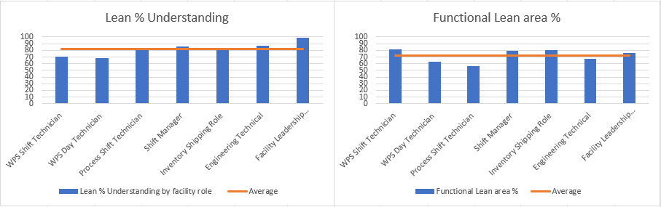
Figure 20 – Overall Average Lean % Understanding & Functional Lean Area %
With the data separated it highlights that the overall lean understanding is higher than the functional lean area average at 81.7% compared with 71.7%, additionally a wider average gap in Lean understanding between shop floor functional roles versus the technical and managerial functional roles is evident with this now being 15% as opposed to 12% pre data separation.
Interestingly the data identifies that the functional area percentage where lean is applied on a more consistent basis is more mixed, highlighting the shop floor role of the WPS Shift Technician at being well above the average of 71.7% at 81% which is ahead of the facility leadership team by 5%. When considering the questions posed to the population this is likely borne out of the areas of standardised work confirmation, communication and inclusion where each of these were consistently scored above the average by the WPS shift technician population as can be seen in figure 21 whereas for example in the facility leadership team, confirmation of work is less likely based on this team leading the site with the next level of leadership being off site. Communication is highlighted as a concern amongst the functional groups of WPS Day Technician, Process Shift Technician and Engineering & Technical with each of these groups falling well below the average in question 8. To compliment the data set further figure 22 shows the weighted data for the scores associated with the lean understanding individual questions only which further highlights the data and gaps in understanding across the facility functional roles captured in figure 19.

The data collected and analysed highlights a variety of gaps with regards to lean understanding at the shop floor levels within the facility which need to be addressed along with the gaps seen regarding lean application, confirmation, and communication across many of the functional areas within the facility. The data presented does however confirm that the facility functional roles subjected to the questionnaire do have a reasonable theoretical understanding of what the requirements are for applying Lean Manufacturing within the facility and that the training gaps identified will not be unsurmountable.

4.2 Lean Assessment at Cabot Carbon Barry
The purpose of undertaking a Lean Assessment is gain an understanding in general of the condition of the Lean Transformation within the organisation. As discussed previously, assessments should be undertaken cyclically to monitor the progress made over a given period, with this stemming from the fifth lean principle ‘striving for perfection’. The assessment is an evaluation undertaken by an organisation to single out improvement opportunities and areas of weakness, whilst offering guidance for areas to prioritise.
Looking back through the annals of time over the thirty years that Cabot Carbon FMO facility in Barry has been in operation it doesn’t appear that a Lean Assessment has been undertaken or at least if one has it has not been recorded. Therefore, if Lean Transformation is to be realised then a full Lean Assessment will be required, however this assessment being undertaken is concentrated on one area of the facility only, being the production warehouse.
Whilst Lean Assessments have not previously been undertaken some lean tool implementations have been attempted such as Visual Management to include 5S, Layered Process Auditing (LPA), Standardised Work approach, Standup Daily Management Meetings (DMM) which highlight the required daily targets by area, some use of A3 Problem Solving (example in Appendix 19), along with a handful of Kaizen events being undertaken, with not all being sustained. The lack of sustaining is most likely in some cases due to a poor level of understanding based on limited training undertaken for facility personnel to fully understand the concepts, however the COVID 19 Pandemic also disrupted the Standup DMM at area of work based on the need to reduce people interactions along with many individuals within the facility defaulting to working from home with these meetings instead moving to an electronic format. The meetings moving to a virtual format has had a negative impact in the production warehouse with regards to visual targets and inclusion in the meetings suppressing the area technician’s ability to discuss daily issues openly.
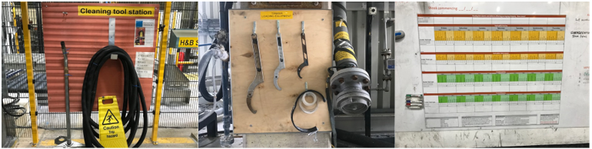
Figure 23 – Examples of 5S and Visual DMM at the Cabot Carbon Production Warehouse

4.3 VSM Current State
To aid with understanding the activities within the production warehouse further with a view to revealing where wastes may exist as measured under the ‘Eight Wastes’ discussed in section 3.2.1 (Ohno’s 7 Wastes – Muda) a ‘Value Stream Mapping (VSM)’ exercise was undertaken (see Figure 24). When undertaking the mapping exercise, the production plan from table 12 for Fiscal Year (FY) 22 was used as the basis of the required throughput – By way of a reminder it needs to be understood that whilst VSM is an important tool within ‘Lean’ it is a static process based on a point or points in time at a ‘Macro Level’ so may not unearth all problems within the process being mapped.
All processes from the storage silo’s forward were considered holistically as part of the mapping with the main areas of interest listed below;
- Product Packing in 10kg paper-sacks.
- Product Packing in Flexible Intermediate Containers (FIBC’s).
- Treated Product Densification.
- Packed Product shaping, palletising, pressing and foil wrapping.
- Road Tanker loading.
- Sea-bulk Container loading.
- Raw Material management (paper-sacks, FIBC’s, Pallets, Wrapping Foils).
- Packed Product End of Line (EOL) conformance checks.
- Packed Product Storage.
- Packed Product Loading.
- Packed Product Shipping.
- Rework of Non-Conforming product.
To aid with unearthing the highlighted wasteful activities identified in the VSM further some of the areas of concern were also mapped at the ‘Micro Level’ by using ‘Process Mapping’ techniques which scrutinise the activities at closer quarters on a step-by-step basis.

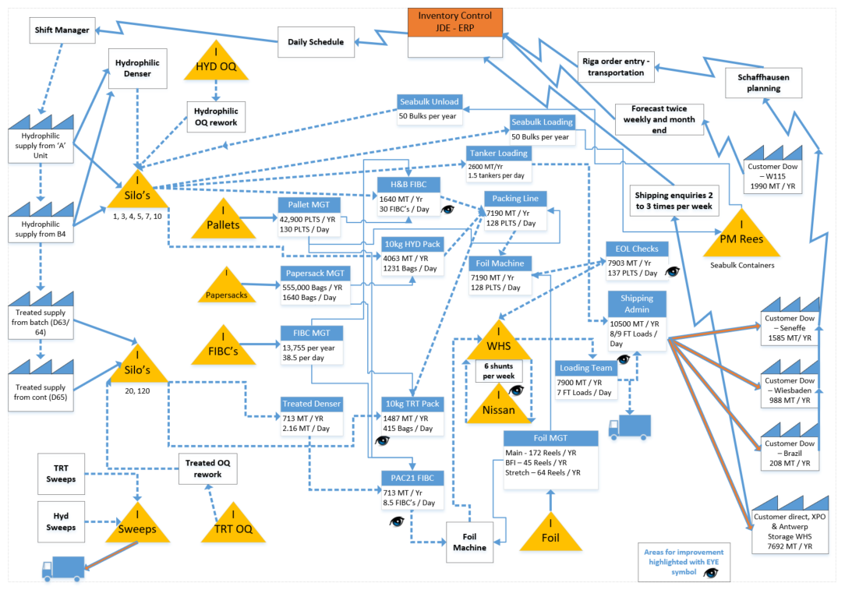
Figure 24 – Production Warehouse Value Stream Map

4.3.1 VSM Current State Highlighted Wastes
The Waste of Transporting;
There are many instances within the production warehouse of transporting packed product from conveyor systems, short distance Forklift Truck (FLT) movements to designated storage areas through to transporting the product from the main storage area to back up storage buildings approximately five hundred meters away.
When considering the length of conveyor systems within the packing line these are quite lengthy, however there are a variety of reasons why this is necessary as follows;
- Additional packing machines added to cope with facility production expansions with conveyors being used to transport the filled paper-sacks to the flattening/shaping system.
- In-line product discrimination added when treated reactors came on-line, enabling two different products to be sent through the packing line system at the same time.
- The paper-sacks need entrained air from the filling machines to be removed so are sent through a flattening and shaping conveyor set which needs to be two stage increasing conveyor length.
Two main areas of concern therefore exist as follows;
- Transportation of packed product from the production warehouse storage location to the back-up storage buildings with this increasing as a requirement in line with the increase seen in packed products over the past few years as highlighted in Figure 22. This activity is undertaken on site using a rigid shunting unit which can transport twelve stock keeping units (SKU’s) at a time, increasing the risk of product damage, using precious resource along with double/triple handling prior to finally loading and shipping the product off site.
- The H&B FIBC machine exists as a standalone package within the production warehouse and does not have an integrated shrink-wrapping machine meaning that each FIBC once filled needs to be removed from the end conveyor using a FLT, turned through ninety degrees and finally placed into the MSK shrink wrapping machine for wrapping. This activity is undertaken on average thirty times per day wasting valuable resource.
The Waste of Unnecessary Inventory;
As the facility has relatively small storage holding on site most of the product manufactured is loaded and shipped from site normally the following day either to external storage warehousing in the United Kingdom (UK) and mainland Europe or direct to customers. The site does hold contingency stock for feeding the treated reactors (130 FIBC’s) along with contingency stock for Dow held in sea-bulk containers (25 x 5000kg) to ensure that these units can run through any interruptions of the main hydrophilic production units. The sea-bulk contingency stock holding of one weeks’ inventory is not considered as waste but necessary along with it being a contractual obligation to ensure the Dow facilities remain supplied.
The Waste of Unnecessary Motion;
This waste is very apparent within the production warehouse and seen in many different areas of the operation, with it mainly consisting of the area technicians moving away from their workstation to carryout activities such as silo changeovers, machine sequence starting, managing line faults, taking loading paperwork from the production warehouse loading area to the shipping office to name but a few.
The Waste of Waiting;
This waste can sometimes be a problem particularly regarding the FIBC filling machines as the fill cycle per FIBC can take on average twenty minutes so the area technicians will move away from the machine to undertake alternative activities which can cause FIBC changeover delays, impacting machine throughput. This is also apparent when waiting for transportation arrivals to load product as timed loading slots are not used, leaving the loading team idle for periods of time during the day and then occasionally a rush of activity.
The Waste of Overprocessing;
This waste has been considered to not be a major concern within the production warehouse, however one concern identified was that there are too many steps taken to get required information entered into the Enterprise Resource Planning (ERP) system with initially the data being captured in paper format and passed through three different departments and logging systems prior to the final entry into the ERP system.
The Waste of Overproduction;
This waste has been considered to not be a concern within the production warehouse. The facility production requirements are set remotely on a monthly basis with the onsite schedulers then determining the order to produce each individual grade based on delivery date to both direct customers and onward customers from the external warehouses so in many cases Just-In-Time (JIT) is achieved with some exceptions only based on lead time.
The Waste of Defects;
The main cause of defects within the production warehouse area are packed product not being packed to the correct weight along with damages to product when transporting, both issues are seldom and tend to be managed quickly and at source owing to inline checkweighers on all packing machines detecting weight related issues enabling the area technician to correct these efficiently. Damaged product is also managed efficiently.
The Waste of Underutilising Employee Skills;
This waste again is apparent within the production warehouse, however as the data from the Lean questionnaire shows there is a high level of inclusion or feeling included within the WPS shift technicians when managing arising problems within the area. Both the WPS shift and day technician roles are highly manual meaning time is taken with these teams operating machinery and equipment along with activities as highlighted in the other ‘Wastes’ moving them away from the value added aspects of their roles along with waiting at some machines as part of the filling sequence which creates the propensity to lead to boredom with this perhaps hindering the untapped potential in many cases.
‘’The greatest waste…is failure to use the abilities of people…to learn about their frustrations and about the contributions that they are eager to make’’. (Deming, 2000)

4.3.2 Process Mapping Activities
As discussed already there were several areas of concern identified as part of the VSM exercise undertaken leading to these areas being mapped using ‘Process Mapping’ techniques, with this looking more closely at each individual step required within the activity highlighting those steps which are ‘Value Adding (VA)’, ‘Non-Value Adding but Necessary (NVAE)’, Non Value Adding (NVA), it is important to remember that ‘Value added activity is something that the customer is prepared to pay for and involves a transformation’. (Bicheno & Holweg, The Lean Toolbox: A handbook for Lean Transformation, 2016), a customer is therefore not prepared to pay for neither the NVAE or NVA activities so these where able should be reduced or removed altogether. The process mapping also enables each step to be analysed and timings considered to identify the consequence to the facility of both the NVAE and NVA activities.

4.3.2.1 H&B FIBC Packing
When analysing the produced current state process map (see figure 25) for the filling of FIBC’s on the H&B machine many wastes and therefore NVA activities were exposed along with NVAE, whilst only two VA existed.

Figure 25 - H&B FIBC Packing Process Map Current State
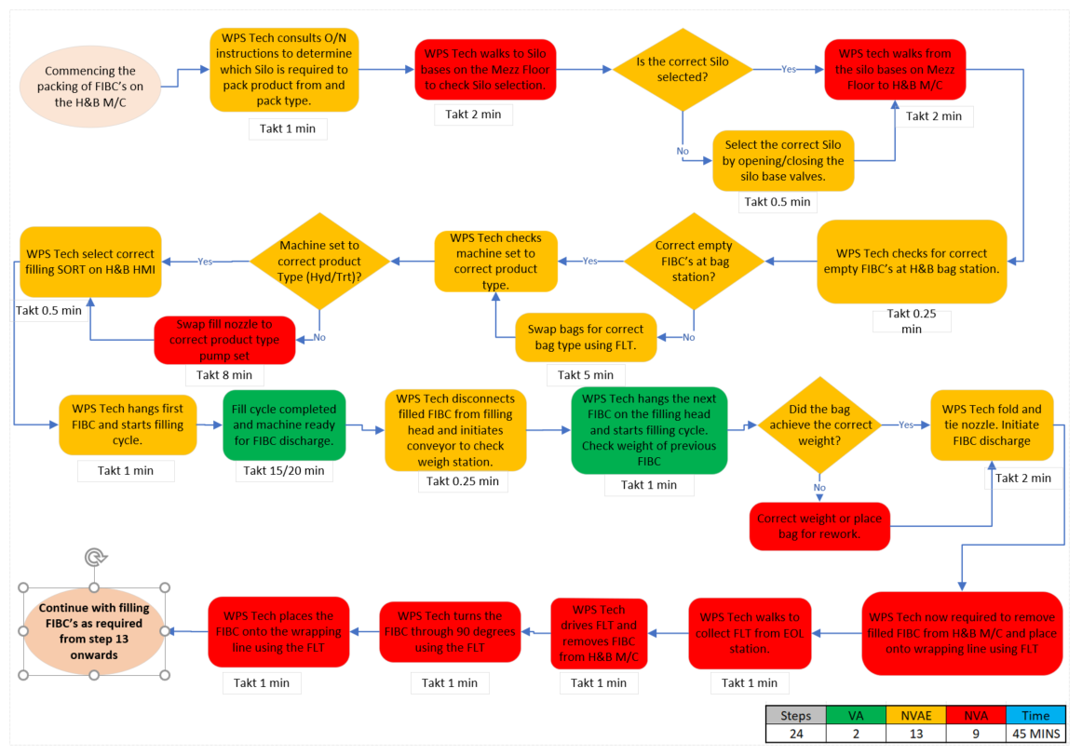
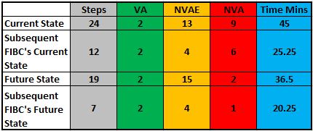
Table 7 – H&B Process Map Value Activities
Table 7 highlights that the initial machine set up to commence, fill and wrap the first FIBC was identified to be forty-five minutes whilst subsequent FIBC’s take twenty-five minutes. The wastes identified are predominantly related to motion of the WPS technician moving away from the machine to check/select correct silo routing and transportation of finished FIBC’s from the H&B machine to the MSK wrapping machine via the use of a forklift truck (FLT). The activities being undertaken which are wasteful can equally be hazardous to those undertaking them as they are moving up and down stairways and operating a FLT in a congested area of the production warehouse so risk also needs to be considered.
Solutions for the above wastes have been considered at a high level as part of this project which come in the guise of automating Silo Selection and adding a conveyor system at the end of the H&B machine to tie this directly into the MSK wrapping machine (see figure 26). A future state process map (see figure 27). was then produced to understand the potential reduction in wasteful activities with the results shown in Table 7. A significant reduction in time down to thirty-six minutes to fill and wrap the first FIBC could be realised with subsequent FIBC’s reduced to twenty minutes and reducing the risks presented to the area technicians.

Figure 26 - Production Warehouse Layout Depicting H&B Machine Conveyor tie in to Wrapping Machine
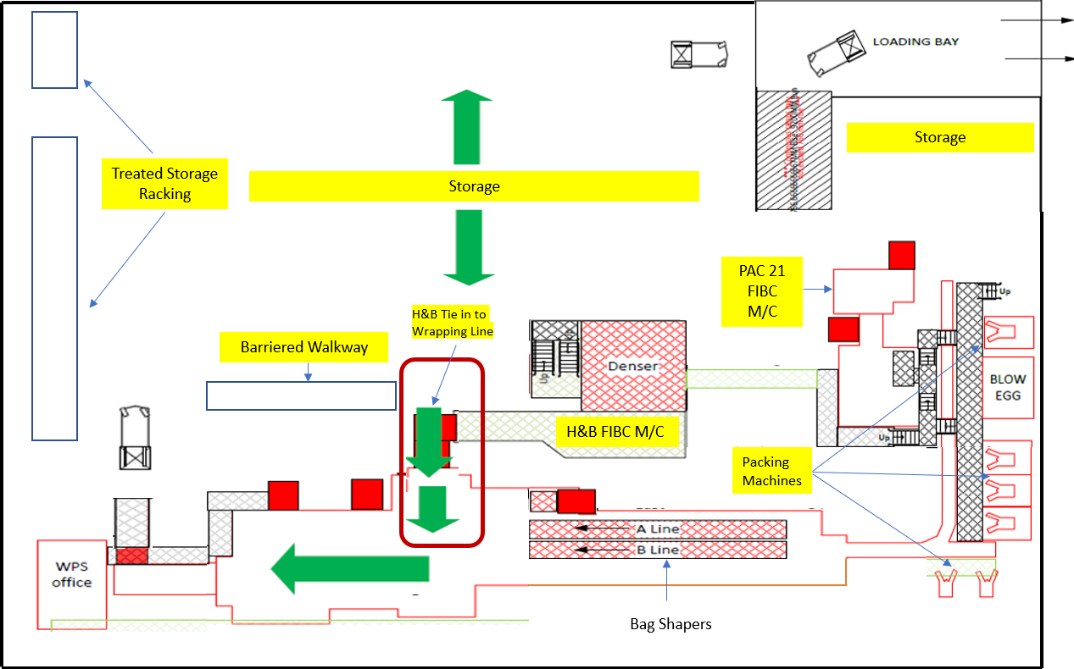

Figure 27 - H&B FIBC Packing Process Map Future State
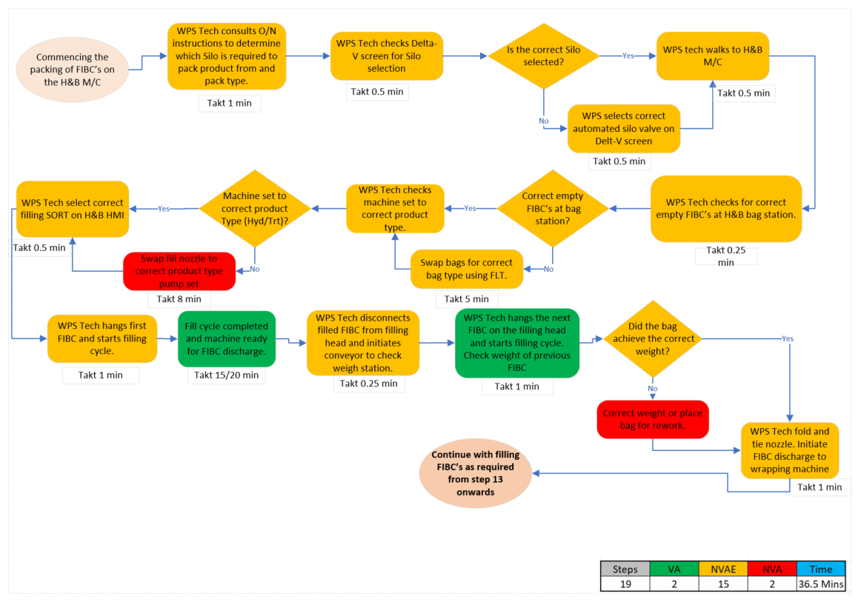
Figure 28 highlights the improvement in the process from the current to future state should, the considered improvement opportunities be realised.
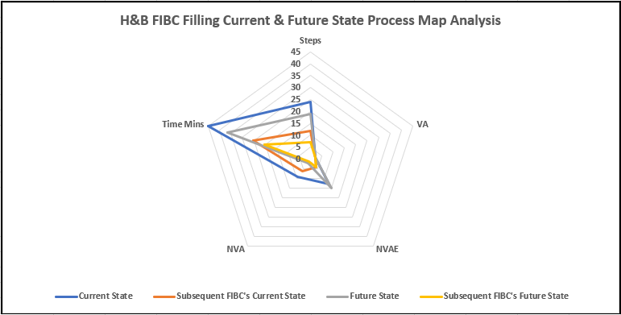
Figure 28 – H&B FIBC Filling Current & Future State Process Map Analysis

4.3.2.2 Treated Paper-Sack Packing
When analysing the produced current state process map (see figure 29) for the filling paper-sacks on the Treated 10kg packing machine many wastes and therefore NVA activities were exposed along with NVAE, whilst only six VA existed.
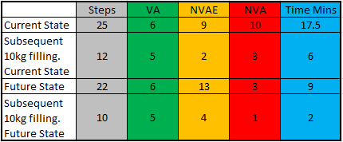
Table 8 – Treated 10kg Process Map Value Activities
Table 8 highlights that the initial machine set up to commence and fill the first paper-sack was identified to be seventeen and a half minutes whilst subsequent paper-sacks can take six minutes when a silo changeover is required. The wastes identified are predominantly related to motion of the WPS technician moving away from the machine to check/select correct silo routing along with the required sequence starting of the packing machine. The activities being undertaken which are wasteful can equally be hazardous to those undertaking them as they are moving up and down stairways on a frequent basis.

Figure 29 - Treated Paper-sack Packing Process Map Current State
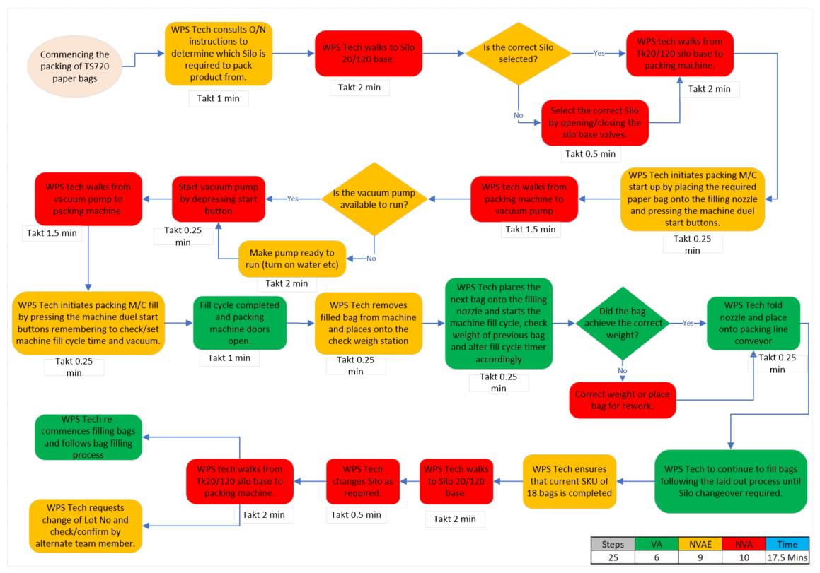
Solutions for the above wastes have been considered at a high level as part of this project which come in the guise of automating Silo Selection and moving the sequence staring of the filling machine locally. A future state process map (see figure 31) was then produced to understand the potential reduction in wasteful activities with the results shown in Table 8. A significant reduction in time down to nine minutes to fill the first paper-sacks could be realised with subsequent paper-sacks reduced to two minutes when a silo changeover is required whilst reducing the risks presented to the area technicians.
Figure 30 highlights the improvement in the process from the current to future state, should the considered improvement opportunities be realised.
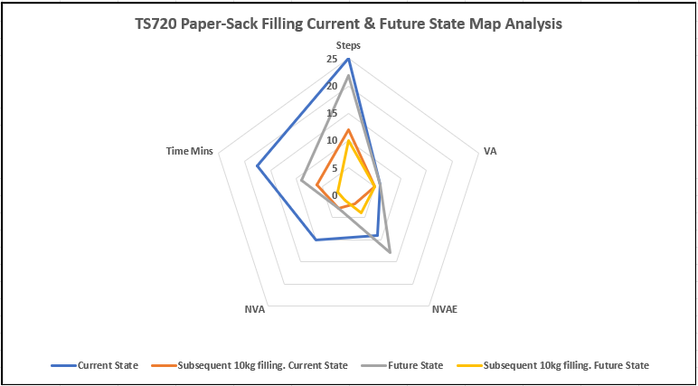
Figure 30 – Paper-sack Filling Current & Future State Process Map Analysis

Figure 31 - Treated Paper-sack Packing Process Map Future State
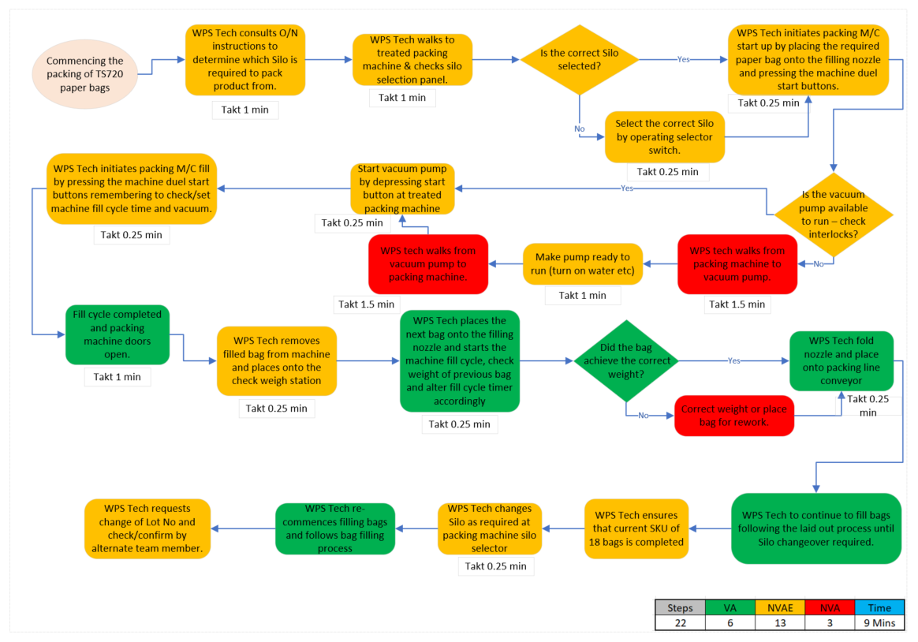

4.3.2.3 Product Shunting
When analysing the produced current state process map (see figure 32) for the shunting of finished product many wastes and therefore NVA activities were exposed along with NVAE, there are no VA activities existing when undertaking product shunting on site.
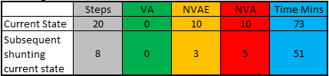
Table 9 – Product Shunting Process Map Value Activities
Table 9 highlights the initial steps required to complete the first shunting activity along with those required for subsequent shunts should they be required. A significant amount of time is taken to shunt product from the production warehouse to the alternative storage areas on site with this activity in its entirety being a waste, those activities rated as NVAE are only required to ensure that the product is safely moved on site and that the Enterprise Resource Planning (ERP) system is updated with the product location.
The shunting activity in the facility has recently increased substantially, in line with the reduction in bulk grades produced and therefore the increase in packed products as highlighted in Figure 24. The shunting requirement is borne out of the storage capacity within the production warehouse only being capable of holding a maximum of 369 SKU’s (see Appendix 16), depending on SKU type.

Figure 32 - Product Shunting Process Map Current State
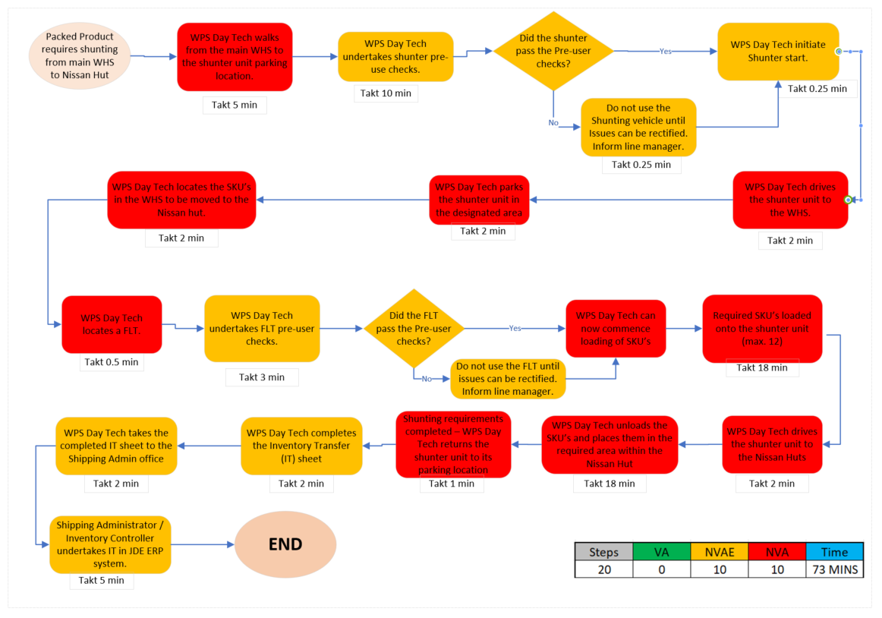

Solution being considered at a high level for the shunting would be to eradicate this completely by increasing the current product loading and shipping window to cover seven-day loading, a contingent part of moving to seven-day loading would be the introduction of Bar-Code technology which will also be considered as a solution in 4.4.2.4 to aid with tracking product SKU’s from the end of the packaging line through to final shipment from site.

4.3.2.4 Facility End of Line (EOL), Storage, Loading and Shipping Process
When analysing the produced current state process map (see figure 33) for the EOL, storage, loading and shipping activities many wastes and therefore NVA activities were exposed along with NVAE, whilst only five were considered as VA, additionally it highlighted fifteen information handovers from one department or person to another potentially causing or leading to errors being made. The main waste areas for this activity were viewed as being; Over-Processing, Waiting, Motion and Underutilising Employee Skills.
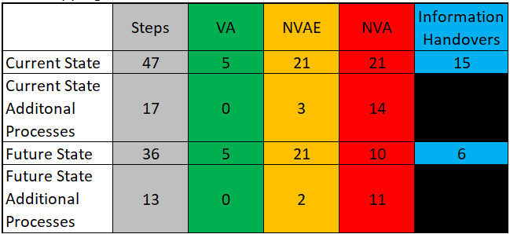
Table 10 – Facility EOL, Storage, Loading & Shunting Process Map Value Activities
Table 10 highlights all required steps from an SKU exiting the EOL, collating and entering production into the ERP system, storage, picking, loading and finally shipping the product from site. The process map also considers the required process for loading and shipping road tankers. As the steps listed do not often occur concurrently due to the production time, laboratory testing and release requirements the timings for each step shown in the process map are not included in this table. One of the main concerns unearthed whilst undertaking the mapping exercise were the number of information handovers which transpire with theses predominantly occurring by way of paperwork being passed from one individual or department to another prior to final entry to the ERP system.

Figure 33 - Facility Storage, Loading and Shipping Process Map Current State
Solution being considered at a high level for this area would be the implementation of a Bar-Coding product tracking system with capability to be connected to the ERP system to enable scanning and logging of product at all stages leading to a live system as opposed to the current system which is updated retrospectively leading to delays. The improvements should the Bar-Code system be implemented are shown further in figure 34 and figure 35.
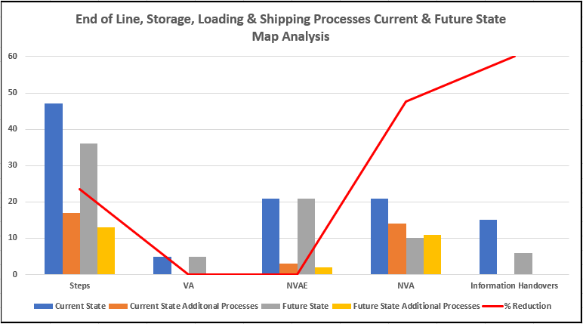
Figure 34 – EOL, Storage, Loading & Shipping Current & Future State Process Map Analysis

Figure 35 - Facility Storage, Loading and Shipping Process Map Future State

4.4 Current Machine Technology and Capability
The production warehouse within the Barry facility houses all packaging equipment which come in the guise of paper-sack and FIBC filling machines, conveyors, bag shapers (flatteners), stacking and palletising machinery along with product pressing and wrapping equipment. A densification unit is also present for treated products. Each of the machines in question have a design rate, instantaneous rate and an availability rate which is used when calculating overall equipment effectiveness (OEE), as a level of human/machine interaction is required to varying degrees the availability rate used in this project is based predominantly on 85% machine uptime, however there are exceptions to this as the treated densification unit has a demonstrated availability of 95% due to limited human interaction being required once brought on line.
The product being packed (Fumed Metal Oxides) is very fine with small particle size which requires air to convey it from the process area to the storage silo’s, whilst cyclonic technology is used to separate the solids and conveying air prior to entering the storage silo’s the product has a tendency to hold air onto its’ surface area which can make it difficult to pack and requires removal as part of the filling, stacking and wrapping processes.

4.4.1 Packing Machinery
The product filling machinery within the production warehouse uses two differing technologies. The 10kg paper-sack machines use vacuum packing technology which draws the product using vacuum from the storage silo and removes some of the entrained air during the sack filling, these machines are semi-automated with the area technician having to place each empty paper-sack onto the fill nozzle and remove it manually with the fill cycle being automated based on pre-set timers. Pump packing technology is utilised for the FIBC machines which again adds further air to effectively convey the products over relatively long distances from the silo bases to the filling machines, again these machines are semi-automated in a similar fashion to the paper-sack filling machines but operate on FIBC pressure and weight as opposed to fill time.
Once the paper-sacks are filled they are manually placed onto a belt conveyor where they are then passed through product discrimination technology prior to entering the bag flattening (shaping) section of the line, once flattening is complete the paper-sacks pass over an in-line checkweigher to check that the correct weight (within tolerances) has been achieved prior to then being lifted by a robot and stacked onto a wooden pallet, each pallet is stacked with eighteen paper-sacks. The full pallet is then transferred via roller conveyors to the product pressing and wrapping line, the press is used to remove further excess air entrained in the product and reduce the SKU height to an acceptable level for onward storage and shipment with the shrink wrapping being used to maintain the achieved height, ensuring stability of the SKU for transportation along with forming a moisture barrier.
The FIBC’s are filled using an automated sequence which presses the FIBC at set pressure intervals to remove the excess entrained air to aid with achieving the desired fill weight. Once the FIBC fill is complete it is moved via roller conveyors to an in-line check weigher to check that the correct weight has been achieved and then further transferred by roller conveyors to the end of the line, at this stage the area technician then utilises a Forklift Truck (FLT) to move the FIBC to the floor, move it through ninety degrees before then placing it onto an in-feed roller conveyor to the shrink wrapping machine. It is important to note that the filled FIBC’s are not further pressed but just shrink wrapped to give the SKU stability and form the required moisture barrier.
The Flattening & Palletising and Shrink-Wrapping sections of the packing line are fully automated and controlled via ‘Programmable Logic Controllers’ (PLC’s).
The treated densification unit again is a process for removing excess entrained air by passing the product through two drums with one being a filter drum connected to a vacuum system and the other being a pressure drum for applying additional pressure to remove the entrained air more efficiently. The densification process can cause clumping of the product but is seen as an effective way to gain quicker incorporation times in the end user’s processes whilst also enhancing the pay load.
Figure 36 highlights in an overview each element of the packing machinery and how they interact whilst additionally showing the packing machine rates V’s the packing line rates along with showing the maximum unit rates which feed into the production warehouse, however what is not considered is product packed on the PAC21 FIBC machine via the treated densification unit as both are standalone units.
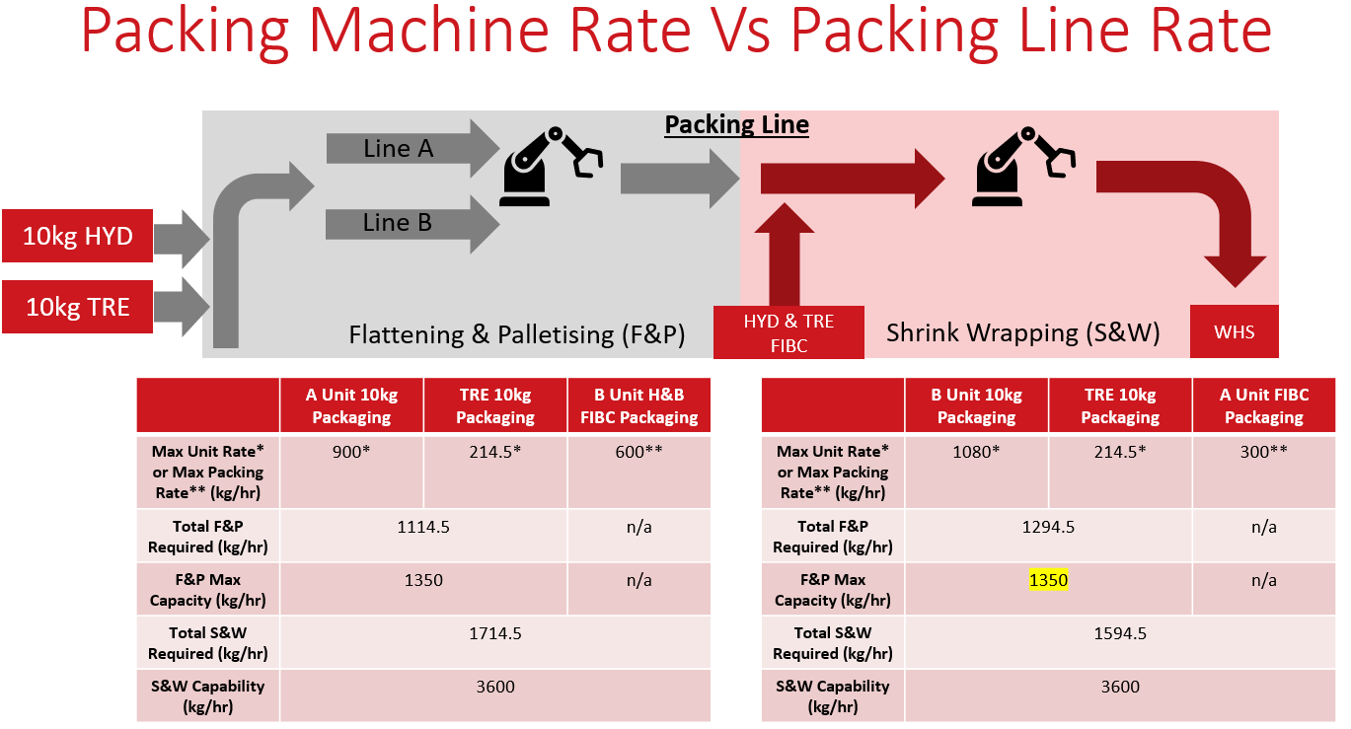
Figure 36 – Packing Machine Rate V’s Packing Line Rate
The true rate of each element of the packing machinery needs to be further understood along with the human interaction in some cases which is highlighted in Table 11, when undertaking the observation within the production warehouse to determine cycle times the differences in these by fumed metal oxide production train and treated reactor were highlighted to be significantly different with this needing to be more clearly understood when planning production to ensure that this doesn’t create more wasteful activities. The fill cycle times for the 10kg and H&B filling machines were undertaken over several visits with those currently being shown in Table 11 being an average, so these can both decrease and increase by approximately ten percent with anything outside of these tolerances highlighting a problem within the process which would require investigation to determine the cause.
Table 11 – All Packaging Machine rates assumptions based on observed cycle times
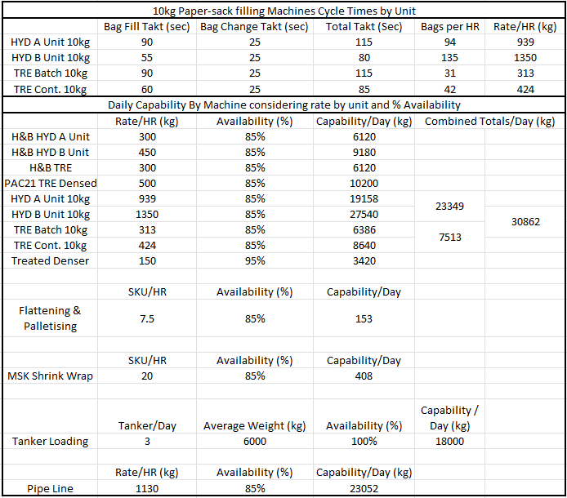
The machine capability rates have become ever more important in recent years and will continue to be a focus moving forward due to the increase seen in the commercial demand (Table 12 and Figure 45), requiring more packed products to serve customer needs with careful planning required to ensure that the production warehouse remains efficient and therefore Lean, with this in mind a ‘bottleneck flow chart’ spreadsheet has been developed to aid the facility Inventory Controller with the production planning. The spreadsheet highlights where individual packing machines are close to, at, or exceeding capacity based on the assumptions seen in Table 11 so action can be taken at the planning stage to stave off potential issues within the production warehouse which could lead to wasteful activities taking place.
Examples of the ‘bottleneck flow chart’ can be seen in figures 37 to 42, with these showing the impacts to the individual machines based on a variety of scenarios to include the following;
- Demand as per plan for FY22, FY25, FY28
- Demand with reduced Treated Densed product for FY22
- Demand with no pipeline outlet to Dow for FY22
- Demand with no tanker outlet to Dow for FY22
When reviewing the ‘bottleneck flowchart Machine / Process Utilisation’ section it is important to remember that this area is colour coded using conditional formatting to highlight the potential impacts with green showing in control, yellow out of control and red above capacity.

Figure 37 - Bottleneck Flowchart - Daily Production Baseline for FY22 taken from Table 12 in Commercial Demand

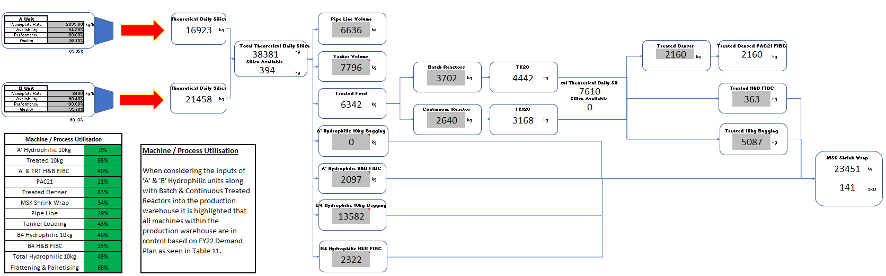

Figure 38 - Bottleneck Flowchart - Daily Production Baseline for FY22 taken from Table 12 in Commercial Demand with reduced Treated Densed volume
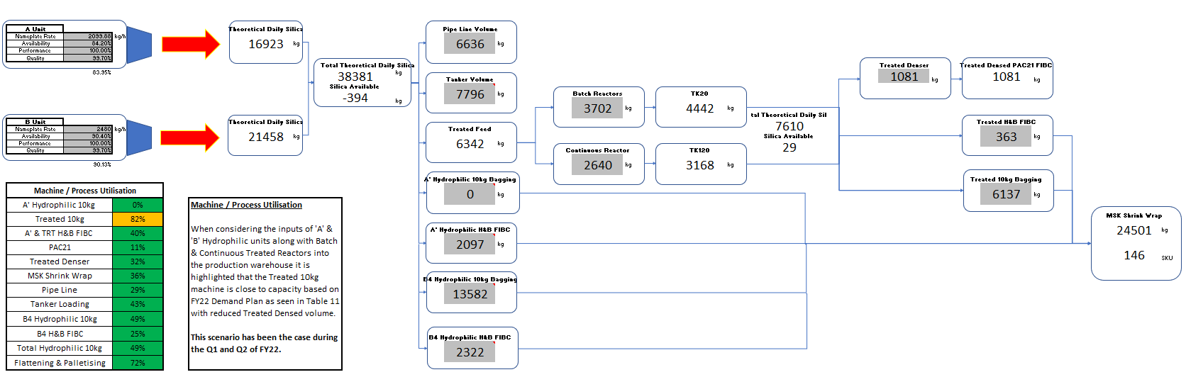

Figure 39 - Bottleneck Flowchart - Daily Production Baseline for FY22 taken from Table 12 in Commercial Demand with no Dow Pipeline outlet
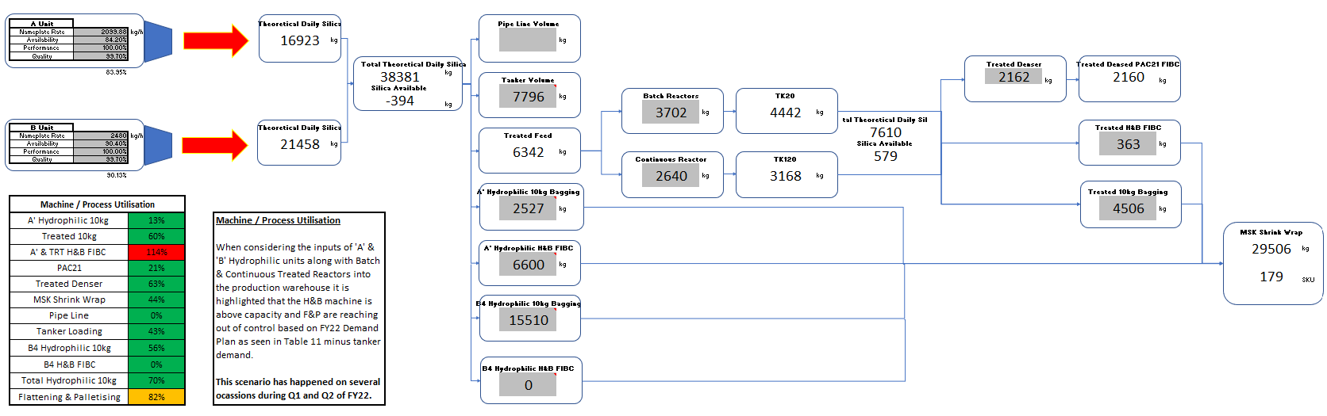

Figure 40 - Bottleneck Flowchart - Daily Production Baseline for FY22 taken from Table 12 in Commercial Demand with no Dow Tanker outlet
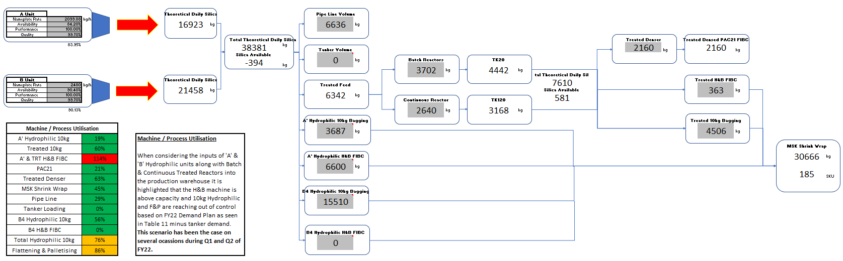

Figure 41 - Bottleneck Flowchart - Daily Production Baseline for FY25 taken from Table 12 in Commercial Demand
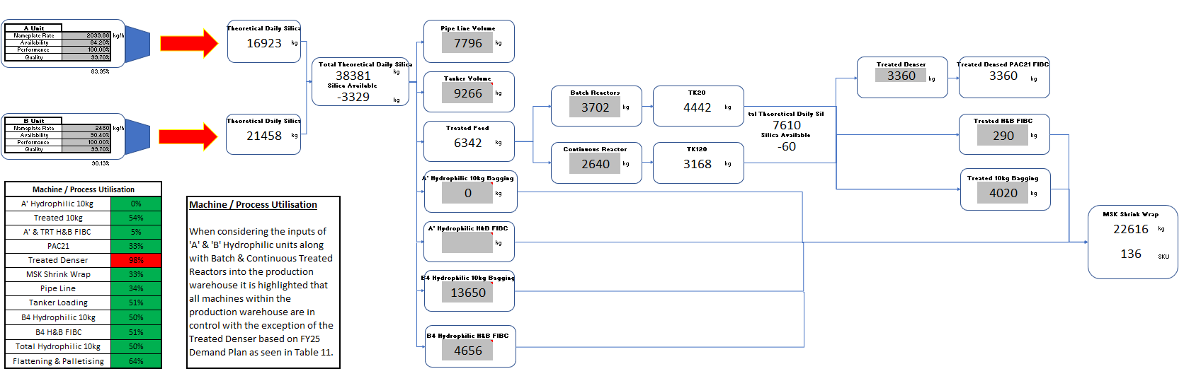

Figure 42 - Bottleneck Flowchart - Daily Production Baseline for FY28 taken from Table 12 in Commercial Demand
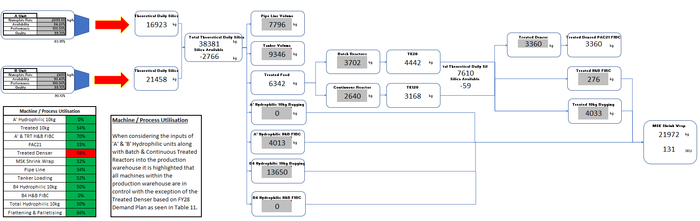

4.5 Area Layout
As previously discussed the production warehouse at the facility houses all the packaging and palletising equipment along with being the main product storage and loading area. The packaging equipment is mainly laid out in an ‘L’ shape along the East and South walls of the building, however as the equipment requirements have changed over time two Flexible Intermediate Bulk Container (FIBC) machines for packing hydrophilic and treated products and a densification unit for treated products have been added with these being placed into what was previously storage space thus reducing storage capacity, see Figures 43/44 which show the production warehouse layout with the FIBC and densification equipment highlighted in red.
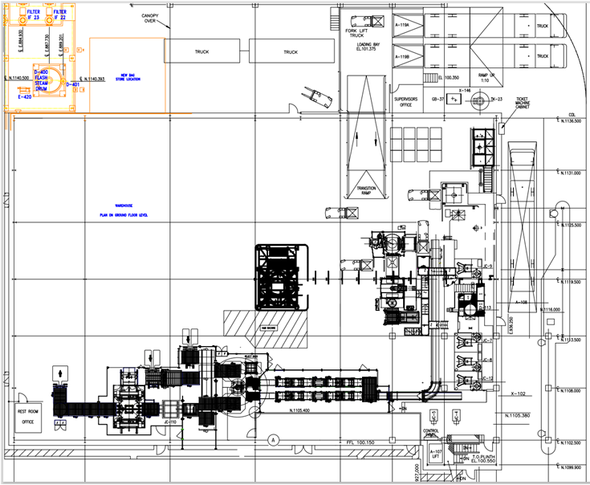
Figure 43 – Barry Production Warehouse Layout
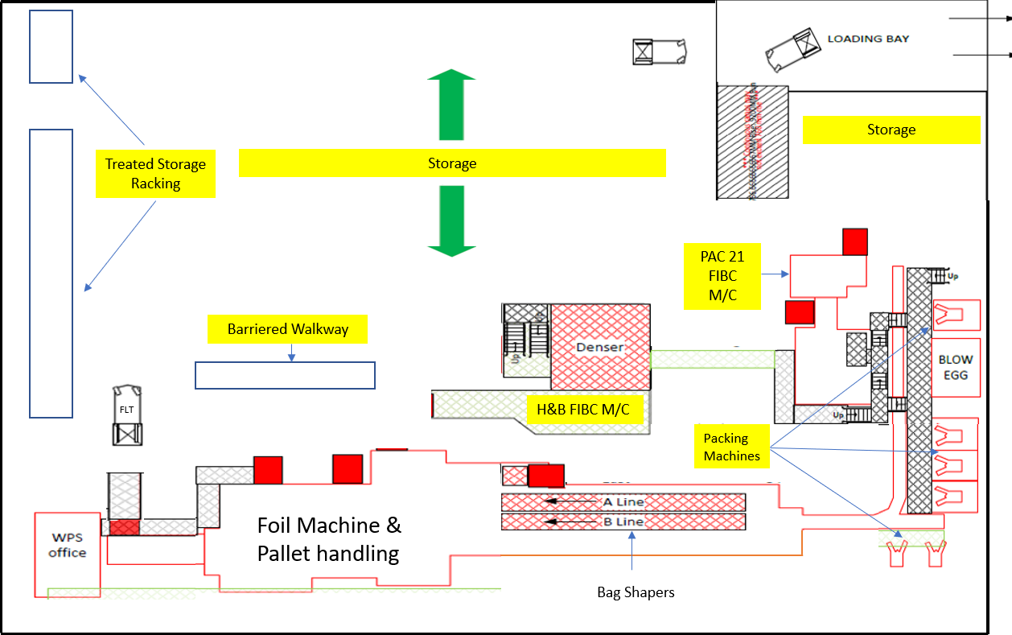
Figure 44 – Further Layout drawing highlighting storage areas
The warehouse storage capacity has a maximum currently of three hundred and seventy Stock Keeping Units (SKU’s) depending on type of SKU being packaged. FIBC’s and treated products need to be single stacked whereas alternative grade SKU’s can be double stacked, see Appendices 16 & 17 for the product stacking plan and actual product storage based on a typical Monday morning.

4.6 Commercial Demand
For the purposes of this project commercial demand for the Barry Facility has been reviewed to better understand the products required, storage and customer delivery method along with pack types, this has been reviewed over an extended period taking into consideration actual data from previous Fiscal Years (FY), the current years plan and forecasted years in the future. Data analysis highlights a demonstrated drop in bulk and pipeline deliveries from the facility with an increase seen in products being packaged in either paper-bags or Flexible Intermediate Containers (FIBC’s), along with a shift in delivery method to some customers who have moved from paper-bags to FIBC’s. The shifts in pack type and delivery methods discussed are placing pressure on the current packaging equipment at the facility based mainly on the reduction in bulk outlet along with capacity increase of the treated production units, further consideration will also need to be given to the potential that two large volume customers are actively reviewing moving from paper-bags to FIBC’s for environmental and sustainability reasons which could potentially see seven hundred and thirty metric tons move to FIBC’s gradually over the next few years (see detail in Appendix 18), a contingent part of this could be the facilities ability to be able to produce a 180kg FIBC. The potential further switch of the two key customers referenced has not been considered in the volumes seen in Table 12 as this is still assuming paper-sacks for these customers (all figures shown are in metric tons).
Table 12 – Commercial Demand by Product, Pack Type and Delivery Method (Guerin 2022)
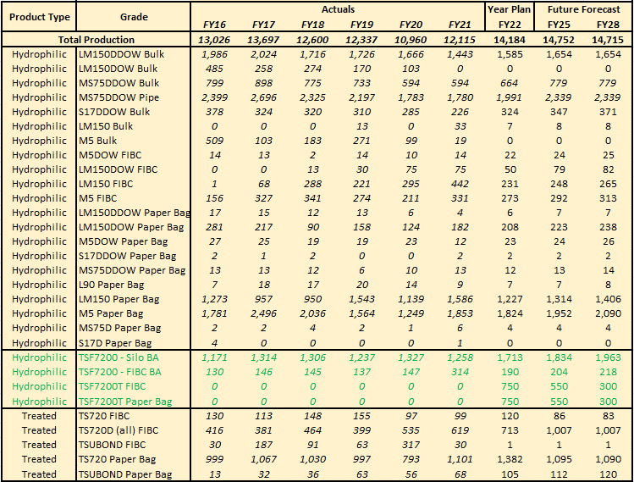
The data presented in Table 12 demonstrates a significant production demand reduction during Fiscal Year (FY) 20 which was because of the COVID 19 pandemic which impacted the global economy significantly, demand recovered gradually throughout FY21 with the FY22 plan showing demand recovering to and exceeding historic levels, this is partially down to the expansion undertaken on the Treated production units along with global recovery.
The production demands are further highlighted in Figure 45, which additionally shows the delivery method to customers as being via bulk (including pipeline direct to Dow), FIBC’s, paper-bags or silo storage. The reduction in bulk delivery methods year on year since FY16 can easily be seen along with the increase in paper-bag, FIBC and silo storage, remembering that the silo storage is feed for treated conversion. Whilst some recovery of bulk demand is apparent in FY22 this is seen to stabilise according to the forecast by FY25 and not demonstrating a recovery to historical levels, however there is no real reduction in packed products until FY28 when FIBC demand is seen to reduce marginally.
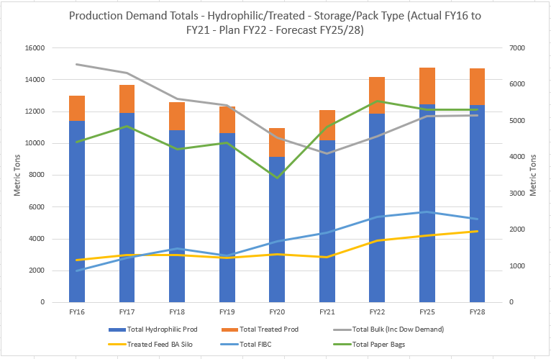
Figure 45 – Production Demands – Storage/Delivery Method and Pack Type

Chapter 5 – Conclusions
This final project was intended to evaluate if lean methodologies, tools and techniques are being used in the Cabot Carbon Barry FMO facility and if so, how these are being applied, whilst additionally proposing opportunities for improvement. The objectives were as follows;
- Learn how Lean Principles and Methodologies can improve the efficiency of a business.
- Understand how Lean Principles and Methodologies can be successfully applied in a production-based warehouse and best practice for a Lean implementation in this environment.
- Understand the role of organisational culture and how it can affect the implementation of Lean Principles and Methodologies.
- Develop and compile a Lean Improvement Road Map for implementation in the Cabot Carbon FMO production warehouse.

5.1 How Lean Can Improve Business Efficiency
The literature research undertaken examined the origins of Lean, its principles, tools, techniques, and its developers over time within the manufacturing sector. The research establishes that Toyota conceptualised Lean whilst trying to apply the mass production ideas learned from their visits to Ford manufacturing plants in the US during the early 1950’s, however Toyota were unable to apply these methods within their environment due to many constraints, this brought about the emergence and development of new ideas over many years which gave rise to the ‘Toyota Production System’ which developed further into what we today call Lean. Lean pursues the ‘Ideal Way’ to manufacture - Aiming for perfect quality, elimination of waste, highly satisfied customers, with engaged employees at the center of the production system. The literature further identifies that Lean is fundamentally a structured system that emboldens discipline. The system is based on a structure comparable to a house with foundations, supporting pillars and a roof with each part therefore supporting the whole, meaning that any organisation only implementing a selection of principles and tools will doubtfully realise the full advantages of Lean.

5.2 How Lean can be applied effectively within a Production-Based Warehouse
When undertaking the research for this project it became apparent that there was limited information pertaining to applying Lean within a Production Warehouse environment, there was literature relating to logistics-based warehouses along with a vast amount of literature for manufacturing within moving production lines such as car plants for example.
To effectively apply or implement Lean within the production warehouse environment a vision should be established, and strategy developed whilst taking learnings from a variety of sources and approaches available. The research shows that many companies have successfully applied ‘Traditional Lean’ along with ‘Leadership’ to their enterprises with great success, the leading authorities regarding these frameworks (Appendix 4) according to Bicheno & Holweg (2016) are Womack & Jones and Liker who have concentrated their efforts on applying or championing the ‘Toyota Production System’ along with the ’Toyota 14 Management Principles’ (Appendix 1) whilst developing the ‘5 Lean Principles’ (Figure 4).
As shown in Figure 8 (Production Operations Transition-To-Lean Roadmap) a phased approach should be employed with this example moving from Phase Zero through to Phase Seven, this approach could therefore be applied to the whole enterprise, a single facility or facility section as the case is with the production warehouse in the Barry FMO facility. Tailoring the individual phases and Lean tools to be used to the individual enterprise to gain momentum is essential in achieving success.
The Lean Questionnaire undertaken during this final project did highlight that whilst there are gaps in knowledge and understanding regarding Lean, which were expected, there is an element of understanding at all respondent levels who took part along with some principles already being applied, meaning that any transition to lean carried out in the future should not be unsurmountable.
Additionally, it has been concluded that both forecasting and facility scheduling has a significant impact on the production warehouses ability to work in a Lean fashion. The forecasting by nature can be unpredictable based on the methods used and where the data feeding into the forecasts originates such as, is this based on historical patterns, expected orders or firm orders placed. Similarly the scheduling of the production needs to consider the machine capability more closely to aid with removing wasteful activities hence the development of the ‘Bottleneck Flowchart’.

5.3 How Organisational Culture affects Lean Implementation
The literature review undertaken acknowledges that focus on both people and leadership is fundamental when instigating Lean transformation and maintaining change. Changing management behaviors stands critically important along with it being questionably futile attempting to engage in a Lean operation with a management approach employing command-and-control philosophies versus one that offers leadership.
‘Culture’ as discussed in the literature review is something that needs to be inherent within everyone inside the organisation from the very top, down to the bottom which needs to be practiced day in, day out. Culture itself tends to be established and led by management. The shop floor is considered a very important place within the ‘Toyota Production System’ so those managers which are considered first-line and therefore leading the face-to-face contact need to be particularly careful regarding their individual behaviors as these are the individuals who tend to be faced with the challenges from those within the workforce prepared to challenge the boundaries set so need to be prepared to carry forward the management line to ensure the set culture doesn’t fail. Culture in itself is not self-sustaining so coaching of all needs to be completed on a continual basis.
Values are closely linked to culture so it is important that organisations establish a set of values to give employees guidance regarding expected behaviors. Cabot Carbon Ltd holds values which directly correlate to Lean; Integrity, Respect, Excellence and Responsibility with further details shown in Appendix 10. Cabot Carbon is therefore in a reasonable position with regards to culture.

5.4 Lean Roadmap
Table 13 – Lean Roadmap Five Year Action Plan Barry FMO Production Warehouse
Fiscal Year | Action
FY22 | - Set a vision with a view to adopting Lean.  Establish an Operations Lean implementation team
FY22 | - Formalised training for the Shift Manager group in Lean Manufacturing tools and techniques.
FY22 | - Awareness training for the Lead Technician groups within the Warehouse and Process areas in Lean Manufacturing tools and techniques.
FY22 | - Cascade the Lean awareness training down through the remainder of the warehouse and process technician groups.
FY22 | - Review and update the produced VSM with actual FY22 production volumes by delivery method as opposed to theoretical based on the forecasted figures in Table 11.
FY22 | - Continue with Process Mapping of the remaining processes not yet mapped within the production warehouse to further unearth wastes.
FY22 | - Further develop 5S within the production warehouse with the emphasis on the sustaining aspect.
FY22 | - Install conveyor system from the H&B machine to the MSK wrapping machine.
FY22 | - Automate Silo Selection of Treated Silo’s.
FY22 | - Implement Bar-Code scanning technology into the Production Warehouse.
FY22 | - Develop the use of the Bottleneck flow chart to aid in highlighting machinery constraints based on the required grade mix and drive the correct decision making to remove machinery clashes.
FY23 | - Replace PAC21 FIBC machine with additional H&B machine or similar (explore available options and technologies that aid with removal of wasteful activities).
FY23 | - Further review and develop the VSM once machinery change has been completed.
FY23 | - Explore SKU weight increases (Paper-sack from 180kg to 200kg, FIBC from 150kg to 180kg) – This will aid sustainability goals but also reduce truck loading requirements and reduce EOL work.  Will need to consider and listen to ‘Voice of Customer’.
FY24 | - Full Silo automation to prevent technician’s moving away from all packing machines to select silo’s.
FY24 | - Increased Treated Denser capacity required – Consideration should be paid to how real the forecast is based on significant drop off in orders during Q1, Q2 & Q3 of FY22.  Consider if expansion is necessary by reaching out to product line, sales and planning teams
FY25 | - Replace Treated Paper-sack filling machine with automated filling technology machine – Consideration should be paid to this being expedited due to significant drop off in TS720D FIBC demand during Q1, Q2 & Q3 of FY22 which are well below the original forecasted numbers, whilst actual sales of Treated Paper-sacks are exceeding forecasted numbers.
FY25 | - Link all production warehouse key equipment to Delta-V / Aspen as this will aid in developing the VSM (Static) to become a system which is live - Dynamic Value Stream Map (DVSM).
FY25 | - Further review and develop the VSM once machinery changes have been completed (see FY25 – 2).
FY26 | - Replace Hydrophilic Paper-sack filling machine with automated filling technology machine.

6.0 References
Anderson, Mary Ann; Anderson, Edward Dr; Parker, Geoffrey Dr. 2013. Operations Management for Dummies. John Wiley & Sons Inc, Hoboken, New Jersey.
Beer, Michael; Nohria, Nitin. 2000. Cracking the Code of Change. Harvard Business Review. 78 (3), pages 133-141.
Bicheno, John; Holweg, Matthias. 2016. The Lean Toolbox: a handbook for lean transformation, 5th Edition, PICSIE Books.
Bicheno, John; Holweg, Matthias. 2009. The Lean Toolbox: The Essential Guide to Lean Transformation, 4th Edition, PICSIE Books.
Boutros, Tristan; Cardella, Jennifer. 2016. The Basics of Process Improvement. CRC Press, Boca Raton.
Burgess, Dr Thomas F. Guide to the Design of Questionnaires. Online. Accessed 12 March 2022. http://www.websm.org/uploadi/editor/File/Burgess_2001_A%20general_introduction.pdf
Burnes, Bernard. 2004. Managing Change 4th Edition. Prentice Hall. Harlow, England.
Caniato, F; Kalchschmidt, M; Ronchi, S. 2011. Integrating quantitative and qualitative forecasting approaches; organizational learning in an action research. The Journal of the Operational Research Society, Abingdon. Vol 62 (3), pages 413 – 424.
Casey, Bob. The Henry Ford. 2010. Henry Ford and Innovation. (Online). (Accessed 05 December 2021). Available from World Wide Web. https://www.thehenryford.org/docs/default-source/default-document-library/default-document-library/henryfordandinnovation.pdf
Collins, Jim. 2001. Good to Great. Random House Business Books. London.
Collis, Jill; Hussey, Roger. 2003. Business Research – A practical guide for undergraduate and post graduate students 2nd Edition. Palgrave Macmillan, Basingstoke.
Cottrell, Stella. 2014. Dissertations and Project reports – A step by step guide. Red Globe Press, London.
Covey, Stephen R. 2004. The 7 Habits of Highly Effective People 15th Anniversary Edition. Simon & Schuster. London.
Crabill, John; Harmon, Ed; Meadows, Don; Milauskas, Ron; Miller, Craig; Nightingale, Deborah; Schwartz, Brian; Shields, Tom; Torrani, Bob. 2000. Production Operations Transition-To-Lean Roadmap. (Accessed 22 January 2022). https://dspace.mit.edu
Cummings, Stephen; Bridgman, Todd; Brown, Kenneth G. 2016. Unfreezing change as three steps: Rethinking Kurt Lewins legacy of change management. Human Relations. 69 (1), pages 33-60. Sage.
Damelio, Robert. 2011. The Basics of Process Mapping, 2nd Edition. CRC Press, New York.
Deming, W Edwards. 2000. Out Of The Crisis. MIT Press, Cambridge Massachusetts.
Dent, Eric B; Goldberg, Susan Galloway. 1999. Challenging ‘’Resistance to Change’’. Journal of Applied Behavioral Science, Vol 35 (1), pages 24-41.
Ford, Henry. 1926 (2018). Today and Tomorrow. Generosity Press. Edited by Otterholt, Greg. https://paulakers.net/wp, Accessed 10/01/2022.
Gerring, John. 2007. Case Study Research – Principles and Practices. Cambridge University Press, Cambridge.
Google Maps. www.google.com/maps/place/cabot+carbon. (23/12/2021)
Guerin, Mark. Global Product Manager (FMO). 2022. Commercial demand planning and forecast.
Hines, Peter; Found, Pauline; Griffiths, Gary; Harrison, Richard. 2008. Staying Lean: Thriving, not just surviving. Lean Enterprise Research Centre, Cardiff.
Hines, Peter; Rich, Nick. 1997. The seven value stream mapping tools. International Journal of Operations & Production Management. 17(1), Pages 46-64.
Holweg, Matthias. 2007. The genealogy of lean production. Journal of Operations Management, Vol 25 (2), p. 420 – 437.
Hounshell, David A. 1985. From the American System to Mass Production 1800 – 1932. Baltimore & London: The Johns Hopkins University Press. Page 217 & 224.
Kehr, Thomas W; Proctor, Michael D. 2017. People Pillars: Re-structuring the Toyota Production System (TPS) House based on Inadequacies Revealed During the Automotive Recall Crisis. Quality and Reliability Engineering International, Vol 33 (4), pages 921-930.
Kotter, John P. 2012. Leading Change. Harvard Business Review Press.
Liker, Jeffrey K. 2004. The Toyota Way – 14 Management Principles. McGraw-Hill. New York. Page 25.
MacInnes, Richard L. 2009. The Lean Enterprise Memory Jogger for Service 1st Edition. Goal/QPC. Salem (New Hampshire).
Mann, David. 2009. The Missing Link: Lean Leadership. Frontiers of Health Services Management, Vol 26 (1), pages 15-26.
Martin, Karen; Osterling, Mike. 2014. Value Stream Mapping – How to Visualise Work and Align Leadership for Organisational Transformation. McGraw Hill. London.
McCalman, James; Paton, Robert A; Siebert, Sabina. 2016. Change Management – A Guide to Effective Implementation, 4th Edition. Sage. London.
Petrarolo, Dino. 1998. The ’20 Keys’ to workplace improvement. Industrial Management, Vol 40 (1), pages 22–28.
Richards, Shaun. 2022A. Cabot Corporation Vision, Strategy. Barry. Photograph.
Richards, Shaun. 2022B. Cabot Corporation Values. Barry. Photograph.
Richards, Shaun. 2022C. Cabot Corporation Guiding Principles. Barry. Photograph.
Rother, Mike; Shook, John. 2018. Learning to See – Value-Stream Mapping to Create Value and Eliminate Muda, 20th Anniversary Edition. Lean Enterprise Institute.
Russell, Roberta S; Taylor, Bernard W. 2009. Operations Management – Along the Supply Chain 6th Edition. John Wiley & Sons (Asia) Pte Ltd.
Russell, Roberta S; Taylor, Bernard W. 2009. Operations Management – Along the Supply Chain 8th Edition. John Wiley & Sons Ltd. Hoboken, New Jersey.
Saunders, Mark; Lewis, Philip; Thornhill, Adrian. 2019. Research Methods for Business Studies 8th Edition. Pearson Education Ltd. Harlow.
Schein, Edgar H; Schein, Peter A. 2016. Organisational Culture and Leadership 5th Edition. John Wiley & Sons. Hoboken, New Jersey.
Schonberger, Richard J. 1996. World Class Manufacturing: The Next Decade – Building Power, Strength and Value. The Free Press. New York.
Sheridan, John H. 1991. Throughput with a capital ‘T’. Industry Week Vol 240 (5), pages 44-49.
Slack, Nigel; Brandon-Jones, Alistair; Johnston, Robert. 2013. Operations Management 7th Edition. Pearson Education. London.
Stadnicka, Dorota; Litwin, Pawel. 2019. Value stream mapping and system dynamics integration for manufacturing line modelling and analysis. International Journal of Production Economics Vol.208, pages, 400-411.
Tortorella, Guilherme; Fogliatto, Flavio. 2017. Implementation of Lean Manufacturing and Situational Leadership styles: An empirical study. Leadership & Organization Development Journal Vol 38 (7), p. 946-968
Winkler, Herwig. 2011. Closed-loop production systems – A sustainable supply chain approach. CIRP Journal of Manufacturing Science and Technology. 4(3), Pages 243-246.
Winstanley, Carrie Dr. 2010. Writing a Dissertation – For Dummies. John Wiley & Sons, Ltd. Chichester.
Wolniak, Radoslaw; Skotnicka-Zasadzień, Bożena; Gębalska-Kwiecień, Anna. 2018. Identification of bottlenecks and analysis of the state before applying lean management. Matec Web of Conferences, Vol 183, pages, 1001-1007. DOI: 10.1051/matecconf/201818301001.
Womack, James P; Jones, Daniel T. 1996. Lean Thinking. London. Simon & Schuster UK Ltd.
Womack, James P; Jones, Daniel T; Roos, Daniel. 2007. The Machine that Changed the World. London: Simon & Schuster UK Ltd.

7.0 Appendices

Appendix 1 – 14 Toyota Way Principles
Taken from – The Toyota Way (Liker, 2004)
- Base your management decisions on a long-term philosophy, even at the expense of short-term financial goals
- Create continuous process flow to bring problems to the surface
- Use “Pull” systems to avoid over production
- Level out the workload (heijunka). (Work like the tortoise not the hare)
- Build a culture of stopping to fix problems, to get quality right first time
- Standardized tasks are the foundation for continuous improvement and employee empowerment
- Use Visual control so no problems are hidden
- Use only reliable, thoroughly tested technology that serves your people and processes
- Grow leaders who thoroughly understand the work, live the philosophy and teach it to others
- Develop exceptional people and teams who will follow the company’s philosophy
- Respect your extended network of partners and suppliers by challenging them and helping them improve
- Go and see for yourself to thoroughly understand the situation (genchi genbutsu)
- Make decisions slowly by consensus, thoroughly considering all options; implement rapidly
- Become a learning organisation through relentless reflection (hansei) and continuous improvement (kaizen)

Appendix 2 – Change at three steps (CATS) as a grand foundation
Taken from – Human Relations (Cummings, Bridgman, & Brown, 2016)
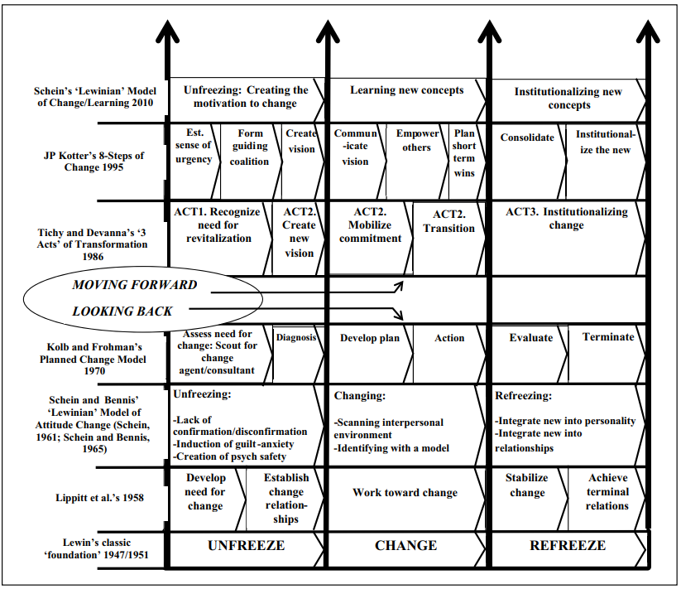

Appendix 3 – Kotter’s 8-Step Change Model
Taken from Leading Change (Kotter, 2012)
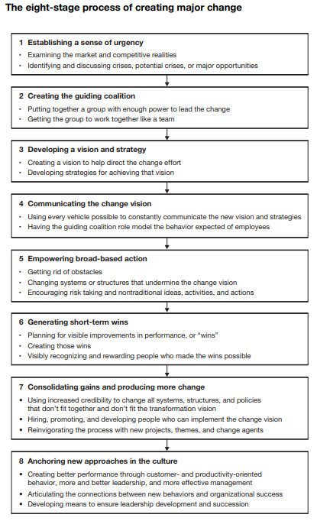

Appendix 4 – Lean Transformation Frameworks
Taken from (Bicheno & Holweg, The Lean Toolbox, 2016)
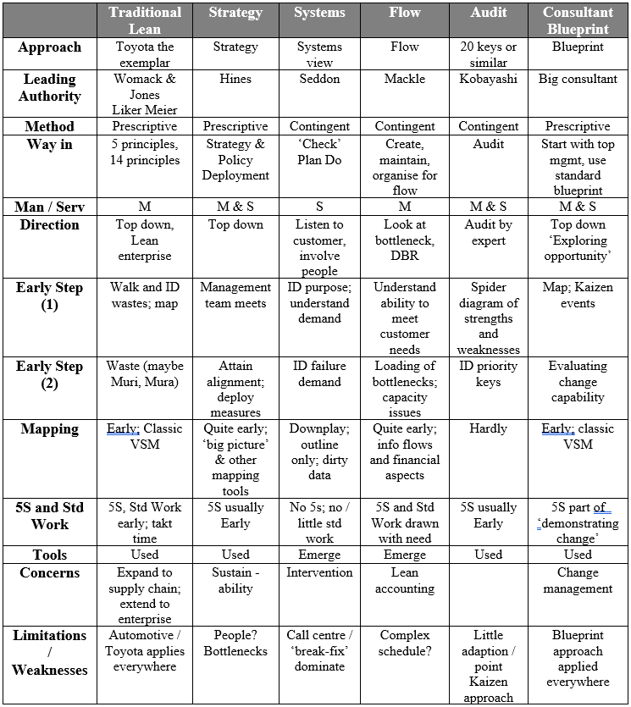

Appendix 5 – The research and dissemination of lean production – a time-line
Taken from, The genealogy of lean production – Journal of Operations Management (Holweg, 2007)

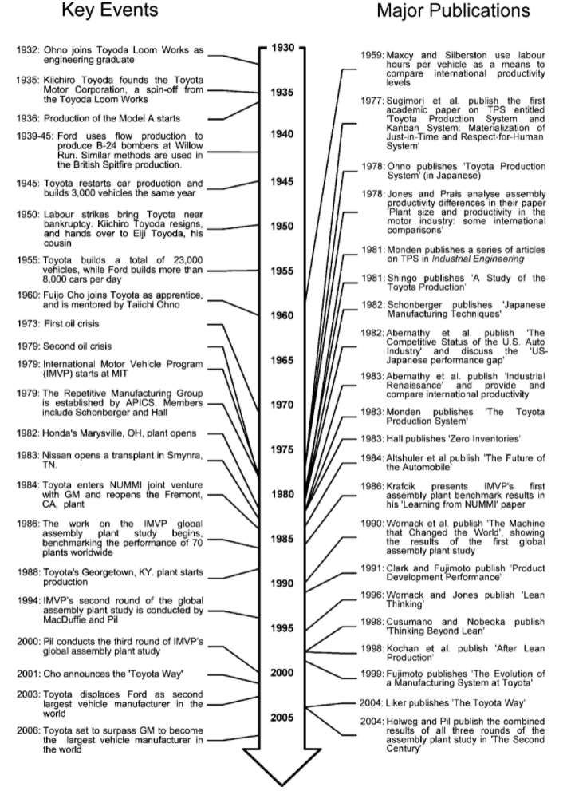

Appendix 6 – The 25 Principles of Lean
Taken from (Bicheno & Holweg, The Lean Toolbox, 2016)
- Customer. The external customer is both the starting and ending point. Seek to maximise value to the customer. Optimise around the customer, not around internal operations. Understand the customers true demand, in price, delivery, frequency, and quality – not what can be supplied. Understand demand patterns. Distinguish between value demand and failure demand.
- Purpose. The ‘big picture’ question is ‘What is the purpose?’ This simple question is the way forward to reduce waste, complexity, and bureaucracy. And do the measures actually work for or against the purpose?
- Simplicity. Lean is not simple, but simplicity pervades. Simplicity in operation, system, technology, control, and the goal. Simplicity is best achieved through avoidance of complexity, rather than by ‘rationalisation’ exercises. Think about ants that run a complex adaptive system without any management information system. Simplicity applies to product through part count reduction and commonality. Simplicity applies to suppliers through working closely with a few trusted partners. Simplicity applies in the plant, by creating focused factories-within-a-factory. Beware of complex computer systems, complex and large automation, complex product lines, and rewards. Select the smallest, simplest machine possible consistent with and without compromising quality requirements.
- Waste. Waste in endemic. Learn to recognise it, and seek to reduce it, always. Everyone from the chairman to the cleaners should wear ‘muda spectacles’ at all times. Seek to prevent waste by good design of products and processes.
- Process. Organise and think by end-to-end process. Think horizontal, not vertical. Concentrate on the way the machines, people or customers move. Map to understand the process.
- Visuality. Seek to make all operations as visible and transparent as possible. Control by sight. Adopt the visual factory. Make it quick and easy to identify when operations or schedules are diverging.
- Regularity. Regularity makes for ‘no surprises’ operations. We run our lives on regularity (sleep, breakfast, etc); we should run our plants on this bsis too. Seek out, by pareto, the top repeating products and build the schedule around regularity – this cuts inventory, improves quality, and allows simplicity of control. Regularity applies also with supply and new product introduction.
- Flow. Seek ‘keep it moving at the customer rate’, ‘one piece flow’ manufacture. Synchronise operations so that the streams meet just in time. Flow should be the aim at cell level, in-company and along supply chains. Synchronise information and physical flows. If the process cannot flow, ‘pulse’ in small batches.
- Evenness. ‘Heijunka’ or levelling is the key to reduced lead-time and quality. Seek ways to level both demand and the process – to level sell, to level buy, to level make. Seek to reduce those killer waves. Be proactive – ask both customers and suppliers if they would not prefer smaller, more frequent batches.
- Pull. Pull releases work depending on system status, thereby capping WIP inventory. Avoid overproduction. Have pull based demand chains, not push-based supply chains. Pull should take place at the customers rate of demand. In demand chains this should be the final customer, not distorted by the intermediate ‘bullwhip’ effect.
- Postponement. Delay activities and committing to product variety as late as possible so as to retain flexibility and to reduce waste and risk. This characteristic is closely associated with the concept of avoiding overproduction, but includes plant and equipment, information, and inventory. This is not the same as simply starting work ate the last possible moment, but is about retaining flexibility at the right levels.
- Prevention. Seek to prevent problems and waste, rather than inspect and fix. Shift the emphasis from failure and appraisal to prevention. Inspecting the process, not the product, is prevention. Seek to prevent mistakes first through simplification, then mistake-proofing, and only then through inspection.
- Time. Seek to reduce overall time to make, deliver, and to introduce new products. Use simultaneous, parallel, and overlapping processes in operations, design and support services. Seek never to delay a value-adding step by a non value-adding step. Time is the best single overall measure. If time reduction is priority you tend to do all the right things: reduce wastes, improve quality.
- Improvement. Improvement, but continuous improvement in particular, is everyone’s concern. Improve though both small actions (kaizens) and larger actions (breakthrough). Improvement goes beyond waste reduction to include innovation and design. Improvement should include deliberate learning and experimentation.
- Partnership. Seek co-operative working both internally between functions, and externally with suppliers. Seek to use teams, not individuals, internally and externally. Employees are partners too. Seek to build trust. Another way of saying this is Win-Win, which is one of Stephen Covey’s principles of highly effective people. You must find a win-win, never win-loose, solution and if you can’t you should walk away.
- Value Networks. Great opportunities for cost, quality, delivery and flexibility lie with cooperating networks. Supply chains compete, not companies. Increasingly, value networks include ‘co-opetition’. Expand the concept of the one-dimensional supply chain to a two-dimensional value network.
- Gemba. Go to where the action is happening and seek the facts. Manage by direct observation. Implementation takes place on the floor, not in the office. Insist on Genshi Genbutsu (go see).
- Questioning (and listening). Encourage a questioning culture. Ask why several time to try to get to the root. Encourage questioning by everyone. As Bertrand Russel said, it is ‘a healthy thing now and the to hang a question on things you have long taken for granted’. A manger who asks questions empowers. Listen actively, not passively/ Restate the other’s viewpoint. ‘Seek first to understand’, said Covey. Coaching skills are required.
- Variation. Variation is the enemy. ‘Whenever you have variation, someone or something will wait’. It occurs in every process, product and person. Know the control limits, and learn to distinguish between natural variation and special deviation. Everyone should seek to reduce special causes. Managers should tackle common cause variation. Sometimes it is better to absorb variation with flexible systems (this is Ashby’s Law of Requisite Variety) and sometimes better to reduce it.
- Avoiding Overload. Overloading resources (Muri) leads to inefficient people and long work queues. Because of variation, loading machines above 85% or 90% utilisation mans both excessive lead times and to uncertainty in delivery. A Toyota ‘secret’ is slight excess capacity.
- Participation. Give operators the first opportunity to solve problems. All employees should share responsibility for success and failure. True participation implies full information sharing.
- Thinking Small. Specify the smallest capable machine, and then build capacity in increments. Get best value out of existing machines before acquiring new ones. Break the ‘economy of scale’ concept by flexible labour and machines. Specify a maximum size of plant to retain ‘family focus’ and to develop thinking people. Locate small plants near to customer sites, and synchronise with their line. Internally and externally make many small deliveries – runners or water spiders – rather than few big ones.
- Trust. If we truly believe in participation and cutting waste, we have to build trust. Trust allows great swathes of bureaucracy and time to be removed internally and externally. In supply chains, Dyer has shown how trust has enabled Toyota to slash transaction costs (that represent as much as 30% of costs in a company). Building trust with suppliers gives them the confidence to make investments and share knowledge. Internally, trust allows a de-layered streamlined, and more creative organisation. A Deming maxim is 90/10 rule: 90% of problems lie with the system, only 10% with the people.
- Knowledge. Since Peter Drucker’s original work on knowledge workers being the engine of today’s corporation, the importance of not only building knowledge but distributing it has become increasingly important. Cultivate both explicit knowledge, but also tacit knowledge, involving softer or stickier skills. It is tacit knowledge that is hard to copy and gives sustainable advantages. Knowledge is built through the scientific method, through experimentation and PDCA.
- Humility and Respect. Lat but by no means least. The more one strives for Lean, the more one realises how little one knows, and how much there is yet to learn. Learning begins with humility. No humility means no learning. Respect should not be confused with ’being nice’. It is recognition of skills that others have that you do not. These skills need to be drawn out for the benefit of all. Look out for pseudo ‘respect’ – for example, asking for ideas but then not allowing time for their consideration. Not listening. Ohno was known to be a shouter at workers, but always fair. Shouting may not be acceptable today but constructive discussion will never be outdated. Two thoughts: The African word ‘Ubuntu’ – a person becomes a person through other people; and Steven Covey’s ‘See to understand before seeking to be understood’.

Appendix 7 – An Overview of Questionnaires
Taken from – Research Methods for Business Students (Saunders, Lewis, & Thornhill, 2019)
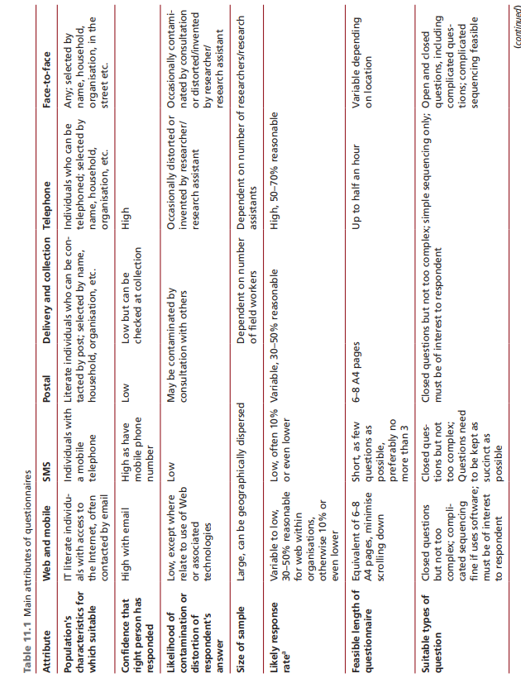
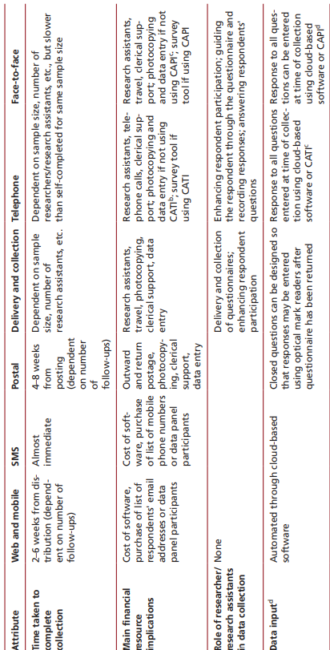

Appendix 8 – Goldratt’s 5 Step Theory of Constraints (TOC) Process
Taken From – The Lean Toolbox (Bicheno & Holweg, The Lean Toolbox, 2016)
- Identify the constraint or constraints.

- Decide how to ‘exploit’ the constraint. A constraint is precious, so don’t waste it. Make sure you keep it going, protect it with a time buffer, seek alternative or routings, don’t process defectives on it, make it quality capable, and sure it has a good maintenance attention, ensure that only parts for which there is a confirmed market in the near future are made on it.

Here the batch size should be maximized consistent with demand requirements. Half supermarkets that facilitate flow into and from the constraints.

- ‘Subordinate’ all other resources to the constraint. Encourage flow to the bottleneck to be as a regular and uninterrupted as possible. This will allow buffer protecting the bottleneck (Drum) to be reduced, thereby a reducing lead time. Reduce variation in resources immediately upstream of the bottleneck. Make everyone aware of the constraints importance. For instance move inventory as fast as possible after processing on the constraint, reduce change over time on non-constraints so as to reduce batch size and improve flow to the constraint, make sure that the constraint is not delayed by a non-constraint (a non-constraint can become a constraint if it is mismanaged). The right batch size at a non-constraint is derived from doing the maximum number of changeovers that time will allow – in other words minimize the batch size and maximize flow.

- ‘Elevate’ the constraint. Break it, but only after doing Steps two and three. Buy an additional machine or work overtime on the constraint. If it were a true bottleneck, this would be worthwhile. Beware, however. It is seldom necessary to break a constraint because this is only necessary where the constraint is a bottleneck. Knowing the constraint is often a valuable piece of information around which planning and control can take place. If you break the constraint, it will move – possibly to a hard-to determine location.

- Finally, if the constraint has been broken, go to step 1. Otherwise continue. Be careful that you do not make inertia the new constraint, by doing nothing. Hutchins makes the useful points that there are five stages for each of these five steps. They are (1) gaining consensus on the problem (2) gain consensus on the direction of the solution (3) gain consensus on the benefits of the solution (4) overcome reservations, and (5) make it happen.

Appendix 9 – Cabot Corporation Vision, Strategy, Values
Taken from – Cabot Corporation Barry FMO site (Richards, Cabot Corporation Vision, Strategy, 2022 A)
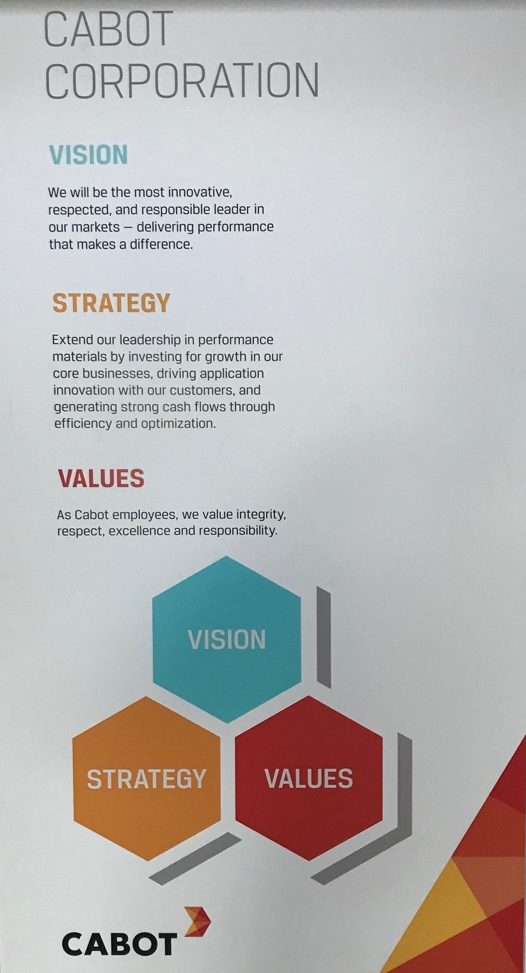

Appendix 10 – Cabot Corporation Values
Taken from – Cabot Corporation Barry FMO site (Richards, Cabot Corporation - Values, 2022 B)
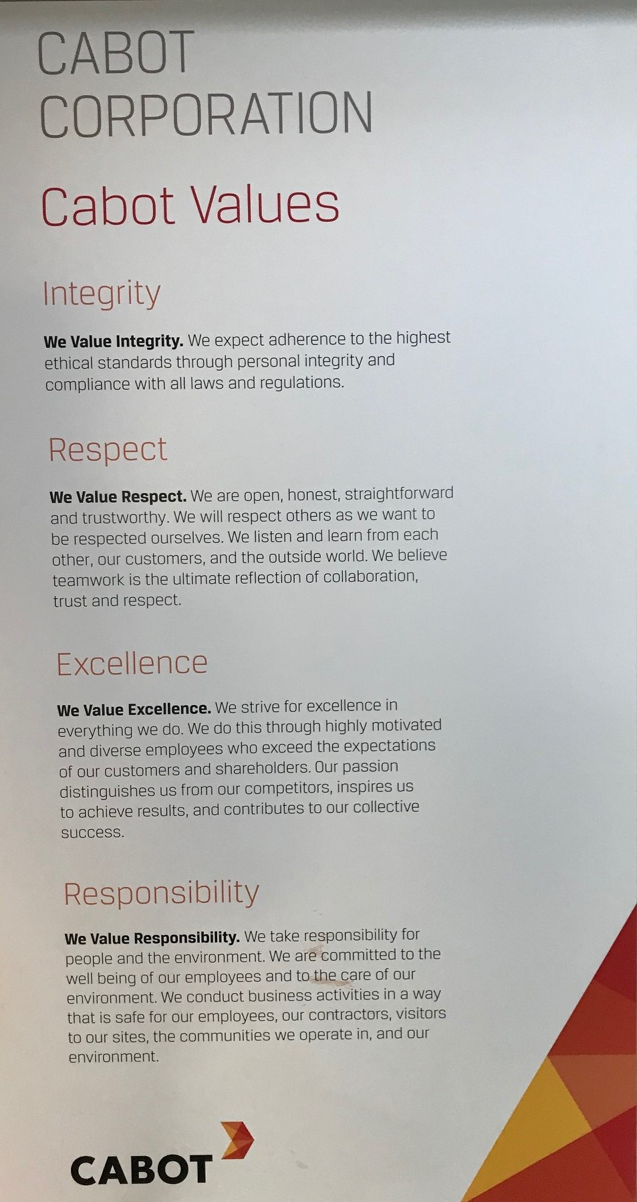

Appendix 11 – Cabot Corporation Guiding Principles
Taken from – Cabot Corporation Barry FMO site (Richards, Cabot Coproration - Principles, 2022 C)
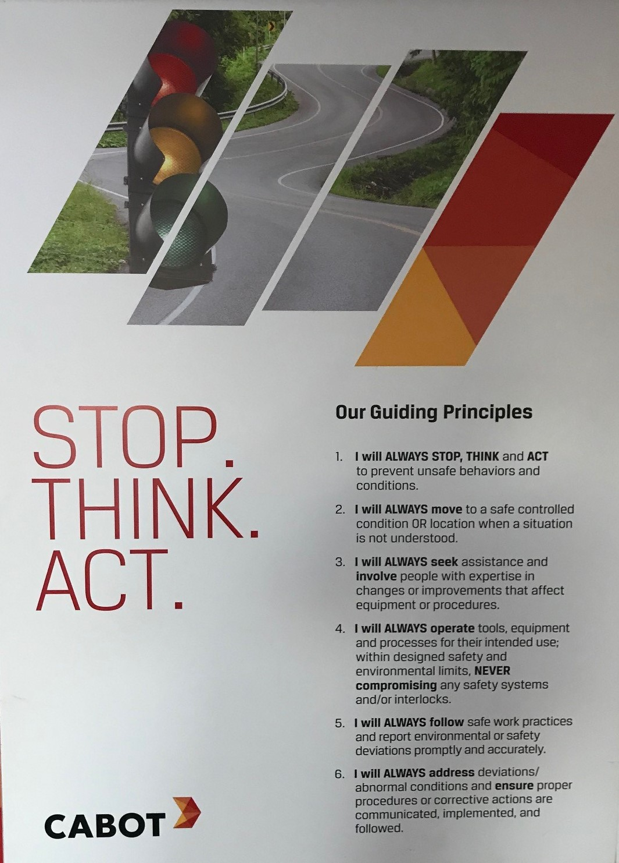

Appendix 12 – Accompanying E-Mail sent with Lean Manufacturing Understanding Questionnaire
Hi all,
As most of you will know I am currently undertaking an MSc Degree in Lean & Agile Manufacturing and working towards the completion of my Final Project (Dissertation).
A key part of the project will be gaining an understanding of what knowledge people have on site regarding Lean Manufacturing principles with a view to understanding required awareness training for the future.
With the above in mind I have put together an 11 question survey in Microsoft Forms (link below), I would really appreciate you taking the 5 minutes or so to complete the survey as this will help my project enormously.
The survey itself is anonymous but will need you to select the team/group that you work within on site so that we can perhaps target certain relevant groups on site to deliver awareness training too that we believe are most in need of or will be applying Lean principles more than others.
Here’s the link to the form “Lean Manufacturing Understanding Questionnaire”:
https://forms.office.com/Pages/ResponsePage.aspx?id=p_vnq0dWi0CNRSy61Wcm_midQNrbwvdCvHqlma1MVOdUM05ORjhTU0hPSUxDMUlJMTVHUU00RllVSC4u
Thanks in advance for your help and best regards,
Shaun
----------------------------------------
Microsoft Forms
Create your own forms at forms.office.com

Appendix 13 – Questionnaire Scoring Table

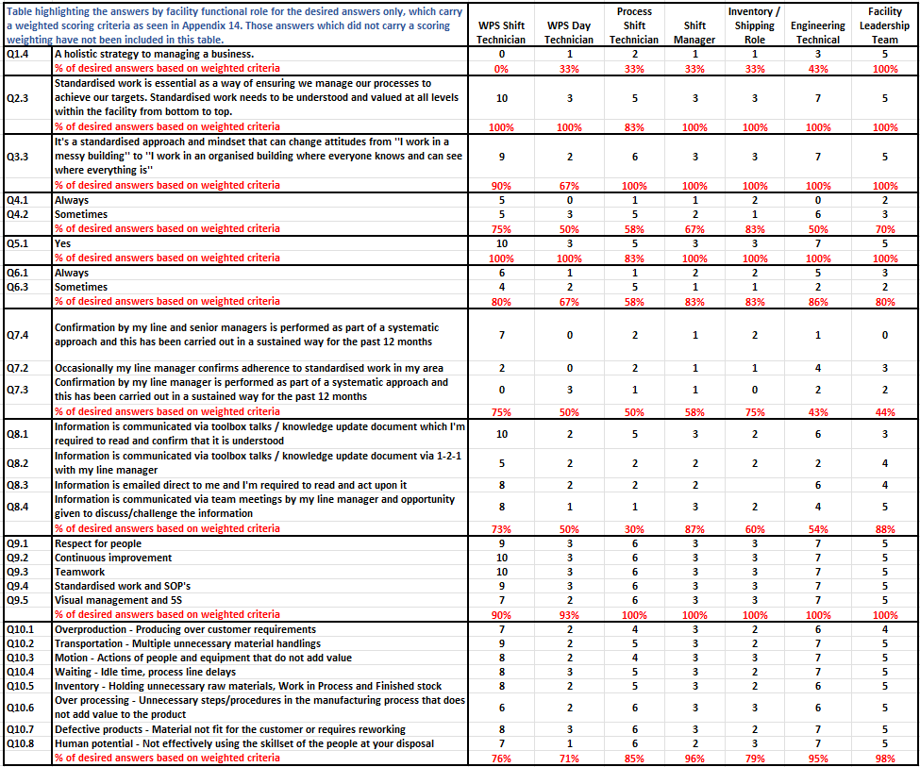

Appendix 14 – Schonberger’s 16 Principles of World Class Manufacturing
Taken from World Class Manufacturing: The Next Decade (Schonberger, 1996)
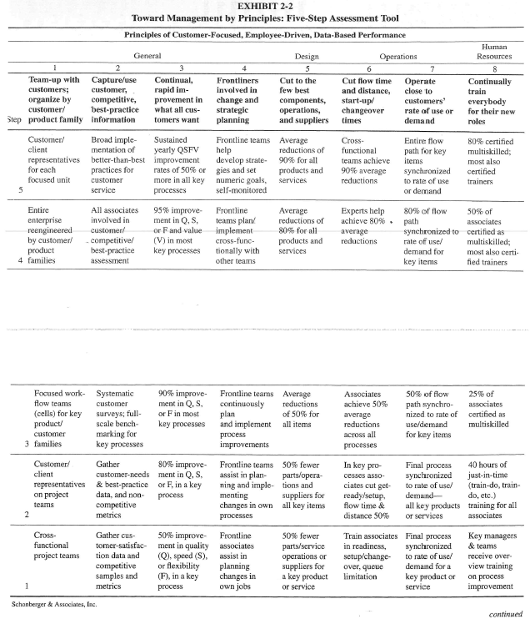
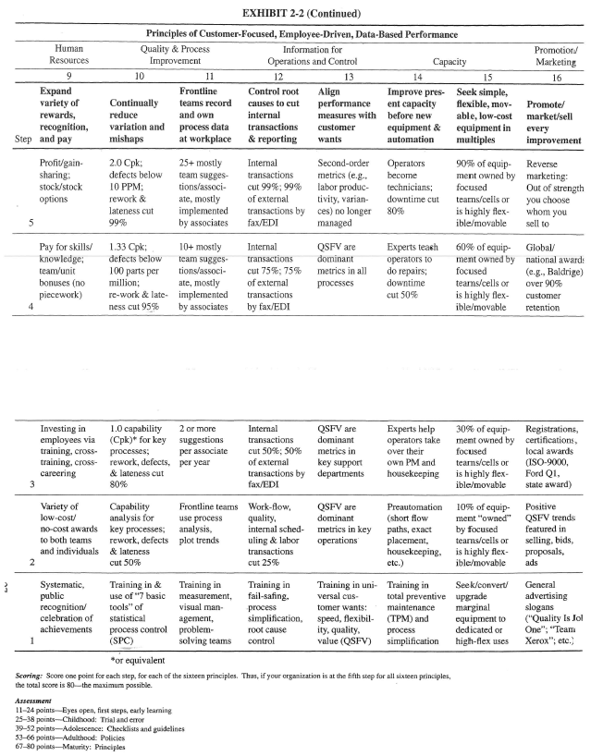

Appendix 15 – Cabot FMO WPS Manager Job Specification
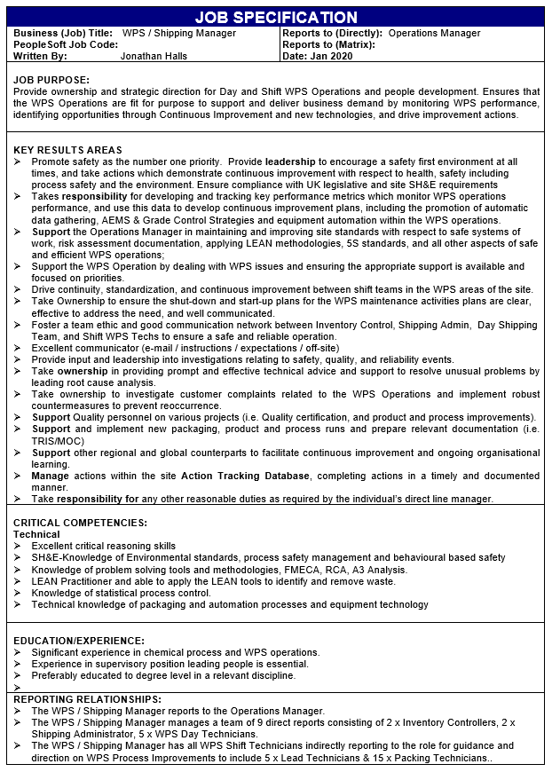

Appendix 16 – Production Warehouse Stacking Plan
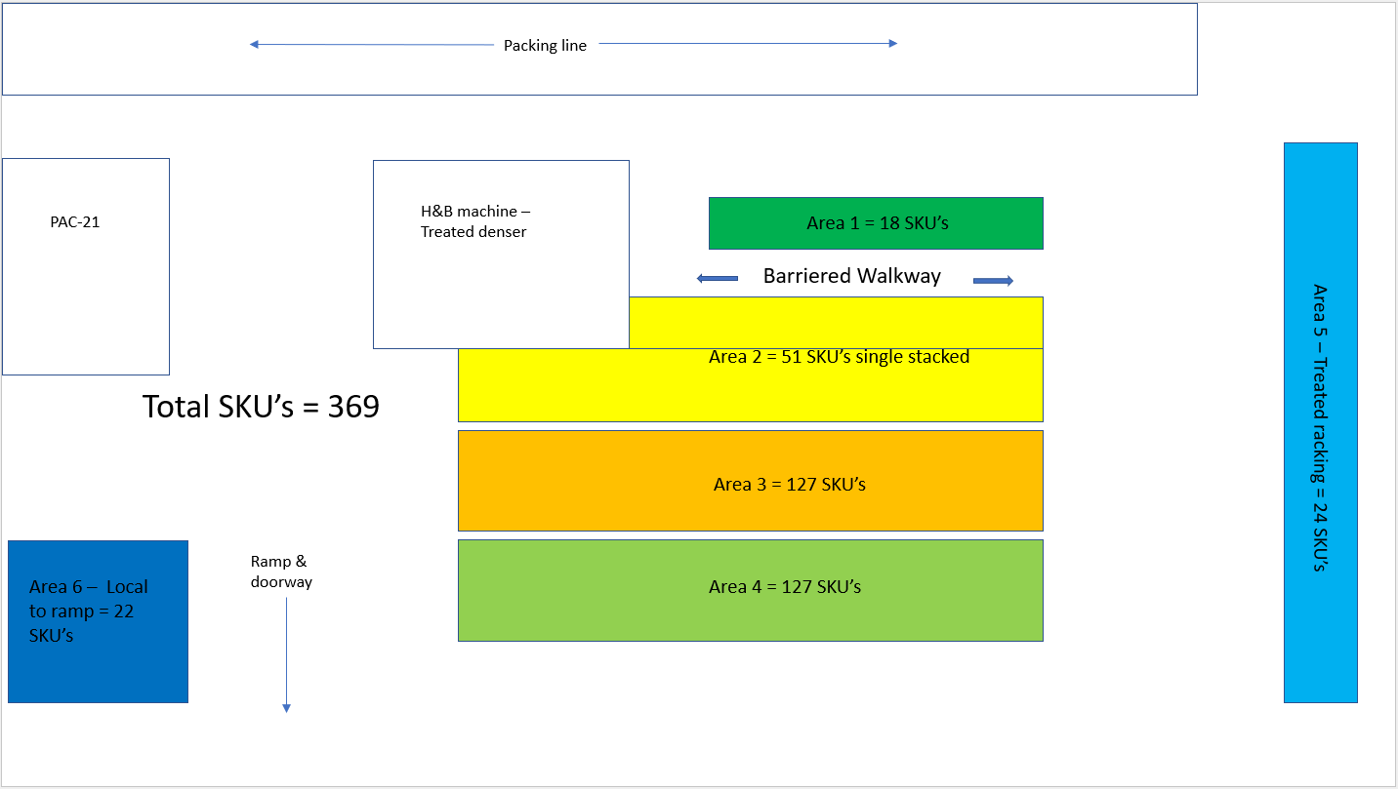

Appendix 17 – Actual Production Warehouse Stacking with range of SKU’s
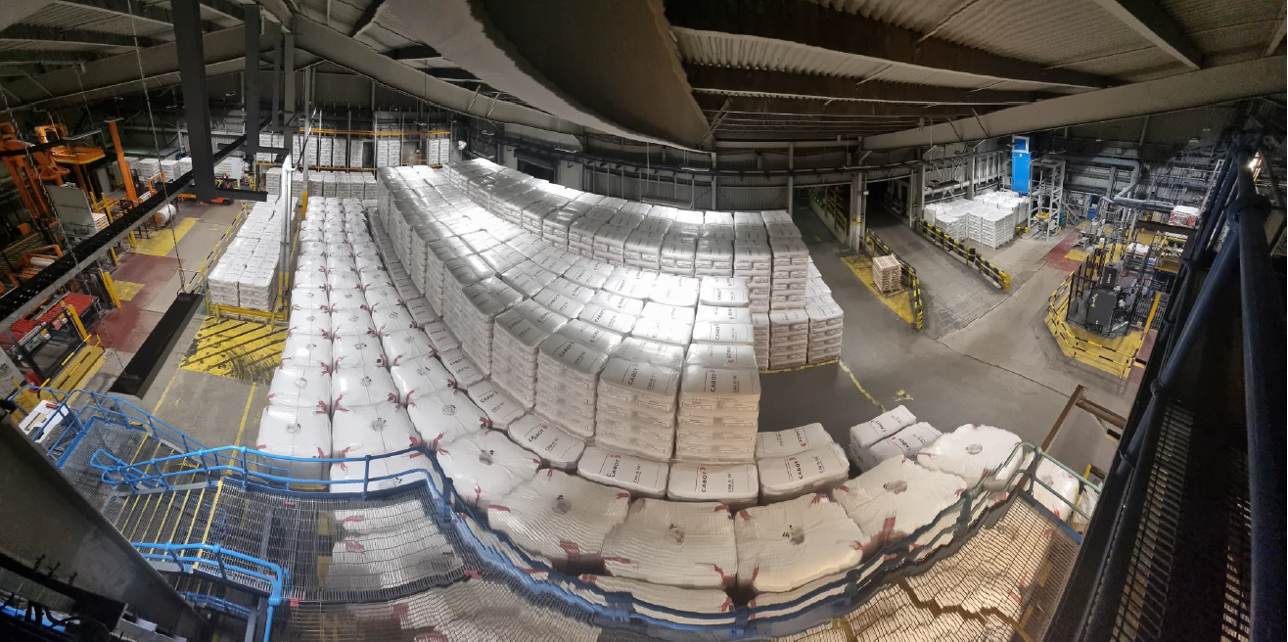

Appendix 18 – Commercial Demand - Email detailing Proposed/Potential Switch from paper-sacks to FIBC’s for large volume key customers forwarded by Cabot EMEA Commercial Director

Hi Ellis

Kingspan is looking to move in time from small bags to FIBC’s for the M5. We also still support the possibility for bulk, Howard is in contact with them.
Looking at the growth (380 MT in 2022) a 180 kg FIBC could be helpful at Kingspan if the final decision is an unload station for FIBC’s (and not bulk).
We also have Krimelte (Wolfgroup) in Spain which we gave all info to move from small bags to FIBC. Here bulk was not possible. Howard maybe a good moment to check where they are with this project. This is LM150.
Initially Krimelte Spain would go over to FIBC and later possibility in Estonia as well. Total 360 MT LM150.
These changeovers will take some time as the individual company assesses their needs and determine the investment in the offloading equipment so expect these transitions over the next couple of years.

Hope this helps and Howard if you could get an update that would be great.

Kind regards,

Erik

Appendix 19 – Example of A3 Problem Solving in Cabot Carbon FMO Production Warehouse
Taken from Cabot Carbon documentation (Richards, Increased Treated Densed Production A3, 2017)
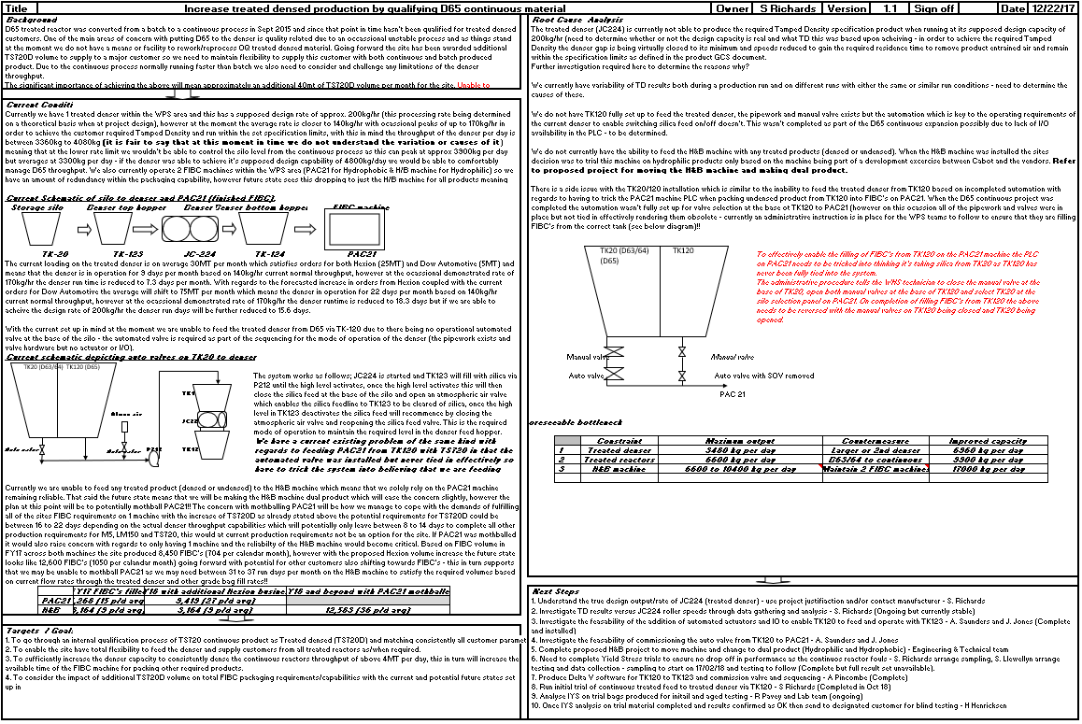

Appendix 20 – Paper-sack and FIBC SKU’s Produced in the Barry FMO Production Warehouse


