4. Chapter Four: Data Analysis

4.1 Introduction

The previous chapter achieved the second objective of study through identification and justification for the approaches selected for the study.

This chapter will achieve the third and fourth objective:

“To analyse the data collected to explore the perspectives of the customer, the employee and managerial forces surrounding the phrase ‘the customer is always right’.”

“To explore through analysis of primary research the impact the phrase ‘the customer is always right’ has on the employee.”

This will be achieved by analysing the data collected using a Statistical Package for the Social Sciences (SPSS). SPSS will support in the analysis and discussing the collected quantitative data. NVivo will be used for the small amount of qualitative data.

4.2 Data Analysis

Data analysis is the process whereby data is applied using statistical or logical technique in order to describe, understand, view and evaluate data (Shamoo and Resnik, 2009). This stage of research can distinguish the significant findings from the other fluctuations found in data (ibid). The quantitative data from study was analysed using the IBM SPSS statics software package and the qualitative data from the study was analysed using NVivo. The functions used were crosstabulations Chi-Square association tests. The data was presented in numerous forms including graphs and charts. The full SPSS and NVivo analyses can be seen in Appendix 2.

4.3 Methods

Participants were categorised by their age, perspective of response, and industry worked in to investigate significant differences between responses. Respondents who did not select the available options and chose to type their answer were removed from the data as many had duplicated the option they could have selected, these were removed for simplicity and to produce clearer data (Buchanan and Scofield, 2018; Google Analytics, 2021).

4.4 Demographics and Descriptive Statistics

The study received 135 voluntary respondents all above the age of 18 years old. The participants took an interest in the research after viewing it on the online platforms selected for distribution (e.g. LinkedIn, Facebook).

Of the total respondents, 32 were male, 102 were female, and 1 identified as non-binary. The age demographic described as simplified included 78 respondents under 35 and 57 respondents over 35. Disregarding the 6 respondents who selected other and provided a different response; 34 responded from the perspective of customer, 41 responded from the perspective of employee, and 54 responded from the perspective of employer or manager. The majority of respondents (33.3%) were in the customer service industry however there was a variety of employment backgrounds: 11.1% hospitality and events, 10.4% retail, 8.1% business and consultancy, 6.7% unemployed.

Figure 4.1 shows the extent participants agreed that the customer is always right. This has been analysed further throughout the Chapter.

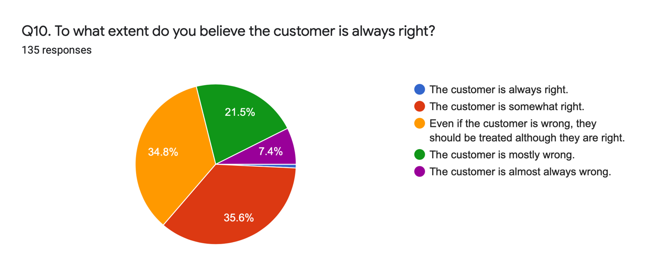
Figure 4.1 Chart showing agreement with extent ‘The customer is always right’ should be followed.

4.5 Chi-Square Analysis

Chi-Square analyses were conducted to investigate statistical associations between the perspective answered from and personal opinion, or agreement with statements. The crosstabulations for each Chi-Square can be found in Appendix 2.

4.5.1 Chi-Square Analysis for Perceptions

Figure 4.2 and 4.3 (below) show a significant association between perspective answered from and answer to Q6. For ease of reference, refer to Appendix 3 for the list of questions.

The results show that the highest levels of disagreement with the statement ‘The customer is always right’ came from respondents who were managers or employers. The highest level of disagreement with the statement came from respondents who were employees. The highest level of agreement with the statement came from those who answered from the perspective of a customer.

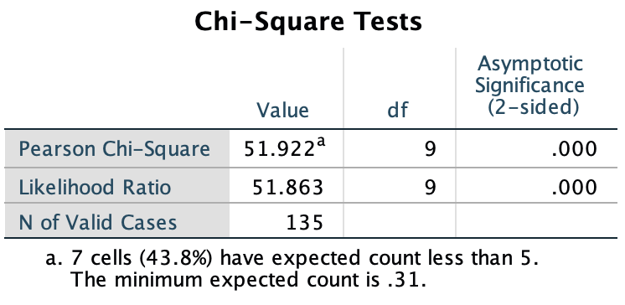
Figure 4.2 Chi-Square test Q4 and Q6, showing significant association between perspective answered from and opinion in response to ‘The customer is always right’. (p=.000).

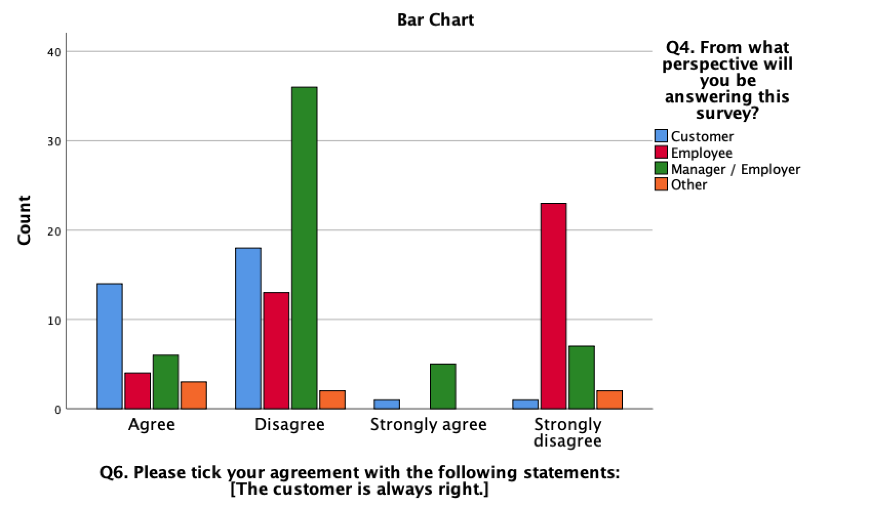
Figure 4.3 Chart showing significant association between perspective answered from and opinion in response to ‘The customer is always right’. (p=.000).

4.5.2 Chi-Square Analysis for Industry

Figure 4.34and 4.5 (below) show a significant association between industry worked in and answer to Q6.

The results show that the highest levels of disagreement with the statement ‘The customer is always right’ came from participants who worked in customer service. These participants also contributed to the highest level of strong disagreement with the statement.

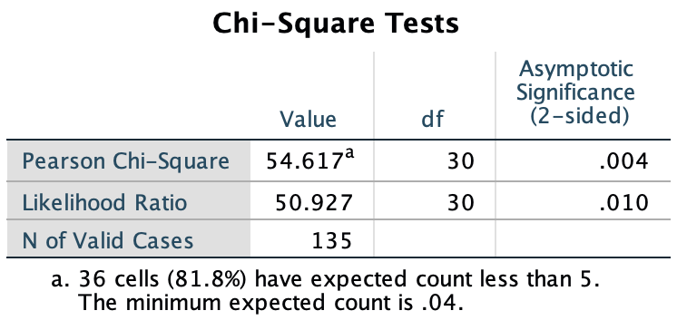
Figure 4.4 Chi-Square Test Q5 and Q6, showing significant association between industry worked in and opinion in response to ‘The customer is always right’. (p=.004).

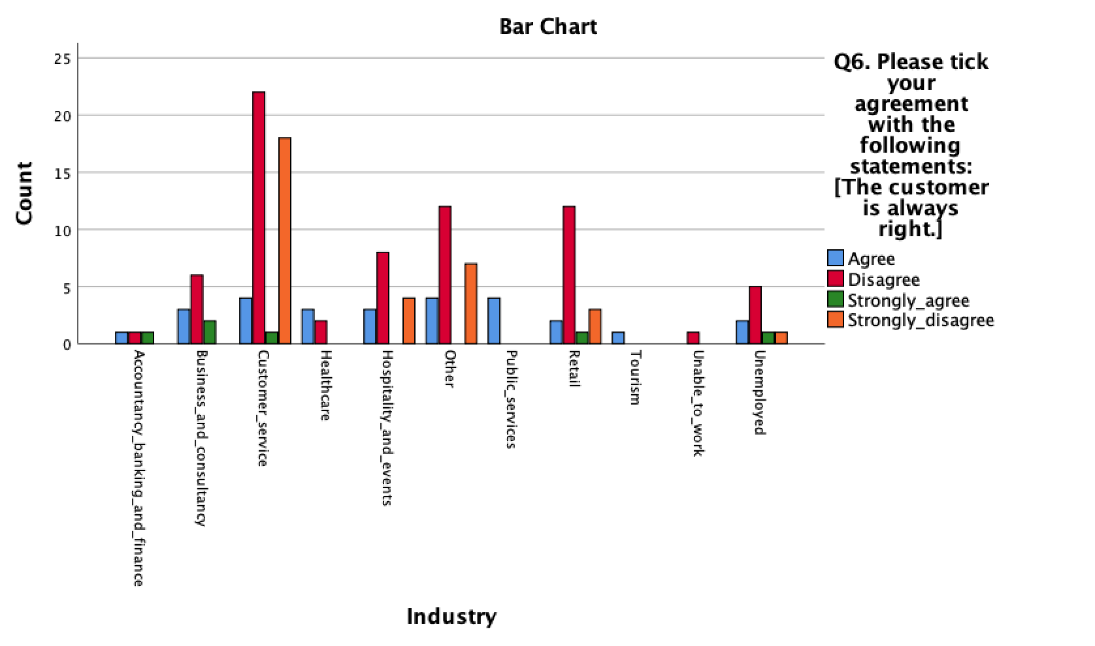
Figure 4.5 Chart showing significant association between industry worked in and opinion in response to ‘The customer is always right’. (p=.000).

4.5.3 Chi-Square Analysis for Age

Figure 4.6 and 4.7 demonstrate a significant association between age and answer to Q6. The 18-24 age demographic, followed by the 25-35 age demographic responded with the highest levels of disagreement in response to the phrase ‘The customer is always right’.

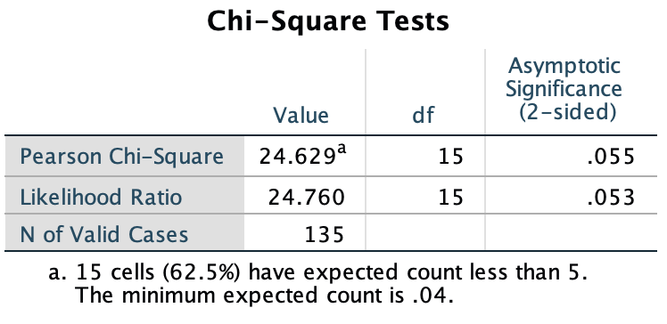
Figure 4.6 Chi-Square test for Q3 and Q6 showing significant association between age and opinion in response to ‘The customer is always right’. (p=.055).

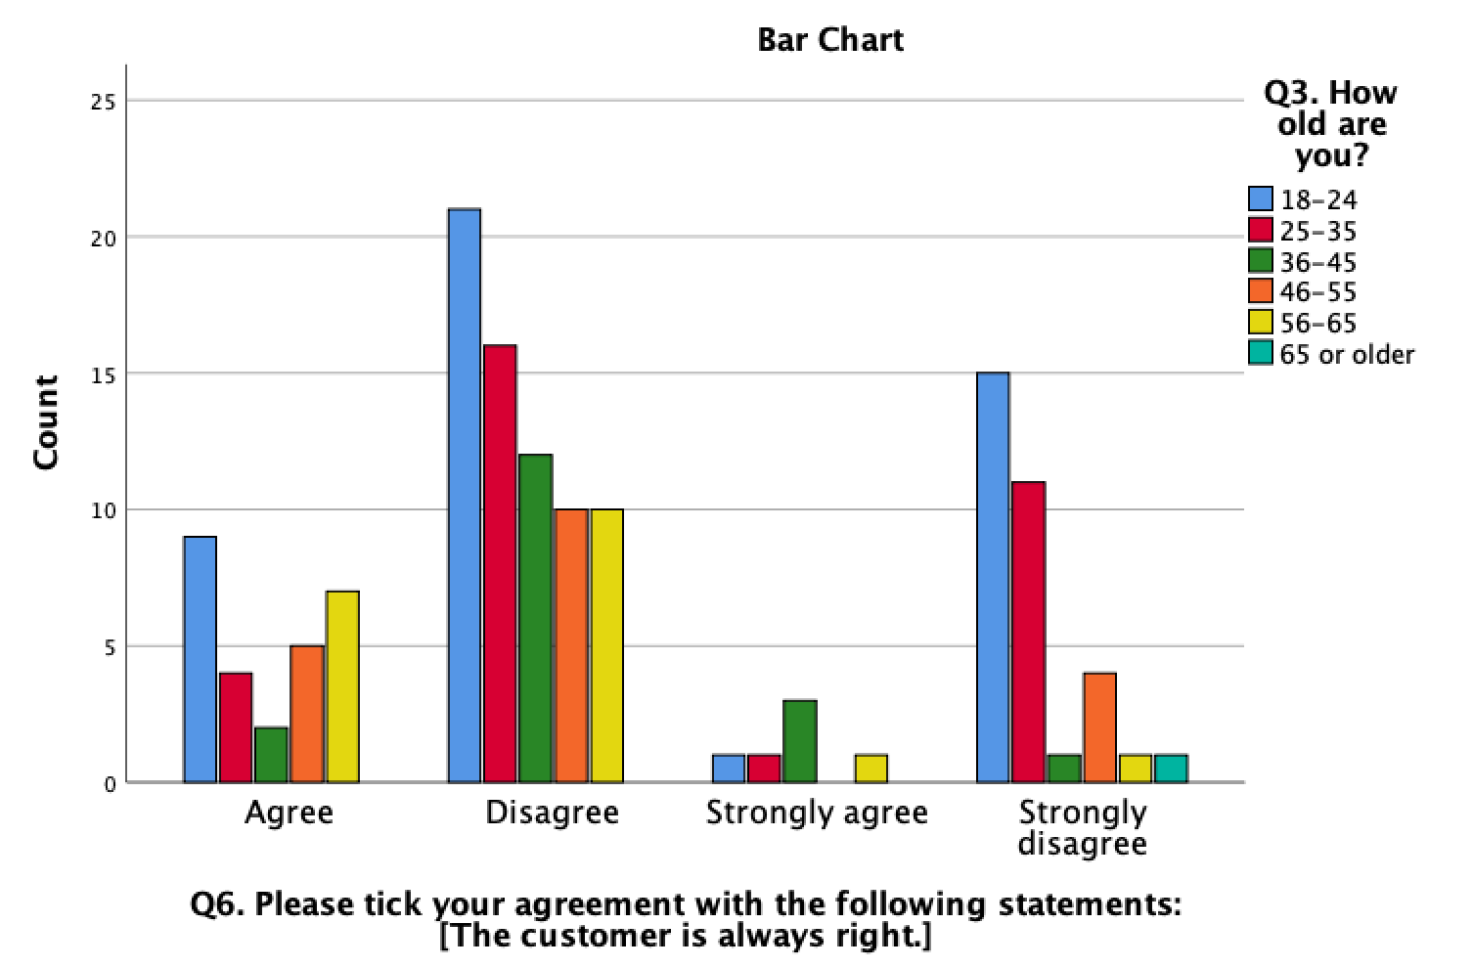
Figure 4.7 Chart showing significant association between age and opinion in response to ‘The customer is always right’. (p=.055).

4.5.4 Chi-Square Analysis for Opinion

Figure 4.8 and 4.9 show a significant association between Q4 and Q10.

The data shows that although the manager or employer participants disagreed the most with the statement ‘The customer is always right’, that demographic showed the highest level of agreement that the customer should be treated although they are right even when they are not. These respondents also agreed to nearly the same extent as the customer that the customer is somewhat right. The highest levels of agreement that the customer is almost always wrong or mostly wrong was from the respondents answering from the perspective of an employee.

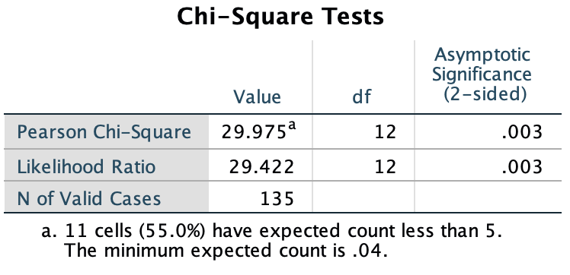
Figure 4.8 Chi-Square test for Q4 and Q10 showing significant association between perspective answered from and opinion in response to ‘To what extent do you believe the customer is always right. (p=.003).

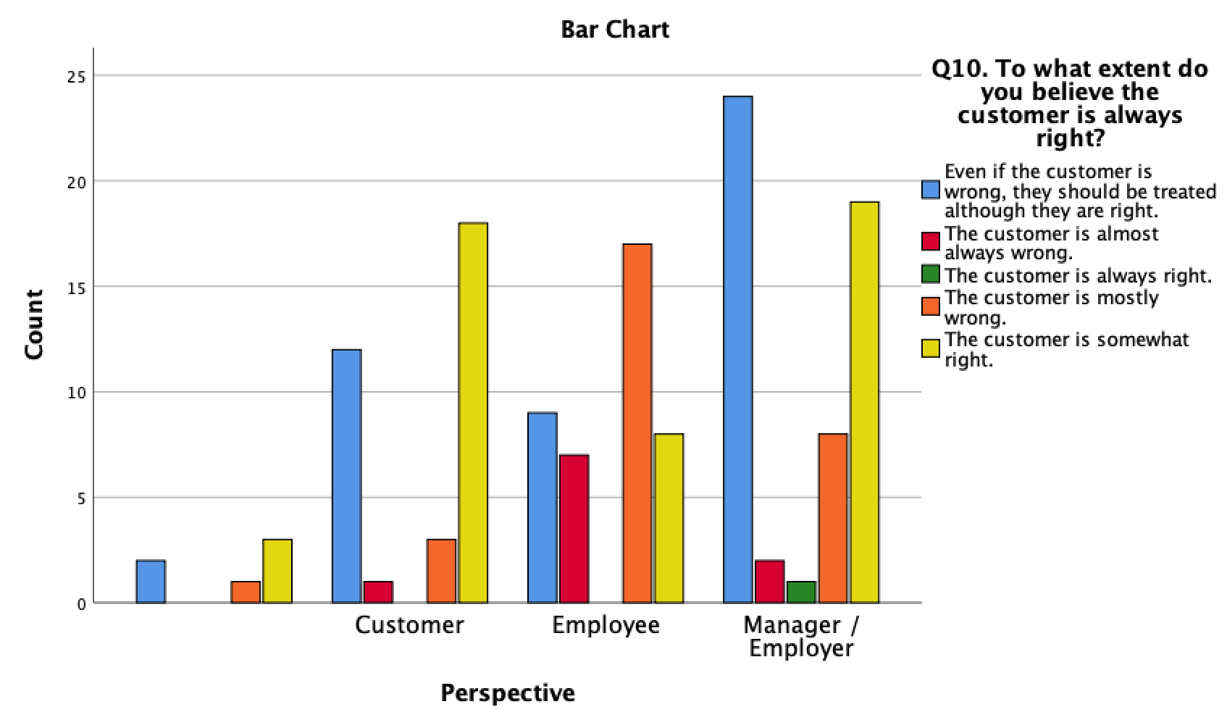
Figure 4.9 Chart showing significant association between perspective answered from and opinion in response to ‘To what extent do you believe the customer is always right?’ (p=.003).

Figure 4.10 and 4.11 demonstrate a significant association between perspective answered from and opinion in regard to personally complaining illegitimately. Only 7 of 135 participants answered yes that they had complained illegitimately for personal gain and all 7 had answered from the perspective of a customer.

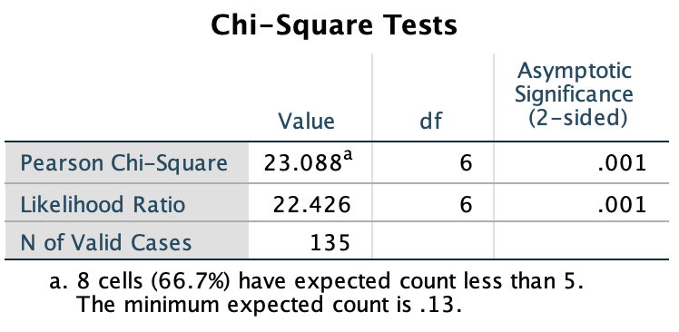
Figure 4.10 Chi-Square test for Q4 and Q12 showing significant association between perspective answered from and opinion in response to ‘Have you ever complained illegitimately for personal gain?’ (p=.001).

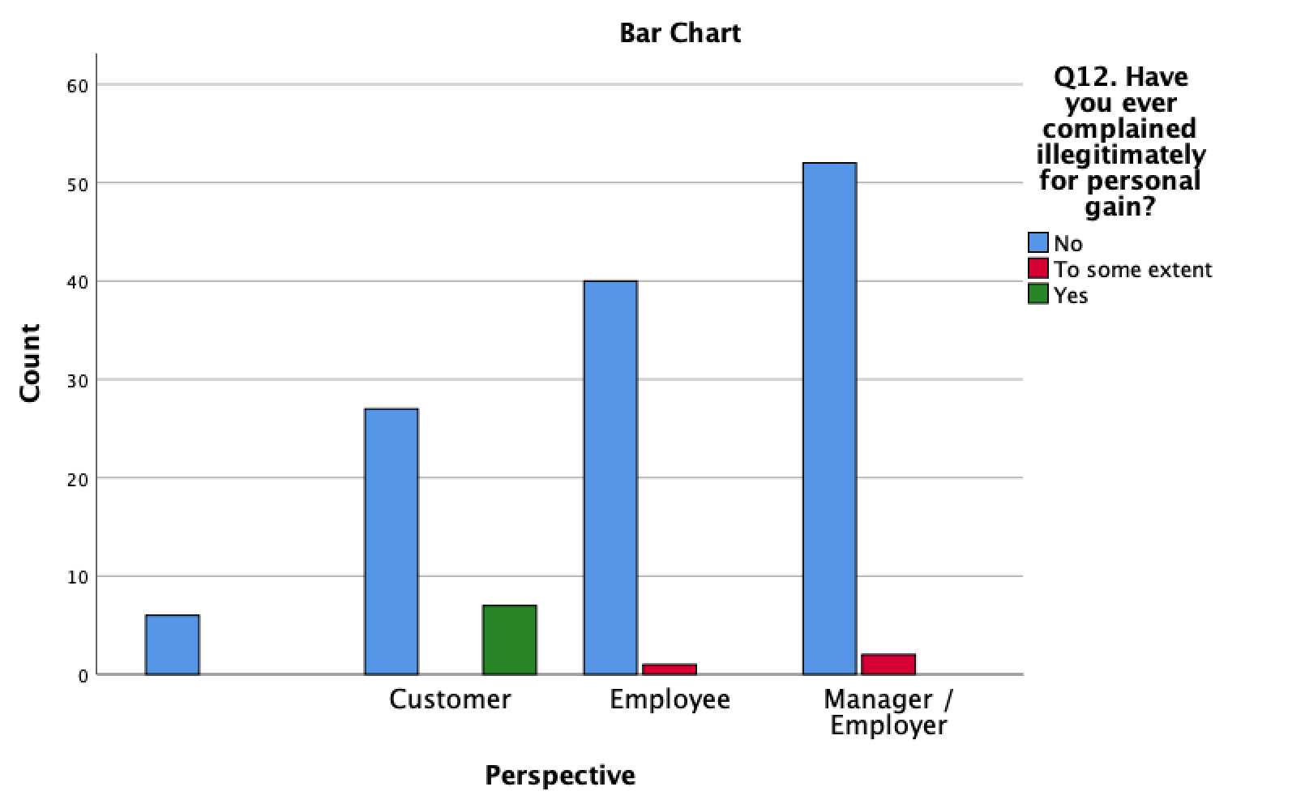
Figure 4.11 Chart showing significant association between perspective answered from and opinion in response to ‘Have you ever complained illegitimately for personal gain?’ (p=.001).

4.6 Crosstabulation

Figure 4.12 shows a negative association between Q4 and Q11. Although those answering from the perspective of manager or employer and employee reported the highest levels of distrust in customer complaints, the p value = .735 showed this comparison between respondent demographics was insignificant.

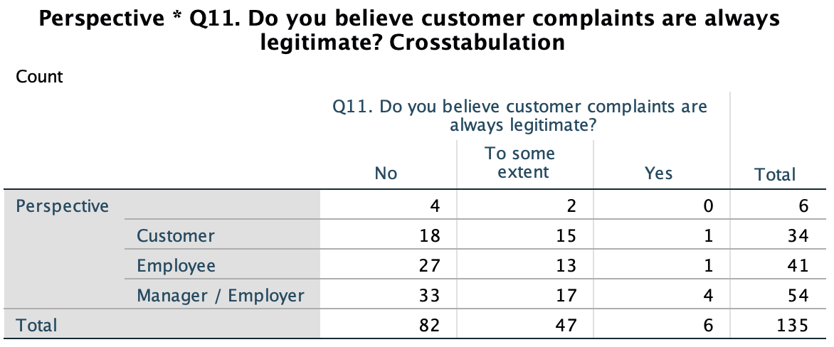
Figure 4.10 Crosstabulation showing negative association between perspective answered from and opinion in response to ‘Do you believe customer complaints are always legitimate?’ (p=.735).

Q14 required response from participants answering from the perspective of employer or manager only. Figure 4.11 demonstrates a significant association between industry worked in and opinion of employer or manager in regard to expecting staff to adopt ‘the customer is always right’ strategy. The p value = .027 (Chi-Square can be seen in Appendix 2) showed that the comparison between industry was significant. The customer service industry employers or managers had the highest level of agreement with the statement.

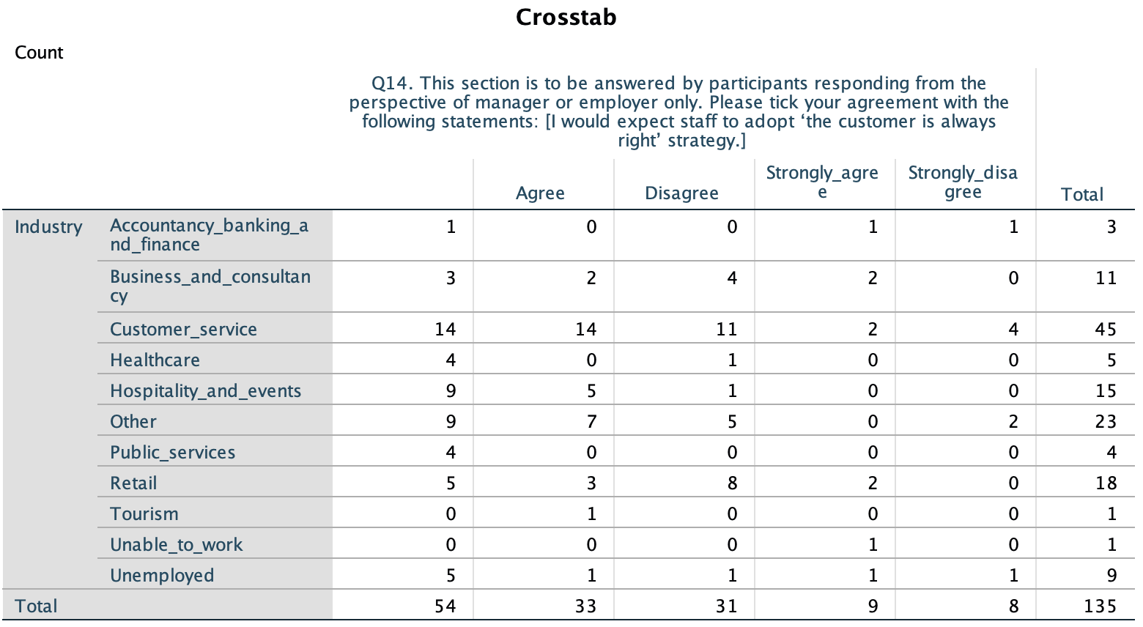
Figure 4.11 Crosstabulation showing significant association between industry worked in and opinion of employer or manager in response to ‘I would expect staff to adopt ‘the customer is always right’ strategy’. (p=.027).

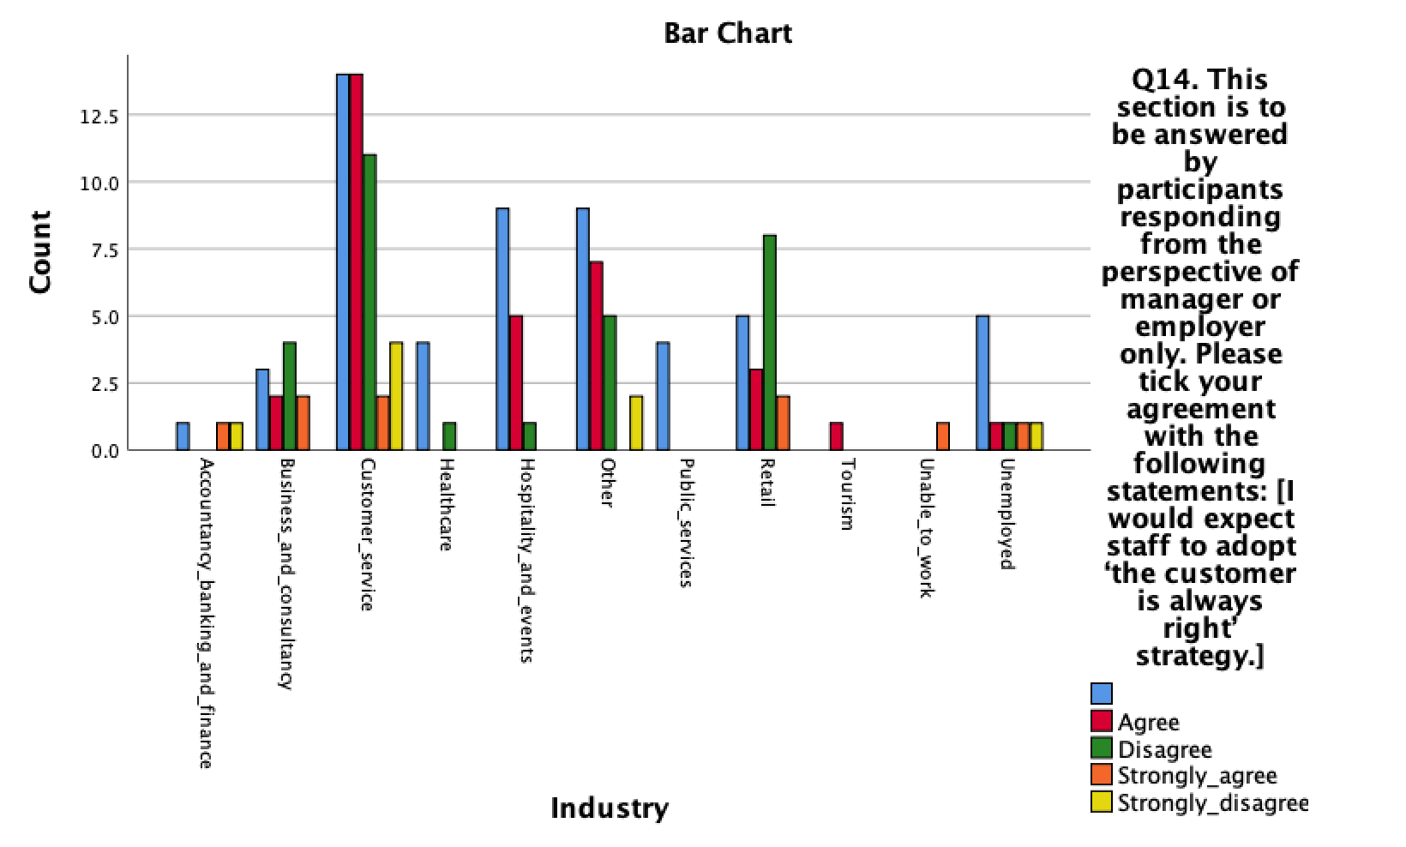
Figure 4.12 Chart showing significant association between industry worked in and opinion of employer or manager in response to ‘I would expect staff to adopt ‘the customer is always right’ strategy’. (p=.027).

4.7 Discussion and Descriptive Analysis

This section of the Chapter will discuss data descriptively. This method of discussion for these responses was selected as it allows for discussion of detail (Trochim, 2020) from questions asked to gain further understanding and provoke further comparison (Foddy and Foddy, 1994, p. 2; Lohr and Raghunathan, 2017). The full list of questions asked as part of Q13 can be found in Appendix 3. Only a select amount of collected data with most relevance to Chapter Two will be discussed in this section.

Out of the 135 respondents, 95 answered from the perspective of an employer, manager or employee. 92% strongly agreed that they had dealt with a customer complaint, 69% strongly agreed that they had been made to feel demoralised by a customer, 57% strongly agreed that dealing with a customer complaint negatively affects their mood, 77% strongly agreed that a happy customer makes them feel happy, 66% strongly agreed that they had been verbally or physically assaulted or threatened by a customer, and 72% strongly agreed that they have had to deal with a customer complaining illegitimately.

Despite 72% strongly agreeing that they have had to deal with a customer complaining illegitimately, 87% responded either strongly agree or agree that it is easier to accept the complaint and apologise than explain why the customer may not be correct. This correlates with the general response received from all participants in Q8 whereby participants were asked questions surrounding preconceived perceptions before purchase. 78% either strongly agreed or agreed that they would always read online reviews before making a purchase, 65% either strongly agreed or agreed that they would trust online reviews, 70% claimed that online reviews were a good source of information and 60% strongly agreed that they understood online reviews can be written by anybody. However, the participants also responded by 56% that they did not believe others had good intentions and by 55% that they did not trust people they do not know. This suggests contradiction, figure 4.13 demonstrates this.
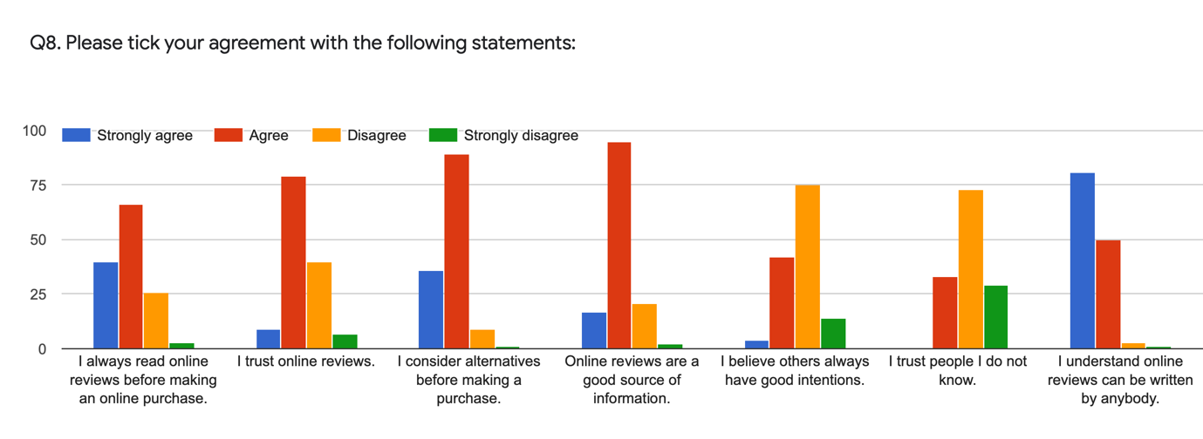
Figure 4.13 Chart showing participant agreement with statements in Q8.

4.8 Qualitative Analysis

This section will briefly discuss response to Q15 which allowed for qualitative response in the questionnaire. The data analysis for this section was completed using NVivo. The responses in full can be seen in Appendix 4.

4.9 Conclusion

This Chapter has successfully achieved the third and fourth objectives of the study: “To analyse the data collected to explore the perspectives of the customer, the employee and managerial forces surrounding the phrase ‘the customer is always right’.”

“To explore through analysis of primary research the impact the phrase ‘the customer is always right’ has on the employee.”

These objectives have been met through analysing the data collected using SPSS and NVivo. The final Chapter will achieve the final objectives of the study which include recommendations for future research in the topic or for the use of respondents in future, it will also highlight potential avenues for further study with consideration to the limitations in the present study.

References

Shamoo, A.E. and Resnik, D.B. (2009) Responsible Conduct of Research. Oxford University Press.

Google Analytics (2021) About Demographics and Interests. Available at: https://support.google.com/analytics/answer/2799357?hl=en (Accessed: 14 April 2021).

Trochim, W.K.R. (2020) Research Methods Knowledge Base. Available at: https://conjointly.com/kb/descriptive-statistics/ (Accessed: 18 April 2021).

Buchanan, E.M. and Scofield, J.E. (2018) ‘Methods to detect low quality data and its implication for psychological research’, Behaviour Research Methods, 50, pp. 2586-2596. Available at: https://doi.org/10.3758/s13428-018-1035-6 (Accessed: 18 April).

Foddy, W. and Foddy, W.H. (1994) Constructing questions for interviews and questionnaires: Theory and practice in social research. Cambridge University Press.

Lohr, S.L. and Raghunathan, T.E. (2017) Combining Survey Data with Other Data Sources, Statistical Science, 32(2), pp. 293-312. Available at: https://www.jstor.org/stable/26408232 (Accessed: 18 April 2021).

