PDP
Further guidance / Arweiniad ychwanegol


Profiad Addysgu Proffesiynol gyda SAC
Professional Teaching Experience with QTS
ECSP6002(C)

rachel.bendall@uwtsd.ac.uk

Introduction / Cyflwyniad

The purpose of this document is to provide you with further guidance, including examples of impact statements and evidence, to support you in completing your PDP.
Pwrpas y ddogfen hon yw i gynnig arwieniad pellach, gan gynnwys enghreifftiau o ddatganiadau effaith a thystiolaeth, i’ch cefnogi wrth i chi gwblhau’ch PDP.

Details of Assessment / Manylion Asesu

Written Assignment:
The title for your assignment is as follows (5000 words):
Professional Development Portfolio (PDP)
Marking the assignment:
This assignment will be marked using the Level 6 assessment criteria.
Deadline:
23.59 on Friday May 31st, 2019.
You must ensure that your PDP is complete and available on OneNote for your tutor to view by this date and time. You should already have shared a link to your PDP with your tutor. There is no submission through Turnitin.

Aseiniad Ysgrifenedig:
Teitl eich aseiniad (5000 o eiriau) ydy:
Portffolio Datblygiad Proffesiynol (PDP)
Marcio’r aseiniad ysgrifenedig
Caiff yr aseiniad ysgrifenedig ei farcio gan ddefnyddio meini prawf asesu Lefel 6.
Dyddiad cau:
23.59 ar Ddydd Gwener y 31ain o Fai, 2019.
Mae’n rhaid i chi sicrhau fod eich PDP wedi’i gwblhau ac ar gael ar OneNote i’ch tiwtor ei weld erbyn yr amser a’r dyddiad hwn. Dylech chi wedi rhannu dolen gyswllt i’ch PDP gyda’ch tiwtor erbyn hyn. Does dim angen ei gyflwyno drwy Turnitin.

FAQs / Cwestiynau cyffredin

Here are the frequently asked questions I’ve received, along with the answers I’ve given:
Dyma’r cwestiynau rwyf wedi’u derbyn yn gyson, ynghyd â’r atebion rwyf wedi’u rhoi:

- What exactly is being assessed?
Beth yn union sy’n cael ei asesu?

- This assignment is about evidencing that you’ve achieved QTS. As such, the evidence you present will be considered, and, more importantly, your explanation of how this has impacted on the teaching and the learning will be assessed (i.e. your impact statements).

Nod yr aseiniad hwn yw cyflwyno tystiolaeth eich bod wedi cyflawni SAC. O ganlyniad, caiff y dystiolaeth rydych yn ei chyflwyno ei hystyried, ac, yn bwysicach, eich esboniad o sut mae hon wedi effeithio ar y dysgu a’r addysgu fydd yn cael ei asesu (h.y. eich datganiadau effaith).

- How will my work be assessed?
Sut bydd fy ngwaith yn cael ei asesu?

- Your work will be assessed using the Level 6 assessment criteria. Not all parts of the criteria are applicable to this assignment, e.g. criticality and evaluation, therefore only the most relevant parts of the criteria will be used to assess your work. These relevant parts can be found at the end of this document.

Caiff eich gwaith ei asesu gan ddefnyddio meini prawf asesu Lefel 6. Nid yw pob rhan o’r meini prawf yn berthnasol, e.g. gwerthuso’n feirniadol, felly y rhannau mwyaf perthnasol yn unig caiff eu defnyddio i asesu’ch gwaith. Mae’r rhannau perthnasol hyn wedi’u cynnwys fel rhan o’r arweiniad hwn.

- Can I use the same evidence for several standards?
Ydw i’n gallu defnyddio’r un dystiolaeth ar gyfer mwy nag un safon?

- Using the same evidence for several standards is acceptable. However, the impact statement each time should have slight differences in accordance with the standard's requirements. Each standard is different so your explanation of how the evidence applies to each standard and the effect it's had on your practice and pupils' learning/ progress/ development/experience (i.e. the impact statement) should be different.

Mae defnyddio’r un dystiolaeth ar gyfer sawl safon yn dderbyniol. Er hyn, fe ddylai’r datganiad effaith bob tro fod bach yn wahanol fel ymateb i ofynion penodol pob safon. Mae pob safon yn wahanol felly dylai’ch esboniad o sut mae’r dystiolaeth yn cyfateb i bob safon a’r effaith mae wedi’i chael ar eich arferion chi a dysgu/cynnydd/datblygiad/profiad y dysgwyr (h.y. y datganiad effaith) fod yn wahanol.

- I’ve had problems setting up my PDP on OneNote. What should I do?
Rwyf wedi cael trafferth yn creu fy PDP ar OneNote. Beth ddylaf ei wneud?

- Please contact Dave Stacey in the first instance as initially advised.

Os gwelwch yn dda, cysylltwch gyda Dave Stacey yn y lle cyntaf fel y’ch cynghorwyd ei wneud yn wreiddiol.

- Does my work have to be exactly 5000 words?
Oes rhaid i fy ngwaith fod 5000 o eiriau yn union?

- The simple answer is ‘no’. As with your first assignment where you included a scheme of work, resources, pupil work etc, this assignment is 5000 words equivalent. This means we won’t be counting every word in the evidence you’ve provided! What we will be looking at is that you’ve sufficiently met the brief by including two pieces of evidence for each standard, and you’ve included an impact statement explaining the effect the evidence you’ve provided has had on the teaching and learning.

Yr ateb syml yw ‘na’. Yn debyg i’ch aseiniad cyntaf lle roedd gofyn i chi gynnwys cynllun gwaith, adnoddau, enghreifftiau o waith plant ag ati, mae’r aseiniad hwn yn gyfwerth â 5000 o eiriau. Golyga hyn na fyddwn yn cyfrif pob gair yn y dystiolaeth rydych wedi’i chynnwys! Yr hyn byddwn yn edrych arno yw eich bod wedi cyflawni gofynion y brîff trwy gynnwys dau ddarn o dystiolaeth ar gyfer pob safon, a’ch bod wedi cynnwys datganiad effaith sy’n esbonio’r effaith mae’r dystiolaeth rydych yn ei chyflwyno wedi’i chael ar y dysgu a’r addysgu.

- What should I be saying in my impact statement?
Beth sydd angen i mi ei gynnwys yn fy natganiad effaith?

- In your impact statement you should be explaining the effect the evidence you’ve provided has had on your teaching/professional development and the pupils’ learning/ progress/ development/experience. I’ve included some examples in this guidance for you to be able to see a variety of approaches from some of your peers.

Yn eich datganiad effaith dylwch esbonio’r effaith mae’r dystiolaeth rydych yn ei chyflwyno wedi’i chael ar ddysgu/cynnydd/datblygiad/profiad y disgyblion a’ch addysgu/datblygiad proffesiynol chi. Rwyf wedi cynnwys rhai enghreifftiau yn yr arwieniad hwn er mwyn i chi gael gweld amrywiaeth o ddulliau gan rai o’ch cyfoedion.

If you have a question about the PDP that hasn’t been answered here, please get in touch.
Os oes gennych gwestiwn am y PDP nad ydyw’n cael ei ateb fan hyn, plîs cysylltwch.

Examples / Enghreifftiau
Please note that the examples given here are varied. This is because there isn’t one correct, perfect way of completing this work.
Sylwch os gwelwch yn dda, mae’r enghreifftiau sydd wedi’u cynnwys yma yn amrywio. Adlewyrcha hyn y ffaith nad oes un ffordd berffaith, gywir o gyflawni’r gwaith hwn.

Student / Myfyriwr A

Student A has used the ‘overview’ page as an index to her PDP. She has noted the dates the evidence was collected, and has included a brief impact statement for each piece of evidence.
Mae Myfyriwr A wedi defnyddio’r dudalen ‘trosolwg’ fel mynegai i’w PDP. Mae wedi nodi’r dyddiadau a gasglwyd y dystiolaeth, ac wedi cynnwys paragraff byr sy’n esbonio effaith pob darn o dystiolaeth.
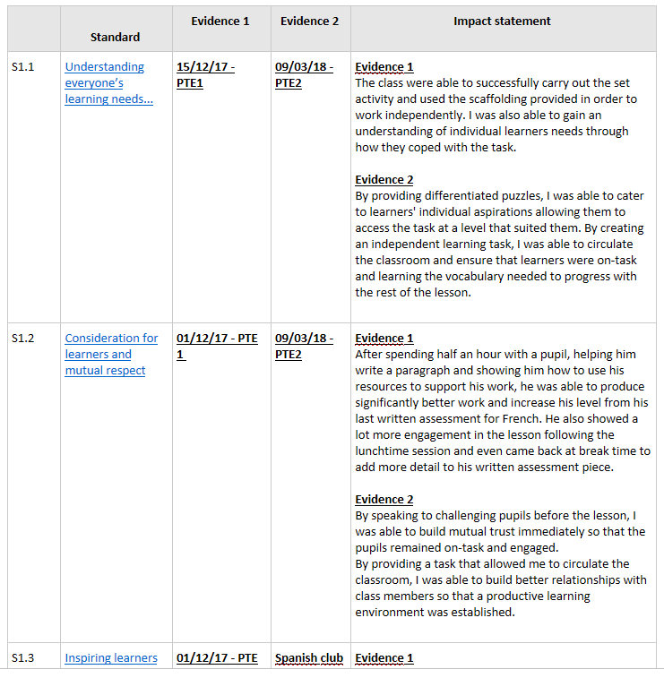
The student has then selected each individual standard and has included pictures and a further brief description of the evidence.
Yna, mae’r myfyriwr wedi dewis pob safon yn unigol ac wedi cynnwys lluniau a disgrifiad byr pellach o’r dystiolaeth.
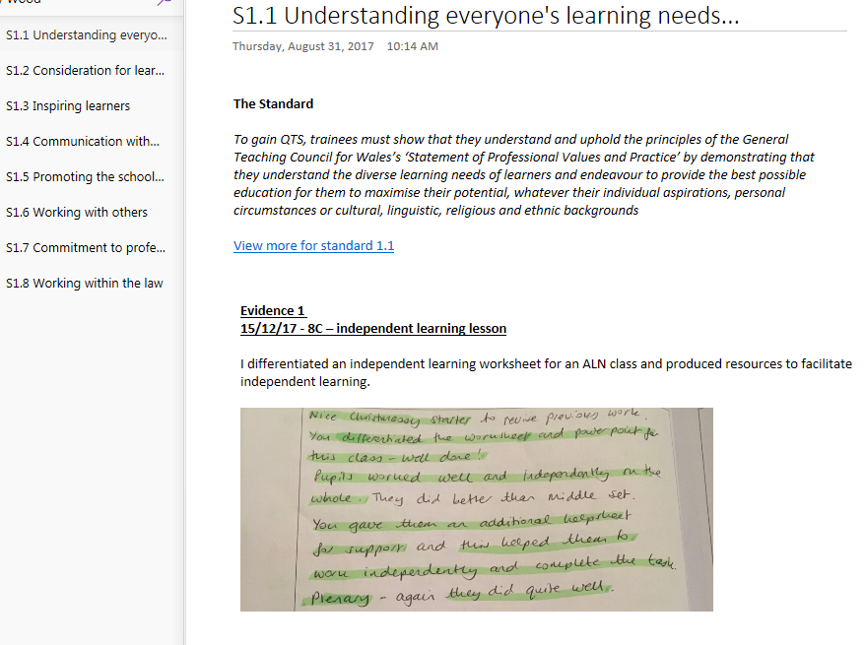

The student has chosen to copy the impact statement from the ‘overview’ page and has pasted it alongside the evidence she is submitting.
Mae’r myfyriwr wedi dewis copïo’r datganiad effaith o’r dudalen ‘trosolwg’ ac wedi’i ludo wrth ymyl y dystiolaeth mae wedi’i chyflwyno.

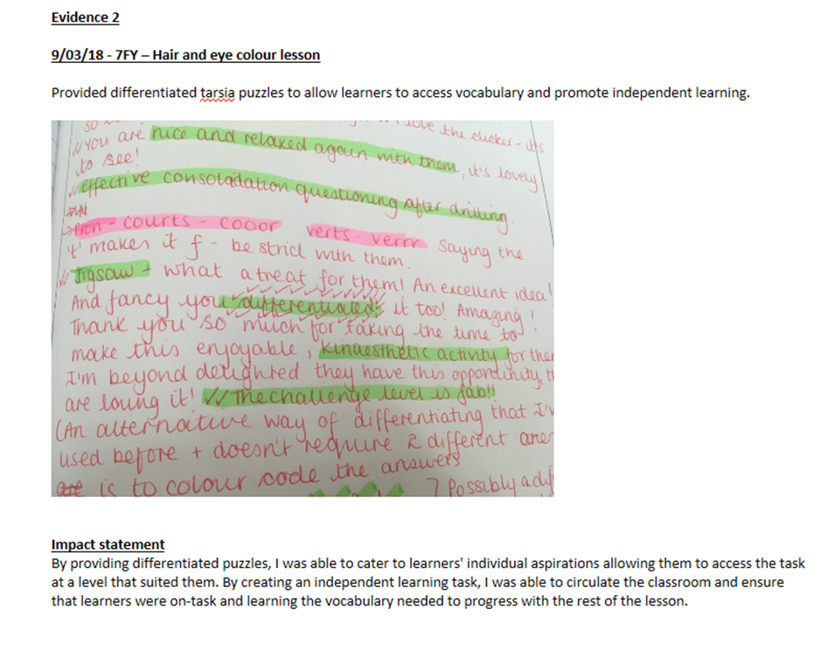

Student / Myfyriwr B

Student B has taken a slightly different approach. She has used the ‘overview’ sheet as a checklist to show which standards have been completed.
Mae myfyriwr B wedi dewis ffordd ychydig wahanol. Mae wedi defnyddio’r dudalen ‘trosolwg’ fel rhestr wirio er mwyn dangos pa safonau mae wedi’u cwblhau.
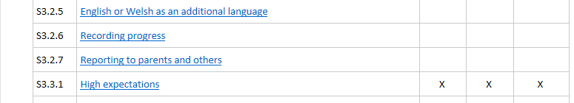

She has then selected the relevant standard and has included her evidence and impact statement there. She has used her mentor’s comments in a formative assessment and in the comments’ booklet as evidence for this standard.
Yna, mae wedi dewis y safon berthnasol ac wedi cynnwys ei dystiolaeth a datganiad effaith yno. Mae wedi defnyddio sylwadau’r mentor mewn asesiad ffurfiannol ac yn y llyfryn sylwadau fel tystiolaeth ar gyfer y safon hon.
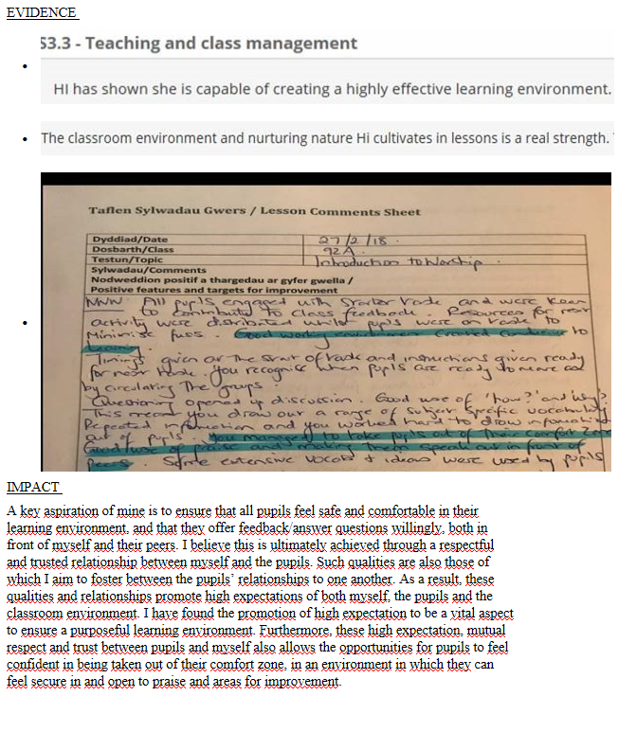

Myfyriwr / Student C

Eto, mae’r myfyriwr hwn wedi defnyddio’r dudalen ‘trosolwg’ fel rhestr wirio.
Again, this student has used the ‘overview’ page as a checklist.
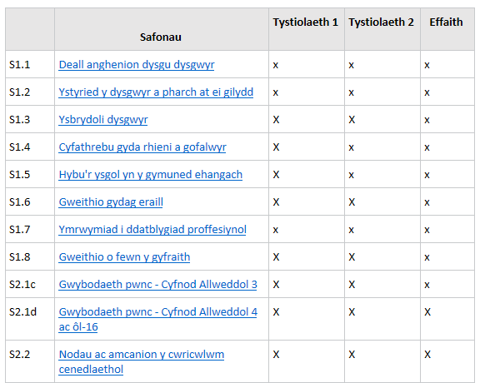

Ar ôl dewis y safon berthnasol, mae’r myfyriwr wedi cynnwys ei dystiolaeth a datganiad effaith yno. Sylwch fod y myfyriwr wedi cadw ‘cofnod allgyrsiol’ ac wedi’i gynnwys fel atodiad, ac mae wedi rhestru’r dyddiadau ar gyfer nosweithi rhieni mae wedi’u mynychu.
After selecting the relevant standard, the student has then added his evidence and impact statement. Notice that the student has kept an ‘extracurricular record’ and has included it as an attachment, and has listed the dates of the parents’ evenings he has attended.
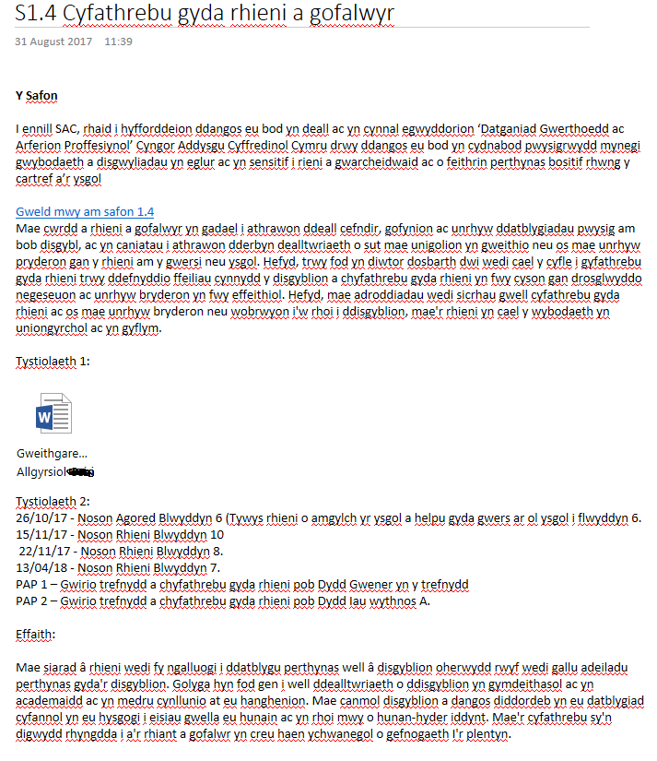

Indicative Grade Descriptors for Level 6
Note: These are not grade criteria but indicative descriptions of the characteristics of assignments at each grade
Learning Outcomes |  | Fail (E) | Borderline Pass (D) | Pass (C) | Good Pass (B) | Excellent Pass (A)
 | Conceptual Understanding & Subject Knowledge | Limited or oblique knowledge of key issues with some errors in significant areas of understanding. | Some concepts understood and explored in specific contexts. | Concepts are satisfactorily understood and explored in wider contexts, but not in great depth. | Good understanding of concepts which are understood and explored in wider contexts and / or in some depth. | Excellent understanding of concepts which are explored in wider contexts and / in or depth.
 | Conceptual Understanding & Subject Knowledge |  | Relevant identification of key issues, but limited in scope or clarity. | Relevant identification and understanding of key issues. | Focused identification of key issues, showing a reasonable understanding. | Purposeful discussion of key issues, showing a depth of understanding.
Intellectual Skills | Assignment requirements | Inadequate or misplaced coverage of the assignment brief, including irrelevant content or significant sections missing. | Adequate application of understanding to the brief. | Sound understanding and coverage of the brief, with relevant key issues identified. | Good understanding and coverage of the brief. Relevant key issues identified and discussed. | Excellent understanding and coverage of the brief. Relevant key issues identified, discussed and explored.
Intellectual Skills | Assignment requirements |  | Appropriate lines of argument are developed and linked effectively to the brief.
Professional Applications | Development of Professional Practice | Lacks focus on resources, intervention or development of practice. | Identifies a focus for resources, intervention or development of practice but this may be limited or superficial. | Satisfactory suggestions for resources, an intervention or development of practice and recommendations for ways forward. | Good suggestions for resources, an intervention or development of practice.  Interventions are justified. | Excellent suggestions for resources, an intervention or development of practice.  Clear rationale for the purposes pursued and strategies employed.
Professional Applications | Development of Professional Practice | Descriptive with no engagement with analysis or development of practice. | Descriptive but some evidence of analysis and/or development of practice. | Problems are identified. Some straightforward justification is offered for solutions and some approaches or recommendations are put forward. | Clearly identifies problems to be solved and justifies approaches adopted or suggested. | Problems are clearly identified and discussed with focus. Explores and justifies approaches in a clear and informed way.
Professional Applications | Personal Professional Development | No evidence of personal professional development. | Description balanced by some analysis with occasional, but limited attempts to engage in analysis, evaluation or reflection on personal practice. | An ability to reflect upon own and others’ professional practice and learning. | Personal values, concerns, priorities and actions are discussed fully. | Personal values, concerns, priorities and actions are contextualised and explored.
Professional Applications | Personal Professional Development | No evidence of reflection. |  | Satisfactory evidence of critical reflection. | Good evidence of critical reflection. | Strong evidence of critical reflection.
Presentation & Use of Language | Clarity of Structure | Rambling or meandering sequence of sections or statements lacking argument and coherent conclusions. | Attempts to link and synthesise arguments made, although may not make a coherent whole with clear conclusions. | Satisfactory links are made between sections. A clear, if simple, line of thought can be seen throughout the assignment. Straightforward conclusions can be seen to be drawn from the main body of the assignment. | Good structure which is logically progressed. A clear line of thought can be seen throughout the assignment. Conclusions are drawn clearly from the main body of the assignment.  Overall presentation of material is good | Secure, well-considered structure, which is logically progressed. An explicit and clear line of thought can be seen linking each section. Conclusions are drawn confidently and in a focused way from the main body of the assignment.  Overall presentation of material is excellent
Presentation & Use of Language | Use of Grammar | Poor craftsmanship and presentation, e.g. uses inappropriate, inaccurate language, poor spelling, punctuation and grammar along with careless expression. | Adequate craftsmanship and presentation, including mainly appropriate use of spelling, punctuation and grammar. Some errors in expression, punctuation and grammar may be evident, although meaning is not obscured. | Sound craftsmanship and presentation including appropriate use of spelling, punctuation and grammar. Written expression is accurate overall, if simple. Errors may be seen in more complicated structures or punctuation. | Craftsmanship is good. Vocabulary and technical expression are used accurately. Grammar and punctuation are accurate, even when using more complex structures or punctuation. Written expression is fluent and used effectively. | Craftsmanship is excellent and fluent. Vocabulary and technical expression are used precisely.  Grammar and punctuation are accurate and used effectively. More complex structures and punctuation are used with confidence. Written expression is used to enhance the points presented.

Disgrifyddion Gradd Dangosol ar gyfer Lefel 6
Sylwer: Nid meini prawf ar gyfer gradd yw’r rhain ond disgrifiadau dangosol o nodweddion aseiniadau ar gyfer pob gradd
Deilliannau Dysgu |  | Methu (E) | Pas Ffiniol (D) | Pas (C) | Pas Da (B) | Pas Rhagorol (A)
 | Dealltwriaeth Gysyniadol a Gwybodaeth o’r Pwnc | Gwybodaeth gyfyngedig neu arosgo o faterion allweddol, gyda rhai gwallau mewn meysydd deall sylweddol. | Rhai cysyniadau wedi’u deall a’u harchwilio mewn cyd-destunau penodol. | Cysyniadau wedi’u deall yn foddhaol a’u harchwilio mewn cyd-destunau ehangach, ond nid yn fanwl. | Dealltwriaeth dda o gysyniadau a gaiff eu deall a’u harchwilio mewn cyd-destunau ehangach ac/ neu yn lled fanwl. | Dealltwriaeth ardderchog o gysyniadau a gaiff eu harchwilio mewn cyd-destunau ehangach ac/ neu yn fanwl.
 | Dealltwriaeth Gysyniadol a Gwybodaeth o’r Pwnc |  | Materion allweddol wedi’u nodi’n berthnasol ond gyda chwmpas neu eglurder cyfyngedig. | Materion allweddol wedi’u nodi’n berthnasol a’u deall. | Materion allweddol wedi’u nodi’n ganolbwyntiedig gan ddangos dealltwriaeth resymol. | Materion allweddol wedi’u trafod yn fwriadol ac yn dangos dealltwriaeth fanwl.
Sgiliau Deallusol | Gofynion yr Aseiniad | Ymdriniaeth annigonol o friff yr aseiniad, neu ymdriniaeth sydd o’i lle, gan gynnwys cynnwys amherthnasol a gyda rhannau sylweddol yn eisiau. | Cymhwyso dealltwriaeth at y briff yn ddigonol | Dealltwriaeth ac ymdriniaeth gadarn o’r briff. Wedi nodi materion allweddol perthnasol. | Dealltwriaeth ac ymdriniaeth dda o’r briff. Wedi nodi a thrafod materion allweddol perthnasol. | Dealltwriaeth ac ymdriniaeth ardderchog o’r briff. Wedi nodi, trafod ac archwilio materion allweddol perthnasol.
Sgiliau Deallusol | Gofynion yr Aseiniad |  | Elfennau priodol o’r ddadl wedi’u datblygu a’u cysylltu’n effeithiol â’r briff.
Cymadwysiau Proffesiynol | Datblygu Arfer Proffesiynol | Diffyg canolbwyntio ar adnoddau, ymyrru neu ddatblygu arfer. | Yn nodi ffocws i’r adnoddau, ymyrru neu ddatblygu arfer, ond gallai fod yn gyfyngedig neu yn arwynebol. | Awgrymiadau boddhaol ar gyfer adnoddau, ymyriad neu ddatblygu’r arfer ac argymhellion ynglŷn â ffyrdd o symud ymlaen. | Awgrymiadau da ar gyfer adnoddau, ymyriad neu ddatblygu’r arfer. Ymyriadau wedi’u cyfiawnhau. | Awgrymiadau ardderchog ar gyfer adnoddau, ymyriad neu ddatblygu’r arfer. Rhesymwaith clir ar gyfer y dibenion y bwriedir eu cyflawni a’r strategaethau a ddefnyddir.
Cymadwysiau Proffesiynol | Datblygu Arfer Proffesiynol | Disgrifiadol heb unrhyw ymgysylltu â dadansoddi neu ddatblygu arfer. | Disgrifiadol ond gyda pheth tystiolaeth o ddadansoddi a /neu ddatblygu arfer. | Wedi nodi’r problemau. Cynigir peth cyfiawnhau syml ar gyfer datrysiadau, a chynigir rhai dulliau neu argymhellion. | Yn nodi’n glir y problemau i’w datrys ac yn cyfiawnhau‘r dulliau a fabwysiadwyd neu a awgrymwyd. | Yn nodi’n glir ac yn trafod y problemau gan ganolbwyntio. Yn archwilio ac yn cyfiawnhau’r dulliau mewn ffordd glir a deallus.
Cymadwysiau Proffesiynol | Datblygiad Proffesiynol  Personol | Dim tystiolaeth o ddatblygiad personol. | Disgrifio wedi’i gydbwyso gan beth dadansoddi gyda chynigion achlysurol ond cyfyngedig i ymgymryd â dadansoddi, gwerthuso neu adfyfyrio ar arfer personol. | Yn gallu adfyfyrio ar ei arfer proffesiynol a’i ddysgu ei hun, yn ogystal â rhai unigolion eraill. | Trafodir gwerthoedd, pryderon, blaenoriaethau a gweithredoedd personol yn gyflawn. | Rhoddir gwerthoedd, pryderon, blaenoriaethau a gweithredoedd personol yn eu cyd-destun a’u harchwilio.
Cymadwysiau Proffesiynol | Datblygiad Proffesiynol  Personol | Dim tystiolaeth o adfyfyrio. |  | Tystiolaeth foddhaol o adfyfyrio beirniadol. | Tystiolaeth dda o adfyfyrio beirniadol. | Tystiolaeth gref o adfyfyrio beirniadol.
Cyflawni a Defnyddio Iaith | Eglurder y Strwythur | Dilyniant crwydrol neu droellog i’r adrannau neu ddatganiadau sy’n ddiffygiol o ran dadl a chasgliadau cydlynol. | Yn rhoi cynigion ar gysylltu a synthesu’r dadleuon a wnaed, er nad ydynt efallai yn dod at ei gilydd ac yn cynnig casgliadau clir. | Yn gwneud cysylltau boddhaol sy’n cysylltu’r adrannau â’i gilydd. Gellir gweld ffordd o feddwl glir ond syml drwy gydol yr aseiniad. Gellir gweld tystiolaeth o dynnu casgliadau syml o brif gorff yr aseiniad. | Strwythur da a gaiff ei symud ymlaen yn rhesymegol. Gellir gweld ffordd o feddwl glir drwy gydol yr aseiniad. Caiff casgliadau eu tynnu’n glir o brif gorff yr aseiniad. Yn gyffredinol, mae cyflwyno’r deunydd yn dda. | Strwythur sicr sydd wedi’i ystyried yn dda ac a gaiff ei symud ymlaen yn rhesymegol. Gellir gweld ffordd o feddwl glir yn cysylltu pob adran. Caiff casgliadau eu tynnu’n hyderus o brif gorff yr aseiniad. Yn gyffredinol, mae cyflwyno’r deunydd yn ardderchog.
Cyflawni a Defnyddio Iaith | Defnyddio Gramadeg | Crefftwaith a chyflwyno gwael, e.e. mae’n defnyddio iaith amhriodol, anghywir, sillafu, atalnodi a gramadeg gwael, yn ogystal â mynegiant esgeulus. | Crefftwaith a chyflwyno digonol, gan gynnwys, ar y cyfan, defnydd priodol o sillafu, atalnodi a gramadeg. Gallai fod rhai gwallau mynegi, atalnodi a gramadeg yn amlwg, er nad yw’r ystyr yn cael ei gymylu. | Crefftwaith a chyflwyno sicr, gan gynnwys defnydd priodol o sillafu, atalnodi a gramadeg. Mae’r mynegiant ysgrifenedig yn gywir ar y cyfan, ond yn syml. Gellir gweld rhai gwallau mewn strwythurau neu atalnodi mwy cymhleth. | Mae’r crefftwaith yn dda. Defnyddir geirfa a mynegiant technegol yn gywir. Mae’r gramadeg a’r atalnodi yn gywir, hyd yn oed wrth ddefnyddio strwythurau neu atalnodi mwy cymhleth. Mae’r mynegiant ysgrifenedig yn rhugl ac yn cael ei ddefnyddio’n effeithiol. | Mae’r crefftwaith yn ardderchog ac yn rhugl. Defnyddir yr eirfa a mynegiant technegol yn fanwl gywir. Mae’r gramadeg a’r atalnodi yn gywir a chânt eu defnyddio yn effeithiol. Defnyddir strwythurau ac atalnodi yn hyderus. Defnyddir mynegiant ysgrifenedig i gyfoethogi’r pwyntiau a gyflawnir.

