For Loops in Python

When we program, we often need to repeat sections of code. These are known as loops. Loops have a set number of iterations (number of times the loop is run)

There are two categories of loop in Python – for and while

Both of these exist in Python, but the for loop has a slightly different emphasis in Python.

Let's start by printing out a sequence of numbers. By default, Python, like many programming languages, starts counting from 0.

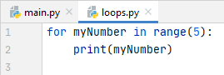

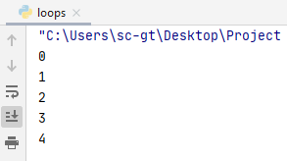

As we can see, Python has counted to 5, starting from 0, so 0-4.

The syntax is similar to if/else. The contents of the loop in Python is always tabbed in. When you untab, you are out of the loop and into the regular program.

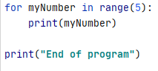
tab in
loop content

outside loop,
back to normal
program flow

loops 5 times

For loops are usually used when the range is known in advance.
We can do this for any number, here's one with 10:

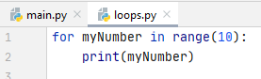

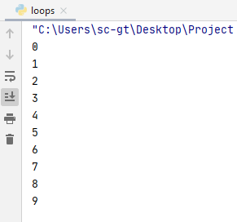

As you can see, Python starts counting at 0 and counts up to 9 (10 total)

We can also set the start of the range, in this case between 5 and 10:

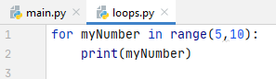

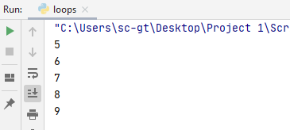

This is a tiny bit weird, as it only counts up to 9, not 10. Think of 10 as the exit value. When the program gets to 10, it stops running the loop

Increments (1 by default)

You may have noticed that by default, Python counts up in increments of 1.

You can set your own increment as follows:

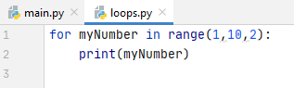

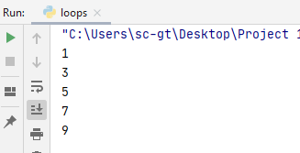
Start at 1, exit on 10, count up in 2

Counting down

It is less common, but we can also count down:

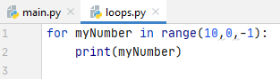

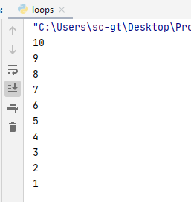

Note that the loop has exited when it reached 0

Using variables in the range
It is fine to use variables in the range for the loop. In the program below, I've asked the user to decide which number they want the program to count to:
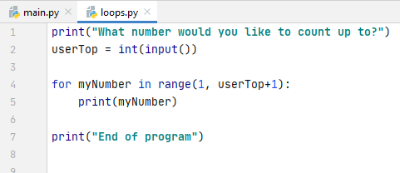
As the program will exit at userTop I've put a +1 on, as the user is expecting to see up to the number they specified (natural language vs computer language again!)

Some output examples:
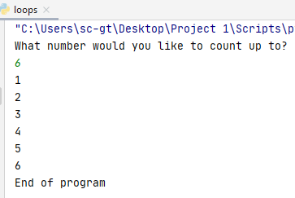
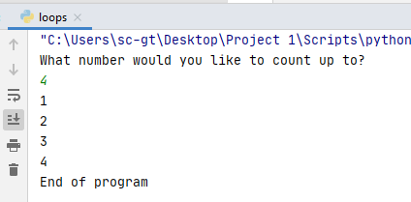

Calculations with for loops
For example if I wanted to print out the 7 times table in primary school style, I know it traditionally starts at 1 and ends at 12.

In the following example, I have done a calculation using myNumber. Remember that myNumber changes as Python moves through the range: 1, then 2, then 3 and so on.

exit at 13, so 12 will be the last
in the range

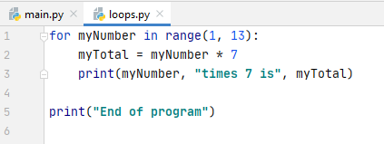
1*7, then 2*7, then 3*7
and so on up to 12*7

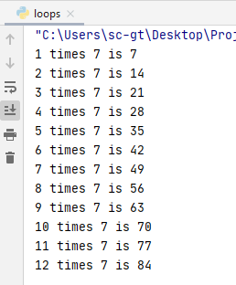

We could also extend this to allow the user to dictate the range:

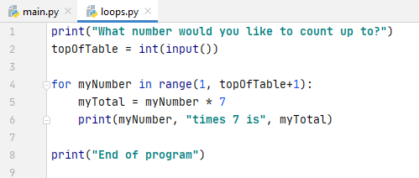

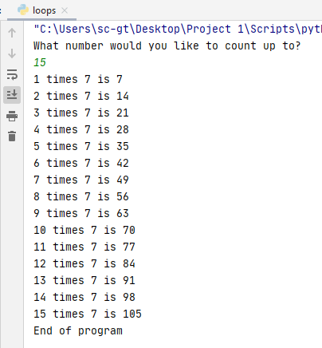

Note: Python for loops are also useful for use with Python lists (arrays in other languages). We will look at lists in a future class.

