University of Wales Trinity Saint David

Evaluating the Effectiveness of Chosen Maintenance Strategies for Dedicated Equipment

Thomas Rosser
2214462
Apprenticeship in Mechanical and Manufacturing Engineering (BEng)
7^{h} April 2025
Plant and Asset Engineering
Word Count - 2735


Table of Contents
1. Introduction 4
2. Critical Review of Current Maintenance Practices 4
2.1 Equipment Overview 4
2.2 Current Maintenance Approach 6
2.3.1 Current strengths: 8
2.3.2 Current Weaknesses: 8
3. Evaluation of Maintenance Improvements 9
3.1 Predictive Maintenance Strategy 9
3.2 Predictive Maintenance Applications for the Acid Cleaner 9
3.2.1 Sensors to implement: 9
4. Implementation Strategy 11
4.1 Sensor Installation and System Integration 11
4.1.1 Staff Training, Adoption, and Change Management 11
4.1.2 Long-Term Maintenance and System Review 12
5. Cost and Resource Considerations 12
5.1 Initial Investment and resources 12
5.1.1 Sensor costs 12
5.1.2 Installation costs 14
5.1.3 Total investment cost 14
5.2 Preventative maintenance costs 14
5.3 Payback period 15
6. Recommendations and Conclusion 15
7. References 16

Table of Illustrations/Tables
Figure 1 - Acid Cleaner 5
Figure 2 - Acid Cleaner Diagram 5
Figure 3 - Style Gauges 6
Figure 4 - Syteline Maintenance History 6
Figure 5 - Excel Booking System 7
Figure 6 - Operator Booking System Warning 7
Figure 7 - Example of monitoring display 12
Figure 8 - PH Sensor (Rs-online.com, 2020) 13
Figure 9 – Level Sensor (Rs-online.com, 2020b) 14
Figure 10 - Pressure Sensor (Rs-online.com, 2020c) 14
Figure 11 - Vibration Monitoring (Rs-online.com, 2020d) 14

1. Introduction
This report examines the current preventative maintenance approach for the Acid Cleaner on Renishaw's FSP2 production line. The Acid Cleaner is critical in ensuring that the stainless-steel ribbon is fully cleaned before being used in downstream processes that required high levels of accuracy and cleanliness.
Currently, a time-based preventative maintenance strategy is in place, supported by internal maintenance teams and digital scheduling technologies like Syteline and Microsoft Excel. To identify areas for improvement, the report assesses the constraints of the current maintenance technique and considers predictive maintenance as a more efficient option. Condition-monitoring sensors such as pH, pressure, and vibration sensors, are proposed to allow for data-driven decision-making and eliminate needless interventions.
The report also includes an implementation strategy that covers system integration, change management, personnel training, and associated expenses. This report aims to justify the transition to predictive maintenance by presenting a comparative analysis and demonstrating the long-term benefits in reliability and cost-efficiency.

2. Critical Review of Current Maintenance Practices

2.1 Equipment Overview
The Acid Cleaner (Fig.1) which is in Renishaws manufacturing site is the first and one of the most crucial components of the FSP2 (Flexible-Scale-Production-v2) process, making sure the stainless-steel ribbon is free of any contamination before being used.
FSP2 begins with blank stainless-steel ribbon which comes into the process as a 2000m ‘pancake’. The pancake is divided into 200m lots by being unwound using fixed speed DC motor. The unwound ribbon passes through pre-tension rollers and then through the Acid cleaner itself whilst being guided by rollers (Fig.2).
Within the acid cleaner there is a mixture of 20% acid and 80% fresh water being sprayed onto the ribbon through fan nozzles above and below to ensure full coverage of the ribbon. The mixture and pressure which is applied to the ribbon effectively removes and dissolves oils and contaminants on the material that may still be present from its manufacturing process. The acid mix is recirculated through a filter, maintaining efficiency and reducing chemical waste. After this stage of cleaning the ribbon travels into a separate tank which sprays 100% fresh water ensuring all residual acid is removed to prevent by-product corrosion.
Once rinsed, the ribbon is dried using mains compressed air. Before the air is blown onto the material it passes through a combination of filters to ensure the air is dry and free of contaminants preventing further contamination and corrosion defects.
Once the desired length of ribbon as been unwound onto a reel, the operator running machine cuts the new 200m lot away from the raw material pancake and places it onto a rack awaiting the next stage of production. Maintaining high cleaning standards of ribbon is essential as any contaminants could have negatives effect on sensitive/high accuracy downstream process such as coating and laser ablation.
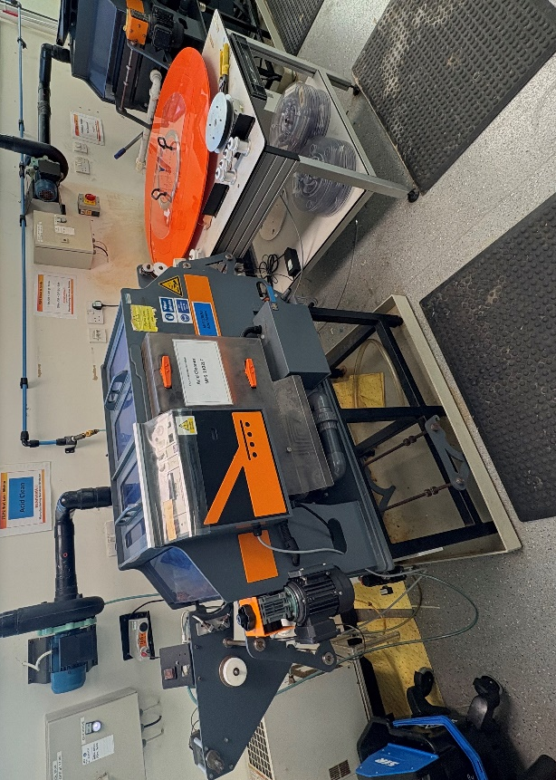
Figure 1 - Acid Cleaner
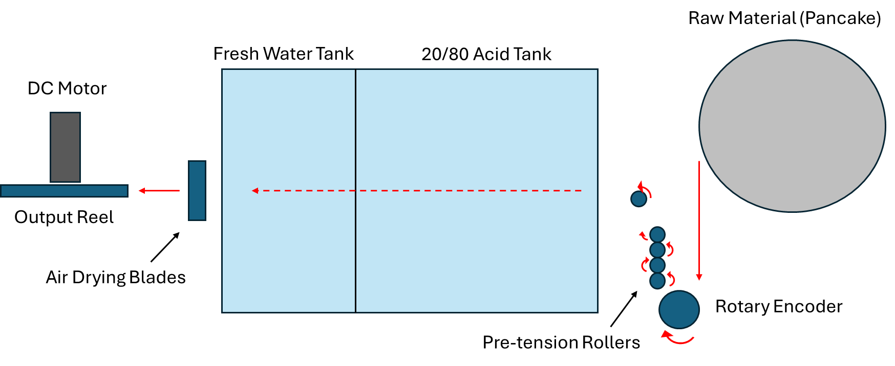
Figure 2 - Acid Cleaner Diagram

2.2 Current Maintenance Approach
The Acid cleaner has a strictly scheduled, preventative maintenance approach, to ensure the reliability of the machine and reduce unexpected breakdowns, with the maintenance tasks having specific time intervals that must be completed accordingly. All the maintenance tasks are completed by an internal maintenance team that covers the entire FSP2 process, eliminating the need for external contractors.
The preventative maintenance schedule is tracked using a companywide software ‘Syteline’. Syteline is used as a digital hub for all Renishaw operations. Each piece of equipment within Renishaw is allocated a unique gauge number which can then be searched in Syteline (Fig.3). When searched all the machine’s information and data is presented, including purchase date, owner and department but more specifically data relating to the maintenance of the machine including when its next due, when it was last completed and who completed it (Fig.4).
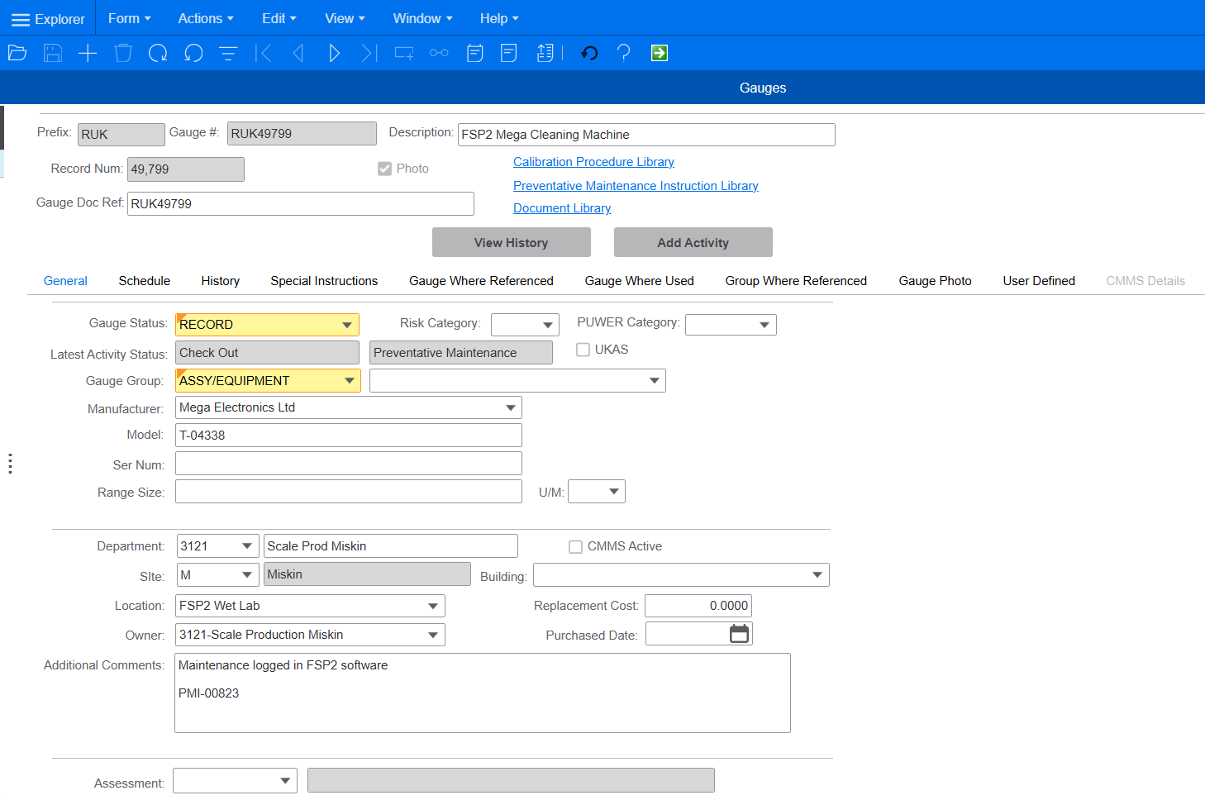
Figure 3 - Style Gauges
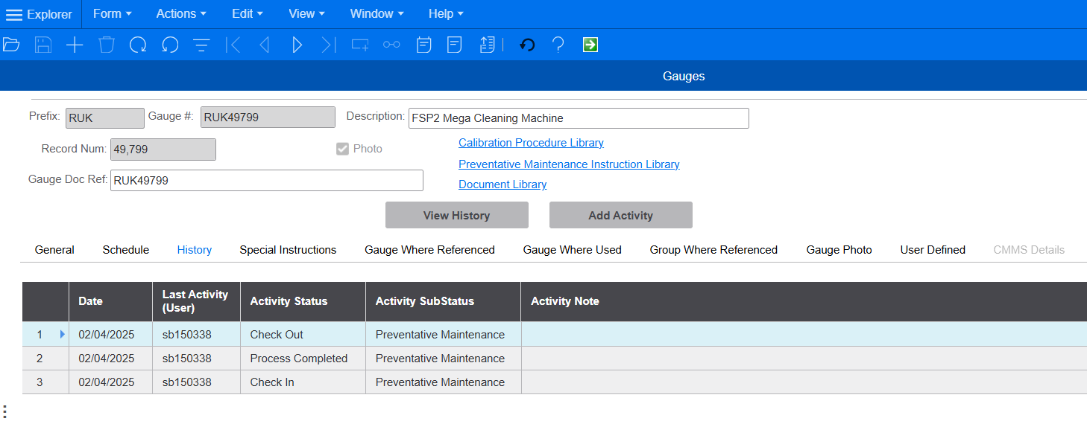
Figure 4 - Syteline Maintenance History

The maintenance team and production supervisors then use an Excel spreadsheet which brings in all the FSP2 equipment’s maintenance schedules from syteline using a query, allowing them to plan ahead and book in essential maintenances. When the maintenance is completed and booked using Syteline, it is the updated in the excel spreadsheet (Fig.5)
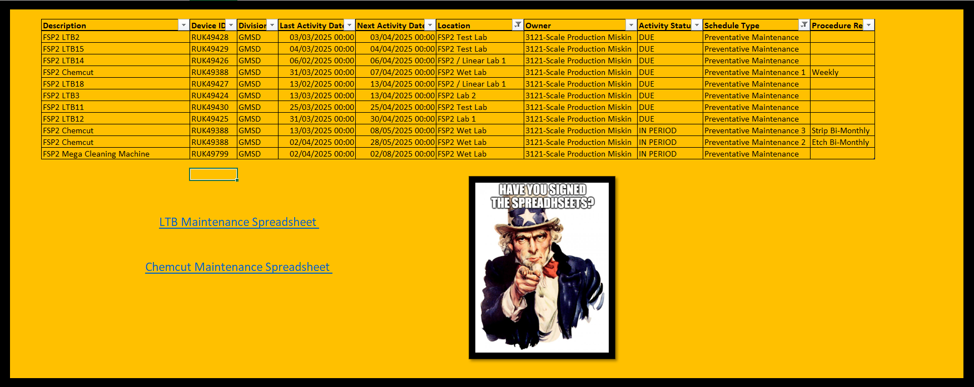
Figure 5 - Excel Booking System
The Acid cleaner is a manual process, without being linked to a computer or software. However, a booking PC is situated in a nearby room. If a maintenance is due or overdue, It will not allow the operator to continue using the software and displays a message stating that the supervisor needs to be contacted regarding a due/overdue maintenance (Fig.6)
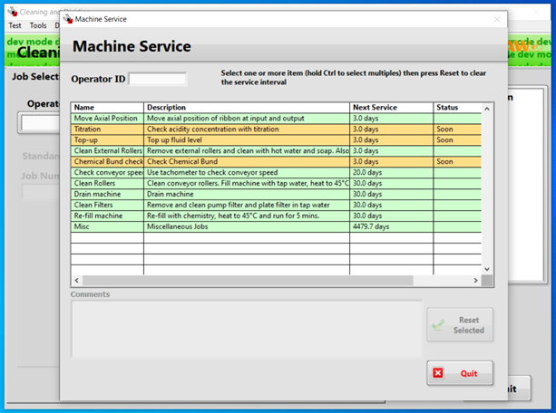
Figure 6 - Operator Booking System Warning
In the Event of an unexpected breakdown, the response time to the machine will be placed as a priority. The downtime of the machine once diagnosed depends on the severity of the issue and the availability of parts (if needed) for the repair. Common parts are kept on site, however more unique or harder to store parts may need to be ordered in.
2.3 Evaluation of Approach
The Acid cleaner’s current preventative maintenance approach ensures it remains functional and reduces breakdowns. Although, despite the advantages of the current system there are still limitations.

2.3.1 Current strengths:
The strict scheduling of preventative maintenance reduces the likelihood of unexpected breakdowns and gives opportunities to highlight possible future issues.
The Acid cleaner has an internal maintenance team so there is no reliance on external contractors. This enables faster and more efficient response to breakdowns, it also promotes better communication between other internal teams such as production management.
The digital tracking of the equipment using Syteline and Excel ensures that maintenances are completed on time and accounted for, giving a digital footprint of the history of the machine and visibility to all related to it.
The operators booking system for using the acid cleaner cannot be used if a maintenance is overdue, forcing the question of the completion of the maintenance to be raised.
Spares for common issues are kept on hand which minimises downtime when dealing with scheduled maintenance and reactive breakdowns.

2.3.2 Current Weaknesses:
As the maintenance is strictly scheduled on time, it does not account for actual machine usage. The acid cleaner is only operated when production requires it to make for demand. Meaning during low times, maintenance could be performed despite the machine being hardly used, this incurs unnecessary labour costs of the maintenance team and costs of replaceable spares.
Despite common spares being kept on hand, more major/complex breakdowns may require unique spares or harder to store spares which need to be ordered in. This can cause a stop to production, with the time for the machine to be operational again relying on the lead time of the spares.
Due to the Acid cleaner being one of the older processes it does not monitor real-time conditions which can be used to predict failures before they occur. Meaning unchecked smaller issue can go unnoticed until they cause larger, more costly and timely breakdowns.
Although the tracking using Syteline and Excel created a robust paper trail of the Acid Cleaner, the method is very heavy on manual data handling which can be quite easily upset by inputting incorrect information.

3. Evaluation of Maintenance Improvements
This Maintenance approach was implemented in 2014 when the Acid cleaner was moved to the miskin manufacturing site. There are some aspects such as the scheduling and maintenance teams that are still relevant, however modern techniques such as predictive maintenance can be explored with the aim of reducing costs and time (Matsuoka, 2017).

3.1 Predictive Maintenance Strategy
Implementing a predictive maintenance plan for the acid cleaner would involve sensors to monitor the conditions and parameters of the machine (IBM, 2023).
This predictive maintenance strategy would enable condition-based servicing. Where unlike the current method, maintenance would only be done when necessary (Fiix, 2023). Syteline would not be able to link with these predictive maintenance systems, however the operating system can be adapted to visually present the data and prevent the operator from using it if there’s a detected issue that needs to be looked at/resolved.
Predicative maintenance would significantly improve the reliability and monitoring of the acid cleaner however it would require initial investment in sensors and labour time for it to be implemented (Chan, 2023). The data presented would be familiar to the maintenance team however a small amount of training may be necessary ensure everyone is comfortable with the new system and happy to analyse the new data.

3.2 Predictive Maintenance Applications for the Acid Cleaner

3.2.1 Sensors to implement:
PH Sensor – A PH sensor is used to measure the acidity of a fluid. In this instance it could be placed in the tank and used to measure the PH of the chemical mix in the acid cleaner (WatElectronics, 2023). This would ensure the concentration of 20/80 is correct and it is not under cleaning or over etching. This sensor would allow the maintenance team to adjust the PH before the negative effects occur.
Fluid level sensor – A level sensor is used to monitor how much fluid is left in the tank (WatElectronics, 2022). Unlike the float switch currently used which stops the machine when there is insufficient fluid left to operate, this fluid level sensor can give current figures on the acid concentrate left in the tank. This data can help know when the machine is likely to need a top-up which can be actioned when the machine is in less demand.
Pressure sensors – Used to monitor pressure in a system, pressure sensors when placed correctly can be used to monitor nozzle blockage (Piping Technology System, 2024). An increase in pressure would indicate a blockage in a nozzle which can be actioned quickly before production is affected by the lack of spray from the problem nozzle.
Velocity/Acceleration sensors – These sensors can be implemented into the take up motor and pump to measure the vibrations and characteristics, this information can be used to determine when they start degrade/wear (Prielipp, 2019). For example, If the take up motor frequency starts increasing rapidly, a bearing may be starting to fail.

4. Implementation Strategy
To implement a predictive maintenance plan for the acid cleaner, the approach needs to be structured, covering all aspects like sensor integration and adaption, training and change management.

4.1 Sensor Installation and System Integration
The sensors to be fitted to the Acid cleaner may first require extra fixturing before being fitted. The PH, fluid level and pressure sensors would need to be fitted inside the machine meaning the Acid cleaner would need to be drained and adapted to occupy the sensors – the vibration analysis of the motor and pump are external and would require minimum work for fitting. Once the sensors are fitted, they require a means of power and transmitting data, this can be done via ethernet or comms caballing to a PLC (plcbasics, 2019).
This data can then be placed into a central database with a custom API (Application programming interface) to then bridge the information into the familiar operating system which can be remotely accessed by the maintenance and production teams. An example of how the information could be seen is shown below (Fig.7)
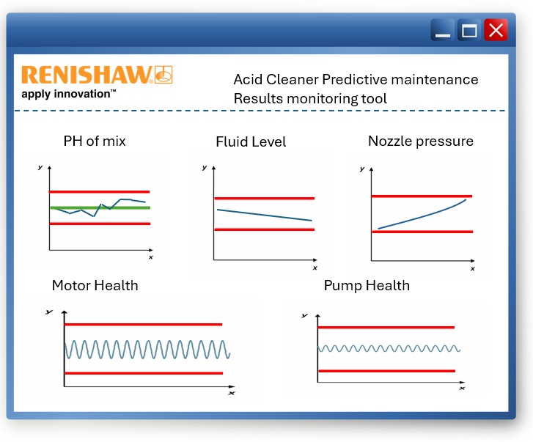
Figure 7 - Example of monitoring display

4.1.1 Staff Training, Adoption, and Change Management
The transition to predictive maintenance from strict preventative maintenance will cause a significant organisational shift. It will require careful planning ensuring that all teams adopt the new method with little to no resistance (Tiefensee, 2022).
Despite already having knowledge in the subject area the maintenance team would require training to correctly interpret the sensor data efficiently and navigate their way around the new software. The training would include data analysis techniques to help identify trends to optimise maintenance schedules. Operators and production teams would receive basic instructions on how to deal with the system and responding/reporting to alert to ensure smooth production flow.
Changes like this effect not only direct but indirect staff, from the operators to the Syteline administrators. Early engagement with all effected is essential. Clearly communicating the benefits of predictive maintenance such as optimised resource allocation and reduced downtime will help people build confidence in the system.
A phased, strong and robust implementation approach would further build trust and confidence in the new method and assure its success (TheKnowledgeAcademy, 2025). The creation of an installation plan would ensure the implementation of the sensors and system is completed on time and aligns with any related training. A commissioning document would go through thorough tests and checks of the new system ensuring that everything works and operates as it should, without this, teething issues can occur causing frustration withing the team.

4.1.2 Long-Term Maintenance and System Review
In order to make sure the new system sustains the long-term benefits it is crucial to establish a review process. Sensor performance and the maintenance schedule efficiency would be assessed at regular intervals. This review ensures the plan stays effective and aligned with production demands (Levitt, 2003).

5. Cost and Resource Considerations
An important part of any change is the cost and resource allocation related to it. Renishaws standard approach to project approvals covers points such as initial cost and resources, cost benefits and pay off period. These give the project sponsors a clear overview of whether the project is financially viable.

5.1 Initial Investment and resources

5.1.1 Sensor costs
A major cost will be the sensors themselves. The main purchasing site used within Renishaw is RS Components, this is a trusted vendor. Any other purchases need to be made by raising a purchase order requisition which can be a lengthy process.
All the sensors chosen are compatible with software integration and work within the operation conditions.

- PH Sensor (Fig.8)
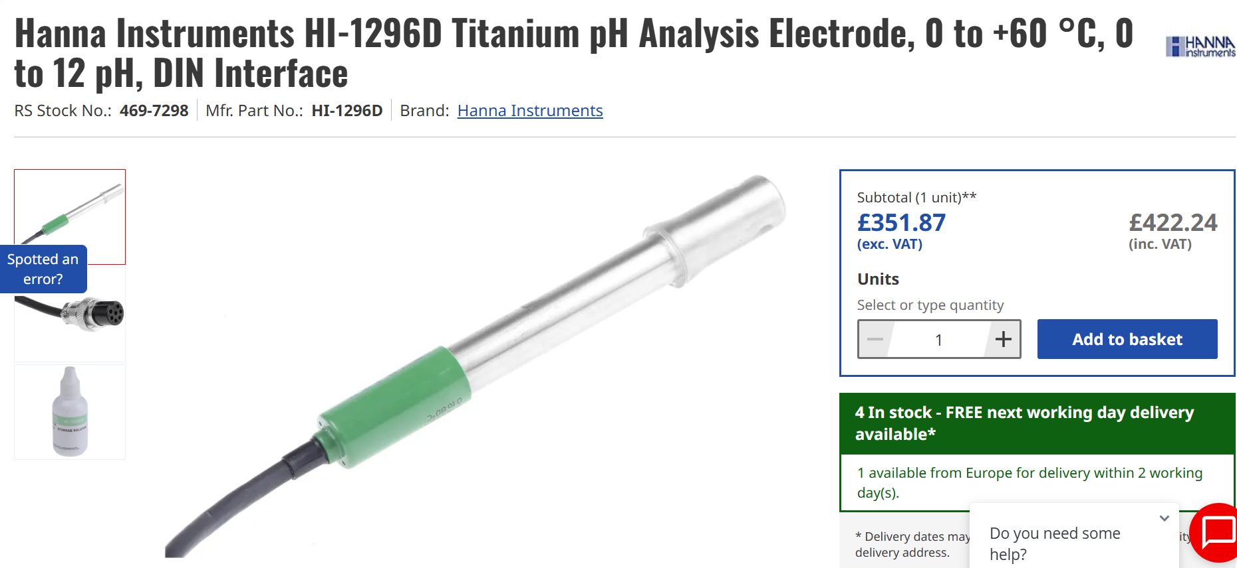
Figure 8 - PH Sensor (Rs-online.com, 2020)
- Fluid level sensor (Fig.9)
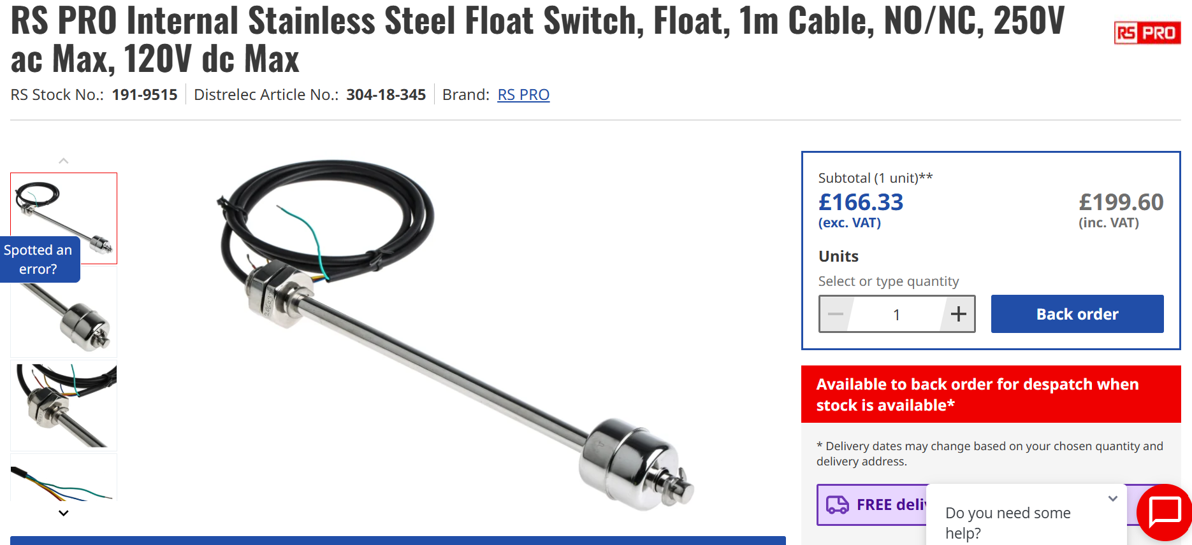
Figure 9 – Level Sensor (Rs-online.com, 2020b)
- Pressure Sensor (Fig.10)
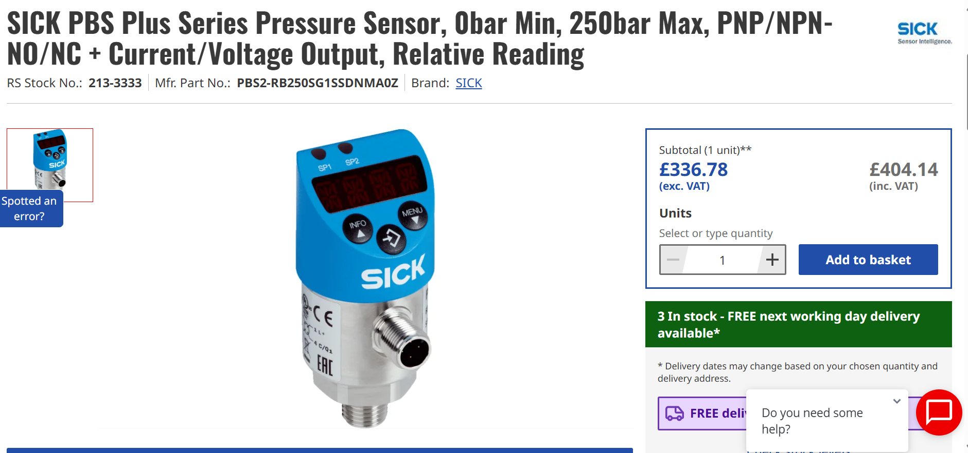
Figure 10 - Pressure Sensor (Rs-online.com, 2020c)
- Vibration analysis (Fig.11)
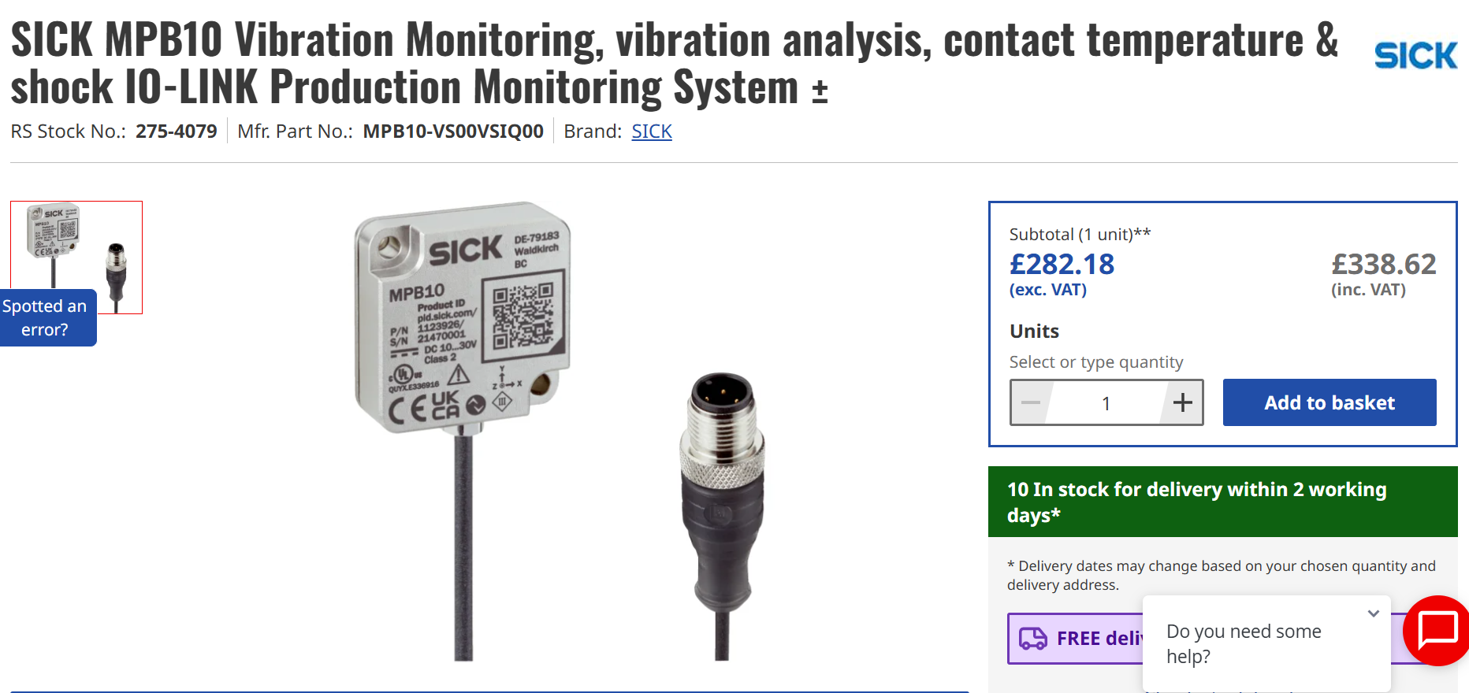
Figure 11 - Vibration Monitoring (Rs-online.com, 2020d)
All these sensors are sourced from RS Components and are compatible with the planned integration. The total costs of all five sensors totals to £1417.

5.1.2 Installation costs
To fit the sensors the maintenance team will need to be allocated time for the job to be completed to a high standard. With two members of the maintenance team fitting these sensors when production isn’t using the machine, it can be estimated that it will take around one working week, this is the equivalent of 74 hours of labour time.
Renishaw uses a standard operational cost per hour, this is stored in Syteline and is currently £75.51 (Syteline, 2025). This cost multiplied by the total time would equate to £5587.74
With the sensors now in place the software needs to be updated to analyse the information and be able to display it on the software. In discussions with the software engineer, the estimated time for this to be completed is 4 days, totalling 31 hours. At a cost of £2340
The maintenance team would require a short training session to ensure they can analyse the data correctly and know what to do when there is an issue. With the time taken to create the presentation and present it to the 6 maintenance team members this totals to £504.08
The total installation cost totals to £8431.74

5.1.3 Total investment cost
With the total cost of the sensors and the total cost of resources for the implementation, the introduction of predictive maintenance on the Acid Cleaner would cost a total of £9848.74

5.2 Preventative maintenance costs
Through the year of 2024-2025, 6 major breakdowns on the Acid Cleaner were logged totalling a downtime of three working weeks, this equates to 111 hours of downtime. The isolated cost of this down time (onward effects not calculated) totals to £8381.
With the preventative maintenance schedule in place, in the year 2024-2025 68 hours of maintenance was completed on the Acid cleaner, during highs and lows of production demand. This totals a cost of £5134.68.
Three of these preventative maintenance tasks require to change parts that may not necessarily need changing. If 50% of the time these spares do not need changing, they still total a cost of £848.
The total cost of the current preventative maintenance structure totals £14363 per annum.

5.3 Payback period
If the predictive maintenance structure was implemented, it would take a total of seven months to be paid off. This type of period would be highly commended by project sponsors and other approvers.

6. Recommendations and Conclusion
Even with its great cost benefits, getting a change of this size implemented can take a significant time whilst waiting for documents to be signed off and costs to be approved. In this time, smaller but still effective changes can be made to make a positive impact. One of these which can be implemented instantly is changing the maintenance schedule from time to throughput. Doing this would significantly reduce the time and money spent on unnecessary maintenance and spares.
The review of the Acid Cleaner's present maintenance plan reveals both operational strengths and inefficiencies, including wasteful maintenance during low-production periods and a lack of real-time monitoring. The suggested predictive maintenance system provides a modern, data-driven strategy that would cut costs, improve dependability, and reduce downtime. Despite the large initial investment, the short payback period and long-term advantages justifies the installation. Adoption is possible with a well-defined change management strategy and proper personnel training. Immediate changes, such as switching to throughput-based scheduling, may also provide benefits while the whole system is being deployed.

7. References
Chan, J. (2023). 7 Benefits of Predictive Maintenance. [online] Limble CMMS. Available at: https://limblecmms.com/blog/benefits-of-predictive-maintenance/.
Fiix (2023). What is Predictive Maintenance? [Benefits & Examples]. [online] Fiix. Available at: https://fiixsoftware.com/maintenance-strategies/predictive-maintenance/.
IBM (2023). Predictive Maintenance. [online] Ibm.com. Available at: https://www.ibm.com/think/topics/predictive-maintenance.
Levitt, J. (2003). Complete guide to preventive and predictive maintenance. New York: Industrial Press.
Matsuoka, Y. (2017). Predictive maintenance for ALL. The Proceedings of Manufacturing Systems Division Conference, 2017(0), p.103. doi:https://doi.org/10.1299/jsmemsd.2017.103.
Piping Technology System. (2024). What Is A Pressure Sensor? Pressure Sensors Working Principle - Piping Technology System. [online] Available at: https://pipingtechs.com/what-is-a-pressure-sensor/.
plcbasics (2019). PLC Basic Sensors and Input Devices – A Beginner’s Guide. [online] PLC Basics. Available at: https://basicplc.com/plc-basic-sensors-and-input-devices/.
Prielipp, L. (2019). What is a Vibration Sensor? | Types of Vibration Sensors - RealPars. [online] www.realpars.com. Available at: https://www.realpars.com/blog/vibration-sensor.
Rs-online.com. (2020a). Hanna Instruments HI-1296D Titanium pH Analysis Electrode, 0 to +60 °C, 0 to 12 pH, DIN Interface. [online] Available at: https://uk.rs-online.com/web/p/ph-probes/4697298?searchId=93d2c9bd-f7a5-44cb-bb0b-46765134df79&gb=s [Accessed 6 Apr. 2025].
Rs-online.com. (2020b). RS PRO Internal Stainless Steel Float Switch, Float, 1m Cable, NO/NC, 250V ac Max, 120V dc Max. [online] Available at: https://uk.rs-online.com/web/p/float-switches/1919515?gb=s [Accessed 6 Apr. 2025].
Rs-online.com. (2020c). SICK MPB10 Vibration Monitoring, vibration analysis, contact temperature & shock IO-LINK Production Monitoring System ±. [online] Available at: https://uk.rs-online.com/web/p/condition-monitoring/2754079?gb=s [Accessed 6 Apr. 2025].
Rs-online.com. (2020d). SICK PBS Plus Series Pressure Sensor, 0bar Min, 250bar Max, PNP/NPN-NO/NC + Current/Voltage Output, Relative Reading. [online] Available at: https://uk.rs-online.com/web/p/pressure-sensors/2133333?gb=s [Accessed 6 Apr. 2025].
Syteline. (2025). Styeline. [online] Available at: https://syteline.renishaw.form.gauges/RUK44692.com.
TheKnowledgeAcademy (2025). Importance of Change Management: Top 10 Reasons. [online] www.theknowledgeacademy.com. Available at: https://www.theknowledgeacademy.com/blog/importance-of-change-management/.
Tiefensee, N. (2022). 10 Reasons Why Change Management Is Important | Runn. [online] Runn. Available at: https://www.runn.io/blog/why-change-management-is-important.
WatElectronics (2022). Flow Sensor : Types, Interfacing, Differences & Its Applications. [online] WatElectronics.com. Available at: https://www.watelectronics.com/flow-sensor/.
WatElectronics (2023). pH Sensor : Working, Types, Pinout, Interfacing & Its Applications. [online] WatElectronics.com. Available at: https://www.watelectronics.com/ph-sensor/.

