26 May 2026
RAM20849142 (Nariman Amjad Ramadhan)

group project- individual report
Guardian Trace – Assistive Wearable Safety Device

APPENDIX GA36a
LEVEL 5 ASSESSMENT SPECIFICATION

Student name: | Nariman Ramadhan | Student ID number: | Ram20849142
Programme: | HND in Electrical and Electronic Engineering
Module: | Group project
Module code: | GOEE5000 | Contribution to Overall Module Assessment (%):
Lecturer: | Lintao Zhang | Internal Verifier: | Rabya Kadhim
Assignment Title: | group project- individual report  Guardian Trace – Assistive Wearable Safety Device | Word count (or equivalent): | 2500 words
Submission deadline: | 26/05/2026 | Return date of provisional marks & written feedback:
Submission method: | All written assessments, where practical and possible, must be submitted via Turnitin unless otherwise instructed by the Lecturer. (Please DO NOT put this assessment specification into Turnitin or it will match many similarities with other students’ submissions.)  Alternative submission method (if applicable):  Late submission of the assessment will result in a late penalty mark:  Work which is submitted up to 1 week late will be capped at 40% for the first attempt and will be awarded a mark of 0% for re-assessment. Late submission penalties may be lifted only if there is an approved extenuating circumstances claim.  Work submitted more than 1 week late will be considered as a non-submission and will not be marked. The work may be considered as a submission for reassessment if offered by an Examining Board or if there is an approved extenuating circumstances claim.
Academic honesty / referencing: | Academic honesty is required. In the main body of your submission you must give credit to authors on whose research and ideas your work is based. Append to your submission a reference list that indicates the books, articles, etc. that you have used, cited or quoted in order to complete this assessment.

Module Learning Outcomes (from module syllabus)
- Produce a detailed specification for a feedback control system.
- Write software code for, and properly document, a given control application.
- Design and document the hardware and software required for fault diagnostics, operator controls, and safe operation.

TASK DESCRIPTION

Use of Generative AI in Assessment
(Lecturer to indicate Yes or Not against each element)

RESEARCH | For this assessment, you can use Generative AI to support you in research, including searching for bibliography, using tools to summarise, compare and interrogate materials. | Yes ☐  No ☒
STRUCTURE | For this assessment, you can use Generative AI to support you in structuring your submission, including creating a draft argument structure, identifying parts and headings, etc. | Yes ☐  No ☒
PROOFREADING | For this assessment, you can use Generative AI to check your own text/creation for grammatical and syntactical mistakes, including rephrasing of your own work within specific standards. | Yes ☐  No ☒
WRITING | For this assessment, you can use Generative AI to create text for submission. | Yes ☐  No ☒
CREATIVE | For this assessment, you can use Generative AI to create creative materials, such as images. | Yes ☐  No ☒
PROGRAMING | For this assessment, you can use Generative AI to create and check code. | Yes ☐  No ☒

Contents
TASK DESCRIPTION 2
Introduction 4
Updated Research and Design Rationale 4
Design and Development Process 5
1- Initial Planning and Component Measurement 5
Diagram 6
2- Initial Cardboard Prototype Development 7
3- AutoCAD and 3D Design Process 9
Audio Design Considerations 10
Wiring Layout and Short-Circuit Prevention 10
Short circuit definition 10
Battery protection consideration 11
Final 3D design 11
Evaluation 15
Cost summary 16
Recommendations for Future Improvements 16
Reflective Journal (Gibbs’ Reflective Cycle) 17
References 18

Introduction
Guardian Trace is a wearable assistive safety device designed to improve the independence, communication, and protection of disabled and dementia users. The device combines GPS tracking, audio communication, and emergency safety features within a compact portable enclosure. The main aim of the project was to create an affordable and user-friendly prototype that could support vulnerable individuals during everyday activities while also providing reassurance to carers and family members. Existing products on the market, such as Apple AirTag and Samsung SmartTag, mainly focus on object tracking and offer limited accessibility features for disabled users (HotAirTag, 2026). Guardian Trace was developed to address this gap by combining tracking, communication, and safety functions into a single wearable system.
The Guardian Trace project was completed as a collaborative team project in which each member had specific responsibilities. Yacob Alkarim was responsible for project management and hardware development, including coordinating tasks and supporting hardware integration. Amani Mohsin focused on software development and project documentation, including collaboration planning and application research. My role was focused on 3D design and health and safety management. My responsibility was to design a practical enclosure that could securely contain all electronic components while remaining comfortable, accessible, and safe for everyday use. This involved measuring components, planning the internal layout, creating AutoCAD models, producing prototypes, and evaluating usability. I also considered several safety factors throughout the design process, including wiring organisation, short-circuit prevention, battery protection, rounded edges, and accessibility for vulnerable users.
The development process followed an iterative design approach in which multiple improvements were made between the first and final prototype. Attention was given to reducing audio feedback between the microphone and speaker, improving internal component organisation, and enhancing the reliability of the enclosure. This report discusses the research, design decisions, safety considerations, development process, final prototype evaluation, and personal reflection related to my contribution to the Guardian Trace project.

Updated Research and Design Rationale
Assistive wearable technologies have become increasingly important in supporting vulnerable individuals, particularly users with dementia, cognitive impairments, and physical disabilities. Modern tracking devices can improve user independence while also providing reassurance and safety for carers and family members. Research conducted by (Doyle et al., 2024) found that wearable GPS tracking systems can significantly improve caregiver confidence and support safer mobility for vulnerable users. Similarly (Cullen et al., 2022), highlighted that wearable monitoring technologies can assist with mobility assessment, location monitoring, and risk prevention for individuals with cognitive impairments. These findings supported the development of Guardian Trace as a wearable safety-focused assistive device.
Existing commercial products such as Apple AirTag, Tile, and Samsung SmartTag influenced the early design research for the project (HotAirTag, 2026). These devices provide reliable location tracking and compact designs; however, they are primarily intended for tracking personal belongings rather than supporting disabled users. Most existing systems focus only on tracking functionality and do not include additional accessibility or communication features. Guardian Trace was designed to address this limitation by integrating GPS tracking, audio communication, and safety-focused features into one wearable device. The project aimed to create a more accessible and user-centred solution that could support both users and carers in everyday situations.
Several important design requirements were identified during the research and planning stage. The enclosure needed to be compact, lightweight, comfortable, durable, and easy to use. Rounded edges were selected to improve comfort and reduce the risk of injury during daily use. Accessibility was also an important consideration because the device is intended for vulnerable users who may have limited mobility or cognitive difficulties. As a result, the enclosure design included a simple external structure, accessible charging access, and sufficient internal space to safely organise components and wiring.
Health and safety considerations played a major role throughout the design process. The system was designed using low-voltage components to reduce electrical hazards and improve operational safety. Attention was given to battery protection, wiring organisation, and short-circuit prevention. The rechargeable LiPo battery required careful consideration because damaged or poorly managed batteries may overheat, fail, or create fire risks. UK Government guidance on electrical energy storage systems highlights the importance of safe battery management, thermal protection, and risk reduction when using rechargeable battery technologies in electronic systems (GOV.UK, 2026). In addition, research into UK health and safety legislation and MHRA guidance demonstrated that wearable assistive technologies intended for vulnerable users must meet strict safety and reliability standards before commercial release. According to the UK Medical Devices Regulations, products intended for medical or assistive purposes must comply with safety, performance, and conformity requirements before entering the UK market. This research reinforced the importance of safety-focused design decisions throughout the development of Guardian Trace.

Design and Development Process

Initial Planning and Component Measurement
The first stage of the development process focused on understanding the physical and technical requirements of the Guardian Trace device. Before beginning the enclosure design, all major electronic components were identified and measured to determine the internal space required for assembly. The main components included the Arduino Nano, Neo-6M GPS module, MAX9814 microphone module, speaker, LiPo battery, SIM800L module, wiring, and charging port. Careful measurement of these components was essential because the project aimed to produce a compact wearable device that would remain comfortable for everyday use.
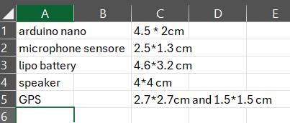
Figure 1: Component measurements of electronic hardware

During the planning stage, several design targets were established. The original aim was to create a lightweight enclosure measuring approximately 7 x 7 x 2 cm with a maximum target weight of 70 g. These requirements were based on wearable device design principles, where portability, comfort, and usability are critical factors. According to (Kim et al., 2025), wearable assistive technologies should be lightweight, ergonomic, and comfortable enough for long-term daily use. These principles strongly influenced the early planning and enclosure development process.
An important part of the planning stage involved organising the internal layout of the device. The placement of components had to support both functionality and safety while maintaining a compact structure. Space management became a significant challenge because multiple electronic components needed to fit inside a relatively small enclosure without creating overheating, wiring congestion, or accessibility issues. To address this, the internal layout was carefully planned before AutoCAD modelling began. Attention was given to battery placement, wiring routes, charging access, and the positioning of audio components.

Diagram
Figure shows the basic hardware structure of the Guardian Trace device. The Arduino Nano acted as the main controller and managed communication between the microphone, speaker, SIML800 EVB module, and battery system. The diagram was used during the design process to help plan the internal component layout, wiring organisation, and enclosure spacing before developing the final prototype.
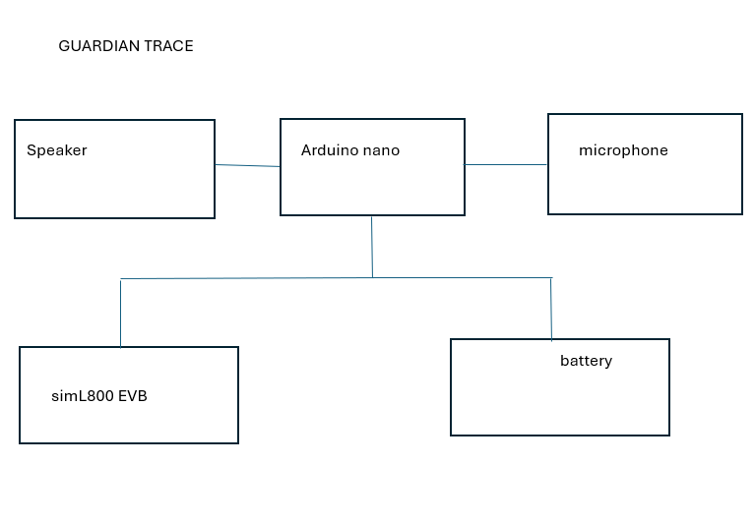
Figure 2: Guardian Trace system block diagram

Initial Cardboard Prototype Development
Before developing the digital CAD enclosure, an initial physical prototype was created using cardboard materials. The purpose of this early prototype was to explore the approximate size, shape, and internal component arrangement of the Guardian Trace device before beginning the 3D modelling process. The cardboard model allowed rapid experimentation with enclosure dimensions, component placement, and accessibility features while avoiding unnecessary material waste during the early stages of development.
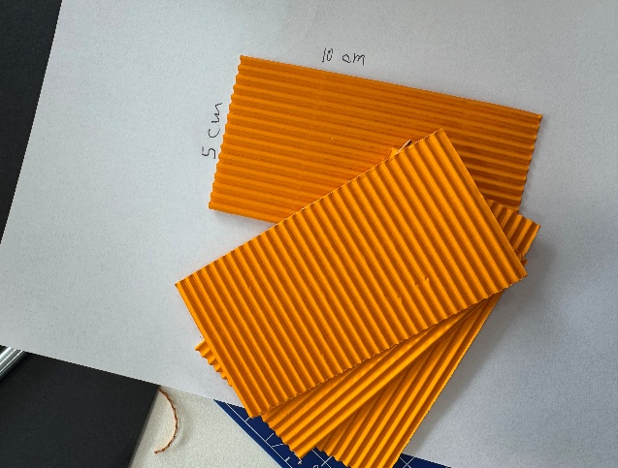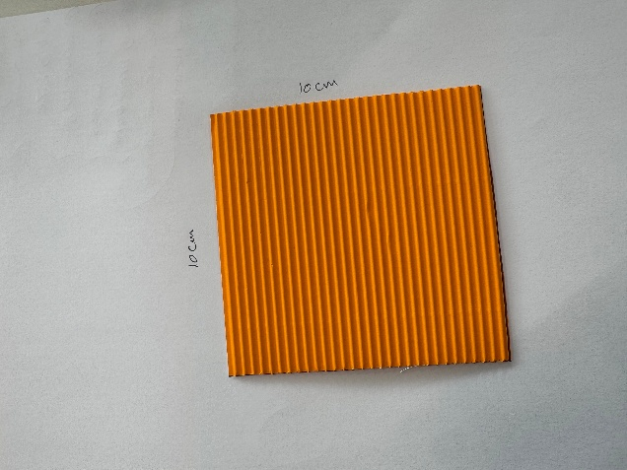
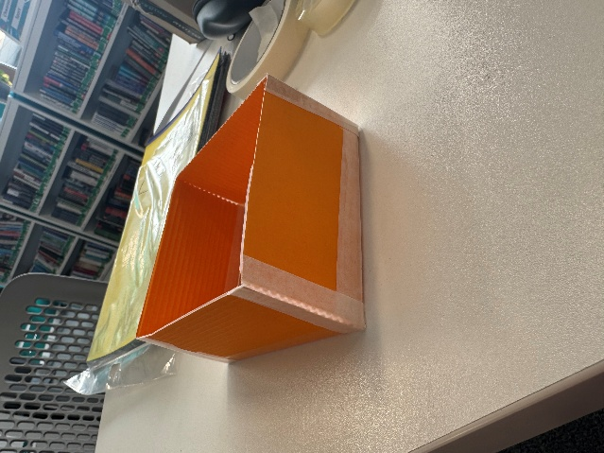
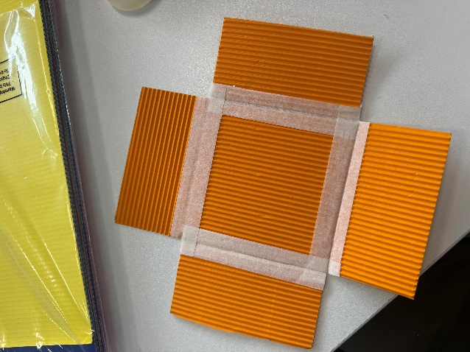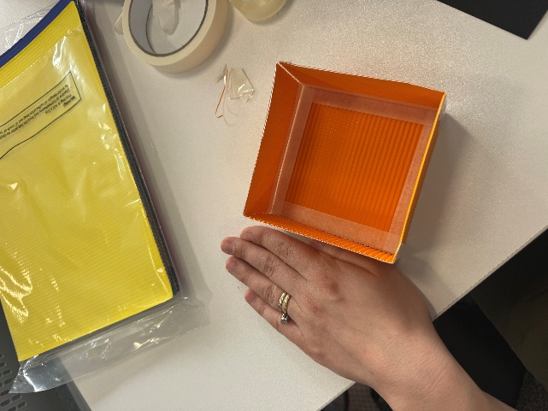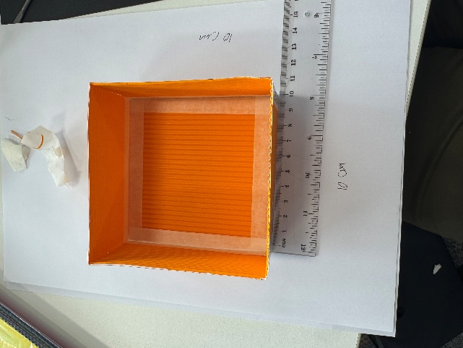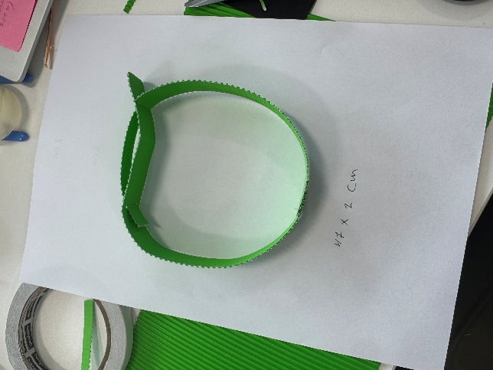
Figure 3: Initial cardboard prototype

AutoCAD and 3D Design Process
Second Prototype Development Using Fusion 360
After evaluating the cardboard prototype, a second prototype was developed using Autodesk Fusion 360. This version improved the internal component spacing and allowed a more accurate enclosure structure to be created. The CAD model helped organise the placement of the Arduino Nano, battery, GPS module, and wiring more effectively compared to the first prototype.
However, several important issues were still not fully considered at this stage. The microphone and speaker positions were not properly optimised, which later caused audio feedback problems. In addition, health and safety considerations such as wire protection, and short-circuit prevention had not yet been fully implemented in the design. Despite these limitations, the prototype provided valuable experience in CAD modelling and helped identify the improvements required for the final enclosure design.

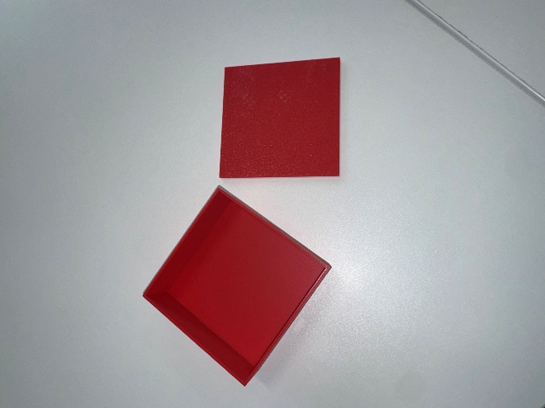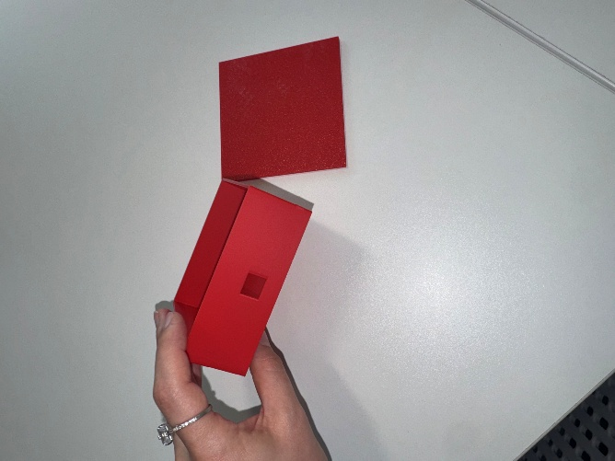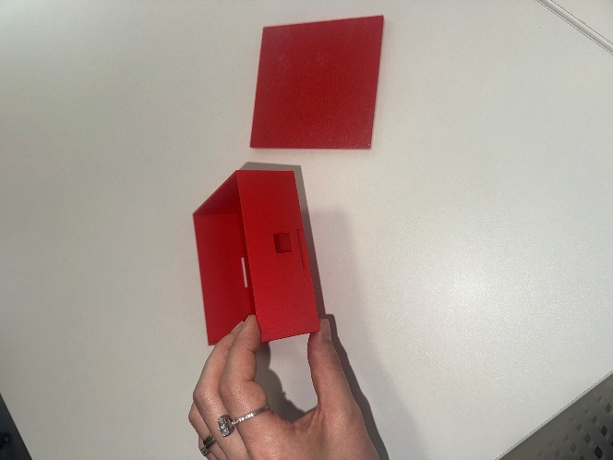Figure 4: Fusion 360 prototype

Audio Design Considerations
One of the most important technical challenges during the enclosure design process involved preventing audio feedback between the microphone and speaker system (Soundcy.com, 2025). Audio feedback occurs when sound from the speaker is directly detected by the microphone, creating echo, distortion, or continuous noise interference. This issue is particularly common in compact wearable devices because components are positioned within a limited internal space.
To minimise this issue, the microphone and speaker were positioned approximately two inches apart inside the enclosure. In addition, both components were oriented in different directions to reduce direct sound transfer between them. These design changes significantly improved audio separation and reduced the likelihood of feedback occurring during operation (Callum, 2024).
The positioning of the audio components also influenced the internal layout of the enclosure. Additional spacing had to be introduced while still maintaining safe wiring organisation and acceptable device dimensions. This required balancing audio performance with overall enclosure compactness. Through repeated prototype testing and layout adjustments, the final enclosure achieved improved audio reliability compared to the initial prototype design.

Wiring Layout and Short-Circuit Prevention
Electrical safety was a major priority throughout the development process because the device is intended for everyday use by vulnerable individuals. One of the key safety concerns involved preventing short circuits inside the enclosure.

Short circuit definition
According to (Henry, 2025) a short circuit occurs when electrical current flows through an unintended low-resistance path, potentially causing overheating, wire damage, or component failure
A short circuit creates a low-resistance path that allows too much current to flow through the circuit. This can generate heat and damage electronic components.
According to Ohm’s Law (Electricalampere, 2025), current increases when resistance decreases. I=R/V​
During the enclosure design process, wiring routes were carefully organised to reduce contact between conductive components. Internal spacing and wire positioning were planned to minimise congestion and reduce the likelihood of exposed connections touching each other. Additional internal supports were also included to stabilise components and prevent movement during operation or handling.
The system was designed using low-voltage electronics to improve operational safety and reduce electrical risks. According to the UK Electricity at Work Regulations 1989(Legislation.gov.uk, 2026), electrical systems should be designed and maintained to prevent danger and minimise the risk of injury. This guidance influenced several safety decisions during the development process, including insulation management, battery protection, and ventilation improvements.

Battery protection consideration

Battery protection was an important consideration during the development of the Guardian Trace device because the system used a rechargeable LiPo battery. According to (Maxworld, 2025), LiPo batteries can become hazardous if they are overcharged, short-circuited, overheated, or physically damaged. To reduce these risks, the enclosure was designed to provide stable battery positioning and prevent unnecessary movement inside the device. Internal spacing and wire organisation were also improved to reduce the possibility of exposed connections contacting the battery terminals.

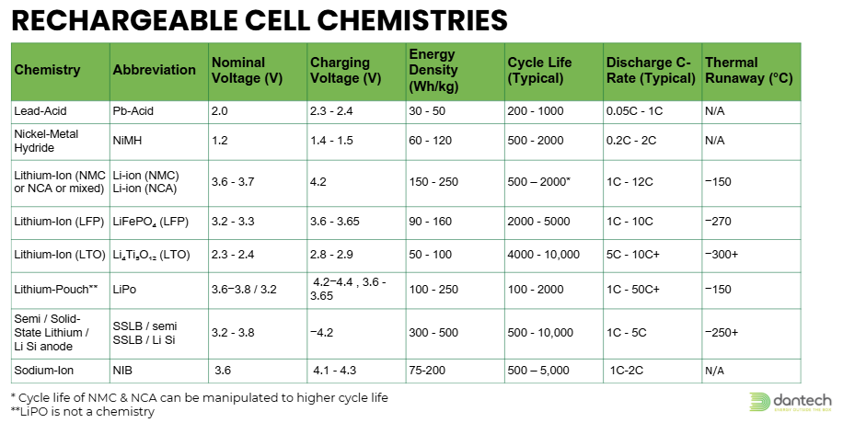
(Danenergy.com, 2025)

Final 3D design
The final Guardian Trace enclosure design was developed after evaluating the weaknesses identified in both the cardboard and Fusion 360 prototypes. Several improvements were introduced to improve safety, usability, and overall reliability. The final design included better internal component organisation, improved wire routing and stronger internal supports to secure the electronic components during use.
The final version of the Guardian Trace prototype was developed after several stages of testing, redesign, and evaluation. The purpose of the final enclosure was to provide a safer, more organised, and more practical wearable structure that could securely contain all electronic components while improving usability and reliability. The final prototype measured approximately 10 x 10 x 2.5 cm and weighed 204.3 g. Although the final design exceeded the original target size and weight, the prototype successfully demonstrated the functionality and integration of the system components.
One of the major improvements involved repositioning the microphone and speaker to reduce audio feedback and improve communication quality. The components were placed further apart and oriented in different directions to minimise direct sound transfer inside the enclosure. Health and safety considerations were also implemented more effectively during this stage, including short-circuit prevention, safer wire organisation, and improved accessibility for users.
The enclosure was designed with rounded edges to improve comfort and reduce injury risks during handling. Openings for the charging port, microphone, and speaker were also refined to improve usability and accessibility. Although the final prototype exceeded the original size and weight targets, the design successfully demonstrated a safer and more practical wearable enclosure compared to the earlier prototype versions.
According to (Semary, Al-Karawi and Abdelwahab, 2024), assistive wearable devices should prioritise accessibility, ergonomic interaction, and user-centred design principles to improve long-term usability and acceptance among vulnerable users.

Overall, the final prototype successfully demonstrated the feasibility of combining assistive tracking, communication, and safety functions into a single wearable device. Although additional improvements are required for future development, the final enclosure provided a safer, more organised, and more reliable solution compared to the earlier prototype stages.

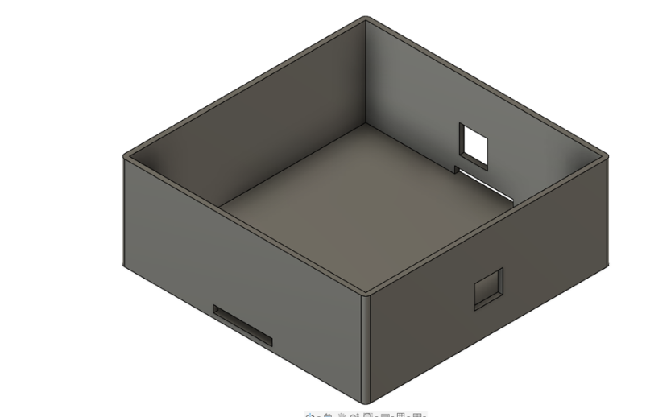
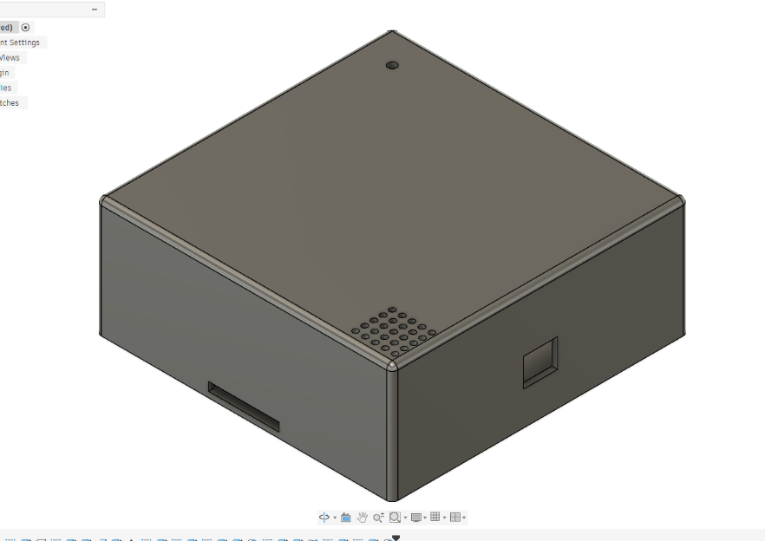
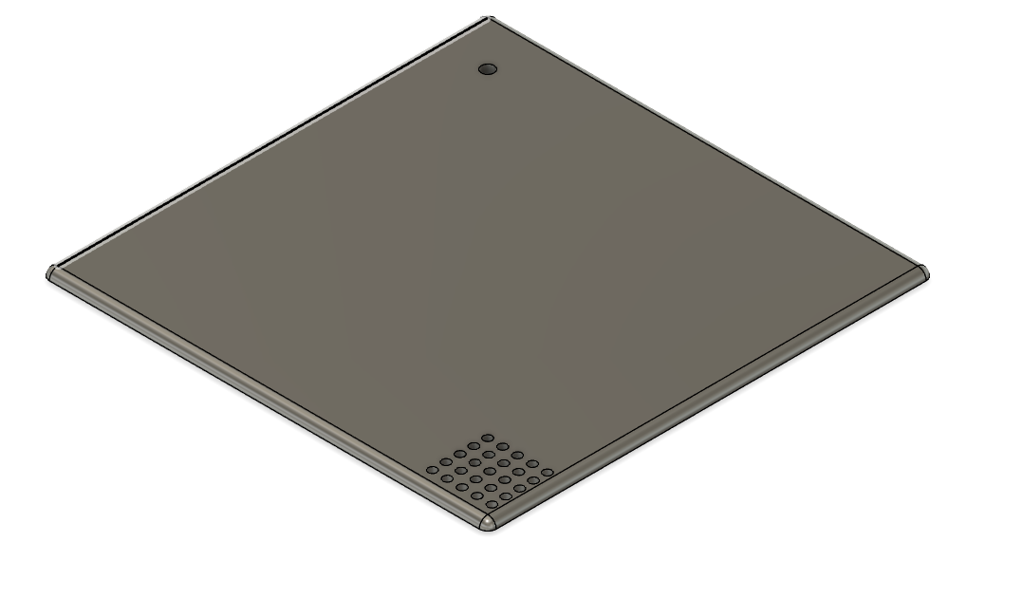
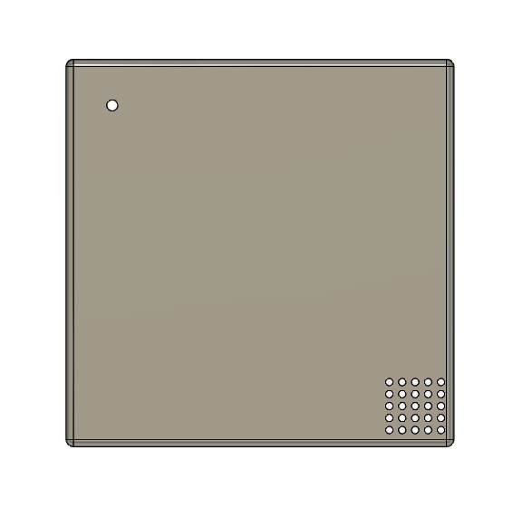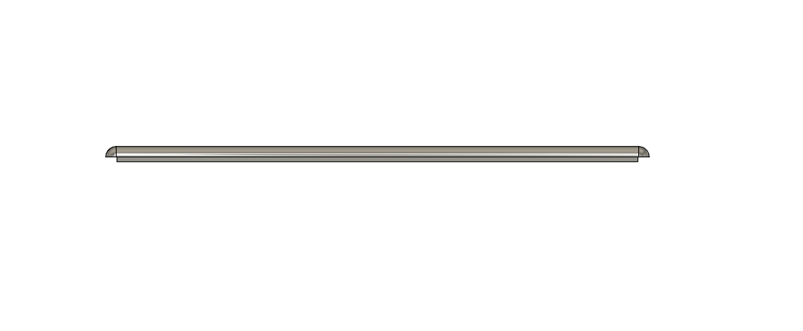
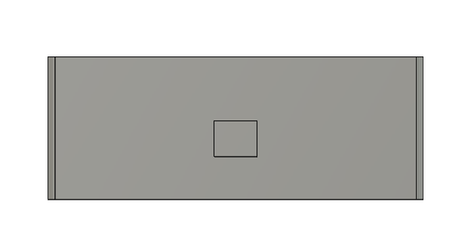

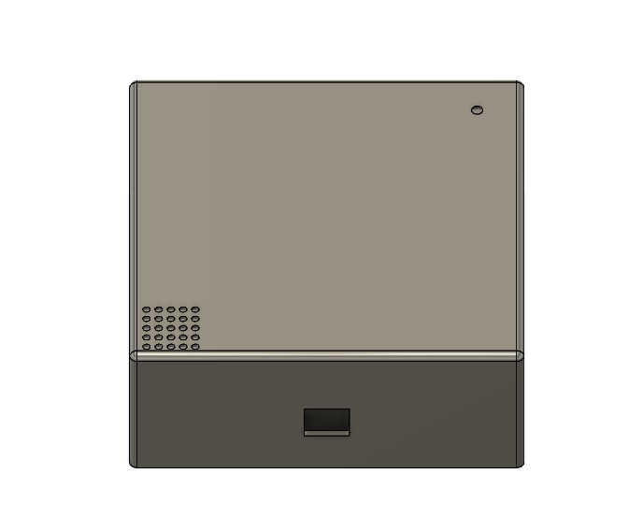
Figure 5: Final enclosure CAD design

Evaluation
The Guardian Trace project successfully demonstrated the development of a wearable assistive safety device that combined GPS tracking, audio communication, and accessibility-focused design within a single prototype. Through iterative development, several weaknesses from the earlier prototypes were identified and improved, resulting in a safer and more practical final enclosure design.
One of the main strengths of the final prototype was the improved internal layout and component organisation. Better wire routing reduced congestion and lowered the risk of short circuits, while additional ventilation helped reduce overheating risks. Increasing the spacing between the microphone and speaker also reduced audio feedback and improved communication reliability. Rounded edges, low-voltage electronics, and improved charging access further enhanced user safety and accessibility.
However, the final prototype also revealed several limitations. The device exceeded the original target size and weight, increasing from the planned 7 x 7 x 2 cm wearable design to approximately 10 x 10 x 2.5 cm and 204.3 g. This was mainly caused using breadboards, temporary wiring methods, and the limited efficiency of the internal component arrangement. As a result, the device was less compact and wearable than originally intended.
Although the prototype functioned successfully as a proof of concept, future versions would require custom PCB development, improved waterproofing, smaller integrated electronics, and further reliability testing to improve portability, durability, and long-term usability. Overall, the project demonstrated strong potential for Guardian Trace as an assistive wearable safety device while identifying important areas for future improvement.

Cost summary
An important objective of the Guardian Trace project was to develop an affordable assistive wearable prototype while remaining within the allocated project budget of approximately £100. The hardware components selected for the system were chosen based on functionality, availability, and cost efficiency. The final prototype included an Arduino Nano, Neo-6M GPS module, MAX9814 microphone module, SIM800L communication module, speaker, LiPo battery, USB charging components, and supporting wiring materials.
The Arduino Nano was selected because it provided a low-cost and compact microcontroller solution suitable for prototype development. Similarly, the Neo-6M GPS module and SIM800L module offered affordable tracking and communication capabilities without requiring expensive specialist hardware. Most of the electronic components used in the prototype were relatively inexpensive individually; however, the combined cost of all components, prototyping materials, and assembly accessories contributed significantly to the overall project expenditure.
The project also considered the future cost implications of mobile application development and commercial deployment. Earlier project planning identified that publishing applications on commercial platforms such as the Apple App Store would involve ongoing annual developer costs, while Android deployment would be more financially accessible. As a result, future software integration was initially considered more practical for Android-based systems.
Overall, the Guardian Trace prototype demonstrated that assistive wearable technologies can be developed using relatively affordable components and accessible manufacturing methods. However, future commercial versions would require investment in custom PCB development, smaller integrated electronics, improved enclosure manufacturing, and regulatory compliance testing, which would increase production costs significantly.

Recommendations for Future Improvements
One of the most important future improvements would involve reducing the overall size and weight of the device. The final prototype exceeded the original design targets due to the use of breadboards, development modules, and temporary wiring arrangements. Future versions should replace these components with a custom-designed printed circuit board (PCB), which would significantly reduce internal space requirements and improve component organisation. A smaller PCB would also improve portability and help create a more practical wearable device.
Additional improvements could also focus on waterproofing and environmental protection. The current prototype provides limited resistance to dust and accidental moisture exposure; however, future enclosure designs could incorporate rubber seals, and stronger materials to improve durability and weather resistance. This would improve reliability during everyday outdoor use.
Battery performance and power efficiency would also require further development. A more efficient power management system could improve battery life and reduce charging frequency, making the device more practical for long-term use. Future development may also include wireless charging or smaller high-capacity battery technologies to improve usability and comfort.
From a software perspective, future versions of Guardian Trace could include a dedicated mobile application with real-time GPS monitoring, emergency alerts, and communication functions for carers and family members. Although the current prototype focused primarily on hardware development and enclosure safety, software integration would significantly improve the functionality and accessibility of the system.
Finally, if the device were to be commercially developed, additional work would be required to comply with UK medical device regulations and MHRA guidance. This would involve extensive safety testing, reliability evaluation, and conformity assessment procedures to ensure the product meets healthcare and assistive technology standards before entering the market.

Reflective Journal (Gibbs’ Reflective Cycle)
Description
During the Guardian Trace project, my main responsibilities focused on the 3D enclosure design and health and safety management of the device. My role involved designing a wearable enclosure capable of securely containing all electronic components while also ensuring the device remained safe, comfortable, and practical for vulnerable users. Throughout the project, I developed CAD models, tested prototype designs, evaluated internal component layouts, and considered important safety factors such as wiring organisation, battery protection, and accessibility.
Feelings
At the beginning of the project, I felt uncertain about my ability to design a functional enclosure because I had limited experience using CAD software and developing wearable products. I was also concerned about fitting all components into a compact structure while still maintaining safety and usability. However, as the project progressed, I became more confident through repeated testing, experimentation, and feedback from team members. Seeing the enclosure gradually improve through each prototype stage increased.
Evaluation
One positive aspect of the project was the improvement achieved between each prototype stage. I successfully improved my CAD skills and understanding of safety-focused design. However, managing internal space limitations and balancing multiple design requirements remained challenging throughout the project.
Analysis
Many of the project challenges were caused by limited internal space and the use of prototype development components such as breadboards and temporary wiring. These components increased enclosure size and complicated the internal layout. In addition, balancing multiple design requirements simultaneously, including comfort, safety, accessibility, durability, and functionality, proved more difficult than expected. The experience demonstrated that successful product design requires continuous testing, planning, and refinement rather than relying on a single design attempt.
Conclusion
Overall, the project significantly improved my technical and problem-solving skills. I developed a better understanding of CAD design, prototyping, health and safety considerations, and user-centred engineering design. I also learned the importance of teamwork, communication, and iterative improvement during engineering projects.
Action Plan
In future projects, I would spend more time planning the internal component layout before beginning CAD development. I would also explore custom PCB design earlier in the process to reduce enclosure size and weight. Additionally, I would improve my CAD skills further and carry out more extensive prototype testing to improve usability, comfort, and reliability before final production.

References
Cullen, A., Mazhar, M.K.A., Smith, M.D., Lithander, F.E., Ó Breasail, M. and Henderson, E.J. (2022). Wearable and Portable GPS Solutions for Monitoring Mobility in Dementia: A Systematic Review. Sensors, 22(9), p.3336. doi: https://doi.org/10.3390/s22093336. (Accessed: 20 May 2026).
Doyle, M., Nwofe, E.S., Rooke, C., Kalyan Seelam, Porter, J. and Bishop, D. (2024). Implementing global positioning system trackers for people with dementia who are at risk of wandering. Dementia, 23(6). doi: https://doi.org/10.1177/14713012241248556.
(Accessed: 20 May 2026).
Legislation.gov.uk. (2011). The Medical Devices Regulations 2002. Available at: https://www.legislation.gov.uk/uksi/2002/618/part/I/made (Accessed: 20 May 2026).
Kim, C.Y., Lee, J., Jeong, E.Y., Jang, Y., Kim, H., Choi, B., Han, D., Oh, Y. and Jeong, J. (2025). Wireless Technologies for Wearable Electronics: A Review. Advanced Electronic Materials. doi: https://doi.org/10.1002/aelm.202400884.
(Accessed: 20 May 2026).

Semary, H.E., Al-Karawi, K.A. and Abdelwahab, M.M. (2024). Using Voice Technologies to Support Disabled People. Journal of Disability Research, 3(1). doi: https://doi.org/10.57197/jdr-2023-0063. (Accessed: 21 May 2026).

Legislation.gov.uk. (2026). The Electricity at Work Regulations 1989. Available at: https://www.legislation.gov.uk/uksi/1989/635/introduction/made?utm_source (Accessed: 22 May 2026).
Medicines (2020). Medical devices: conformity assessment and the UKCA mark. GOV.UK. Available at: https://www.gov.uk/guidance/medical-devices-conformity-assessment-and-the-ukca-mark?utm_source [Accessed 21 May 2026].
HotAirTag. (2026). AirTag 2 vs SmartTag 2: Which Tracker Wins in 2026? Available at: https://hotairtag.com/airtag-vs-smarttag/ (Accessed: 21 May 2026).
GOV.UK. (2026). Health and safety in grid scale electrical energy storage systems (accessible webpage). Available at: https://www.gov.uk/government/publications/grid-scale-electrical-energy-storage-systems-health-and-safety/health-and-safety-in-grid-scale-electrical-energy-storage-systems-accessible-webpage.
Soundcy.com. (2025). Understanding Feedback In Sound: Causes, Effects, And Solutions Explained | SoundCy. Available at: https://soundcy.com/article/what-is-feedback-in-sound (Accessed: 22 May 2026).

Callum (2024). What Is Audio Feedback and How Do I Fix It? | Gear4music.Gear4music Blog. Available at: https://www.gear4music.com/blog/audio-feedback/ (Accessed: 22 May 2026).

Henry (2025). Electrical Short Circuit: Types, Causes, and Prevention - The Engineering Knowledge. The Engineering Knowledge. Available at: https://www.theengineeringknowledge.com/electrical-short-circuit/ (Accessed: 23 May 2026).

Danenergy.com. (2025). Battery Design Explained: From Prototyping to Certification. Available at: https://www.danenergy.com/blog-posts/battery-design-explained-from-prototyping-to-certification (Accessed: 25 May 2026).
Maxworld (2025). Ultimate Guide to Lithium Polymer Battery Safety Standards in Wearable Technology - Maxworld Power. Maxworld Power. Available at: https://www.maxworldpower.com/ultimate-guide-to-lithium-polymer-battery-safety-standards-in-wearable-technology/ (Accessed: 25 May 2026).
Electricalampere (2025). Ohm’s Law – Statement, Formula, Derivation, Examples & Uses. Electrical Ampere. Available at: https://electricalampere.com/ohms-law/ (Accessed: 25 May 2026).

