

LEVEL 6

SEMESTER 1

MODULE CODE: SHSS6082
Landscape and Sustainable Recreation
aSSESSMENT TYPE: assignment
Assessment: 2

COMPONENT WEIGHTING: 50%

WORD COUNT: 2500WORDS

MODULE TUTOR: Dr Louise Emanuel

Reflective Fieldwork Journal
During this module you will visit a number of sites on fieldwork. At each site you should keep detailed notes relating to the following issues:

• Landscape Character
• Landscape Quality
• Designations
• Use
• Access
• Future Potential

These notes should subsequently be written up into a reflective and critical account of the landscape at each location, which incorporates relevant academic and policy related literature and provides suggestions sustainable approaches to recreational development at the site. Maps, sketches and photographic evidence should be used as appropriate. You should include details of two fieldwork sites in the main body of the work, and include the notes relating to the third in an appendix.

SUBMISSION DETAILS:

Submit by Turnitin on or before Friday 12th January 2018

Date feedback to be returned to student: On or before Friday 9th February 2018

School of Sport, Health & Outdoor Education

Assessment Feedback Sheet

Student No./Name: Luke Thomas-Enoch (1501041)
Module: Landscape and Sustainable Recreation
Module Code: SHSS6082

Personal Evaluation – to support your academic progress please complete the section below BEFORE submitting your work.
What do you consider to be the best aspects of this work? |  |  | The extra research I did whilst visiting these sites.
Which aspects do you consider could have been improved in this piece of work? |  |  | If I had the opportunity to do this assignment again, I would use Gibbs Reflective Cycle as I find it a more structured piece of work to follow.
What have you found most satisfying whilst undertaking this submission? |  |  | Learning about the historical aspects of the parks and the Gower.
ASSESSMENT CRITERIA | Learning  Outcomes |  | GRADE
ASSESSMENT CRITERIA |  |  | Poor  < 20% | Weak  20-29% | Unsatisfactory  30-39% |  | Satisfactory  40 – 49% | Good  50 – 59% | Very Good  60 – 69% | Excellent  70 – 84% |  | Exceptional  85– 100% | %
Your discussion of the nature of landscape within the context of the fieldwork locations | 1 |  |  |  |  |  |  |  |  |  |  |  | 20%
Your critical evaluation of external and internal influences that affect the perception, interpretation and use of landscape at the fieldwork sites. | 2 |  |  |  |  |  |  |  |  |  |  |  | 20%
Your critical discussion of the relationship between landscape and recreation and your suggestion of sustainable approaches to the interpretation and use of landscape for recreation. | 3 |  |  |  |  |  |  |  |  |  |  |  | 40%
Your identification and use of relevant academic and other material to help inform and develop your argument | 1,2,3 |  |  |  |  |  |  |  |  |  |  |  | 20%
It is expected that students will present work that is proof read, correctly referenced and adheres to the Assessment Checklist. Therefore a range of 0 – 10 marks will be deducted for non-completion of any of the points on the checklist below.
TUTOR COMMENTS:

Submission date:  via Turnitin |  | Return date:  (at least within 4 weeks) |  |  |  | Tutor: |  |  |  |  | Mark:

Assignment Checklist

- Please complete the Personal Evaluation section of the Assessment Feedback sheet, add your name and details, and paste the whole of this assignment document into the front of your assignment

- Submission is a single word file, clearly labelled with your name and module code
- Font style - Times New Roman, size -12 for text and 14 for headings
- Ink colour – black only
- Line spacing – 1.5 line spacing and 2cm- 2.5cm page margins
- Quotations more than three lines to be indented 1 line spacing
- One line space between paragraphs, paragraphs must be left aligned
- Pagination (your assignment should have page numbers)
- All tables and figures are internally referenced and have a title
- Word count checked and written at end of text (before references and any appendix)
- Assignment is within 10% of the word limit (excluding references and any appendices)
- All references in the text are included in the reference list
- Correct referencing following the Harvard style, as described in the Palgrave study skills book ‘Cite them Right’.
- Correct spelling using UK English
- Correct use of punctuation
- Grammar and syntax correct- double check anything that has a green line under it
- I have read my assignment out loud to myself and it makes sense and is easy to read
- Somebody else has read my work and it makes sense to him or her!
- I have checked and I have not plagiarised
Failure to follow these guidelines will cost you marks!
Reflective Fieldwork Journal

In this paper, I will be reflecting upon two sites I visited that use the aesthetic aspects of the landscape to bring in tourism and income to the sites and referring to a third location for comparison. The paper will be looking at the external and internal factors that I experienced when participating in these field studies. I will be reflecting on and analysing my experiences regarding the positive and negative aspects I gained from visiting these landscapes. Further research into these areas came from the use of articles, books, notes from peers and photographs.

The sites that will be looked at are Dinefwr Park which was home of a wealthy Rhys family who were descendants of the Princes of Deheubarth, whose dynasty ruled the region for over 300 years. The grounds is a large estate with a castle with woodland and a large house, Tŷ Newton, that was built in 1660 and gets its name from a mistranslation of Welsh into English when Wales started to become anglicised (National Trust, 2017). Cyfarthfa Park is the home of the Crawshay family, who were powerful iron masters of Merthyr Tydfil, William Crawshay the 2nd is famous for his passion for horticulture with his collection of exotic plants and Victorian gardens, as well as being believed to be one of the first to grow pineapples in Britain (Gross, 1980).

The third location is the Gower Heritage Centre which was established in 1990. This site educates visitors about the traditional and cultural heritage that is specific to the people of the Gower, with their mixed Welsh, West Country and Norman ancestry. The site embraces the beauty of the Gower Peninsular being located by Three Cliffs Bay as well as offering people the chance to learn bushcraft, to go climbing and walking and is based in an old mill house which is now a museum focused on rural life from the 12th century in the Gower (Gowerheritagecentre.co.uk, 2018).

All of these areas are protected either by the National Trust or government funding. They attract thousands of visitors each year which put money back into the local economy as well as helping the maintenance of the site. They all hold significant historical and cultural identity to the people who live in and around the area.
While reflecting on these field trips I will be using Schön (1983) to analyse my own performance. This is a four-stage process which includes: thinking about the situation, thinking about the situation beforehand, considering the thinking process that was used to bridge the gap between the before and after experience, and then summarising it.

This landscape matters to us because it is the setting of our daily lives. If it is ugly, we suffer. If it is beautiful, our spirits are raised. Moreover, the landscape contains the evidence of how our fathers and grandfathers, and generations before them, used the land. It is full of human history, and of nature (Ecovast, 2006).

When focusing on the concept of landscape there are many factors that come into play, such as the natural history and topography of an environment, or even artificial features that have shaped the land. Another factor when discussing landscape which is normally not discussed, are the people who live, work and breath within that landscape and how it can hold a deep philosophical attachment to the individuals (Cresswell, 2008).

Dinefwr Park

Prior to my visit to Dinefwr Park, I did an online search to see what information I could find. From this I found out that the site is famous for its history, archaeology, designed landscape, ecology, geology and buildings. A Roman fort and a medieval town have been uncovered in the park. Dinefwr has within its grounds a medieval castle that belonged to Welsh royalty and is one of Wales’ best example of an ancient wood, as well as being in the Carmarthen flood plain (Llandeilo.org, 2017). In 1990 the National Trust took over the maintenance of the site and have recognised the park as a Site of Special Scientific Interest (SSSI) and also the only parkland National Nature Reserve (NNR) (see appendix 2) in Wales (National Trust, 2017). This now gives the site protection and is also beneficial for not just the cultural heritage of Wales, but also for scientific research that looks at the biology and geology of the area (National Trust, 2017).
My visit to Dinefwr Park on the 5th of December was a very interesting and eye-opening experience, as not only was it just educational and focussing on what the sites purpose was, but it also showed me a different side to West Wales, as I normally think of the area as rural, flat farm land. However, Dinefwr had a different appearance, as the Park is nestled within the surrounding hills and forest. This image portrayed a very rural place stuck in time and there was something that was comforting to know that places like these still exist (see appendix 2).
The group was introduced to the park ranger who gave us a tour and we looked at many factors about the park, including the history, what happened to the site and future plans. One of these plans was improving upon and developing a geo car park. They showed us the car park and the damage caused to it from the Christmas fair. Below, I have done a quick sketch of what the site could hypothetically look like in the future:

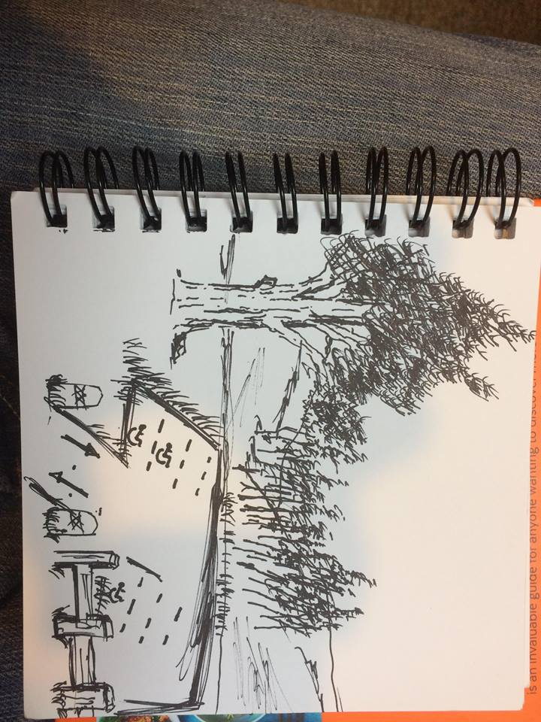

I think this would improve tourism and encourage visitors by allowing more people to visit through improved access and helping to reduce the impact of cars which cause damage to the terrain; it will also add to its aesthetic appearance.
Schön (1983) encourages us to reflect in and on action and what I gained from my visit to Dinefwr was interesting in terms of a very picturesque landscape, however I was disappointed with the quality of information available to the generable public. For example, whilst visiting the site I only came across two information posters. I found this to be very disheartening as Dinefwr has a vibrant history and factual information should be offered to the general public. If we compare this to Cyfarthfa Park and the Gower Heritage Centre, that has made an effort to inform the public as much as possible about the grounds (see appendix 1&3).

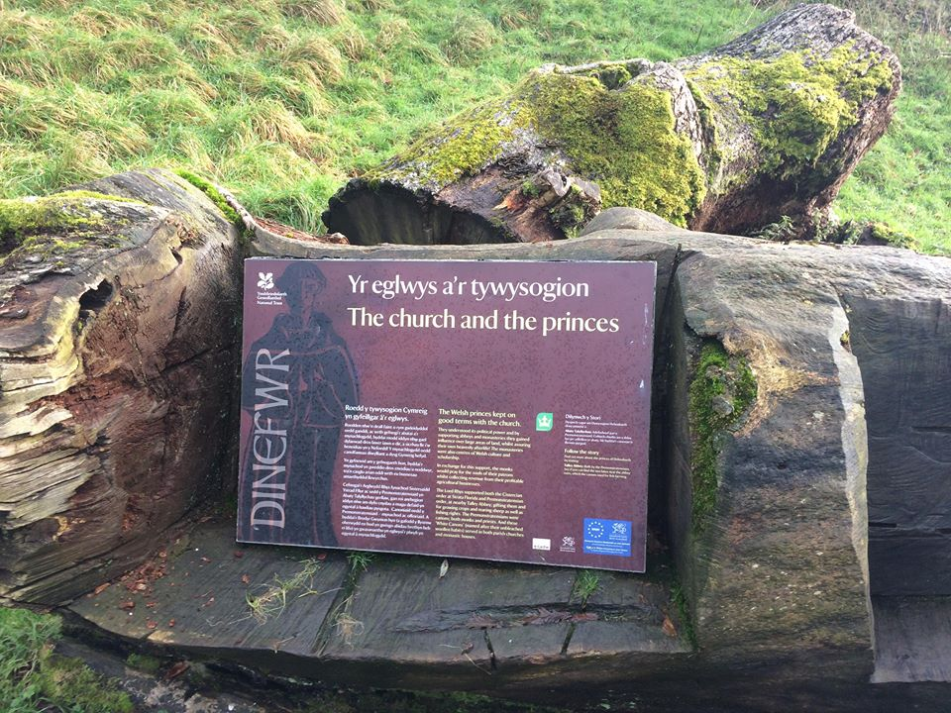

(Bilingual poster informing people historical facts).

Future developments I would suggest for Dinefwr park include refurbishing the old Butcher’s building (see appendix 2) as a café, as I believe this would be appreciated by the general public. I would develop more informational posters to educate people about the Welsh and local heritage. For example, Cyfarthfa Park has both a café and many cast iron posters about the history of the grounds which I found very useful for learning as well as being visually appealing (see appendix 3). As Somers (1997, cited in Elizabeth Bird, 2002) says that stories that are passed down are a ‘glimpse into understanding and making sense of the social world, through which we constitute our social identities’. These stories help with human interaction as a means for the individuals to come to terms with what is happening in their surrounding environment; this is what is referred to as sense of place (Elizabeth Bird, 2002). So my time spent at Dinefwr made me feel a connection with my own Welsh identity and I experienced a feeling of longing and almost sadness for my country - this is known as ‘Hiraeth’ in Welsh. I believe that the poem below best reflects my emotions that I felt within that moment:
To be born in Wales,
Not with a silver spoon in your mouth,
But, with music in your blood
And with poetry in your soul,
Is a privilege indeed.
(Harris, 1967)

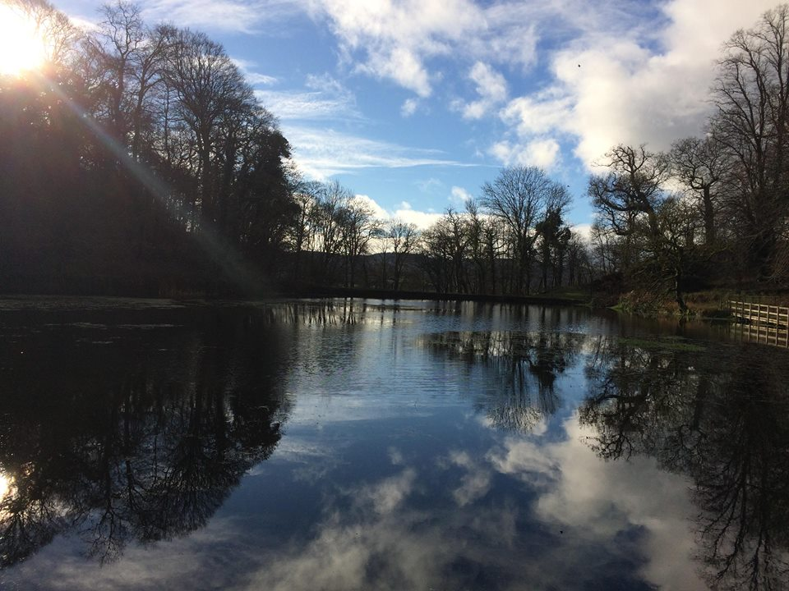
However, I can see why people flock to Dinefwr Park each year just because of its sheer beauty. The Park offers short walks, but with an almost artistic landscape, such as in the picture below.

Every so often Dinefwr opens the Tŷ Newton house for ghost tours to the public. The house is said to be one of the most haunted buildings in the country, with many of the family said to still be present there (National Trust, 2017). In many respects this is similar to the Gower Heritage site with their tours on the local folklore and the little hobbit-like people known as ‘Fairy Folk’ who are very mischievous and are said to cause many problems for people who live in the area (see appendix 4) (Myddle-earth.info, 2018). The most famous is the Gwrach y Rhibyn which is said to be like the Irish Banshee and to be an omen of death (Batcow.co.uk, 2018) (see appendix 5).

On summarising this visit to Dinefwr I believe that more development is needed for educational purposes for both tourists and the general public, as a means to inform about Welsh and local history, showing that we are a nation with its own identity, culture and heritage and as well putting money back into the maintenance of important sites.

Cyfarthyf Park
Living in Merthyr I had visited Cyfarthfa Park on a number of occasions; however, on my visit on the 20th of December 2017, I saw it in a different light. I previously used to go to the school on the left-hand side of the castle and had never thought much about the history and reason behind the park being there, until I started to do my own research. The park used to be the hunting grounds for the upper and lower classes in Merthyr Tydfil until 1824 (Visitmerthyr.co.uk, 2018). When William Crawshay the 2nd a local iron master, bought the grounds and built a castle-designed house for his family, making a public statement about how much money he was making from the natural resources that Merthyr and the surrounding valleys held deep beneath the earth (Gross, 1980).
Cyfarthfa has always been an iconic image for Merthyr town and is a source of pride for many people. It shows how a once small settlement in the Upper Taf fechan valley became a source for most of the worlds iron and coal (Gross, 1980). This personally is a source of pride to me as I was told growing up that many of my relatives moved to Merthyr just for the work and without them I would not be here today. So, I feel a great sense of connection to Cyfarthfa Castle just because of the imagery it projects about the power and wealth of the iron industry in Merthyr. Elizabeth Bird (2002) talks about people finding a sense of place from the stories passed down from generations.

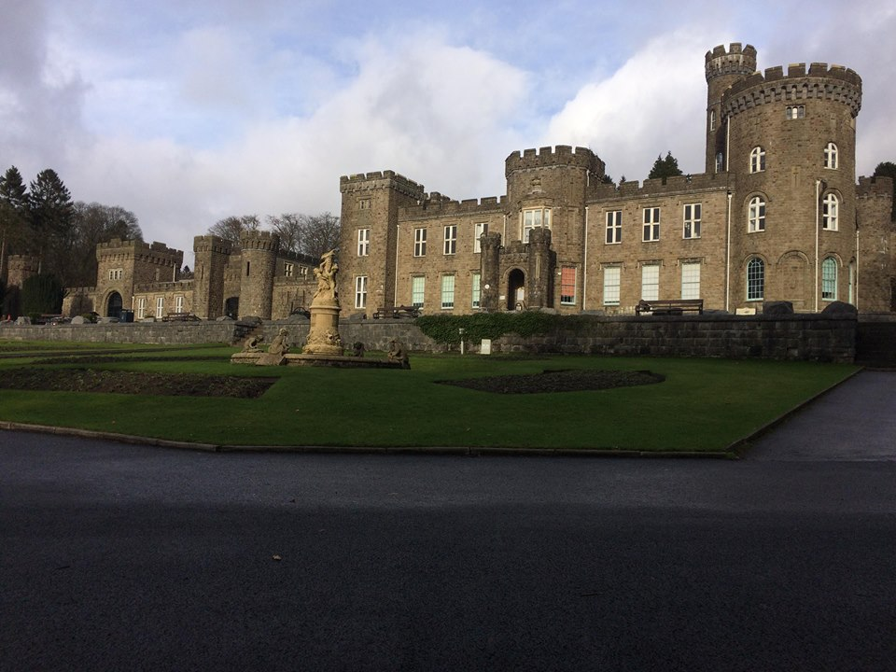

(Cyfarthfa Castle)
Although Cyfarthfa is important for tourism and contributing to the local economy, back in 1831 it gave a very different image to the people of Merthyr Tydfil, as William Crawshay the 2^{nd,} as well as other iron masters, paid their workers in currency only allowed to be used in their ‘tuck’ shops and pubs and human rights were not taken in to consideration. Dic Penderyn attempted to start a socialist revolution for the working classes of the time and it was said to be the first time in recorded history that the red flag was seen which later became the flag of the communist party (Williams, 2003).

The location of Cyfarthfa is very surprising as it is almost surrounded by the historical industrial town of Merthyr; however, just behind the Castle and towards Cefn coed y cummyr is an abundance of woodland and greenery which is a Nature Reserve and SSSI, due to the fact that it is sitting on the Central Northern Outcrop which sits on very pure, and rich in minerals, Carboniferous and Dowlais limestone which allows for a wide diversity of geology and ecology (Perkins, Evans and Gillham, 1982).

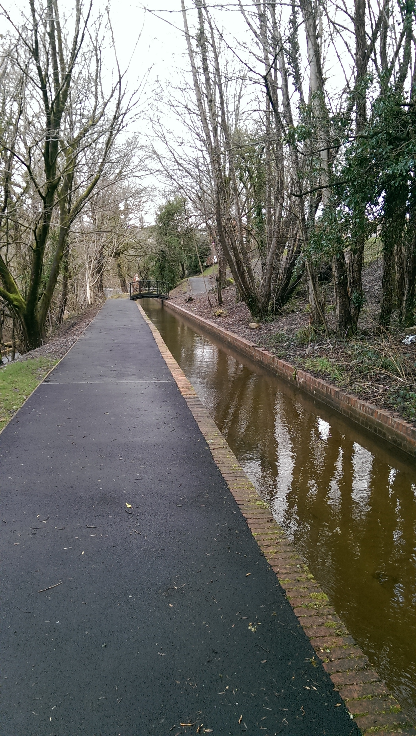

This site is, therefore, similar to Dinefwr Park as this is also a SSSI and Nature Reserve (National Trust, 2017). Due to this natural resource of green space, I believe that Cyfarthfa could develop by promoting green exercise and bushcraft for the general public and visitors. Green exercise refers to any form of physical exercise undertaken in natural environments. Green exercise is also known to provide, not just physical, but also psychological health benefits (NHS.UK, 2016). The benefits of green exercise in regard to both young and old people, occur because of the enhanced enjoyment of exercise when it takes place in the outdoors. Green spaces may also encourage greater distractibility from daily stresses allowing people to feel better about themselves and therefore boosting their self-esteem (Reed, Wood and Barton, 2013). Many young people only take part in physical education through the school curriculum; however, green exercise offers an alternative approach to physical education, as it involves self-understanding and can help people to understand their own motor abilities (Reed, et al, 2013).

Cyfarthfa could really benefit from looking at the Gower Heritage Centre and how they use bushcraft as a tool to educate visitors. It is easy to access for the local schools and would make it a more enjoyable place for parents with children and there is plenty of space and the means to introduce it. It is also good to inform and pass down knowledge of edible plants and how to survive in nature, as few people know about the beneficial properties that plants carry in this country and how there is now a revival to teach this forgotten, but once common knowledge (darkorian321, 2012) (see appendix 1).

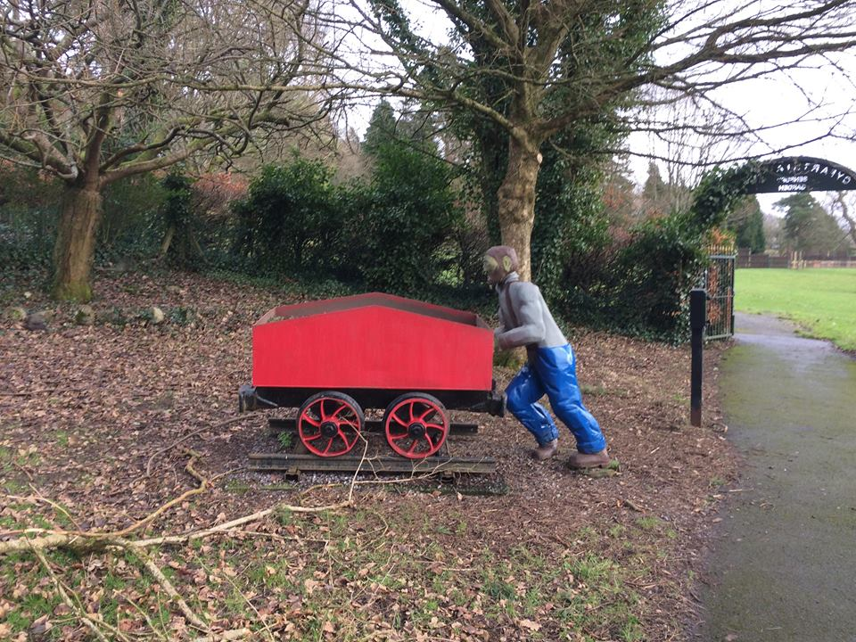
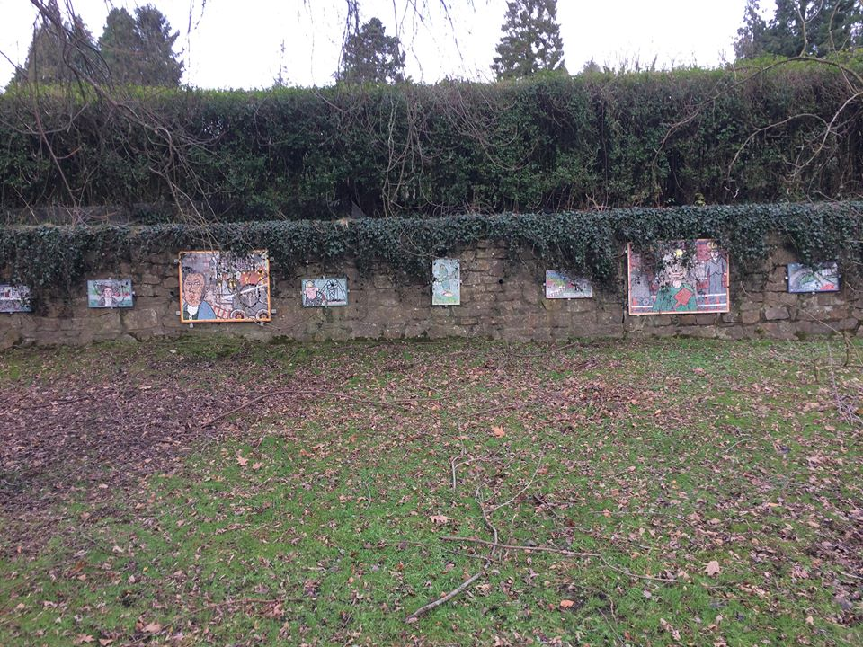
(Art work related to the industrial history of Merthyr)

As seen above, local art work was placed around Cyfarthfa Park to remind local people and tourists about Merthyr’s once booming industrial heritage. I would personally add that this was a very surreal moment for me, as growing up in Merthyr I was told all about the history of the town and to be proud of it, and how there is iron all over the world that has Merthyr’s name stamped on it. It was so nice to see how local schools and artists have come together to make this reminder of the heritage that is specific to Merthyr.
Wattchow and Brown (2011) make the point that places have no feelings apart from the human experience there; but a place is a location of experience. It evokes and organises memories, images, feelings, meanings and the work of one’s own imagination. The feeling of a place is the manifestation of one’s own mental projection of a person’s individuality. This is due to a collection of experiences that are specific to that place. Schön (1983) encourages us to make links and summarise our experiences, to help the user make a breakthrough. What I gained from my time at Dinefwr and Cyfarthfa and from my own investigation into the Gower Heritage Centre was a glimpse and an understanding into the past and what happens when the old way of life is entwined with the modern era. It made me proud of my local and Welsh Heritage, something that I usually take for granted and do not connect with often. I believe that these sites do need further development, with education, access, leisure and advertising their historical importance so as to contribute to the economy, encourage tourism and preserve our heritage.

World count; 2552

Reference list

Batcow.co.uk. (2018). Wraiths, Omens & Visitants. [online] Available at: http://www.batcow.co.uk/strangelands/wraiths.htm [Accessed 16 Jan. 2018].

Cresswell, T. (2008). Place: A short introduction. Oxford: Blackwell. Available at: http://moodle.uwtsd.ac.uk/pluginfile.php/53339/mod_resource/content/1/Cresswell%2C%20T%20%282008%29%20Place%3B%20A%20short%20introduction%2C%20chapter%202.pdf. [Accessed 11 Nov. 2017].

darkorian321 (2012). Ray Mears' Bushcraft S01E01 - Aboriginal Britain. [video] Available at: https://www.youtube.com/watch?v=Th6EOlLK0DA [Accessed 18 Jan. 2018].

Ecovast (2006). ECOVAST Landscape Identification A guide to good practice. [ebook] Available at: http://www.ecovast.org/papers/good_guid_corr_e.pdf [Accessed 1 Jan. 2018].

Faison, E. (n.d.). Seeing the Landscape in Landscape Art. [ebook] Available at: http://highstead.net/pdfs/landscape%20art.pdf [Accessed 10 Jan. 2018].

Gowerheritagecentre.co.uk. (2018). Gower Heritage Centre. [online] Available at: http://www.gowerheritagecentre.co.uk/main.htm [Accessed 3 Jan. 2018].

Gross, J. (1980). A Brief History of Merthyr Tydfil. The Starling Press LTD.

Harris, B. (1967). Origin of the 'to be born Welsh' quote. [online] Mgjohn.com. Available at: http://www.mgjohn.com/quoteorigin.htm [Accessed 10 Jan. 2018].

Llandeilo.org. (2017). Llandeilo History - Dinefwr Park - Introduction. [online] Available at: https://www.llandeilo.org/nt_intro.html [Accessed 30 Dec. 2017].

Myddle-earth.info. (2018). Pennard Castle Fairies - The Pagan Federation - Mid-West and Wales. [online] Available at: http://myddle-earth.info/pennard-castle-fairies/articles/the-fairies-of-pennard-castle-gower [Accessed 16 Jan. 2018].

National Trust. (2017). Dinefwr Park. [online] Available at: https://www.nationaltrust.org.uk/dinefwr/features/dinefwr-park [Accessed 30 Dec. 2017].

Perkins, J., Evans, J. and Gillham, M. (1982). The historic Tâf Valleys. 2nd ed. [Merthyr Tydfil]: Merthyr Tydfil and District Naturalists' Society, pp.18-20, 176
Schön, D. (1983). The Reflective Practitioner: How professionals think in action. London: Temple Smith. Available at: https://hhs.hud.ac.uk/lqsu/Sessionsforall/supp/Sch%C3%B6n%20reflection-in%20and%20-on%20action.pdf [Accessed 9 Nov. 2017].

Visitmerthyr.co.uk. (2018). Visit Merthyr: Cyfarthfa Park & Museum. [online] Available at: http://www.visitmerthyr.co.uk/attractions/cyfarthfa-park-museum.aspx [Accessed 11 Jan. 2018].
Williams, G. (2003). The Merthyr rising. Cardiff: University of Wales Press.

Wattchow, B. and Brown, M. (2011). A pedagogy of place. Clayton: Monash University Publishing.
Appendix 1

Gower Heritage Centre, Gower Peninsula, Flora & Fauna

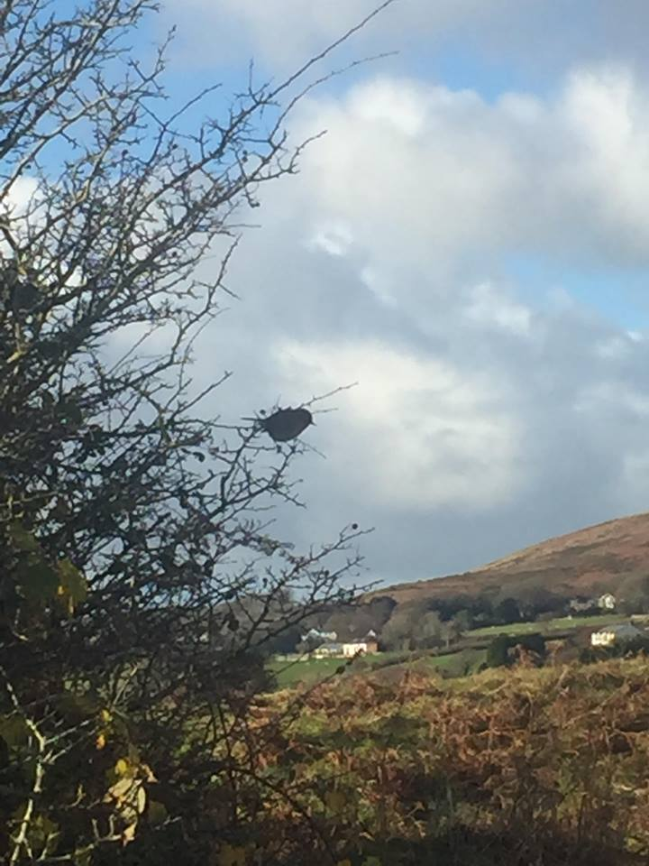
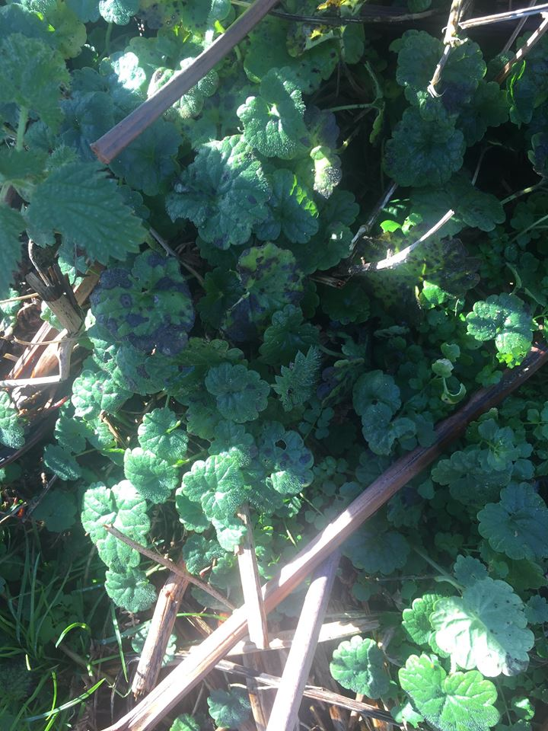

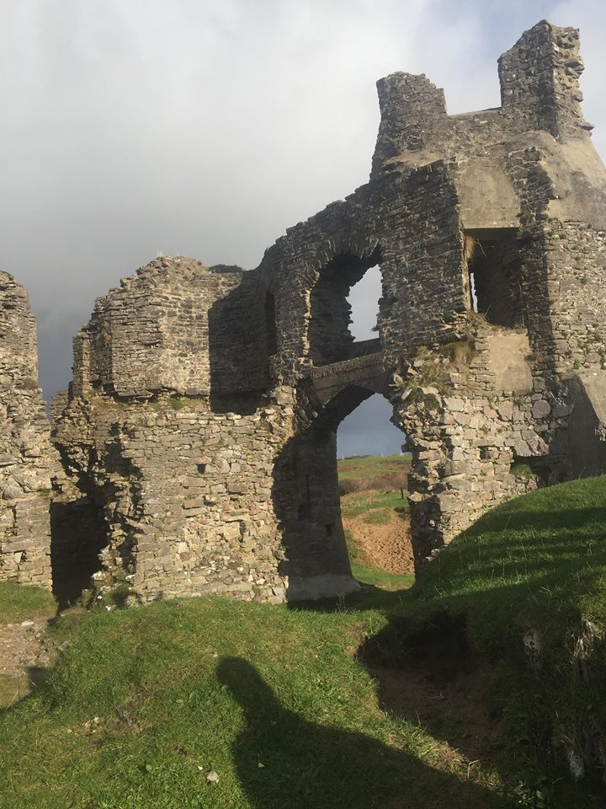
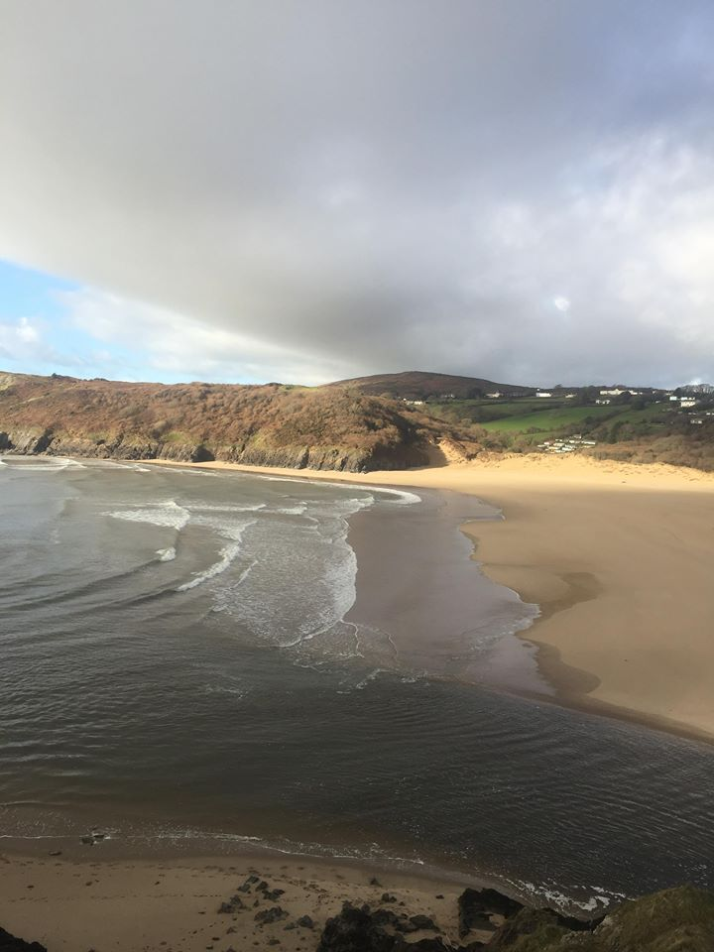

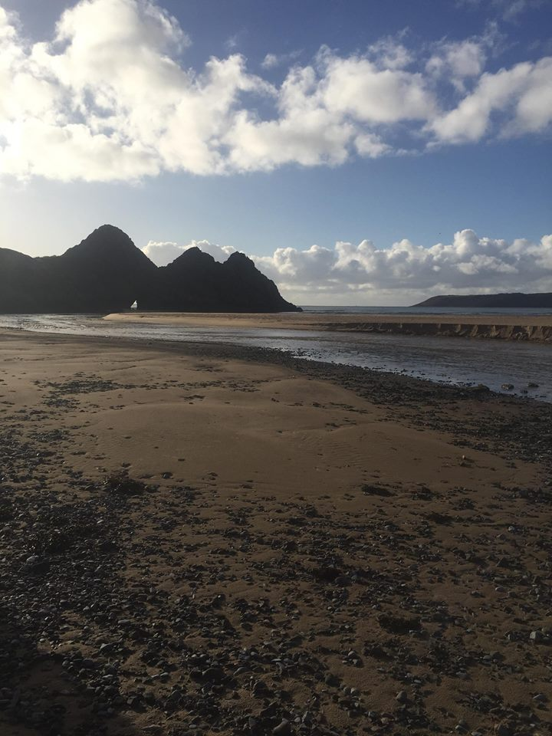

Appendix 2

Dinefwr Park & Nature Reserve

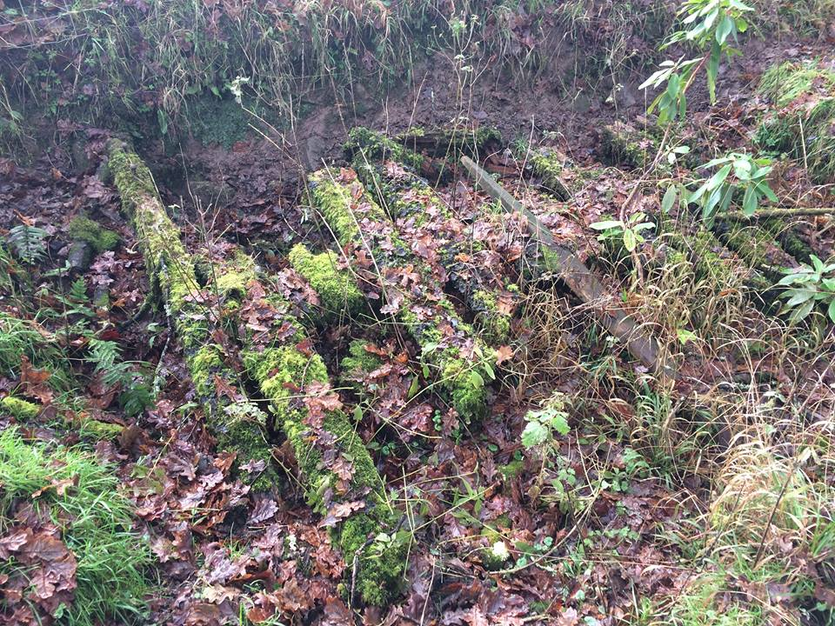
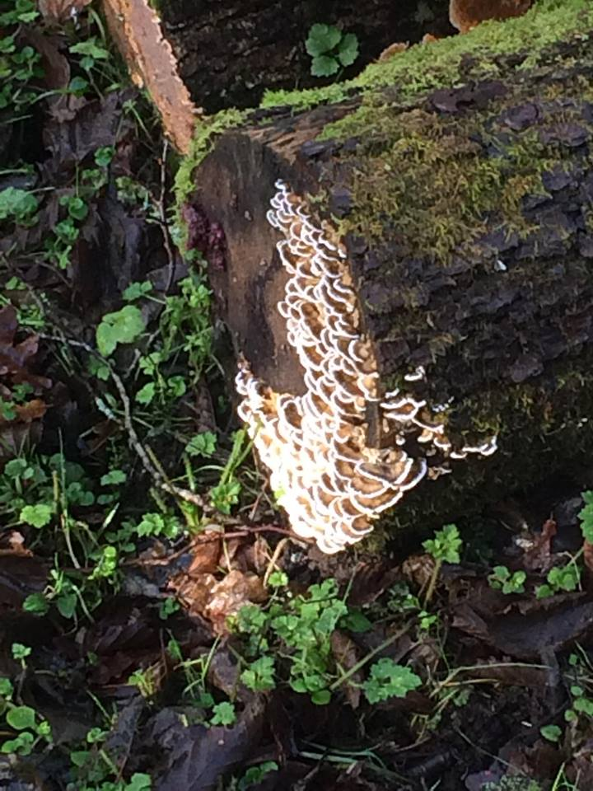

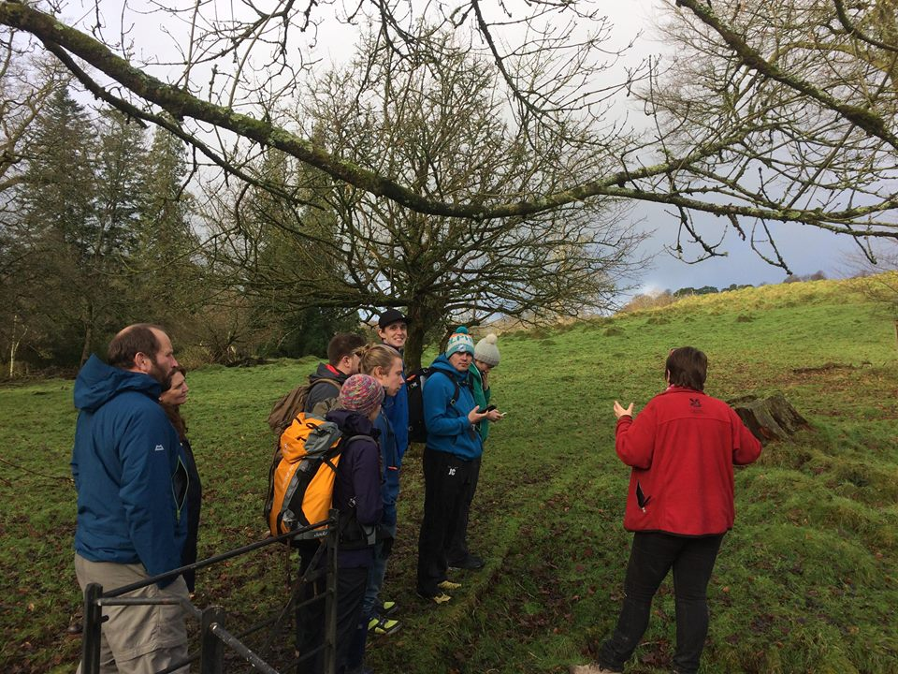
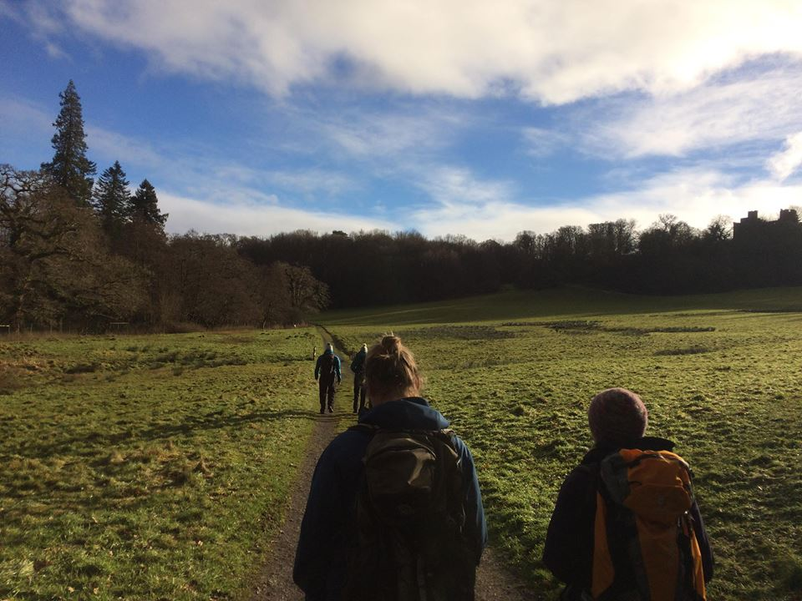

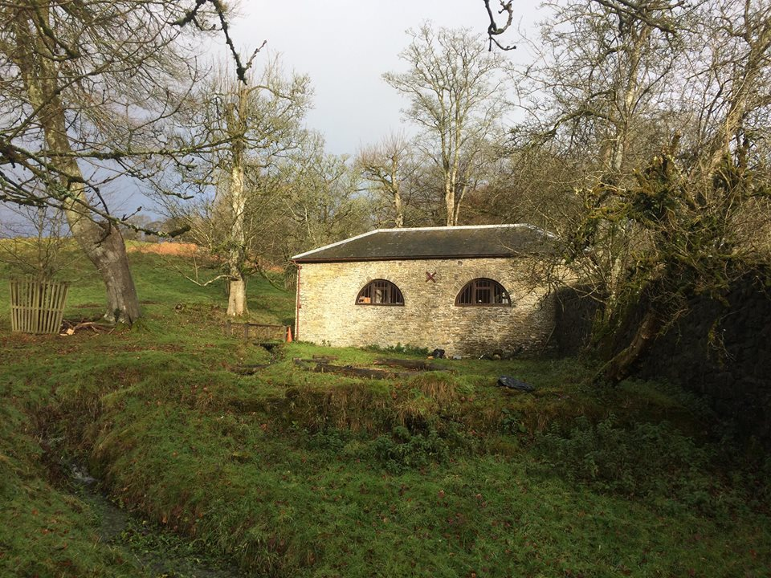
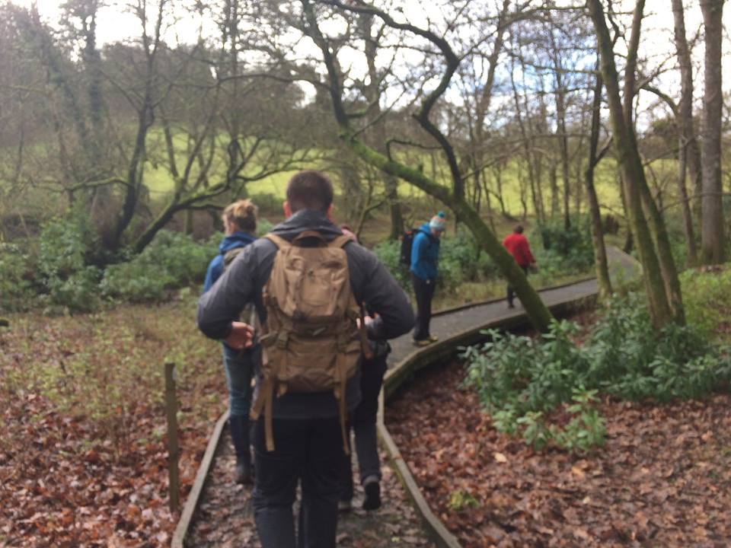

Appendix 3

Cyfarthfa Park, Informational posters and Nature Reserve

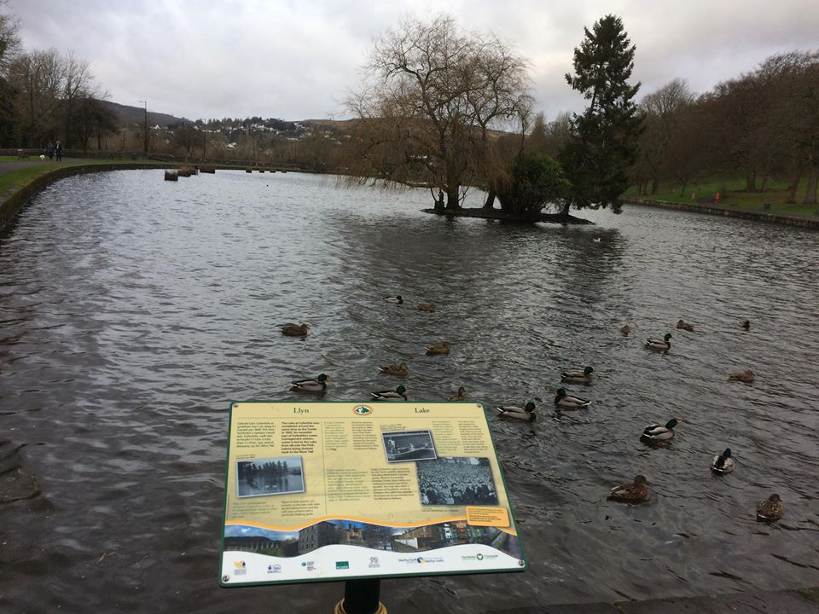

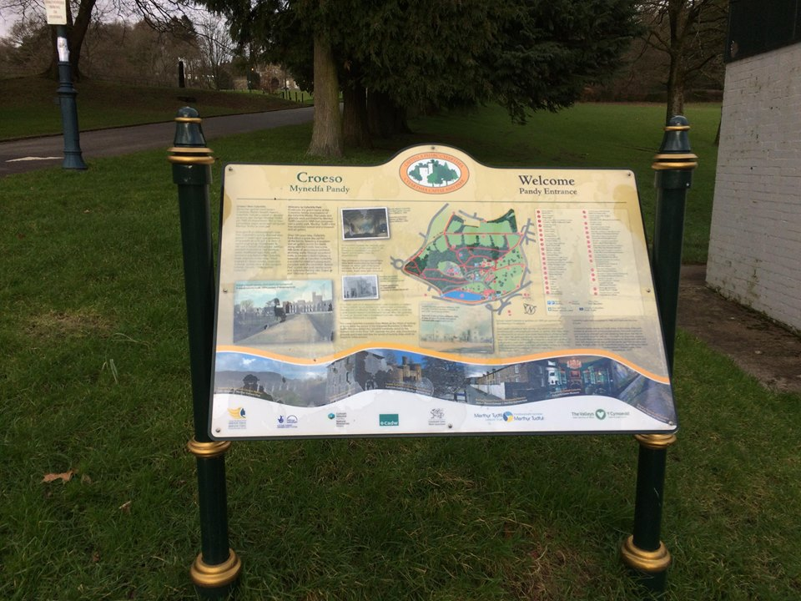

Appendix 4

Gower Heritage Centre

On the 28th November 2017 we visited Dryad Bushcraft. Due to the poor condition of the forest paths the group decided to go for walk to Three Cliffs Bay. We explored the area on the way to the beach stopping at different plants that could be eaten, or used for medicine, or even fed to livestock as they used to do many years ago during the cold months. We discussed the landscape of the area and how it was once used by the Normans and also learnt about the folk stories of the community.

We walked down to the beach looking at plants and things we could eat on the way. We discussed the folk tales and how the land used to flood and how the boats would come in for safety to the castle. We walked and climbed to the arch and talked about the plants we could eat. We scrambled to the top and walked to the castle and headed back down to the heritage site.

Facts of the place
- In spring, yellow willow grass grows within the castle grounds and it is the only place it can be found in the Gower.
- The South Gower is historically English who took it because it was better agricultural land. The North part of the Gower remained Welsh.
- The rocks are carboniferous limestone and red sand stone and over 480 million years old.

What the area is used for
- Walks
- Historical talks
- Bushcraft
- Foraging
- Climbing
- Golf course
Access
- Mixture of access
- National Trust land
- Gower Heritage have an input into path rights
- The golf course owns a lot of the land (so private land).

What can be found:
Birds
- Egret
- Robin
- Seagulls
- Starlings

Edible Plants
- Teasels
- Chanel bank
- Hairy biter cress
- Ale Hoof
- Ground ivy
- Sea bolt
- Gorse bush flowers
- Sea pursing
- Seaweed

The faery folk of the Gower

- Described as hobbit-like people. They are known as being very mischievous and have long silver hair. You cannot see them directly, but only seen from the corner of your eye.
- Gwrach-y-Rhibyn is said to be related to the Irish Banshee, which is a messenger of death.

Appendix 5

Folklore, Gwrach-y-Rhibyn



