University of Wales Trinity Saint David – London

Economic Analysis for Samsung

Assignment 1

Student name: Maria Ivanova Etova
Student number: 2030546

Module name: Management economics
Module code: LCBB5003

Lecturer: Taye Osadiya

Submission date: 09 January 2023

Table of Contents:
Title page……………………………………………………………………………………..1
Introduction…………………………………………………………………………………..3
About Samsung……………………………………………………………………………...3
Demand and Market equilibrium…………………………………………………………...3
Substitutes………………………………………………………………………………………………4
Complements…………………………………………………………………………………………..5
Customers income…………………………………………………………………………………….6
Customers’ tastes and preferences………………………………………………………………….7
Customers’ expectations of price…………………………………………………………………….7
Demographics………………………………………………………………………………………….8
Price Elasticity of Demand………………………………………………………………….9
Substitution effects: Luxury vs. Necessity…………………………………………………………..9
Income effect………………………………………………………………………………………….10
Pricing policy………………………………………………………………………………………….11
Conclusion………………………………………………………………………………….12
References………………………………………………………………………………….13

INTRODUCTION
In this report, I will do an economic analysis of a Samsung group product. The economic analysis aims to analyse the factors that directly affect the business and have an impact on its viability (Vaidya, 2022). In my work, I will analyse the demand, supply, substitutes and complements for a product and how a change in these units affects a company`s profit. The product that I chose for my report is Samsung Galaxy S 22 Ultra.
ABOUT SAMSUNG
The Samsung Group is one of the leading companies, in the world, to produce electronics. Since its inception, the company`s mission has been aimed at global development and the changing technological world. It was founded in 1938 by Lee Byung – Chull in a city called Taegu. It is one of the largest South Korean companies including several subsidiaries. Its production is approximately one–fifth of the country`s exports, and the company`s focus is on the production of electronics, heavy industry, defence, and others (Burris, 2020). Later in 1969, Samsung Electronics was founded, quickly establishing itself in the Korean market as a leader in home electrical appliances. In the 1970s and early 1080s, Samsung Electronics expanded globally and became one of the 5 largest electronics companies in the world. In 2021, Samsung significantly increase its profits, the reason for this is that the Korean technology giant reports a large increase in the sale of smartphones. Since the Samsung Galaxy S 21 Ultra launch, sales have doubled compared to the previous model. An alleged reason for this increase in sales is that this model is $200 cheaper than the previous one (Neerman, 2021). It is the predecessor of the Galaxy S22 Ultra which combines the innovation of the Galaxy S21 Ultra and the power of the Note processor.
DEMAND AND MARKET EQUILIBRIUM
When it comes to consumers, the brand awareness of Samsung is at 95% in the United Kingdom. 44% of them like the brand and 22% of respondents say they use Samsung, of which 17% say they would buy a brand product again, meaning 81% of Samsung`s customer base has brand loyalty (Kunst, 2022).

Substitutes
Samsung Galaxy is a series of Android-based smartphones marketed and manufactured by Samsung Electronics. Samsung S22 Ultra is the latest product launched by Samsung, in a short time it has become among the most preferred smartphones in the Galaxy series, the improvements and innovations in this model have placed it in the top charts for the most wanted smartphone. It is one of the best high-tech smartphones, but it has a lot of substitutes - other smartphone brands.
Substitute or substitutable goods are products and services that consumers recognise as similar or identical to another product in the market (Hayes, 2022). Substitutes play an important role in the market as they allow consumers to choose between several products. These are products that can be used for the same purpose and share a connection to the same good. This relationship can be close, such as two brands of coffee, or distant, such as tea and coffee. Goods can also be perfect and imperfect substitutes. Perfect substitutes are the same product but of a different brand, while imperfect substitutes are different products that are used for the same purpose, such as cars and bicycles.
Samsung is one of the leading companies in the sale of smartphones, it ranks second in terms of market share in the world.
According to research in 2022, in the first place is the American manufacturer Apple with 28.43% market share, followed by Samsung with 28.19%, followed by Xiaomi, Oppo, Huawei, and Vivo.

Source: www.statista.com
There are several types of Samsung Galaxy substitutes on the market, these are Xiaomi, Apple iPhone, and Google Pixel, but the main one is Apple.
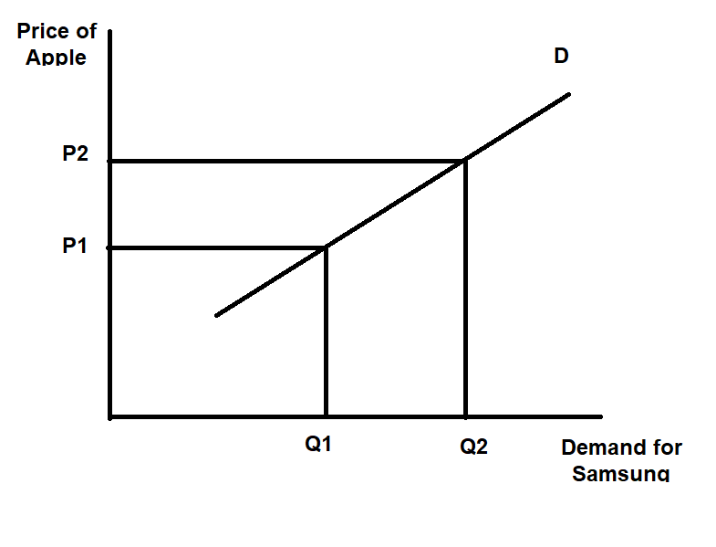
Samsung and Apple are perfect substitutes, they are almost the same products. Both brands offer models containing the latest technologies in smartphone production. They are the two main competitors in the manufacture and sale of mobile phones. Samsung Galaxy line and Apple`s iPhone are the top-ranked smartphones in terms of customer satisfaction. Globally, the two brands together have 40% of the market share (Laricchia, 2022). They are very close substitutes, they have a strong positive cross-price elasticity, therefore any change in the price of one product affects the demand for the other. This means if Apple raises its price, Samsung will register an increase in the demand for its product.
Made by: Maria Ivanova Etova

Complements
Complementary goods are products that are used together with the main product. (Boyce, 2022). They have a negative cross-elasticity of demand. This means that if the price of the primary product rises, the demand for the complimentary goods will decrease and if the price decreases, the demand for them will increase.
Samsung has several complementary goods such as cases, chargers, car stands, Android apps and many others. One of the most strongly associated with the smartphone’s complimentary products is Android applications. If the price of Samsung goes up and customers prefer Apple, it means that the demand for Android apps would also decrease.
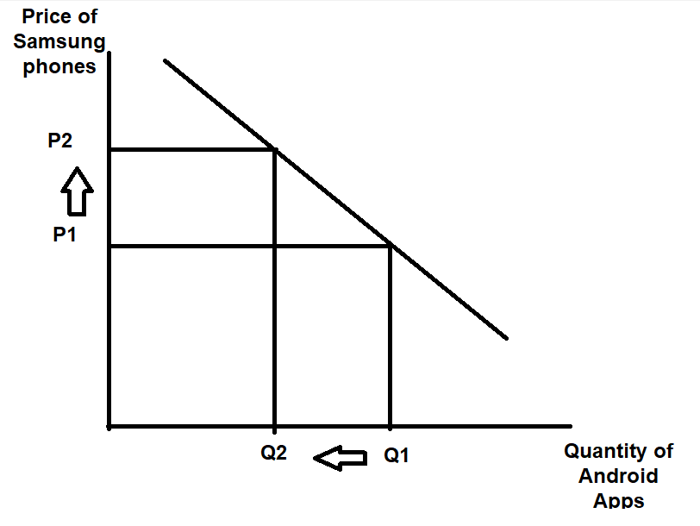
Made by: Maria Ivanova Etova

Customer income
Consumer income has a positive relationship with smartphone demand. If the users` income increases, they will have more interest in buying a new smartphone. Therefore, the demand for Samsung`s smartphones is closely related to consumer income.
Statistics report a 5% growth in 2022 in the income of people working full-time in the United Kingdom compared to 2021. The average income for 2022 is £33,000 (Clark, 2022). However, there is a difference in the standard of living of people, therefore Samsung smartphones can be seen as a luxury or as a normal good depending on the income of a given household. People with high incomes tend to see the brand as a normal good, while those with lower incomes consider it a luxury.
Smartphone market leaders Apple and Samsung are also the most used brands among the more affluent in the United Kingdom. However, many lower-income households prefer their substitutes with lower prices.
Customer taste and preferences
When UK consumers choose a new smartphone, they pay particular attention to factors such as design, brand influence in the market, innovation, price and many others.
A survey shows that 90% of adults in the United Kingdom use smartphones (Dsouza, 2022). Six in ten consumers say battery life is very important to them when choosing a new smartphone, and a third pay particular attention to charging time. For this reason, some manufacturers offer fast charging.
Although the smartphone market is huge, the competition is also very high, but globally the two most preferred brands are Apple and Samsung. The new Samsung S22 Ultra is among the most preferred and innovative smartphones on the market. It combines the vision of the Galaxy S series and the power of the Note series. It is the first model of the Galaxy S series that has a built-in S Pen, which gives customers the ability to sketch and take notes on their smartphones. This smartphone has an AMOLED 2X display that prevents glare. There is also a significant improvement in battery life. The artificial intelligence uses an average of 5,000 mAh of charge per day and can also predict when to enter battery-saving mode. It also has a charger for fast charging and has the function to charge other phones as well. Another very important advantage is that this Samsung model is reinforced and significantly more impact resistant than its competitors. Samsung offers its customers the opportunity to take even better and more professional photos with its wide-angle 108 megapixels wide-angle camera, while that of Apple is 48 megapixels.
Customer expectation of price
Many customers expect the price of smartphones to go down, but contrary to expectations, prices will rise due to new technologies coming in daily. Smartphone manufacturers are putting more and more funds into the development and improvement of their products, for example, more powerful processors, 5G networks, improvements in cameras and many other features. The price of the Samsung Galaxy S22 Ultra is approximately US $ 1,140. The new Galaxy S23 Ultra is expected to be priced slightly higher than its predecessor the S22 Ultra, due to higher production costs (Taylor, 2023).
Despite the increase in Samsung`s prices the demand for their products would not drastically decrease, thanks to customer loyalty. Also, most smartphone users want a high-tech device because nowadays a large number of people work through their smartphones.
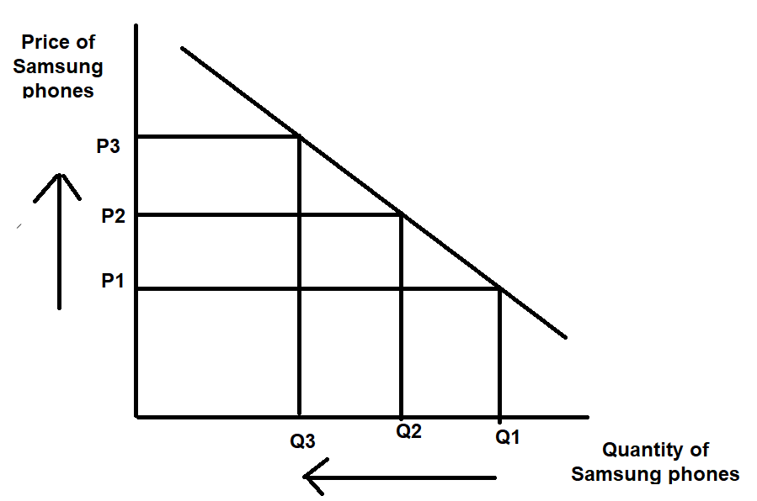
Made by: Maria Ivanova Etova

Demographics
Samsung is one of the leading companies selling mobile phones. It ranks in the top five most preferred brands in the world. According to a survey in the United Kingdom, 22% of respondents believe that from 2017 to today Samsung has significantly improved its ratings and the quality of the smartphones they produce (Kunst, 2019). Also, the percentage of Samsung users in the United Kingdom has increased over the past five years and is trending to keep growing. A big part of their customers is loyal to the brand and would not prefer another one. In 2019 Samsung users were 30.47% of all people that use smartphones, and 79.2 million units were sold, while Apple users were 26.37% and 44.8 million units were sold (Jay, 2022).
PRICE ELASTICITY OF DEMAND
Price elasticity of demand is the ratio of the percentage change in quantity demanded of a product to the percentage change in price.
Substitution effects: Luxury vs. Necessity
Luxury goods are not necessary for consumers` lives nor are they used daily, but they are highly preferred when there is an increase in consumer income. Therefore, they have a positive relationship with consumer income, when income increases their demand also increases (Kenton, 2021)
Normal goods or necessity goods are products or services that have a direct relationship with the income of the population. When there is an increase in income or a positive change in the economic condition of the country, their demand increase (Team, 2022).
In the beginning, smartphones slowly entered society and at first, they were considered luxury items used as an accessory. However, nowadays smartphones are considered normal goods and considered as necessary as food and clothing (Observer, 2020). For this reason, Samsung cannot be classified as luxury goods, but rather as normal.
Since Samsung operates in a highly competitive market, price elasticity of demand is observed. Although it has a lot of loyal customers, for the majority of auditory the price is of primary importance. If Samsung increases the price of its products, the company will suffer a drop in its demand, as customers would turn to a similar product with a lower price from competing brands such as Apple, Nokia, LG and others. For this reason, Samsung strives to offer its customers similar prices to competing companies. Despite the competitive market, it is one of the leading smartphone brands and has a large number of loyal customers who would continue to use the brand no matter the price. The brand has a strong reputation and recognition in the market, which is why Samsung strives to produce high-tech smartphones to remain among the most preferred brands in the world and to be able to increase the loyalty of its customers.

Income effect
The income effect on demand is the change in consumer needs and demand because of changes in disposable income (Team, 2022).
Disposable income is the money that people have available to spend for goods or services or savings. Changes in income can be positive or negative. For example, positive changes are observed with an increase in salary and negative changes with a decrease. Consumer income is key to consumer demand, and the relationship between the two can be direct and inverse (EconomicsOnline, 2020). In normal goods any changes in income have an effect, when income increases, their demand also increases, while in inferior good when the income of consumer increase, their demand decreases.
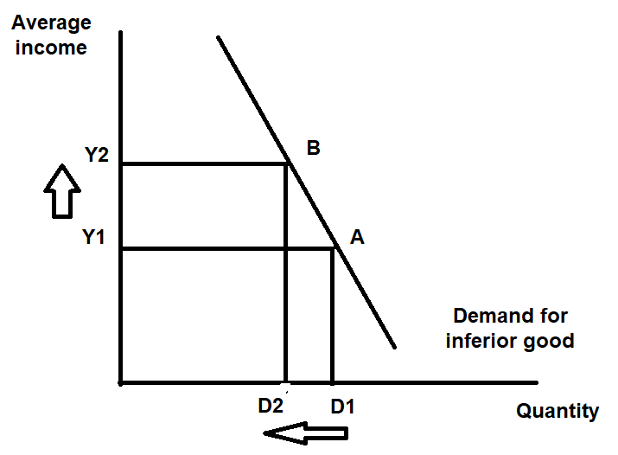
Made by: Maria Ivanova Etova
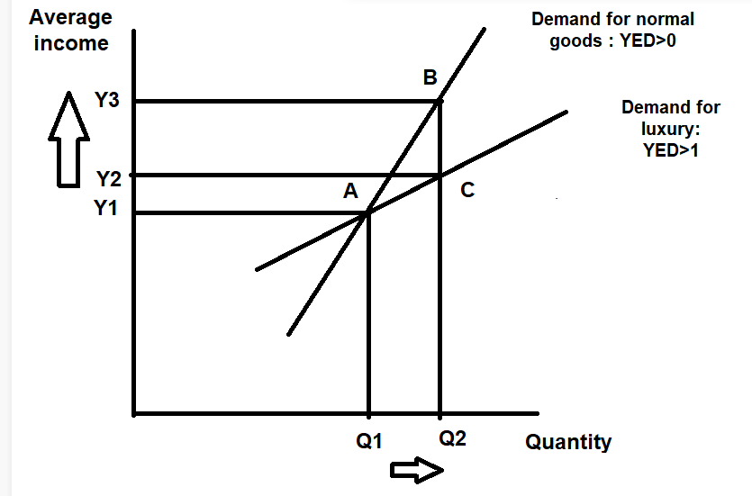
Made by: Maria Ivanova Etova

Although Samsung is not a luxury good but is classified as normal, a difference in the elasticity of demand for the product can be observed among different types of populations. The United Kingdom population is classified into two groups, people with a high standard of living, which are people who earn above the average income, and people with a lower standard of living, which are people who earn below the average wage. For both groups of consumers, demand has different elasticities. For Samsung users with lower income, demand would be highly elastic and any changes in income would have an impact, while for those with higher income, demand is more inelastic as this group of people have high disposable income and future changes in their income would not affect their demand.
Pricing policy
Pricing ranks first in any marketing strategy. In the fast-changing times we live in, price is critical for any company. The price of a product is formed based on various factors such as the cost of a product, the price of competing companies, the profit of the company, as well as the income of the population should be considered.
The highly competitive market in which Samsung operates requires the company to have a very well-developed pricing policy, as any mistake in pricing can cost a large drop in sales. The company should study the prices of competing brands, not only its biggest competitor Apple but also competitors that offer smartphones at lower prices so that it can develop products that are affordable to the poorer section of the population. In this way, the company will be able to significantly increase its customer audience. Another strategy to increase sales that Samsung can prepare is to include a gift with a purchased smartphone such as headphones, chargers, phone case and others, so their products would be more attractive to consumers. They can also explore new markets so that they can increase their customer audience, this would lead to a significant increase in the company`s sales.

CONCLUSION
Economic analysis is of utmost importance for any company in the market. Managers should examine every single factor that would affect their sales and profit. Not the right analysis or the lack of it would lead to serious losses or even bankruptcy of a company.
As I mentioned above in my report, Samsung is one of the leading brands producing smartphones. To maintain its position the managers of the company should prepare daily reports on the state of the company and study the behaviour of its competitors in order to prepare a strategy tailored to the market, as well as to study the financial situation of consumers to be able to offer products affordable to them.

References
Boyce, P., 2022. Complementary Goods Definition. [Online]
Available at: https://www.boycewire.com/complementary-goods-definition/
[Accessed 5 January 2023].
Burris, M., 2020. The History of Samsung (1938-Present). [Online]
Available at: https://www.lifewire.com/history-of-samsung-818809#toc-2000-to-present
[Accessed 4 December 2022].
Clark, D., 2022. Earnings and wages in the UK - Statistics & Facts. [Online]
Available at: https://www.statista.com/topics/3850/wages-and-salaries-in-the-uk/#topicHeader__wrapper
[Accessed 6 January 2023].
Dsouza, R., 2022. The smartphone features that drive Brits’ purchase choices. [Online]
Available at: https://yougov.co.uk/topics/technology/articles-reports/2022/02/02/smartphone-features-drive-brits-purchase-choices
[Accessed 6 January 2023].
EconomicsOnline, 2020. Demand and Income. [Online]
Available at: https://www.economicsonline.co.uk/competitive_markets/demand_and_income.html/
[Accessed 8 January 2023].
Hayes, A., 2022. Substitute. [Online]
Available at: https://www.investopedia.com/terms/s/substitute.asp#:~:text=A%20substitute%2C%20or%20substitutable%20good,used%20in%20place%20of%20another.
[Accessed 3 January 2023].
Jay, A., 2022. A number of Smartphone and Mobile Phone Users Worldwide in 2022/2023: Demographics, Statistics, Predictions. [Online]
Available at: https://financesonline.com/number-of-smartphone-users-worldwide/#:~:text=Source%3A%20StatCounter%202021-,How%20many%20Samsung%20users%20are%20there%20in%20the%20world%3F,comes%20up%20to%201.033%20billion.
[Accessed 8 January 2023].
Kenton, W., 2021. What Is a Luxury Item (aka Luxury Good)? Definition and Examples. [Online]
Available at: https://www.investopedia.com/terms/l/luxury-item.asp
[Accessed 8 January 2023].
Kunst, A., 2019. Samsung smartphone public perception changed in the UK 2017. [Online]
Available at: https://www.statista.com/statistics/722981/samsung-smartphone-public-perception-change-in-the-uk/?fbclid=IwAR2pQs__S8_7-3mgqzoFDFpERXUQSQp7RBXo1za43GsgjBDxUfs99n6_aaY
[Accessed 8 January 2023].
Kunst, A., 2022. Samsung brand profile in the UK 2022. [Online]
Available at: https://www.statista.com/forecasts/1252247/samsung-consumer-electronics-online-shops-brand-profile-in-the-uk
[Accessed 05 January 2023].
Laricchia, F., 2022. Smartphone market share in the U.S. 2017-2022, by model. [Online]
Available at: https://www.statista.com/statistics/755671/united-states-smartphone-market-share-by-model/
[Accessed 5 January 2023].
Neerman, P., 2021. Samsung makes twice as much from smartphones and TVs. [Online]
Available at: https://www.retaildetail.eu/news/electronics/samsung-makes-twice-much-smartphones-and-tvs/
[Accessed 4 December 2022].
Observer, T., 2020. From luxury to necessity, how smartphones change the way we use technology. [Online]
Available at: https://techobserver.in/2020/09/11/from-luxury-to-necessity-how-smartphones-change-the-way-we-use-technology/?fbclid=IwAR1qb2Z5OEFmiJpUWdt2VTnzYsvZxPNipkZQrobDNAIoNPhpE08AMYD3m3M
[Accessed 9 January 2023].
Taylor, J. L., 2023. Samsung Galaxy S23 Plus and S23 Ultra price rumored, S23 costs $899. [Online]
Available at: https://www.sammyfans.com/2023/01/06/samsung-galaxy-s23-plus-ultra-price-rumored/
[Accessed 7 January 2023].
Team, B. I. E., 2022. Income effect definition in economics (with examples). [Online]
Available at: https://uk.indeed.com/career-advice/career-development/income-effect-definition-economics?fbclid=IwAR1La3kPQl2zw49ScV9SvJUuKGtsgI-lnworvNFPCyvhOngdTxBcgDbDAfg
[Accessed 8 January 2023].
Team, C., 2022. Normal Goods. [Online]
Available at: https://corporatefinanceinstitute.com/resources/economics/normal-goods/?fbclid=IwAR1URbYCRehHMxTB6lCU1CfgF9Twm5OhOcvUh3x4x76nDKGiHsBiu_-iov0
[Accessed 8 January 2023].
Vaidya, D., 2022. Economic Analysis. [Online]
Available at: https://www.wallstreetmojo.com/economic-analysis-2/
[Accessed 3 December 2022].

