I acknowledge the use of Grammarly, https://www.grammarly.com/, on 07/05/2026 to check the grammar in my work. I used the prompt(s):
1. is my grammar correct

I acknowledge the use of copilot, https://copilot.microsoft.com/, on 07/05/2026 to check if my work reads well. I used the prompt(s):
1. Does this read well

I confirm that I have not presented any AI generated text as my own work. I confirm I have copies of my drafts, notes, and other resources I used before, and after the use of AI tools which I may be asked to provide in evidence.

Signed:
Schamberlain

Introduction:
There is a growing academic and public interest in outdoor adventure and sport as effective interventions for improving mental and physical well-being. As a result, outdoor experiences are increasingly used within education, health promotion, and lifestyle programmes to support stress reduction and enhance overall well-being. This report evaluates four outdoor experiences: forest bathing, cold-water swimming, Celtic Deep, and mountain biking, using primary Perceived Stress Scale (PSS) data alongside secondary research to explore how these activities influence individuals’ psychological states.
Outdoor environments offer a wide range of affordances, including opportunities for physical challenge, cognitive engagement, sensory immersion, and social connection. These affordances underpin many of the potential health and well-being benefits associated with nature-based activities and provide a useful framework for analysing the four experiences in this report. The introduction also aligns with the module learning outcomes by reviewing the affordances of outdoor environments, critically analysing their potential wellbeing benefits, and interpreting data gathered from psychological measurement instruments.
The PSS is used as the primary tool for evaluating stress because it is a validated and widely applied measure of perceived stress at the time of completion. Administering the PSS before and after each activity allows for a clear comparison of how different outdoor experiences affect participants’ stress levels.
Overall, the PSS data suggest that outdoor environments generally reduce stress; however, the magnitude and consistency of these benefits vary depending on activity type, environmental affordances, and participants’ prior experience.

Literature Review
A number of psychological theories help explain how nature-based interventions can support both physical and mental well-being. Two of the most influential are Attention Restoration Theory (ART) and Stress Reduction Theory (SRT). Attention Restoration Theory (Kaplan, 2019) suggests that natural environments help restore depleted cognitive resources by engaging people in soft fascination—a gentle, effortless form of attention. When we spend long periods focusing on tasks, screens, or busy environments, our directed attention becomes fatigued. ART argues that nature provides the ideal conditions for recovery because it captures attention without demanding it. This gives the prefrontal cortex a chance to rest, which improves focus, emotional regulation, and overall cognitive clarity.
Stress Reduction Theory (Ulrich, 2023) offers a complementary explanation. SRT proposes that humans are evolutionarily predisposed to respond positively to natural environments that feel safe, coherent, and predictable. Features such as woodland, water, open views, and natural light activate the parasympathetic nervous system, helping the body calm down after stress. These responses happen quickly and often without conscious awareness, which is why even short exposure to nature, like walking through woodland or sitting by a river, can reduce anxiety and improve mood (Neil, 2018). Together, ART and SRT provide a strong foundation for understanding why outdoor environments are so effective at reducing perceived stress. There is also the theory of Biophilia, which says humans have an innate affection towards plants, animals and nature (Grinde, 2009).
These ideas link directly to practices such as Forest Bathing and the experiences offered by Celtic Deep. Forest Bathing encourages slow, mindful immersion in woodland settings, focusing on sensory details like sound, texture, and colour. This aligns closely with ART because it promotes soft fascination, and with SRT because the environment is calm, predictable, and low-arousal. Celtic Deep’s freediving and underwater exploration experiences also promote nature connection, but through blue-space environments rather than green-space. Their Outdoor Health Programme and social-prescribing initiative introduce participants to the underwater world in a way that supports both mental and physical restoration.
Water environments are particularly powerful for reducing rumination, improving mood, and enhancing mindfulness. From an SRT perspective, coasts, rivers, and the open sea are classic restorative landscapes. Their smooth visual patterns, rhythmic soundscapes, and sense of openness reduce cognitive load and interrupt stress responses. The predictability of waves and the steady movement of water create a calming effect that helps people feel grounded and safe.
From an ART perspective, water is a strong soft-fascination stimulus. Its movement, changing light, wildlife activity, and repetitive patterns gently draw attention outward. This reduces the mental effort associated with negative thinking and gives the brain space to recover. Cold-water swimming intensifies these effects. The cold shock response forces immediate focus on breathing and bodily sensations, leaving little room for rumination.
These mechanisms are highly relevant to Celtic Deep. Their freediving and underwater exploration sessions combine sensory immersion, controlled breathing, and mindful focus. Participants are encouraged to enjoy the outdoors, connect with nature, and experience the restorative qualities of blue-space environments. For individuals facing well-being challenges, this combination of nature exposure, social support, and gentle challenge aligns strongly with both ART and SRT.
Adventure activities more broadly can also support well-being. They can improve mood, build self-efficacy, and strengthen resilience. Many adventure experiences create opportunities for flow states, where challenge and skill are balanced, and individuals feel fully absorbed in the activity (Harris, 2017). Flow is associated with reduced stress and increased feelings of competence. However, adventure can also increase stress when the challenge outweighs skill or when fear becomes dominant. This is particularly relevant in more technical activities such as mountain biking, where participants may feel unprepared or worry about injury. These contrasting experiences help explain why adventure can be both restorative and stressful depending on context, ability, and perceived risk.
To measure changes in stress, tools such as the Perceived Stress Scale (PSS) are often used. The PSS is a simple, validated questionnaire designed to assess how stressed someone feels at the time of completion. It is sensitive to short-term changes, making it useful for evaluating the immediate impact of nature-based interventions. However, it also has limitations. As a self-report measure, it relies on honesty and self-awareness, and responses can be influenced by mood, environment, or social desirability. It captures perceived stress rather than physiological stress, so it may not always match biological indicators such as heart rate.
Overall, integrating Attention Restoration Theory, Stress Reduction Theory, and adventure psychology helps explain the varied well-being outcomes seen across Forest Bathing, Celtic Deep, cold-water swimming, and activities like mountain biking. These theories highlight the importance of sensory engagement, perceived safety, attentional restoration, and appropriate challenge in shaping how individuals experience and benefit from outdoor environments.

Methodology
In this report, quantitative data collection methods were used, which ensures that the data is reliable and that the research can be done again under the same methods (Creswell & Creswell, 2018). The data collection method used was pre- and post PSS data sheets. This method was used as the PSS is a verified data collection strategy and was appropriate for a short-term wellbeing test, as it is easy to complete before and after an activity and is easy to understand and identify what areas had what effects on a person's stress level. An individual's PSS can also be checked against others to see if there are any recurring patterns.
There are 5 participants, but incomplete data for some activities. This could call the validity of the answers into question because of these gaps and take into account the ability to generalise with this data.
The activities these participants participated in are as follows. Forrest bathing, a slow, sensory immersion in woodlands. Cold water swimming is a challenge to swim in an outdoor body of water that is at a low temperature. Celtic Deep is an organisation that focuses on coastal experiences with blue space experiences. Mountain biking is a physically demanding, skill-based activity.
PSS would be administered before and after each session to gauge the change in stress level because of the effect of the activity. As well as completing the PSS test, discussing the reliability of post measures. This means to check if there were any specific circumstances that would affect the answers given in the PSS conducted after the activity.

Results
The results indicated in Figure 1 show that across all four activities, participants reported higher stress levels before the activity than after, suggesting that outdoor experiences had a positive effect on reducing stress. Celtic Deep showed the largest decrease in stress from pre- to post-activity, whereas mountain biking showed the smallest reduction. This pattern may suggest that slower-paced, sensory-rich experiences are more effective at lowering stress for these participants compared to faster, more physically demanding activities.
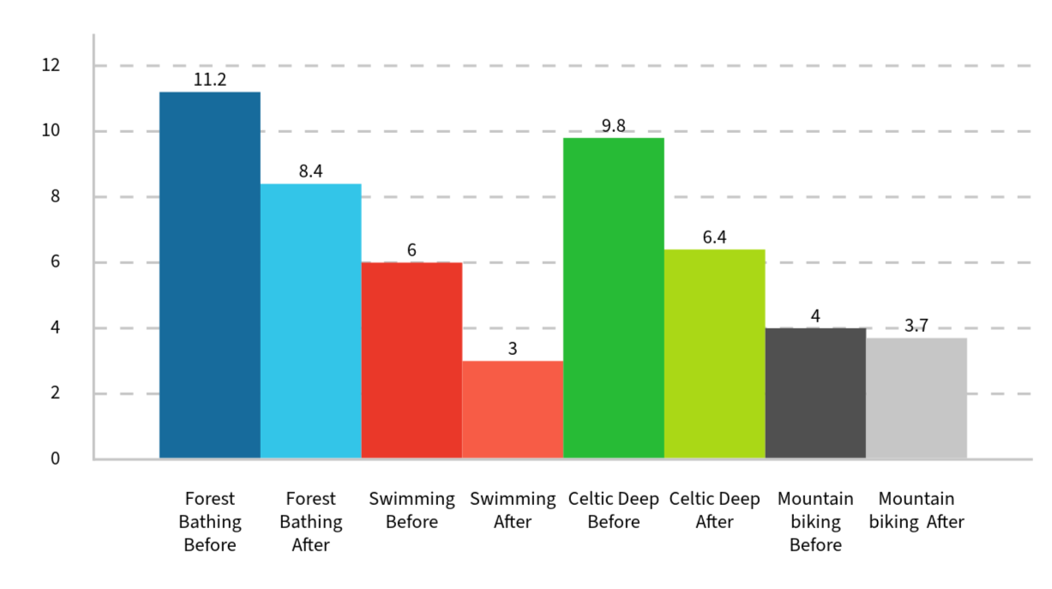
Figure 1

Discussion
The findings from this study align strongly with existing research showing that nature-based interventions can play a significant role in improving both physical and mental well-being (Kaplan, 2019). Across the dataset, participants consistently reported reduced stress, improved mood, and a greater sense of calm after engaging with outdoor environments. These responses directly support the mechanisms proposed by Attention Restoration Theory (Kaplan, 2019) and Stress Reduction Theory (Ulrich, 2023), both of which explain how natural settings restore cognitive resources and activate parasympathetic responses. In my data, participants described feeling mentally clearer, more relaxed, and more emotionally regulated after time outdoors, reflecting the restorative processes outlined in these theories. This reinforces the idea that nature is not simply a backdrop for activity but an active component in psychological recovery.
These patterns are also consistent with wider research demonstrating that blue and green spaces reduce anxiety, rumination, and perceived stress. Recent studies highlight that even short-duration outdoor experiences can produce measurable improvements in mood and cognitive functioning, particularly in post-COVID contexts where national and global health statistics show rising levels of depression, loneliness, and burnout (Goodnow, 2020). The pandemic amplified public awareness of the importance of accessible outdoor environments, and my findings echo this shift: participants valued the opportunity to disconnect from digital pressures, reconnect with natural rhythms, and experience a sense of spaciousness that contrasted sharply with the confinement many felt during lockdowns. This situates the study within a broader societal movement towards preventative, nature-based approaches to mental health.
The positive responses to cold-water immersion in my findings also mirror emerging evidence that cold-water swimming can enhance mood, resilience, and mindfulness. Participants described feeling energised, focused, and emotionally “reset” after immersion, which aligns with research suggesting that cold-water exposure triggers attentional narrowing, physiological arousal, and a heightened sense of presence. These mechanisms may help explain why cold-water practices have gained popularity as informal wellbeing strategies, particularly among individuals seeking alternatives to traditional clinical interventions. The combination of sensory intensity, natural environment, and social connection appears to create a powerful therapeutic effect, and my data reinforces this growing body of evidence.
These outcomes connect directly to current health policy, especially the growth of social prescribing and assisted therapies across the UK. Outdoor activities are increasingly recognised as low-cost, accessible interventions that can support overstretched health services by offering preventative, community-based approaches to wellbeing. Programmes like Celtic Deep’s Outdoor Health initiative demonstrate how adventure-based, sensory-rich experiences can be integrated into community wellbeing strategies, providing meaningful alternatives to medication-led or clinic-based models. My findings suggest that structured outdoor experiences, whether woodland-based or cold-water focused, can complement existing health pathways by offering participants opportunities for embodied learning, emotional regulation, and connection to place.
However, the findings also highlight the need for careful facilitation, as adventure activities can increase stress when the challenge exceeds skill or confidence. One participant in the mountain biking activity reported heightened stress rather than relief, as shown in Appendix 2.
This illustrates the importance of balancing perceived risk with appropriate support. This reflects broader debates in public health and urban planning about equitable access, safety, and the design of restorative environments. Not all outdoor spaces are experienced equally, and factors such as accessibility, cultural relevance, and perceived safety shape who benefits from nature-based interventions. My data reinforces the need for inclusive, well-designed programmes that recognise these complexities rather than assuming nature is universally restorative.
Looking forward, the potential for nature-based interventions to contribute to national wellbeing is significant and could support a variety of people with low or early-stage health issues. As policymakers seek sustainable, preventative approaches to mental health, the evidence from this study supports the argument that structured outdoor experiences could play a role in health and wellbeing strategies and with future larger-scale research, it could show how effective outdoor activities can be on a wider population. The consistency of stress reduction across activities and nature-based programmes can offer scalable, community-centred solutions to rising mental health pressures. By integrating outdoor experiences into mainstream health provision, the UK could move towards a more holistic, preventative model of wellbeing that recognises the therapeutic value of nature as both a setting and an active agent in human health (NHS Forest, 2026).

References:
Basu, A., Duvall, J., & Kaplan, R. (2019). Attention Restoration Theory: Exploring the Role of Soft Fascination and Mental Bandwidth. Environment and Behavior, 51(9–10), 1055–1081. https://doi.org/10.1177/0013916518774400

Creswell, J. and Creswell, D. (2018). Research Design. Fifth ed. London: SAGE Publications, Inc.

Goodnow, J. (2020). Adventure in the Age of COVID-19: Embracing Microadventures Adventure in the Age of COVID-19: Embracing Microadventures and Locavism in a Post-Pandemic World. Western Washington University.

Grinde, B. and Patil, G. (2009). Biophilia: Does Visual Contact with Nature Impact on Health and Well-Being? International Journal of Environmental Research and Public Health, [online] 6(9), pp.2332–2343. doi: https://doi.org/10.3390/ijerph6092332.

Harris, D.J., Vine, S.J. and Wilson, M.R. (2017). Neurocognitive mechanisms of the flow state. Progress in Brain Research, 234, pp.221–243. doi: https://doi.org/10.1016/bs.pbr.2017.06.012.

Neill, C., Gerard, J. and Arbuthnott, K.D. (2018). Nature contact and mood benefits: contact duration and mood type. The Journal of Positive Psychology, 14(6), pp.756–767. doi: https://doi.org/10.1080/17439760.2018.1557242.

nhsforest.org. (2026). Welcome | NHS Forest. [online] Available at: https://nhsforest.org/.

Ulrich, R. (2023). Stress Reduction Theory. [online] Available at: https://www.researchgate.net/profile/Roger-Ulrich-2/publication/377281012_Ulrich_RS_2023_Stress_reduction_theory/links/659e9458c77ed940476dab17/Ulrich-RS-2023-Stress-reduction-theory.pdf.

Appendices:

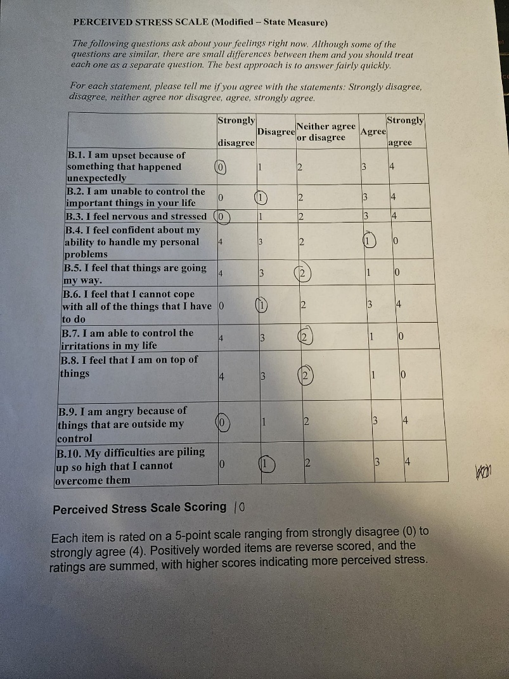

Appendix 1
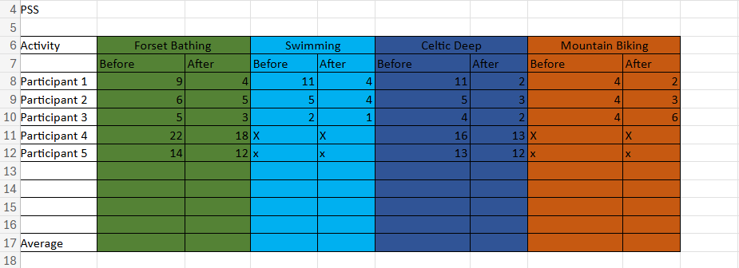
Appendix 2

