Commentary on Royal 14 B V, Membranes 4 and 5
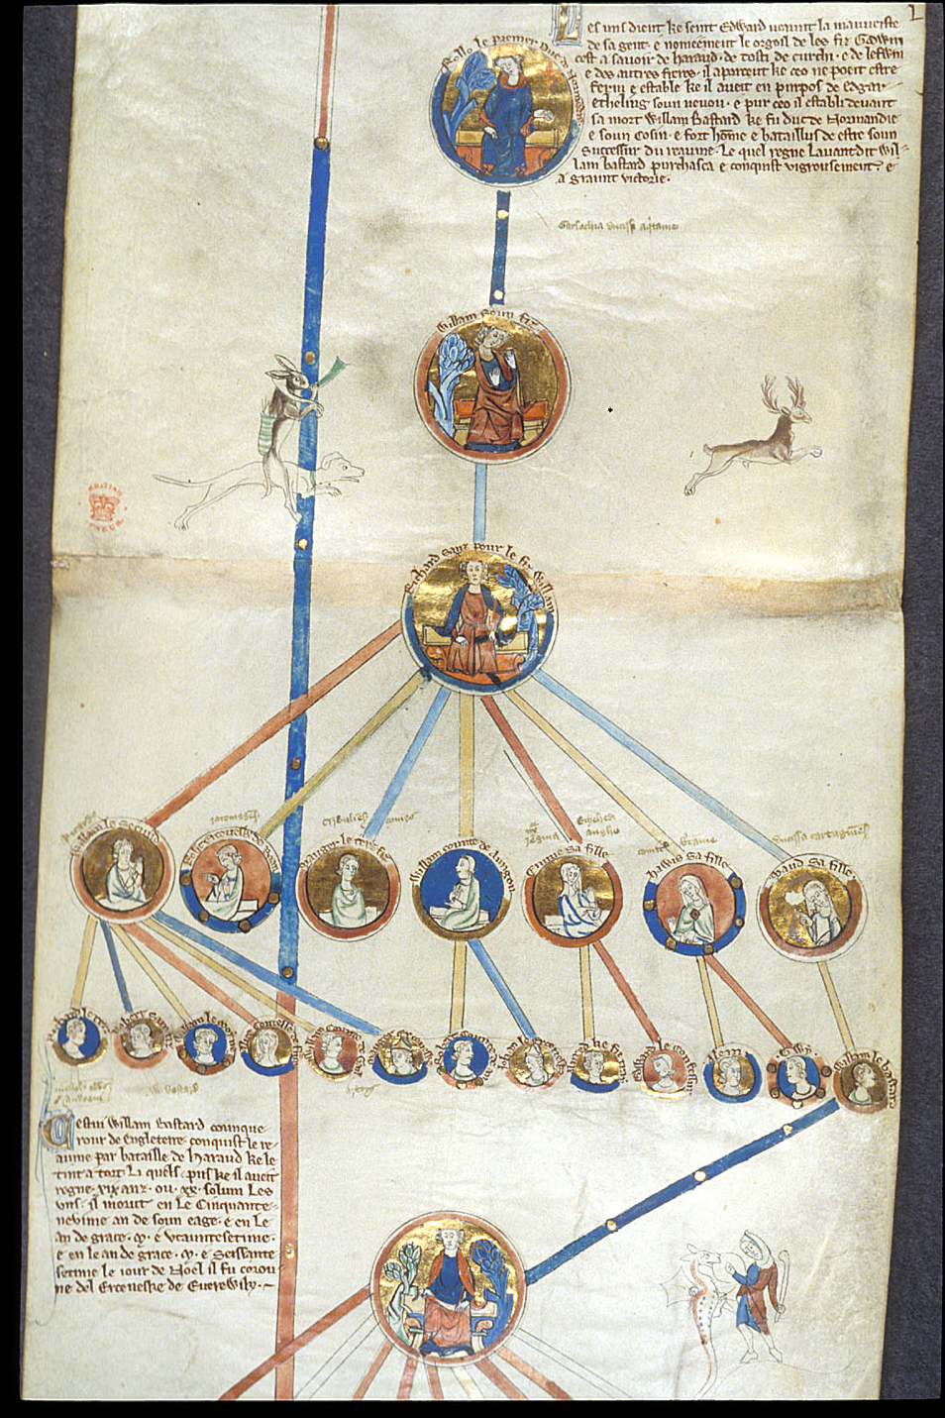
Rollo and his Descendants, from the Genealogical Chronicle of the English Kings
Membranes 4 and 5 of the British Library manuscript Royal 14 B V are among the most interesting documents to survive from the Norman tradition. Written in French, the roll traces the ducal line of Normandy from Rollo through his successors to William the Conqueror and beyond. The portrait medallions, rendered in gold, blue, and terracotta and linked by descending coloured lines, showing clear genealogical connections supported by the accompanying text. In the margin, a hare on horseback pursues a leaping stag; a joke that would be very obvious to the reader and was a very common addition to manuscripts of the time.
Rollo sits at the apex of the diagram, kick starting what later Norman writers would construct retrospectively as a new genealogical narrative, when Charles the Simple ceded territory around Rouen to Rollo and his followers in exchange for their conversion and their military service along the Seine in 911. He was, at once, the dynasty’s Viking progenitor and the first Norman, the figure who turned a raiding force into a territorial lordship. That ancestry still carried weight a century and a half later. As Katherine Cross has shown, ‘William traced his descent and ducal authority from his great-great-great-grandfather, Rollo the viking; the people he ruled over were still called Normanni because of their viking origins.’ Dudo of Saint-Quentin, writing at Richard I’s commission, recorded how the duke had asked him to set down ‘the rights which [Richard’s son Richard] asserted in the realm of his great-grandfather ROLLO.’ The image here is the visual form of that same demand.
From Rollo the diagram descends through William Longsword, Richard I, Richard II, and the subsequent dukes to William the Conqueror. The coloured lines make the succession look neat and direct, the natural flow of a family tree rather than the contested, crisis-punctuated reality of Norman ducal politics. This was a deliberate choice. Bouchard has shown that ‘the eleventh-century dukes of Normandy, for example, dramatically pared down the list of their tenth-century ancestors in order to establish their unique legitimacy,’ and the roll demonstrates this clearly. Cross makes the same point from the other direction: ‘early medieval genealogies emerge as complex texts which, far from being simple records of biological descent, were ultimately ideological statements’ representing ‘the subjective perception and political impact of constantly evolving ethnic relations.’ In place of Norman history’s actual disorder, the roll offers a smooth, easy-to-interpret line from Viking warlord to king of England.
William the Conqueror is where the diagram brings the focal point to the end of the roll and makes his ascension as smooth as possible. His medallion is the point that the genealogical line narrows again from the fan of children and grandchildren above him, making him both the inheritor of everything above and the origin of everything that follows. The French text presents 1066 not as military conquest but as the natural end of a dynastic progression that began with Rollo. The conquest of England was, by any honest account, an invasion, however the roll insists it was inheritance, and this was not a new strategy. Writing in William’s own lifetime, William of Poitiers described in the Gesta Willelmi how Charles the Simple had ‘bought the peace and friendship of Rollo, the first duke of the Normans, and ancestor of the future dukes, by giving him his daughter Gisela in marriage and Brittany in perpetual servitude,’ establishing a line of legitimate territorial acquisition that 1066 could be made to continue.
The Anglo-Saxon Chronicle offers a useful counter-perspective. Its compilers noted with apparent flattery that William ‘was a very wise and great man, and more honoured and more powerful than any of his predecessors,’ then immediately catalogued his harshness toward the poor, his punishing forest laws, and the suffering his rule had brought to England, giving the underlying impression that this was not someone worthy of the crown of the nation. That the same events could be read simultaneously as conquest and legitimate inheritance, depending on who was doing the reading, shows how contested the Norman claim was, and why it was so crucial to keep producing this kind of documentation.
Scholars of Norman historical writing have long noted the effort that went into shaping the dynasty’s self-image. Cross has argued that Norman historians ‘created a strong narrative of the origins and characteristics of the Norman people,’ attributing the Normans’ success in England, Sicily, and the Levant to their Normanitas, and that Dudo’s history ‘devoted much time and emphasis to the viking past, describing how Rollo the viking leader became the first of the Norman dukes.’ Emily Albu has shown that Norman historical writing aimed ‘to verify the legitimacy of Norman princes and to authenticate the rights of Normans to inhabit and dominate their lands.’ Where the chronicles achieved this through narrative, using legalistic and occasionally sycophantic prose, the genealogical roll achieves it more bluntly. Biological connection is presented as political justification, without needing argument.
Nick Webber has observed that ‘the ruling family are often the only members of society who can trace a pure line of descent (however mythical) from their heroic forefathers.’ Mythical is the right word. The Norman ducal genealogy from Rollo onwards was not a biological fact but a constructed narrative, adjusted by each generation to suit its needs. Bouchard’s central argument, that medieval noble families should be understood ‘primarily as a construct, specific to a certain time and place, rather than a self-evident and unchanging entity,’ fits this roll exactly. It was produced in the thirteenth century, after Normandy had been absorbed into the Capetian royal domain in 1204 and likely shortly after King Edward I ascended the throne in 1272. Written in French, this roll was part of a new wave of ‘feudal manual’ intended for the English aristocracy. For this audience in the late 13th century, Anglo-Norman French was the prestige language of the court, law, and high-status literature, once again reinforcing the legitimacy of the genealogical line.
Kenneth Baxter Wolf, writing on the Normans in southern Italy, noted that Norman chroniclers worked to ‘recast the barbarians, who had always played peripheral, antagonistic roles in histories dedicated to the Roman empire, as the protagonists of their own historical dramas,’ turning military power into political authority through narrative. The genealogical roll does the same, but in a single image. Rollo in his portrait medallion looks nothing like a pagan raider, he looks like a duke – seated, robed and gesturing with kingly authority. The violence of 911 is nowhere in the image. What remains is a line of descent flowing down through five generations to William the Conqueror, and from William the line would continue outward to the branches of his descendants including Edward.
The marginal hare on horseback is worth finishing with. Inversions of this kind, the hunted animal turned hunter, were a staple of thirteenth-century manuscript decoration, ranging from pure ornament to social satire. In a Norman genealogical roll, the scene does something more specific – it signals cultural confidence. Hunting was a defining aristocratic pursuit and treating it as material for a visual joke implies a commissioning king entirely at ease with his own identity. The marginal scene is an addition that shows the descendants of the genealogical like of this roll were not just warriors and administrators but literate, aristocratic and, most importantly, worthy of holding one of the highest political positions in Europe.
Bibliography
Dudo of Saint-Quentin, History of the Normans, trans. by Eric Christiansen (Woodbridge: Boydell Press, 1998)
Albu, Emily, The Normans in their Histories: Propaganda, Myth and Subversion (Woodbridge: Boydell Press, 2001)
Bouchard, Constance Brittain, 'Those of My Blood': Constructing Noble Families in Medieval Francia (Philadelphia: University of Pennsylvania Press, 2001)
Cross, Katherine, Heirs of the Vikings: History and Identity in Normandy and England, c.950–c.1015 (York: York Medieval Press, 2018)
'The Anglo-Saxon Chronicle: Assessment of William I', in The Anglo-Saxon Chronicle, trans. and ed. by G. N. Garmonsway (London: Dent, 1953), s.a. 1087
Webber, Nick, The Evolution of Norman Identity 911–1154 (Woodbridge: Boydell Press, 2005)
William of Poitiers, Gesta Willelmi, ed. and trans. by R. H. C. Davis and Marjorie Chibnall (Oxford: Clarendon Press, 1998)
Wolf, Kenneth Baxter, Making History: The Normans and their Historians in Eleventh-Century Italy (Philadelphia: University of Pennsylvania Press, 1995)

Katherine Cross, Heirs of the Vikings: History and Identity in Normandy and England, c.950–c.1015 (York: York Medieval Press, 2018), p. 2.
Dudo of Saint-Quentin, ‘Preface’, History of the Normans, trans. by Eric Christiansen (Woodbridge: Boydell Press, 1998), in Moodle Document, p. 1. <https://moodle.uwtsd.ac.uk/course/view.php?id=13501> [Accessed 7 Apr 2026]
Bouchard, “Those of My Blood” Constructing Noble Families in Medieval Francia in the Middle Ages, (Philadelphia: University of Pennsylvania Press, 2001), p. 3.
Cross, Heirs of the Vikings, p. 26.
William of Poitiers, ‘Gesta Willelmi’, in Gesta Willelmi (Oxford, 1998), in Moodle Document, <https://moodle.uwtsd.ac.uk/course/view.php?id=13501> [Accessed 7 Apr 2026]
‘The Anglo-Saxon Chronicle: Assessment of William I’, in The Anglo Saxon Chronicle, trans. and ed. G. N. Garmonsway (London, 1953), s.a. 1087 in Moodle Document, <https://moodle.uwtsd.ac.uk/course/view.php?id=13501> [Accessed 11 Apr 2026]
Cross, Heirs of the Vikings, p. 16.
Emily Albu, The Normans in their Histories: Propaganda, Myth and Subversion (Woodbridge, 2001), pp. 1–2. Quotation from Albu Introduction.pdf <https://moodle.uwtsd.ac.uk/course/view.php?id=13501> [Accessed 7 Apr 2026]
Nick Webber, The Evolution of Norman Identity 911–1154 (Woodbridge, 2005), p. 8. Quotation from Webber Introduction (1).pdf, <https://moodle.uwtsd.ac.uk/course/view.php?id=13501> [Accessed 10 Apr 2026]
Bouchard, Those of My Blood, p. 2.
Kenneth Baxter Wolf, Making History: The Normans and their Historians in Eleventh-Century Italy (Philadelphia, 1995), p. 4. Quotation from Baxter Wolf Introduction (1).pdf. <https://moodle.uwtsd.ac.uk/course/view.php?id=13501> [Accessed 7 Apr 2026]

