This is my exploration of three key words supported by a variety of images, synthesised with at least three visual practitioners and philosophers. I will attempt to explore and critically examine and make connections between ‘self-expression’, ‘overthinking’, and ‘wit’ within graphic design, to form a question for my independent research dissertation. These words will be linked with a variety of designers, but heavily connected with Joseph Müller-Brockmann, Rokus Anelius and Josh King.

Self-Expression

What is it to ‘express yourself’? By one definition from Heejung and Sherman (2007), expressing yourself can be expressing your values, your morals, your personal style, and your personality. Self-expression is arguably even the choices we make in life, as “through choice, people can make their preferences and values overt”. Therefore, by a designer simply choosing to design for a certain client, for example a vaping company, this could be viewed as that designer expressing themself and their values. A study from the source finds culture to be an affecting factor to self-expression, impacting a designer’s attitude to expressing their individuality in practice. A designer from a place where self-expression is encouraged may design more self-expressively, communicating their personality and individuality.

Swiss Design is described as a mentality rather than a nationality by Museum für Gestaltung Zürich (2014, pg.9). The purpose of Swiss style is to eliminate a need for creative-expression and apply greater focus on clarity and purpose (pg.113). Intrigano (2018) refers to it as “objective graphic design”, stating the style even discouraged illustration as this communicated creative expression. Instead, photographs were encouraged as they were more factual. Rosetti’s Ballads and Narrative Poems was a piece from the Arts and Crafts movement pre-Swiss style, where a decorative aesthetic influenced by nature and patterns was encouraged. Whereas Weniger Lärm depicts an objective Swiss style with standardised typography and photography. Swiss style has influenced many designers, and perhaps even their willingness for self-expression in their designing.

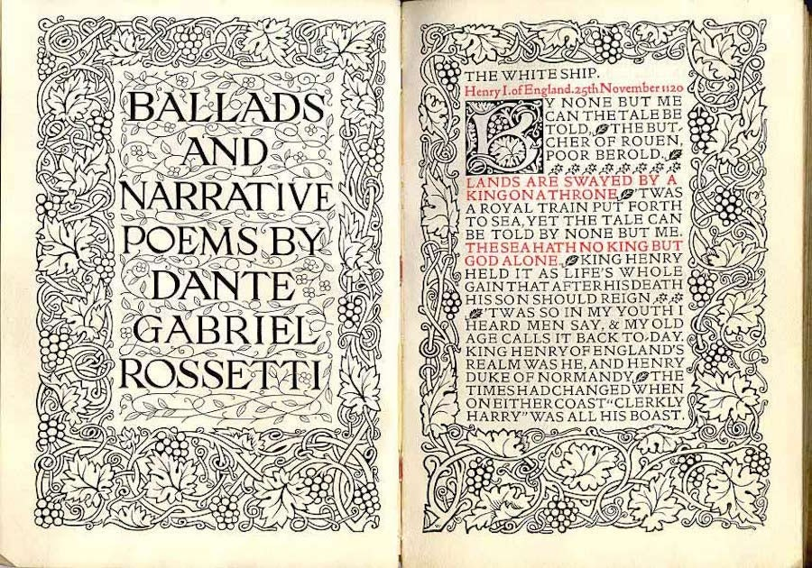
Dante Gabriel Rosetti. Ballads and Narrative Poems. [book illustration] Figure. 1.

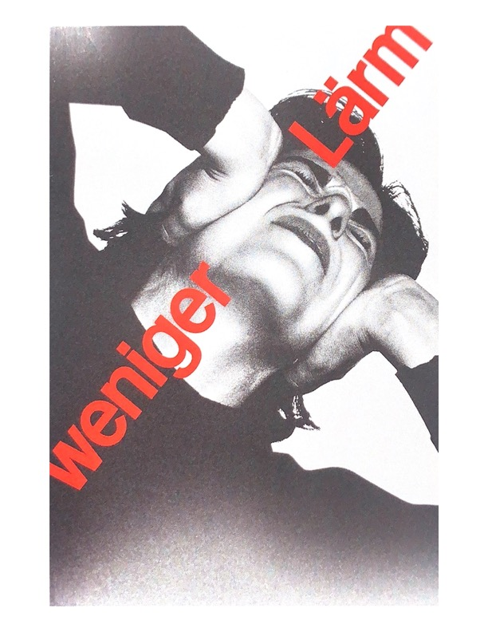
Joseph Muller Brockman. Weniger Lärm. [graphic design] Figure. 2

In some perceptions, all art is an expression of the self (Green, 2007). This suggests that even the act of creating is expressing oneself. Yet others hold the opinion that an artist can create work that is “expressive without expressing his or her own feelings; Beethoven is said to have brought audiences to tears while smirking through his performances”. The latter implies that a designer who creates work for a client might be satisfied with just being expressive in the creative sense through their work, but not expressing themselves or their essence through said work, remaining personally detached from it.

So, we ask, do you need to express your individuality as a graphic designer at all? Shaughnessy (2015, p. 99) discusses a similar view to Green (2007), stating that the traditionally minded graphic designer sees designing within trend and personal taste as a “superfluous and unprofessional” approach, implying the designer is merely a separated reporter of the client’s message, simply providing the design skills required. This could be seen in both a negative way and positive way when thinking about the role of a graphic designer in the client’s shoes. Some clients could find it impersonal that the designer remains personally detached from the work they are creating, perhaps even viewing it as a lack of passion for the creations they are paying for. Others might see it as more personal that the designer detaches their own personal expression, as they may prioritise the client’s essence and message even more successfully.

This exploration of self-expression has allowed me to question the role of the designer in expressing themselves in practice, and whether they need to or should at all. Varying sources have expressed dispute over the topic, and many questions have arisen in this investigation. How can a designer create something without communicating their own essence? How has the Swiss Style impacted the self-expression of designers in practice? Should a designer express their own individuality in their work? And how does culture affect a designer’s self-expression?

Overthinking in design/ Intuition in design

‘Overthinking’, or ‘overponderabilia’ (Vangkilde and Sausdal, 2016), is defined as being "tied up with conceptual description and self-reflection". The work of Rokas Alenius’ Overthinking seems to agree with this same interpretation of the word with his use of warped typography and the confused form of shape displaying the mind as ‘all over the place’ and the artist even refers to overthinking as “the demon”. Within ‘Overponderabilia’, the centrality of distance is linked to reflection, as we must distance ourselves from our practice to reflect and avoid overthinking.

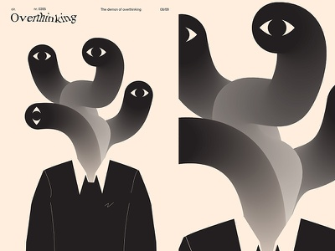
Rokus Alenius (2019). Overthinking. [graphic design] Figure. 3

Exploring thought-processes could improve understanding of overthinking and allow for its management. Managing overthinking can be linked to the theories of Kahneman in his book, Thinking, Fast and Slow (2012). Fast thinking is discussed in terms of trusting intuition, as when intuition is acted upon when relevant expertise on an area can be applied, it will likely lead to correct decision-making. Alternatively, when this fast-thinking fails, slow-thinking instigates, the more deliberate and purposeful form of thinking. As designers, could the answer to avoiding the negative notions of overthinking be to trust our intuition? Could slow-thinking manage our decision-making and avoid overthinking when intuition fails?

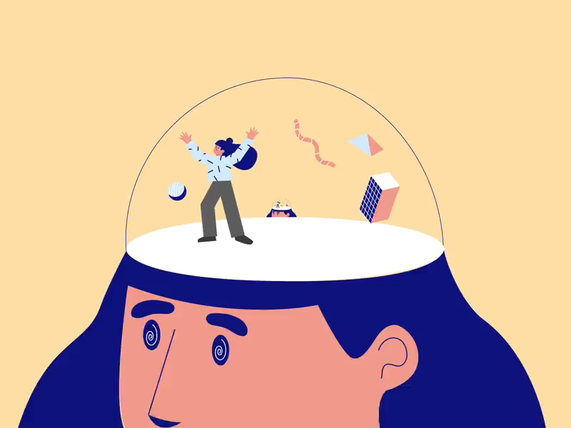
Butter Draws (2020). When you’re stuck in your head, head, head. Figure. 4

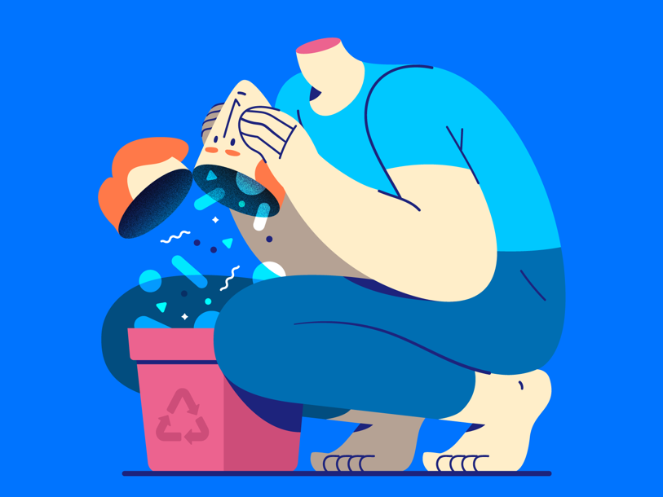
Gaspart (2020). Empty Your Mind. Figure. 5.

‘Overthinking’, described as “a loop of unproductive thoughts” that can be unnecessary (Petric, 2018), is supported by visual practitioner Butters Draw with this loop analogy represented in ‘When you’re stuck in your head, head, head’, giving a sense of entrapment when overthinking occurs. Comparably, Gaspart visualises an overwhelm of thought in ‘Empty Your Mind’ displaying a clearance of thoughts as a positive, counteracting overthinking. Petric (2018) discusses how a lack of positive emotion can lead to negative knots forming and overthinking occurring as the mind compensates for a lack of positivity. The negativity disentanglement tool here is positivity, as positive thoughts help us think productively and stop overthinking. ‘OverThinking Poster Design’ shows a representation of various knots in the mind that resonates with this analogy (2018). Therefore, perhaps a graphic designer could manage overthinking by the maintenance of a healthy emotional life.

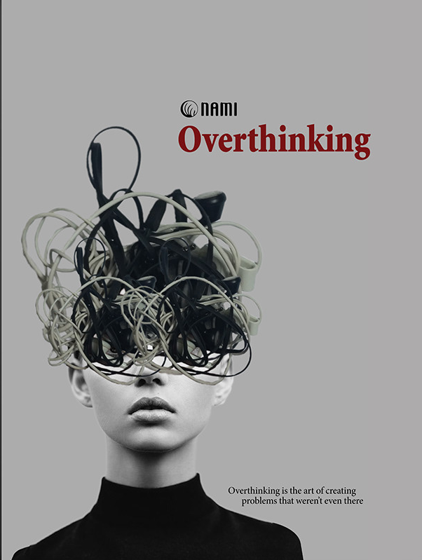
Menna Osama Oheb (2019). OverThinking Poster Design. [Figure. 6

Overthinking could be used as a tool for designers to utilise (Smith, 2012), viewing the attributes that overthinkers often have, such as always asking questions, and the ability to put themselves in other’s shoes, as advantages. For example, “overthinkers like to futz around in brains that don’t belong to them”, a beneficial attribute within user experience design, where entering the shoes of the user is essential. 3D render, ‘Overthinking’ by Melad with its optimistic feel could be agreeable with this philosophy, portraying overthinking as many possibilities of ideas in the form of floating shapes that could accumulate to a useful insight, implying it is better to be filled with thought than empty.

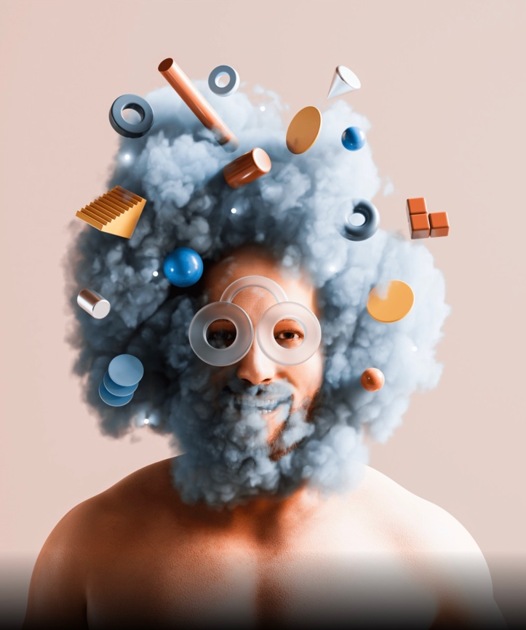
John Melad (2021). Overthinking. Figure. 7

‘Overthinking’ in graphic design is fascinating due to its potential to both limit me and give me an advantage to tap into. A consistent aspect of visual interpretations of what ‘overthinking’ is, is the use of form and shape alluding to a splurge of thought in the mind; whether this is positive or negative is down to perception. Many contrasting questions have risen from exploring overthinking. Namely, what methods could we take to prevent overthinking in practice? How important is distancing ourselves from our practice in avoiding overthinking? How can we manage overthinking as well as embrace it in practice? And, is overthinking a positive mentality for a graphic designer, or does the thought process limit our practise?

Wit/ Humour

Stuart and Asbury (1996), in their book A Smile in the Mind (pg.12-14), discuss how wit usually involves holding more than one concept in the mind to make witty solutions, a juggling of ideas in intelligent ways. There are two emotions at play when wit is successfully experienced, recognition and surprise, and both emotions should be experienced in high levels. For example, if a designer created something that the viewer had high familiarity of but little surprise, the result would be dilute and forgettable. Take the work of Josh King in Ring, Ring, Ring, Ring, Ring. In his interpretation of the Olympic symbol so widely known, there is a great deal of familiarity with the colour combination, and a great deal of surprise when we connect this to the Olympic rings, but this time the ‘rings’ symbolise the beginning of the Olympic Games, like ringing the doorbell, and the viewer ‘gets it’.

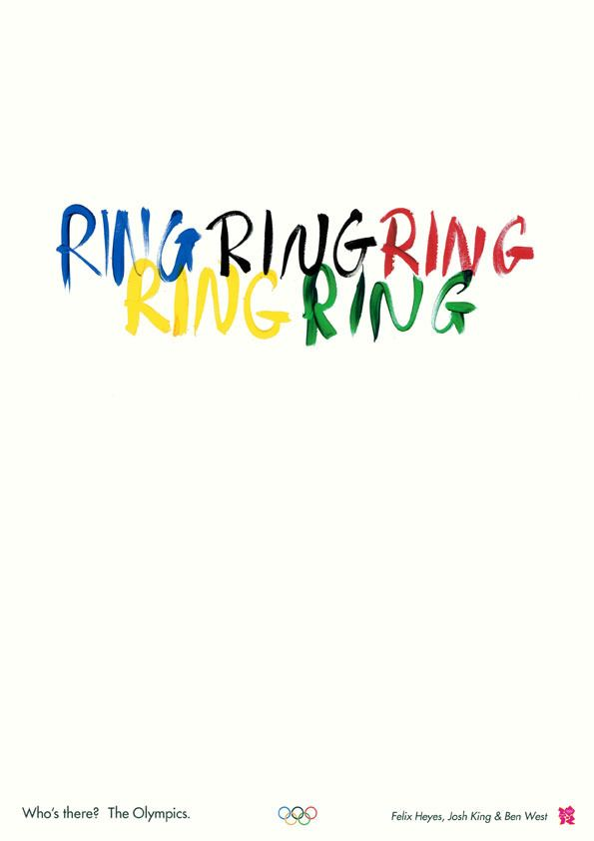
Ring, Ring, Ring, Ring, Ring by Josh King. [graphic] Figure. 8.

Perhaps the earliest forms of graphic wit date back to Christian manuscripts of the eighteenth century, when scribes would interpretatively draw letters for simple pleasure (Heller and Anderson, 1991), as in figure 9. This simple pleasure taken from wit is something that remains evident in modern graphic wit, as many designers have an attitude of “I hope people have fun when they see my work” (Fulleylove, 2020). Towards the nineteenth century, graphics were increasingly influenced by political, social, and technological advancement much like today. Progressive educators began including metamorphosed alphabets for children’s learning in school as in figures 10 and 11, both playful forms of wit as educational aids.

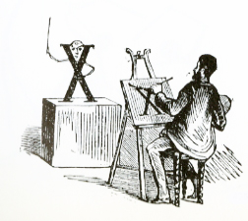

PrintMag (2011) [drawing]. Figure. 9.

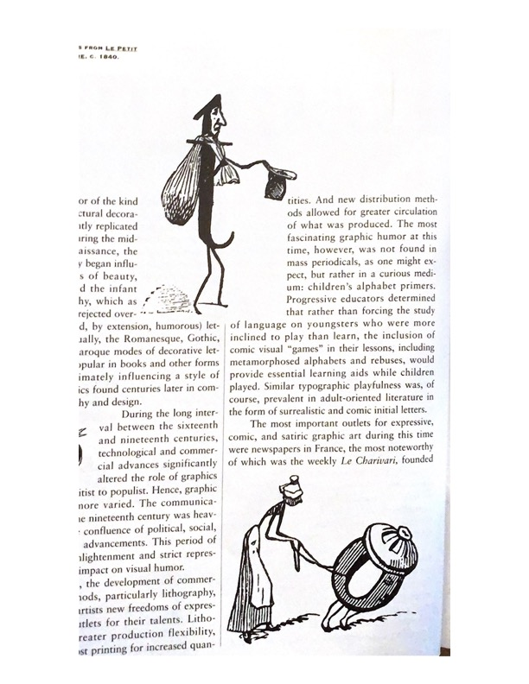
Heller and Gail (1991). Figure.10.

Heller and Gail (1991). Figure. 11.

Stuart and Asbury (1996) allude to wit’s interactive power, as the viewer is invited to decode the artwork, with the urge to understand being “as basic as hunger”. Wit is a folder in which humour sits in a file, with its power to provoke other emotions, “a smile, an inward nod of respect… a feeling of awe” making it a powerful tool for designers. Ukrainian designer, Korolevtseva, provokes strong emotion using wit with form and colour in You Can’t Be Silent (2022) to symbolise Ukraine, and Russia. Korolevtseva portrays the realities her country faces to raise awareness and counteract Russian misinformation; a truly powerful, even tear-jerking form of wit. Similarly, Pablo Amargo is a key visual practitioner for graphic wit. In his design for French Red Cross in figure. 13, alluding war in Ukraine, he cleverly shows us through the scarf how this is the lives of not just the mother and child, but of the wider Ukrainian population, on the move and seeking refuge.

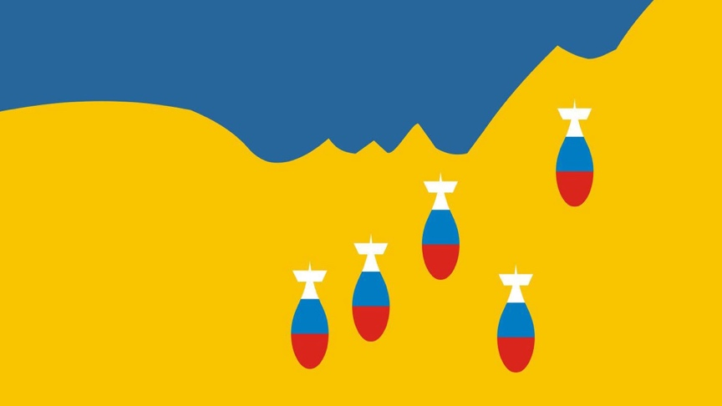
Katerina Korolevtseva (2022). You Can’t be Silent (2022) Figure. 12.

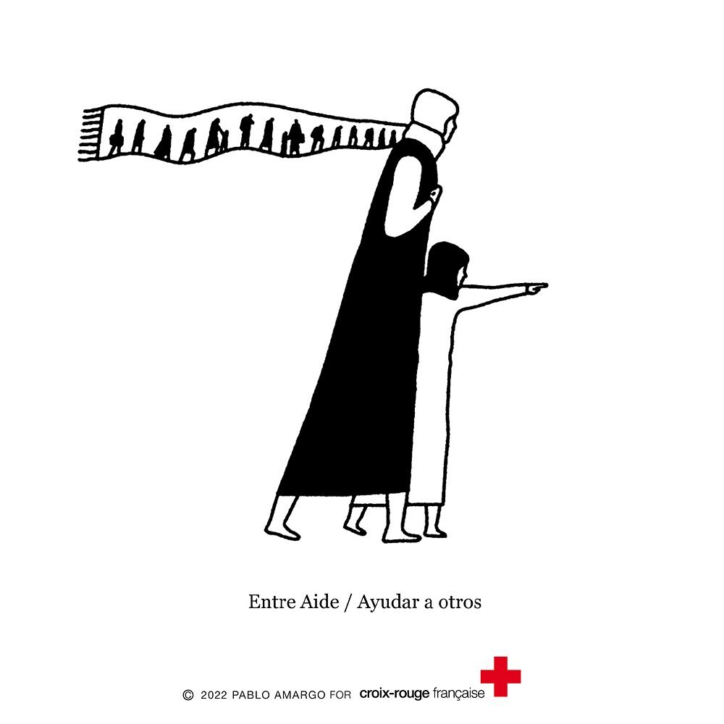
Pablo Amargo (2022). Figure. 13.

Due to the relatability that humour creates in an audience as a form of wit, designers can use it as a tool to make connections with their audience (D&AD, 2021). The timing of using humorous wit is vital to making this connection, the audience must be prepared for it. The Led by Donkeys billboard The Tories Are Lying was timed during the Brexit campaigning to challenge the dishonesties of many politicians when the British public were perplexed and frustrated with the Brexit campaigning. This was the perfect time to connect to the public with humorous wit.

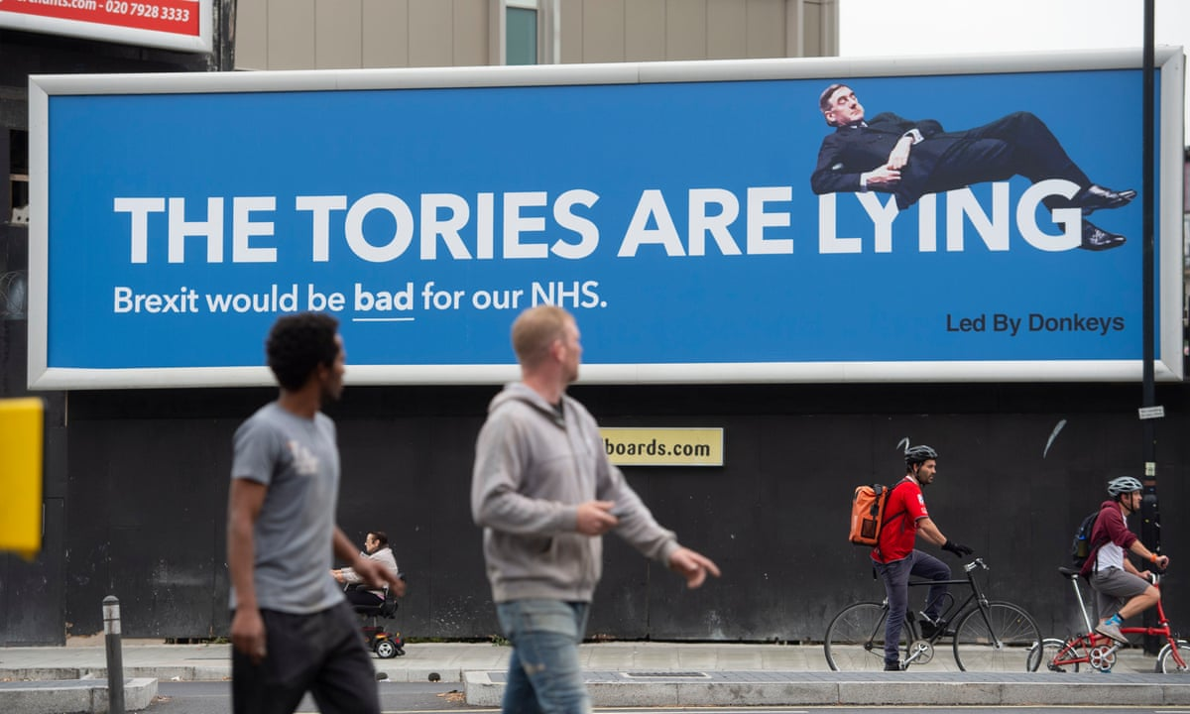
Led By Donkeys (2019). The Tories Are Lying [billboard graphic] Figure. 14.

Designers Lennarts and De Bruijn make interesting connections between humour in design and overthinking (Gosling, 2017). Their EKKO campaign collection successfully instils humorous wit, with the designers themselves granting their success to often having “no real strategy” and having a “we just did it” approach. This interestingly alludes to the benefit of thinking less to achieve graphic wit, alluding to overthinking as a limitation to successfully instilling graphic wit.

This exploration of wit has highlighted its unbelievable power as a tool for graphic designers, perhaps the most powerful tool I have discovered in impacting an audience and creating an unforgettable feeling. However, wit that confuses the audience is worse than any idea at all, and so designers must use it cautiously. Fascinating questions have arisen during this exploration, such as, is overthinking a limitation to achieving graphic wit? Could wit be a powerful tool for change? And is wit the most impactful form of visual communication?

Conclusion

Investigating ‘self-expression’, ‘overthinking’ and ‘wit’ has allowed me to understand the concepts in more depth and has unsealed many questions that could be fascinating to explore for my independent research project. There have been noticeable connections between the keywords in how they could affect a graphic designer’s practice. I feel the stand-out question to this exploration is what is the role of wit in a designer’s practice, and what are its limitations?

POSSIBLE END OF ESSAY QS:
Is overthinking a positive mentality for a graphic designer, or does the thought process limit our practise?
What is the role of self-expression in a designer’s practice?
How can a designer use wit as a tool in practice?
What is the role of wit in a designer’s practice?
How can wit be used as a tool in graphic deisgn?
How can you put a time-constraint on creative expression in practice?
Is trusting our intuition the key to success as a graphic designer?

Referencing

Vangkilde, K., Sausdal, D. (2016) ‘Overponderabilia: Overcoming Overthinking When Studying “Ourselves”, Qualitative Social Research, 17(2). Available at: https://www.proquest.com/docview/2539303934?accountid=130472&parentSessionId=GN%2FnMqQCT45yD%2FadyfcmeuYucSokKwt%2Foct9b2A0SEM%3D&pq-origsite=primo

Petric, D. (2018). Emotional knots and overthinking. Research Gate. Available at: https://www.researchgate.net/publication/325742568_Emotional_knots_and_overthinking (Accessed: 20 March 2022).

Smith, C. (2012). Why “Overthinking” is a Commodity for Designers. Centerline Digital. Available at: https://centerline.net/blog/why-overthinking-is-a-commodity-for-designers/ (Accessed: 14 March 2022).

Shaughnessy, A. (2010) How to be a Graphic Designer, Without Losing Your Soul. London, UK: Laurence King Publishing Ltd.

Intrigano. (2018) The Objectivity of Swiss Design. 20 May. Available at: https://www.youtube.com/watch?v=GZAjFbnJ40Q (Accessed: 11 April 2022).

D&AD. (2021) How To Use Humour in Your Work | New Blood Festival 2021. 22 July. Available at: https://www.youtube.com/watch?v=FZtvpexedgI&t=857s (Accessed: 19 March 2022).

Heller, S., Gail. A. (1991) Graphic Wit. New York, Watson-Guptill Publications.

Heejung, K.S., Sherman, D.K. (2007) ‘”Express Yourself”: Culture and the Effect of Self-Expression on Choice’, Journal of Personality and Social Psychology, 92(1). pp. 2-6. Available at: https://web-s-ebscohost-com.ezproxy.uwtsd.ac.uk/ehost/pdfviewer/pdfviewer?vid=0&sid=60da1d13-faa6-4112-80c2-3f300fe8af2c%40redis (Accessed: 20 March 2022).

Green, M.S. (2007). Self-Expression. paras. 8-9. Available at: https://web-s-ebscohost-com.ezproxy.uwtsd.ac.uk/ehost/pdfviewer/pdfviewer?vid=0&sid=86d8d0a9-0c4b-40d2-9cd7-5b0dbe1ee4a5%40redis (Accessed: 8 April 2022).

Museum für Gestaltung Zürich. (2014). 100 Years of Swiss Graphic Design. Pg.9 and pg.113. Lars Müller Publishers.

Kahneman, D. (2012) Thinking, Fast and Slow. London: Penguin. Available at: https://r3.vlereader.com/EpubReader?ean=1780141918921

Gosling (2017) A Lesson in Not Overthinking and Designing with Humor from Lennarts & De Bruijn. Available at: https://eyeondesign.aiga.org/a-lesson-in-not-overthinking-and-designing-with-humor-from-lennarts-de-bruijn/ (Accessed: 23 April 2022).
Fulleylove (2020). Youting Lin Uses Humour to Bring Her Designs to Life. Available at: https://www.creativereview.co.uk/youting-lin-graphic-design-animation/ (Accessed 23 April 2022).

Stuart, D., Asbury, N. (1996). A Smile in The Mind: Witty Thinking in Graphic Design. pg. 12-14. Phaidon Press Limited.

Figures

Figure. 1.
Dante Gabriel Rosetti. Ballads and Narrative Poems. [book illustration] Available at: https://99designs.co.uk/blog/design-history-movements/swiss-design/ (Accessed: 21 April 2022.)

Figure. 2.
Joseph Muller Brockman. Weniger Lärm. [graphic design]. Museum für Gestaltung Zürich. (2014). 100 Years of Swiss Graphic Design. Pg.9. Lars Müller Publishers.

Figure. 3.
Alenius, R. (2019) Overthinking [graphic] Available at: https://dribbble.com/shots/6960267-Overthinking/attachments/11356153?mode=media (Accessed: 22 April 2022).

Figure. 4.
Butter Draws. (2020). When you’re stuck in your head, head, head. [motion graphic] Available at: https://dribbble.com/shots/12005998-When-you-re-stuck-in-your-head-head-head (Accessed: 13 April 2022).

Figure. 5.
Gaspart. (2020). Empty Your Head. [illustration] Available at: https://dribbble.com/shots/13801297-Empty-Your-Mind/attachments/5407654?mode=media (Accessed: 28 March 2022).

Figure. 6.
Menna Osama Moheb (2019). Overthinking Poster Design. [graphic poster]. Available at:
https://www.behance.net/gallery/81363453/OverThinking-Poster-Design?tracking_source=search_projects%7Coverthinking%20graphic (Accessed: 12 April 2022).

Figure. 7.
John Melad (2021). Overthinking. [illustrative 3D render]. Available at: https://www.behance.net/gallery/131038311/Overthinking (Accessed: 21 April 2022).

Figure.8
King, J. Ring, Ring, Ring, Ring, Ring. [graphic]. Fiell, P. Fiell, C. (2013) New Graphic Design: The 100 Best Contemporary Graphic Designers. pg. 264.

Figure. 9.
PrintMag (2011). What Made Scribes Laugh? Available at: https://www.printmag.com/daily-heller/what-made-scribes-laugh/ (Accessed: 21 April 2022).

Figure. 10.
Heller, S. and Gail. A (1991) Graphic Wit. pg.16. New York, Watson-Guptill Publications.

Figure. 11.
Heller, S. and Gail. A (1991) Graphic Wit. pg.16. New York, Watson-Guptill Publications.

Figure. 12.
Katerina Korolevtseva You Can’t Be Silent [graphic] Available at: https://www.designweek.co.uk/issues/28-february-5-march-2022/ukraine-graphic-design/ (Accessed: 23 April 2022).

Figure. 13.
Pablo Amargo. [graphic illustration] Available at: https://www.instagram.com/pablo.amargo/?hl=en (Accessed: 9 April 2022).

Figure. 14.
Led By Donkeys. (2019). The Tories Are Lying [billboard graphic] Available at: https://www.theguardian.com/politics/2019/sep/25/get-ready-for-brexit-satire-led-by-donkeys-launches-billboard-contest (Accessed: 13 April 2022).

QS for Donna
- I have multiple artists not purely one with many works for overthinking section – is this okay?
- I haven’t got a clear theorist for each keyword I have multiple, is that okay?
- Do I need to double space my document?
- Do I exclude the refernce writing under each photograph from my word count?
- Are my figure references correct – can’t find how to cite graphics in cite me right.
- Should I have used only three visual practitioners rather than the multiple I’ve used to support each keyword? – found it hard to find one artist with multiple works for words like overthinking
- Is it okay that I haven’t made links between the keywords a massive amount?

