Examine the Challenges and Opportunities for Global Logistics at Heathrow Terminal 5

Denis Nedzhmiev
Student ID: 2029363

Table of Contents
Introduction 3
The Rationale of the Study 6
Research Focus 7
Literal View 7
Literature Review 7
Aims and Objectives 9
Objectives 9
Research Questions 10
Research Methods 10
Study Design 10
Data Collection Method 11
Data Analysis 12
Ethical Considerations 13
Expected Outcomes 13
Project Plan 13

Introduction
Background to Study
Cross-border logistics, as Furuichi (2021) describes, is an integral part of the global supply chain that serves multiple functions, including the sufficient flow of goods between and among countries. In addition to the flow of goods, cross-border logistics also includes transportation of the goods as well as tax compliance and other cross-border safety precautions. Logistics in the context of cross-border is holistic and involves several services and activities as described in the definition. As Furuichi (2021) further asserts, cross-border logistics is an important aspect of international trade as it determines the effectiveness and efficiency of trade between two or more countries. Cross-border logistics is particularly important in the modern economy that is significantly integrated. Figure 1 shows the international trade in export volumes globally since 1950.
Figure 1 shows that international export trade volume has been steadily rising over the last 70 years with periodic slight declines. Technological advancement, in particular, is largely associated with the increase in international trade in the 20th and 21st centuries (Tien et al., 2019). Most of the periodic decline in international trade has always been occasioned by international events, specifically crises that cause significant global economic contraction, which is a result of individual adverse economic conditions of countries. The sharp decline in exports in the period 2007 – 2008 as indicated in the figure, for instance, was due to the global financial crisis (Charalambides and Thanopoulou, 2014). Similarly, the major dip in 2020-2021 is due to the COVID-19 effect on the world's economy (Shin et al., 2020). As Figure 1 indicates, however, the levels of exports in the post-COVID-19 period are historically higher, meaning that international trade has grown even further despite the adverse global effect of the COVID-19 pandemic. The efficiency and effectiveness of cross-border logistics are, therefore, of fundamental importance, considering the implications of the pandemic on the international supply chain.
Figure 1: Trends in global export value of trade in goods from 1950 to 2022
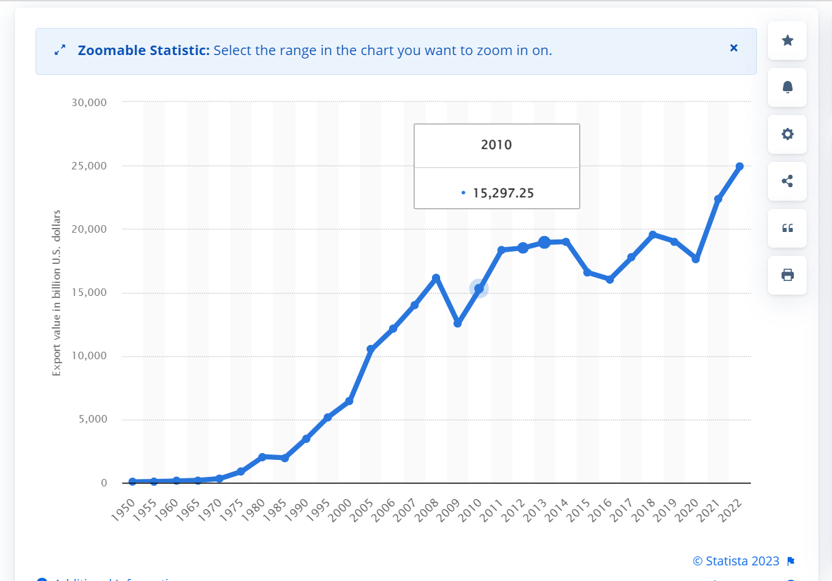
Source: (Sabanoglu, 2023) https://www.statista.com/statistics/264682/worldwide-export-volume-in-the-trade-since-1950/
Heathrow Airport is ranked as the world's largest airport in terms of customer seats at 3.4 million, after Dubai International Airport, which has over 4.5 million customer seats (Junior et al., 2021). In terms of logistics, Heathrow Airport is the only hub airport in the United Kingdom that accepts both international and European cargo freight (Junior et al., 2021). Additionally, Heathrow also serves over 200 destinations in over 80 countries around the world. As such, the airport plays a major logistical role in Europe, the United Kingdom, and international trade.

Research Problem
The political changes in the UK through Brexit have caused significant changes in the UK's trading arrangement with the European block and another global partner. Furthermore, the adverse effect of COVID-19 on global logistics, high inflation that has persisted since early 2022, and the lasting effects of the pandemic on the economy have significantly influenced cross-border movement (Minenna, 2021). Socially, the various restrictions by public health and international bodies regarding safety to avoid infection and the spread of the virus have necessitated significant changes at cross-border points. The traveler’s perception of destination safety, for instance, has been reported as a major determinant of visitors, particularly tourists to a given country. Technology has provided significant leverage to deal with the emerging challenges during and after the Covid-19 pandemic. Technology has particularly been useful in helping businesses and state organisations cope with a number of challenges. As such cross-border behaviors and interactions occur, various legal instruments have been pursued to increase cross-border economic exchange and interaction on the one hand and to limit the adverse effects of cross-border movement, especially after the pandemic (Saxunova et al., 2022). The renewed global call for environmentally sustainable economic production and social behaviors has also been magnified. Based on the above-stated PESTLE issues, the cross-border points have come under focus. Heathrow, as the second largest airport globally, is under significant scrutiny given the role it plays in enhancing the efficiency and safety of cross-border logistics. The proposed Study is, therefore, important in examining the challenges and opportunities for global logistics at Heathrow Terminal 5 (Denicol, 2020).

The Rationale of the Study
The adverse effects of the COVID-19 pandemic have caused a significant decline in the customers and service movement at the airport. However, the numbers have been rising steadily since the reopening of the world after the pandemic (Liao et al., 2023). In anticipation of future logistic needs, Heathrow Airport has undergone expansion and technological transformation, both of which are expected to positively influence customer movement and logistics handling (Herdman, 2022). It is unclear, how the future logistics demands are likely to influence the current logistic handling procedures and activities at Heathrow Terminal 5; hence, there is a need for research to explore the challenges to provide data on how to best handle the current and present demand.
The study investigates the challenges and opportunities within the global logistics framework at Heathrow Airport Terminal Five with a focus on cross-border operations. The rationale of the research is underpinned by the function of efficient logistics in the global economy in post-COVID-19 era to optimise the operations at the airport.
The accomplishment of the first objective explores the impacts of mandatory rail usage on the logistics chain. The exploration of the impact is important to assess the adaptability and effectiveness of the policies to enhance efficiency of cross-border logistic. The second objective examine the impact of poor financial management on the logistics to acknowledge the financial elements that ensure seamless operations while the third objective examines just-in-time delivery to meet the demands of logistics at the global level (Lee et al., 2021). Lastly, the fourth objective explores the impact of integrated planning on cross-border logistics, stressing the role of collaborative efforts (Fernández et al., 2022). Therefore, the findings will provide information on logistics to policymakers, professionals, and stakeholders engaged to optimise international transportation and trade networks.

Research Focus
The research is only limited to the cross-border challenges and opportunities at Heathrow Terminal 5, that is, the issues that aid or hinder effective and efficient cross-border movement of people and goods at the terminal. The Study also focuses only on the current issues that affect the organisation because of the potential for using the Study findings for decision-making. As a result, the study is limited to challenges and opportunities from 2018 to the present. This period is adequate enough to incorporate the pre- and post-COVID-19 challenges and opportunities.

Literal View

Literature Review
Change et al. (2020) argue that one of the challenges facing cross-border logistics is tracking goods. The Study proposed the importance of blockchain technology in mitigating the challenge. According to Change et al. (2020), blockchain technology was estimated to have the capacity to track up to $3 trillion worth of goods by 2023. Large international airports such as Heathrow handle significantly larger quantities of goods and could, therefore, benefit from blockchain technology to enhance goods logistic efficiency.
Gu et al. (2023) noted that embracing hydrogen-powered aircraft is one of the opportunities that would revolutionise the aviation industry because it is a solution for advancing sustainability in aviation. Nevertheless, a realisation of the innovation requires substantial infrastructure at the airport. The benefits and opportunities arising from adopting the latest technologies in the largest international airports include improvements in operations and efficiency to ensure streamlining of operations, check-in processes, handing baggage, and security checks. Besides, the integration of digitalisation and automation will assist in reducing time wastages and augment operational efficiency (Gu et al., 2023).
Jazairy et al. (2017) research on how to improve cross-border logistics performance with respect to on-time delivery and cost-efficiency in the shipper-third party logistics (3PL) provider relationship with an offshore outsourcing agent. The results found that trust, communication, compliance with recommended practices and procedures, standardisation of procedures, and work agreements are some of the methods of enhancing cross-border logistics. He et al. (2021) also assert that e-commerce logistics is one of the modern and widely used methods of overcoming logistic challenges at cross-borders. Similar findings are also reported by Liu et al. (2021) on the potential of e-commerce.
Gil et al. (2012) explained the significance of technology adoption in the expansive infrastructure at airports such as Heathrow's Terminal 5. The study stressed that innovation in the airport is contingent on strategic decisions regarding the adoption of technology influenced by the assessment of profitability and absorptive capacity. This decision-making process entails interdependent actors such as stakeholders with different risk attitudes, and limited standards (Gil et al., 2012). The schedules of the project hindered the adoption of technology which brought tension between the opportunity to invest in the latest technology and the limited time available to develop the capacity to negotiate and assimilate associated risks and assess profitability. A scrutiny of different international airports showed that irrespective of remaining committed to hydrogen-powered planes or flights, the current infrastructure at the airports is still ill-equipped to incorporate the operations (Gu et al., 2023). The requirements for the adjustments need different facets, entailing the use of land, airside development, infrastructure utility, security protocols, and safety. Moreover, the aviation sector needs concurrent development and equipment, including ground support, refueling, and the development of supportive policies and regulations focusing on hydrogen-powered aircraft (Gu et al., 2023).
He et al. (2021) and Liu et al. (2021) argue for the case of e-commerce logistics for cross-border efficiency and effectiveness. Both studies assert that the major challenge of cross-border logistics, particularly for e-commerce logistics. However, the authors also argue that large volume of data or information that changes continuously over time are major challenges. However, predictive analytics, big data analytics, and blockchain logistics are reported as significant strategies for enhancing cross-border logistics. It is expected, therefore, that Heathrow Terminal 5 has incorporated, or at least has intentions of incorporating, the same to enhance its cross-border logistics.

Aims and Objectives
The aim of the Study is to examine the challenges and opportunities for cross-border logistics at Heathrow Airport Terminal Five.

Objectives
The researcher will achieve the above aim by fulfilling the below objectives.
- To review literature on the opportunities and challenges of global logistics exhibited at Heathrow Airport Terminal Five
- To critically analyse the impact of mandatory usage of rail and poor financial management in the logistics chain at Heathrow Airport Terminal Five
- Based on research gap, to carry out qualitative analysis using interview to explore challenges and opportunities on cross border logistics at Heathrow Airport Terminal Five
- To analyse data collected using thematic analysis on integrated planning on cross-border logistics via Heathrow Terminal Five.
integrated planning on cross-border logistics, stressing the role of collaborative efforts
- To make recommendation on how to address the challenges and improve the (cross-border / global) logistics at Heathrow Airport Terminal Five

Research Questions
The researcher will achieve the above objectives by answering the below researcher questions.
- What are the opportunities and challenges of global logistics at Heathrow Terminal Five?
- What are the impacts of using rail and poor financial management in the logistic chain at Heathrow Terminal Five.
- What would you recommend to address the challenges and improve the cross-border logistics at Heathrow Airport Terminal Five.

Research Methods

Study Design
The study will adopt a qualitative content analysis design. As Drisko and Maschi (2016) describe, content analysis involves the exploration of secondary data to establish themes related to the research question or objective. Often, content analysis involves the analysis of textual data, which could be in the form of books, journal articles, newspapers, magazines, or any other source that is determined to be authentic. The goal of the content analysis is to establish patterns of similarities and differences from a different set of secondary data (Drisko & Maschi, 2016). Content analysis is almost similar to the thematic or meta-analytic design, except that the former does not involve a systematic selection of sources. As Rocks et al. (2020) observe, systematic or meta-analytic designs involve a systematic selection of empirical studies, often published in peer-reviewed journals. For evidence-based practices, the systematic literature review always involves the selection of randomised controlled trials. In content analysis, there is no limit on the type of sources as long as they are academic and authentic. In this study, the sources to be used are journal articles, books, industry reports, newspapers, magazines, and institutional/organisational publications.
The content analysis design is preferred because of the nature of the Study. According to Kleinheksel et al. (2020), content analysis design is usually preferred in research scenarios where there could be a potentially wide range of information available but with a lack of specific concurrence regarding specific phenomena. Also, content analysis is preferred in research scenarios where knowledge and practice change continuously. It is argued that challenges and opportunities at Heathrow Terminal 5 change continuously, hence the need to use research techniques that will effectively capture the current status.

Data Collection Method
As already mentioned, secondary data will be used for the Study; and shall be obtained through internet search. Specific search terms would be used to locate the relevant information. The following search terms will specifically be used: "challenges and opportunities," "global logistics," "cross-border logistics," and “Heathrow Terminal 5”. Various combinations of the search terms will be used to look for the relevant articles to include in the analysis. Specific inclusion criteria will be used to determine the sources to be included in the analysis. The following inclusion criteria will be used to guide what is included in the Study: i) all the sources must be published in English and the first language; the sources must have been published from 2018 to the present. The sources must be on cross-border logistics, Heathrow Airport, and must be on the challenges and opportunities for cross-border logistics. All the articles must be specific on Heathrow Terminal 5, or Heathrow airport.
Research strategy
The present study will focus on Netnography focusing on secondary research processes whereby the researcher will use existing data instead of participating in and directly observing the online communities. This process will provide insights into different elements of online reports on the topic. Accordingly, the research will conduct a systematic review to select existing articles and studies to understand the existing information and gaps on the topic. The data collection process will entail secondary data derived from articles, blogs, social media and other online contents.
Sampling Method
The study will follow a systematic review that allows for the implementation of purposive sampling to select articles underpinned by a given criterion instead of relying on the chance-based approach. The first step that the researcher will follow will entail inclusion and exclusion criteria to ensure eligibility and involve elements such as the research question, outcomes, and the study design. The researcher will set the parameters to identify studies, aligning with the objectives of the systematic review.
The comprehensive search approach will follow to identify relevant studies to the research question. This process entails the exploration of electronic databases, examine literature, and scrutinize conference proceedings. The researcher will follow non-random sampling by deliberately selecting studies that underpin the predetermined criteria that align with the research question. Thus, the researcher will use purposive sampling by selecting articles that are relevant to the topic.

Data Analysis
A five-step thematic analysis will be used to analyse the selected sources. According to Castleberry and Nolen (2018), a thematic analysis is a qualitative research technique that is used to analyse qualitative textual data. The technique uses two fundamental features – the codes and themes. As Dawadi (2021) describes further, the codes are specific words, sentences, or phrases in the data set that have a specific meaning that corresponds to a specific research question. The assumption of thematic analysis is that different textual data sources, including interview transcripts, are likely to use different words, sentences, or phrases to refer to similar meanings. For instance, different authors are likely to express different digital challenges in cross-border logistics. The codes, therefore, are the specific words or phrases that the researcher identifies as having similar meanings. These codes from various sources combine to form the theme, which is usually presented as the main findings that correspond to specific research questions or objectives.

Ethical Considerations
Since the Study uses secondary data, which are essentially publicly available, there are no particular ethical considerations: that is, there is no potential privacy and confidentiality violation. The researcher will, however, duly note the sources of every information used to answer the research questions using the analysis.

Expected Outcomes
Considering the recent expansion of Heathrow Airport, the research expects that the logistics handling capacity of Heathrow Terminal 5 has increased. The study also expects that Heathrow Terminal 5 has incorporated digital technology as the major driver of efficient and effective cross-border logistic services. The expected challenges are the unanticipated effects of the COVID-19 pandemic with regards to either a decline or increase in cross-border movement, country-specific cross-border legal and social restrictions, and the customer's perception of the specific cross-border restrictive measures at Terminal 5.

Project Plan

References
Castleberry, A. and Nolen, A., 2018. Thematic analysis of qualitative research data: Is it as easy as it sounds?. Currents in pharmacy teaching and learning, 10(6), pp.807-815.
Chang, Y., Iakovou, E. and Shi, W., 2020. Blockchain in global supply chains and cross border trade: a critical synthesis of the state-of-the-art, challenges and opportunities. International Journal of Production Research, 58(7), pp.2082-2099.
Dawadi, S., 2021. Thematic analysis approach: A step by step guide for ELT research practitioners. Journal of NELTA, 25(1-2), pp.62-71.
Drisko, J.W. and Maschi, T., 2016. Content analysis. Pocket Guide to Social Work Re.
Furuichi, M., 2021. Cross-border logistics practices, policies, and its impact. In Global Logistics Network Modelling and Policy (pp. 47-69). Elsevier.
Gil, N., Miozzo, M. and Massini, S., 2012. The innovation potential of new infrastructure development: An empirical study of Heathrow airport's T5 project. Research Policy, 41(2), pp.452-466.
Gu, Y., Wiedemann, M., Ryley, T., Johnson, M.E. and Evans, M.J., 2023. Hydrogen-Powered Aircraft at Airports: A Review of the Infrastructure Requirements and Planning Challenges. Sustainability, 15(21), p.15539.
Haralambides, H.E. and Thanopoulou, H., 2014. The economic crisis of 2008 and world shipping: Unheeded warnings. SPOUDAI-Journal of Economics and Business, 64(2), pp.5-13.
He, X., Meng, S. and Liang, J., 2021. Analysis of cross-border E-Commerce logistics model based on embedded system and genetic algorithm. Microprocessors and Microsystems, 82, p.103827.
Herdman, A. 2022. Logistics UK: Heathrow Airport – the Sky is the Limit. [Online] Available at: https://www.aircargonews.net/monthly-exclusive/logistics-uk-heathrow-airport-the-sky-is-the-limit/#:~:text=Heathrow%20Airport%20is%20the%20only,the%20rest%20of%20the%20world. [Accessed December 1, 2023]
Jazairy, A., Lenhardt, J. and Von Haartman, R., 2017. Improving logistics performance in cross-border 3PL relationships. International Journal of Logistics Research and Applications, 20(5), pp.491-513.
Junior, A.C.P., Hollaender, P.S., Mazzanati, G.V. and Bortoletto, W.W., 2021. Efficiency drivers of international airports: A worldwide benchmarking study. Journal of Air Transport Management, 90, p.101960.
Kleinheksel, A.J., Rockich-Winston, N., Tawfik, H. and Wyatt, T.R., 2020. Demystifying content analysis. American journal of pharmaceutical education, 84(1), p.7113.
Lee, R., Shammut, M., Allen, J., Gao, X., Yang, T. and Cao, M., 2021. Investigating the Implications of the London Heathrow Airport Expansion for the Landside Freight Industry. Logistics 2021, 5, 50.
Liao, R., Liu, W. and Yuan, Y., 2023. Resilience Improvement and Risk Management of Multimodal Transport Logistics in the Post–COVID-19 Era: The Case of TIR-Based Sea–Road Multimodal Transport Logistics. Sustainability, 15(7), p.6041.
Liu, A., Osewe, M., Shi, Y., Zhen, X. and Wu, Y., 2021. Cross-border e-commerce development and challenges in China: A systematic literature review. Journal of theoretical and applied electronic commerce research, 17(1), pp.69-88.
Rocks, S., Berntson, D., Gil-Salmerón, A., Kadu, M., Ehrenberg, N., Stein, V. and Tsiachristas, A., 2020. Cost and effects of integrated care: a systematic literature review and meta-analysis. The European Journal of Health Economics, 21, pp.1211-1221.
Sabanoglu, T. (2023). Trade: export value worldwide 1950-202. Stratita, Sep 29, 2023 [online] Available at : https://www.statista.com/statistics/264682/worldwide-export-volume-in-the-trade-since-1950/ [Accessed: December 1, 2023]
Shin, W., Tan, T.R., Stoller, P., Yew, W. and Lieo, D., 2020. Issues on the logistics challenges in the pandemic period. J. Crit. Rev, 7(8), pp.776-780.
Tien, N.H., Anh, D.B.H. and Thuc, T.D., 2019. Global supply chain and logistics management.
Xie, F.J., Feng, R.C. and Zhou, X.Y., 2022. Research on the optimization of cross-border logistics paths of the “belt and road” in the inland regions. Journal of Advanced Transportation, 2022, pp.1-14.

