LEVEL 5 SYSTEMS ENGINEERING
DESIGN PORTFOLIO
Mr Finn Mallon

Contents

Introduction 2
What is Systems Engineering? 2
The Case Study 3
Customer Requirements 3
Performance – 3
User Friendly- 3
Safety- 4
Availability- 4
Cost- 4
Easy to Transport- 5
Pairwise Comparison of Requirements 6
What is Pairwise Comparison? 6
Why do people use Pairwise Comparison? 6
Pairwise Comparison for The Munition 6
Required Functionality 9
What is Required Functionality? 9
Required Functionality for The Munition 9
QFD 1 10
What is a QFD? 10
What is QFD 1? 10
QFD 1 for The Munition 10
Functional Means Analysis 12
What is a Functional Means Analysis? 12
Functional Means Analysis for The Munition 12
Feature Importance’s 14
What Are Feature Importance’s? 14
Control Factors 15
What are Control Factors? 15
The Munitions Control Factors 15
Noise Factors 17
What are Noise Factors? 17
References 18

Introduction

This assignment will look into a design and manufacture case study and a solution for it will be made using a series of established systems engineering tools. The result of the tools being used will help in overcoming some of the major design and manufacturing issues that come within the case study. The following processes will be used in order to solve the case study:
- Key Customer Requirements
- Critical System Functionality
- Concept Derivation and Design Choices
- Potential Failure Modes
- Critical Design Features
- The Manufacturing Processes Involved
- Critical Process Steps
- Process Control Measures
Each step in the process will allow the case study to be solved as efficient as possible, reducing time trying to figure out what to do next.

What is Systems Engineering?

Systems engineering is an interdisciplinary field of engineering and management that focuses on designing and managing complex systems over their life cycles. It involves the integration of various engineering disciplines and specialties to create a holistic approach to developing systems that meet customer needs and requirements. [1]

The Case Study

This Design and manufacturing Case Study will be focused around a Generic Munition. The Munition has lots of requirements that need to be met. Some of the Requirements are designed to enhance performance, others make the munition user friendly, some of them are safety specific and others are required in order to keep the cost at a reasonable rate. There is a lot to focus on when a munition is being created, this process will be solved within this case study.

Customer Requirements

Within systems engineering a requirement list is basically a collection of system requirements that are all in relation to a specific function of the whole system. They ultimately help in organising the requirements as well as putting them into a category that all need to be addressed during the system development process.
The munition has lots of customer requirements. These requirements cover a wide range of different areas such as Performance, Safety, Cost etc. Each requirement category has an originator which the requirement is put in place to assist. For example, the Performance category is put in place to assist the Crew/ End User which will be using the munition in its entirety. The following list will highlight the Customer Requirements that are intended for a munitions:

Performance –

These requirements are aimed to suit and assist the Crew/ End User of the whole munition. There are four main requirements that fall under the Performance category, they are:
- The tank crew requires that the munition system shall destroy the specific target.
- The tank crew requires that the system shall have consistent performance.
- The tank crew requires that the systems shall be accurate.
- The tank crew requires that the system should have an effective range of at least 2km.

User Friendly-

These requirements are aimed to suit and assist the Crew/ End User and the Logistics team. There are three main requirements that fall under the User Friendly category, they are:
- The tank crew requires that the munition should be easy to easy to handle (Rate of fire 3 round per minute)
- The tank crew require that the round should have easy training characteristics.
- The tank crew requires that the round should be light weight.

Safety-

These requirements are aimed to suit everyone that comes into the whole process from design to manufacture to the use of the munition, this includes the logistics team, the main customer and the end user. There are three main requirements that fall under the Safety category, they are:
- Logistics, Main customer and the tank crew require that the round is IM compliant.
- Logistics, Main customer and the tank crew require the round to be resistant to environmental conditions.
- Logistics, Main customer and the tank crew require that the round only functions when operationally required.

Availability-

These requirements are aimed to suit the main customer and in this case it is the Ministry of Defence (MoD). There is only one main requirement that falls under the Availability category, they are:
- The main customer requires that the round should be available in suitable quantity for forthcoming operations.

Cost-

These requirements are also strictly aimed to suit the main customer, in this case the MoD. There are six main requirements that fall under the Cost category, they are:
- The main customer requires the munition to be cost effective
- The main customer requires a minimum development time.
- The main customer requires high reliability.
- The main customer requires that the munition has a fast production cycle.
- The main customer requires the munition to have a long service life (10 years)
- The main customer requires the munition to be interoperable.

Easy to Transport-

These requirements are strictly suited to assist the logistics team. There are three main requirements that fall under the Easy to Transport category, they are:
- Logistics require the munition to be transportable in bulk
- Logistics requires that the munition copes with the required temperature range
- Logistics require that the munition copes with the service vibration.

Pairwise Comparison of Requirements

What is Pairwise Comparison?

Pairwise comparison is the process of utilising head-to-head pairings to compare a collection of possibilities and determine which is overall the most desired. This well-liked research technique is employed for conducting large-scale voting, guiding strategic choices, and ranking people's preferences. [2]
By conducting pairwise comparisons for all of the requirements system engineers can priorities an order of the given requirements. Having this comparison can help with allocating resources, help in making design decisions and making sure that the most important requirements are met first. Pairwise comparison is often used in AHP and QFD to help with decision making and help with prioritising requirements based on criteria such as performance, cost and other user needs.

Why do people use Pairwise Comparison?

Easy Input: Anyone can quickly and easily decide to compare two things at once, even when ranking possibilities that appear complex at first. Due to its easy-to-understand design, Pairwise Comparison surveys don't require any prior training from respondents.
Long Lists: Asking people to order a lengthy list of alternatives according to their preferences places a significant cognitive strain on them, which lowers survey completion rates and increases the submission of bad data. Pairwise comparison can be used to score as little as two alternatives or as many as hundreds in a single survey.
Numerical Results: Pairwise comparison is highly favoured by decision makers because to its ability to enhance qualitative options, such as text statements or images, with numerical data, so making them significantly more valuable for informing key decisions.
Real Decisions: Pairwise comparison forces respondents to weigh possibilities and make decisions in accordance with their individual needs or preferences, simulating how people actually make choices. The research results will also be more accurate if the data collection technique is more like how real-world individuals think and behave.

Pairwise Comparison for The Munition

The Pairwise comparison conducted for the generic munitions had four different score ratings that could be assigned when comparing each requirement to one another to ultimately decide which requirement is the most desired by the customer. The four scores that could be assigned were:
- 1 = No Preference, Reciprocal = 1
- 2 = Slight Preference, Reciprocal = 0.5
- 5 = Preference, Reciprocal = 0.2
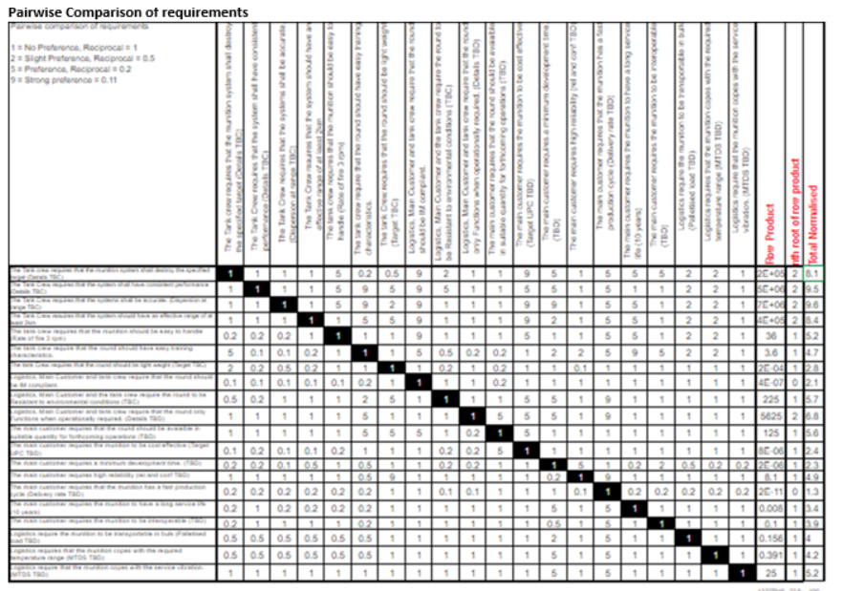
- 9 = Strong Preference, Reciprocal = 0.11
(Figure 1 – Pairwise Comparison of Requirements)

After conducting the pairwise comparison it was clear that the function that came out on top was “That the Tank Crew Requires that the system shall be accurate”. This is obvious and is a safety and a performance requirement. This result can be seen clearer in the graph below:

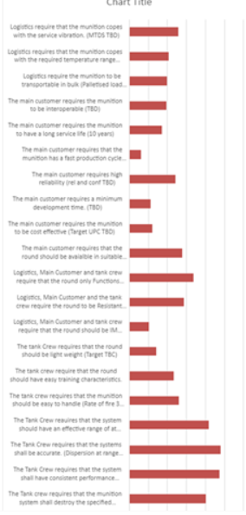

(Figure 2 – Graph Pairwise Comparison)

The requirement that came out on top was closely followed by “The tank crew requires that the system shall have consistent performance”. Yet again this is another requirement that is a safety and performance critical requirement as the crew need to know what the munition is going to do at all times in order to keep it safe.

Required Functionality

What is Required Functionality?

In systems engineering, the required functionality refers to the set of functions or capabilities that a system must possess in order to fulfil its intended purpose or meet the specified requirements. This includes both primary functions as well as any secondary or supporting functions necessary for the system to operate effectively and efficiently. Defining the required functionality is a critical step in the system development process, as it guides the design, implementation, and testing phases to ensure that the final product meets the needs of its users.

Required Functionality for The Munition

Below shows the required functionality list for the munition.
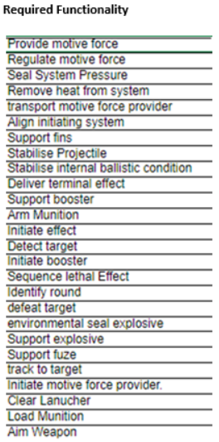

(Figure 3 – Required Functionality)
The system is always required to, provide and regulate a motive force, seal system pressure when firing, remove heat from the system, transport the motive force provider, align the initiating system, support the fins, stabilise the projectile, stabilise internal ballistic conditions, deliver terminal effect, support the booster, arm the munition, initiate effect, detect the target, initiate the booster, sequence lethal effect, identify round, defeat target, environmental seal explosive, support the explosive, support the fuze, track to target, initiate motive force provider, clear the launcher, load munition and arm weapon.
As you can see there is a large list of required functionalities expected of the system. Some of these more important than others.

QFD 1

What is a QFD?

In systems engineering, Quality Function Deployment (QFD) is a technique used to ensure that the design of a system or product meets the needs and expectations of the stakeholders. It involves translating customer requirements into specific engineering characteristics and requirements. QFD helps in prioritizing design features, identifying potential conflicts or trade-offs, and ensuring that the final system design aligns with the customer's needs and preferences. It's a systematic approach that facilitates cross-functional collaboration and decision-making throughout the system development lifecycle.

What is QFD 1?

QFD 1, in systems engineering, typically refers to the first stage or phase of the Quality Function Deployment process. During this initial phase, the focus is on gathering and understanding customer needs, requirements, and preferences. This involves techniques such as market research, customer surveys, interviews, and focus groups to identify and prioritize the key features and characteristics that customers desire in the system or product. The output of QFD 1 is often a comprehensive list of customer requirements and expectations, which serve as the basis for subsequent stages of the QFD process, where these requirements are translated into specific technical characteristics and design parameters.

QFD 1 for The Munition

Below is the QFD constructed for the munition. The QFD rating are either one of four scores. They are:
- Blank = not related at all
- 1 = slightly related
- 3 = related
- 9 = very related
The QFD 1 will show how the required functions relate to the customer requirements. For example, provide motive force is very related to the fact that the tank crew require that the munitions system shall destroy the specified target. Meaning without the system providing the right amount of motive force the system shall not destroy the specified target.

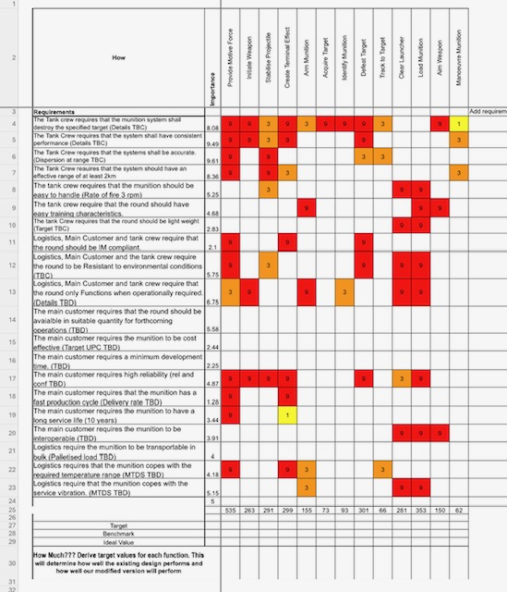

(Figure 4 –QFD 1)
From undertaking QFD 1 it is clear that providing the motive force for the munition is the most essential function that the system needs to complete. On the other hand, Manoeuvring the munition came out as the least essential function the system has to complete. This can all be seen in the QFD 1 Functional Importance’s Graph below:
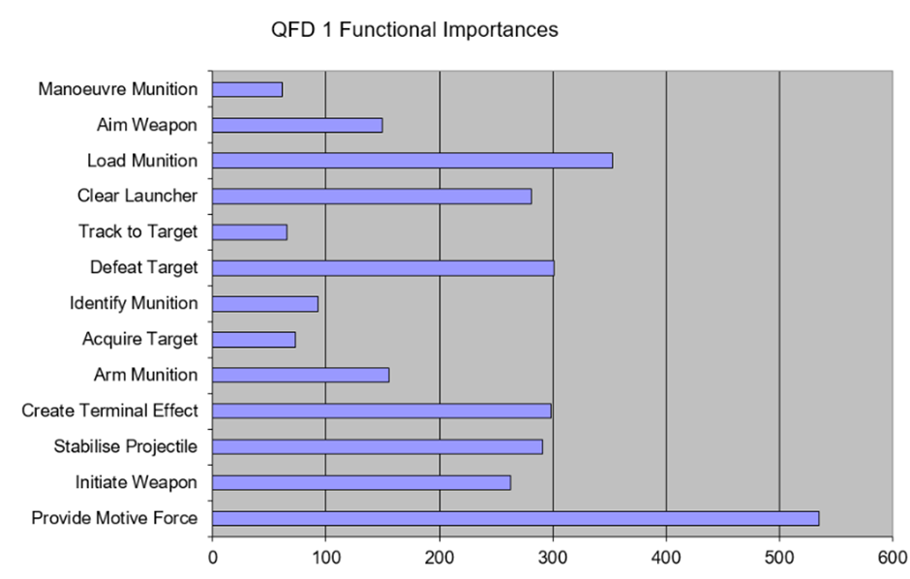

(Figure 5 – QFD 1 Functional Importance’s Graph)

Functional Means Analysis

What is a Functional Means Analysis?

A functional means analysis is a methodical procedure used in product design and engineering to comprehend the functionalities needed in a system, process, or system. It entails determining the critical tasks the system must complete in order to fulfil its intended purpose, as well as the methods by which these tasks are completed. This analysis aids in requirement definition, dependency comprehension, and design optimisation for effective achievement of goals.

Functional Means Analysis for The Munition

In order to complete the Functional Means Analysis, the functions from the QFD 1 had to be inputted into a table. All of the possible ways each function could possibly be completed were then thought of. This is shown below in (Figure 6).
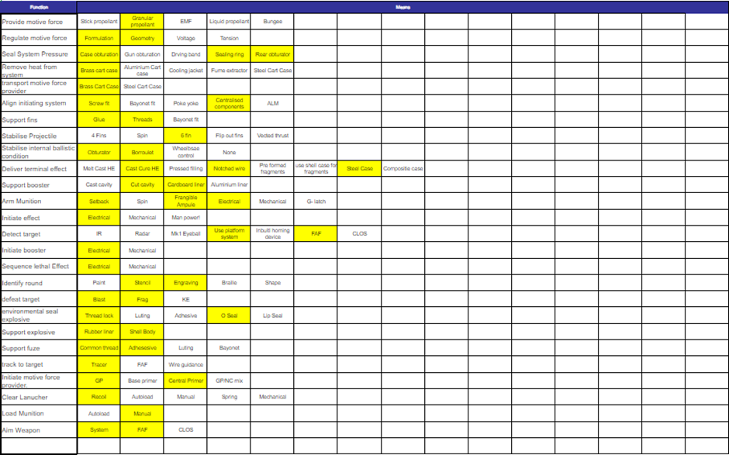
(Figure 6 – Functional Means Analysis)
Once multiple different means had been identified for each function they had to be whittled down to the best ones. The yellow highlighted squares are the best ideas for that function and have the higher chance of being taken forward to the next stage of the systems engineering process.
In this case it was identified that in order to provide sufficient motive force it is best to use granular propellant in the design. This comes down too many different reasons. With granular propellant there is improved safety as it is less sensitive to shock and impact compared to traditional explosives. This therefore reduces the risk of accidental detonation during handling and transport. With granular propellant there is also a controlled burn rate. This is done by adjusting various different factors such as particle size, shape and also the chemical composition. Having this leverage allows the engineers to tailor the propellants performance to meet specific requirements.
There is also an efficient energy release as granular propellant typically has a higher energy release compared to other explosives which allows them to deliver more energy per unit volume or weight. Granular propellant is also better for the environment and is also very versatile. [3]
Another means that was identified in order to remove heat from the system was to use a brass cart case. The reason for this is because brass has a relatively high heat capacity which means it can absorb and store a significant amount of heat therefore taking it away from the system allowing it too cool down. [4]
The rest of the highlighted means that were selected are all shown in (Figure 6).

Feature Importance’s

What Are Feature Importance’s?
[5]
Feature importance’s refer to the significance or contribution of individual features (also known as variables or attributes) in a machine learning model's prediction or classification process.
When building a machine learning model, various features are used as inputs to make predictions or classify data points. Feature importance’s help to identify which of these features have the most influence on the model's output.
Importance scores are typically calculated based on the model's performance metrics, such as accuracy, precision, or mean squared error, and how they change when individual features are removed from or added to the model.
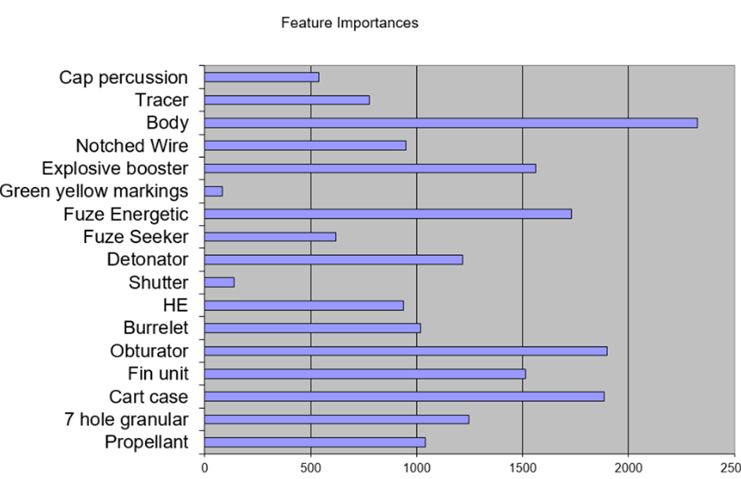

(Figure 7 – Feature Importance’s)

After creating a list of all of the parts that were going to be used in the munition design the body of the munition was highlighted as the most important. This is clear as the body hold all of the parts of the munition together, without this the munitions parts could not work together. It is the backbone of the munition. Some of the reasons it is considered the most important part are listed below: [6]
- Containment and Stability: The body houses the explosive material and other critical components of the munition, such as fuzes and detonators. It provides containment to ensure that the explosive remains stable and safe until intentionally detonated.
- Functionality: The design and construction of the body determine the overall functionality of the munition, including its ability to penetrate targets, disperse payload, or achieve other desired effects. The body must be structurally sound to withstand the forces exerted during firing, transport, and impact.
- Safety: A well-designed body helps to prevent accidental detonation or premature explosion of the munition. It may incorporate features such as safety mechanisms, arming devices, and protective coatings to minimize the risk of unintended detonation due to mishandling or environmental factors.
- Lethality and Effectiveness: The body shape, material composition, and construction techniques can significantly impact the lethality and effectiveness of the munition against its intended targets. For example, aerodynamic body shapes may enhance accuracy and range, while specialized casings or liners may optimize fragmentation or blast effects.
- Integration and Compatibility: The body of the munition must be compatible with other components, such as propulsion systems, guidance systems, and delivery platforms, to ensure proper integration and functionality within the larger system.

Control Factors

What are Control Factors?

Control factors, also known as control variables or independent variables, are variables that are intentionally manipulated or controlled in an experiment or study. These factors are altered or held constant to observe their effect on the dependent variable, which is the variable being measured or observed. Control factors are crucial for ensuring that any observed changes in the dependent variable can be attributed to the manipulated variables rather than external factors. In experimental design, controlling for these factors helps to isolate the effect of the variables of interest and improve the validity and reliability of the results.

The Munitions Control Factors

There were six control factors that had to be looked at, they were:
- Pressure Budget
- Upper and Lower Temperature
- Fragmentation Pattern
- Circular Area Probable
- 120 dia
- Length
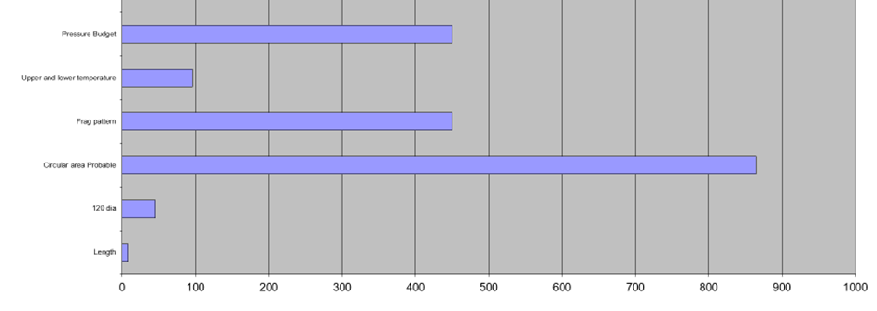
(Figure 8 – Control Factors)

It is clear from (Figure 8) that Circular Area Probable came out as the biggest control factor. Circular Error Probable (CEP) is a measure used to quantify the accuracy of a weapon system, including explosives. It represents the radius of a circle within which a certain percentage of projectiles or explosives are expected to impact, given a specific firing or delivery scenario.
In the context of explosives, CEP is often used to assess the precision of munitions, such as bombs or artillery shells, in hitting their intended targets. A smaller CEP indicates higher accuracy, as it means that a higher percentage of explosions will occur closer to the target point.
CEP is influenced by various factors, including the precision of the guidance system (if applicable), environmental conditions, and inherent variability in the weapon's performance. It is an important metric for evaluating the effectiveness of weapon systems and informing tactical decision-making in military operations. [7]

Noise Factors

What are Noise Factors?

Noise factors, are variables in an experiment or study that can affect the outcome but are not of primary interest. Unlike control factors, which are intentionally manipulated, noise factors are typically uncontrollable or difficult to control. These factors can introduce variability or random fluctuations into the data, making it harder to detect the true effects of the variables of interest.
Also, using functional means analysis highlights all the possible ways of carrying out the functions of the system meaning they can be whittled down and the best idea can be taken forward into the design stage.
Also the fact that all of the control and noise factors are noted helps to know what can be changed and what cannot be. This allows the design team to get a better understanding when designing a new munition (in this case) to what they can do to effect the performance of the overall system.

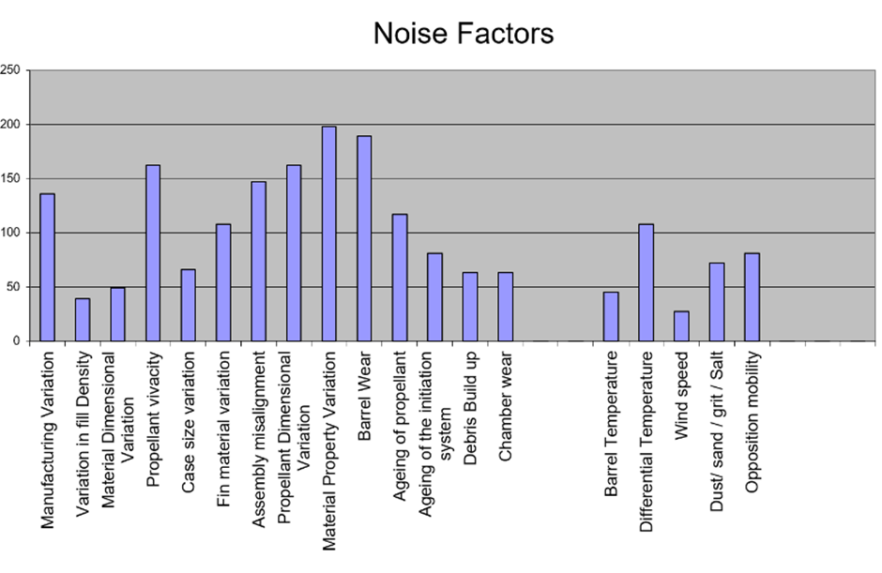
(Figure 9 – Noise Factors)
There were nineteen Noise Factors that had to be looked at, they were:
- Manufacturing Variation
- Variation in Fill Density
- Material Dimensional Variation
- Propellant Vivacity
- Case Size Variation
- Fin Material Variation
- Assembly Misalignment
- Propellant Dimensional Variation
- Material Property Variation
- Barrel Wear
- Ageing of Propellant
- Ageing of The Initiation System
- Debris Build Up
- Chamber Wear
- Barrel Temperature
- Differential Temperature
- Wind Speed
- Dust/Sand/Grit/Salt
- Opposition Mobility
It is clear from (Figure 9) that out of the fourteen Noise Factors ‘Material Property Variation’ came out as the biggest Noise Factor. This is the biggest noise factor as the physical and chemical characteristics within an explosives material cannot be changed. This is a huge downside as the variation can have significant implications for the performance and behaviour of the explosive in different conditions and applications.

Conclusion

All in all, Systems engineering is a great way of thinking, it simplifies the way of thinking and helps to keep every part of the process in order. Starting with the customer requirements then undertaking a pairwise comparison for the requirements to ultimately decide which ones are the priority and most important. Then to go onto the required functionality of the system so all aspects of its workings are recorded and everyone on the systems engineering team is aware on how the system works. Completing the first QFD helps to understand the customers’ requirements, preferences and needs by comparing them to the functionalities of the system to gauge a better idea of which ones are most important and which one’s work with the systems functions the best allowing them to be prioritised. Having a clear plan for each section allows everything to be easily checked once the final product has been completed, it is easy to gain access to any part of the process if each part is noted down. If mistakes are made it is easy to go back to the drawing board and find out where the process went wrong so the Systems Engineer team can go down and follow a different plan.

References

[1] | “INCOSE,” [Online]. Available: https://www.incose.org/about-systems-engineering/what-is-systems-engineering. [Accessed 12th March 2024].
[2] | 18 March 2024. [Online]. Available: https://www.opinionx.co/blog/pairwise-comparison#:~:text=Pairwise%20comparison%20is%20the%20process,and%20conducting%20voting%20at%20scale..
[3] | “National Park Services,” [Online]. Available: https://www.nps.gov/parkhistory/online_books/npsg/explosives/Chapter2.pdf. [Accessed 15th March 2024].
[4] | J. Siewert, “Cartridge Cases &,” Burlington.
[5] | T. Shin, “builtin,” 7th November 2023. [Online]. Available: https://builtin.com/data-science/feature-importance. [Accessed 20th March 2024].
[6] | “Wikipedia,” [Online]. Available: https://en.wikipedia.org/wiki/Cartridge_(firearms). [Accessed 2nd April 2024].
[7] | “BernardHill,” [Online]. Available: http://bernardhill.com/blog/circular-error-probable26102014. [Accessed 18th April 2024].

