

Assessment 1 – Reading Task Template
PART 1: Upload your photo of your A3 in-class notes here:
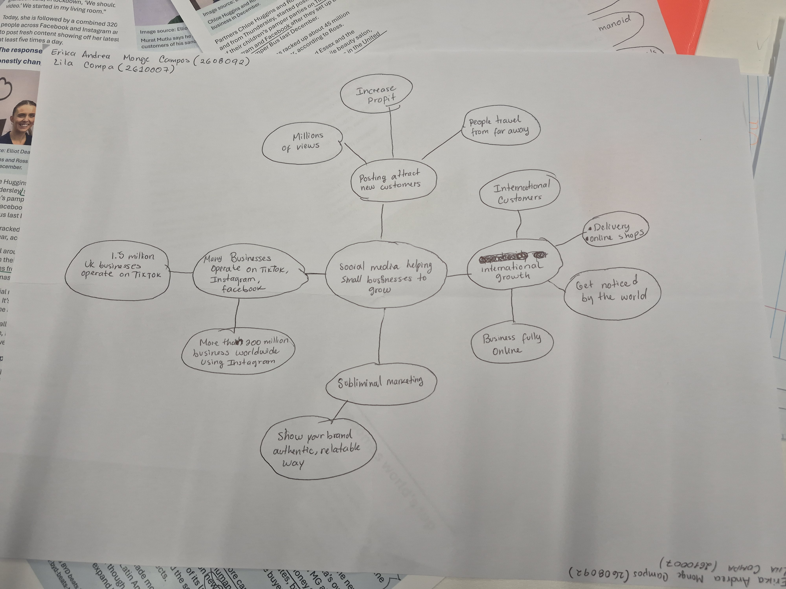

PART 2:
- Answer every question below in 1-3 full sentences.
- Use your own words. Do not use generative AI to answer these questions.
- Include a specific detail from the text when asked.
REMINDER
- The main idea is the overall message of the whole text.
- A key point helps to explain the main idea.
- A specific detail or example from the text shows that the key point is true.

- What is the main idea of the whole text?
The main idea is to understand how social media has helped small businesses to grow up and to be known by many people even from worldwide.

- What is one key point that supports the main idea, and which specific example from the text shows this?
“About 1.5 million UK businesses operate on TikTok and more than 200 million businesses worldwide are using Instagram to reach customers”.
One example is Lindsay Loo’s Boutique. Is an online shop, the owner Linda started to post on Instagram and, after 46 years selling on markets, has moved the business fully online and now is selling across the UK and Australia.

- What is a different key point that supports the main idea, and which specific example from the text shows this?
“A number of businesses in Essex are currently enjoying a boost in business after going viral”. Honeywood Sandwich shop went viral on TikTok and thanks to this, It opened up possibilities for the restaurant to generate more revenue and attract new customers that even travel long distances reach it. Also the content post by its customers has helped boost the business.

- Which part of the text do you think is most important, and why?
For me, the most important part of the text is the number of people benefiting from the platforms, as this helps to understand through actual figures whether they are effective.

Reflection:
- What did you find difficult in this task (including in-class components), and why was it difficult?
The mind map was difficult for me as I have to identify a lot of important information and classify them but also think it’s lack of practice.

- What helped you with this difficulty, and how did it help you?
I made notes in my notebook, classifying them by importance so that I could later create the mind map.

