BMSW4003
Digital Skills and Research Method
Assessment 2

Contents
Introduction 2
Background 3
Objectives 5
Research Method 6
Survey 7
Result 14
Discussion 15
Conclusion 16
References 17
Appendices 18
Appendix 1: Survey Questionnaire 18

Introduction
The recent Corona Virus (Covid-19) Pandemic has changed many things and the education sector is one of them. Many educational institutions are now depending on the Virtual Learning Environment (VLE) to ensure academic teaching among the students (Thomas, 2012). Virtual Learning Environment is helping students to continue their study from home or a safe place without being hampered by the recent pandemic. Many institutions have adopted technology-based education to provide the necessary classes, information, data, and resource to facilitate the study of the students. This research will provide information about the importance of virtual learning. It will also show a statistical view of the students of ‘University of Wales Trinity Campus’ and their opinion on the importance and difficulties of virtual learning, how is the environment important for virtual learning, and what necessary steps can be taken to further improvise the process of virtual learning.

Background
Virtual Learning Environment (VLE) is a virtual learning system that creates an educational environment that is designed with the purpose to help the teachers and students from educational institutions using computer-based hardware and software (Thomas, 2012). Virtual learning first began in the 1840s by Isaac Pitman who used to teach shorthand to his students using newspaper and correspondence. The first virtual learning system was used to deliver necessary information to students (Keppell, Souter, Riddle, and Tynan, 2014). It was called ‘distance learning’ at that time. It was in the 1970s when virtual learning became and an important source of interaction between the teachers and the students.
Many universities, schools, and colleges use virtual teaching methods and technologies to facilitate their academic activities. Many educational institutions provide academic mail to both the teachers and the students. Using mail to exchange information has become a common practice nowadays. The advancement in the field of technology changed the perspective of virtual learning. Technology played a major role in reshaping the model and structure of online teaching.
The following table will show how virtual learning developed from the 1840s to the present day.
Year | Event
1840 | Issac Pitman began teaching shorthand to his students. He used newspapers to teach shorthand to his students(Nelson and Erlandson, 2012).
1847 | Distance education first began at the Illinois University of The United States of America (Thomas, 2012).
1906 | The first university of ‘distance education’ was founded. The name of the university was ‘University of Wisconsin-Extension’. The university was founded in Madison, Wisconsin of the United States (Thomas, 2012).
1956-1958 | A physics professor from the University of Berkley broadcasted physics lessons to the students of various public schools (Nelson and Erlandson, 2012).
1988 | Computer-based hardware and software were being used for the first time for virtual learning (Nelson and Erlandson, 2012).
2000-present | Many business organisation, teaching mediums, educational institutions are using virtual learning to improve the skill of the employees and their students (Thomas, 2012).
Table 1: Development of Virtual Learning
In the 2000s, virtual learning technologies were used by many business companies to train their employees (Keppell, Souter, Riddle, and Tynan, 2014). Employees were given access to various skill-based programs at home and the ability to earn online skills and degrees. Now the educational institutions are using virtual platforms and mediums to improve the quality of their students.

Objectives
The objective of this research is to show the impact of virtual learning among students. The selected educational institution for this research is the ‘University of Wales Trinity Saint David London Campus’. The students are using an online platform for educational purposes. Virtual learning is playing an important role in the recent Corona Virus outbreak. The aim of virtual learning is given below:
- Virtual learning improves the quality of learning and teaching for both the teachers and the students. The students of the university from the London Campus are improving their learning skills via virtual learning platforms (UWTSD, 2020).
- Virtual learning provides professional development opportunities to the students of the University of Wales Trinity Saint David London Campus (UWTSD, 2020).
- Virtual learning benefits the university by increasing enrollments. The university provides online courses (UWTSD, 2020). So many students who want to go through higher education are taking advantage of such benefits.
The research is going to focus on these aims and objectives of virtual learning of the students from the London campus of ‘University of Wales Trinity Saint David’.

Research Method
Every research is done by using some specific research method. To complete this research, the Quantitative Research Method has been used. Quantitative research is a kind of research where numerical data are collected and analysed (Chandra and Harindran, 2017). Quantitative Research is a systematic investigation of various phenomena (Scheurich, 2014). The research was based upon a survey of over 40 students from the ‘University of Wales Saint Davis’ London campus.
40 students from the London campus of the university took part in the survey. The participants that took part in the servey were chosen by using the random sampling method. This method was applied to ensure that the research doesn’t go through any bias or any kind of variables in data that may result in a failed research. Quantitative research requires. proper data and analysis along with a standard result. The students that took part in the survey were fully informed about the research process and purpose. They gave their consent when they participated in the survey.
The research was completed using the deductive approach. The deductive approach develops a hypothesis based on existing theory (Chandra and Harindran, 2017). It designs a research strategy to test the hypothesis (Chandra and Harindran, 2017). In this case, a questionnaire was designed to survey 40 students of the university. They gave answers based upon the questions and the answers created a hypothesis. The hypothesis was then used to plan a research strategy and the strategy concluded into a result.

Survey
40 students from the university participated in a survey about the impact and importance of virtual learning. The researcher had arbitrairy selected 40 respondents which was the basic approach of random sampling method. This method was applied to ensure that the research doesn’t go through any bias or any kind of variables in data that may result in a failed research. These 40 students were given proper instructions about the research procedure and purpose before making them a crucial part of this survey. They gave their consent when they participated in the survey. There is a line graph attached to every question that will give a clear view of each data. The research questions and the answer of the participants are given below:
- Are you taking virtual classes from the university?
Yes | No
40 | 0
Table 2: Answers to Question 1


Figure 1: Line Graph of Question 1

- Have you done any kind of virtual classes before?
Yes | No
25 | 15
Table 3: Answers to Question 2

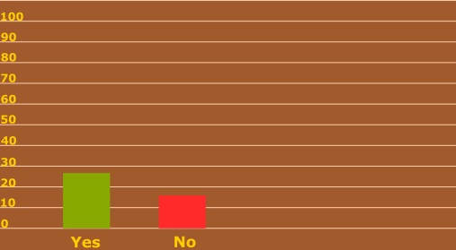
Figure 2: Line Graph of Question 2

- Are you satisfied with your Virtual Learning Environment?
Yes | No
31 | 9
Table 4: Answers to Question 3

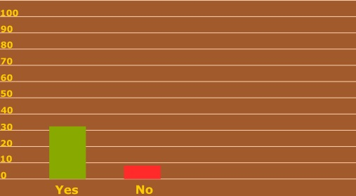
Figure 3: Line Graph of Question 3

- Are you satisfied with your virtual learning skills?

Yes | No
22 | 18
Table 5: Answers to Question 4


Figure 4: Line Graph of Question 4

- Which Learning Management System (LMS) you prefer for virtual classes?
Blackboard | Google Classroom | Zoom Meeting
6 | 24 | 10
Table 6: Answers to Question 5


Figure 5: Line Graph of Question 5

- Is your teacher helping you with your virtual classes?
Yes | No
34 | 6
Table 7: Answers to Question 6


Figure 6: Line Graph of Question 6

- Are you capable enough to complete your virtual learning without any help from your teacher or the university?

Yes | No
20 | 20
Table 8: Answers to Question 7


Figure 7: Line Graph of Question 7
- Are you capable enough to cope up with the virtual learning environment provided by the university?

Yes | No
27 | 13
Table 9: Answers to Question 8


Figure 8: Line Graph of Question 8

- Do you have sufficient technology to help you with your virtual classes?

Yes | No
34 | 6
Table 10: Answers to Question 9
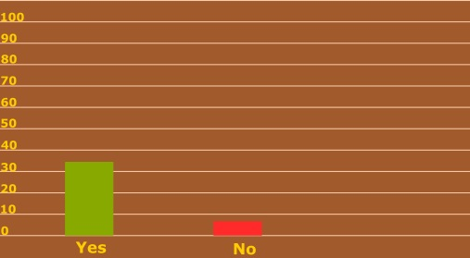Figure 9: Line Graph of Question 9
- How much time you are spending online for virtual learning?

1-2 hours | 2-4 hours | 4-8 hours | 8-12 hours
7 | 18 | 11 | 4
Table 11: Answers to Question 10

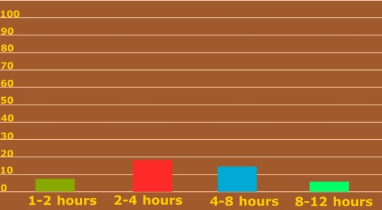
Figure 10: Line Graph of Question 10

- Do you prefer offline learning more efficient than online learning?

Yes | No
17 | 23
Table 12: Answers to Question 11

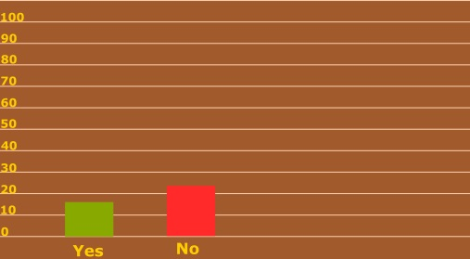
Figure 11: Line Graph of Question 11
- Do you think virtual learning is more efficient than offline teaching?

Yes | No
23 | 17
Table 13: Answers to Question 12

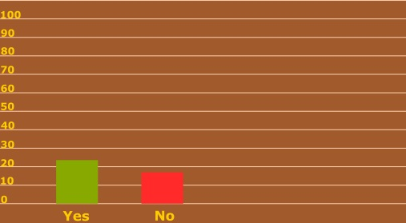
Figure 12: Line Graph of Question 12

Result
The survey shows that all 40 students are taking part in virtual learning activities. Among these students, 25 students were accustomed to virtual learning before. 31 students concluded that they have satisfactory virtual learning environment. 22 students are satisfied with their virtual learning skills while 18 students are not satisfied.
The students prefer Google Classroom for their virtual classes. 24 students said yes to using Google Classroom as using their learning management system. 10 students prefer Zoom Meeting and 6 prefer Blackboard.
34 students are getting help from their teacher with their virtual activity. 20 students think that they are capable of virtual learning without taking help from their teacher or the university. 20 students said no to the question.
34 students have the required technology they need to complete their virtual learning. 27 of them can cope up with the virtual learning environment provided by the university.
The students are spending 1-12 hours online daily for virtual classes. The number of students that spend 1-2 hours daily for an online class is 7, 18 students spend 2-4 hours, 11 students spend 4-8 hours and 4 students spend 8-12 hours.
23 students among these 40 students prefer online classes over offline classes. They think the virtual platform is the best platform to facilitate their study.
40 students from the university participated in this survey about the impact and importance of virtual learning. These are the results the survey provided us.

Discussion
The survey shows that Virtual Learning is really important. Due to the recent Covid-19 outbreak, it is almost impossible for the university to take offline classing. Online classes are helping the students to continue their studies even in this difficult situation. The teachers and the university is providing the students with all the materials, necessary information, and data to continue their study even from their home.
The students are accustomed to online teaching before and they have the necessary devices to take part in virtual learning. The success of virtual learning depends a lot on the use of proper technology. It is important to utilise computer-based hardware and software for virtual teaching. A good internet connection is another key element of virtual learning. The teachers need to be qualified to participate in virtual learning. Without their active presence, the students won’t get a proper virtual learning environment. They have to help the students so that they can get the maximum benefit from this virtual learning platform.
40 students from the ‘University of Wales Trinity Saint David London Campus’ participated in the survey about the impact and importance of virtual learning. The researcher had arbitrairy selected 40 respondents which was the basic approach of random sampling method. This method was applied to ensure that the research doesn’t go through any bias or any kind of variables in data that may result in a failed research. The students that participated in the survey had full knowledge of the survey. They gave their consent when they participated in the survey. The survey shows that students prefer online teaching over offline teaching. It is saving their time and workforce.
The ‘University of Wales Trinity Saint David’ London Campus is ensuring a better online teaching process and a better learning environment for its students. The students are participating in the online classes and are being able to facilitate their studies even in the time of Corona Virus.

Conclusion
We live in an era where technology is of great importance. As technology is improving, it is upgrading educational systems along with it. No one can deny the benefits of virtual learning. Virtual learning requires a better learning environment. So, every educational institution needs to provide a better virtual learning environment to its students.

References
Chandra, V., and Harindran, A., 2017. Research Methodology. [S.l.]: Pearson Education India.
Keppell, M., Souter, K., Riddle, M., and Tynan, B., 2014. Physical And Virtual Learning Spaces In Higher Education. Hershey: IGI Global.
Nelson, B., and Erlandson, B., 2012. Design For Learning In Virtual Worlds. Hoboken: Taylor & Francis.
Scheurich, J., 2014. Research Method In The Postmodern. Hoboken: Taylor and Francis.
Thomas, M., 2012. Design, Implementation, And Evaluation Of Virtual Learning Environments. Hershey, PA: Information Science Reference.
UWTSD, W., 2020. University Of Wales Trinity Saint David. [online] Uwtsd.ac.uk. Available at: <https://www.uwtsd.ac.uk/> [Accessed 16 December 2020].

Appendices

Appendix 1: Survey Questionnaire
- Are you taking virtual classes from the university?
Yes | No
40 | 0

- Have you done any kind of virtual classes before?
Yes | No

- Are you satisfied with your Virtual Learning Environment?
Yes | No

- Are you satisfied with your virtual learning skills?

Yes | No

- Which Learning Management System (LMS) you prefer for virtual classes?
Blackboard | Google Classroom | Zoom Meeting

- Is your teacher helping you with your virtual classes?
Yes | No

- Are you capable enough to complete your virtual learning without any help from your teacher or the university?

Yes | No

- Are you capable enough to cope up with the virtual learning environment provided by the university?

Yes | No

- Do you have sufficient technology to help you with your virtual classes?

Yes | No

- How much time you are spending online for virtual learning?

1-2 hours | 2-4 hours | 4-8 hours | 8-12 hours

- Do you prefer offline learning more efficient than online learning?

Yes | No

- Do you think virtual learning is more efficient than offline teaching?

Yes | No

