BMSW5002
Developing Relationships and Workplace Achievement
Student – Uanjuma Thompson
Student Number – 1713127
Lecturer –
Submission Date – 07/08/2020

Contents

Introduction 1.0
Building the right HRM around Employee preconceptions and requirements including support structures within the company 2.0
Conclusions 2.1
Role of Employee engagement for future success of Dats TV Limited 3.0

Conclusions 3.1
Managing Personnel Career Development plus Performance and Succession 4.0
Conclusions 4.1
Career Development Plan for Uanjuma Thompson (Director of Dats TV Limited) 5.0
- Career Ambitions
- Improvement Strategy
- SWOT
- Plan Outlined
- Timeline
Conclusions 5.1
References 6.0

Introduction 1.0
This report will critically assess the value of:
- Building the right HRM Systems for “Dats Tv Limited” which will monitor the outcomes of
our reward systems and how these reward systems optimise the organisations performance over the long a short term.
- Training/development of employees within an organisation and the importance of creating an environment of support and satisfaction which enables better business function, and successful attainment of long-term goals and short-term targets of “Dats Tv Limited”.
- Developing strategies which support motivation and optimisation of the organisation’s employees over the long and short term. This concept will be illustrated through use of the “Harvard Framework” produced by Beer et al (1984).
- A detailed PDP will be formulated, tailor made to fit the employee development needs and requirements by law relevant to the Dats Tv Limited’s market sectors of Media production.
Dats is a Birmingham based Media production company based in Birmingham UK. Starting in 2018 with three partners from radically different walks of life Dats TV limited managed to establish recognised creative brand within the well-established corporate circles of the media industry, this recognition was in the form of a recognition for good works in the field of media 2018-2019 CE50 Award.
The CE50 award is given out to the most radical an innovative media company start-up recognised from a nationwide pool of talent, the list is filtered down to the just 50 selected companies who then receive the award at the annual CE50 award show and after party. The award itself is from the Creative England UK (creativeengland.co.uk) who pride themselves on being pivotal to the nations “Creative Economy” (2019).
Dats Tv ‘s directors have had to adapt on the job to any human resource needs for all projects and internal action plan, this was done by way of planned training plus mentorship scheduled over a 12-month period. The training/mentorship programs completed by the team were
- Bid writing and presentation training plus mentorship (facilitated by DOC Society UK 2019)
- YouTube plus social media content production training (Facilitated by Little Dot Studios Limited

“Performance is a function of Ability + Motivation + Opportunity” Boxall and Purcell (2003)

Building the right HRM around Employee preconceptions and requirements including support structures within the company 2.0

Within most business entities across the globe, it is well established that the Human Resource (HR) department is in charge of the decision-making processes within a company when concerning the workforce.
Storey (2001) sets out a strategy to achieve the goals of HRM taking into account the assumption that, the people within an organisation are the actual high valued asset, and these assets gift the organisation with an edge over its competitors.
This strategy takes into account a set of beliefs which Storey (2001) sets out as:
- Support in the form of the development of adequate strategy which enhance the success rate of the company. This strategy should be part of wider strategy of the organisation as a whole.
- Taking a major role in evolving the and enhancing a culture of high performance.
- Cultivation of a highly skilled talent base within the organisation who are fully engaged in fulfilling the needs of the organisation.
- Sustainment of a fully cohesive work relationship between high level management and front-line employees, this relationship should be built on trust and respect and a sense of value appreciation. With trust and the knowledge of being valued and organisation can work more effectively and efficiently over the longer term.
- Creation of a complementary work environment and employee experience.
- Enhancement of employee wellbeing as major stakeholders of the organisation.
- Attain “social legitimacy” as set out by Pfeffer (1975) where he defines in his study the merits a cohesive value system between the organisation and its environment.

Conclusions 2.1

Taking into consideration the Storey (2001) belief system you can see that one of the organisations major stakeholders are the people and rightly so, as the employees are what keep the company ticking over like a well oiled machine, and if the HRM framework is built to a dynamic structure that takes into consideration the organisations values and the values of the macro environment so as to synchronize these values, the company can attain a high level of “social Legitimacy” as stated by Pfeffer (1975) in his study into the merits of a cohesive value system between an organisation and its environment. In “Figure 1.1” below it details perfectly the importance of people to an organisation perfectly in the form of a flow chart. I want you to take a closer look at this particular segment of the flow chart by Beer et al (1984),
This section demonstrates the connection between organisational effectiveness and the link it has with the individual’s well-being and the societal well-being as a whole. These long-term consequences are brought about by the HRM policy choices which could be said to hinge on the Reward systems and career path incentives which include, human resource flow and reward systems.
This further establishes the expectations of people through the study of how the HRM systems could be structured around the expectations of the people within the company and their requirements and employee rights by law.

The main support structure of any organisation has to be the Managerial team or individual whichever the case may be concerning the size of the company. Managing the workforce plays a major role in the success of Dats Tv’s Third sector projects as these projects go through a strict reporting procedure where the content and engagement are scrutinised for justification for the funding and any future funding application. Project management comes under great scrutiny on a project-by-project bases in regard to success rates, engagement and reach, the figure below by Fayol (2017) shows the role of management and how it is an integrated organisational undertaking.

Focusing on the structure you can see that Management must take into consideration the needs and expectations of the workforce under their supervision and the expectations of the directorship above them, this is done with great emphasis placed on the need of the internal stakeholders as a priority. Becker et al (2001) theorised the link between people strategy and performance and it can be seen from this figure below that structure also plays a major role in the flow of these strategies and the performance rates attached to these actions.

Role of Employee engagement for future success of Dats TV Limited 3.0

Beer et al (1984) was in the belief that the HRM strategy involved all administrations that affect cohesiveness between the workforce and the organisation on a whole. This belief is characterised by two functioning factors:
- The first belief is that the line manager is responsible for ensuring an adequate strategy that is not only competitive but also fully in line with the organisations policies.
- HR must create cohesive and supportive policies which control the activities of HR and its development implementation strategy.
The Harvard HRM framework best illustrates this concept visually and shows the major effects the people within the organisation have on the long-term well-being, organisational effectiveness and societal wellbeing on a whole as mentioned in figure 1.1 below.

Conclusions 3.1

The Harvard HRM framework best illustrates this concept visually and shows the major effects the people within the organisation have. The workforce has a specific value to an organisation which can be quantified in terms of productivity, attainment of short-term targets and progression towards long term goals.
At Dats TV Limited the organisation has realised that each individual that works for the company, whether upper management, volunteers or subcontractors, all add value to the success of the company and all require proper protection under the law in terms of:
- Legal contracts
- insurances
- Data protection
- Health and safety
- Public liability
Just to name some of the legal requirements that keep the company in a secured position to enable positive long-term results.
Trust and respect are a driving force to realise these principles of regulated and valued business output in our market sector of media production. Stakeholders are another major consideration when it comes to the drafting Dats TVs company policies. Being committed to valuing the workforce who toil on behalf of the company’s success becomes a clear objective for the longevity of any company. These guidelines are set out in the HRM standards produced by the CIPD based on the standards given by the British Standards Institute (2018).
Having clear and successive reward systems in place are a must for the motivation and wellbeing of any company. Dats Tv Limited has taken these theories from Storey (2001) and Beer et al (1984) and used it in the practical sense of creating a reward system within the HRM which is based on the success of any given project, meaning that no matter what position you play within a project, all data regarding the work carried out by a subcontractors and employees in terms of hours put in, over time, taking on extra position to get the job done and successful project management will be collected and used as a points system which will (after the data in analysed by Dats Tv’s board of directors) be rewarded in terms of repeat booking for subcontractors and bonuses alongside promotion to higher paying position within the company, for employees and upper management.

Managing Personnel Career Development plus Performance and Succession 4.0

Managing personnel well within an organisation can foster a competitive edge for a company within its market sector. Legge (1989) argues that managing personnel appropriately can be a result of an organisational culture of integrated strategic business planning. This planning can be accounted as the foundation of human resources putting high value on the employees. Within a successful progressive HR system where employees are seen as a valuable commodity you will find a well-defined Career Development Plan which focuses on the wellbeing and progression of each individual within the company. Within Dats TV each Director, subcontracted, employee, business mentors and volunteer are seen as an asset to the company rather than a liability as argued by Beer et al (1984). The company Dats TV Limited must organise a Strategic Human Resource Management System that creates proper career development that takes into account:
- Employee influence on the long-term success of the company
- The need for smooth acquisition of the right human resources and continued flow upwards through the organisation through. Experience and training programs
- Reward systems set up for personnel motivation on all levels in the form of promotions and end of year bonuses bases on work and success rates.
Within the media industry that Dats tv is a part of gauging personnel success rates on any given project has become more accessible in the form of analytical services which come as part of the media outlet platforms used by Dats tv. By using the data collected from the different media platforms the company can form a picture of how successful each media project or campaign is, using this information the teams involved can be identified and the project managers can be rewarded alongside any other noted outstanding work.
Dats TV has decided to open a Café, this outlet will be opening in June 2021 and the current date is early April 2021, so that gives the company roughly six to seven weeks to create and execute a Career development plan for one of the directors. This plan must develop the relevant skill set and certification for the director so he can run a Café Barr which serves food, drinks and coffee legally and to a high standard of service managing at least two extra Barr staff on pay role. The training necessary will be:
- Food and hygiene training plus certificate
- Alcohol licence training plus certificate
- Barista training
To assist in the success of the development plan a SMART aims strategy will be used to enable that the plan is:

S – Specific to the plan clear and transparent for all involved to comprehend
M – Measured accurately to fully understand the quality aspects of each product or project
A – Achievable and attainable with the current skill sets available and the current equipment range and quality
R – Relevant to the overall organisational goal and development plans
T – Time framed and completed within any given project timeframe
The reason we must ensure that the proper development plan is executed is mainly for the long term success and profitability of the company as a whole as Chamorro-Premuzic (2017) stated, all companies face perils they must overcome and more often than not these problems stem from the human factor of the company, now how a company reacts to any given situation in terms of who they employ or who they fire, who they promote and who they demote all plays a role in how motivated the workforce is and how likely the workforce will stay as part of the organisation. HRM is inevitable as Boxall et al once stated and the existence of well-defined career development plans should be seen as an inevitable action in regards the continued growth of any organisation and in this case Dats TV.

Conclusions 4.1

One of the most important factors within a development plan for any member of the Dats TV group is feedback. As detailed within this report, the third sector endeavours of Dats Tv Limited come with an evaluation process which initial full disclosure of any details regard any the specific project the people involved and the impact on the wider society.
By fostering a more transparent approach to evaluation of personally Dats Tv have created a culture of communication that works. Team members regularly have conference calls where minutes are taken. The data from the meetings is analyse and recommendations are made for discussion at the next scheduled team meeting of conference call. Any progress, achievement or outstanding work by an individual is noted and tallied for fair appraisal of work and adequate reward and career progression within the organisation. Dats Tv run a more organic organisational structure as shown in the diagram below. In this structure the three Partners have their own hierarchical structure within the whole structure with accountability flowing from each structure to its designated director, then the three directors meet to discuss the progression and success rates of each groups work within the organisation. Managers and workers cross communicate between each other to keep the support structures intact with clear lines of communication.
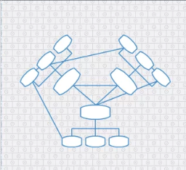
Director/CEO
Worker
Worker
MNGR
Worker
Worker
MNGR
MNGR
Worker
Worker
Director
Director

This has created a system whereby an individual has taken a volunteer position within the company and climbed all the way to being an official partner, shareholder and discission making director of the company. The figure below outlines Dats Tv’s vison to incorporate an AI controlled value chain system which will without human error appraise the works of any individual within the organisation alongside rewarding the customer for loyalty. This system is Knowledge based system where touch points are created along the customer and internal stakeholders’ interaction with the organisation, this information is the analysed by the AI and the recommendations are reviewed by the board of direction for discission making process.

Figure 2.5

Career Development Plan for Uanjuma Thompson (Director of Dats TV Limited) 5.0

Career Ambitions

- Successful Bar/Café Directorship
- Established media production company with extensive client list Management
- Well established and highly profitable Digital real-estate platform ownership and Directorship
- Movie Director Credits
- Movie Producer Credits
- Movie Executive Produce Credits

Improvement Strategy

- Barista Training
- Alcohol licence training
- Food and Hygiene Training
- Digital real-estate online course
- Leadership and management BA HE courses
- SMART strategy
- Progression timeline
The improvement strategy will incorporate all the relevant training required to lift Uanjuma to a level of achievement whereby he can successfully run a small bar in the Birmingham city centre employing the right staff and managing the workforce to a high and successful standard of high profitability and high level of service to customer. To achieve this, aim a range of training courses will be completed to put Uanjuma in the know about Bar tending and managing Food preparation alongside delivering an online presence for the whole bar/café experience.

SWOT

Strengths:
- Adaptable
- Educated to level 4 NVQ
- Highly Motivated
- Successful business owner
- Currently in Higher education for a BA in Leadership and Management
- Computer literate
- Fast learner

Weaknesses:
- Workaholic (needs to know when to rest)
- Experimental
- No bar experiences
- No experience with a coffee machine
- No Alcohol Licence
- No Food and Hygiene Certificate

Opportunities:

- Chance to own a bar with an estimated weekly turnover of £10,000 pounds per week
- Raise working capital for organisation
- Raise Net worth of Dats TV
- Raise yearly wage of all directors at Dats Tv
- Create employment opportunities
- Raise Uanjuma’s individual skill level
- Raise value of DATS TV’s digital real-estate

Threats:

- Timeframes
- Pandemic regulations set by government in the next few months
- Success rate on passing the training courses set
- Competitors
- Home schooling children
- Overworking
- Individual wellbeing
- Overall success of Dats TV

SMART Objectives

Specific/Measured:

- Start the Barista course by 29/04/2021, Complete Barista Training by 29/05/2021
- Start the Licence application by 15/04/2021, Receive Alcohol licence by 29/05/2021
- Start the training by 15/04/2021Complete Food and Hygiene Training by 29/05/2021
- Start Digital real-estate online course by 29/04/2021 ongoing
- Continue the Leadership and management BA HE courses Starting May 2021 ending September 2021
- Follow the SMART strategy
- Monitor the Progression timeline
- Receive all relevant pass certificates

Achievable and Relevant:

- As Uanjuma has shown high success rates in the past in concerns to passing of needed training to help with the success of Dats Tv so far has shown that this plan is very achievable and as the plan has a full description of the steps that must be taken it can be seen that the proposal is in a very good position for achievement.
- The Plan has stuck to the exact issues Dats TV needs to solve to become a successful bar owner and Production company. Uanjuma has already secured a contract for executive production for a movie to be released on Netflix so it looks very positive that Dats TV Limited will achieve the objectives laid out which are very relevant to the overall strategic plan of Dats TV’s board of directors.

Time – Bound:

- Start the Barista course by 29/04/2021, Complete Barista Training by 29/05/2021
- Start the Licence application by 15/04/2021, Receive Alcohol licence by 29/05/2021
- Start the training by 15/04/2021Complete Food and Hygiene Training by 29/04/2021
- Start Digital real-estate online course by 29/04/2021 ongoing
- Continue the Leadership and management BA HE courses Starting May 2021 ending September 2021

Plan Outlined

Each Training course will be completed within the time frame set out within this SMART plan and with all the relevant training in place Uanjuma will be able to start the bar and continue the success and progression of Dats TV in terms of profitability and sustainability in an ethical manner for years to come.

Timeline

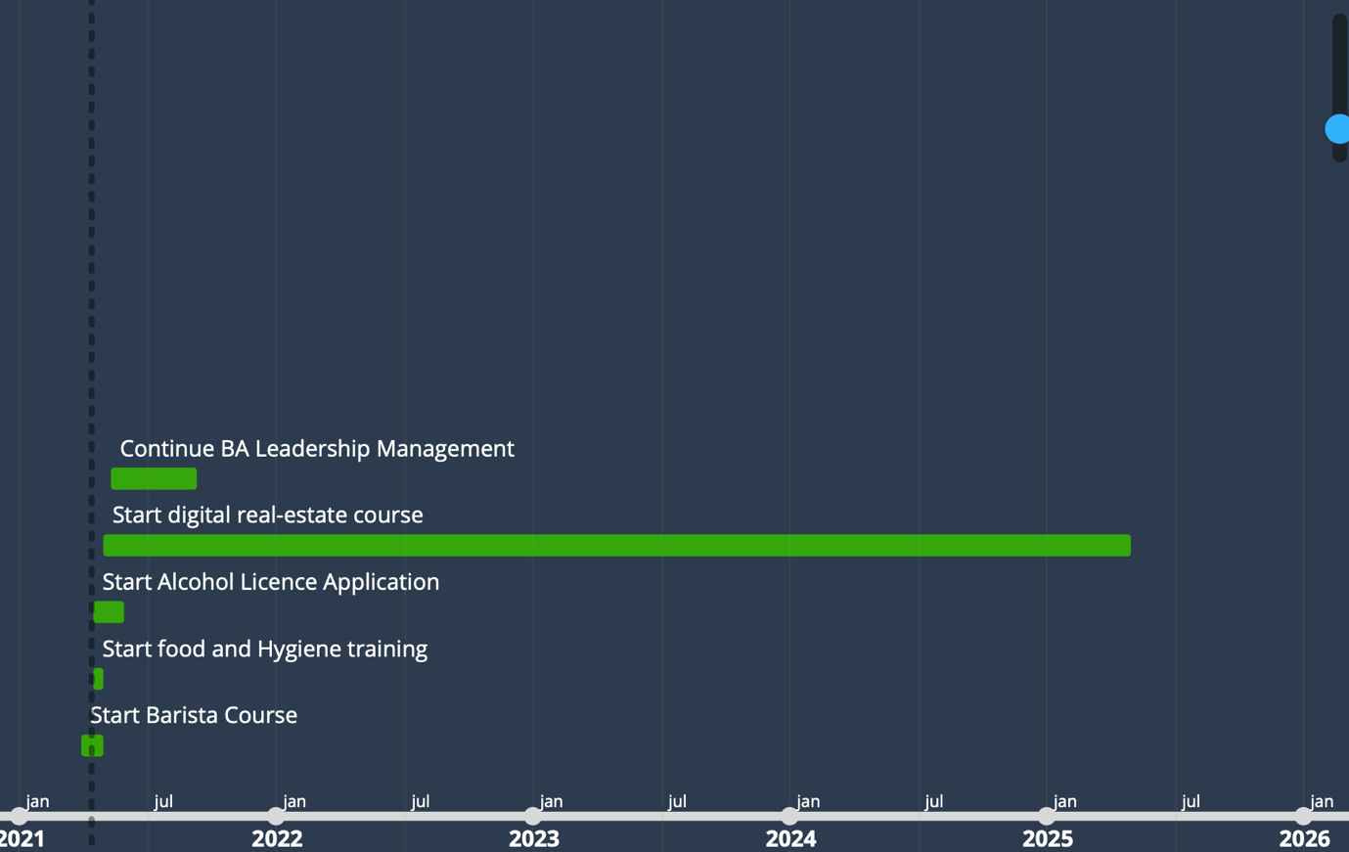

Conclusions 5.1

If the Strategic Progression career plan is followed laid out within this report, Dats Tv will see a huge upturn in profitability and sustainability. This will allow the company to strengthen its support structure by adding personnel and defining the managerial roles within the company for future success in the media industry sector.

References 6.0

Dowling, J. and Pfeffer, J., 1975. Organizational legitimacy:
Social values and organizational behaviour.
Pacific sociological review, 18(1), pp.122-136.

https://www.creativeengland.co.uk/ce50/2019-2/

Schuler RS, Jackson SE, Storey J.
HRM and its link with strategic management. Human resource management:
A critical text. 2001;2:114-30.

Henry Fayol Fourteen Principles. November 2017.
DOI: 10.14738/assrj.422.3889.

