REPORT MODEL
Developing Employability Skills and Personal Branding for a Career as a Health Care Assistant in the UK Health and Social Care Sector

Name: Naheeda Akhter
Student Number: 2240548
Programme – BSc Health and Social Care
Module – Changemakers: Building your Personal Brand for Sustainable Employment
Module Code – BMHP5015
Assignment Title – Component 2 – Written Assignment (Report)
Lecturer Name
Internal Verifier – Dr Eleni Koutsogeorgou-Andreou
Submission Date – Thursday 2nd April 2026

Introduction
The health and social care sector in the United Kingdom requires professionals with a wide range of skills, knowledge and personal attributes to deliver safe and effective care. Employability skills such as communication, teamwork, empathy and professional ethics are essential for ensuring high-quality service delivery. The purpose of this report is to analyse the employability skills required for the role of Health Care Assistant (HCA) within the UK healthcare system.
This report will examine the job description and person specification for the role and identify the key competencies required for successful performance. It will also evaluate my current skills, qualifications and experience in relation to these requirements. In addition, the report will explore strategies for developing a strong personal brand and professional identity in order to improve employability within the health and social care sector.
Finally, a five-year action plan will be developed outlining the steps required to strengthen my skills, gain relevant experience and build a professional network that will support my career progression within the healthcare industry.

2. Job Description and Person Specification

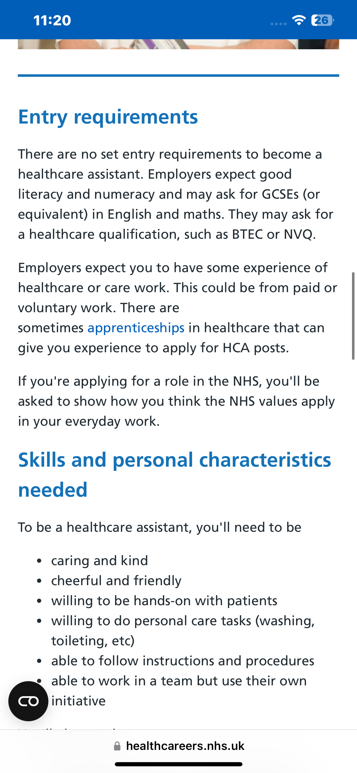
figure 1 shows a current vacancy for Health Care Assistant within the NHS…..
The role selected for this report is Health Care Assistant, a key support role within the National Health Service (NHS). Health Care Assistants work alongside nurses and other healthcare professionals to provide essential patient care in hospitals, clinics and community settings. Their duties typically include assisting patients with personal care, monitoring vital signs, maintaining patient records and providing emotional support to patients and their families.
According to NHS Careers, Health Care Assistants are responsible for supporting the delivery of safe, compassionate and effective care to individuals with different health needs (NHS, 2024). The job description often requires individuals to demonstrate strong communication skills, empathy, teamwork and the ability to follow clinical procedures.
The person specification for this role typically includes both essential and desirable criteria. Essential skills include effective communication, the ability to work as part of a team, basic literacy and numeracy skills and a caring attitude towards patients. Employers also expect candidates to demonstrate an understanding of patient dignity, confidentiality and safeguarding responsibilities (Skills for Care, 2023).
In addition, employers may prefer candidates who have completed relevant qualifications such as a Health and Social Care course or have previous experience in a care environment. These requirements highlight the importance of both academic knowledge and practical experience for individuals seeking employment in the healthcare sector.
3. Analysis of Employability Skills
Several key employability skills are required for individuals working as Health Care Assistants in the UK healthcare system.
Communication Skills
Communication is one of the most important skills in health and social care. Healthcare professionals must communicate effectively with patients, families and colleagues to ensure accurate information sharing and high-quality care delivery. Poor communication can lead to misunderstandings and potential risks to patient safety (World Health Organization, 2023).
Empathy and Compassion
Empathy enables healthcare workers to understand patients’ emotional and physical needs. Compassionate care improves patient satisfaction and contributes to positive healthcare outcomes.
Teamwork
Health Care Assistants work closely with nurses, doctors and other healthcare professionals. Effective teamwork ensures coordinated care and supports efficient healthcare delivery.
Time Management
Healthcare settings can be busy and demanding. Time management skills allow professionals to prioritise tasks and manage workloads effectively.
Professionalism and Ethical Practice
Healthcare workers must follow ethical standards including confidentiality, safeguarding and respect for patient dignity. Professional behaviour builds trust between healthcare professionals and patients.
According to Skills for Care (2023), these skills are essential for maintaining high standards of care and ensuring that patients receive safe and effective treatment.
4. Self-Evaluation of My Skills
A useful way to evaluate my current abilities is through a SWOT analysis.
Strengths
Weaknesses
Strong communication skills
Limited clinical experience
Caring and empathetic personality
Need more practical training
Studying Health and Social Care degree
Limited professional network
Opportunities
Threats
Volunteering in healthcare settings
High competition for jobs
NHS training programmes
Limited job opportunities without experience
Professional networking platforms
Rapid changes in healthcare requirements
My academic studies have helped me develop knowledge of healthcare policies, safeguarding practices and patient-centred care approaches. These skills provide a strong theoretical foundation for working within the healthcare sector. However, practical experience is an area where I need further development.
Gaining hands-on experience through volunteering or part-time work in care settings will help improve my confidence and practical abilities.
5. Current Qualifications and Experience (~150 words)
I am currently studying BSc Health and Social Care, which provides a strong academic understanding of healthcare systems, safeguarding practices and patient-centred care approaches.
During my studies I have developed knowledge of ethical practice, communication in healthcare and the importance of teamwork within multidisciplinary environments. These competencies are essential for healthcare professionals working in patient-focused roles.
In addition to my academic studies, I aim to gain practical experience through volunteering opportunities in hospitals, care homes or community health organisations. Practical experience will allow me to apply theoretical knowledge in real healthcare environments and develop essential patient care skills.
6. Personal Brand and Professional Identity
Personal branding refers to how individuals present their skills, values and professional identity to potential employers. Developing a strong personal brand can improve employability and career opportunities.
A strong professional identity within healthcare should demonstrate compassion, professionalism and commitment to patient wellbeing. My personal brand will focus on being a caring, responsible and motivated healthcare professional dedicated to delivering high-quality care.
To develop my personal brand, I will create a professional CV, build a LinkedIn profile and participate in healthcare-related training programmes. Maintaining professional behaviour in academic and professional settings will also contribute to building a positive reputation.
According to Arruda (2019), personal branding helps individuals differentiate themselves from other candidates and demonstrate their unique strengths to employers.
7. Networking Strategy
Networking plays an important role in career development and employment opportunities. Building relationships with professionals within the healthcare sector can provide valuable insights, mentorship and job opportunities.
I plan to develop my professional network through several strategies including creating a LinkedIn profile, attending healthcare career events and connecting with professionals in the NHS. Additionally, university lecturers and placement supervisors can provide guidance and professional recommendations.
Engaging with professional organisations and healthcare communities can also help individuals stay informed about industry developments and potential job opportunities (Forbes, 2022).
8. Unique Selling Point
My unique selling point is my strong commitment to compassionate and patient-centred care combined with academic knowledge in health and social care. I possess strong interpersonal skills and a genuine desire to support vulnerable individuals.
My multicultural background also enables me to communicate effectively with people from diverse cultural and social backgrounds. This is particularly valuable in the UK healthcare system, which serves a diverse population.
These strengths allow me to contribute positively to healthcare teams and support the delivery of respectful and inclusive care.
9. Five-Year Action Plan
Timeframe
Action
Purpose
Year 1
Complete Health and Social Care degree modules
Gain academic knowledge
Year 2
Volunteer in healthcare or care home
Gain practical experience
Year 3
Complete training (first aid, safeguarding)
Improve professional skills
Year 4
Apply for NHS Healthcare Assistant jobs
Start healthcare career
Year 5
Undertake further professional training
Career progression
This structured plan will allow me to gradually develop the necessary skills and experience required for employment within the healthcare sector.
10. Conclusion
In conclusion, the role of Health Care Assistant requires a wide range of employability skills including communication, empathy, teamwork and professional responsibility. These competencies are essential for providing safe and effective care within healthcare environments.
This report analysed the skills required for this role and evaluated my current abilities through self-assessment. While my academic studies provide a strong foundation of knowledge, further practical experience and professional training are required to strengthen my employability.
By developing a clear action plan, building a strong personal brand and expanding my professional network, I aim to successfully achieve my career goal of working as a Health Care Assistant in the UK healthcare sector.

Harvard References
- Arruda, W. (2019) Digital you: Real personal branding in the virtual age. London: Routledge.
- Beardwell, J. and Thompson, A. (2020) Human resource management. 9th edn. London: Pearson.
- Cottrell, S. (2021) Skills for success: Personal development and employability. 4th edn. London: Red Globe Press.
- Forbes (2022) Why networking is essential for career success. Available at: https://www.forbes.com (Accessed: 6 March 2026).
- Health Careers (2024) Entry requirements for healthcare assistants. Available at: https://www.healthcareers.nhs.uk/explore-roles/healthcare-support-worker/roles-healthcare-support-worker/healthcare-assistant (Accessed: 6 March 2026).
- Health Education England (2022) Healthcare career framework. London: HEE. Available at: https://www.hee.nhs.uk (Accessed: 6 March 2026).
- HSCIC (2022) Health and social care workforce report. London: NHS Digital.
- NHS (2024) Healthcare assistant role overview. Available at: https://www.healthcareers.nhs.uk/explore-roles/healthcare-support-worker/roles-healthcare-support-worker/healthcare-assistant (Accessed: 6 March 2026).
- NHS Employers (2023) Developing staff: Training and workforce development. Available at: https://www.nhsemployers.org (Accessed: 6 March 2026).
- Skills for Care (2022) Safeguarding adults and children in social care. Leeds: Skills for Care.
- Skills for Care (2023) Core skills for the adult social care workforce. Leeds: Skills for Care.
- Thompson, N. (2020) Theory and practice of communication in health and social care. London: Palgrave.
- University of Plymouth (2022) Building your personal brand in healthcare. Available at: https://www.plymouth.ac.uk (Accessed: 6 March 2026).
- World Health Organization (2023) Health workforce competencies. Geneva: WHO. Available at: https://www.who.int (Accessed: 6 March 2026).
- Chartered Institute of Personnel and Development (CIPD) (2021) Employability skills in the workplace. London: CIPD.

