Luke Hunt

Prepared for:
Alan Nantel

Lighting LAyout and sound index calculation
Date Completed: 31/03/2023

Word Count: 490
Table of Contents
Task A: 2
1.0 – Calculations: 2
1.1 – The Room Index: 2
1.2 – Utilisation Factor: 3
1.3 – The Number of Lamps required: 4
1.4 – A suitable layout (value of Smax) for the lamp fittings: 5
Task B: 6
2.0 – Calculations: 6
2.1 – Overall SRI for the brick wall: 6
2.2 – Overall SRI for the Window: 7
2.3 – Average Transmission Coefficient: 7
2.4 – Overall Sound Reduction Index for the entire wall: 8
3.0 – Frequency and Wavelength of a sound and their implications: 9
3.1 – Definition of frequency and the wavelength of a sound: 9
3.2 - A buildings’ internal design and services support 9
3.3 - A partition wall’s construction technique 10
3.4 - The choice of Insulation types available 10
References 11

Task A:

A room measures 20m by 6m by 3m in height requires a service illuminance of 600lux on the work surfaces which are set 1mabove the floor. The luminaire mounting height is 2m above working plane.
The 65W Aluminium Industrial reflector lamps (with incandescent bulb) chosen to have a luminous efficacy of 70 Lumens per W.
They are to be mounted from the ceiling in luminaires which have a DLOR of 70%.
The room reflectance’s are 0.5 for the ceiling and 0.5 for the walls.
The Light Loss Factor is 0.7.

1.0 – Calculations:

– The Room Index:
RI = (L x W)
(H x m (L+W))
RI = (20 x 6)
(2 (20+6))
RI = 120
2 x 26
RI = 120
2 x 26
RI = 120
52
RI = 2.3076923077
= 2.31

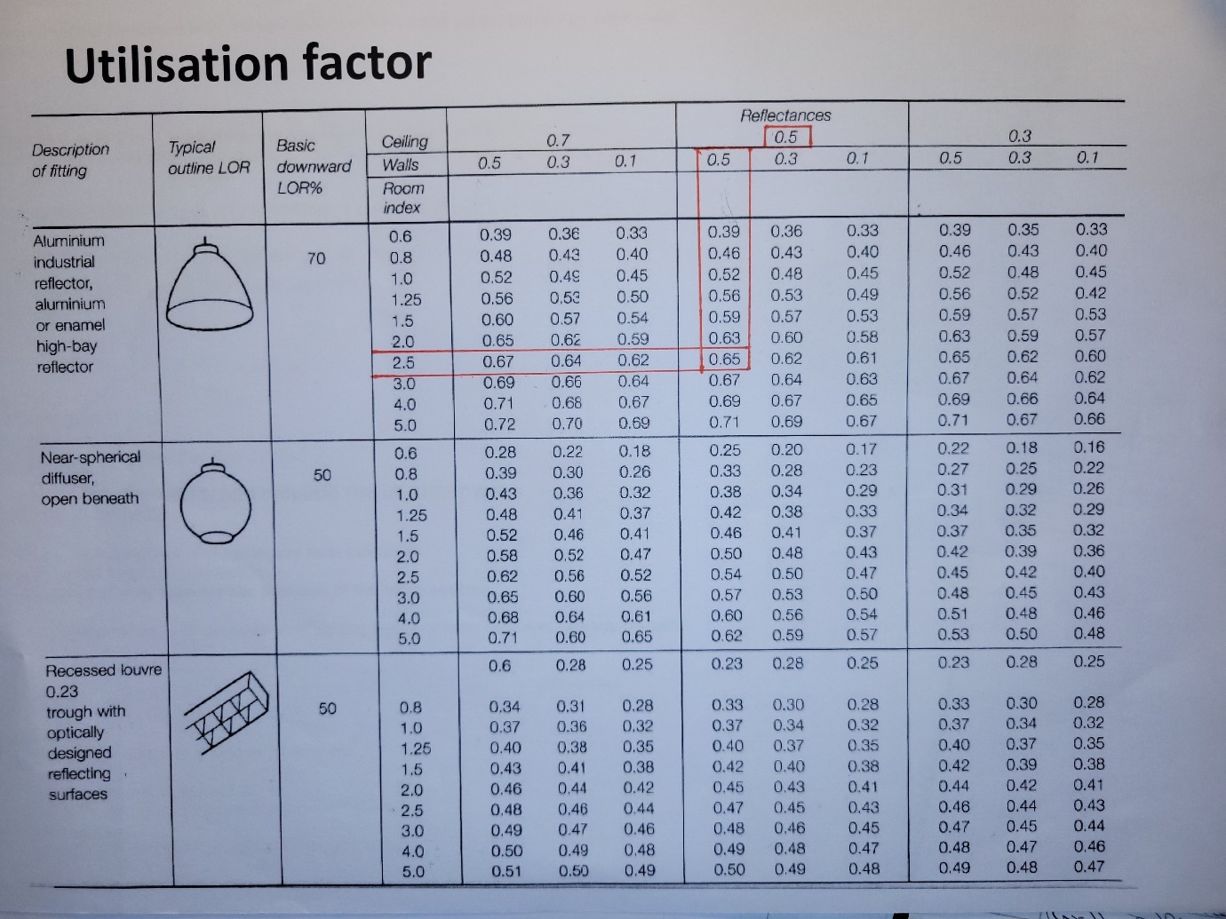
– Utilisation Factor:

Utilisation Factor = 0.65

(Ceiling Reflectance = 0.5)
(Wall Reflectance = 0.5)
(Aluminium Industrial Reflector)
(Room Index = 2.31 Therefore = 2.5)

1.3 – The Number of Lamps required:
N = E x A
F x UF x LLF
N = 600 x (20 x 6)
(65 x 70) x 0.65 x 0.7
N = 600 x 120
4,550 x 0.65 x 0.7
N = 72,000
2,070.25
N = 34.7784084048
N = 36 lamps (given the extra 70%)

1.4 – A suitable layout (value of Smax) for the lamp fittings:

Smax 1.0 = Incandescent bulb
Smax 1.5 = Fluorescent Bulb

Therefore:
Smax = 1.0 x 2
= 2.0m apart (Maximum length)
½ Smax = 1.0m (Light to Wall)

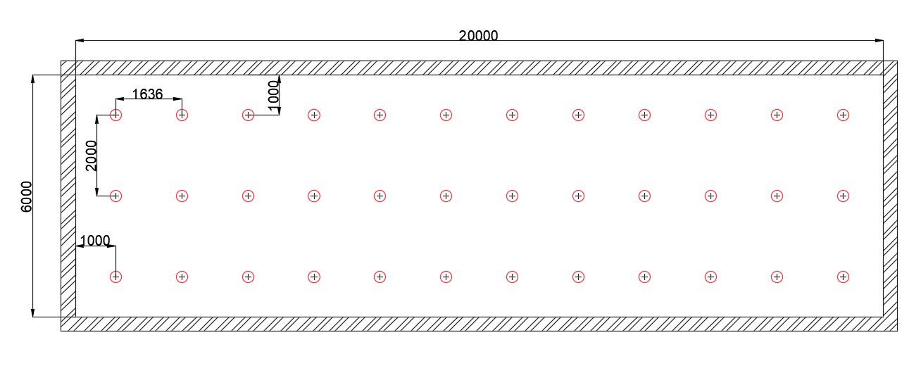

- Light to Wall = 1,000mm/1m
- Distance between each light = 1,636mm/1.6m (length)
- Distance between each light = 2,000mm/2m (width)
- Total length = 20,000mm/20m
- Total width = 6,000mm/6m

Task B:

- (2.0) A brick wall of area 20m² contains a window of area 4m².
The values of sound reduction indexes are:
50dB for the brickwork and 10dB for the window.

– Calculations:

2.1 – Overall SRI for the brick wall:

Brick wall area = 20m² – 4m² = 16m²
SRI = 50dB

SRI = 10 x (log₁₀ (1/T))

50 = 10 x (log₁₀ (1/T₁))

5 = log₁₀ (1/T₁))

1/T₁ = 10⁵

T₁ = 10⁻⁵

T₁ = 0.000010 Transmission coefficient for brick wall

2.2 – Overall SRI for the Window:

Window area = 4m²
SRI = 10dB

SRI = 10 x (log₁₀ (1/T))

10 = 10 x (log₁₀ (1/T₂))

1 = log₁₀ (1/T₂))

1/T₂ = 10¹

T₂ = 10⁻¹

T₂ = 0.10 Transmission coefficient for window

2.3 – Average Transmission Coefficient:

T₀ = (T₁ x A₁) + (T₂ x A₂)
A₁ + A₂
T₀ = (10⁻⁵ x 16) + (10⁻¹ x 4)
16 + 4
T₀ = 0.00016 + 0.4
20
T₀ = 0.020008 Average Transmission Coefficient

2.4 – Overall Sound Reduction Index for the entire wall:
SRI = 10 x (log₁₀ (1/T))

SRI = 10 x (log₁₀ (1/0.0020008))

SRI = 10 x (log₁₀ (49.980008))

SRI = 10 x 1.69

SRI = 16.98796321

SRI = 17dB Overall Sound Reduction Index for the entire wall

- (3.0) Define frequency and the wavelength of a sound, and discuss the implication of dealing with these two parameters in:
2a. A buildings’ internal design and services support
2b. A partition wall’s construction technique
2c. The choice of Insulation types available

3.0 – Frequency and Wavelength of a sound and their implications:

3.1 – Definition of frequency and the wavelength of a sound:

The frequency of sound is described as the number of vibrations or waves per second through any given object or element (Britannica, 2023).
The wavelength is the length of one complete wave or cycle in a horizontal direction (2023).

3.2 - A buildings’ internal design and services support

The internal design of a building and its services support are crucial for human comfort. Sound can permeate through most materials used to construct a building and so is important to design in any sound energy movement resistance. Sound finds the path of least resistance within a building in order to pass through. If a buildings internal design is ineffective due to poor workmanship, it then allows for the potential of sound to leak through gaps and holes in the structure; for example, service entry points, plug sockets, or vibrate through materials like fixing screws and nails (Home Building & Rennovating, 2020). Insulation provides a dense and tight barrier within the walls and around the services, making sound waves less effective at passing through any gaps within the building. Additional layers surrounding any service or part of a structure reduces the energy soundwaves thus, decreasing the level of noise (Superfoil, 2021).

3.3 - A partition wall’s construction technique

There are various ways in which to construct a partition wall, each with their own benefits in construction. There are techniques that can be used to improve its impact on and resistance to the frequency and wavelengths of sound. Different soundproofing materials and methods of construction can provide an efficient barrier to sound, using light weight, durable partition walls, thus making savings on materials and cost, yet providing maximum space, and potential for flexibility.
A partition wall is used within buildings to divide up the internal space for privacy and flexibility. Partition walls are not load bearing and so if not well insulated, sound can pass through. The insulation must provide a loosely dense barrier to absorb any surrounding sound. With many types of partition walls available, it is possible to diversify the internal design and give flexibility within it. Movable walls, for example, allow for one large room to be converted into smaller, more private spaces. In doing so, the soundproofing partition acts as sound barrier, and reduces soundwave energy, whilst maintaining a level of comfort within a building (The Constructor, 2021).

3.4 - The choice of Insulation types available

The fundamental properties of insulation are keeping heat in and keeping cold out of a building. But it is also fundamental for controlling sound and preventing/dampening unwanted sound from external sources – Impact and Airbourne sound. There are numerous types of insulation used in construction, but in particular are Mineral Wool, Fibreglass, Blown-in Cellulose, Spray Foam Insulation and Foam board (Better Soundproofing, 2022). Each of these have their benefits, but fundamentally achieve the same goal; that is to slow and trap the energy of the soundwave as it passes through the light and porous insulation, to an acceptable decibel level.
The type of insulation used in a building can vary depending on factors such as the type of building, the structures’ materials, what the building is to be used for, the location of the building etc. It is primarily down to the purpose of the building and how much soundproofing is needed to ensure the necessary comfort levels are met.

References
Better Soundproofing, 2022. Best Soundproofing Insulation for Noise Reduction. [Online]
Available at: https://bettersoundproofing.com/best-soundproofing-insulation/
[Accessed 20th March 2023].
Britannica, 2023. frequency. [Online]
Available at: https://www.britannica.com/science/frequency-physics
[Accessed 20th March 2023].
Home Building & Rennovating, 2020. Soundproofing Regulations: Part E. [Online]
Available at: https://www.homebuilding.co.uk/advice/soundproofing-regulations-part-e
[Accessed 20th March 2023].
Nantel, A., 2023. s.l.:s.n.
Superfoil, 2021. Does Insulation Reduce Sound Pollution?. [Online]
Available at: https://www.superfoil.co.uk/does-insulation-reduce-sound-pollution/
[Accessed 20th March 2023].
The Constructor, 2021. Partition Walls in Construction: Important features and specifications. [Online]
Available at: https://theconstructor.org/building/partition-walls-building-construction/217914/
[Accessed 20th March 2023].

