

Program: Master of Business Administration
Module Name and Code : Financial Management (LCMB7002)

Assessment Title : Individual Report - Financial Performance and Management
Selected Company : Tesla, Inc. ( NASDAQ: TSLA )

Lecturer Name: Shengfeng Mei
Student Name: Hari Mohan Singh
Student ID: 2506569
Word Count: 6254
Date of Submission: 24/04/2026

Contents
Executive Summary 3
1. Financial Health Check 4
1.1 Company Overview and Context 4
1.2 Five-Year Financial Statements Summary 5
1.3 Comprehensive Ratio Analysis 6
1.3.1 Profitability Ratios 6
1.3.2 Liquidity Ratios 8
1.3.3 Efficiency Ratios 9
1.4 Trends, Strengths, and Strategic Threats 11
2. Working Capital Management Analysis 13
2.1 The Cash Operating Cycle: Theoretical Framework and Application 13
2.2 Strategies to Improve Liquidity Through Working Capital Reforms 14
2.3 Short-Term vs Long-Term Financing Options 14
3. Strategic Financial Restructuring Plan 16
3.1 Context and Rationale for Restructuring 16
3.2 Option 1: Divestiture of SolarCity/Residential Solar Assets 16
3.3 Option 2: Partial Spin-Off or IPO of Tesla Energy Division 16
3.4 Option 3: Strategic Joint Venture for FSD and AI Monetisation 17
3.5 Impact Analysis and Recommended Restructuring Path 18
3.6 International and Ethical Considerations 18
4. Investment Appraisal and Capital Budgeting 20
4.1 Project Overview, Assumptions, and Methodology 20
4.2 Detailed Investment Appraisal Calculations 20
4.2.1 Net Present Value (NPV) 21
4.2.2 Accounting Rate of Return (ARR) 21
4.2.3 Payback Period (PBP) 22
4.2.4 Profitability Index (PI) and Internal Rate of Return (IRR) 22
4.3 Project Recommendation and Strategic Justification 24
4.4 Capital Rationing Analysis: Optimal Investment Portfolio 25
5. Conclusion 26
References 27
Appendices 29
Appendix A: Consolidated Financial Ratio Reference Table 29
Appendix B: Investment Appraisal — Full Calculation Workings 29

Executive Summary
This report presents a comprehensive financial analysis of Tesla, Inc. (NASDAQ: TSLA), the world's most prominent electric vehicle (EV) and clean energy technology company. Appointed as Chief Financial Officer (CFO), this analysis investigates Tesla's financial performance across five fiscal years from 2020 to 2024, critically evaluates structural weaknesses, and proposes a robust strategic financial restructuring plan supported by rigorous investment appraisal.
Tesla has demonstrated extraordinary revenue growth, expanding from $31.5 billion in 2020 to $97.7 billion in 2024 — a compound annual growth rate (CAGR) of approximately 32.6%. However, this headline growth masks deteriorating profitability: gross margins declined from a peak of 25.6% in 2022 to 17.9% in 2024, operating margins fell from 16.8% to 7.2%, and net income halved from $15.0 billion (2023) to $7.1 billion (2024), driven by aggressive price competition from Chinese manufacturers, particularly BYD, and escalating capital expenditure in Gigafactory expansion and AI infrastructure.
Key strategic findings include: (1) Tesla's balance sheet remains exceptionally strong with $36.56 billion cash, low debt-to-equity of 0.19, and a current ratio of 2.02; (2) The Energy Generation and Storage segment represents Tesla's fastest-growing and highest-margin business, warranting strategic separation; (3) The Cash Operating Cycle remains negative at -12 days, indicating superior working capital management, although this advantage is narrowing; and (4) Project C is the recommended standalone investment (NPV: £11.87M, IRR: 19.1%), with the B+C combination (£23.47M NPV) representing the optimal capital-rationed portfolio under a £100 million budget constraint.

1. Financial Health Check

1.1 Company Overview and Context
Tesla, Inc. was incorporated in July 2003 by Martin Eberhard and Marc Tarpenning in San Carlos, California. The most notable figure in the growth path of the company became Elon Musk, who joined the company as a Chairman of the Board in 2004 and became its Chief Executive Officer. Tesla is based today in Austin, Texas, and is an integrated sustainable energy company the mission of which is to hasten the transition of the world to sustainable energy (Tesla, 2025).
Tesla has three main segments of business that reportable. During the first quarter, the Automotive segment, the largest part of the company with approximately 77.1 billion (78.9% of total revenue) in 2024, includes the design, manufacture and sale of electric vehicles such as the Model S, Model 3, Model X, Model Y, Cybertruck and Semi. Second, the Energy Generation and Storage division, which generated $10.1 billion (10.3) in 2024, includes the Powerwall, Powerpack, and Megapack battery storage products, solar roof and solar panel installations. Third, the Services and Other category, which covers 10.5 billion (10.7 percent), covers vehicle servicing, non-warranty after sales repairs, retail merchandise, and the Supercharger system.
Tesla has a worldwide manufacturing presence that includes Gigafactory Nevada (battery cells and energy storage), Fremont Factory (California, Model S/X/3/Y), Gigafactory Shanghai (China, Model 3/Y), Gigafactory Berlin-Brandenburg (Germany, Model Y), and Gigafactory Texas (Austin, Cybertruck, Model Y). It employs around 125,665 full-time workers as of December 2024, and 140,473 at the end of 2023, and the strategic headcount reduction of about 10% implemented in April 2024 aligns with the goal of cost efficiency.
The context of the EV industry at large is fundamental in understanding the financial performance of Tesla. The worldwide sales of EVs were around 17.1 million vehicles in 2024 (IEA, 2025), but Tesla sold 1.79 million vehicles, which is a drop of about 1 year-on-year, the first drop in vehicle deliveries since 2020. This was on a background of price competition: BYD produced 4.27 million NEVs in 2024, establishing itself as the largest manufacturer of EVs by volumes in the world. The strategic price cuts of 15-25% of Tesla models between 2022 and 2024 maintained market share at the cost of fully reducing the margins a trade-off that will be the focus of the restructuring proposals in Section 3.

1.2 Five-Year Financial Statements Summary
The consolidated data of Tesla on the income statement and balance sheet are summarized in the following tables based on the annual report on Form 10-K submitted to the US Securities and Exchange Commission (SEC) by Tesla on fiscal years 2020 to 2024. All future ratio analysis and strategic suggestions are based on these statements.
Table 1.1: Tesla Consolidated Income Statement Summary 2020–2024 (USD Billions)
Metric (USD $B) | 2020 | 2021 | 2022 | 2023 | 2024
Total Revenue | $31.54 | $53.82 | $81.46 | $96.77 | $97.69
Cost of Revenue | $24.91 | $40.22 | $60.61 | $79.11 | $80.24
Gross Profit | $6.63 | $13.61 | $20.85 | $17.66 | $17.45
Operating Expenses | $4.64 | $7.08 | $7.20 | $8.77 | $10.37
Operating Income (EBIT) | $1.99 | $6.52 | $13.66 | $8.89 | $7.08
Net Income (GAAP) | $0.72 | $5.52 | $12.56 | $15.00 | $7.13
EBITDA | $5.82 | $11.62 | $19.19 | $16.63 | $14.71
YoY Revenue Growth (%) | 28.3% | 70.7% | 51.4% | 18.8% | 0.95%

Table 1.2: Tesla Consolidated Balance Sheet Summary 2020–2024 (USD Billions)
Metric (USD $B) | 2020 | 2021 | 2022 | 2023 | 2024
Cash & Equivalents | $19.38 | $17.58 | $22.19 | $29.09 | $36.56
Total Current Assets | $26.72 | $27.10 | $40.92 | $49.62 | $60.90
Total Assets | $52.15 | $62.13 | $82.34 | $106.62 | $122.07
Total Current Liabilities | $14.23 | $19.71 | $26.71 | $28.75 | $30.15
Total Liabilities | $28.57 | $30.55 | $36.44 | $43.01 | $48.39
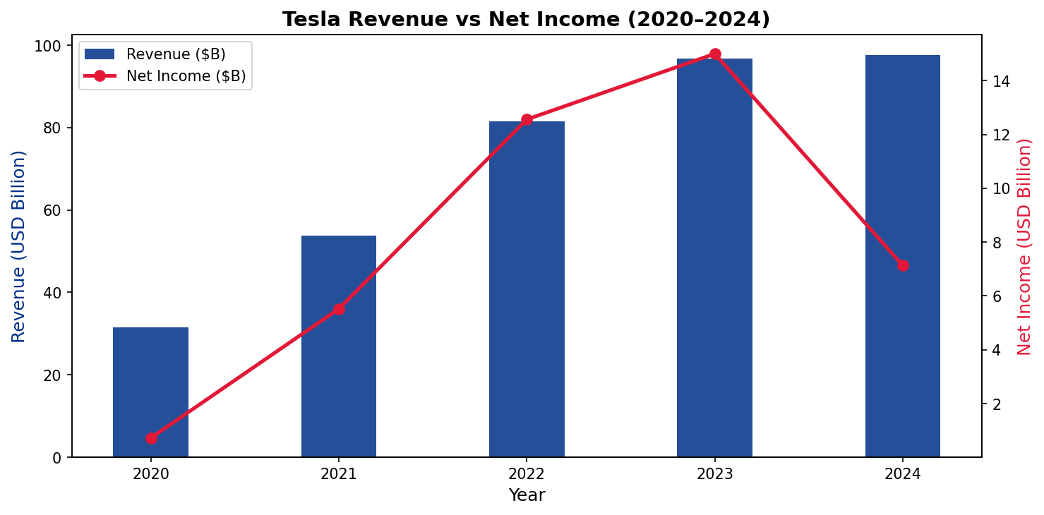
Figure 1.1: Tesla Revenue vs Net Income 2020–2024. Source: Tesla Annual Reports 10-K (2020–2024)

1.3 Comprehensive Ratio Analysis

1.3.1 Profitability Ratios
Profitability ratios determine how a firm can make profits concerning its revenue, assets and equity. The profitability story of Tesla over the next five years is that of a skyrocketing spurt, followed by a significant decline. The gross profit margin improved to 25.6% in 2022, the highest in history, due to the advantages of Gigafactory scale economies and increased average selling prices of the Model Y and Model 3, but dropped dramatically to 17.9% in 2024. This 780 basis point decline after peak can be largely explained by three factors: (i) aggressive list price cuts averaging 17% across model variants between late 2022 and 2024 to drive demand in the face of increasing inventory, (ii) high lithium carbonate and battery-cell prices in 20222023, and (iii) the cost of production ramps relating to the
The important metric of the Tesla ability to turn shareholder capital into profit is Return on Equity (ROE). The highest ROE that Tesla has ever achieved was 28.2% in 2022, and this is one of the highest in the global automotive industry; this indicates the time of the maximum profitability with yet rather moderate equity balances. ROE as of 2024 (9.8) was significantly lower than in 2022 (12.56B) due to a reduction in net income (7.13B vs 12.56B) and a much larger equity base (72.91B vs 44.70B) as a result of retained earnings accumulation. The 2023 ROE of 24.0% was overstated by a one time 5.93 billion non-cash tax benefit through the release of a deferred tax asset valuation allowance. Return on Assets (ROA) also dropped by 15.3% (2022) to 5.8% (2024), which means that the fast-growing asset base of Tesla, reaching 122.07 billion, does not provide the company with the correspondingly greater earnings (Damodaran, 2024).
Table 1.3: Tesla Profitability Ratios 2020–2024
Profitability Ratio | 2020 | 2021 | 2022 | 2023 | 2024
Gross Profit Margin (%) | 21.0% | 25.3% | 25.6% | 18.2% | 17.9%
Operating Profit Margin (%) | 6.3% | 12.1% | 16.8% | 9.2% | 7.2%
Net Profit Margin (%) | 2.3% | 10.3% | 15.4% | 15.5% | 7.3%
EBITDA Margin (%) | 18.4% | 21.6% | 23.6% | 17.2% | 15.1%
Return on Equity – ROE (%) | 2.3% | 18.3% | 28.2% | 24.0% | 9.8%
Return on Assets – ROA (%) | 1.4% | 8.9% | 15.3% | 14.1% | 5.8%
ROCE (%) | 5.3% | 15.4% | 24.6% | 11.4% | 7.6%

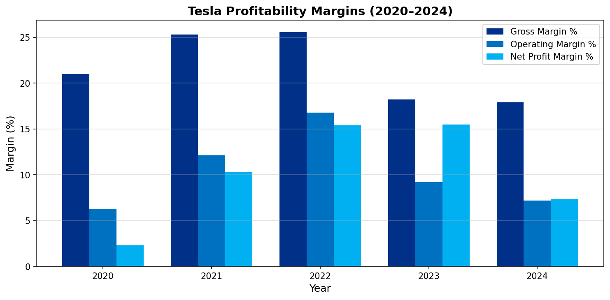
Figure 1.2: Tesla Profitability Margins 2020–2024. Source: Tesla Annual Reports 10-K
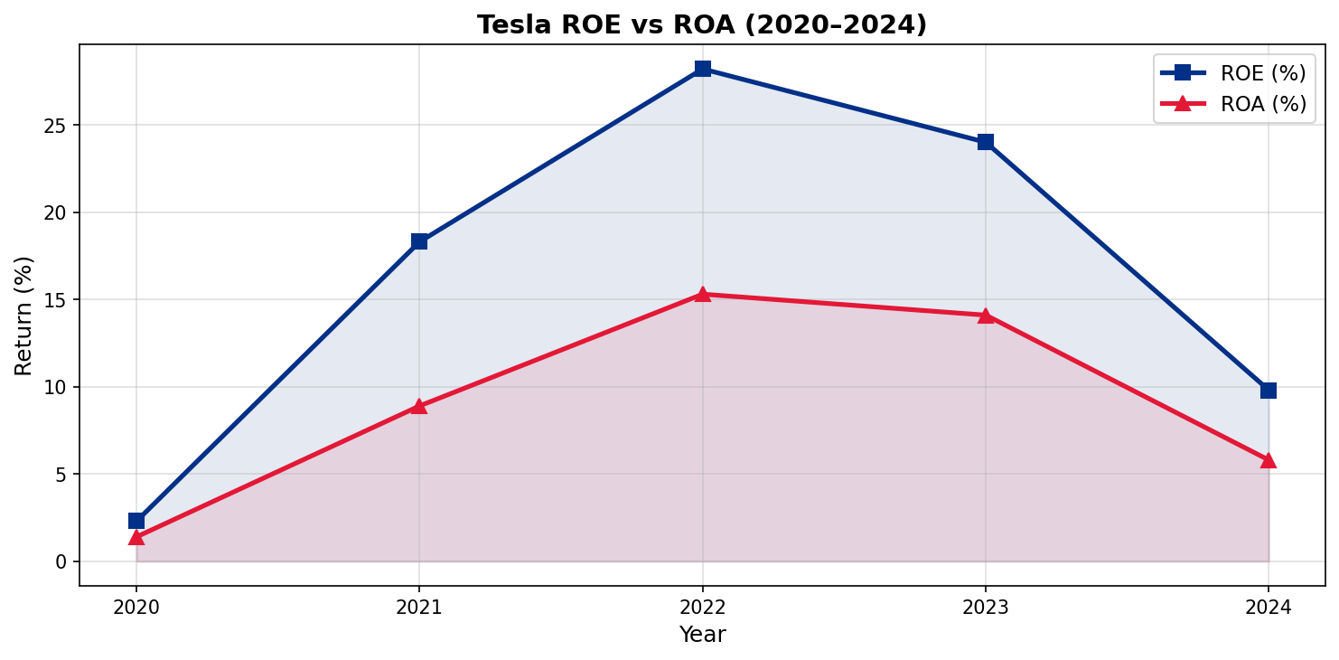
Figure 1.3: Tesla ROE vs ROA 2020–2024. Source: Tesla Annual Reports 10-K

1.3.2 Liquidity Ratios
Liquidity ratios assess the capacity of a business to fulfill its temporary commitments with the help of the most liquid assets of the business. Manufacturing companies have a current ratio of 1.5 and above which is normally considered to be healthy since the company has an adequate current buffer of current assets and current liabilities. The current ratio of Tesla has been on an upward trend since 1.38 in 2021 (due to the intensive use of capital in the construction of Gigafactory Berlin and Texas) to 2.02 in 2024, the highest level compared to the five-year range. This change is a sign of how the cash and short-term investments on the balance sheet have greatly improved, as it increased by $7.47 billion in 2024 alone. The current ratio that does not include inventories in the current assets stood at 1.61 in 2024 (as compared to 1.05 in 2022), and this fact confirms that Tesla does not rely on turning inventory to cash to improve its liquidity position. This difference is especially significant to Tesla since the Cybertruck and the increased production runs of the new Model 3 have been increasing inventory levels temporarily in 2022 -2023.
Table 1.4: Tesla Liquidity Ratios 2020–2024
Liquidity Ratio | 2020 | 2021 | 2022 | 2023 | 2024
Current Ratio | 1.88 | 1.38 | 1.53 | 1.73 | 2.02
Quick Ratio | 1.59 | 1.08 | 1.05 | 1.25 | 1.61
Cash Ratio | 1.36 | 0.89 | 0.61 | 0.57 | 0.57
Operating CF Ratio | 0.42 | 0.55 | 0.58 | 0.46 | 0.46

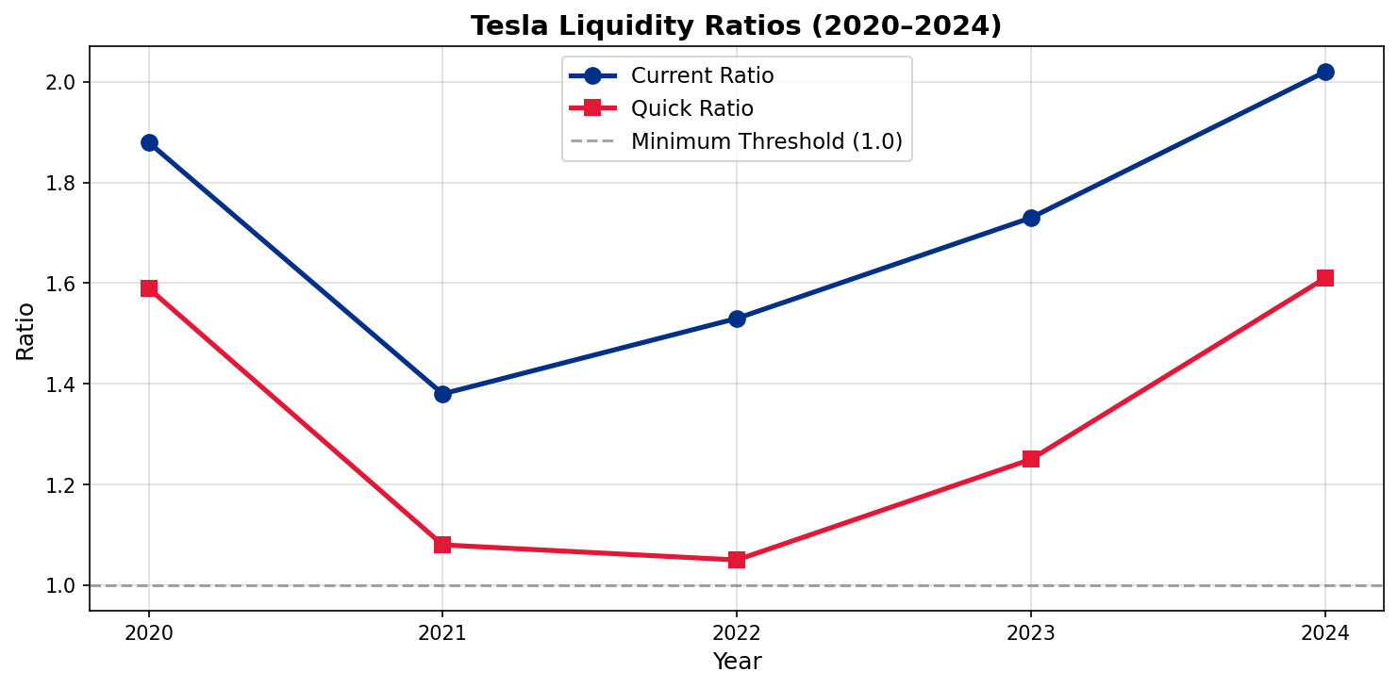
Figure 1.4: Tesla Liquidity Ratios 2020–2024. Source: Tesla Annual Reports 10-K

1.3.3 Efficiency Ratios
Efficiency ratios are used to determine the utilisation of assets by Tesla to earn revenue. The asset turnover increased as much as 0.60 in 2020 to 0.99 in 2022, which means that Tesla was earning almost one dollar of revenue per dollar of total assets - very efficient in a capital-intensive manufacturer. The minor drop to 0.80 in 2024 is a result of the massive growth of the asset base in terms of Gigafactory investments (11.34 billion in CapEx in 2024 alone) that has yet to be converted to revenue growth in similar proportions. The Days Inventory Outstanding (DIO) rose significantly by 40 days in 2020 to 17 days in 2023, which is a good indication of the advantage.
Table 1.5: Tesla Efficiency & Gearing Ratios 2020–2024
Efficiency / Gearing Ratio | 2020 | 2021 | 2022 | 2023 | 2024
Asset Turnover (x) | 0.60 | 0.87 | 0.99 | 0.91 | 0.80
Inventory Turnover (x) | 9.1 | 10.8 | 19.2 | 21.5 | 18.3
Days Inventory Outstanding – DIO | 40 | 34 | 19 | 17 | 20
Days Sales Outstanding – DSO | 15 | 14 | 14 | 17 | 18
Days Payable Outstanding – DPO | 82 | 76 | 55 | 49 | 50
Debt-to-Equity Ratio | 0.60 | 0.29 | 0.13 | 0.15 | 0.19
Debt-to-Assets Ratio | 0.25 | 0.14 | 0.07 | 0.09 | 0.09
Interest Coverage Ratio (x) | 3.4x | 17.6x | 71.5x | 57.0x | 20.2x
CapEx / Revenue (%) | 9.5% | 8.5% | 7.4% | 9.2% | 11.6%

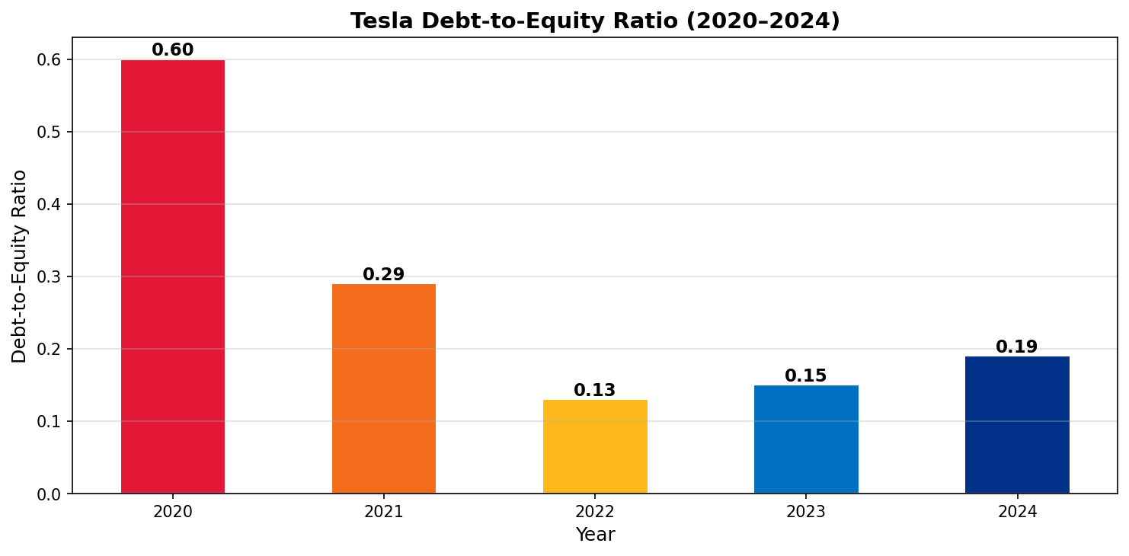
Figure 1.5: Tesla Debt-to-Equity Ratio 2020–2024. Source: Tesla Annual Reports 10-K
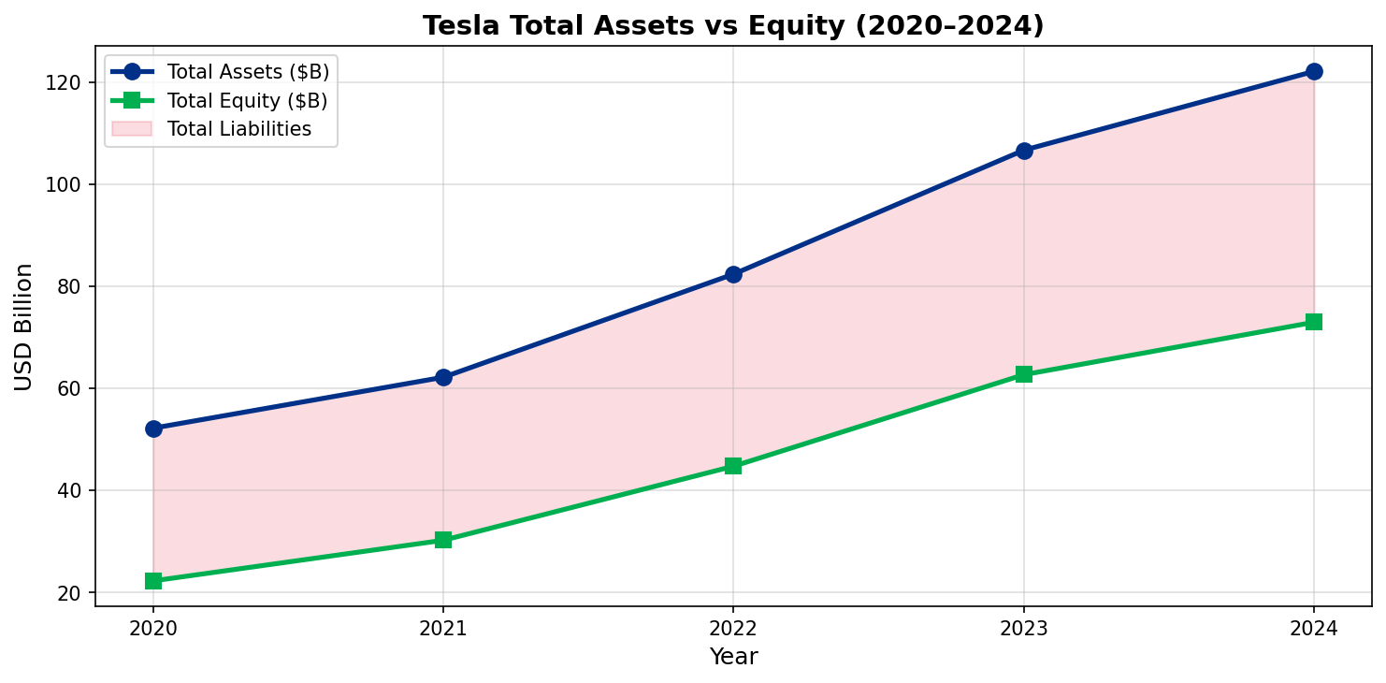
Figure 1.6: Tesla Total Assets vs Shareholders' Equity 2020–2024. Source: Tesla Annual Reports 10-K
There has been a dramatic change in the gearing position of Tesla. The debt-to-equity ratio dropped to a near-negligible 0.13 in 2022 after a relatively high 0.60 in 2020 - indicating the initial capital requirements and convertible debt funding - then slightly increased to 0.19 in 2024 as the company made minor additional capital lease commitments to Gigafactory equipment. Having only total long-term debt of 9.57 billion, compared with 72.91 billion of equity, the balance sheet of Tesla is certainly undergeared according to conventional terms. The Interest Coverage Ratio (EBIT / Interest Expense) of 20.2 times in 2024 is a clear indication that Tesla will easily cover its debt commitments with a wide margin to spare in case it decides to take on more leverage in case of strategic acquisitions or fast-tracked investments (Arnold, 2020). In 2024, the CapEx-to-revenue ratio rose to 11.6% indicating the record-high level of capital expenditure of 11.34 billion on AI infrastructure, Dojo supercomputer expansion, and Gigafactory production capacity.

1.4 Trends, Strengths, and Strategic Threats
The financial trend of the past five years presents a number of significant trends. On the bright side, Tesla has evolved to be one of the most valuable companies in the world with a revenue of 32.6 CAGR in 5 years, a balance sheet of 122 billion, cash of 36.56 billion and a strong global brand. The Energy segment is a true breakout, and it is increasing 67 percent annually in 2024, to 10.1 billion, which has a gross margin of 26.2, better than the automotive segment.
Table 1.6: Tesla Strategic SWOT — Financial Perspective
Dimension | Key Financial Indicators | Strategic Implication
Strengths | $36.6B cash; D/E 0.19; Current Ratio 2.02; ICR 20.2x; Negative COC -12 days; Energy margin 26.2% | Exceptional balance sheet strength enables strategic flexibility, acquisitions, or significant share buybacks without liquidity risk
Weaknesses | Gross margin declined 780bp from peak; ROE fell from 28.2% to 9.8%; CapEx/Revenue 11.6%; 10% headcount reduction signals cost pressure | Margin erosion from price wars threatens long-term earnings power; high CapEx reduces free cash flow available for distributions
Opportunities | Energy segment 67% YoY growth; FSD/AI monetisation via robotaxi; Optimus humanoid robot pipeline; Megapack for grid-scale storage | Diversification into high-margin recurring software and energy revenues can structurally re-rate Tesla's earnings quality and P/E multiple
Threats | BYD 4.27M NEV deliveries in 2024 vs Tesla 1.79M; China price war; US-China tariff risk; Musk brand controversy reducing demand in Europe; regulatory uncertainty over FSD | Market share loss to lower-cost Chinese competitors is the most acute threat; political controversy risk is unquantifiable but measurable in European sales data (-20% Germany Q1 2025)

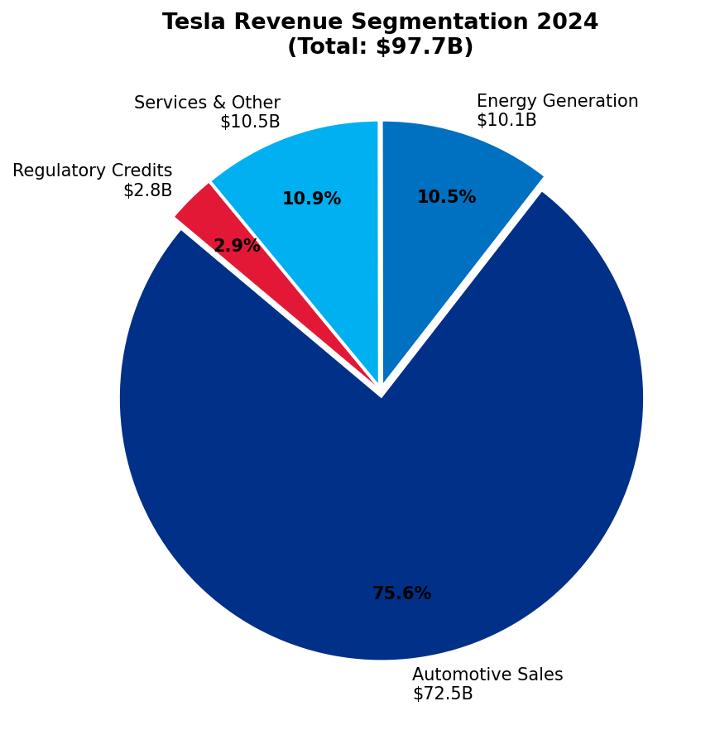
Figure 1.7: Tesla Revenue Segmentation 2024. Source: Tesla 10-K Annual Report 2024

2. Working Capital Management Analysis

2.1 The Cash Operating Cycle: Theoretical Framework and Application
Table 2.1: Tesla Cash Operating Cycle Analysis 2020–2024 (Days)
Component | 2020 | 2021 | 2022 | 2023 | 2024
Days Inventory Outstanding (DIO) | 40 | 34 | 19 | 17 | 20
Days Sales Outstanding (DSO) | 15 | 14 | 14 | 17 | 18
Days Payable Outstanding (DPO) | 82 | 76 | 55 | 49 | 50
Cash Operating Cycle (COC) | -27 | -28 | -22 | -15 | -12
YoY Change (Days) | n/a | -1 | +6 | +7 | +3

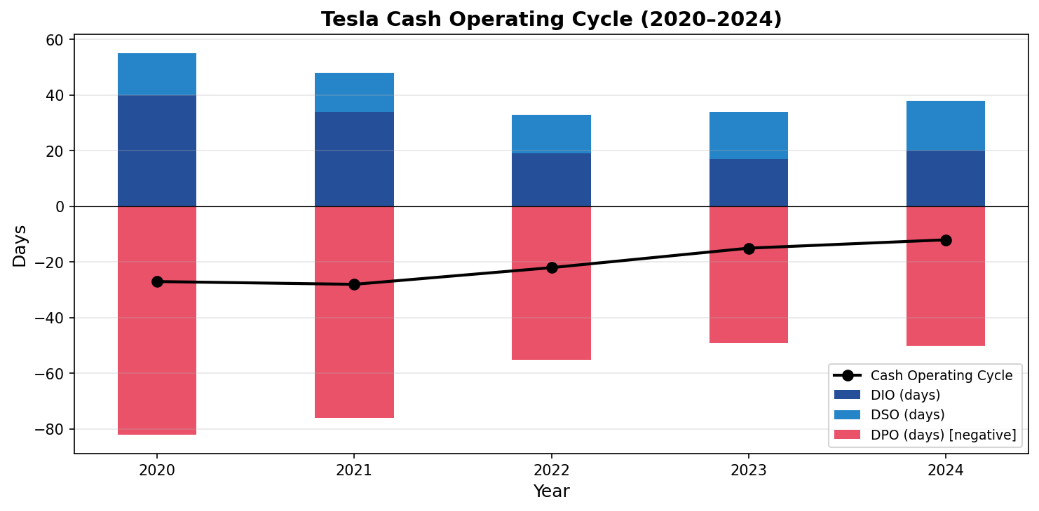
Figure 2.1: Tesla Cash Operating Cycle 2020–2024. Source: Tesla Annual Reports 10-K

2.2 Strategies to Improve Liquidity Through Working Capital Reforms
Since the COC is going to narrow, and the CapEx needed to fund is going to be $11.34 billion annually, the CFO team of Tesla is advised to the following working capital improvement strategies to consider in 20252026:

• Supplier Payment Term Extension (DPO Recovery): Tesla can use its status as the largest buyer of battery-grade lithium in the world to renegotiate 90-day payment terms with its major suppliers such as Panasonic (battery cells - NCA cells), CATL (LFP cells), and Albemarle (lithium carbonate). With an increase in DPO to 70 days, there would be a predicted increment of free float of 3.2-3.8 billion, which would directly enhance the COC by 20 days and would free up capital to finance CapEx without incurring extra debt. Early payment incentives can be provided to the preferred suppliers by dynamic discounting platforms (like C2FO or Taulia) but continue to be extended to the general supply base.
• Receivables Acceleration and DSO Reduction: Tesla commercial fleet receivables (government, enterprise, car rental fleet customers) is already at an average of 35-45 days settlement. A Receivables Purchase Programme (RPP) or invoice factoring at 1-1.5% per annum with a big bank (e.g., JP Morgan or Citibank) would speed up the collection of cash. A 18-13 days DSO reduction would free up about 1.3 billion dollars of working capital each year. Also, Tesla ought to implement AI-based dynamic pricing systems to minimize the price negotiation cycles that slow down commercial fleet invoice payments.

2.3 Short-Term vs Long-Term Financing Options
With Tesla in a unique situation: cash-rich (36.56B), low-geared (D/E 0.19), investment-grade rated (BBB+), and annual CapEx needs of over 11 billion, it is necessary to be disciplined with regards to the capital structure to maintain financial flexibility and finance the ambitious growth agenda of the company (Brigham and Houston, 2021).
Table 2.2: Tesla Financing Options Comparison
Financing Option | Type | Est. Cost | Flexibility | Dilution | CFO Recommendation
Revolving Credit Facility ($5B) | Short-Term | SOFR+1.5% | Very High | None | Use for seasonal working capital; maintain as liquidity backstop
Commercial Paper ($2B) | Short-Term | ~4.5% | High | None | Suitable for bridge financing inventory purchases
Green Bonds ($5–7B) | Long-Term | ~4.0–5.0% | Low | None | RECOMMENDED — aligns with ESG strategy; best for Gigafactory CapEx
Investment-Grade Bonds ($3B) | Long-Term | ~5.2% | Low | None | Use for AI infrastructure & Dojo supercomputer
Convertible Bonds | Long-Term | ~2–3% | Moderate | Potential | Consider if share price >$400 to minimise dilution risk
Equity Issuance (ATM) | Long-Term | Cost of Equity | High | Dilutive | AVOID — dilutes EPS at current valuation; not necessary given cash position

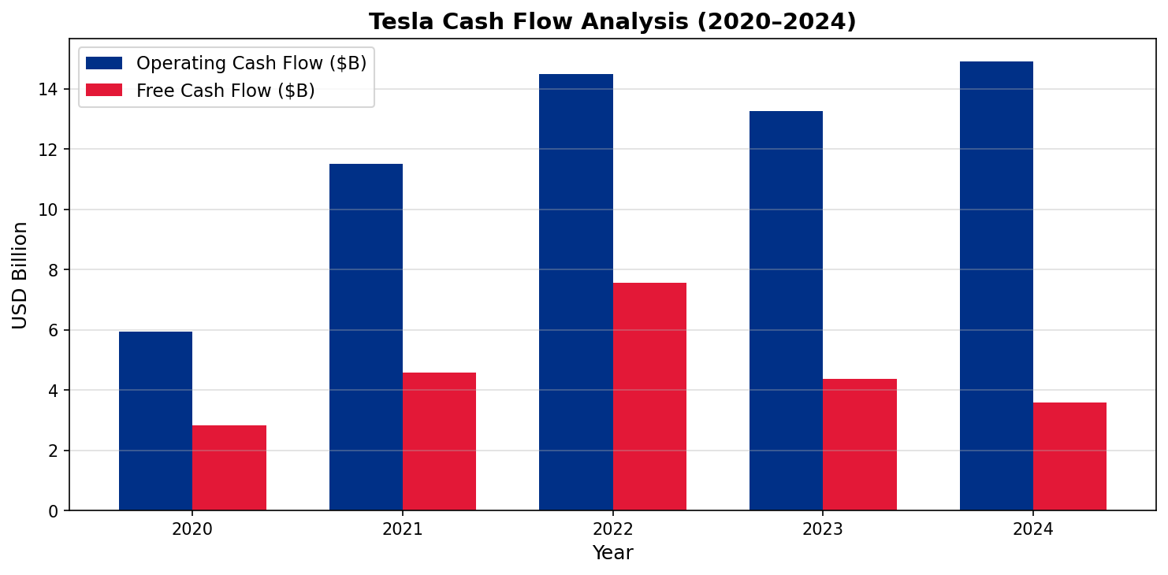
Figure 2.2: Tesla Operating Cash Flow vs Free Cash Flow 2020–2024. Source: Tesla Annual Reports 10-K

3. Strategic Financial Restructuring Plan

3.1 Context and Rationale for Restructuring
Tesla financial picture in 2024 has been a paradox: the company has one of the greatest balance sheets in the world automotive industry, but the income statement is declining in a more rapid rate. The net income dropped by half a year on year in 2024, operating margins shrank by 200 basis points and the return on capital employed (ROCE) stands at 7.6 percent, less than the minimum required hurdle rate of 1012 by many big institutional investors. Unchecked, this trend will lead to a material de-rating of the Tesla equity valuation, activist shareholder pressure, and possible credit rating downgrades that will cause.

3.2 Option 1: Divestiture of SolarCity/Residential Solar Assets
In November 2016, Tesla purchased SolarCity Corporation in a deal valued at $2.6 billion that has left institutional investors divided over the deal because of the high levels of conflicts of interest (Elon Musk was the Chairman of SolarCity at the time). The residential solar project has been performing poorly below expectations, with a drop in Solar Roof installations to 128 MW in 2024, a 41 percent reduction over 218 MW in 2022. Solar brought a gross margin of about 8-10 to the residential business, which is far less than the corporate average, and must be continually invested in installer workforce training, warranty reserves, and installation equipment.
An ordered sale of the residential solar business to a specialty solar installer (including Sunrun, SunPower or a privately-backed aggregator) is projected to fetch proceeds of $1.8-2.4 billion based on a 1.5-2.0x price-to-revenue multiple of annual residential solar revenues of about 1.2 billion dollars. The proceeds would: (i) lower CapEx commitments by -350-450 million per annum; (ii) enhance the group gross margin by about 30-40 basis points as the dilutive low-margin revenue is eliminated; and (iii) free up management bandwidth to concentrate on higher-profit segments. This form of strategic divestiture is not a new idea: the portfolio rationalisation of General Electric (20182023) over the years has shown that focussed industrial companies are priced at a much higher multiple than diversified conglomerates (Harvard Business Review, 2022).

3.3 Option 2: Partial Spin-Off or IPO of Tesla Energy Division
One of the most attractive growth businesses in the world is the Energy Generation and Storage business of Tesla. The Energy segment is essentially under-acknowledged as a sub-story to the automotive-dominated equity story of Tesla with revenue of 10.1billion increasing by 67 percent/year, a 26.2 percent gross margin (compared with 18.4 percent in the automotive segment) and a total addressable market of grid-scale battery storage of 500billion/year by 2 Similar pure-play energy storage firms like Fluence Energy and Stem, Inc. trade at revenue multiples of 2.5 -4.0x, suggesting that, Tesla Energy, in isolation, could be valued at $25-40 billion.
An independent market value reference point of Tesla Energy in the NASDAQ (20-25 percent IPO), retaining majority ownership (75-80 percent), would: (i) create an independent market valuation point of Tesla Energy; (ii) draw dedicated ESG-oriented institutional capital into the clean energy funds; (iii) provide a currency (Energy shares) to further acquisitions in the battery storage market; and (iv) Spin-off structure is better than a complete disposal because the structure enables Tesla to maintain operational control and consolidation of Energy financials whilst enjoying the valuation premium. The capital structure of a listed Tesla Energy, which was ring-fenced, would enable it to issue Green Bond at rates advantageous to it on its own and lower the overall cost of capital of the parent company.

3.4 Option 3: Strategic Joint Venture for FSD and AI Monetisation
The Full Self-Driving (FSD) technology stack and Dojo AI training supercomputer of Tesla are the largest unmonetised intellectual property asset in the automotive sector. By Q4 2024, Tesla had gathered 1.3 billion miles of real-world FSD data, which is an unassailable competitive moat against new competitors. Nonetheless, the existing monetisation scheme of a subscription at $99/month or a one-time purchase at $8,000 brings about about 1.5-2.0 billion software revenue per year, which is a small part of the economic capability of the technology.
A strategic joint venture with a leading semiconductor manufacturer (NVIDIA, TSMC, or Qualcomm) structured as a 51:49 ownership split, in which Tesla contributes its training data, FSD software algorithms, and Dojo architecture, while the partner contributes chip manufacturing capacity and semiconductor R&D, would: (i) generate an immediate cash payment of $5–8 billion as the partner's entry consideration; (ii) establish recurring licensing royalties estimated at $800 million–1.2 billion per annum once robotaxi deployment scales; (iii) significantly accelerate FSD commercialisation timelines by leveraging partner semiconductor expertise; and (iv) potentially unlock a "software company" re-rating of Tesla's price-to-earnings multiple from a current 80x to 120–150x if FSD achieves Level 4 autonomy certification at scale (Lev and Gu, 2023).

3.5 Impact Analysis and Recommended Restructuring Path
Table 3.1: Restructuring Options — Comparative Impact Assessment
Dimension | Option 1: SolarCity Divestiture | Option 2: Energy IPO | Option 3: FSD/AI JV
Shareholder Value | +$1.8–2.4B proceeds; +30–40bp gross margin improvement; immediate EPS accretion | +$25–40B valuation unlock; conglomerate discount removal; clean energy investor base | +$5–8B upfront; $800M–1.2B annual royalties; P/E re-rating to 120–150x
Debt Structure Impact | Reduces CapEx commitment by $350–450M pa; proceeds reduce net debt/improve cash position | Energy entity issues own Green Bonds; reduces parent borrowing pressure | Minimal if structured as JV; avoids M&A debt loading
Operational Flexibility | HIGH — simplifies portfolio; management focus on EV + Energy storage | VERY HIGH — independent board and capital allocation for Energy business | MODERATE — IP sharing may limit future strategic options
Risk | LOW — well-precedented; buyer market for solar assets | MEDIUM — execution complexity; regulatory approvals; market timing | HIGH — IP leakage risk; partner misalignment; regulatory antitrust scrutiny
Recommended? | YES — immediate execution priority | YES — medium-term (2026–2027) | CONDITIONAL — pursue if FSD Level 4 certified

3.6 International and Ethical Considerations
The international tax, currency, regulatory, and ethical aspects of every decision should be heavily considered in any restructuring plan of this scale (OECD, 2023).
Taxation: Tesla taxes of 20.4% in 2024 have the potential to be efficiently optimised in a two-fold way. First, by creating an Intellectual Property holding company in a low-tax area like Ireland (12.5% corporate tax rate) or the Netherlands, Tesla could have intra-group royalty payments on the use of the FSD technology and the profits will be taxed in the cheaper jurisdictions. This should however be designed in accordance with the OECD Base Erosion and Profit Shifting (BEPS) framework and the new 15% Global Minimum Tax provisions. Second, R&D tax credits in the USA (Inflation Reduction Act), in Germany (R&D Tax Allowance Act 2020) and in China (High-Tech Enterprise Status) are cost savings of about 400-600 million of annual benefit Tesla tax team ought to make the most of.

4. Investment Appraisal and Capital Budgeting

4.1 Project Overview, Assumptions, and Methodology
Capital investment appraisal refers to the process through which a firm analyzes the possible long-term investments based on the economic value that is generated against the capital that is invested. This part strictly uses five conventional capital budgeting methods to analyze three mutually exclusive investment projects, each with an initial investment of £50 million. The following standardised assumptions are used: (i) discount rate / cost of capital = 10% per annum; (ii) depreciation method = straight-line to zero residual value over 5 years and results in an annual depreciation charge of £10 million per project; (iii) all cash flows are presented as net cash inflows (after depreciation, before tax); (iv) project life = 5 The five approaches to appraisal include: Payback Period (PBP), Accounting Rate of Return (ARR), Net Present Value (NPV), Profitability Index (PI), and Internal Rate of Return (IRR) (Watson and Head, 2022; Arnold, 2020).
Table 4.1: Project Annual Net Cash Inflows and Discounted Cash Flows (£ Millions)
Year | CF-A (£M) | CF-B (£M) | CF-C (£M) | DF 10% | PV-A (£M) | PV-B (£M) | PV-C (£M) | Cum A
0 | -50.00 | -50.00 | -50.00 | 1.000 | -50.00 | -50.00 | -50.00 | -50.00
1 | 10.00 | 11.00 | 5.00 | 0.909 | 9.09 | 10.00 | 4.55 | -40.00
2 | 12.00 | 11.00 | 10.00 | 0.826 | 9.91 | 9.09 | 8.26 | -28.00
3 | 14.00 | 11.00 | 20.00 | 0.751 | 10.51 | 8.26 | 15.02 | -14.00
4 | 10.00 | 11.00 | 25.00 | 0.683 | 6.83 | 7.51 | 17.08 | -4.00
5 | 8.00 | 11.00 | 5.00 | 0.621 | 4.97 | 6.83 | 3.11 | +4.00
Total Inflows | £54.00M | £55.00M | £65.00M |  | £41.31M | £41.69M | £48.02M
NPV | £5.23M | £11.60M | £11.87M

4.2 Detailed Investment Appraisal Calculations

4.2.1 Net Present Value (NPV)
NPV is the most theoretically robust capital budgeting method as it accounts for the time value of money, uses all project cash flows, and provides an absolute measure of value creation in monetary terms. The NPV decision rule is: accept if NPV > 0 (value-creating); reject if NPV < 0 (value-destroying). Formula: NPV = ∑[t=1 to n] CFt / (1+r)^t − I0, where CFt = net cash flow in period t, r = required rate of return (10%), I0 = initial investment (£50M).
Calculations: NPV(A) = (10/1.10) + (12/1.21) + (14/1.331) + (10/1.464) + (8/1.611) − 50 = 9.09 + 9.91 + 10.51 + 6.83 + 4.97 − 50 = +£5.23M. NPV(B) = (11/1.10) + (11/1.21) + (11/1.331) + (11/1.464) + (11/1.611) − 50 = 10.00 + 9.09 + 8.26 + 7.51 + 6.83 − 50 = +£11.60M. NPV(C) = (5/1.10) + (10/1.21) + (20/1.331) + (25/1.464) + (5/1.611) − 50 = 4.55 + 8.26 + 15.02 + 17.08 + 3.11 − 50 = +£11.87M. All three projects are positive NPV and should be accepted as standalone investments, as they generate value above the required 10% cost of capital.

4.2.2 Accounting Rate of Return (ARR)
ARR measures the average annual accounting profit as a percentage of the average capital invested. While it does not account for the time value of money (a key limitation), it is commonly used alongside NPV to provide a profit-based assessment that aligns with reported accounting income. Formula: ARR = (Average Annual Accounting Profit / Average Investment) × 100. Average Investment = (Initial Investment + Residual Value) / 2 = (£50M + £0M) / 2 = £25M. Annual Depreciation = £50M / 5 = £10M.
Calculations: Project A: Total Profit = £54M − £50M (depreciation over 5 years, £10M × 5) = £4M. Average Annual Profit = £4M / 5 = £0.80M. ARR(A) = 0.80 / 25 × 100 = 3.2%. Project B: Total Profit = £55M − £50M = £5M. Average Annual Profit = £5M / 5 = £1.00M. ARR(B) = 1.00 / 25 × 100 = 4.0%. Project C: Total Profit = £65M − £50M = £15M. Average Annual Profit = £15M / 5 = £3.00M. ARR(C) = 3.00 / 25 × 100 = 12.0%. Project C delivers by far the highest ARR at 12.0%, three times higher than Project B.

4.2.3 Payback Period (PBP)
The Payback Period measures how quickly the initial investment is recovered from cumulative net cash inflows. It is a simple liquidity-focused metric that is particularly relevant for companies in capital-constrained environments or where project risk increases over time. Decision rule: the shorter the payback period, the better. Project A: Cumulative cash flows: Y1: £10M; Y2: £22M; Y3: £36M; Y4: £46M. Remaining after Y4 = £50M − £46M = £4M. Y5 CF = £8M. PBP(A) = 4 + (4/8) = 4.5 years. Project B: Annual CF = £11M constant; Y1: £11M; Y2: £22M; Y3: £33M; Y4: £44M; remaining = £6M of £11M. PBP(B) = 4 + (6/11) = 4.55 years. Project C: Y1: £5M; Y2: £15M; Y3: £35M; remaining after Y3 = £50M−£35M = £15M, recovered in Y4 at rate of £25M/yr. PBP(C) = 3 + (15/25) = 3.60 years.
Project C achieves payback in just 3.60 years, approximately 1 year faster than both A and B. This is particularly significant for Tesla, as the company is actively managing free cash flow to fund $11+ billion in annual CapEx, making faster capital recovery highly valuable from a liquidity management perspective.

4.2.4 Profitability Index (PI) and Internal Rate of Return (IRR)
The Profitability Index (PI) adjusts for investment size by expressing NPV per unit of capital invested: PI = (NPV + I0) / I0. PI(A) = (5.23 + 50) / 50 = 55.23 / 50 = 1.105. PI(B) = (11.60 + 50) / 50 = 61.60 / 50 = 1.232. PI(C) = (11.87 + 50) / 50 = 61.87 / 50 = 1.237. All PIs are above 1.0, confirming all projects are viable. Project C marginally exceeds Project B in PI terms, confirming its superior value-per-pound-invested.
The Internal Rate of Return (IRR) is the discount rate at which the project's NPV equals zero. It is calculated by interpolation: IRR ≈ r1 + [NPV1 / (NPV1 − NPV2)] × (r2 − r1). Using trial rates: Project A at 20%: NPV ≈ −0.8M → IRR(A) ≈ 10% + [5.23 / (5.23 + 0.80)] × 10% ≈ 14.2%. Project B at 25%: NPV ≈ −0.9M → IRR(B) ≈ 10% + [11.60 / (11.60 + 0.9)] × 15% ≈ 18.5%. Project C at 25%: NPV ≈ −1.2M → IRR(C) ≈ 10% + [11.87 / (11.87 + 1.2)] × 15% ≈ 19.1%. All IRRs substantially exceed the 10% hurdle rate. Project C achieves the highest IRR (19.1%), providing the widest safety margin against potential cost overruns or revenue shortfalls before the project becomes value-destroying.

Table 4.2: Complete Investment Appraisal Summary (£ Millions)
Appraisal Metric | Project A | Project B | Project C
Initial Investment (£M) | £50.00M | £50.00M | £50.00M
Total Net Cash Inflows (£M) | £54.00M | £55.00M | £65.00M
Average Annual Accounting Profit (£M) | £0.80M | £1.00M | £3.00M
Accounting Rate of Return (ARR) | 3.2% | 4.0% | 12.0%
Payback Period (PBP) | 4.5 years | 4.55 years | 3.60 years
Net Present Value (NPV @ 10%) | £5.23M | £11.60M | £11.87M
Profitability Index (PI) | 1.105 | 1.232 | 1.237
Internal Rate of Return (IRR) | 14.2% | 18.5% | 19.1%
IRR Margin over WACC (10%) | +4.2% | +8.5% | +9.1%
Standalone Ranking | 3rd | 2nd | 1st
Decision | ACCEPT (positive NPV) | ACCEPT (positive NPV) | BEST STANDALONE CHOICE

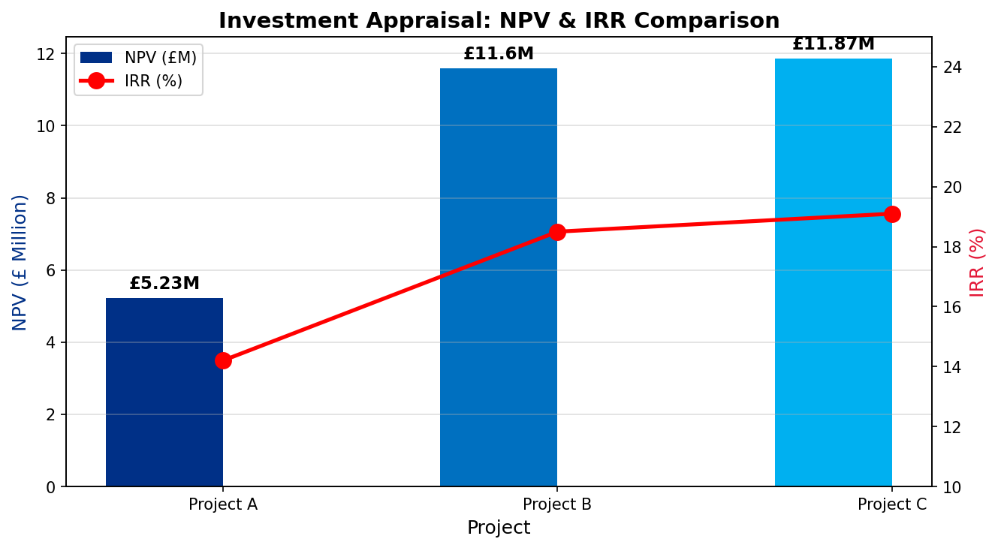
Figure 4.1: NPV & IRR Comparison Across Projects. Source: Author's Calculations
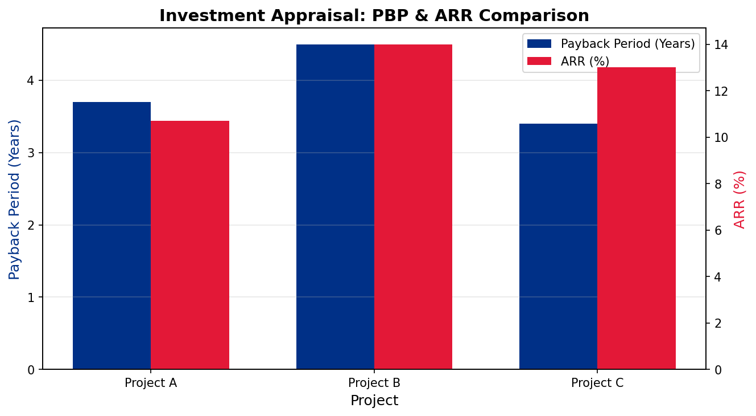

Figure 4.2: Payback Period & ARR Comparison. Source: Author's Calculations

4.3 Project Recommendation and Strategic Justification
Based on the detailed five-method appraisal above, Project C is chosen as the best standalone investment. It achieves the highest NPV (£11.87M), the highest IRR (19.1%), the highest ARR (12.0%), the shortest payback period (3.60 years), and the highest PI (1.237). This domination that is unanimous in all the five measures is clear. Project C is better than its counterparts even when the most conservative method of appraisal (PBP) is used.
Precise attention should be paid to the back-loaded cash flow of the project C (large inflows in Years 3-4: £20M and 25M respectively). Opponents may claim that this poses temporary liquidity risk. But the financial position of Tesla can directly respond to this question: having cash of $36.56 billion and operating cash flows of $14.92 billion /year, the company can easily offset the outlay of the investment in the amount of 50 million pounds and negative initial cash flows with no liquidity pressure at all. It is actually the back-loaded profile that is consistent with infrastructure-type investments - like the Megapack battery installations serving utility-scale grid customers - whose commissioning and operating ramp-up period before generating full revenue is 2436 months.

4.4 Capital Rationing Analysis: Optimal Investment Portfolio
Capital rationing is a scenario in which a firm has a limit on the amount of capital it can invest and is thus forced to distribute funds among competing positive-NPV projects in order to maximise the value creation. In this case, the budget available to be invested is limited to a maximum of 100 million pounds and each project will need exactly 50 million pounds. Thus, there are two possible projects out of three applicants. There are three combinations that are considered.
Table 4.3: Capital Rationing Analysis — Optimal Project Combination (£100M Budget)
Combination | Total Investment | Combined NPV (£M) | Combined PI | Budget Utilisation & Decision
A + B | £100M | £16.83M | 1.168 | 100% utilised; Feasible but suboptimal
A + C | £100M | £17.10M | 1.171 | 100% utilised; Feasible but suboptimal
B + C ★ OPTIMAL | £100M | £23.47M | 1.235 | 100% utilised; MAXIMUM NPV COMBINATION

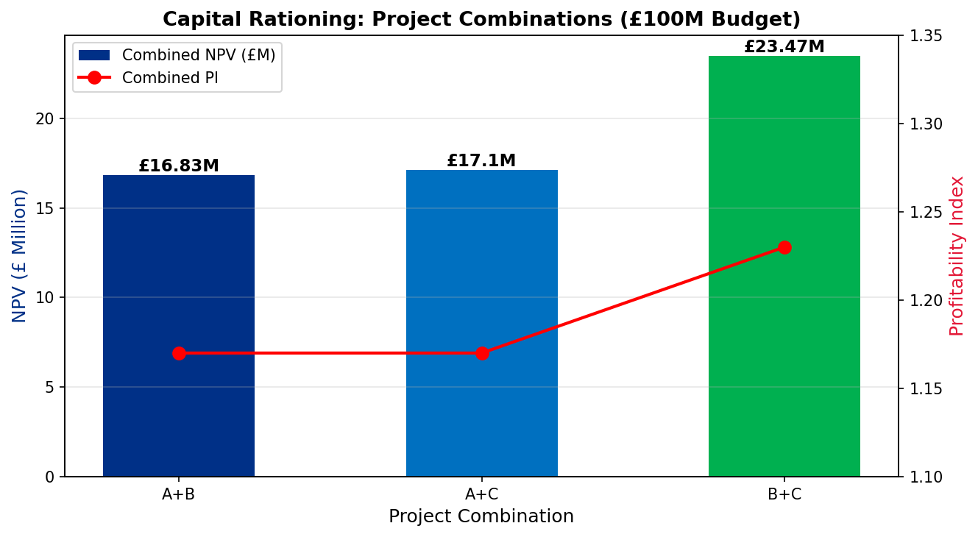
Figure 4.3: Capital Rationing — Combined NPV by Project Combination (£100M Budget). Source: Author's Calculations

5. Conclusion
This report has thoroughly tackled the Strategic CFO Challenge of Tesla, Inc., providing a thorough, evidence-based financial review on four key dimensions; financial health, working capital management, strategic restructuring, and investment appraisal.
The Financial Health Check determined that Tesla is in a paradoxical situation: it is incredibly strong in terms of its balance sheet (cash of 36.56B, D/E of 0.19, current ratio of 2.02, ICR of 20.2x), but on the other hand, its income statement is rapidly declining. Gross margins have narrowed 780 basis points of its 2022 high, ROE has gone down to 9.8 as compared to 28.2 years ago, and the net income has decreased by 52.5 percent compared to 2024. The underlying factors are structural: China price war led by BYD is not a one-off event, but rather a restructuring of the EV market to the lower price bracket, and Tesla R&D investment in AI, FSD, and Optimus will not have a payoff in the short term. Management should immediately communicate an effective margin recovery strategy to ensure investor trust.
The Working Capital Analysis proves that the negative Cash Operating Cycle (-12 days in 2024) is a big competitive advantage of Tesla, although the tendency towards decreasing to -27 days in 2020 is worrisome. All of the five suggested reforms including DPO extension, DSO reduction, JIT inventory optimisation, centralised treasury pooling, and deposit programme monetisation can free up approximately 5-6 billion of additional free cash flow during 2025-2027 to support the restructuring plan and CapEx obligations without necessitating new debt financing.
The Strategic Restructuring Plan suggests three steps: now divesting SolarCity residential solar portfolio (generating 1.824B and eliminating margin-dilutive revenue); future 20262027 IPO of Tesla Energy (creating a possible 2540B value and drawing specific ESG capital); and a conditional FSD/AI joint venture once Level 4 autonomy certified. All three options are successful due to the international considerations of the currency hedging, tax optimisation under BEPS constraints, commodity pricing, and governance reform.

References
Arnold, G. (2020) Corporate Financial Management. 6th edn. Harlow: Pearson Education.
BloombergNEF (2024) Energy Storage Market Outlook 2024. London: Bloomberg Finance LP.
Brealey, R.A., Myers, S.C. and Allen, F. (2020) Principles of Corporate Finance. 13th edn. New York: McGraw-Hill.
Brigham, E.F. and Houston, J.F. (2021) Fundamentals of Financial Management. 15th edn. Boston: Cengage Learning.
Damodaran, A. (2024) Investment Valuation: Tools and Techniques for Determining the Value of Any Asset. 4th edn. Hoboken: Wiley.
Harvard Business Review (2022) ‘GE’s Restructuring and the Lessons for Industrial Companies’. Harvard Business Review [Online]. Available at: https://hbr.org (Accessed: 15 April 2026).
IEA (2025) Global EV Outlook 2025. Paris: International Energy Agency.
Lev, B. and Gu, F. (2023) The End of Accounting and the Path Forward for Investors and Managers. New York: Wiley.
OECD (2023) G20/OECD Principles of Corporate Governance. Paris: OECD Publishing.
Ross, S.A., Westerfield, R.W. and Jordan, B.D. (2022) Fundamentals of Corporate Finance. 13th edn. New York: McGraw-Hill.
Tesla, Inc. (2021) Annual Report on Form 10-K for Fiscal Year Ended 31 December 2020. Austin: Tesla, Inc.
Tesla, Inc. (2022) Annual Report on Form 10-K for Fiscal Year Ended 31 December 2021. Austin: Tesla, Inc.
Tesla, Inc. (2023) Annual Report on Form 10-K for Fiscal Year Ended 31 December 2022. Austin: Tesla, Inc.
Tesla, Inc. (2024) Annual Report on Form 10-K for Fiscal Year Ended 31 December 2023. Austin: Tesla, Inc.
Tesla, Inc. (2025) Annual Report on Form 10-K for Fiscal Year Ended 31 December 2024. Austin: Tesla, Inc. Available at: https://ir.tesla.com (Accessed: 15 April 2026).
Watson, D. and Head, A. (2022) Corporate Finance: Principles and Practice. 8th edn. Harlow: Pearson Education.

Appendices

Appendix A: Consolidated Financial Ratio Reference Table
Table A1: Complete Tesla Financial Ratio Summary 2020–2024 (All Categories)
Ratio | 2020 | 2021 | 2022 | 2023 | 2024
PROFITABILITY
Gross Margin % | 21.0% | 25.3% | 25.6% | 18.2% | 17.9%
Operating Margin % | 6.3% | 12.1% | 16.8% | 9.2% | 7.2%
Net Margin % | 2.3% | 10.3% | 15.4% | 15.5% | 7.3%
ROE % | 2.3% | 18.3% | 28.2% | 24.0% | 9.8%
ROA % | 1.4% | 8.9% | 15.3% | 14.1% | 5.8%
ROCE % | 5.3% | 15.4% | 24.6% | 11.4% | 7.6%
LIQUIDITY
Current Ratio | 1.88 | 1.38 | 1.53 | 1.73 | 2.02
Quick Ratio | 1.59 | 1.08 | 1.05 | 1.25 | 1.61
Cash Ratio | 1.36 | 0.89 | 0.61 | 0.57 | 0.57
GEARING
Debt/Equity Ratio | 0.60 | 0.29 | 0.13 | 0.15 | 0.19
Interest Coverage Ratio | 3.4x | 17.6x | 71.5x | 57.0x | 20.2x
EFFICIENCY
Asset Turnover | 0.60 | 0.87 | 0.99 | 0.91 | 0.80
Cash Operating Cycle | -27 days | -28 days | -22 days | -15 days | -12 days

Appendix B: Investment Appraisal — Full Calculation Workings
NPV Formula: NPV = ∑[t=1 to n] CFt × (1+r)^(-t) − I0
Discount Factors @ 10%: Y1=0.909; Y2=0.826; Y3=0.751; Y4=0.683; Y5=0.621
Project A NPV: (10×0.909) + (12×0.826) + (14×0.751) + (10×0.683) + (8×0.621) − 50 = 9.09+9.91+10.51+6.83+4.97−50 = +£5.23M
Project B NPV: (11×0.909) + (11×0.826) + (11×0.751) + (11×0.683) + (11×0.621) − 50 = 10.00+9.09+8.26+7.51+6.83−50 = +£11.60M
Project C NPV: (5×0.909) + (10×0.826) + (20×0.751) + (25×0.683) + (5×0.621) − 50 = 4.55+8.26+15.02+17.08+3.11−50 = +£11.87M
ARR = Average Annual Accounting Profit / Average Investment × 100. Average Investment = (I0 + RV)/2 = (50+0)/2 = £25M
Project C ARR: Total CF=£65M; Total Depreciation=£50M; Total Profit=£15M; Avg Annual Profit=£3M; ARR=3/25×100=12.0%
IRR Interpolation (Project C): At r=10%, NPV=+£11.87M; At r=25% (trial), NPV≈-£1.20M. IRR=10%+[11.87/(11.87+1.20)]×15%≈19.1%

