Introduction to jQuery

It is essential to understand native Javascript, which we have already studied a little of in this module. This allows you to understand how a web browser handles code and what is happening “under the bonnet”. You may also be in a situation where you need to write a bespoke Javascript routine for a specific purpose.

However, for common tasks, for example creating and interacting with standard and basic elements of pages, native Javascript can be tedious to write. Therefore, there are many Javascript libraries that have grown up over the years.

jQuery is a very popular Javascript library. It helps us to speed up writing Javascript code. It includes routines for common tasks which are wrapped into methods (library functions) that can be called using one line of code. Another big advantage is that the creators of JQuery have built in cross-browser compatibility. This mean that jQuery creates code that works the same across major browsers (Chrome, Firefox, Microsoft Edge etc)

To use jQuery, we need to download the jQuery library. This is just one .js file.

Go to https://jquery.com/download/ and download the latest version of the development edition. At the time of writing this is jQuery 3.6.0

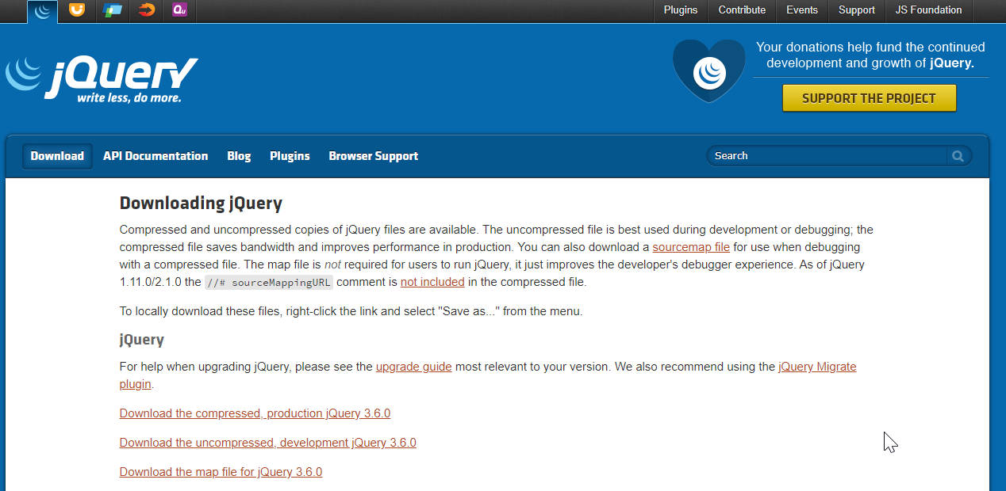

Save the library file to somewhere appropriate for you. For example, I’ve created a folder on my desktop called “JQ” so I can find it easily.

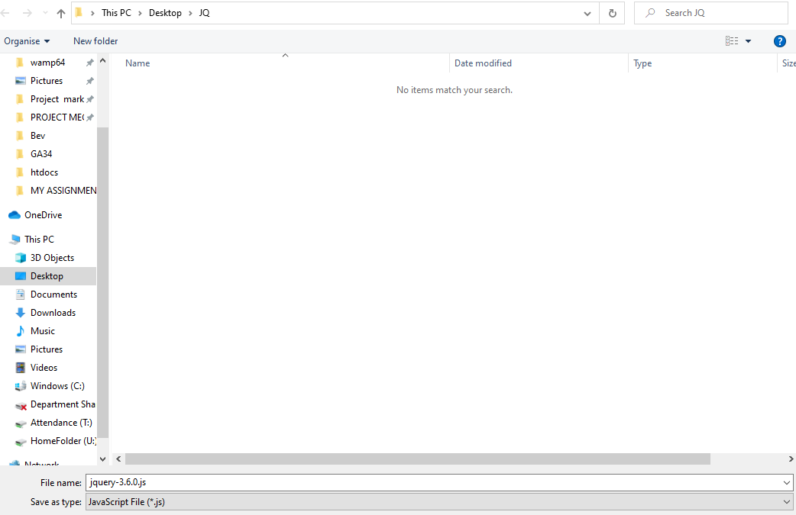

Set up your HTML page as usual with <head></head> and <body></body> tags.

Include your jQuery library file in a script tag. jQuery will not run until all the HTML elements have loaded. So it makes sense to load the jQuery after the HTML elements have loaded. Your code would look something like this:

page1.html
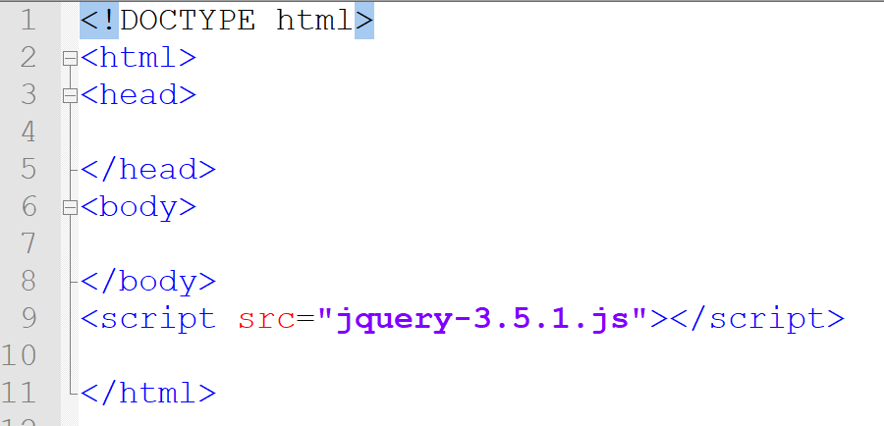

To write our jQuery, we will also need a .js file of our own. Create a blank file called myscripts.js and put a link to it as shown below:

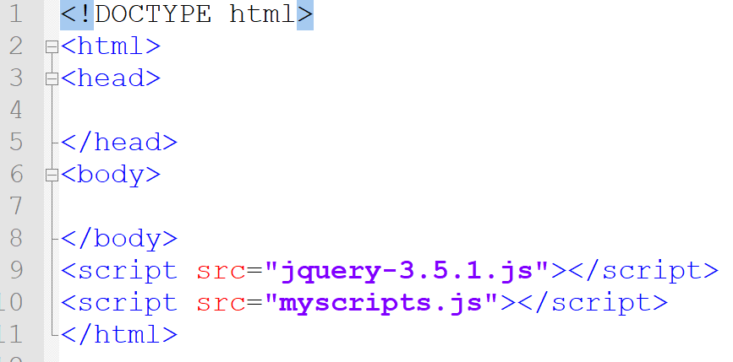

I have now got 3 files in my JQ folder:

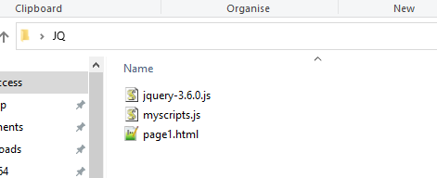

In your myscripts.js file, we need a function to call jQuery. This will be done when the page is loaded. There are a few ways to do this, here is one:

$(pageready)

function pageready()
{

}

To prove that it is working, put a simple Javascript alert in the function. Then run your HTML page (page1.html)

$(pageready)

function pageready()
{
alert(“hello”)
}

When page1.html loads you should see a popup:

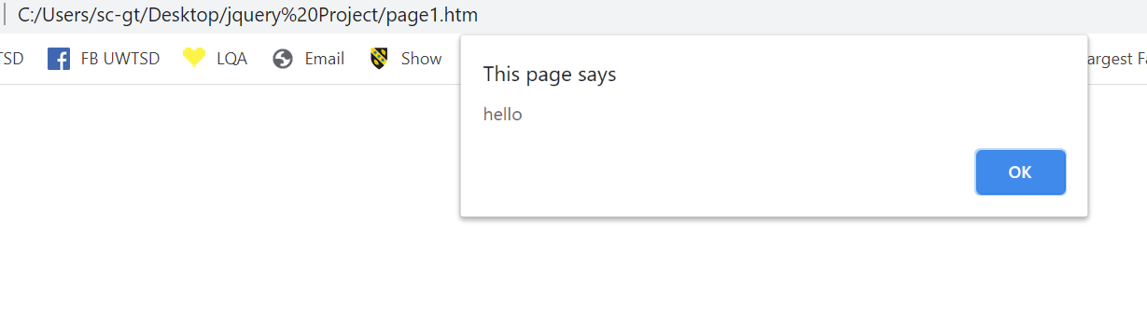

This can also be written:
$( document ).ready(function() {
alert("hello")
});

