Coaching & Mentoring Skills for the Workplace BMSW6105
Individual Reflection

Elena Gabriela Snopu – 2019133
Rexon Nting

Table of Contents
Introduction 3
Critical Evaluation of Coaching and Mentoring 4
Critical Evaluation to Improve Performance and Morale 5
Analysis of the Skills of an effective coach 7
Apply strategies to effectively coach or mentor at an appropriate level 10
Conclusion 12
Reference Lists 13
Apendix 15
Roleplay 15

Introduction
This entire reflection report carries information regarding all the skills and knowledge that are important to become an effective coach and mentor to maintain a good and positive environment in the workplace. It includes a critical evaluation of the coaching session, a critical evaluation of coaching and mentoring to improve the performance and morale of the employees and an analysis of the behaviour, skills, values and beliefs to become an effective coach or mentor. This can help in improving the performance of employees in the workplace. The skills, behaviour, beliefs and values are explained with the help of different strategies. The coaching session given by Philippa is going to help employees a lot (Rahman, 2019).

Critical Evaluation of Coaching and Mentoring
I had the chance to consider my management style and the most recent changes in my department during the coaching session. It was an enlightening experience that helped me understand how my actions affected the team and the necessity to modify my strategy. Overall, the workshop brought out both my strengths and my room for managerial growth. The realisation that my workplace has been performing continuously well in terms of output and staff morale was one aspect of the coaching session that went well. My confidence in the team's ability and the results we accomplished together was strengthened by this acknowledgement. Additionally, it confirmed that the modifications I made, including enhanced automation and flexibility, can get favourable results after decreasing costs and time (Vandergoot et al., 2019).
The session did, however, highlight some places where I could have made improvements. First of all, I realised that it might not always be true for my presumption that my team members are as dedicated and motivated as I am. Although I am passionate about my profession, it's crucial to recognise that others could have different goals and expectations. I need to keep reminding myself to consider everyone's viewpoints and modify my leadership style as necessary going the future. The manner I run team briefings is another thing I would change going forward. I concluded that the team members' lack of dialogue and engagement may have been a result of my stiff and authoritative style. I unintentionally fostered a hierarchical environment that hindered free communication by highlighting the fact that choices are passed down to me and that I am only carrying them out (Vandergoot et al., 2019).
I should work to create a warmer atmosphere where staff members feel free to voice their worries, thoughts, and ideas to address this. To do this, I can actively promote involvement and provide room for free dialogue during team briefings. The coaching session also highlighted any possible departmental disregard for mental health issues. Even though I have addressed the logistical challenges of working from home, it seems like I have not given enough thought to the team members' emotional well-being. In the future, I must give my staff's mental health priority and offer them the tools or help they need to deal with any issues they might be having. This could entail setting up seminars or putting in place regulations that support a healthy work-life balance and mental health (Pattnaik and Jena, 2020).
The training also emphasised the significance of considering individual circumstances and consultation when deciding whether to go back to work. I came to understand how unhappiness and worry might result from the quick expectation for all personnel to report back without sufficient conversation or consideration of unique situations. I need to have open discussions with my fellow team members, taking into consideration their unique wants and concerns, if I want to progress in this area. I may build trust with them, make sure their opinions are heard, and show empathy by incorporating them in the process of making choices (Pattnaik and Jena, 2020).
In the end, the coaching session helped me understand my approach to leadership and the changes that are required. It brought attention to the successful components of my department's operation while also emphasising the necessity of modifying my strategy to take into account unique motives and concerns. Going forward, I'll work to foster an atmosphere that is more welcoming and open, prioritise mental wellness, and engage the team in decision-making. I'm convinced that by applying what I've learned from this reflection, I can improve my department's overall performance and satisfaction (Nurbaeti, 2022).

Critical Evaluation to Improve Performance and Morale
Within the given environment, mentoring and coaching can in fact boost departmental performance and morale. I have seen how the team has been affected by recent changes and corporate demands as the manager who is in charge of quality assurance. Even while the adoption of automation and greater flexibility has led to cost savings and efficiency improvements, it is crucial to deal with the potential adverse effects on staff morale and well-being (Nurbaeti, 2022).
First off, coaching and mentoring might be crucial in helping the other teammates who have taken on bigger roles. The workload has changed due to one member's retirement and another's reassignment, which could lead to stress and burnout. By offering individualised coaching, I can make sure that people get the tools, direction, and assistance they need. I may evaluate their issues, correct any skill gaps, and provide feedback to improve their performance through routine one-on-one meetings. This tailored strategy takes into account their particular situation and aids in boosting their confidence, which increases productivity and job happiness (Hultman, 2020).
Mentoring can help foster personal and professional development. As a successful microbiologist, I am aware of the value of ongoing learning and development in sustaining interest and drive. We may provide possibilities for knowledge exchange, skill development, and career counselling by partnering team members with knowledgeable mentors within the organisation. Mentors can provide knowledge, counsel, and encouragement based on their own experiences, building a feeling of community among professionals and giving people a place to discover their potential. Investing in their progress can allay worries about their future employment and show the company's dedication to its long-term development (Hultman, 2020).
It is also critical to close the communication gap that has developed. The structured team briefings distributed through Microsoft Teams unintentionally contributed to the team members' sense of disconnection and helplessness. I need to take a more inclusive and participative approach to boost morale and participation. I ought to motivate team members to express their concerns, comments, and ideas rather than solely relying on choices from top management. This can be done by making the team briefings interactive meetings that encourage input and discussion. The team will feel more actively involved in decision-making processes if given proper value, empowerment and interest in the results (Al Hilali et al., 2020).
Additionally, coaching and mentoring can offer much-needed support in light of the potential mental health concerns brought on by the change to remote work and the upcoming return to the office. Prioritising employee well-being is crucial, as is fostering a climate in which people feel free to voice their concerns. I can promote a culture that prioritises the team's overall well-being by actively listening, offering resources for mental health help, and promoting a healthy work-life balance. I can support team members in overcoming obstacles, developing resilience, and identifying tactics to preserve their mental and emotional health through coaching and mentoring (Al Hilali et al., 2020).
Mentoring and coaching can have a big impact on raising the quality assurance department's productivity and morale. I may raise team members' enthusiasm, inspiration, and overall job happiness by offering individualised support, encouraging professional progress, and resolving communication issues. Furthermore, I can foster a culture that puts the team's well-being first by recognising and dealing with any possible mental health issues. These initiatives will help us manage the present difficulties and defeat corporate pressures while achieving sustainable success (Clack, 2021).

Analysis of the Skills of an effective coach
An efficient coach or mentor comprises a variety of abilities, traits, attitudes, convictions, and values that help them support and mentor others in their professional and personal development. As a manager in the case study, Philippa Graham is encountering difficulties but by embracing the traits of a successful coach or mentor, I may be able to solve these issues and improve the performance of my team (Clack, 2021). The following is a breakdown of the essential qualities of a successful coach or mentor:
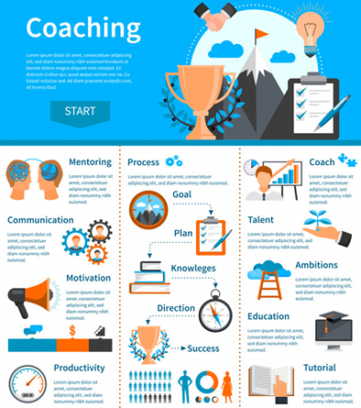
Active Listening: Skilled listeners make for effective coaches and mentors. Without interrupting or making snap judgements, they give their team members' concerns, ideas, and viewpoints their entire attention. With the help of attentive listening, the atmosphere helps mentors to be confident so they can possess a workplace where open communication is easy for other employees.

Empathy: Mentors and coaches with empathy can understand and relate to the feelings and perceptions of others. They put their own feet in the shoes of their mentees, noting their concerns and providing support as needed. They develop interpersonal ties and foster a sense of belonging and well-being among the team participants by demonstrating empathy (Turato et al., 2022).
Flexibility: A skilled mentor or coach recognises that every individual is unique and may require an alternate method to mentoring or coaching. They can modify their strategies to the different needs, advantages, and drawbacks of their colleagues since they are flexible and adaptable in this regard. This makes it possible for them to offer tailored advice and support.
Emotional Intelligence: For coaches and mentors, emotional intelligence is essential. They have a high level of awareness of themselves, which allows them to recognise and efficiently control their own emotions. They also comprehend other people's feelings and can relate to their difficulties. They can deal with challenging circumstances, settle disputes, and foster an environment that is encouraging and supportive through making use of emotional intelligence (Nuryanti et al., 2019).
Positive Reinforcement: Effective mentors and coaches place a strong emphasis on praising good deeds and accomplishments. While praising and recognising the advancements and accomplishments of their team members, they offer constructive criticism. This strategy inspires people to keep progressing and growing, enhancing morale and performance as a whole.
Continuous Learning: Mentors and coaches adopt a growth attitude and look for ways to advance themselves constantly. They continue to grow their knowledge and abilities by staying current with the most recent business trends and best practices. They encourage their mentees to embrace a similar perspective and pursue ongoing personal and professional progress by modelling how to be lifelong learners (JABAK, 2023).
Trust and Confidentiality: Mentors and coaches provide a secure and private setting for people to discuss their problems, worries, and goals. By communicating honestly and openly, they cultivate trust while protecting the confidence and privacy of their team colleagues. This trust allows mentees to be open and vulnerable, to ask for advice, and to confidently strive towards their objectives.
Collaborative Approach: An inclusive and collaborative workplace is fostered by effective coaches and mentors. They promote communication, collaboration, and idea-sharing among team members. They enable people to offer their distinctive viewpoints by encouraging a sense of responsibility and involvement, which fosters innovative thinking and creativity within the team (Weiss et al., 2021).
Ethics and Integrity: High standards of morality and integrity are upheld by coaches and mentors. They serve as role models by conducting themselves with integrity, fairness, and professionalism. They make sure that their activities are consistent with the company's ideals and encourage their team members to make moral decisions.

Apply strategies to effectively coach or mentor at an appropriate level
I recognise the value of successfully mentoring and coaching my staff, especially during trying times, as a manager in charge of quality assurance. Given the recent adjustments made to our department as a result of corporate demands, I need to use a variety of tactics to help my team members and allay their worries (Khan et al., 2023). I would use the following strategies to properly coach and mentor them:
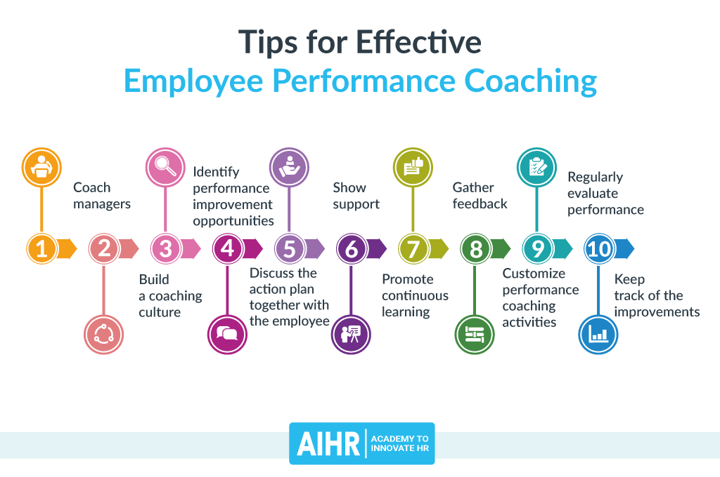
Empathy and Active Listening: I would start by empathising with my team members' worries and actively listening to what they had to say. For them to feel at ease expressing their ideas and emotions, I need to establish a welcoming and secure environment. I may indicate that I respect their feelings and viewpoints by emulating true empathy.
Clear Communication: I would enhance my communication during team briefings to address an environment of fear and dissatisfaction. I would promote conversation and debate rather than just delivering the decisions that were handed down to me. I'd like to emphasise how important their opinions are and how we can all work together to find solutions to the problems we face (Susanto et al., 2022).

Individualised Approach: I would take an individualised approach to teaching and mentoring since I understand that each team member is different. I would schedule one-on-one conversations to learn about each person's unique situation, issues, and goals. I can offer more effective support and aid in their career and personal growth by adjusting my advice to meet their unique needs.
Recognising Successes: It is important to recognise and appreciate the efforts and successes of my team members. I may raise morale and inspire them to continue their passion and dedication by recognising their contributions. Regularly thanking employees for their hard work will promote a pleasant workplace culture and increase job satisfaction (Barinua and Ibe, 2022).
Skills Development: It is my duty as a manager to assist my team members in advancing their careers. I would pinpoint their skill deficiencies and provide them with chances for improvement and training. This could entail taking pertinent online courses, seminars, or workshops. I would improve their abilities and demonstrate my dedication to their long-term success by investing in their skill sets.
Work-Life Balance: I would put a priority on work-life balance discussions given the shift to remote employment and the possibility of mental health risks. I would have frank discussions with them about their unique situations and potential difficulties. I can support my team members in achieving a healthy work-life balance, which is essential for their general well-being and productivity, by exhibiting flexibility and understanding (Sjarifudin and Rony, 2023).
Opportunities for Mentorship: I would promote mentoring among the team members to promote a culture of ongoing learning and development. I would encourage mentor-mentee relationships so that seasoned team members could impart their wisdom and help others who could use it. In addition to enhancing each person's skill set, this would encourage cooperation and teamwork.
Finally, during times of transition and uncertainty, good mentoring and coaching are essential. I may help and empower my team members by using tactics like listening intently, clear communication, individualised methods, recognition, skill development, the balance between work and life considerations, and mentorship opportunities. I can do this by assisting them in overcoming obstacles, growing as individuals and professionally, and ultimately contributing to the accomplishments of our division and the organisation as a whole (Van et al., 2023).

Conclusion
This entire reflection report has given information about the coaching and mentoring by Philippa to her team members. The coaching and mentoring session helped the employees in reducing different types of issues and challenges which is going to improve the morale and performance of the employees in the workplace. As this report has covered the critical evaluation of coaching sessions and mentoring to improve performance, this has helped to analyse the skills and attitudes of an effective coach or mentor. This reflection report is very helpful in better understanding the coaching and mentoring importance in the workplace.

Reference Lists
Al Hilali, K.S., Al Mughairi, B.M., Kian, M.W. and Karim, A.M. (2020) Coaching and mentoring. Concepts and practices in development of competencies: A theoretical perspective. International Journal of Academic Research in Accounting, Finance and Management Sciences, 10(1), pp.41-54.
Barinua, V. and Ibe, U.M. (2022) Employee mentoring and organisational effectiveness. International Journal of Trend in Management Research and Development, 6(4), pp.202-213.
Clack, L. (2021) Employee engagement: Keys to organizational success. The Handbook of workplace well-being, pp.1001-1028.
Hultman, K. (2020) Building a Culture of Employee Optimization. Organization Development Journal, 38(2).
JABAK, H. (2023) The Effect Of Training & Development On Job Satisfaction: The Mediating Effect Of Coworker Support. Journal of Positive School Psychology, 7(6), pp.379-386.
Khan, S., Khan, M.I., Rais, M. and Aziz, T. (2023) Organizational productivity: a critical analysis of the impact of employee motivation. Reviews of management sciences, 5(1), pp.13-37.
Nurbaeti, S. (2022) Significance of the Influence of Leadership Model, Morale, and Satisfaction on Performance Consistency. PRODUKTIF: Journal of Management, 1(1), pp.10-18.
Nuryanti, B.L., Masharyono, M. and Fauziatunisa, H. (2019) May. The effect of coaching on employee performance. In 1st International Conference on Economics, Business, Entrepreneurship, and Finance (ICEBEF 2018) (pp. 136-139). Atlantis Press.
Pattnaik, L. and Jena, L.K. (2020) Mindfulness, remote engagement and employee morale: conceptual analysis to address the “new normal”. International Journal of Organizational Analysis, 29(4), pp.873-890.
Rahman, U.H.F.B. (2019) Diversity management and the role of leader. Open Economics, 2(1), pp.30-39.
Sjarifudin, D. and Rony, Z.T. (2023) Mentoring and Coaching Programs to Improve Performance Management. International Journal of Multidisciplinary Research, 1(5), pp.485-496.
Susanto, P.C. and Sawitri, N.N. (2022) Coaching, Mentoring, Leadership Transformation and Employee Engagement: A Review of the Literature. Dinasti International Journal Of Education Management And Social Science, 4(2), pp.297-308.
Turato, G., Whiteoak, J. and Oprescu, F. (2022) Allied health front-line manager perceptions of factors impacting workplace morale and burnout risk. Journal of Organization and Management, 36(7), pp.857-874.
Van, V.T., Huong, N.L.T. and Hong, N.T.T. (2023) Factors for Improving the Effectiveness of Professional Training of Employees in Modern Conditions. Journal of Management and Technology, 27(1 (110)), pp.131-145.
Vandergoot, S., Sarris, A. and Kirby, N. (2019) Factors that influence the transfer generalization and maintenance of managerial‐leadership skills: A retrospective study. Performance Improvement Quarterly, 32(3), pp.237-263.
Weiss, J.A. and Merrigan, M. (2021) Employee Coachability: New Insights to Increase Employee Adaptability, Performance, and Promotability in Organizations. International Journal of Evidence Based Coaching & Mentoring, 19(1).

Apendix

Roleplay
Conversation for a coaching session
(Philippa and John are waiting to start the coaching session in a meeting room.)
Philippa: John, good morning. I appreciate you being here today. I know that you've had some difficulties in your new position. I want to explore those issues in this coaching session and see if we can come up with any answers together. Determine whether mentoring or coaching would be better appropriate for your requirements before we get started.

John: Merci Philippa. At this time, I believe coaching would be more beneficial for me. Although I value your knowledge and skills, I need help defining my objectives and coming up with plans to better handle my workload.

Philippa: John, that seems like a wise decision. Then, let's move forward using a coaching strategy. I propose that we employ the GROW paradigm to frame our conversation. Objectives, Reality, Options, and Will are its initials. It will assist us in examining your existing condition, determining your intended results, and figuring out the steps you may take to get there. That seems good, right?

John: Absolutely. The GROW model is one I'm familiar with, and I believe it provides a helpful framework. Let's move on.

(They use GROW to start the coaching session)
Philippa: Goals will be the first step we take. What goals do you have for this coaching session? What particular outcomes would be beneficial to you?

John: My workload has been excessive, and I've been finding it difficult to juggle my involvement in the kids club with my new obligations. I want to learn better ways to handle my workload and maybe look into a position that will better suit my interests and obligations outside of work.

Philippa: John, I appreciate you sharing it. Let's proceed to the Reality phase now. What is the situation right now? Can you elaborate on your workload, time restrictions, and difficulties in handling your responsibilities?

John: Obviously. Since being promoted, my workload has greatly risen, making it challenging for me to devote myself to the young club and find the time to study my new position. When it comes to meeting deadlines and giving the teenagers at the club the support they require, I frequently feel overworked and pressured.

Philippa: John, thank you for being so open. Let's go to the options stage now. What methods or techniques do you believe would help you handle your workload more effectively and locate a position within the business that promotes a better balance between work and life?

(They explore a variety of options and methods, including assigning chores to others, realigning priorities, and looking for prospective business prospects.)
Philippa: Let's now proceed to the Will stage. Which alternatives, John, most appeal to you? Which ones inspire you to pursue them? And how can I assist you in implementing those choices?

John: I believe distributing some of the work and asking my staff for aid could lessen the stress. I'm also curious about additional positions that would let me contribute to the organisation while still finding time for my job at the kids club. I think I can take the steps they need to advance in these areas with your help.

(The coaching session goes on, emphasising the development of an action plan and talking about how Philippa might help John.)
Debrief:
Philippa: John, I appreciate you participating in this coaching session. What do you think of our conversation today? Did it aid you in gaining an understanding and spotting viable solutions?

John: Philippa, John. It was helpful to freely talk about my struggles and consider other options. I'm more inspired and assured that I can find a solution.

Philippa: John, I'm pleased to hear that. Keep in mind that I am here to support you as your coach throughout the process. Let's arrange frequent follow-up meetings so we can monitor your development and, if necessary, change our strategy. Do you have any further questions or concerns that you would want to voice?

John: No, Philippa; I believe we have finished everything so far. I value your advice and assistance. Working on these next steps and achieving a better balance is something I'm looking forward to.

Philippa: Fantastic, John. I'm sure we can alter things for the better if you're determined and we keep working together. Keep in mind that you may always get in touch with me if you need help. Good luck with your adventure, and let's get together again to discuss your results in a few weeks.

(They leave the coaching session feeling upbeat and determined to follow the action plan.)

Conclusion
In the end, the training has done smoothly. The issues and challenges faced by John has discussed with Philippa to improve their performance and morale. This coaching session is also very helpful in better understanding the main causes behind the issues faced by the team members to solve them.

