

Designing and Building an Electric Bicycle with smart features controlled via a Microcontroller.

By
Curtis Rees 2003711

Supervisor: Gareth Jones
Second Marker: Gary Jones

Individual Project
Electrical & Electronic Engineering

April 2024

DECLARATION

I, Curtis Rees declare that I am the sole author of this Project; that all references cited have been consulted; that I have conducted all work of which this is a record, and that the finished work lies within the prescribed word limits.

This work has not previously been accepted as part of any other degree submission.

FORM OF CONSENT

I Curtis Rees hereby consent that my Project, submitted in candidature for the B.Sc. (Hons) Electrical and Eelectronic Engineering degree, if successful, may be made available for inter-library loan or photocopying (subject to the law of copyright), and that the title and abstract may be made available to outside organisations.

B.Sc. (Hons) Electronic and Electrical Engineering

Contents
Abstract 5
Chapter 1 – Introduction 6
Chapter 2 – Research 6
Overview / History 6
Why E-Bikes are a Good Alternative 7
Existing Products 8
Mid-Drive and Rear Wheel Hub Motors 9
E-Bike Motor Torque output 10
E-Bike Batteries 10
E-Bike Battery Capacities 11
Additional E-Bike Battery Specifications 12
Why Most E-Bikes use Lithium-Ion Batteries 12
The introduction of E-Bikes in Major Cities Along with Charging Stations 13
Regenerative Breaking 14
Chapter 3 - Design 15
Microcontroller Selection 15
Motor Selection 17
Battery Selection 17
Display Selection 19
Throttle Selection 20
Temperature Sensor Selection 21
Safety Lights 21
Speed / Distance sensor Selection 22
Chapter 4 - Implementation 23
Chapter 5 – Analysis 30
Practical Prototype of E-bike 36
Chapter 6 – Evaluation 38
Chapter 7 – Conclusion 38
Chapter 8 – Reflection 39
Chapter 9 - Bibliography 41
Chapter 10 – Appendices 45

Abstract
The electric bicycle (e-bike) represents a promising solution to address urban transportation challenges, while promoting sustainability and active mobility. This project consists of comprehensive research into electric bicycles, culminating in the design, construction, and evaluation of a prototype e-bike integrated with smart features enabled by a microcontroller-based control system. The primary objectives are to investigate the environmental, social, and technological aspects of e-bikes, develop a functional prototype showcasing key components and smart functionalities, and evaluate the performance and effectiveness of the integrated microcontroller system.
The research delves into the environmental impact, health benefits, and technological advancements associated with electric bicycles. Through literature review and analysis, the project aims to elucidate the role of e-bikes in promoting sustainable transportation systems and improving urban mobility. Furthermore, the study explores the integration of microcontroller technology in e-bikes, focusing on motor control, user interface enhancements, and data analysis capabilities.
The design and construction phase involve the development of a prototype e-bike, showcasing essential components such as the electric motor, battery pack, motor controller, and associated electronic systems. Smart features are added to the prototype using a microcontroller platform, enabling functions such as headlights, indicators, user interface enhancements, and addition data showcased on the display.
The implementation of smart features involves programming the microcontroller to interface with various sensors, actuators, and communication modules, all ensuring the rider is kept as safe as possible. The evaluation phase consists of rigorous testing, performance analysis, and general feedback to assess the functionality, usability, and effectiveness of the integrated microcontroller system in enhancing e-bike safety and user experience.
Through a combination of theoretical research, practical experimentation, and analysis, this project aims to contribute to the growing body of knowledge on electric bicycles and microcontroller-based smart systems. It will do this by showcasing the design, construction, and evaluation of a prototype e-bike with advanced features. The project seeks to highlight the role of microcontroller technology in enhancing their functionality and safety.

Chapter 1 – Introduction

Figure 7 [28]

In recent years, electric bicycles (e-bikes) have gained significant popularity as an eco-friendly alternative to traditional bicycles and motorized vehicles. With advancements in battery technology, motor efficiency, and electronic controls, e-bikes offer a convenient and sustainable mode of transportation for urban commuters, recreational riders, and eco-conscious individuals alike. This project will undertake the design, construction, and programming of a prototype electric bicycle, leveraging modern technologies such as microcontrollers to enhance performance and functionality.
The primary objective of this project is to develop a functional e-bike prototype that demonstrates the integration of an electric motor with a traditional bicycle design. The prototype will feature an electric motor, battery pack, motor controller, and a microcontroller-based control system to manage power deliver. Additional sensors will be integrated to monitor system parameters, and provide user interface functionalities. Through hands-on experimentation and iterative design refinement, the project aims to showcase the effectiveness of electrically powered bicycles, while exploring the role of microcontrollers in enhancing e-bike functionality.

Chapter 2 – Research

Overview / History
Electric bicycles (E-bikes) have emerged as a popular and environmentally friendly mode of transportation, offering a convenient and eye opening alternative to traditional bicycles and motorized vehicles. This section provides an overview of e-bikes, including historical development, market trends, and fundamental components and working principles to have a better understanding of why E-bikes are such a good alternative.
Electric bicycles, often referred to as e-bikes, are bicycles equipped with an electric motor that assists propulsion. They provide riders with the option to pedal manually or engage the electric motor for added assistance, enabling easier and more efficient travel, especially over long distances or challenging terrain. E-bikes are classified based on factors such as motor power, pedal assistance level, maximum speed, and regulatory standards, with various categories including pedelecs, throttle-assist e-bikes, speed pedelecs, and cargo e-bikes.
The development of electric bicycles dates back several decades, with early prototypes emerging in the late 19th and early 20th centuries. However from researching, significant advancements in battery technology, motor efficiency, and regulatory frameworks have spurred the rapid growth of the e-bike industry in recent years. Market trends indicate a surge in e-bike sales worldwide, which is likely to be driven by factors such as urbanization, increasing traffic congestion, rising fuel costs, and growing environmental awareness. E-bikes have gained popularity among commuters, recreational riders, delivery services, and tourism operators, contributing to a diverse and expanding market landscape. [1]

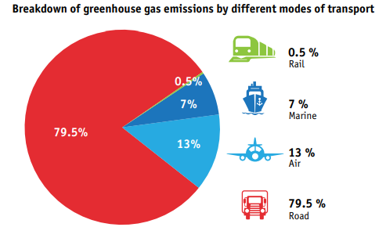
Why E-Bikes are a Good Alternative
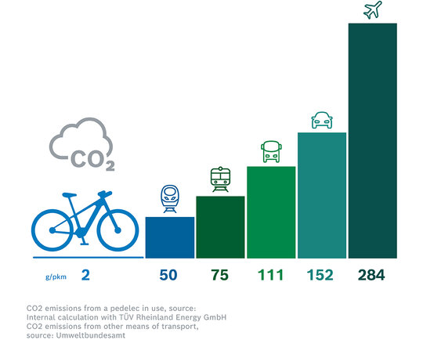

Figure 10 Breakdown of Greenhouse Gas Emissions by Different Modes of Transport [32]

E-bikes offer several advantages that make them a compelling alternative to traditional bicycles and motor vehicles. E-bikes produce zero tailpipe emissions, making them an environmentally friendly mode of transportation. By replacing car trips with e-bike rides, individuals can reduce their carbon footprint, lower air pollution levels, and contribute to mitigating climate change. [2]
Compared to owning and maintaining a car, e-bikes are significantly more cost-effective. E-bike riders save on fuel costs, parking fees, insurance premiums, and vehicle maintenance expenses. Additionally, e-bikes have lower upfront costs than electric cars or motorcycles, making them accessible to a wider range of individuals. [3]
Riding an e-bike provides an opportunity for physical activity and exercise, contributing to improved cardiovascular health, increased muscle strength, and enhanced overall fitness. E-bikes offer a low-impact form of exercise that is suitable for people of all ages and fitness levels, promoting active lifestyles and wellbeing. [4]
E-bikes offer the convenience of door-to-door transportation without the hassle of parking or traffic congestion. Riders can navigate through congested urban areas, access bike lanes and pathways, and reach their destinations efficiently. E-bikes also provide flexibility in commuting options, allowing riders to combine cycling with public transit or other modes of transportation. [5]
E-bikes can often travel at speeds faster than traditional bicycles, allowing riders to cover longer distances in less time. With e-bikes, commuters can avoid traffic delays, reduce commute times, and arrive at their destinations faster than if they were traveling by car or public transit. [6]
In addition to being able to travel faster than traditional bicycles, E-bikes make cycling more accessible to people who may face barriers to traditional biking, such as physical limitations, long distances, or challenging terrain. With electric assistance, riders can conquer hills, headwinds, and long distances with ease, empowering more individuals to enjoy the benefits of cycling. [7]

Existing Products
Specialized Turbo Levo Pro Carbon 2023 [8] | Haibike AllTrack 4 29 2023 [9] | German E-Bike Conversion Kit [10]
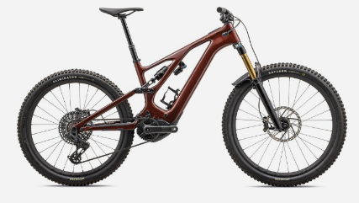 | 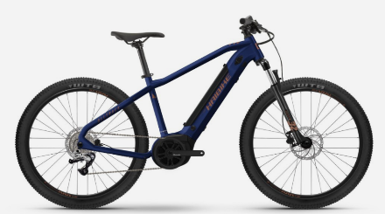 | 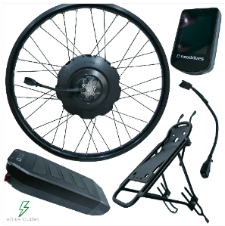
Motor: 565W, 90Nm  4 Power settings | Motor: 250W, 65Nm  4 Power Settings | Motor: 250W, 750W Peak Torque. 1 Power setting
Battery: 700Wh | Battery: 500Wh | Battery: 11.25Ah
£10,250.00 | £1,999.00 | £879.20

In comparing the three existing e-bike products, their key specifications, performance features, and price points were evaluated, to assess their value and suitability for different types of riders.
The Specialized Turbo boasts a powerful 565W motor with 90Nm of torque, paired with a high-capacity 700Wh battery. These specifications indicate excellent performance capabilities, with high power output and long battery life. Priced at £10,250, this high-end e-bike represents a significant investment but offers top-of-the-line performance and features. The high price point reflects the premium quality and advanced technology of this e-bike. It is suitable for riders who prioritize performance, range, and luxury features, such as integrated electronics and high-quality components.
This mid-range Haibike Alltrack 4 features a 250W motor with 65Nm of torque and a 500Wh battery. While not as powerful as the high-end model, it still offers respectable performance and range for most riding needs. Priced at £1,999, this mid-range e-bike offers a balance of performance and affordability, making it accessible to a broader range of riders. The price point makes this e-bike a popular choice for riders seeking a good balance of performance, reliability, and value. It is suitable for daily commuting, recreational riding, and light off-road adventures.
Finally the e-bike conversion kit, which allows users to retrofit their existing bicycles with electric assist capabilities. It includes a motor, battery, controller, and other components needed for conversion. Priced at £879, this conversion kit offers an affordable alternative to purchasing a new e-bike, allowing riders to upgrade their current bicycle with electric assistance. The low price point of the conversion kit makes it an attractive option for budget-conscious riders who already own a suitable bicycle and want to experience the benefits of e-bike technology. It offers a cost-effective way to transform a standard bike into an e-bike, providing increased versatility and usability.
Overall, the comparison highlights the diverse range of e-bike products available on the market, catering to different budgets, preferences, and riding needs. Whether seeking top-tier performance, mid-range affordability, or budget-friendly versatility, riders have options to choose from based on their individual priorities and requirements.

Mid-Drive and Rear Wheel Hub Motors
Electric bicycles (e-bikes) are equipped with electric motors that provide assistance to the rider, enhancing the cycling experience by reducing the effort required to pedal and increasing overall speed and range. The electric motor is a crucial component of an e-bike, and there are two main types commonly used: the mid-drive motor located in the bottom bracket and the rear wheel hub motor.
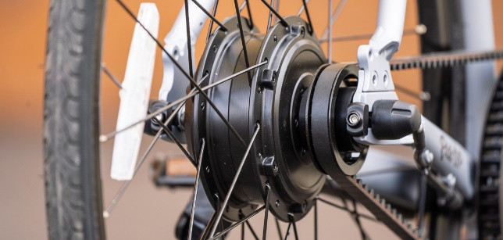
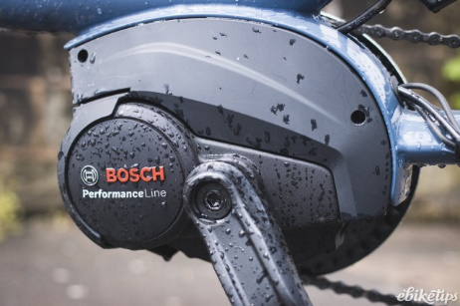
Figure 2 Rear Wheel Hub Motor
Figure 1 Mid Drive Motor

The mid-drive motor is positioned at the bike's bottom bracket, which is the part of the frame where the pedals are located. This placement provides a central and low centre of gravity, improving overall stability and handling of the e-bike. Mid-drive motors leverage the bike's gears, allowing for more efficient power delivery and better utilization of the motor's torque. By driving the chain directly, these motors can take advantage of the bike's existing gearing system to optimize performance, particularly on hills and uneven terrain. The location of the motor results in a more natural riding experience, as the motor assistance is delivered directly to the pedals, simulating the sensation of a traditional bicycle with added power. This design also facilitates easier maintenance and servicing of the motor. [11]
Rear wheel hub motors offer straightforward installation and compatibility with a wide range of bicycle frames, as they do not require any modifications to the bike's drivetrain or gearing system. This makes them a popular choice for aftermarket e-bike conversions. While rear wheel hub motors may lack the mechanical advantage of mid-drive motors when climbing steep hills or traversing rough terrain, they provide consistent and reliable power delivery, particularly on flat surfaces and urban environments. The position of the rear wheel hub motor can affect the e-bike's balance and handling, with some riders noting a slightly different feel compared to traditional bicycles. [12]
Both mid-drive and rear wheel hub motors offer distinct advantages and considerations for e-bike riders. The choice between these motor types depends on factors such as riding style, terrain, preferences, and intended use of the e-bike. By understanding the characteristics and differences between these motor configurations, riders can select the most suitable e-bike to meet their needs and preferences.

E-Bike Motor Torque output
Entry-level e-bike motors often have torque ratings ranging from 30 Nm to 60 Nm. While these motors provide sufficient assistance for flat terrain and moderate inclines, they may struggle on steeper climbs or challenging off-road trails.
Mid-range e-bike motors typically offer torque ratings between 60 Nm and 80 Nm. These motors deliver ample assistance for a wide range of riding conditions, including urban commuting, recreational cycling, and light off-road adventures.
High-performance e-bike motors may boast torque ratings exceeding 80 Nm, with some models reaching up to 100 Nm or more. These high-torque motors excel in demanding terrain, providing robust assistance for steep climbs, technical trails, and aggressive riding styles. [13]

E-Bike Batteries
When it comes to e-bikes, the battery is a critical component that directly impacts performance, range, and overall riding experience. Two common battery configurations found in e-bikes are frame-mounted batteries and frame-integrated batteries.
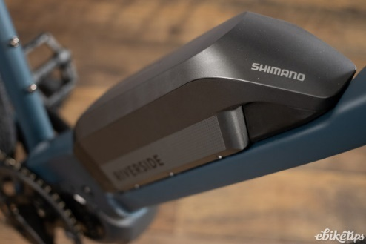

Figure 4 Frame Integrated Battery

Figure 3 Frame Mounted Battery

Frame-mounted batteries are typically mounted externally on the e-bike's frame, often on the downtube or seat tube. This placement allows for easy access and removal of the battery for charging or maintenance purposes. These batteries come in various shapes and sizes, offering versatility in terms of compatibility with different e-bike frames. Riders can choose from a range of battery capacities and form factors to suit their preferences and riding needs. [14]
Since frame-mounted batteries are easily accessible, charging them is convenient and straightforward. Riders can remove the battery from the frame and connect it to a standard electrical outlet using the provided charger. The external placement of frame-mounted batteries allows for a modular design approach, enabling e-bike manufacturers to offer interchangeable batteries or upgrade options for riders seeking extended range or higher performance.
Frame-integrated batteries are seamlessly integrated into the e-bike's frame, often housed within the downtube or integrated into the frame structure itself. This integration creates a sleek and streamlined appearance, with the battery concealed within the bikes frame, and out of view. The integration of the battery into the frame enhances the e-bike's aesthetic appeal, creating a cohesive and visually appealing design. This clean and minimalist look is favoured by many riders seeking a modern and sophisticated e-bike aesthetic. [15]
By positioning the battery within the frame, frame-integrated batteries contribute to improved weight distribution and balance, while enhancing the e-bike's handling and stability, particularly in high speeds or off-road riding scenarios. The internal placement of frame-integrated batteries offers enhanced protection against external elements, such as water, dust, and impact. This protection helps safeguard the battery from damage and extends its lifespan, ensuring reliable performance over time.
Both frame-mounted batteries and frame-integrated batteries offer unique advantages and considerations for e-bike riders. Frame-mounted batteries provide versatility, convenience, and modular design options, while frame-integrated batteries offer a more aesthetic appeal, improved weight distribution, and enhanced protection. Ultimately, the choice between these battery configurations depends on factors such as rider preferences, riding style, and aesthetic preferences.

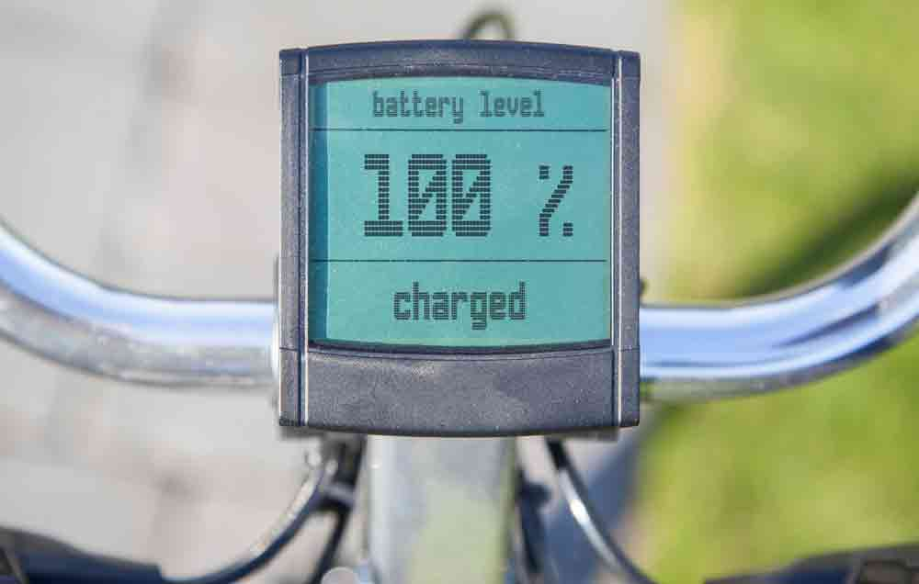
E-Bike Battery Capacities

Figure 5 Battery Level [28]
E-bikes come equipped with a wide range of battery capacities, measured in watt-hours (Wh), which directly impacts the range and performance of the e-bike. Most entry-level e-bikes feature batteries with capacities ranging from 250Wh to 400Wh. With these battery capacities, riders can expect a range of approximately 20 to 40 miles (32 to 64 kilometres) on a single charge, depending on factors such as terrain, riding style, and the level of assistance provided by the electric motor. [16]
Mid-range e-bikes typically come equipped with batteries ranging from 400Wh to 600Wh. With these battery capacities, riders can achieve a range of approximately 40 to 60 miles (64 to 96 kilometres) on a single charge, offering extended range and versatility for longer rides and varied terrain.
High-performance e-bikes may feature batteries with capacities exceeding 600Wh, ranging up to 800Wh or more. With these higher-capacity batteries, riders can enjoy extended range capabilities, with ranges exceeding 60 miles (96 kilometres) on a single charge. These e-bikes are well-suited for demanding terrain, long-distance touring, and high-speed commuting.
Specialized e-bikes, such as cargo bikes or electric mountain bikes (eMTBs), may feature larger battery capacities ranging from 800Wh to 1,000Wh or higher. These specialized e-bikes are designed for specific applications and may offer ranges exceeding 60 miles (96 kilometres) or even 100 miles (160 kilometres) on a single charge, catering to the needs of riders seeking maximum range and endurance. [17]

Additional E-Bike Battery Specifications
E-bike batteries typically operate at voltages ranging from 36 volts (V) to 48V or higher, depending on the motor and controller specifications. Lithium-ion (Li-ion) batteries are the most common type used in modern e-bikes due to their high energy density. The charging times for these e-bike batteries vary depending on the charger's output and the battery capacity. From the research, typical charging times ranging from 3 to 6 hours for a full charge.

Why Most E-Bikes use Lithium-Ion Batteries
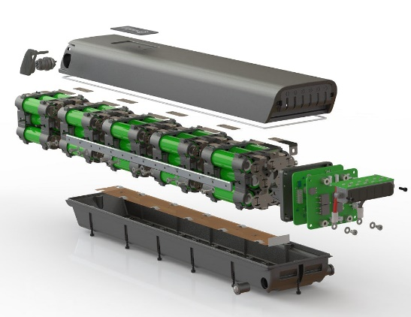
Figure 6 Inside Lithium-Ion Battery [29]

From researching it is clear a very large portion of E-Bikes implement Lithium-ion Batteries within their design. This is because lithium-ion batteries offer a high energy density, meaning they can store a large amount of energy in a relatively small and lightweight package. This allows e-bike manufacturers to design sleek and compact battery packs without compromising on range or performance.
Compared to other types of rechargeable batteries, such as lead-acid or nickel-metal hydride (NiMH) batteries, lithium-ion batteries have a significantly lower energy to weight ratio. This lightweight construction reduces the overall weight of the e-bike, improving handling, manoeuvrability, and ride comfort. [18]
Lithium-ion batteries typically have a longer cycle life compared to other battery types, meaning they can withstand a greater number of charge-discharge cycles before experiencing significant degradation in performance. This durability ensures that e-bike batteries maintain their capacity and reliability over extended periods of use and limit degradation in performance.
Lithium-ion batteries support fast charging capabilities, allowing e-bike riders to recharge their batteries quickly and conveniently. With the use of compatible chargers, e-bike batteries can be fully charged in a matter of hours, making them ideal for daily commuting and recreational riding. In addition to the fast charging capabilities, these batteries offer low self-discharge rate, meaning they retain their charge over time even when not in use. This ensures that e-bike batteries remain ready for use whenever needed, without the need for frequent recharging or maintenance.
Lithium-ion batteries can operate effectively across a wide range of temperatures, from freezing cold to scorching heat, without significant performance degradation. This versatility makes them suitable for use in various climates and environmental conditions. [19]
The last major advantage to using lithium-ion batteries over batteries is that they incorporate advanced safety features, such as built-in protection circuits and thermal management systems. This is incorporated to prevent overcharging, over-discharging, and overheating. These safety mechanisms ensure safe and reliable operation of e-bike batteries, minimizing the risk of accidents or malfunctions.
Overall, the combination of high energy density, lightweight construction, long cycle life, fast charging, low self-discharge rate, wide operating temperature range, and safety features makes lithium-ion batteries the preferred choice for most e-bike manufacturers and riders. These advantages contribute to the widespread use of lithium-ion battery technology within the electric bicycle industry.
Top of Form

The introduction of E-Bikes in Major Cities Along with Charging Stations

Figure 8 E-Bike Charging Station powered via Solar Panels [30]

The emergence of e-bike charging stations reflects the growing popularity and adoption of electric bicycles as a sustainable and convenient mode of transportation. These charging stations are specifically designed to cater to the needs of e-bike riders, providing them with access to convenient and reliable charging station. [20]
As e-bike usage continues to rise in urban areas and beyond, cities and municipalities are investing in infrastructure to support e-bike riders. This includes the installation of e-bike charging stations at key locations such as transportation hubs, bike sharing stations, parks, recreational areas, and commercial districts.
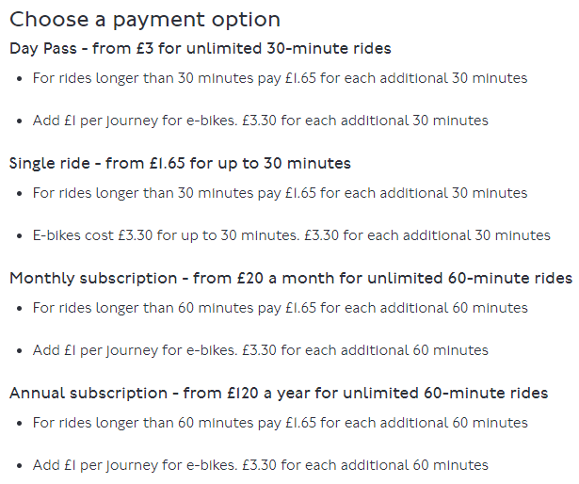

Figure 9 Costs to Hire a Santander Cycle [31]

Figure 9 shows the costs to hire a Santander bicycle. These stations are dotted all around London and work in a way in which riders take a bicycle from one station and taking it to another one close to their destination.

Figure 11 Taxi Fares London

Figure 11 then shows the Taxi Fares in London. As shown by the data, taxi fares are a great deal more than E-Bikes. These prices for the E-Bikes have been put in place in order to encourage people to use these bicycles and produce less emissions especially for the short journeys.

Regenerative Breaking
Regenerative braking is a technology that allows electric vehicles, including e-bikes, to recover and convert kinetic energy into electrical energy during braking or coasting. When a rider applies the brakes or reduces pedal assistance while coasting, the electric motor on the e-bike acts as a generator, converting the kinetic energy of the moving bike back into electrical energy. This electrical energy is then fed back into the e-bike's battery, where it can be stored and used later to power the motor during acceleration or provide additional range. [21]
It also extends the range of e-bikes by capturing energy that would otherwise be lost during braking or coasting. This can be particularly beneficial for riders on longer journeys or hilly terrain. By recovering and reusing energy, regenerative braking improves the overall energy efficiency of e-bikes, reducing the need for frequent recharging and maximizing battery life.
Regenerative braking can provide smoother and more controlled braking, especially on steep descents or when riding at higher speeds. This can improve rider safety and confidence, particularly in challenging riding conditions. By reducing the reliance on fossil fuels and minimizing energy wastage, regenerative braking contributes to environmental sustainability and helps to reduce greenhouse gas emissions associated with e-bike usage. [22]
The effectiveness of regenerative braking can vary depending on factors such as riding style, terrain, and battery technology. In some cases, the amount of energy recovered may be relatively small compared to the overall energy consumption of the e-bike. Regenerative braking systems may introduce additional wear and tear on components such as brake pads and motors, particularly during extended periods of heavy braking or frequent use.
Regenerative braking systems are typically integrated into the motor and control electronics of e-bikes. Some e-bike models may offer adjustable regenerative braking settings, allowing riders to customize the level of regenerative braking force based on their preferences and riding conditions.

Chapter 3 - Design

Microcontroller Selection
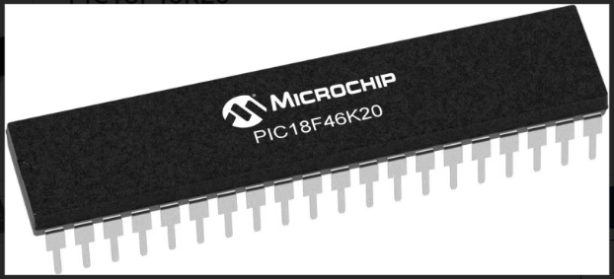

Figure 12 Hardware of PIC18F46K20 Microcontroller [41]

In the designing stage of this e-bike project, one crucial aspect is selecting the appropriate microcontroller to control various functions and features of the e-bike system. A PIC microcontroller is a small, programmable device that serves as the brain of electronic systems and applications. It performs a wide range of tasks, including processing data, controlling external devices, and executing predefined instructions based on programmed logic. While there are numerous options available in the market, the PIC18F46K20 microcontroller has been chosen for several reasons.
The PIC18F46K20 microcontroller stands out as an excellent choice for the E-bike project due to its versatile features and capabilities. The PIC18F46K20 offers robust performance suitable for controlling the various functions of an e-bike, including motor control, battery management, user interface, and communication protocols. With a high-speed CPU running at up to 64 MHz, ample memory resources, and integrated peripherals such as PWM modules and analogue-to-digital converters (ADCs), the PIC18F46K20 can efficiently handle real-time tasks and data processing requirements of the e-bike system.
Energy efficiency is crucial for e-bike applications to maximize battery life and optimize overall power consumption. The PIC18F46K20 features low-power operation modes and optimized peripherals, making it well-suited for battery-powered devices like e-bikes. By minimizing power consumption during idle periods and optimizing power management strategies, the PIC18F46K20 helps prolong the e-bike's battery life and enhance its range.
The PIC18F46K20 integrates a wide range of peripherals essential for e-bike functionality, including analogue-to-digital converters (ADCs) for reading sensor inputs, pulse-width modulation (PWM) modules for motor control, serial communication interfaces (UART, SPI, I2C) for external device connectivity, and digital I/O pins for interfacing with user inputs and outputs. One of the primary reasons for selecting the PIC18F46K20 is my familiarity with this microcontroller. Having used it in previous projects, I am already well-acquainted with its architecture, programming environment, and capabilities.
Feature | PIC18F46K20 [23] | PIC16F887 [24] | PIC32MX270F256D [25]
Architecture | 8-bit | 8-bit | 32-bit
CPU | RISC | RISC | MIPS
Clock Speed | Up to 64MHz | Up to 20MHz | Up to 50Mhz
Flash Memory | Up to 64KB | 14KB | 256KB
RAM | Up to 3.8KB | 368bytes | 64KB
EEPROM | Up to 256 bytes | 256bytes | -
Peripherals | UART, SPI, I2C, PWM, ADC | UART, SPI, I2C,PWM, ADC | UART, SPI, I2C, PWM, ADC
Operating Voltage | 2.0V-5.5V | 2.0V5.5V | 2.3V-3.6V
Package | Various | Various | Various
Development Tools | MPLAB IDE, MPLAB X IDE | MPLAB IDE, MPLAB X IDE | MPLAB X IDE, Harmony
Applications | Embedded Systems, Control | Control, Automation | IoT, Control, Automation
Cost | £2.61 | £3.88 | £4.74

This comparison table highlights the key features and specifications of the PIC18F46K20 microcontroller compared to two other PIC microcontrollers (PIC16F887 and PIC32MX270F256D). It includes details such as architecture, CPU, clock speed, memory, peripherals, operating voltage, package, cost, development tools, community support, and typical applications. This information can help in selecting the most suitable PIC microcontroller for a specific project based on its requirements and constraints.

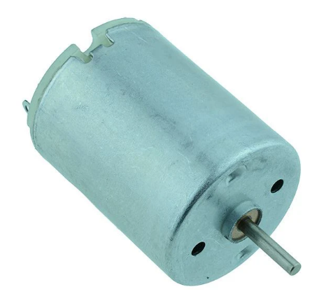
Motor Selection

Figure 13 Switch Electronics DC Motor [33]

In the process of developing this e-bike prototype, selecting the appropriate motor is very important to achieving the desired performance characteristics and functionality. After careful consideration and evaluation of various motor options, it’s been chosen to utilize a High Torque Round DC Motor from ‘Switch Electronics’ with a voltage range of 1.5V to 6.0V and a maximum speed of 9600rpm. The motor's voltage range of 1.5V to 6.0V perfectly matches the operating voltage of one of the breadboards on the prototype, which operates at a nominal voltage of 5V. This compatibility ensures seamless integration and eliminates the need for more than two voltage regulation circuitry, simplifying the overall design.
Utilizing a DC 5V motor for the prototype allows for testing and proof of concept without committing to the specific motor that will be used in the final e-bike product. A 5V DC motor has been chosen due to factors such as availability, cost-effectiveness, and ease of integration with existing components and systems within the prototype.


Battery Selection
Figure 14 3.7V Lithium ion Batteries [34]

The subsequent phase in the design process involves battery selection. For this purpose, two 3.7V lithium-ion batteries have been chosen. These batteries were selected due to their high energy density, lightweight construction, and compatibility with the power requirements of the e-bike prototype. Additionally, lithium-ion batteries are renowned for their reliability and longevity, making them an ideal choice for powering electronic devices such as e-bikes.
Given the different voltage requirements of the e-bike components, it will be necessary to incorporate voltage regulation into the system. Specifically, two voltage regulators will be employed, one to step down the battery voltage to 5V for powering components such as the motor and LCD screen, and another to regulate it to 3.3V for the PIC microcontroller and other electronic components that are to be added that require this specific voltage level.
By utilizing these 3.7V lithium-ion batteries and incorporating voltage regulation mechanisms, the e-bike prototype will be equipped with a reliable power source to meet the diverse voltage needs of the various components, ensuring optimal performance and functionality.
Feature | Lithium-ion (18650) Battery | AA Batteries | Large 12V Battery
Chemistry | Lithium-ion | Alkaline | Lead-acid
Voltage | 3.7V | 1.5V (per battery) | 12V
Capacity (mAh) | Typically 2000-3500mAh | Typically 1500-3000mAh | Varies (typically 50-200Ah)
Energy Density (Wh/kg) | 100-250 Wh/kg | 80-90 Wh/kg | 30-40 Wh/kg
Cycle Life | 500-1000 cycles | 10-50 cycles | 200-500 cycles
Rechargeable | Yes | No | No (some exceptions)
Size and Weight | Small and Lightweight | Small and Lightweight | Large and Heavy
Cost | Moderate to High | Low | Moderate to High
Applications | Electronics, Electric vehicles | Portable devices, Toys | Automotive, Solar systems

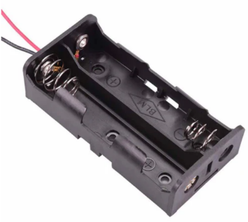
This comparison table provides an overview of the key features and characteristics of lithium-ion (18650) batteries, AA batteries, and large 12V batteries. It includes details such as chemistry, voltage, capacity, energy density, cycle life, rechargeability, size and weight, cost, and typical applications. This information helps in understanding the suitability of each battery type for different purposes and applications. Key features to why the lithium ion batteries (18650) were used is for the rechargeability and cycle life which are very important on an E-bike.
Top of Form

Figure 15 18650 x 2 Battery Holder 150mm Leads [35]
Top of Form

To align with the specifications of the e-bike prototype, it's imperative to elevate the voltage output of the power source. Recognizing that a single 3.7V lithium-ion battery falls short of meeting these requirements, the decision to utilize two batteries in tandem has been made. This arrangement will effectively double the voltage output, resulting in a combined voltage of 7.4V.



Display Selection
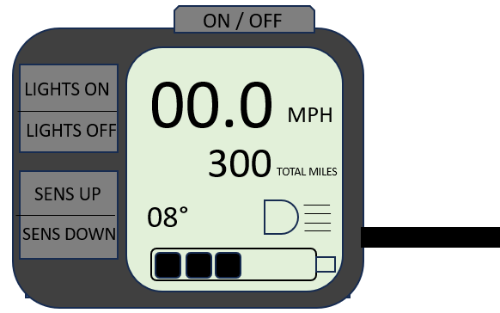

Two Rubber bands used for the bracket
The Display and Control unit Interface
Side view of bracket attaching display unit to the handlebars.

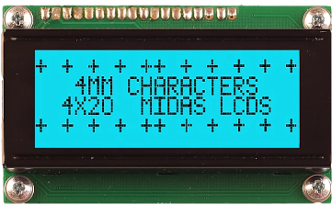
In the subsequent phase of the design process, careful consideration has been given to the selection of a suitable display for the e-bike prototype. After thorough evaluation, a 20x4 LCD screen has been chosen as the optimal solution. Several factors contributed to this decision, with the primary factor being the display's ability to accommodate the extensive information that needs to be conveyed to the user.

Figure 16 Midas LCD Display, 4 Rows by 20 Characters [36]

The 20x4 LCD screen offers four lines of display, providing ample space to present a diverse range of data and information in a clear and organized manner. This level of flexibility is essential for conveying essential metrics and feedback to the e-bike rider, such as speed, battery level, distance travelled, and various system diagnostics.
Additionally, the LCD screen's compatibility with the microcontroller and ease of integration were key considerations. The chosen display seamlessly interfaces with the microcontroller, allowing for straightforward programming and control. Its compact form factor and low power consumption make it well-suited for integration into the e-bike prototype without adding unnecessary bulk or draining the battery excessively.
Furthermore, the LCD screen's robust construction and durability ensure reliable performance even in demanding outdoor environments, making it an ideal choice for the rugged conditions often encountered during e-bike rides.

Throttle Selection
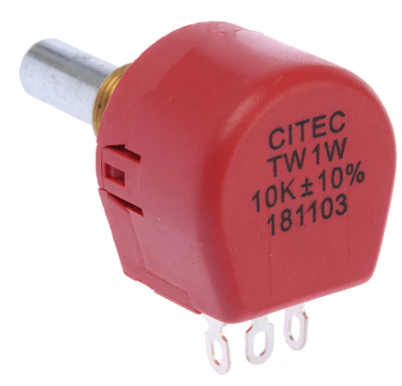
Figure 42 10 Ohm Potentiometer [40]

Incorporating a potentiometer into the e-bike prototype to serve as a throttle is a practical and effective approach. A potentiometer, often referred to as a "pot," is a variable resistor that allows for precise control over voltage or current in a circuit. When used as a throttle, the potentiometer functions similarly to how a throttle operates in a traditional vehicle.
Much like how a throttle in a car controls the amount of fuel supplied to the engine, the potentiometer in the e-bike prototype regulates the voltage supplied to the motor. By adjusting the position of the potentiometer's knob or lever, the resistance in the circuit changes, thereby altering the voltage output. This change in voltage directly affects the speed of the motor, allowing the rider to accelerate the e-bike as desired.
The potentiometer's role as a throttle provides precise and responsive control over the e-bike's speed. As the rider adjusts the potentiometer, they can fine-tune the motor's output to match their desired speed and riding conditions. This level of control enhances the overall riding experience and allows for seamless transitions between different speeds.
By incorporating the potentiometer between the power source and the motor, we can effectively modulate the voltage supplied to the motor, thereby controlling its speed. This approach offers a simple yet effective means of implementing throttle functionality in the e-bike prototype, demonstrating versatility and adaptability in design.
The resistance of the potentiometer determines how much voltage is passed to the motor. A 10 ohm potentiometer offers relatively low resistance, allowing for finer control over the voltage output. This means we can adjust the motor's speed across its full range, from 0% to 100%, effectively utilizing its capabilities. On the other hand, a 10k ohm potentiometer has significantly higher resistance compared to the 10 ohm one. This means that even at its lowest setting, it might still offer too much resistance to allow sufficient voltage to reach the motor, limiting its speed capabilities.

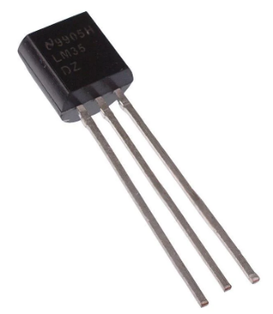
Temperature Sensor Selection

Figure 17 LM35 Temperature and Humidity Sensor [37]

Within the next part of the design process, the focus shifts towards implementing a method to measure temperature effectively. For this purpose, careful consideration has been given to selecting a temperature sensor that not only accurately measures temperature but also integrates seamlessly with the e-bike's existing system. After thorough evaluation, the LM35 temperature sensor has been chosen as the optimal solution.
The LM35 temperature sensor offers several advantages that make it well-suited for the e-bike application. Firstly, it provides precise and reliable temperature measurements with a linear output proportional to the Celsius temperature. This feature ensures accurate temperature readings, crucial for monitoring environmental conditions during e-bike rides.
Furthermore, the LM35 sensor operates over a wide temperature range (-55°C to 150°C), making it suitable for diverse weather conditions and environments. This versatility enables the e-bike to monitor temperature fluctuations effectively, enhancing rider safety.
Additionally, the LM35 sensor's simple interface and compatibility with microcontrollers allows easy integration into the e-bike's system. By interfacing the LM35 sensor with the microcontroller, temperature data can be readily processed and displayed on the LCD screen in real-time. This functionality not only provides valuable information to the rider but also enables the implementation of safety features, such as displaying warnings when temperatures indicate the presence of ice on the road.
Overall, the LM35 temperature sensor stands out as an excellent choice for the e-bike project due to its precision, reliability, wide operating range, and compatibility with the existing system. By incorporating this sensor into the design, the e-bike prototype will be equipped with enhanced temperature monitoring capabilities, contributing to a safer and more enjoyable riding experience.

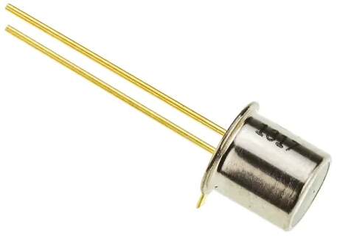
Safety Lights

Figure 18 BPX Full Spectrum Si Photodiode [38]
In the next part of the design process, the focus turns toward enhancing the safety features of the e-bike prototype by incorporating lighting systems. Both front and rear lights will be integrated into the design to ensure visibility and safety, especially during low level light conditions or at night. These lights will be automatically controlled through the use of a photodiode, which will detect ambient light levels and activate the lights accordingly. These lights will be operated via the microcontroller and for the prototype white, red and orange LED’s will be used on the breadboard to simulate them working.
Additionally, to enhance the e-bike's visibility and provide signalling capabilities, indicators for left and right hands turns will be included. These indicators will be programmed to blink for half a second, providing clear and intuitive signals to other road users about the rider's intentions.
It's worth noting that while safety features like lights and indicators are crucial for rider safety, the prototype will not include a brake light. This decision stems from the fact that integrating a brake light would require a mechanical braking system, such as hydraulically controlled breaks, which falls outside the scope of the current prototype design. However, the inclusion of front and rear lights, along with indicator lights, will significantly enhance the e-bike's safety and visibility on the road.

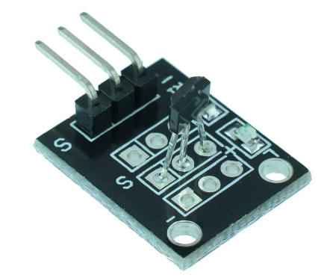
Speed / Distance sensor Selection

Figure 19 Hall Effect Magnetic Sensor Module [39]
It is now required select an appropriate sensor for measuring the speed of the e-bike's wheel, more specifically the front wheel. Its decided that the front wheel would be more suitable for measuring the E-bikes speed as the E-Bike design provides the rear wheel with power, so if that wheel was to lose traction due to the motor, then an inaccurate measurement of speed would be given. Several methods exist for measuring wheel speed, including but not limited to, optical sensors, magnetic sensors, and accelerometer-based systems. After careful consideration, it was determined that a Hall effect sensor would be the most suitable choice for this application.
There are two main types of Hall Effect Sensors, one being the Hall Effect Magnetic Sensor and the other being the Hall Effect Current Sensor. For measuring the speed of a wheel and detecting one complete rotation, a Hall effect magnetic sensor would be more suitable than a Hall effect current sensor. A Hall effect magnetic sensor detects changes in magnetic field strength. Placing a magnet on the rotating wheel and positioning the Hall effect sensor nearby allows for the detection of each rotation of the wheel. As the magnet passes by the sensor with each rotation of the wheel, it generates a magnetic field change, which is detected by the Hall effect sensor. This signal can be processed to count the number of rotations or calculate the speed of the wheel.
A Hall effect current sensor, on the other hand, measures the magnetic field generated by the current flowing through a conductor. It is typically used to measure current in a wire or circuit, rather than rotational movement. While it's possible to indirectly infer wheel speed or rotation by measuring the current in a motor or other component involved in wheel rotation, this method is more complex and less direct compared to using a magnetic sensor directly detecting wheel rotation. [26]
Therefore, for directly measuring the speed of a wheel and detecting one complete rotation, a Hall effect magnetic sensor is the more appropriate choice. It offers a simpler and more direct method of detecting rotational movement without the need for additional components or complex calculations.
Implementing a speed limiter on the e-bike is essential to ensure compliance with government regulations, particularly in the UK where strict laws govern electric bicycles. These regulations mandate that the electric motor of an e-bike should not provide propulsion when the bike is traveling above 15.5 mph (25 km/h), and the motor's maximum power output should not exceed 250 watts. By incorporating a speed limiter into the e-bike's system, it restricts the motor's output and prevents the bike from exceeding the legal speed limit. This not only ensures adherence to regulatory requirements but also promotes safer riding, enhancing overall road safety for riders and pedestrians alike. [27]

Chapter 4 - Implementation
Chapter 4 of the project will delve into the software design aspect, detailing the programming and simulation processes for the e-bike prototype. The software design will primarily focus on coding the PIC microcontroller to control various aspects of the e-bike's functionality. The circuitry will be constructed using Proteus software, providing a virtual platform for simulation and testing of the microcontroller code.
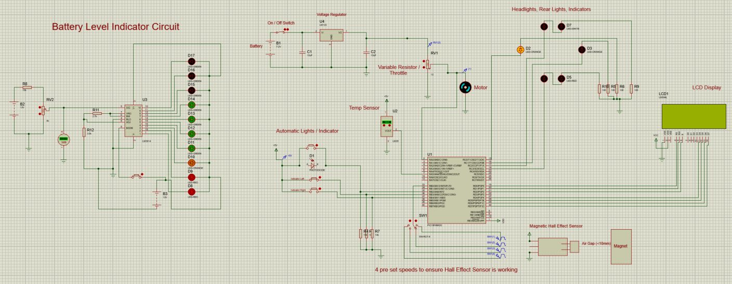

Figure 20 Full Circuit Diagram (Proteus)
Figure 20 shows the full completed Proteus Circuit of the E-Bike prototype. Within this circuit is all the necessary parts and components sourced within the design phase so it can be fully simulated and tested.
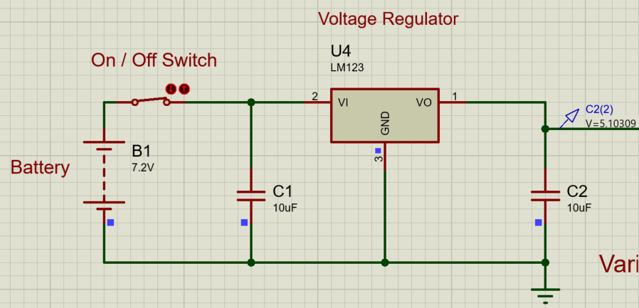

Figure 21 Voltage Regulator circuit
Figure 21 depicts the voltage regulator circuit responsible for regulating the 7.2V supply voltage sourced from the lithium-ion batteries, down to a stable 5.1V output. This regulation is achieved through the implementation of an LM123 5.1V voltage regulator, ensuring a consistent and reliable power supply for downstream components. Two capacitors have been strategically incorporated into the circuit to enhance stability and filter out any voltage fluctuations or noise. Additionally, a voltage probe has been positioned after the voltage regulator to verify and confirm that the output voltage has been effectively reduced to 5.1V as intended. This circuit plays a crucial role in maintaining proper voltage levels throughout the e-bike system, contributing to its overall performance and functionality.
Within the voltage regulator circuit, an on/off switch is strategically positioned after the battery connection. This switch serves as a master power switch for the entire e-bike system. When the switch is turned on, it allows current to flow from the battery to the rest of the circuitry, including the voltage regulator and other electronic components. This enables the e-bike to be powered up and ready for operation.
Conversely, when the switch is turned off, it interrupts the flow of current from the battery, effectively cutting off power to the entire e-bike system. This is useful for conserving battery life when the e-bike is not in use, as well as for safety reasons, such as when performing maintenance or repairs on the vehicle. By incorporating this master power switch into the voltage regulator circuit, users can easily control the power status of the e-bike with a simple toggle, providing convenience and enhancing safety during operation and maintenance.

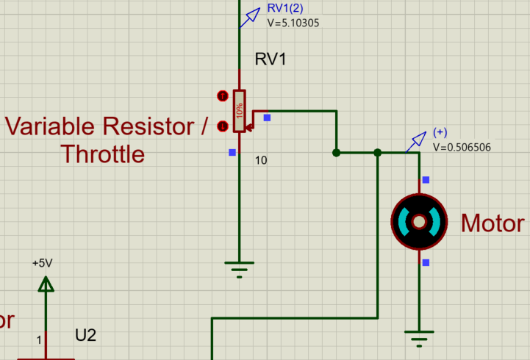
Figure 22 Variable Resistor and Motor Relationship

Figure 22 illustrates a simulation of the throttle and motor system operating in tandem. The variable resistor, representing the throttle control, modulates the incoming 5.1V voltage supply. Depending on the setting of the variable resistor, the voltage output varies, directly influencing the speed at which the motor rotates. A potentiometer has been chosen to directly simulate a throttle, as the hardware method of altering the potentiometer is to twist it.
In this specific scenario, the variable resistor is set to 10%, resulting in an output voltage of 0.506506V. This very low voltage output translates to a slow rotation speed of the motor. The proportional relationship between the voltage output from the variable resistor and the motor speed allows for precise control over the e-bike's acceleration, enabling users to adjust their speed according to their preferences and riding conditions.
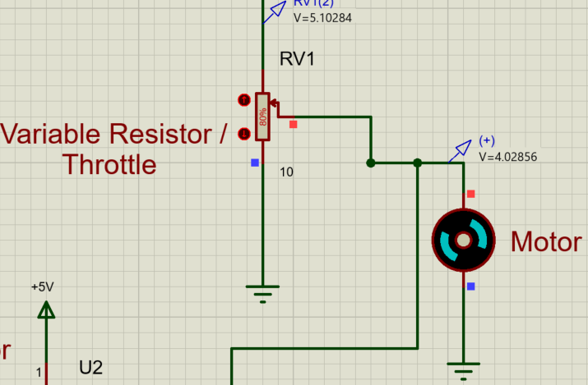

Figure 23 Variable Resistor and Motor Relationship

In Figure 23, the variable resistor is adjusted to 80%, resulting in a higher voltage output of 4.02856V. This increased voltage effectively accelerates the motor to rotate at a significantly faster speed compared to the previous scenario. By manipulating the variable resistor, users can easily control the amount of voltage supplied to the motor, thereby regulating its speed and overall performance.
The ability to adjust the variable resistor allows for precise throttle control, enabling riders to customize their speed according to their preferences and riding conditions. Whether cruising at a leisurely pace or accelerating to navigate through challenging terrain, the throttle mechanism provides the flexibility to adapt to various situations, enhancing the overall riding experience of the e-bike. Through this simulation, the relationship between the variable resistor setting, voltage output, and motor speed is effectively demonstrated, showcasing the versatility and responsiveness of the throttle system.
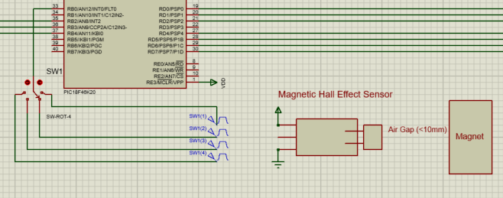
Figure 24 Hall Effect Sensor Circuit (Proteus)

Figure 24 shows the Hall effect sensor segment of the circuit, connected to port B0, an interrupt port on the PIC microcontroller. This configuration enables the microcontroller to detect changes in the magnetic field generated by the rotating wheel, providing input for speed measurement and control.
Furthermore, the Hall effect sensor is integrated into a 4-way switch setup, featuring four pulse generators operating at distinct frequencies and pulse widths. Each pulse generator simulates a different speed setting, representing various velocities at which the wheel could rotate. This arrangement facilitates the emulation of multiple speed scenarios, allowing for comprehensive testing and analysis of the e-bike's performance under different operating conditions.
By incorporating the Hall effect sensor and pulse generators into the circuit, the e-bike prototype can accurately measure wheel speed and adjust its functionality accordingly, ensuring optimal operation and responsiveness during real-world usage.

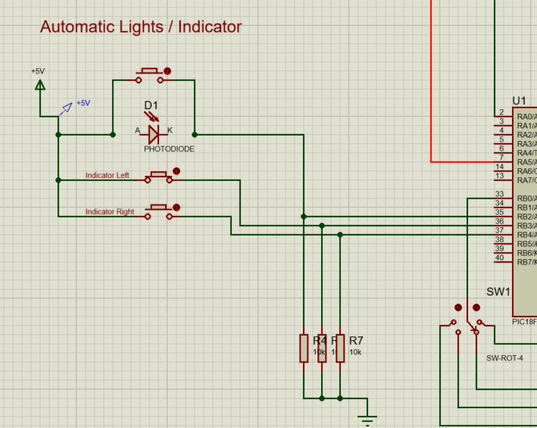

Figure 25 Photodiode Implementation and Input Buttons for the Indicator Lights
Figure 25 depicts the implementation of the photodiode and two buttons, designated for indicating left and indicating right. In this configuration, the photodiode has been substituted with a button for testing purposes. Each input, representing the photodiode and the two buttons, is connected to a 10k resistor, serving as a pull-down resistor, and then routed to the ground before being connected to ports B2, B3, and B4 of the PIC microcontroller.
This setup enables the microcontroller to detect changes in input states, whether triggered by the photodiode, that’s indicating its becoming dark, or the buttons, for indicating left or indicating right. The pull-down resistors ensure that the inputs remain in a defined state when the buttons are not pressed, preventing floating voltages and ensuring reliable detection of button presses. By interfacing these inputs with the microcontroller, the e-bike prototype can accurately interpret user commands for indicating turns, enhancing safety during rides.
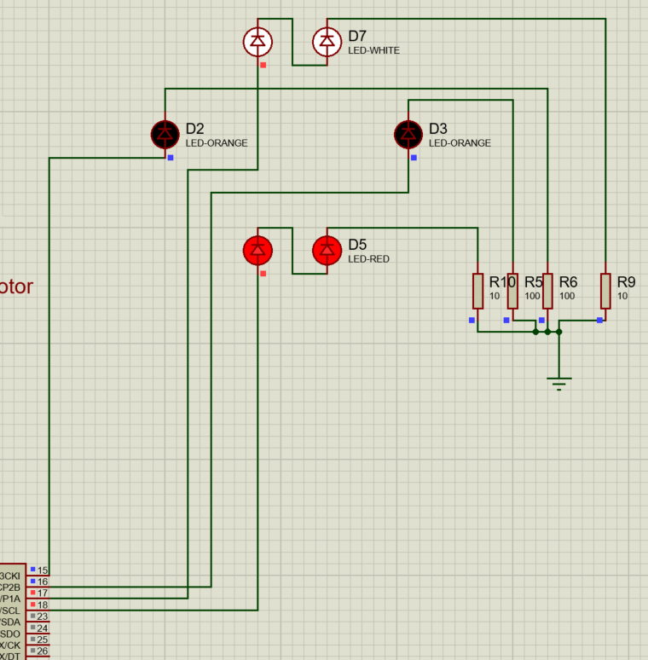
Figure 26 Lights and Indicators

Figure 26 presents the output of the circuit depicted in Figure 25, showcasing the functionality of the photodiode and two buttons in controlling various components of the e-bike prototype. In this visualization, the simulated outputs include:
- Two white headlights, represented by two white LEDs, providing illumination at the front of the e-bike for visibility and safety during rides.
- Two rear lights, simulated by two red LEDs, serving as taillights to alert vehicles and pedestrians of the e-bike's presence from behind.
- An indicator left LED, in orange, signalling the intention to turn left.
- Another indicator right LED, also in orange, signalling the intention to turn right.
By visually representing these outputs, Figure 26 demonstrates how the e-bike prototype utilizes the inputs from the photodiode and buttons to control various lighting elements, enhancing visibility and safety for the rider and surrounding traffic. Additionally, the inclusion of indicator LEDs facilitates clear communication of the rider's intentions, further contributing to safe navigation on the road or cycle paths.
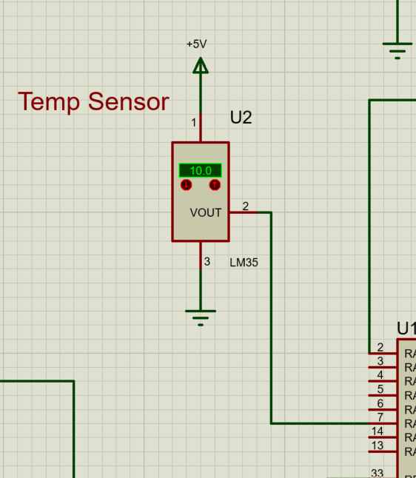
Figure 27 LM35 Temperature sensor Circuit

The LM35 temperature sensor is an analogue device that outputs a voltage proportional to the temperature it detects. Unlike digital signals that have discrete high and low states, the output of the LM35 is a continuous voltage that varies linearly with temperature changes. Therefore, an analogue pin on the microcontroller is required to read and interpret this analogue voltage signal accurately.
An analogue pin, such as pin A5 (AN4) in this case, is capable of measuring and processing analogue signals within a specified voltage range. By connecting the LM35 temperature sensor to an analogue pin, the microcontroller can convert the varying voltage output from the sensor into digital values that represent temperature readings. This allows the microcontroller to monitor and respond to changes in temperature, enabling the temperature to be displayed on the LCD screen and even apply warnings, such as an ice warning when the temperature drops below a certain value to keep the rider as safe as possible.
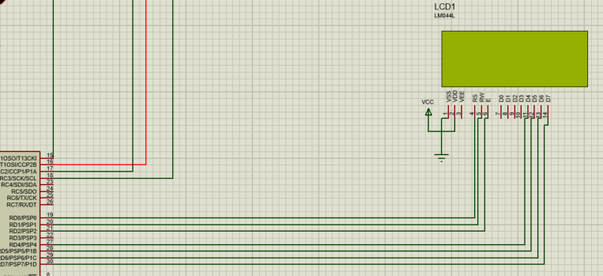
Figure 28 LCD Screen Circuit

Figure 28 illustrates the connection of an LCD screen to the PIC microcontroller, along with the necessary power and ground connections. In this setup, each data pin on the LCD screen has been assigned and defined within the source code, allowing the microcontroller to send data to the LCD for display. Additionally, the control pins RS (Register Select), RW (Read/Write), and Enable, have been properly connected and defined in the source code to enable communication between the microcontroller and the LCD screen.
By establishing these connections and defining the pins in the source code, the microcontroller can effectively control the display on the LCD screen, allowing for the presentation of relevant information such as speed, distance, temperature and indication symbols showcasing which indicator has been pressed and when its currently blinking. Integration of an LCD screen provides a user-friendly interface for interacting with the e-bike system, enhancing its usability and functionality.
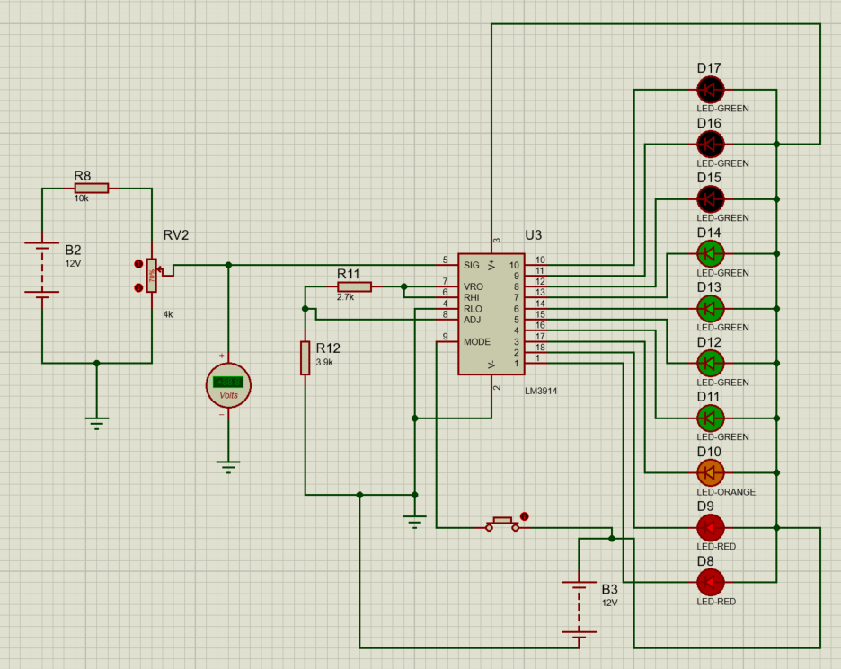
Figure 29 Battery Level Indicator Circuit

Figure 29 represents the battery level indicator circuit in the Proteus simulation. This circuit utilizes an LM3914 integrated circuit, which serves as a battery level indicator. The LM3914 takes a reading from an adjustable variable resistor connected to the 12V battery. Based on this reading, the LM3914 illuminates a corresponding number of LEDs to indicate the battery's charge level.
In this configuration, the 10 LEDs are divided into segments, each representing 10% of the full battery capacity. As the adjustable variable resistor changes, the LM3914 adjusts the number of illuminated LEDs to reflect the current battery charge level accurately. This provides a visual indication of the remaining battery capacity, allowing users to monitor the battery status conveniently.
By incorporating the battery level indicator circuit into the e-bike system, users can easily assess the battery's charge level at a glance, enabling informed decisions about when to recharge the battery and ensuring uninterrupted operation of the e-bike.

Chapter 5 – Analysis
Within this chapter we look into the crucial phase of analysing the e-bike prototype within the Proteus simulation. The primary objective is to test and validate the functionality of the design features, ensuring their reliability and effectiveness. The analysis process involves systematically evaluating each feature of the e-bike prototype to verify its performance under simulated conditions.
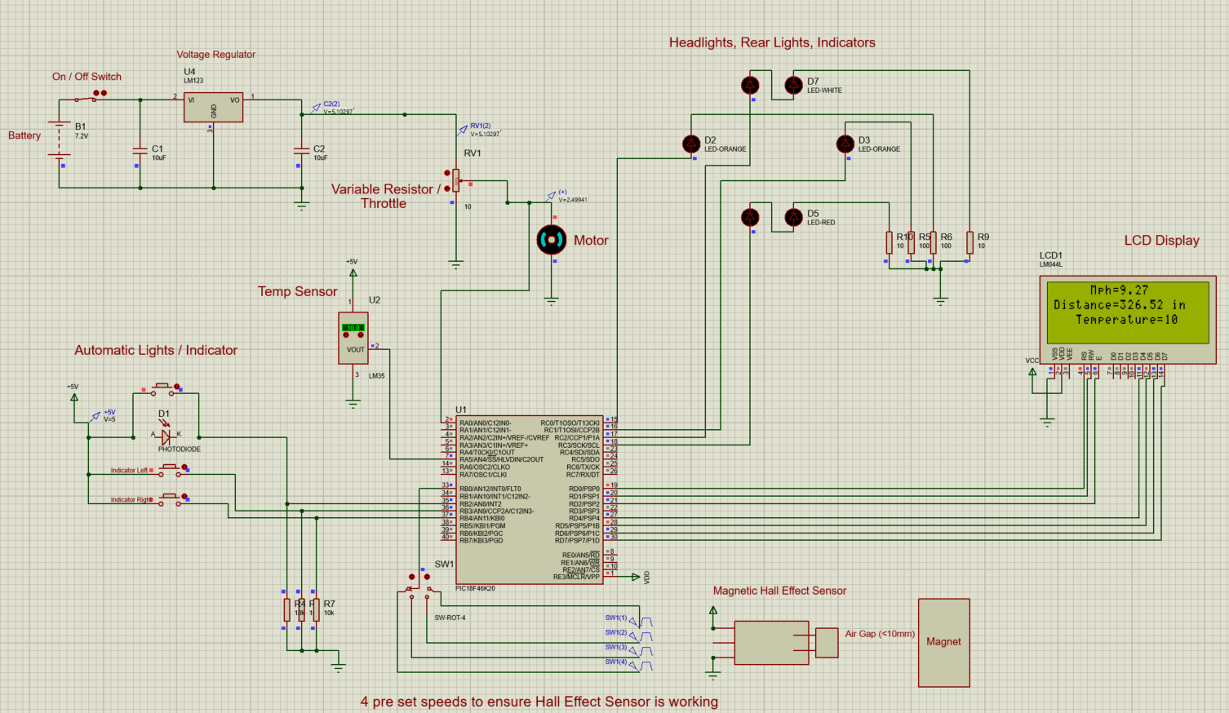
Firstly, we will be testing the Hall effect magnetic sensor, a key component responsible for measuring wheel speed. This will be achieved by setting up a 4-way switch with four pulse generators, each operating at different frequencies to simulate varying wheel speeds. The resulting speed data will be visualized on the LCD screen in real-time, allowing for immediate observation and assessment of the sensor's functionality. By conducting these tests, we aim to confirm the accuracy and responsiveness of the Hall effect sensor in detecting changes in wheel speed.

Figure 30 Speed 1 Hall Effect Sensor
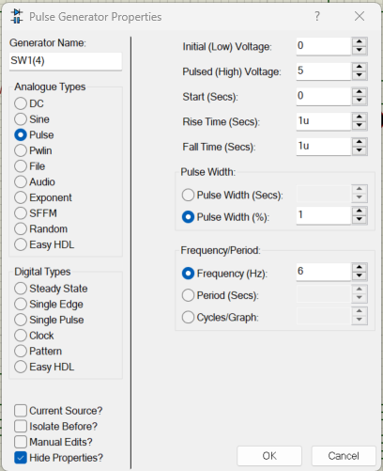

Figure 31 Speed 1 Pulse Generator settings

During the evaluation of ‘Speed 1’ of the magnetic hall effect sensor, the 4-way switch was positioned to generate a pulse wave with specific characteristics. The pulse wave had a pulse width of 1% and a frequency of 6Hz. This signal was received by the B0 interrupt pin and processed by the microcontroller.
The microcontroller calculated the corresponding wheel speed and displayed it on the LCD screen. The recorded speed for this configuration was determined to be 9.27 mph. The code within the proteus software will be shown in the Appendices of the report.
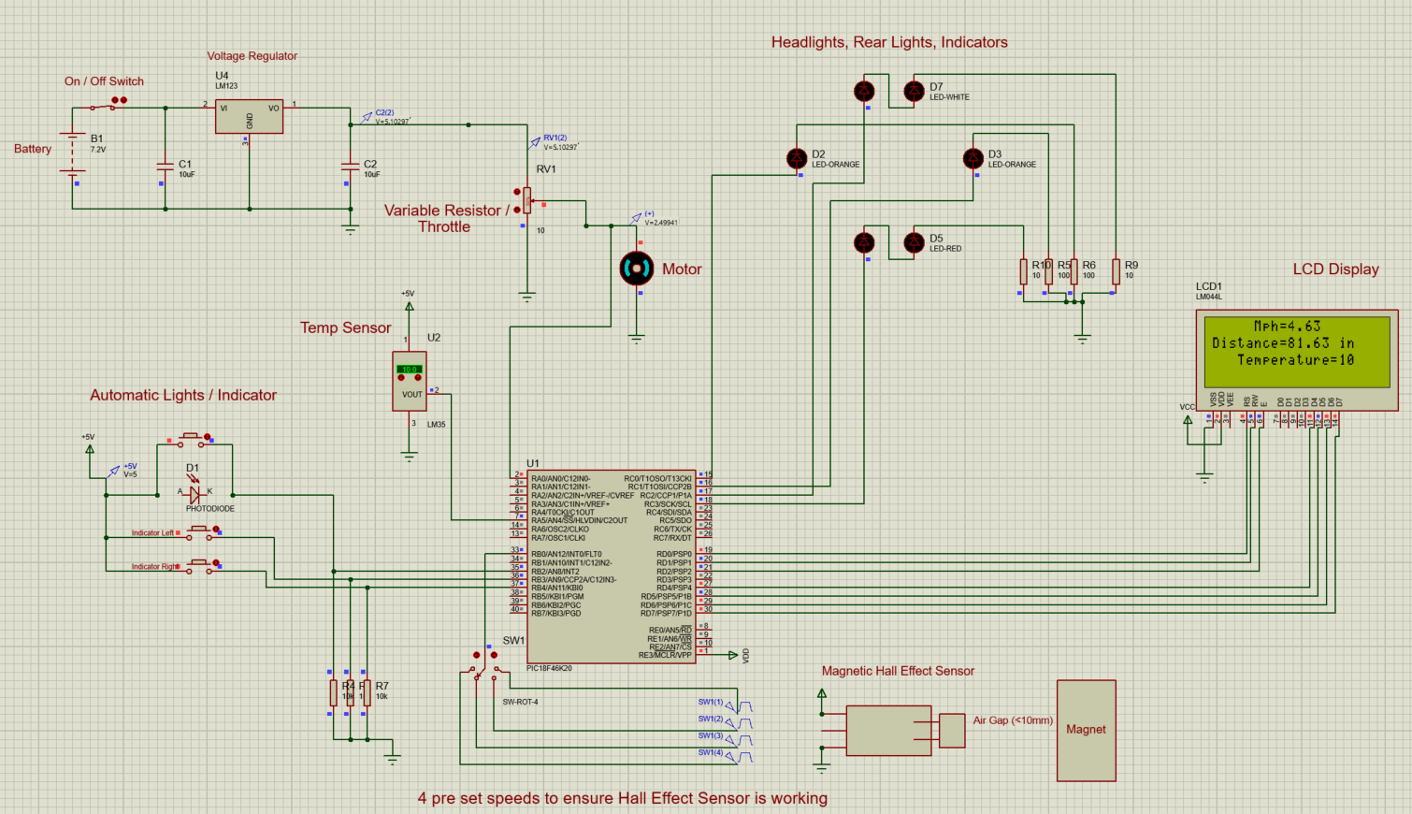
Figure 32 Speed 2 Hall Effect Sensor

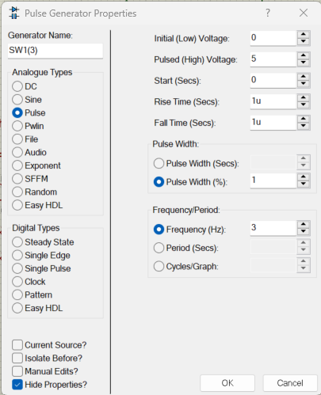

Figure 33 Speed 2 Pulse Generator Settings

In the evaluation of ‘Speed 2’ of the magnetic hall effect sensor, the pulse generator settings were adjusted to maintain a consistent pulse width of 1%, as per the testing protocol. However, the frequency was set to 3Hz, representing a moderate speed scenario. This signal was transmitted to the B0 interrupt pin for processing by the microcontroller.
From processing the input signal the microcontroller determined the corresponding wheel speed and presented the result on the LCD screen. The recorded speed for ‘Speed 2’ was measured to be 4.63 mph.
These findings showcase the performance of the magnetic hall effect sensor at moderate speeds. By accurately capturing and analysing the input signal, the sensor successfully translated the simulated wheel speed into real-time data
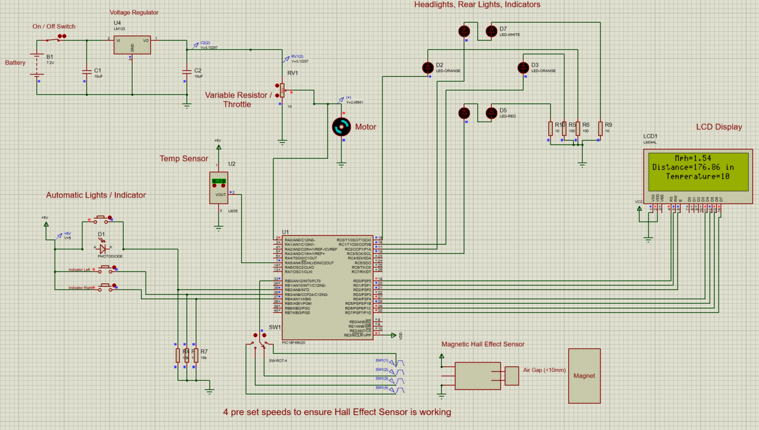
Figure 34 Speed 3 Hall Effect Sensor

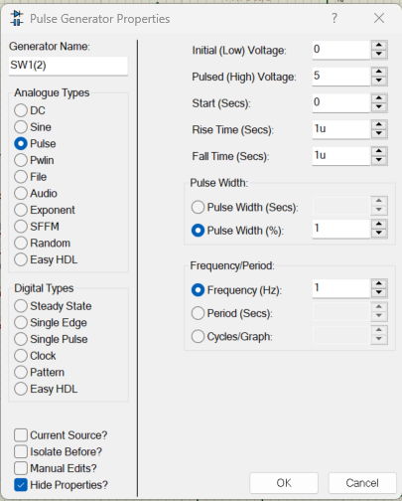

Figure 35 Speed 3 Pulse Generator Settings

During the evaluation of ‘Speed 3’ of the magnetic hall effect sensor, the pulse generator settings remained consistent with a pulse width of 1%, as specified for all speed tests. However, the frequency was adjusted to 1Hz, representing a lower speed condition. This signal was transmitted to the B0 interrupt pin for processing by the microcontroller.
From the input signal, the microcontroller calculated the corresponding wheel speed and displayed the result on the LCD screen. The recorded speed for ‘Speed 3’ was determined to be 1.54 mph.
These results provide insights into the performance of the magnetic hall effect sensor at lower speeds. Despite the reduced frequency, the sensor accurately detected and interpreted the input signal.
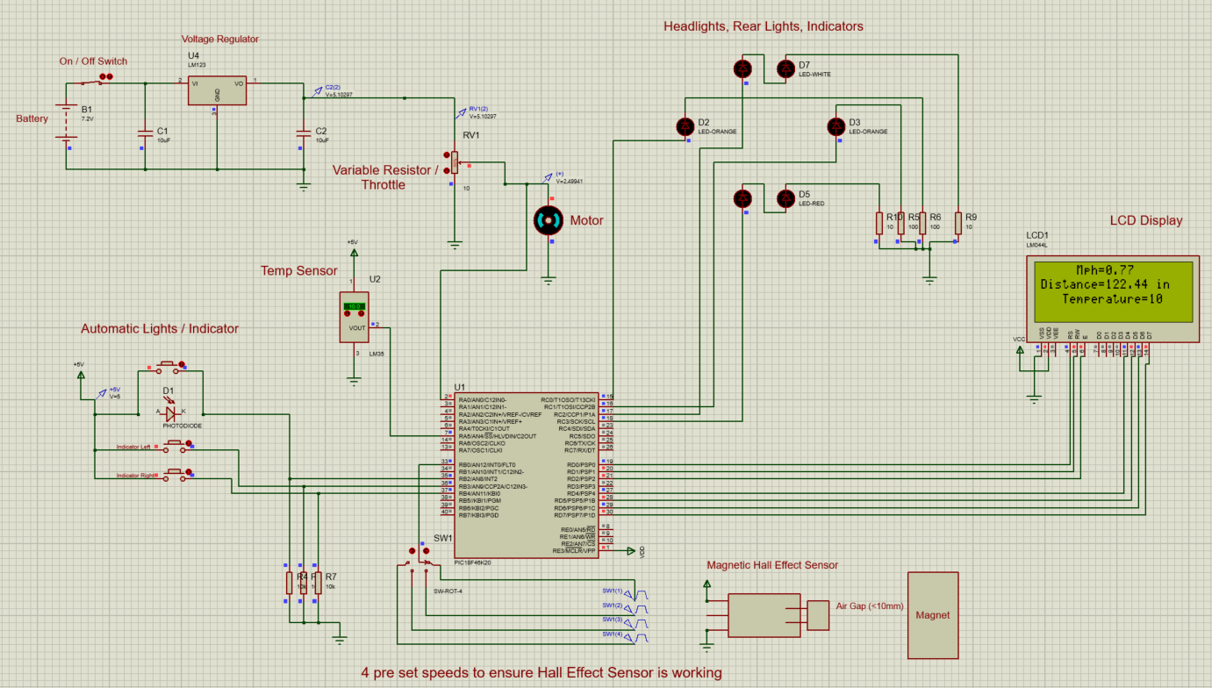
Figure 36 Speed 4 Hall Effect Sensor

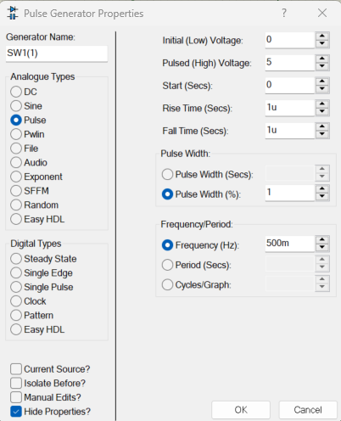

Figure 37 Speed 4 Pulse Generator Settings

Finally, ‘speed 4’ test was completed. This time the frequency was reduced to 500mHz, representing an extremely slow speed condition. This signal was transmitted to the B0 interrupt pin for processing by the microcontroller. From processing the input signal, the microcontroller calculated the corresponding wheel speed and presented the result on the LCD screen. The recorded speed for Speed 4 was determined to be 0.77 mph.

The next phase of our analysis involves testing the temperature sensor integrated into the e-bike prototype. We will utilize the LM35 temperature sensor, which is adjustable within the Proteus software, to simulate temperature variations. As the temperature setting on the LM35 sensor is adjusted, the corresponding temperature readings will be displayed on the LCD screen in real-time.
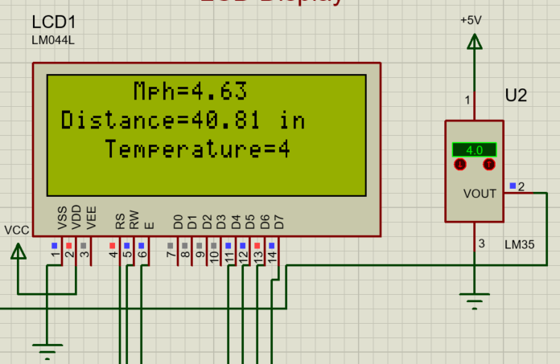
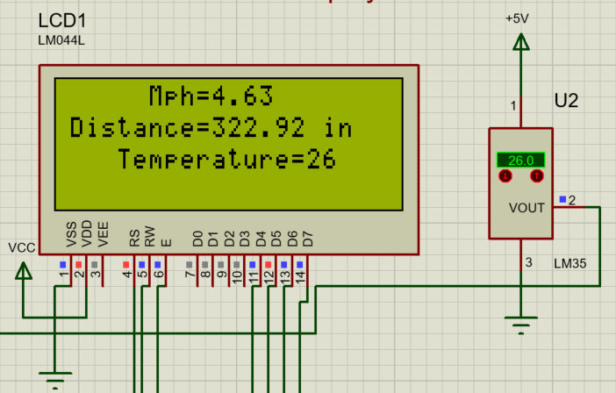
Figure 39 Temperature Sensor Test

Figure 38 Temperature Sensor Test
Figure 38 and 39 both show the LM35 temperature sensor working within the proteus simulation.
In addition to testing the LM35 temperature sensor's functionality, an additional feature has been implemented to enhance rider safety. When temperatures drop below 2 degrees Celsius, a warning message will be displayed on the LCD screen to alert riders of potential icy conditions.
This will be tested within the proteus simulation, where again the LM35 temperature sensor will be directly adjusted to below 2 degrees Celsius. When this condition is met, the warning message will be triggered and displayed prominently on the LCD screen. This is shown in figure 40.
This added feature serves to enhance the e-bike prototype's safety measures by providing timely warnings to riders about potentially hazardous icy conditions. By integrating this functionality into the temperature monitoring system, it will improve rider awareness and promote safer riding practices in various weather conditions.
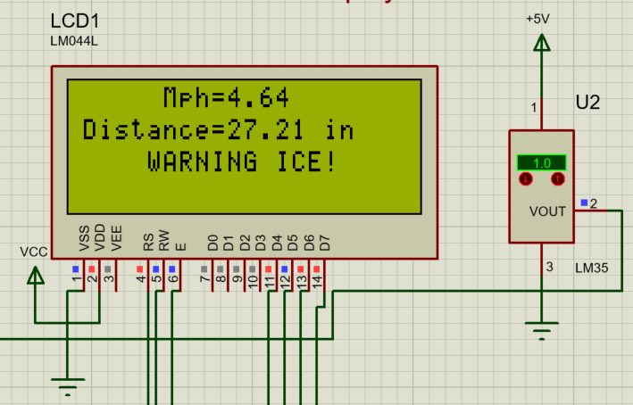
Figure 40 Temperature Sensor Warning Message Test

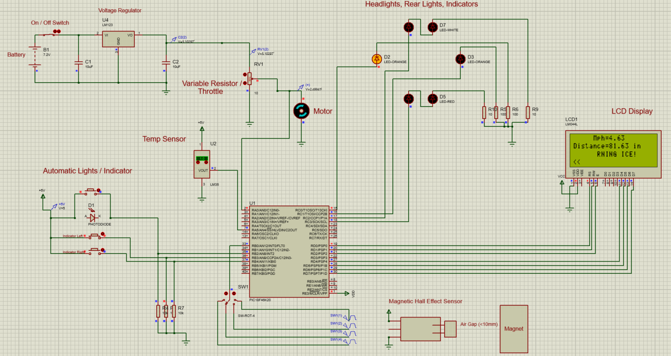
Figure 41 Left Indicator Light Working

Testing of the indicator lights is the final stage of the analysis process for the e-bike project. The functionality of the left and right indicator buttons is crucial for ensuring rider safety and awareness on the road. Upon pressing either the left or right indicator button, the microcontroller activates the corresponding pin, initiating a blinking effect with half-second delays. This blinking mimics the behaviour of traditional vehicle indicators, providing a clear visual signal to other road users of the rider's intended direction.
In addition to the physical indicator lights, the microcontroller also updates the LCD screen to display indicator symbols once either button is pressed. This dual feedback mechanism enhances rider awareness by providing both visual cues on the bike itself and on the dashboard display.
By testing the indicator lights and their associated functionality, we ensure that riders can confidently signal their intentions while riding, reducing the risk of accidents and promoting safe road behaviour. This comprehensive approach to indicator design underscores our commitment to rider safety and underscores the effectiveness of the e-bike prototype in real-world conditions.

Practical Prototype of E-bike

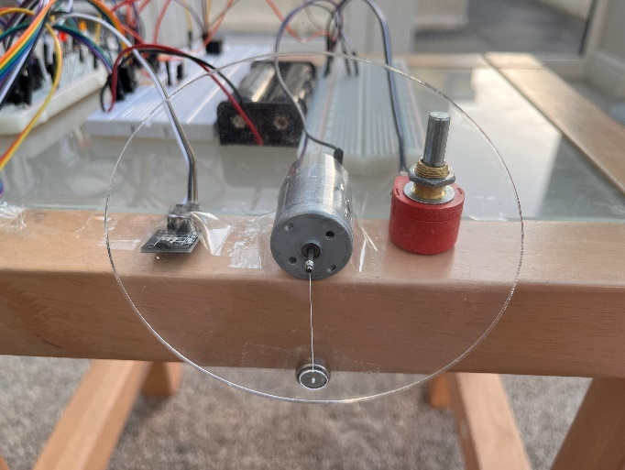
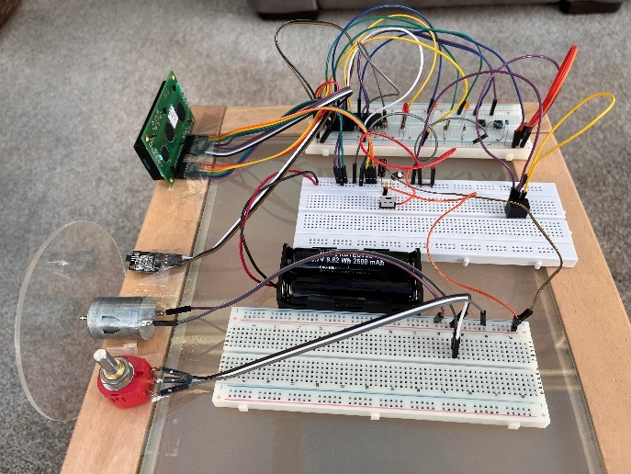

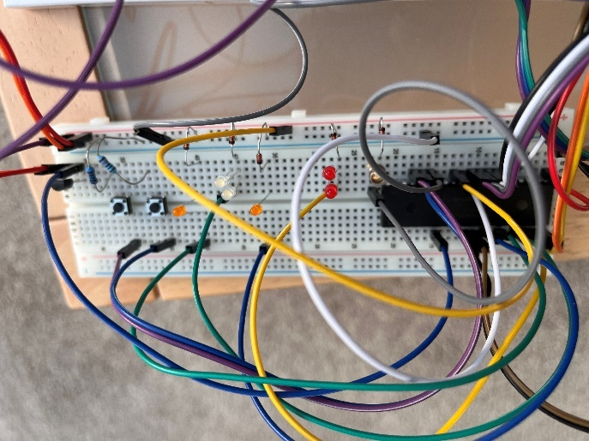
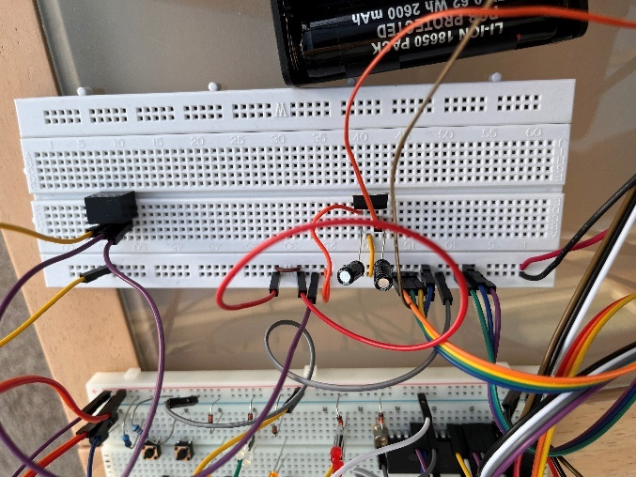

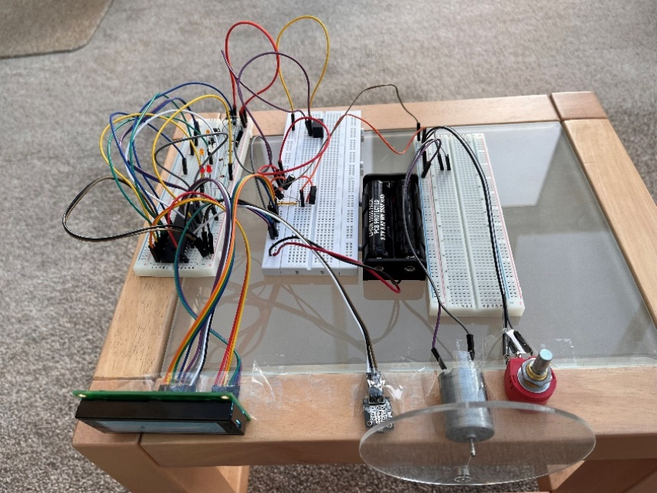
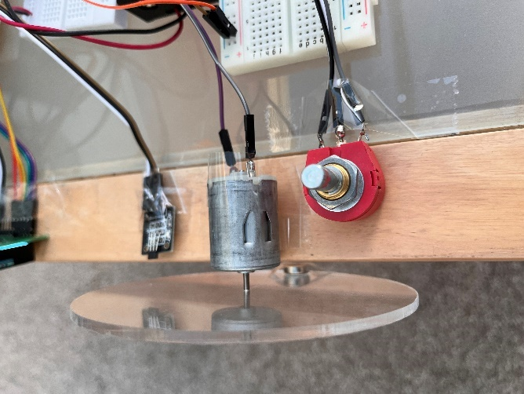

Figure 42 Photos of E-Bike Prototype Built in Person

Chapter 6 – Evaluation
One of the project's strengths lies in its systematic approach to design and implementation. From the initial research phase, where the concept of electric bicycles was explored, to the selection of components and technologies, careful consideration was given to each aspect of the e-bike's design. This thorough planning ensured that the prototype would meet the project's objectives and functional requirements.
The integration of advanced features, such as the microcontroller-based control system and sensors for speed and temperature monitoring, demonstrates the project's commitment to innovation and technology. By incorporating these elements, the e-bike prototype offers enhanced functionality and safety, providing riders with a modern and efficient riding experience.
Testing played a crucial role in the evaluation of the e-bike prototype. Through simulated testing in the Proteus software environment, various components and systems were rigorously evaluated for performance and reliability. The results of these tests provided valuable insights into the functionality of the prototype and highlighted areas for refinement and improvement.
One notable feature of the e-bike prototype is its emphasis on safety. The inclusion of features such as temperature monitoring, warning systems for icy conditions, front and rear lights as well as indicator lights, underscores the project's commitment to rider safety. By integrating these safety measures, the e-bike prototype aims to promote responsible and secure riding practices, enhancing the overall user experience.
Despite the project's successes, there are areas for future development and refinement. Further testing and optimization of the prototype's components and systems may be required to ensure optimal performance under real-world conditions. Additionally, considerations for scalability and manufacturability could be explored to facilitate the transition from prototype to production.
The speed test conducted on the magnetic hall effect sensor yielded positive results, effectively simulating the sensor's calculation across multiple speed scenarios. The consistency in the sensor's performance across varying frequencies indicates the reliability and effectiveness of the implemented code. These findings validate the functionality of the magnetic hall effect sensor and provide confidence in its ability to accurately detect wheel speed in real-world applications. Overall, the successful execution of the speed test demonstrates the efficacy of the code and underscores its suitability for the e-bike prototype, contributing to the overall validation of the design.
Top of Form

Chapter 7 – Conclusion
Throughout the project, I have gained valuable insights into electric bike technology, electronic circuitry, microcontroller programming, and project management. This experience has not only expanded my technical skills but also fostered problem-solving abilities, creativity, and a sense of accomplishment.
While the prototype demonstrates the feasibility of integrating smart functionalities into electric bikes for enhanced safety and usability, it also suggests several avenues for further research and improvement. Some of these include:
- Exploring additional smart features, such as GPS navigation, theft detection, automatic lighting adjustment, and smartphone integration, could further enhance the functionality and appeal of electric bikes.
- Investigating advanced battery technologies, energy harvesting methods, and battery management systems could improve the efficiency, range, and longevity of electric bike batteries, addressing key concerns in electric vehicle design.
- Conducting user experience studies and feedback surveys to understand rider preferences, pain points, and usability issues could inform iterative design improvements and tailor electric bike designs to meet user needs more effectively.
- Assessing the environmental impact of electric bikes compared to conventional bicycles and fossil fuel-powered vehicles could provide valuable insights into the sustainability benefits and potential drawbacks of widespread electric bike adoption.
- Analysing regulatory frameworks, safety standards, and incentive programs related to electric bikes at local, national, and international levels could inform policy recommendations to support the adoption and integration of electric bikes into transportation systems.
- Regenerative braking, a potential improvement for electric bikes, could enhance efficiency by converting kinetic energy into electrical energy during braking, thereby extending battery life and increasing overall range without compromising performance.
Overall, while the e-bike project has achieved its primary objectives, there remains ample opportunity for further research, innovation, and collaboration to advance electric bike technology and promote sustainable urban mobility solutions. By continuing to explore these avenues, we can contribute to the ongoing evolution of electric bikes and their role in shaping the future of transportation.

Chapter 8 – Reflection
Engaging in the design, construction, and testing phases of the e-bike project has improved my technical skills, such as circuit design, programming, and prototyping. These hands-on experiences contribute to my growth as a technically proficient individual.
Overcoming challenges I encountered during the project, whether in component selection, circuit debugging, or software troubleshooting, has developed my problem-solving abilities. This has improved my resilience and adaptability in facing challenges.
Managing the various aspects of the e-bike project, from research and design to implementation and testing, has significantly improved my project management skills. I’ve gained experience in planning, organizing, and executing tasks.
Developing solutions for the design requirements of the e-bike project sparked my creativity and innovation. Whether I’m designing circuit layouts, programming functionalities, or integrating smart features, it’s increased my creative thinking to find possible solutions.
Given the focus on electric bikes and their environmental benefits, the project has heightened my awareness of sustainability issues and the importance of eco-friendly transportation solutions. My environmental consciousness has increased due to this project.
Overall, the e-bike project has likely contributed to my personal growth and development, equipping me with valuable skills, experiences, and perspectives that extend beyond the project itself.

Chapter 9 - Bibliography

[1] | N. B. H. &. O. Lim, “science direct,” 02 12 2019. [Online]. Available: https://www.sciencedirect.com/science/article/abs/pii/S0306261919320100#preview-section-abstract. [Accessed 15 04 2024].
[2] | T. Elliot, “science direct,” 10 2018. [Online]. Available: https://www.sciencedirect.com/science/article/abs/pii/S2352550918301428. [Accessed 16 04 2024].
[3] | P. Rerat, “t and f online,” 05 05 2023. [Online]. Available: https://www.tandfonline.com/doi/full/10.1080/23800127.2024.2332006. [Accessed 16 04 2024].
[4] | 1. B. GOJANOVIC, “medicine & science in sports & exercise,” 2011. [Online]. Available: https://d1wqtxts1xzle7.cloudfront.net/74154345/KLUWER_Iglesias_Katia_-_Electric_Bicycles_as_a_New_Active_Transportation_Modality_20160427-libre.pdf?1635954958=&response-content-disposition=inline%3B+filename%3DElectric_Bicycles_as_a_New_Active_Transp.pdf&. [Accessed 16 04 2024].
[5] | “cycling news,” 20 01 2023. [Online]. Available: https://www.cyclingnews.com/features/best-electric-bikes-for-commuting-power-up-your-ride-to-work/. [Accessed 17 04 2024].
[6] | “emovement,” 06 03 2024. [Online]. Available: https://emovement.co.uk/blogs/news/are-electric-bikes-worth-investing-in. [Accessed 17 04 2024].
[7] | “energy saving trust,” 07 06 2020. [Online]. Available: https://energysavingtrust.org.uk/electric-bikes-explained/. [Accessed 16 04 2024].
[8] | “specialized,” [Online]. Available: https://www.specializedconceptstore.co.uk/product/366715/2023-turbo-levo-pro-carbon/option/. [Accessed 04 2024].
[9] | “haibike,” [Online]. Available: https://www.haibike.com/gb/en/electric-bikes/electric-mountain-bikes/electric-trail-bikes/alltrack-4-29-gb705?id=45200340. [Accessed 04 2024].
[10] | “ebike outlet,” [Online]. Available: https://ebikeoutlet.co.uk/products/german-ebike-conversion-kit. [Accessed 04 2024].
[11] | C. Wasko, “bosch-ebike,” [Online]. Available: https://www.bosch-ebike.com/ca/everything-about-the-ebike/stories/hub-drive-vs-mid-drive-ebikes#:~:text=For%20a%20mid%2Ddrive%20eBike,of%20riding%20a%20traditional%20bike.. [Accessed 04 2024].
[12] | “magicyclebike,” 26 05 2023. [Online]. Available: https://www.magicyclebike.com/blogs/news/ebike-hub-motor-what-is-it-and-how-it-works#:~:text=It%20is%20usually%20placed%20on,turn%2C%20so%20gearing%20is%20required.. [Accessed 04 2024].
[13] | “the electric bike shop,” [Online]. Available: https://www.theelectricbikeshop.co.uk/news/5-numbers-about-your-ebike-you-need-to-know/#:~:text=Ebikes%20generally%20have%20maximum%20torque,or%20up%20a%20steep%20hill.. [Accessed 04 2024].
[14] | “emovement,” 07 03 2024. [Online]. Available: https://emovement.co.uk/blogs/news/inside-an-electric-bike#:~:text=Many%20electric%20bikes%20have%20their,for%20easier%20removal%20and%20replacement.. [Accessed 04 2024].
[15] | “medium,” 07 09 2023. [Online]. Available: https://medium.com/@worldpowerstation/ebike-frame-battery-88ab4f33c9ec#:~:text=The%20ebike%20frame%20integrated%20battery,handling%20characteristics%20of%20the%20bike.. [Accessed 04 2024].
[16] | “raleigh,” [Online]. Available: https://www.raleigh.co.uk/gb/en/electric-bike-knowledge/electric-bike-batteries/. [Accessed 04 2024].
[17] | M. Kazimer, “pink bike,” 04 03 2023. [Online]. Available: https://www.pinkbike.com/news/what-type-of-emtb-should-you-buy-in-2023.html. [Accessed 04 2024].
[18] | “ebike kit,” [Online]. Available: https://www.ebikekit.com/blogs/news/electric-bike-batteries-explained#:~:text=Lithium%20batteries%20are%20light%20and,%2C%20aka%3A%20Battery%20Monitoring%20System.. [Accessed 04 2024].
[19] | M. Hampton, “blog.storemasta,” [Online]. Available: https://blog.storemasta.com.au/how-does-temperature-affect-the-safety-of-lithium-ion-batteries#:~:text=If%20temperatures%20are%20too%20cold,such%20as%20fire%20and%20explosion.. [Accessed 04 2024].
[20] | “urbantransportgroup,” 11 2021. [Online]. Available: https://www.urbantransportgroup.org/system/files/general-docs/UTG%20E-bikes%20Report%20FINAL.pdf. [Accessed 04 2024].
[21] | S. Wilkinson, “autoexpress,” 21 08 2023. [Online]. Available: https://www.autoexpress.co.uk/tips-advice/353643/regenerative-braking-what-it-and-how-does-it-work. [Accessed 04 2024].
[22] | “evelo,” 07 09 2020. [Online]. Available: https://evelo.com/blogs/learn/why-don-t-more-bikes-use-regenerative-braking. [Accessed 04 2024].
[23] | “Farnell,” [Online]. Available: https://uk.farnell.com/microchip/pic18f46k20-i-pt/mcu-8bit-pic18-64mhz-tqfp-44/dp/1439591. [Accessed 02 04 2024].
[24] | “Farnell,” [Online]. Available: https://uk.farnell.com/microchip/pic16f887-i-pt/mcu-8bit-pic16-20mhz-tqfp-44/dp/1439542. [Accessed 02 04 2024].
[25] | “Farnell,” [Online]. Available: https://uk.farnell.com/microchip/pic32mx270f256d-50i-pt/ic-32bit-mcu/dp/2449081. [Accessed 02 04 2024].
[26] | “electronics tutorials,” [Online]. Available: https://www.electronics-tutorials.ws/electromagnetism/hall-effect.html. [Accessed 04 2024].
[27] | “gov.uk,” [Online]. Available: https://www.gov.uk/electric-bike-rules. [Accessed 10 04 2024].
[28] | J. Lindsey, “bicycling,” 19 06 2017. [Online]. Available: https://www.bicycling.com/bikes-gear/g20045132/your-ebike-questions-answered/.
[29] | “Bike Europe,” [Online]. Available: https://www.bike-eu.com/27504/quantum-leap-in-battery-innovations-presented-at-eurobike. [Accessed 20 03 2024].
[30] | T. Balcom, “tbal,” [Online]. Available: www.tbalcom.com. [Accessed 28 03 2024].
[31] | “transport for london,” [Online]. Available: https://tfl.gov.uk/modes/cycling/santander-cycles/what-you-pay. [Accessed 28 03 2024].
[32] | “UNDP,” [Online]. Available: https://climate-box.com/textbooks/3-how-to-prevent-dangerous-climate-change/3-2-energy-efficiency-and-energy-saving/3-2-1-environmentally-friendly-transport/. [Accessed 28 03 2024].
[33] | “switch electronics,” [Online]. Available: https://www.switchelectronics.co.uk/products/high-torque-round-dc-motor-1-5v-to-6-0v-9600rpm?variant=45333588410677. [Accessed 05 04 2024].
[34] | “RS online,” [Online]. Available: https://uk.rs-online.com/web/p/speciality-size-rechargeable-batteries/8801558?gb=a. [Accessed 05 04 2024].
[35] | “Switch electronics,” [Online]. Available: https://www.switchelectronics.co.uk/products/18650-x-2-battery-holder-150mm-leads. [Accessed 05 04 2024].
[36] | “RS online,” [Online]. Available: https://uk.rs-online.com/web/p/lcd-monochrome-displays/2543574?gb=a. [Accessed 05 04 2024].
[37] | “Switch electronics,” [Online]. Available: https://www.switchelectronics.co.uk/products/lm35dz-nopb-temperature-and-humidity-sensor. [Accessed 06 04 2024].
[38] | “RS online,” [Online]. Available: https://uk.rs-online.com/web/p/photodiodes/4975677?gb=s. [Accessed 07 04 2024].
[39] | “Switch Electronics,” [Online]. Available: https://www.switchelectronics.co.uk/products/hall-effect-magnetic-sensor-module. [Accessed 07 04 2024].
[40] | “RS online,” [Online]. Available: https://uk.rs-online.com/web/p/potentiometers/5028637?gb=s. [Accessed 12 04 2024].
[41] | “microchip,” [Online]. Available: https://ww1.microchip.com/downloads/en/devicedoc/40001303h.pdf. [Accessed 04 2024].

Chapter 10 – Appendices
#include <main.h>
#define LCD_ENABLE_PIN PIN_D2
#define LCD_RS_PIN PIN_D0
#define LCD_RW_PIN PIN_D1
#define LCD_DATA4 PIN_D4
#define LCD_DATA5 PIN_D5
#define LCD_DATA6 PIN_D6
#define LCD_DATA7 PIN_D7
#include <math.h>
#include <lcd.c>

/****************************************** globals variables ********************/
unsigned long int pulse_count=0,old_pulse_count=0;
unsigned long int clicks=0;
float ispeed=0,mph=0, mph_distance=0;
float wheel_size=4.33071; // diameter in inches of the 110mm i made
float circumference=wheel_size*3.14159; // calc number of inches

/****************************************** globals variables ********************/

void throttle(void);
void Indicators (void);
void temperature2 (void);
void auto_lights (void);
void speed_isr();

unsigned int throttle2=0;

unsigned int throttle3;
float wheel_inch=3.93701;

unsigned int temp;
unsigned int degrees;

int milli_sec=0.0001;

#INT_RTCC
void RTCC_isr(void)
{

set_timer0(0); // reset the timer
ispeed = 0.0; // set speed to zero
}

#INT_EXT
void EXT_isr(void)
{
pulse_count++; // increment the external pulse counter
clicks=get_rtcc(); // get the current click count of timer 0
set_timer0(0); // reset the click counter (timer 0)
}

#define LCD_ENABLE_PIN PIN_C2
#define LCD_RS_PIN PIN_C0
#define LCD_RW_PIN PIN_C1
#define LCD_DATA4 PIN_C4
#define LCD_DATA5 PIN_C5
#define LCD_DATA6 PIN_C6
#define LCD_DATA7 PIN_C7

void main()
{

setup_adc_ports(sAN1|sAN2);

setup_timer_0(RTCC_INTERNAL|RTCC_DIV_256); //4.2 s overflow

enable_interrupts(INT_RTCC);
enable_interrupts(INT_EXT);
enable_interrupts(GLOBAL);

setup_adc(ADC_CLOCK_INTERNAL|ADC_TAD_MUL_0);
setup_comparator(CP2_A1_A2 | CP2_OUT_ON_A5);
lcd_init();

while (1)
{
set_adc_channel(0);
// throttle();
indicators();
temperature2();
auto_lights();

{
if(old_pulse_count!=pulse_count)
{

old_pulse_count=pulse_count;

lcd_gotoxy(1,2); // line 4
printf(lcd_putc,"Distance=%f in",circumference*pulse_count);
}

ispeed = circumference / (clicks*0.000064);
mph=ispeed * 3600/63360;
lcd_gotoxy(1,1); //line 1
printf(lcd_putc," Mph=%f ",mph);
lcd_gotoxy(1,2); // line 2 update the click counter

}

}

}

void indicators (void)
{
if (input(pin_B3))
{
output_high(pin_C0);
lcd_gotoxy(21,2);
printf(lcd_putc,"<< ");
delay_ms(500);
output_low(pin_C0);
lcd_gotoxy(21,2);
printf(lcd_putc," ");
delay_ms(500);

}
if (input(pin_B4))
{
output_high(pin_C1);

lcd_gotoxy(21,2);
printf(lcd_putc," >>");
delay_ms(500);
output_low(pin_C1);
lcd_gotoxy(21,2);
printf(lcd_putc," ");
delay_ms(500);

}
}

void throttle (void)
{
lcd_gotoxy(1,1);
set_adc_channel(0);
delay_ms(10);
throttle2=read_adc();
if (mph>15.5)
{
throttle2=0;
}

}

void temperature2 (void)
{
set_adc_channel(4);
delay_ms(10);
temp=read_adc();
degrees=temp*2.02;
if(degrees>2)
{
lcd_gotoxy(21,1);
printf(lcd_putc, " Temperature=%d ",degrees);

}

if(degrees<2)
{
lcd_gotoxy(21,1);
printf(lcd_putc, " WARNING ICE! ");
}
}

void auto_lights (void)
{
if (input(pin_B2))
{
output_high(pin_C2);
output_high(pin_C3);
}
if (!input(pin_B2))
{
output_low(pin_C2);
output_low(pin_C3);
}
}

