Everyday Life in Athens and Rome (HPAH4020)
Identifying female experiences and agency in Lysias 1

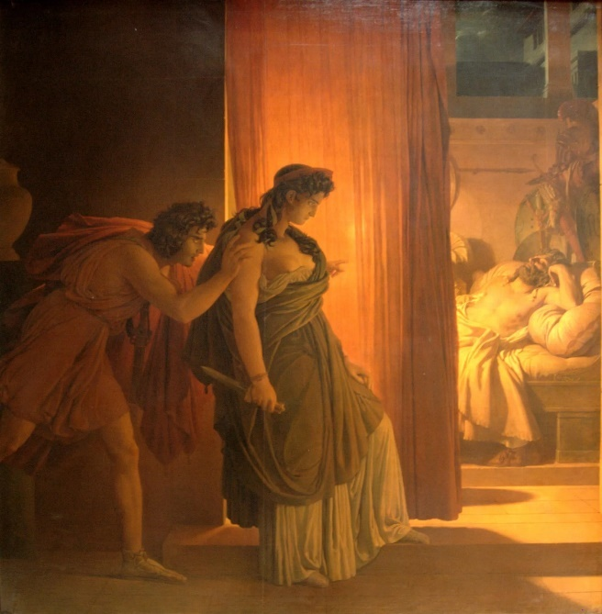
Lysias, the son of a Syracusan metic residing in Athens, was living in the city in the late fifth to early fourth century BC. During the period of the 30 tyrants (404/403 BC) Lysias’ brother Polemarchos was killed due to his support of the exiled democratic faction, while Lysias aided the cause with money and materials. This temporarily won him citizenship status in the restored democracy (before the decree of Thrasyboulos was quashed and those that metics that had received citizenship were disenfranchised). After the democratic restoration Lysias took up a career as a speech writer. His skill was such that later Alexandrian tradition would place him among the so-called Ten Attic Orators. In this speech (On the Murder of Eratosthenes), the defendant Euphiletos must prove that he did not premeditate the murder of Eratosthenes, but lawfully killed him as a response to his being caught in the act of adultery with Euphiletos’ wife. Our purpose here, however, is to examine the legal speech for traces of the activities and experiences of the unnamed women. I have not given the whole speech, but relevant segments when the key women in it appear.
When reading the text (given below), you should consider and respond to the following questions:
- Identify the (unnamed) female figures that are alluded to in the speech – what roles did they have to play in the unfolding events?
- What level of “freedom” of movement do the women mentioned appear to have?
- What role to women appear to play in facilitating, hindering or “policing” each other’s actions?
- What do you make of Euphiletos’ relationship with his wife and the slave girl that serves them?
- Can we infer anything from the claim that Euphelitos’ wife went with Eratosthenes' mother to the Thesmophoria?

Lysias 1 On the Murder of Eratosthenes – trans. W.R.M. Lamb (1930) – Loeb Classical Library

1.1: I should be only too pleased, sirs, to have you so disposed towards me in judging this case as you would be to yourselves, if you found yourselves in my plight. For I am sure that, if you had the same feelings about others as about yourselves, not one of you but would be indignant at what has been done; you would all regard the penalties appointed for those who resort to such practices as too mild.

1.2: And these feelings would be found, not only among you, but in the whole of Greece: for in the case of this crime alone, under both democracy and oligarchy, the same requital is accorded to the weakest against the strongest, so that the lowest gets the same treatment as the highest. Thus you see, sirs, how all men abominate this outrage.

1.3: Well, I conceive that, in regard to the severity of the penalty, you are all of the same mind, and that not one of you is so easygoing as to think it right that men who are guilty of such acts should obtain pardon, or to presume that slight penalties suffice for their deserts.

1.4: But I take it, sirs, that what I have to show is that Eratosthenes had an intrigue with my wife, and not only corrupted her but inflicted disgrace upon my children and an outrage on myself by entering my house; that this was the one and only enmity between him and me; that I have not acted thus for the sake of money, so as to raise myself from poverty to wealth; and that all I seek to gain is the requital accorded by our laws.

1.5: I shall therefore set forth to you the whole of my story from the beginning; I shall omit nothing, but will tell the truth. For I consider that my own sole deliverance rests on my telling you, if I am able, the whole of what has occurred.

1.6: When I, Athenians, decided to marry, and brought a wife into my house, for some time I was disposed neither to vex her nor to leave her too free to do just as she pleased; I kept a watch on her as far as possible, with such observation of her as was reasonable. But when a child was born to me, thence-forward I began to trust her, and placed all my affairs in her hands, presuming that we were now in perfect intimacy.

1.7: It is true that in the early days, Athenians, she was the most excellent of wives; she was a clever, frugal housekeeper, and kept everything in the nicest order. But as soon as I lost my mother, her death became the cause of all my troubles.

1.8: For it was in attending her funeral that my wife was seen by this man, who in time corrupted her. He looked out for the servant-girl who went to market, and so paid addresses to her mistress by which he wrought her ruin.

1.9: Now in the first place I must tell you, sirs (for I am obliged to give you these particulars), my dwelling is on two floors, the upper being equal in space to the lower, with the women's quarters above and the men's below. When the child was born to us, its mother suckled it; and in order that, each time that it had to be washed, she might avoid the risk of descending by the stairs, I used to live above, and the women below.

10.10: By this time it had become such an habitual thing that my wife would often leave me and go down to sleep with the child, so as to be able to give it the breast and stop its crying. Things went on in this way for a long time, and I never suspected, but was simple-minded enough to suppose that my own was the chastest wife in the city.

10.11: Time went on, sirs; I came home unexpectedly from the country, and after dinner the child started crying in a peevish way, as the servant-girl was annoying it on purpose to make it so behave; for the man was in the house—

10.12: I learnt it all later. So I bade my wife go and give the child her breast, to stop its howling. At first she refused, as though delighted to see me home again after so long; but when I began to be angry and bade her go, —“Yes, so that you,” she said, “may have a try here at the little maid. Once before, too, when you were drunk, you pulled her about.”

10.13: At that I laughed, while she got up, went out of the room, and closed the door, feigning to make fun, and she took the key away with her. I, without giving a thought to the matter, or having any suspicion, went to sleep in all content after my return from the country.

10.14: Towards daytime she came and opened the door. I asked why the doors made a noise in the night; she told me that the child's lamp had gone out, and she had lit it again at our neighbor's. I was silent and believed it was so. But it struck me, sirs, that she had powdered her face,1 though her brother had died not thirty days before; even so, however, I made no remark on the fact, but left the house in silence.

10.15: After this, sirs, an interval occurred in which I was left quite unaware of my own injuries; I was then accosted by a certain old female, who was secretly sent by a woman with whom that man was having an intrigue, as I heard later. This woman was angry with him and felt herself wronged, because he no longer visited her so regularly, and she was keeping a watch on him until she should discover what was the cause.

10.16: So the old creature accosted me where she was on the look-out, near my house, and said,—“Euphiletus, do not think it is from any meddlesomeness that I have approached you; for the man who is working both your and your wife's dishonor happens to be our enemy. If, therefore, you take the servant-girl who goes to market and waits on you, and torture her, you will learn all. It is,” she said, “Eratosthenes of Oe who is doing this; he has debauched not only your wife, but many others besides; he makes an art of it.”

10.17: With these words, sirs, she took herself off; I was at once perturbed; all that had happened came into my mind, and I was filled with suspicion,—reflecting first how I was shut up in my chamber, and then remembering how on that night the inner and outer doors made a noise, which had never occurred before, and how it struck me that my wife had put on powder. All these things came into my mind, and I was filled with suspicion.

10.18: Returning home, I bade the servant-girl follow me to the market, and taking her to the house of an intimate friend, I told her I was fully informed of what was going on in my house: “So it is open to you,” I said, “to choose as you please between two things,—either to be whipped and thrown into a mill, and to be irrevocably immersed in that sort of misery, or else to speak out the whole truth and, instead of suffering any harm, obtain my pardon for your transgressions. Tell no lies, but speak the whole truth.”

10.19: The girl at first denied it, and bade me do what I pleased, for she knew nothing; but when I mentioned Eratosthenes to her, and said that he was the man who visited my wife, she was dismayed, supposing that I had exact knowledge of everything. At once she threw herself down at my knees, and having got my pledge that she should suffer no harm,

10.20: she accused him, first, of approaching her after the funeral, and then told how at last she became his messenger; how my wife in time was persuaded, and by what means she procured his entrances, and how at the Thesmophoria, while I was in the country, she went off to the temple with his mother. And the girl gave an exact account of everything else that had occurred.

10.21: When her tale was all told, I said,—“Well now, see that nobody in the world gets knowledge of this; otherwise, nothing in your arrangement with me will hold good. And I require that you show me their guilt in the very act; I want no words, but manifestation of the fact, if it really is so.” She agreed to do this.

10.22: Then came an interval of four or five days ... as I shall bring strong evidence to show. But first I wish to relate what took place on the last day. I had an intimate friend named Sostratus. After sunset I met him coming from the country. As I knew that, arriving at that hour, he would find none of his circle at home, I invited him to dine with me; we came to my house, mounted to the upper room, and had dinner.

10.23: When he had made a good meal, he left me and departed; then I went to bed. Eratosthenes, sirs, entered, and the maid-servant roused me at once, and told me that he was in the house. Bidding her look after the door, I descended and went out in silence; I called on one friend and another, and found some of them at home, while others were out of town.

10.24: I took with me as many as I could among those who were there, and so came along. Then we got torches from the nearest shop, and went in; the door was open, as the girl had it in readiness. We pushed open the door of the bedroom, and the first of us to enter were in time to see him lying down by my wife; those who followed saw him standing naked on the bed.

10.25: I gave him a blow, sirs, which knocked him down, and pulling round his two hands behind his back, and tying them, I asked him why he had the insolence to enter my house. He admitted his guilt; then he besought and implored me not to kill him, but to exact a sum of money.

10.26: To this I replied, “It is not I who am going to kill you, but our city's law, which you have transgressed and regarded as of less account than your pleasures, choosing rather to commit this foul offence against my wife and my children than to obey the laws like a decent person.”

10.27: Thus it was, sirs, that this man incurred the fate that the laws ordain for those who do such things; he had not been dragged in there from the street, nor had he taken refuge at my hearth1, as these people say. For how could it be so, when it was in the bedroom that he was struck and fell down then and there, and I pinioned his arms, and so many persons were in the house that he could not make his escape, as he had neither steel nor wood nor anything else with which he might have beaten off those who had entered?

The latter half of the speech continues with “proofs” (logical arguments to support the defendants case), the legal basis for Euphelitos’ actions, witnesses, and a warning about the social dangers of punishing men who kill adulterers in the act.

