International Financial Management

LCBB6002

Assessment 1

Managing Foreign Exchange Risks

Dr Rexon Nting

Lilija Tconeva
2029799

January 2024
Table of Contents

- Introduction 4

- Foreign exchange risks 4

- Managing foreign exchange risks 6

- Strategies to manage exposure 6

- Conclusion 8

References 10

References (Figures) 12

List of Figures

FIGURE NO | DESCRIPTION | PAGE NO
1 | MNC Environment | 4
2 | FERM Model | 8

- Introduction

International financial management is essential for multinational corporations. It involves international investing and financing decisions about how to maximise the value of MNCs. Furthermore, it gives companies a perspective about the influences of movements in exchange rates, foreign interest rates, inflation and labour costs all affecting cost of production and prices (Madura, Hoque and Krishnamurti, 2018, p. 3). One of the main goals of a MNC is to maximize shareholder wealth. Managers are expected to take decisions that will increase stock price and serve stakeholders interest as a way to obtain funds and support its operations. As a result, management is used to motivate employees and organise resources efficiently; marketing, to increase consumer awareness and accounting and finance- to record the financial information about revenue and expenses of the MNC and evaluate the outcomes of various strategies (Madura, Hoque and Krishnamurti, 2018). A major factor that affects a MNC’s business strategies, cost of operations and revenue is the exchange rate movements. Therefore, a MNC needs to adopt certain strategies to manage exposure to exchange rate risks that affect their performance in overseas market.
This report includes an evaluation of strategies MNC uses to manage the foreign exchange risks.

- Foreign exchange risks

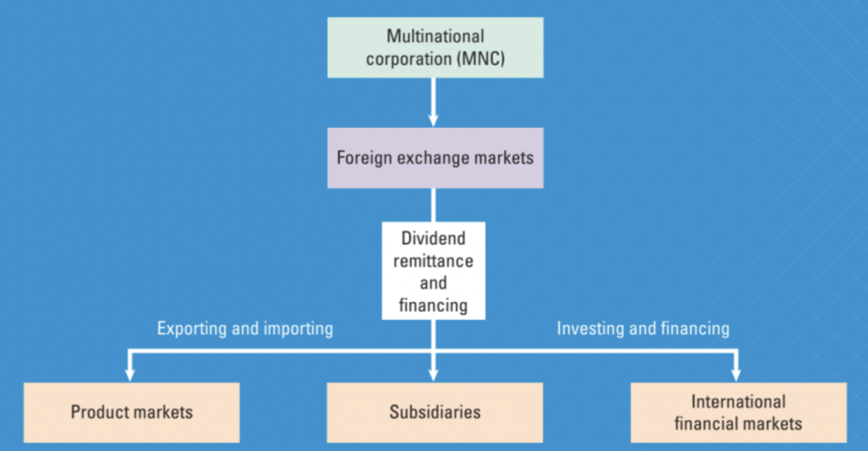
Figure 1: MNC Environment (Madura, Hoque and Krishnamurti, 2018, p. 1)

Foreign exchange risks result from the use of foreign currencies in international operations which MNCs exchange to support logistical operations, facilitate foreign investment, and sustain partnerships (Fig.1).
The foreign exchange rate is central for determining the economic situation of a country as it provides financial security, increases purchasing power and allows global trades (Akter, 2021). This rate fluctuates depending on the supply and demand of the currency. A higher exchange rate would make export expensive and import cheaper for a country. The opposite, lower exchange rate makes the export more affordable but the import costly. Therefore, a higher exchange rate makes a country’s economic conditions favourable as it helps keep the balance of trade lower (Akter, 2021).
From the number of factors that influence the exchange rate, five are the most important: inflation, interest rates, income levels, government control and changes in expectations. These factors shift the demand and supply axis and create a new exchange rate in a new equilibrium position (Akter, 2021).
In summary, foreign exchange risks refer to the losses that may incur from a foreign transaction due to currency fluctuations. All businesses and investors that expect foreign cash flow are directly exposed and most firms bear indirect or competitive exposure. Consequently, managing foreign exchange risk is critical for businesses success. It enhances value because it moderates cash flow volatility- mitigating underinvestment, decreasing the chances of financial distress and costs and reducing the cost of debt (Hutson, Laing and Ye, 2019).
The inevitability of foreign exchange risks means that a MNC needs to adopt effective strategies to sustain their profitability. There are three types of exposure:
- Economic- represents a risk that a company’s value may decline as a result of currency movement causing a loss in competitive strength (Arnold, 2013).
- Translation risks arise when financial data denominated in one currency is expressed in terms of another currency. To counter this risk a company can hedge by borrowing in the same currency as the denomination of the assets (Arnold, 2013).
- Transaction risks- transactions made in foreign currency that have variable value in home currency because of exchange rate movement (Arnold, 2013).
Businesses that engage in frequent international operations may consider multicurrency accounts that offer a valuable shield against the unpredictability of foreign exchange risks. These accounts simplify international transactions as they consolidate various currencies in one place. They streamline cross-border payments, reduce transfer costs and enhance cash flow management, providing a competitive edge in the global market (Pratt, 2023).

- Managing foreign exchange risk
Theories that inform the foreign exchange risk management are IRP (Interest Rate Parity), PPP (Purchasing Power Parity), and IFE (International Fisher Effect).
The IRP theory indicates that interest rate variation in two nations offsets the difference spot exchange rate and the forward exchange rate. The theoretical framework indicates that different currencies should have the same hedged investment returns irrespective of the prevailing interest rates. The PPP theory assesses the currencies' relative value through the comparison of their purchasing power (Arnold, 2013). The IFE theory states that the projected disparity between two currencies’ exchange rates is roughly equal to their nation’s NIR (nominal interest rates) (Shobande & Shodipe, 2021). Therefore, nations with high NIR experience high inflation rates and currency depreciation.

- Strategies to manage exposure
Derivatives are financial instruments used to speculate, invest and hedge in financial markets (Oldani, 2005). The hedging strategy involves taking currency market positions that offset losses associated with exchange rate fluctuations. The shareholder value theories of financial risk management suggest that in reducing the volatility of expected future cash flows, hedging creates value.

Derivatives as hedging strategy can be summed up as:
- future contracts- increase market efficiency and liquidity. They are widely used to hedge and speculate in both financial and commodity markets (Oldani, 2005)
- options contacts- give clients the right to sell and purchase currency at a specific price (Oldani, 2005)
- swaps- tend to create new investment opportunities in order to hedge against any type of risks such as interest rate and credit default (Oldani, 2005)
- forwards refer to customised agreements that enable MNCs to create exchange rates for future contracts, which protects them against potential currency volatilities (Oldani, 2005)
- repos used to finance liquidity not to speculate or hedge (Oldani, 2005)

Every hedging strategy offers diverse protection, flexibility, and financial ramifications, which improves MNCs’ risk exposure.

- Currency risk sharing implements a collaborative approach to managing risks.
Essentially, the risk management process involves modifying service/product prices based on the changes in currency values, ensuring a fair distribution of the financial burden (Jacque, 2013). The strategy enables all MNCs to accomplish long-term goals of profit maximisation and continuous expansion.

- The netting strategy supports the foreign exchange risk management process
through a sustained balance between payables and receivables in diverse currencies (Tiwary, 2019). For instance, a corporation transfers components of £15m to its foreign subsidiary. In the same month the subsidiary has to transfer goods for £30m to the mother company. Instead, it nets out the values of receivables and payables and sends £15m. The strategy minimises the need to convert currencies, which reduces costs and exposure (Tiwary, 2019). Generally, netting supports MNCs in reducing credit, reducing chances of credit default, and maintaining adequate liquidity to ensure optimal performance.

- Matching is effective in eliminating currency exposure when the exposure
cash flow is relatively constant, by acquiring a debt denominated in the particular currency (Tiwary, 2019). For example, a U.S company receives predictable dollar cash inflow with continuing export sales to Canada. The U.S firm uses this to pay the principal and interest payments on Canadian dollar debt and matches the cash flow (Tiwary, 2019).

- Back-to-back loan- businesses borrow each other’s currency for equal value at
current spot rate. For example, a British and a Dutch firms lend pound and euro respectively to invest, avoiding the exchange market entirely (Tiwary, 2019).

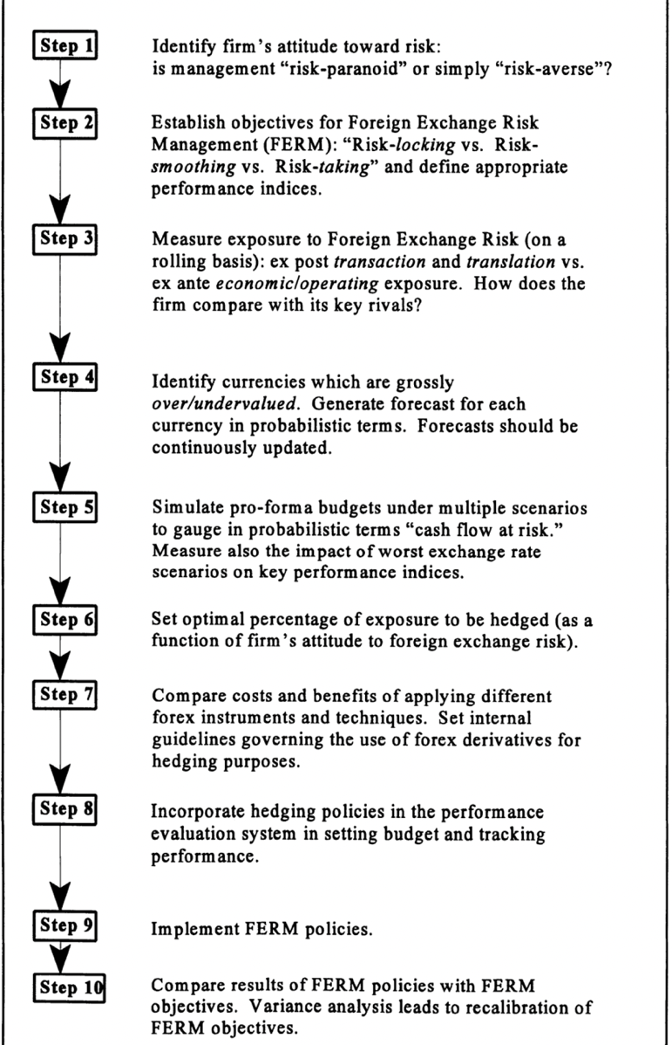
Figure 2: FERM model (Jacque, 2013)

- Conclusion

The integration of economies has allowed businesses to flourish profitably by taking advantage of lower cost production factors and favourable market conditions for their products and services. However, these advantages come with a factor of risks associated with floating exchange rate system which makes the MNCs highly vulnerable to potential losses or gains due to foreign exchange rate fluctuations. Although FX risks have significant impact on the financial performance of businesses that operate internationally, they can be identified, managed and mitigated. After a company had identified the risks and the exposure it can hedge by opting for operational and/or financial strategies. As Figure 2 shows a FERM model could be employed to ensure performance success. Ultimately, the risk management strategies enable businesses to strengthen their logistical operations, facilitate foreign investment and sustain global partnerships.

References

Akter, R. (2021) Factors that determine and influence foreign exchange rates. Available at: https://www.preprints.org/manuscript/202106.0240/v1 (Accessed: 23 December 2023)

Arnold, G. (2013) Essentials of corporate financial management. 2nd Ed. Harlow: Pearson

Hutson, E., Laing, E. and Ye, M. (2019) ‘Mutual fund ownership and foreign exchange risk in Chinese firms’. Journal of International Financial Markets, Institutions and Money, 60, pp.169-192. Available at: https://www.sciencedirect.com/science/article/abs/pii/S1042443117304353 (Accessed: 24 December 2023)
Jacque, L. (2013) Management and control of foreign exchange risk. London: Kluwer Academic Publishers
Madura, J., Hoque, A. and Krishnamurti, C. (2018) International Financial management. 1st Ed. Australia: Cengage AU
Oldani, C. (2005) ‘An overview of the literature about derivatives’. EconWPA, Macroeconomics. Available at: https://www.researchgate.net/publication/23747760_An_Overview_of_the_Literature_about_Derivatives (Accessed: 02 January 2024)

Pratt, L. (2023) How businesses can navigate currency exchange risks with multicurrency accounts. Available at: https://www.forbes.com/sites/forbesbusinesscouncil/2023/12/08/how-businesses-can-navigate-currency-exchange-risks-with-multicurrency-accounts/ (Accessed: 02 January 2024)

Shobande, O. and Shodipe, O. (2021) ‘Monetary policy interdependency in Fisher effect: A comparative evidence’. Journal of Central Banking Theory and Practice, 10(1), pp.203-226. Available at: https://www.researchgate.net/publication/349733321_Monetary_Policy_Interdependency_in_Fisher_Effect_A_Comparative_Evidence (Accessed: 02 January 2024)

Tiwary, A.R. (2019) ‘Study of currency risk and the hedging strategies’. Journal of Advanced Studies in Finance (JASF), 10(19), pp.45-55. Available at: https://www.semanticscholar.org/paper/Study-of-currency-risk-and-the-hedging-strategies.-Tiwari/c849b6653771578ed290c15fd393e8a369298a27 (Accessed: 02 January 2024)

REFERENCES FIGURES

Madura, J., Hoque, A. and Krishnamurti, C. (2018) MNC Environment [ Figure 1]. Available at: https://books.google.co.uk/books?hl=en&lr=&id=vkNMDwAAQBAJ&oi=fnd&pg=PR1&dq=Madura,+J.,+Hoque,+A.+and+Krishnamurti,+C.+(2018)+International+Financial+management.+&ots=xfNGfXZ0_L&sig=n2RZXUMDHJZwuUDHqwH5jZHX_1s&redir_esc=y#v=onepage&q&f=false (Accessed: 23 December 2023)

Jacque, L. (2013) FERM Model [Figure 2]. Available at: https://books.google.co.uk/books?hl=en&lr=&id=Nh72CAAAQBAJ&oi=fnd&pg=PR13&dq=Jacque,+L.+(2013)+Management+and+control+of+foreign+exchange+risk&ots=nJjHqURG4G&sig=pKvSjEexG9ZxTv3IVL5pR0p73XU&redir_esc=y#v=onepage&q=Jacque%2C%20L.%20(2013)%20Management%20and%20control%20of%20foreign%20exchange%20risk&f=false (Accessed: 02 January 2024)

