Ana Carden-Coyne, David Morris and Tim Wilcox, eds., The Sensory War, 1914–2014(Manchester Art Gallery: Manchester, 2014)
Images from section entitled ‘Shocking the Senses’

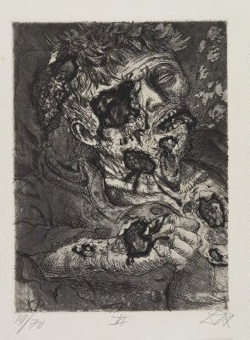
Otto Dix, War 26: Dying Soldier, 1924
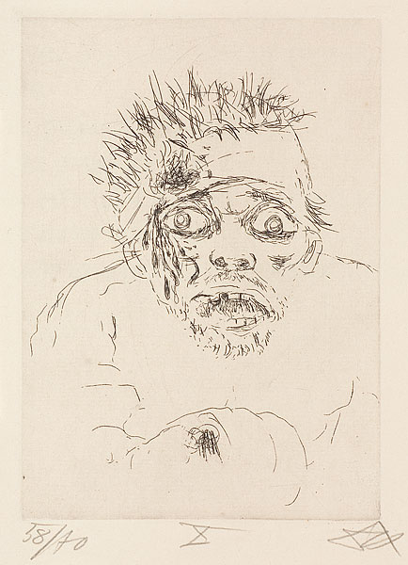
Otto Dix, War 10: Wounded Man Fleeing – Battle of the Somme, 1924

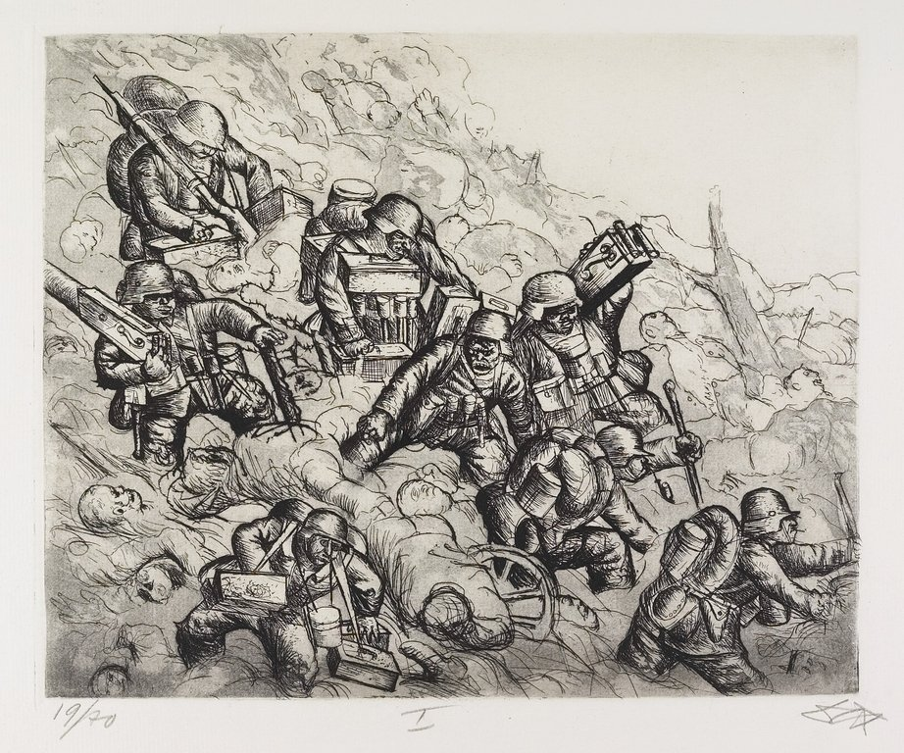
Otto Dix, War 41: Machine Gun Party advances, Somme November 1916, 1924
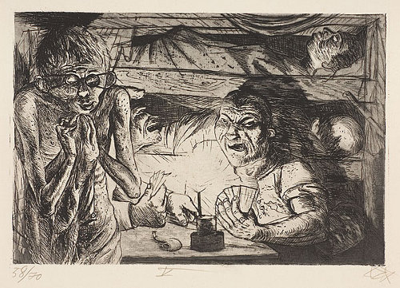
Otto Dix, War 45: Dugout, 1924

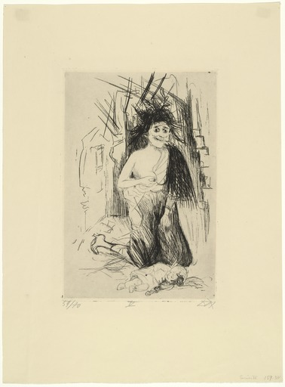
Otto Dix, War 35: The Madwoman of St Marie-a-Py,1924
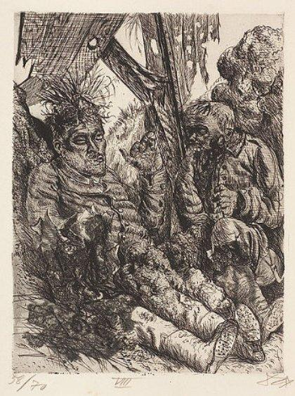
Otto Dix, War 28: Seen on the Escarpment at Clery-sur-Somme, 1924

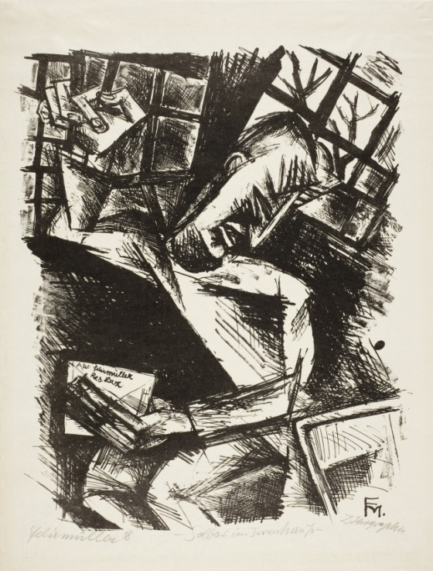
Conrad Felixmüller, Soldier in the Madhouse 2, 1918

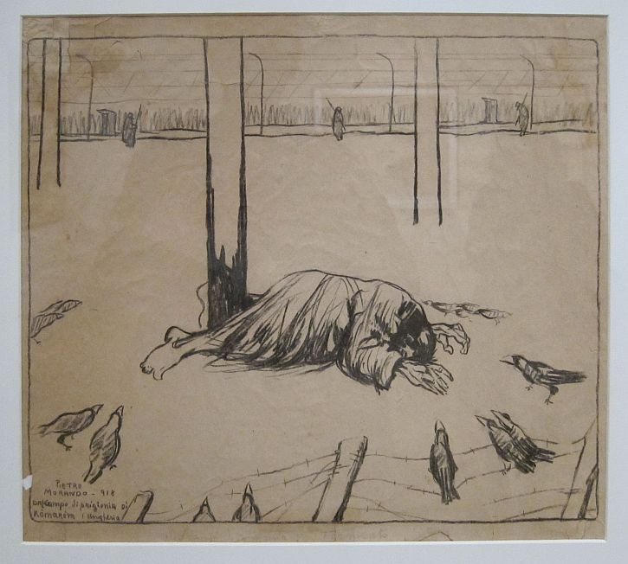
Pietro Morando, Enemy Reprisals: Komarom Prion, Hungary, 1918
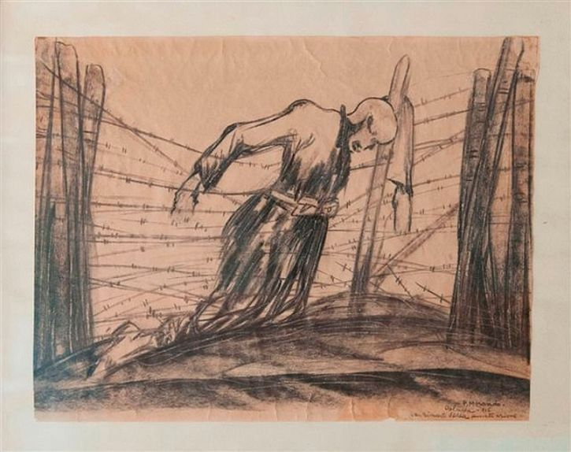
Pietro Morando, A Remnant of the Last Action, Oslavia, 1916

