Certificate of Higher Education Skills for the Workplace (Health & Social Care)
Module Title: Introduction to Health and Social Care

Module Code: LCHS4003

Lecturer Name: Dr Muhammad Aliyu

Assignment
Task 1: Poster on “Community Mental Health Services: Supporting Recovery in community”
Portfolio – Task 2: Community Antenatal Midwifery Services

Student Name: Justyna Gajewska
Student ID Number: 2517291

Contents
Introduction 4
History and Early Development. 4
Critical Analysis of the Existing Operation. 5
3.1 Current Model of Care 5
3.2 Critical Challenges 5
Importance in Improving the Quality of Life. 6
Conclusion 7
References 7

Task 1: Poster on “Community Mental Health Services: Supporting Recovery in community”

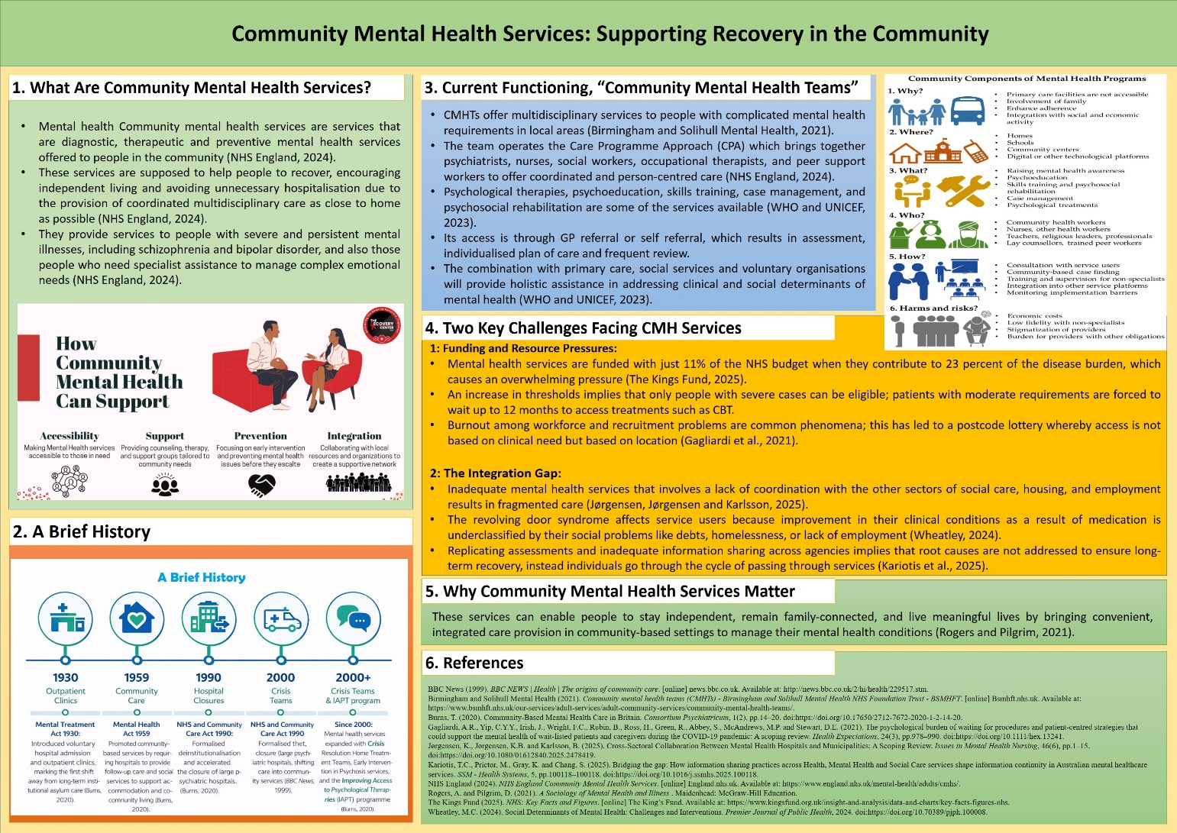

Task 2: Community Antenatal Midwifery Services: Origins, Current Functioning, and Impact on Quality of Life

Introduction
Community antenatal midwifery services offer midwife-led care to community-based clinics, children centers and women homes and mostly with low risks of pregnancy (NHS, 2023). This essay will suggest that as much as these services are profoundly rooted in the history of the UK and have shown strong progress in improving the quality of life, they now confront systemic issues such as workforce issues and long-term disparities that can challenge the sustainability of such services. To elaborate on this argument, the essay will discuss the origins and historical background of this service, critically analyze how it is currently operating, and how it is important to service users.

History and Early Development.

Community antenatal midwifery services have origins in the late nineteenth century in which high rates of maternal mortality led to the realization that community-based practitioners had to be skilled and accessible (Greenlees and Bryder, 2015). Within this timeframe, voluntary programs and Poor Law authorities have hired midwives to work with deprived communities, which is why the fundamental principle of maternity care delivery outside the institutional walls was established (Davis, 2012). One of the most significant changes was the Midwives Act 1936, which made it mandatory that local authorities directly employ salaried domiciliary midwives, professionalizing community-based maternity care and ending unqualified and untrained "handywomen" who previously attended most births at home (Yuill, McCourt and Rocca-Ihenacho, 2020). These services became part of a universal and tax-funded system in 1948, with the creation of the NHS, and made the provision of antenatal care to all women, whether they could afford it or not, and incorporated midwifery into the formal healthcare system (Clement, 2023). Nevertheless, the second half of the twentieth century was marked by the high degree of centralization: the prominent Peel Report (1970) supported the idea of 100% hospital birth, with the transition of birth to institutions and the radical decrease in domiciliary care (Boden, 2026). Nevertheless, community midwives could not be replaced by maternity care, which necessitated a consistent historical conflict between community and hospital-based approaches that persists in affecting modern maternity policy (Rocca-Ihenacho and Alonso, 2020).

Critical Analysis of the Existing Operation.

3.1 Current Model of Care
The modern community antenatal midwifery services are designed on a model of focus on accessibility and risk-stratified care. Women are now able to make direct referral to the community midwives without the need to access a general practitioner, which greatly enhanced access to antenatal support at an early stage (NHS, 2023). In simple pregnancies, community midwives offer holistic care throughout the process that includes booking appointments to postnatal care (BHR Hospitals, 2026). Where issues are identified, women are given shared care with consultant obstetricians with continuity of care left to midwives in the community. One of the policy goals has been the Midwifery Continuity of Carer model where small case loading teams allow women to have the same midwife during pregnancy, birth, and postnatally (Rocca-Ihenacho and Alonso, 2020). This model has a perfect ratio of one midwife to thirty-six women and is designed to provide an improved support to the most vulnerable group (BHR Hospitals, 2026).

3.2 Critical Challenges
Despite these hopes, there is still an enormous discrepancy in implementation. One of the core issues is workforce pressures: most community midwives have 1:150 caseloads, which is multiple times higher than the recommended one, thus, inevitably leading to safety and quality of care issues (BHR Hospitals, 2026). According to the recent Nursing and Midwifery Council statistics, forty-five per cent of midwives have experienced the instances of patient safety damage, which is directly associated with insufficient staffing and workload demands (NMC, 2026). Capacity pressures often lead to the depletion or cessation of services, and community midwives are redistributed to hospital units, among others, which affects safety (Buchanan, 2026). The Amos review interim report reveals that structural racism and ongoing inequalities keep compromising the quality of services that women of Black and Asian origins are particularly exposed to a greater risk of adverse outcomes (NHS Race and Health Observatory, 2026). This forms a spotty and uneven image where brilliant and bad care are next to each other (Buchanan, 2026).

Importance in Improving the Quality of Life.

Community based antenatal midwifery services greatly improves the quality of life in a variety of interrelated ways. It is proved that continuity of carer models not only decrease obstetric interventions but also raise normal birth rates and enhance the safety of low-risk women (Sandall et al., 2016). The psychological advantages are also sometimes convincing: women having known midwives say that they feel less anxious and are feeling supported during their experience, and the program of case loading achieved ninety-eight per cent positive answers (Wesson and Carter, 2026). The group antenatal care models also empower women to a greater extent, making them better prepared to birth and providing a better partner communication, and alleviating mental distress (Mazzoni and Carter, 2017). Practical barriers are eliminated by self-referral routes and community sites like children centers and local clinics where care is truly accessible due to the reduction of travel fees (NHS, 2023). These results are the examples of the West Middlesex case loading scheme: a ninety-two per cent of women indicated that it assisted in attaining the positive experience of childbirth, ninety-seven per cent of the respondents judged the program excellent, and one hundred per cent of the participants said they would recommend the program, homebirth rates were twenty-three per cent, which is considerably higher in comparison with the national average (Wesson and Carter, 2026). These services have a positive influence on clinical safety as well as the psychological and social experience of pregnancy due to their promotion of continuity and empowering shared decision-making.

Conclusion

Antenatal midwifery has proved its worth since its professionalization under the Midwives Act 1936, up to the present community models. Nevertheless, labor scarcity, unfair access, and systematic strains singled out in the review by Amos still threaten changes. The future lies in transforming the robust evidence into a consistent practice- replacing patchy implementation with a model that is available to all women and really provides them with safe and personalized and community-based care.

References

BHR Hospitals (2026). News - News - Maternity services. [online] BHR Hospitals. Available at: https://www.bhrhospitals.nhs.uk/news/maternity-services-3554/.
Boden, G. (2026). Changing birth support | AIMS. [online] Aims.org.uk. Available at: https://www.aims.org.uk/journal/item/changing-birth-support [Accessed 11 Mar. 2026].
Buchanan, M. (2026). Racism and staffing issues factors in ‘failing’ maternity care, report finds. [online] 26 Feb. Available at: https://www.bbc.com/news/articles/c30968817q3o.
Clement, M. (2023). The founding of the NHS: 75 years on - History of government. [online] history.blog.gov.uk. Available at: https://history.blog.gov.uk/2023/07/13/the-founding-of-the-nhs-75-years-on/.
Davis, A. (2012). Pregnancy and childbirth: antenatal care, birth and postnatal care. Modern Motherhood, pp.84–107. doi:https://doi.org/10.7228/manchester/9780719084553.003.0004.
Greenlees, J. and Bryder, L. (2015). Western Maternity and Medicine, 1880-1990. Routledge.
Mazzoni, S.E. and Carter, E.B. (2017). Group prenatal care. American Journal of Obstetrics and Gynecology, 216(6), pp.552–556. doi:https://doi.org/10.1016/j.ajog.2017.02.006.
NHS (2023). Your Antenatal Care. [online] nhs.uk. Available at: https://www.nhs.uk/pregnancy/your-pregnancy-care/your-antenatal-care/.
NHS Race and Health Observatory (2026). NHS - Race and Health Observatory. [online] NHS – Race and Health Observatory. Available at: https://nhsrho.org/latest/page/10/ [Accessed 11 Mar. 2026].
NMC (2026). Over half of professionals satisfied in their work, new NMC data show - The Nursing and Midwifery Council. [online] Nmc.org.uk. Available at: https://www.nmc.org.uk/news/news-and-updates/over-half-of-professionals-satisfied-in-their-work-new-nmc-data-show/.
Rocca-Ihenacho, L. and Alonso, C. (2020). Where do women birth during a pandemic? Changing perspectives on Safe Motherhood during the COVID-19 pandemic. Journal of Global Health Science, 2. doi:https://doi.org/10.35500/jghs.2020.2.e4.
Sandall, J., Soltani, H., Gates, S., Shennan, A. and Devane, D. (2016). Midwife-led Continuity Models versus Other Models of Care for Childbearing Women. Cochrane Database of Systematic Reviews, [online] 4(4). doi:https://doi.org/10.1002/14651858.cd004667.pub5.
Wesson, N. and Carter, N. (2026). The search for continuity | AIMS. [online] Aims.org.uk. Available at: https://www.aims.org.uk/journal/item/the-search-for-continuity [Accessed 11 Mar. 2026].
Yuill, C., McCourt, C. and Rocca-Ihenacho, L. (2020). ‘Pop-up’ birth centers? Considering COVID-19 responses and place of birth in England – Society for Medical Anthropology. [online] Medanthro.net. Available at: https://medanthro.net/rapid-response/pop-up-birth-centers-considering-covid-19-responses-and-place/ [Accessed 11 Mar. 2026].

