Module Name: Understanding and Engaging Stakeholders
Module Code: LCLM5001
Assignment Title: Understanding the importance of stakeholder Engagement in the successful commencement and completion of the project
Student Name: Elena Georgieva Goranova
Student ID: 2246479

Table of Contents
Company Introduction 3
SWOT Analysis of Smith & Nephew 4
Internal and external stakeholders who are involved in the project 6
The roles and responsibilities of the key stakeholders, along with the benefits and challenges 7
Application of appropriate frameworks, models, and theories for stakeholder engagement 9
Stakeholder matrix 9
Stakeholder engagement plan 9
Stakeholder communication plan 10
RACI Matrix 10
Key stakeholders' engagement processes executed by the Project Manager and managing conflicts using the 4C’s model 12
Ways the Project manager executes processes to engage the key stakeholders 12
Using the 4C’s model to manage conflict 14
Evaluate the impact of stakeholders’ engagement on Smith & Nephew’s business performance and recommendations 16
Impact of Stakeholder Engagement on Business Performance 16
Recommendations for Future Stakeholder Engagement 17
Conclusion 18
References 19

Company Introduction
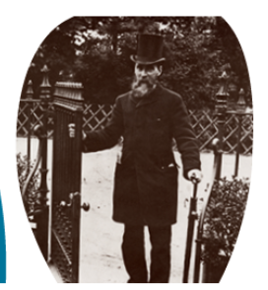
Figure: Thomas James, the founder of Smith & Nephew
Source: (Smith & Nephew, 2025a)
The chosen company in the United Kingdom that will launch the new wearable health device will be Smith & Nephew. This is considered to be a portfolio medical technology company that remains focused on the replacement and regeneration of soft and hard tissue. In addition to this, the value of the company is to develop a culture of care, collaboration and courage that sets the company apart from the rivals. The company shows such a culture where empathy and understanding for customers and patients are present (Smith & Nephew, 2025a). In the year 1856, a chemist's shop was opened in Hull, the United Kingdom, by Thomas James, and he developed a new method to refine cod liver oil. Horation Smittht entered into a partnership with his uncle Thomas in the year 1896, and the name of the business became TJ Smith and Nephew. There are three global units present in this business, and they include orthopaedics, sports medicine, ENT and advanced wound management. Furthermore, a series of partnerships is followed by the business with high-profile organisations and brands (Smith & Nephew, 2025a). It is crucial to mention that Smith & Nephew is committed towards the highest standards of corporate governance, and the leadership team plays a vital role here.

SWOT Analysis of Smith & Nephew
The SWOT analysis can be a strategic tool here with the purpose of appraising the selected company, Smith & Nephew, in an appropriate way.
Strengths
The company is committed towards wound management and the other two global units, and this is the reason why the brand invests much in innovation and technology. From this type of approach, it becomes able to come forward with advanced wound management technologies as well as orthopaedics assisted by robotics. Another strength that can be mentioned here is the diverse portfolio of the business, as the company has three different global units. The diverse global units, such as orthopaedics, sport medicine and ENT and wound management, help to reduce excessive dependency on a single unit and maintain a balance in the business (Smith & Nephew, 2025a). It is considered to be a leader in the global medicine technology field and has a strong brand reputation and recognition as one of its key strengths. Another strength that can be mentioned here is the global presence of the business, and it has international distribution channels and a sales network.
Weaknesses
In the current business environment, Smith & Nephew is facing excessive competition from other similar service and product providers, and it is one of its weaknesses. Furthermore, the health sector businesses are facing pressure to reduce costs and being a part of this sector, Smith & Nephew is also facing the same pressure. Due to this, the profit margin in the products and services has been reduced to a great extent. Another weakness that can be mentioned here is the increased complexity in the business aspect. There is a need that the company to pay attention to these weaknesses and take several key steps to tackle the issues properly.
Opportunties
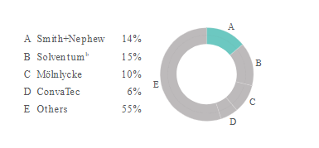
Figure: Market presence of Smith & Nephew in the global wound management market
Source: (Smith & Nephew, 2025b)
Despite the weaknesses, there are different kinds of opportunities present in front of the business, and they include the expansion of the business in the emerging markets. The value og the global market of the company is around 50 billion US dollars, and there are strong long-term growth drivers and technology advancements (Smith & Nephew, 2025b). Through this, the company gains the opportunity to expand into other global markets and achieve further advancement in the business. Another opportunity presented in front of the company is to use robotics, advanced technologies and digital tools for wound care and surgeries.
Threats
There are different kinds of threats that have the potential to affect the business of Smith & Nephew to a great extent. The regulations and legal frameworks are increasing in the medical sector of the United Kingdom, and due to this, there is a threat to the business to face legal complexities. As a result of the increasing competition, Smith & Nephew faces a threat to lose its position in the market and face other business difficulties. Another threat that can be mentioned here is the economic downturns in the global business environment. This type of situation may affect the entire business of the company to a great extent (Christopher et al., 2013).

Internal and external stakeholders who are involved in the project
The project will involve different external as well as internal stakeholders in order to make the product launch process successful.
External stakeholders
Patients: Patients will be a crucial external stakeholder as the medical equipment will be used by them, and the success of the product launch will depend on their acceptance.
Healthcare professionals: The new medical device can be recommended by healthcare professionals such as nurses, physicians, and clinical staff and due to this, they will be crucial external stakeholders.
Clinics and hospitals: The healthcare organisations, namely, clinics and hospitals, can recommend their patients to use the new medical device, and they are also an important stakeholder.
Government regulatory agencies: It will be highly crucial for the company to meet the regulations, privacy and safety concerns while launching the new product in the market.
Investors: With the funding provided by the investors, the product launch project will gain success, and due to this, they will also be a noteworthy stakeholder (Christopher et al., 2013).
Internal stakeholders
Product development team: The product development team will be responsible for executing plenty of tasks such as product design, manufacturing and testing, and this is the reason why they will be the most important stakeholder in the project.
Research and development department: The research and development team in the organisation will be responsible for using the crucial hardware and software related to the product. Furthermore, it will be their key responsibility to meet the data security standards in an appropriate way.
Marketing and sales department: Being an important internal stakeholder, it will be the responsibility of the marketing team to ensure that the product gains the attention of the right audiences. Furthermore, the product will be sold by the sales team, resulting in a high return on investment and profit generation (Nevins, 2021).
IT department: With the information technology team, Smith & Nephew will be able to integrate with the existing systems and ensure the proper management of the technical infrastructure.

The roles and responsibilities of the key stakeholders, along with the benefits and challenges
External stakeholders
Patients: Patients will use the device, and due to this, they will ensure that the product is comfortable to use and whether they have the potential to fulfil their expectations and preferences or not. They can achieve the key benefits of tracking the heart rate, sleep patterns and oxygen levels from the use of the device. However, it can be complicated for them to use the device at the initial stage due to the technical features (Nevins, 2021).
Healthcare professionals: The healthcare professionals will recommend that patients use the new medical device and contribute to increasing the sales of the product. In this way, their patients can get medical benefits, and their recognition can also be improved. Furthermore, they can face the challenge to face negative recognition if the products fail to fulfil the expectations of the patients.
Clinics and hospitals: The product will be recommended by the healthcare organisations; however, it can be challenging for these organisations to tackle the situation if the product has the potential to fulfil the expectations of audiences (Christopher et al., 2013).
Government regulatory agencies: In the project, it will be the core responsibility of the government regulatory agencies to ensure that the product is safe as well as efficient to be used by the general public. However, it can face the challenge of identifying any kind of regulatory gaps, and it will be highly crucial for the organisation to meet the regulatory needs.
Internal stakeholders
Product development team: The product development team will be responsible for designing, developing and testing the new product, and while doing so, they can find it challenging to meet the preferences and needs of target audiences. Through proper development, it can gain the benefit of developing the product properly and achieve market recognition (Ashcroft, 2017).
Research and development department: The research and development team will play a vital role in ensuring that the product meets market requirements or not. Furthermore, the benefit of proper development as per the market changes can be achieved by them. In contrast to this, they can find it complicated to stay aligned with the changes emerging in the health sector of the United Kingdom (Nevins, 2021).
Marketing and sales department: It will be a core responsibility of the marketing team to reach the right number of audiences and convince them to purchase the new product. The products will be sold by the sales team, and these two teams can gain the benefit to enhance the sales of the product and achieve recognition in the organisation. It can be challenging to meet the preferences and needs of customers in an appropriate way.
IT department: The IT department will pay attention to the technical infrastructure of the product and will benefit from proper technical alignment. The challenge that can come on the path will be improper technical infrastructure and product inefficiency (Freeman, 2023).

Application of appropriate frameworks, models, and theories for stakeholder engagement

Stakeholder matrix
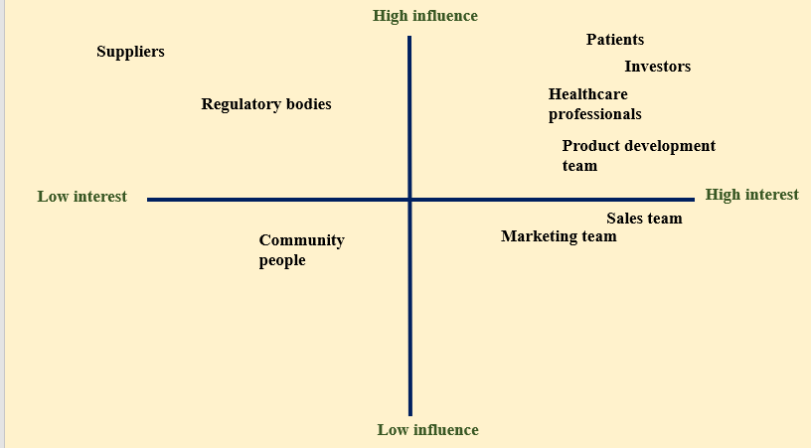
Figure: Stakeholder Matrix
Source: (Author)
High power and high interest: Patients, investors, healthcare professionals and the product development team of the organisation will be those stakeholders in the project who will have high power and high interest. It will be highly important to keep them engaged and manage them in an appropriate way.
High power and low interest: Suppliers for the development of the new product and regulatory bodies will be the stakeholders with high power and a low interest.
Low power and high interest: The sales and marketing team of the organisation is one of those stakeholders who will have high interest and low influence. They cannot change any project-related decisions; however, the efficiency and success will depend on them.
Low power and low interest: The local community people will be in the category of low-power and low-interest stakeholders (Parnell et al., 2025).

Stakeholder engagement plan
Stakeholder analysis: Through a proper stakeholder analysis, the project manager will be able to understand the interests and preferences of different stakeholders (Hoory, 2025).
Setting objectives: The objectives for the stakeholder management plan will be set beforehand to proceed accordingly.
Proper allocation of roles: The project manager will allocate the key responsibilities to different stakeholders such as the product development team, the sales and marketing team and the IT department (Wells, 2024).
Engagement activities: It will be an essential aspect to keep every stakeholder engaged with the engagement activities, such as feedback sessions, workshops and newsletters.
Regular updates: It will be ensured by the project manager that the engagement activities are effective or not, and they will be tracked with the key metrics (Nevins, 2021).

Stakeholder communication plan
Communication objectives: The objective of the communication plan will be to convey every detail of information about the project to every stakeholder. It will help to keep them engaged and contribute to the project.
Selection of communication channels: In this aspect, the project manager will use different communication channels, such as social media platforms, official meetings, and virtual meetings on efficient platforms (Freeman, 2020).
Feedback mechanism: In order to gain the feedback of every stakeholder, the project manager will maintain a feedback mechanism to resolve the issues faced by the stakeholders.

RACI Matrix
Project activities | Project manager | Product development team | patients | Healthcare professionals | Marketing and sales department | IT department | Investors | Research and development department
Setting project goals | R, A | R | I | I | I | C | C | C
Product development | C | R, A | I | I | I | R | C | R
Product testing | C | R, A | I | I | I | C | C | R
Regulatory compliance | C | R | I | I | I | C | I | R
product marketing | C | I | I | I | R, A | I | C | I
Product sales | C | I | I | I | R, A | I | C | I
Feedback after the launch of the product | R | R | I | I | I | I | C | R, A
Analysis: The RACI matrix plays a vital role in showing the responsible, accountable, consulted and informed stakeholders for the different project activities. Considering them, the project manager will allocate the tasks to them and will contribute to maintaining an effective communication process (Kujala et al., 2022).

Key stakeholders' engagement processes executed by the Project Manager and managing conflicts using the 4C’s model

Ways the Project manager executes processes to engage the key stakeholders
Engaging the diverse stakeholders of Smith & Nephew, such as Patients, Healthcare professionals, and many more, requires the use of co-creation and feedback loops, digital platforms, integrated strategies, regulatory collaboration, and data-driven engagement. This, as a result, will allow the organisation to improve the way their products are performing, such as implant design for a more holistic value creation across their clinical, commercial, and digital upfront.
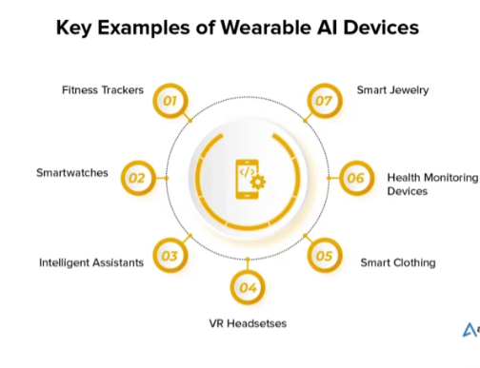
Figure: Wearable Devices with different features which can be added in
Source: (AppInventiv, 2025)
Stakeholder Engagement Processes
Patients & Caregivers: In order to engage the patients and the caregivers, the project manager can use tools such as Patient Advisory Boards (PABs) for direct input and digital feedback for convenience. Moreover, they will also utilise activities as support groups for peer connection, and advocacy partnerships to amplify voices involving the patients and the families for the care decisions. This, as a result, will allow the project to improve its quality and create a patient-centred healthcare experience with better product designs (Ellis et al., 1991).
Healthcare Professionals (HCPs) & Clinical Staff: Engaging the healthcare professional and clinical staff, the project manager integrates tools such as “Smith+Nephew Academy”, expert forums (KOLs), clinical trial participation, and direct sales force interaction (Hanass-Hancock et al., 2025). With the execution of the same, the brand will be able to provide continuous education, gather clinical insights, and ensure proper product use while co-developing solutions such as optimal implant alignment.
Clinics & Hospitals: The project manager will be focusing on integrating value-based care programs, integrated solutions such as devices and software, along with key account management, supply chain efficiency discussions. The execution of this will allow the project to improve patient outcomes, operational efficiency and demonstrate the economic and clinical value (Hanass-Hancock et al., 2025).
Government & Regulators: For the engagement of the same, the company will initiate a regulatory body, with a proactive regulatory engagement and public health initiatives. This, as a result, will allow the project manager to ensure compliance while advocating for supportive policies and aligning with the national health priorities.
R&D Department: The aspect of cross-functional ideation with the marketing, sales, IT, and patient feedback integration will be aligned and attained. This will outcome to driving innovation, developing user-centric products, and integration of digital health features, all with design thinking workshops (Hanass-Hancock et al., 2025).
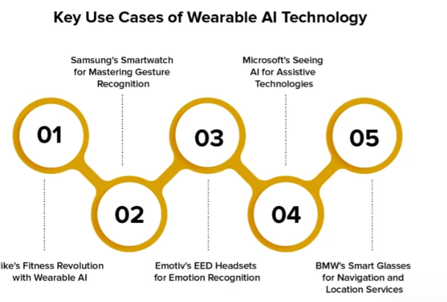
Figure: Uses of Wearable Technology around different companies and gestures
Source: (AppInventiv, 2025)
Marketing & Sales: The training on the new tech, leveraging the clinical evidence collected from the R&D department for the customisation of the content and market segmentation (Subbiah, 2023). This will allow the project flow to effectively communicate value while building strong relationships, and drive adoption across diverse markets such as professional v/s customers.
IT Department: Data analytics of the patient outcomes and market trends alongside digital platform development, such as Smith+Nephew Academy, cybersecurity, and data privacy. The execution of the same will allow the organisation to enable data-driven decisions, support digital health strategies, and enhance the internal as well as external platforms (Pietronudo et al., 2022).
Product Development: The early stakeholder input from the patients and the HCPs aligned with agile development cycles, pilot testing, and integration of R&D insights will be the main elements to execute the engagement in this department. With the execution of the brand will be able to create commercially viable, clinically effective, and user-friendly products. This will allow the project manager to meet the real-world needs, such as advanced wound dressings and designing a new wearable health device that tracks the heart (Pietronudo et al., 2022).

Using the 4C’s model to manage conflict
In the launch of the new wearable health device project, conflicts may arise when it comes to managing the project. Hence, in this project, the project manager will be integrating the 4Cs model, such as Communication, Coordination, Cooperation, and Collaboration. This will be initiated in the project by establishing clear communication with open channels, active listening, and many more for a shared vision. Afterwards, the implementation of structured coordination to align the tasks and foster cooperation across teams and finally achieving deep collaboration for innovative solutions. This thereby proactively allows managing conflicts for ensuring alignment, transparency, and shared ownership, especially around technical challenges such as data privacy and feature overlaps (Supena et al., 2021).
Communication (The Foundation)
The project manager sets up regular stand-ups, transparent dashboards, and clear channels such as Slack and Jira so that they can continue sharing updates, roadblocks, and feedback (Galvin et al., 2024). This, as a result, will allow the project to prevent misunderstandings about features such as apps, devices, and timelines by ensuring everyone hears the same message and has a voice (Galvin et al., 2024).
Coordination (The Structure)
When it comes to conflict management, defining the clear roles related to who owns firmware, who owns UI, and others, is a necessity (Buda and Primiero, 2024). Other than that, they also need to describe their dependencies, and this includes the marketing team with the final specs and using tools so that they can track the progress towards the launch date. This will allow the team to avoid duplication of effort or dropped balls, both hardware and software teams designing the charging port by synchronising activities.
Cooperation (The Task Alignment)
The task alignment requires teams to cooperate, and hence, they need to encourage the teams, such as data science and design, in order to keep the work in parallel while dividing tasks like data security protocols and user testing. As a result, this will allow the team to smooth out the disagreements over resource allocation by establishing shared objectives and mutual reliance within Smith & Nephew (Buda and Primiero, 2024).
Collaboration (The Innovation & Resolution)
The project manager can facilitate a joint workshop, such as within different teams, which will allow brainstorming the solutions for the complex issues like privacy concerns and fitting features. As a result of that, the project manager will be able to resolve deep-seated conflicts, such as privacy features conflicting with data utility, by collectively creating novel, mutually beneficial solutions and leveraging diverse expertise (Buda and Primiero, 2024).

Evaluate the impact of stakeholders’ engagement on Smith & Nephew’s business performance and recommendations
With a robust stakeholder engagement, the launch of the product will allow driving a better product-market fit, faster adoption, trust, compliance, and funding (Chams et al., 2023). This ultimately will lead to increased sales and brand loyalty for the operations of Smith & Nephew.

Impact of Stakeholder Engagement on Business Performance
Users or Patients (Early Adopters and End-Users)
The early adopters will allow the stakeholders to directly enhance the performance of the business by driving product improvement through feedback. Thus, this as a result will boost the adoption and retention, leading to positive reviews, strong word-of-mouth, and increased sales impact. With this, the creation of a virtuous cycle of user satisfaction and market success will be accentuated and enhanced, as seen in the project. Subsequently, it says that stakeholder input is seen to improve the study design and outcomes for the launch of the product.
Healthcare Professionals (HCPs) (Doctors and Therapists)
The HCPs or Healthcare Professionals can validate the product, which will allow clinical relevance and ensure it addresses real patient needs (Blanes-Selva et al., 2023). Engaging the HCPs, such as the doctors and the therapists, will allow them to drive the success of the business by embedding the service into caregiving. Their direct involvement will build confidence, making the HCPs advocate rather than just prescribers. The company can endorse trusted Healthcare Professionals with this tool so that the company can gain quicker acceptance, reducing time to market. With the higher adoption rate and stronger endorsements, the brand can directly translate them into increased sales and market share. This will also ensure that the business strategies are truly focused on valuable innovation while avoiding R&D dead ends.
Investors and Partners (Retail and Tech)
Effective stakeholder engagement builds investor and partner confidence in the market viability of Smith & Nephew, alongside their scalability and strategic direction. This, as a result, will lead to critical funding, partnerships, and access to distribution channels, and it further translates to direct marketing scale-up as well as revenue growth. Considering this will validate strategic alignment and unlock opportunities within the brand (Blanes-Selva et al., 2023). In addition to that, the stakeholder alignment will ensure the prospect of AI governance, data privacy, and security, fostering trust for adopting new tech. Thus, this translates to potentially amalgamating large-scale projects and improving delivery speed as well as the quality. With this, the company will be able to prove market understanding, strategic focus, and operational capability, reducing perceived risk for investors and partners, which as a result builds confidence. Additionally, this also secures resources for their research and development team for the expansion and optimisation of the brand’s market share.

Recommendations for Future Stakeholder Engagement
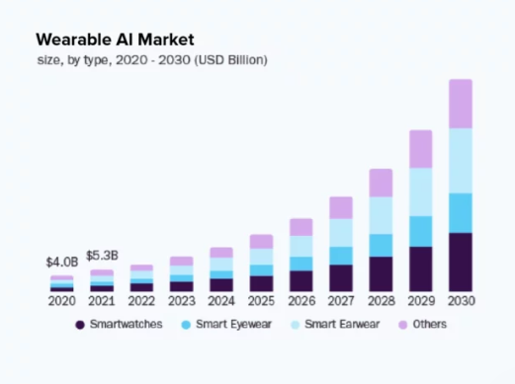
Figure: Statistical Figure related to the way people wear different wearables in the market
Source: (AppInventiv, 2025)
A few recommendations will be that Smith & Nephew will be that they can implement continuous beta testing with diverse user groups for real-world feedback on comfort, data accuracy, like PPG sensors. This will allow the brand to ensure that the machine is accurately taking marks and tracking the beats. Moreover, they can also partner with the research hospitals for studies proving efficacy regarding stress, sleep, to chronic disease to build credibility. Collaboration with the insurance companies and wellness platforms to expand the strategic reach will also be beneficial for the brand. Moreover, engaging early with regulatory bodies to classify the device as wellness vs. medical will be a beneficial suggestion. As a result, they can meet safety standards, potentially using AI-driven insights for predictive health within Smith & Nephew.

Conclusion
Smith & Nephew is a major British global medical technology company which was founded in the year 1856, specialising in devices for Orthopaedics, Wound Management, and Sports Medicine. The brand has been helping people regain their mobility and live without any limits. In this assessment, the scenario regarding an aspect regarding the understanding and engagement of the stakeholders has been associated. With the consideration of the mentioned company, these aspects as been evaluated via the instance and need to engage them for a project. The term can be defined as the identification of the groups affected by or influenced by the work. Afterwards, a proactive consideration is taken so that one can involve the stakeholders through a clear, two-way communication, and listening to their needs. Moreover, building trust and incorporating their feedback to ensure project success, aligning goals, mitigating risks, and fostering long-term buy-in is also necessary prospect within the project. In this assessment, all these key steps are used to map the stakeholders and tailor communication. This, as a result, allowed the project to be transparent with encouraged participation, and a consistent approach which enables the creation of a shared value and commitment. The execution of the same has allowed it the be developed with consistent adaptation of strategies. Smith & Nephew is willing to launch a wearable watch, which will be beneficial for the patients and the caregivers. Hence, with the amalgamation of numerous models and frameworks has been evaluated to identify and engage the stakeholders. Apart from that, the project has also integrated a 4Cs model, which focuses on Communication, Coordination, Cooperation, and Collaboration aspects. This enabled the portfolio to understand the way the project can be completed without any conflicts or issues arising.

References
AppInventiv, (2025). Wearable AI. [Online] Available at: https://appinventiv.com/blog/ai-and-wearable-technology/ [Accessed 4 December 2025].
Ashcroft, J. (2017). The relational lens: understanding, measuring, and managing stakeholder relationships. Cambridge: Cambridge University Press.
Blanes-Selva, V., Asensio-Cuesta, S., Doñate-Martínez, A., Pereira Mesquita, F. and García-Gómez, J.M., (2023). User-centred design of a clinical decision support system for palliative care: Insights from healthcare professionals. Digital Health, 9, p.20552076221150735.
Buda, A.G. and Primiero, G., (2024). A pragmatic theory of computational artefacts. Minds and Machines, 34(Suppl 1), pp.139-170.
Chams, N., Guesmi, B. and Gil, J.M., (2023). The nexus between research impact and sustainability assessment: From stakeholders’ perspective. Research Evaluation, 32(2), pp.484-495.
Christopher, M., Payne, A., and Ballantyne, D. (2013). Relationship Marketing: Creating Stakeholder Value. Saint Louis: Taylor and Francis
Ellis, C.A., Gibbs, S.J. and Rein, G.L., (1991). Groupware: Some issues and experiences. Communications of the ACM, 34(1), pp.38–58. doi:10.1145/99977.99987
Freeman, R.E., (2020). The stakeholder approach revisited. In Wirtschafts-und unternehmensethik (pp. 657-671). Wiesbaden: Springer Fachmedien Wiesbaden.
Freeman, R.E., (2023). Stakeholder management: framework and philosophy. In R. Edward Freeman’s selected works on stakeholder theory and business ethics (pp. 61-88). Cham: Springer International Publishing.
Galvin, K., Tomlin, D., Timmer, B.H., McNeice, Z., Mount, N., Gray, K. and Short, C.E., (2024). Consumer Perspectives for a Future Mobile App to Document Real-World Listening Difficulties: Qualitative Study. JMIR Formative Research, 8, p.e47578.
Hanass-Hancock, J., Ndlovu, T., Willan, S., Zulu, N., Mhlongo, S., Mabunda, A., Padayachee, T., Lloyd, J., Mthethwa, T. and Carpenter, B., (2025). Co-designing the disability awareness toolkit for disability-inclusive and accessible health and post-GBV clinical services in South Africa. International Journal for Equity in Health, 24(1), pp.1-16.
Hoory, L., (2025). What Is A Stakeholder Analysis? Everything You Need To Know. [Online] Available at: https://www.forbes.com/advisor/business/what-is-stakeholder-analysis/ [Accessed 2 December 2025].
Kujala, J., Sachs, S., Leinonen, H., Heikkinen, A. and Laude, D., (2022). Stakeholder engagement: Past, present, and future. Business & Society, 61(5), pp.1136-1196.
Nevins, M., (2021). The Single Best Way To Engage And Manage Your Stakeholders. [Online] Available at: https://www.forbes.com/sites/hillennevins/2021/08/12/the-single-best-way-to-manage-your-stakeholders/ [Accessed 2 December 2025].
Parnell, G.S., Bresnick, T.A., Johnson, E.R., Tani, S.N. and Specking, E., (2025). Handbook of decision analysis. John Wiley & Sons.
Pietronudo, M.C., Zhou, F., Caporuscio, A., La Ragione, G. and Risitano, M., (2022). New emerging capabilities for managing data-driven innovation in healthcare: the role of digital platforms. European Journal of Innovation Management, 25(6), pp.867-891.
Smith & Nephew, (2025a). Who we are. [Online] Available at: https://www.smith-nephew.com/en/who-we-are#our-purpose [Accessed 1 December 2025].
Smith & Nephew, (2025b). Our business units. [Online] Available at: https://www.smith-nephew.com/en/who-we-are/our-business-units#overview [Accessed 1 December 2025].
Subbiah, V., (2023). The next generation of evidence-based medicine. Nature medicine, 29(1), pp.49-58.
Supena, I., Darmuki, A. and Hariyadi, A., (2021). The Influence of 4C (Constructive, Critical, Creativity, Collaborative) Learning Model on Students' Learning Outcomes. International Journal of Instruction, 14(3), pp.873-892.
Wells, R., (2024). 3 Stakeholder Mapping Techniques for Project Management In 2024. [Online] Available at: https://www.forbes.com/sites/rachelwells/2024/01/05/3-stakeholder-mapping-techniques-for-project-management-in-2024/ [Accessed 2 December 2025].

