

MODULE CODE: BMIH5007

MODULE: FINANCIAL MANAGEMENT FOR THE HOTEL INDUSTRY
ASSESSMENT 1
Student name : Mircea-Catalin Leva
Student id : 2244690
Module leader: Tristan Hawkins

I confirm that I have not used any AI tools in the research and creation of this
assignment. I confirm that I have not presented any AI generated materials as my own
work. I confirm I have copies of my drafts, notes, and other resources I used, which I may be asked to provide in evidence.

Table of Contents
Assignment 1: Report 4
1.0 Introduction 4
2.0 Total Revenue: Comparative Evaluation of the growth potential of Shangri-La and Premier Inn 4
3.0 Market position: A comparative analysis of the market positions of Shangri-La and Premier Inn 5
4.0 Growth potential: Comparative evaluation of the growth potential of Shangri-La and Premier Inn 10
5.0 Conducting a comparison between Shangri-La and Premier Inn regarding the financial commitment related to CSR 11
6.0 Recommendation 12
7.0 Conclusion 13
Assignment 2: Report 14
1. Introduction 14
2. Evaluation of the trends in the financial performance of the past three years of The City Hotel 14
2.1 Trends of revenue and expenses 14
2.2 Profitability trends 15
2.3 Patterns of liquidity 16
2.4 Trends of solvency 17
3. Determination of the key reasons for the decline in profit to focus on real-world events and the current economy 18
3.1 Rising labour costs and hotel staff shortages 18
3.2 Cost of living crisis 20
3.3 Changing consumer behaviour 21
4. Turnaround strategy to revitalize the financial health and develop a brand reputation of the Hotel 21
4.1 Delivering personalized services to customers to improve experience 21
4.2 Promoting digital presence and innovation to develop brand value 21
4.3 Controlling operational costs and maximizing profit 22
5. Conclusion 22
Reference List 24
Appendices 30
Appendix 1: Calculation of ratios 30

Assignment 1: Report

1.0 Introduction
In the current cutthroat business landscapes wherein, businesses are focusing more on gaining a competitive edge over others, they tend to strategies and financial approaches which would help them to sustain in the markets, and boat their financial performance for the longer term. This study on Financial Management for the Hotel Industry will critically evaluate the financial management approaches of two prominent market players in the global hospitality sector, namely Shangri-la and Premier Inn. The study will assess and compare the total revenue of both firms and analyse their market positions, growth potentials, and financial commitments towards CSR. Relevant recommendations will be made concerning the gathered information.

2.0 Total Revenue: Comparative Evaluation of the growth potential of Shangri-La and Premier Inn
Premier Inn is a UK-based hotel chain owned and operated by Whitbread PLC. In 2023, Premier Inn recorded a total of £3 billion worth revenue.
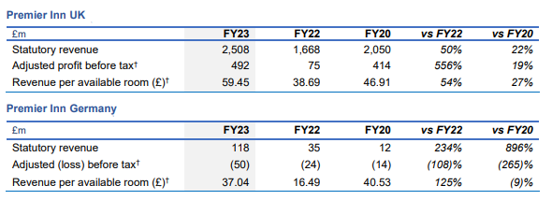
Figure 1: Highlights of financial revenue generated by Premier Inn over time
(Source: Whitbread PLC, 2023)
From the above figure, the revenue trends of Premier Inn in the recent past can be analysed. As can be seen in the figure, Premier Inn has registered a dip in revenue between FY2020 and FY2022. The reduction in revenue between FY 2020 and FY 2022 can be attributed to the Covid-19 lockdowns across the UK. In comparison, the revenue registered by Premier Inn in Germany has consistently increased from FY2020 to FY 2023. Shangri-La, a Hong-Kong based hospitality company saw a 46.5% boost in its revenue in 2023 and registered $2.1 billion revenue in FY 2023. According to He (2024), the considerable increase in Shangri-La’s revenue is a result of the revocation of travel restrictions in mainland China and Hong Kong.
The Hong-Kong-based hotel Shangri-La mainly generates its revenue mainly from its business and leisure travel activities. Shangri-La has developed a portfolio of 4 different hotel brands, namely, “Shangri-La, Traders Hotels, Kerry Hotels, and Hotel Jen”. Each of these brands attract different segments of customers. Moreover, Shangri-La has also invested in commercial properties, serviced apartments, restaurant bars, and wellness businesses that act as sources of revenue for the company as well. Contrarily, the sole source of Premier Inn’s revenue is its accommodation services.
The consistent growth in Premier Inn’s revenue can be attributable to the loyalty of its customers to the brand. According to a report, Premier Inn’s brand awareness in the UK is as high as 93% (Knust, 2023). Furthermore, the report also stated that nearly 42% of all hotel customers in the UK are likely to choose Premier Inn during their travel. Another key factor that presumably contributes to the revenue growth of Premier Inn is its affordability. As of 2023, the average cost of a one-night stay in Premier Inn hotels is nearly £79.76 only whereas, the average cost of room rent is as high as £153.68 (Statista, 2024). Affordability is, therefore, one of the key factors driving the revenue growth of Premier Inn. Shangri-La, in contrast, charges $216.28 or £165.31 for a night stay (Shangri-La, 2024). Hence, Shangri-La is perceived as a luxury hotel brand and exhibits a much lower occupancy rate as compared to Premier Inn. For instance, the average occupancy rate of Shangri-La stood at 60% whereas that of Premier Inn was above 80% for FY 2023 (Statista, 2024). The comparatively low occupancy rate can be a potential obstacle to the growth potential of Shangri-La in the future.

3.0 Market position: A comparative analysis of the market positions of Shangri-La and Premier Inn
In order to gain a comparative understanding of the market position of Shangri-la and Premier Inn, it becomes important to note the core business goals which set them aside from the other bands and pave the way for their business to create a unique market presence and position. As per Statista (2024) reports, it has been observed that Premier Inn is amongst the most popular hospitality brands as of the 2nd quarter of 2024, in the UK. The Statista report based its findings on the YouGov’s rating wherein Premier Inn received a staggering 78% of rating, making it the most popular brand in the UK [Refer to figure 2].
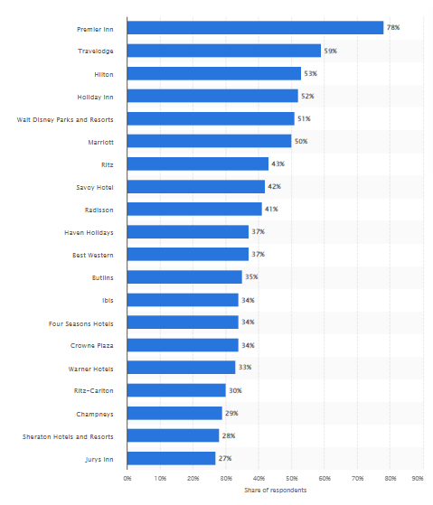
Figure 2: Most popular hotel brand in the UK as of 2024 Q2
(Source: Statista, 2024)
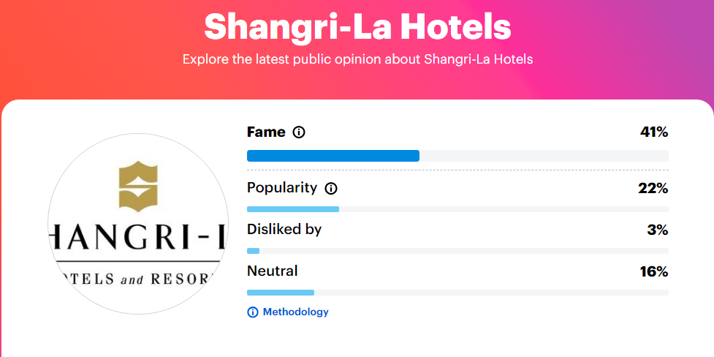
Figure 3: Popularity checker of Shangri-la hotels in the UK as of 2024
(Source: YouGov, 2024)
On the other hand, based on the YouGov reports, it has been found that Shangri-La has 22% popularity in the UK, with a fame rating of 41% [Refer to figure 3]. In order to gain a better comparison, figure 3 illustrates the overall popularity of hotel brands based on their fame and popularity in the UK, wherein it can be noted that Premier Inn is positioned as the first sport with a popularity of 72% and fame of 98% as of 2024, Q3. In comparison, Shangri-La Hotel is positioned in the 29th spot, with a fame of 41% and popularity of 22% [Refer to figure 4]
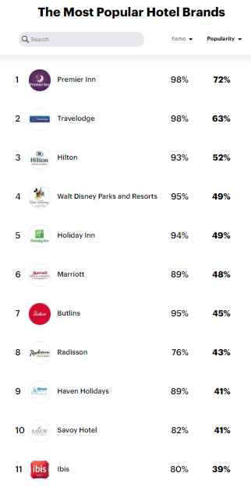
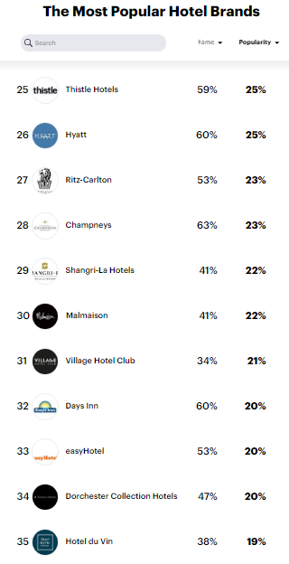
Figure 4: Most popular hotel brands as of Q3, 2024
(Source: YouGov, 2024)
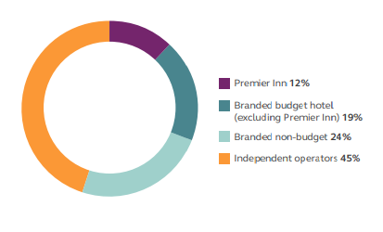
Figure 5: Market share of Premier Inn
(Source: Whitbread, 2023)
In terms of the market share, Premier Inn has a total of 12% of the UK hospitality sector’s market share. This depicts that Premier Inn holds a 12% market share on the room supply basis in the UK (Whitbread, 2023) [Refer to figure 5]. Yet on the contrary side, Shangri-La has been making strides to curate a significant market share in the UK hospitality sector. Since Premier Inn has a stronghold in the nation, Shangri-La needs to focus on enhancing its product offerings which as a result would help the company to attract major attention to the customer base, and enhance its market share. In the aspect of customer demographics, both brands focus on attracting affluent customers to their brands and ensure that they can provide top-notch services to the guests and customers.

4.0 Growth potential: Comparative evaluation of the growth potential of Shangri-La and Premier Inn
In order to understand the growth potential of the UK hospitality sector, it can be noted that the sector was employing around 1.8 million people as of 2019. The sector was comprised of around 143,000 businesses (including SMES to large firms) in the hotel and hospitality industry (Gov, 2023). The UK hospitality sector is anticipated to stall in 2024, yet the market potential is expected to rise in the coming years, since the market is rapidly evolving, and hotel brands are significantly emphasizing inculcating changes to sustain in the markets (PwC, 2023). With this respect, the expansion strategies of both firms are different to each other. It can be noted that the UK and Germany have remained the primary focus of Premier Inn's expansion plan. In 2016, Premier Inn opened its first hotel in Germany, located in Frankfurt then in 2019 in Hamburg and Munich (Premier Inn, 2023). As per the reports of Gill (2024), Premier Inn has planned to additionally integrate around 750 to 1,250 rooms in the UK and 400 rooms in Germany by 2025. This will help Premier Inn to optimise its products and service offerings to the customer segments. Furthermore, the brand has also aimed to add around 3,500 rooms under the Premier Inn network, wherein it will convert 112 underperforming restaurants. This plan is intended to be done before 2030, and this will do under the “accelerating growth plan” of Premier Inn (O’Neill, 2024). In comparison, the premium hotel chain Shangri-La, which is controlled by the Kuok Group, has travelled to over 22 countries, with a focus on Asia Pacific (Shangri-La Group, 2024). The Middle East, Europe, North America, Africa, and Oceania are just a few of the regions where Shangri-La has expanded, in contrast to Premier Inn. Premier Inn has decided to further expand its domestic market, whereas Shangri-La has adopted a more aggressive strategy for international expansion, according to a comparison of the two hotels' expansion plans (Shangri-La Group, 2024). However, the expansion and growth scope can experience numerous roadblocks. As the UK is experiencing a skilled staff shortage, rising inflation rates leading to the demands for wage hikes, and many others could potentially pose growth barriers for the business expansion of both firms.

5.0 Conducting a comparison between Shangri-La and Premier Inn regarding the financial commitment related to CSR
Ensuring social and economic commitments is beneficial for the hospitality sector to gain its brand value by focusing on improving its brand visibility. The management of Shangri-la focuses on creating enriching learning environments for about 200 children and emphasises preserving valuable habitats of species like panda and the golden monkey (Shangri-la, 2024). Analysing the financial statement of Shangri-la, it has been recognised that the revenue of this hospitality firm was USD1.006 billion for the last fiscal year. 3.2 million USD has been invested as a loan by Shangri-la to boost its community engagement and attain sustainable objectives (Shangri-la, 2024). ESG strategy has been launched by the management of Shangri-la to boost its sustainable growth with the support of 2030 sustainability-linked loan targets and they are focused on attaining their objectives by the end of 2030 (Shangri-la, 2024). USD 3.5 billion has been invested by Shangri-la in the fiscal year 2023 as a green loan to achieve sustainable milestones (Shangri-la, 2023). Therefore, utilising green loans enables Shangri-la to contribute to sustainable growth and it is further helpful for them in improving their brand reputation by delivering high-quality services. Accordingly, sustainable practices are utilised by Shangri-la to accomplish long-term growth by focusing on maximising their profitability and improving brand value.
Premier Inn, the UK-based biggest hotel brand owned by Whitbread focuses on providing high-quality services to targeted guests to improve their productivity. 70.9% of the palm oil is utilised by Premier Inn and they are focused on using this oil within their recipe by being certified with RSPO (Whitbread, 2024). The administration of Premier Inn focused on achieving a commitment of 100% cage-free status by the end of the fiscal year 2025 to use whole shells and fresh ingredients. The statutory revenue of Premier Inn was £2,960 million along with £561 million Adjusted profit before tax for the year 2022-23 (Whitbread, 2024). Premier Inn focused on attaining net zero carbon emission by the end of the year 2040 along with a commitment to delivering high-powered electric charging points 600 (Premier inn, 2021). Additionally, solar panels in 20% of UK hotels are installed by Premier Inn to accomplish sustainable growth and it is further helpful for them in accomplishing sustainable growth. Premier Inn focused on working according to the Corporate Sustainability Reporting Directive (CSRD) to boost its growth by focusing on achieving sustainable growth while analysing current trends.

6.0 Recommendation
Shifting pricing strategy: From the above discussion, it has been found that Shangri-La operates as a luxury hotel brand and charges premium prices from its customers. However, Shangri-La has experienced a low occupancy rate in the last financial year which might potentially disrupt its revenue generation. In order to deal with this, Shangri-La can consider shifting to a more demand-based pricing strategy. Under this strategy, Shangri-La can implement dynamic prices for its rooms depending on competition, market demands and so on. Adopting a dynamic pricing might help Shangri-La increase its occupancy rate and boost revenue generation.
Collaborating with suppliers: Hotels can provide services internationally by working together with distributors and communicating properly with them to boost their productivity. Working effectively and monitoring the performance of a particular company with the motive to enhance the growth of a specific hotel is advantageous for the hospitality sector to gain access to various regions by understanding the preferences of concerned local customers. Collaborating with local suppliers can help a business maximise productivity (Krishnan et al., 2021). Therefore, the management of a hotel chain can boost its brand value by working together with local suppliers while opening new hotels in different regions.

7.0 Conclusion
In conclusion, it was analysed that between FY2020-2022, Premier Inn's revenue decreased. The Covid-19 lockdowns over the UK were amongst the main reasons for the revenue decline, whereas, Shangri-La recorded $2.1 billion in revenue in FY 2023, a 46.5% increase over the previous year. The growth prospects of the UK, along with the market expansion aspects of Premier Inn and Shangri-La were analysed in the study. The position of the brands was noted, with Premier Inn holding the first position, whereas Shangri-La holding the 29th position in the UK’s most popular hotel brands.

Reference List
Assignment 1:
Gill, R. (2024). Premier Inn targets further UK expansion. [online] Businesstravelnewseurope.com. Available at: https://www.businesstravelnewseurope.com/Accommodation/Premier-Inn-targets-further-UK-expansion.‌[Accessed 15 Oct. 2024].
Gov. (2023). Hospitality strategy: Reopening, recovery, resilience. [online] GOV.UK. Available at: https://www.gov.uk/government/publications/hospitality-strategy-reopening-recovery-resilience/hospitality-strategy-reopening-recovery-resilience.‌[Accessed 15 Oct. 2024].
He, K. (2024). Shangri-La Returned to Profit in 2023 as Revenue Jumped 47% on Travel Recovery. [online]. Available at: <https://www.mingtiandi.com/real-estate/finance/shangri-la-returned-to-profit-in-2023-as-revenue-jumped-47-on-trFY23 Resultsavel-recovery/> [Accessed on: 15th October 2024].
Knust, A. (2023). Premier Inn brand awareness, usage, popularity, loyalty, and buzz among hotel customers in the UK in 2022. [online]. Available at: <https://www.statista.com/forecasts/1335699/premier-inn-hotels-brand-profile-in-the-uk> [Accessed on: 15th October 2024].
Krishnan, R., Yen, P., Agarwal, R., Arshinder, K. and Bajada, C., (2021). Collaborative innovation and sustainability in the food supply chain-evidence from farmer producer organisations. Resources, Conservation and Recycling, 168, p.105253. https://opus.lib.uts.edu.au/bitstream/10453/145159/3/C227BB2B-A12E-4C0D-B440-1FA5AC6B9E1F%20am%20combined%20.pdf[Accesseed on 15 October 2024]
O’Neill, S. (2024). Premier Inn to Grow Hotel Room Count by 25% Before 2030. [online] Available at: https://finance.yahoo.com/news/premier-inn-grow-hotel-room-181728239.html?guccounter=1&guce_referrer=aHR0cHM6Ly93d3cuZ29vZ2xlLmNvbS8&guce_referrer_sig=AQAAAEweTBk9ZGscKeMHIyAyXnGnrDc4AKMLFPdHt2207BWR0MNcpebQe-VR2vJjl0qQLMDftxhlgHL7ZWjaXxqbeXAzvwhrdwmOjtTqAfGCGsvK7TpMAJ8afIautIIgNeD_i83ypeWSE80N96cslPzKme-QgmA0barnrOEy68_p1OTQ. [Accessed 15 Oct. 2024].
Premier Inn (2023). International development. [online] Premier Inn. Available at: https://www.premierinn.com/gb/en/business/international-development.html.‌[Accessed 15 Oct. 2024].
Premierinn, (2021). Our pledge to reach net zero carbon emissions ten years early. [Online] Available at: https://www.premierinn.com/gb/en/news/2021/net-zero-carbon-emissions.html [Accesseed on 15 October 2024]
PwC (2023). UK Hotels Forecast 2023-2024 - PwC UK. [online] PwC. Available at: https://www.pwc.co.uk/industries/hospitality-leisure/insights/uk-hotels-forecast.html.‌[Accessed 15 Oct. 2024].
Shangri-La Group, (2024). About Shangri-La. [online]. Available at: <https://www.shangri-la.com/group/our-story/about-shangri-la> ‌[Accessed 15 Oct. 2024].
Shangri-la, (2023). Shangri-La Group Releases 2023 Interim Results. [Online] Available at: https://www.shangri-la.com/group/media/media_post?post=Aug30_2023InterimResults [Accesseed on 15 October 2024]
Shangri-la, (2024). Corporate Social Responsibility. [Online] Available at: https://www.shangri-la.com/xian/shangrila/about/corporate-social-responsibility/ [Accesseed on 15 October 2024]
Shangri-la, (2024). Shangri-La Group Releases 2024 Interim Results. [Online] Available at: https://www.shangri-la.com/group/media/media_post?post=Shangri-La%20Group%20Releases%202024%20Interim%20Results#:~:text=As%20of%2030%20June%202024,undrawn%20facilities%20of%20USD550%20million. [Accesseed on 15 October 2024]
Shangri-la, (2024). SUSTAINABILITY REPORT 2023. [Online] Available at: https://sitecore-cd.shangri-la.com/-/media/Project/Shangri-La-Group/Sustainability/Images/Sustainability-Report/2023_SustainabilityReport.pdf [Accesseed on 15 October 2024]
Statista (2024). Most Popular Hotel Brands in the UK 2019. [online] Statista. Available at: https://www.statista.com/statistics/951262/most-popular-hotel-brands-uk/.[Accessed 15 Oct. 2024].
Statista, (2024). Premier Inn hotel occupancy rates UK and Ireland 2024. [online]. Available at: <https://www.statista.com/statistics/739831/premier-inn-hotel-occupancy-rates/#:~:text=As%20of%20the%20fiscal%20year,Ireland%20during%20the%20same%20year.> [Accessed on: 15th October 2024].
Statista, (2024). Premier Inn: average room rate in the UK and Ireland 2009-2024. [online]. Available at: <https://www.statista.com/statistics/740692/premier-inn-arr-average-room-rate/> [Accessed on: 15th October 2024].
Whitbread (2023). The Economic and Social Impact of Premier Inn Hotels Available at: https://cdn.whitbread.co.uk/media/2023/08/The-economic-and-social-impact-of-Premier-Inn-hotels.pdf.‌[Accessed 15 Oct. 2024].
Whitbread, (2024). Building advantage. [Online] Available at: https://cdn.whitbread.co.uk/media/2024/05/Whitbread-PLC-Annual-Report-and-Accounts-2023_Single_pages-1.pdf [Accesseed on 15 October 2024]
Whitbreadplc. (2024). Whitbread. [online]. Available at: <https://cdn.whitbread.co.uk/media/2023/04/Final-FY23-RNS-Final-Combined.pdf> [Accessed on: 15th October 2024].
YouGov (2024). Shangri-La Hotels popularity & fame | YouGov. [online] Yougov.co.uk. Available at: https://yougov.co.uk/topics/travel/explore/brand/Shangri_La_Hotels[Accessed 15 Oct. 2024].
YouGov (2024). The most popular hotel brands in the UK | Travel | YouGov Ratings. [online] yougov.co.uk. Available at: https://yougov.co.uk/ratings/travel/popularity/hotel-brands/all.‌[Accessed 15 Oct. 2024].

