BSc/HND Health and Social Care

Changemaker Building your Personal Brand for Sustainable Employment (BMHP5015_BIRM)

SHIRLEY OBENG ASARE
Student ID: 2021949

E-Portfolio – Assignment Comp 1

Lecturer’s Name: Dr Tayo Korede

Personal Statement – MSc Public Health
Tackling health and social inequalities is one of the major challenges of social work. Problems with health and wellbeing have increasingly become global social justice and human rights, and these are the building blocks upon which the work of social work resolves. I am aware of the mitigating plans those countries all over the world are putting in place to reduce the increasing rate of social exclusion, vulnerability, harm, and abuse.
I continually strive to develop a deeper understanding of the social issues across diverse cultures, and this pursuit has served to widen my knowledge and led me to question some of the decisions that governments, especially many developing countries like Ghana take.
The journey began in the early stages of my primary education where I personally experienced social exclusion and abuse when growing up. In many primary and secondary schools, I saw many young girls suffering different forms of abuse without any formal and practical intervention from the state. Apart from that, my experience with the response and support accorded the vulnerable adults is not appropriate to reduce the trauma they go through every day.
I started working in the health care sector about nine years ago to understand what the vulnerable go through, and to develop skills to care for them. After significant number of years, I feel that my passion lie with Social Work, particularly with the relationship between healthcare and policy. I am also focused on creating my own social enterprise, which will take the form of advocacy towards young people suffering abuse in developing countries.
My current undergraduate degree will help provide me with the theoretical basis of health and social care. I can also make use of my experience working with a few institutions such as Inmates Compassion for African Development (ICFAD) and Senior Correctional Centre (SCC) in Ghana in protecting the vulnerable from all forms of sexual, physical and emotional harm and abuse, and working with families and others around them.
Because policy and networking come with building my advocacy business, I have decided to pursue further education in MSc Public Health and Social Care in Practice at the UWTSD Birmingham Campus after level 6. This postgraduate programme offers a practice-based profession skills that is focused on transforming care for the aged, children and young people, and addressing public health related issues. The objective of the programme resonates with my passion and career aspirations, as it focuses on the importance of lifestyle-related diseases, mental well-being and longer-term conditions of individuals and groups.
At this stage in my career, I like to be educated in a context which is well advanced in social work, and can provide me with the tools to form partnerships with people, to evaluate and diagnose the problems that people face, and be able to provide a support as a lasting solution. I am hopeful that the modules in this programme will provide me with the theories and practical skills to enable me to become a qualified public health and social practitioner in a wide range of settings.
I anticipate the challenging nature of the social work programme, but I believe that the rewards I can get, such as helping me to make a difference in someone’s life is all I seek so that several thousands of vulnerable children and adults do not suffer in silence as I did, so many years ago.

CURRICULUM VITAE
SHIRLEY OBENG ASARE
Address · 4 Westbrook NN8 3TA; Phone · 07446836249
Email · shirlmats@yahoo.com

A talented care assistant who has a diverse range of clinical knowledge and a comprehensive understanding of care planning and delivery. Self-motivated and with a reliable and flexible approach to the changing needs of healthcare. Objective to work with a network of policy makers, healthcare providers and the general public on efficient delivery of social and health services equitably.
SUMMARY OF SKILLS
- Ambulation
- Personal Care
- Preparing Meals
- Problem Solving
- Dressing/Undressing
- Updating Records
- Recognizing when patients are in pain and discomfort and then taking action.
- Willing to be accountable for own work.
- Providing reassurance and support to patients, careers and family members.
- Having regard for a client’s customs, religious beliefs and doctrines.
- Physically fit, having plenty of stamina and able to lift & carry heavy loads.
- Experience of taking clinical observations.
- Can understand and comply with detailed procedures.
- Experience of working in hospitals, hospices, senor homes, as well as the homes of patients.
- Proven ability to work within a team as well as on own initiative.
- Good hygiene skills (e.g. food handling, hand washing etc.).
EXPERIENCE

Dates: Jan 2022 – Present
Social Worker (Intern), Northamptonshire Children’s Trust
- Assist in making contact for the public and professionals for making referrals for children who are at risk of significant harm or in need.
- Work with other agencies and services in the region to provide support and make referrals.
- Help in working with children and young people on a short-term basis
- Transfer cases from DAAT to the other agencies and teams.

Dates: 2017 – Present
Team Leader, WEATHERSPOON
- Responsible for Task Allocation
- Leads and conducts regular meetings about progress of the unit.
- Planning and Preparation of Meals
- Provision of Food Service
- Time Management and Response to customer needs.
- Carefully identify possible allergies for vulnerable customers.

Dates: 12th January 2013 – 19 December 2016
Carer, DALE HOUSE CARE HOME
- Responsible for assisting clients to lead a normal lifestyle, as well as looking out for signs or physical or mental deterioration in a client, and also reporting any health and safety issues and equipment failures to senior managers.
- Being attentive to the client’s needs.
- Recognized and avoided situations that may be detrimental to the health and wellbeing of a client.
- Assisted with the induction of new clinical members of staff.
- Initiated emergency procedures.
- Assisted with the fluid and dietary needs of patients including completion of menu cards and recording intake and output of fluids and solids.
- Recorded routine observations of weight, blood pressure & pulse etc.

EDUCATION

December 2023 (Expected)
BSC HEALTH & SOCIAL CARE
UNIVERSITY OF WALES TRINITY SAINT DAVID
Some of the courses include:
- Introduction to Physiology
- Introduction to Research
- Changemakers: Building your Personal Brand for Sustainable Employment

December 2021
CERTIFICATE FOR THE WORKPLACE (HEALTH & SOCIAL CARE, LEVEL 4), UNIVERSITY OF WALES TRINITY SAINT DAVID
Some of the courses include:
- Problem Solving and Decision Making
- Effective Team Working and Communications
- Digital Skills and Research
- Psychology
- Academic and Employability Skills

December 2016
NVQ LEVEL 1 & 2
- Maths
- English
- Health and Social Care (Client Management)
ACTIVITIES/INTEREST
- Passion for the wellbeing of vulnerable people
- Excellent Speaker of the German Language and Culture
- Motivate People
- Excellent Team Player
- Good Communication Skills
- Presentation Skills

PITCH ON TV DOCUMENTARY

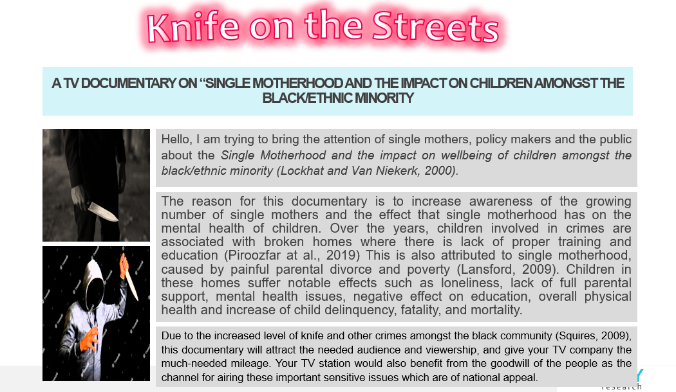

References
Lansford, J.E., 2009. Parental divorce and children's adjustment. Perspectives on psychological science, 4(2), pp.140-152.
Lockhat, R. and Van Niekerk, A., 2000. South African children: A history of adversity, violence and trauma. Ethnicity & Health, 5(3-4), pp.291-302.
Piroozfar, P., Farr, E.R., Aboagye-Nimo, E. and Osei-Berchie, J., 2019. Crime prevention in urban spaces through environmental design: A critical UK perspective. Cities, 95, p.102411.
Squires, P., 2009. The knife crime ‘epidemic’and British politics. British Politics, 4(1), pp.127-157.

