CLAUDIU PINDICI
Student ID: 2246687
Module name and code: ENTREPRENEURSHIP LCBB5001
Assignment title: Component 1: Written Report (Business Plan)
Lecturer’s name: Vasilios Tavlaridis
Table of Contents
Introduction 3
Overview of the business idea, product/s, and/or service/s 3
Legal format 4
Management of the company 5
SWOT analysis model 5
4Ps of marketing 7
Cash Flow Forecast 9
Conclusion 11
References 12

Introduction
The business plan is a document that provides strategies and financial forecasts and offers a comprehensive roadmap for new business growth and development (Allen et.al 2021). The present report is based on development of a business plan for a pet care spa business in the UK that will cover products, services, management, legal format, SWOT analysis, marketing mix, and cash flow forecast for new business. The business will operate with the new of Luxe pet care spa within UK.

Overview of the business idea, product/s, and/or service/s
The business idea will be a pet care spa in the UK that will offer a wide range of services and products. The business aims to offer holistic wellness and grooming experiences to pets, emphasizing both physical grooming and mental well-being. The name of the business will be 'Luxe Pet Spa’. The spa will provide several services tailored to increase the overall happiness and health of pets, making it the number one destination for pet owners prioritizing the care of furry friends. The services will include standard grooming, specialized grooming, wellness treatments, and spa packages (Zhang et.al 2022). The products will include retail products such as organic shampoos, supplements, and pet accessories. The consultancy and vaccination service from Pet Nutrition will also be given.
Further, emergency services will also be provided in critical conditions for pets. The services offered will be premium to offer better services to the customers. The business will also have memberships or subscriptions for clients regularly visiting the facility to groom their pets. Membership will include discounts and coupon codes to encourage loyalty. The delivery of subscription boxes for supplies of products of pets will be given if asked by the clients on a regular basis. Subscription boxes can aid a lot to the success of a pet care business (Zhang et.al 2022).
Across the UK, pet grooming services are increasing because people own pets and spend most of their income on pet grooming and clothing. It is estimated that people in the UK spend 10 billion pounds annually on their pet dogs, and around 58% of pet owners buy birthday and Christmas presents for their pets. The statistics also show that 52% of UK adults own a pet even though the prices of pets have increased majorly, and there is a crisis in the cost of living after the pandemic. Further, 3.3 billion pounds worth is determined in relation to the UK pet food market, bringing more chance of selling pet products by new business (Kerr, 2024). Such a hike in data brings effective opportunity for the Luxe Pet Spa.
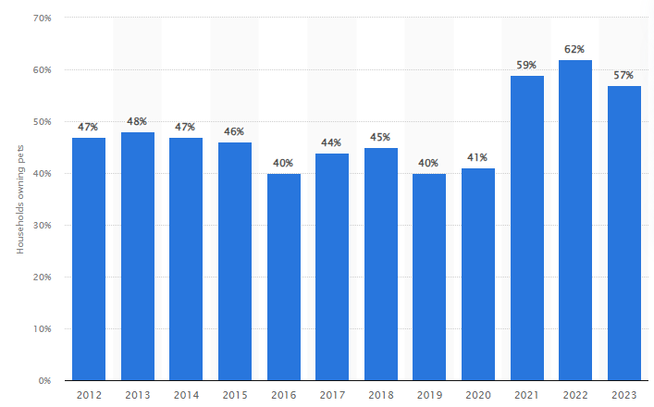
Figure 1: Share of households owning a pet in the United Kingdom
(Source: Statista, 2024)
The image above shows that 62% of households in the UK owned pets in 2022 and 57% in 2023 (Statista, 2024). Further, the industry is growing at a consistent rate, making the business idea attractive and profitable for the business entrepreneur.

Legal format
There are different legal structures that the new startup business can follow, which are sole trader, partnership, limited liability Company, and corporation. The pet care spa business will follow a sole trader legal format initially; the business starts with limited funds and resources. The other reasons for selecting this business are that it is easy to start and the business does not need to engage in high regulatory complications (Allen et.al 2021). This structure provides full control to the owner and provides flexibility in managing major financial risks in the business. The business will save on taxes charged at a high rate, as in the case of companies. The business's profits will be considered the owner's income, and tax will be charged accordingly.
For the owner of Luxe Pet Care, the financial management will also be easy as it will support keeping accurate records of expenses and income, and there will be a separate bank account for streamlining the finances. The owner is not required to take the formal registration, but it will be important for notifying the authorities for self-employment. Based on services like grooming and daycare, particular licenses will be required, like business operation permissions and pet grooming licenses, and also need to adhere to local legislation as well (Mayer, 2021). Further, sole traders will also take public liability insurance and employers' liability insurance if employees are hired.

Management of the company
Owner: As the business will operate under a sole trader, there will be a single owner responsible for managing the operationsbusiness's entire operations. The owner will offer personalized services to the clients on special days if they want, as the business that will be operated will not have any strict terms and conditions. The owner will have experience grooming pets and spa treatments and a love for pets, which will be seen in the business while treating pets. Effective management is essential and the owners are required to emphasize a lot on various areas (Zhang et.al 2022).
Employees: Being a small business, the owner will keep only one employee in the initial group with particular knowledge, skills, and experiences. The employee's role will be to bathe, clean, cut, and trim the nails of the pets while acting friendly (Muvhali and Singh, 2021). The employee will have experience working in the same business for at least two years. The employee will also need to keep the facility clean where the services will be offered. Interpersonal skills will also be included in the employee, and relevant industry standard salary will be offered.
External professionals/ experts: The business will look for one pet nutritionist and one veterinarian. Such experts offer medical advice, health checkups, emergency care, and vaccinations. They also offer nutritional diets and supplements to pets to ensure their health and wellness (Nicholas et.al2021). Such experts will be needed to ensure the safety and health of pets, establish business creditability, offer guidance on services in relation to health, and raise the wellness of the services.
Therefore, for sole traders, it will be important to have employees and experts to assure that new business will run smoothly in the future, considering every industry trend.

SWOT analysis model
Strengths  The business will offer unique service offerings that combine grooming, wellness treatment, training, and retail products to cater to customers' broad range of needs.  The business will focus on a niche market, as it will be focusing on pet care wellness and spa treatment, which is tapping into the growing market.  The business will offer a personalized customer experience by providing tailored services and developing strong relationships with pets and clients. Personalized services can aid a lot in attraction and retention of clients (Muvhali and Singh, 2021).  The business will have qualified staff who are skilled and knowledgeable, increasing client trust and service quality for pets. | Weaknesses  The business will have high operating costs, which will include expenses related to employee salary, equipment, and facilities, which will influence the profits of the business.  The business will be dependent on the local market, as its revenue will be highly based on local clientele, which will further be impacted by local economic conditions.  The business will also be impacted by seasonality, as it will experience fluctuations depending on holidays or seasons, which will impact the flow of cash.  Luxe Pet Spa will have limited market awareness as the business will be new. Brand recognition will be slow initially, requiring useful marketing strategies.
Opportunities  The increase in pet ownership in the UK, especially in urban areas, will drive the demand for pet care services and create new businesses.  The business will also seek partnerships and collaborations with well-known pet stores, veterinarians, and animal shelters to ensure cross-promotions (Zhang et.al 2022).  The business will consider an online website and e-commerce platform for selling its pet products. With the use of an online website, regular or new clients will make bookings or look for consultancy time whenever required.  The business will also consistently follow trends in pet wellness, as raising awareness of pet wellness develops opportunities for spa and grooming services. | Threats  The business will face stiff competition, as the number of pet care businesses has consistently increased, which might result in tough competition within the local market.  Luxe Pet Spa will also face economic downturns in the UK economy, which will influence its revenue and sales as people will consider such services discretionary (Jueprasith, 2023).  The business will face challenges related to regulatory changes, as changes in regulation regarding pet care, safety, and health might raise its operational costs in the future.  There will also be a threat of change in consumer preferences, as evolving pet-care trends might need consistent adaptation to meet clients' new expectations.

Based on the above analysis, Luxe Pet Spa will need to leverage strengths and opportunities while identifying weaknesses and threats to ensure sustainable success and growth in the competitive pet care industry of the UK.

4Ps of marketing
Product and services refers to the goods or services the business will market. The business will offer services that include grooming services (bathing, cutting, and de-shedding), pet training and behaviour services, and wellness treatment (hydrotherapy, aromatherapy, and massages). The products will include health supplements, organic shampoos, and pet accessories (Nicholas et.al 2021). The reason for offering products and services is important as the market for pet products is increasing continuously.
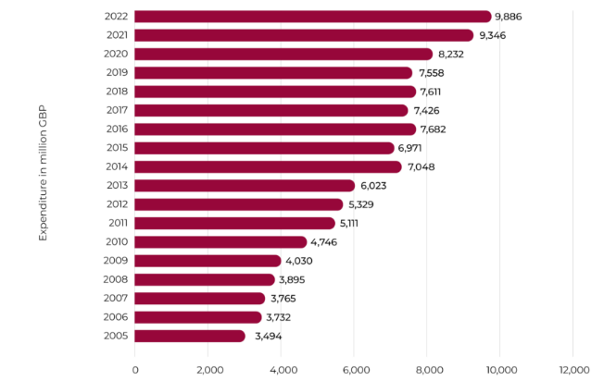
Figure 2: Consumer spending on pets and other products in the UK
(Source: Martyn, 2024)
The above image shows that in 2022, the expenditure carried out was 9,886 million pounds for pet care products (Martyn, 2024). Further, veterinary and pet services amount to 5.3 billion pounds in 2020, making it important for Luxe Pet Spa to offer such products and services for pets in addition to spa and grooming services.
Price: It means the cost of the product or services that the business will charge. The business will charge prices on the basis of a competitive pricing strategy for grooming services as there is high competition in the UK pet grooming industry (Ali and Anwar, 2021). However, premium pricing will be charged for wellness treatment and luxury packages for pets. Apart from this, the business will also offer discounts and loyalty coupons to members or subscribed clients.
Place: This refers to the location where the product or service will be given to the customers. The location will be London City as it is highly populated and recognised as an urbanised area with high pet ownership. The distribution channels will include direct service delivery at the facility, with potential for mobile grooming service. An online booking system will also be presented to enhance customer convenience.
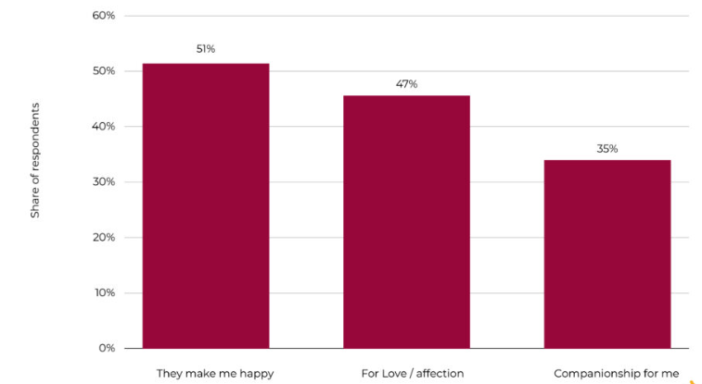
Figure 3: Reasons people get dogs in the UK
(Source: Martyn, 2024)
Further, the above graph shows that 51% of people in the UK get dogs because they make them happy (Martyn, 2024). This means dogs are popular pets, creating major demands for local pet services for care and grooming.
Promotions: This refers to how the business will advertise its products or services. The business will use social media marketing heavily, as it is the most popular medium used by people to search for anything or post about their happiness. Such marketing will be conducted by regularly posting pictures of pets before and after grooming sessions.
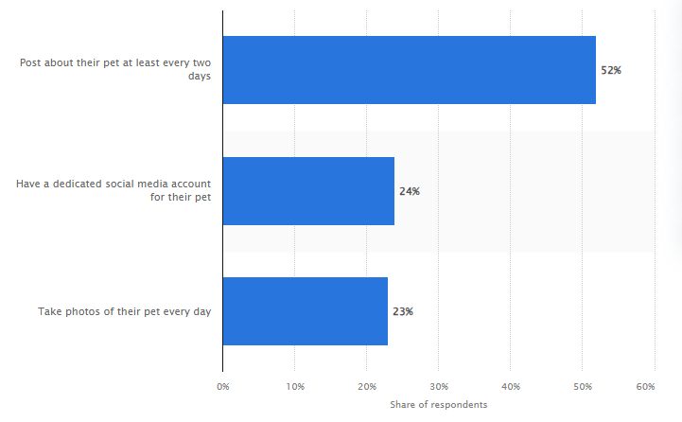
Figure 4: Share of pet owners in the United Kingdom sharing posts on social media
(Source: Statista, 2024)
Based on the above graph, 52% of pet owners share their pet pictures on social media at least every two days (Statista, 2024). This shows their happiness and love for pets, which will create demand for Luxe Pet Spa to promote products and services.

Cash Flow forecast
12-Month Cash Flow Forecast
for Luxe Pet Spa
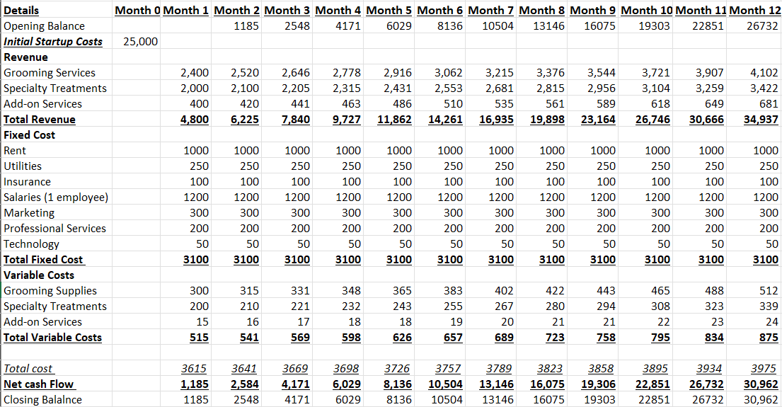
Figure 5: 12-Month Cash Flow Forecast
(Source: Created by author)
Notes:
Initial Startup Costs: These are one-time expenses necessary to launch the business, which will be deducted from the startup funding of £25,000.
Initial Startup Costs | Amount
Renovation/Shop Setup | 8,000
Equipment (grooming tools, dryers, etc.) | 5,000
Furniture (tables, waiting area, etc.) | 2,500
Initial Inventory (shampoo, towels, products) | 2,000
Licensing/Permits | 500
Branding & Website Development | 3,200
Marketing (initial promotion) | 2,000
Professional Fees (legal, consultancy) | 800
Miscellaneous | 1000
Total Initial Costs | 25,000

Income (Revenue): Average price per service, assuming 30 customers per week initially, with 15 for grooming, 10 for treatments, and 5 for add-ons (Startup Donut, 2024)
- Grooming services: £40 per session
- Specialty treatments: £50 per session
- Add-ons: £20 per session
Expenditure
Fixed Costs:
- Rent: £1,000/month (for a small storefront location)
- Utilities (water, electricity, gas): £250/month
- Insurance (business, liability): £100/month
- Salaries: 1 employee (assistant): £1,200/month
- Marketing: £300/month (social media, local ads)
- Professional services (accountant, legal): £200/month
- Software/Technology: £50/month (booking system, POS)
Variable Costs (per service):
- Grooming supplies (shampoo, towels, etc.): £5 per session
- Specialty treatments (special products, oils): £10 per session
- Add-ons (food, equipment, etc.): £3 per session
Estimated increase of 5-10% in customer numbers each month as the business gains traction.

Conclusion
The report concluded by providing an understanding of the business plan for Luxe Pet Spa, which offers pet care and spa services. The plan discussed a sole trader legal format to be managed by the owner, staff, and external professionals. The systematic SWOT analysis and marketing mix have been carried out, along with a financial forecast of cash flow.

References
Ali, B.J. and Anwar, G., (2021). Marketing Strategy: Pricing strategies and its influence on consumer purchasing decision. Ali, BJ, & Anwar, G.(2021). Marketing Strategy: Pricing strategies and its influence on consumer purchasing decision. International journal of Rural Development, Environment and Health Research, 5(2), pp.26-39.
Allen, W.T., Kraakman, R. and Khanna, V.S., (2021). Commentaries and cases on the law of business organization. Aspen Publishing.
Jueprasith, S., (2023). FACTORS THAT INFLUENCE PET PARENTS TOWARD USING PET GROOMING SERVICES (Doctoral dissertation, Mahidol University).
Kerr, K., (2024). 15 Surprising UK Pet Spending Statistics to Know in 2024.[Online]. Available through: <https://www.dogster.com/statistics/pet-spending-statistics-uk> [Accessed on: 5th October 2024].
Martyn, M., (2024). How Many Dogs & Cats Are in the UK? 2024 Pet Ownership Statistics UK. [Online]. Available through: <https://worldanimalfoundation.org/advocate/pet-ownership-statistics-uk/ > [Accessed on: 5th October 2024].
Mayer, C., (2021). The future of the corporation and the economics of purpose. Journal of Management Studies, 58(3), pp.887-901.
Muvhali, M. and Singh, T.S., (2021). Pet groomers' occupational exposures: an under-researched group of workers in a growing pet-care industry. Current Allergy & Clinical Immunology, 34(2), pp.87-95.
Nicholas, J.C., Ackerman, L., Wasche, L., Weinstein, P., Burns, K.M., Russo, S., Dicks, M.R., McGaunn, M.J. and Block, G., (2021). Practice Management Considerations. Pet‐Specific Care for the Veterinary Team, pp.773-855.
Startup Donut, (2024). How to start up a pet grooming business. [Online]. Available Through:<https://www.startupdonut.co.uk/start-up-business-ideas/types-of-business/how-to-start-up-a-pet-grooming-business> [Accessed on: 5th October 2024].
Statista, (2024). Share of households owning a pet in the United Kingdom (UK) from 2012 to 2023*. [Online]. Available through: <https://www.statista.com/statistics/308235/estimated-pet-ownership-in-the-united-kingdom-uk/> [Accessed on: 5th October 2024].
Statista, (2024). Share of pet owners in the United Kingdom (UK) who post about their pet on social media in 2023. [Online]. Available through: <https://www.statista.com/statistics/1424011/uk-pet-social-media-account/#:~:text=According%20to%20a%20survey%20conducted,their%20pampered%20pets%20every%20day.> [Accessed on: 5th October 2024].
Zhang, W., Cao, H. and Lin, L., (2022, March). Analysis of the future development trend of the pet industry. In 2022 7th International Conference on Financial Innovation and Economic Development (ICFIED 2022) (pp. 1682-1689). Atlantis Press.

