

Smart Home Network Security Optimised Requirements.

by
Bright Nyakamha

Supervisor: Dr Kapilan Radhakrishnan

Project submitted as part of the requirements for the award of
BSc (Hons) Computing Networks & Cyber Security

April 2021

Project title | Building a Secure Smart Home Network
Project type | Experiment
Description:
Most part of UK has broadband coverage and millions of home users are connected to Internet via ISPs. How secure are today’s home network? The main aim of this project is to analyse the existing security measures on Home network and recommend steps or new security measures for Smart Home Network.

1.2 Research Aims and Objectives

AIM
To identify home/small office home office network security vulnerabilities and how to secure them to Enterprise standards.

Objectives
- To gain and develop understanding and knowledge in Network security
- To gain insight and understanding of securing network security and vulnerabilities
- To determine the best practise methods in securing Home Network
- To utilise implement information gained in to create a secure Home Network
.

ABSTRACT

The advancement in technology of IoT and automation is pinned on the baseline technology of Internet connectivity that utilises different networking protocols. The impetus adoption of wireless communication protocols has been equalled with an increase data theft, critical in maintenance of seamless connectivity and security is application of safeguarding standards that ensure security within in the Smart Home . In the operations of Smart homes therein lay security vulnerabilities that present attack surfaces for nefarious activities, through understanding, learning and identification the present existent vulnerabilities within hardware, wireless protocols, and encryption standards a baseline bench marking can be developed to determine solutions that make the Smart Home secure to mitigate against perceived threats. The use and application of Virtual machines provides a sandboxed lab environment to test that effectiveness of known protocols can be tested without compromise to the live environment. It is important and imperative for the Network supply chain of ISPs, Hardware manufacture and the end-user to endear themselves to threats that exist and apply a common framework necessary in the provision of a safe operatable environment as the best solution is reliance on all partakers fulfilling part of their obligation.
The feasibility in the application of standardised security framework in a Smart Home faces challenges, due to a mixture of variables such as the choice of hardware, end-user knowledge ,application of security, patching schedule, and the number of devices within a network. All is not doom and gloom though, as mitigation steps can be implemented and applied that harden the Smart Home security infrastructure with the basic being implementation of SMNP on home networks that take stock of network nodes and can trigger intrusion detection and prevention. The market has available SNMPs software products that are capable of patching deployment of attached nodes to a network. The hardware inclusion in home networks has security challenges that emanate from replica products that deliver service but undercut the consumer on security. The Smart Home network security is as good as the devices attached to it and protocols used . There need for the decommissioning from networks legacy devices reliant on relegated Wireless encryption protocols.

Glossary
AES- Advanced Encryption Standard
BSSID- Basic Service Set Identifier
CCMP- Counter Mode Block Chaining Message Authentication Code Protocol

EAP- Extensible Authentication Protocol

GRE- Generic Routing Encapsulation

ICV- Integrity Check Value

IETF- International Engineering Task Force

IoT- Internet of Things

MUD- Manufaturer Usage Description

NIST- National Institute of Standards & Technology

PNAC- Port Network Access Control

PSK- Pre-shared Key Protocol
RFMON- Radio Frequency Monitoring
SAE- Simultaneous Authentication of Equals
SSID- Service Set Identifier
SSL- Secure Socket Layer
SOHO- Small Office Home Office

TKIP- Temporary Key Integrity Protocol
VLAN- Virtual Local Area Network
QoE- Quality of Experience
QoS- Quality of Service
VPN- Virtual Private Network
WEP- Wired Equivalent Protocol

WLAN- Wireless Local Area Network
WPA- Wi-Fi Protected Access Protocol

ACKNOWLEGMENTS
Learning is a continuous process and knowledge is a cumulative collective effort that is sustained through dedicated academics that thrive to foster and encourage critical thinking from their students. I would like to express my sincere gratitude to DR Kapilan Radhakrishnan, my academic supervisor for the guidance in compilation of my project, and his tremendous contribution in mentoring, academic guidance, and professional support through my academic journey at UWTSD from first year. I would want to express utmost gratitude DR Nitheesh Kaliyamurthy who have equipped with necessary and knowledge and appreciation in virtualisation concept and operation environment . Finally, I wish to thank my wife Anne for support, motivation, and encouragement through the many hours of working through my project, whilst she catered for the family.

Table of Contents
ABSTRACT 3
Glossary 5
ACKNOWLEGMENTS 6
Chapter 1 8
1.0 Introduction and Background 8
Chapter 2 13
Literature Review 13
Introduction 13
2.1Standard Security Structure 15
2.2 Hardware Patching and Firmware Update 16
2.2 Wireless Encryption and Ciphers 17
WEP Protocol- 19
WPA 20
WPA 2 20
WPA 3 22
2.3 End-user Security Knowledge 22
Related Work Literature Review 26
Home Network Security 26
eMUD: Enhanced Manufacturer Usage Description for IoT Botnets Prevention on Home Wi-Fi routers 27
Securing a Connected Home 28
Authentication for wireless home network 29
War Driving and WLAN security Issues-Attacks, Security Design and Remedies 30
Chapter 3 33
3.1Research Methodology 33
3.2 Research Dissection 33
3.3Research Philosophy 34
3.4Research approach 34
3.5 Research Strategy- 35
3.5.1Methods 35
3.5.2Resources 35
3.6 Research Choice 36
3.7 Time Horizon 36
3.8 Data Collection and Analysis 37
3.9 Limitations 38
3.10 Risk 38
Chapter 4 40
Design and Implementation 40
4.1 Introduction 40
4.2 Problem formulation 40
4.3Design 41
4.4 Implementation 42
Chapter 5 Results 47
5.1 Results 47
5.2 Evaluation 47
Chapter 6 50
6.1 Conclusion 50
6.2 Recommendations 50
7.0 Introduction 52
7.1 Barriers Encountered 52
7.2 Positives 52
7.3 Guidance to Future Students 53
7.4 Summary 53
Chapter 8 Reference 54
Chapter 9 Appendix 57

Chapter 1

1.0 Introduction and Background
The ubiquity in efficient home broadband delivery in the United Kingdom has accelerated through the inception of the Government programme Build Digital UK (BDUK) in 2013. In 1998 9% of households had internet access and by 2017 the figure had increased to 90%. [1]The current market projection and indicators anticipate that by 2040 each household to have at least 1 smart device. Cognisant of the transformation that has already being registered in the broadband sector, the need for security in home network has increased more than ever. The UK Government has invested an estimated £200 million towards rural fibre connectivity with a target to achieve full fibre broadband network by 2033[2] There are however noted barriers that may be a hinderance to Smart Home adoption, these include security and consumer data privacy. The incremented dependency on IoT needs a matched growth in enhanced Smart home network security to counteract against breaches.
The security vulnerabilities the exist within the IoT devices has led the consented effort by the UK government to push for changes and promulgate into law certain security guarantee by suppliers at the point of sale through the Department for Digital, Culture, Media and Sport[3]. There has been a registered increment in ownership of smart and connected IoT devices amongst the UKs public, with 49 % of the UK consumers having purchased a smart device since Covid pandemic outbreak [4].Proposal of new cyber laws being put in motion to protect the public against product hardware security flaws. As a requirement supplier need to divulge information regards security patching and software update at POS. To be included are mobile phones as a response to public input that established a 1/3 of consumers keep mobile phones for 4 years yet providers offer security updates only over a period 2 years.[4]
In 2019 a major scandal that exposed vulnerabilities as Google and Amazon came under the spotlight for Alexa and Home devices that were able to record conversations and employees having access to listen in [5]The adoption and progression towards Smart homes requires matched security elasticity in the limitation to attack exposure. The outbreak of Corona Virus (Covid-19) required improvised solutions to keep the Global economies and wheels of production in motion. The paradigm shift in the discharge of Commercial and Enterprise business due to Covid-19 has turned homes into hub centres, that require significant investment in security. In matching the current and expected changes in home broadband use, there is need to improve the in home network security to the equivalence of Enterprise security, to ensure Confidentiality, Integrity and Availability (C.I.A).
The progression in Wi-Fi generations to the current Wi-Fi 6 (802.11ax) with maximum link rates of 600-9608 Mbit/swill increase the WLAN operational efficiency and capability of handling and incorporating IoT device pool through data encoding and resultant higher throughput.[6] The noted improvements will however increase the network exposure to breach in security through incrementing the possible attack vectors and platform. The Covid pandemic necessitated paradigm shift in work patterns to maintain and sustain productivity over lockdown periods. The adaptation of working from home concept operates efficiently with a secure home network there is therefore for an assessment of the security challenges in the seamless delivery of working from home concept against the backdrop of potential cybercrime activities
The changes brought about as a temporary scalability measures of allowing employees to work from home during Covid-19 lockdown has indication of changing the working culture of many Enterprise entities. The upsurge in remote working requires a holistic approach in ensuring compact home network security to match the growth of IoT devices and remote employment against the unprecedented rise in Cybercrime. Data is the biggest mine field for Cybercriminals and its manipulation can be detrimental to the continual operation of entities and individuals. The identification of Home Network security weaknesses and solution provision would have saved the British consumer from losses amounting to an estimated £4.6bn in 2018[7], [8]The cumulative cost incurred from insecure home networks is more than just financial, as it can be traumatic with victims suffering emotional stress, relationship breakdowns that may need the involvement of institutes such as National Health services (NHS) in managing patients mental challenges attributable to security breach such as identity fraud related activities.
The CIA Triad is a venerable model in security that is used in the policy formulation and the identification of any areas of weakness and the remediation procedures to such. Confidentiality operates on a need-to-know bases, thus the provision and defining clear access levels of information. Integrity is there to guarantee the non-alteration of data by any unauthorised party, as once alteration occurs the meaning and content of the application changes. Availability, it is availing data to the user as and when needed through ensuring system scalability.[9] The major Global challenge is to scale up home broadband security to levels acceptable by Enterprises, so that systems and sensitive information is not compromised. Secure remote sites allow continuity and flexibility in formulation of work patterns. Enterprises can also reliably utilise remote networks with confidence, in circumstances such as phases of National lockdowns.
QoS and QoE are the fundamental elements to a WLAN that can only be augmented through a reliant and secure network . It is therefore imperative to have secure network that is designed to identify and prevent potential security breach . The area of Home network security is a wide topic and area where research has been and must be undertaken to identify the inexhaustive areas of security vulnerabilities to match the continual growth and complexity .

Chapter 2

Literature Review

Introduction
Network security is a necessity in the protection of sensitive and confidential data from being accessed by any unauthorised party. Home network security entails the protection of the connected network devices that would include the router, computers, smartphones, and other Wi-Fi enabled devices[10] There are however challenges in achieving secure and risk-free network operating environments, as there exist an inexhaustive pool of hurdles especially in the securing of Home network. The challenges include but not limited to cost, user knowledge, product firmware and wireless encryption standards.
The phenomenal dynamic transition that has been registered in the Internet service provision and availability, has seen a major transformation in the traditional Home setup, with a more robust device and gadget interaction being a notable smart home feature. The major hinderance in the erection of secure systems in Smart home IoT networks is financial limitations as they operate on a shoe-string budgets [4]. Security is an expensive investment, though the expenses that arise from a breach occurrence may ultimately outweigh the investment. Whilst it is prudent to be proactive in securing home networks, most Small home network principals tend to be reactive, as the cost and knowledge can be prohibitive factor[11]. In their research in the Study of Wireless Network security Dr Yogesh Kumar etal they highlighted the vulnerabilities associated with wireless security and how to mitigate 11 of the concerns and improve efficiency through addressing the known security issues.
The intensity in the pace of emerging technology for the home has seen it being matched with a delivery of faster broadband in the UK, with delivery of Ultrafast broadband possible to an estimated 53% of the UK homes and full fibre broadband to 10% of the homes as of 2019.[2] The noted omnipresence of higher broadband download and upload speeds has seen the emergence of more SOHO and Smart homes due to availability of sustainable broadband speeds. A Smart home is a home that is equipped with interconnected devices and gadgets that can perform automated task normally done by humans. A SOHO being a small Local Area Network(LAN)with a support capacity of between 1-10 people[12].
In a quest to achieve and maintain efficiency and excellency, a database is maintained and catalogued for known vulnerabilities which enhances efficiency in the remediation of any known catalogued vulnerabilities. Critical in the achieving of objectives of secure home network, is the utilisation of filter-based analytics framework that can be utilised in capturing persistent attacks on network setup and establish a correlation with known CVEs and distributed attacks on home network infrastructure. The network security resolutions tasks are a continual process as there is a sustained challenge to deal with the ever-emerging attack vectors in the network/systems.

2.1Standard Security Structure
A WLAN security structure should be designed to support 5 parts of an open and full-scale security model as a prerequisite to minimise attack on a network. As a basic requirement the home network administrators should configure the 5 parts to encompass and meet the demand requirements of the clients registered to the network. It is ideal to create a facade of an indestructible network to deter cyber criminals.

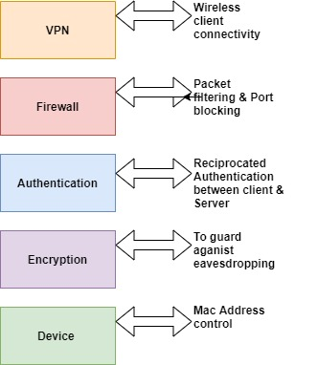
Fig 1: 5 Part WLAN Support Security Structure

VPN -is an important aspect in security as it secures the tunnelled data through encryption. The AES encryption protocol is the standard that is used in VPNs. Most internet protocols such as LDAPS and SSH would by default have in-built encryption and using them over VPN connection would be an incremental extra layer of security. To enable functionality of routing protocols GRE are inbuilt in VPNs[13]
Firewall-A necessity in the monitoring and control of incoming and outgoing traffic and can be applied in both software and hardware form or as a combination of both. The myriad threats of hacking and malware emanate from external network and a Firewall can be applied and configured to packet filter and block on IP address chain[14]
Authentication-In a WLAN network setup, EAP as a method of authentication in connecting authenticated wireless clients involving WPA setup and WEP has primarily 2 methods of authentication, thus Open System authentication and the shared key Authentication [15]
Encryption-This is a beneficial alteration of information that is broadcast through network communications to make it complicated and harden the task of cybercriminals to understand and deduct any useful information through eavesdropping.[16]
Device -The wireless clients can be managed and administered through device MAC address data that is maintained with the router such as an EAS for enterprise networks.[14]

2.2 Hardware Patching and Firmware Update
Misconfigured devices and inbuilt apps can be manipulated and used as an easy exploit in the launching of an attack on a network. Networking is the communication of inter-connected devices using network protocols that govern the exchange of information securely. The security of a network is reliant on the hardware and software rudimental security updates and features, that include the patching and firmware update.
Fundamentally, stability and security of SOHO/Smart home network is heavily dependent on the quality and reliability of the firmware release of devices contained within the network(Pappa, Ma, Butttyan 2015). Technology is dynamic and ever evolving, hence new threats constantly emerge with new vulnerabilities being exposed by tech security experts, cyber criminals, and ordinary enthusiast. Manufacturers have an obligation to ensure their network hardware and software duly operate updated firmware that is not flawed with vulnerabilities that would duly expose end-user to threat exploits[12].
The virgin media home broadband routers Super Hub 2 and Super Hub 2AC both Netgear brands were discovered to have a major security flaw in 2017, the vulnerability laid within the backup configuration for port forwarding and dynamic DNS setting for any future restoration, though encryption was provisioned, but the key was discovered to be the same for all hubs[17]. This loophole was identified as a potential exploitation point for attackers, equipped with an administrative access they could manipulate the configuration file and allow remote access[6]. The broadband accessories and kit provisioned by Internet Service Providers(ISPs) at times just comes with bear minimum security that leaves the user compromised and very vulnerable to cyber-attacks.
Inherently add on service and feature sets such as NetBIOS, FTP, Universal Plug and play that are embedded within the routers are gateway platform for attackers to gain a foothold on victim’s network. As home routers provide a dual service of firewall security and routing, they are on average the first and last line of defence from attack[8]The feature sets are tribulations of an expanded attack surface with mobile phones rich feature sets, having a documented expansion on the attack surface evident with Bluetooth8, NFC7 SMS 6.[17]

2.2 Wireless Encryption and Ciphers

A wireless connection can either be indoor out outdoors. Wireless network is a network that comprises of an interconnection of devices that can communicate and share information via a wireless connection (Wi-Fi) [18]thus the network operates without the use and utilisation of cables. Wireless network is the main thrust in the operation and implementation of smart technology, with its greatest unique selling point being user mobility and stable connectivity guarantee within a set network. The reliability of WLAN relies heavily on a secure operational platform that encrypts the wireless connections, since data is transmitted over radio waves it susceptible to interception and eavesdrop. The major fault line and deficiency with Wi-Fi from inception has been the lack of inbuilt security privacy on open public networks and encryption, making it susceptible to attack from different forms of vectors by anyone with the right tools.

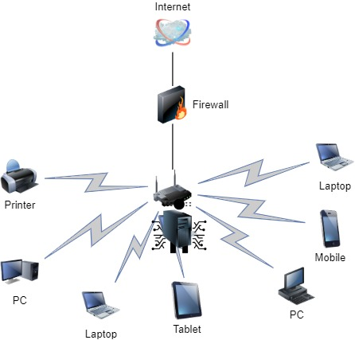
Fig 2: Indoor Wireless Router Connection
Encryption is a method that transforms and converts plaintext or any kind of data from readable into ciphertext or an encoded version of that data (Wilkins 2011). The encryption of data is for preventing eavesdropping through ensuring the CIA tirade is upheld. The smart and IoT technology in SOHO networks is heavily reliant on wireless technology and most has evolved to Wireless Local Area Networks(WLAN) utilising the 802.11 standard Wi-Fi specification standards protocol as opposed to IEEE 802.3 standard specification for Ethernet[19]. Wireless network security is a combination of authentication, encryption, and authorisation. Embedded in the wireless security are the standard ciphers that are coded based on mathematical algorithms with set parameters for performing encryption and decryption. There has been a generational development of Wi-Fi standard encryption protocols and notably the Standard wireless encryption protocols are WEP, WPA, WPA II and WPA III[20].
There are generally three categories of Authentication that include Password (what you know) token or certificate(what you have) and biometrics( what you are) . In SOHO networks to have an authentication process that covers all these categories is challenging and not feasible due to the nature of network architecture setup and an array of varied technical reasons that includes the lack of an appointed network administrators in Home Networks. These challenges leaves password being the main choice of preference in the accessing of network connectivity. Password’s authentication to access the network is an important part in securing a SOHO network, it is prudent to have the right and correct level of encryption[6] WEP encryption standard has/ had many security flaws as evident with the large-scale cyber-attack on T.J.Maxx in 2009 which brought to the fore vulnerabilities with the encryption standard.

WEP Protocol-
The primary goal is attaining a secure wireless network to the standards of Ethernet wired network and protect and keep data integrity. WEP is part of the 802.11 standard with a privacy key of 40 to 104 bits. Predominantly WEP uses 2 shared keys that are Unicast Session Key an encryption key used to protect unicast traffic between a wireless AP and wireless client, there is a single sender and receiver. Multicast Key – also referred to as global key, it is primarily designed to protect broadcast and multicast traffic from a single AP and all the wireless clients connected in that network. In active WLAN each 802.11 packet is separately encrypted, with RC4 cipher stream being generated through a 64-bit RC4 key. The WEP key length can either be a 64 bit or 128 bits, with the IV being part of the bit length and accounting for 24 bits in either a 64 bit or 128 bit key length. The IV is attached to the Cipher text as plain text [20]

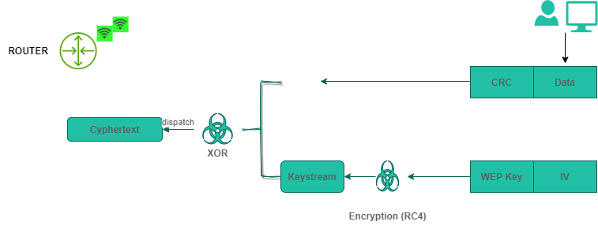
Fig 3:WEP Process

WPA
Protocol-is a development of Wi-Fi alliance for better “authentication” and was ratified in 2004. The evident security flaws with WEP required a secure alternate, with WPA was the solution a protocolThe standard encryption method being TKIP with validation parameters that encompass a re-keying mechanism, message integrity check , extended initialisation vector and a per packet mixing function. In TKIP an invalid MAC can be a trigger to a rekeying of the session, with intrusion attempts being countered through the invalidation of the key the attacker will be attempting to crack with enterprise mode WAP-EAP using a stringent 802.1x authentication that is dependent on central authentication sever for individual user authentication. The personal mode WPA-PSK is to enable the easy management and implementation of SOHO and home networks, allowing users to enter password for AP connectivity which activates the authentication process and TKIP authentication. Users have an option of either utilising a maximum security and compatibility, but it requires user knowledge and hardware that is built to supports the full package of Temporal Key Integrity Protocol Standard.

WPA 2

It uses CCMP as an authentication protocol based on AES algorithm as a provision of integrity and authentication and with TKIP dormant and embedded in the protocol standard. Inclusion of TKIP in WPA provides a fallback system and an allowance for interoperability with “legacy” devices incompatible with WPA 2 authentication protocol. AES or Rijndael is an encryption standard that was formulated by NIST for electronic data encryption with 3 block ciphers consisting of AES-128, AES-192 and AE -256 bit and key lengths of 128, 192 and 265 bits. AES is a symmetric clock cipher and therefore utilises the same key to both encrypt and decrypt[20]

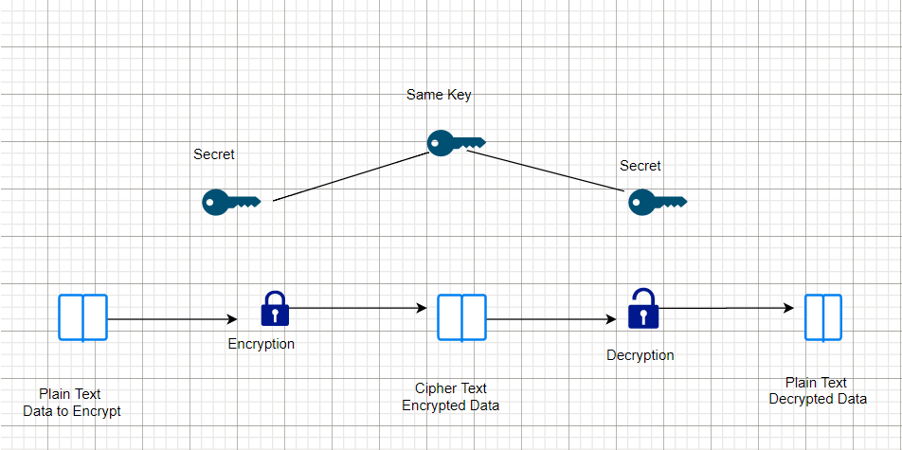

Fig 4: Symmetric Key Encryption illustration

The AES -256 with a key length of 256 bit is practically challenging to break and hack using brute force as it supports quite a large bit size that makes it a strong encryption standard.

Key Size | Possible Combination
1 bit | 2
2 bits | 4
4 bits | 16
8 bits | 256
16 bits | 65536
32 bits | 4.2 *10⁹
56 bits DES | 7.2 *10¹⁶
64 bits | 1.8 *10¹⁹
128 bits AES | 3.4 *10³⁸
192 bits AES | 6.2 *10⁵⁷
256 bits AES | 1.1 *10⁷⁷

Fig 4: A table illustration of Key Size and Combinations

WPA 3
A 2018 inception and improvement from WPA/WPA2 replacing the PSK authentication method with SAE. Still in its infancy and not yet a mandatory for Wi-Fi Alliance certification and as such there is limited device compatibility with the WPA3 protocol.
Wireless signal strength should be configured not to propagate beyond the confines of the SOHO network service users, as a preventative measure against eavesdropping susceptibly. An effective method is dependent on the use of ids and the automatic disablement of Wi-fi in periods of idleness as it minimises the risk of attack

2.3 End-user Security Knowledge
The home broadband router is a considered cash cow for hackers, as once plugged-in during connection by the ISP rarely do the consumers do an assessment of their home routers and overtime they are left without the necessary firmware and security updates and making them more susceptible to exploitation and malware. There are extremities in security compromise ,besides identity theft, they can be used to generate fake traffic as a decoy of illegal online activities happening on a different site.[7] It should be a matter of national interest for Government, ISPs and business Enterprise to raise awareness with the public on the importance of adhering to basic security protocols necessary in the protection of their home network.
Cyber hygiene is key in the maintenance of secure home broadband network , however the lack of security appreciation and knowledge leaves end user heavily exposed and tilting the odds in favour of threat actors. The initial steps of security enhancement are normally neglected by end user which are necessary precautionary steps against security threats, these include simple security sanity steps such as changing of username and password, the standard secure password requirement of a 15-character password that is inclusive of number and letters and should neither be a dictionary name
The literature and technical jargon terms contained within router product manual is tedious and confusing to most end-users hence creating a significant burden in their quest for resolution and interpretation of graphical tabulations and technical terms[17]. Due to bureaucratic and penalty charges imposed on customer by service providers, end-users are forced to solicit advise from non-bona fide retail outlets and computer technicians to fill the knowledge gap.
A recommendation and auxiliary security measure that requires end-user technical knowledge to implement is the allocation of static IP address to devices on the network through disabling the DHCP . DHCP is prone to manipulation from hackers through Starvation and Spoofing attacks. Physical and Logical ports are an integral part in connectivity and protocol application of networking, but of importance is their disablement when not in use to minimise the attack vectors. Hackers thrive on obscure listening programs to manipulate programs and bypass set security to infiltrate networks. A discovery of embedded process within firmware of certain router models is kept open to listen to Port 32764[21]. SerComm is a router manufacturer that supplies hardware to Netgear, Linksys Cisco and Diamond and deliberately has 32764 port open for customer and product support purposes, however this port can be used as an /
Home network end-users should practise safe surfing and be conscious of program installations as some webpages are bombarded with installation pop up prompts of better and efficient running of a program. Unless certain, installation of unsolicited software can be risky with majority embedded with malware. The malware variants include Rootkits, these seek administrator access to a system and gaining rights to editing, deletion and modification[22]. Ransomware denies user access to critical systems and programs and threaten exposure or release of personal information unless payment is made. Adware is a malicious software that displays ads on a system which can put a strain on computer`s resources. Spyware is a software that spies on system or user with covert extraction of information from victim`s hard drive.
The security of a network should be a continuous process, feasible with a pragmatic approach and the standard requirement being use of an antivirus software. Due to limited knowledge and complexity in administering systems through implementation of automatic detection, removal and quarantining of malware, smarthomes end-users have an option of utilising and installation of a firewall on the network boundary that are purpose built to do the undertaking. Firewall traffic validation is critical in the prevention and detection of malicious software filtering a network, through utilisation of security enhancement hardware and software application features designed against indexed and catalogued CVEs[23]. The protection against any new threats such as polymorphic viruses would need pattern codes that are able to flush those type of threats, hence the importance and encouragement of end-user with limited security knowledge to be reliant on routers and firewalls with less need for user configuration.
For easiness of trouble shooting and problem prognosis, network connected devices such as routers and IoT devices have permissive default configurations. These configs are more customer service oriented than security,[24] and this increases the avenues of network security exploitation. An imperative recommended security measure is the disablement of remote management tool on routers as a guard against rogue remote configurations. In mitigating the attack surface of a Home network, routers and other devices are host to legacy software and services that create a security loopholes on the network environment. Considering emerging technology most devices are preinstalled with product life cycle software and applications “bloatware” and the standard recommended requirement is removal of dormant unutilised software and applications [25]
The concept of “work is an activity not a location” can be enhanced through utilisation of using SSL Secure Sockets Layer , IPsec and Multiprotocol Label Switching (MPLS) that allows transfer of data between nodes using short path labels to speed traffic flow based on IP Virtual Private Networks. Biometric authentication has increasingly become a recommended and trusted form of securing personal devices in a home network and other forms of security includes personal firewalls, intrusion detection and anti-virus software. The amalgamation and integration of these security protocols and applications is a guaranteed way that Enterprises eliminate or minimise security breach within their extended infrastructure that includes remote and home working[6].

Related Work Literature Review

Home Network Security

Hans Scholten , Hykle van Dijk etal. Secure and safe service usage are key elements in a Home and personal network. As there are no dedicated systems administrators to manage this networks admin and security and service is reliant on automated setup and applications. The use of automated service sacrifices security and privacy requirements[26]. The enhancement of home security through establishments of a mechanism that integrates service discovery and usage. The underlaying security concept being derived from the exchange of keys and certificate that are aggregated with service discovery and the encryption and authentication of services message
Security and protection privacy should be fundamental elements in the operation of service discovery feature in devices, but there is an element of neglect with embedded device protocols such UPnP and Bluetooth[27]. The service discovery can be secured protocols can be through application of Diffie-Hellman key exchange to encrypt exchange between service and user. The experiment the researchers undertook highlighted performance of security engine as the determinant of secure service discovery[28]
The research focused on the presentation of security mechanisms that seamlessly integrates with the device service discovery. The researchers concluded home network had become more vulnerable to external attacks because of weakness or none-existence of encryption protocols. They however recommended the use of Diffie-Hellman key exchange, security imprinting and security modules as a method of security enhancement through data authentication, device authentication and data confidentiality[26].

eMUD: Enhanced Manufacturer Usage Description for IoT Botnets Prevention on Home Wi-Fi routers

Syed Muhammad Sajjad etal 2020. DDoS causes disruption on the Internet service provision and IoT devices operability . The increase of in home IoT devices has increased the attack surfaces for attack vectors, as they are easy to exploit. The advent of the Mirai botnet source code has given threat actors an attack launch pad.
To standardise and maintain functionality, the IETF proposed RFC 8520 MUD with a goal to provide a means for end devices to signal to the network the type of access and network functionality required for them to function properly[29]. The researcher’s focal point was a study and evaluation of MUD and its limitations and architectural enhancement. There are known vulnerabilities that exist with home wi-fi routers, with open ports and weak passwords and inherent router firmware vulnerabilities and the home router is the inherent MUD controller and if compromised exposure of attached network devices becomes inevitable.
The researchers proposed a methodology application that adopts OWASP firmware testing technology for routers, with the identification and discovery of vulnerabilities[30]. The proposed mechanism centred on the elimination of vulnerabilities before creation of MUD profile to minimise the attack surface. Identified vulnerabilities should be patched if given a scoring of high or medium and with the identified vulnerabilities being shared with peers through blockchain smart contracts. A proposed mechanism of authentication for Device MUD profile and MDU server[31]
The research concluded IoT devices are compromised through default credentials to make them bots, with higher compromise on MDUs that had no vulnerability assessment. The attacks were 80% success on devices with unaugmented MDU risk profile and 2 % in devices with risk augmented MUD profiles. On enforcement of MUD profile an attack rate of 3 % was achieved and 97% attack success rate was achieved on IoT devices with profiles not enforced.[30]
The researcher’s advocacy was under pinned on a collaborative mitigation strategy formulated The Research concluded security is compacted and enhanced in MUD profile enforcement through the use of the home firewall, and the proposed mechanism of authentication of device MUD profile and MUD file generator. In furthering the home network security hardening they researchers recommended blockchain patching distribution to counter firmware vulnerabilities[30]

Securing a Connected Home

A Campbell etal. The Smart home has become a device heterogeny environment sustained through automation and features reliant on wireless connectivity, voice recognition and machine learning. There is need for scalability in a smarthome network as the network architecture must continuously co-opt smart devices. Devices that were previously designed with a single functionality can now perform the core function and the add on functions through the advent of virtual assistance designs of Tech giants such as Amazon and Google. A smart home appliance such as a refrigerator can be used to set reminders of items that need replenishments, present the homeowner with weather forecast as add on to core function of food preservation.
The pace and incremented addition of IoT devices in the smart home has not been entirely matched, with the security neglected to being an afterthought issue and product functionality taking precedence. Remediation on the security flaws becomes reliant on patching, which may cause PII security breach. Patching and update needs device owner approval and essential knowledge to administer ,and without it leaves their home network exposed. A compromise of an IoT device can be an attacker’s backdoor entrance to a home network[23]
The researcher proposed an insertion of a dual-purpose device that has IPS or IDS capabilities with a discovery wireless radio communication setup. The device will be controlled through a mobile app that shows device home network infrastructure and statistics of bandwidth usage. Notification of malicious activity can be flagged through the app and with access control capabilities on IoT devices on the network. Rather than use anomaly based and signature-based IDS as breach indicators, a combination of both would be required and baseline bench marking created for major devices on the network.
The hybrid application of network monitoring provides flexibility in the management of IoT devices on a network, but however the only limitation is the compatibility issue, with limitations to application setup to a network with a Router and Modem.

Authentication for wireless home network

Stéphane Onno etal 2012, The panacea to enhancement of Home network security lies within the application and use of 802.1X network authentication protocol standard. IEEE802.1X is a PNAC control standard that provisions for secure network access. 802.1X is an Enterprise standard that utilises a RADIUS server of network user authentication, with an allowance of unique credentials per user and eliminating reliance on single network password that can be compromised. The adoption of WPA2–802.1X user-based authentication in home networks would mitigate the authentication security inadequacies.
The user behaviour and knowledge were identified as important in the application of network security safeguarding standards. The PSK is shared with guest and family besides being visible behind the network gateway. The challenge lies in the PSK being registered on a number of mobile devices. WPA 2 is susceptible to passive sniffing of traffic from another connected device and MAC-address spoofing. Establishment of rogue access points through WSC a feature that increases security risks.
The researchers proposed a user-based authentication, thus establishing secure authentication on user basis derived from credentials strength and renewal. Scalability and robustness would be attained from implementation and use of WPA2-802.1X that provide self-registration to home users. The proposed security operation flow is a deviation from WPA2-PSK to WPA-802 per session key system, with admin retaining a granular access allocation for finer network monitoring. WPA2-802.1x authentication will rely on dedicated server certificate. To guard against ARP cache poisoning, passive sniffing WPA2-802.1x tallies device MAC address and user identity and apply device specific encryption. This allows easier detection and prevention of network anomalies
The solution involves embedding of a FreeRadius authentication server within the home router that utilises PEAP authentication method, to allow mutual authentication reliant on server certificate and client credentials. Included is a web portal to direct unregistered users to an applet powered by SUIX for registration

War Driving and WLAN security Issues-Attacks, Security Design and Remedies
Biju Isssac and Lawan A 04,2007 The rapid advancement of mobility computing reliant on WLAN to sustain emerging technology created the need for robustness in security approach as the fuzzy boundaries made it easy for the interception of radio signals. The expansion of network coverage through utilisation of Wireless protocols such as WEP, that has been identified as having security flaws embedded within the encryption algorithm RC4
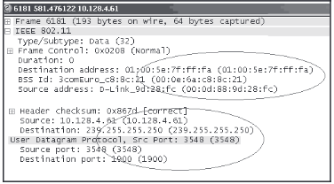
Fig:5
The researchers conducted a war drive experiment capturing packets using Netstumbler software for wireless network detection and Link Ferret. They identified networks in operation without encryption that included enterprise institutes. Critical information captured included BSSID, SSID, source and destination node of IP addresses, IV, checksum details and node open ports all that can be weaponised to launch a DoS attack. The researchers managed to crack the WEP key using Aircrack.
The researchers noted other flaws and vulnerabilities present in wireless networks that included APs with default admin passwords and protocol standards that were available on vendor user manuals. DoS attacks and session hijacks manipulation of 802.11 MAC deigned for a shared channel for multiple networks through de-authentication request, rogue APs, repeated transmission of RTS/CTS frames to jam the network. The other forms of susceptibilities identified within WLANs included ARP poisoning using Cain & Abel software, OS weakness in SNMP protocol for remote management of device.
The researchers identified weakness in WPA pre-shared key setup in 802.11g that can be could be compromised using a passive dictionary attack with CoWPAtty crack tool leveraging on the non-availability of 802.1x authentication, with an assortment of password cracking tools. WPA utilises MIC tom prevent message modification that works by disabling the AP after 2 consecutive MIC failures within a second and requiring user reauthentication after 1 minute. An attacker can utilise this security protocol to set up a rogues AP.
The researchers concluded that the impossibility of having security risk free WLAN, but the on the application of security measures that would minimise exposure to security compromise. The key bastion fortresses they recommended for defence included the use of strong encryption standards, mutual authentication, non-use of default security features such as vendor issued admin passwords, good detection intrusion detection software and VPN implementation amongst their host of measure.

Chapter 3

3.1Research Methodology
An investigation will be carried on a soho network to investigate and establish vulnerabilities that are prevalent and underlaying at the detriment of Security. Whilst it is acknowledgeable that SOHO network security vulnerabilities are colossal with IOT growth and more research needs to be undertaken. Contained within this chapter is a discussion on the quantitative strategy of the data collection and the associated tools that will be utilised for the analysis of the collected data.

3.2 Research Dissection
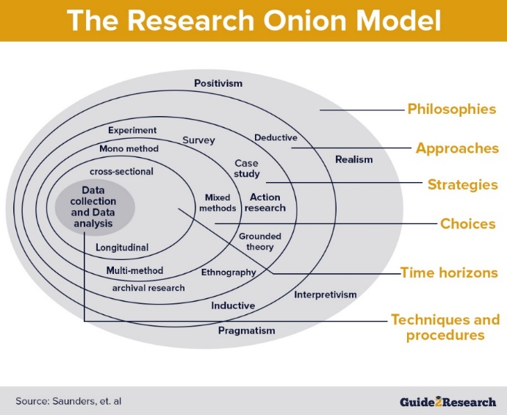
Fig 5
In dissection of the methodology, the researcher utilised the Saunders Research Onion in the establishment of conduct and approach. The selection in use of the Research Onion was based on the adaptability aspect in the onion application, that can be tailor made to suit and align with the research objectives. The research onion model is an essential framework that contains the basic elements necessary in aiding and provision of a guidance important to the successful delivery of the research project. The researcher adopted the model as a continual reference during undertaking the research.

3.3Research Philosophy
Research philosophy relates to the development of knowledge and nature of that knowledge, Saunders et al. There are different philosophical approaches and within them involves the refinement and developing of logical reasoning through reference and incorporation of established methods and ideas that have been thought through structural phase[32]. The arms of philosophy include Positivism- which relates to data of experience and their properties and relations. Interpretivism- it is a research approach that deducts access to reality and is derived through social construction, through use of shared meanings and instruments[]. Pragmatism is a philosophical concept that alludes relevance if action supports it, pragmatics, and realism. The assumption is that the knowledge that the researcher had, was independent of the study and therefore the researcher needed to establish knowledge and understanding through utilising techniques of objective observation and experimentation.

3.4Research approach
According to Saunders Research Onion model there 2 philosophical approaches, Deductive and Inductive. The generalised difference in these approaches is, deductive approach has an expected pattern that stems from tested observation whilst inductive begins with observation in a quest of pattern identification the research will be conducted on the premise of previous and related work to the research topic. The researcher during the course research conduct will attempt to make deductive conclusion based the results in relation to the premise of related work and research undertaken on the research topic. The deductive approach was elected choice on the possibility to measure concepts quantitatively and the measurement variables and concepts causal relationship the deductive approach as a preferred approach offered elements suitable the research needs, time availability as the research was undertaken and had to be completed within sensitive time scale period, the abundance of sources from related studies gave the researcher access to a wealth of literature

3.5 Research Strategy-
The research will use the application of process that will examine results against and in comparison, to expected results. In instances were not possible to utilise the appropriate tools, the experimentation will procced by way of simulation and emulation of the real-life scenarios using virtual environments. Simulation application are ideal in maintenance of validity by repeating test experiments, in set and exact environment. Through simulations, conditions can be varied, and outcome investigated without waiting for natural occurrence.

3.5.1Methods
- Set up simulation virtual lab environment, consisting of rogue access point, threat actor and valid client.
- Set up a Smart Home network topology
- Simulate a wireless authentication protocol
- Launch an MiM attack on the Control plane
- Launch a backdoor attack on the data plane
- Assess the vulnerabilities

3.5.2Resources
802.11n wireless Adapter- An adapter with packet injection and monitoring mode capabilities and operable in 2.4GHZ and 5GHZ frequency range. Packet injection allows the sending data packets to wireless connected devices within range. The monitoring aspect allows the capturing of packets received by wireless connected services within range
Nmap-Network Mapper is an open-source vulnerability and network discovery tool critical in finding open ports and detection of security risks. Ideal in the identification of devices running on a system and the discovery of host that are available and services that they offer. The tool can be used in the monitoring of single host to large networks [33]
Kismet- is part of the Kali linux distro that is an open source tool and wireless sniffing tool. Compatible with Windows OS, macOs and linux the Kismet can sniff 802.11a/b/g/n traffic. A versatile utility tool that can be used for benign purposes such as intrusion detection and wireless scanning. Kismet packet sniffing and capture is not confined to a specific SSID and access point.[34]

3.6 Research Choice

There are 3 pathways with reference to the Research onion and these includes Multi, Mixed and Mono methods of approach. The Multi method is based on the use of a wider methods selection, the mixed method is predominately pinned on the use of 2 or more methods of research, qualitative and quantitative research. Mono method compromises a singular method of research approach[32]. The researcher adopted a Multi approach method as a choice of progression and utilised qualitative and quantitative methodology.

3.7 Time Horizon

According to Saunders time horizons are a necessity and of importance to research design and articulates their need for research design independent of the research methodology used. Importantly there a 2 types of time horizons, that are Cross-sectional and Longitudinal[…]. Cross-sectional is a study that analyses data variables collected at specific given point and time on a predefined set. Longitudinal involves a study over a period on a variable or group of subjects […]. The researcher adopted a Cross-sectional dimension approach through running a series of experiments on predefined smart home network and test using different set of variables to determine the vulnerabilities that lie therein. In aligning with progression to the time scale the researcher used the Gnatt Chart as a timeline milestone achievement targets for the 6 months allocated period.

3.8 Data Collection and Analysis
An integral part that has a significant bearing in the validation and reliability of the research. The layer is primarily an elaboration on the data used in the research regards to collection and analysis aspects. The 2 significant types of data are Primary and Secondary data.
Primary data- is new data collected for sole purposes aligned with resolving the issue that needs addressing ie Research topic. There are varied methods of primary data collection and these include Interviews, Observations, Surveys, experiments
Secondary Data- is data that has been collected by other credible sources that can be public or existing information. and can be used for analysis and investigation of research questions. The sources of data include but not limited to Government statistics, Trade publications, Market research reports and Company websites
The research was conducted via the application of both primary and secondary data. Primary data was obtained through deployment of the necessary experiments in establishment of a better insight understanding and appreciation the network security of network security protocols and identification of security vulnerabilities. Secondary data was used and applied in the establishment of the research questions and objectives of the research. An array of sources was utilised in undertaking the literature review, these included electronic and non-electronic sources of journal, books and articles from but not limited to University of Trinity St David`s online library. The basis of literature review had a major influence from research papers and material that has been carried in the research spheres of SOHO and Home network security and direction of my Project Supervisor.

3.9 Limitations

Limitation are the associated shortcomings, influences and conditions that are beyond the researchers control that would be restrictive to the methodology and conclusion[35]
Sample Size- The experimentation was carried on limited resources, therefore limiting the sample size of the research.
Age of data- The technology sector is a dynamic sector and sustained on continuous evaluation and patching of identified vulnerabilities. Identified and known vulnerabilities in eras of certain sources used in literature review, such as firmware were no longer relevant due to remediations process and problem product decommissioning.
Time constraints- Longitudinal challenges as the research had to be completed within the time frame requirements in line with the prescribed submission dates.
Covid-19 pandemic- Due to the Covid pandemic outbreak the researcher was unable to access and utilise the library facilities at UWTSD but had to rely only on online library services and facilities and Interviews as a data collection instrument could not be applied in circumstances to determine end-user security knowledge .
Funding and Finance- Limited funding and finance had a bearing researchers’ sample size and the apparatus in undertaking experimentation. The researcher could not invest in recommended industry recommended security hardware products and different high spec IoT devices designed to withstand nefarious activities.

3.10 Risk

Risk if the possibility of a negative outcome occurring because of an action or undertaking these include damage, loss, injury, or any other negative impact in the short or long term[36].
Health and safety- A due diligence process of assessment and a careful examination of potential harm that could arise and identification of the mitigatory measures for damage limitation against potential risk in research undertaking was done. The possible risks identified were eye strain and repetitive strain injury. The researcher followed the recommended precautionary measures of taking regular breaks, working in suitable environments with less strain on the body and application of the correct ergonomics in the use of computing equipment and associated accessories[37].
Invasion of Privacy -The researcher took all due care in ensuring the activities carried out with the research will be solely used for academic purposes. To guard adhere to safeguarding and privacy to data protection no personal information was deemed necessary in conducting the research and all activities of penetration testing were undertaken on the researcher’s private network and virtual platform. The research was undertaken with minimal requirement of hardware equipment and the researcher had it place health and safety[36]

Chapter 4

Design and Implementation

4.1 Introduction

Problem formulation is there for the guidance and clarity purposes of the research problem, that seeks to establish relevance to the core issue that needs addressing. The author attempts a dissection of the problem through harnessing the aims and objectives elements to developing an analysis instrument course.

4.2 Problem formulation

The SOHO network has become an integral and essential element in the sustenance of the working from home concept, an aide to automated utilities and a core driver of functionality in modern smart homes. Are the home networks secure to sustain the concept ?, as there exist covert and overt security issues.
In an interrogation attempt to establish understanding, the researcher uses a practical approach in the probing of some elements of their set network through the application and utilisation of various tools. The researcher using Virtual machine mounted with Kali Linux distro attempts to target network client device for de-authentication. A wireless adapter with monitoring and packet injection capabilities being utilised in undertaking the task.
The proposed problem formulation by the researcher advances the notion on the need for attentive remediation research of neglected and relegated flaws within home networks that are necessary to security. The research can be a necessity for future researchers in further probing of security vulnerabilities and formulation of concerted resolution by ISPs, Hardware manufacturers and end-users.

4.3Design

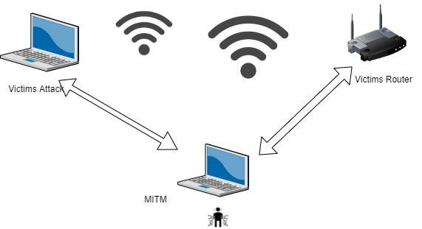
Fig:8 MiM attack representation.

Resources
The researchers conceptualised designed involved the wardrive approach in identification of the target by administering a scan of available BSSID using wireless network adapter with a chip set capability of monitoring and packet injection. The researchers exploit on the target home network security leverages on the end user perceived lack of basic technical security knowledge and them maintaining a default password provided by their ISP provider[38]
VMware -A Virtual machine that is software-based replica of a physical computer, that is necessary to carry out experimentation in a sandboxed environment. Necessary in the setting of a lab environment[39], the virtual machine complete with Kali linux and the necessary tools required to undertake necessary experimentations.
Wireshark- is an open-source packet analyser that is operational on and runs on a multi-platform that runs on Linux, windows, macOS, Solaris, FreeBSD, NetBSD. The tool does live packet capture and offline analysis. It has a decryption support for a varied number of protocols such as WEP, WPA/WPA2, Kerberos, SNMP3 and to read/write on many captured file formats[40]
HP laptop- 16G ram, with core speed of 1.3GHz with a 64-bit windows operating system

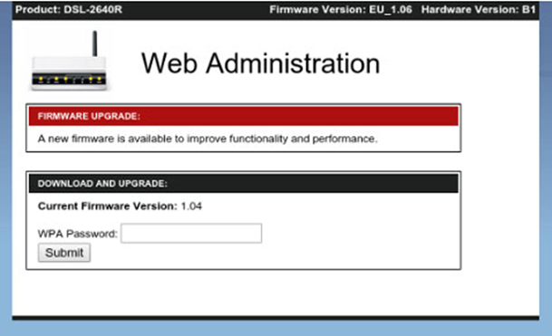
Fig 9 :Router Firmware Update Probe
Through utilising Kali linux Wi-fiPhiser tool is deployed as minimal server that would respond to target victim`s HTTP and HTTPs request and Hijack the 4 handshake. On the target request to access internet the Wi-fiphiser will respond with a fake page that prompts the victims Wi-fi password to perform the necessary firmware upgrade. Once password submission is complete the password is known to the attacker.

4.4 Implementation
The key aspects regard of the implementation relates to an attack aimed at compromising the Control plane and Data plane through leveraging on vulnerabilities that can be exploited within the Wi-fi protocols. The researcher utilised aircrcak-ng a preinstalled tool within the Kali Linux distro and tp-link AC1900 wireless adopter.

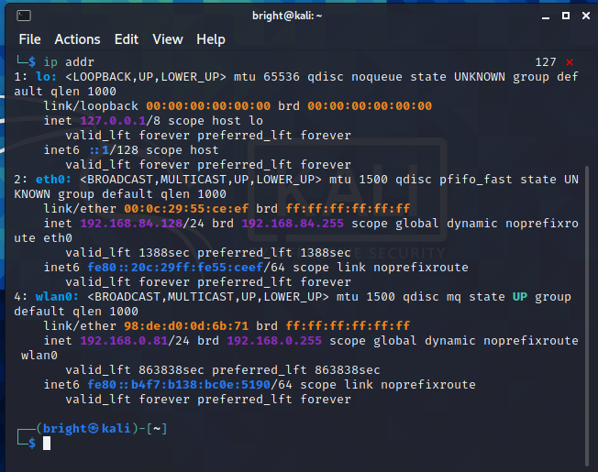
Fig: 10
The above interface depicts the researcher logon to the Kali environment with wlan0 signalling connection to the wireless adapter.
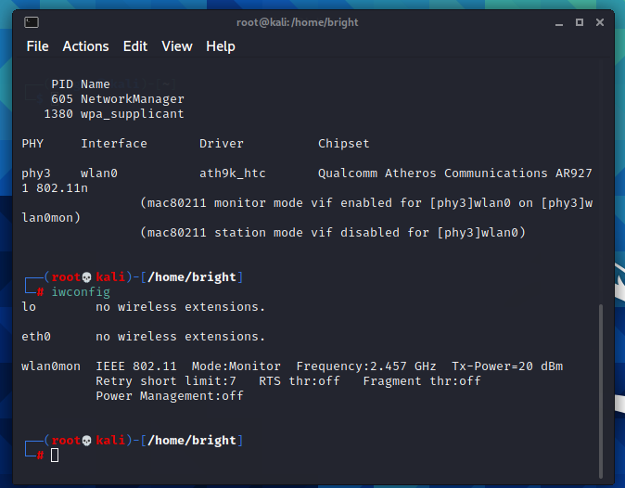
Fig: 11
The above depicts the researcher setting the wireless adapter into monitoring to enable the scanning of the environment for Wi-Fi BSSIDS within range.
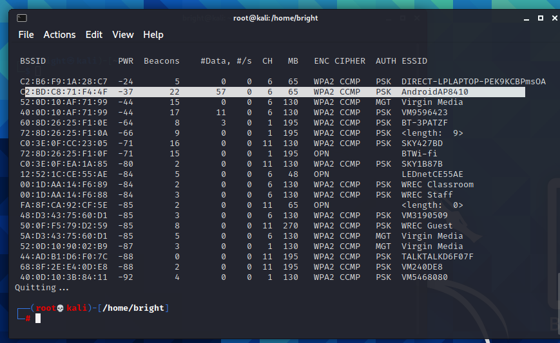
Fig: 12
The search for target victims is ran in the terminal airodump-ng wlan0mon, the target victim network is highlighted (Please note for ethical reasons the researcher`s target is their own network). BSSID- is the MAC address of the AP, PWR-signal level with higher indicating close proximity distance to the AP, Beacons- are packet announcements generated by the AP, #/s- data packets being generated over a 10 second period, CH- is the channel number the AP is transmitting from derived from beacon packets, ENC- encryption algorithm ie WEP, WPA or WPA 2, Cipher- thus the detected cipher, Auth the authentication protocol and ESSID- the wireless display name.

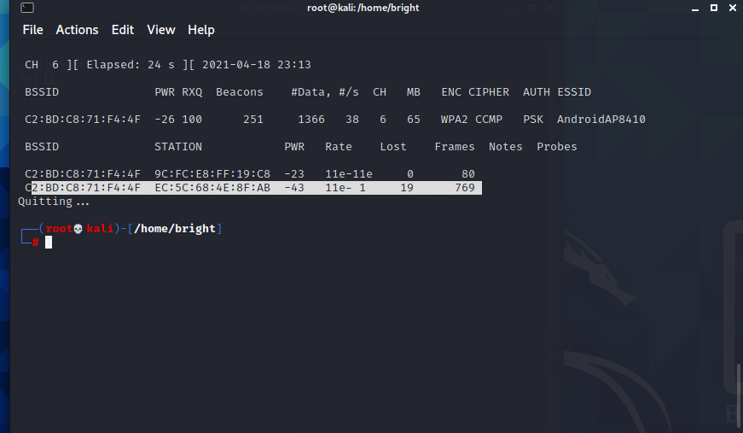
Fig: 13 Target Focus
On establishment of target network, there need to establish the device that are connected on the target network
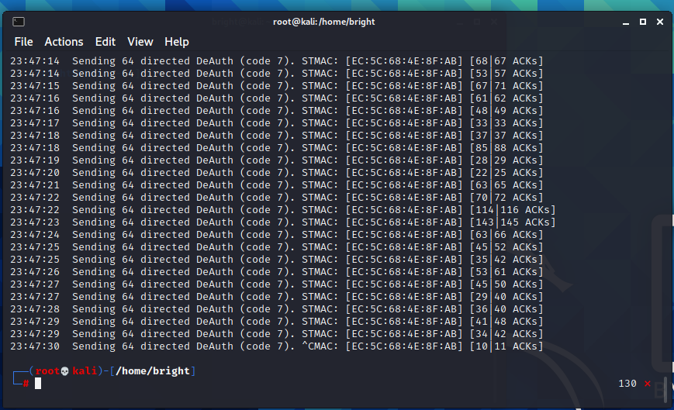
Fig: 14 Device De-authentication
After a selection of the target network the de-authentication process is instigated in the terminal through the command aireplay-ng -0 0 -a “mac address of AP” -c “mac address of de-authentication client” wlan0m

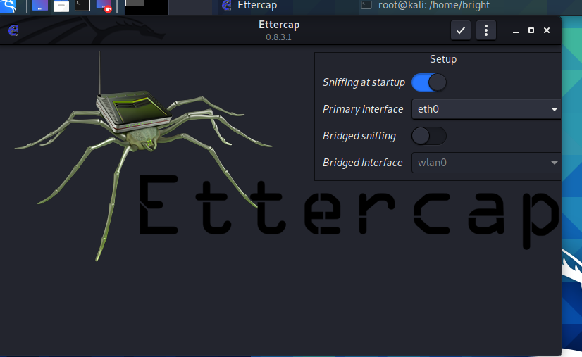
Fig 15: Starting Ettercap to initiate MiM
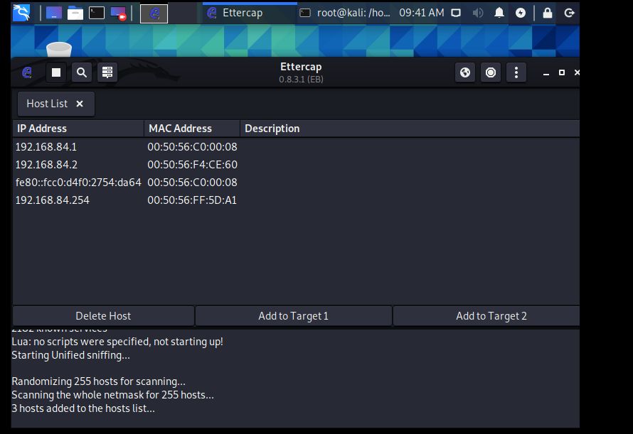
Fig 16. Ettercap application to capture target host

Chapter 5 Results
The researcher in this chapter collates collective summation of the findings based on the experimentations undertaken.

5.1 Results
The researcher with the use of Kali Linux distro tools managed to carry a wardrive attack sand carried out a scan on the Wi-Fi signal emissions. The guiding parameters to the wardrive was the determination and extraction of BSSID, SSID, Channels ,Wireless Encryption, Cipher text within the reconnaissance phase. The results obtained by the researcher were critical in deployment on the next attack phase which was the target identification and de-authentication of client from the network. The researcher managed to deploy the Ettercap tool to scan undertake launch sniffing, scanning for host, extraction of host list with the options and initiated men in the middle attack and capture of packets from the target network . Due to lack of the relevant skill set the researcher failed in their attack and attempt to break into the network connected IoT devices

5.2 Evaluation

The success of Smart Home concept is reliant on wireless technology and therein contained some exploitable security vulnerabilities. The experimentation and qualitative analysis of the home wireless encryption protocols identified that vulnerabilities exist across the adoption of wireless connection protocols, with the WEP protocol 64-bit RC4 ideal for archival and relegation for learning and academic research purposes due to its susceptibility to Cipher text decryption. The WEP protocol can be easily brute forced with the use of free available software, there is easiness in forging of authentication messages. The WEP protocol does not prevent replay attacks as recorded attacks can be replayed and passed as legitimate.
WPA as a wireless security is equipped with vital inception design features necessary in the resolution of WEP weaknesses, but still with use of exploits that lie within wireless protocol features. As demonstrated with use of Evil Twin attack, leveraging on the router handshake session hijack, a de-authentication attack can be launched that forces a user to disconnect from their legitimate Wi-fi AP and directs them to a rogue AP that forces the target victim to reveal their password as they attempt to “reauthenticate”. The WPA PSK is for ideal for SOHO networks and does not use an authentication sever with negotiation only occurring on initial session and this never transmitted over the Air with the AP as both client and AP possess the key.
WPA 2 protocols that are designed and reliant on TKIP and AES encryption are protocols difficult to crack and requires a hacker’s ingenuity in coercing the Victim to voluntarily provide their password or leads as a launch pad for a hacker’s attack and to retrieve the password.
As demonstrated vulnerabilities of SOHO networks emanate from reliance of end-user on default network security setup. Router firmware. Conformity to standards association ISPs have an obligation to maintain certain services charters set within their deliverables.
Basic network security appreciation is of paramount importance in the attainment of a secure SOHO network, as some exploited vulnerabilities are a result of end user lack of knowledge. The increase in size of the SOHO data plane has seen the need to harden the normal Control plane handling policies by utilising market available SNMP products such as PRTG to monitor and give a live poll of nodes and devices. Essentially alarms are triggered on devices that need patching and with outdated firmware.

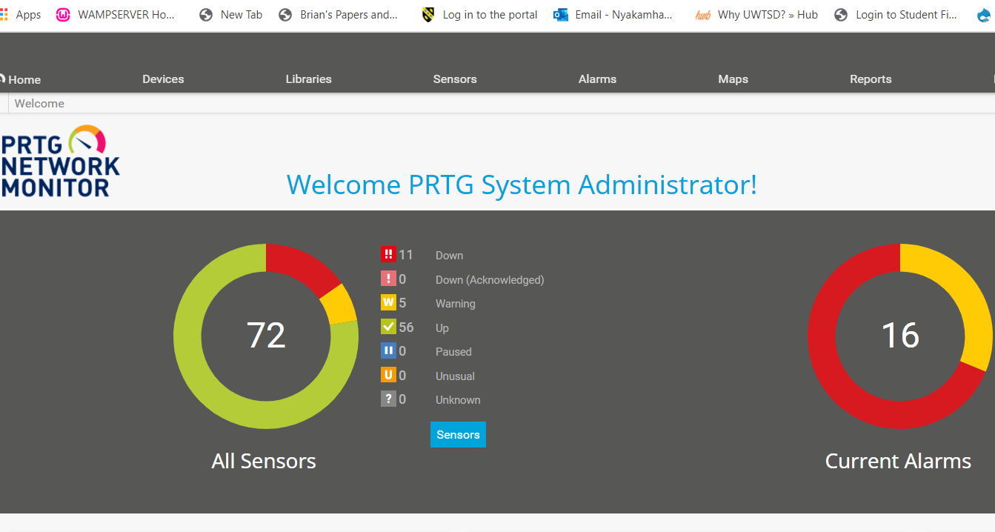
Fig 17: PTRG SNMP monitor

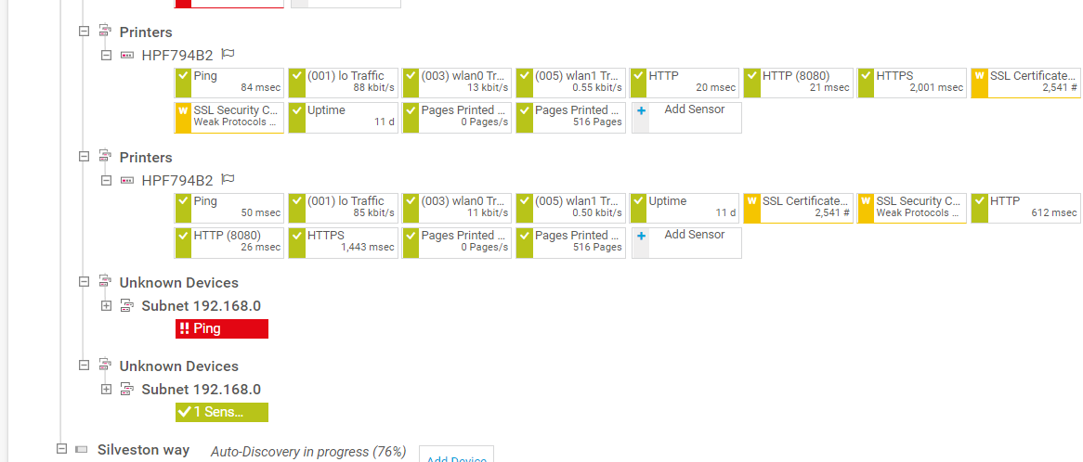
Fig 18: PTRG Nodes

Chapter 6

6.1 Conclusion
The subject of home network security is a wide area that will benefit from continuous and further research studies. As part of the greater core element that sustains emerging technologies and thrust drive towards the Smart concept. Networks will continue to face incessant susceptibility challenges due to non-compatibility of diverse elements necessary in driving sustainability. The researcher’s literature review identified challenges that perpetuate the issues within home security, and these range from hardware, firmware, end-user knowledge, application of wireless protocols and encryption. The diversified ISPs, Hardware products and end-user needs, reduces the feasibility of standardised remediation across the board. There is a greater need to address end-user mundane approach to basic network security challenges, identification, and prevention as 90% acts of network security breach are due to internal[41]
The researcher initially set out to address and achieve project objectives, that were knowledge and understanding on the issues preventative in establishing secure home networks. The researcher had set objective of increasing the academic knowledge and understanding and the researcher undertook independent experiments in network security probing through gathering of independent tutorial YouTube and Netacad cyber ops platform. The necessary explorations undertaken by researcher will suffice in the setting up and implementation of secure home network with reduced risk of attack, however attainment of a perfect solution will be impossible as there are various factors to consider.
It is therefore important to continuously focus on WLAN as they remain an easy target for hackers to exploit. ISPs and hardware providers have a duty of ensuring the end-user is equipped and continuously educated on the importance of security. WLAN technology is continual increasing at a rapid pace, and this has been characterised by more demands to support lager smart home networks and technological installation.

6.2 Recommendations
The information obtained by the researcher is not conclusive in the resolution of home network security Challenges, therefore there is still need for further research in the area. The researcher’s focus was on segment of broader plane as the research did not cover in-depth guidance on lager industrial scale settings . Future and further studies need to still be undertaken on pillars of the security 5-part structure of VPN, device, encryption, firewall and authentication. There is still need for more investment of finance and skills to further studies on the security and hardware requirements. The researcher final suggestion is future students to invest more on the attainment of the necessary cyber security practical skills to better understand the threats in the technology industry.

-

Chapter 7 Reflection

7.0 Introduction

It a birds eye view personal summary assessment of the procedural challenges and achievements realised in undertaking the research project journey and this include how certain aspects could have been done differently and advise to future students.
In undertaking the research, I developed an understanding and appreciation on the topic of study, as I had minimal skills in the securing of data plane and content plane. I gained and developed necessary personal skills that include communication, in attaining the required and expected project outcome there was engagement needs that required constant communication with my project supervisor. Self-management and task prioritisation as during undertaking the research they were other module and study demands that required attention. Planning through the utilisation of Gantt chart made it possible to work within set time frame and attaining the deliverables.

7.1 Barriers Encountered

Time management proved challenging due to uncontrollable and controllable variables, the uncertainty due to outbreak of the covid pandemic required adjustments to deliverables and research methodology. The Project required intense and a good appreciation of elements of ethical hacking, hence it was imperative to undertake the necessary due diligence in establish permissible actions of hacking within confines of the law. Disposable income to invest in an array of resources necessary in the undertaking of the relevant project experiments.

7.2 Positives

There was professional and adequate guidance from the project supervisor that was extended over and above the confines of the allocated supervision slots to direct and aide in directing me to the important sources of relevant information necessary for project deliver.
The undertaking of the final year major project has enabled a refinement in personal planning and organisation through prioritising necessary deliverables activities to evenly balance the load without neglecting other elements necessary to the course.
The covid pandemic brought challenges in the limitation of the traditional face to face academic delivery, but Teams’ platform as backup platform proved to equally effective and alternative approach towards attainment of the Green environment as carbon footprint was reduced due to limited travel.
Determination to succeeded stretched me beyond the limit, and it was positive to note self- motivation plays an important part in delivering and overcoming of challenges through application and utilisation of the varied module topics that have been learned at UWTSD

7.3 Guidance to Future Students

Time management is a critical as attention is/will be divided across modules that require same amount of commitment. Engagement and following the Supervisors guidance is a self- reassurance way of off coasting from the aims of the project deliverables. The key skills of self- management that include discipline and focus are critical. Crucial before embarking on any experimentation of data collection ethical considerations are to be done as there exist a thin line of permissible academic undertaking and crime.

7.4 Summary
Learning is a continuous process that has advanced humanity through breaking down barriers in different academic fields and disciplines. The undertaking of the project presented challenges with resolutions derived from 3 years of academic journey at UWTSD. The key pinnacles of success in Project management lay within planning of resources such as time, cost as this do have a bearing on the outcome and validity of results.

Chapter 8 Reference

[1] “Be a part of the connected future of the UK - GOV.UK.” https://www.gov.uk/guidance/be-a-part-of-the-connected-future-of-the-uk (accessed Apr. 23, 2021).
[2] “£200 million rollout of full fibre broadband begins - GOV.UK.” https://www.gov.uk/government/news/200-million-rollout-of-full-fibre-broadband-begins (accessed Apr. 23, 2021).
[3] “Government response to the call for views on consumer connected product cyber security legislation - GOV.UK.” https://www.gov.uk/government/publications/regulating-consumer-smart-product-cyber-security-government-response/government-response-to-the-call-for-views-on-consumer-connected-product-cyber-security-legislation (accessed Apr. 22, 2021).
[4] “UK’s proposed IoT cyber security law gathers momentum.” https://www-computerweekly-com.cdn.ampproject.org/v/s/www.computerweekly.com/news/252499590/UKs-proposed-IoT-cyber-security-law-gathers-momentum?amp_js_v=a6&amp_gsa=1&amp=1&usqp=mq331AQFKAGwASA%3D#aoh=16190609827702&csi=0&referrer=https%3A%2F%2Fwww.google.com&amp_tf=From%20%251%24s&ampshare=https%3A%2F%2Fwww.computerweekly.com%2Fnews%2F252499590%2FUKs-proposed-IoT-cyber-security-law-gathers-momentum (accessed Apr. 23, 2021).
[5] C. Fachkha, “Security Monitoring of the Cyber Space,” Cybersecurity Policies and Strategies for Cyberwarfare Prevention, pp. 62–83, Aug. 2016, doi: 10.4018/978-1-4666-8456-0.ch004.
[6] A. F. Rochim, B. Harijadi, Y. P. Purbanugraha, S. Fuad, and K. A. Nugroho, “Performance comparison of wireless protocol IEEE 802.11ax vs 802.11ac,” Feb. 2020, doi: 10.1109/ICoSTA48221.2020.1570609404.
[7] “Why the UK is investing £1.9bn in cyber security.” https://www.newstatesman.com/spotlight/cyber/2018/05/why-uk-investing-19bn-cyber-security (accessed Jan. 14, 2021).
[8] “Cybercrime To Cost The World $10.5 Trillion Annually By 2025.” https://cybersecurityventures.com/hackerpocalypse-cybercrime-report-2016/ (accessed Jan. 14, 2021).
[9] “CyberOps Associate -War Stories.” https://contenthub.netacad.com/cyberops/1.1.2 (accessed Apr. 23, 2021).
[10] A. K. Simpson, F. Roesner, and T. Kohno, “Securing vulnerable home IoT devices with an in-hub security manager,” in 2017 IEEE International Conference on Pervasive Computing and Communications Workshops, PerCom Workshops 2017, May 2017, pp. 551–556, doi: 10.1109/PERCOMW.2017.7917622.
[11] “Chapter 9 -- Protecting Your System: Network (Internet) Security, NCES Publication 98-297 (National Center for Education Statistics).” https://nces.ed.gov/pubs98/safetech/chapter9.asp (accessed Jan. 15, 2021).
[12] N. Hampton and P. Szewczyk, “A survey and method for analysing soho router firmware currency,” in Australian Information Security Management Conference, AISM 2015, 2015, pp. 11–27, doi: 10.4225/75/57b697e7d9388.
[13] “What is a VPN? | Virtual Private Networks Explained | Norton.” https://us.norton.com/internetsecurity-privacy-what-is-a-vpn.html (accessed Apr. 23, 2021).
[14] “Securing Wireless LANs - Google Books.” https://www.google.co.uk/books/edition/Securing_Wireless_LANs/QsIALlyDDtsC?hl=en&gbpv=1&dq=Held+G.+2003.+Securing+Wireless+Lans.+USA:+Wiley+Publishing.&pg=PR7&printsec=frontcover (accessed Apr. 23, 2021).
[15] “Scaling Networks.” https://contenthub.netacad.com/legacy/CCNA/ScN/6.0/en/index.html#1.1.1.2 (accessed Jan. 14, 2021).
[16] “Strong wireless security for the SOHO network - ProQuest.” https://search-proquest-com.ezproxy.uwtsd.ac.uk/docview/215981672?accountid=130472&rfr_id=info%3Axri%2Fsid%3Aprimo (accessed Nov. 15, 2020).
[17] P. Szewczyk and C. Valli, “Ignorant Experts: Computer and Network Security Support from Internet Service Providers,” Sep. 2010, doi: 10.1109/NSS.2010.42.
[18] “LAN switching and wireless : CCNA exploration companion guide - University of Wales Trinity Saint David.” https://whel-primo.hosted.exlibrisgroup.com/primo-explore/fulldisplay?docid=44UWTSD_ALMA21166385640002421&context=L&vid=44WHELF_UWTSD_VU1&lang=en_US&search_scope=CSCOP_EVERYTHING&adaptor=Local%20Search%20Engine&tab=tab1&query=any,contains,IEEE%20network%20infrastructure%20security&facet=creator,include,Cisco%20Systems,%20Inc&offset=0 (accessed Jan. 15, 2021).
[19] S. Onno, R. Gelloz, O. Heen, and C. Neumann, “User-based authentication for wireless home networks,” in IEEE International Conference on Consumer Electronics - Berlin, ICCE-Berlin, 2012, pp. 218–220, doi: 10.1109/ICCE-Berlin.2012.6336530.
[20] “Differences Among WEP, WPA, WPA2 and WPA3 Wireless Security Protocols.” https://searchnetworking.techtarget.com/feature/Wireless-encryption-basics-Understanding-WEP-WPA-and-WPA2 (accessed Apr. 23, 2021).
[21] E. Lear, R. Droms, and D. Romascanu, “Manufacturer Usage Description Specification,” Mar. 2019. doi: 10.17487/RFC8520.
[22] T. Denning, T. Kohno, and H. M. Levy, “Computer security and the modern home,” Communications of the ACM, vol. 56, no. 1. pp. 94–103, Jan. 2013, doi: 10.1145/2398356.2398377.
[23] S. Dave, B. Trivedi, and J. Mahadevia, “Efficacy of Attack Detection Capability of IDPS Based on its Deployment in Wired and Wireless Environment,” International Journal of Network Security & Its Applications, vol. 5, no. 2, pp. 103–115, Mar. 2013, doi: 10.5121/ijnsa.2013.5208.
[24] “Being Prepared to be Unprepared: Meaning Making is Critical for the Resilie...: EBSCOhost.” https://web-a-ebscohost-com.ezproxy.uwtsd.ac.uk/ehost/detail/detail?vid=0&sid=021983cd-2290-48a1-96e5-6db11ce31ee3%40sdc-v-sessmgr01&bdata=JnNpdGU9ZWhvc3QtbGl2ZQ%3d%3d#AN=145692427&db=hus (accessed Jan. 15, 2021).
[25] “5 Reasons Why Penetration Testing is Important?” https://www.testingxperts.com/blog/5-Reasons-Why-Penetration-Testing-is-Important (accessed Jan. 14, 2021).
[26] H. Scholten and H. van Dijk, “Home network security,” in Proceedings - 7th International Conference on Networking, ICN 2008, 2008, pp. 249–255, doi: 10.1109/ICN.2008.80.
[27] “Bluetooth® Technology Website.” https://www.bluetooth.com/ (accessed Apr. 23, 2021).
[28] P. C. V. O. and M. J. W. W. Diffie, “Authentication and authenticated key exchanges,” Springer Science+Business Media B.V, vol. Volume 2, Number 2, 1992, pp. 107–125.
[29] J. Guth et al., “A detailed analysis of iot platform architectures: Concepts, similarities, and differences,” in Internet of Things, vol. 0, no. 9789811058608, Springer International Publishing, 2018, pp. 81–101.
[30] “eMUD: Enhanced Manufacturer Usage Description for IoT Botnets Prevention on Home WiFi Routers | IEEE Journals & Magazine | IEEE Xplore.” https://ieeexplore-ieee-org.ezproxy.uwtsd.ac.uk/document/9187209 (accessed Apr. 23, 2021).
[31] S. M. Sajjad, M. Yousaf, H. Afzal, and M. R. Mufti, “EMUD: Enhanced manufacturer usage description for iot botnets prevention on home wifi routers,” IEEE Access, vol. 8, pp. 164200–164213, 2020, doi: 10.1109/ACCESS.2020.3022272.
[32] “Understanding the Research Onion | Writing Guides | 15 Writers.” https://15writers.com/research-onion/ (accessed Feb. 19, 2021).
[33] “Nmap: the Network Mapper - Free Security Scanner.” https://nmap.org/ (accessed Feb. 28, 2021).
[34] “Kismet - Kismet.” https://www.kismetwireless.net/ (accessed Feb. 28, 2021).
[35] “Research Limitations - Research-Methodology.” https://research-methodology.net/research-methods/research-limitations/ (accessed Mar. 14, 2021).
[36] “Assessing Risks and Benefits.” https://research.uci.edu/compliance/human-research-protections/irb-members/assessing-risks-and-benefits.html (accessed Mar. 14, 2021).
[37] “Computer health and safety | Department of Education.” https://www.education-ni.gov.uk/articles/computer-health-and-safety (accessed Mar. 14, 2021).
[38] “How to Hack Wi-Fi: Stealing Wi-Fi Passwords with an Evil Twin Attack « Null Byte :: WonderHowTo.” https://null-byte.wonderhowto.com/how-to/hack-wi-fi-stealing-wi-fi-passwords-with-evil-twin-attack-0183880/ (accessed Apr. 20, 2021).
[39] “VMware Workstation Player | VMware | UK.” https://www.vmware.com/uk/products/workstation-player.html (accessed Apr. 03, 2021).
[40] “Wireshark · Go Deep.” https://www.wireshark.org/ (accessed Feb. 28, 2021).
[41] “Guide to Cyber Threat Information Sharing,” Special Publication - Council for Agricultural Science and Technology, 2016, doi: 10.6028/nist.sp.800-150.

Chapter 9 Appendix

Gnatt chart


