E-Portfolio

Module Name: Digital Skills for Personal Development and Business Growth

MODUL LEAD: PHILIPPA FITZGERALD
STUDENT NAME : PETRU ALEXANDRU STANESCU
STUDENT ID:2244013

DATA:05.07.2024
Contents
Task 1 3
Introduction: The Power of Storytelling in Branding 3
Defining Storytelling in Brand Development 4
Real-World Example: A Case Study in Effective Brand Storytelling 4
The Impact of Storytelling on Customer Engagement and Loyalty 5
Conclusion: Storytelling as a Strategic Advantage in the Modern Marketplace 6
Reference 7
Task 3 8
Analysis of Selected Questions 11
Utilizing the findings 14
Reference 16
Task 4 17
Introduction: Integrating Questionnaire Insights into Design 17
Audience Segmentation: Targeting Specific Customer Segments 18
Website Design: Applying Data-Driven Decisions 18
Marketing Materials: Leveraging Customer Preferences 20
SEO Strategies: Optimizing for Search Engines 21
Conclusion 23
Reference 24

Task 1

Introduction: The Power of Storytelling in Branding
Consumers and manufacturers both demand that the brand they represent be as different from all others as possible. I believe that one of the most effective strategies they possess is the storytelling technique. Some branding goes beyond mere advertisement in the use of stories that influence the psyche of the audience. It is not just about sharing information about the product, its benefits, and successes but also seeking to establish emotional bonds with the consumers. The use of story-telling aspects also makes brands more relatable and memorable, as well as helping to share their values, mission, and vision (Gill, 2011). Beside the benefits of the benefits of using this approach in terms of attracting attention, it also benefits the business by gaining loyal and trusting customers. This way, storytelling gives brands a distinct approach and identity in the sea of similar brands that target the same audience. As consumers value sincerity and emotion, being able to tell stories effectively becomes a crucial role in the effort to establish long-term relations and enhance brand familiarity

Defining Storytelling in Brand Development
Brand narratives, or brand stories, are the intentional and deliberate act of presenting a brand as a character with certain personality traits, beliefs, and mission in connection with customers. While conventional marketing communications aim at presenting product attributes and service advantages, the storytelling approach appeals to people's emotions and captures their attention with personal stories. This approach encompasses the process of telling a story that seeks to capture the core of the brand, such as its background, purpose, and goals. The narrative can be wisely implemented in videos, social networks, blogs, and advertisements with the consistency of its targeted message. From the perspective of personal or corporate branding, storytelling drives a positive attribute of the brand by making it more personal (Woodside et al., 2008). This serves as a perfect opportunity for brands to set themselves apart from the competition, as they are able to share aspects of the brand that are not tangible or physical with their audience in a direct and intimate manner. Brand storytelling means not only knowing your target clients and what you want to say but also how to do it in the most compelling manner.

Real-World Example: A Case Study in Effective Brand Storytelling
The Nike brand is a good example of how storytelling can be effectively used in branding, specifically the Just Do It campaign. This campaign initiated back in 1988 turned Nike into a symbol of desire and convention, which was originally a mere sportswear company. Nike has chosen to tell the world about the success and failure that athletes experience in their day-to-day lives, and something that is enjoyed by many, whether they are active athletes or not, is success and the battle against adversity. Nike’s approach to incorporating many and various athletes and their biographies offers an inspiring story of ordinary people turning into champions regardless of color, gender, or athletic ability. In this sense, the equity of the campaign is positioned in powerful feelings and the brand’s association with strength and motivation. Nike, for instance, relays its narratives in sensational ads and, with the support of influential athletes, ensures its imagery resonates with the targeted consumers. The message repeats on all levels, bringing to life the brand’s character and goal, a clear depiction of how strategic narrations can bring about change. Nike has illustrated how effective storytelling is in establishing a sound and relevant corporate personality for its company in a crowded market.

The Impact of Storytelling on Customer Engagement and Loyalty
The use of storytelling increases customer interest and reintroduces the audience to the brand by invoking emotional appeal that the audience can easily relate to. Especially when it comes to the story that the brands share, customers can find a personal connection and get a sense of understanding and being appreciated. Thereby, this leads to a loyal consumer base since customers are more inclined to spend money on brands that are sympathetic to their cause. He indicated that by storytelling, the company can explain what the brand stands for, what it supports, and where it is headed in a way that other forms of advertising may not achieve, thus making the brand familiar to the customer. Also, the use of storytelling helps in engaging customers since it creates an inviting environment by letting customers be characters in the story (Gill, 2011). Whether for social media contests, engaging customers in their own posts, or involving customers in a unique experience around the brand, the use of storytelling makes them feel that they want to be part of the story to be shared around and with the brand.

Conclusion: Storytelling as a Strategic Advantage in the Modern Marketplace
Thus, storytelling can be considered one of the main competitive assets of the current market to use for developing brand affiliation, emotional bonds, and proof points. Telling stories effectively is a good way through which brands can be able to express their aim and vision in a manner that will find a good place in the hearts of consumers. This emotional engagement is particularly important in a context that is characterized by high levels of rivalry; therefore, appealing to the audience’s emotions and making them find something personal in a brand is highly valued. Not only do people pay attention to their favorite brands, but these success stories keep customers coming back for the long haul. Furthermore, storytelling helps lower the disconnect between individual brand experiences and provides a consistent brand narrative (Solomon, 2014). It makes the consumers engage and be part of the brand's experience, meaning they are ambassadors. However, as it has been evident in the Nike ‘Just Do It’ case, storytelling is an effective persuasive technique that is designed to trigger emotion and call for action.

Reference
Denning, S., 2006. Effective storytelling: Strategic business narrative techniques. Strategy & Leadership, 34(1), pp.42-48.
Fog, K., Budtz, C. and Yakaboylu, B., 2005. Storytelling: Branding in practice. Springer.
Gill, R., 2011. Corporate storytelling as an effective internal public relations strategy. International Business and Management, 3(1), pp.17-25.
Herskovitz, S. and Crystal, M., 2010. The essential brand persona: storytelling and branding. Journal of Business Strategy, 31(3), pp.21-28.
Lundqvist, A., Liljander, V., Gummerus, J. and Van Riel, A., 2013. The impact of storytelling on the consumer brand experience: The case of a firm-originated story. Journal of Brand Management, 20(4), pp.283-297.
Muniz Jr, A.M. and O'Guinn, T.C., 2001. Brand community. Journal of consumer research, 27(4), pp.412-432.
Pulizzi, J., 2012. The rise of storytelling as the new marketing. Publishing research quarterly, 28(2), pp.116-123.
Simmons, A., 2006. The story factor: Inspiration, influence, and persuasion through the art of storytelling. Basic Books.
Solomon, M.R., 2014. Consumer behavior: Buying, having, and being. Pearson.
Woodside, A.G., Sood, S. and Miller, K.E., 2008. When consumers and brands talk: Storytelling theory and research in psychology and marketing. Psychology & Marketing, 25(2), pp.97-145.

Task 2

https://youtu.be/22twEqeRj9s

Task 3
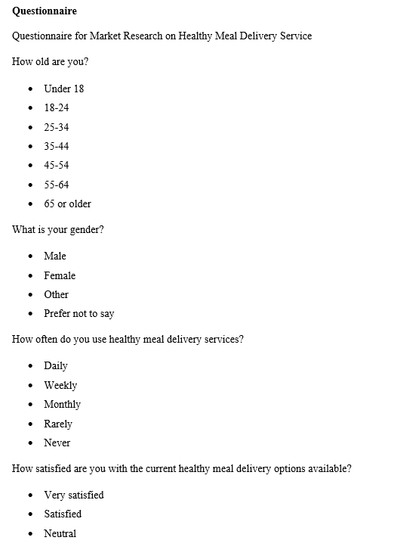
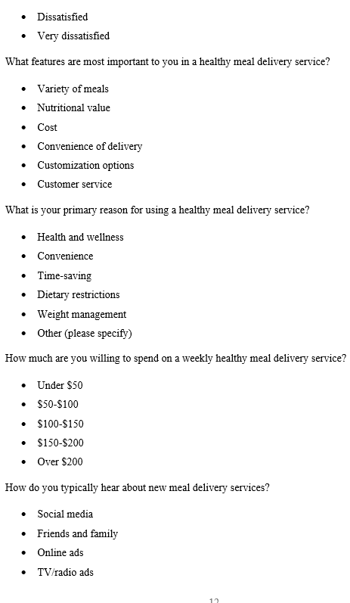

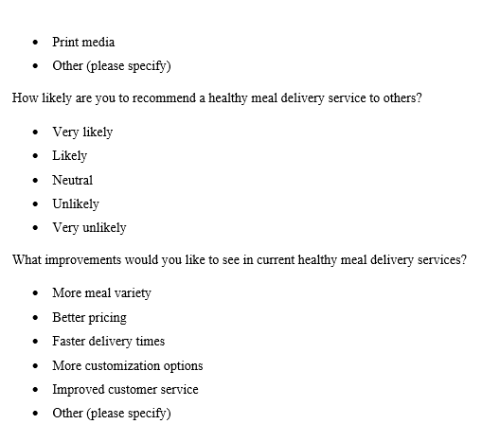

Analysis of Selected Questions
Question 1: How often do you use healthy meal delivery services?
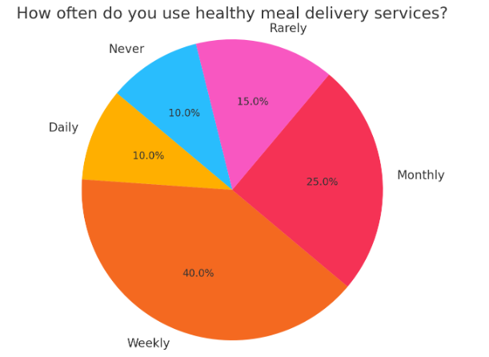
Figure 1: How often do you use healthy meal delivery services?
The answers to this question offer important information about the frequency of use of healthy meal delivery services by our target population. Furthermore, assessing the frequency of using such services, 40% of the respondents mentioned that they make such services on a weekly basis. This versatility implies that the audience needed predictable, reliable meal solutions that could be easily fitted into their daily routine. The aspect of weekly usage also shows the possibility of coming up with a subscription service that is designed to feed loyal clients who always require wholesome meals consistently (Malhotra et al, 2017). Furthermore, this way of using the language also helps in planning such processes as deliveries, supplies, stock management, and others to guarantee consistent and unhindered service delivery. The survey also shows that 10% of the customers use the service daily, and there could be a market for a select group of people who require fresh, high-quality personalized meals delivered per day.
Question 2: What features are most important to you in a healthy meal delivery service?
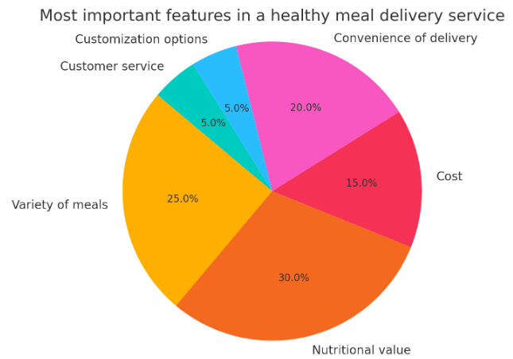
Figure 2: What features are most important to you in a healthy meal delivery service?
Once again, the breakdown of this question shows that the features most appreciated by the respondents are the nutritional content at 30%, variety of meals at 25%, and convenience of delivery at 20%. This further depicts that customers are more concerned with the health benefits of foods and the variety of meals they can order at their convenience. Through these pivotal areas, we can better establish the relevance of our services to the needs of the customer. To ensure repeat patronage from customers, especially the health-conscious ones, the provision of a large-capacity menu that will meet the variety of needs of the customers will help keep satisfying their needs. Availability of delivery is another significant consideration, where the ability to make many deliveries whenever and as often as possible is cited as an important attribute that consumers expect (Malhotra et al, 2017). Pricing was the least critical factor, as customers only perceived its importance at 15%, which could mean that they are willing to pay more to get better quality and more convenient meal services. Customer services and product customization were also given 5% of their preference, indicating that while both are relevant, they might not be the main deciding factor for consumers.
Question 3: What is your primary reason for using a healthy meal delivery service?
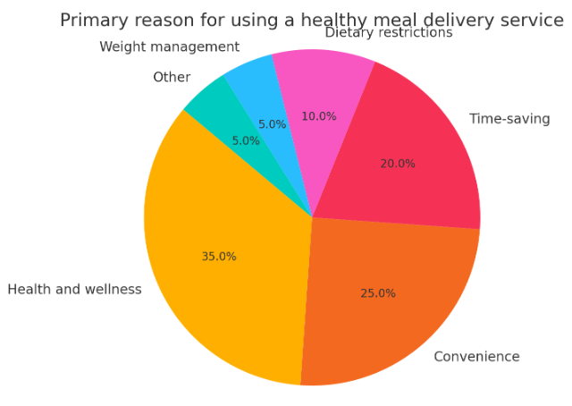
Figure 3: What is your primary reason for using a healthy meal delivery service?
According to the survey results, health and wellness (35%) are the primary motivating factors in ordering food from healthy meal delivery service providers, while convenience and time saving are also considered significant, standing at 25% and 20%, respectively. This insight makes it critical for us to market our service as something that will benefit anyone with a busy lifestyle who is willing to lead a healthier life. Stressing the beneficial impacts associated with the product and the time that the client can save on preparing food will target a larger market of people with a desire to eat healthy but not cook. As it is revealed that health and wellness are the top concerns, advertising strategies should try to focus on the healthy aspects of the food offered, such as the nutritional values of the foods served and the fresh and quality ingredients used in preparing the meals (Dillman et al., 2014).
Question 4: How likely are you to recommend a healthy meal delivery service to others?
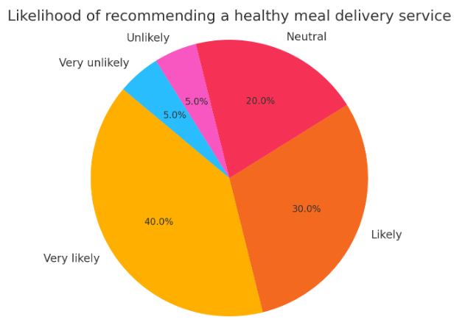
Figure 4: How likely are you to recommend a healthy meal delivery service to others?
The answers to this question show how satisfied customers are generally and how likely they are to tell others about your business. Many of the people who answered (40%) said they would definitely suggest the service to others, and another large group (30%) said they were likely to do so. This upward trend shows that customers are very happy and will stay loyal. Referral programs or testimonials can help the brand's image and bring in more customers by encouraging happy customers to talk about their good experiences. The data also shows that a smaller group (20%) is neutral. This means that our service might need to be improved in order to turn these neutral customers into champions (Dillman et al., 2014).

Utilizing the findings
Developing a Subscription Model:
Developing weekly meal plans for consumers can be helpful because the company is confident that those people are going to use their services regularly to get those meals. In order to ensure the customer stays subscribed, incentives may also be put in place, such as discounted prices or special meals.
Enhancing Nutritional Value and Meal Variety:
Engaging nutritionists to help determine that the meals we offer meet high levels of health to help enhance the credibility of the brand can be taken a notch higher.
Optimizing delivery convenience:
One way is through the integration of flexible scheduling, which allows customers to pick delivery times that fit their daily schedule, leading to increased satisfaction.
Targeted marketing campaigns:
Featuring stories of people who have achieved great things after using our meals, with a with an emphasis on nutritional values as well as how our meals can easily fit into people’s busy schedules, can appeal to health-conscious clients (Malhotra et al, 2017).
Referral and loyalty programs:
Programs such as reward points that are earned when a customer places regular orders could act as a reminder of the company through constant orders and can also increase customer loyalty.

Reference
Bryman, A. and Bell, E., 2015. Business research methods. Oxford University Press.
Creswell, J.W. and Creswell, J.D., 2017. Research design: Qualitative, quantitative, and mixed methods approach. Sage publications.
Dillman, D.A., Smyth, J.D. and Christian, L.M., 2014. Internet, phone, mail, and mixed-mode surveys: The tailored design method. John Wiley & Sons.
Fowler, F.J., 2014. Survey research methods. Sage publications.
Hair Jr, J.F., Page, M. and Brunsveld, N., 2019. Essentials of business research methods. Routledge.
Malhotra, N.K., Nunan, D. and Birks, D.F., 2017. Marketing research: An applied approach. Pearson.
Pallant, J., 2020. SPSS survival manual: A step-by-step guide to data analysis using IBM SPSS. Routledge.
Patten, M.L. and Newhart, M., 2017. Understanding research methods: An overview of the essentials. Routledge.
Saunders, M., Lewis, P. and Thornhill, A., 2019. Research methods for business students. Pearson education.
Wilson, J., 2014. Essentials of business research: A guide to doing your research project. Sage.

Task 4

Introduction: Integrating Questionnaire Insights into Design
Our logo and even the layout of this website promoting our healthy meal delivery service were notably inspired by the findings of this questionnaire. This way, the questionnaire provided valuable insights on what aspects are important to customers and their decisions in this regard, such as nutritional value, variety of meals, and delivery convenience. From these realizations, we were able to make modifications to the content and structure of our website to better meet the needs and wants of our viewers (Ryan, 2016). Also, the data allowed for the definition of segments within customer groups, which makes it possible to share appropriate inserts in the advertising materials. By placing emphasis on these key factors, we want to establish a positive link through which prospective buyers will be inclined to select our service. This summary will take into account how we integrated these findings into the website and the materials used in marketing, along with segmentation, website appearance, marketing messages, and competent optimization of SEO.

Audience Segmentation: Targeting Specific Customer Segments
Audience segmentation is one of the critical activities for creating communication pieces and websites that will be more persuasive to different customer segments. Based on the questionnaire data, we identified several key segments: Apart from that, most of the products target health-conscious people, working-class people, and families who do not have time to prepare food from scratch. It is important to remember that each group is likely to have different concerns and expectations that are not met by the current marketing and website materials. Promotional information emphasizes using only fresh and healthy products in production as well as the benefits learners can derive from them. For active people, options that will be beneficial in terms of time and convenience are stressed (Gilmore and Pine, 2007). A distinct advantage of our site is its simplicity and the easy-to-use ordering services that we offer. With the promotion of family meal offers and special menu options, customers are more likely to make purchases that are relevant to their large households and diverse preferences for individual meals. Others target specific groups in the population; hence, by understanding the messaging and design elements that appeal to those segments, our communications are more meaningful to them. Not only does this strategy capture more consumers, but it also fosters deeper satisfaction and customer loyalty since each segment contains people with unique wants and requirements that can be fulfilled effectively.

Website Design: Applying Data-Driven Decisions
The structure of this website is designed considering the results that were obtained from the questionnaires. In that way, the needs and wants of the target group are met. One of the key information choices unveiled as soon as a client enters our homepage is the nutritional and meal diversity guarantee. This approaches the core areas of concern as expressed by our respondents. In view of this, it will be necessary to ensure that the website has been designed in a way that will enable it to be accessed quickly and easily, especially by working professionals. To name a few, Have an easy way of placing your orders; have the option to choose your meals; be excellent for mobile device users, etc. For one, a special section of family plans suggests the adaptability of our services to suit multiple members of a household with various eating requirements. Also, we have ensured that SEO has placed customer testimonials and success stories as main sections of the site to assure trust.
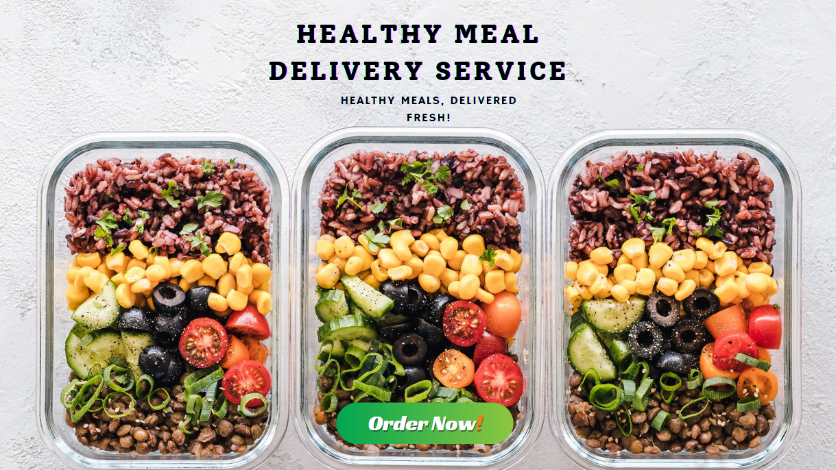
Figure 5: Website front page
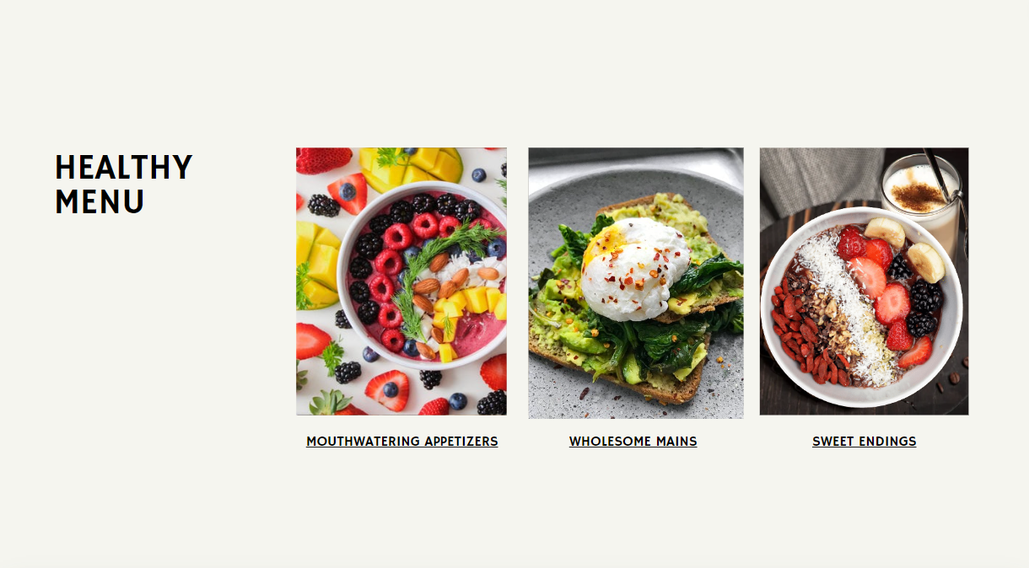
Figure 6: Website menu page

Marketing Materials: Leveraging Customer Preferences
The promotional materials developed for our campaign are tailored in line with the customer preferences that may be spotted in the questionnaires developed for the purpose. Knowing the biggest concerns for our audience—which are the nutritional value of the foods we serve, the diversification of meals, and convenience—marketing content that resonated with the audience was devised. For those who are weight-conscious, our brochures, posts on social media pages, and advertisements will all contain information about the high nutritional value of our meals. We provide ingredient lists with descriptions, and we have nutritionist approval on the site. For working people, we emphasize the simplicity of our service in our advertising messages, exalting how one gets meals delivered without straining (Smith and Zook, 2016). These include testimonies and short instructional tutorials on how to navigate the different operations of the service. Potential customers are reached with promotional appeals and informational propaganda about our modern meal options as appealing to the versatile needs and preferences of families. Communication strategy also involves preparing interesting and creative materials, like recipes that are appealing to the family segment, and providing guidance on proper nutrition.
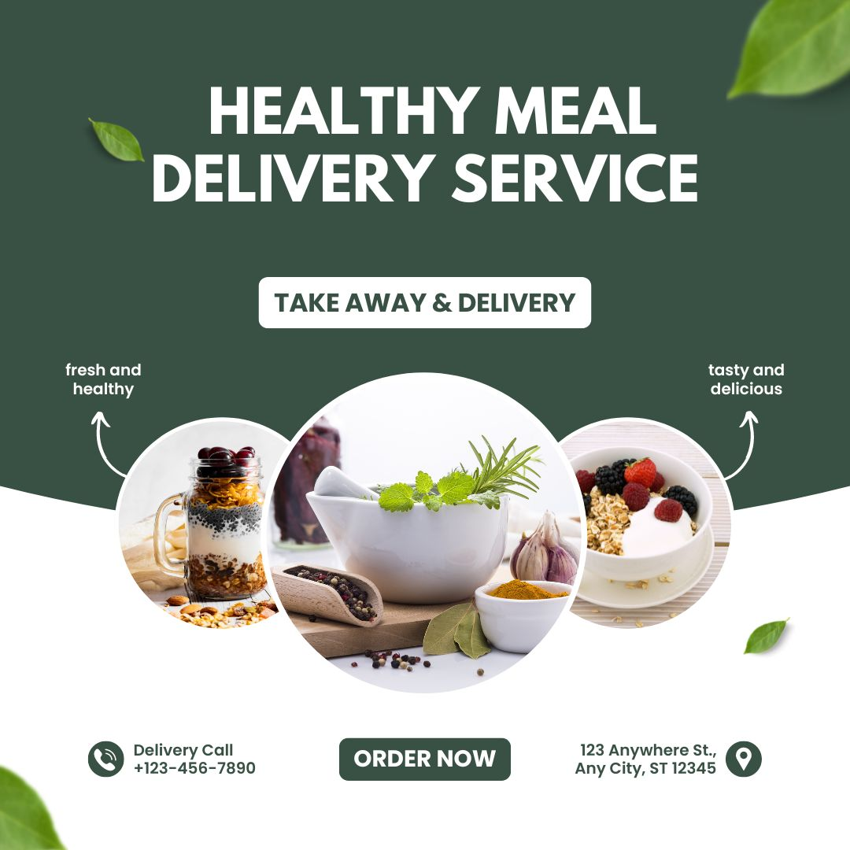
Figure 7: Marketing material

SEO Strategies: Optimizing for Search Engines
Based on the answers to our questionnaire, our SEO approach is meant to get the most people to see it. We found the most important search terms that had to do with nutritional value, meal variety, and ease of use, and then we used these keywords naturally in the text and metadata of our website. Some of the intended keywords that are used on each page are "healthy meal delivery," "nutritious meal plans," and "convenient food service (Chaffey and Ellis-Chadwick, 2019)."We also focus on writing high-quality, useful blog posts that answer common questions from our readers, like how to plan meals ahead of time and why balanced diets are good for you. We also use backlinks from trustworthy health and wellness websites to improve our search engine ranking. Our website's ability to draw in and retain visitors is guaranteed by this comprehensive SEO plan.

Conclusion
Finally, the survey provided a wealth of valuable data that informed the development of our website and promotional materials. Nutrition, usability, and food diversity were the main focuses of our content because we knew our consumers and how they behaved. By segmenting our target demographic, we were able to craft engaging content for health-conscious individuals, time-pressed professionals, and families (Baker and Saren, 2016). By utilizing search engine optimization strategies, we guarantee that our website will rank highly in search results, attracting targeted visitors. By enhancing the user experience and bolstering our brand's presence, this data-driven approach helps us stand out in the competitive healthy meal delivery market. Customers are made happier and more loyal as a result.

Reference
Baker, M.J. and Saren, M., 2016. Marketing theory: A student text. Sage.
Chaffey, D. and Ellis-Chadwick, F., 2019. Digital marketing. Pearson UK.
Fill, C. and Turnbull, S.L., 2016. Marketing communications: discovery, creation and conversations. Pearson.
Gilmore, A. and Pine, B.J., 2007. Authenticity: What consumers really want. Harvard Business Press.
Holliman, G. and Rowley, J., 2014. Business to business digital content marketing: marketers’ perceptions of best practice. Journal of research in interactive marketing, 8(4), pp.269-293.
Kotler, P. and Armstrong, G., 2018. Principles of marketing. Pearson.
Roberts, M.L. and Zahay, D., 2012. Internet marketing: Integrating online and offline strategies. Cengage Learning.
Rowley, J., 2004. Online branding. Online information review.
Ryan, D., 2016. Understanding digital marketing: marketing strategies for engaging the digital generation. Kogan Page Publishers.
Smith, P.R. and Zook, Z., 2016. Marketing communications: Integrating offline and online with social media. Kogan Page Publishers.

