

Student name: Fariha Batool
Student ID number: 2328297

BSc Health and Social Care

Module: Changemaker: Creativity and Value Creation
Module Code: BMHP5014

Lecturer: Dr Precious Igbinigie

Assignment Title: Component 1
Online Portfolio of Set Exercises

Submission Date: 17th November 2025
Task 1 – Concept Map
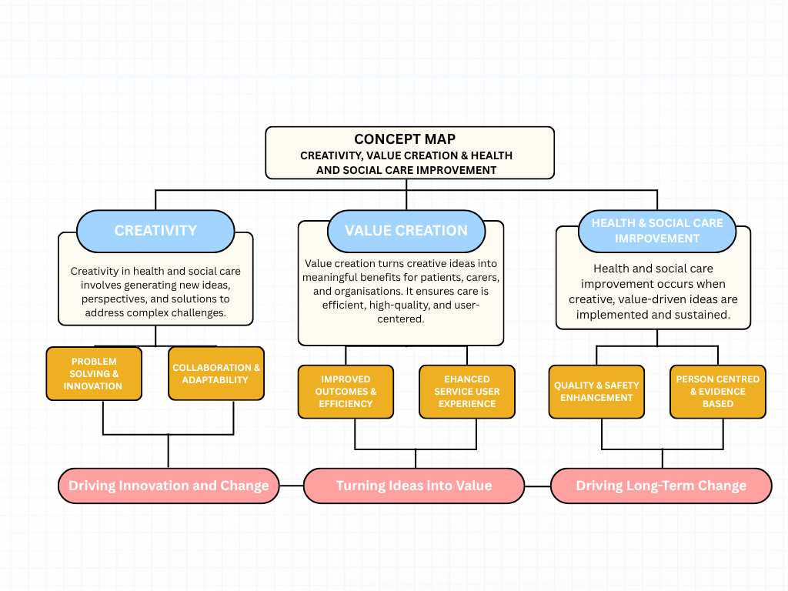
Create a concept map that outlines the relationship between creativity, value creation, and health and social care improvement. Within the concept map explain how these concepts interact in a health and social care context (250 words).

Creativity, value creation, and health and social care improvement are closely linked concepts that work together to strengthen the quality, safety, and person-centred nature of care. Creativity encourages practitioners to generate new ideas, approaches, and solutions that can address complex or changing needs within services. This type of thinking helps staff explore alternatives, adapt their practice, and respond more flexibly to service users, which is essential in environments where needs and contexts vary. Creative thinking supports innovation, enabling teams to identify gaps and develop more engaging, efficient, or responsive ways of working.
Value creation takes these ideas and turns them into real benefits — improved outcomes, better service-user experiences, more efficient practices and stronger relationships (Peng et al., 2022). In health and social care, value is defined not only by cost-effectiveness but by how well services support wellbeing, independence, and user satisfaction. This means that creative ideas must be evaluated and implemented in ways that genuinely enhance the care journey.
When creativity and value creation operate together, they drive sustainable improvement across the sector. Creativity highlights opportunities for positive change, while value creation ensures these ideas translate into real-world benefits. This combination supports a cycle of continuous improvement, where new practices are tested, refined, and embedded into everyday care. As a result, services become more responsive, person-centred, and outcome-focused, contributing to long-term improvements in quality, safety, and user experience (Menear et al., 2019).

Task 2 - Self-Reflection of Group Activity
Complete a self-Reflection on the Convergent/Divergent thinking class activity using a reflective model (250 words, 1 source)
Using Gibbs’ Reflective model my reflections on the classroom activity where we were given a paperclip and asked to generate as many alternative uses as possible. This was designed to develop our divergent and convergent thinking skills.
Description:
The task involved first brainstorming creative uses for a simple paperclip then narrowing these ideas down to the most practical or effective ones.
Feelings:
Initially, I felt slightly unsure because the activity seemed simple, but as I began generating ideas, I realised how challenging it is to think beyond the obvious. I also found it fun and surprisingly engaging.
Evaluation:
The activity worked well because it pushed me to loosen my thinking and not judge ideas too quickly. However, I noticed I sometimes limited myself by worrying whether an idea sounded “realistic”, which reduced my creativity.
Analysis:
This exercise showed me how important flexible thinking is within Health and Social Care. Practitioners often need to think imaginatively—for example, adapting resources for individuals with different needs or finding creative solutions to communication barriers. Research suggests that creativity in care settings directly improves innovation and problem-solving (Mann, 2018).
Conclusion:
I learned that creativity can be developed through small tasks, and I should practice generating ideas more freely.
Action Plan:
In future group tasks, I will try suspending judgement during brainstorming, encourage others to explore unusual ideas, and consciously shift between divergent and convergent thinking.

Task 3 - Case Study of a UK innovation
Write a concise case study analysis of an innovative project or initiative within the NHS or UK social care. Focus on how creativity was used to drive change and the value it created for patients or service users (400 words, 2 sources).
Artificial intelligence and machine learning are starting to play a bigger role in NHS cancer services, helping doctors to predict how cancers might develop and which treatments are most likely to work. The NHS has long struggled with growing cancer cases, long waiting times, and the challenge of giving patients treatment that suits their individual needs. The study by Zhang et al. (2023) looks at how machine learning tools can support doctors in making faster and more accurate decisions about diagnosis and treatment options.
This project’s main innovation is how it combines large amounts of data—from scans, lab results, and genetics—to spot patterns that humans might miss. By using creative approaches to data analysis, NHS teams are better equipped to understand how a tumour might behave or respond to treatment. This represents a big shift from traditional methods that relied only on the experience and judgment of clinicians.
A key part of the innovation involved building trust in the technology. NHS researchers worked closely with data scientists to design systems that explain how they reach conclusions, helping doctors to check and understand AI-generated advice. This approach, known as explainable AI, makes the process more transparent and reassuring for both staff and patients. Hospitals such as University College London Hospitals and The Christie NHS Foundation Trust have shown how these tools can help identify the right treatment more quickly and reduce unnecessary tests.
Bringing together data from different sources also required creative teamwork across medical, academic, and technology sectors. By linking imaging, lab results, and population data, NHS teams could see a fuller picture of each patient’s condition and respond more effectively (NHS England, 2024).
This initiative has created real value for patients and the healthcare system. More accurate predictions have led to quicker diagnoses, fewer invasive procedures, and faster access to suitable treatments. Patients also feel more confident knowing their care is tailored to them, not based on averages. For the NHS, using AI in this way saves time and resources while improving patient outcomes. The success of these projects shows how creative use of technology can make cancer care more personal, efficient, and effective across the health service.

Task 4 - Research Task
Identify a current issue in health and social care (e.g. e.g., mental health stigma, access to care for vulnerable populations). Find two pieces of academic research (journal articles) that explain the reason for this problem. Paraphrase the findings of each article (300 words, 2 sources).
Article 1: Understanding and Addressing Mental Health Stigma Across Cultures
This article explores how mental health stigma develops across different cultural contexts and how it affects access to psychiatric care. The authors explain that stigma can appear in three main ways: public stigma (negative attitudes from others), self-stigma (feeling shame or guilt about one’s condition), and structural stigma (discrimination within organisations or policies). In many cultures, people may associate mental illness with weakness or family dishonour, which often prevents individuals from seeking treatment. As a result, people delay or avoid care, which can lead to their mental health worsening. The study highlights that mental health interventions must be culturally appropriate to be effective. For example, involving community or religious leaders, using familiar language, and sharing personal recovery stories can help reduce fear and stigma. The authors also argue that health systems should focus on addressing structural inequalities and improving public understanding of mental health. Overall, the article shows that stigma is a key barrier to care and that culturally sensitive approaches are essential for improving outcomes (Yang et al., 2023).
Article 2: The Impact of Mental Health-Related Stigma on Help-Seeking
This systematic review examines over 140 studies to assess how stigma influences whether people seek help for mental health problems. It finds a consistent link between higher levels of stigma and lower help-seeking behaviour. Self-stigma and fear of being judged are the strongest barriers, while worries about confidentiality and social reputation also play a major role. The review identifies young people, men, ethnic minorities, and certain professionals (such as those in the military or healthcare) as groups most affected by stigma. Although the overall effect is moderate, stigma still acts as one of the main reasons people delay or avoid support. The authors conclude that tackling stigma through education, public campaigns, and positive contact with individuals who have lived experience can make help-seeking more acceptable and improve early intervention rates (Clement et al., 2015).

Task 5 - Podcast
Record a two-minute Podcast.
https://uowtsd-my.sharepoint.com/:u:/g/personal/2328297_student_uwtsd_ac_uk/IQAXXwEp6RtfQrroAamUAwcDAbOg-63bA9yKHPrAFyyVTOE?nav=eyJyZWZlcnJhbEluZm8iOnsicmVmZXJyYWxBcHAiOiJPbmVEcml2ZUZvckJ1c2luZXNzIiwicmVmZXJyYWxBcHBQbGF0Zm9ybSI6IldlYiIsInJlZmVycmFsTW9kZSI6InZpZXciLCJyZWZlcnJhbFZpZXciOiJNeUZpbGVzTGlua0NvcHkifX0&e=usM3U4

Task 6 - NHS Leadership Framework Analysis
Write a short summary (200 words) explaining the key components of the NHS Leadership Framework. Then, choose one component and describe (150 words) how a leader might use it to encourage creativity and improve care in the NHS (2 sources).
The NHS Leadership Framework outlines the behaviours and competencies needed for effective leadership across health and social care. It emphasises that leadership is not limited to senior roles but is a responsibility shared across the workforce (NHS Leadership Academy, 2011). The Framework includes several key components. Personal Qualities encourages self-awareness, emotional intelligence, and acting with integrity. Working with Others highlights the importance of building strong relationships, clear communication, and effective multidisciplinary working (NHS Leadership Academy, 2011). Managing Services focuses on organising safe, efficient services and ensuring resources are used responsibly. Improving Services promotes the use of feedback, evidence and innovation to enhance care. Setting Direction helps leaders interpret policy, data and future trends to guide teams with confidence. Creating the Vision involves developing a shared purpose that inspires and motivates staff. Collectively, these components support compassionate and collaborative leadership that strengthens patient care and drives improvement across the NHS.
The Working with Others component can significantly enhance creativity within NHS teams. Leaders who encourage open communication allow staff to share new ideas without fear of criticism (West et al., 2015). By involving different professional groups such as nurses, social care partners and administrative staff, leaders bring together varied insights, which supports more creative problem-solving (NHS Leadership Academy, 2011). Regular multidisciplinary discussions, reflective sessions and joint learning opportunities help staff explore alternative approaches to care. Actively listening, valuing contributions and recognising collaborative efforts further strengthen team confidence. As West et al. (2015) note, compassionate and inclusive leadership creates conditions where innovation can thrive. When staff feel heard and respected, they are more likely to experiment, contribute ideas and co-produce improvements. This leads to a more innovative culture and better, more responsive patient care.
Task 7 - Self-Reflection Journal Entry
Write a short journal entry about what you learned in this module. Focus on how your understanding of creativity and value creation withing H&SC has changed and how it has informed your professional practice (200 words).
This module has helped me develop a clearer and more practical understanding of creativity within Health and Social Care. Before, I tended to associate creativity with something artistic or optional, but now I understand it as a practical tool for solving real-world problems and improving outcomes. Instead, I now recognise it as an important way of thinking that can improve problem-solving, support more personalised care, and lead to better outcomes. Creativity means being willing to adapt, explore alternatives, and design approaches that genuinely meet a person’s needs.
My understanding of value creation has also broadened. Previously, I viewed value mainly in terms of efficiency or measurable outcomes. Through this module, I have learned that value also includes the emotional, psychological, and social benefits people gain from high-quality, person-centred care. Creating value can involve improving a person’s confidence, strengthening their independence, enhancing communication, or simply ensuring they feel heard and respected.
This learning has influenced my professional practice by encouraging me to think outside the box when planning or delivering support. I am now more open to considering different methods, adapting interventions, and focusing on strengths rather than limitations. I have also become more aware of how small creative adjustments can significantly improve a service user’s experience. Overall, the module has reinforced the importance of integrating creativity and value-driven thinking into everyday practice to achieve more meaningful and effective care.

Reference
Clement, S. et al. (2015) ‘What is the impact of mental health-related stigma on help-seeking? A systematic review of quantitative and qualitative studies’, Psychological Medicine, 45(1), pp. 11–27. Cambridge University Press. Available at: What is the impact of mental health-related stigma on help-seeking? A systematic review of quantitative and qualitative studies - PubMed (Accessed: 25 October 2025).
Gibbs, G. (1988). Learning by Doing: A Guide to Teaching and Learning Methods. Oxford: Further Education Unit, Oxford Polytechnic. Available at: Gibbs' Reflective Cycle | Reflection Toolkit | Reflection Toolkit (Accessed: 10 November 2025).
Menear, M., Blanchette, M-A., Demers-Payette, O. et al. (2019) ‘A framework for value-creating learning health systems’, Health Research Policy and Systems, 17:79. Available at: https://health-policy-systems.biomedcentral.com/articles/10.1186/s12961-019-0477-3 (Accessed: 10 November 2025).
NHS England (2024) Artificial Intelligence in the NHS: Improving Cancer Diagnosis and Treatment. Available at: https://www.england.nhs.uk (Accessed: 20 October 2025).
NHS Leadership Academy (2011) NHS Leadership Framework. Leeds: NHS Leadership Academy. Available at: 65589 Leadership Framework_Layout 1 (Accessed: 2 November 2025).
Peng, Y., et al. (2022) ‘Value cocreation in health care: systematic review’, Journal of Medical Internet Research, 24(3):e33061. Available at: https://pmc.ncbi.nlm.nih.gov/articles/PMC8994154/ (Accessed: 10 November 2025).
West, M., Eckert, R., Collins, B. and Chowla, R. (2015) Caring to Change: How compassionate leadership can stimulate innovation in health care. London: The King’s Fund. Available at: Caring To Change And Compassionate Leadership | The King's Fund (Accessed: 26 October 2025).
Yang, L. et al. (2023) ‘Understanding and addressing mental health stigma across cultures for improving psychiatric care’, Frontiers in Psychiatry, 14, 10220277. PubMed Central. Available at: Understanding and Addressing Mental Health Stigma Across Cultures for Improving Psychiatric Care: A Narrative Review - PubMed (Accessed: 25 October 2025).
Zhang, Y., et al. (2023) Machine Learning and AI in Cancer Prognosis, Prediction, and Treatment Selection: A Critical Approach. Journal of Personalized Medicine, 13(7), 10312208. Available at: https://pmc.ncbi.nlm.nih.gov/articles/PMC10312208/ (Accessed: 20 October 2025).

