

Artificial Intelligence for Credit Risk Assessment

Predicting Loan Default Risk with Logistic Regression and Random Forest

Module: ACCA7026 – Artificial Intelligence

MSc Data and Artificial Intelligence

University of Wales Trinity Saint David

Lecturer: Malik Mehmoud

ASSIGNMENT- ML Model

STUDENT NAME: VIVEK NELAPATI
STUDENT ID NUMBER: 2511594

Contents
Abstract: 2
1. Introduction and Problem Statement: 3
2. Methodology 4
2.1 Data Preparation: 4
Figure 1: Class balance of the delinquency-risk proxy target (positive rate = 1.78%). 5
Figure 2: Pearson correlations of the top 15 numerical features with the default proxy target. 6
2.2 Algorithms and Pipeline Design: 6
3. Experiments and Results: 8
Figure 3: Precision-Recall and ROC curves for random forest and logistic regression. 9
Figure 4: Confusion matrices at the F1-optimal threshold for each model. 9
Figure 5: Random forest: mean decrease in impurity (top 15 feature importances). 10
Figure 6: shows the top 15 standardised coefficients (log-odds scale) in logistic regression. 11
Figure 7: The random forest's SHAP summary plot, displaying the direction of influence at the feature level. 12
4. Discussion 13
4.1 Model Comparison: 13
4.2 Interpretability: 13
4.3 Ethics and Fairness: 13
Figure 8: shows the actual default rate by homeownership status, area, and income verification. 14
Figure 9: shows the average model-predicted risk by application type, income verification status, homeownership, and area. 15
5. Conclusion and Recommendations: 16
References: 17

Abstract:
Lenders are using machine learning more and more to automate and enhance credit risk assessment; nevertheless, there are actual trade-offs between predictive capacity, transparency, and fairness when selecting an algorithm. Using 10,000 Lending Club loans that started in the first quarter of 2018, this study creates and analyses two supervised classifiers to predict early-stage loan failure risk: a random forest ensemble and a logistic regression baseline. A delinquency-risk proxy target was created, and hyperparameters were adjusted by five-fold cross-validation using average precision as the scoring measure to correct for extreme class imbalance, since less than 2% of loans in this snapshot have a proven bad outcome.
At the expense of transparency, the random forest produced a slightly higher ROC-AUC (0.662) and PR-AUC (0.040) than logistic regression (0.559 and 0.031, respectively). Both models' projections are driven by the debt-to-income ratio, credit limits and utilisation, income, and recent credit-inquiry activity, according to SHAP research, providing assurance that the two methods are capturing a consistent underlying risk signal while having distinct mechanics. Even though no protected trait was directly employed, a fairness audit spanning socioeconomic proxy factors (homeownership, income verification, and geography) found patterns consistent with indirect bias risk. The report comes to the conclusion that any implementation of such a model should maintain human oversight, continuous bias monitoring, and not be seen as a replacement for confirmed-outcome data gathered during a full loan lifespan due to the dataset's constraints.

1. Introduction and Problem Statement:
One of the earliest and most significant uses of predictive analytics in finance is credit risk assessment, which determines the likelihood that a borrower won't repay a loan as agreed. Conventional underwriting used logistic regression models based on a limited number of manually chosen variables and rule-based scorecards. The ability of machine learning techniques, such as tree-based ensembles, to model non-linear interactions between applicant, credit-bureau, and loan-level attributes without requiring the modeller to specify those interactions in advance has led financial institutions to gradually adopt these techniques over the past ten years.
This change is supported by a sizable corpus of comparative literature. Ensemble techniques like random forest and gradient boosting often outperform logistic regression on conventional classification metrics, especially on imbalanced and non-linear data, according to studies employing consumer lending data [1], [2], [3]. Once class imbalance was corrected with resampling, a previous comparative research using a LendingClub dataset similar to the one employed here discovered that ensemble tree approaches recovered more discriminative signal than a logistic baseline [3]. However, other authors warn that in certain situations, a well-tuned logistic model can match or surpass ensemble performance, and that the "best" model largely depends on the interaction structure in the data and how much performance depends on regulatory interpretability constraints [4].
This trade-off goes beyond academics. The Equal Credit Opportunity Act (ECOA) and its implementing Regulation B, which forbid discrimination on protected characteristics and recognise disparate-impact liability even in the absence of overt discriminatory intent, are the main fair-lending laws that govern credit decisions in the United States. The joint assessment of predictive performance, interpretability, and fairness carried out in this study was motivated by the fact that a model that is more accurate but more difficult to explain, or that depends on variables correlated with protected characteristics, creates both a compliance risk and a valid ethical concern.
10,000 Lending Club loans from the first quarter of 2018 are included in the dataset used here, loans_full_schema.csv, which has 56 variables covering applicant, credit-bureau, and loan-level attributes [5]. Only seven loans are confirmed charge-offs; the great majority of loans (9,375 out of 10,000) are still "Current" and have not achieved a final resolved outcome because this is a snapshot taken soon after origination. This is a well-known drawback of using LendingClub's public loan-level data for default modelling: the observed outcome distribution reflects both underlying credit quality and the length of time a loan has been outstanding [3], [5]. Therefore, the main problem statement of this report is twofold: (i) to develop and rigorously compare two credit-risk classifiers under this data constraint, using leakage-free feature engineering and a defensible proxy target; and (ii) to assess, beyond raw accuracy, the interpretability and fairness of each model's predictions, considering the ethical and regulatory implications of credit decisioning.

2. Methodology

2.1 Data Preparation:
There are too few confirmed charge-offs (7) to model directly because the raw loan_status variable is significantly skewed toward "Current." Therefore, a pragmatic delinquency-risk proxy was created: current and fully paid loans were branded 0, whereas any loan exhibiting indications of repayment issues—charged off, in grace period, or late by 16 or more days—was labelled default = 1. This is a common, transparent workaround for this dataset, yielding 178 positive cases out of 10,000 (1.78% positive rate). However, it assesses early delinquency risk rather than proven lifetime default, a drawback that is explored in the Discussion.

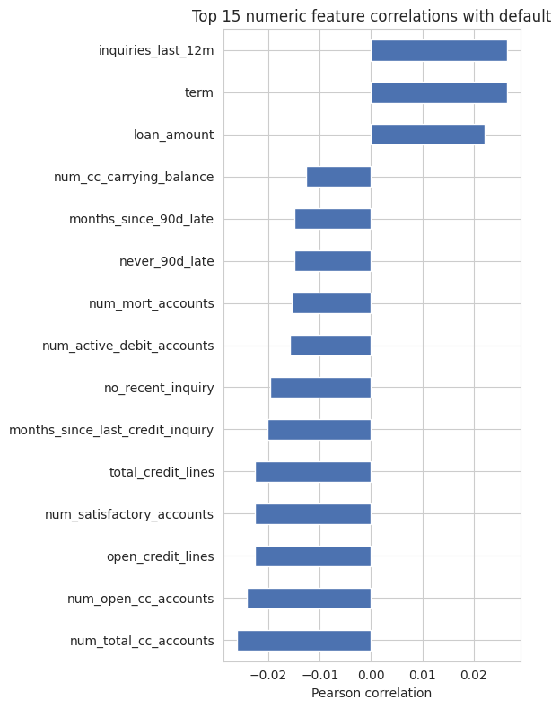

Figure 1: Class balance of the delinquency-risk proxy target (positive rate = 1.78%).

Prior to modelling, two categories of columns were eliminated. First, outcome-leakage fields (balance, paid_total, paid_principal, paid_interest, and paid_late_fees) explain the performance of a loan since its origination and allow a model to see the result rather than forecast it. Second, adding circular fields (grade, sub_grade, interest_rate, installment) would primarily cause the model to re-derive Lending Club's current score rather than independently assess risk from applicant and credit-bureau attributes. These circular fields are Lending Club's internal risk assessment, assigned at origination. A sensitivity check was used to confirm their removal (Section 4).
Emp_title (high-cardinality free text) and issue_month (a single-quarter snapshot with negligible signal) were dropped; earliest_credit_line was converted into a derived credit_history_years feature; the 50-level state field was divided into four US Census regions to reduce dimensionality and support the subsequent fairness analysis; and the three months_since_* recency fields were explicitly encoded using a binary “never happened” flag plus a large sentinel value. Since the application_type indicator already existed, the three joint-application fields—which were almost 85% missing—were eliminated. Only a little amount of residual missingness (up to 8.2% in emp_length) remained for pipeline-based imputation after cleaning, leaving 44 features (36 numerical, 7 categorical after joins).
In line with US consumer lending practices under ECOA/Regulation B, which generally prohibits gathering these information for underwriting, exploratory research verified that the dataset contains no fields related to gender, race, or age. Homeownership, income-verification status, and location are examples of socioeconomic proxies that were kept for further fairness study because they can correspond with protected traits even when none are used explicitly.
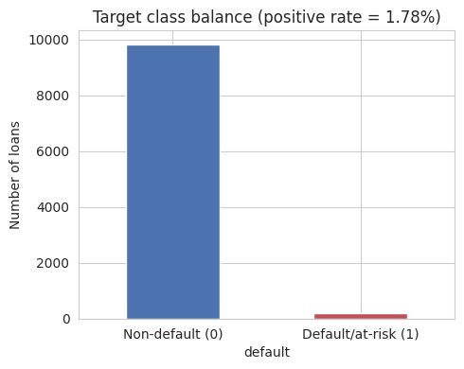

Figure 2: Pearson correlations of the top 15 numerical features with the default proxy target.

2.2 Algorithms and Pipeline Design:
The traditional-versus-ensemble trade-off described in the literature was represented by two complementary classifiers: (i) random forest, a non-linear bagged ensemble of decision trees that can capture interactions and threshold effects between features without manual specification, and (ii) logistic regression, a linear, directly interpretable baseline whose coefficients express log-odds effects [1]–[4].
A single scikit-learn pipeline centred on a ColumnTransformer encompassed both models: most-frequent imputation and one-hot encoding were applied to categorical features, while median imputation and standard scaling were applied to numerical features. Information leakage from the held-out data into the fitted scaler and encoder was prevented by fitting preprocessing only on training folds during cross-validation rather than on the entire dataset up front. To maintain the ~1.8% positive rate in both partitions, the data was split 80/20 (8,000 train, 2,000 test) with stratification on the target.
Both classifiers utilised class_weight="balanced" to up-weight the minority class during training because to the extreme class imbalance. Because average precision (PR-AUC) is significantly more informative than either accuracy or ROC-AUC when positives are this rare (accuracy is trivially high for any model that mostly predicts the majority class, and ROC-AUC can appear deceptively strong even when precision at usable thresholds is very low), hyperparameters were adjusted using GridSearchCV with five-fold stratified cross-validation. The logistic regression grid selected C=10 (best CV average precision 0.029) after searching the inverse-regularization strength C across {0.01, 0.1, 1, 10}. The random forest grid selected 400 trees, unrestricted depth, and a minimum leaf size of 5 (best CV average precision 0.052) by searching n_estimators over {200, 400}, max_depth over {4, 8, None}, and min_samples_leaf over {1, 5}. This already showed, prior to any test-set evaluation, that the ensemble was extracting somewhat more separable signal from the same features.
An F1-optimal decision threshold was chosen using out-of-fold predictions on the training set only, via cross_val_predict, and then applied unaltered to the unaltered test set because the default 0.5 probability threshold is a bad choice with only ~180 positive cases (it causes both models to systematically under-predict the positive class). Optimistic bias from tuning and assessing on the same data is prevented by this two-stage process: set the threshold on training-fold predictions, then evaluate once on test data.

3. Experiments and Results:
Test-set performance for both tuned models at their respective F1-optimal thresholds (0.74 for logistic regression and 0.20 for random forest) is summarised in Table 1.
Model | Accuracy | Precision | Recall | F1 | ROC-AUC | PR-AUC
Logistic Regression | 0.928 | 0.050 | 0.167 | 0.076 | 0.559 | 0.031
Random Forest | 0.968 | 0.032 | 0.028 | 0.030 | 0.662 | 0.040

With ROC-AUC of 0.662 against 0.559 for logistic regression and PR-AUC of 0.040 versus 0.031—both significantly over the 0.018 prevalence baseline for PR-AUC—Random Forest produced the stronger ranking metrics, suggesting a real (if minor) discriminative signal. While random forest's extremely high accuracy (0.968) is primarily an artefact of the extreme class imbalance rather than evidence of strong positive-class detection, logistic regression traded precision for significantly higher recall (0.167 vs. 0.028) at the cost of more false positives. Both confusion matrices show a small number of correctly identified defaults against a very large true-negative count, with only 36 true positive cases in the 2,000-row test set.

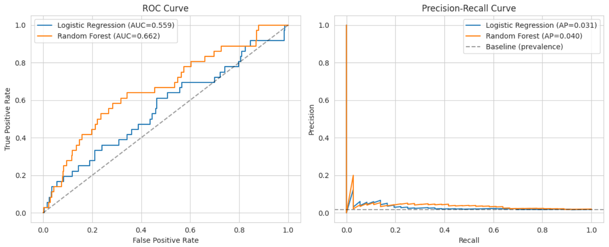

Figure 3: Precision-Recall and ROC curves for random forest and logistic regression.

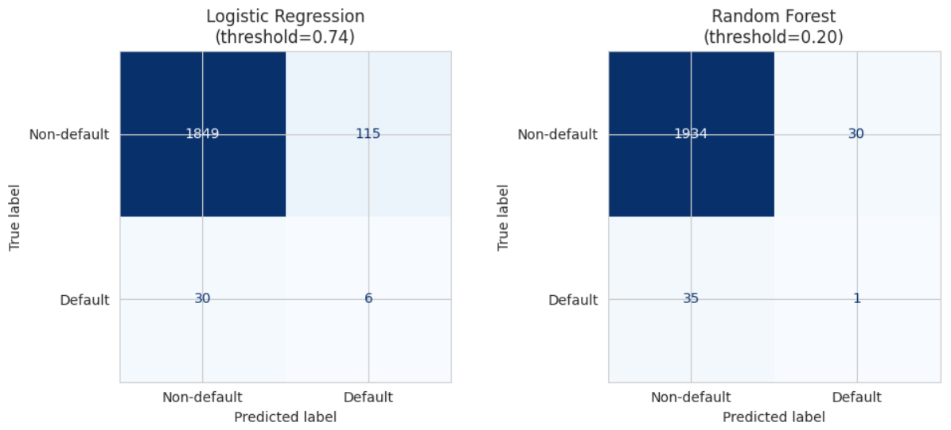

Figure 4: Confusion matrices at the F1-optimal threshold for each model.

The amount of signal excluded by the circularity decision in Section 2.1 was measured by a sensitivity check. A random forest trained solely on Lending Club's grade and interest_rate fields produced a ROC-AUC of 0.646, which is comparable to and within the range of the 0.662 obtained by the full model constructed entirely from raw applicant and credit-bureau attributes. This is a helpful two-way check: it demonstrates that the engineered feature set captures a significant portion of the same risk signal that Lending Club's internal grade already encodes, and it confirms that adding grade/interest_rate directly would have been close to circular reasoning because those two fields alone almost recover the discriminative power of the internal score.
A feature-importance analysis revealed that the two models often agreed on which features carried the greatest signal. The debt-to-income ratio, total debit limit, total credit limit, months since last credit inquiry, credit utilisation, annual income, loan amount, and length of credit history were the leading drivers of Random Forest's mean drop in impurity. The same recency-of-inquiry and delinquency-history features (months_since_last_credit_inquiry, the never_delinquent and never_90d_late “never happened” flags) as well as loan purpose categories like small business (associated with higher risk) and several purpose categories associated with lower risk were the focus of logistic regression's largest-magnitude standardised coefficients. A model-agnostic cross-check on the impurity-based importances is provided by SHAP values calculated for the random forest, an approach whose value for generating comprehensible, scorecard-style explanations from tree-based credit models has recently been demonstrated in the literature [6]. These values attribute each individual prediction to feature-level contributions, corroborate this same set of top drivers, and also show direction of effect (e.g., higher debt-to-income and utilisation push predicted risk upward).

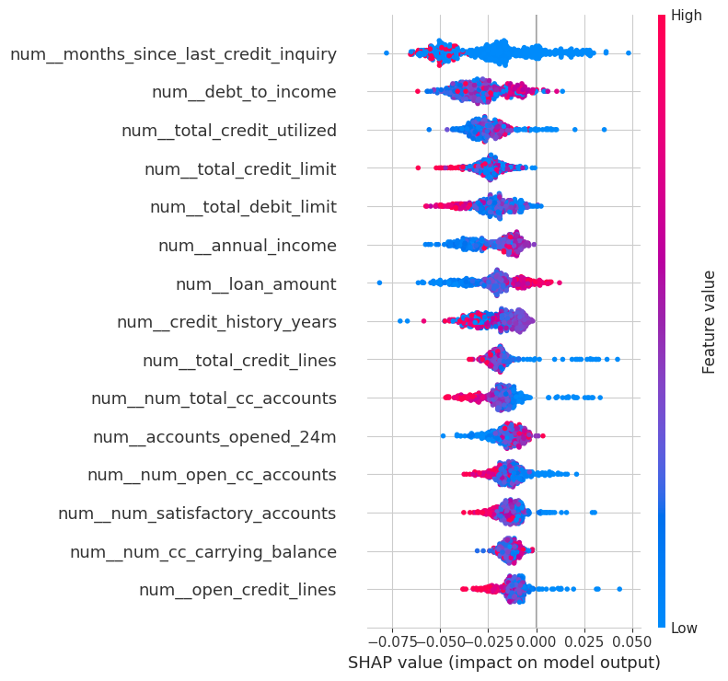

Figure 5: Random forest: mean decrease in impurity (top 15 feature importances).
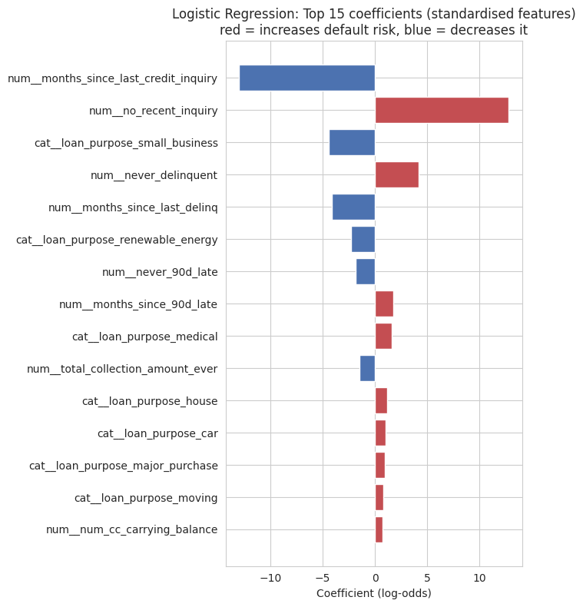

Figure 6: shows the top 15 standardised coefficients (log-odds scale) in logistic regression.
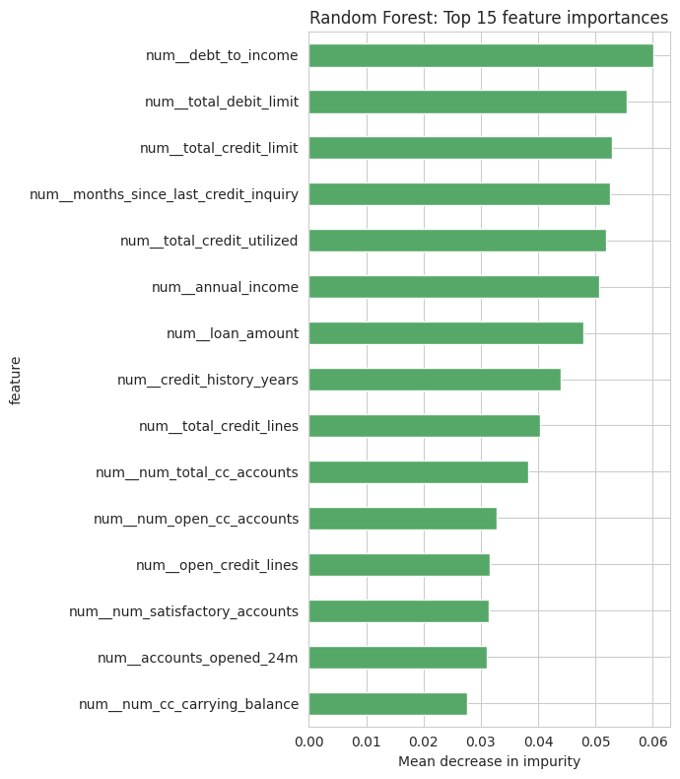

Figure 7: The random forest's SHAP summary plot, displaying the direction of influence at the feature level.

4. Discussion

4.1 Model Comparison:
By capturing non-linear interactions among features like utilisation, credit-line counts, and inquiry recency, ensemble tree methods generally outperform linear baselines on imbalanced consumer-credit data [1]–[3]. This is consistent with Random Forest's advantage on both ranking metrics. The precision below 5% at useable recall levels indicates that the vast majority of applicants identified as high-risk would not really exhibit repayment difficulties in this snapshot; nonetheless, the absolute margin is limited and both models' absolute performance is low from a commercial standpoint. This should not be seen as proof that either approach is generally inappropriate for the task, but rather as a result of the data-availability constraint mentioned in Section 2.1 (very few confirmed poor outcomes to learn from).

4.2 Interpretability:
In regulated lending environments, where adverse-action notices must provide precise, comprehensible justifications for a decision, logistic regression's coefficients are directly interpretable as log-odds effects and do not require post-hoc explanation tools. To attain such transparency, Random Forest needed an additional interpretability layer (impurity-based significance and SHAP), and even then, SHAP explains individual predictions rather than producing a single global equation. The encouraging conclusion is convergence: rather than disagreeing on what counts, both methodologies and interpretability techniques (coefficients and SHAP) emphasised essentially the same few drivers: debt-to-income, credit usage and limits, income, and query recency. This consistency boosts the likelihood that the signal is authentic and not an artefact of a specific program.

4.3 Ethics and Fairness:
The fairness analysis (Table 2) demonstrates that available socio-economic proxies still contain systematic heterogeneity in both actual and expected risk, despite the dataset's exclusion of gender, colour, and age in accordance with US fair-lending practices.

Group variable / level | n | Actual default rate (%) | Mean predicted risk (%)
Region: Midwest | 1,768 | 1.36 | 5.32
Region: Northeast | 1,996 | 2.25 | 6.37
Region: South | 3,640 | 1.84 | 5.75
Region: West | 2,596 | 1.62 | 5.67
Homeownership: Mortgage | 4,789 | 1.42 | 5.34
Homeownership: Own | 1,353 | 2.51 | 6.46
Homeownership: Rent | 3,858 | 1.97 | 6.08
Verified income: Not verified | 3,594 | 1.17 | 4.57
Verified income: Source verified | 4,116 | 1.90 | 6.22
Verified income: Verified | 2,290 | 2.53 | 6.87
Application: Individual | 8,505 | 1.66 | 5.59
Application: Joint | 1,495 | 2.47 | 6.83

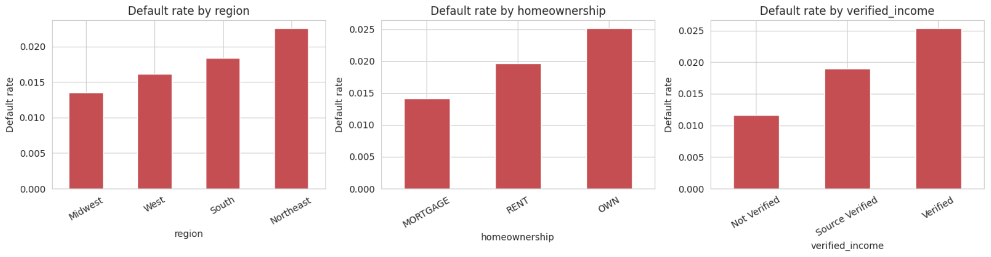

Figure 8: shows the actual default rate by homeownership status, area, and income verification.

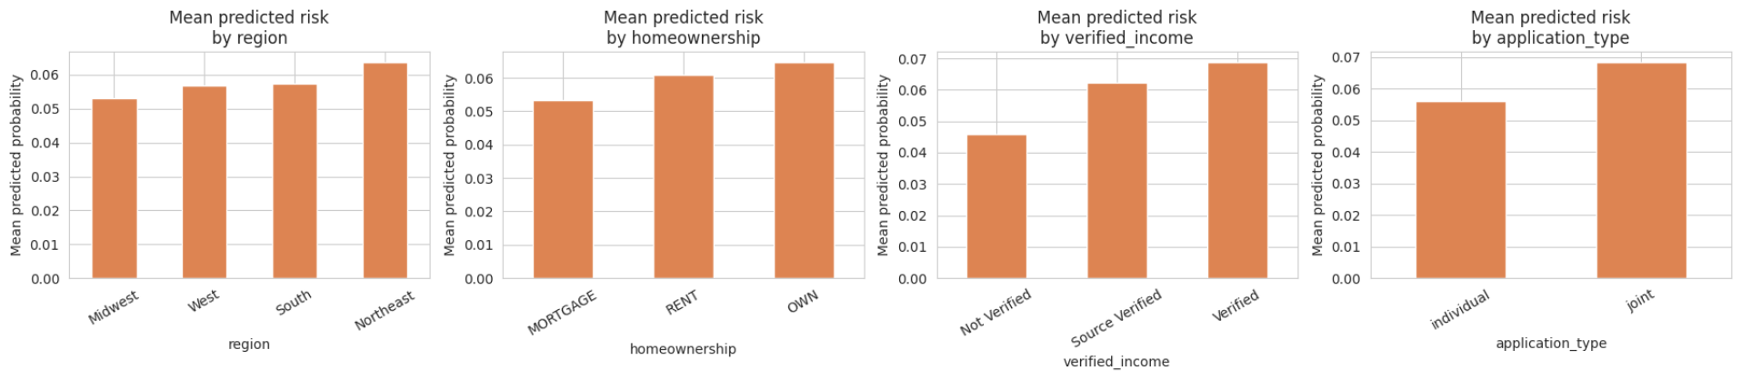

Figure 9: shows the average model-predicted risk by application type, income verification status, homeownership, and area.

Even though annual income is already a model feature, renters had a higher mean predicted risk than mortgage holders, indicating that homeownership carries a risk-relevant signal beyond income alone. Additionally, homeownership is a well-established proxy for wealth and, historically, for demographic composition (a legacy of unequal access to homeownership in the United States). A naive interpretation that "verification should reduce risk" would be misleading, as applicants with verified income demonstrated a higher actual and predicted default rate than unverified applicants. This is likely due to Lending Club's selective verification of applicants it already deems to be higher-risk. The Northeast had a somewhat higher rate, but regional differences were rather minor but not insignificant.
With just about 178 positive examples in the entire dataset, subgroup estimates contain significant statistical uncertainty, thus none of these patterns should be interpreted as proof of illegal discrimination on their own. They do, however, highlight that eliminating sensitive fields from a dataset does not, by itself, ensure an unbiased model and show precisely the kind of indirect, proxy-driven disparity that regulators expect lenders to actively test for under ECOA's disparate-impact doctrine, even when no protected attribute is used directly.

5. Conclusion and Recommendations:
For early-stage loan default risk, this study created and contrasted logistic regression and random forest classifiers using a limited, quarterly Lending Club snapshot. While logistic regression provided readily readable coefficients at somewhat lower discriminative power, random forest achieved somewhat superior ranking performance (ROC-AUC 0.662 vs. 0.559; PR-AUC 0.040 vs. 0.031) at the expense of requiring extra interpretability tools. The logistic coefficients identified the same core risk drivers as the SHAP-based explanation of the random forest: debt-to-income, income, credit utilisation and limits, and recent credit-inquiry activity. This is a comforting consistency check between the two very different modelling approaches. Even in the absence of any protected factor in the data, proxy-driven discrepancies in anticipated risk were found by a fairness audit across homeownership, income-verification status, and area that warrant active monitoring.
Four recommendations are based on these findings. First, because the current proxy target and the consequent poor precision limit real-world applicability, any practical deployment should be postponed until a longer observation window delivers a considerably larger number of confirmed, resolved outcomes (Fully Paid or Charged Off). Second, if a single model must be selected today, random forest is better on predictive grounds, but it should be combined with SHAP-based explanations for each unfavourable decision to maintain the transparency that both applicants and regulators demand; alternatively, a well-regularized logistic model continues to be a more transparent and defendable option where interpretability is given precedence over the final few points of ranking performance. Third, considering how sensitive these estimates were to already-constrained sample sizes, regular disparate-impact testing of homeownership, income-verification status, and any other socio-economic proxy variable should be conducted continuously, not only during model-build time. Fourth, in accordance with ECOA's adverse-action notice requirements, human review should continue to be involved in any borderline or unfavourable decision, both to make up for the model's existing low precision and to give applicants a way to challenge automated risk assessments.

References:
[1] T. H. Nguyen and D. B. Tran, “Business analytics using random forest trees for credit risk prediction: A comparison study,” ResearchGate preprint, 2025.
[2] S. Kumar et al., “Machine learning approach to credit risk prediction: A comparative study using decision tree, random forest, support vector machine and logistic regression,” ResearchGate preprint, 2023.
[3] Y. Zhang et al., “Evaluating machine learning models for personal credit risk: A comparison of logistic regression, random forest, and XGBoost,” ResearchGate preprint, 2025.
[4] S. Kakkar, “Explainable AI models for credit risk scoring in banking: Balancing accuracy and regulatory transparency,” Int. J. Financial Data Sci. (IJFDS), vol. 3, no. 2, pp. 1–6, Aug. 2025, doi: 10.34218/IJFDS_03_02_001.
[5] LendingClub, “Loans full schema dataset (Q1 2018 originations),” openintro.org, 2018. [Online]. Available: https://www.openintro.org/data/index.php?data=loans_full_schema
[6] R. Hlongwane, K. Ramaboa, and W. Mongwe, “A novel framework for enhancing transparency in credit scoring: Leveraging Shapley values for interpretable credit scorecards,” PLOS ONE, vol. 19, no. 8, e0308718, Aug. 2024, doi: 10.1371/journal.pone.0308718.
[7] Consumer Financial Protection Bureau, “Consumer Financial Protection Circular 2023-03: Adverse action notification requirements and the proper use of the CFPB's sample forms provided in Regulation B,” Sept. 19, 2023. [Online]. Available: https://www.consumerfinance.gov/compliance/circulars/circular-2023-03-adverse-action-notification-requirements-and-proper-use-of-the-cfpbs-sample-forms-provided-in-regulation-b/
[8] scikit-learn developers, “scikit-learn: Machine learning in Python — Release 1.8.0,” Dec. 2025. [Online]. Available: https://scikit-learn.org/

