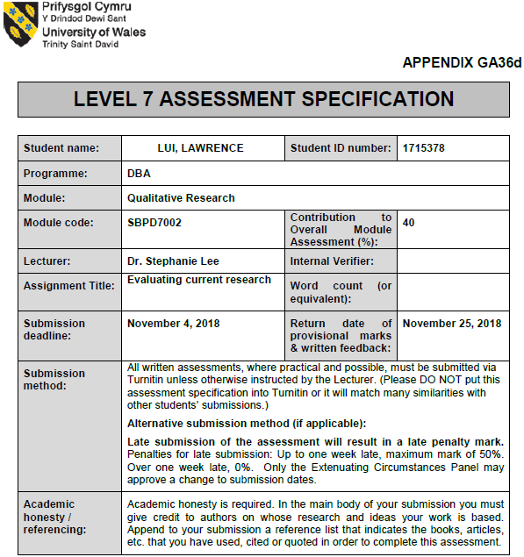
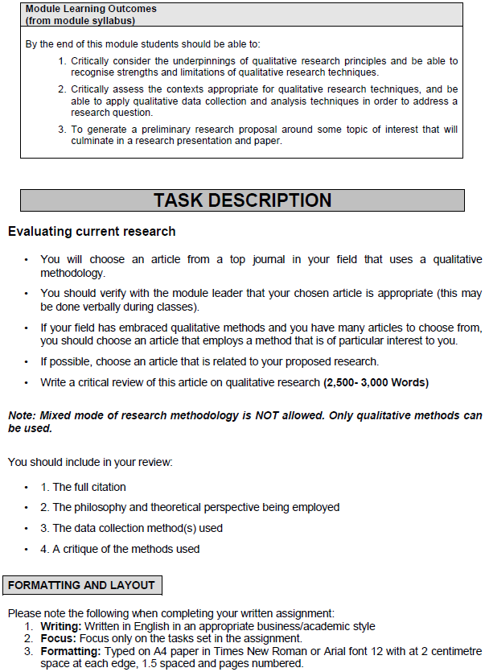
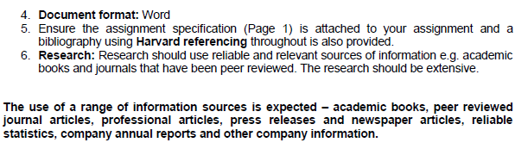

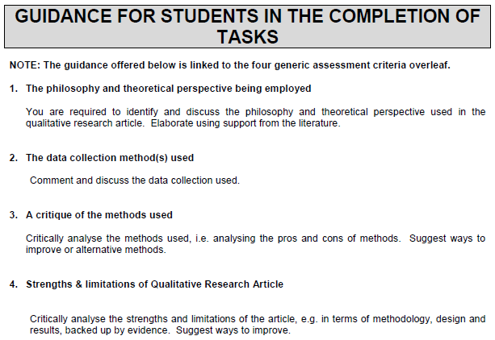
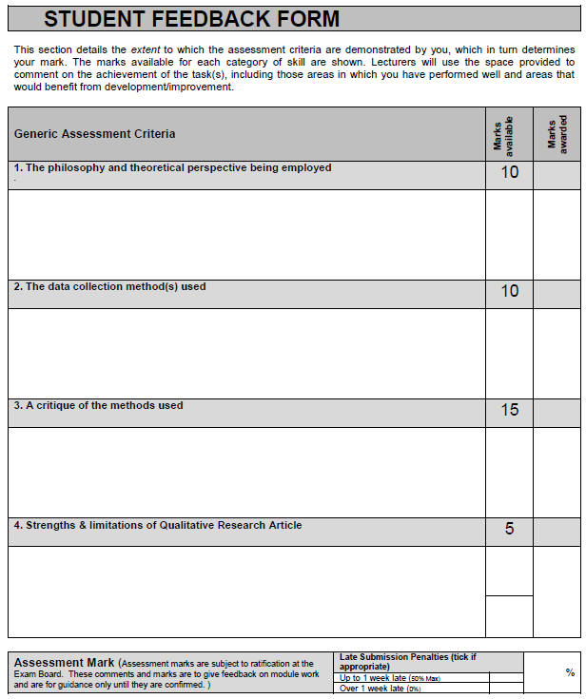
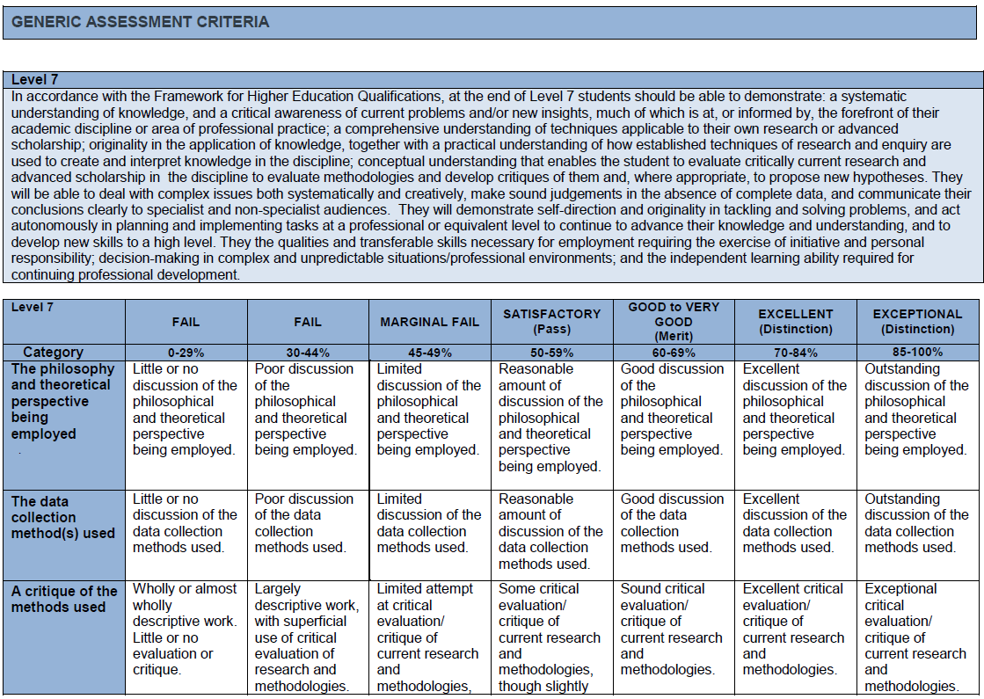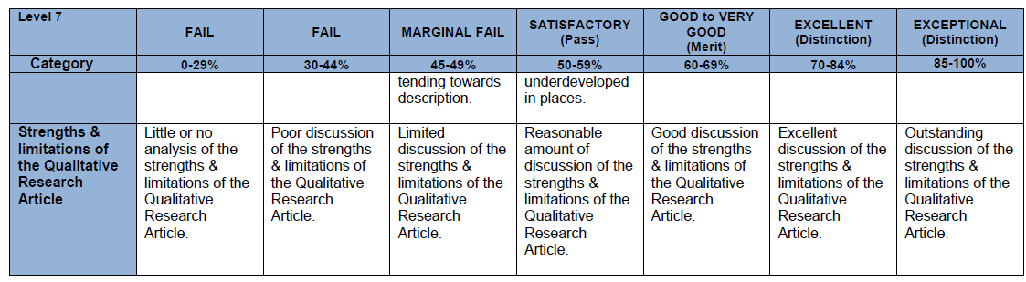
Table of Contents
- PART ONE: CRITIQUING THE PAPER 9
- CRITIQUE INTRODUCTION 10
- BRIEF SUMMARY OF THE ARTICLE 11
- HEGEMONY 12
- RESEARCH PROBLEM, ORGINALITY AND VALUE 12
- RESEARCH PHILOSOPHY 13
- CRITIQUE ON RESEARCH DESIGN & COLLECTION METHOD 13
- CRITIQUE EVALUATION - LIMITATIONS & STRENGTHS OF THIS QUALITATIVE RESEARCH ARTICLE 15
- CONCLUSION 19
- REFERENCES 20

PART ONE: CRITIQUING THE PAPER
“The Hegemony of the real estate industry:
Redevelopment of ‘Government/ Institution or Community’ (G/IC) land in Hong Kong”

WORD COUNT: 2,590

CRITIQUE INTRODUCTION
The title of the peer-reviewed article to be critiqued is “The hegemony of the real estate industry: Redevelopment of ‘Government/ Institution or Community’ land in Hong Kong”. The authors are Lee, Wai Ying Joanna and Tang, Wing Shing and the article was published on 6 December 2016 with the Impact Factor of 2.604 as of 30 Sep 2018. The purpose of the article is to give an alternative answer to the land question of G/IC redevelopment by addressing that there is a social phenomenon.in Hong Kong where the government, property developers, professionals as well as other parties have altogether participated in the capital accumulation process in different ways and to different extents.

The authors have not deeply considered Hong Kong’s private housing market in a complete picture. The paper does not land on a good theory because a wide spectrum is necessary to be studied in order to come up with a conclusion on whether hegemony exists in Hong Kong.

The purposes of this critique paper are as below:

- To critically evaluate the underpinnings of qualitative research principles as well as the authors’ philosophy and theoretical perspectives, limitations & strengths of this qualitative research methods, and expression of propositions that are based on, for instance, superficial information, misunderstanding of situational factors or hasty generalization.

- To critically assess the contexts that are suitable for qualitative research techniques and the strengths and limitations of the qualitative research article.

BRIEF SUMMARY OF THE ARTICLE
The authors, Lee and Tang, have orientated the readers to the study by addressing hegemony of the real estate industry that the authors think it actually exists in Hong Kong. Lee and Tang consider that Government/ Institution or Community land redevelopment links to a number of parties such as the government, real estate developers, experts, charitable bodies, religious organisations and even the general public -- all take part in this capital accumulation projects in Hong Kong, and hegemony is proven to exist in the process of changing of land usage.

Out of the 438 applications of redevelopment projects of Government/ Institution or Community land from 1990 to 2015, the authors picked two redevelopment projects in the study with the aim to dig into the different stakeholders’ perspectives in the hegemonic redevelopment regime in Hong Kong -- one project is related a church at No. 1 Star Street in Wanchai and the other one is “Ebenezer School and Home for the Visually Impaired” in Pok Fu Lam. These entities are charitable or educational in nature, and hence the land was usually held under unrestricted leases which do not have user restrictions. Lee and Tang point out that through the process of repeated negotiations and offers, the real estate developers are making huge profits whereas other parties including the charitable groups and the general public also take part in similar urban redevelopment projects. The reason is that the property developers will apply for lease modifications to build residential units or “commercial plus residential” elements which usually can be sold with high prices after redevelopment.

HEGEMONY
Early in 1971, the concept of hegemony was raised by Gramsci. He considers the problem of hegemony a creation by the dominant group and this is commonly supported by all sectors of society. It is somewhat a consent given by the general public and this acknowledgement is caused by the prestige which the dominant group enjoys due to its unique social position (Gramsci, 1971). Until around year 2000, there were literatures which started to superficially discuss the overall concept of the domination of landed capital in real estate development (Cheng 2001; Goodstadt, 2005; Poon 2014; Smart and Lee, 2003). However, these articles do not elaborate how the government and real estate developers collude or work with each other to dominate others so that they are in total control of real estate hegemony (Tang et al, 2011).

In Hong Kong, hegemony is often discussed because real estate developers realise clearly that the Hong Kong Government is glad to see high prices of land sale (correctly speaking, it is sale of land use rights) (Tang et al, 2011). Through the sale of land which constitutes and secures a high level of income, the Hong Kong Government accumulates a major portion of the city’s wealth (Haila, 2000).

RESEARCH PROBLEM, ORGINALITY AND VALUE
The research problem in the article is whether there is a phenomenon that exists in the redevelopment of Government/ / Institution or Community land. In the eyes of Lee and Tang, the value of the study rests on the fact the existing literature has failed to admit that the rocket-high prices are caused by hegemonic construction of land redevelopment projects.

RESEARCH PHILOSOPHY
An inductive approach is used in the article. The essence is associated with Hong Kong citizens who commonly face a social phenomenon – rocket high property prices. The inductive approach is employed to generate a result that associates the redevelopment of Government/ Institution or Community land to the benefits that are rewarded to real estate developers and other stakeholders. The research strategy is explanatory as the authors have performed a few personal interviews to find out facts about this type of land redevelopment.

Lee and Tang’s position in this qualitative study is epistemological and their comments reflect a relatively high degree of interpretivism that comprises of subjective interpretations. There is some constructivism in the article but certain standpoints are weak and this will be discussed in the later part of this research paper.

CRITIQUE ON RESEARCH DESIGN & COLLECTION METHOD
Throughout the paper, it is noted that Lee and Tang conducted three interviews only. One interview was conducted with “a senior town planner” in the Planning Department. Another interview was with a senior church member of Our Lady of Mount Carmel Church at No.1 Star Street in Wanchai, which later was redeveloped to a residential project with this church being re-constructed inside the new building. The authors also interviewed with Cheung Kong Holdings, the relevant real estate developer – however the title of the interviewees was not mentioned. For these three interviews, no real names were put down in the study. In addition, no questionnaire or other forms of interviews was performed (e.g. telephone interviews or focus-group interviews) for the study.

The rigor requirements of a proper qualitative research should show that the research design and collection method is able to meet the criteria of achieving internal validity, external validity and reliability. Moreover, the research design and collection method should also come with trustworthiness which includes creditability and auditability (Guba and Lincoln, 1981). Throughout the article, only two projects were selected to find out the existence of hegemony and that only three interviews were conducted by Lee and Tang. The adequacy and validity of the research is seriously questionable as there are 438 applications of redevelopment projects of Government/ Institution or Community land from 1990 to 2015. As there is no questionnaire distributed to stakeholders, reliability and validity of data and collection method is low. The research method lacks auditability as no name of interviewees is revealed in the article.

Per above, the research methods are only confined to three personal interviews. It is necessary to point out that there is also no description of the interviewees’ age, background or expertise. The length of interviews was not mentioned. Moreover, the questions raised to the interviewees are not disclosed in the article. Hence, it is hard to judge the reliability of information provided by the authors.

Lee and Tang could have done the research methods better. If there is a chance to reconstruct the research methods with the aim to enhance creditability level, I would recommend to include personal interviews with different real estate developers, at least one government official at the Development Bureau of Hong Kong, and randomly select some residents who bought redeveloped properties. The authors could send a well-structured questionnaire to the neighborhood to collect their comments with respect to the redevelopment process, project scheme as well as their feelings and opinion towards the issue of real estate hegemony. Lastly, opinions from the general public should also be collected because it is where the largest noise of hegemony issue originated from.

CRITIQUE EVALUATION - LIMITATIONS & STRENGTHS OF THIS QUALITATIVE RESEARCH ARTICLE

Lee and Tang’s article has certain limitations and strengths. My viewpoints are summarized below with a sub-heading for easy identification purpose.

LIMITATIONS

Superficial Judgement & Validity Issue (Article P.3404, 3407)
In the introduction, the authors state that due to the vested interest in land of the Hong Kong government and the real estate developers, the government-enterprise collusion continues to bolster the hegemony of the real estate industry. Lee and Tang specifies that giant real estate developers play a vital role in everyone’s lives but the majority of citizens keep silent.

The above appears to be superficial comments, particularly when talking about government-enterprise collusion it is an accusation without concrete evidence.

Lee and Tang point out that the widespread argument for the sky-high property prices is the scarcity of land and increasing demand which leads to the unaffordable housing prices. I think the Lee and Tang could have given more statistics such as the respective land area held by the government and the real estate developers as well as the housing affordability index. The authors seem to purposely omit other factors that are not related to hegemony and have led to the housing prices, such as the effects of worldwide and local financial policies like Quantitative Easing (“QE”) implemented by mainly the United States, Europe and Japan (Amaden, 2008; Cho and Rhee, 2013), and Qualified Domestic Institutional Investor (“QDII”) Scheme which brings a lot of hot money to the financial system in Hong Kong (Hui. Ng and Lau, 2011). Also, other factors like abnormally-low interest rates for mortgages, ease of topping up mortgage loan, a major increase in tourists and expats are all crucial factors that are not related to hegemony but caused the housing prices to surge for years. Hence, Lee and Tang’s have some bias on the hegemony issue and they do not address the surrounding factors objectively. This will mislead the readers.

Authors’ perspectives are technically wrong, unfair, or inadequately researched
(Article P. 3410, 3416 and 3417)
Lee and Tang address that the existing system on Government/ Institutional or Community land expedites the change of usage from G/ IC to private, revenue-generating development has perpetuated the real estate hegemony in Hong Kong. The authors believe that the government supplies real estate developers with prime land and those charitable entities bunker the housing prices. Moreover, Lee and Tang repute that the redevelopment of G/IC sites embodies a redistribution of benefits from the general public to the real estate developers.

I consider that this theoretical perspective is incorrect because if this land practice has not been so arranged, there would be fewer housing units completed over the past two decades which means that the housing prices could be higher than the existing level. The authors’ critical thinking ability is doubtful. The concept of “redistribution of profits” is unfair because the home buyers or property investors generally made money from their investment as well.

Logic Problem
(Article P. 3405, 3416)
Lee and Tang state that most people in Hong Kong are conscious in their buying of properties (also the selling of land to the real estate developers), but they are unconscious about the ramification of this. They elaborate this concept by saying that this buying/ selling actions will perpetuate the uneven power between the real estate giants and the general public. I consider that there is some problem with the authors’ logical thinking ability, and we should rethink the social phenomenon that if those property buyers never bought a property, they could have become financially poorer during these decades of property prices catapult. These people would need to rent a place to live or else they might need to seek the government-subsidized housing which in return increases the burden of the Hong Kong Government.

Lee and Tang also point out that the redevelopment project of Catholic Diocese church which once lacked funds to renovate and the developer had the desire to redevelop to a luxury residential project. It is mentioned in the article that it is a “win-win situation” for the Catholic Diocese and the developer. Most importantly, I noted that the property buyers only purchased at HK$4,936 per sq. ft. in 1999 and later the average price surged to over HK$22,000 per sq. ft. in 2018. Furthermore, the environment has become superior because the luxury residence gives neighborhood a modern and exquisite atmosphere. Hence, I consider that under this circumstance, all parties are actually benefited from the change of land usage and the subsequent redevelopment. The authors’ standpoint of the creation of real estate hegemony is actually unjustifiable.

Bad Opening (Abstract) (P.3404)
Although the article is in English, there are two paragraphs of abstract – one of them is written in Chinese and the other one is English. This presentation is not necessary as the remaining part of the article is entirely expressed in English.

The abstract in one way points out that people have misconception towards the term “hegemony”, however the author does not elaborate the issue of “real estate hegemony” very well in the article. The abstract does not constitute enough power to establish a standpoint about the complex property market, particularly for Hong Kong. The abstract may cast an image to certain readers that the authors are not very much familiar with the real estate environment in Hong Kong.

Ethics
There are no ethical issues discussed on data collection or other aspects in the paper. Regarding the accuracy of collected information as mentioned in the “Critique on Research Design and Collection Method” section, the authors could have done some in-depth interviews to ensure the validity and reliability of data. This will enhance the creditability and validity of the study.

Missing of a Coding Tree
Without a coding tree, it would be harder to show the richness, complexities and contradictions of the social phenomenon which is the basis of qualitative methods.
The authors could have drawn a tree to identify the codes and themes of real estate hegemony particularly if these elements can justify the overall social concept or will reflect the people’s psychology towards hegemony.

Strengths of the Article
The article has shown a high level of English proficiency and its writing style makes readers easy to follow. The authors have made a lot of efforts in obtaining plenty references from different journals to enrich the study.

CONCLUSION
The research paper does not state the discussion on its significance. The authors have missed the chance to introduce the reader to the importance of the topic being studied and place the topic into a particular context. Overall, the article touches the concept of redevelopment of Government/ Institutional Community land with some superficial judgements and illogical statements that lead people think the real estate developers are hegemonic in the redevelopment process. The research methodology should largely be improved as stated in the “Critique on Research Design and Collection Method” section, otherwise the validity, objectivity, auditability might be questioned by the readers or scholars. Last but not least, it should be noted that most properties in Hong Kong are not built from G/IC redevelopment, and hence the research value of the article is not quite significant to the general public, the government or the real estate sector.

REFERENCES

Amadeo, K. (2018). How QE4 Changed Fed History. [online] The Balance. Available at: http://www.thebalance.com/qe4-explanation-pros-and-cons-3305532 [Assessed 14 Oct 2018]

Cheng, H. L. (2001). Consuming a dream: Homes in advertisements and imagination in contemporary and imagination in contemporary Hong Kong. In: Mathews G and Lui TL (eds) Consuming Hong Kong. University of Hong Kong, pp. 205-236.

Cho, D. and Rhee, C. (2013). Effects of Quantitative Easing on Asia: Capital Flows and Financial Markets. ADB Economic Working Paper Series, (350), pp.14-15

Goodstadt, L.F. (2005). Uneasy Partners: The Conflict between Public Interest and Private Profit in Hong Kong. Hong Kong University Press.

Gramsci, A. (1971). Selections from the Prison Notebooks. New York: Institutional Publishers.

Haila, A. (2000). Real Estate in Global Cities: Singapore and Hong Kong as Property States. Urban Studies, 37(12), pp.2241-2256.

Hui, E. and Ng, I. (2009). Price discovery of property markets in Shenzhen and Hong Kong. Construction Management and Economics, 27(12), pp. 1175-1196.

REFERENCES (CONT’D)

Morse, J., Barrett, M., Mayan, M., Olson, K. and Spiers, J. (2002). Verification Strategies for Establishing Reliability and Validity in Qualitative Research. International Journal of Qualitative Methods, 1(2), pp.13-22.

Poon, A. (2014). Land and the Ruling Class in Hong Kong. Singapore: Enrich Professional Publishing.oon, A. (2005).

Tang, W.S., Lee, J. and Ng, M.K. (2011). Public engagement as a tool of hegemony: The case of designing a new central harbourfront in Hong Kong. Critical Sociology 38(1), pp. 89-106.

Wong, S. H. (2015). Real Estate Elite, Economic Development, and Political Conflicts in Postcolonial Hong Kong. China Review 15(1), 1-38. Chinese University Press. Retrieved November 1, 2018, from Project MUSE database.

