
Network Operating Systems and services (NOSS)
Component One

January 27, 2022
Samantha John
2115880

Contents
Task 1 2
Part 1 Virtual Machine and Operating System Installation 2
Part 2 Virtual Network Configurations 14
Task 2 22
Deployment of a Network Directory Service 22
Pre-requisite 22
Deploying AD 24
Creating User accounts 28
Creating an additional user 30
Object attributes 32
Adjoining the domain and testing user logins 34
Task 3 39
Observations 39
i. 39
ii. 40
iii. 41
iv. 42
v. 42
vi. 43
References 44

Task 1

Part 1 Virtual Machine and Operating System Installation

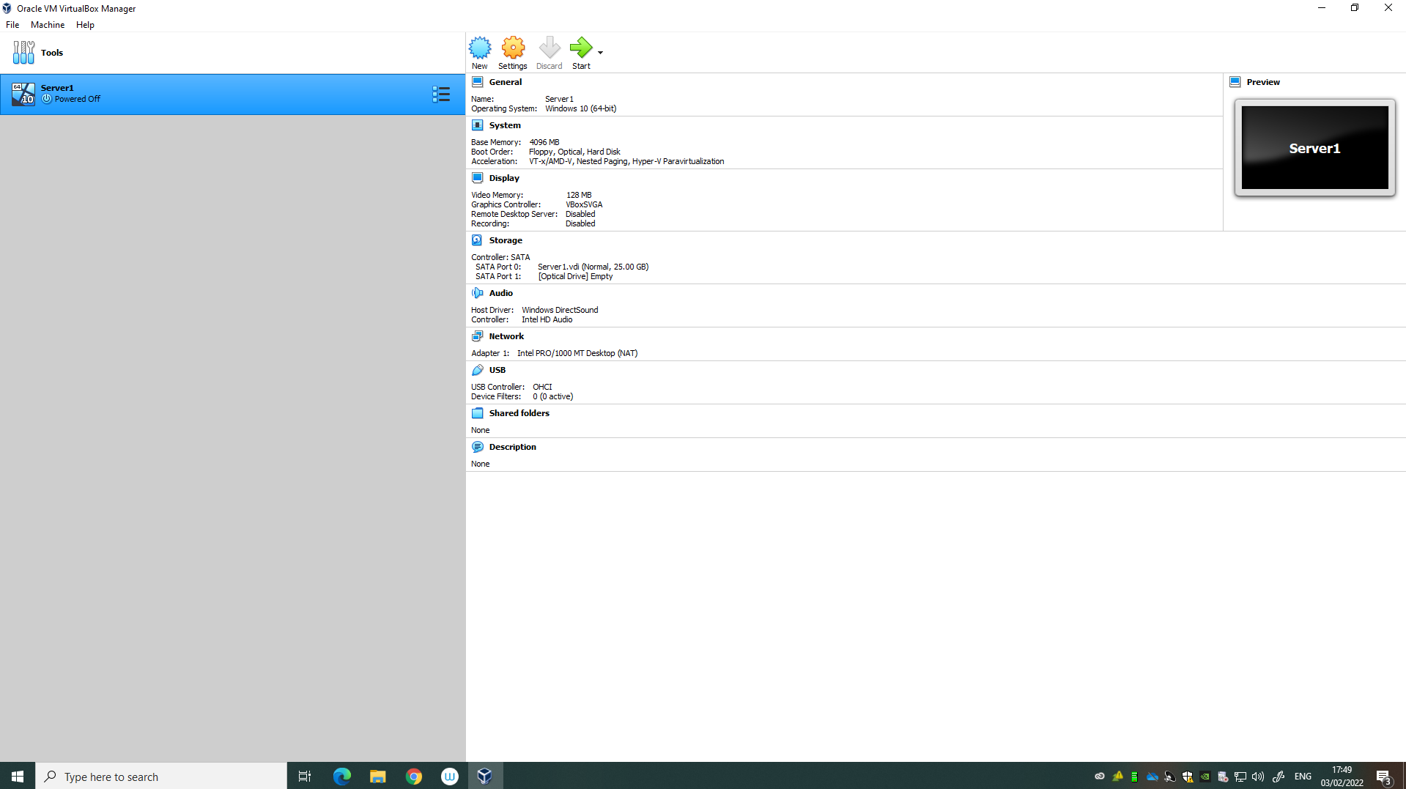
Figure1 Server1
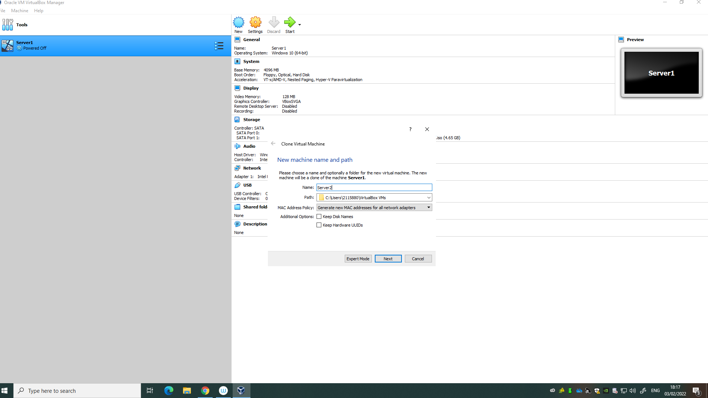
Figure 2. Creation of server2 using the clone feature
Server Specifications:
Windows Server 2019 64-bit addition: Hardware requirements for Windows Server | Microsoft Docs
4096MB of memory
25GB Hard disk

The above screenshot shows the creation of another server, references Server2 using the clone feature within VirtualBox. Here it is essential to ensure that the clone is set to generate a new MAC address for the clone device. A MAC address is used in network drive communication, should two devices on the same local area network have the same MAC address both devices would not be able to communicate properly.
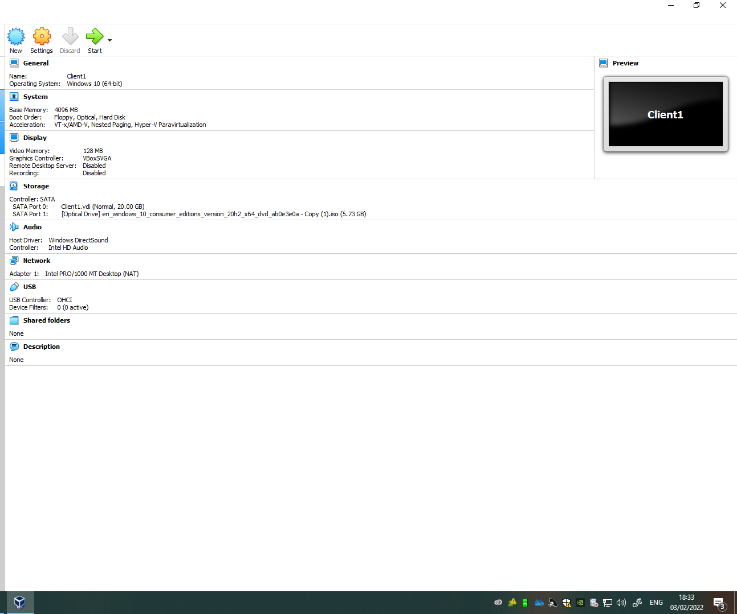
Figure3. Client 1
The above screenshot demonstrates the creation of the client machine referenced as client 1.
Installing a Microsoft Windows 10 64-bit ISO edition: Windows 10 system requirements (microsoft.com)
Speciation’s:
- Hard disk of 20GB
- 4096MB of memory
A clone of client 1 was made and referenced as client 2 using the clone feature used to create server1, again ensure that the MAC address is unique.
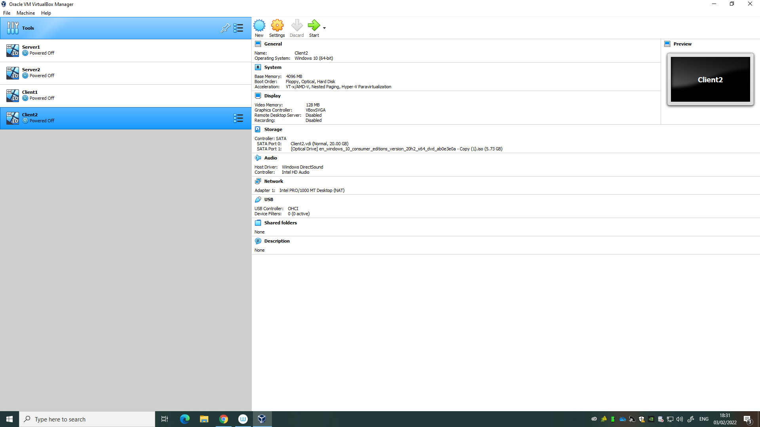
Figure 4 Demonstrates two servers and two clients

Parts x-xxi

The next few screenshots demonstrate the changes made to the servers and client to optimise the performance of the Type 2 Hypervisor.

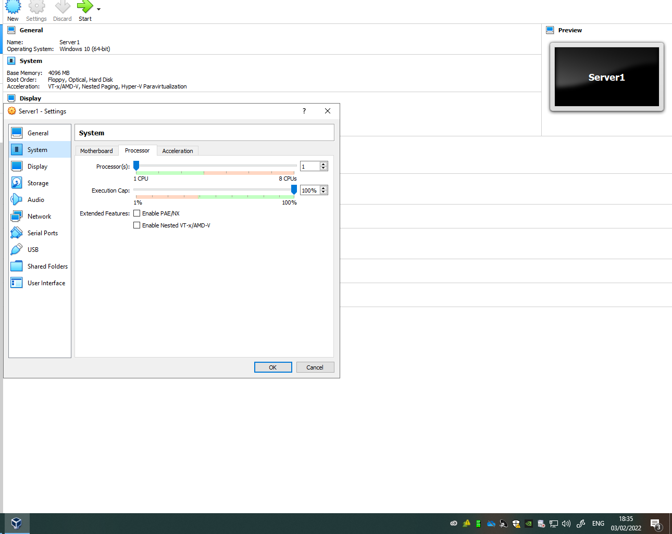
Figure 5 Server 1 with 1 CPU.
The above screenshot shows that the servers initially have 1 CPU assigned to them, Waddilove suggests [1] that we can improve VirtualBox performance by allocating additional CPU’s. However, assigning too many CPU’s to the guest machines will impact the performance of the host machine.

Host machine specification:
11th Gen Intel(R) Core(TM) i5-1135G7 @ 2.40GHz 1.38 GHz
4 cores

Based on the host machines specifications the CPU’s on the guest machine were kept at 1 CPU.

Waddilove [1] also suggests that by increasing the display video memory the performance of VirtualBox can be improved. However, on checking each of the servers and client devices it was established that the display video memory was already set to maximum and therefore were unchanged.

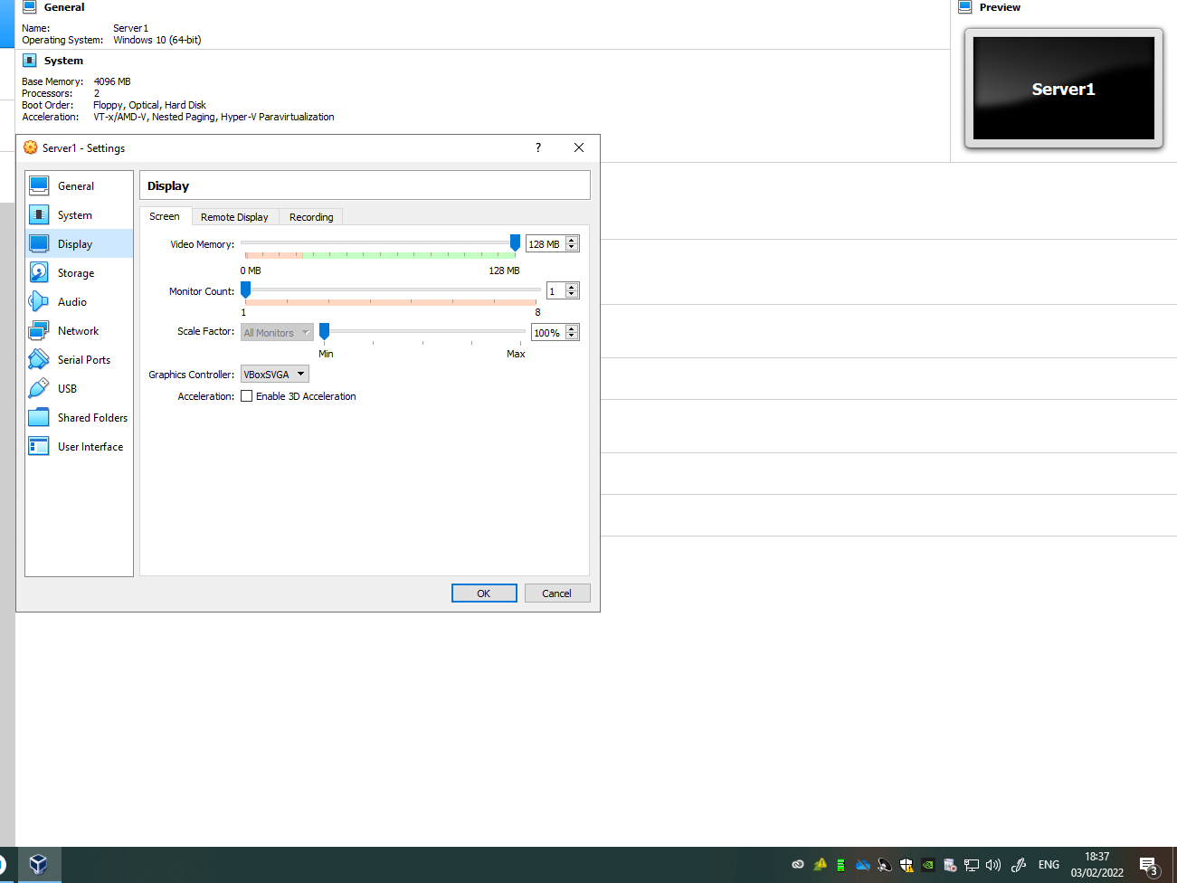
Figure 6 Display video memory is set to 125MB

Based on the design brief each server and client device could undergo further adjustments to improve the guest machine’s performance.
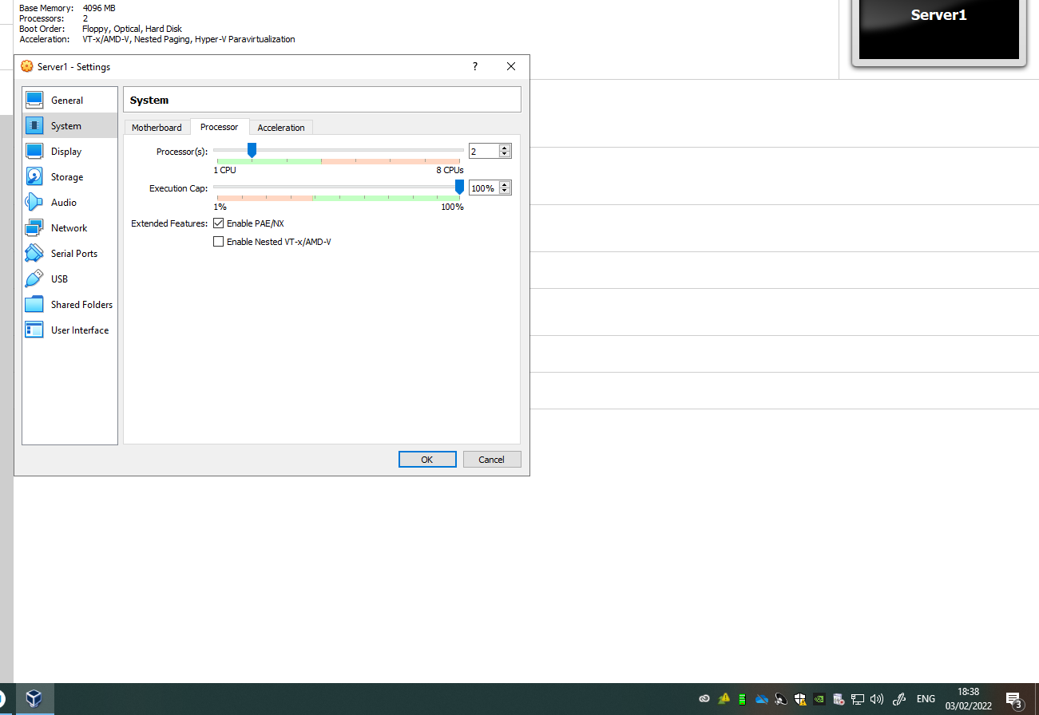
Figure 7 PAE/NX setting is enabled

The above screenshot shows that PAE/NX were enabled on Server1 and replicated across all devices.
According to the VirtualBox manual [2] enabling Physical Addressing Extension (PAE)/No Extension (NX) allows the CPU to access more than 4 GB of RAM which is achieved by adding another 4 bits of memory addresses. However, an Open-Source Microsoft document [3] states that “PAE is used only by 32-bit versions of Windows running on x86-based systems.” On this occasion both the host and guest machine are operating on a 64-bit OS.

Parts xxii - xxxvi
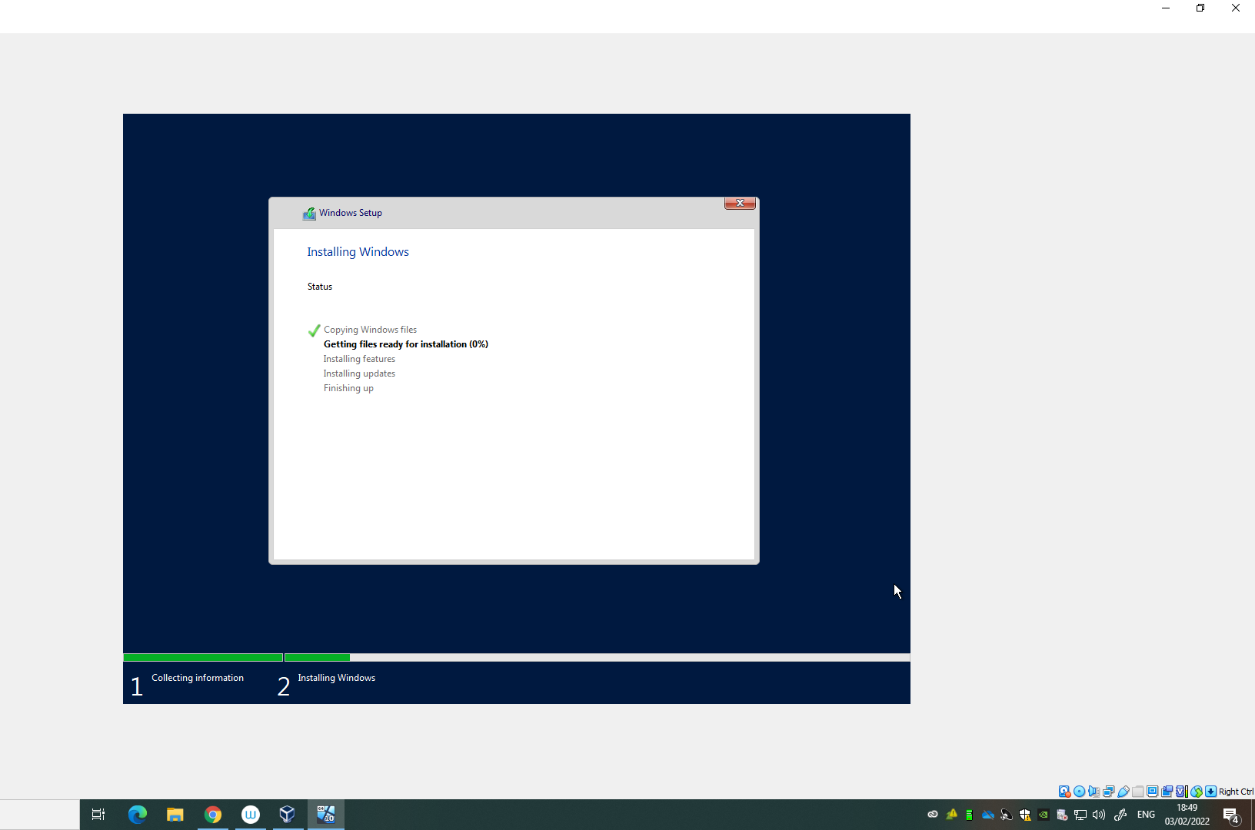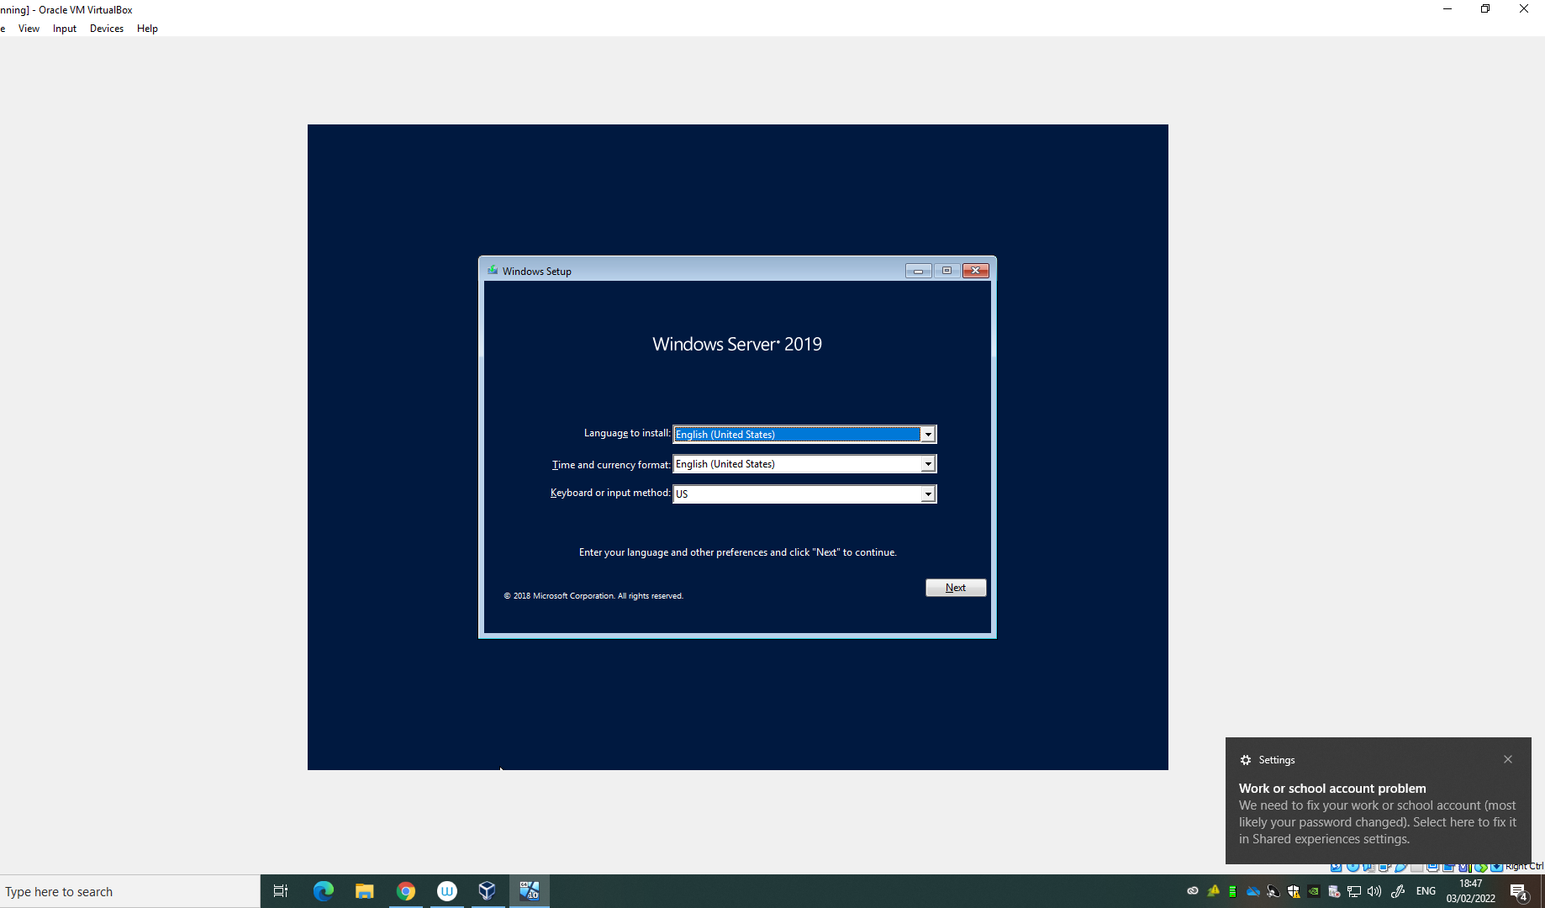
Figure 8 Server1 launches into Windows server 2019 set-up

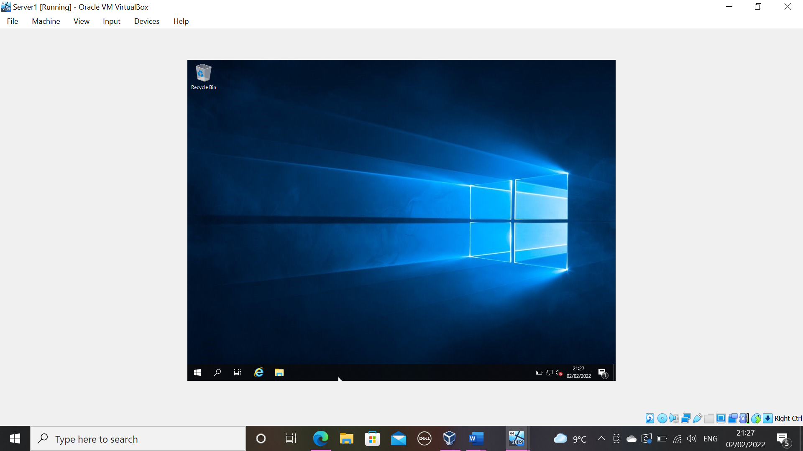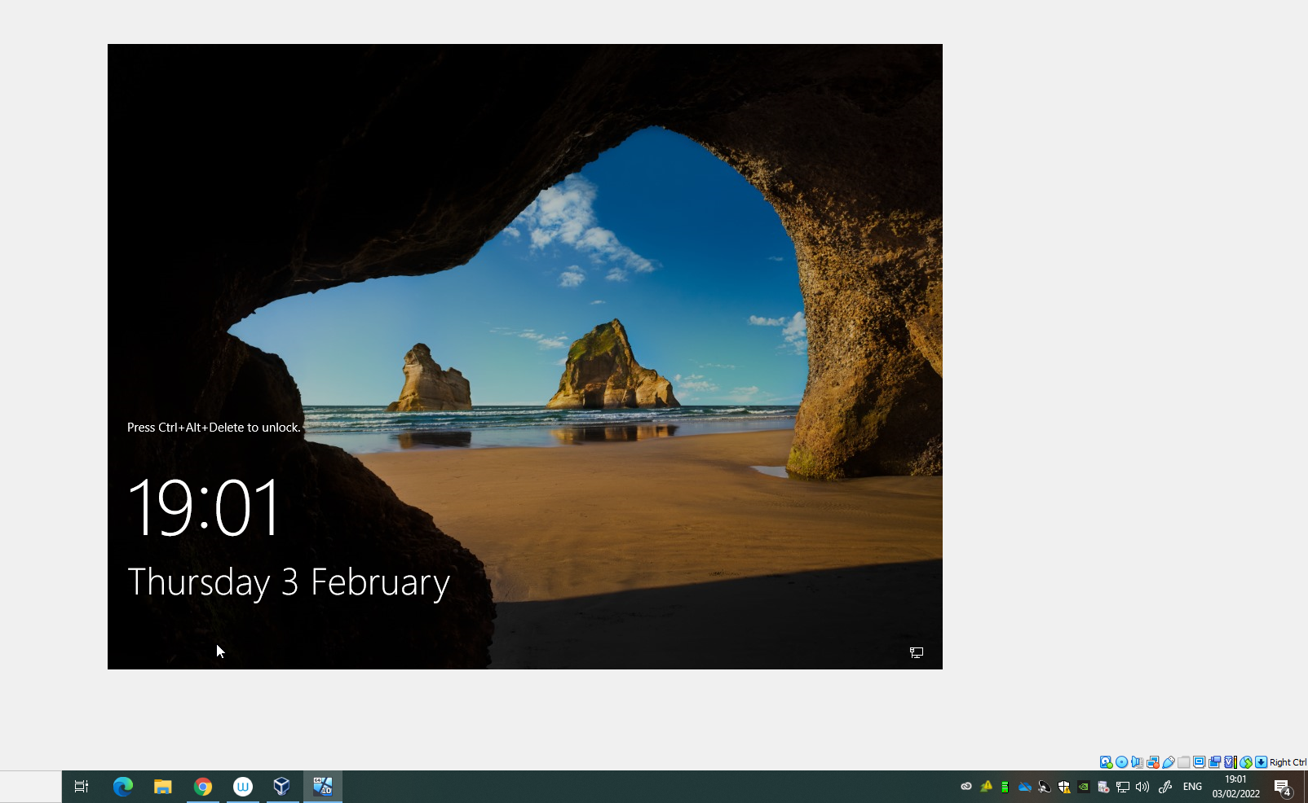
Figure 9 Successful installation

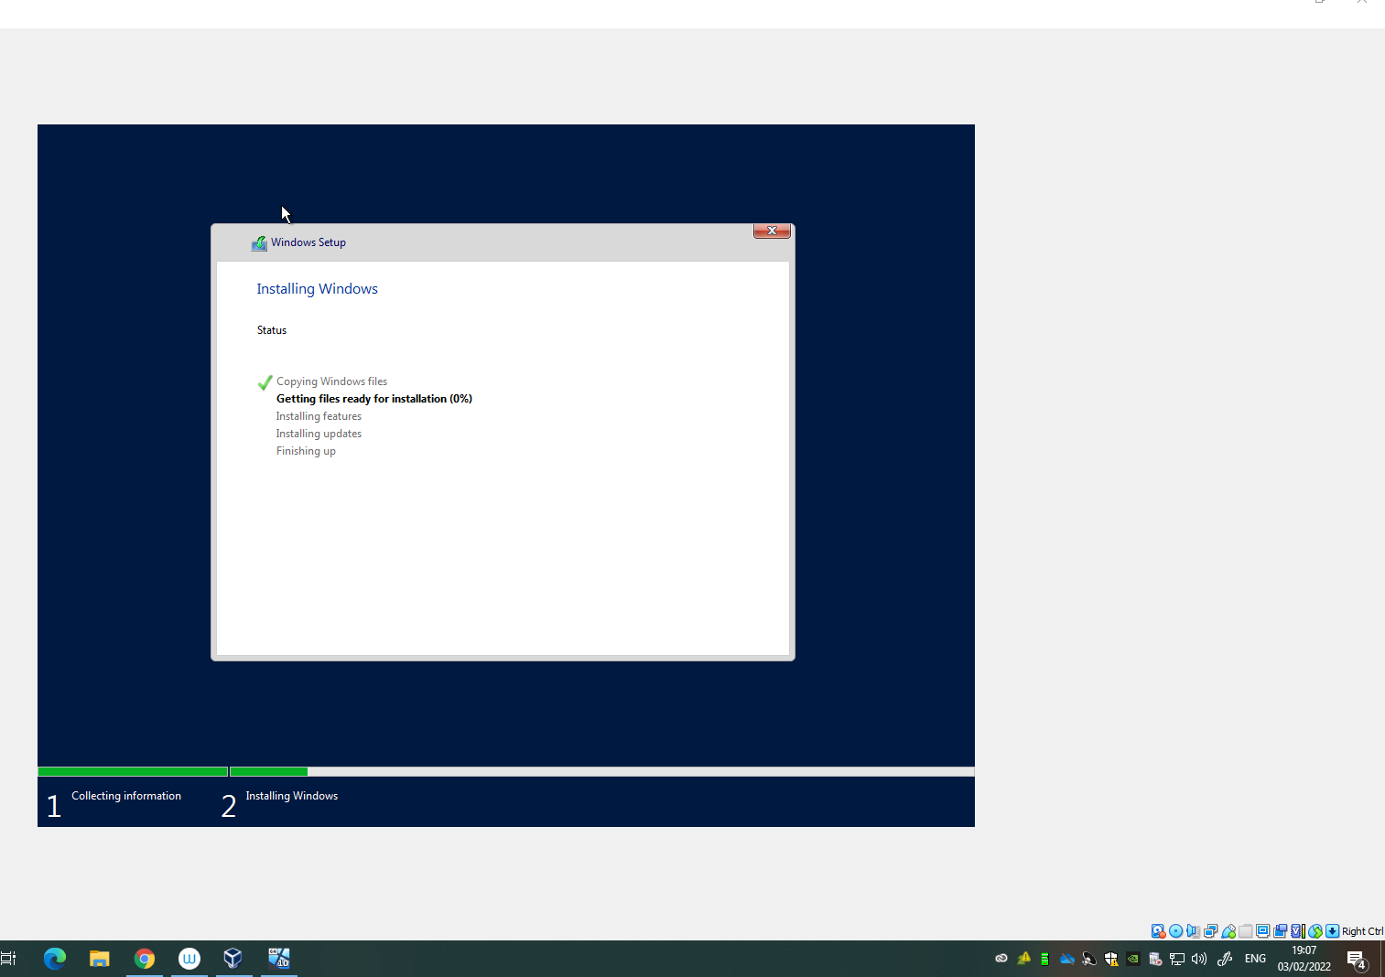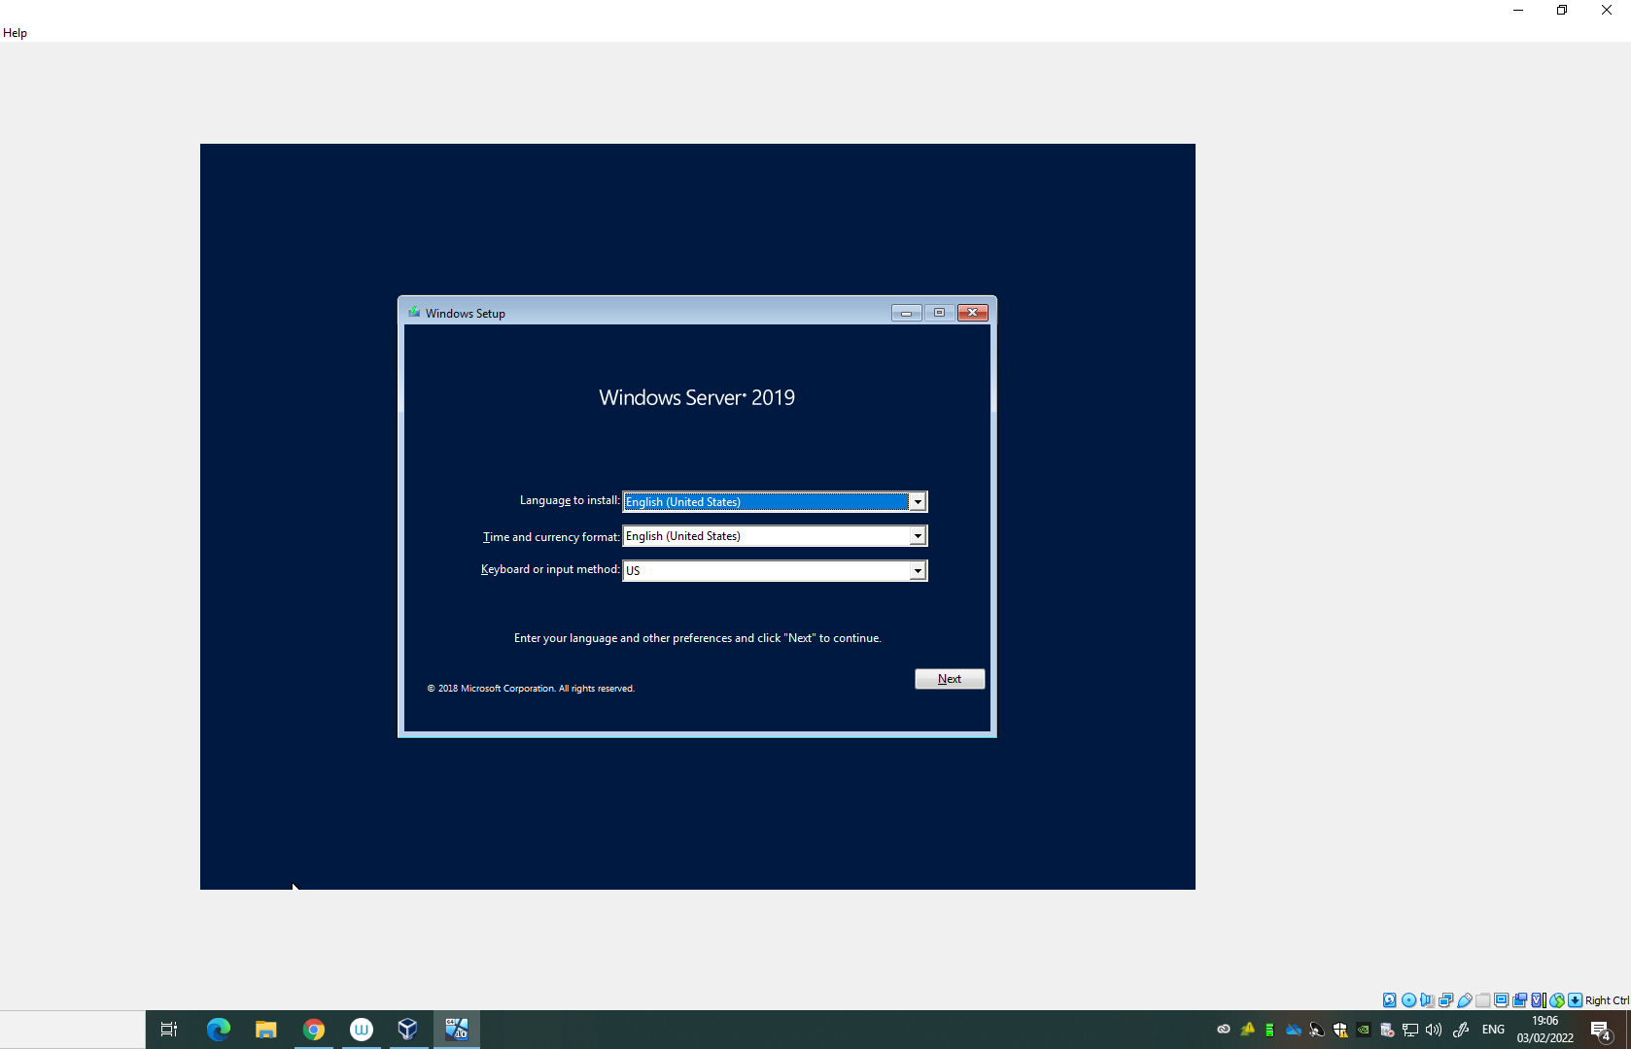
Figure 10 Server2 launches into Windows server 2019 set-up

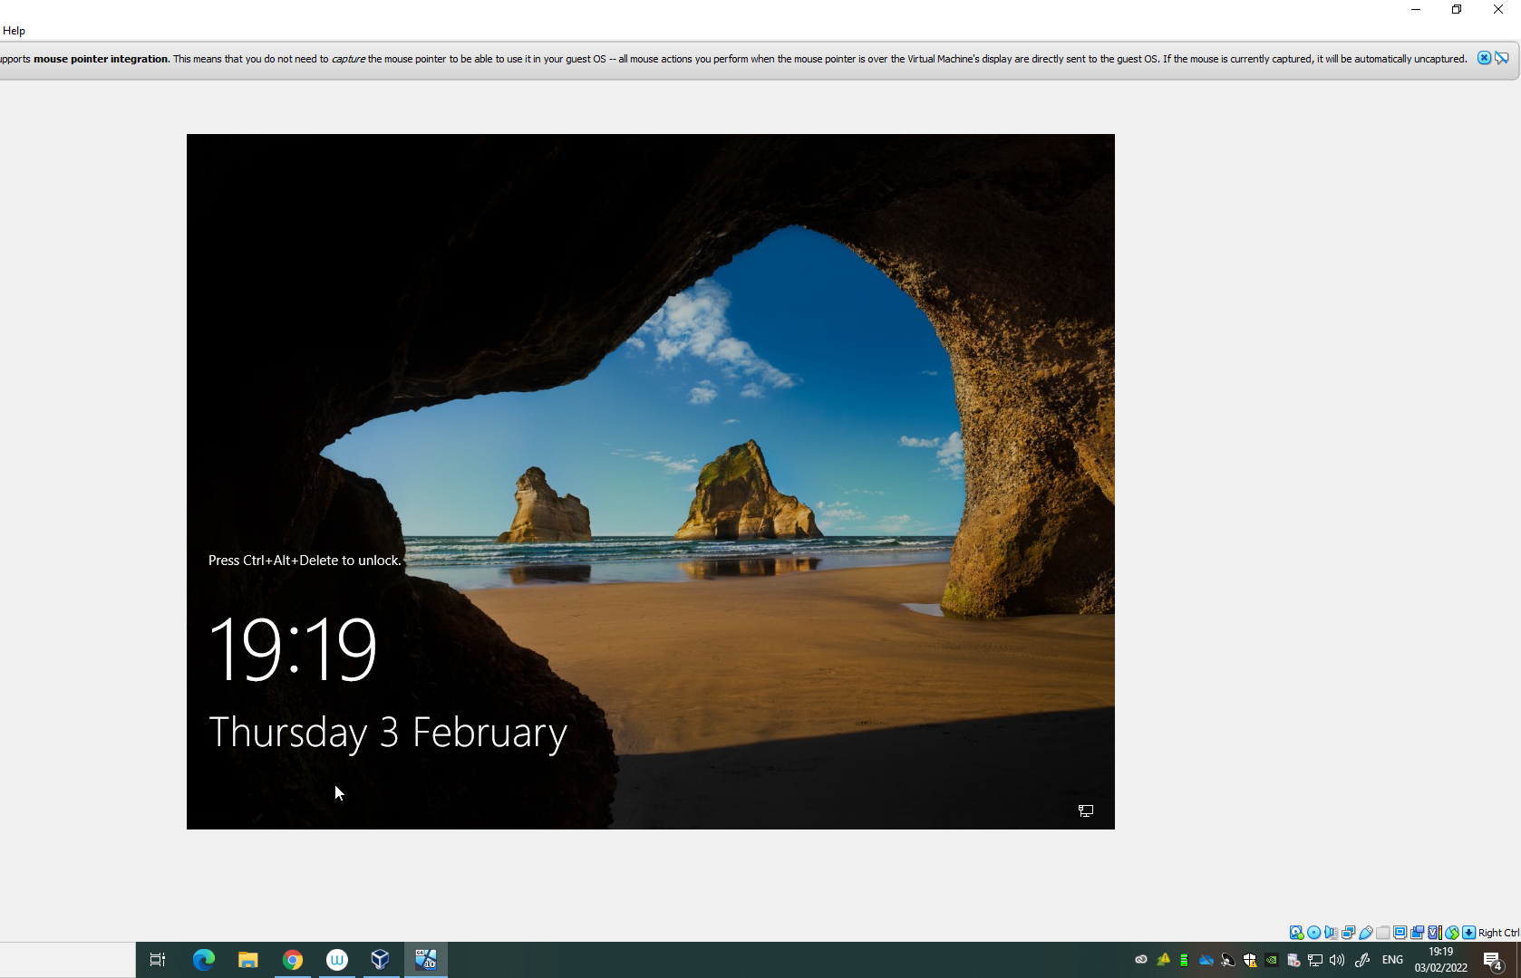
Figure 11 successful installation Server 2

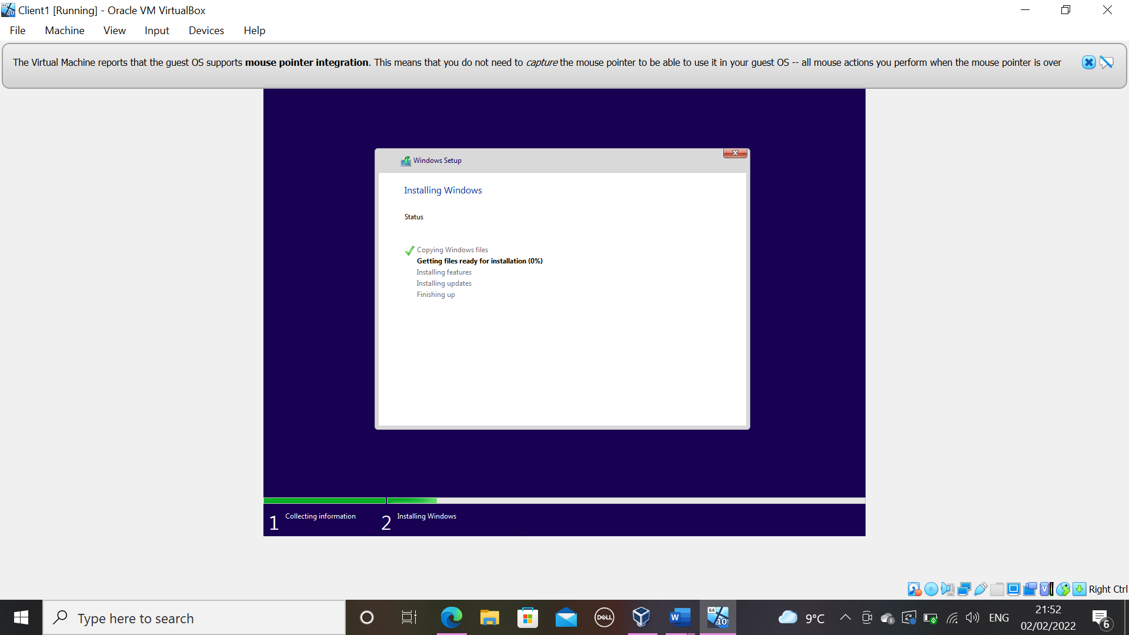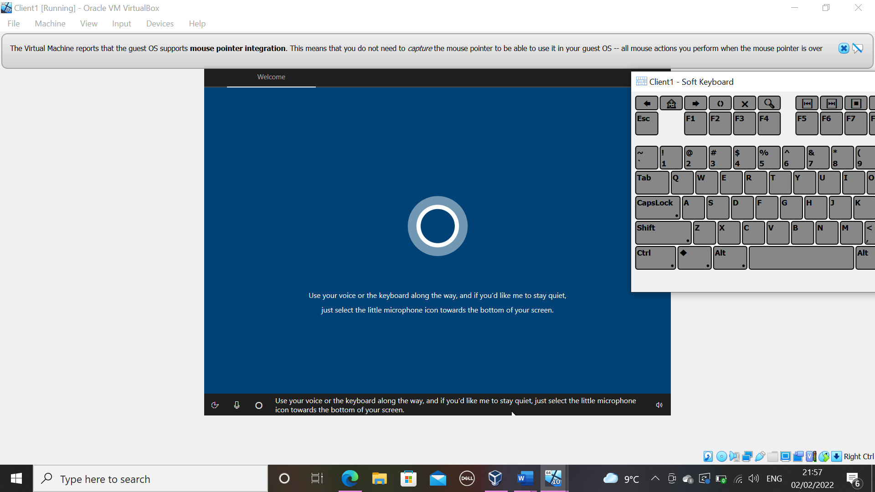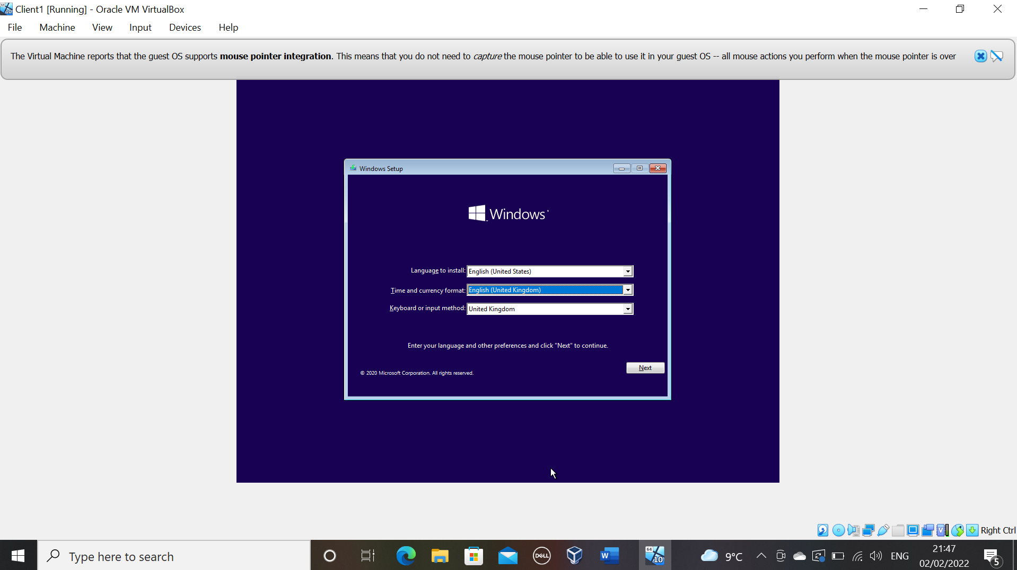
Figure 9 Demonstrates the start of windows 10 Education installation for client1 and successful installation
Operating System: Windows 10 Education
Minimum requirements to enable hypervisor software: Enable Hyper-V on Windows 10 | Microsoft Docs

As the above requirements suggests Windows Home Edition would not be compatible with a type 2 hypervisor architecture as virtualisation is not enabled this edition.

The above steps were successful on client 2.
(Sectional word count 557)

Part 2 Virtual Network Configurations

Parts i – xx
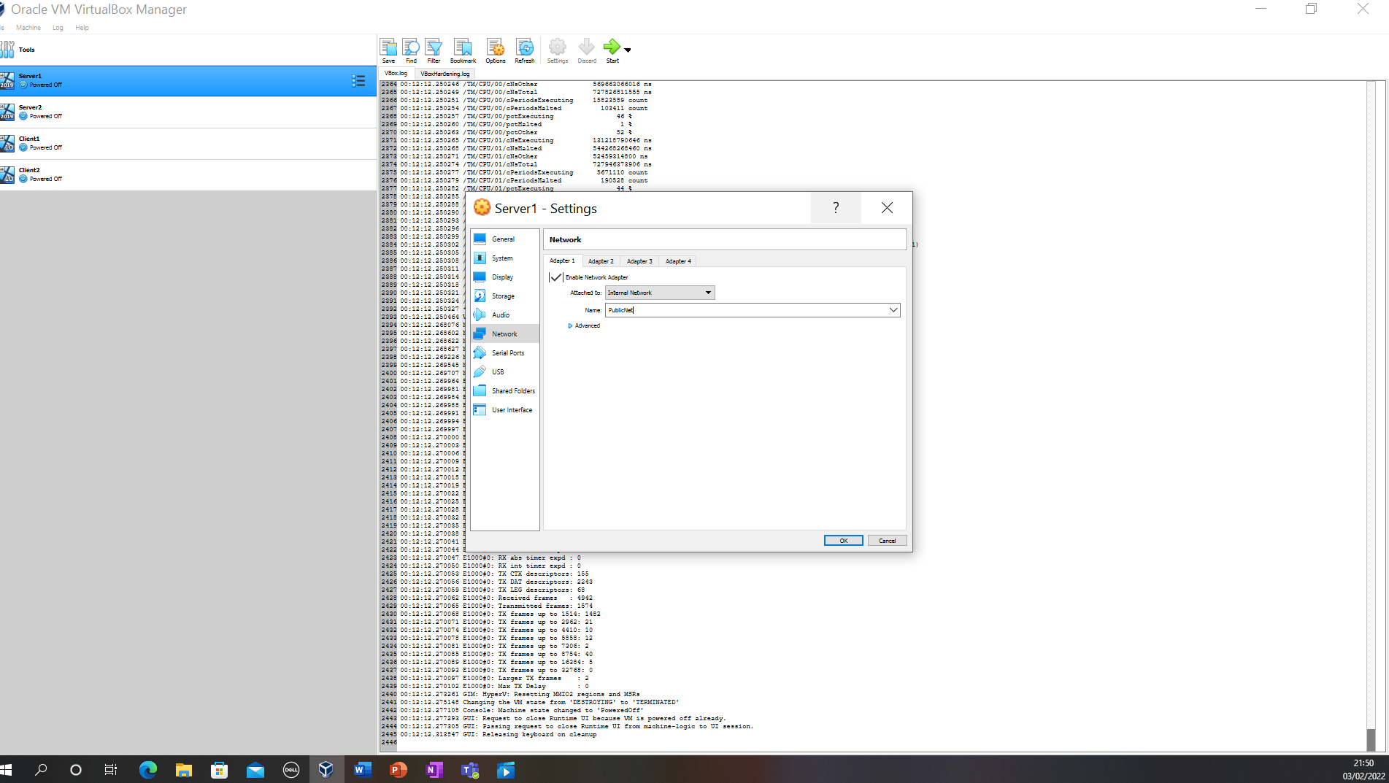
Figure 13 Server with internal network - PublicNet
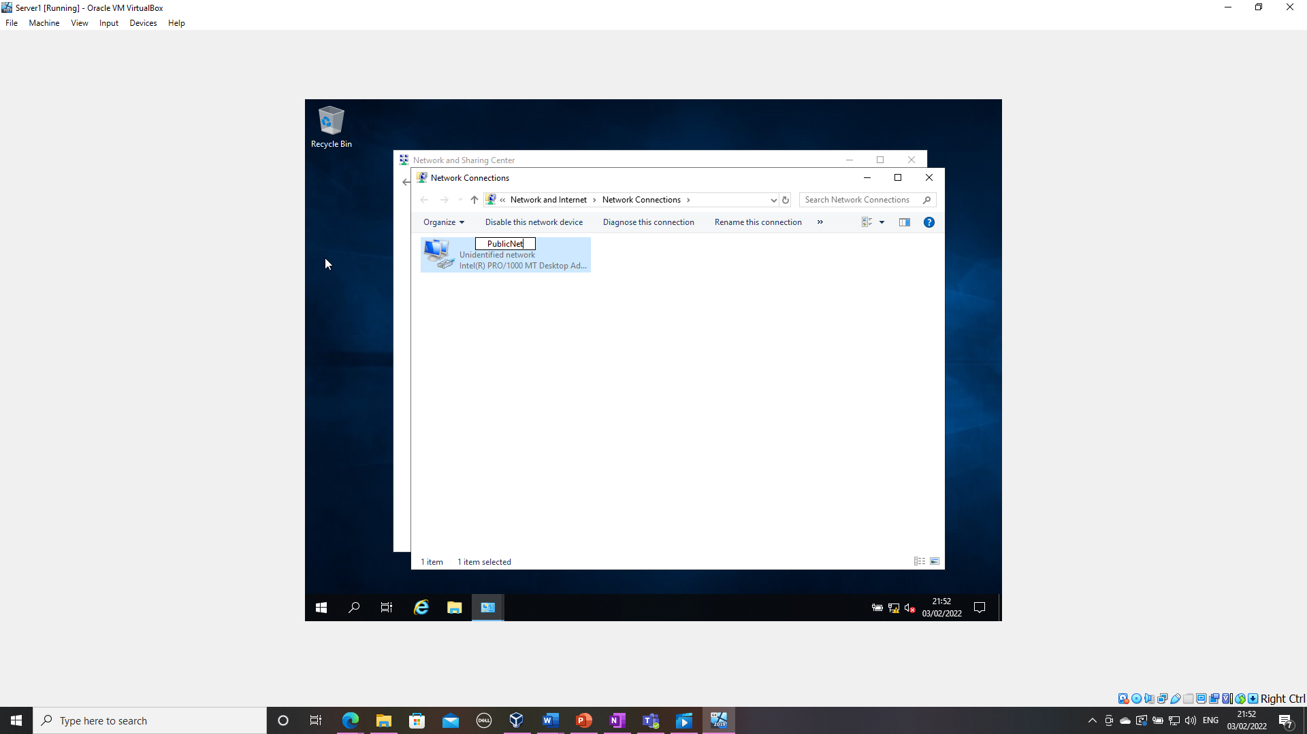
Figure 14 Server 1 network connection renamed - PublicNet
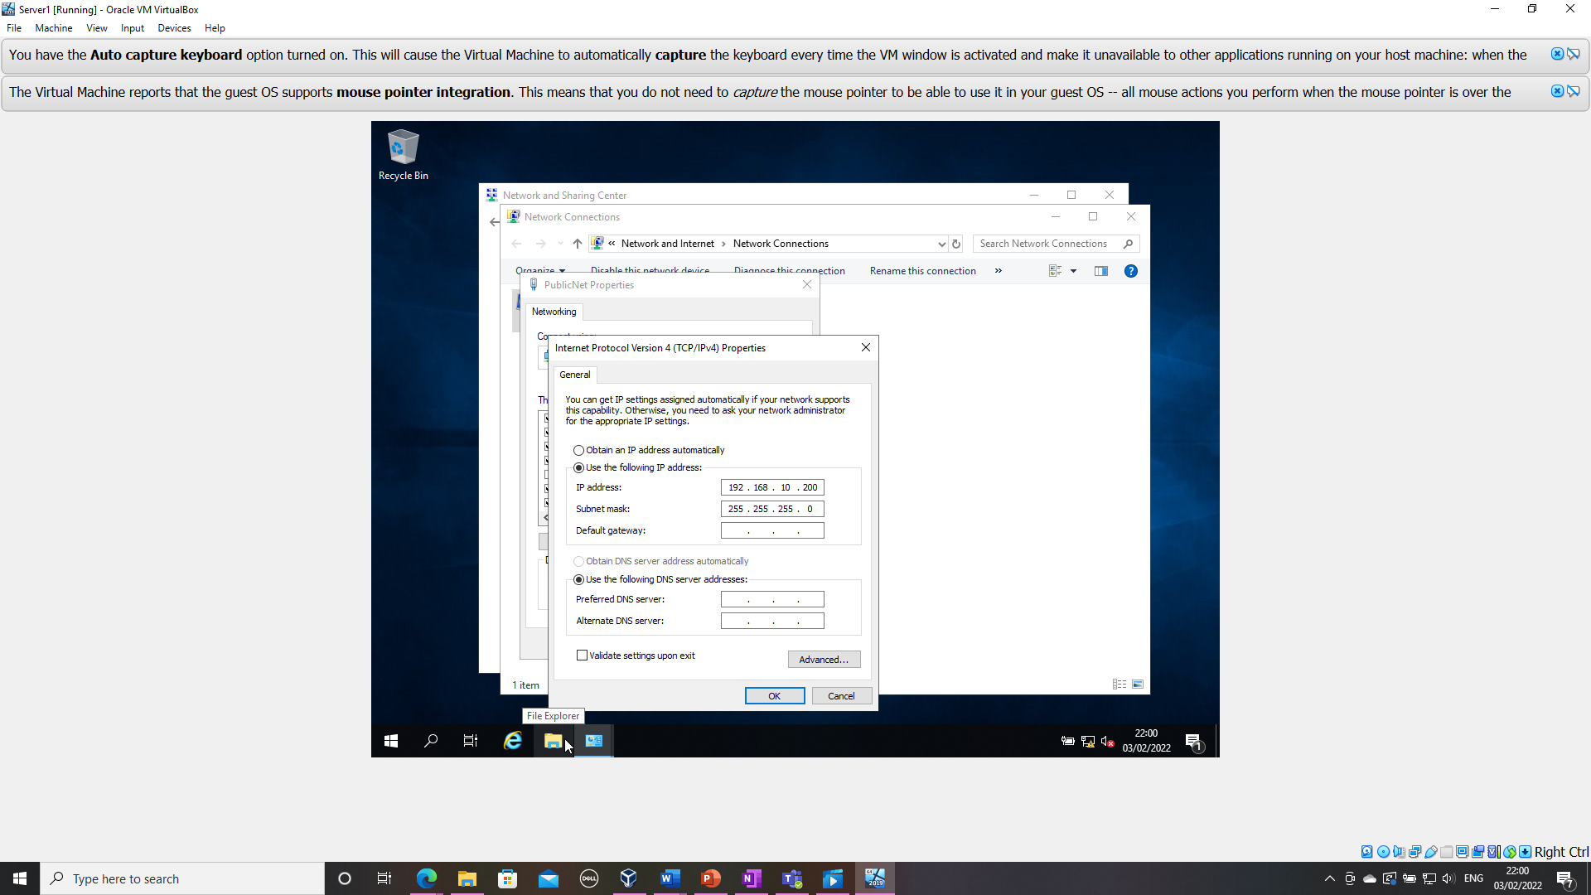
Figure 15 IP address changed for Server1
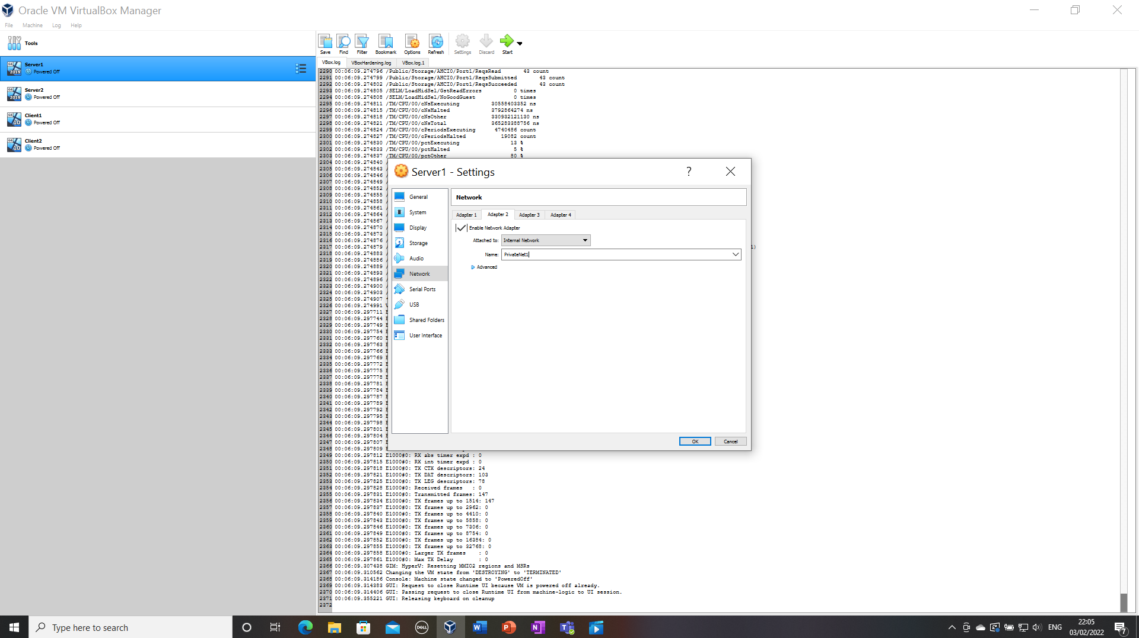
Figure 16 Adapter 2 named PrivateNet1 - IP address set

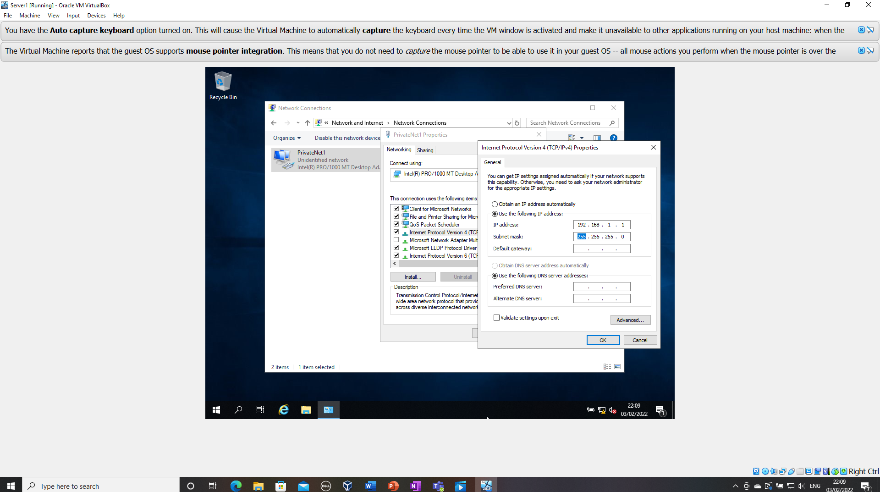
Figure 17 Additional adaptor created on server 1

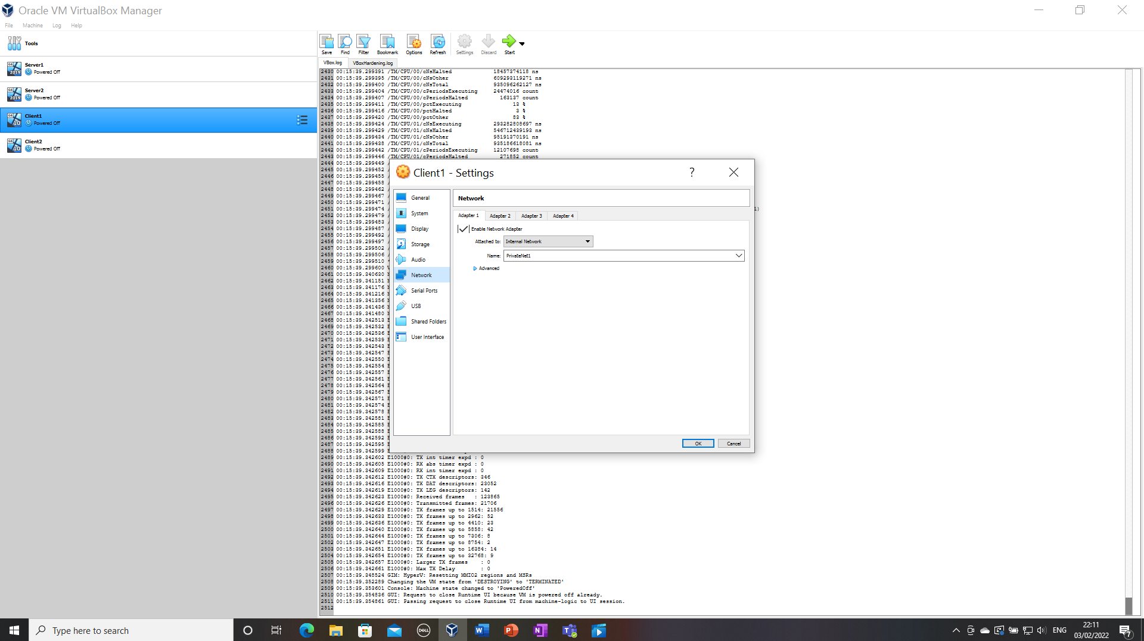
Figure 18 Adapter 1 altered for client 1

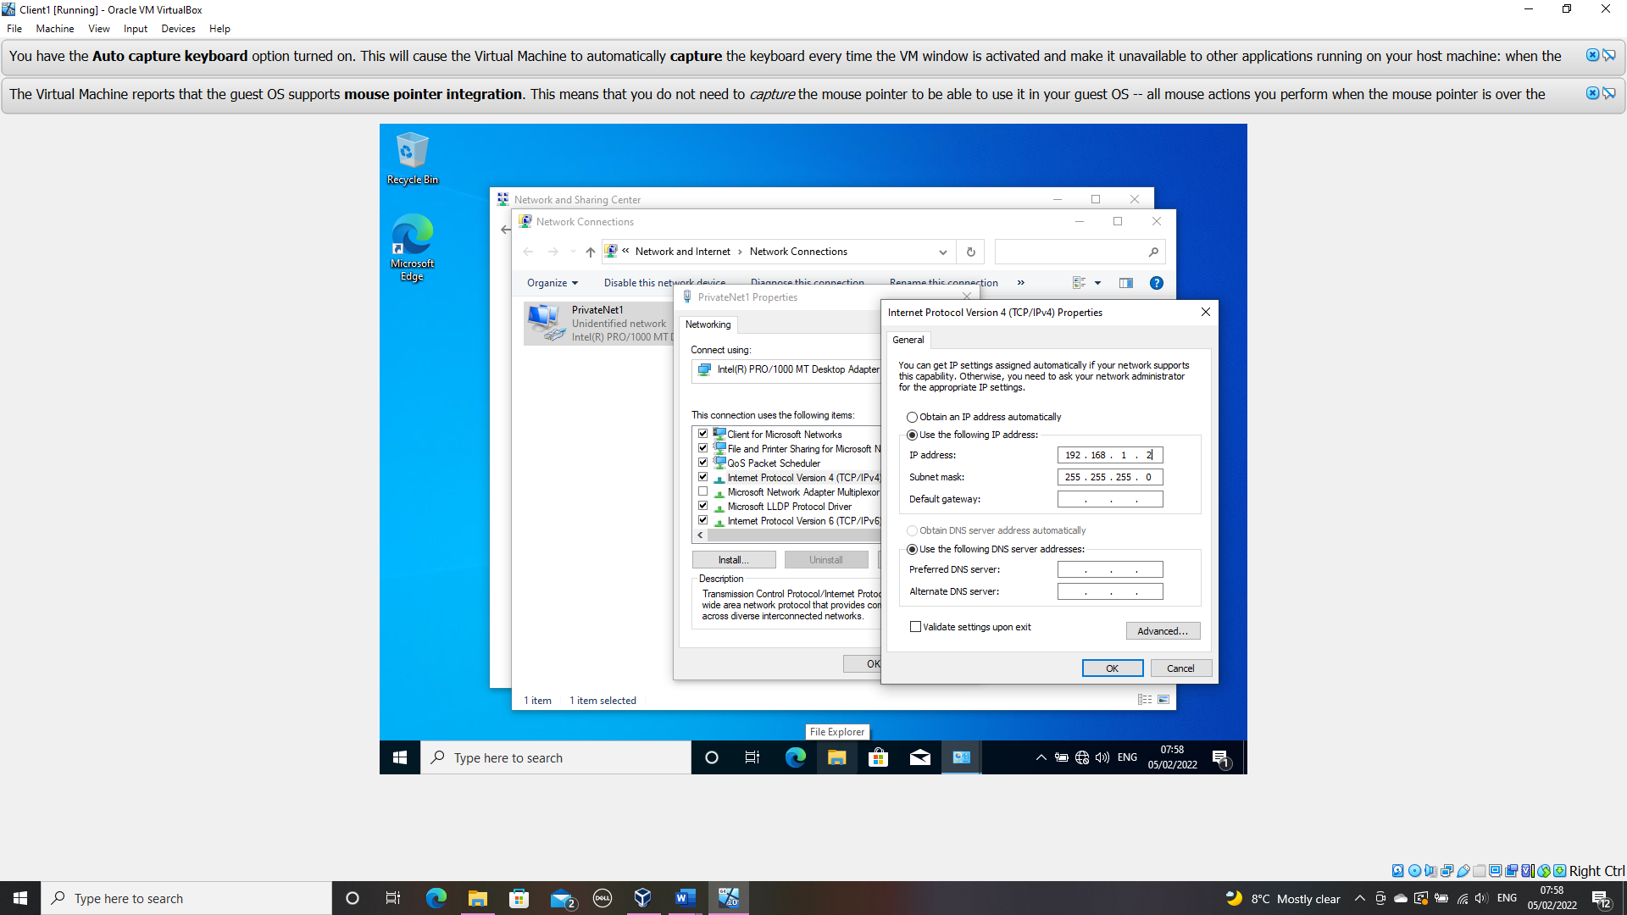
Figure 19 IP address changed to PrivateNet1 on client1

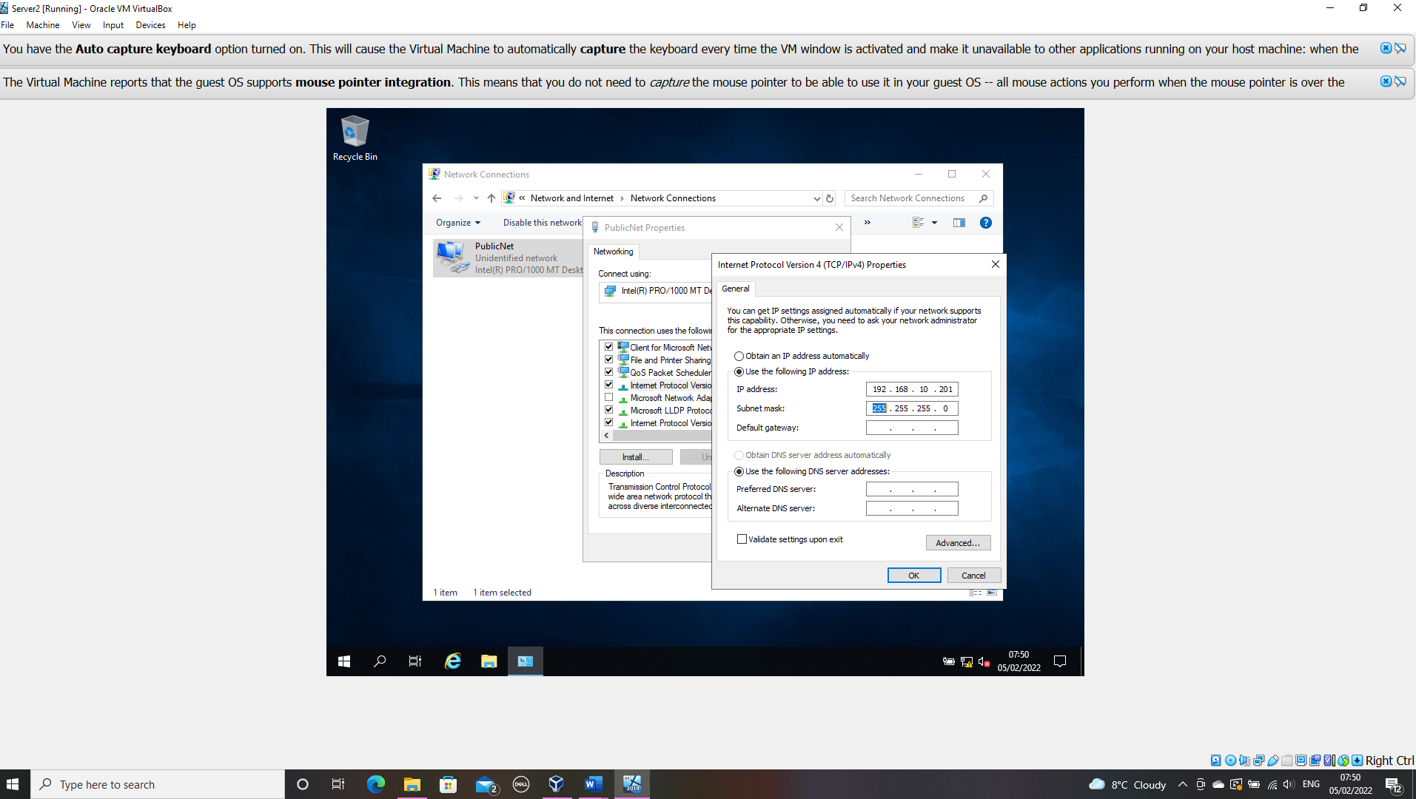
Figure 20 IP address changed for Server2
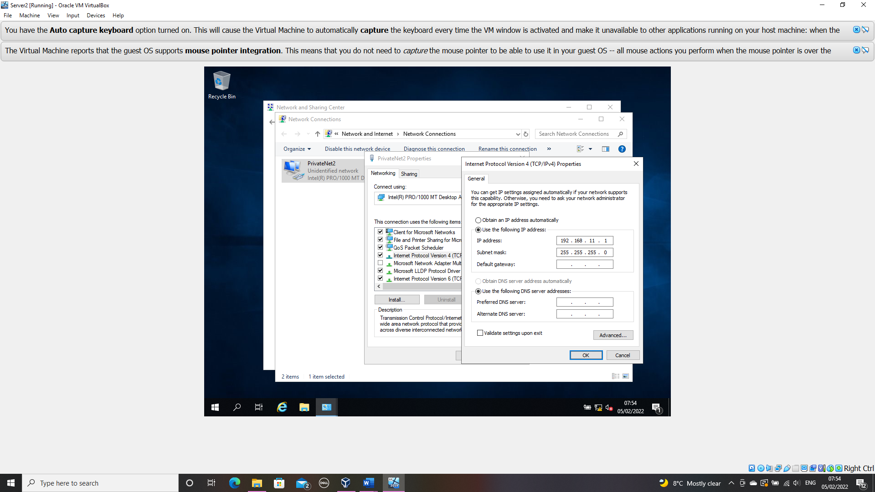
Figure 21 Additional adaptor created on server2 - PrivateNet2

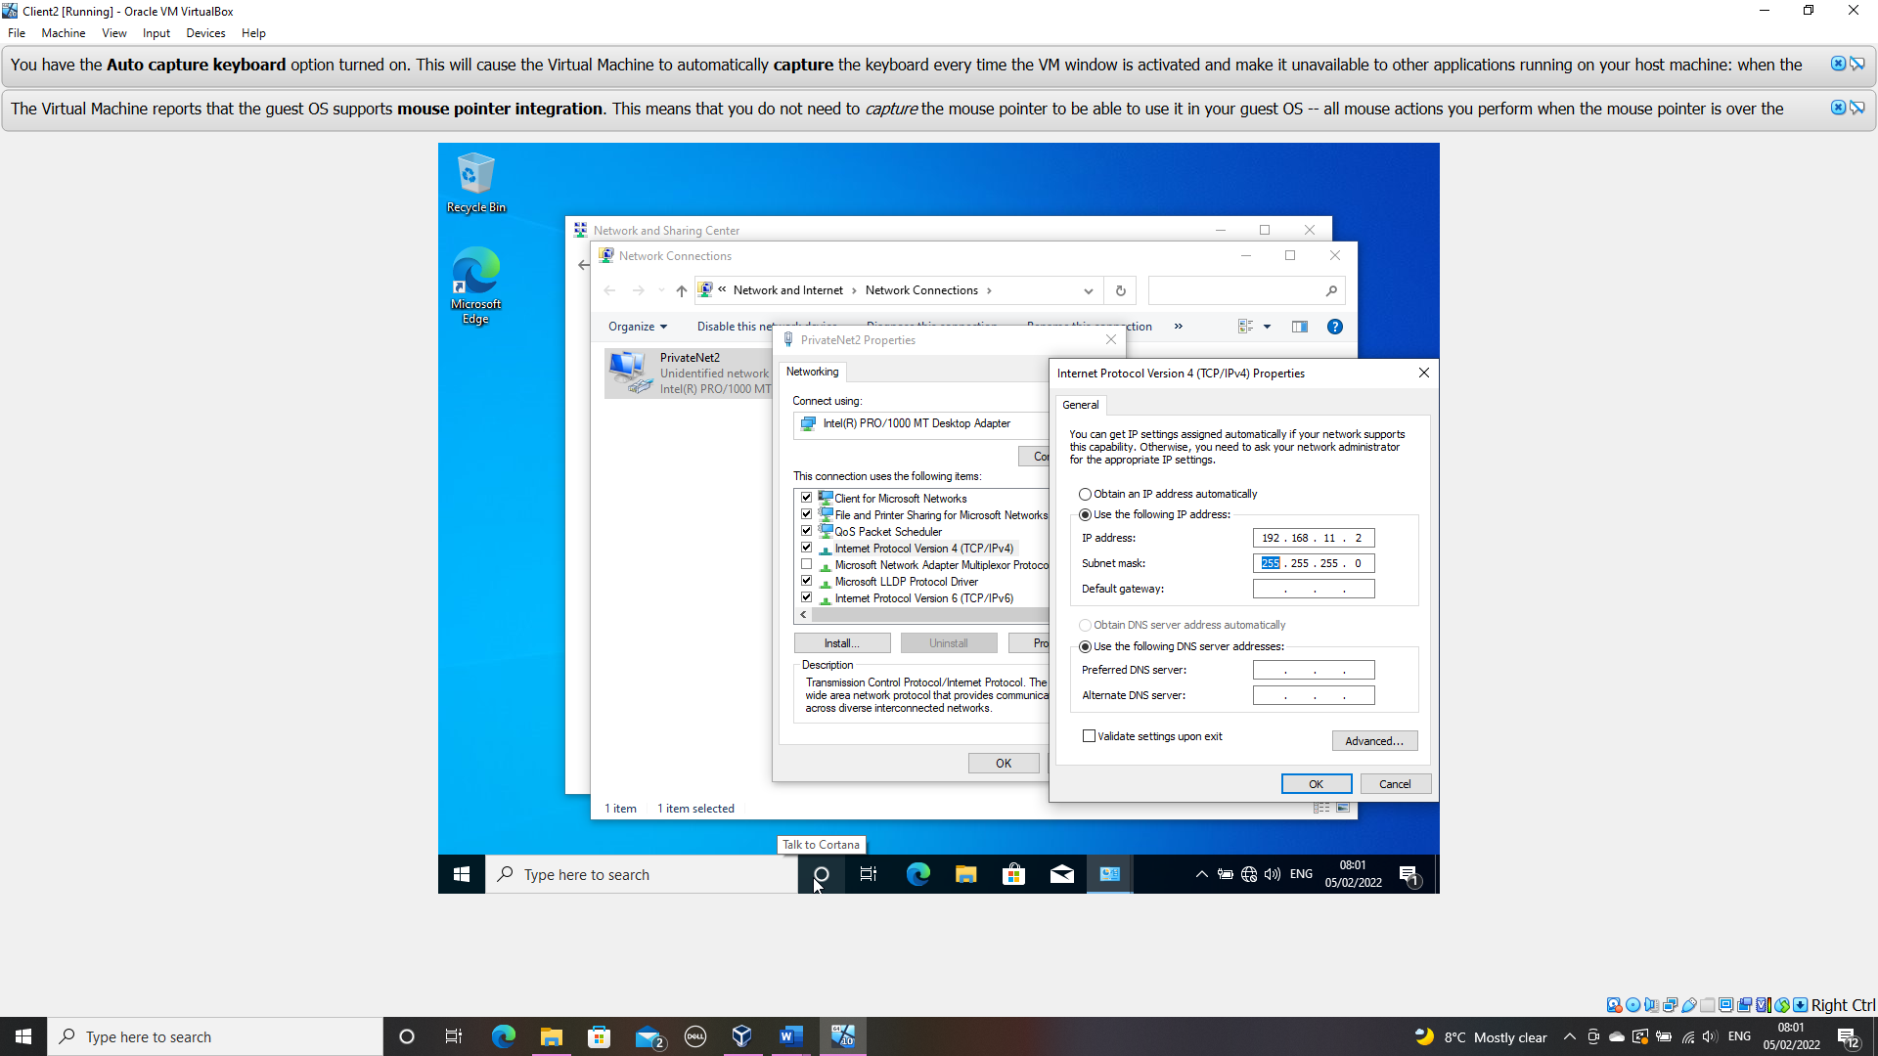
Figure 102 IP address changed for PrivateNet1 on client2

To check the connectivity between the server and the client device on this LAN it is advisable to disable the firewall within the server, this is to ensure that we do not get a timed-out request during the ping test.
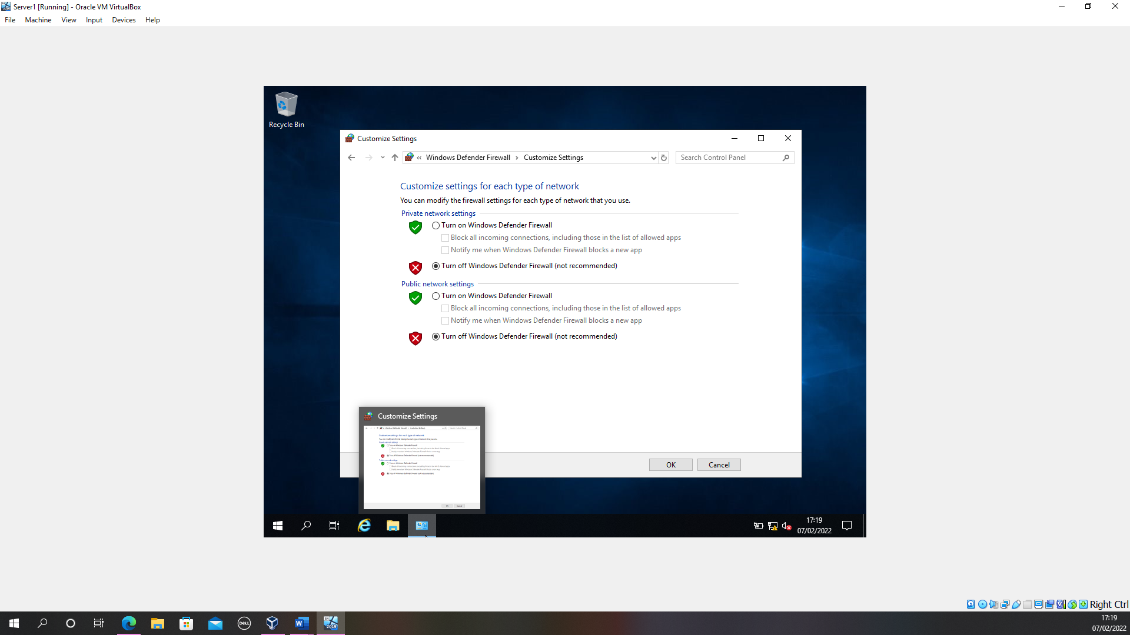
Figure 23 Firewall disabled - server 1

When attempting to run a server and a client machine the host machine was not able to function appropriately, to combat this the base memory on both was reduced to 2530 MB.
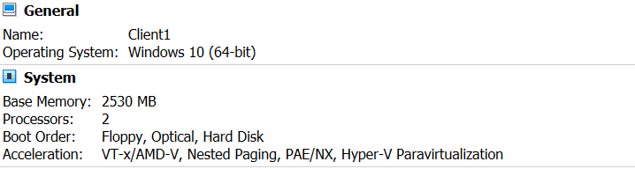
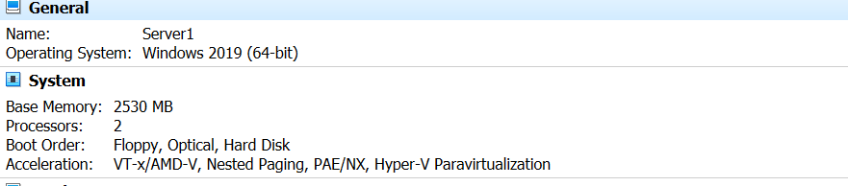
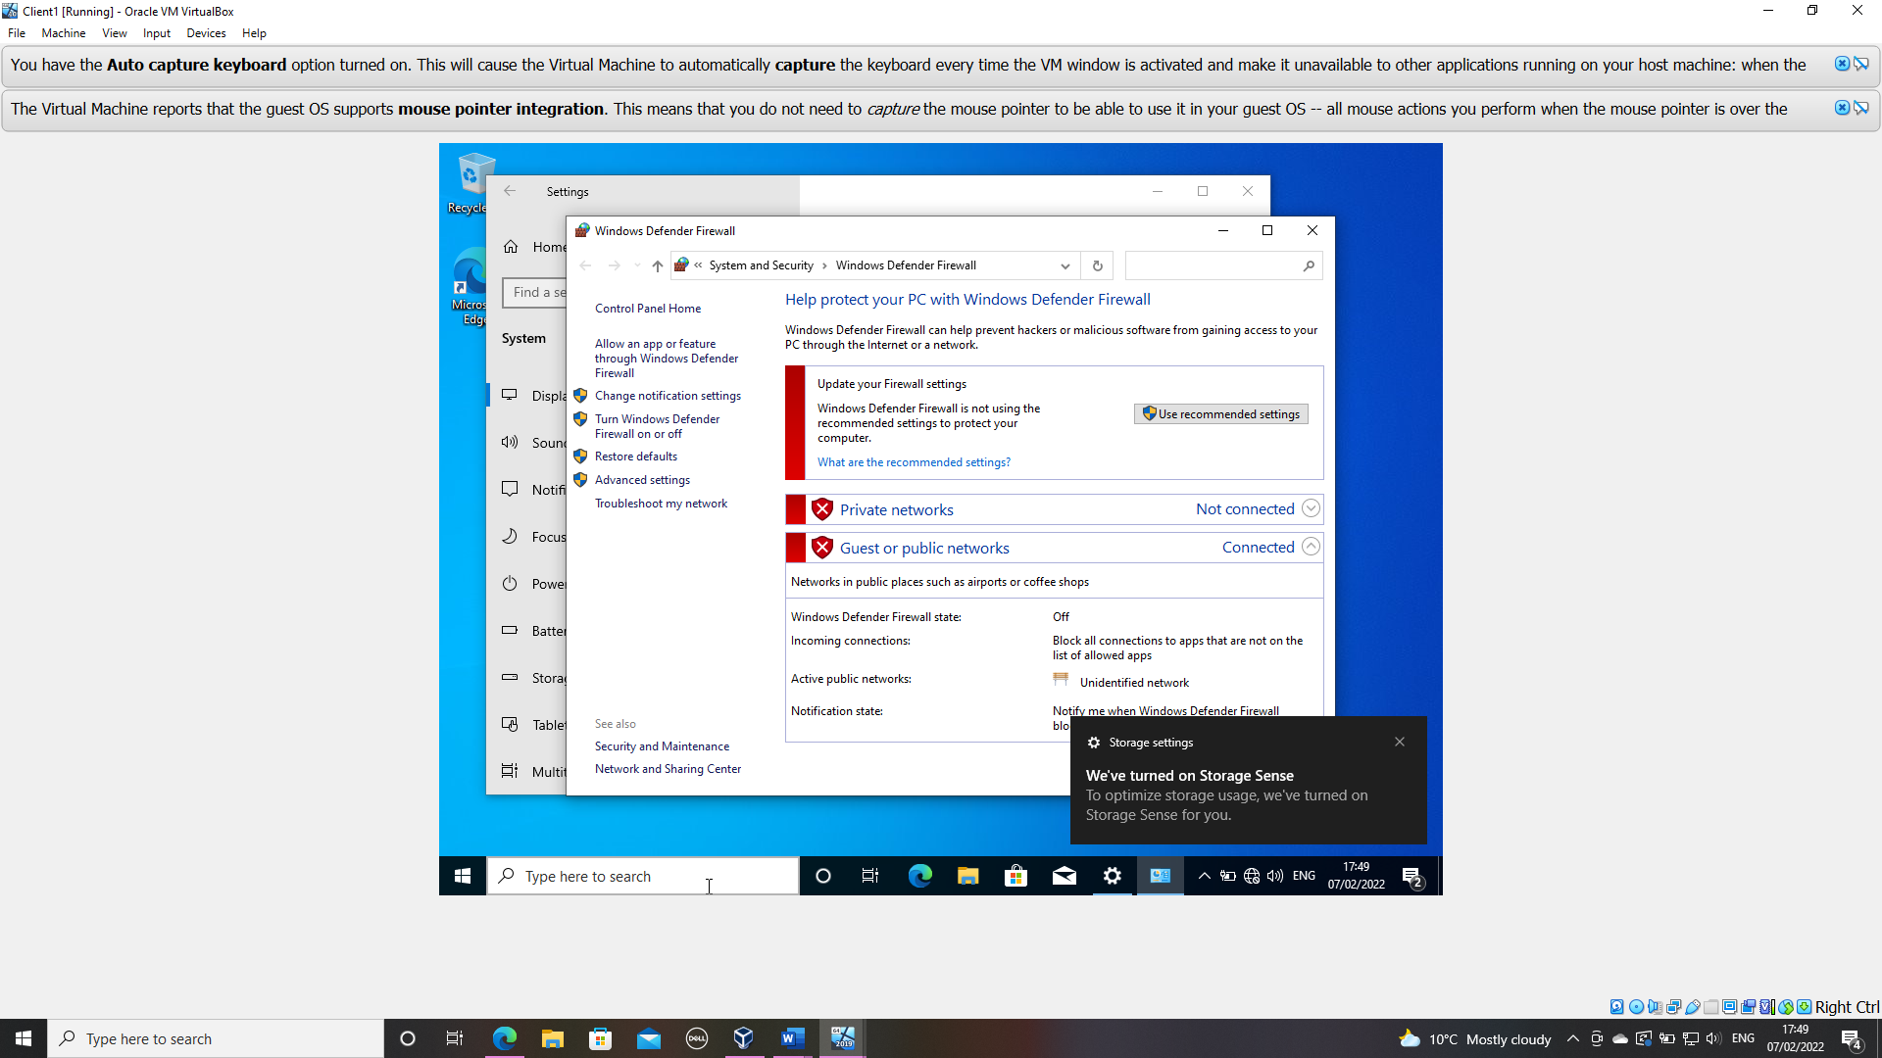
Figure 24 Firewall disabled - client 1

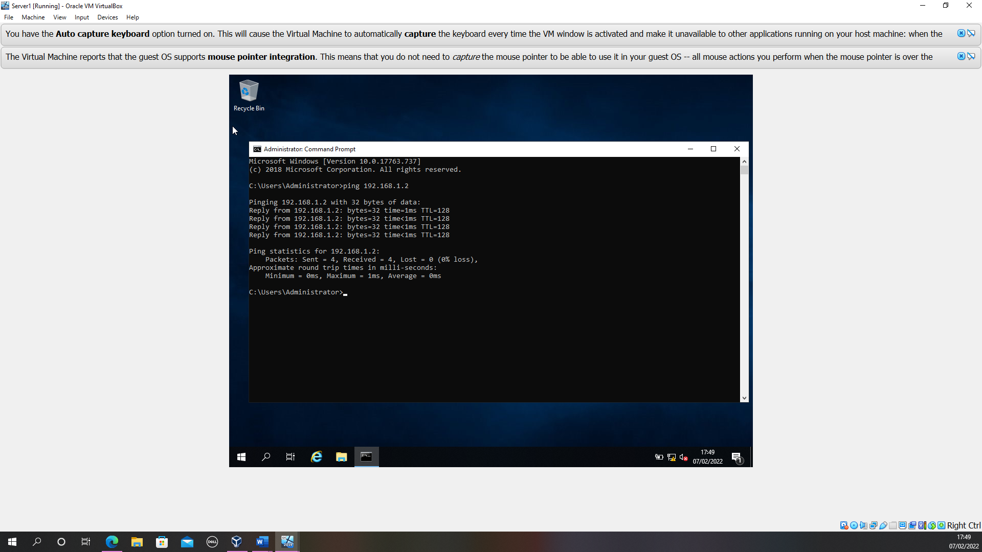
Figure 25 Successful ping to 192.168.1.2-client1

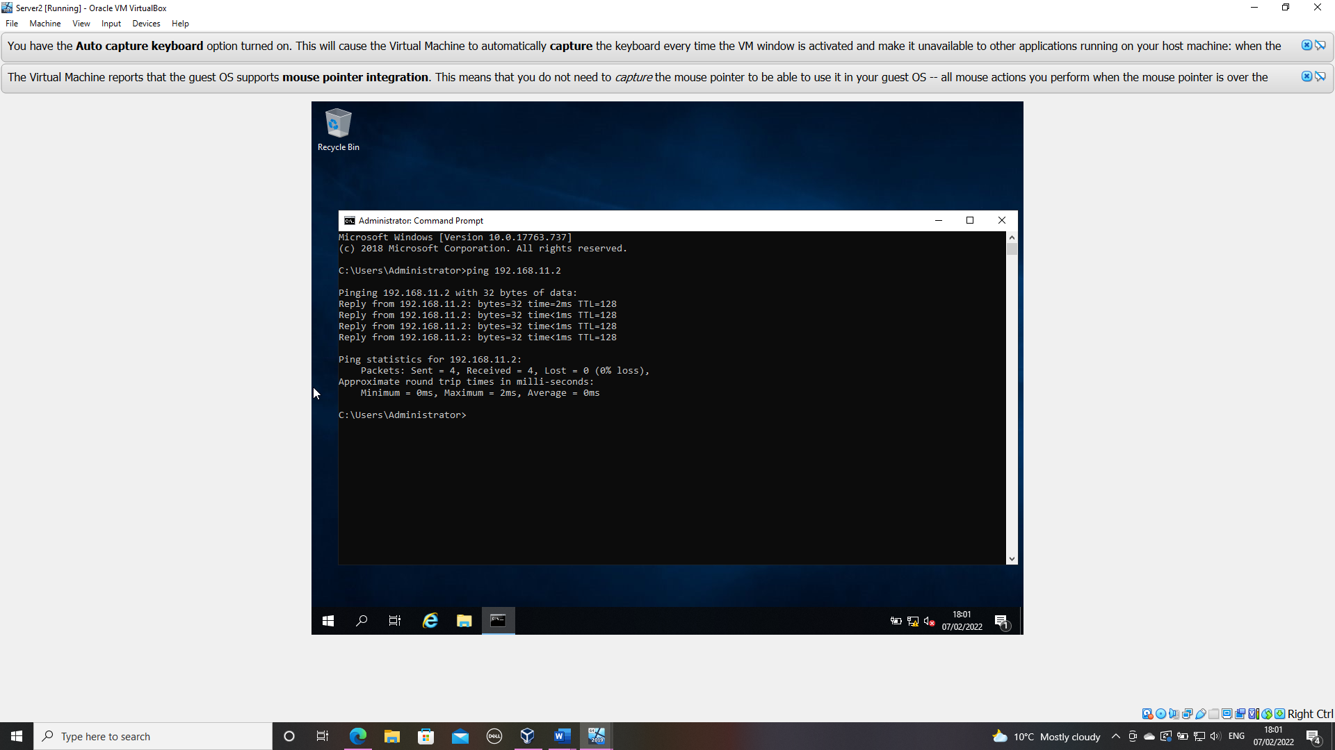
Figure 26 Successful ping to 192.168.11.2-client2
(Sectional word count 190)

Task 2

Deployment of a Network Directory Service

Pre-requisite
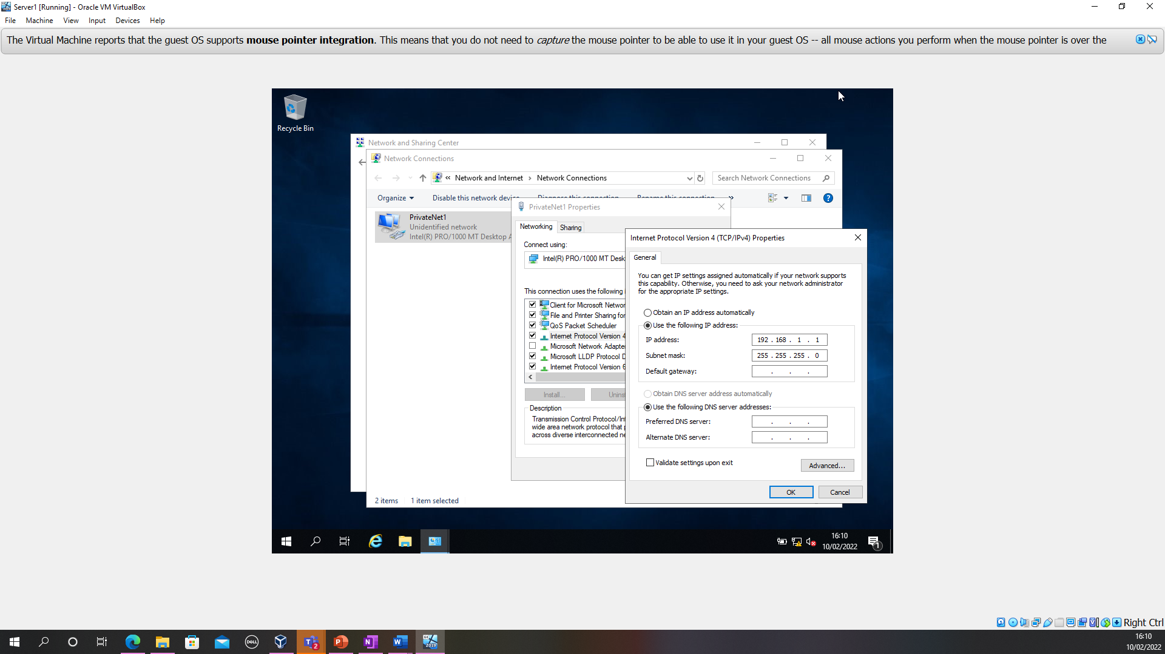
Figure 27 Server1 IP address statically defined
A statically defined IP address means that the IP addresses has been manually entered by the administrator. Although this is manageable for a small LAN consisting of a few objects, this would not be manageable or maintainable in a larger network consisting of multiple objects. In larger networks IP addresses are assigned dynamically by a dynamic host configuration protocol.

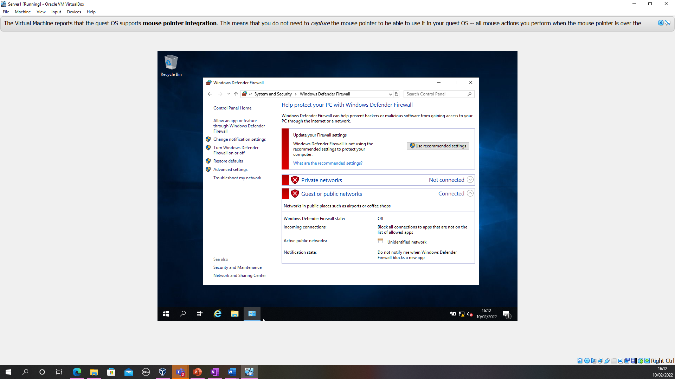
Figure 28 Server1 firewall disabled
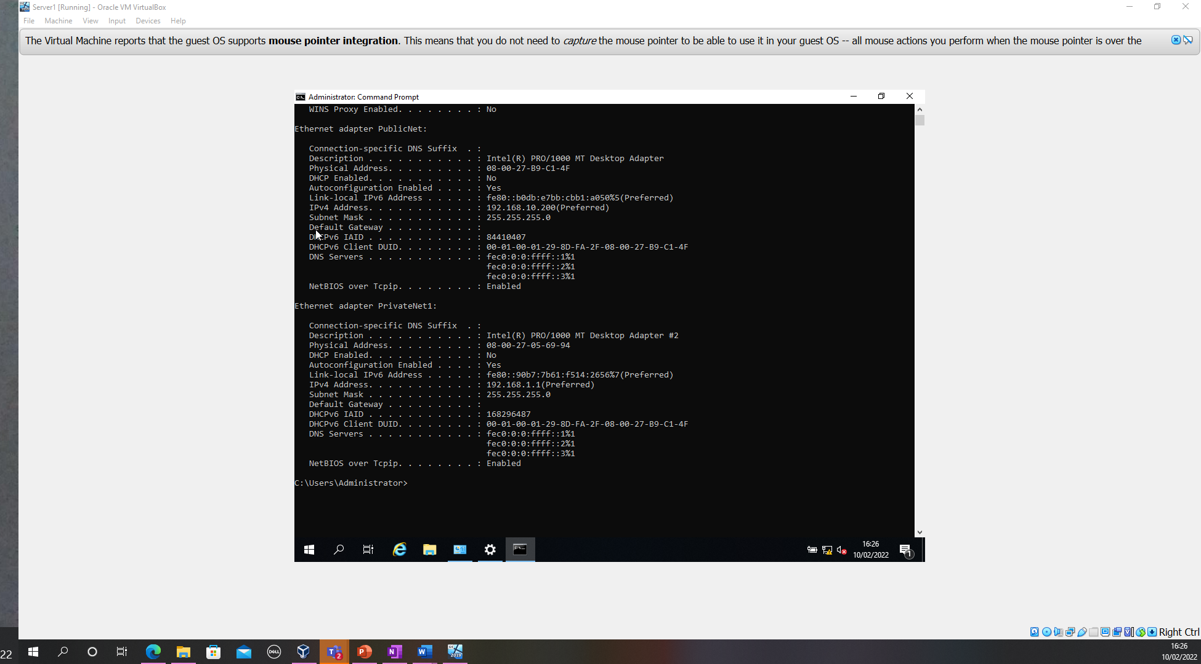
Figure 29 DNS not yet been set up.

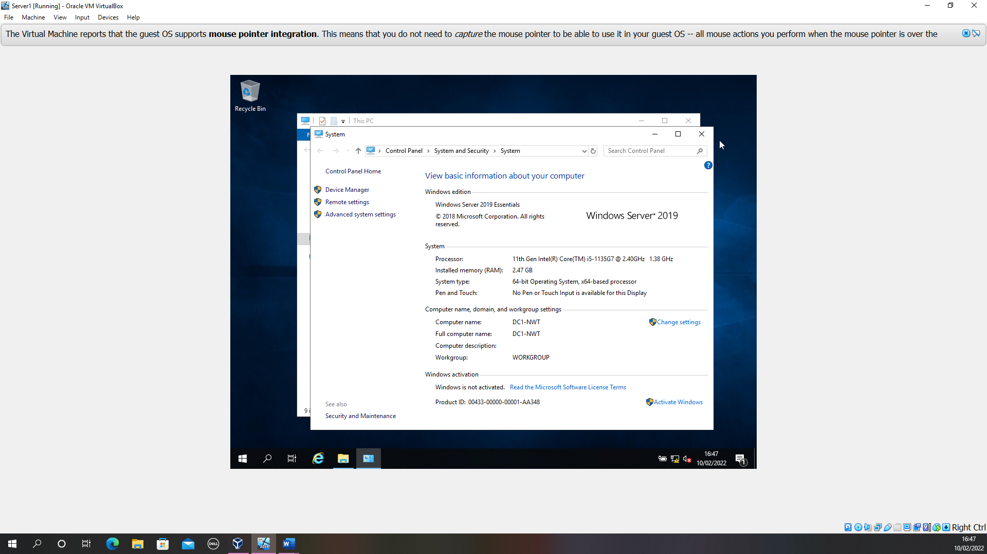
Figure 30 PC name changed

Deploying AD

The next few screenshots demonstrate the installation process for AD on Server1
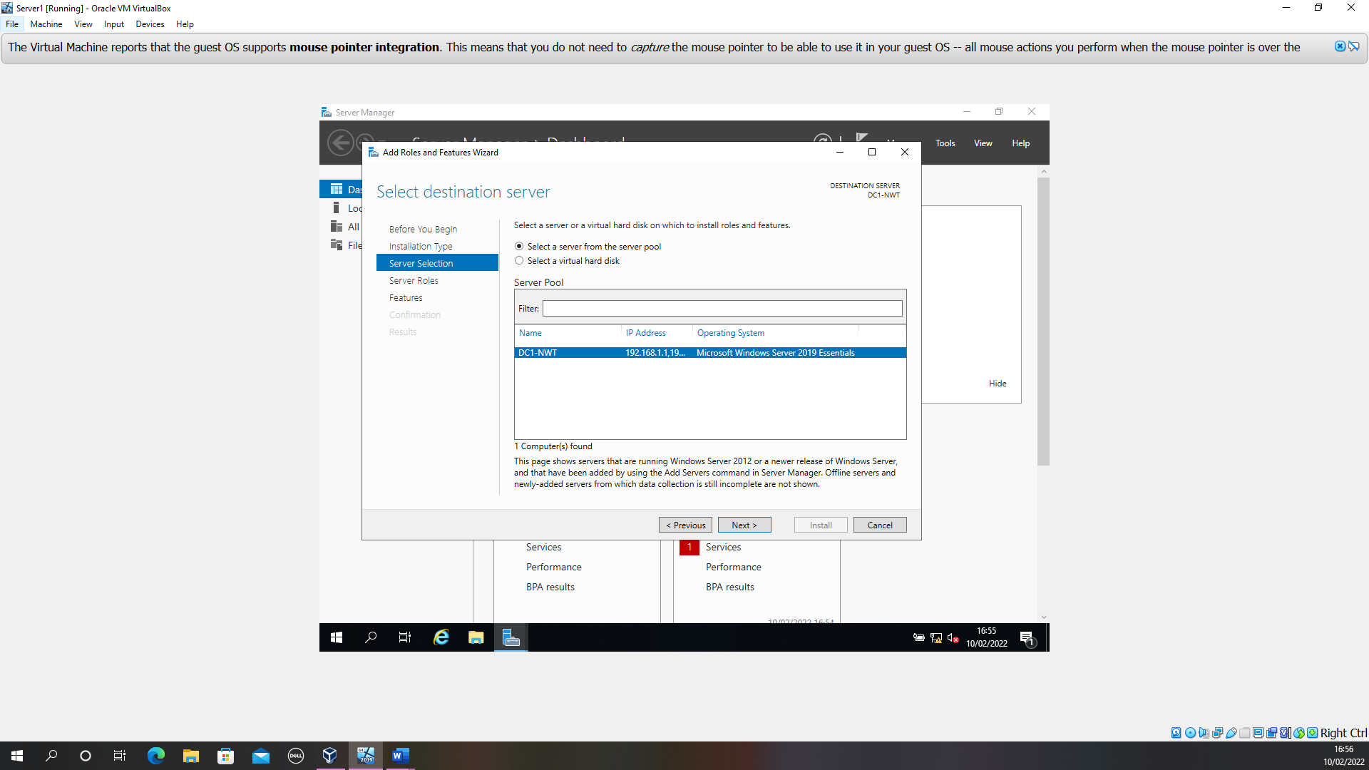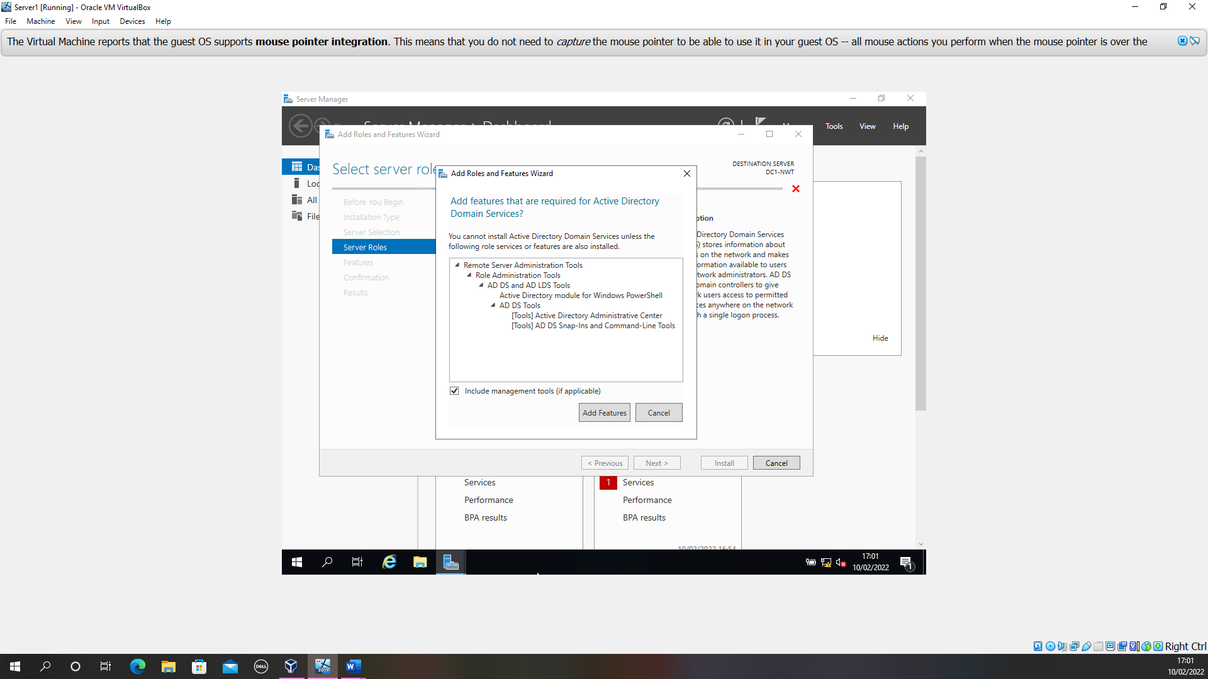
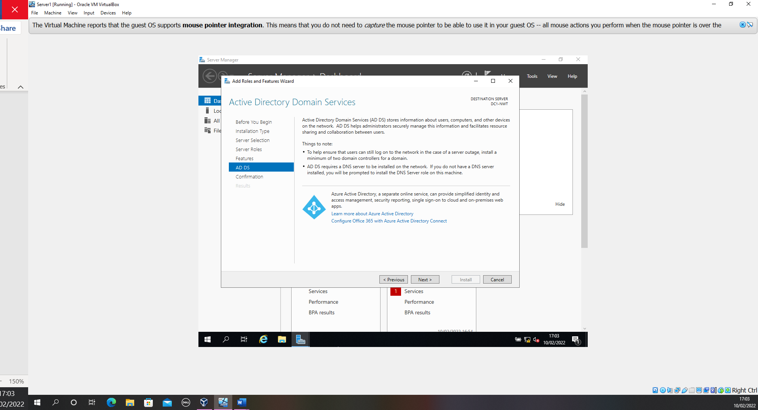
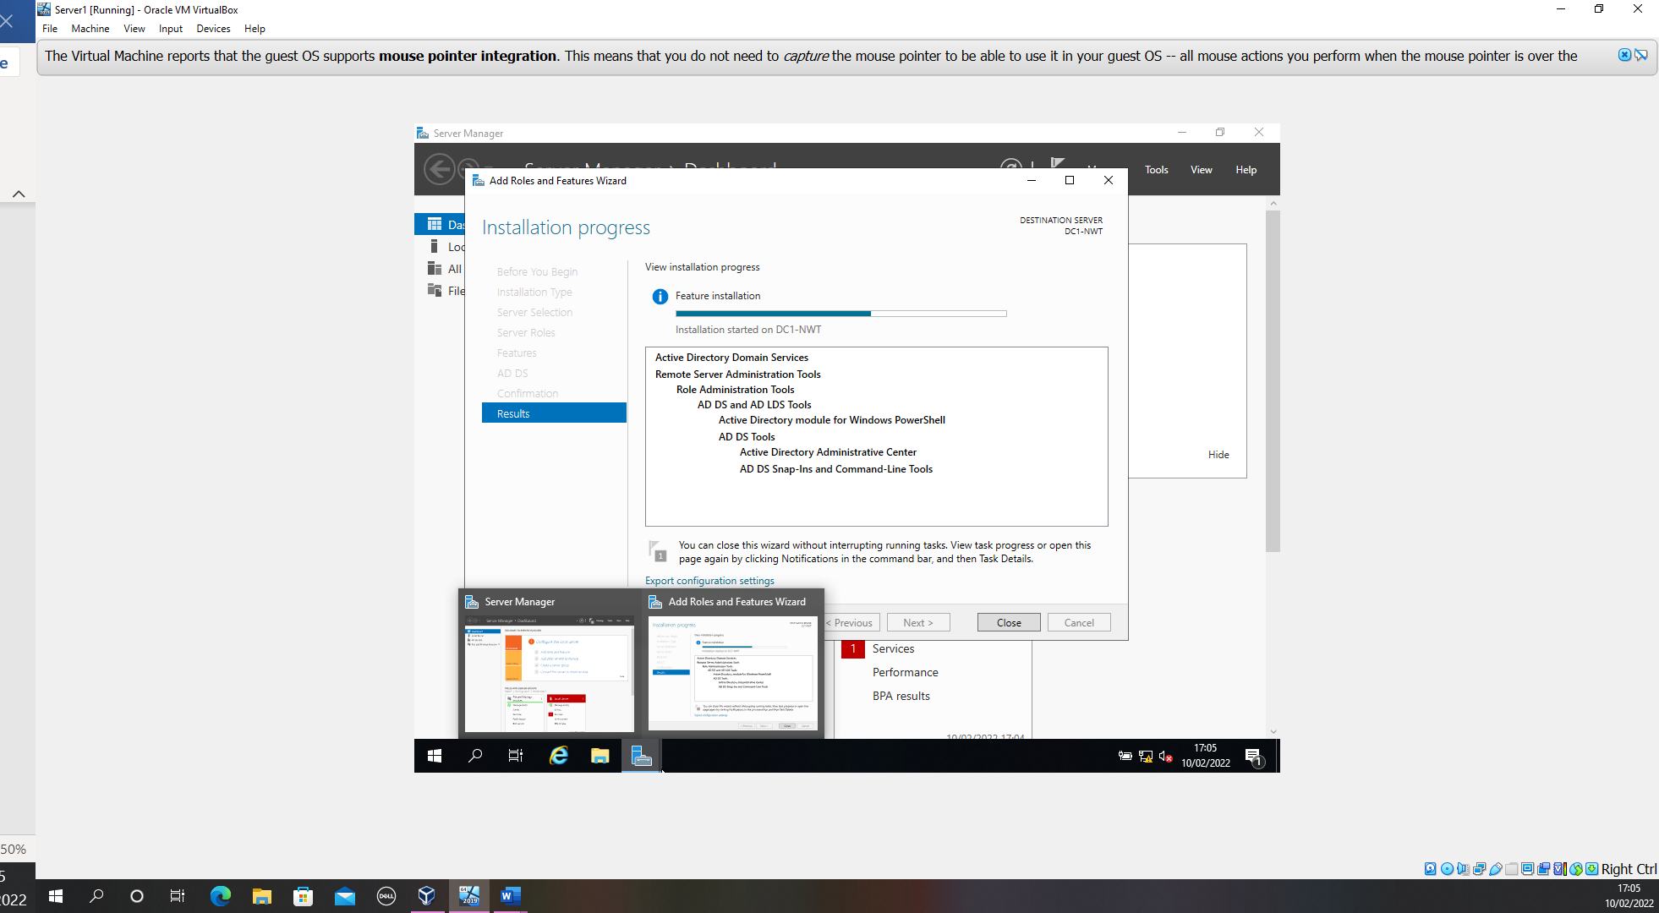
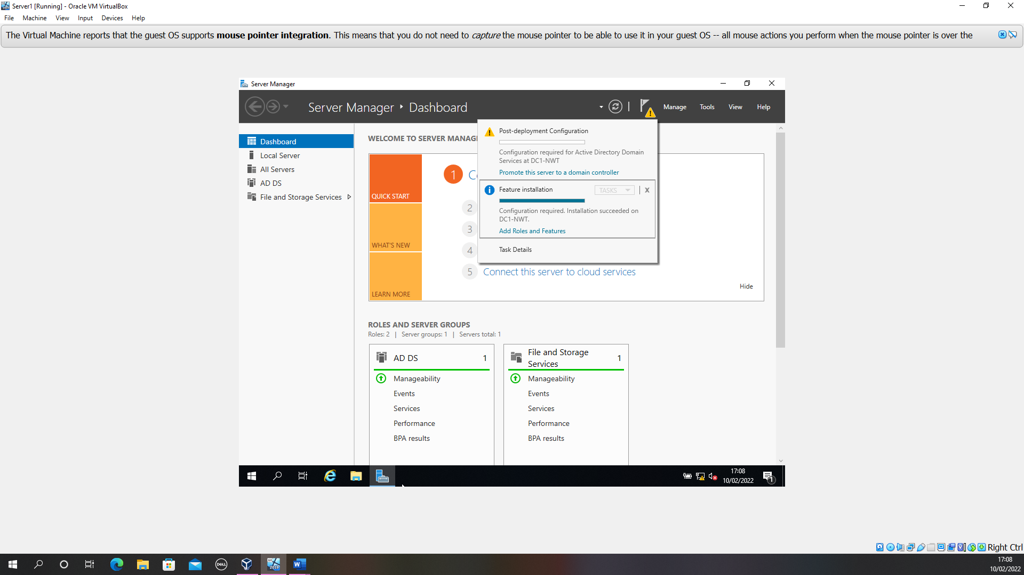
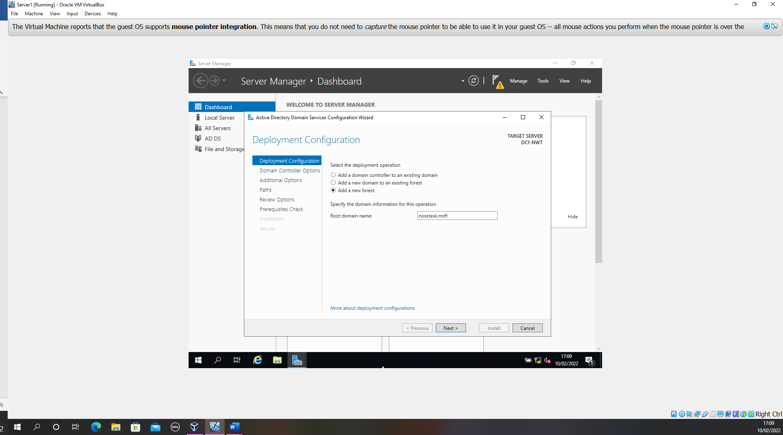

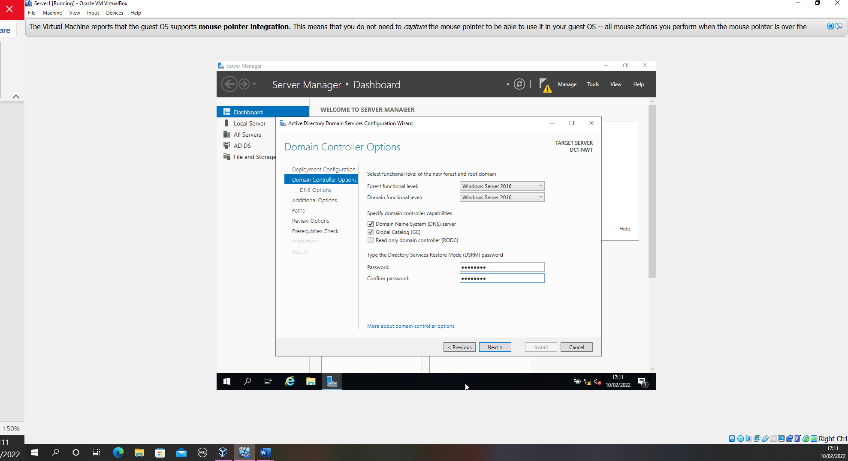

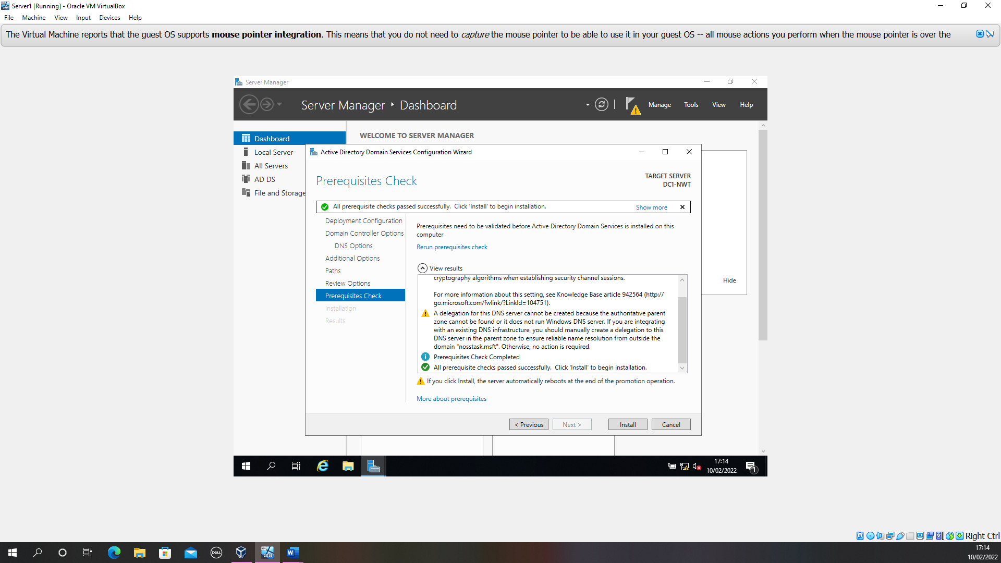

Creating User accounts

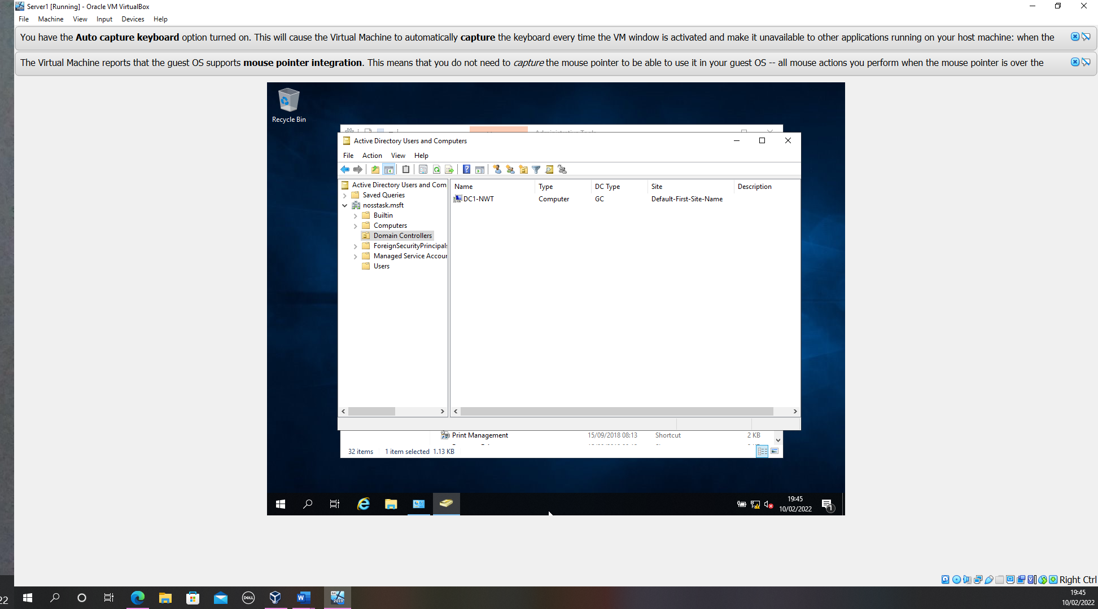
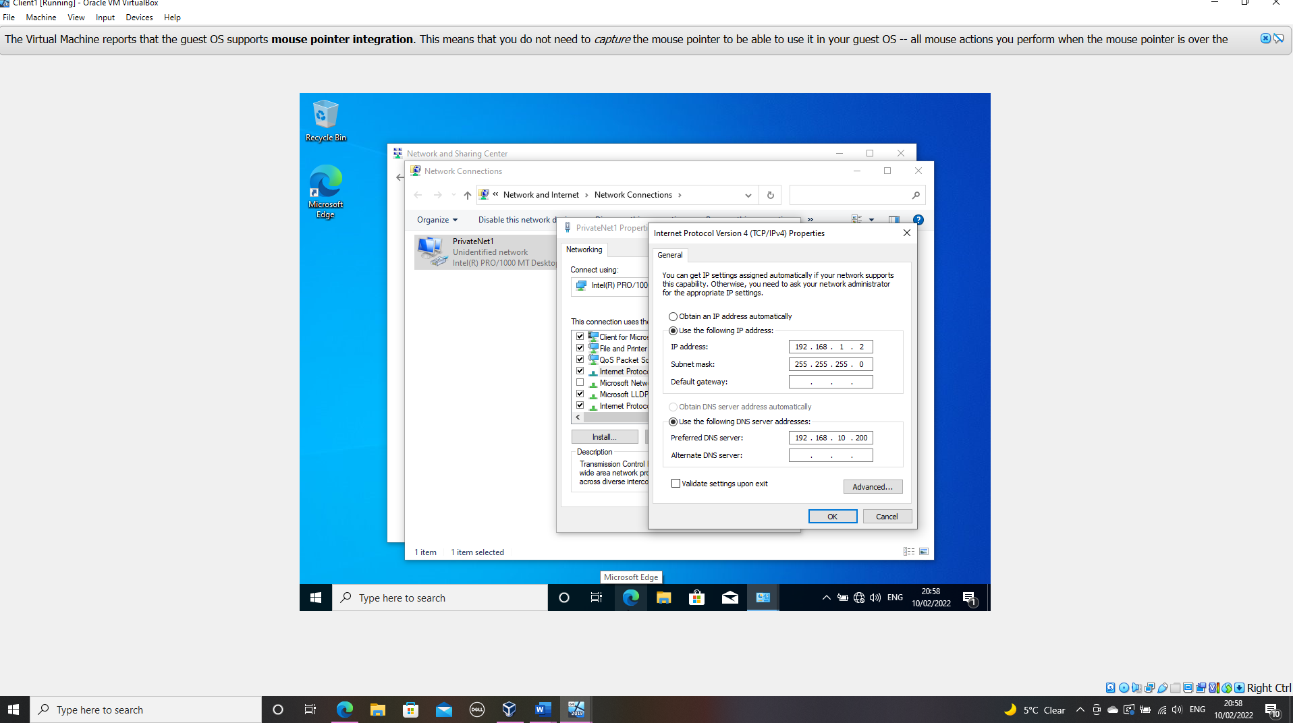

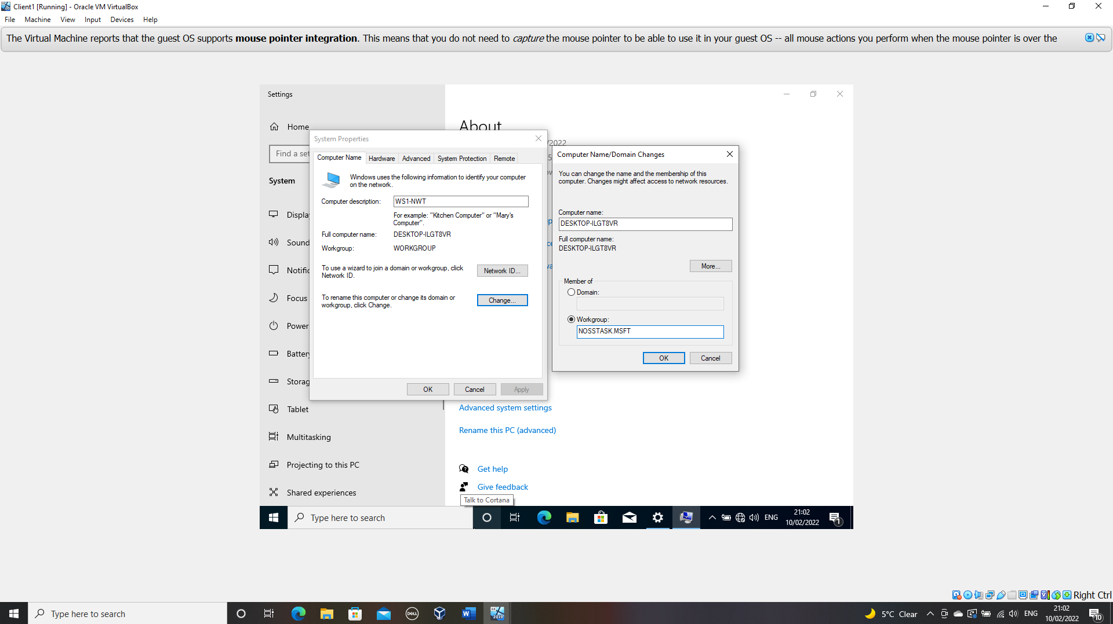
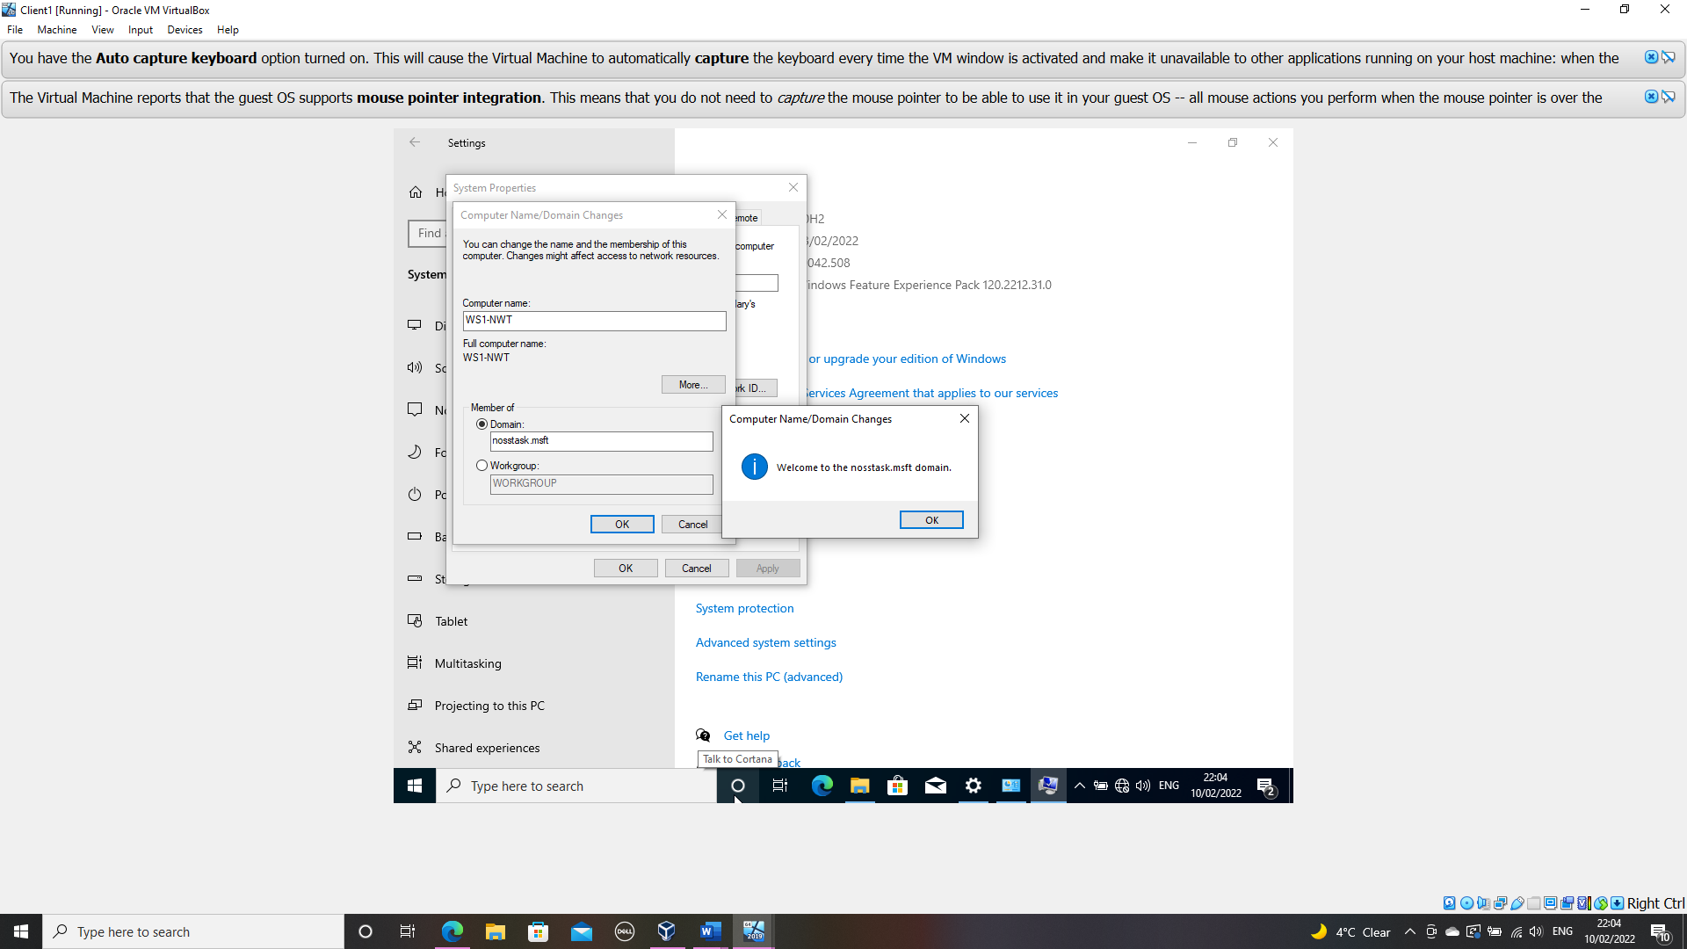
Figure 31 Server DC1-NWT is listed as the domain controller and successfully changed

Creating an additional user

In order to comply with Microsoft’s minimum password complexity, the following document was utilised Microsoft Password requirements.
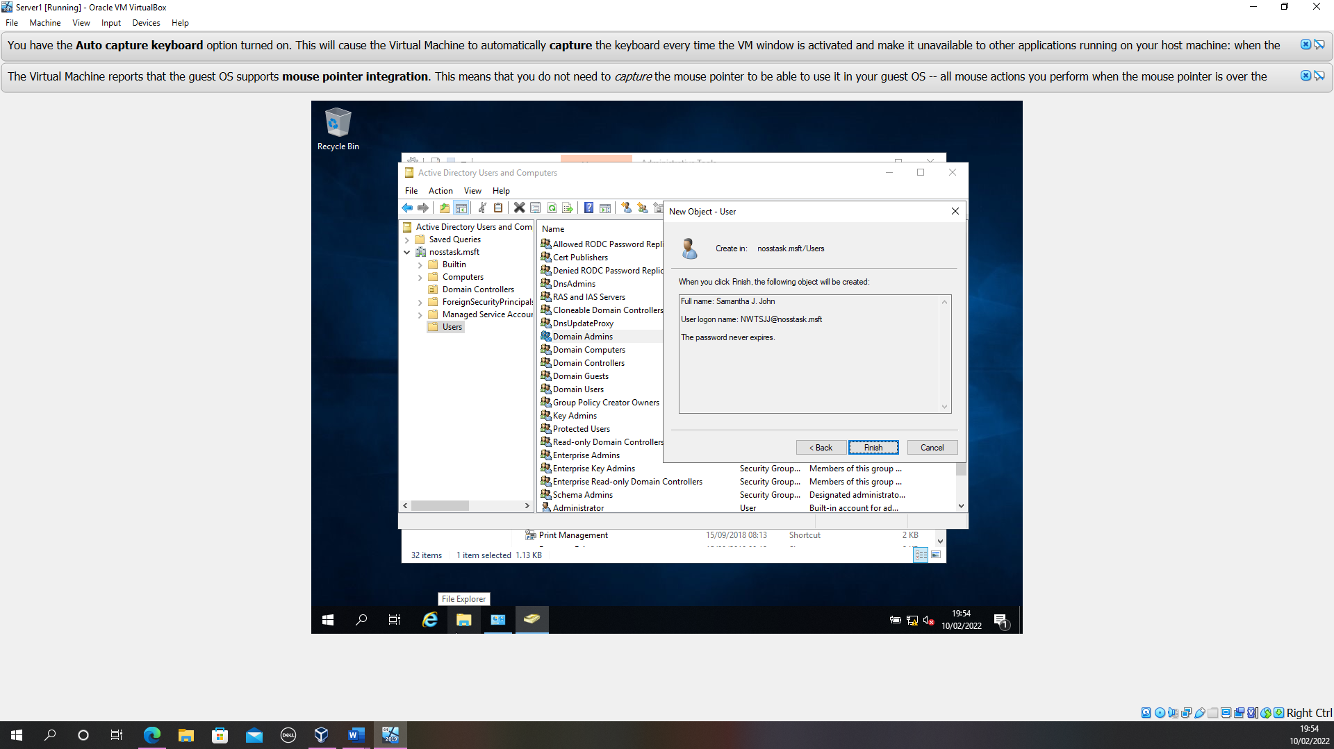
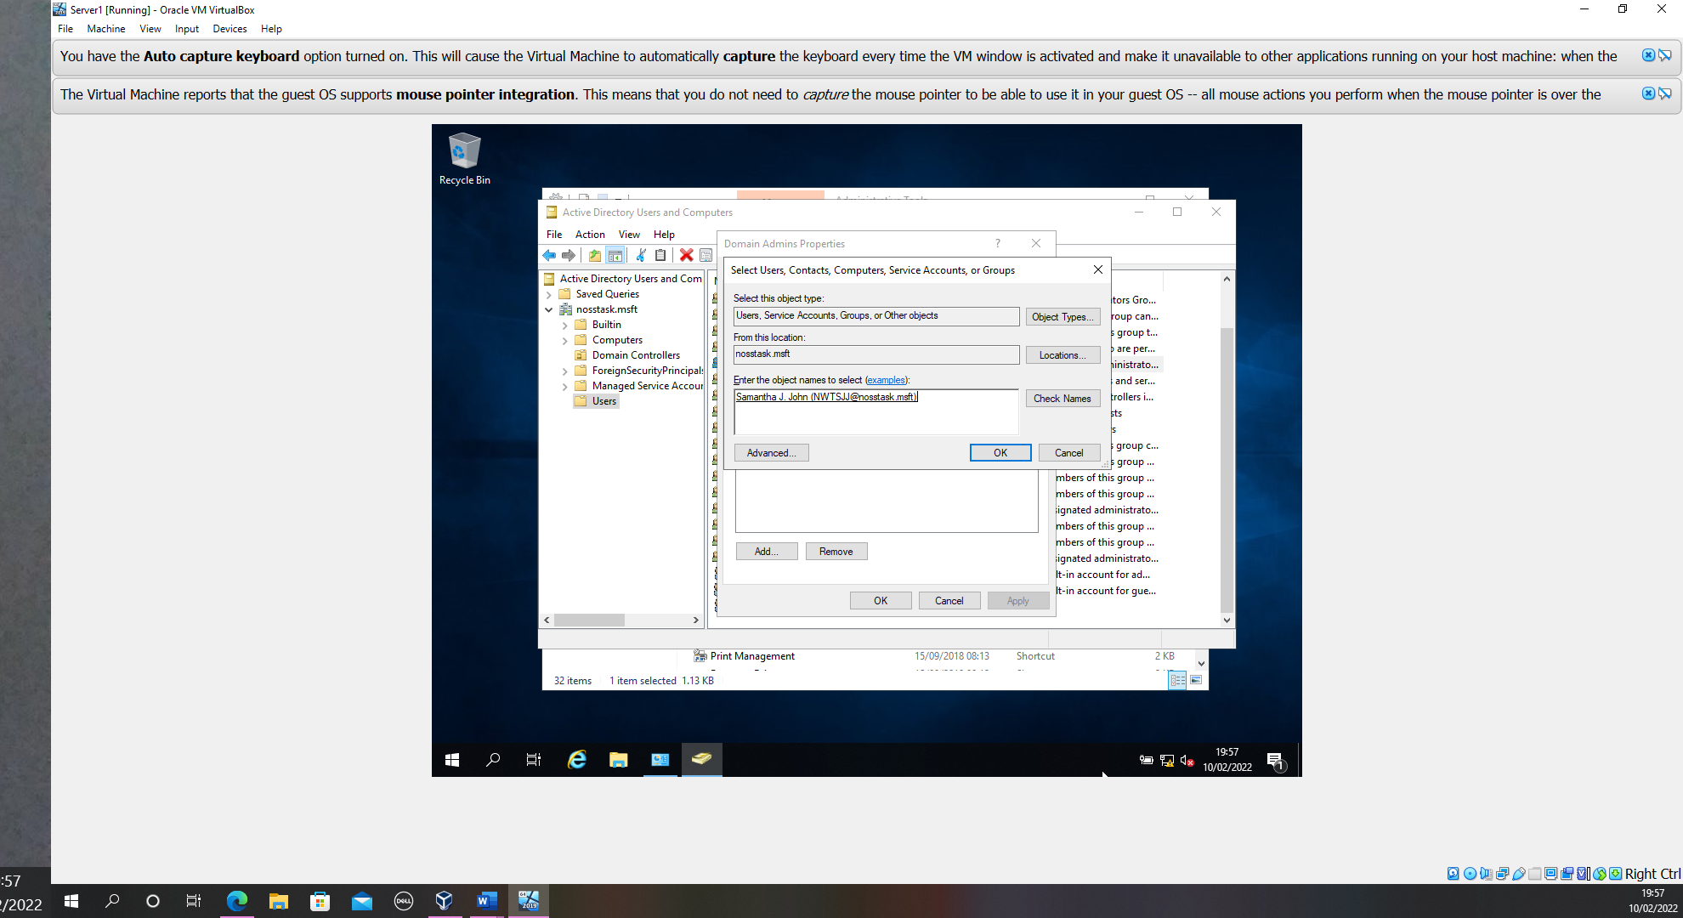

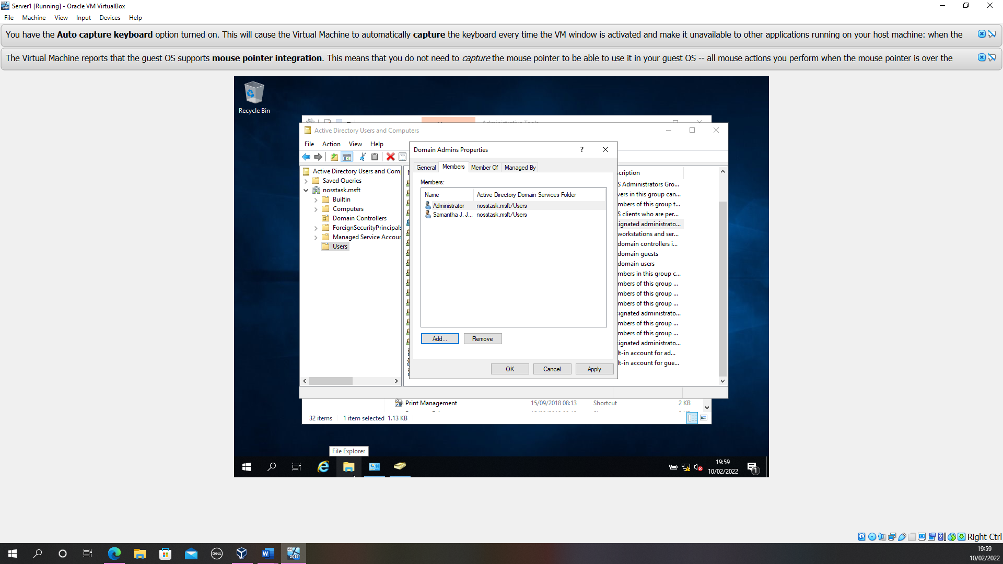
Figure 32 Successful creation of additional account and added to the membership group of domain controller

Object attributes

Creation of an additional user
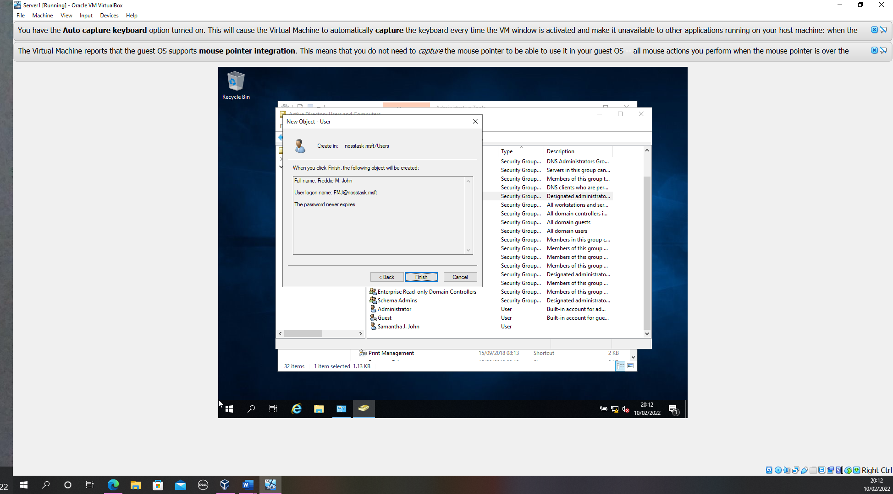
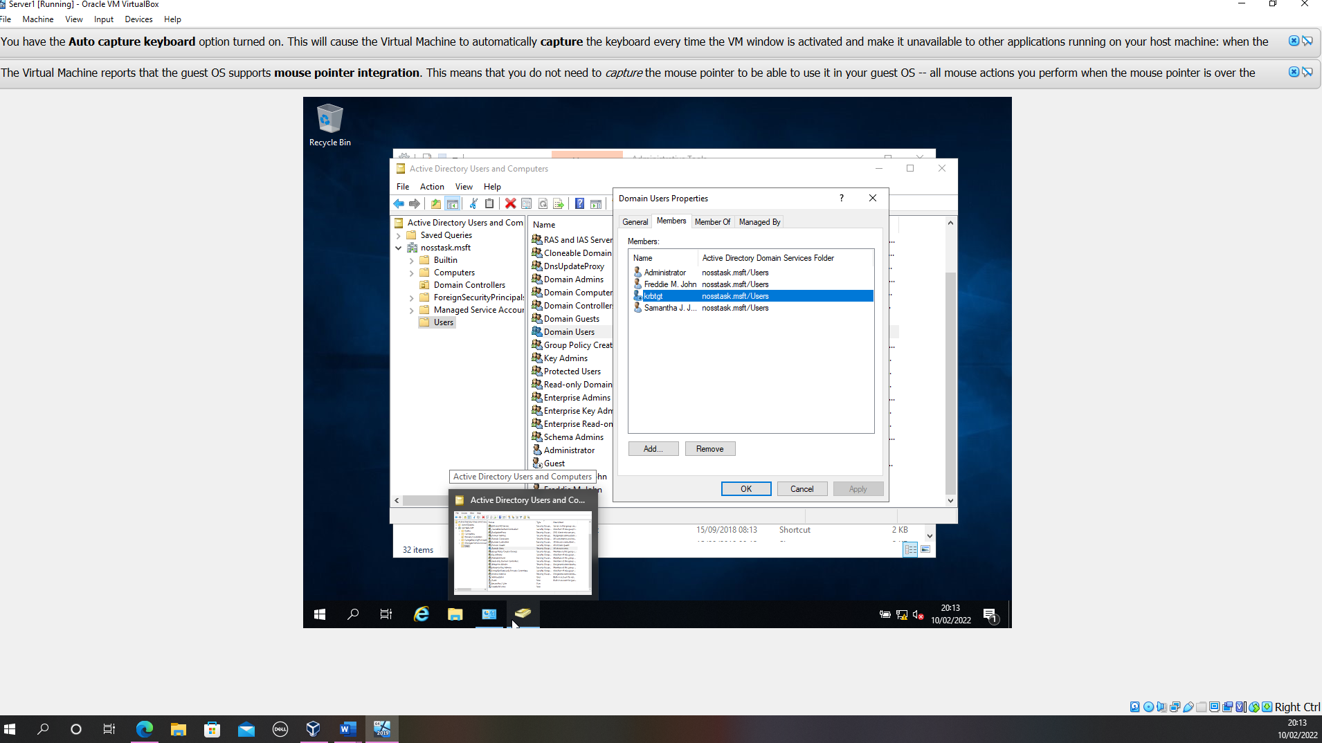
Figure 33 User is a member of the global group
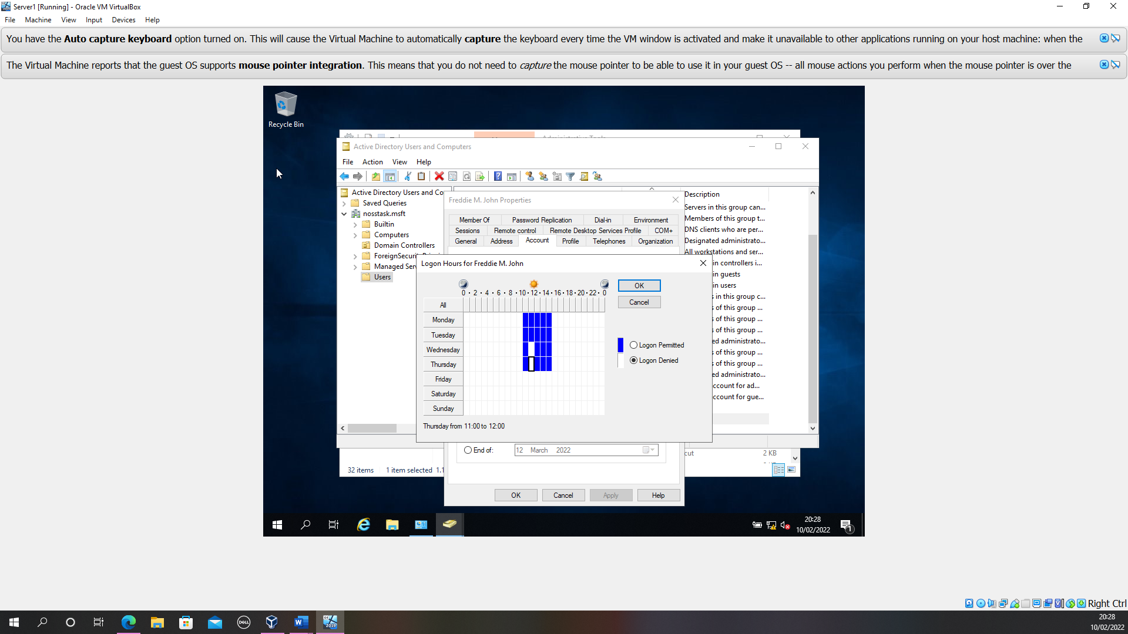
The user should only be able to access the system between the hours of 10am and 3pm Monday through to Thursday, additionally they should not be allowed access to the system between 11am and 12pm Wednesday and Thursday.

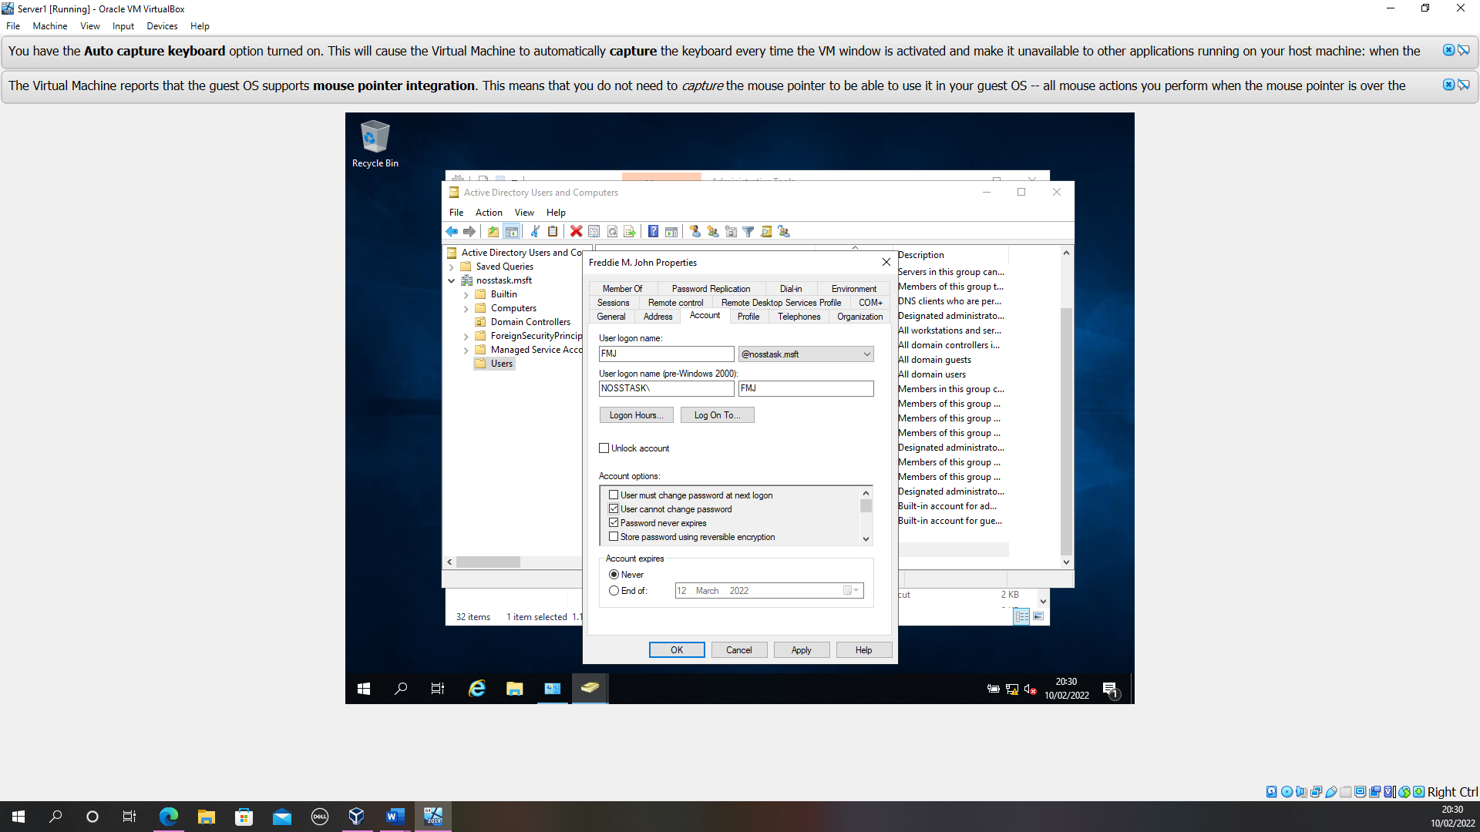
Figure 34 User unable to change their password

Adjoining the domain and testing user logins

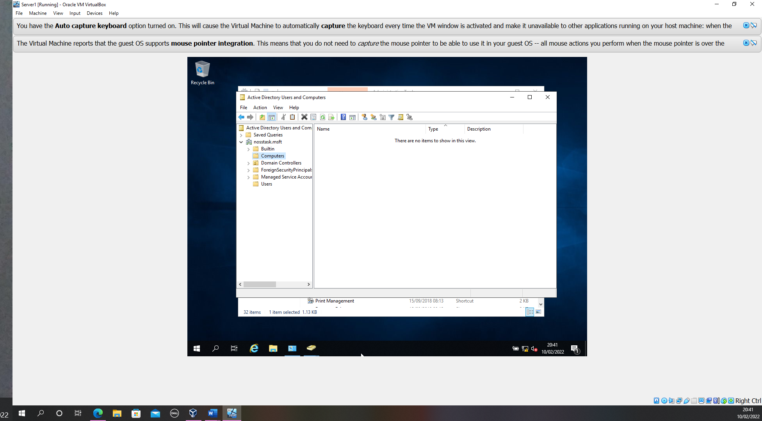
This verifies that no computer accounts are currently created for client 1 or client 2

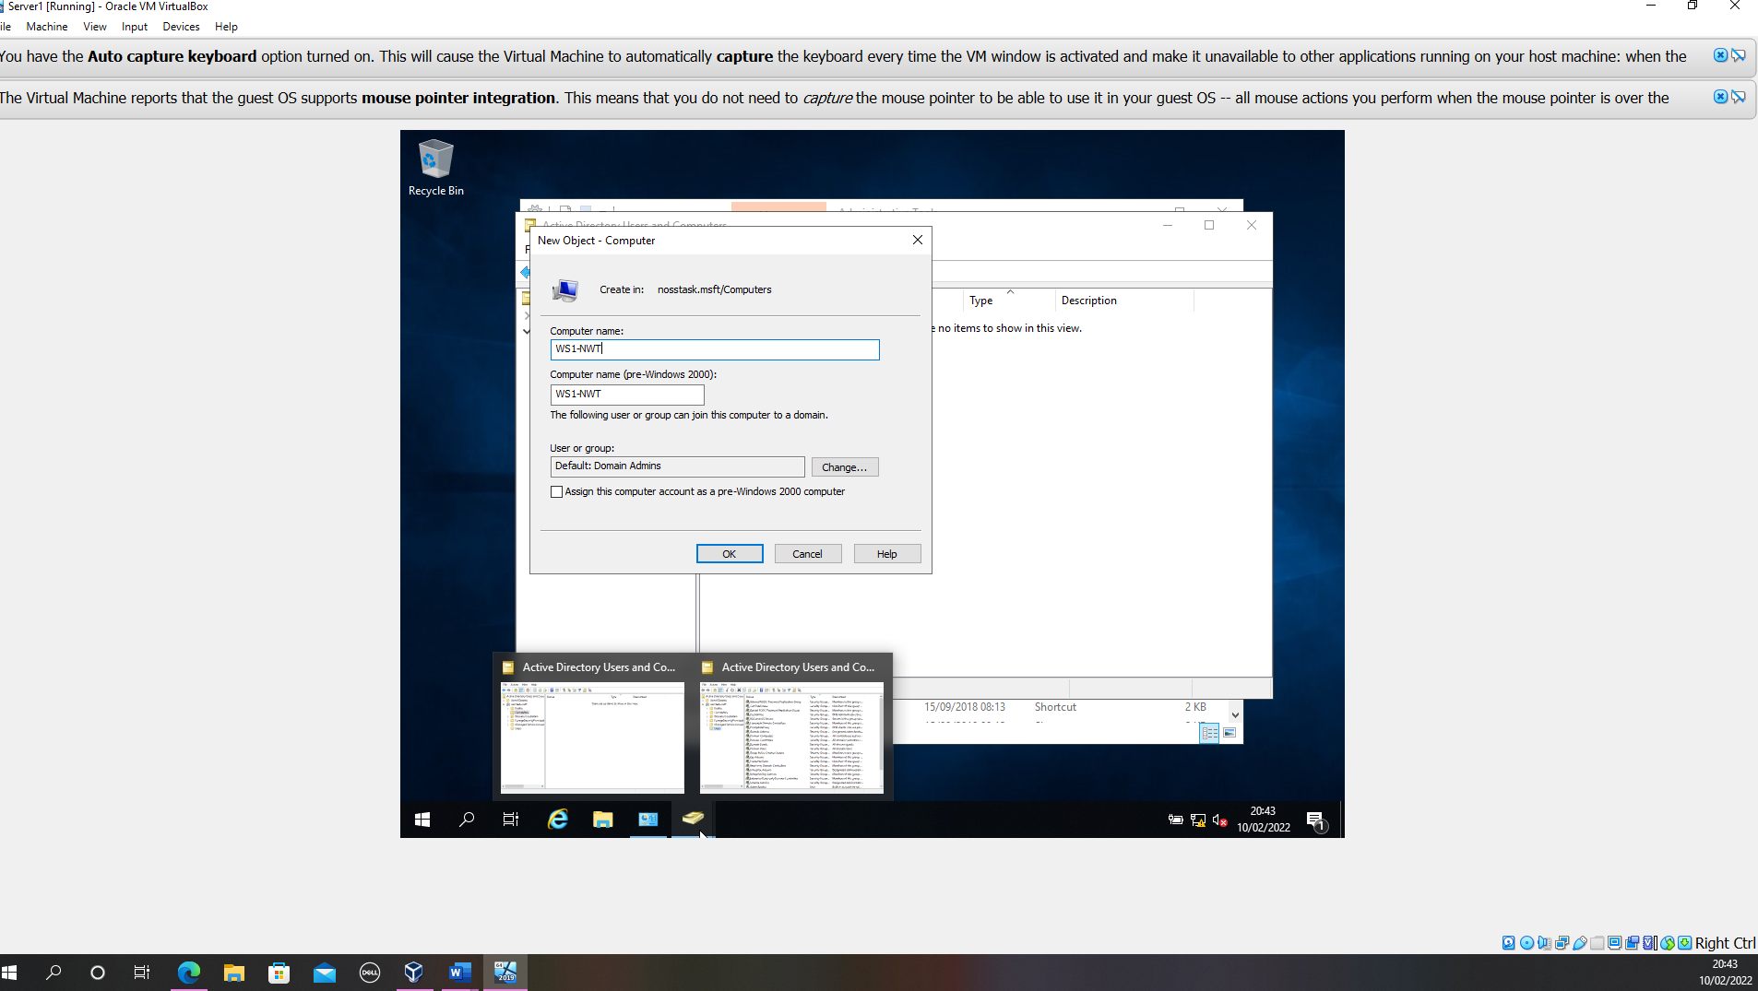
Figure 35 Computer account created

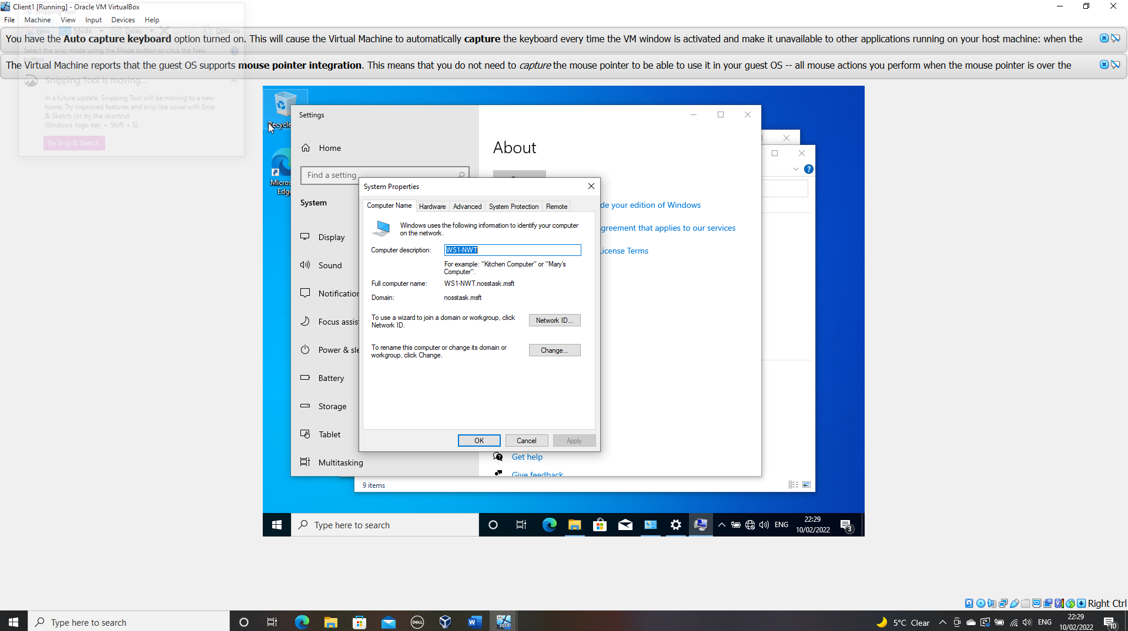
Figure 36 Computer name changed client 1

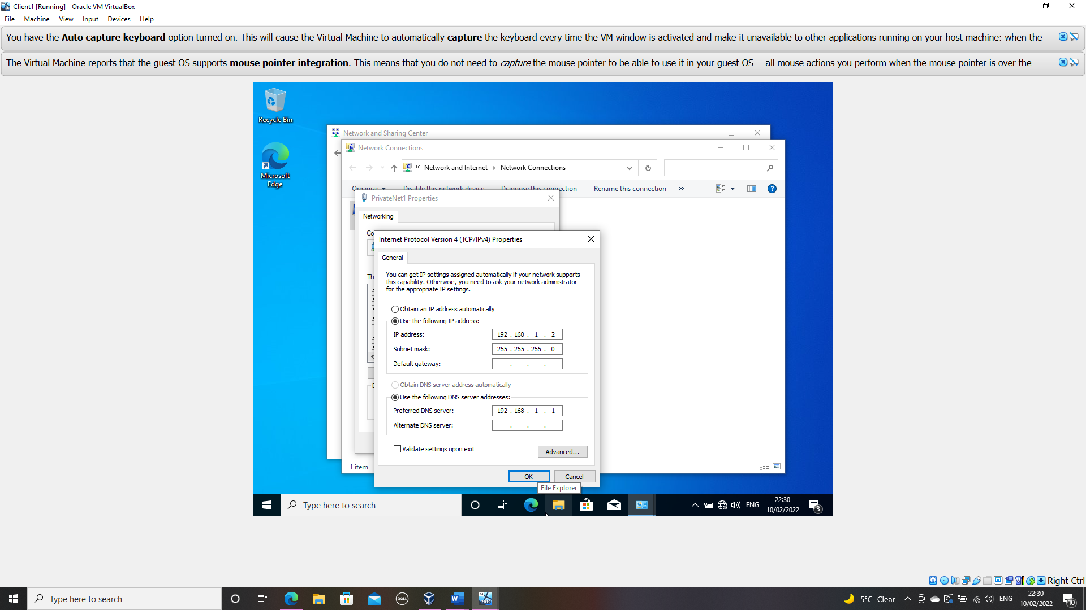
Figure 37 DNS changed in client 1

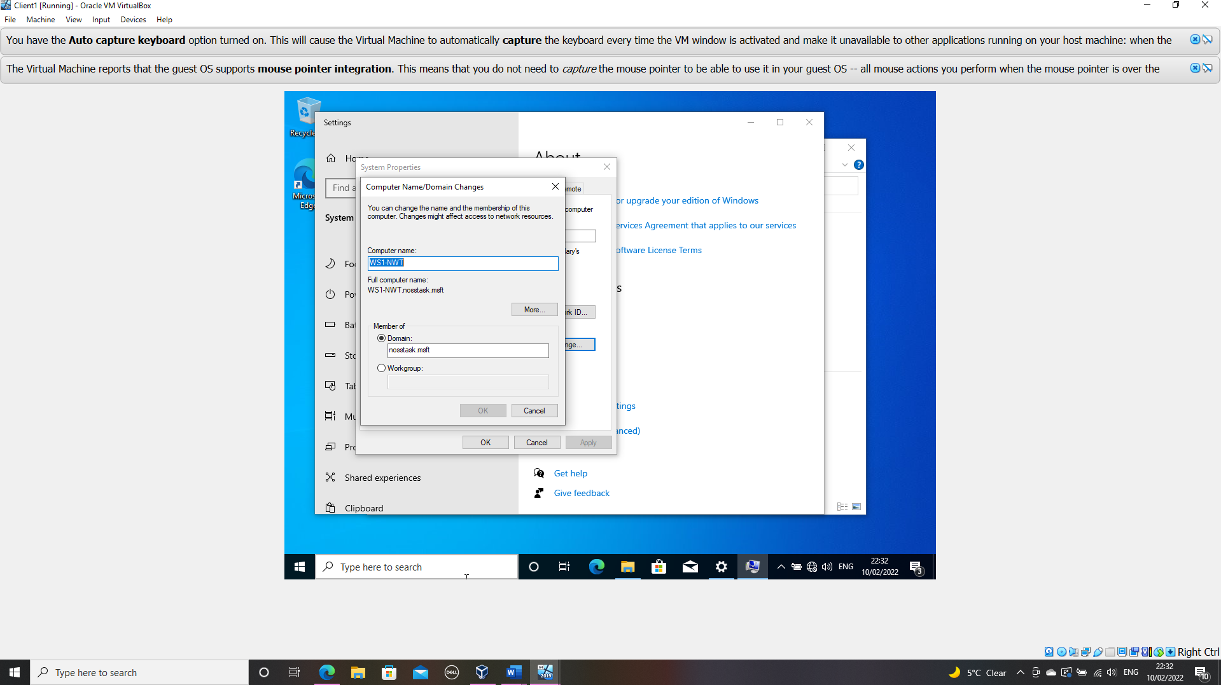
Figure 38 Domain controller changed in client 1

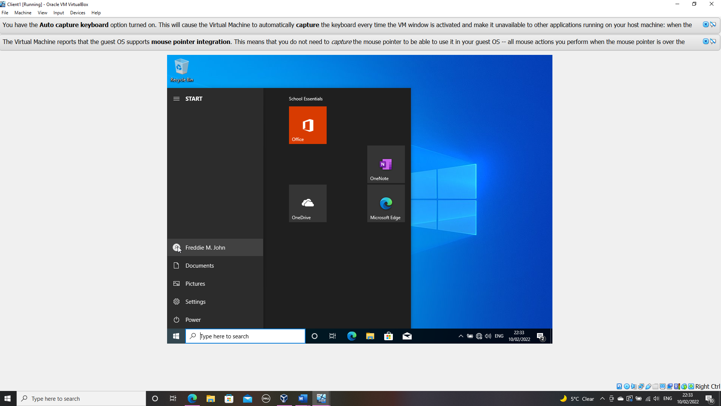

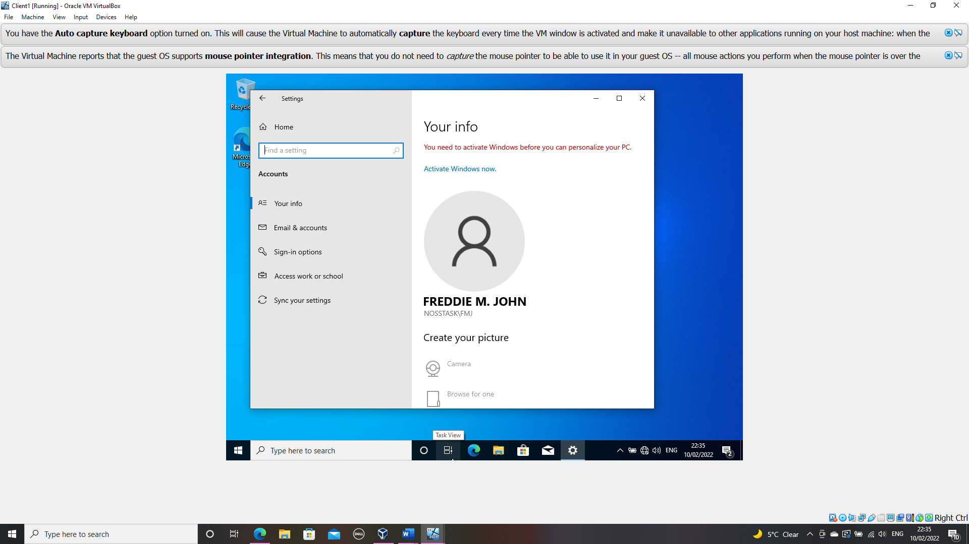
Figure 39 Account switched to a non-admin account on client 1

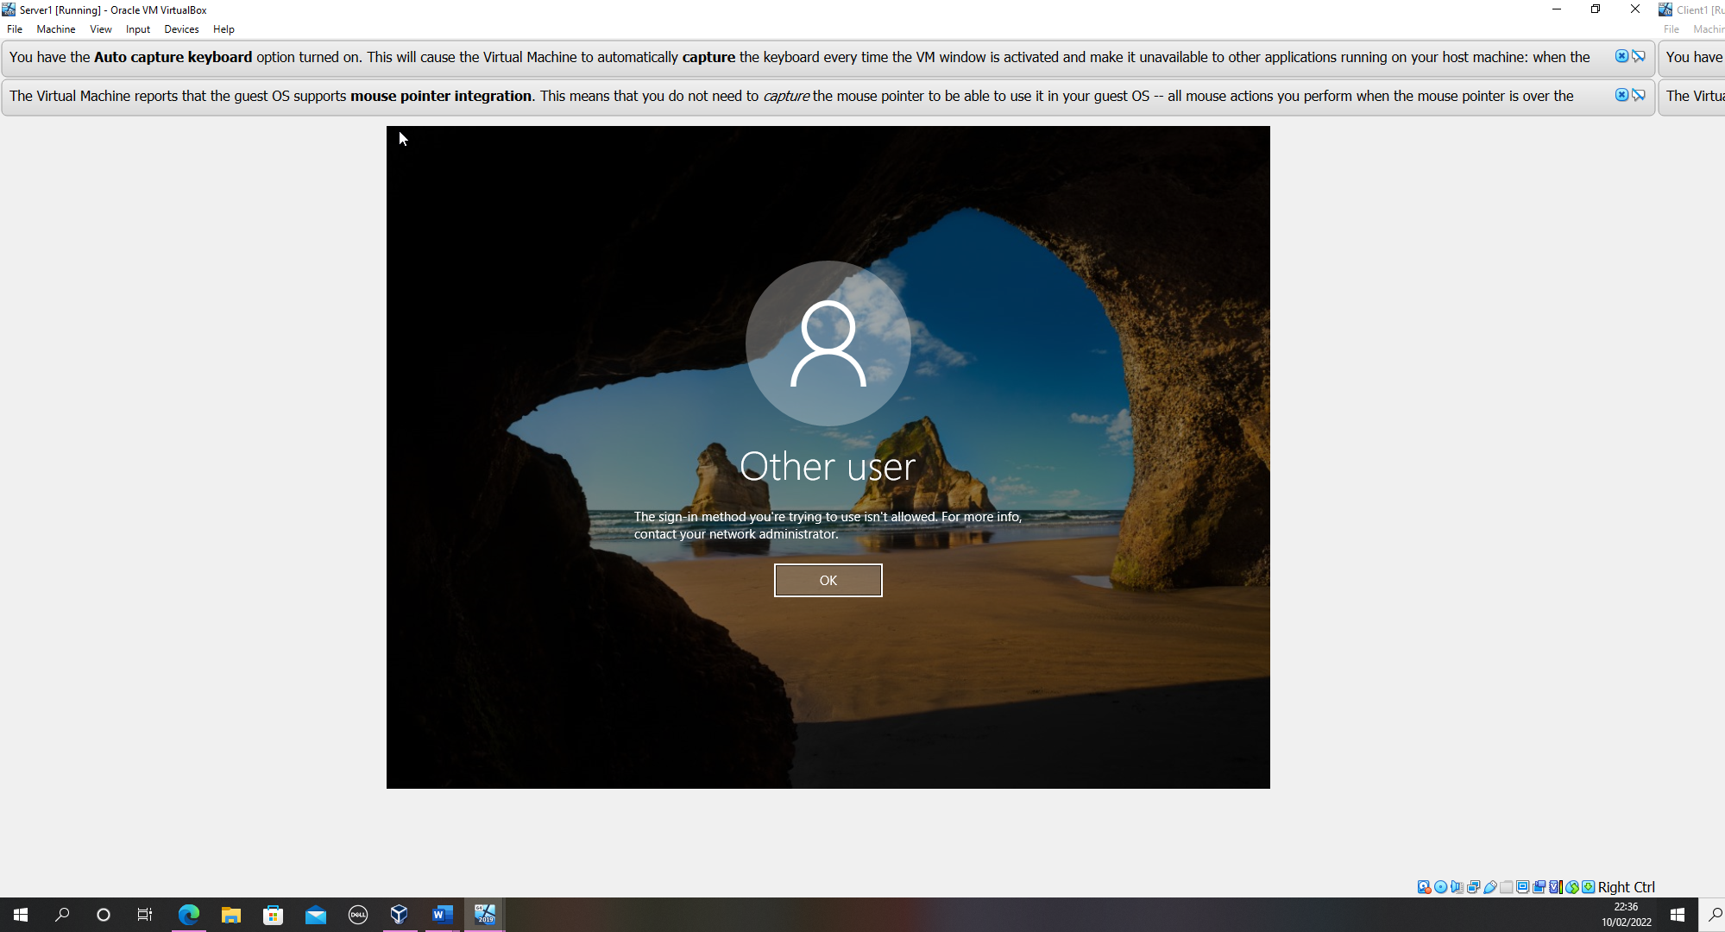
Figure 40 Log in with a non-admin account to server 1 was not successful.

(Sectional word count 297)

(Practical section word count 1044 of 1000)

Task 3

Observations

i.
Hypervisor is a piece of software that allows a host machine to share its resources such as CPU, RAM and hard disk with a guest machine also known as a Virtual Machine which runs on top of the host machine.
There are two types of hypervisors, the first is type one which is installed directly on top of the hardware layer with no Operating Systems or other software inbetween.
According to Bigelow [4] type one hypervisors offer excellent security. Although multiple guest machines can run on the same host machine as they have their own OS they have no dependency on one another and are therefore isolated from each other, this set up ensure attacks are isolated to the one guest machine, therefore preventing attacks from spreading to others.
Type one hypervisors dynamically allocates resources to the VM, ensuring that only the resources being utilised at that time are taken away from the host machine.
However, there are some drawbacks to a type one set up, for example the need for an administrator to manually allocate the resources for the application, which has cost implications for both deploying and maintenance. An example of a type one vendor would be Microsoft’s Hyper-V [5] which according to Microsoft is currently supported on Windows server 2022,2019 and 2016.
The second type of Hypervisor is a type two hypervisor, which runs within the operating system sitting on top of the physical hardware, which means there is an additional layer between the physical machine and the hypervisor. As there are no underlying operating systems, type two hypervisors are relatively easy to set up and manage, as a result they are considered relatively low cost to run. (ref)
However, resources are assigned by the developer and cannot be dynamically managed by the host therefore this can often put a drain on the host machine and when multiple VM’s are running at the same time the system can crash due to the strain placed on the host machines resources.
An example of a type two vendor would be Oracle VM VirtualBox which is Open-Source software and according [6] to VirtualBox runs on a multitude of operating systems including Windows and Linux.
In conclusion the main difference between a type one and type two hypervisor is the way in which they are placed on the architecture.
(Sectional word count 392)

ii.
“Simply put, cloud computing is the delivery of services – including servers, storage, database, networking software, analytics, and intelligence – over the internet” [7].
Cloud computing allows a company’s data and applications to be stored on web servers/computers located in data centres away from the actual company premises, these data centres are often owned and managed by third-party companies. It offers many benefits; the most obvious benefit is that there is no need to purchase expensive software and hardware as these costs are absorbed by the cloud provider. This along with the pay as you go ethos, which allows companies to only pay for what they use makes cloud computing a very cost-effective option. Another benefit is the scalability aspect that cloud computing offers. As the needs of the company increase and decrease so can the resource it uses, with the option to scale both up and out.
However, there are also some drawbacks to cloud computing, one of these is that it can become vulnerable to attack as all the components are accessed via the internet. However there many steps that can be taken to limit the risk of attack.
Amazon web services [8] is just one of the many examples of a cloud computing vendor.
(Sectional word count 206)

iii.
In simple terms a Domain Name System is the equivalent to the yellow pages for the internet, its role therefore is to keep a record of domain names and their respective Internet Protocols Address so that sites and objects can be identified from one another.
Dauti [9] describes the DNS process using the following steps:
- By entering a web address into the browser's, your computer's browser will make a request on the internet to access the requested website.
- The request is then sent to the recursive resolver, generally provided by the Internet Service Provider.
- The recursive resolver will then contact the root servers that stores information about top-level domains.
- The top-level domains will provide the DNS information to the recursive resolver.
- Once the information is received, it will then contact the local domain name server to establish the IP address.
- The recursive resolver provides the IP to the client’s browser which produces the web server content.
Which can be translated into a visual diagram
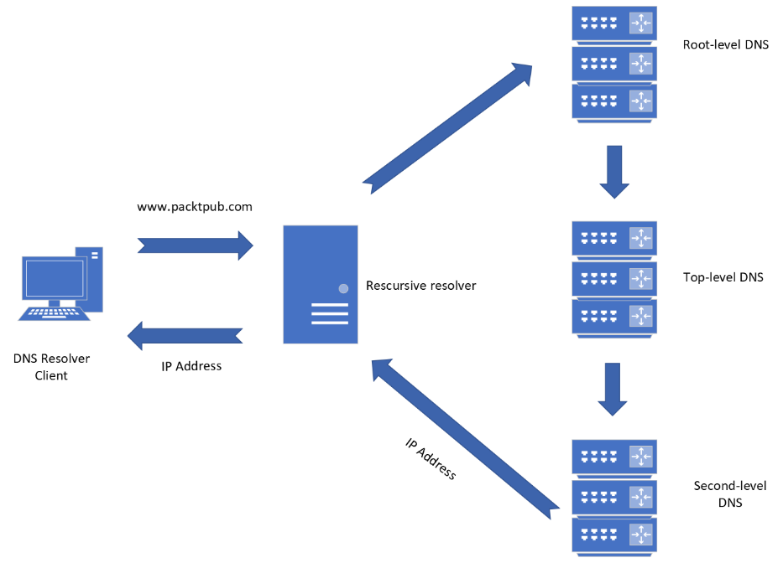
Fig11 DNS request
DNS servers are created within an active directory to store information about objects such as user and access rights as well as devices connected and managed within a network. It makes use of DNS services to enable communication between domain controllers and clients.
(Sectional word count 217)

iv.
One critical role-based installation used in an enterprise network is Dynamic Host Configuration Protocol Server. The main functionality of a DHCP server is to automatically assign Internet Protocol addresses to the end user devices, routers, and layer 3 switches contained within the network. It also takes on the role of storing each IP address currently connected to the network and assigning new IP address as required.
Another critical feature-based installation is ‘Group Policy Management’, according to Wilson [10] GPM is one of the features in Windows that allows system administrators to manage and control the configuration of users and computers within the active directory environment rather than having to configure each device individually.
(Sectional word count 114)

v.
One of the terms mentioned in the practical element was the Windows Ping command. The purpose of this is to establish if a host device is reachable across the network using the IPv4 address. It also enables us to monitor a networks performance. This command is not unique to Windows and is available across each of the different operating systems, although there is slightly different process for accessing the command line prompt window where the ping command is executed.
Another term mentioned in the practical element was ‘Active Directory’. Designed to run with Microsoft Windows Server it enables administrators to manage user permission and network access. Linux does not offer an off the shelf package like Microsoft’s AD, however developers can build a version of AD with the use of Kerberos and OpenLDAP or through the use of one of the open-source management tools such as FreeIPA [11].
Another term mentioned in the practical element was firewalls. Cheshire [12] describes a firewall as a filtering device that allows or rejects network access requests. It does this by enforcing network security policies which aim to protect the network from outside attackers.
Windows OS utilises Windows Defender as it’s firewall management software, this is displayed in a graphical user interface. Windows Defender Firewall offers many features, one of which is the management of inbound and outbound packet rules. This function allows rules to be opened or disabled, as well as managing which port numbers are accepted by specifying which profiles can run each rule.
In comparison Linux operating system uses software such as ‘Netfiler’ to filter and manage network address translation as well as Iptables and Uncomplicated Firewall which enables developers to set up firewalls. Linux uses a command line prompt environment to manage features such as the firewall. However, simpler configurations are available in both Open-source and commercial software which can be used to set up and maintain firewalls within Linux. An example of an open-source Linux firewall solution would be IPCop [13] a further example of a commercial alternative would be Endian UTM [14]. In order to allow and disable firewall rules in Linux using the command line prompt, commands such as enable and disable can be utilised. Similarly commands such as ‘add’ and ‘remove’ can be used to manage the ports numbers that are accepted for each rule.
(Sectional word count 390)

vi.

Thinking back over this component of the course I realise that I have learnt many valuable theoretical and practical skills, such as the role in which DNS plays in an active directory environment and how to configure an active directory within a network environment.
The way in which this component was laid out with written instruction and practical guidance enabled me to gain the most from this task and cement the steps required to set up an AD DS.
For the future I feel I could improve on the activity outcomes by reading through the complete task before beginning the implementation process so that I fully understand what is expected of me and the system requirements of the chosen device. sFrom this activity I now feel confident to set out a professional report that can be interpreted by a wide range of readers such as professionals and non-technical readers.

(Sectional word count 150)

(Part 3-word count 1469 of 1500)

(Total document word count 2513 of 2500)

References

[1] | R. Waddilove, “Raw Info Pages,” [Online]. Available: http://www.rawinfopages.com/tips/2017/07/speed-up-virtualbox-in-windows/. [Accessed 03 February 2022].
[2] | Oracle Corporation, “VM VirtualBox Manual,” 13 December 2012. [Online]. Available: https://www.virtualbox.org/manual/ch03.html#settings-processor. [Accessed 07 February 2022].
[3] | GitHub, “Microsoft Documentation,” Microsoft, 01 July 2021. [Online]. Available: https://docs.microsoft.com/en-us/windows/win32/memory/physical-address-extension?redirectedfrom=MSDN. [Accessed 05 February 2022].
[4] | S. J. Bigelow, “Tech Target,” Tech Target Network, 13 January 2021. [Online]. Available: https://searchservervirtualization.techtarget.com/feature/Whats-the-difference-between-Type-1-and-Type-2-hypervisors. [Accessed 05 February 2022].
[5] | Microsoft, “Microsoft Documentation,” 29 07 2021. [Online]. Available: https://docs.microsoft.com/en-us/windows-server/virtualization/hyper-v/hyper-v-technology-overview. [Accessed 05 February 2022].
[6] | VirtualBox, “VirtualBox,” [Online]. Available: https://www.virtualbox.org/. [Accessed 05 February 2022].
[7] | Microsoft, “Azure Microsoft,” Microsoft, [Online]. Available: https://azure.microsoft.com/en-gb/overview/what-is-cloud-computing/#benefits. [Accessed 17 February 2022].
[8] | Amazon, “Amazon Web Services,” Amazon, [Online]. Available: https://aws.amazon.com/products/?pg=WICC-N&aws-products-all.sort-by=item.additionalFields.productNameLowercase&aws-products-all.sort-order=asc&awsf.re%3AInvent=*all&awsf.Free%20Tier=*all&awsf.tech-category=*all. [Accessed 17 02 2022].
[9] | B. Dauti, “Windows Server 2019 Administration Fundamentals :,” in A Beginner's Guide to Managing and Administering Windows Server Environments, 2nd Edition,, Birmingham, Packt Publishing, Limited, 2019. ProQuest Ebook Central,, 2019, p. 149.
[10] | M. Wilson, “PC and Network Downloads,” 22 07 2021. [Online]. Available: https://www.pcwdld.com/group-policy-management#wbounce-modal. [Accessed 16 02 2022].
[11] | FreeIPA, “FreeIPA,” [Online]. Available: https://www.freeipa.org/page/Main_Page. [Accessed 24 02 2022].
[12] | J. Cheshire, “Microsoft Azure Fundamentals,” in Exam Ref AZ-900, Second edition ed., Burlington, MA: Jones & Bartlett Learning, 2021, p. 200.
[13] | IPCop.org, “IPCop - The Bad Packets Stop Here,” IPCop Team, [Online]. Available: https://www.ipcop.org/. [Accessed 24 02 2022].
[14] | Endian, “Endian,” Endian, 2003. [Online]. Available: https://www.endian.com/products/network-security/. [Accessed 24 02 2022].

