LCLM 5005: Organisational Culture
Component 1: Organisational Culture: Individual Report

Chosen Organisation: Tesco

Student ID: 2411676
Student Name: Raducu Flavian George
Teacher: Alfred Mensah

Table of Contents
Introduction 3
The way organisational culture influences the organisation's structure and decision-making process 4
Application of relevant frameworks to analyse the organisational culture 4
The way the organisation leverages its culture to adapt external environmental influences 8
Role of organisational culture in effective organisational functioning 10
Impact of organisational culture on organisational performance 11
Evidence-based recommendations for improvements 12
Conclusion 14
Reference List 15

Introduction
Organisational culture consists of shared values, beliefs, and behaviours within an enterprise. In a workplace, organisational culture influences the way staff interact, make decisions, and meet the shared goals of the enterprise (Mullins and Christy, 2016, p. 574). The aim of the study is to identify the impact of organisational culture in business operations based on the organisational practices of Tesco. Tesco is a multinational grocery and general merchandise retailer in the UK. The retailer started its operation in 1919 and now it has become the market leader in the grocery sector. The enterprise holds 28.5% market share in the UK and its revenue was £73,712 million in the financial year 2025 (Tesco Plc, 2026). Tesco gathers purchasing-related data of people and turns it into profitable information, which enables the enterprise to attain popularity in the UK retail industry.

The way organisational culture influences the organisation's structure and decision-making process
Impact of organisational culture on organisational structure
Tesco follows a tall organisational structure, which features multiple layers of management between the Board of Directors at the top and the checkout assistants at the bottom. The organisation's tall organisational structure relies on a strong ‘command-and-control’ culture with strict task delegation (Tesco Plc, 2025). Clear reporting lines help Tesco to maintain service consistency in the organisation. In the business operation, when the retail enterprise values stability and predictability, the tall structure solidifies a culture of rules and compliance. The employees follow strict guidelines, and upper management retains control over store operations, pricing, and inventory.
Impact of organisational culture on decision-making process
Clear hierarchies and standardised operating procedures at Tesco imply that high-level strategic decisions, large-scale financial investments, and store policies are concentrated at the executive and managerial levels. This ensures uniformity across thousands of stores and supply chains (Tesco Plc, 2025a). The retailer depends on empirical data and technology-driven metrics to make decisions regarding the improvement of inventory, supply chain efficiency and personalised marketing. Major corporate strategies like store formats, supply chain logistics and major financial investments are centralised at the top management level in the UK. The Executive Committee and the Group Chief Executive determine the overarching directions, ensuring standardised execution across thousands of stores.

Application of relevant frameworks to analyse the organisational culture
Schein’s Model
Artefacts
Schein’s model of organisation breaks corporate culture into artefacts, espoused values, and basic underlying assumptions. As per the aspects of artefacts in Schein’s cultural model, store layouts, uniforms, and daily routines reflect the organisational practices of a company (Harboe, 2026). In terms of Tesco, the presence of service sessions, and self-check-out kiosks dictates the way employees interact with the retail space. The distinct coloured polo shirts and name badges worn by customer assistants and managers immediately identify the roles and establish a sense of uniformity and brand presence on the shop floor, which are the observable elements of the organisation. The use of handled devices for stock-checking, specific inventory software and customer service desks are tangible technologies that demonstrates the way Tesco maintains its daily operations.

Espoused Values
In the organisational aspect, espoused values represent a company’s stated beliefs, goals, and strategic philosophies. Tesco applies the core principles of espoused values through official corporate codes to declare expectations for employees and corporate behaviour publicly. The retailer claims to centre its operations around the requirements of customers, co-workers, and local communities. The enterprise utilises data-driven insights, such as the Club card scheme and customer feedback loops to tailor product offerings and store layouts, which reflects its stated policy of adapting to customer needs (Tesco Plc., 2025). The core feature of the organisational culture of the organisation is listening carefully to employees and values the different perspectives of team members. In practice, the principles of espoused values are applied through HR policies that focus on employee well-being, flexible working, and training programs that attempt to align its public commitment with human resource practices.
Basic underlying Assumption
Basic underlying assumptions are the deeply ingrained, unconscious beliefs that drive employee behaviour in a workplace (Eskandari, et al., 2024). At Tesco, the concept of basic underlying assumption dictates the way the workforce perceives customer service, operational efficiency, and decision-making. Tesco’s organisational culture focuses on ‘We make what matters better together’ (Tesco Plc. 2024). For employees, shared values dictate treating every staff with respect, continuous development, and commitment to understanding people. It fosters a culture of listening and fair treatments.
Strengths and Limitations
The strengths of Schein’s cultural model is it breaks the organisational culture into three structured layers that gives teams a practical way to analyse organisational dynamics (Eskandari, et al., 2024). The employees of Tesco are encouraged to work as one team, share diverse perspectives and support one another to achieve the shared organisational goals (Tesco Plc, 2024). On the contrary, the limitation of espoused values concepts of Schein's model is difficult to align with stated values and actual tactic assumptions in the workplace that creates challenges for the retailer to drive operational change and execute consistent customer service.

Hofstede’s Cultural Dimensions
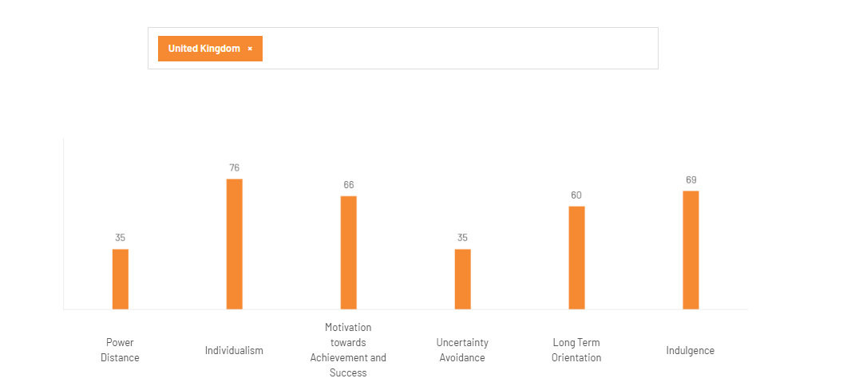
Figure 1: Cultural Dimension factors of Hofstede
(Source: The Culture Factor, 2026)
Power Distance
The UK’s low score of 35 on Hofstede’s Power Distance Index shapes Tesco’s organisational culture by fostering a collaborative, egalitarian environment. This leads to effective decision-making and open communication channels between store-floor staff and corporate leadership (Tesco Plc, 2022). For instance, Managers and executives at Tesco prefer accessible, two-way communication rather than relying on a rigid chain of command, which allows staff to share feedback and ideas to upper management easily.
Individualism
The 76 score in Hofstede’s framework indicates high individualism, which implies that individuals are highly self-reliant, motivated by personal rewards, and prioritise autonomy. In Tesco’s highly hierarchical and team-focused retail environment, the high individualism factor forces the enterprise to invest in employee development initiatives (Tesco Career, 2022). Tesco uses performance-linked incentives and successful career development structures within the workplace rather than relying on collective, group-based awards to influence individuals to perform well in the workplace.
Motivation towards achievements
A Hofstede score of 68 in the Motivation towards Achievements and success dimension indicates a highly driven and competitive culture. At Tesco, the highly driven and competitive culture creates an organisational culture that focuses on target-setting, performance-based rewards and clear hierarchical goals (Tesco Plc, 2022).
In the workplace, the staffs are continuously evaluated through strict KPIs, sales targets and personal development plans. Success is openly recognised and celebrated, which motivates staff to improve their performance level.
Uncertainty Avoidance Index
The UK has a low uncertainty avoidance score of 35, which forced Tesco to create an adaptable and less-risk averse culture. Consequently, the employees are more willing to embrace new technology, maintain flexible working conditions, and engage with evolving retail strategies (CIPD, 2024). The low uncertainty score supports Tesco to focus on inclusive hiring practices and gender-balanced corporate environment. Employees are encouraged to voice new ideas to improve customer service.
Long-Term Orientation
In Tesco’s organisational culture, this long-term orientation manifests as a blend of traditional values and future-focused strategies, where organisational leaders emphasise adaptable, forward-looking goals while balancing the need for immediate, quantifiable business performance. The UK’s Long-Term orientation score of 60 indicates a balanced, pragmatic society (Gerlich, 2023). The organisation uses values-based hiring and structured development to ensure staffs align with long-term company goals, which allow for a continuous two-way flow of knowledge in the UK market.
Indulgence
A high Indulgence score of 69 means employees prefer free gratification of basic desires, optimism, and leisure time. It is identified that Tesco supports the high indulgence aspects by offering staff flexible shift patterns, generous annual leave, and perks like the Tesco Club card, which provides immediate financial gratification and lifestyle flexibility (Tesco Plc, 2026). Managers at Tesco UK adopt a more democratic management style, which allows employees greater freedom and optimism to express themselves at work. It is important for maintaining morale in high-turnover retail environments.
Strengths and Limitations
The strengths of Hofstede’s organisational culture model are it offers clear standardised terms to discuss hierarchy, risk and team dynamics (Magala et al., 2024). Based on the long-term orientation factor, it is found that the organisational culture of Tesco encourages testing new ideas, modifying operations and integrating digital solutions to secure a long-term competitive advantage (Tesco Careers, 2026). The limitations of Hofstede’s model is it considers cultural dimensions as fixed constants in organisational culture, which is unable to capture the way the uncertainty avoidance factors affect the organisational culture of the Tesco.

The way the organisation leverages its culture to adapt external environmental influences
Political Factor
The UK’s National Minimum Wage and National Living Wage Policy indicate that employees must receive £12.71 per hour in the workplace (Government Digital Service, 2026). Tesco’s organisational culture remains supportive and employee-focused, as the company proactively sets its base pay to £13.28 per hour. These salary rates not only exceed the statutory minimum wage but also ensure that staff across all age groups receives equitable and highly competitive compensation.
Economic Factor
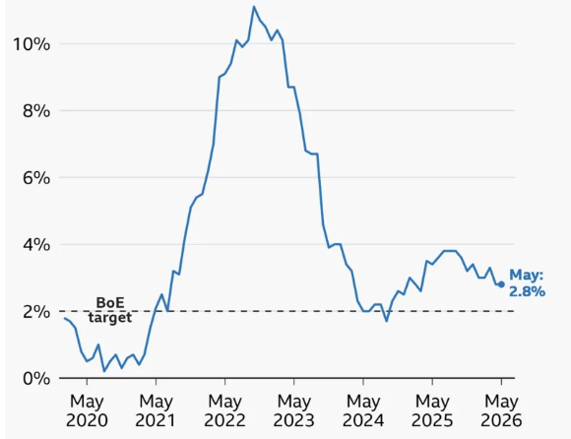
Figure 2: Inflation rate in UK from May 2020 to May 2026
(Source: BBC News, 2026)
As per the above image, the inflation rate of the United Kingdom was 2.8% in May 2026 (BBC, 2026). The enterprise depends on the ‘Save to Invest’ programs, urging management at all levels to find operational inefficiencies (Tesco, 2024). Inflation rates eroded the spending power of the workforce. As an outcome, Tesco’s HR culture lends into staff well-being and competitive compensation.

Social Factor
The demand for flexible working across the UK is increasing, where almost 76% of staff actively seeks flexible hours (HRD Connect, 2024). The rising demand for flexible working practices forces Tesco to implement flexible hour policy in the workplace. The employees across all levels can request for flexible working arrangements, such as job-sharing, part-time hours and hybrid working, from their first day of joining (Jangoulun Singsit, 2023). In the workplace, meeting the demand of flexible working practices of the employees increases the employee engagement level.
Technological Factor
The rise of e-commerce and automated supply chains accelerates a shift towards digital upskilling, which requires staff to adapt to modern technologies. Tesco invests in self-led learning systems and AI-based training programs to create a productive work culture and increase the efficiency level of the staff in the workplace (Tesco Plc, 2026a). Tesco collaborates with platforms like Perceptyx to capture real-time feedback from the workforce, which allows the management to adapt training and support in the workplace.
Legal Factor
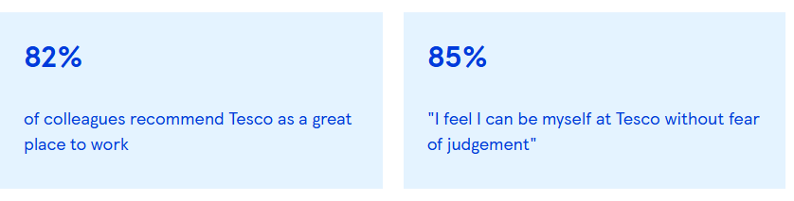
Figure 3: Feedback of employees regarding the working environment of Tesco
(Source: Tesco Plc, 2026b)
The UK’s Equality Act 2010 legally protects individuals from discrimination, harassment, and victimisation in workplaces. Tesco adheres to the guidelines of Equality Act 2010 to create an organisational culture, which is free from discrimination and harassment. The retailer’s corporate policies actively align with the Act’s statutory guidelines to prevent discrimination from the workplaces based on disability, race, and other protected characteristics.
It is identified that the retailer promotes a diverse workplace by enforcing policies against discrimination in hiring, promotions, and daily operations. Based on figure 3, 82% of staff states that Tesco is a great place to work, while 85% of employees point out the working environment is free from fear of judgment (Tesco Plc, 2026b). The enterprise mandates training to foster an inclusive organisational culture, which aligns with the guidelines of Equality Act 2010.

Environmental Factor
External environmental factors, especially climate change, sustainability factors, compel Tesco to shift its organisational culture from a traditional volume-driven retail model to an organisational culture that focuses on environment consciousness, agility, and waste reduction. Tesco leaders encourage employees to be adaptable, embracing new low-carbon agricultural innovations, and digital solutions (Tesco Plc, 2025a). The enterprise creates an organisational culture, where teams across procurement supply chain and retail operations collaborate closely to achieve plastic reduction and source responsibly. Tesco’s internal culture prefers strict ethical compliance and clear communications with consumers and shareholders.

Role of organisational culture in effective organisational functioning
Organisational culture acts an enabler in organisational function
In a workplace, when culture aligns with strategic objectives, it acts as a powerful catalyst for organisational effectiveness. The organisational culture of Tesco prioritises continuous learning and psychological safety, which increase the innovation level among staff and support them to take calculated risks. It is examined that an organisational culture that prioritises continuous learning is able to enhance the adaptability level of the employees (Mustafa, and Lleshi, 2024). Continuous learning enables Tesco to function effectively by driving an agile, highly skilled, and motivated workforce. It ensures that employees are able adapt to evolving consumer trends, accelerates leadership development and optimises daily routines (Mullins and Christy, 2016, p. 574).
Organisational culture acts as an enabler to effective organisational functioning when companies focus on an engaged and diversified workplace. Tesco’s diversified organisational culture operates as a strategic enabler for its business by driving higher innovation, lowering employee turnover and fostering a deep collection with the diverse communities it serves. In the workplace, celebrating different identities, and backgrounds, Tesco reports an estimated 20% increase in innovation driven by diverse team thinking (Tesco Plc, 2026b). The examples highlight that managing a diversified workplace creates an organisational culture that improves the innovation level among the employees.
Transparency in organisational communication supports the organisational culture by building trust, establishing clear accountability and ensuring team alignment. In Tesco's workplace, through transparent communication, leaders explain the reasons behind changes, which inform employees to make effective decisions in the workplace. Transparency in Tesco’s organisational communication depends on a blend of top-down corporate reporting and bottom-up employee engagement (Tesco Plc, 2026).
The retailer focuses on fostering trust through open dialogues, internal surveys and digital platforms to ensure staff are aligned with broader company goals and values.
Justification
Employee empowerment and well-being initiatives not only increase the employee engagement level at a workplace, but also improve the innovation level of the staff (Knox and Marin-Cadavid, 2023). In Tesco terms, the company is able to boost staff morale, employee retention, and on-the-job productivity through employee empowerment and well-being strategies. In addition, the retailer integrates a continuous improvement culture across its workforce, which ensures that daily operations from logistics in local distribution hubs to customer service on the shop floor are constantly, optimised, eliminating from the workplace inefficiencies (PMI, 2026). The retailer empowers staff at all levels to take responsibility and make effective decisions regarding work practices by focusing on inclusion and treating employees equally. The collaborative work environment reduces work pressures and encourages healthy debate for better decision-making.

Impact of organisational culture on organisational performance
Improvement in staff retention and productivity
Tesco’s organisational culture drives its performance by balancing a strong customer-centric focus with rigorous cost-control. Through emphasising employee training, clear roles, and structured rewards, the enterprise boosts staff retention and productivity (Tesco Careers, 2022). Tesco design an organisational culture that values personal development, diversity and structure reward systems, the enterprise enhances worker capabilities by investing in continuous learning programs and training sessions.
Development in employee adaptability and growth
The company's culture drives employee adaptability and growth by blending structured learning, flexible working arrangements, and active engagement strategies (Tesco, 2025a). Through promoting a shared understanding of goals and comments to personal developments, the company creates an environment where employees can continuously evolve.

Critically analysis the way organisational culture influences the performance
The organisational culture of Tesco affects the organisation's performance by driving employee engagement, customer service quality, operational agility, and financial outcome. The strong service-oriented culture aligns frontline staff with brand value, which reduces staff turnover and increases employee motivation level (Tesco Careers, 2026). On the other hand, the performance-driven working culture stifles employee creativity, creates intense performance pressures and slow adaptability to structural changes (Smith and Cooper, 2023). The organisational culture of the retailer supports the enterprise to increase staff motivation level; however, it decreases staff creativity and creates intense pressures for staff to develop their productivity continuously.

Evidence-based recommendations for improvements
Empowerment of store-level staff in decision-making
Tesco’s organisational leaders can empower store-level staff to make decisions to resolve customer-related problems. For example, John Lewis empowers store-level staff to make decisions regarding customer-related requirements (Engine, 2022). At John Lewis, frontline workers are expected to make autonomous customer service decisions, while access to real-time data allows them to manage inventory and resolve issues. Based on the transformational leadership theory, providing autonomy to staff not only increases employee motivation, but also enhances organisational performance (Eaton et al., 2024). In the workplace, empowering store-level staff in decision-making can address the issue regarding ‘staff creativity’ by lowering rigid barriers and fostering intrinsic motivation, which align with transformational leadership theory. In terms of Tesco, offering autonomy to staff to manage customer-related requirements with innovative solutions can increase the employee engagement level and improve organisational performance, which align with transformational leadership theory, as it can influence staff to increase their efficiency level.
Modernisation of learning and development initiatives to increase employee performance
The retailer can modernise its learning and development initiatives in the workplace to develop the digital skills of the employees. Tesco can leverage digital rolls to offer accessible, bit-sized training. Based on the motivational factor of Herzberg Two Factor theory, offering continuous learning opportunities to employees increases their staff performance level and job satisfaction rate (Koncar et al., 2022). Tesco can modernise its learning and development initiatives in the workplace, which can meet the motivational factor of Herzberg Factor theory, as it can increase the staff proficiency level. For example, Matalan modernised its learning and development programs by collaborating with THRIVE to implement AI-based learning platforms for its 11,000 staff (Learning News, 2022).
Matalan is able to increase the employee performance level in the digital area by implementing an AI-based learning platform. Modernisation of learning and development initiatives can address issues regarding intense pressures of improving productivity in the workplace by replacing outdated training with targeted and tech-driven upskilling. Tesco can modernise its learning and development initiatives in the workplace by incorporating AI-based learning platforms. The strategy can improve its organisational performance by increasing the digital skills of the employees, which align with motivational factor of Herzberg Factor theory, as it motivate staff to develop their performance level.

Conclusion
Based on the entire discussion, it has been summarised that effective organisational culture prefers continuous learning, diversity, and employee engagement, which results in high employee productivity and efficiency. It is found that the retailer uses performance-linked incentives and successful career development structure in the workplace, which influences employees to perform well. The company’s culture encourages employees to test new ideas, modify operations, and use digital solutions, which increase their proficiency level in the workforce. In addition, the retailer to create a diversified organisational culture has followed the guidelines of Equality Act 2010.

Reference List
BBC News, (2026). UK inflation: What is the rate and why are prices still rising? [online] Bbc.com. Available at: https://www.bbc.com/news/articles/c17rgd8e9gjo [Accessed 12 July 2026].
CIPD, (2024). Transforming the HR operating model: Tesco. [online] CIPD. Available at: https://www.cipd.org/en/knowledge/case-studies/operating-model-tesco/ [Accessed 14 July 2026].
Eaton, L., Bridgman, T. and Cummings, S., (2024). Advancing the democratization of work: A new intellectual history of transformational leadership theory. Leadership, 20(3), pp.125-143. https://journals.sagepub.com/doi/abs/10.1177/17427150241232705
Engine, (2022). Five top UK retail brands for customer experience in 2022. [online] Enginecxdesign.com. Available at: https://enginecxdesign.com/perspectives/top-5-retail-brands-for-customer-experience-in-2022 [Accessed 15 July 2026].
Eskandari, D., Haghparast Ghomesheh, A., Jabbari, M., Gholami, A. and Ahmadi, O., (2025). Development of a New Index to Assessing the Safety Culture Based on the Edgar Schein Model (Audit Approach). The Scientific World Journal, 2025(1), p.3166187. https://onlinelibrary.wiley.com/doi/abs/10.1155/tswj/3166187
Gerlich, M., (2023). How short-term orientation dominates Western businesses and the challenges they face—an example using Germany, the UK, and the USA. Administrative Sciences, 13(1), p.25. https://www.mdpi.com/2076-3387/13/1/25
Government Digital Service, (2026). National Minimum Wage and National Living Wage rates. [online] GOV.UK. Available at: https://www.gov.uk/national-minimum-wage-rates [Accessed 11 July 2026].
Harboe, S., (2026). Time for revival: re-conceptualising organisational culture through critical realism. Journal of Critical Realism, 25(1), pp.1-22. https://www.tandfonline.com/doi/abs/10.1080/14767430.2026.2617820
HRD Connect, (2024). Over half of UK workers ready to take advantage of new flexible working laws. [online] HRD. Available at: https://www.hrdconnect.com/2024/04/04/over-half-of-uk-workers-ready-to-take-advantage-of-new-flexible-working-laws/ [Accessed 12 July 2026].
Jangoulun Singsit, (2023). Tesco to offer flexible working rights to employees. [online] Retail Insight Network. Available at: https://www.retail-insight-network.com/news/tesco-employees-flexible-work/ [Accessed 12 July 2026].
Knox, S. and Marin-Cadavid, C., (2023). A practice approach to fostering employee engagement in innovation initiatives in public service organisations. Public Management Review, 25(11), pp.2027-2052. https://www.tandfonline.com/doi/abs/10.1080/14719037.2022.2055775
Koncar, P., Santos, T., Strohmaier, M. and Helic, D., (2022). On the application of the Two-Factor Theory to online employer reviews. Journal of Data, Information and Management, 4(1), pp.1-23. https://link.springer.com/article/10.1007/s42488-021-00061-3
Learning News, (2022). Learning News - the learning sector’s newswire.” [online] Available at: https://learningnews.com/news/thrive/2022/matalan-joins-forces-with-digital-learning-and-skills-specialist-thrive-to-fuel-business-growth [Accessed 16 July 2026].
Magala, S.J., Erten, C., Bell, R.M., Claes, M.T., Yazici, S. and Karabag, A. eds., (2024). Hofstede Matters. Taylor & Francis.
Mullins, L. and Christy, G. (2016). Management and Organisational Behaviour (11th ed.). Pearson Education Limited.
Mustafa, B. and Lleshi, S., (2024). The impact of lifelong learning and investments in employee development on employee productivity and performance. Multidisciplinary Reviews, 7(8), pp.2024175-2024175. https://pdfs.semanticscholar.org/c69f/bec73fca7eb98806b7dfd2be427f6cee0348.pdf
PMI, (2026). How Tesco Built a Sustainable CI Culture. PMI. [online] Available at: https://pmi.co.uk/knowledge-hub/how-tesco-built-a-sustainable-ci-culture/ [Accessed 14 July 2026].
Smith, V. and Cooper, L., (2023). Brave New Leader: How to Transform Workplace Pressure Into Sustainable Performance and Growth. Right Book Press.
Tesco Careers, (2022). Training and development - Tesco Careers. [online] Available at: https://kariera.itesco.cz/en/training-and-development/ [Accessed 16 July 2026].
Tesco Careers, (2026). Why work here. [online] Available at: https://www.tesco.com/careers/en-IN/our-culture/why-work-here [Accessed 8 Aug. 2026].
Tesco Plc, (2022). Annual Report and Financial Statements 2022. [online] Available at: https://www.tescoplc.com/media/759057/tesco-annual-report-2022.pdf [Accessed 12 July 2026].
Tesco Plc, (2024). Core Purpose and Values. [online] Available at: https://www.tescoplc.com/about/how-we-do-business/core-purpose-and-values/ [Accessed 8 July 2026].
Tesco Plc, (2025). Tesco launches the UK’s largest closed loop grocery Media and Insight platform, powered by dunnhumby. [online] Available at: https://www.tescoplc.com/tesco-launches-the-uk-s-largest-closed-loop-grocery-media-and-insight-platform-powered-by-dunnhumby/ [Accessed 10 July 2026].
Tesco Plc, (2025a). Making a positive impact. [online] Available at: https://www.tescoplc.com/media/wvkj1yic/tesco-sustainability-report-2025.pdf [Accessed 12 July 2026].
Tesco Plc, (2026). Core Purpose and Values. [online] Available at: https://www.tescoplc.com/about/how-we-do-business/core-purpose-and-values/ [Accessed 10 July 2026].
Tesco Plc, (2026a). Tesco launches large-scale colleague trial of new AI assistant, designed to lighten the load for customers. [online] Available at: https://www.tescoplc.com/tesco-launches-large-scale-colleague-trial-of-new-ai-assistant-designed-to-lighten-the-load-for-customers/ [Accessed 11 July 2026].
Tesco Plc, (2026b). Diversity, Equity and Inclusion. [online] Available at: https://www.tescoplc.com/sustainability/colleagues/diversity-equity-and-inclusion [Accessed 12 July 2026].
The Culture Factor, (2026). Country comparison tool. [online] Available at: https://www.theculturefactor.com/country-comparison-tool?countries=united+kingdom [Accessed 11 July 2026].
‌

GAI Declaration
I know about the referencing guidelines and GAI usage level of the LCCA University. I declare that I do not use any kinds of GAI tools and software to complete the assignment. I have used the provided resource, books, journals, and the official websites of Tesco to complete my assignment.

