

Underwater Target Detection Optimization Algorithm Based on YOLOv7

by
Yaocai Chen
Supervisor: Dr Tim

Project submitted as part of the requirements for the award of
MSc Software Engineering and Artificial Intelligence

November 2023

DECLARATION

I, ............................................Yaocai Chen………………………………… declare that I am the sole author of this Project; that all references cited have been consulted; that I have conducted all work of which this is a record, and that the finished work lies within the prescribed word limits.

This work has not previously been accepted as part of any other degree submission.

Signed : Yaocai Chen

Date : September 12, 2023

FORM OF CONSENT

I ............................................Yaocai Chen………………………………… hereby consent that my Project, submitted in candidature for the MSc Software Engineering and Artificial Intelligence degree, if successful, may be made available for inter-library loan or photocopying (subject to the law of copyright), and that the title and abstract may be made available to outside organisations.

Signed : Yaocai Chen

Date : September 12, 2023

Underwater Target Detection Optimization Algorithm Based on YOLOv7

Yaocai Chen
University of Wales Trinity Saint David
2200435@student.uwtsd.ac.uk

Abstract— The scarcity of underwater image data sets, the small scale and easy aggregation of detected objects, and the low visibility of underwater scenes bring many challenges to underwater object detection in complex environments. In this thesis, the accuracy of object detection was improved by improving the YOLOv7 object detection network. The results are as follows.
Aiming at the small scale of detected objects in underwater object detection.Two-layer feature fusion network and a multi-layer feature crossover fusion network using attention module were proposed in this thesis. At present, the comm only used feature pyramid only combines the features of two adjacent layers through simple fusion, but does not establish the relationship between the layers well. However, the two feature fusion methods proposed in this paper can effectively utilize channel information and degraded pixel information of different feature layers through the attention mechanism and feature attention module to obtain information-rich features. In addition, it is verified by experiments that feature fusion can improve the problem of small scale of detected objects.
By analyzing the detailed structure and principle of YOLO series deep learning algorithms, the superiority of neural network design and the rationality of loss function design are clarified, and a new YOLOV7 deep learning algorithm is proposed to complete underwater target detection work.
Aiming at the object overlapped in underwater object detection. A positioning quality object detection network with positioning loss is proposed in candidate box generation and regression positioning network in this thesis. At present,in the process of non-maximum suppression in object detection network, the box with the highest classification score in the overlapping box is retained in the result,which makes the detector pay more attention to the accuracy of the category and ignore the positioning quality. In this thesis, the proposed network suppressed the poor quality detection frames in the candidate frame generation and regression positioning network through centrality loss function and IoU loss function, so as to obtain better quality candidate frames and positioning frames.In addition, the experiment proves that increasing the locating loss can improve the over-lapping phenomenon of detected objects.

Keywords— Underwater Object Detection, YOLOv7, Location Loss, Attention Mechanism

Table of contents

I. Table of contents 3
II. introduction 3
Project Aim and Objectives 4
III. Literature review 4
Underwater image enhancement 5
IV. research methodology 6
Evaluation Criteria 8
V. Development methodology 9
VI. Design and Implementation 11
The role of wise-IoU loss function in target detection 13
VII. Results and discussion 14
VIII. Conclusion and recommendation 14
IX. reflection 15

introduction
Computer vision is a simulation of biological vision using computers and related devices, allowing computers and systems to analyze meaningful information from images, videos, and other visual inputs, and take action or provide suggestions based on this information, giving computers the ability to discover, observe, and understand. With the development of hardware devices and deep learning, computer vision is increasingly being widely applied in various fields such as retail industry, inventory management, manufacturing, autonomous driving, agriculture, etc. By integrating with computer vision, users can be provided with automated and affordable services, providing information support for their decision-making.
In the field of computer vision, object detection based on deep learning has the characteristics of automation, low cost, high accuracy, and strong universality. It can effectively reduce labor costs, timely detect abnormal situations, and reduce disease losses. It is a cheap and efficient means of information collection, widely used in various fields.
Object detection is a major problem in computer vision, whose task is to perform automatic recognition and localization on objects to be detected. Driven by deep convolution networks, researchers have proposed many deep learning-based object detection methods, which greatly improve the performance. Detection of underwater objects and resources is an important task. Underwater is rich in biological and power resources, and there are many unknown dangers while waiting for human exploration. In order to explore underwater targets more safely and comprehensively, underwater target detection and underwater robotics are on the agenda. Underwater robots are designed to replace humans to go deep into the seabed and perform dangerous tasks such as underwater scientific research and military mission investigations, marine resource assessment and seabed geological testing. Underwater target detection is a key fundamental technology to help underwater robots better perform these underwater tasks. However, underwater environments are very different from land environments, making target identification more difficult. Although the benchmark dataset has achieved good performance, there are some problems with the image quality such as colour distortion, blurring and contrast distortion due to the absorption and scattering properties of light in water and other reasons when there is not enough light source in the water, resulting in lower accuracy of target detection in underwater images. The study of underwater target detection algorithms is very necessary in the reality where the recognition accuracy of underwater target detection algorithms is still low.
Underwater target detection can be divided into target signal acquisition, feature extraction and target detection according to the process order. The acquisition of the signal is the guarantee for the efficient completion of the subsequent detection work. As the acquired signal is often associated with a series of interference such as noise, the processing of the signal or image is very important. Early underwater target detection mainly used unsupervised feature extraction and target detection, or manual detection methods. This detection process cannot guarantee the accuracy and reliability of detection, and the detection process lacks supervision, and the detection results are unreliable. Due to the lack of guidance on target classification, it is often impossible to achieve effective target classification results. With the continuous development of machine learning technology, it turns out that more and more related technologies have been applied to the field of target detection, and supervised underwater target detection technology has also been greatly developed. Underwater target detection as an important part of underwater vision technology is also more and more influenced by new technologies and new ideas. Therefore, this project discusses and designs more suitable underwater target detection algorithms to complete the work of underwater target detection. From this, I can learn how to use image processing and deep learning to detect and classify marine organisms living in complex environments to meet the needs of ocean development.

Project Aim and Objectives
Due to the significant limitations of underwater acoustic images, most of them suffer from high interference, low resolution, and low signal-to-noise ratio. The accuracy of underwater small target detection using acoustic images is low, while optical images can obtain most effective information in close range underwater imaging. Even if underwater images have issues such as color deviation, distortion, and unclear contrast, using underwater optical images for daily target detection is still a relatively reliable and feasible solution. Given the excellent performance of deep learning methods in machine vision tasks, introducing deep learning technology into underwater scenes and utilizing the powerful feature extraction and learning capabilities of neural networks to solve the problem of detecting small underwater targets is a feasible research approach. Research has shown that due to the unique nature of underwater scenes, when directly introducing object detection methods that have significant detection effects on natural image datasets into underwater scene processing for underwater object detection problems, many problems still arise, especially for the detection of small targets that require more accuracy. Therefore, for underwater small target detection tasks, it is necessary to redesign target detection methods suitable for underwater scenes based on existing research and addressing the problems existing in underwater target detection.
According to the characteristics of underwater datasets and the current challenges faced by underwater target detection tasks, the main problems that need to be addressed in underwater small target detection tasks include: (1) due to the characteristics of color deviation, blurring, and low contrast in underwater images, the feature details extracted from underwater images are severely lost, resulting in insufficient feature expression and discrimination ability of the target; (2) The underwater environment is complex, with diverse background scenes in underwater images, significant changes in the scale of the target to be detected, and the presence of occlusion phenomenon, which requires high performance of the detection model. The detection model needs to be flexible in dealing with target detection problems at different scales in different situations; (3) Due to the presence of multiple detection targets in a single image in the marine biology dataset, it is inevitable that some low-quality annotation examples will be generated during the manual annotation process, which can add irrelevant feature information such as background and microorganisms, affecting the accuracy of model detection.

Literature review
Research status of target detection
Object detection is an important field in the research direction of computer vision. Single stage and two-stage object detection are deep learning object detection algorithms mainly divided into two types: single stage and two-stage object detection. The single stage object detection algorithm is to input the entire image into a convolutional neural network, and directly output the prediction results through the network, which can quickly detect the target object. Common algorithms include YOLO series, SSD, Retina Net, etc. Compared to two-stage object detection algorithms, single-stage algorithms have faster detection speed but relatively lower accuracy, especially in small object detection and object occlusion. The two-stage object detection algorithm first generates candidate box region proposals, and then classifies each candidate box. Therefore, compared to the single stage algorithm, it can more accurately locate and recognize target objects. However, due to the need to first create candidate boxes for classification, the detection speed of the two-stage algorithm is relatively slow. In recent years, the emergence of YOLO V5, YOLOX, and YOLOv7 has been improving, but the accuracy of single stage algorithms is low.
Convolutional neural network CNN is a core component of the Region Proposal algorithm. Early convolutional neural networks were mainly used for image classification, proposed by Professor Yann LeCun. However, traditional object detection has two main problems, namely accuracy and detection speed. The Region Proposal addresses these two issues. The commonly used region proposal methods include Selective Search and Edge Boxes. With the development of CNN, the Top-5 error of Microsoft's ResNet and Google's Inception V4 models has decreased to less than 4%. Therefore, using CNN for image classification of candidate regions can improve accuracy and detection speed.
In the early stage of object detection algorithms, the sliding window strategy was widely used to extract features through traversal. However, this method required exhaustive enumeration of all possible window positions and sizes, and the computational complexity was very high. Girshick et al. proposed R-CNN, which used Selective Search to generate multiple candidate boxes and then used convolutional neural networks (CNN) to extract features and classify each candidate box. This method has achieved good results, but it requires processing the candidate boxes extracted by Selective Search one by one, resulting in high computational complexity and inability to achieve real-time updates. In addition, the presence of a fully connected layer requires that the input prop osal must have the same size, which will to some extent distort the image and affect the detection results. In order to solve these problems, the SPP-NET algorithm proposed by He et al. provides a good solution. This algorithm introduces an SPP layer, which can perform spatial pyramid pooling on convolutional features, thereby eliminating operations such as crash/warp. At the same time, this algorithm can also ensure that candidate boxes of different sizes can be input into the same fully connected layer, avoiding the problem of image distortion. Subsequently, in 2015, Girshick et al. proposed Fast R-CNN, which uses the RoI Pooling layer to solve the problem of a large number of duplicate calculations in R-CNN and SPP-NET algorithms, while also introducing a multitasking approach for classification and regression together. Finally, by using SVD to decompose the parameter matrix of the fully connected layer, the Fast R-CNN algorithm can greatly reduce the computational complexity of the fully connected layer. In 2016, Ren et al. proposed a new Faster R-CNN algorithm, which introduced an RPN network to extract proposals. Compared with traditional methods, RPN networks can not only improve detection accuracy, but also significantly improve detection speed. With the rapid development of these algorithms, the effectiveness and speed of object detection based on deep learning are getting better and faster.
The Faster R-CNN algorithm has become one of the mainstream object detection algorithms, but due to its slow speed, it is not suitable for certain real-time scene application requirements. To address this issue, researchers have proposed algorithms such as YOLO and SSD. The YOLO algorithm proposed by Redmon et al. in 2016 is a convolutional neural network that can simultaneously predict multiple Box positions and categories. The YOLO algorithm adopts a network design strategy similar to Google Net, achieving end-to-end object detection with fast speed. However, the regression method used has resulted in a decrease in accuracy. In 2016, Liu et al. proposed the SSD algorithm, which combines the advantages of YOLO and Faster R-CNN, making it perform well in terms of speed and accuracy. The SSD algorithm can achieve high-precision detection results in object detection of different sizes and shapes by using feature maps of different scales for regression at various positions in the entire image. Compared to YOLO, the advantage of SSD algorithm is that it can predict targets at multiple scales and is not limited by a single scale. Compared with FasterR-CNN, the advantage of SSD algorithm is that it can directly use feature maps for prediction, reducing unnecessary calculations, and effectively solving the problem of Faster R-CNN in small object detection. DETR (Detection Transformer), which has emerged in recent years, is a Transformer based object detection algorithm proposed by Facebook AI in 2019. The goal of DETR is to achieve object detection through an end-to-end approach, eliminating the need for traditional object detection methods to use steps such as anchor and non maximum suppression (NMS). Due to the problem of DETR converting target detection tasks into a sequence to sequence, there may be some positioning errors when predicting the position of the target. In contrast, traditional two-stage methods typically achieve more accurate target localization in the second stage. With the continuous development of algorithms, the YOLO series has become a research hotspot for researchers. There are currently three popular versions of YOLO, namely YOLOv5, YOLOX, and YOLOv7. YOLOv5 was proposed by an author named ultralytics on Github, and has advantages such as small model size, low deployment cost, high flexibility, and fast detection speed. However, its performance still needs to be improved; YOLOX, proposed by Zheng et al., has faster speed and better detection performance compared to other versions of YOLO, and has achieved a transition from Anchor based to Anchor free, making it more flexible. YOLOv7 was proposed by Wang et al. and has received widespread attention due to its excellent performance in speed and accuracy. YOLOv7 adopts a new model structure and optimization strategy, significantly improving detection accuracy and speed by introducing adaptive convolution modules and SPP-block modules.
In summary, the current target detection algorithms have achieved fast speed and high accuracy, but further improvement is still needed. With the continuous upgrading of computer hardware and optimization of algorithms in the future, it is believed that object detection algorithms will become more mature and have a wider range of applications.

Underwater image enhancement
Underwater image restoration and enhancement technologies include traditional underwater image enhancement methods and underwater image enhancement methods based on depth learning.
Traditional underwater image enhancement technology can improve the existing image quality, such as using hardware facilities or traditional image processing algorithms. Hardware based approach: The original idea of image enhancement researchers is to improve the hardware imaging device to achieve the expected high-quality, high-definition underwater image. However, this method of improving hardware is not adaptable to different shooting environments, and has certain limitations. At the same time, due to the high cost of hardware, it cannot be well popularized, which leads to the limitation in practical application. Methods based on traditional image algorithms: In order to reduce the restrictions and budget problems caused by hardware improvements, researchers began to work on improving image enhancement algorithms and improving underwater image quality without changing the existing imaging hardware. Two main image enhancement methods are: non physical modeling and physical modeling. Non physical model method: non physical model technology does not need to establish a physical model, its core is to process the final image and modify the image pixels to improve the visual quality of the image, which is an image enhancement technology. The existing non physical model image enhancement technologies such as histogram equalization and gray world hypothesis are used to directly process the underwater degraded images. Some researchers have also tailored appropriate algorithms for the characteristics of underwater images, such as color correction methods. According to the method of physical model: underwater image restoration based on physical model, its core is to use mathematical model to model the underwater environment imaging, and use its corresponding parameters to get better results from its calculation, which is an image restoration technology. On this basis, a physical model based on the assumed premise or existing knowledge is established, for example, using the assumed underwater imaging model to reverse restore high-quality underwater images. The key point in the study of physical models is a priori model based on local assumptions. In the constructed physical model, the algorithm complexity is high, and the adaptability in different environments is poor.
With the increase of data and computing power, deep learning technology with robust semantic learning ability is widely used in various image visual tasks, and has performed well in various tests. Underwater degraded image enhancement can be based on CNN (Conv evolutionary Neural Network) and GAN (Generic Advanced Network). Based on CNN: UIE-Net (Underwater Image Enhancement net, UIE-Net) has studied a new underwater image enhancement algorithm. Through color correction and haze removal of local areas of the image, the convergence efficiency of the algorithm is effectively improved and the accuracy of the algorithm is improved. Later, Anwar and others trained the Underwater Convolutional Neural Network (UWCNN) using underwater paired datasets synthesized in the room, and directly used UWCNN to reconstruct clear underwater images. In various underwater scenes, the universality of the model is verified by real and synthetic underwater images. Most of the previous algorithms use RGB color space for training, and are insensitive to image brightness, saturation and other attributes. UIEC'2-NetP4 effectively integrates RGB color space and HSV color space into one CNN, which has good performance both subjectively and objectively. In many underwater environments, it is difficult to obtain a large number of paired underwater image data. Researchers have applied the Underwater Generic Adversary Networks (UGANs) based on unpaired underwater images to generate real underwater high-quality images. GAN based approach: Li et al. designed WaterGAN network to generate a training dataset containing corresponding depth information, aerial color images and a large number of underwater images in the real world. The image data is used as an input for underwater image color correction in the two-stage model. Similar to waterGAN, Li et al. also used GAN algorithm to enhance underwater images. On the basis of non degraded images, a pair of underwater images are reconstructed using GAN method, and a new method is proposed to convert degraded underwater images into high-resolution images. Due to the constraints of paired underwater images on image enhancement, a large number of degraded underwater images cannot be fully utilized. Li et al. proposed a weakly supervised underwater color correction model, which mainly includes the confrontation network and loss function: confrontation loss, consistency loss and SSIM loss. This method can not only ensure the structural information of the input underwater images, but also correct their color degradation. Later, for underwater image enhancement in different domains, Uplavikar et al. implemented a network that can simultaneously adapt to image enhancement in various underwater environments using Domain adversarial learning technology. Although some achievements have been made in depth learning restoration and enhancement of underwater images, there is no underwater image enhancement algorithm suitable for various backgrounds and scenes. The scalability and robustness of underwater image enhancement methods need to be improved.
Research Status of Boundary Box Regression Loss
The development of bounding box regression loss has always been an important part of the progress of target detection algorithms. Over the years, various losses have been proposed and applied to various target detection models.
Initially, the loss of L-normal form was used to train the bounding box regression model. For example, L loss (mean absolute error, MAE) and L loss (mean square error, MSE) measure the difference between the predicted and real boundary boxes by taking the mean square error of coordinates. However, L loss is sensitive to outliers in the presence of non derivable points. To solve these problems, Smooth L loss is introduced. This loss function combines the advantages of L loss, L loss and loss, and provides better performance in the target detection model.
The coordinate regression of the loss of the L-normal form does not have scale in variance, and does not take into account the correlation between coordinates. Therefore, direct coordinate regression such as L and L2 is actually difficult to describe the regression effect between the prediction box and the real box. Therefore, the 2016 Intersection over Union (IoU) loss was proposed, which calculated the coordinate points as a whole, with scale invariance. IoU is defined as the ratio of intersection and union between two bounding boxes.
IoU loss improves the performance of target detection, but it also has a disadvantage: when the prediction box and the real box do not intersect, the IoU loss value is always О Unable to judge the distance between the two; When IoU loss value is constant, it is impossible to accurately judge the advantages and disadvantages of bounding box regression. GIoU (Generalized Intersection over Union) considers the minimum external frame of the prediction box and the real box in the loss function, which solves the problem of IoU. However, when one bounding box encloses another, GIoU will degenerate into IoU. To solve this problem, DIoU (Distance IoU) considers the centrality factor into the loss, and then proposes CIoU (Complete IoU), which considers the aspect ratio of the prediction box and the real box. Later, with the continuous research on boundary box loss, researchers proposed many new boundary box regression losses based on IoU, such as CDIoU, EIoU, Coal EIoU, SIoU, etc.

research methodology
This chapter will explore the most suitable methods for underwater target detection from the aspects of establishing experimental platforms, establishing experimental datasets, and selecting experimental evaluation standards. Conduct comparative experiments using underwater target datasets on corresponding experimental platforms, and draw conclusions through comprehensive comparison by specifying evaluation criteria.
Establishment of experimental platform
The experimental platform is a laptop, and the data training server platform is provided by Polar Chain AI Cloud. The specific platform specifications are shown in Table 1.
project | server configuration | Experimental Platform Configuration
CPU | Intel Xeon Gold 5218 | Intel i7-12700H
GPU | RTX 3090 | NVIDIA GeForce RTX 3050 Ti
Memory | 43G | 8G
External Storage | 1TB SSD | 512TB SSD
Operating System | Linux Ubuntu 18.04 LTS | Windows 11
Programming Tools | python | python
Data Processing Data | Numpy | Numpy
Table.1. Distribution of species numbers in the URPC dataset
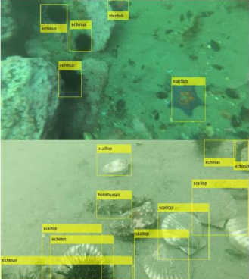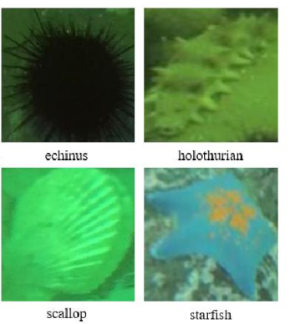

- Sample maps of various species in the URPC dataset
In this article, the tool used for annotating images is LabelImg. As shown in Figure 2 (a), LabelImg is a visual image annotation software that is suitable for multiple operating system environments such as Linux and Windows. The production of deep learning datasets should first select the folder where the images are located and the folder where the annotation files should be stored. Then, the object to be detected should be indicated through frame annotation. Then, different category names should be annotated for different categories of targets, and finally, the annotation work should be completed by saving. The image annotation information is retained in an XML file format, which records in detail the type and location information of the target appearing in the image. The generated result is shown in Figure 2 (b).
As the image annotation work has been completed, corresponding programs are designed based on the annotation results to complete the production of machine learning datasets. Firstly, the annotation file of the deep learning dataset contains specific information about the type and location of the target to be detected. Then, the location information can be obtained by reading the content of the image annotation file and performing image capture operations to obtain a separate underwater target image.
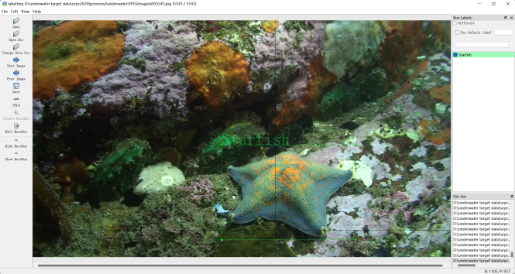
(a)LabelImg interface
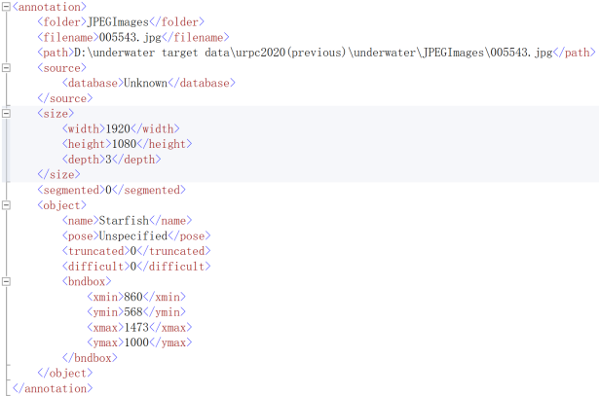
(b) XML file structure
- Image annotation tool and result diagram
The model trained using UIEC2-Net generates underwater image enhancement images on URPC2020, as shown in Figure 3. The left side shows the original image and the right side shows the enhancement image. Because the resolution of the URPC2020 dataset is relatively high, image enhancement is performed by reducing the width and height of the image by half. From the figure, it can be seen that the color of the original image is blue-green, and the sensory quality is not good. The enhanced color of the image is easy for people to watch, and it is significantly better in terms of brightness and saturation.
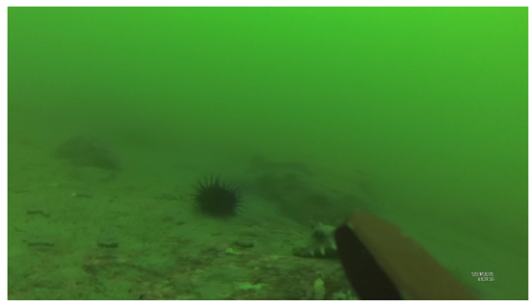
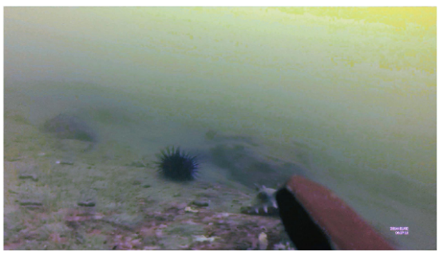
- Original image and enhanced image using UIEC ^ 2-Net
The quality and quantity of dataset samples have a significant impact on the ultimately trained network. The underwater image dataset produced through the dataset has a relatively small sample space. Therefore, this article adopts transfer learning to improve the robustness of the model, reduce training difficulty, and improve detection accuracy. Firstly, the YOLO algorithm is pre trained using a pre trained dataset to obtain the pre trained model of the network. Then, based on the pre trained model, the underwater target dataset is used for training to generate the final underwater target detection model. The pre trained and final models generated are shown in Figure 4. The overall training steps are divided into: building and preparing the YOLO network framework, pre training the network model, and training the underwater target detection model.


- Pre training model (b) Underwater detection model
- YOLOv7 algorithm model results
As shown in the figure, a cfg model parameter file was established based on the proposed YOLOv7 loss function and model network structure. Batchsize represents the number of images loaded in a single model training session, while subdivisions represent the number of times the loaded images are fed into the network for training. Considering the capacity limitations of the graphics memory, it is usually set comprehensively to prevent memory overflow and improve training speed. Channels, which are integer multiples of 8, represent the color channels of the input image. Due to the color image, it is set to 3. The training frequency epoch is set to 300, and the model undergoes 300 iterations to fit the weights of network parameters through the loss function to obtain the final training model. The learning rate represents the learning rate, which affects the frequency of internal parameter updates in the network. It is generally set between 0.01 and 0.001 to prevent slow training speed and weak parameter fitting effect. The model is implemented using NVIDIA CUDA programming for pre training and formal training, with a simple structure that is easy to transplant and install.

Evaluation Criteria
IoU, also known as intersection union ratio, refers to the ratio of the area of intersection and union between bounding boxes. As shown in Figure 4, the ratio of the blue area in the figure is the IoU value.
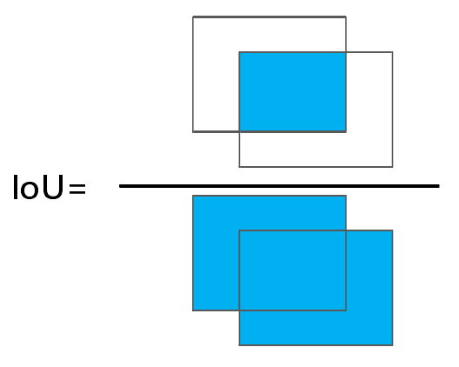
- YOLOv7 algorithm model results
If two bounding boxes are represented by A and B respectively. The calculation result of IoU can be expressed as:
$IoU=\frac{\left|A∩B\right|}{\left|A∪B\right|}$.............................................(1)
IoU plays an extremely important role in object detection algorithms. By calculating the IoU value, the degree of overlap between the predicted box and the actual box can be determined, thereby evaluating the quality of the predicted box. In object detection algorithms, an IoU value is usually artificially set as a threshold, which is used to divide positive and negative samples. Samples with IoU values greater than this threshold for candidate boxes and real boxes are defined as positive samples, while the remaining samples are defined as negative samples. IoU is also applied in non maximum suppression algorithms.
Complete IoU (CIoU) is used in YOLOv7 to calculate positioning loss, and its calculation formula is shown in equation 2:
$L_{CIoU}=1−IoU+\frac{ρ^{2}\left(b^{A},b^{B}\right)}{c^{2}}+αϑ$ ...................................(2)
Among them, IoU is the Intersection over Union (IoU), used to measure the overlap between the anchor box and the target box; $b^{A}$ and $b^{B}$ represent the center points of the predicted box and the true box, respectively; $ρ$ is the Euclidean distance between two points; $c$represents the diagonal length of the minimum bounding rectangle between the predicted box and the actual box; α is a balance parameter; $ϑ$ is used to calculate the consistency of the aspect ratio between the prediction box and the target box.
CIoU comprehensively considers the issues of overlapping area, center point distance, and aspect ratio consistency in boundary regression, making the convergence accuracy of the detection box higher and the regression process more stable. However, the v in equation (2) does not reflect the true difference between the height and width, and its confidence level, which will hinder the model from effectively optimizing the similarity problem. And CIoU uses a monotonic focusing mechanism, which assumes high-quality examples in the training data and aims to enhance the fitting ability of boundary box loss. However, when the target detection training set contains low-quality examples, blindly strengthening the regression of boundary boxes to low-quality examples will obviously reduce the model's detection performance. Therefore, this article uses WIoU (Wise IoU) as the bounding box regression loss function, and its calculation formula is as follows:
$L_{WIoUv3}=rL_{WIoUv1}$....................................................(3)

r=$\frac{β}{δα^{β}}$.......................................................................(4)
$L_{WIoUv1}=R_{WIoU}L_{IoU}$...................................................(5)
$R_{WIoU}=exp\left(\frac{{\left(x−x_{gt}\right)}^{2}+{\left(y−y_{gt}\right)}^{2}}{\left({W_{g}}^{2}+{H_{g}}^{2}\right)}\right)$..................................(6)
$β=\frac{L_{IoU}^{∗}}{L_{IoU}}ϵ\left[0,\right.$+∞)...............................................................(7)
Among them, ${WIoU}_{v1}$is a loss function with a two-layer attention mechanism; r is the non monotonic focusing coefficient; $R_{WIoU}$ is a distance metric; $W_{g}$、$H_{g}$ is the width and height of the minimum bounding box; $x_{gt}、y_{gt}$ is the center point of the real box; β To describe the quality of the anchor frame Outliers; $L_{IoU}^{∗}$ is the monotonic focusing coefficient; $L_{IoU}$ is the sliding average value with momentum m.
${WloU}_{v1}$constructed a distance attention mechanism based on distance measurement, which weakens the penalty of geometric measurement when the anchor box and target box coincide well, but intervenes in the training of the model multiple times. Due to $L_{IoU}$ dynamic nature, the quality division criteria for anchor frames are also dynamic, which enables ${WIoU}_{v3}$ to make gradient gain allocation strategies that best suit the current situation at every moment. A small outlier indicates a high quality anchor box, and a small gradient gain is assigned to it to focus the boundary regression on ordinary quality anchor boxes; Allocating smaller gradient gains to anchor boxes with higher outliers will effectively prevent low-quality examples from generating larger harmful gradients.
To verify the effectiveness of the proposed model for underwater biological detection, accuracy, recall, and average accuracy were used to evaluate the performance of underwater biological detection. Accuracy is defined as the ratio of the number of correctly predicted samples of underwater organisms to the total number of predicted samples of underwater organisms. The recall rate is defined as the ratio of the correctly predicted sample size of underwater organisms to the actual total sample size of underwater organisms. The average accuracy is defined as the integration of the PR curve. The formula is defined as follows:
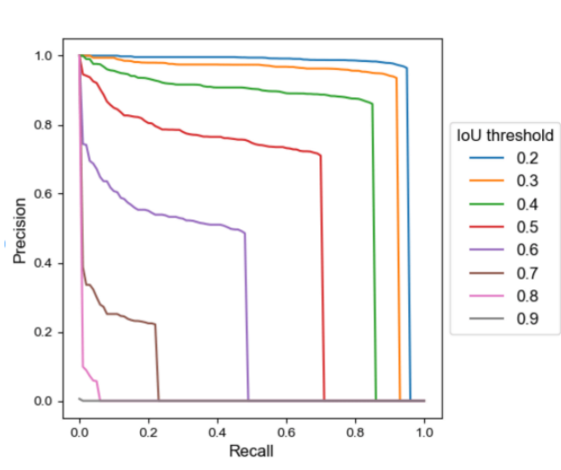
- precision recall curve
The precision recall curve in the figure shows that the adjustment of the threshold value will have a direct effect on the accuracy and recall. For the classification and localization information detected by the network, if the threshold is high, because many objects that need to be detected are not detected, the recall is lower. Correspondingly, the lower the threshold, the network will detect a lot of wrong localization information and the precision will be lower. A good target detection network should detect all objects that need to be detected and not detect objects that do not need to be detected. If the accuracy is proportional to the recall ratio, then this target detection network is the best network. In the figure, the value of AP is in the region below the precision recall curve. mAP (mean Average Precision) stands for averaging the AP of all the categories that need to be detected.
To verify the effectiveness of the proposed model for underwater biological detection, accuracy, recall, and average accuracy were used to evaluate the performance of underwater biological detection. Accuracy is defined as the ratio of the number of correctly predicted samples of underwater organisms to the total number of predicted samples of underwater organisms. The recall rate is defined as the ratio of the correctly predicted sample size of underwater organisms to the actual total sample size of underwater organisms. The average accuracy is defined as the integration of the PR curve. The formula is defined as follows:
$P=\frac{TP}{TP+FP}$...........................................(8)
$R=\frac{TP}{TP+FN}$...........................................(9)
$AP=\int_{0}^{1}{P(R)dR}$................................(10)
The number of samples predicted for underwater organisms is TP (True Positive), the number of samples incorrectly predicted in the prediction results is FP (False Positive), and the number of samples not predicted for underwater organisms is FN (False Negative).

Development methodology
Water-net
While deep learning-based image enhancement networks have made notable advancements, there exists a broad spectrum of such networks. In this context, Li et al. introduced Water-Net, employing a purely CNN-based approach as a foundational model to foster the progression of deep learning-based image enhancement. Consequently, I present an overview of Water-Net, detailing its underwater image input processing and network architecture.
Given the wide array of underwater environments and lighting conditions, there is no one-size-fits-all algorithm for enhancing underwater images. One approach involves an input and fusion strategy, involving multiple preprocessing steps for underwater images, with fusion-based conventional algorithms demonstrating superior results. Water-Net adopts a similar strategy. Leveraging the inherent degradation of underwater images, three distinct inputs are generated using three algorithms: White Balance (WB), Histogram Equalization (HE), and Gamma Correction (GC).
The WB algorithm rectifies color disparities in underwater images, drawing directly from Ancuti et al.'s proposed WB algorithm, which has been empirically proven to be effective. HE is employed to enhance image contrast, with the Lab color space's L component being transformed back to the RGB color space using MATLAB's adapthisteq function. The GC algorithm is utilized to improve the brightness of darker regions in underwater images, with a Gamma Correction value of 0.7 selected for experimentation, also found to be effective.
Inspired by the promising results of underwater image enhancement through fusion techniques, Water-Net incorporates a fusion gated network structure. It employs three images generated by traditional algorithms as input to learn three confidence maps, ultimately combining their outputs into an enhanced result. These confidence maps, learned within the network, identify critical features contributing to the final result.
Water-Net's network architecture and parameter settings are depicted in the figure. It constitutes a pure CNN network structure compatible with widely used backbone networks like the U-Net architecture, enhancing the quality of underwater images. The network takes three images processed by the aforementioned algorithms and the original image as inputs. Three feature transformation units are employed to refine these inputs, mitigating artifacts and chromatic aberrations introduced by the WB, HE, and GC algorithms. Finally, the three image inputs and the three network-generated confidence maps are combined to produce the ultimate underwater image enhancement results using the provided formula.
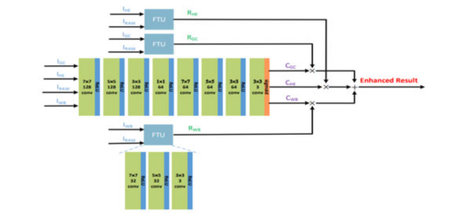
- Water-Net infrastructure
FUnIE-GAN
In many deep learning image enhancement networks require paired underwater datasets, however collecting a large number of paired underwater datasets is difficult. Most of the existing networks use paired datasets imitated and synthesised using mathematical models of underwater image imaging, and the enhancement effect is not very obvious in real underwater natural environments where paired images are lacking.The FUnIE-GAN network is able to use both paired and unpaired underwater images for enhancement, and achieves better image quality. Therefore, the network structure and loss function of FUnIE-GAN are described below.
Underwater image enhancement is essentially learning a mapping from a given source domain and (underwater distorted image) to an output desired domain Y (underwater enhanced image).FUnIE-GAN uses a conditional GAN-based model, where the generators in the model wish to generate an image through an iterative min-max game, which is carried out by an adversarial discriminator in the model to discriminate between the generators and ultimately, after many operations learning a mapping from X to Y. An image generation network is designed inspired by the U-Net principle. It is a network consisting of a network of encoders and decoders corresponding to each other, and the feature layer information of the generators is shown in Fig. In more detail, the output of each encoder is connected to the corresponding corresponding image decoder for decoding. This idea of jump connections in generator networks has proved to be very effective when used in image-to-image conversion and image quality enhancement problems. Previous generative models had long running time, FUnIE-GAN uses a simpler generative model with fewer parameters in order to achieve fast inference. For the discriminator in FUnIE-GAN, a Markovian PatchGAN [S4] architecture is used. The feature level information of the discriminator is illustrated in Fig. This architecture performs discrimination based only on patch-level image information, considering pixels to be uncorrelated outside the patch size. This architecture is effective for capturing underwater image grain and style information. In addition, this patch-level based discrimination uses fewer parameters than the global discrimination at the image level and is therefore more computationally efficient.
Design of underwater biological detector based on YOLOV7
This article selects the latest version of YOLOv7 from the newly proposed YOLO series as the basic algorithm for the detector. YOLOv7 is a one-stage object detection algorithm that processes and learns the target area, position, and category of the corresponding object in one go through direct regression. Its detection speed is usually much faster than two-stage object detection algorithms, and it can achieve a good balance between accuracy and efficiency, laying a good foundation for achieving real-time tracking and counting of underwater organisms. The structure of YOLOv7 mainly includes four parts: Input input, Backbone backbone network, Neck network, and Head output, as shown in Figure 6.
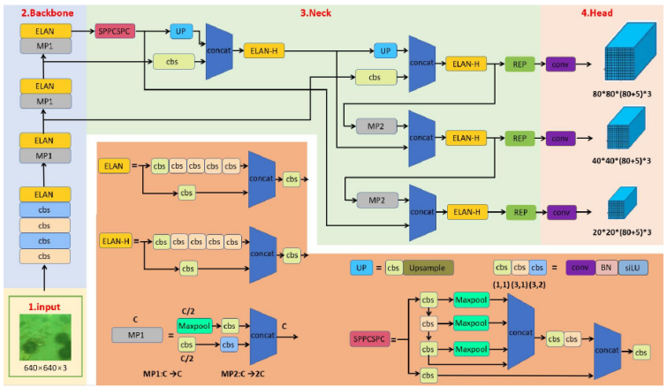
- Network structure of YOLOv7
The input of the YOLOv7 model adopts various technologies, including Mosaic data enhancement and adaptive image filling, to improve data diversity and coverage. At the same time, in order to adapt to different datasets, the model also integrates adaptive anchor box calculation at the input end, which can automatically set the initial anchor box size, thereby improving the accuracy and stability of target detection. The Backbone backbone network extracts different levels of features from images through deep convolution operations, which can effectively represent the shape, size, and position information of the target. Firstly, it passes through 4 layers of CBS convolutional layers, and then through an ELAN module composed of multiple CBS. The input and output feature sizes remain unchanged, and the number of the first two CBS channels will change. The subsequent CBS input channels will be consistent with the output channels, and the final CBS output will be the desired channel. Afterwards, it passes through the MP layer, mainly divided into Maxpool and CBS, where MP1 and MP2 are mainly the ratio changes in the number of channels, Then there are three MP+ELAN outputs, corresponding to the C3/C4/CS outputs. The Neck network layer is the same as the YOLOv5 network, which includes a feature pyramid FPN and a path aggregation structure PAN. The difference is that it replaces the CSP module in YOLOv5 with an ELAN-H module, and downsampling is changed to an MP-2 layer, introducing a RepConv reparameterization structure. The Head output end is the final part of the YOLOv7 model, mainly responsible for predicting targets of different sizes on feature maps of different sizes, thereby achieving accurate detection and positioning of targets.
In fact, YOLOv7 provides seven different models for different scenarios and applications, including YOLOv7 tiny and YOLOv7 X. Based on the actual needs of underwater biological detection, the standard version of YOLOv7 is selected to achieve a fast and high-precision underwater biological detector.

Design and Implementation
General Flow of Target Detection Algorithm
The approximate flow of the training and detection phases of a typical target detection algorithm is.
the autopilot training set image adaptive scaling to a fixed size, and then according to the set batch-size (batch-size) into the network model;.
after the algorithm forward propagation to get the position and type information of the prediction frame of the object to be detected, the forward propagation of the algorithm consists of three parts: feature extraction network (Backbone), feature fusion network (Neck), and the detection head (Prediction), in which the feature extraction network extracts the feature information, the feature fusion network fuses the shallow positional information with the deep semantic information, and the detection head is based on the rich feature information. Detection head gives the category and location of the object to be detected based on the rich feature information; the
Class loss functions such as CE Loss, Focal Loss, DR Loss, and AP Loss are used to calculate the gap between predicted and real classes, and bounding box regression loss functions such as MSE, Smooth Ll Loss, and Balanced L1 Loss are used to calculate the gap between predicted and labeled boxes;
through the gradient descent of the loss function, iteratively update the weight parameters of the convolution, fully connected and other layers in the model, and continuously reduce the category loss and the bounding box loss.
Obtain the weight parameters of the model when the loss function takes the minimum value under the specified number of iterations (epoch).
the test set of images adaptive zoom to a fixed size, passed into the trained model, the category of the object to be detected and the prediction frame. The general target detection algorithm training and detection process is shown in Figure 7.
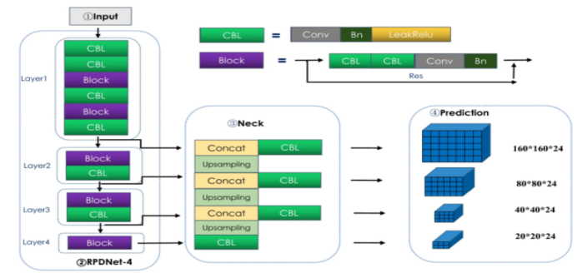
- Deep learning target detection model training process
In feature extraction networks, the way information is propagated and fused is very important. Generally speaking, in the bottom-up propagation process of feature extraction network information, the deeper the network experienced, the richer the semantic information extracted to the target as a whole, but the more serious the loss of localization and positioning information at the bottom layer. In order to both retain the rich semantic information of deep objects and take into account the shallow localization information, in 2017 Tsung-Yi Lin proposed Feature Pyramid Networks FPN (Feature Pyramid Networks). The basic idea is to add a top-down information flow channel on top of the bottom-up feature pyramid and connect the two lines horizontally; the top-down process is achieved by up-sampling, while the horizontal connection is a channel splicing of the up-sampling results with the feature matrices of each branch of the feature pyramid. The network structure is shown in Figure 8.
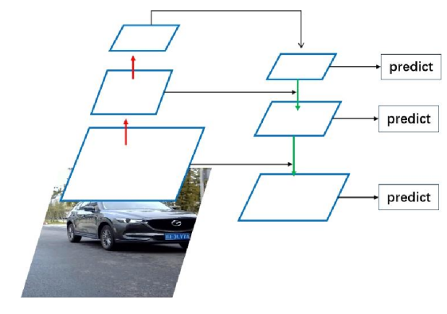
- FPN network structure
In 2018, PANet (Path Aggregation Network), jointly proposed by the University of Hong Kong, Tsinghua University, and Tencent Labs, added a bottom-up feature fusion layer and two "short-cut" layers connecting the bottom and top layers to FPN. The feature fusion layer in the YOLOv7 network adds feature extraction modules such as SPPCSPC, CBS and ELAN-W on top of the PANet network, so that the top layer feature matrix has rich speech information while retaining the location information in the bottom layer, which further improves the classification accuracy and the bounding box position regression accuracy. The feature fusion structure used in YOLOv7 is shown in Figure 9.
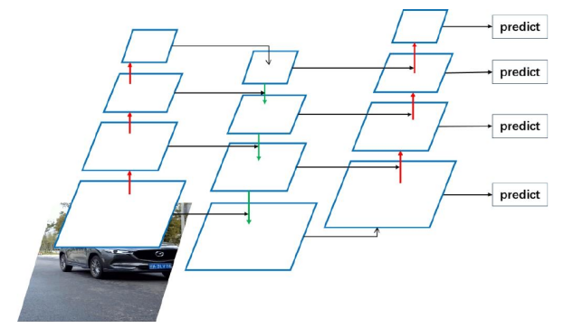
- PANet network architecture
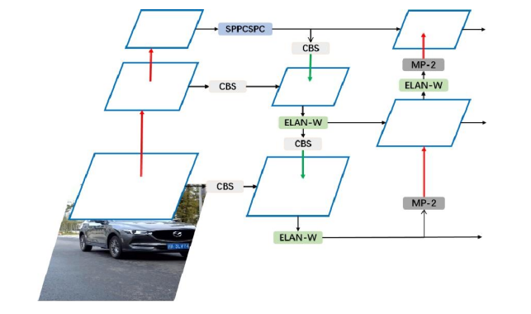
- Feature fusion structure in YOLOv7
Attention Mechanisms and Characteristic Attention Module
For the connection between two neighbouring layers in the FPN network module is just a simple addition, it can be found that such a simple operation cannot combine resolution and semantic information well. The attention mechanism can find out the key information in a picture or feature, so the attention mechanism can be used in feature fusion. Meanwhile, in the classical de-fogging network FFA, a feature attention module is constructed by incorporating the influence of different weight information contained in various channel features and the existence of non-homogeneity in different image pixels. The same problem exists for underwater image target detection networks, where the attention mechanism can be linked to the feature attention model and FPN. Next, we will elaborate on the attention mechanism and feature attention module (FA) in detail.
People tend to focus their attention on what they are interested in and not on what is irrelevant. In this way, people are able to find useful news from the huge amount of information. Since there is still a certain lack of computational power, when models such as convolutional neural networks remember all the information, they become more complex and cannot be used in real-world scenarios. The brain remembers the key words and content when it is engaged in reading a line. There are natural language researchers who have applied human attention methods to machine learning, resulting in attention mechanisms. The principle of attention in deep learning is to classify the weights of numerous information into high and low values, and extract the useful information to improve training and detection.
Most of the current attention mechanisms are based on the coding and decoding framework, and a diagram of the coding and decoding structure is given in Figure.The Encoder-Decoder model is to learn the mapping relation from the original X to the output Y. The Encoder-Decoder model is to learn the mapping relation from the original X to the output Y. The function of Encoder in the model is to transform the original X into an intermediate state of semantic information, and the function of Decoder is to transform the intermediate semantic information and the original data record information into the final expected output Y. Encoder-Decoder is a universally applied network model, which has been used in both natural language processing and visual processing. For example, for picture information interpretation, X is the picture to be described and Y is the final statement. However, Encoder-Decoder frameworks all indiscriminately transform the original X into intermediate semantic information without incorporating the idea of attention mechanism. In order to be able to incorporate the attention mechanism into the model, the intermediate semantics was made to carry out the extension of the intermediate semantic information into more than one, corresponding to different weights of the semantics, the schematic diagram is shown in Figure 9.
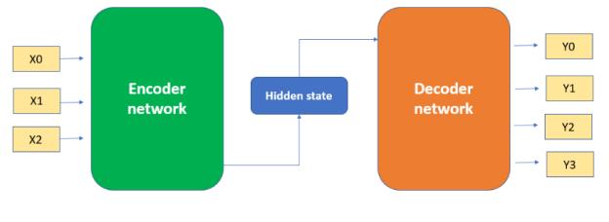
- Attention-Based Encoder-Decoder Framework
For most of the current attention mechanisms, we divide it into two steps: Step 1 is to use Query and Key and specific algorithms to obtain their weights, and Step 2 is to use the weights obtained in the former method to calculate the sum of the weights of Value to obtain the final output. The idea of Query, Key and Value comes from recommender system, the general practice is that given the input Query, the correlation between Query and Key is calculated by certain algorithms, and finally the appropriate Value is found according to the calculated correlation, for example, in the case of purchasing a product, the Query can represent the user's purchasing information (age and purchasing power, etc.), and the Key represents the information (price and material, etc.) of the product, and the Key represents the product's information (price and material, etc.). Key represents the product information (price, material, etc.) and Value represents the product that the end user wants to buy. The first step described above can be composed of two more steps, one is to use the Query and Key to perform the relevance analysis, and the other is to normalize the initial results of the previous step. The structure shown in the figure describes the processing steps of the attention mechanism. Meanwhile, in the first step, Query and Key can use different algorithms and computational functions to calculate the correlation, and the two commonly used methods are the dot product of vectors and the vector Cosine similarity. The algorithms used in the first step are different, and the magnitude of the final value is unknown. In the second step, a method similar to SoftMax is used to normalize the initial result, which not only normalizes the result, but also assigns the weights in a more detailed way, as shown in the SoftMax formula. The output of the second stage, α, is the weight value of Value, and the final result can be calculated by the formula. With the above three steps the attention value of Query can be derived, and most of the current applications of the attention mechanism follow the above abstraction operation steps.
$α_{i}=Softmax({Sim}_{i})=\frac{e^{{Sim}_{i}}}{\sum_{j=1}^{L_{x}}{e^{{Sim}_{j}}}}$.....................................(11)
$Attention(Query,Source)=\sum_{i=1}^{L_{x}}{α_{i}∙{Value}_{i}}$..................(12)
Self-attention mechanism is a development of the attention mechanism, which requires Query and Key to compute the correlation, the self-attention mechanism pays more attention to the internal phase greyness of the data symbols, and the automatic attention mechanism is to analyse the interactions between the words, which improves the problem of long-distance dependency in natural language. The main steps of the auto-attention mechanism are:The first step converts the input words into corresponding vectors. The second step gets Q, K and three feature vectors based on the particular vector. The third step yields a score for each vector. The fourth step normalises the score by an algorithm. The fifth step sums all the V's after multiplying the result of normalisation process and V to get the final result. When applied in a real network, Q, K and V are efficiently calculated using matrices, the results of Q and K are multiplied again, multiplied with appropriate constants, normalised using an algorithm and finally multiplied by V to get the final result, the process is shown in the figure. Finally, after experimentation using heat maps it was confirmed that the attention mechanism is able to correlate information from its own context well.
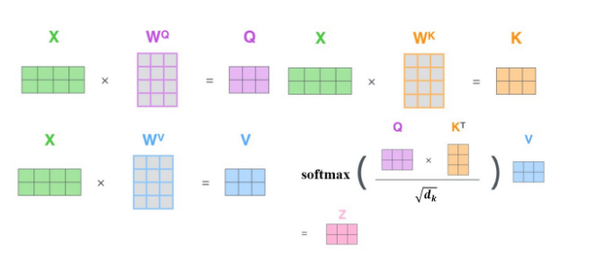
- Schematic diagram of the flow of the attention mechanism
CBAM is a simple and effective attention mechanism that integrates channel features and spatial features through convolutional operations. Key features extracted along these two main dimensions are then refined into intermediate feature maps at each convolutional block of the deep neural network, adaptively learning which channels and pixels are more important in specific tasks, thereby improving the performance and generalization ability of the deep neural network. The CBAM attention mechanism can be combined with different types of network structures, helping to improve accuracy while effectively alleviating overfitting in the network. As shown in Figure 11, it is a schematic diagram of the structure of the CBAM attention mechanism module.
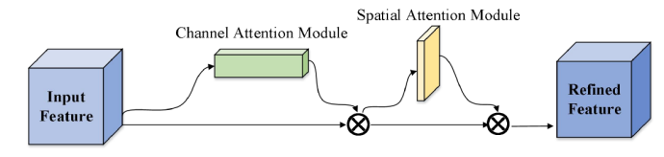

- CBAM structure diagram
The CBAM attention mechanism takes each channel of the input feature map as a feature detection block, and outputs the channel attention map through the inter channel correlation of features. For the feature map of the F ∈$R^{(C×H×W)}$layer, C represents the number of channels, H and W represent the length and width of the feature map (in pixels). The channel attention module first calculates the weight of each channel $M_{C}$∈ $R^{(C×1×1)}$, and the calculation formula is shown in equation (13).
$M_{C}(F)=σ(W_{1}$($W_{2}(F_{avg}^{C}$))+$W_{1}$($W_{2}(F_{max}^{C}$)))..............(13)
In equation (13),$F_{avg}^{C}$ and $F_{max}^{C}$ represent the feature maps after average pooling and maximum pooling, respectively, and o represents the sigmoid activation function. $W_{1}$ and $W_{2}$, representing the weights of two fully connected layers, $W_{1}$ ∈ $R^{Clr×C}$, W${∈R}^{C×Clr}$, r is the compression rate. Secondly, the pooled feature map is fed into a shared multi-layer perceptron (Shared MLP) to obtain the feature map $M_{c}$ belonging to the channel domain. Finally, the obtained channel attention feature map $M_{c}$. Multiply the original feature map F and send it to the spatial attention module to enhance the response of important channels. Figure 12 shows the structure of the CBAM channel attention module.
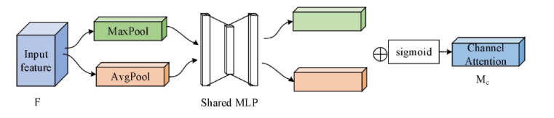
- CBAM structure diagram
Spatial attention focuses on the relationship between different spatial positions outputted by convolutional layers, and selectively aggregates the spatial features of each space through weighted spatial features. As shown in equations (14), spatial attention uses the feature map F obtained by multiplying the channel attention feature map $M_{C}$ with the original feature map $F_{S}$ as input, and sequentially performs maximum pooling and average pooling, followed by 7 × 7 The convolution kernel of 7 is used to obtain the spatial attention weight map $M_{S}∈R^{(1×H×W)}$, as shown in equations (15). Figures 13. show the structure of the CBAM spatial attention module.
$F_{S}=M_{C}×F$..................................................................(14)
$M_{S}(F_{S})=σ(f^{(7×7)}([F_{avg}^{s};F_{max}^{s}$]))................................(15)

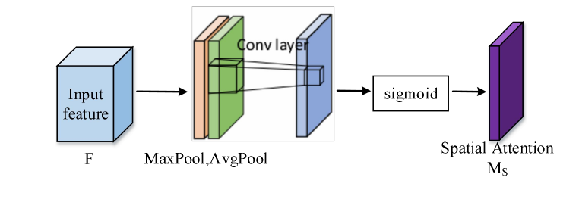
- CBAM structure diagram

Multiply the convolutional spatial attention feature map M with feature map F, and then add it to the original feature map F to enhance the response of important positions. Finally, the summed feature map is activated by the ReLU function to output the final feature map M, as shown in equation (16).
$M_{F}$(F)=max(0,($M_{S}×F_{S})+F)$......................................(16)

The role of wise-IoU loss function in target detection
Wise-IoU loss function is a commonly used loss function for target detection, which is used to measure the similarity between the prediction results of the detection frames and the real labelled frames, so as to guide the optimization of the model.
In target detection, the commonly used loss functions are Cross Entropy Loss Function, Smooth L1 Loss Function, Focal Loss, etc., but all these loss functions only consider the positional error of the detection frames without considering the differences in the size and shape of the detection frames. And Wise-IoU loss function can solve this problem effectively.
The Wise-IoU loss function is designed on the basis of IoU (Intersection over Union), which uses the idea of IoU to take into account the differences in the size and shape of the detection frames, while avoiding the instability of IoU calculation. Specifically, the Wise-IoU loss function uses a weighting method called "Wise" to weight the IoUs to obtain more accurate loss values. This weighting method allows the model to pay more attention to differences in the size and shape of the detection frames, thus improving detection accuracy.
Overall, the role of the Wise-IoU loss function in target detection is that it can help the model to more accurately estimate the similarity between the detection frames and the real labelled frames, thus guiding the optimisation of the model and improving the detection accuracy.

Results and discussion

Use the model trained by FUnIE-GAN to generate an underwater image enhancement map on URPC2020, such as the original image on the left and the enhanced image on the right. Because the resolution of the URPC2020 data set is relatively high, the width and height of the image are reduced by half before image enhancement. It can be seen from the picture that the color of the original picture is blue-green and the sensory quality is not good. The color of the enhanced picture is easier for people to see and is obviously better in terms of brightness and saturation.

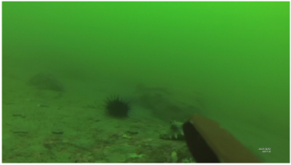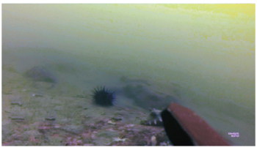
- Original image and enhanced image using FUnIE-GAN
method | echinus | holothurian | scallop | starfish | mAP
Original | 0.865 | 0.834 | 0.834 | 0.812 | 0.843
Enhanced | 0.88 | 0.835 | 0.843 | 0.801 | 0.854
- Target detection results of original and enhanced images under URPC2020 based on Yolov7
After adding the CBAM attention mechanism and wise-iou to yolov7, the detection effect has been significantly improved. Compared with yolov5-m, the map value has increased by 3.9%, as shown in the table below.The parameters of yolov5-m and the improved yolov7 are not much different, but the detection effect is indeed significantly improved.
Method | precision | recall | map
yolov5-m | 0.856 | 0.79 | 0.823
YOLOV7 | 0.84 | 0.807 | 0.843
Yolov7-CBAM-Wise-iou | 0.834 | 0.815 | 0.862
- Target detection results of Yolov5-m and improved Yolov7
The result curves of improved Yolov7 are shown in the following figure,The superiority of the improved algorithm is verified.
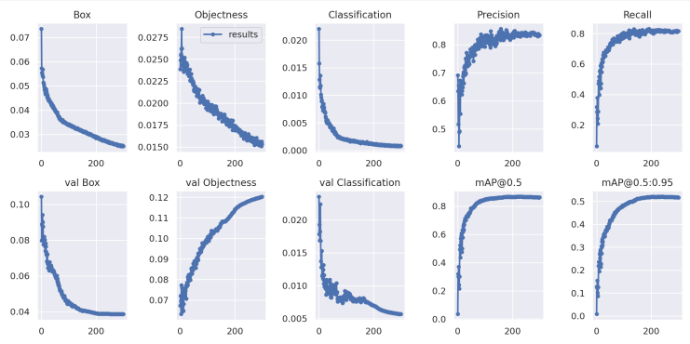

- The result curves of improved Yolov7
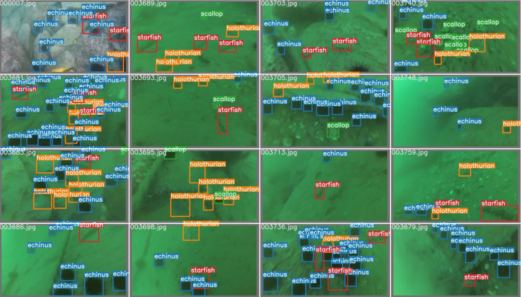
- The detection result of improved Yolov7
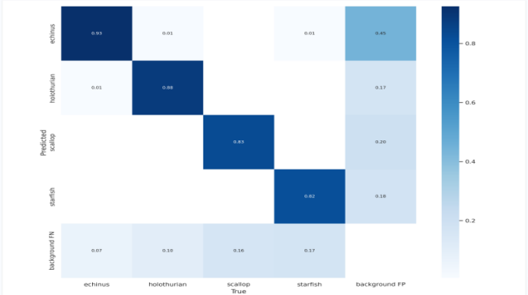
- The confusion_matrix result of improved Yolov7

Conclusion and recommendation
The underwater environment has a large number of biological and mineral resources, and resource collection in the underwater environment is more dangerous, and underwater robots can explore the underwater environment instead of humans. Underwater target detection is one of the problems that need to be solved in underwater robot operation. There are many problems in the underwater environment, such as the scale of the detected objects in the water varies greatly, the organisms in the water are easy to gather resulting in the overlap of the detected objects in the picture, the image quality degradation caused by the refraction and scattering of the light in the underwater environment, and the difficulty of collecting the underwater marker pictures. Aiming at these problems by optimising the target detection network, certain results have been obtained.
Aiming at the problem of small scale of the detected object in underwater target detection, this paper proposes an upper and lower two-layer feature fusion network and a multi-layer feature cross-fusion network using an attention module. The way of simply fusing the features of two adjacent layers of the feature pyramid does not establish the relationship between the layers well. The two feature fusion approaches proposed in this paper use the attention mechanism and the feature attention module can effectively utilise the fusion relationships, channel information and pixel information of different feature layers to obtain information-rich features. CBAM attention mechanism can improve the problem of small scale of the detected object.
Aiming at the problem of overlapping detected objects in underwater target detection, this paper proposes a localisation-quality target detection network with localisation loss added to the candidate frame generation and regression localisation network. In the non-maximum suppression process in the target detection network, the frame with the largest classification score among the overlapping frames is preferentially retained, which causes the detector to pay more attention to the category accuracy and neglect the localisation quality. The network proposed by Wooden uses centrality loss function and IoU loss function in candidate frame generation and regression localisation network to suppress bad quality detection frames and obtain more quality candidate and localisation frames. Finally, it is validated on URPC2020 dataset , the results show that:The average detection accuracy of the localisation quality network on URPC2020 dataset is improved by 1.9% compared to the base yolov7 network.
This paper proposes an end-to-end network for target detection tasks in underwater optical images based on deep learning algorithms, and achieved good detection results through experiments. However, there are still deficiencies and further research is needed. For example, although the method in this paper has improved the detection accuracy, it is far from reaching the ideal height. The outlook for future work is as follows:
(1) Preprocess underwater images before detection to improve image quality. The poor image quality caused by the underwater imaging environment is an important factor affecting the accuracy of target detection. Therefore, improving image clarity, correcting chromatic aberration, and improving image resolution through certain processing methods will help to better complete target detection. Task. Image restoration technology is a method to restore image quality based on the principle of image degradation in the imaging process, which can mainly solve the problems of image blur, distortion and noise; super-resolution reconstruction technology can improve image resolution through interpolation, neural network and other methods.
(2) More underwater data sets need to be obtained. This article uses several conventional data augmentation methods during training. Using more data augmentation methods will help improve the training effect of the network. This article uses a combined data set containing more than 5,000 images, but this still cannot fully train the network for deep learning, so it is necessary to introduce more underwater image data. At the same time, the method in this paper performs well on the data set used in this paper, but the application effect for different targets and different environments is unknown. Therefore, introducing more underwater data sets can test the effect of the method in this paper in different scenarios, which is conducive to the development of the method. further improvement.

reflection
The network in this article has made some improvements to the problems of object detection networks in complex underwater environments, but some parts can be further optimized and improved. The following is a specific explanation of the shortcomings of each part and the methods that can be optimized:
- This article proposes an image fusion target detection network that integrates enhanced images and original images, enabling the original and enhanced images to cooperate with each other. However, the current image fusion method is still relatively simple and has not fully demonstrated the effects of the original image and the enhanced image. In the future, techniques such as attention mechanism can be used to make the fusion of the enhanced image and the original image more conducive to target detection.
- Research on simplifying the parameter quantity of detection models from a practical application perspective. In order to better serve underwater autonomous fishing robots with research on underwater target detection methods, on the one hand, it is necessary to continue to improve the detection accuracy of detection methods; On the other hand, it is necessary to further simplify the detection model while ensuring detection accuracy, reduce the number of model parameters, and improve detection speed.

References
- Zhao,Z.Q;Zheng,P;Xu,S.T.; Wu, X. Object detection with deep learning. In Proceedings of the Computer Vision and Pattern Recognition(CVPR), Salt Lake City,UT,USA,18-23 June 2018.
- Sarkar, P; De,S;Gurung, S.A Survey on Underwater Object Detection. In Intelligence Enabled Researcht; Springer: Singapore,2022; pp.91-104.
- Jian, M; Liu, X.; Luo,H.; Lu,X.; Yu,H; Dong, J.Underwater image processing and analysis: A review.Sigonal Process. Lmage Commun. 2021,91,116088.
- Simonyan,K.; Zisserman, A. Very deep convolutional networks for large-scale image recognition.arXio 2014, arXiv:1409.1556.
- Zhao,Z.Q;Zheng,P; Xu,S.T; Wu,X.Object detection with deep learning. In Proceedings of the Computer Vision and Patter Recognition (CVPR),Salt Lake City,UT, USA, 18-23 June 2018.
- Tong, Z.; Chen, Y; Xu, Z.;Yu,R.Wise-loU: Bounding Box Regression Loss with Dynamic Focusing Mechanism. arXio 2023, arXiv:2301.10051.
- Sermanet,P; igen,D.; Zhang,X;Mathieu,M.; Fergus, R.;LeCun, Y.Overfeat: Integrated recognition, localization and detection using convolutional networks. arXio 2013, arXiv:1312.6229.
- Liu, Z; Zhuang,Y.; Jia,P; Wu,C;Xu,H; Liu, Z.A Novel Underwater Image Enhancement and Improved Underwater Biological Detection Pipeline.J. Mar. Sci. Eng. 2022,10,1204.
- Wang , C.Y; Bochkovskiy, A.; Liao,H.Y.M. YOLOv7: Trainable bag-of-freebies sets new state-of-the-art for real-time object detectors. arXiv 2022, arXiv:2207.02696.
- Li,Y; Bai,X; Xia,C.An Improved YOLOV5 Based on Triplet Attention and Prediction Had Optimization for Marine Organism Detection on Underwater Mobile Platforms. J. Mar. Sci.Eng. 2022,10,1230.
- Gholami A, Kwon K, Wu B, et al. Squeezenext: Hardware-aware neural network design[C]. Proceedings of the IEEE Conference on Computer Vision and Pattern Recognition Workshops, 2018: 1638-1647.
- Girshick R.Fast r-cnn[C]. Proceedings of the IEEE international conference on computer vision, 2015:1440-1448.
- Wang Y, Zhang J, Cao Y, et al. A deep cnn method for underwater image enhancement[C]. 2017 IEEE International Conference on Image Processing (ICIP),2017: 1382-1386.
- Liu, Z.; Zhuang, Y.; Jia, P.; Wu, C.; Xu, H.; Liu, Z. A Novel Underwater Image Enhancement and Improved Underwater Biological Detection Pipeline. J. Mar. Sci. Eng. 2022, 10, 1204.
- Wang, C.Y.; Bochkovskiy, A.; Liao, H.Y.M. YOLOv7: Trainable bag-of-freebies sets new state-of-the-art for real-time object detectors. arXiv 2022, arXiv:2207.02696.
- Zhu, X.; Lyu, S.; Wang, X.; Zhao, Q. TPH-YOLOv5: Improved YOLOv5 based on transformer prediction head for object detection on drone-captured scenarios. In Proceedings of the IEEE/CVF International Conference on Computer Vision, Montreal, BC, Canada, 11–17 October 2021; pp. 2778–2788.
- Tong, Z.; Chen, Y.; Xu, Z.; Yu, R. Wise-IoU: Bounding Box Regression Loss with Dynamic Focusing Mechanism. arXiv 2023, arXiv:2301.10051.
- Woo, S.; Park, J.; Lee, J.Y.; Kweon, I.S. Cbam: Convolutional block attention module. In Proceedings of the European Conference on Computer Vision (ECCV), Munich, Germany, 8–14 September 2018; pp. 3–19.
- Xie K,Pan W,Xu S. An underwater image enhancement algorithm for environment recognition and robot navigation[J]. Robotics, 2018,7(1): 14.
- Sung M, Yu S C, Girdhar Y. Vision based real-time fish detection using convolutional neural network[C]//OCEANS 2017-Aberdeen.IEEE, 2017: 1-6.
- Tian z,Shen C, Chen H, et al. Fcos: Fully convolutional one-stage object detection[C]V/Proceedings of the IEEE international conference on computer vision.2019: 9627-9636.
- Zhang S,Chi C, Yao Y, et al.Bridging the gap between anchor-based and anchor-free detection via adaptive training sample selection[C]//Proceedings of the IEEE/CVF Conference on Computer Vision and Pattern Recognition.2020: 9759-9768.
- Zhao Q,Sheng T, Wang Y, et al. M2det: A single-shot object detector based on multi-level feature pyramid network[C]//Proceedings of the AAAI Conference on Artificial Intelligence.2019,33:9259-9266.
- Pedersen M, Bruslund Haurum J, Gade R, et al. Detection of marine animals in a new underwater dataset with varying visibility[C]. Proceedings of the IEEE/CVF Conference on Computer Vision and Pattern Recognition Workshops,2019.2019: 18-26.
- [67] Fan B,Chen w,Cong Y, et al. Dual Refinement Underwater Object Detection Network[M].Proceedings of the 16th European Conference on Computer Vision，Cham:Springer International Publishing, 2020,275-291.
- Liu H, Song P, Ding R.Towards domain generalization in underwater object detection[C]. 2020 IEEE International Conference on Image Processing (ICIP), 2020.IEEE,2020:1971-1975.

